Rao Xu-April 2015

Result: Successfully create auto login with shellinabox.

Con: local test showed the auto login speed is still slow compared to terminal.

Steps:

1. go to <https://github.com/anilgulecha/shellinabox> to download latest version of shellinabox with all raw resource files. Save as **shellinaboxauto.**
2. cd shellinaboxauto to access into the downloaded folder.
3. Install shellinabox

Under shellinaboxauto, type `./configure' to configure the package for the system.

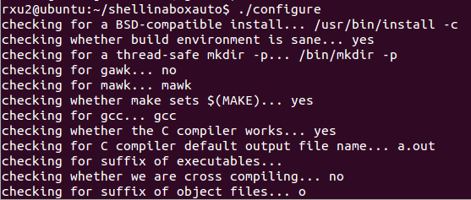

Type `make' to compile the package.

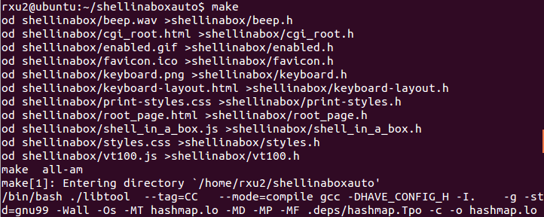

Type `sudo make install' to install the programs and any data files and documentation.

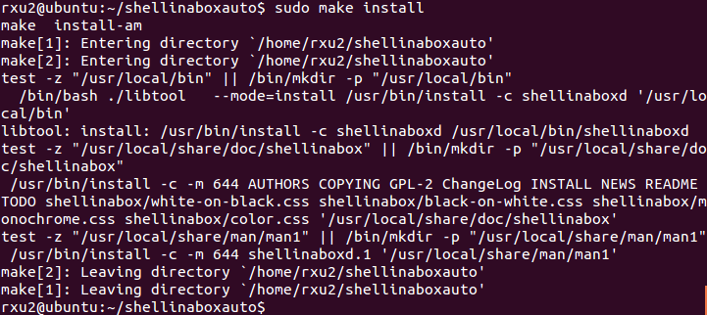

Then start shellinabox



Then open the firefox browser to test shellinabox, localhost:4200 is working.

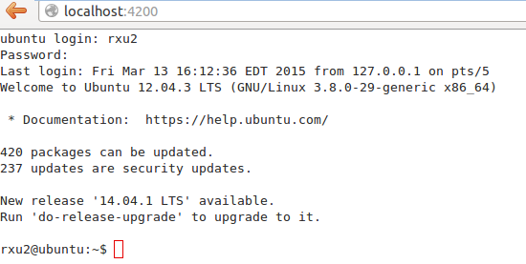

Auto login successfully: with command

**http://localhost:4200/?u=admin&p=password**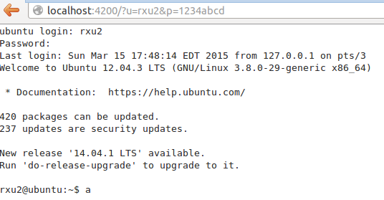

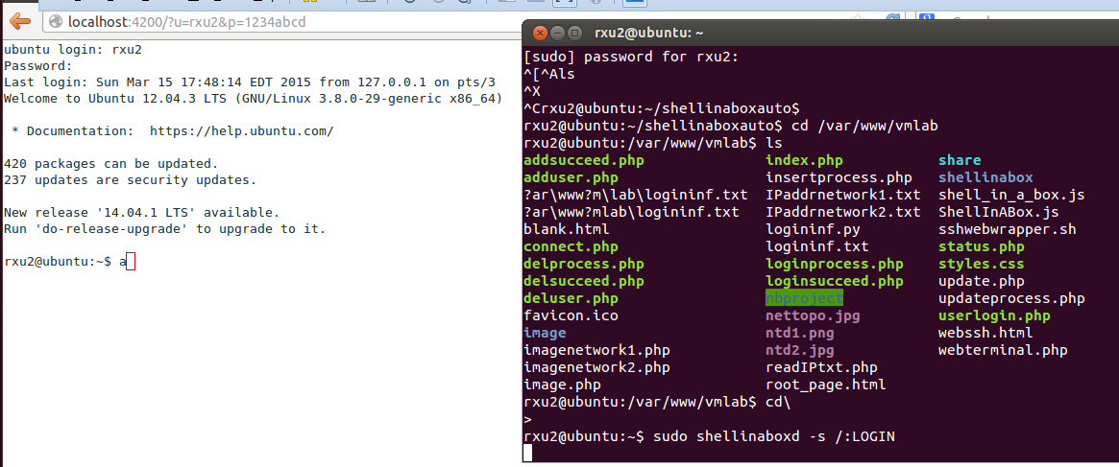

Has to run sudo shellinaboxd –s /:LOGIN everytime to start shellinabox. Exit the command line, the shellinabox service will stop.

Then go back to the webterminal.php file and change 6 iframes’ feature to **frame1.location.href='http://localhost:4200/?u=admin&p=password’**

Test webterminal.php in the firefox browser. It works!

Please see the attached video. Thanks.

