introduction, problem definition and related results’ illustration (plots/demos), conclusion/summary, and each team member’s contribution.

Introduction:

The spectrogram is a useful tool that visualizes the frequency-domain content of a signal as it varies with time. It does with with one axis that represents time, and another that represents frequency and a third that represents the amplitude of a frequency using color. For this part of the project we synthesize some AM/FM signals and then analyze these signals using the spectrogram, and examine how the spectrogram section length impacts the accuracy of the analysis.

Problem Definition:

Spectrograms are formed by taking sections of a signal and performing an FFT on each section to get the spectrum. These sections are usually of a fixed number of samples and are overlapped. The choice of section length is important, as there are tradeoffs involved in making it larger or smaller. If we make the section length short we can track rapid changes in the frequency content of the signal, however we may not have enough data to perform an accurate frequency measurement. If we make the section length long we can accurately measure the frequency of the signal, however long section lengths fail to track fast changes in the signal.

If we have a signal composed of multiple sinusoids whose frequencies are very close, for example, we may need a very long section length to resolve their frequencies using a spectrogram.

So we would like to make our section length as small as possible, but also accurate enough to track the frequency content of our signal. The frequency resolution of the spectrogram is inversely proportional to the section length. So how can be go about finding an appropriate section length?

Results:

We use an example beat signal is defined as:



The phases are random and $f_{Δ}=4$. This signal is shown below and will be used for our spectrogram analysis. The signal appears as below when plotted.

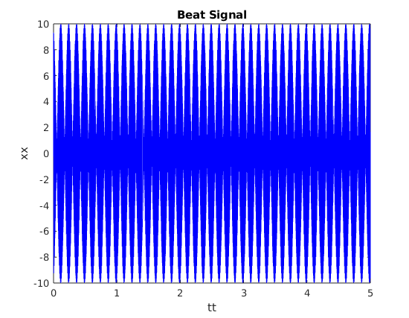

We would expect a spectrogram of this signal to have two lines, one at 1020 and one at 1028. If we plot a spectrogram of this signal 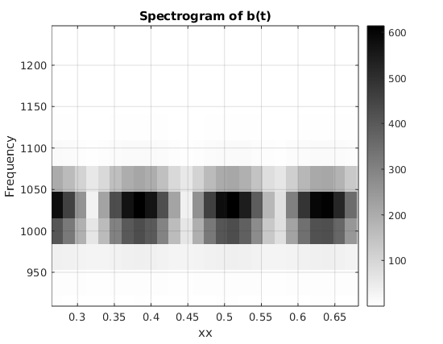using a section length of 256 we get the below.

This does not correctly represent where we would expect the lines to be, it lacks the accuracy given by longer section lengths.

Upping the section length of 4000, using an iterative guess and check method results in more accurate results.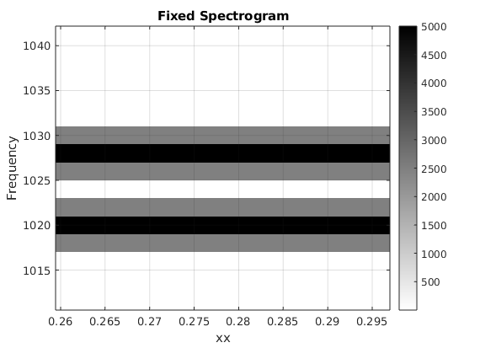

This section length is not necessarily minimal. We know there is an inverse relationship between section duration and frequency separation, so we can try to calculate a constant C like:

$\left|f_{1}−f_{2}\right|=\frac{C}{T_{SECT}}$ where $T_{SECT}=\frac{L_{SECT}}{f_{SAMP}}$

These equations can help us approximate the correct section length. We solve for C first using our frequencies from before, and then we can apply the approximation to different frequencies in a different signal. Solve for C above gives C = 4.

Next we can change to $f_{Δ}=16$ and try analyzing the different beat signal, giving two frequencies at 1008 and 1040, which should appear in the spectrogram. Using our constant we found, we can solve for Lsect in the previous equations, and find Lsect = 1000.

What follows is a spectrogram plot for the new signal:

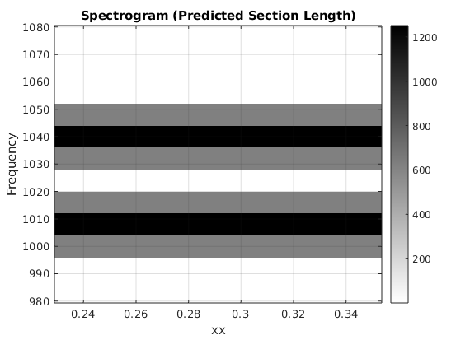

This shows the lines at the correct positions, showing our predicted section length was accurate.

Conclusion:

Spectrograms are a useful tool for analyzing the frequency content of signals, however they can be inaccurate if the section length is chosen to be too small. Using the inverse relationship between section duration and frequency separation we can predict a section length approximately, while trying to keep the section length appropriately small.

Team member contribution:

Derek Anderson for Lab S7 2.1