Peelii Larval Structure - Sites and Years

Alan Couch

Wed Sep 21 11:30:42 AM 2016

## Loading required package: knitr

## Loading project configuration

## Autoloading helper functions

## Running helper script: funRel.R

## Autoloading cache

## Autoloading data

## Loading data set: DARTallIdentifiers

## Loading data set: qslAllLarvaInfo

## Loading data set: qslMetaLarvAndAdultsUnion

## Loading data set: qslMPeeliiForRelated

## Loading data set: Report.DMac15.1861

## Munging data

## Running preprocessing script: 01MungeGeneticsDatacontaminationfix.R

## Loading required package: dplyr

##   
## Attaching package: 'dplyr'

## The following objects are masked from 'package:stats':  
##   
## filter, lag

## The following objects are masked from 'package:base':  
##   
## intersect, setdiff, setequal, union

## Running preprocessing script: 02MungeLarvaSnpsByYears.R

## Running preprocessing script: 03MungeLarvaSnpsByYearCombos.R

a<-suppressPackageStartupMessages({  
library(plyr)  
library(dplyr)  
library(ggplot2)  
library(dart)  
library(tsne)  
library(adegenet)   
library(pegas)  
library(hierfstat)  
library(ade4)  
library(mmod)  
library(poppr)  
})  
  
ptm <- proc.time()

### Basic PopGen

pairDistPlot(gi, gi$pop, within=FALSE, sep="-", data=FALSE,violin=TRUE, boxplot=TRUE, jitter=TRUE)

## $violin

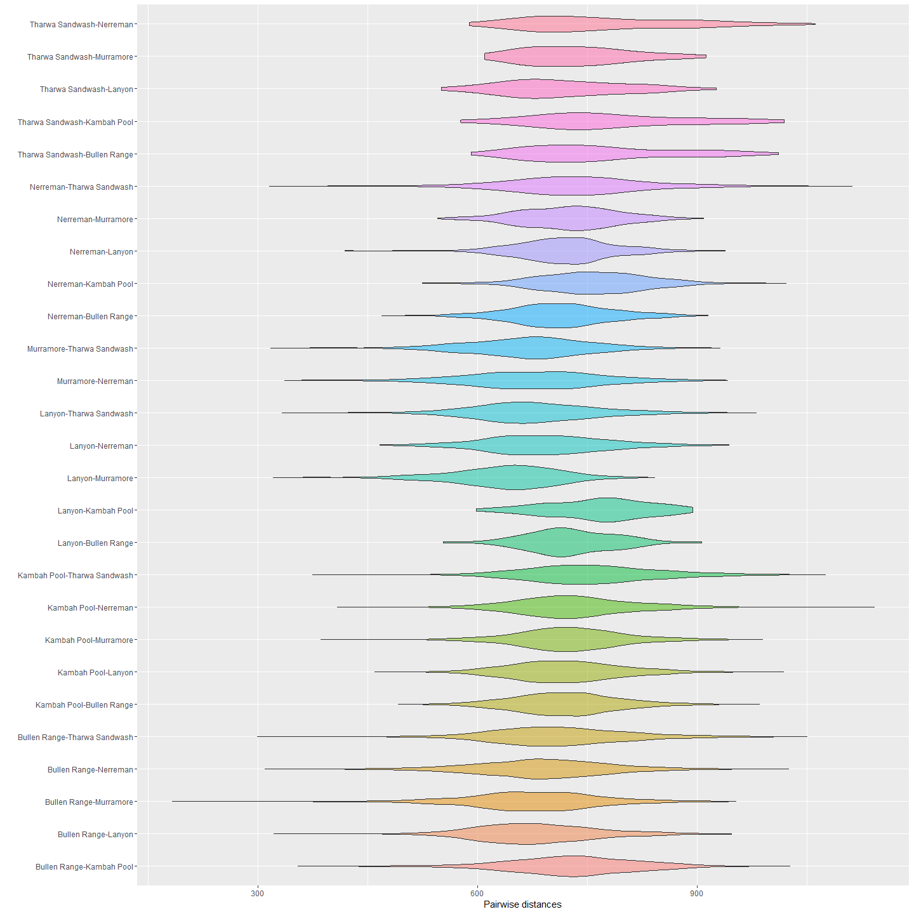

##   
## $boxplot

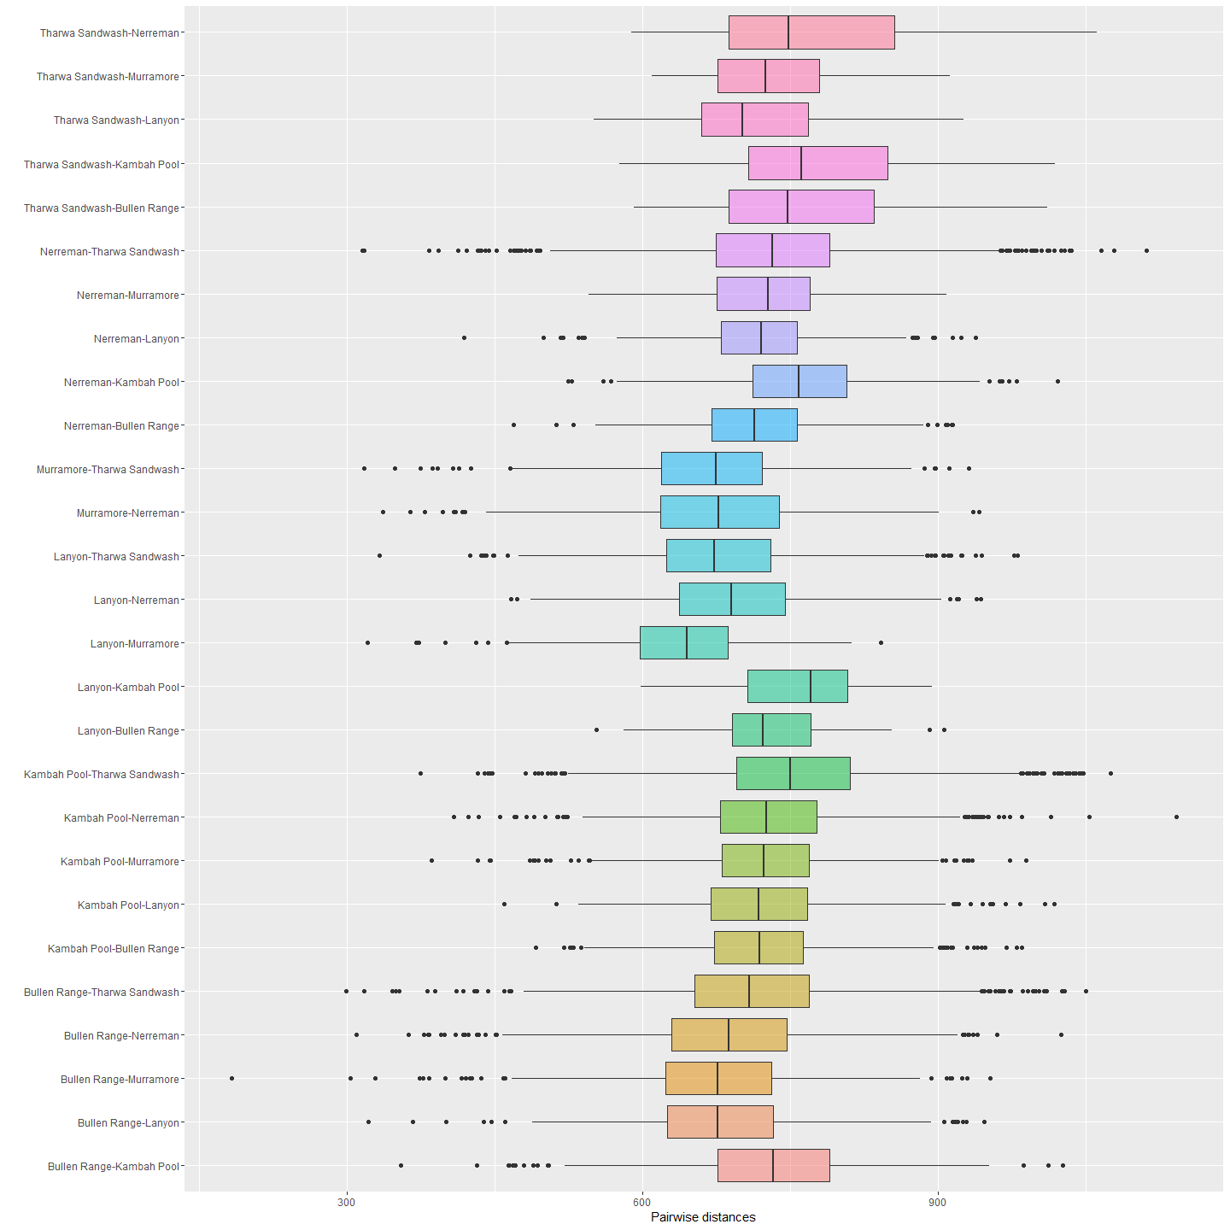

##   
## $jitter

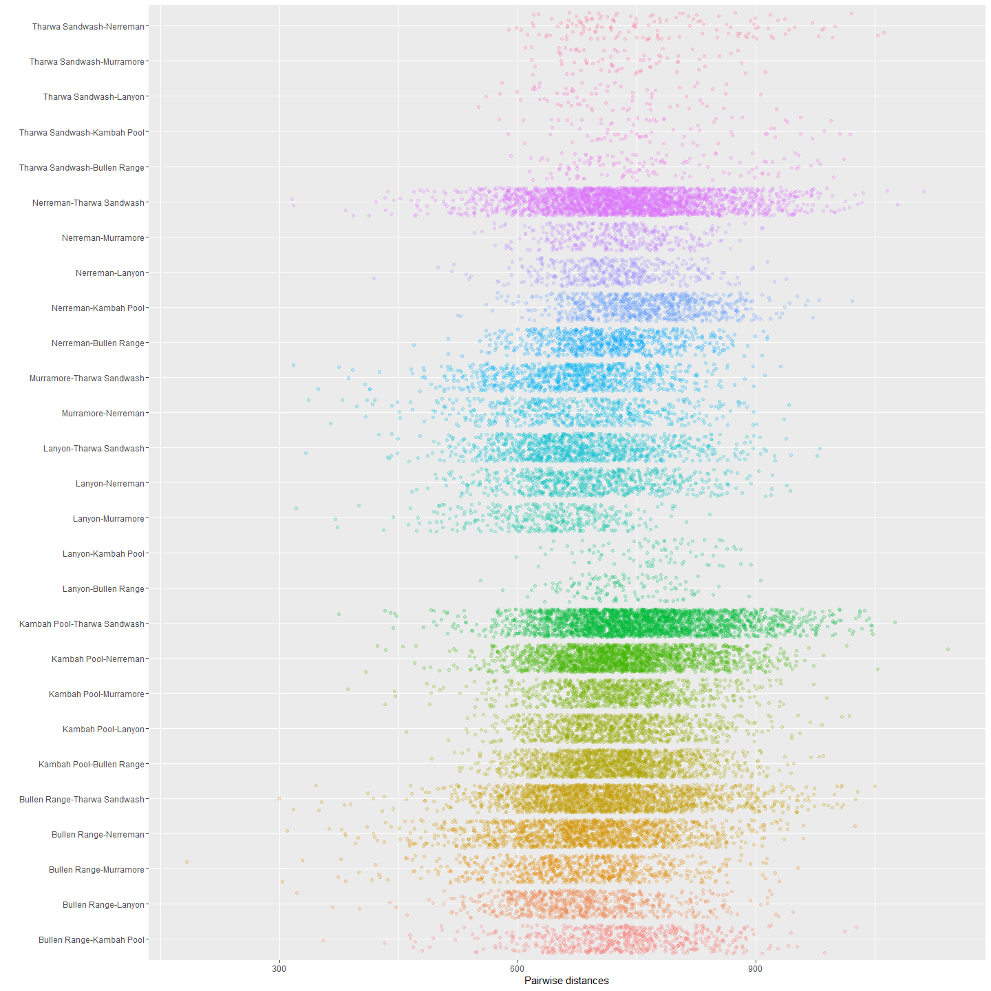

fstat(gi)

## pop Ind  
## Total 0.01827464 -0.1371021  
## pop 0.00000000 -0.1582691

#Is the structure between populations significant?  
popStrSig<- gstat.randtest(gi, nsim = 99)  
popStrSig

## Monte-Carlo test  
## Call: gstat.randtest(x = gi, nsim = 99)  
##   
## Observation: 0   
##   
## Based on 99 replicates  
## Simulated p-value: 1   
## Alternative hypothesis: greater   
##   
## Std.Obs Expectation Variance   
## NaN 0 0

plot(popStrSig)

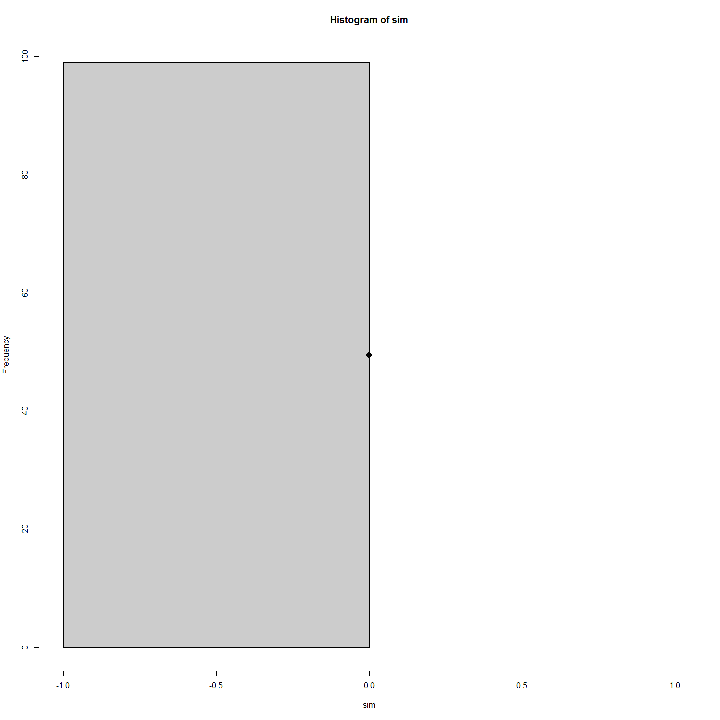

giHs <- genind2hierfstat(gi)  
#head(giHs)  
varglob<-varcomp.glob(giHs$pop, giHs[, -1])  
varglob$overall

## Pop Ind Error   
## 3.93667 -33.47080 244.95118

varglob$F

## Pop Ind  
## Total 0.01827464 -0.1371021  
## Pop 0.00000000 -0.1582691

#Pairwise Fst (populations)  
matFst <- pairwise.fst(gi[1:50, treatOther = FALSE])  
matFst

## 1 2 3  
## 2 -0.3540884   
## 3 -0.6989234 -0.1901033   
## 4 -0.9214085 -0.4227752 -0.5910064

#Thus there is no significant difference between populations.  
is.euclid(matFst)

## [1] FALSE

#gi  
div <- summary(gi)

##   
## # Total number of genotypes: 243   
##   
## # Population sample sizes:   
## Bullen Range Kambah Pool Lanyon Murramore Nerreman Tharwa Sandwash   
## 42 54 21 18 55 53   
##   
##   
## # Number of alleles per population:   
## Bullen Range Kambah Pool Lanyon Murramore Nerreman Tharwa Sandwash   
## 7177 7130 7024 7059 7365 7465   
##   
## # Percentage of missing data:   
## [1] 22.73779

div$pop.eff

## Bullen Range Kambah Pool Lanyon Murramore Nerreman Tharwa Sandwash   
## 42 54 21 18 55 53

names(div)

## [1] "N" "pop.eff" "loc.n.all" "pop.nall" "NA.perc" "Hobs" "Hexp"

par(mfrow = c(2, 2))  
plot(div$pop.eff, div$pop.nall, xlab = "Colonies sample size", ylab = "Number of alleles", main = "Alleles numbers and sample sizes", type = "n")  
text(div$pop.eff, div$pop.nall, lab = names(div$pop.eff))  
barplot(div$loc.n.all, ylab = "Number of alleles", main ="Number of alleles per locus")  
barplot(div$Hexp - div$Hobs, main = "Heterozygosity: expected-observed",ylab = "Hexp - Hobs")  
barplot(div$pop.eff, main = "Sample sizes per population", ylab = "Number of genotypes", las = 3)

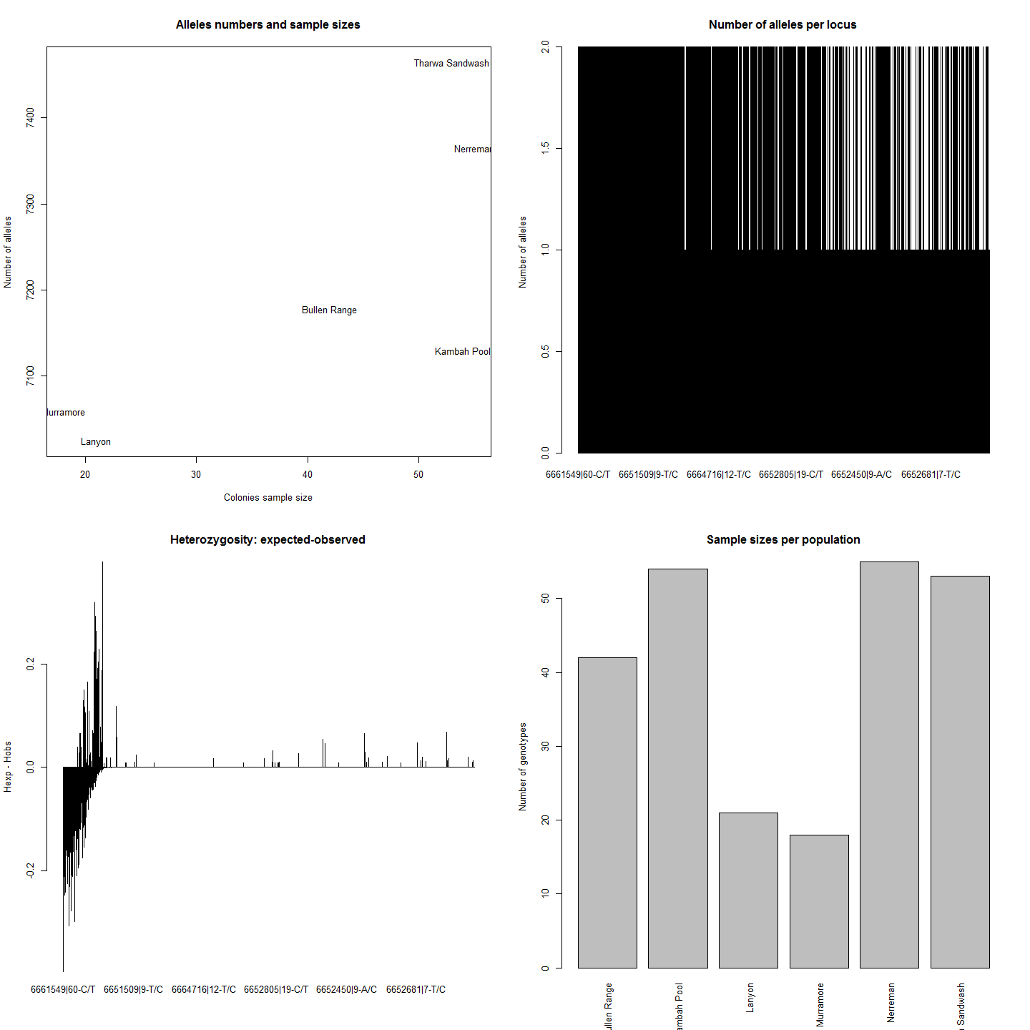

plot(div$Hobs, xlab="Loci number", ylab="Observed Heterozygosity",main="Observed heterozygosity per locus")  
  
mean(nAll(gi)) # Number of alleles per locus

## [1] 1.309554

plot(div$Hobs,div$Hexp, xlab="Hobs", ylab="Hexp", main="Expected heterozygosity as a function of observed heterozygosity per locus")  
  
bartlett.test(list(div$Hexp, div$Hobs)) # a test : H0: Hexp = Hobs

##   
## Bartlett test of homogeneity of variances  
##   
## data: list(div$Hexp, div$Hobs)  
## Bartlett's K-squared = 198.48, df = 1, p-value < 2.2e-16

basicstat <- basic.stats(gi, diploid = TRUE, digits = 2)   
names(basicstat)

## [1] "n.ind.samp" "pop.freq" "Ho" "Hs" "Fis" "perloc" "overall"

basicstat$overall

## Ho Hs Ht Dst Htp Dstp Fst Fstp Fis Dest   
## 0.04 0.03 0.03 0.00 0.03 0.00 0.01 0.02 -0.17 0.00

#mmod outputs  
diff_stats(gi, phi_st = FALSE)

## $per.locus  
## Hs Ht Gst Gprime_st D  
## 6661549|60-C/T 0.537851343 0.507644027 -5.950492e-02 -1.563695e-01 -7.843532e-02  
## 6650588|15-C/T 0.506733320 0.499743555 -1.398670e-02 -3.412176e-02 -1.700443e-02  
## 6661794|21-A/G 0.472113392 0.487421375 3.140606e-02 7.094710e-02 3.479834e-02  
## 6664081|63-G/A 0.495192568 0.500418265 1.044266e-02 2.477197e-02 1.242223e-02  
## 6653885|30-A/G 0.487902403 0.493291859 1.092549e-02 2.554592e-02 1.262913e-02  
## 6661177|64-C/T 0.488242329 0.493365986 1.038510e-02 2.430114e-02 1.201426e-02  
## 6661457|52-C/T 0.510937824 0.502320494 -1.715504e-02 -4.223784e-02 -2.114414e-02  
## 6653401|39-G/A 0.501183705 0.501121486 -1.241594e-04 -2.986971e-04 -1.496798e-04  
## 6657572|30-T/A 0.444760300 0.451942974 1.589288e-02 3.423931e-02 1.552340e-02  
## 6661566|34-A/G 0.473030252 0.469106223 -8.364906e-03 -1.908024e-02 -8.935684e-03  
## 6663962|65-C/T 0.475354340 0.476734231 2.894465e-03 6.616559e-03 3.156166e-03  
## 6665217|18-A/G 0.501054015 0.501242186 3.754096e-04 9.028187e-04 4.525648e-04  
## 6661207|60-A/C 0.492928372 0.489539337 -6.922905e-03 -1.640598e-02 -8.020250e-03  
## 6661398|51-C/T 0.467089493 0.470293957 6.813747e-03 1.532221e-02 7.215764e-03  
## 6651899|27-T/A 0.454520277 0.472177818 3.739596e-02 8.165658e-02 3.884480e-02  
## 6653020|28-A/C 0.486948094 0.495577676 1.741318e-02 4.058711e-02 2.018412e-02  
## 6653704|64-T/G 0.497846562 0.499884182 4.076184e-03 9.732953e-03 4.869316e-03  
## 6650504|59-T/C 0.488323375 0.498092787 1.961364e-02 4.581878e-02 2.291153e-02  
## 6652003|38-G/C 0.451878579 0.455386915 7.704077e-03 1.684056e-02 7.680786e-03  
## 6661105|11-G/T 0.482983024 0.490174064 1.467038e-02 3.395044e-02 1.669045e-02  
## 6661432|29-C/A 0.466909440 0.464777645 -4.586697e-03 -1.033425e-02 -4.798722e-03  
## 6652162|44-A/T 0.483151705 0.482769676 -7.913274e-04 -1.837567e-03 -8.869811e-04  
## 6653798|57-C/T 0.495252350 0.490581872 -9.520283e-03 -2.267694e-02 -1.110371e-02  
## 6653191|40-A/G 0.488478451 0.486333379 -4.410702e-03 -1.035639e-02 -5.032214e-03  
## 6664876|31-G/A 0.458901732 0.461173687 4.926462e-03 1.091472e-02 5.038541e-03  
## 6661163|31-T/C 0.494744674 0.485714721 -1.859106e-02 -4.431925e-02 -2.144647e-02  
## 6652675|16-G/T 0.496427537 0.501420139 9.956923e-03 2.367993e-02 1.189724e-02  
## 6652288|45-C/T 0.483775088 0.476748525 -1.473851e-02 -3.436196e-02 -1.633373e-02  
## 6650933|66-G/A 0.503456786 0.498948448 -9.035680e-03 -2.187613e-02 -1.089534e-02  
## 6653948|58-T/C 0.484907503 0.500467765 3.109144e-02 7.198543e-02 3.625041e-02  
## 6663083|49-G/A 0.479890466 0.492176296 2.496225e-02 5.730697e-02 2.834594e-02  
## 6662726|45-A/G 0.473212868 0.469648146 -7.590197e-03 -1.731645e-02 -8.120294e-03  
## 6664756|9-C/T 0.459589753 0.451950245 -1.690343e-02 -3.766198e-02 -1.696380e-02  
## 6661688|18-A/G 0.482623630 0.483139721 1.068204e-03 2.477057e-03 1.197020e-03  
## 6666128|43-C/G 0.430809134 0.429374968 -3.340126e-03 -7.046547e-03 -3.023590e-03  
## 6652433|13-A/G 0.465076340 0.464837896 -5.129614e-04 -1.150850e-03 -5.349038e-04  
## 6652352|5-T/C 0.491716170 0.491271114 -9.059260e-04 -2.139175e-03 -1.050725e-03  
## 6664270|14-C/A 0.487252525 0.491294970 8.228142e-03 1.922496e-02 9.460668e-03  
## 6651416|17-C/T 0.493241088 0.501428737 1.632864e-02 3.854019e-02 1.938827e-02  
## 6664751|11-T/A 0.478118037 0.480224091 4.385566e-03 1.007520e-02 4.842599e-03  
## 6657734|47-A/G 0.435611958 0.431141142 -1.036973e-02 -2.209390e-02 -9.505835e-03  
## 6663081|18-A/G 0.436497270 0.443991968 1.688026e-02 3.582618e-02 1.596024e-02  
## 6651148|64-A/T 0.496734513 0.493938334 -5.660988e-03 -1.351351e-02 -6.667285e-03  
## 6656916|22-T/C 0.448737205 0.460009490 2.450446e-02 5.308166e-02 2.453774e-02  
## 6653573|49-T/C 0.487231003 0.487025703 -4.215376e-04 -9.865802e-04 -4.804494e-04  
## 6661198|22-T/G 0.484516450 0.490879273 1.296209e-02 3.009658e-02 1.481209e-02  
## 6665027|17-A/T 0.479706704 0.483774832 8.409136e-03 1.936219e-02 9.382696e-03  
## 6664900|6-C/T 0.473064396 0.487496225 2.960398e-02 6.702087e-02 3.286587e-02  
## 6650826|66-G/A 0.510453399 0.501538825 -1.777444e-02 -4.372500e-02 -2.185183e-02  
## 6653766|40-A/C 0.499477429 0.500833473 2.707574e-03 6.487880e-03 3.251107e-03  
## 6665588|8-C/T 0.458210945 0.456423582 -3.916020e-03 -8.680329e-03 -3.958804e-03  
## 6652573|8-C/A 0.447797343 0.450959686 7.012475e-03 1.521757e-02 6.872137e-03  
## 6652700|14-C/G 0.481425357 0.481628735 4.222702e-04 9.770656e-04 4.706226e-04  
## 6664334|9-A/G 0.465250250 0.469616581 9.297651e-03 2.082558e-02 9.798223e-03  
## 6651772|17-A/T 0.467232559 0.467434008 4.309675e-04 9.706233e-04 4.537414e-04  
## 6651828|36-G/A 0.486367694 0.502018746 3.117623e-02 7.238574e-02 3.656558e-02  
## 6650476|13-A/C 0.446429637 0.478023789 6.609326e-02 1.414042e-01 6.848810e-02  
## 6651474|15-T/C 0.472622180 0.468924691 -7.885036e-03 -1.797002e-02 -8.413296e-03  
## 6652836|30-C/T 0.491512454 0.490483385 -2.098072e-03 -4.953402e-03 -2.428542e-03  
## 6653346|25-C/A 0.481462556 0.482439604 2.025223e-03 4.684876e-03 2.261085e-03  
## 6658563|22-C/T 0.442495894 0.443606033 2.502534e-03 5.383886e-03 2.389520e-03  
## 6661870|10-G/T 0.498554086 0.501150097 5.180108e-03 1.238358e-02 6.212463e-03  
## 6657169|37-T/C 0.453347190 0.448477589 -1.085807e-02 -2.388727e-02 -1.068964e-02  
## 6661569|7-A/G 0.443923171 0.445904391 4.443150e-03 9.579695e-03 4.275424e-03  
## 6652342|46-G/A 0.447459836 0.461077321 2.953406e-02 6.376506e-02 2.957429e-02  
## 6656937|18-C/T 0.449309249 0.446548487 -6.182446e-03 -1.348873e-02 -6.015926e-03  
## 6661537|56-G/A 0.454887878 0.454454895 -9.527516e-04 -2.097770e-03 -9.531602e-04  
## 6664008|14-G/A 0.484385501 0.479907906 -9.330113e-03 -2.175476e-02 -1.042080e-02  
## 6651473|53-G/A 0.467819155 0.477071694 1.939444e-02 4.356302e-02 2.086330e-02  
## 6661884|29-T/A 0.492503404 0.499851120 1.469981e-02 3.465651e-02 1.737403e-02  
## 6662691|24-C/T 0.428650670 0.432602430 9.134855e-03 1.915087e-02 8.299848e-03  
## 6661181|61-C/T 0.460084167 0.465484708 1.160197e-02 2.572649e-02 1.200307e-02  
## 6651798|39-C/A 0.494167569 0.487841059 -1.296838e-02 -3.084525e-02 -1.500855e-02  
## 6661610|46-T/C 0.520920006 0.505718811 -3.005859e-02 -7.574616e-02 -3.807597e-02  
## 6653512|60-C/G 0.469256451 0.468513186 -1.586434e-03 -3.588032e-03 -1.680507e-03  
## 6651413|19-C/A 0.500083233 0.501140104 2.108934e-03 5.060149e-03 2.536913e-03  
## 6651436|18-C/T 0.512622233 0.500756612 -2.369539e-02 -5.861953e-02 -2.921501e-02  
## 6663093|22-C/A 0.439615555 0.442143840 5.718241e-03 1.223098e-02 5.414037e-03  
## 6652854|20-T/C 0.435511376 0.436775975 2.895304e-03 6.151326e-03 2.688307e-03  
## 6657907|22-C/T 0.426814523 0.433990738 1.653541e-02 3.450382e-02 1.502386e-02  
## 6664719|5-A/G 0.428322267 0.435052161 1.546917e-02 3.237094e-02 1.412662e-02  
## 6651857|34-G/T 0.430745875 0.432393215 3.809820e-03 8.025068e-03 3.472629e-03  
## 6658182|11-G/A 0.439987288 0.446413242 1.439463e-02 3.075639e-02 1.376959e-02  
## 6661203|33-G/T 0.468868837 0.477545674 1.816965e-02 4.090257e-02 1.960383e-02  
## 100066381|65-T/C 0.497975858 0.499392908 2.837545e-03 6.778803e-03 3.387207e-03  
## 6661291|28-A/C 0.487989865 0.497534256 1.918338e-02 4.478833e-02 2.236922e-02  
## 6651404|67-A/G 0.468820489 0.470758773 4.117361e-03 9.293973e-03 4.378822e-03  
## 6661583|6-T/C 0.457917497 0.441354711 -3.752715e-02 -8.370152e-02 -3.666479e-02  
## 6653019|13-C/T 0.447444811 0.443472447 -8.957408e-03 -1.948797e-02 -8.626896e-03  
## 6661633|39-G/T 0.447847151 0.447285110 -1.256563e-03 -2.731588e-03 -1.221492e-03  
## 6653539|14-G/C 0.468340764 0.466280233 -4.419082e-03 -9.983067e-03 -4.650793e-03  
## 6652507|49-A/G 0.414005823 0.416689139 6.439613e-03 1.317009e-02 5.494901e-03  
## 6662661|7-T/C 0.447829640 0.453670362 1.287438e-02 2.790728e-02 1.269331e-02  
## 6661859|57-A/G 0.501752807 0.500583277 -2.336333e-03 -5.629556e-03 -2.816745e-03  
## 6661395|60-C/T 0.521912427 0.491624099 -6.160871e-02 -1.565671e-01 -7.602372e-02  
## 6661690|43-G/A 0.477231894 0.490633374 2.731465e-02 6.235938e-02 3.076274e-02  
## 6653303|26-C/T 0.481364057 0.496272191 3.004024e-02 6.909085e-02 3.449387e-02  
## 6650697|6-C/A 0.501780288 0.500555105 -2.447648e-03 -5.898232e-03 -2.950945e-03  
## 6661748|26-C/T 0.487865121 0.487869830 9.650544e-06 2.261246e-05 1.103196e-05  
## 6661276|34-A/G 0.450759931 0.478710290 5.838679e-02 1.260932e-01 6.106698e-02  
## 6651590|59-C/G 0.455908845 0.454690733 -2.678992e-03 -5.911718e-03 -2.686563e-03  
## 6661435|48-G/A 0.414126573 0.438347769 5.525566e-02 1.119389e-01 4.961043e-02  
## 6664012|53-A/G 0.459866963 0.460133743 5.797878e-04 1.287951e-03 5.926983e-04  
## 6651071|8-C/T 0.446869124 0.470264598 4.974960e-02 1.068669e-01 5.075574e-02  
## 6661174|27-G/A 0.472523759 0.464500755 -1.727232e-02 -3.943046e-02 -1.825221e-02  
## 6657901|34-G/A 0.458577127 0.458334110 -5.302167e-04 -1.175288e-03 -5.386173e-04  
## 6661288|56-T/C 0.439631075 0.435267425 -1.002522e-02 -2.151159e-02 -9.344522e-03  
## 6664895|15-G/A 0.502987155 0.501221007 -3.523693e-03 -8.513690e-03 -4.264233e-03  
## 6665065|54-A/G 0.446928047 0.444207622 -6.124221e-03 -1.330402e-02 -5.902507e-03  
## 6653483|52-C/T 0.491198180 0.487514763 -7.555497e-03 -1.784647e-02 -8.687272e-03  
## 6652822|57-G/A 0.433398030 0.439052133 1.287798e-02 2.720406e-02 1.197476e-02  
## 100065688|55-A/G 0.477888611 0.475352345 -5.335549e-03 -1.227611e-02 -5.829252e-03  
## 6661405|37-G/T 0.455129403 0.467229784 2.589814e-02 5.674306e-02 2.664937e-02  
## 6661817|33-A/G 0.419925389 0.416020462 -9.386383e-03 -1.945413e-02 -8.078121e-03  
## 6651443|47-G/T 0.431816445 0.434046330 5.137436e-03 1.083909e-02 4.709503e-03  
## 6651921|15-T/A 0.476069613 0.478853515 5.813682e-03 1.330008e-02 6.376195e-03  
## 6654090|16-G/A 0.487703604 0.500385911 2.534505e-02 5.906868e-02 2.970696e-02  
## 6653899|53-A/G 0.456892510 0.454530471 -5.196657e-03 -1.149400e-02 -5.218942e-03  
## 6661211|62-G/A 0.502586299 0.502102448 -9.636496e-04 -2.325232e-03 -1.167280e-03  
## 6652984|32-G/A 0.455442581 0.463527194 1.744151e-02 3.830092e-02 1.781545e-02  
## 6661495|42-T/C 0.463582886 0.464390119 1.738266e-03 3.887263e-03 1.805834e-03  
## 6650679|43-C/T 0.460557544 0.452616574 -1.754458e-02 -3.916569e-02 -1.766484e-02  
## 6661246|33-G/A 0.406033454 0.409334887 8.065361e-03 1.626833e-02 6.669938e-03  
## 6653043|54-C/G 0.441651703 0.448451738 1.516336e-02 3.249050e-02 1.461461e-02  
## 6651254|12-A/T 0.477453623 0.474494509 -6.236352e-03 -1.433934e-02 -6.795450e-03  
## 6653789|32-G/T 0.458207828 0.454725855 -7.657301e-03 -1.698595e-02 -7.712122e-03  
## 6650988|24-G/A 0.434418075 0.440136246 1.299182e-02 2.749342e-02 1.213229e-02  
## 6650862|68-C/A 0.500975779 0.500568699 -8.132357e-04 -1.955900e-03 -9.789032e-04  
## 6653541|8-A/G 0.446480528 0.445915073 -1.268080e-03 -2.749825e-03 -1.225877e-03  
## 6662900|30-G/A 0.428713480 0.432855509 9.569079e-03 2.006167e-02 8.700423e-03  
## 6653618|37-G/A 0.498707483 0.497092364 -3.249131e-03 -7.782866e-03 -3.866289e-03  
## 6664721|14-C/T 0.417439170 0.427143639 2.271945e-02 4.658744e-02 1.998995e-02  
## 6652395|48-C/T 0.449110139 0.451823190 6.004672e-03 1.306425e-02 5.909821e-03  
## 6661842|33-T/A 0.484537291 0.482969989 -3.245134e-03 -7.559595e-03 -3.648688e-03  
## 6661739|54-G/A 0.446444944 0.445382854 -2.384666e-03 -5.171961e-03 -2.302404e-03  
## 6652644|26-G/A 0.469632196 0.464434405 -1.119166e-02 -2.537884e-02 -1.176042e-02  
## 6652332|20-T/C 0.428919475 0.441939551 2.946121e-02 6.154363e-02 2.735882e-02  
## 6651976|25-G/A 0.464018118 0.464033200 3.250328e-05 7.277052e-05 3.376816e-05  
## 6661113|14-C/T 0.472761162 0.468108059 -9.940232e-03 -2.266912e-02 -1.059050e-02  
## 6661301|20-G/A 0.431136089 0.433501371 5.456229e-03 1.149719e-02 4.989488e-03  
## 6662986|27-C/T 0.400783509 0.404686111 9.643528e-03 1.927510e-02 7.815409e-03  
## 6653529|7-G/A 0.426520696 0.445857869 4.337071e-02 8.997237e-02 4.046285e-02  
## 6651972|24-A/G 0.430545625 0.428718211 -4.262506e-03 -8.989959e-03 -3.850873e-03  
## 6652901|58-C/T 0.406525626 0.437262045 7.029290e-02 1.401612e-01 6.214877e-02  
## 6653167|32-C/T 0.478388042 0.469255089 -1.946266e-02 -4.495000e-02 -2.101091e-02  
## 6652763|59-G/A 0.453855587 0.453082809 -1.705600e-03 -3.748860e-03 -1.697965e-03  
## 6651610|56-G/C 0.467181739 0.474999221 1.645788e-02 3.694443e-02 1.760634e-02  
## 6661486|27-C/T 0.434067093 0.433714278 -8.134736e-04 -1.725164e-03 -7.481066e-04  
## 6664344|37-A/G 0.417737276 0.418352372 1.470282e-03 3.029251e-03 1.267667e-03  
## 6661743|17-G/A 0.383923918 0.392480865 2.180220e-02 4.228221e-02 1.666732e-02  
## 6651212|18-A/G 0.500695970 0.501415149 1.434299e-03 3.446127e-03 1.728436e-03  
## 6651054|64-T/A 0.454852146 0.450990117 -8.563444e-03 -1.888252e-02 -8.501243e-03  
## 6653313|42-A/G 0.452533466 0.453958256 3.138591e-03 6.875209e-03 3.123017e-03  
## 6652640|45-C/A 0.425255131 0.434743843 2.182598e-02 4.537204e-02 1.981132e-02  
## 6653127|48-G/A 0.456901137 0.442477231 -3.259808e-02 -7.249950e-02 -3.187023e-02  
## 6652179|62-G/A 0.467039785 0.481338944 2.970705e-02 6.649260e-02 3.219563e-02  
## 6664422|18-A/G 0.425305027 0.426597396 3.029481e-03 6.321920e-03 2.698549e-03  
## 6661732|8-C/T 0.408698046 0.416018931 1.759748e-02 3.558743e-02 1.485715e-02  
## 6658587|26-G/A 0.490537934 0.478799261 -2.451690e-02 -5.803229e-02 -2.764957e-02  
## 6661161|53-A/C 0.495743279 0.496191084 9.024849e-04 2.147292e-03 1.065659e-03  
## 6657089|25-C/T 0.464375275 0.467429577 6.534252e-03 1.462007e-02 6.842782e-03  
## 6650998|9-A/T 0.467392955 0.492743733 5.144820e-02 1.147357e-01 5.711703e-02  
## 6652379|23-G/C 0.448896860 0.448689584 -4.619574e-04 -1.005982e-03 -4.513321e-04  
## 6652823|50-C/A 0.431357167 0.426364076 -1.171086e-02 -2.477130e-02 -1.053686e-02  
## 6653209|28-G/C 0.474549087 0.484096501 1.972213e-02 4.486351e-02 2.180393e-02  
## 6664750|24-C/T 0.397705107 0.396735165 -2.444808e-03 -4.873369e-03 -1.932491e-03  
## 6666098|18-G/A 0.444460253 0.445257486 1.790499e-03 3.866203e-03 1.722072e-03  
## 6664416|28-A/G 0.424293170 0.424723258 1.012631e-03 2.110296e-03 8.964732e-04  
## 6661208|26-A/T 0.469908899 0.465689134 -9.061334e-03 -2.054994e-02 -9.552543e-03  
## 100017494|26-T/C 0.471373025 0.466946831 -9.479010e-03 -2.155852e-02 -1.004760e-02  
## 6657426|10-G/T 0.357200569 0.357122141 -2.196110e-04 -4.099954e-04 -1.464120e-04  
## 6650467|17-T/C 0.414219006 0.419221989 1.193397e-02 2.438909e-02 1.024885e-02  
## 6661591|23-T/C 0.426797347 0.429030432 5.204958e-03 1.088525e-02 4.674965e-03  
## 6661615|53-A/G 0.462862623 0.470562301 1.636272e-02 3.643614e-02 1.720159e-02  
## 6651689|52-C/T 0.438857221 0.436763507 -4.793702e-03 -1.026114e-02 -4.477394e-03  
## 100093282|6-C/T 0.377805250 0.383215684 1.411851e-02 2.715308e-02 1.043487e-02  
## 6651044|31-C/T 0.397873653 0.407452909 2.351009e-02 4.663486e-02 1.909086e-02  
## 6663926|8-G/A 0.494741468 0.486644945 -1.663743e-02 -3.964618e-02 -1.922942e-02  
## 6661122|39-C/T 0.482865937 0.475265959 -1.599100e-02 -3.722588e-02 -1.763561e-02  
## 6653015|45-G/T 0.412907003 0.420418740 1.786727e-02 3.639012e-02 1.535376e-02  
## 6651960|46-A/G 0.416341321 0.423861296 1.774159e-02 3.634767e-02 1.546104e-02  
## 6658395|10-A/G 0.377827146 0.375816641 -5.349698e-03 -1.032914e-02 -3.877711e-03  
## 6664288|7-C/G 0.382961742 0.382632333 -8.609035e-04 -1.674551e-03 -6.406271e-04  
## 6651937|12-G/T 0.431689808 0.429492929 -5.115052e-03 -1.081161e-02 -4.638760e-03  
## 6661119|32-T/C 0.485585935 0.483846841 -3.594307e-03 -8.390655e-03 -4.056873e-03  
## 6653567|68-C/T 0.432859585 0.434480115 3.729814e-03 7.885949e-03 3.428844e-03  
## 6657105|21-A/G 0.438110308 0.447997896 2.207061e-02 4.692797e-02 2.111643e-02  
## 6653958|12-C/T 0.398202534 0.400073416 4.676345e-03 9.316042e-03 3.730587e-03  
## 6664417|17-G/A 0.405453284 0.417483717 2.881653e-02 5.782840e-02 2.428156e-02  
## 6653929|22-G/A 0.405058844 0.409535584 1.093126e-02 2.200032e-02 9.029614e-03  
## 6653560|40-C/T 0.450502565 0.446397036 -9.197034e-03 -2.012162e-02 -8.965710e-03  
## 6651307|58-C/T 0.404181969 0.399896559 -1.071630e-02 -2.162938e-02 -8.630977e-03  
## 6651918|7-T/C 0.454491455 0.468915655 3.076076e-02 6.725321e-02 3.173010e-02  
## 6652335|27-T/C 0.438962394 0.454542197 3.427581e-02 7.281319e-02 3.332355e-02  
## 6652403|61-A/C 0.427338715 0.434921130 1.743400e-02 3.640565e-02 1.588880e-02  
## 6661676|25-C/T 0.445585688 0.450252506 1.036489e-02 2.238784e-02 1.010108e-02  
## 6657686|15-A/G 0.412242172 0.410016450 -5.428370e-03 -1.109492e-02 -4.544160e-03  
## 6661180|15-G/A 0.421883201 0.422256497 8.840494e-04 1.834701e-03 7.748516e-04  
## 6664065|56-A/T 0.419639814 0.413349485 -1.521795e-02 -3.156193e-02 -1.300640e-02  
## 6662654|14-C/T 0.406626844 0.403527467 -7.680708e-03 -1.555687e-02 -6.267982e-03  
## 6661258|19-T/G 0.452829470 0.473507049 4.366900e-02 9.494131e-02 4.534801e-02  
## 6661326|21-G/T 0.389556018 0.390270029 1.829532e-03 3.595145e-03 1.403591e-03  
## 6661503|51-G/A 0.426997499 0.436398061 2.154126e-02 4.491886e-02 1.968696e-02  
## 6665677|54-T/C 0.360834711 0.360020943 -2.260334e-03 -4.245580e-03 -1.527807e-03  
## 6651345|67-A/G 0.372902467 0.378736011 1.540267e-02 2.938368e-02 1.116294e-02  
## 6653158|39-C/T 0.393019381 0.388957382 -1.044330e-02 -2.068961e-02 -8.030567e-03  
## 6661434|33-C/T 0.375976515 0.386853984 2.811776e-02 5.376822e-02 2.091742e-02  
## 6650700|61-G/A 0.442954150 0.457167083 3.108914e-02 6.655904e-02 3.061780e-02  
## 6665573|50-G/T 0.381221339 0.377901088 -8.786031e-03 -1.706878e-02 -6.438976e-03  
## 100103686|15-C/T 0.447918931 0.447487367 -9.644172e-04 -2.096656e-03 -9.380460e-04  
## 6661407|28-A/T 0.379692011 0.380318548 1.647401e-03 3.185885e-03 1.212050e-03  
## 6662956|24-T/G 0.388972512 0.401048469 3.011097e-02 5.878109e-02 2.371603e-02  
## 6653198|44-C/T 0.448310730 0.444644362 -8.245618e-03 -1.796498e-02 -7.974853e-03  
## 100119886|12-A/G 0.350838214 0.358156939 2.043441e-02 3.762002e-02 1.352894e-02  
## 6653976|22-T/C 0.401621966 0.409917906 2.023805e-02 4.042220e-02 1.663685e-02  
## 6661123|44-T/C 0.372601357 0.370795212 -4.871007e-03 -9.325663e-03 -3.454542e-03  
## 6661423|44-C/T 0.397516335 0.436997503 9.034644e-02 1.767542e-01 7.863682e-02  
## 6661694|9-T/C 0.444627056 0.462299459 3.822718e-02 8.197115e-02 3.818494e-02  
## 6653208|48-G/A 0.441419403 0.428559859 -3.000641e-02 -6.485205e-02 -2.762619e-02  
## 6661587|35-T/C 0.428072211 0.442923047 3.352916e-02 6.988116e-02 3.115953e-02  
## 6653932|10-C/T 0.372592974 0.393666132 5.353053e-02 1.012998e-01 4.030524e-02  
## 6657861|14-G/A 0.385603457 0.401559540 3.973528e-02 7.699652e-02 3.116440e-02  
## 6664287|35-C/T 0.406243102 0.403703637 -6.290419e-03 -1.272913e-02 -5.132333e-03  
## 6653108|33-A/G 0.372962251 0.403149267 7.487801e-02 1.411843e-01 5.777072e-02  
## 6650863|33-C/T 0.374330967 0.379896210 1.464938e-02 2.801465e-02 1.067384e-02  
## 6653166|35-T/C 0.414585262 0.412254356 -5.654050e-03 -1.160296e-02 -4.777960e-03  
## 6652001|24-A/G 0.377172857 0.376889460 -7.519363e-04 -1.448972e-03 -5.460202e-04  
## 6657913|25-C/G 0.366487180 0.368201127 4.654919e-03 8.809146e-03 3.246557e-03  
## 100109898|15-G/A 0.370574683 0.371022074 1.205834e-03 2.298370e-03 8.529516e-04  
## 6661240|65-T/A 0.345831340 0.351101958 1.501164e-02 2.745477e-02 9.668364e-03  
## 6661268|13-G/A 0.380153701 0.383723499 9.303046e-03 1.797691e-02 6.910999e-03  
## 6653580|43-G/T 0.395698647 0.402276224 1.635090e-02 3.236319e-02 1.306152e-02  
## 6657145|22-C/A 0.383783501 0.390348030 1.681712e-02 3.263933e-02 1.278355e-02  
## 6661660|20-C/T 0.385781002 0.383416756 -6.166256e-03 -1.206189e-02 -4.619028e-03  
## 6652645|41-C/T 0.396123801 0.403990453 1.947237e-02 3.854465e-02 1.563231e-02  
## 6651100|28-C/T 0.394514391 0.407090271 3.089212e-02 6.084853e-02 2.492389e-02  
## 6661548|20-A/G 0.439052131 0.438212510 -1.916015e-03 -4.100379e-03 -1.796149e-03  
## 6657725|32-C/T 0.386244891 0.385650083 -1.542354e-03 -3.016505e-03 -1.162957e-03  
## 6652908|9-A/T 0.403570139 0.404585795 2.510359e-03 5.048237e-03 2.043471e-03  
## 6661838|60-T/G 0.387830647 0.389833175 5.136884e-03 1.005920e-02 3.925438e-03  
## 6652562|28-G/A 0.377484069 0.389285570 3.031579e-02 5.808640e-02 2.274930e-02  
## 6654077|33-C/T 0.394505947 0.395421105 2.314389e-03 4.584656e-03 1.813709e-03  
## 6661761|38-G/A 0.454036727 0.449378527 -1.036587e-02 -2.283100e-02 -1.023849e-02  
## 6658102|52-C/T 0.386228510 0.399857894 3.408557e-02 6.619032e-02 2.664715e-02  
## 6657350|31-T/A 0.388840572 0.389750936 2.335760e-03 4.584078e-03 1.787483e-03  
## 6651178|33-C/T 0.360863822 0.366554769 1.552550e-02 2.905943e-02 1.068495e-02  
## 6661253|38-T/C 0.361070401 0.390909513 7.633253e-02 1.412075e-01 5.604206e-02  
## 100104030|16-C/A 0.446014099 0.451975408 1.318945e-02 2.849478e-02 1.291291e-02  
## 6664895|24-C/A 0.487393105 0.489710746 4.732672e-03 1.106859e-02 5.425538e-03  
## 6653522|21-A/G 0.392049231 0.392474223 1.082855e-03 2.136923e-03 8.388690e-04  
## 6661899|11-A/G 0.422058157 0.431182842 2.116199e-02 4.375415e-02 1.894589e-02  
## 6650883|48-C/T 0.377610930 0.375134001 -6.602785e-03 -1.274736e-02 -4.775654e-03  
## 6661607|53-C/G 0.362483391 0.365679848 8.741136e-03 1.642476e-02 6.016704e-03  
## 6654004|30-T/A 0.397934910 0.406987384 2.224264e-02 4.413636e-02 1.804285e-02  
## 6653722|5-T/G 0.395466221 0.401867991 1.593003e-02 3.152070e-02 1.270752e-02  
## 6654003|26-C/A 0.387494623 0.393802528 1.601794e-02 3.128160e-02 1.235824e-02  
## 6652045|5-C/T 0.405118273 0.405157403 9.658072e-05 1.948196e-04 7.893413e-05  
## 6658305|27-T/C 0.412876320 0.413278468 9.730676e-04 1.988429e-03 8.219349e-04  
## 6657714|46-T/C 0.401979464 0.401419235 -1.395621e-03 -2.801262e-03 -1.124167e-03  
## 6661603|40-G/C 0.367608454 0.376902502 2.465902e-02 4.656231e-02 1.763600e-02  
## 6650949|5-A/T 0.315659067 0.322566215 2.141311e-02 3.738803e-02 1.211177e-02  
## 6664725|29-A/G 0.490272701 0.499843058 1.914672e-02 4.490327e-02 2.253053e-02  
## 6657697|38-A/G 0.350348658 0.356465608 1.716000e-02 3.158859e-02 1.129889e-02  
## 6661471|62-C/G 0.384944161 0.393342248 2.135058e-02 4.147877e-02 1.638502e-02  
## 6661765|40-G/A 0.351639837 0.356146310 1.265343e-02 2.336015e-02 8.340684e-03  
## 6661481|66-A/C 0.461830446 0.466518130 1.004823e-02 2.236042e-02 1.045251e-02  
## 6653282|53-T/C 0.387098590 0.394636707 1.910141e-02 3.725633e-02 1.475888e-02  
## 6652110|26-C/T 0.392501160 0.403904199 2.823204e-02 5.545398e-02 2.252457e-02  
## 6652196|51-C/T 0.417925569 0.416867943 -2.537078e-03 -5.233074e-03 -2.180394e-03  
## 6652944|56-G/A 0.387543166 0.395091005 1.910405e-02 3.728851e-02 1.478865e-02  
## 6658191|17-C/G 0.386650649 0.387592214 2.429267e-03 4.750482e-03 1.842144e-03  
## 6661286|15-G/A 0.327412479 0.324166921 -1.001200e-02 -1.789879e-02 -5.790576e-03  
## 6653684|7-T/C 0.387229077 0.382287842 -1.292543e-02 -2.537770e-02 -9.676507e-03  
## 6653203|66-A/G 0.360835463 0.371758892 2.938310e-02 5.484304e-02 2.050820e-02  
## 6661751|44-T/G 0.369011317 0.422114597 1.258030e-01 2.333774e-01 1.009906e-01  
## 6661711|66-G/A 0.360477407 0.365564519 1.391577e-02 2.603908e-02 9.545456e-03  
## 6650674|36-C/T 0.336117029 0.333677810 -7.310100e-03 -1.323270e-02 -4.409003e-03  
## 6653554|14-G/A 0.374064743 0.375518387 3.871033e-03 7.415536e-03 2.786826e-03  
## 6651804|55-G/C 0.380498543 0.379718468 -2.054352e-03 -3.981001e-03 -1.511038e-03  
## 6664076|29-C/A 0.347717215 0.350773310 8.712450e-03 1.600035e-02 5.622276e-03  
## 6663980|50-G/A 0.319556025 0.323589998 1.246631e-02 2.193034e-02 7.114131e-03  
## 100102214|5-C/T 0.395958675 0.392345303 -9.209675e-03 -1.832988e-02 -7.178395e-03  
## 6653379|50-A/G 0.365896270 0.363676779 -6.102921e-03 -1.156349e-02 -4.200241e-03  
## 6651865|33-T/G 0.380360464 0.395974822 3.943270e-02 7.576821e-02 3.023892e-02  
## 6661260|22-A/T 0.357125311 0.359302741 6.060154e-03 1.129828e-02 4.064425e-03  
## 6651954|62-T/C 0.362505638 0.366313057 1.039389e-02 1.952456e-02 7.166968e-03  
## 6656942|42-G/A 0.335473454 0.340227006 1.397171e-02 2.515976e-02 8.583951e-03  
## 6652635|57-G/A 0.360776211 0.352210393 -2.432017e-02 -4.587886e-02 -1.608041e-02  
## 6661149|41-C/T 0.391081822 0.393722011 6.705719e-03 1.319732e-02 5.203042e-03  
## 6650632|65-G/A 0.366536391 0.375733066 2.447662e-02 4.614133e-02 1.742169e-02  
## 6650568|31-G/C 0.349749311 0.356672797 1.941131e-02 3.568391e-02 1.277689e-02  
## 6650938|6-C/T 0.344111110 0.345524325 4.090059e-03 7.476966e-03 2.585587e-03  
## 6658511|21-A/C 0.352992402 0.359570377 1.829399e-02 3.380603e-02 1.220012e-02  
## 6654094|65-T/C 0.296008756 0.295397340 -2.069809e-03 -3.529589e-03 -1.042200e-03  
## 6653106|31-C/T 0.355883129 0.354657502 -3.455804e-03 -6.442671e-03 -2.283363e-03  
## 6661381|44-A/G 0.320101451 0.320719750 1.927847e-03 3.401279e-03 1.091278e-03  
## 6652779|66-A/G 0.336097653 0.340420820 1.269948e-02 2.289609e-02 7.814102e-03  
## 6650898|47-G/A 0.339487160 0.340720565 3.619989e-03 6.571930e-03 2.240813e-03  
## 6657805|7-A/G 0.356730762 0.366585861 2.688347e-02 4.988212e-02 1.838440e-02  
## 6661727|46-C/T 0.352707638 0.352301451 -1.152953e-03 -2.137925e-03 -7.530205e-04  
## 6662592|9-C/T 0.298039414 0.315395176 5.502862e-02 9.304725e-02 2.966964e-02  
## 6661085|13-C/T 0.318567714 0.321649793 9.582094e-03 1.684176e-02 5.427530e-03  
## 6661239|45-A/G 0.359157114 0.359711354 1.540792e-03 2.884296e-03 1.037834e-03  
## 6665990|9-G/C 0.494748080 0.495064480 6.391087e-04 1.517723e-03 7.514668e-04  
## 6650977|39-G/A 0.329477403 0.326928160 -7.797566e-03 -1.397670e-02 -4.562251e-03  
## 6652000|22-C/T 0.309012868 0.308005303 -3.271259e-03 -5.684737e-03 -1.749784e-03  
## 6658391|30-C/T 0.294321430 0.306915783 4.103521e-02 6.921197e-02 2.141658e-02  
## 6661184|41-C/G 0.491751734 0.500732658 1.793557e-02 4.219543e-02 2.120442e-02  
## 6651519|67-C/G 0.345295127 0.343505891 -5.208749e-03 -9.557004e-03 -3.279467e-03  
## 6652011|54-C/T 0.344713048 0.341107704 -1.056952e-02 -1.939652e-02 -6.602317e-03  
## 6661376|29-C/T 0.290377244 0.284870958 -1.932905e-02 -3.281304e-02 -9.311345e-03  
## 6650669|9-A/G 0.351257073 0.359923741 2.407918e-02 4.432654e-02 1.603101e-02  
## 100073501|45-A/G 0.372821951 0.368923686 -1.056659e-02 -2.026021e-02 -7.458676e-03  
## 6651742|50-G/A 0.347721574 0.353816610 1.722654e-02 3.158294e-02 1.121307e-02  
## 6653416|29-C/T 0.370433805 0.377538354 1.881809e-02 3.573418e-02 1.354180e-02  
## 6661643|49-G/A 0.322906652 0.331567368 2.612053e-02 4.605235e-02 1.534923e-02  
## 6650635|62-G/A 0.351881531 0.354740703 8.059890e-03 1.489898e-02 5.293793e-03  
## 6651529|9-C/T 0.308052789 0.311541007 1.119666e-02 1.937426e-02 6.049394e-03  
## 6652878|58-G/T 0.356681368 0.356841102 4.476330e-04 8.349074e-04 2.979559e-04  
## 6665222|67-C/A 0.323551261 0.325288344 5.340133e-03 9.463131e-03 3.081534e-03  
## 6661481|18-C/T 0.477642317 0.502484037 4.943783e-02 1.124604e-01 5.706830e-02  
## 6665990|48-C/G 0.490833429 0.499033062 1.643104e-02 3.859772e-02 1.932483e-02  
## 6661216|67-C/T 0.316509783 0.315503908 -3.188152e-03 -5.600992e-03 -1.766008e-03  
## 6663955|62-T/C 0.467929920 0.499924592 6.399900e-02 1.425155e-01 7.215893e-02  
## 6652246|10-G/A 0.303298390 0.310723218 2.389531e-02 4.096157e-02 1.278854e-02  
## 6661167|12-T/A 0.367008693 0.365549599 -3.991508e-03 -7.572990e-03 -2.766093e-03  
## 6661710|53-G/A 0.307943510 0.303502429 -1.463277e-02 -2.544714e-02 -7.700667e-03  
## 6664085|17-G/T 0.352917512 0.357650493 1.323354e-02 2.447652e-02 8.777207e-03  
## 6661652|62-A/C 0.428000752 0.432070079 9.418209e-03 1.972136e-02 8.537059e-03  
## 6657045|15-A/G 0.360351359 0.362131212 4.914938e-03 9.211517e-03 3.339057e-03  
## 6661805|6-C/G 0.487187141 0.485655817 -3.153107e-03 -7.383036e-03 -3.583353e-03  
## 6652339|26-G/T 0.383557120 0.381581182 -5.178290e-03 -1.009078e-02 -3.846465e-03  
## 6661277|47-G/A 0.319606937 0.322683476 9.534229e-03 1.678339e-02 5.426048e-03  
## 6661335|49-T/G 0.313098051 0.315829683 8.649067e-03 1.508361e-02 4.772091e-03  
## 6652597|28-C/T 0.328461543 0.341082214 3.700185e-02 6.563442e-02 2.255240e-02  
## 6661737|51-G/T 0.294958246 0.298562225 1.207111e-02 2.049588e-02 6.134068e-03  
## 6664079|62-A/T 0.282724297 0.283113075 1.373226e-03 2.296772e-03 6.504247e-04  
## 6661334|49-G/T 0.324356371 0.324555286 6.128838e-04 1.088400e-03 3.532892e-04  
## 6661187|52-C/T 0.326037204 0.322856471 -9.851849e-03 -1.757598e-02 -5.663339e-03  
## 6653800|24-G/A 0.309425874 0.309781393 1.147642e-03 1.993783e-03 6.177786e-04  
## 6665242|22-G/A 0.463992457 0.498425436 6.908351e-02 1.525546e-01 7.708767e-02  
## 6651247|35-C/G 0.332058925 0.330733437 -4.007723e-03 -7.205913e-03 -2.381326e-03  
## 6653693|39-C/A 0.412060659 0.416703826 1.114261e-02 2.269179e-02 9.476830e-03  
## 6661436|12-T/C 0.327834531 0.341753090 4.072695e-02 7.212133e-02 2.484845e-02  
## 6650629|61-C/A 0.280480759 0.282964826 8.778711e-03 1.461530e-02 4.142877e-03  
## 6653328|49-C/T 0.372001468 0.372610437 1.634330e-03 3.121911e-03 1.163637e-03  
## 6650603|26-A/G 0.363587315 0.360491750 -8.587064e-03 -1.621936e-02 -5.836902e-03  
## 6651494|48-G/A 0.334647436 0.321728080 -4.015613e-02 -7.301016e-02 -2.330077e-02  
## 6652060|23-C/T 0.288276729 0.301105137 4.260441e-02 7.122620e-02 2.162932e-02  
## 6657933|10-C/T 0.374890843 0.373743197 -3.070679e-03 -5.898296e-03 -2.203094e-03  
## 6651038|40-T/C 0.275259165 0.272687178 -9.432006e-03 -1.564669e-02 -4.258604e-03  
## 6664362|28-C/T 0.317234399 0.327730018 3.202520e-02 5.592791e-02 1.844666e-02  
## 6651571|67-C/T 0.312616095 0.314068912 4.625790e-03 8.068006e-03 2.536254e-03  
## 6664050|15-A/G 0.355603510 0.349092444 -1.865141e-02 -3.486284e-02 -1.212496e-02  
## 6652084|30-C/T 0.321964319 0.322880545 2.837661e-03 5.019296e-03 1.621553e-03  
## 6661846|32-C/T 0.282023621 0.286892166 1.696995e-02 2.826702e-02 8.137111e-03  
## 6653638|33-A/C 0.338154330 0.341964115 1.114089e-02 2.015477e-02 6.907565e-03  
## 6657305|12-A/C 0.305507826 0.312953597 2.379193e-02 4.091495e-02 1.286541e-02  
## 6663909|36-C/T 0.295356312 0.292989353 -8.078652e-03 -1.378012e-02 -4.030904e-03  
## 6661305|58-A/G 0.284633562 0.284616209 -6.097162e-05 -1.022788e-04 -2.910985e-05  
## 6657606|35-G/A 0.275020119 0.283335183 2.934709e-02 4.829240e-02 1.376325e-02  
## 6661206|19-A/C 0.265542286 0.262854415 -1.022570e-02 -1.674159e-02 -4.391601e-03  
## 6657339|6-G/A 0.302525222 0.301332893 -3.956848e-03 -6.813119e-03 -2.051392e-03  
## 6657292|22-T/A 0.317268195 0.323912316 2.051210e-02 3.590568e-02 1.167800e-02  
## 6661485|59-A/G 0.320135989 0.322290597 6.685294e-03 1.178418e-02 3.803009e-03  
## 6650475|43-C/T 0.317876524 0.315126857 -8.725590e-03 -1.537700e-02 -4.837249e-03  
## 6652083|41-G/A 0.305634642 0.315135008 3.014697e-02 5.178765e-02 1.641850e-02  
## 6663998|25-T/C 0.296536047 0.292481597 -1.386224e-02 -2.371256e-02 -6.916260e-03  
## 6661115|22-T/G 0.317326201 0.315567464 -5.573249e-03 -9.807557e-03 -3.091496e-03  
## 100102214|35-G/A 0.328540424 0.322760755 -1.790698e-02 -3.211751e-02 -1.032914e-02  
## 6651822|26-T/C 0.301093610 0.298302718 -9.355905e-03 -1.609391e-02 -4.791872e-03  
## 6653698|49-A/T 0.341800928 0.341325171 -1.393854e-03 -2.541922e-03 -8.673801e-04  
## 6651072|34-A/C 0.294585763 0.296184741 5.398582e-03 9.173775e-03 2.720066e-03  
## 6661221|40-G/A 0.293077171 0.293423508 1.180331e-03 2.003137e-03 5.879062e-04  
## 6664084|45-C/T 0.460436196 0.491842562 6.385451e-02 1.402229e-01 6.984835e-02  
## 6664046|47-A/G 0.289805428 0.288215611 -5.516070e-03 -9.330675e-03 -2.686279e-03  
## 6664412|13-G/A 0.379678396 0.389625669 2.553033e-02 4.913703e-02 1.924280e-02  
## 6652764|38-C/T 0.272931194 0.282090187 3.246832e-02 5.324201e-02 1.511658e-02  
## 6652859|41-C/T 0.325933328 0.331051015 1.545891e-02 2.743573e-02 9.110708e-03  
## 6662842|43-C/T 0.376437855 0.382954961 1.701794e-02 3.263871e-02 1.254170e-02  
## 6653459|28-T/C 0.303752743 0.302186335 -5.183586e-03 -8.943315e-03 -2.699746e-03  
## 6652467|20-G/T 0.307544285 0.319752544 3.818033e-02 6.566369e-02 2.115646e-02  
## 6658444|32-T/G 0.273624292 0.272499673 -4.127047e-03 -6.823670e-03 -1.857913e-03  
## 6663948|54-G/A 0.327025606 0.339318266 3.622752e-02 6.413366e-02 2.191940e-02  
## 6661848|65-T/G 0.259893503 0.260687625 3.046259e-03 4.936161e-03 1.287580e-03  
## 6661692|19-C/T 0.300993216 0.301479611 1.613359e-03 2.768794e-03 8.350044e-04  
## 6661666|47-C/A 0.235935475 0.235026549 -3.867333e-03 -6.078533e-03 -1.427512e-03  
## 6657189|5-T/A 0.315702110 0.320366324 1.455900e-02 2.545687e-02 8.179270e-03  
## 6663931|25-C/T 0.317278585 0.320422909 9.813044e-03 1.721432e-02 5.526689e-03  
## 6661747|23-A/G 0.292074857 0.303485960 3.760010e-02 6.326001e-02 1.934290e-02  
## 6664777|21-T/G 0.297988241 0.308688902 3.466487e-02 5.884721e-02 1.829142e-02  
## 6657196|41-G/A 0.269043579 0.274305939 1.918427e-02 3.137415e-02 8.639136e-03  
## 6662626|20-G/C 0.259229418 0.264884245 2.134830e-02 3.443582e-02 9.160451e-03  
## 6661431|59-G/A 0.285130738 0.286491065 4.748234e-03 7.962960e-03 2.283483e-03  
## 6651183|67-C/T 0.286275326 0.293658222 2.514112e-02 4.205880e-02 1.241302e-02  
## 100020564|19-A/G 0.251877333 0.254951823 1.205910e-02 1.929644e-02 4.931529e-03  
## 6658409|20-A/C 0.267098310 0.265327841 -6.672762e-03 -1.094010e-02 -2.898838e-03  
## 6661097|28-C/T 0.309941220 0.307890454 -6.660701e-03 -1.159829e-02 -3.566246e-03  
## 6657230|7-A/G 0.281296558 0.283672062 8.374121e-03 1.395867e-02 3.966316e-03  
## 6661119|56-G/A 0.396364179 0.429056192 7.619518e-02 1.491988e-01 6.499020e-02  
## 6661554|36-A/G 0.271640534 0.269188929 -9.107376e-03 -1.503213e-02 -4.039112e-03  
## 6650618|9-G/C 0.241983933 0.242492503 2.097261e-03 3.318740e-03 8.051070e-04  
## 6653999|19-C/T 0.200093544 0.201416961 6.570536e-03 9.844020e-03 1.985358e-03  
## 6663991|5-C/T 0.280420439 0.277235757 -1.148727e-02 -1.920075e-02 -5.310904e-03  
## 6652381|42-A/T 0.276851493 0.276847470 -1.453240e-05 -2.411529e-05 -6.676238e-06  
## 6651915|13-C/T 0.299622123 0.305459559 1.911034e-02 3.261824e-02 1.000163e-02  
## 6662884|19-C/T 0.252635809 0.251283429 -5.381888e-03 -8.650702e-03 -2.171438e-03  
## 6664330|6-A/G 0.270563091 0.278767915 2.943245e-02 4.813611e-02 1.349779e-02  
## 6658057|21-T/G 0.253513408 0.251468510 -8.131827e-03 -1.309345e-02 -3.287237e-03  
## 6664271|29-T/G 0.319707249 0.319974514 8.352675e-04 1.473121e-03 4.714399e-04  
## 6658345|31-A/G 0.266577194 0.270381878 1.407152e-02 2.295870e-02 6.225088e-03  
## 6664281|18-T/A 0.249702169 0.252493114 1.105355e-02 1.763966e-02 4.463740e-03  
## 6651466|33-G/A 0.240865872 0.243153961 9.410043e-03 1.484697e-02 3.616893e-03  
## 6651085|26-C/T 0.208076264 0.211929483 1.818161e-02 2.745072e-02 5.838773e-03  
## 6653605|24-T/C 0.270380676 0.274547935 1.517862e-02 2.488862e-02 6.853861e-03  
## 100044679|44-A/G 0.261199836 0.274914610 4.988740e-02 8.022938e-02 2.227629e-02  
## 100115090|8-A/G 0.228642030 0.227666752 -4.283800e-03 -6.670013e-03 -1.517239e-03  
## 6661464|30-G/T 0.236580886 0.243941260 3.017273e-02 4.714330e-02 1.156959e-02  
## 6650884|45-C/T 0.269124869 0.272789085 1.343241e-02 2.199515e-02 6.016156e-03  
## 6661861|5-T/C 0.216495780 0.220620358 1.869537e-02 2.852680e-02 6.317125e-03  
## 6651870|51-T/C 0.305395282 0.318938540 4.246353e-02 7.274228e-02 2.339735e-02  
## 6650549|15-C/T 0.246945286 0.249908178 1.185592e-02 1.884783e-02 4.721396e-03  
## 6662909|15-A/C 0.234505432 0.248687237 5.702667e-02 8.838771e-02 2.223160e-02  
## 6661345|10-T/C 0.179431605 0.188457864 4.789537e-02 6.937766e-02 1.320001e-02  
## 100096951|40-T/A 0.244080151 0.248535870 1.792787e-02 2.835828e-02 7.073320e-03  
## 6651934|39-C/A 0.309794318 0.315307086 1.748381e-02 3.029164e-02 9.584567e-03  
## 6653561|20-A/G 0.275886361 0.277811611 6.930058e-03 1.146859e-02 3.190522e-03  
## 6663982|40-G/A 0.235729852 0.235501037 -9.716072e-04 -1.525842e-03 -3.592675e-04  
## 6661677|22-C/T 0.304463609 0.308570620 1.330979e-02 2.290225e-02 7.085774e-03  
## 6661705|29-C/G 0.299547743 0.317672512 5.705489e-02 9.664244e-02 3.105097e-02  
## 6661413|63-C/T 0.221641470 0.225634673 1.769765e-02 2.718833e-02 6.156345e-03  
## 100065757|18-C/G 0.202532055 0.202962558 2.121098e-03 3.190395e-03 6.478055e-04  
## 6661266|30-A/G 0.236388307 0.243735549 3.014432e-02 4.708729e-02 1.154604e-02  
## 6661310|64-T/C 0.238509065 0.242232687 1.537209e-02 2.414995e-02 5.867892e-03  
## 6661349|63-A/G 0.244210758 0.245666261 5.924718e-03 9.395803e-03 2.310967e-03  
## 100116458|50-G/A 0.221846493 0.223545797 7.601594e-03 1.170472e-02 2.620518e-03  
## 6665749|7-G/A 0.229891087 0.229862587 -1.239877e-04 -1.932051e-04 -4.440952e-05  
## 6652731|67-C/G 0.255305240 0.259899598 1.767743e-02 2.838503e-02 7.403341e-03  
## 6653078|31-C/T 0.223328188 0.223436359 4.841265e-04 7.479293e-04 1.671308e-04  
## 6653889|13-C/T 0.214420637 0.220905023 2.935373e-02 4.457715e-02 9.905127e-03  
## 6650390|62-T/A 0.233238800 0.231594424 -7.100238e-03 -1.112785e-02 -2.573488e-03  
## 6665512|36-G/A 0.258402501 0.258605428 7.846975e-04 1.269542e-03 3.283620e-04  
## 6653694|33-C/T 0.256633236 0.274772702 6.601626e-02 1.051798e-01 2.928212e-02  
## 6661130|57-A/C 0.234073395 0.234102250 1.232562e-04 1.931043e-04 4.520728e-05  
## 6650397|43-A/G 0.271571198 0.278726744 2.567226e-02 4.207597e-02 1.178791e-02  
## 6652725|65-G/A 0.218251287 0.219066631 3.721896e-03 5.708936e-03 1.251568e-03  
## 6664898|31-T/A 0.222211190 0.227326866 2.250362e-02 3.456381e-02 7.892646e-03  
## 6664740|45-G/A 0.212226796 0.216954099 2.178942e-02 3.304739e-02 7.201011e-03  
## 6661717|60-G/A 0.179534518 0.189187565 5.102369e-02 7.387260e-02 1.411840e-02  
## 6661866|27-T/C 0.281103337 0.280651509 -1.609925e-03 -2.688192e-03 -7.542021e-04  
## 6661803|57-G/C 0.201732750 0.201554088 -8.864208e-04 -1.332754e-03 -2.685743e-04  
## 6653812|35-T/C 0.225472665 0.222339615 -1.409128e-02 -2.189377e-02 -4.854134e-03  
## 6653634|39-G/A 0.171755774 0.191220038 1.017899e-01 1.445356e-01 2.820076e-02  
## 6653421|13-A/G 0.211327620 0.213175351 8.667659e-03 1.316541e-02 2.811405e-03  
## 6653117|34-C/G 0.266379601 0.274571253 2.983434e-02 4.851126e-02 1.339928e-02  
## 6652078|22-T/A 0.202907378 0.202576790 -1.631917e-03 -2.457606e-03 -4.976915e-04  
## 6663918|8-C/G 0.222194632 0.222289918 4.286550e-04 6.612733e-04 1.470070e-04  
## 6651738|38-G/C 0.217130516 0.241262610 1.000242e-01 1.503123e-01 3.699022e-02  
## 100073717|6-G/A 0.176035822 0.174597061 -8.240461e-03 -1.202100e-02 -2.095373e-03  
## 6662614|36-C/T 0.234261108 0.233503066 -3.246387e-03 -5.090764e-03 -1.187937e-03  
## 6663009|7-C/T 0.235286074 0.233707857 -6.752947e-03 -1.061115e-02 -2.476560e-03  
## 6665630|52-T/C 0.230650707 0.233750216 1.325992e-02 2.062758e-02 4.834488e-03  
## 6661118|33-G/A 0.236580713 0.237496913 3.857735e-03 6.059203e-03 1.440152e-03  
## 6651890|7-G/A 0.205503125 0.209718261 2.009904e-02 3.023584e-02 6.366498e-03  
## 6650967|42-C/A 0.234405943 0.236502764 8.865945e-03 1.387198e-02 3.286578e-03  
## 6661605|18-C/T 0.231351245 0.235293687 1.675541e-02 2.607087e-02 6.154867e-03  
## 6651286|19-T/A 0.198908016 0.203421747 2.218903e-02 3.309132e-02 6.761367e-03  
## 6653631|43-C/T 0.224254006 0.222144460 -9.496278e-03 -1.471773e-02 -3.263252e-03  
## 6661436|18-C/T 0.247986455 0.254826446 2.684176e-02 4.260312e-02 1.091468e-02  
## 6661386|46-C/T 0.299707982 0.308546821 2.864667e-02 4.880846e-02 1.514598e-02  
## 6656991|15-A/G 0.263015718 0.272344239 3.425268e-02 5.539271e-02 1.518923e-02  
## 6658489|9-C/T 0.235876569 0.233149562 -1.169638e-02 -1.841139e-02 -4.282565e-03  
## 100018527|6-C/T 0.177613954 0.177267161 -1.956326e-03 -2.855728e-03 -5.060287e-04  
## 6663957|56-G/A 0.243055658 0.253090918 3.965081e-02 6.236471e-02 1.590911e-02  
## 6653138|31-G/A 0.165253343 0.168003287 1.636839e-02 2.345380e-02 3.953214e-03  
## 6653361|55-G/A 0.183585329 0.189702451 3.224587e-02 4.709261e-02 8.991197e-03  
## 6662597|30-A/G 0.172279266 0.179058716 3.786160e-02 5.447788e-02 9.828605e-03  
## 6653013|37-T/C 0.193377964 0.198228560 2.446971e-02 3.622596e-02 7.216162e-03  
## 6664770|35-T/G 0.202154339 0.203366635 5.961133e-03 8.955167e-03 1.823353e-03  
## 100018912|62-G/T 0.209852725 0.216860876 3.231635e-02 4.876380e-02 1.064331e-02  
## 6650463|42-T/A 0.205211752 0.205323856 5.459846e-04 8.242573e-04 1.692582e-04  
## 6664775|59-A/G 0.354186081 0.378861260 6.512986e-02 1.194630e-01 4.584945e-02  
## 6651694|29-A/T 0.187301820 0.189156006 9.802416e-03 1.444556e-02 2.737822e-03  
## 6664064|49-A/G 0.173350470 0.174654406 7.465802e-03 1.082152e-02 1.892848e-03  
## 6652918|18-G/A 0.217279619 0.217986162 3.241230e-03 4.965958e-03 1.083212e-03  
## 6651840|35-G/A 0.184568862 0.186768589 1.177782e-02 1.729168e-02 3.237150e-03  
## 6651055|13-G/A 0.207835039 0.218187467 4.744740e-02 7.119938e-02 1.568223e-02  
## 6653477|22-A/T 0.154737657 0.158396580 2.309976e-02 3.264340e-02 5.194490e-03  
## 6661719|26-T/A 0.191553231 0.197079185 2.803926e-02 4.138735e-02 8.202327e-03  
## 6661828|67-T/A 0.375558688 0.406229211 7.550054e-02 1.429324e-01 5.894009e-02  
## 6654030|47-G/A 0.184645427 0.183350483 -7.062670e-03 -1.040920e-02 -1.905837e-03  
## 6665066|58-G/C 0.467630580 0.495975170 5.714921e-02 1.273628e-01 6.389080e-02  
## 6653260|47-G/T 0.194827477 0.194934212 5.475411e-04 8.159462e-04 1.590732e-04  
## 6650860|49-G/A 0.189189590 0.197821195 4.363337e-02 6.401875e-02 1.277478e-02  
## 6654039|20-G/A 0.195724150 0.199923559 2.100508e-02 3.120900e-02 6.265626e-03  
## 6665336|52-C/T 0.210949354 0.216312850 2.479509e-02 3.752267e-02 8.156885e-03  
## 6650985|20-G/A 0.183500643 0.184999946 8.104344e-03 1.189159e-02 2.203509e-03  
## 6665243|28-G/C 0.368507119 0.431819298 1.466173e-01 2.706737e-01 1.203095e-01  
## 6662888|44-A/C 0.184254652 0.187421263 1.689569e-02 2.477065e-02 4.658234e-03  
## 6665236|63-T/C 0.207348423 0.214707785 3.427618e-02 5.153761e-02 1.114138e-02  
## 6663983|17-C/T 0.153623798 0.154044923 2.733785e-03 3.873867e-03 5.970758e-04  
## 100066027|14-A/T 0.153337912 0.159791741 4.038900e-02 5.678586e-02 9.147209e-03  
## 6653607|5-T/C 0.186618554 0.186633595 8.059543e-05 1.189023e-04 2.219153e-05  
## 6661170|39-C/T 0.219903095 0.223013113 1.394545e-02 2.139220e-02 4.784048e-03  
## 6661781|60-G/A 0.139751430 0.144710027 3.426575e-02 4.747352e-02 6.916974e-03  
## 100073694|44-G/A 0.183773912 0.183579567 -1.058645e-03 -1.556729e-03 -2.857231e-04  
## 6663947|55-T/C 0.176018757 0.178456650 1.366098e-02 1.984088e-02 3.550410e-03  
## 6661831|54-T/C 0.143753331 0.145895731 1.468446e-02 2.051949e-02 3.002499e-03  
## 6652266|47-T/C 0.184689485 0.187872769 1.694383e-02 2.485424e-02 4.685259e-03  
## 6663080|20-G/A 0.138616155 0.140233517 1.153335e-02 1.603021e-02 2.253158e-03  
## 6665672|66-T/A 0.196279980 0.199982491 1.851417e-02 2.754074e-02 5.528060e-03  
## 6658491|28-C/A 0.275301065 0.287107079 4.112060e-02 6.753454e-02 1.954911e-02  
## 6661680|19-G/T 0.130229721 0.132699373 1.861088e-02 2.558174e-02 3.407317e-03  
## 6662595|39-C/T 0.196933516 0.208338942 5.474457e-02 8.091734e-02 1.704281e-02  
## 6665990|6-A/T 0.389638417 0.408977271 4.728589e-02 9.209535e-02 3.802111e-02  
## 6657377|47-C/T 0.114729759 0.121436022 5.522466e-02 7.404027e-02 9.090463e-03  
## 6661828|68-T/A 0.344571688 0.363979789 5.332192e-02 9.659505e-02 3.553359e-02  
## 6651958|27-A/G 0.186049206 0.184807516 -6.718825e-03 -9.918830e-03 -1.830611e-03  
## 6653919|17-C/T 0.209461704 0.227185166 7.801329e-02 1.166012e-01 2.690338e-02  
## 100021874|46-A/G 0.108310431 0.111248443 2.640946e-02 3.535406e-02 3.953858e-03  
## 100016068|62-T/A 0.140205162 0.140552155 2.468783e-03 3.443935e-03 4.842915e-04  
## 6665489|31-C/T 0.156732283 0.161647598 3.040759e-02 4.300953e-02 6.994668e-03  
## 100082278|57-C/T 0.250341978 0.257653707 2.837812e-02 4.516935e-02 1.170410e-02  
## 6651291|51-G/T 0.141155485 0.141220308 4.590141e-04 6.412876e-04 9.057115e-05  
## 6653890|21-C/T 0.170418463 0.178591033 4.576137e-02 6.559405e-02 1.182172e-02  
## 6663954|56-C/A 0.295002017 0.302345200 2.428741e-02 4.114056e-02 1.249907e-02  
## 100021943|40-T/C 0.145022696 0.144740427 -1.950172e-03 -2.738225e-03 -3.961772e-04  
## 6652214|62-T/A 0.182813414 0.184084767 6.906347e-03 1.012766e-02 1.866922e-03  
## 100022950|33-A/C 0.155050305 0.156702070 1.054080e-02 1.493858e-02 2.345841e-03  
## 6651253|68-C/T 0.197617762 0.198692577 5.409438e-03 8.081323e-03 1.607436e-03  
## 6650643|36-C/A 0.300100889 0.298635328 -4.907528e-03 -8.422384e-03 -2.512753e-03  
## 6652860|42-G/A 0.144261489 0.143594928 -4.641954e-03 -6.515450e-03 -9.347170e-04  
## 6664014|62-G/A 0.140550168 0.140084519 -3.324055e-03 -4.644273e-03 -6.501583e-04  
## 6661808|48-C/T 0.151565207 0.151083393 -3.189060e-03 -4.513386e-03 -6.814628e-04  
## 6658138|27-A/C 0.141524527 0.144569587 2.106293e-02 2.931882e-02 4.256466e-03  
## 100017513|60-C/T 0.130640237 0.129402617 -9.564108e-03 -1.322689e-02 -1.708320e-03  
## 6661261|32-C/T 0.194388588 0.195243220 4.377268e-03 6.514464e-03 1.273018e-03  
## 6652821|67-C/T 0.099832793 0.103160450 3.225711e-02 4.272584e-02 4.436053e-03  
## 6666304|10-A/T 0.266849730 0.293370863 9.040139e-02 1.453387e-01 4.340905e-02  
## 6665455|61-G/T 0.232054583 0.240691639 3.588432e-02 5.567367e-02 1.349636e-02  
## 100082682|51-T/C 0.137048769 0.136495017 -4.056941e-03 -5.646069e-03 -7.700350e-04  
## 6653384|6-A/G 0.116178444 0.118706619 2.129767e-02 2.879406e-02 3.432605e-03  
## 100023325|25-A/G 0.044767300 0.043850106 -2.091658e-02 -2.638660e-02 -1.152215e-03  
## 100101067|36-C/T 0.158047868 0.171822684 8.016879e-02 1.124582e-01 1.963268e-02  
## 6651685|49-T/A 0.133590201 0.133787506 1.474769e-03 2.041991e-03 2.732735e-04  
## 6653586|60-T/C 0.148934408 0.149371109 2.923597e-03 4.119854e-03 6.157470e-04  
## 6666177|13-A/T 0.373790871 0.406856521 8.127104e-02 1.532482e-01 6.336347e-02  
## 6652540|8-G/T 0.188937300 0.190181024 6.539689e-03 9.663095e-03 1.840141e-03  
## 6651209|49-A/G 0.123389828 0.126206600 2.231874e-02 3.041656e-02 3.855906e-03  
## 100066244|11-A/T 0.134002315 0.134387334 2.864990e-03 3.967701e-03 5.335142e-04  
## 6652377|20-G/A 0.206783292 0.208437600 7.936705e-03 1.198784e-02 2.502682e-03  
## 6661200|23-T/G 0.118457577 0.118988399 4.461125e-03 6.067295e-03 7.225818e-04  
## 100064741|45-G/C 0.327872056 0.340546182 3.721706e-02 6.595544e-02 2.262806e-02  
## 6658040|18-T/A 0.100082341 0.100980601 8.895365e-03 1.184051e-02 1.197789e-03  
## 6653702|48-T/C 0.107867410 0.108448631 5.359414e-03 7.201183e-03 7.817956e-04  
## 6652310|50-C/T 0.138528436 0.142754354 2.960272e-02 4.099287e-02 5.886557e-03  
## 100080867|16-C/T 0.135982881 0.135157111 -6.109703e-03 -8.495913e-03 -1.146880e-03  
## 6665067|64-C/A 0.343782613 0.348692147 1.407985e-02 2.567500e-02 8.977880e-03  
## 6653076|28-C/T 0.109729086 0.107874736 -1.718985e-02 -2.325021e-02 -2.499487e-03  
## 6653648|6-G/A 0.151653561 0.156142502 2.874900e-02 4.043345e-02 6.349681e-03  
## 6651991|67-A/T 0.139952594 0.140473269 3.706577e-03 5.167852e-03 7.264833e-04  
## 6661634|15-T/G 0.105997043 0.106463156 4.378165e-03 5.871570e-03 6.256533e-04  
## 6664050|24-G/C 0.121300299 0.128395103 5.525759e-02 7.463790e-02 9.689049e-03  
## 6652868|58-A/G 0.107124003 0.109110873 1.820964e-02 2.438444e-02 2.670297e-03  
## 6661564|13-A/G 0.091905114 0.092273200 3.989082e-03 5.267162e-03 4.864056e-04  
## 6650547|43-C/G 0.113343160 0.114020639 5.941720e-03 8.031970e-03 9.168986e-04  
## 100064827|8-G/C 0.144252127 0.148033284 2.554261e-02 3.563590e-02 5.302249e-03  
## 6650552|61-G/A 0.097019246 0.097557413 5.516407e-03 7.322850e-03 7.151865e-04  
## 6661602|25-T/C 0.090937416 0.096514579 5.778570e-02 7.540800e-02 7.362084e-03  
## 6661456|61-G/A 0.113651317 0.113363321 -2.540472e-03 -3.441215e-03 -3.899093e-04  
## 6651197|66-T/A 0.098770677 0.099099736 3.320479e-03 4.418333e-03 4.381464e-04  
## 6652994|27-C/T 0.117788159 0.122271921 3.667042e-02 4.951659e-02 6.098892e-03  
## 6661887|13-A/T 0.109197719 0.111742035 2.276955e-02 3.053382e-02 3.427449e-03  
## 6661310|58-T/C 0.097313560 0.100178287 2.859628e-02 3.779872e-02 3.808268e-03  
## 6650745|19-T/G 0.096785774 0.096888700 1.062308e-03 1.411070e-03 1.367458e-04  
## 100017712|8-T/A 0.093282596 0.094801709 1.602410e-02 2.113944e-02 2.010478e-03  
## 6651911|52-G/A 0.119726110 0.135002346 1.131553e-01 1.508410e-01 2.082475e-02  
## 6650417|11-A/C 0.084404063 0.085610788 1.409548e-02 1.842191e-02 1.581560e-03  
## 6652308|53-T/G 0.070473710 0.070824390 4.951408e-03 6.385845e-03 4.527215e-04  
## 6661174|36-C/T 0.181079638 0.180138238 -5.225986e-03 -7.665879e-03 -1.379475e-03  
## 6651243|32-G/A 0.117567397 0.120146095 2.146301e-02 2.906231e-02 3.506712e-03  
## 6662595|43-G/A 0.115862944 0.116632716 6.599966e-03 8.946033e-03 1.044777e-03  
## 6661238|17-G/T 0.104888721 0.105638299 7.095702e-03 9.499127e-03 1.004896e-03  
## 6653091|46-C/G 0.088477706 0.089886460 1.567259e-02 2.056817e-02 1.854595e-03  
## 6651733|50-G/A 0.092266839 0.092959251 7.448548e-03 9.832143e-03 9.153502e-04  
## 6661209|58-G/A 0.142478388 0.142616954 9.715932e-04 1.359366e-03 1.939063e-04  
## 6662998|47-T/C 0.091963950 0.094642354 2.830027e-02 3.718926e-02 3.539601e-03  
## 6650989|12-C/T 0.110680435 0.110479151 -1.821925e-03 -2.459304e-03 -2.716028e-04  
## 6661260|32-A/C 0.134870323 0.138357166 2.520175e-02 3.478142e-02 4.836514e-03  
## 6664754|18-T/C 0.087210083 0.088530850 1.491872e-02 1.955457e-02 1.736348e-03  
## 6653705|22-C/A 0.117741247 0.119701239 1.637403e-02 2.219837e-02 2.665874e-03  
## 6651897|14-A/G 0.100214635 0.104165434 3.792811e-02 5.020207e-02 5.268988e-03  
## 6661468|27-G/A 0.111806549 0.118020543 5.265180e-02 7.039430e-02 8.395460e-03  
## 6662877|32-C/T 0.070530457 0.070241415 -4.114972e-03 -5.317048e-03 -3.731696e-04  
## 6652769|52-G/A 0.058563797 0.059975058 2.353080e-02 2.985300e-02 1.798861e-03  
## 6657468|35-T/C 0.049212317 0.050686852 2.909106e-02 3.650378e-02 1.861027e-03  
## 6664040|37-G/T 0.061361921 0.064401884 4.720301e-02 5.978221e-02 3.886434e-03  
## 6654036|20-C/G 0.070018718 0.071484486 2.050470e-02 2.635015e-02 1.891352e-03  
## 6652581|49-T/C 0.041562194 0.042684334 2.628928e-02 3.274300e-02 1.404962e-03  
## 6663926|28-C/T 0.272079085 0.314435285 1.347056e-01 2.162406e-01 6.982550e-02  
## 6650558|18-A/C 0.077553924 0.078494450 1.198206e-02 1.555007e-02 1.223519e-03  
## 6650767|11-C/T 0.056671652 0.056528664 -2.529476e-03 -3.219354e-03 -1.818937e-04  
## 6650470|54-G/A 0.072601595 0.073346408 1.015472e-02 1.311299e-02 9.637443e-04  
## 6652008|64-T/A 0.042242234 0.042565236 7.588403e-03 9.493303e-03 4.046979e-04  
## 100066158|21-G/A 0.071333988 0.071462606 1.799799e-03 2.324821e-03 1.661976e-04  
## 6661900|39-T/C 0.456515414 0.475736987 4.040378e-02 8.849540e-02 4.244074e-02  
## 100022191|13-A/T 0.100901047 0.111150160 9.220961e-02 1.208408e-01 1.367918e-02  
## 6665045|39-A/T 0.066897115 0.067059455 2.420840e-03 3.111770e-03 2.087747e-04  
## 6652766|56-A/G 0.076805620 0.078269641 1.870484e-02 2.422258e-02 1.902985e-03  
## 6652767|24-T/A 0.053930304 0.053712267 -4.059351e-03 -5.153087e-03 -2.765593e-04  
## 6651271|49-G/A 0.053391711 0.054745027 2.472034e-02 3.118341e-02 1.715577e-03  
## 6661314|26-G/A 0.050912251 0.050535008 -7.464999e-03 -9.452649e-03 -4.769765e-04  
## 6653619|65-T/C 0.044935703 0.045422079 1.070792e-02 1.342532e-02 6.111117e-04  
## 100116986|5-T/C 0.051601230 0.052714396 2.111692e-02 2.660667e-02 1.408478e-03  
## 100116987|6-T/G 0.048832597 0.049865943 2.072249e-02 2.603575e-02 1.303678e-03  
## 6653081|42-A/G 0.048066850 0.048256868 3.937638e-03 4.959852e-03 2.395354e-04  
## 6664720|40-A/G 0.062102093 0.063738371 2.567179e-02 3.267817e-02 2.093547e-03  
## 6652605|24-T/C 0.042737098 0.042936220 4.637635e-03 5.808232e-03 2.496149e-04  
## 6661530|52-T/G 0.033806611 0.034382741 1.675638e-02 2.074171e-02 7.155467e-04  
## 6653380|28-A/G 0.031642547 0.031896893 7.973999e-03 9.865740e-03 3.151883e-04  
## 6661534|38-G/A 0.056332031 0.057305339 1.698458e-02 2.152505e-02 1.237690e-03  
## 100100705|17-C/A 0.046530256 0.049421709 5.850573e-02 7.278142e-02 3.639071e-03  
## 6661784|26-C/G 0.068058598 0.068577813 7.571168e-03 9.734158e-03 6.685581e-04  
## 6653485|62-T/C 0.023838887 0.024295519 1.879488e-02 2.301812e-02 5.613393e-04  
## 6658269|15-G/A 0.030744937 0.030493818 -8.235106e-03 -1.021241e-02 -3.109024e-04  
## 6657310|18-C/G 0.018845130 0.018925687 4.256522e-03 5.201505e-03 9.852586e-05  
## 6653319|56-C/A 0.028786637 0.029489131 2.382214e-02 2.929430e-02 8.679791e-04  
## 6662895|13-G/A 0.040873391 0.040373734 -1.237577e-02 -1.552223e-02 -6.251390e-04  
## 6650569|12-C/A 0.040154658 0.041073208 2.236372e-02 2.783466e-02 1.148372e-03  
## 100018011|33-A/T 0.042304247 0.044236063 4.367060e-02 5.424580e-02 2.420579e-03  
## 6653025|64-G/A 0.025480414 0.025426349 -2.126353e-03 -2.619454e-03 -6.657483e-05  
## 100020592|58-C/G 0.046882680 0.047113627 4.901927e-03 6.165612e-03 2.907691e-04  
## 6651157|23-G/A 0.022136430 0.022109376 -1.223639e-03 -1.501975e-03 -3.319960e-05  
## 6652995|7-T/C 0.023666585 0.023640662 -1.096540e-03 -1.348040e-03 -3.186158e-05  
## 6664385|5-T/G 0.013478331 0.013480551 1.647269e-04 2.003664e-04 2.701138e-06  
## 100080823|15-G/A 0.025538261 0.025444310 -3.692401e-03 -4.550364e-03 -1.156954e-04  
## 100098565|15-A/G 0.032853458 0.032306345 -1.693516e-02 -2.108394e-02 -6.788379e-04  
## 6662594|6-A/G 0.024181609 0.024164107 -7.243059e-04 -8.908349e-04 -2.152311e-05  
## 6662608|14-T/C 0.034682517 0.034710201 7.975843e-04 9.913304e-04 3.441477e-05  
## 100111015|17-T/A 0.031267189 0.031507494 7.626924e-03 9.433323e-03 2.976738e-04  
## 6651630|13-G/A 0.029891698 0.030689334 2.599066e-02 3.198355e-02 9.866559e-04  
## 100015677|15-G/A 0.021542313 0.021564723 1.039175e-03 1.274200e-03 2.748348e-05  
## 100021199|37-T/C 0.004973980 0.004913964 -1.221336e-02 -1.476536e-02 -7.237922e-05  
## 6651723|7-T/C 0.018225626 0.018279770 2.961958e-03 3.618189e-03 6.617884e-05  
## 6651946|25-T/C 0.029796691 0.029809549 4.313684e-04 5.334938e-04 1.590458e-05  
## 6652107|59-C/T 0.011470198 0.011490244 1.744562e-03 2.117027e-03 2.433364e-05  
## 6662703|23-A/G 0.021689676 0.021693744 1.875265e-04 2.300122e-04 4.990013e-06  
## 6656926|24-G/A 0.028962085 0.029447066 1.646961e-02 2.028617e-02 5.993360e-04  
## 6662639|8-G/T 0.015468352 0.015323157 -9.475526e-03 -1.157121e-02 -1.769714e-04  
## 6644134|13-A/C 0.027647016 0.028447092 2.812508e-02 3.451556e-02 9.873905e-04  
## 100015999|30-C/T 0.029421430 0.029747257 1.095320e-02 1.351267e-02 4.028454e-04  
## 6651264|67-C/T 0.019524945 0.019239728 -1.482437e-02 -1.819745e-02 -3.490760e-04  
## 100082192|45-T/C 0.018190149 0.018199820 5.313716e-04 6.493907e-04 1.182005e-05  
## 6658187|20-A/G 0.016312143 0.016607579 1.778924e-02 2.162414e-02 3.604023e-04  
## 6658030|16-T/G 0.014586357 0.014556139 -2.075976e-03 -2.529096e-03 -3.679859e-05  
## 6664447|43-A/G 0.024289206 0.024123959 -6.849929e-03 -8.436098e-03 -2.032333e-04  
## 6657081|38-A/G 0.003650034 0.003627663 -6.166907e-03 -7.436570e-03 -2.694410e-05  
## 6657519|27-C/A 0.014318686 0.014282890 -2.506204e-03 -3.052663e-03 -4.357900e-05  
## 6657646|21-G/A 0.026060432 0.026374057 1.189141e-02 1.461675e-02 3.864198e-04  
## 6658294|22-A/G 0.013021941 0.013281435 1.953804e-02 2.366253e-02 3.155003e-04  
## 6663106|39-T/C 0.011073676 0.011104872 2.809219e-03 3.406897e-03 3.785441e-05  
## 6665877|8-T/C 0.011706967 0.011673383 -2.876952e-03 -3.495249e-03 -4.077790e-05  
## 6657134|12-C/T 0.029892425 0.029947343 1.833833e-03 2.267576e-03 6.793278e-05  
## 6662930|5-G/T 0.013238058 0.013317454 5.961829e-03 7.241539e-03 9.655385e-05  
## 100073664|24-C/A 0.008949762 0.008899034 -5.700308e-03 -6.910020e-03 -6.142240e-05  
## 100093267|33-A/T 0.055031307 0.055267406 4.271945e-03 5.420241e-03 2.998186e-04  
## 6665045|33-A/T 0.020446925 0.020316033 -6.442765e-03 -7.902883e-03 -1.603484e-04  
## 6653064|39-T/C 0.011073676 0.011104872 2.809219e-03 3.406897e-03 3.785441e-05  
## 6652028|11-T/C 0.010067671 0.010047960 -1.961743e-03 -2.378966e-03 -2.389438e-05  
## 6652053|54-A/G 0.018697307 0.018687622 -5.182656e-04 -6.338342e-04 -1.184363e-05  
## 6661327|40-C/T 0.038147259 0.038601353 1.176370e-02 1.464185e-02 5.665249e-04  
## 100020810|55-A/G 0.029161916 0.029345916 6.270038e-03 7.740345e-03 2.274324e-04  
## 6661141|23-C/T 0.009553868 0.009534579 -2.023127e-03 -2.452163e-03 -2.337088e-05  
## 100018274|35-A/G 0.032379594 0.032637608 7.905425e-03 9.788482e-03 3.199777e-04  
## 100020489|64-T/C 0.011557323 0.011445793 -9.744157e-03 -1.185281e-02 -1.354004e-04  
## 100021048|30-T/C 0.031959806 0.033104412 3.457563e-02 4.256622e-02 1.418874e-03  
## 100021494|48-T/C 0.008321843 0.008331418 1.149293e-03 1.390405e-03 1.158671e-05  
## 100015195|36-C/T 0.008745340 0.008767498 2.527342e-03 3.058022e-03 2.682475e-05  
## 6652099|5-C/T 0.018026115 0.018099472 4.053030e-03 4.948907e-03 8.964521e-05  
## 100019298|65-T/C 0.030805167 0.032118321 4.088491e-02 5.021072e-02 1.625871e-03  
## 100020731|53-A/G 0.015844431 0.015829101 -9.684353e-04 -1.181061e-03 -1.869151e-05  
## 100065190|44-T/C 0.009319126 0.009300472 -2.005731e-03 -2.430493e-03 -2.259566e-05  
## 6651997|59-A/G 0.003924549 0.003884066 -1.042303e-02 -1.258315e-02 -4.877191e-05  
## 6658436|20-C/T 0.009739199 0.009719815 -1.994348e-03 -2.417719e-03 -2.349041e-05  
## 6650975|51-G/A 0.010224244 0.010135627 -8.743116e-03 -1.061869e-02 -1.074388e-04  
## 6657565|7-G/A 0.017332795 0.017405643 4.185310e-03 5.106685e-03 8.895954e-05  
## 6658077|34-T/C 0.003573865 0.003550727 -6.516529e-03 -7.858124e-03 -2.786569e-05  
## 6652620|41-C/T 0.015052152 0.015002451 -3.312840e-03 -4.038837e-03 -6.055230e-05  
## 6657312|42-G/A 0.006332846 0.006288539 -7.045686e-03 -8.520714e-03 -5.350734e-05  
## 6657368|39-G/A 0.011365950 0.011385066 1.678990e-03 2.037267e-03 2.320220e-05  
## 6657412|9-T/G 0.018279214 0.018240740 -2.109257e-03 -2.579325e-03 -4.702895e-05  
## 6657526|48-C/T 0.013698893 0.013762741 4.639196e-03 5.639125e-03 7.768182e-05  
## 6658588|11-C/T 0.012737902 0.012761282 1.832058e-03 2.226020e-03 2.841727e-05  
## 6662668|7-A/T 0.009483296 0.009593370 1.147395e-02 1.386873e-02 1.333532e-04  
## 6662868|15-G/A 0.025409761 0.025939796 2.043326e-02 2.505680e-02 6.526245e-04  
## 6663029|17-G/A 0.026604577 0.026698556 3.520025e-03 4.336427e-03 1.158578e-04  
## 6664446|24-T/C 0.016517682 0.016421502 -5.856979e-03 -7.154798e-03 -1.173549e-04  
## 100086116|7-C/A 0.009671527 0.009658536 -1.345006e-03 -1.630209e-03 -1.574119e-05  
## 100093344|14-G/C 0.004207357 0.004173448 -8.124907e-03 -9.807019e-03 -4.086258e-05  
## 100098451|30-G/T 0.015469348 0.015467241 -1.362396e-04 -1.660608e-04 -2.568432e-06  
## 100104877|27-G/A 0.010729913 0.010634386 -8.982817e-03 -1.091591e-02 -1.158754e-04  
## 6656935|13-T/G 0.007389707 0.007404457 1.992084e-03 2.407338e-03 1.783213e-05  
## 6657240|11-C/T 0.018310523 0.018401548 4.946597e-03 6.040658e-03 1.112674e-04  
## 6657387|17-A/T 0.010407048 0.010329531 -7.504436e-03 -9.113706e-03 -9.399901e-05  
## 6658126|24-C/G 0.016652638 0.016671258 1.116901e-03 1.362674e-03 2.272256e-05  
## 6662893|11-C/G 0.015935436 0.015915029 -1.282248e-03 -1.564015e-03 -2.488497e-05  
## 100098564|20-T/C 0.003361090 0.003337959 -6.929616e-03 -8.355162e-03 -2.785054e-05  
## 100108662|16-G/A 0.004833758 0.004773880 -1.254273e-02 -1.516242e-02 -7.220200e-05  
## 100090375|13-A/C 0.024569410 0.024676404 4.335860e-03 5.329466e-03 1.316261e-04  
## 6654111|67-T/C 0.000000000 0.000000000 NaN NaN 0.000000e+00  
## 100018022|29-C/T 0.012303613 0.012338668 2.841086e-03 3.449812e-03 4.259027e-05  
## 100018793|30-G/A 0.016795053 0.016779948 -9.001626e-04 -1.098845e-03 -1.843524e-05  
## 100019919|22-G/A 0.015467572 0.015497282 1.917092e-03 2.335757e-03 3.621177e-05  
## 100020224|39-A/G 0.006796718 0.006747444 -7.302742e-03 -8.836166e-03 -5.953445e-05  
## 100021950|26-G/A 0.019341178 0.019563399 1.135901e-02 1.386815e-02 2.719244e-04  
## 100065898|33-G/A 0.020273269 0.020263322 -4.908712e-04 -6.012934e-04 -1.218301e-05  
## 100016342|65-A/G 0.025861281 0.025505237 -1.395964e-02 -1.724444e-02 -4.385955e-04  
## 6653141|47-T/A 0.019924380 0.019760639 -8.286208e-03 -1.016244e-02 -2.004834e-04  
## 100020182|5-A/G 0.005827785 0.005760570 -1.166825e-02 -1.411692e-02 -8.113173e-05  
## 100017739|16-A/G 0.003424269 0.003405179 -5.606208e-03 -6.758143e-03 -2.298688e-05  
## 100019425|22-T/C 0.011955262 0.011961572 5.275274e-04 6.406249e-04 7.663690e-06  
## 100019993|60-T/C 0.006844960 0.006800549 -6.530484e-03 -7.900911e-03 -5.366036e-05  
## 100020111|24-T/C 0.007636535 0.007574794 -8.150809e-03 -9.872332e-03 -7.465898e-05  
## 100022090|7-C/A 0.003105606 0.003089617 -5.174867e-03 -6.235640e-03 -1.924580e-05  
## 100020509|41-C/T 0.006917026 0.006939875 3.292413e-03 3.975796e-03 2.760969e-05  
## 100019969|57-T/C 0.009766780 0.009797731 3.158987e-03 3.825757e-03 3.750742e-05  
## 100021750|68-T/G 0.003287612 0.003271247 -5.002724e-03 -6.029103e-03 -1.970295e-05  
## 6650682|7-C/T 0.003652138 0.003628013 -6.649588e-03 -8.019420e-03 -2.905587e-05  
## 100073640|6-A/G 0.014280622 0.014380104 6.917985e-03 8.410214e-03 1.211071e-04  
## 6658242|13-G/A 0.012620430 0.012787166 1.303931e-02 1.580595e-02 2.026404e-04  
## 6661085|49-C/T 0.011461634 0.011488816 2.365984e-03 2.870741e-03 3.299702e-05  
## 6650645|14-C/G 0.011708095 0.011871984 1.380469e-02 1.671573e-02 1.989968e-04  
## 100022464|43-T/A 0.009375420 0.009298211 -8.303672e-03 -1.007544e-02 -9.352801e-05  
## 100065437|41-T/C 0.011885157 0.011908762 1.982189e-03 2.406284e-03 2.866722e-05  
## 6652497|42-C/A 0.006154219 0.006113619 -6.640836e-03 -8.029014e-03 -4.902114e-05  
## 6653265|58-G/C 0.019308670 0.019161570 -7.676837e-03 -9.408026e-03 -1.799958e-04  
## 6653475|24-G/A 0.003423042 0.003404974 -5.306215e-03 -6.396117e-03 -2.175550e-05  
## 100021941|30-C/T 0.007469530 0.007426839 -5.748176e-03 -6.957721e-03 -5.161447e-05  
## 6658496|17-G/A 0.000000000 0.000000000 NaN NaN 0.000000e+00  
## 6661755|16-A/C 0.023438244 0.023564494 5.357622e-03 6.576404e-03 1.551357e-04  
## 6661423|60-C/T 0.025974536 0.025008102 -3.864485e-02 -4.798133e-02 -1.190648e-03  
## 100015613|67-G/A 0.024162149 0.024213445 2.118500e-03 2.604043e-03 6.307956e-05  
## 6652888|64-A/G 0.013545144 0.013627350 6.032376e-03 7.329406e-03 1.000009e-04  
## 6657111|13-T/C 0.018664197 0.018322340 -1.865797e-02 -2.290085e-02 -4.180313e-04  
## 6658119|34-T/A 0.012307941 0.012358801 4.115296e-03 4.995782e-03 6.179270e-05  
## 6661367|26-G/T 0.009443167 0.009510369 7.066171e-03 8.548160e-03 8.141105e-05  
## 100111976|26-A/G 0.006986299 0.006951420 -5.017496e-03 -6.069446e-03 -4.214893e-05  
## 100016385|11-T/C 0.013760450 0.013811023 3.661836e-03 4.452253e-03 6.153520e-05  
## 100073644|37-C/T 0.012703058 0.012680042 -1.815134e-03 -2.206987e-03 -2.797453e-05  
## 6650454|46-A/G 0.007969687 0.007923647 -5.810482e-03 -7.036772e-03 -5.569210e-05  
## 6650627|13-T/C 0.007114436 0.006972776 -2.031616e-02 -2.465425e-02 -1.712101e-04  
## 6651042|67-C/T 0.004213879 0.004174535 -9.424722e-03 -1.137897e-02 -4.741239e-05  
## 6652424|44-T/C 0.009209414 0.009186894 -2.451361e-03 -2.970432e-03 -2.727567e-05  
## 6653438|30-C/T 0.007746381 0.007703593 -5.554237e-03 -6.724588e-03 -5.174594e-05  
## 6653954|43-A/G 0.008492943 0.008359935 -1.591021e-02 -1.931726e-02 -1.609772e-04  
## 6657314|43-G/A 0.004078842 0.004067341 -2.827588e-03 -3.408931e-03 -1.385744e-05  
## 6657355|38-G/A 0.015580293 0.015222978 -2.347205e-02 -2.874720e-02 -4.355636e-04  
## 6657359|15-A/G 0.018052024 0.018440769 2.108076e-02 2.565381e-02 4.750705e-04  
## 6657460|29-G/A 0.003576286 0.003551130 -7.083758e-03 -8.543123e-03 -3.029476e-05  
## 6657482|8-A/G 0.006798146 0.006747682 -7.478829e-03 -9.049559e-03 -6.097220e-05  
## 6657781|17-C/A 0.006264632 0.006188138 -1.236141e-02 -1.496420e-02 -9.237158e-05  
## 6661090|62-A/T 0.003049140 0.003033443 -5.174936e-03 -6.235370e-03 -1.889506e-05  
## 6661394|35-A/G 0.000000000 0.000000000 NaN NaN 0.000000e+00  
## 6662671|17-A/G 0.005267035 0.005218117 -9.374656e-03 -1.133040e-02 -5.901248e-05  
## 6662872|17-G/T 0.007651430 0.007600025 -6.763891e-03 -8.190331e-03 -6.216252e-05  
## 6663077|27-G/T 0.006641953 0.006662548 3.091174e-03 3.731904e-03 2.487936e-05  
## 100080773|11-T/C 0.013100635 0.013154494 4.094346e-03 4.974362e-03 6.548880e-05  
## 6650529|9-A/G 0.006271067 0.006286268 2.418089e-03 2.918607e-03 1.835602e-05  
## 6651847|21-G/A 0.005845690 0.005763554 -1.425098e-02 -1.725090e-02 -9.914311e-05  
## 6652313|42-C/T 0.009499046 0.009422575 -8.115734e-03 -9.848263e-03 -9.264537e-05  
## 6656897|6-A/T 0.010593273 0.010427433 -1.590415e-02 -1.935086e-02 -2.011380e-04  
## 6657147|18-G/A 0.013012968 0.012852589 -1.247835e-02 -1.520941e-02 -1.949924e-04  
## 6657176|29-T/G 0.012435213 0.012481637 3.719437e-03 4.516166e-03 5.641107e-05  
## 6657326|12-G/A 0.018177514 0.018294851 6.413657e-03 7.828837e-03 1.434111e-04  
## 6657353|6-A/G 0.014674248 0.014630052 -3.020972e-03 -3.681379e-03 -5.382623e-05  
## 6657411|13-G/A 0.007257344 0.007248205 -1.260861e-03 -1.524478e-03 -1.104695e-05  
## 6657545|31-T/C 0.024469779 0.024911630 1.773672e-02 2.174083e-02 5.435207e-04  
## 6657603|29-G/A 0.007075662 0.007089442 1.943798e-03 2.348267e-03 1.665437e-05  
## 6657689|26-G/A 0.007126498 0.006974787 -2.175139e-02 -2.640388e-02 -1.833602e-04  
## 6657743|8-C/G 0.006042333 0.006057561 2.513751e-03 3.033314e-03 1.838372e-05  
## 6657998|8-A/G 0.013705872 0.013786403 5.841341e-03 7.098723e-03 9.798020e-05  
## 6658208|29-C/T 0.000000000 0.000000000 NaN NaN 0.000000e+00  
## 6658287|13-A/G 0.006509963 0.006531617 3.315193e-03 4.001647e-03 2.615455e-05  
## 6658348|17-A/T 0.007301633 0.007262384 -5.404460e-03 -6.540123e-03 -4.744555e-05  
## 6658475|20-C/A 0.006850498 0.006799115 -7.557323e-03 -9.145165e-03 -6.208504e-05  
## 6658498|16-G/A 0.009527407 0.009524409 -3.147240e-04 -3.813257e-04 -3.631673e-06  
## 6658580|46-G/C 0.005147003 0.005066588 -1.587157e-02 -1.920538e-02 -9.699686e-05  
## 6661448|44-G/T 0.006266650 0.006285532 3.004031e-03 3.625392e-03 2.280120e-05  
## 6661799|23-C/T 0.010569614 0.010548995 -1.954528e-03 -2.371416e-03 -2.500627e-05  
## 6662617|41-T/G 0.006153246 0.006169574 2.646554e-03 3.193838e-03 1.971505e-05  
## 6662633|33-G/C 0.003049384 0.003033483 -5.241753e-03 -6.315965e-03 -1.913929e-05  
## 6662813|9-G/T 0.007946268 0.007889471 -7.198997e-03 -8.720548e-03 -6.870146e-05  
## 6662843|9-A/G 0.006271067 0.006286268 2.418089e-03 2.918607e-03 1.835602e-05  
## 6662968|7-T/C 0.010030763 0.009932028 -9.941065e-03 -1.207416e-02 -1.196824e-04  
## 6662976|12-A/C 0.006386097 0.006406230 3.142751e-03 3.793156e-03 2.431510e-05  
## 6664360|25-T/C 0.005089368 0.005056982 -6.404146e-03 -7.734193e-03 -3.906158e-05  
## 6664442|16-C/T 0.007313712 0.007255884 -7.969816e-03 -9.649623e-03 -6.990494e-05  
## 6664875|15-A/G 0.029506732 0.029715575 7.028062e-03 8.677892e-03 2.582310e-04  
## 100021224|39-C/T 0.027505259 0.027560890 2.018494e-03 2.489695e-03 6.864592e-05  
## 100073899|13-T/C 0.015816724 0.015863634 2.957086e-03 3.603400e-03 5.719683e-05  
## 100098800|29-G/T 0.009362475 0.009308837 -5.762089e-03 -6.987908e-03 -6.497433e-05  
## 100100663|9-T/A 0.006463421 0.006416743 -7.274403e-03 -8.798873e-03 -5.637796e-05  
## 6650431|37-G/A 0.003911493 0.003881890 -7.626115e-03 -9.201308e-03 -3.566398e-05  
## 6656974|5-A/T 0.012427819 0.012480405 4.213459e-03 5.115468e-03 6.389691e-05  
## 6657112|32-C/T 0.012042873 0.011868257 -1.471291e-02 -1.792345e-02 -2.120941e-04  
## 6657945|33-T/A 0.012304226 0.012358182 4.366009e-03 5.299850e-03 6.555370e-05  
## 6658433|38-T/A 0.003223826 0.003208244 -4.856681e-03 -5.852551e-03 -1.875818e-05  
## 6664304|20-G/T 0.011032206 0.011048045 1.433693e-03 1.739125e-03 1.921944e-05  
## 6664309|9-T/C 0.026133311 0.026649197 1.935844e-02 2.376150e-02 6.356766e-04  
## 100116189|14-C/A 0.009485043 0.009593661 1.132189e-02 1.368538e-02 1.315902e-04  
## 100045177|15-A/G 0.018052024 0.018440769 2.108076e-02 2.565381e-02 4.750705e-04  
## 100073820|20-A/G 0.005818838 0.005759078 -1.037664e-02 -1.255089e-02 -7.213156e-05  
## 100086048|24-A/T 0.015407083 0.015466752 3.857916e-03 4.698317e-03 7.272378e-05  
## 100098455|12-T/G 0.006513086 0.006469292 -6.769600e-03 -8.187861e-03 -5.289795e-05  
## 100098486|16-T/A 0.003908174 0.003881336 -6.914493e-03 -8.341482e-03 -3.233132e-05  
## 100098772|34-A/T 0.006212247 0.006171643 -6.579204e-03 -7.954865e-03 -4.902998e-05  
## 100112391|7-C/G 0.012079179 0.012301262 1.805372e-02 2.185045e-02 2.697587e-04  
## 6651055|18-T/C 0.018893289 0.018742772 -8.030684e-03 -9.838199e-03 -1.840990e-04  
## 100086270|5-G/C 0.026121773 0.026124509 1.047347e-04 1.290500e-04 3.371439e-06  
## 100112446|22-G/C 0.115489172 0.118089263 2.201802e-02 2.974048e-02 3.527497e-03  
## 6661857|31-C/T 0.008464400 0.008533240 8.067356e-03 9.747741e-03 8.331402e-05  
## 6658676|11-C/G 0.006913166 0.006939231 3.756258e-03 4.535480e-03 3.149639e-05  
## 100016220|5-A/G 0.007314448 0.007257722 -7.815896e-03 -9.462976e-03 -6.857229e-05  
## 100021127|7-A/G 0.003818051 0.003792907 -6.628998e-03 -7.995886e-03 -3.028745e-05  
## 6665873|25-A/G 0.020618127 0.020797466 8.623088e-03 1.054736e-02 2.197366e-04  
## 6654134|52-T/A 0.132694263 0.140715629 5.700409e-02 7.798153e-02 1.109832e-02  
## 100016595|6-G/A 0.004570300 0.004515470 -1.214254e-02 -1.467359e-02 -6.609724e-05  
## 100021410|63-C/T 0.010812746 0.010731638 -7.557819e-03 -9.182399e-03 -9.839323e-05  
## 100023315|21-T/C 0.006996762 0.006951151 -6.561601e-03 -7.939821e-03 -5.511847e-05  
## 6653760|49-C/A 0.013630714 0.013602195 -2.096668e-03 -2.551840e-03 -3.469607e-05  
## 100021585|32-T/G 0.006326712 0.006285653 -6.532107e-03 -7.898756e-03 -4.958398e-05  
## 100023219|12-A/G 0.012664983 0.012653485 -9.087009e-04 -1.104629e-03 -1.397487e-05  
## 6658683|43-C/T 0.015776725 0.015628030 -9.514654e-03 -1.162272e-02 -1.812946e-04  
## 100064732|20-A/G 0.073956402 0.074103454 1.984408e-03 2.570446e-03 1.905545e-04  
## 100016355|33-T/C 0.012570498 0.012614105 3.457038e-03 4.198355e-03 5.299510e-05  
## 100019393|16-C/T 0.015624616 0.015640165 9.941824e-04 1.211714e-03 1.895518e-05  
## 100020119|15-A/G 0.000000000 0.000000000 NaN NaN 0.000000e+00  
## 100022894|28-G/A 0.009522030 0.009303054 -2.353807e-02 -2.865211e-02 -2.652974e-04  
## 100082537|56-C/T 0.008095456 0.008042106 -6.633896e-03 -8.036309e-03 -6.454310e-05  
## 100016273|19-A/G 0.007064171 0.007087527 3.295456e-03 3.980058e-03 2.822736e-05  
## 100023327|12-C/T 0.006436752 0.006414672 -3.442015e-03 -4.160040e-03 -2.666693e-05  
## 100015858|19-C/T 0.000000000 0.000000000 NaN NaN 0.000000e+00  
## 100022410|6-G/A 0.000000000 0.000000000 NaN NaN 0.000000e+00  
## 100017258|51-G/T 0.017036247 0.017034978 -7.450108e-05 -9.095211e-05 -1.549344e-06  
## 100019095|48-C/T 0.009686041 0.009784275 1.004000e-02 1.214146e-02 1.190339e-04  
## 100020063|20-G/A 0.010948641 0.011084033 1.221499e-02 1.478414e-02 1.642682e-04  
## 100015954|31-A/G 0.005771246 0.005751146 -3.494908e-03 -4.221185e-03 -2.425968e-05  
## 100021964|13-G/C 0.004920693 0.004905083 -3.182446e-03 -3.840265e-03 -1.882483e-05  
## 100085852|36-T/C 0.008009363 0.007648025 -4.724587e-02 -5.769800e-02 -4.371061e-04  
## 6651226|18-G/C 0.004316132 0.004280609 -8.298549e-03 -1.001805e-02 -4.281219e-05  
## 100021819|62-A/C 0.004179594 0.004168821 -2.584042e-03 -3.115475e-03 -1.298115e-05  
## 100022277|8-T/G 0.004180164 0.004168916 -2.697983e-03 -3.252926e-03 -1.355386e-05  
## 100064827|60-G/T 0.003164934 0.003148034 -5.368489e-03 -6.469587e-03 -2.034461e-05  
## 100018209|24-G/C 0.003570275 0.003550129 -5.674767e-03 -6.841885e-03 -2.426200e-05  
## 100022569|31-G/A 0.007456575 0.007411122 -6.132990e-03 -7.423984e-03 -5.495257e-05  
## 6653298|40-A/G 0.003356865 0.003337255 -5.875907e-03 -7.083161e-03 -2.361054e-05  
## 100015576|20-G/A 0.003431819 0.003406437 -7.451110e-03 -8.985513e-03 -3.056297e-05  
## 100016155|45-A/G 0.000000000 0.000000000 NaN NaN 0.000000e+00  
## 100018361|5-C/T 0.005412455 0.005382363 -5.590871e-03 -6.753106e-03 -3.630702e-05  
## 100018644|13-A/G 0.010252565 0.010231772 -2.032242e-03 -2.464954e-03 -2.521060e-05  
## 100065285|54-G/A 0.007231227 0.007172283 -8.218340e-03 -9.950197e-03 -7.124833e-05  
## 100066085|48-C/G 0.003421426 0.003404705 -4.911169e-03 -5.919451e-03 -2.013419e-05  
## 100066350|63-A/G 0.007023376 0.006968190 -7.919649e-03 -9.585982e-03 -6.669114e-05  
## 100082653|31-C/G 0.000000000 0.000000000 NaN NaN 0.000000e+00  
## 100019242|15-T/C 0.004793158 0.004767114 -5.463287e-03 -6.594725e-03 -3.140345e-05  
## 100065918|65-C/T 0.000000000 0.000000000 NaN NaN 0.000000e+00  
## 100082574|16-T/C 0.000000000 0.000000000 NaN NaN 0.000000e+00  
## 100112503|22-T/C 0.003226190 0.003208638 -5.470000e-03 -6.592457e-03 -2.112967e-05  
## 6651116|23-G/A 0.000000000 0.000000000 NaN NaN 0.000000e+00  
## 6664424|11-C/T 0.000000000 0.000000000 NaN NaN 0.000000e+00  
## 100017539|66-C/A 0.012652430 0.012686156 2.658513e-03 3.229380e-03 4.099020e-05  
## 100019104|53-C/T 0.010264773 0.010391351 1.218111e-02 1.473304e-02 1.534692e-04  
## 100020067|42-A/C 0.003163982 0.003147875 -5.116628e-03 -6.165751e-03 -1.938915e-05  
## 100020868|41-A/G 0.006388945 0.006406704 2.772068e-03 3.346015e-03 2.144882e-05  
## 100064882|50-T/C 0.011164686 0.011171913 6.468826e-04 7.849221e-04 8.770215e-06  
## 6658317|12-A/T 0.003493802 0.003475819 -5.173852e-03 -6.236844e-03 -2.165571e-05  
## 6661605|7-T/C 0.000000000 0.000000000 NaN NaN 0.000000e+00  
## 6664288|12-C/T 0.004431363 0.004393531 -8.610817e-03 -1.039688e-02 -4.560035e-05  
## 100016786|17-G/A 0.010355242 0.010248601 -1.040542e-02 -1.264347e-02 -1.293082e-04  
## 100020956|6-T/C 0.000000000 0.000000000 NaN NaN 0.000000e+00  
## 100016197|32-C/T 0.000000000 0.000000000 NaN NaN 0.000000e+00  
## 100017640|9-C/G 0.003293627 0.003272249 -6.533060e-03 -7.875869e-03 -2.573813e-05  
## 100018738|55-G/T 0.007680978 0.007593294 -1.154752e-02 -1.399661e-02 -1.060349e-04  
## 6651375|43-G/A 0.007498629 0.007457946 -5.455005e-03 -6.602667e-03 -4.918861e-05  
## 6651394|40-A/T 0.003049481 0.003033499 -5.268458e-03 -6.348177e-03 -1.923690e-05  
## 6657692|30-G/C 0.003572438 0.003550489 -6.182021e-03 -7.454238e-03 -2.643347e-05  
## 6661438|21-G/A 0.018101761 0.018449059 1.882470e-02 2.291980e-02 4.244408e-04  
## 100015230|14-A/T 0.009143244 0.009239923 1.046324e-02 1.264529e-02 1.170860e-04  
## 100015429|54-A/G 0.011155715 0.011170418 1.316248e-03 1.596897e-03 1.784270e-05  
## 100016348|67-T/C 0.009323604 0.009269983 -5.784359e-03 -7.014672e-03 -6.495067e-05  
## 100022665|32-G/A 0.010694951 0.010615563 -7.478475e-03 -9.084774e-03 -9.629575e-05  
## 6650646|12-A/G 0.000000000 0.000000000 NaN NaN 0.000000e+00  
## 6651058|8-C/T 0.003163516 0.003147798 -4.993351e-03 -6.017046e-03 -1.892153e-05  
## 6652871|25-G/T 0.007331450 0.007260556 -9.764345e-03 -1.182685e-02 -8.570180e-05  
## 6653284|49-A/G 0.006721938 0.006673653 -7.235226e-03 -8.753694e-03 -5.833458e-05  
## 100020780|47-T/C 0.004563987 0.004514418 -1.098011e-02 -1.326567e-02 -5.975529e-05  
## 100082291|18-C/T 0.000000000 0.000000000 NaN NaN 0.000000e+00  
## 6657270|16-C/A 0.007759696 0.007711411 -6.261448e-03 -7.581993e-03 -5.839465e-05  
## 6658306|32-A/G 0.003503101 0.003477369 -7.399882e-03 -8.924282e-03 -3.098709e-05  
## 6663971|20-C/T 0.011163552 0.011171724 7.315096e-04 8.875917e-04 9.917380e-06  
## 100018785|45-G/A 0.003648303 0.003627374 -5.769594e-03 -6.956892e-03 -2.520613e-05  
## 100019578|24-A/G 0.007368444 0.007325635 -5.843759e-03 -7.072832e-03 -5.175243e-05  
## 100021429|16-A/G 0.017458996 0.017492991 1.943341e-03 2.372525e-03 4.151869e-05  
## 6651301|13-T/C 0.000000000 0.000000000 NaN NaN 0.000000e+00  
## 6653801|25-T/C 0.000000000 0.000000000 NaN NaN 0.000000e+00  
## 6662791|9-T/C 0.006514348 0.006532348 2.755424e-03 3.326357e-03 2.174089e-05  
## 6665675|15-G/A 0.003422463 0.003404878 -5.164782e-03 -6.225453e-03 -2.117501e-05  
## 6665677|34-G/A 0.003904634 0.003880747 -6.155424e-03 -7.424603e-03 -2.877753e-05  
## 6651053|25-C/T 0.006686165 0.006669916 -2.436071e-03 -2.944397e-03 -1.962931e-05  
## 6651062|23-G/C 0.003164966 0.003148039 -5.376901e-03 -6.479735e-03 -2.037653e-05  
## 6657266|49-A/G 0.006160789 0.006170831 1.627401e-03 1.964348e-03 1.212561e-05  
## 6661781|11-G/A 0.000000000 0.000000000 NaN NaN 0.000000e+00  
## 6662884|20-G/A 0.003431819 0.003406437 -7.451110e-03 -8.985513e-03 -3.056297e-05  
## 6661633|24-T/C 0.000000000 0.000000000 NaN NaN 0.000000e+00  
## 100064957|57-C/G 0.003580329 0.003551804 -8.031064e-03 -9.687466e-03 -3.435272e-05  
## 6650480|42-G/T 0.007183566 0.007144265 -5.501041e-03 -6.656336e-03 -4.750231e-05  
## 6651168|20-T/C 0.006934413 0.006876776 -8.381425e-03 -1.014495e-02 -6.964758e-05  
## 6651202|6-G/T 0.004657312 0.004634243 -4.977833e-03 -6.007330e-03 -2.781171e-05  
## 6651669|51-A/T 0.003163107 0.003147730 -4.885226e-03 -5.886625e-03 -1.851140e-05  
## 6651901|52-A/G 0.003982925 0.003970699 -3.079012e-03 -3.711876e-03 -1.472967e-05  
## 6652133|6-G/A 0.013689595 0.013855673 1.198628e-02 1.454830e-02 2.020597e-04  
## 6652277|34-G/T 0.000000000 0.000000000 NaN NaN 0.000000e+00  
## 6652429|23-C/A 0.000000000 0.000000000 NaN NaN 0.000000e+00  
## 6652852|41-C/T 0.010925957 0.011080252 1.392522e-02 1.684793e-02 1.871992e-04  
## 6653859|66-G/C 0.000000000 0.000000000 NaN NaN 0.000000e+00  
## 6657107|30-C/T 0.003165422 0.003148115 -5.497427e-03 -6.625145e-03 -2.083379e-05  
## 6657341|14-T/G 0.000000000 0.000000000 NaN NaN 0.000000e+00  
## 6657827|41-T/C 0.003421538 0.003404723 -4.938496e-03 -5.952421e-03 -2.024633e-05  
## 6657863|36-T/C 0.012418884 0.011990449 -3.573134e-02 -4.372930e-02 -5.205869e-04  
## 6657972|11-T/G 0.003287972 0.003271307 -5.094352e-03 -6.139644e-03 -2.006420e-05  
## 6658332|28-G/A 0.000000000 0.000000000 NaN NaN 0.000000e+00  
## 6661576|17-T/C 0.000000000 0.000000000 NaN NaN 0.000000e+00  
## 6662852|8-G/C 0.000000000 0.000000000 NaN NaN 0.000000e+00  
## 6665753|18-G/A 0.009016076 0.008812621 -2.308681e-02 -2.808591e-02 -2.463676e-04  
## 6665974|16-T/A 0.004000105 0.003973562 -6.679766e-03 -8.058678e-03 -3.197888e-05  
## 6665974|39-G/C 0.003109388 0.003090248 -6.193654e-03 -7.464814e-03 -2.303955e-05  
## 100022319|61-G/T 0.003996667 0.003972990 -5.959668e-03 -7.188868e-03 -2.852725e-05  
## 100066473|44-C/T 0.006746286 0.006466261 -4.330551e-02 -5.277668e-02 -3.383120e-04  
## 6650457|59-C/T 0.000000000 0.000000000 NaN NaN 0.000000e+00  
## 6650512|39-G/A 0.004516393 0.004506486 -2.198435e-03 -2.651257e-03 -1.194260e-05  
## 6650541|48-T/C 0.000000000 0.000000000 NaN NaN 0.000000e+00  
## 6650816|44-C/T 0.000000000 0.000000000 NaN NaN 0.000000e+00  
## 6651070|58-A/C 0.000000000 0.000000000 NaN NaN 0.000000e+00  
## 6651408|58-C/G 0.000000000 0.000000000 NaN NaN 0.000000e+00  
## 6651681|14-C/T 0.000000000 0.000000000 NaN NaN 0.000000e+00  
## 6651690|41-A/G 0.000000000 0.000000000 NaN NaN 0.000000e+00  
## 6651751|52-A/G 0.003224431 0.003208345 -5.013815e-03 -6.042100e-03 -1.936571e-05  
## 6651951|29-T/C 0.000000000 0.000000000 NaN NaN 0.000000e+00  
## 6652480|24-G/A 0.016450454 0.016513918 3.843041e-03 4.685181e-03 7.743016e-05  
## 6652536|25-A/G 0.000000000 0.000000000 NaN NaN 0.000000e+00  
## 6653136|38-A/G 0.003650034 0.003627663 -6.166907e-03 -7.436570e-03 -2.694410e-05  
## 6653193|66-G/C 0.000000000 0.000000000 NaN NaN 0.000000e+00  
## 6653366|47-T/C 0.000000000 0.000000000 NaN NaN 0.000000e+00  
## 6653406|51-T/C 0.004080266 0.004067578 -3.119344e-03 -3.760895e-03 -1.528819e-05  
## 6653654|13-A/G 0.000000000 0.000000000 NaN NaN 0.000000e+00  
## 6653743|54-T/C 0.006387522 0.006345993 -6.544108e-03 -7.913770e-03 -5.015500e-05  
## 6653795|65-G/T 0.000000000 0.000000000 NaN NaN 0.000000e+00  
## 6656968|20-T/C 0.004780772 0.004765049 -3.299511e-03 -3.981060e-03 -1.895743e-05  
## 6657138|49-C/T 0.012731448 0.012805669 5.795896e-03 7.036609e-03 9.021293e-05  
## 6657141|6-G/A 0.004570300 0.004515470 -1.214254e-02 -1.467359e-02 -6.609724e-05  
## 6657590|27-T/C 0.005821764 0.005759566 -1.079907e-02 -1.306298e-02 -7.507459e-05  
## 6657970|16-C/G 0.000000000 0.000000000 NaN NaN 0.000000e+00  
## 6658518|17-G/A 0.000000000 0.000000000 NaN NaN 0.000000e+00  
## 6658664|15-C/A 0.015264353 0.015377561 7.361886e-03 8.958013e-03 1.379552e-04  
## 6661383|36-A/G 0.003504305 0.003477569 -7.688057e-03 -9.272369e-03 -3.219573e-05  
## 6661406|53-T/C 0.000000000 0.000000000 NaN NaN 0.000000e+00  
## 6661709|47-A/C 0.003049140 0.003033443 -5.174936e-03 -6.235370e-03 -1.889506e-05  
## 6661820|30-C/T 0.009669636 0.009781541 1.144036e-02 1.383083e-02 1.355963e-04  
## 6661892|24-C/T 0.006266149 0.006285448 3.070411e-03 3.705451e-03 2.330472e-05  
## 6662654|9-C/A 0.012419046 0.012416141 -2.339766e-04 -2.843160e-04 -3.529943e-06  
## 6662663|5-A/T 0.000000000 0.000000000 NaN NaN 0.000000e+00  
## 6663104|29-A/G 0.008220895 0.008166839 -6.618886e-03 -8.019116e-03 -6.540413e-05  
## 6664717|21-A/G 0.004412924 0.004390458 -5.117057e-03 -6.174004e-03 -2.707896e-05  
## 6665800|40-A/C 0.000000000 0.000000000 NaN NaN 0.000000e+00  
## 6665804|30-T/C 0.000000000 0.000000000 NaN NaN 0.000000e+00  
## 100018586|15-A/G 0.000000000 0.000000000 NaN NaN 0.000000e+00  
## 100045576|29-G/A 0.000000000 0.000000000 NaN NaN 0.000000e+00  
## 100064632|55-G/A 0.006515956 0.006532616 2.550219e-03 3.078764e-03 2.012264e-05  
## 100124805|23-T/C 0.000000000 0.000000000 NaN NaN 0.000000e+00  
## 6650420|21-G/A 0.000000000 0.000000000 NaN NaN 0.000000e+00  
## 6650787|62-C/A 0.000000000 0.000000000 NaN NaN 0.000000e+00  
## 6650795|22-T/C 0.003226190 0.003208638 -5.470000e-03 -6.592457e-03 -2.112967e-05  
## 6651016|52-G/A 0.004416677 0.004391084 -5.828494e-03 -7.033420e-03 -3.084833e-05  
## 6651805|15-A/G 0.000000000 0.000000000 NaN NaN 0.000000e+00  
## 6652208|23-C/T 0.003225594 0.003208539 -5.315440e-03 -6.405979e-03 -2.053198e-05  
## 6652257|65-G/T 0.000000000 0.000000000 NaN NaN 0.000000e+00  
## 6652383|57-G/C 0.000000000 0.000000000 NaN NaN 0.000000e+00  
## 6652388|11-A/G 0.000000000 0.000000000 NaN NaN 0.000000e+00  
## 6652788|54-A/G 0.000000000 0.000000000 NaN NaN 0.000000e+00  
## 6652943|57-G/A 0.000000000 0.000000000 NaN NaN 0.000000e+00  
## 6653199|35-A/C 0.000000000 0.000000000 NaN NaN 0.000000e+00  
## 6653447|32-A/G 0.005071039 0.005053927 -3.385856e-03 -4.086503e-03 -2.063890e-05  
## 6653467|25-G/A 0.003353571 0.003336706 -5.054279e-03 -6.091700e-03 -2.030567e-05  
## 6653565|10-G/C 0.000000000 0.000000000 NaN NaN 0.000000e+00  
## 6653569|24-A/T 0.003163107 0.003147730 -4.885226e-03 -5.886625e-03 -1.851140e-05  
## 6654084|42-A/G 0.003356014 0.003337113 -5.663795e-03 -6.827173e-03 -2.275724e-05  
## 6656901|37-A/C 0.000000000 0.000000000 NaN NaN 0.000000e+00  
## 6656919|48-T/A 0.003163679 0.003147825 -5.036623e-03 -6.069243e-03 -1.908567e-05  
## 6656965|28-C/T 0.005989106 0.005958502 -5.136168e-03 -6.206913e-03 -3.694591e-05  
## 6657179|25-G/A 0.003353571 0.003336706 -5.054279e-03 -6.091700e-03 -2.030567e-05  
## 6657434|21-C/A 0.003163982 0.003147875 -5.116628e-03 -6.165751e-03 -1.938915e-05  
## 6657454|17-T/C 0.000000000 0.000000000 NaN NaN 0.000000e+00  
## 6657477|8-A/G 0.009157593 0.009242315 9.166732e-03 1.108143e-02 1.026058e-04  
## 6657523|10-C/T 0.009315979 0.009268713 -5.099570e-03 -6.183335e-03 -5.725310e-05  
## 6657578|8-C/T 0.003163516 0.003147798 -4.993351e-03 -6.017046e-03 -1.892153e-05  
## 6657628|10-A/G 0.003818424 0.003792970 -6.711036e-03 -8.094977e-03 -3.066279e-05  
## 6657698|41-A/G 0.012569306 0.012613907 3.535817e-03 4.293955e-03 5.420185e-05  
## 6657753|24-G/A 0.000000000 0.000000000 NaN NaN 0.000000e+00  
## 6657784|15-C/G 0.004078765 0.004067328 -2.811860e-03 -3.389958e-03 -1.378032e-05  
## 6657818|27-A/G 0.009034059 0.008815618 -2.477883e-02 -3.015511e-02 -2.645185e-04  
## 6657821|26-T/C 0.008766603 0.008405545 -4.295472e-02 -5.245215e-02 -4.371012e-04  
## 6657854|14-G/A 0.008222044 0.008167031 -6.735941e-03 -8.161135e-03 -6.656245e-05  
## 6657918|33-T/A 0.003163107 0.003147730 -4.885226e-03 -5.886625e-03 -1.851140e-05  
## 6657923|13-T/C 0.000000000 0.000000000 NaN NaN 0.000000e+00  
## 6657975|18-C/G 0.003733243 0.003708627 -6.637516e-03 -8.005493e-03 -2.964997e-05  
## 6658063|26-T/C 0.000000000 0.000000000 NaN NaN 0.000000e+00  
## 6658152|11-T/C 0.006714531 0.006665752 -7.317936e-03 -8.853844e-03 -5.893115e-05  
## 6658175|49-T/C 0.007925982 0.007934754 1.105463e-03 1.336858e-03 1.060998e-05  
## 6658353|18-G/T 0.004987816 0.004916270 -1.455296e-02 -1.760233e-02 -8.628591e-05  
## 6658417|35-C/A 0.000000000 0.000000000 NaN NaN 0.000000e+00  
## 6658431|14-A/G 0.003493329 0.003475740 -5.060426e-03 -6.099972e-03 -2.118046e-05  
## 6658485|8-A/G 0.000000000 0.000000000 NaN NaN 0.000000e+00  
## 6658531|35-G/A 0.014790900 0.015091413 1.991283e-02 2.415792e-02 3.660292e-04  
## 6661099|20-G/A 0.003431819 0.003406437 -7.451110e-03 -8.985513e-03 -3.056297e-05  
## 6661250|41-T/C 0.003353798 0.003336744 -5.110990e-03 -6.160123e-03 -2.053374e-05  
## 6661252|5-A/G 0.007314448 0.007257722 -7.815896e-03 -9.462976e-03 -6.857229e-05  
## 6661823|31-T/C 0.006477528 0.006421468 -8.730032e-03 -1.056278e-02 -6.771014e-05  
## 6661826|50-T/A 0.003227050 0.003208782 -5.693127e-03 -6.861683e-03 -2.199257e-05  
## 6661853|33-G/A 0.003353621 0.003336715 -5.066810e-03 -6.106819e-03 -2.035606e-05  
## 6662682|18-G/C 0.008424321 0.008335469 -1.065954e-02 -1.292769e-02 -1.075286e-04  
## 6662708|45-C/A 0.003426564 0.003405561 -6.167123e-03 -7.435164e-03 -2.528967e-05  
## 6662717|10-T/A 0.003163262 0.003147755 -4.926339e-03 -5.936214e-03 -1.866734e-05  
## 6662720|17-G/A 0.005256032 0.005216283 -7.620164e-03 -9.206544e-03 -4.795075e-05  
## 6663956|7-C/T 0.012562462 0.012777504 1.682974e-02 2.038401e-02 2.613334e-04  
## 6664324|31-T/C 0.000000000 0.000000000 NaN NaN 0.000000e+00  
## 6664897|36-T/G 0.003287891 0.003271293 -5.073735e-03 -6.114771e-03 -1.998291e-05  
## 6664904|21-A/G 0.003577006 0.003551250 -7.252502e-03 -8.746932e-03 -3.101749e-05  
## 6665135|35-C/T 0.000000000 0.000000000 NaN NaN 0.000000e+00  
## 6665977|58-C/T 0.003850325 0.003798287 -1.370062e-02 -1.654964e-02 -6.268803e-05  
## 100062054|9-T/G 0.000000000 0.000000000 NaN NaN 0.000000e+00  
## 100066053|65-C/G 0.000000000 0.000000000 NaN NaN 0.000000e+00  
## 100073867|18-T/C 0.007673422 0.007590728 -1.089412e-02 -1.320280e-02 -1.000005e-04  
## 100098449|11-T/C 0.003423733 0.003405089 -5.475167e-03 -6.600000e-03 -2.244898e-05  
## 100102329|39-G/C 0.003567515 0.003549669 -5.027704e-03 -6.060940e-03 -2.149270e-05  
## 100104849|27-A/C 0.006265964 0.006285418 3.094990e-03 3.735094e-03 2.349116e-05  
## 100118311|8-T/G 0.000000000 0.000000000 NaN NaN 0.000000e+00  
## 6651728|12-T/C 0.021094111 0.022034204 4.266516e-02 5.185893e-02 1.152421e-03  
## 6651869|31-G/A 0.000000000 0.000000000 NaN NaN 0.000000e+00  
## 6651992|39-T/C 0.000000000 0.000000000 NaN NaN 0.000000e+00  
## 6652070|15-A/G 0.005829628 0.005760877 -1.193421e-02 -1.443949e-02 -8.298556e-05  
## 6652698|58-A/G 0.003427794 0.003405766 -6.467920e-03 -7.798289e-03 -2.652479e-05  
## 6653498|29-C/G 0.003294933 0.003272467 -6.865101e-03 -8.276720e-03 -2.704810e-05  
## 6656984|39-A/T 0.003357748 0.003337402 -6.096266e-03 -7.349126e-03 -2.449709e-05  
## 6656988|16-A/T 0.005133744 0.005064378 -1.369676e-02 -1.656631e-02 -8.366824e-05  
## 6657054|5-A/G 0.005827785 0.005760570 -1.166825e-02 -1.411692e-02 -8.113173e-05  
## 6657255|43-C/T 0.006487522 0.006423134 -1.002445e-02 -1.213221e-02 -7.777060e-05  
## 6657257|18-T/G 0.003991599 0.003972145 -4.897671e-03 -5.906544e-03 -2.343867e-05  
## 6657264|21-A/C 0.003164675 0.003147991 -5.300015e-03 -6.386980e-03 -2.008484e-05  
## 6657486|25-A/G 0.000000000 0.000000000 NaN NaN 0.000000e+00  
## 6657731|27-T/C 0.007306890 0.007256462 -6.949356e-03 -8.412301e-03 -6.095871e-05  
## 6657762|30-T/G 0.003163107 0.003147730 -4.885226e-03 -5.886625e-03 -1.851140e-05  
## 6658275|5-T/C 0.004791899 0.004766904 -5.243441e-03 -6.329063e-03 -3.013839e-05  
## 6658351|8-T/A 0.006266898 0.006285573 2.971087e-03 3.585658e-03 2.255131e-05  
## 6658356|40-T/A 0.000000000 0.000000000 NaN NaN 0.000000e+00  
## 6662713|37-C/T 0.008322821 0.008255082 -8.205740e-03 -9.945852e-03 -8.196908e-05  
## 6662735|7-T/C 0.004434147 0.004393995 -9.137824e-03 -1.103439e-02 -4.839647e-05  
## 6662802|35-T/C 0.000000000 0.000000000 NaN NaN 0.000000e+00  
## 6664285|14-G/T 0.010954898 0.011085076 1.174352e-02 1.421492e-02 1.579436e-04  
## 6664286|5-A/G 0.011082562 0.011106353 2.142105e-03 2.598221e-03 2.886912e-05  
## 6664411|22-G/A 0.000000000 0.000000000 NaN NaN 0.000000e+00  
## 100116189|12-G/A 0.010331972 0.010402551 6.784792e-03 8.215601e-03 8.557917e-05  
## 100020566|50-G/A 0.006212247 0.006171643 -6.579204e-03 -7.954865e-03 -4.902998e-05  
## 100073416|9-G/C 0.003567300 0.003549633 -4.977281e-03 -6.000093e-03 -2.127692e-05  
## 100073555|13-T/C 0.000000000 0.000000000 NaN NaN 0.000000e+00  
## 100073946|24-C/A 0.003729330 0.003707975 -5.759252e-03 -6.944972e-03 -2.572212e-05  
## 100082262|34-C/T 0.003226521 0.003208694 -5.555983e-03 -6.696202e-03 -2.146218e-05  
## 100082279|42-T/G 0.000000000 0.000000000 NaN NaN 0.000000e+00  
## 100093533|7-G/T 0.007144690 0.007105726 -5.483477e-03 -6.634800e-03 -4.709337e-05  
## 100093556|10-T/A 0.003105231 0.003089555 -5.073885e-03 -6.113832e-03 -1.886985e-05  
## 100093571|9-A/T 0.003049140 0.003033443 -5.174936e-03 -6.235370e-03 -1.889506e-05  
## 100093658|5-T/C 0.003658646 0.003629098 -8.141906e-03 -9.822158e-03 -3.558753e-05  
## 100102354|38-T/G 0.003164636 0.003147984 -5.289593e-03 -6.374407e-03 -2.004530e-05  
## 100102368|8-T/C 0.003499826 0.003476823 -6.616165e-03 -7.977839e-03 -2.770083e-05  
## 100108745|39-G/C 0.003109388 0.003090248 -6.193654e-03 -7.464814e-03 -2.303955e-05  
## 100124806|24-A/G 0.000000000 0.000000000 NaN NaN 0.000000e+00  
## 6652013|36-G/A 0.000000000 0.000000000 NaN NaN 0.000000e+00  
## 100019613|42-A/G 0.003423798 0.003405100 -5.491225e-03 -6.619379e-03 -2.251489e-05  
## 6653942|18-C/G 0.000000000 0.000000000 NaN NaN 0.000000e+00  
## 100021748|48-G/A 0.013082594 0.012864193 -1.697741e-02 -2.071328e-02 -2.655549e-04  
## 100022307|64-C/T 0.003357737 0.003337401 -6.093392e-03 -7.345657e-03 -2.448552e-05  
## 6661279|61-A/G 0.003808845 0.003791373 -4.608318e-03 -5.556245e-03 -2.104638e-05  
## 100016043|65-A/G 0.007029554 0.006958629 -1.019233e-02 -1.234254e-02 -8.571211e-05  
## 100021551|26-C/G 0.000000000 0.000000000 NaN NaN 0.000000e+00  
## 6651509|9-T/C 0.000000000 0.000000000 NaN NaN 0.000000e+00  
## 100015681|31-G/A 0.003167177 0.003148408 -5.961491e-03 -7.185086e-03 -2.259461e-05  
## 100022444|19-C/T 0.007063296 0.006964253 -1.422157e-02 -1.723631e-02 -1.196966e-04  
## 100065978|51-A/C 0.000000000 0.000000000 NaN NaN 0.000000e+00  
## 100015971|32-G/A 0.010975098 0.010990461 1.397834e-03 1.695541e-03 1.863998e-05  
## 100018341|11-C/T 0.003572166 0.003550444 -6.118066e-03 -7.377026e-03 -2.615967e-05  
## 100018791|30-T/A 0.003811354 0.003791791 -5.159264e-03 -6.221224e-03 -2.356524e-05  
## 100021444|27-G/T 0.003108680 0.003090130 -6.002945e-03 -7.234684e-03 -2.232927e-05  
## 6651402|31-T/C 0.000000000 0.000000000 NaN NaN 0.000000e+00  
## 6652371|36-A/G 0.000000000 0.000000000 NaN NaN 0.000000e+00  
## 100016955|21-T/C 0.013025861 0.013086009 4.596416e-03 5.583362e-03 7.313109e-05  
## 100017267|60-T/C 0.000000000 0.000000000 NaN NaN 0.000000e+00  
## 100017271|28-T/A 0.006268632 0.006285862 2.741100e-03 3.308256e-03 2.080664e-05  
## 100017633|14-G/T 0.007562546 0.007495679 -8.920714e-03 -1.080571e-02 -8.085161e-05  
## 100018216|18-C/T 0.000000000 0.000000000 NaN NaN 0.000000e+00  
## 100018585|65-G/A 0.000000000 0.000000000 NaN NaN 0.000000e+00  
## 100018930|7-A/G 0.003576968 0.003551244 -7.243555e-03 -8.736126e-03 -3.097917e-05  
## 100019458|6-T/C 0.000000000 0.000000000 NaN NaN 0.000000e+00  
## 100020508|64-T/C 0.022640800 0.022809447 7.393740e-03 9.064618e-03 2.070647e-04  
## 100021998|13-T/C 0.008106071 0.007964768 -1.774094e-02 -2.153953e-02 -1.709487e-04  
## 100065288|30-C/T 0.000000000 0.000000000 NaN NaN 0.000000e+00  
## 6657675|5-C/T 0.006685038 0.006669729 -2.295365e-03 -2.774249e-03 -1.849499e-05  
## 100018006|38-A/G 0.008175785 0.008119388 -6.945986e-03 -8.415582e-03 -6.823445e-05  
## 100018907|18-T/C 0.007673422 0.007590728 -1.089412e-02 -1.320280e-02 -1.000005e-04  
## 100018908|67-C/T 0.005784340 0.005753329 -5.390202e-03 -6.512896e-03 -3.743044e-05  
## 100019522|42-C/T 0.006266542 0.006285514 3.018358e-03 3.642672e-03 2.290988e-05  
## 100021552|23-G/T 0.003353390 0.003336676 -5.009053e-03 -6.037136e-03 -2.012379e-05  
## 100021990|59-T/C 0.003294596 0.003272411 -6.779438e-03 -8.173299e-03 -2.671013e-05  
## 100066166|11-T/A 0.003105572 0.003089612 -5.165649e-03 -6.224520e-03 -1.921148e-05  
## 6651977|40-G/C 0.000000000 0.000000000 NaN NaN 0.000000e+00  
## 6661494|35-T/C 0.000000000 0.000000000 NaN NaN 0.000000e+00  
## 6661600|20-T/C 0.000000000 0.000000000 NaN NaN 0.000000e+00  
## 100023675|41-A/G 0.007624241 0.007582560 -5.496956e-03 -6.654342e-03 -5.040148e-05  
## 100064707|39-C/T 0.000000000 0.000000000 NaN NaN 0.000000e+00  
## 100066332|9-G/A 0.003106293 0.003089732 -5.360001e-03 -6.458967e-03 -1.993508e-05  
## 100111975|14-G/C 0.036156475 0.038360137 5.744668e-02 7.070959e-02 2.743594e-03  
## 100015765|23-G/A 0.003648264 0.003627368 -5.760678e-03 -6.946129e-03 -2.516713e-05  
## 100017875|29-A/G 0.003360162 0.003337805 -6.698162e-03 -8.075712e-03 -2.691904e-05  
## 100019456|25-T/C 0.009299401 0.009209833 -9.725237e-03 -1.180279e-02 -1.084903e-04  
## 100019962|30-A/G 0.000000000 0.000000000 NaN NaN 0.000000e+00  
## 100020185|57-C/A 0.004697266 0.004640902 -1.214498e-02 -1.467841e-02 -6.795562e-05  
## 100020870|33-C/G 0.006512796 0.006532089 2.953548e-03 3.565386e-03 2.330318e-05  
## 100021266|13-G/A 0.004431134 0.004393493 -8.567478e-03 -1.034446e-02 -4.537043e-05  
## 6651172|33-A/G 0.003229732 0.003209229 -6.388780e-03 -7.701218e-03 -2.468339e-05  
## 100015703|20-A/G 0.018018612 0.018435201 2.259747e-02 2.749030e-02 5.090796e-04  
## 6653988|60-A/T 0.003226050 0.003208615 -5.433828e-03 -6.548815e-03 -2.098979e-05  
## 100018373|30-C/T 0.003288328 0.003271366 -5.184805e-03 -6.248772e-03 -2.042082e-05  
## 100020483|16-G/A 0.014893810 0.015108564 1.421409e-02 1.726570e-02 2.616016e-04  
## 100022388|34-C/T 0.012340155 0.012354795 1.185001e-03 1.439428e-03 1.778805e-05  
## 100022854|43-G/T 0.003049140 0.003033443 -5.174936e-03 -6.235370e-03 -1.889506e-05  
## 100023104|56-C/T 0.000000000 0.000000000 NaN NaN 0.000000e+00  
## 100023409|22-T/C 0.006580124 0.006534722 -6.947882e-03 -8.404362e-03 -5.484385e-05  
## 100086339|36-T/G 0.003106938 0.003089840 -5.533930e-03 -6.668793e-03 -2.058270e-05  
## 6651925|23-G/C 0.000000000 0.000000000 NaN NaN 0.000000e+00  
## 100120327|18-G/A 0.000000000 0.000000000 NaN NaN 0.000000e+00  
## 100120327|6-G/A 0.009015386 0.009010072 -5.897681e-04 -7.142443e-04 -6.434634e-06  
## 100016290|59-A/C 0.005409352 0.005381845 -5.110992e-03 -6.172858e-03 -3.318741e-05  
## 100020594|60-T/A 0.003163453 0.003147787 -4.976767e-03 -5.997042e-03 -1.885862e-05  
## 100022242|47-G/T 0.000000000 0.000000000 NaN NaN 0.000000e+00  
## 100022320|10-T/C 0.003051902 0.003033903 -5.932768e-03 -7.149600e-03 -2.166545e-05  
## 100022502|23-T/A 0.003163197 0.003147745 -4.909063e-03 -5.915376e-03 -1.860181e-05  
## 6651745|39-T/C 0.006246326 0.006185087 -9.901076e-03 -1.197970e-02 -7.394873e-05  
## 6661848|25-T/G 0.004183716 0.004169508 -3.407488e-03 -4.108965e-03 -1.712069e-05  
## 100016236|36-G/T 0.009190888 0.009122739 -7.470266e-03 -9.061011e-03 -8.253774e-05  
## 100016349|39-A/G 0.011831888 0.011841958 8.503504e-04 1.032463e-03 1.222846e-05  
## 100016910|15-T/A 0.014292490 0.014459376 1.154176e-02 1.401858e-02 2.031678e-04  
## 100020122|19-C/G 0.003293627 0.003272249 -6.533060e-03 -7.875869e-03 -2.573813e-05  
## 100021092|17-T/C 0.019863763 0.019943000 3.973200e-03 4.860605e-03 9.701207e-05  
## 100022165|12-A/G 0.003566772 0.003549545 -4.853425e-03 -5.850637e-03 -2.074694e-05  
## 100023470|59-G/A 0.006712416 0.006665399 -7.053827e-03 -8.533833e-03 -5.680116e-05  
## 6661692|56-G/A 0.000000000 0.000000000 NaN NaN 0.000000e+00  
## 100016458|65-C/G 0.000000000 0.000000000 NaN NaN 0.000000e+00  
## 100018964|48-T/G 0.000000000 0.000000000 NaN NaN 0.000000e+00  
## 100021554|25-A/G 0.011338443 0.011149000 -1.699193e-02 -2.069449e-02 -2.299388e-04  
## 100023185|19-T/G 0.000000000 0.000000000 NaN NaN 0.000000e+00  
## 6650701|18-A/G 0.000000000 0.000000000 NaN NaN 0.000000e+00  
## 6652394|37-T/C 0.000000000 0.000000000 NaN NaN 0.000000e+00  
## 6653506|13-T/A 0.000000000 0.000000000 NaN NaN 0.000000e+00  
## 6664058|35-C/T 0.000000000 0.000000000 NaN NaN 0.000000e+00  
## 100016479|45-A/T 0.000000000 0.000000000 NaN NaN 0.000000e+00  
## 100017508|19-C/G 0.000000000 0.000000000 NaN NaN 0.000000e+00  
## 100018962|16-T/C 0.000000000 0.000000000 NaN NaN 0.000000e+00  
## 100022682|11-A/T 0.000000000 0.000000000 NaN NaN 0.000000e+00  
## 100066335|57-A/T 0.000000000 0.000000000 NaN NaN 0.000000e+00  
## 100082668|8-A/T 0.003051343 0.003033810 -5.779253e-03 -6.964379e-03 -2.110418e-05  
## 6658494|15-A/G 0.000000000 0.000000000 NaN NaN 0.000000e+00  
## 100015625|54-A/G 0.000000000 0.000000000 NaN NaN 0.000000e+00  
## 100016249|62-A/C 0.011034158 0.011048371 1.286348e-03 1.560438e-03 1.724474e-05  
## 100016393|18-A/T 0.003052243 0.003033960 -6.026087e-03 -7.262196e-03 -2.200666e-05  
## 100016660|55-C/T 0.000000000 0.000000000 NaN NaN 0.000000e+00  
## 100017075|58-G/A 0.000000000 0.000000000 NaN NaN 0.000000e+00  
## 100017124|8-A/G 0.007583450 0.007534508 -6.495788e-03 -7.864728e-03 -5.917987e-05  
## 100017541|11-T/A 0.003105572 0.003089612 -5.165649e-03 -6.224520e-03 -1.921148e-05  
## 100018026|11-T/C 0.003290799 0.003271778 -5.813523e-03 -7.007408e-03 -2.290003e-05  
## 100019630|31-T/C 0.000000000 0.000000000 NaN NaN 0.000000e+00  
## 100019855|44-T/C 0.003050457 0.003033662 -5.536154e-03 -6.671098e-03 -2.021545e-05  
## 100019873|44-G/A 0.000000000 0.000000000 NaN NaN 0.000000e+00  
## 100019915|44-G/T 0.000000000 0.000000000 NaN NaN 0.000000e+00  
## 100022465|65-C/G 0.000000000 0.000000000 NaN NaN 0.000000e+00  
## 100022648|51-G/A 0.000000000 0.000000000 NaN NaN 0.000000e+00  
## 100044512|21-C/T 0.003732846 0.003708561 -6.548518e-03 -7.898009e-03 -2.925188e-05  
## 6650696|57-G/A 0.000000000 0.000000000 NaN NaN 0.000000e+00  
## 6653452|20-G/A 0.000000000 0.000000000 NaN NaN 0.000000e+00  
## 100015340|55-T/G 0.003166399 0.003148278 -5.755761e-03 -6.936839e-03 -2.181396e-05  
## 100017500|23-A/C 0.003643045 0.003626498 -4.562845e-03 -5.500453e-03 -1.992918e-05  
## 100020588|47-C/A 0.000000000 0.000000000 NaN NaN 0.000000e+00  
## 100022422|51-G/T 0.000000000 0.000000000 NaN NaN 0.000000e+00  
## 100022425|5-T/C 0.000000000 0.000000000 NaN NaN 0.000000e+00  
## 100023388|34-C/A 0.000000000 0.000000000 NaN NaN 0.000000e+00  
## 100023484|57-G/A 0.000000000 0.000000000 NaN NaN 0.000000e+00  
## 100023525|29-A/G 0.003572336 0.003550472 -6.157942e-03 -7.425167e-03 -2.633038e-05  
## 100064648|32-T/C 0.003163644 0.003147819 -5.027309e-03 -6.058008e-03 -1.905034e-05  
## 100065646|5-C/A 0.003424955 0.003405293 -5.774030e-03 -6.960686e-03 -2.367580e-05  
## 100073396|12-C/T 0.000000000 0.000000000 NaN NaN 0.000000e+00  
## 100073814|33-T/C 0.003226096 0.003208623 -5.445817e-03 -6.563279e-03 -2.103615e-05  
## 6650655|58-G/A 0.000000000 0.000000000 NaN NaN 0.000000e+00  
## 6651105|51-A/C 0.000000000 0.000000000 NaN NaN 0.000000e+00  
## 6651192|9-A/G 0.000000000 0.000000000 NaN NaN 0.000000e+00  
## 6652274|53-T/C 0.000000000 0.000000000 NaN NaN 0.000000e+00  
## 6652608|18-G/C 0.000000000 0.000000000 NaN NaN 0.000000e+00  
## 6652649|33-C/G 0.000000000 0.000000000 NaN NaN 0.000000e+00  
## 6653266|5-T/A 0.000000000 0.000000000 NaN NaN 0.000000e+00  
## 6661462|57-A/G 0.000000000 0.000000000 NaN NaN 0.000000e+00  
## 100016352|41-C/T 0.000000000 0.000000000 NaN NaN 0.000000e+00  
## 100016515|37-T/A 0.000000000 0.000000000 NaN NaN 0.000000e+00  
## 100016629|18-T/C 0.015161200 0.015122458 -2.561858e-03 -3.123156e-03 -4.720560e-05  
## 100017186|6-T/C 0.008340043 0.008003764 -4.201516e-02 -5.127307e-02 -4.069291e-04  
## 100018441|46-A/T 0.000000000 0.000000000 NaN NaN 0.000000e+00  
## 100019819|59-T/G 0.003353471 0.003336690 -5.029386e-03 -6.061668e-03 -2.020556e-05  
## 100021768|16-G/T 0.005774925 0.005751759 -4.027500e-03 -4.864991e-03 -2.795972e-05  
## 100022658|14-G/A 0.003572835 0.003550555 -6.274954e-03 -7.566440e-03 -2.683135e-05  
## 100022749|22-C/T 0.000000000 0.000000000 NaN NaN 0.000000e+00  
## 100023505|21-C/G 0.004077818 0.004067170 -2.617918e-03 -3.156017e-03 -1.282934e-05  
## 100064613|60-T/C 0.003353353 0.003336670 -5.000013e-03 -6.026230e-03 -2.008743e-05  
## 6650443|20-C/T 0.000000000 0.000000000 NaN NaN 0.000000e+00  
## 6650647|27-A/C 0.000000000 0.000000000 NaN NaN 0.000000e+00  
## 6650672|16-T/C 0.000000000 0.000000000 NaN NaN 0.000000e+00  
## 6650875|47-G/A 0.007884795 0.007927889 5.435739e-03 6.567587e-03 5.212371e-05  
## 6652044|30-A/G 0.000000000 0.000000000 NaN NaN 0.000000e+00  
## 6652814|39-C/T 0.000000000 0.000000000 NaN NaN 0.000000e+00  
## 6653050|59-G/T 0.000000000 0.000000000 NaN NaN 0.000000e+00  
## 6653245|23-A/G 0.000000000 0.000000000 NaN NaN 0.000000e+00  
## 6653382|37-T/C 0.000000000 0.000000000 NaN NaN 0.000000e+00  
## 100015237|28-T/A 0.000000000 0.000000000 NaN NaN 0.000000e+00  
## 100016165|7-G/A 0.009160799 0.009242849 8.877151e-03 1.073202e-02 9.937052e-05  
## 100017157|49-G/A 0.000000000 0.000000000 NaN NaN 0.000000e+00  
## 100017486|22-T/G 0.004180617 0.004168992 -2.788434e-03 -3.362043e-03 -1.400851e-05  
## 100019175|10-C/G 0.000000000 0.000000000 NaN NaN 0.000000e+00  
## 100019665|26-G/A 0.000000000 0.000000000 NaN NaN 0.000000e+00  
## 100020841|64-T/C 0.008718634 0.008662885 -6.435412e-03 -7.800456e-03 -6.748747e-05  
## 100120329|23-A/G 0.006780484 0.006799015 2.725568e-03 3.291216e-03 2.238922e-05  
## 6650705|36-C/T 0.000000000 0.000000000 NaN NaN 0.000000e+00  
## 6651136|7-G/C 0.000000000 0.000000000 NaN NaN 0.000000e+00  
## 6651295|17-C/T 0.000000000 0.000000000 NaN NaN 0.000000e+00  
## 6651888|7-A/G 0.000000000 0.000000000 NaN NaN 0.000000e+00  
## 6652092|41-A/G 0.004398451 0.004388046 -2.371147e-03 -2.859303e-03 -1.254080e-05  
## 6652390|29-T/C 0.000000000 0.000000000 NaN NaN 0.000000e+00  
## 6653344|40-A/G 0.000000000 0.000000000 NaN NaN 0.000000e+00  
## 100017290|62-G/T 0.000000000 0.000000000 NaN NaN 0.000000e+00  
## 100017981|57-C/T 0.000000000 0.000000000 NaN NaN 0.000000e+00  
## 100018180|55-T/C 0.011666155 0.011593130 -6.298921e-03 -7.657574e-03 -8.866342e-05  
## 100018460|39-T/G 0.006274321 0.006232200 -6.758534e-03 -8.172495e-03 -5.086378e-05  
## 100018667|65-G/A 0.003428967 0.003405962 -6.754395e-03 -8.144164e-03 -2.770124e-05  
## 100019573|61-A/C 0.000000000 0.000000000 NaN NaN 0.000000e+00  
## 100020403|29-G/T 0.012571688 0.012565367 -5.030855e-04 -6.114503e-04 -7.682325e-06  
## 100023540|56-T/G 0.000000000 0.000000000 NaN NaN 0.000000e+00  
## 100065318|8-A/G 0.000000000 0.000000000 NaN NaN 0.000000e+00  
## 100066600|5-T/C 0.000000000 0.000000000 NaN NaN 0.000000e+00  
## 100066622|14-T/C 0.003167578 0.003148475 -6.067411e-03 -7.312904e-03 -2.299655e-05  
## 100086014|36-T/C 0.008009363 0.007648025 -4.724587e-02 -5.769800e-02 -4.371061e-04  
## 100098840|27-G/A 0.004946035 0.004909307 -7.481431e-03 -9.035862e-03 -4.429344e-05  
## 6650711|25-C/A 0.000000000 0.000000000 NaN NaN 0.000000e+00  
## 6651249|51-G/C 0.000000000 0.000000000 NaN NaN 0.000000e+00  
## 6653001|20-G/A 0.000000000 0.000000000 NaN NaN 0.000000e+00  
## 6653114|14-T/A 0.003981701 0.003970495 -2.822326e-03 -3.402251e-03 -1.350100e-05  
## 6653811|17-T/C 0.000000000 0.000000000 NaN NaN 0.000000e+00  
## 6661187|29-A/C 0.000000000 0.000000000 NaN NaN 0.000000e+00  
## 100015694|44-A/T 0.007869401 0.007925324 7.056132e-03 8.522493e-03 6.763883e-05  
## 100016554|8-A/G 0.009499358 0.009596047 1.007592e-02 1.218251e-02 1.171395e-04  
## 100017386|12-G/A 0.005249308 0.005215162 -6.547394e-03 -7.908689e-03 -4.119109e-05  
## 100017844|43-G/A 0.010346872 0.010327536 -1.872274e-03 -2.271069e-03 -2.344576e-05  
## 100020562|42-C/G 0.000000000 0.000000000 NaN NaN 0.000000e+00  
## 100021051|67-G/T 0.004180652 0.004168998 -2.795444e-03 -3.370500e-03 -1.404375e-05  
## 100065266|5-T/C 0.000000000 0.000000000 NaN NaN 0.000000e+00  
## 6650693|44-C/T 0.000000000 0.000000000 NaN NaN 0.000000e+00  
## 6651276|7-A/G 0.003576968 0.003551244 -7.243555e-03 -8.736126e-03 -3.097917e-05  
## 6651724|68-A/G 0.000000000 0.000000000 NaN NaN 0.000000e+00  
## 6652175|66-T/C 0.000000000 0.000000000 NaN NaN 0.000000e+00  
## 6652356|17-A/G 0.000000000 0.000000000 NaN NaN 0.000000e+00  
## 6653008|30-C/G 0.000000000 0.000000000 NaN NaN 0.000000e+00  
## 6653473|47-C/T 0.000000000 0.000000000 NaN NaN 0.000000e+00  
## 6653869|47-T/G 0.000000000 0.000000000 NaN NaN 0.000000e+00  
## 6654016|14-A/G 0.000000000 0.000000000 NaN NaN 0.000000e+00  
## 6664729|22-C/T 0.006530946 0.006535114 6.378204e-04 7.703178e-04 5.034757e-06  
## 6661750|65-G/A 0.000000000 0.000000000 NaN NaN 0.000000e+00  
## 100016089|30-C/T 0.000000000 0.000000000 NaN NaN 0.000000e+00  
## 100017364|16-A/G 0.000000000 0.000000000 NaN NaN 0.000000e+00  
## 100017568|38-A/G 0.014589262 0.014669869 5.494713e-03 6.683931e-03 9.816014e-05  
## 100017636|20-G/A 0.003431819 0.003406437 -7.451110e-03 -8.985513e-03 -3.056297e-05  
## 100018230|62-T/C 0.000000000 0.000000000 NaN NaN 0.000000e+00  
## 100020647|25-G/A 0.013023614 0.013085635 4.739633e-03 5.757153e-03 7.540741e-05  
## 100023048|6-T/C 0.000000000 0.000000000 NaN NaN 0.000000e+00  
## 100023313|65-G/T 0.006756925 0.006681710 -1.125692e-02 -1.363089e-02 -9.087262e-05  
## 100023842|66-T/C 0.000000000 0.000000000 NaN NaN 0.000000e+00  
## 6650662|57-T/A 0.000000000 0.000000000 NaN NaN 0.000000e+00  
## 6650857|56-T/C 0.000000000 0.000000000 NaN NaN 0.000000e+00  
## 6650871|15-T/G 0.000000000 0.000000000 NaN NaN 0.000000e+00  
## 6652354|41-T/G 0.003286525 0.003271066 -4.726074e-03 -5.695373e-03 -1.861233e-05  
## 6652712|18-A/G 0.000000000 0.000000000 NaN NaN 0.000000e+00  
## 6652897|32-G/A 0.004179208 0.004168757 -2.507046e-03 -3.022597e-03 -1.259415e-05  
## 6653119|17-A/G 0.000000000 0.000000000 NaN NaN 0.000000e+00  
## 6653277|45-G/C 0.000000000 0.000000000 NaN NaN 0.000000e+00  
## 6653413|34-C/T 0.000000000 0.000000000 NaN NaN 0.000000e+00  
## 6653686|19-A/G 0.000000000 0.000000000 NaN NaN 0.000000e+00  
## 6653906|8-T/C 0.000000000 0.000000000 NaN NaN 0.000000e+00  
## 6656936|12-G/A 0.000000000 0.000000000 NaN NaN 0.000000e+00  
## 6658216|16-T/C 0.000000000 0.000000000 NaN NaN 0.000000e+00  
## 6661637|61-A/T 0.000000000 0.000000000 NaN NaN 0.000000e+00  
## 6664071|59-C/T 0.000000000 0.000000000 NaN NaN 0.000000e+00  
## 6652420|13-T/G 0.000000000 0.000000000 NaN NaN 0.000000e+00  
## 100017654|43-G/C 0.003163107 0.003147730 -4.885226e-03 -5.886625e-03 -1.851140e-05  
## 100021742|38-C/A 0.000000000 0.000000000 NaN NaN 0.000000e+00  
## 100044665|10-T/G 0.006268562 0.006285851 2.750358e-03 3.319424e-03 2.087688e-05  
## 100064985|48-C/T 0.000000000 0.000000000 NaN NaN 0.000000e+00  
## 100065246|12-A/G 0.003166837 0.003148351 -5.871556e-03 -7.076562e-03 -2.225334e-05  
## 100066557|28-C/T 0.000000000 0.000000000 NaN NaN 0.000000e+00  
## 100082397|38-C/A 0.000000000 0.000000000 NaN NaN 0.000000e+00  
## 6650620|8-A/G 0.000000000 0.000000000 NaN NaN 0.000000e+00  
## 6650692|56-G/A 0.006491810 0.006423849 -1.057948e-02 -1.280543e-02 -8.208607e-05  
## 6650978|6-G/A 0.005618686 0.005566077 -9.451674e-03 -1.142770e-02 -6.348722e-05  
## 6651221|15-T/C 0.000000000 0.000000000 NaN NaN 0.000000e+00  
## 6651235|33-A/G 0.000000000 0.000000000 NaN NaN 0.000000e+00  
## 6651703|33-T/C 0.000000000 0.000000000 NaN NaN 0.000000e+00  
## 6651891|44-T/C 0.000000000 0.000000000 NaN NaN 0.000000e+00  
## 6652170|11-A/G 0.010665166 0.010587853 -7.302025e-03 -8.869843e-03 -9.377545e-05  
## 6652463|46-A/C 0.010271961 0.010392549 1.160330e-02 1.403590e-02 1.462073e-04  
## 6652496|43-C/T 0.000000000 0.000000000 NaN NaN 0.000000e+00  
## 6653226|65-A/G 0.000000000 0.000000000 NaN NaN 0.000000e+00  
## 6653778|39-T/A 0.003167849 0.003148520 -6.139009e-03 -7.399307e-03 -2.326826e-05  
## 6654074|20-G/T 0.000000000 0.000000000 NaN NaN 0.000000e+00  
## 6658572|16-A/G 0.003424269 0.003405179 -5.606208e-03 -6.758143e-03 -2.298688e-05  
## 6661139|49-C/A 0.000000000 0.000000000 NaN NaN 0.000000e+00  
## 6661309|12-G/A 0.000000000 0.000000000 NaN NaN 0.000000e+00  
## 6661345|40-C/G 0.003286416 0.003271048 -4.698428e-03 -5.662024e-03 -1.850335e-05  
## 6662659|12-A/C 0.003286949 0.003271136 -4.834097e-03 -5.825678e-03 -1.903816e-05  
## 100120331|53-T/G 0.006266596 0.006285523 3.011242e-03 3.634089e-03 2.285590e-05  
## 100020242|53-A/G 0.000000000 0.000000000 NaN NaN 0.000000e+00  
## 100021807|31-T/C 0.000000000 0.000000000 NaN NaN 0.000000e+00  
## 100065925|36-C/T 0.000000000 0.000000000 NaN NaN 0.000000e+00  
## 100066073|6-T/C 0.006521859 0.006231009 -4.667770e-02 -5.691226e-02 -3.513102e-04  
## 100102122|31-C/A 0.003163107 0.003147730 -4.885226e-03 -5.886625e-03 -1.851140e-05  
## 6650428|57-G/T 0.000000000 0.000000000 NaN NaN 0.000000e+00  
## 6652370|62-G/A 0.000000000 0.000000000 NaN NaN 0.000000e+00  
## 6653373|60-G/T 0.000000000 0.000000000 NaN NaN 0.000000e+00  
## 6653417|48-C/G 0.003421426 0.003404705 -4.911169e-03 -5.919451e-03 -2.013419e-05  
## 6653777|46-G/T 0.000000000 0.000000000 NaN NaN 0.000000e+00  
## 6653792|53-C/A 0.003105648 0.003089624 -5.186302e-03 -6.249433e-03 -1.928837e-05  
## 6654058|18-T/C 0.004543464 0.004510998 -7.197062e-03 -8.688399e-03 -3.913693e-05  
## 6661147|26-G/C 0.000000000 0.000000000 NaN NaN 0.000000e+00  
## 6661226|53-C/T 0.000000000 0.000000000 NaN NaN 0.000000e+00  
## 6661658|19-C/T 0.000000000 0.000000000 NaN NaN 0.000000e+00  
## 6661670|43-T/C 0.000000000 0.000000000 NaN NaN 0.000000e+00  
## 6663906|23-C/T 0.000000000 0.000000000 NaN NaN 0.000000e+00  
## 6664040|9-G/T 0.003649830 0.003627629 -6.120177e-03 -7.380149e-03 -2.673967e-05  
## 100017806|36-A/G 0.003504305 0.003477569 -7.688057e-03 -9.272369e-03 -3.219573e-05  
## 100019553|65-G/A 0.004649830 0.004632996 -3.633381e-03 -4.383611e-03 -2.029450e-05  
## 100020150|48-T/C 0.000000000 0.000000000 NaN NaN 0.000000e+00  
## 100022824|15-T/C 0.004793158 0.004767114 -5.463287e-03 -6.594725e-03 -3.140345e-05  
## 100045255|15-T/C 0.000000000 0.000000000 NaN NaN 0.000000e+00  
## 100064683|52-A/G 0.003050168 0.003033614 -5.456850e-03 -6.575431e-03 -1.992555e-05  
## 100065044|38-G/T 0.000000000 0.000000000 NaN NaN 0.000000e+00  
## 100065331|11-A/G 0.000000000 0.000000000 NaN NaN 0.000000e+00  
## 100082376|10-G/T 0.000000000 0.000000000 NaN NaN 0.000000e+00  
## 100114017|32-T/C 0.000000000 0.000000000 NaN NaN 0.000000e+00  
## 6650513|52-C/T 0.004663536 0.004635281 -6.095647e-03 -7.358019e-03 -3.406490e-05  
## 6650793|26-A/C 0.000000000 0.000000000 NaN NaN 0.000000e+00  
## 6650805|11-A/G 0.000000000 0.000000000 NaN NaN 0.000000e+00  
## 6650968|18-A/T 0.000000000 0.000000000 NaN NaN 0.000000e+00  
## 6651099|28-A/G 0.000000000 0.000000000 NaN NaN 0.000000e+00  
## 6651150|45-T/C 0.000000000 0.000000000 NaN NaN 0.000000e+00  
## 6651383|67-T/G 0.000000000 0.000000000 NaN NaN 0.000000e+00  
## 6651541|66-T/C 0.000000000 0.000000000 NaN NaN 0.000000e+00  
## 6651588|49-C/T 0.013746428 0.013865145 8.562303e-03 1.040016e-02 1.444467e-04  
## 6651711|11-A/G 0.000000000 0.000000000 NaN NaN 0.000000e+00  
## 6651715|59-C/G 0.000000000 0.000000000 NaN NaN 0.000000e+00  
## 6651731|68-G/T 0.000000000 0.000000000 NaN NaN 0.000000e+00  
## 6652027|41-G/A 0.003105415 0.003089586 -5.123420e-03 -6.173582e-03 -1.905426e-05  
## 6652109|27-A/G 0.009034059 0.008815618 -2.477883e-02 -3.015511e-02 -2.645185e-04  
## 6652130|35-T/C 0.000000000 0.000000000 NaN NaN 0.000000e+00  
## 6652152|19-T/G 0.000000000 0.000000000 NaN NaN 0.000000e+00  
## 6652278|43-G/C 0.003049140 0.003033443 -5.174936e-03 -6.235370e-03 -1.889506e-05  
## 6652658|29-A/T 0.000000000 0.000000000 NaN NaN 0.000000e+00  
## 6652840|16-G/A 0.004833758 0.004773880 -1.254273e-02 -1.516242e-02 -7.220200e-05  
## 6652867|64-C/T 0.000000000 0.000000000 NaN NaN 0.000000e+00  
## 6652883|26-G/C 0.000000000 0.000000000 NaN NaN 0.000000e+00  
## 6653149|58-C/T 0.004337556 0.004284179 -1.245888e-02 -1.505330e-02 -6.433033e-05  
## 6653187|24-G/T 0.000000000 0.000000000 NaN NaN 0.000000e+00  
## 6653229|41-A/G 0.000000000 0.000000000 NaN NaN 0.000000e+00  
## 6653591|11-G/C 0.000000000 0.000000000 NaN NaN 0.000000e+00  
## 6653796|8-T/C 0.003499826 0.003476823 -6.616165e-03 -7.977839e-03 -2.770083e-05  
## 6653829|21-C/A 0.000000000 0.000000000 NaN NaN 0.000000e+00  
## 6653872|47-G/T 0.000000000 0.000000000 NaN NaN 0.000000e+00  
## 6653967|40-G/A 0.000000000 0.000000000 NaN NaN 0.000000e+00  
## 6657086|36-C/A 0.000000000 0.000000000 NaN NaN 0.000000e+00  
## 6657671|40-C/T 0.000000000 0.000000000 NaN NaN 0.000000e+00  
## 6657902|21-T/C 0.000000000 0.000000000 NaN NaN 0.000000e+00  
## 6661102|10-A/G 0.000000000 0.000000000 NaN NaN 0.000000e+00  
## 6661477|67-A/G 0.000000000 0.000000000 NaN NaN 0.000000e+00  
## 6661483|14-G/C 0.011738429 0.011877040 1.167047e-02 1.413791e-02 1.683085e-04  
## 6661530|26-C/G 0.003991606 0.003972146 -4.899078e-03 -5.908242e-03 -2.344541e-05  
## 6661560|54-A/G 0.000000000 0.000000000 NaN NaN 0.000000e+00  
## 6661564|45-T/A 0.000000000 0.000000000 NaN NaN 0.000000e+00  
## 6662672|28-C/A 0.000000000 0.000000000 NaN NaN 0.000000e+00  
## 6664046|51-T/C 0.006156297 0.006170082 2.234241e-03 2.696492e-03 1.664501e-05  
## 6664055|23-C/T 0.000000000 0.000000000 NaN NaN 0.000000e+00  
## 100120332|58-C/A 0.006266451 0.006285499 3.030452e-03 3.657258e-03 2.300162e-05  
## 100120330|33-G/T 0.006384668 0.006405992 3.328657e-03 4.017381e-03 2.575244e-05  
## 100015220|59-C/A 0.000000000 0.000000000 NaN NaN 0.000000e+00  
## 100016151|11-T/C 0.004083547 0.004068125 -3.790962e-03 -4.571273e-03 -1.858241e-05  
## 100016562|12-G/A 0.010842645 0.010748080 -8.798352e-03 -1.069257e-02 -1.147224e-04  
## 100016798|34-C/T 0.000000000 0.000000000 NaN NaN 0.000000e+00  
## 100021467|36-G/A 0.000000000 0.000000000 NaN NaN 0.000000e+00  
## 100065538|21-A/T 0.010269332 0.010392111 1.181462e-02 1.429088e-02 1.488634e-04  
## 100065912|28-G/A 0.015298204 0.015175963 -8.054905e-03 -9.831893e-03 -1.489681e-04  
## 100098480|21-A/C 0.000000000 0.000000000 NaN NaN 0.000000e+00  
## 6650742|33-G/A 0.003353621 0.003336715 -5.066810e-03 -6.106819e-03 -2.035606e-05  
## 6650889|38-G/T 0.000000000 0.000000000 NaN NaN 0.000000e+00  
## 6651263|53-A/C 0.000000000 0.000000000 NaN NaN 0.000000e+00  
## 6651318|7-C/T 0.000000000 0.000000000 NaN NaN 0.000000e+00  
## 6651340|27-C/T 0.000000000 0.000000000 NaN NaN 0.000000e+00  
## 6651392|24-C/T 0.003163200 0.003147745 -4.909962e-03 -5.916461e-03 -1.860522e-05  
## 6651403|11-C/A 0.000000000 0.000000000 NaN NaN 0.000000e+00  
## 6651475|6-A/G 0.000000000 0.000000000 NaN NaN 0.000000e+00  
## 6651645|50-G/A 0.000000000 0.000000000 NaN NaN 0.000000e+00  
## 6651662|13-T/A 0.000000000 0.000000000 NaN NaN 0.000000e+00  
## 6651726|49-G/A 0.000000000 0.000000000 NaN NaN 0.000000e+00  
## 6651740|27-G/A 0.000000000 0.000000000 NaN NaN 0.000000e+00  
## 6651858|23-A/G 0.003425557 0.003405393 -5.921076e-03 -7.138168e-03 -2.427948e-05  
## 6651880|60-C/T 0.000000000 0.000000000 NaN NaN 0.000000e+00  
## 6651889|58-T/C 0.000000000 0.000000000 NaN NaN 0.000000e+00  
## 6651919|45-G/T 0.000000000 0.000000000 NaN NaN 0.000000e+00  
## 6652026|29-G/T 0.000000000 0.000000000 NaN NaN 0.000000e+00  
## 6652151|12-T/C 0.000000000 0.000000000 NaN NaN 0.000000e+00  
## 6652259|45-G/T 0.000000000 0.000000000 NaN NaN 0.000000e+00  
## 6652382|40-G/A 0.014657514 0.014732758 5.107267e-03 6.213541e-03 9.163611e-05  
## 6652492|21-C/T 0.000000000 0.000000000 NaN NaN 0.000000e+00  
## 6652504|25-A/G 0.000000000 0.000000000 NaN NaN 0.000000e+00  
## 6652541|50-A/G 0.000000000 0.000000000 NaN NaN 0.000000e+00  
## 6652568|29-G/T 0.000000000 0.000000000 NaN NaN 0.000000e+00  
## 6652593|5-G/T 0.000000000 0.000000000 NaN NaN 0.000000e+00  
## 6652667|36-T/C 0.000000000 0.000000000 NaN NaN 0.000000e+00  
## 6652794|64-C/T 0.000000000 0.000000000 NaN NaN 0.000000e+00  
## 6652856|20-T/A 0.000000000 0.000000000 NaN NaN 0.000000e+00  
## 6653235|13-T/G 0.000000000 0.000000000 NaN NaN 0.000000e+00  
## 6653395|26-G/A 0.000000000 0.000000000 NaN NaN 0.000000e+00  
## 6653420|50-G/A 0.000000000 0.000000000 NaN NaN 0.000000e+00  
## 6653458|58-C/T 0.000000000 0.000000000 NaN NaN 0.000000e+00  
## 6653463|23-A/G 0.008473561 0.008534767 7.171369e-03 8.666756e-03 7.407484e-05  
## 6653479|25-T/C 0.000000000 0.000000000 NaN NaN 0.000000e+00  
## 6653599|33-C/T 0.000000000 0.000000000 NaN NaN 0.000000e+00  
## 6653745|15-T/C 0.012588153 0.012781786 1.514914e-02 1.835511e-02 2.353219e-04  
## 6653871|33-G/A 0.000000000 0.000000000 NaN NaN 0.000000e+00  
## 6653881|45-G/A 0.000000000 0.000000000 NaN NaN 0.000000e+00  
## 6657644|31-G/T 0.000000000 0.000000000 NaN NaN 0.000000e+00  
## 6657994|16-G/A 0.000000000 0.000000000 NaN NaN 0.000000e+00  
## 6658139|28-G/A 0.000000000 0.000000000 NaN NaN 0.000000e+00  
## 6658379|30-A/G 0.004526086 0.004508101 -3.989309e-03 -4.812777e-03 -2.167917e-05  
## 6658529|38-A/G 0.003650034 0.003627663 -6.166907e-03 -7.436570e-03 -2.694410e-05  
## 6658559|22-T/G 0.000000000 0.000000000 NaN NaN 0.000000e+00  
## 6658652|28-T/C 0.003576743 0.003551207 -7.190835e-03 -8.672449e-03 -3.075336e-05  
## 6658660|28-C/G 0.000000000 0.000000000 NaN NaN 0.000000e+00  
## 6661093|40-C/A 0.000000000 0.000000000 NaN NaN 0.000000e+00  
## 6661130|16-T/C 0.000000000 0.000000000 NaN NaN 0.000000e+00  
## 6661369|40-T/C 0.000000000 0.000000000 NaN NaN 0.000000e+00  
## 6661393|35-C/A 0.003495810 0.003476153 -5.654563e-03 -6.816989e-03 -2.367010e-05  
## 6661665|50-T/C 0.000000000 0.000000000 NaN NaN 0.000000e+00  
## 6661672|7-G/A 0.000000000 0.000000000 NaN NaN 0.000000e+00  
## 6661712|36-C/T 0.004319601 0.004281187 -8.972804e-03 -1.083352e-02 -4.629709e-05  
## 6663057|27-A/C 0.003163107 0.003147730 -4.885226e-03 -5.886625e-03 -1.851140e-05  
## 6663982|51-T/G 0.000000000 0.000000000 NaN NaN 0.000000e+00  
## 6665517|21-A/T 0.014791429 0.014852626 4.120247e-03 5.014396e-03 7.453832e-05  
## 6665665|51-T/C 0.003107188 0.003089881 -5.601043e-03 -6.749762e-03 -2.083260e-05  
## 6665807|65-G/A 0.000000000 0.000000000 NaN NaN 0.000000e+00  
## 100104824|10-C/A 0.007543822 0.007570435 3.515417e-03 4.247580e-03 3.217864e-05  
## 100020394|66-C/G 0.000000000 0.000000000 NaN NaN 0.000000e+00  
## 100020441|43-A/C 0.009154487 0.009241797 9.447316e-03 1.141994e-02 1.057402e-04  
## 100021095|9-T/C 0.000000000 0.000000000 NaN NaN 0.000000e+00  
## 100021324|61-A/G 0.000000000 0.000000000 NaN NaN 0.000000e+00  
## 100044982|27-T/C 0.000000000 0.000000000 NaN NaN 0.000000e+00  
## 6633176|7-T/C 0.000000000 0.000000000 NaN NaN 0.000000e+00  
## 6650394|45-T/C 0.000000000 0.000000000 NaN NaN 0.000000e+00  
## 6650524|64-C/A 0.000000000 0.000000000 NaN NaN 0.000000e+00  
## 6650526|41-A/C 0.000000000 0.000000000 NaN NaN 0.000000e+00  
## 6650616|12-C/T 0.000000000 0.000000000 NaN NaN 0.000000e+00  
## 6650617|39-T/G 0.000000000 0.000000000 NaN NaN 0.000000e+00  
## 6650695|29-G/A 0.000000000 0.000000000 NaN NaN 0.000000e+00  
## 6650768|33-C/T 0.003163399 0.003147778 -4.962348e-03 -5.979650e-03 -1.880393e-05  
## 6650776|41-A/G 0.000000000 0.000000000 NaN NaN 0.000000e+00  
## 6650824|6-C/G 0.000000000 0.000000000 NaN NaN 0.000000e+00  
## 6650856|61-G/C 0.004180750 0.004169014 -2.815100e-03 -3.394213e-03 -1.414255e-05  
## 6650931|6-C/T 0.000000000 0.000000000 NaN NaN 0.000000e+00  
## 6650932|50-A/G 0.003224619 0.003208377 -5.062410e-03 -6.100722e-03 -1.955360e-05  
## 6650935|64-T/C 0.000000000 0.000000000 NaN NaN 0.000000e+00  
## 6650950|61-A/C 0.000000000 0.000000000 NaN NaN 0.000000e+00  
## 6650971|13-G/A 0.000000000 0.000000000 NaN NaN 0.000000e+00  
## 6651076|54-T/C 0.000000000 0.000000000 NaN NaN 0.000000e+00  
## 6651094|7-C/T 0.000000000 0.000000000 NaN NaN 0.000000e+00  
## 6651112|44-A/C 0.000000000 0.000000000 NaN NaN 0.000000e+00  
## 6651140|51-A/G 0.000000000 0.000000000 NaN NaN 0.000000e+00  
## 6651141|28-C/T 0.000000000 0.000000000 NaN NaN 0.000000e+00  
## 6651166|8-G/A 0.000000000 0.000000000 NaN NaN 0.000000e+00  
## 6651232|36-T/A 0.000000000 0.000000000 NaN NaN 0.000000e+00  
## 6651234|42-A/T 0.000000000 0.000000000 NaN NaN 0.000000e+00  
## 6651248|33-A/T 0.000000000 0.000000000 NaN NaN 0.000000e+00  
## 6651256|30-A/G 0.004526086 0.004508101 -3.989309e-03 -4.812777e-03 -2.167917e-05  
## 6651296|34-G/A 0.000000000 0.000000000 NaN NaN 0.000000e+00  
## 6651362|29-A/G 0.000000000 0.000000000 NaN NaN 0.000000e+00  
## 6651505|25-A/G 0.008577141 0.008373968 -2.426245e-02 -2.951003e-02 -2.459169e-04  
## 6651536|18-C/T 0.000000000 0.000000000 NaN NaN 0.000000e+00  
## 6651549|18-T/C 0.000000000 0.000000000 NaN NaN 0.000000e+00  
## 6651584|29-A/G 0.000000000 0.000000000 NaN NaN 0.000000e+00  
## 6651585|28-G/A 0.000000000 0.000000000 NaN NaN 0.000000e+00  
## 6651603|27-G/A 0.000000000 0.000000000 NaN NaN 0.000000e+00  
## 6651650|53-C/T 0.003896814 0.003879443 -4.477566e-03 -5.398934e-03 -2.092610e-05  
## 6651682|41-G/A 0.000000000 0.000000000 NaN NaN 0.000000e+00  
## 6651722|21-T/C 0.000000000 0.000000000 NaN NaN 0.000000e+00  
## 6651790|34-A/C 0.000000000 0.000000000 NaN NaN 0.000000e+00  
## 6651836|41-C/A 0.000000000 0.000000000 NaN NaN 0.000000e+00  
## 6651920|32-T/A 0.000000000 0.000000000 NaN NaN 0.000000e+00  
## 6651945|47-T/C 0.000000000 0.000000000 NaN NaN 0.000000e+00  
## 6651948|51-G/A 0.000000000 0.000000000 NaN NaN 0.000000e+00  
## 6651949|50-A/C 0.003570730 0.003550204 -5.781529e-03 -6.970757e-03 -2.471900e-05  
## 6651978|13-T/C 0.000000000 0.000000000 NaN NaN 0.000000e+00  
## 6651988|28-A/T 0.000000000 0.000000000 NaN NaN 0.000000e+00  
## 6651995|36-G/C 0.000000000 0.000000000 NaN NaN 0.000000e+00  
## 6651996|46-A/G 0.000000000 0.000000000 NaN NaN 0.000000e+00  
## 6652021|23-A/T 0.000000000 0.000000000 NaN NaN 0.000000e+00  
## 6652050|59-T/C 0.000000000 0.000000000 NaN NaN 0.000000e+00  
## 6652102|5-C/T 0.000000000 0.000000000 NaN NaN 0.000000e+00  
## 6652139|9-C/G 0.000000000 0.000000000 NaN NaN 0.000000e+00  
## 6652157|32-T/A 0.000000000 0.000000000 NaN NaN 0.000000e+00  
## 6652164|29-T/C 0.000000000 0.000000000 NaN NaN 0.000000e+00  
## 6652198|12-T/A 0.003163107 0.003147730 -4.885226e-03 -5.886625e-03 -1.851140e-05  
## 6652209|23-C/G 0.000000000 0.000000000 NaN NaN 0.000000e+00  
## 6652232|10-G/A 0.000000000 0.000000000 NaN NaN 0.000000e+00  
## 6652236|58-T/C 0.000000000 0.000000000 NaN NaN 0.000000e+00  
## 6652248|19-T/C 0.000000000 0.000000000 NaN NaN 0.000000e+00  
## 6652256|38-A/G 0.000000000 0.000000000 NaN NaN 0.000000e+00  
## 6652399|58-G/T 0.000000000 0.000000000 NaN NaN 0.000000e+00  
## 6652408|36-G/T 0.000000000 0.000000000 NaN NaN 0.000000e+00  
## 6652455|7-A/G 0.000000000 0.000000000 NaN NaN 0.000000e+00  
## 6652563|7-G/C 0.000000000 0.000000000 NaN NaN 0.000000e+00  
## 6652666|14-C/T 0.000000000 0.000000000 NaN NaN 0.000000e+00  
## 6652708|30-T/C 0.000000000 0.000000000 NaN NaN 0.000000e+00  
## 6652718|43-C/A 0.000000000 0.000000000 NaN NaN 0.000000e+00  
## 6652723|11-A/G 0.000000000 0.000000000 NaN NaN 0.000000e+00  
## 6652744|49-T/G 0.000000000 0.000000000 NaN NaN 0.000000e+00  
## 6652761|57-T/G 0.000000000 0.000000000 NaN NaN 0.000000e+00  
## 6652809|41-A/G 0.003421253 0.003404676 -4.868958e-03 -5.868522e-03 -1.996096e-05  
## 6652820|37-G/T 0.000000000 0.000000000 NaN NaN 0.000000e+00  
## 6652865|19-C/G 0.000000000 0.000000000 NaN NaN 0.000000e+00  
## 6653005|35-T/C 0.000000000 0.000000000 NaN NaN 0.000000e+00  
## 6653010|64-G/C 0.000000000 0.000000000 NaN NaN 0.000000e+00  
## 6653038|53-G/C 0.000000000 0.000000000 NaN NaN 0.000000e+00  
## 6653130|47-A/T 0.000000000 0.000000000 NaN NaN 0.000000e+00  
## 6653175|37-A/G 0.000000000 0.000000000 NaN NaN 0.000000e+00  
## 6653237|34-C/T 0.003642753 0.003626449 -4.495776e-03 -5.419529e-03 -1.963597e-05  
## 6653376|49-A/C 0.000000000 0.000000000 NaN NaN 0.000000e+00  
## 6653396|18-A/G 0.000000000 0.000000000 NaN NaN 0.000000e+00  
## 6653462|51-G/A 0.000000000 0.000000000 NaN NaN 0.000000e+00  
## 6653499|18-A/G 0.000000000 0.000000000 NaN NaN 0.000000e+00  
## 6653523|14-A/C 0.000000000 0.000000000 NaN NaN 0.000000e+00  
## 6653530|62-T/C 0.000000000 0.000000000 NaN NaN 0.000000e+00  
## 6653604|19-T/A 0.000000000 0.000000000 NaN NaN 0.000000e+00  
## 6653643|33-G/C 0.000000000 0.000000000 NaN NaN 0.000000e+00  
## 6653655|16-T/C 0.000000000 0.000000000 NaN NaN 0.000000e+00  
## 6653725|23-C/A 0.004181383 0.004169119 -2.941514e-03 -3.546725e-03 -1.477802e-05  
## 6653838|44-C/T 0.000000000 0.000000000 NaN NaN 0.000000e+00  
## 6653994|51-G/A 0.000000000 0.000000000 NaN NaN 0.000000e+00  
## 6656884|31-A/G 0.005405018 0.005381123 -4.440582e-03 -5.362419e-03 -2.883021e-05  
## 6656889|19-A/G 0.003570478 0.003550162 -5.722333e-03 -6.899301e-03 -2.446561e-05  
## 6657085|18-T/G 0.003812249 0.003791941 -5.355785e-03 -6.458455e-03 -2.446385e-05  
## 6657130|23-G/T 0.007368720 0.007325681 -5.875086e-03 -7.110794e-03 -5.203020e-05  
## 6657217|6-G/T 0.000000000 0.000000000 NaN NaN 0.000000e+00  
## 6657267|27-G/T 0.003108680 0.003090130 -6.002945e-03 -7.234684e-03 -2.232927e-05  
## 6657331|17-A/G 0.000000000 0.000000000 NaN NaN 0.000000e+00  
## 6657391|26-A/G 0.007606675 0.007580911 -3.398646e-03 -4.112432e-03 -3.115479e-05  
## 6657478|16-A/C 0.000000000 0.000000000 NaN NaN 0.000000e+00  
## 6657485|17-C/T 0.005264859 0.005217754 -9.027762e-03 -1.091035e-02 -5.682475e-05  
## 6657548|20-A/G 0.000000000 0.000000000 NaN NaN 0.000000e+00  
## 6657600|33-G/A 0.003353621 0.003336715 -5.066810e-03 -6.106819e-03 -2.035606e-05  
## 6657637|34-A/C 0.000000000 0.000000000 NaN NaN 0.000000e+00  
## 6657667|22-A/G 0.000000000 0.000000000 NaN NaN 0.000000e+00  
## 6657873|49-G/A 0.000000000 0.000000000 NaN NaN 0.000000e+00  
## 6658002|34-T/C 0.000000000 0.000000000 NaN NaN 0.000000e+00  
## 6658172|30-C/A 0.006266272 0.006285469 3.054139e-03 3.685826e-03 2.318129e-05  
## 6658300|7-T/A 0.000000000 0.000000000 NaN NaN 0.000000e+00  
## 6658375|19-C/G 0.003647700 0.003627274 -5.631389e-03 -6.790054e-03 -2.460165e-05  
## 6658441|13-C/T 0.003651323 0.003627878 -6.462639e-03 -7.793661e-03 -2.823790e-05  
## 6658569|13-G/A 0.010996040 0.011091933 8.645234e-03 1.047152e-02 1.163502e-04  
## 6661094|36-A/G 0.000000000 0.000000000 NaN NaN 0.000000e+00  
## 6661297|9-T/G 0.000000000 0.000000000 NaN NaN 0.000000e+00  
## 6661311|33-T/C 0.000000000 0.000000000 NaN NaN 0.000000e+00  
## 6661392|20-A/G 0.000000000 0.000000000 NaN NaN 0.000000e+00  
## 6661396|55-T/C 0.004007657 0.003974821 -8.261048e-03 -9.969618e-03 -3.956198e-05  
## 6661401|35-G/A 0.004544437 0.004511160 -7.376609e-03 -8.905480e-03 -4.011478e-05  
## 6661459|27-G/A 0.000000000 0.000000000 NaN NaN 0.000000e+00  
## 6661496|33-C/G 0.000000000 0.000000000 NaN NaN 0.000000e+00  
## 6661598|62-A/G 0.006043597 0.006057771 2.339868e-03 2.823593e-03 1.711268e-05  
## 6661609|59-A/C 0.004009759 0.003975172 -8.700955e-03 -1.050146e-02 -4.167244e-05  
## 6661636|18-T/A 0.003165696 0.003148161 -5.569791e-03 -6.712453e-03 -2.110834e-05  
## 6661653|9-G/A 0.000000000 0.000000000 NaN NaN 0.000000e+00  
## 6661756|25-G/A 0.000000000 0.000000000 NaN NaN 0.000000e+00  
## 6661788|59-G/T 0.000000000 0.000000000 NaN NaN 0.000000e+00  
## 6661804|5-T/A 0.000000000 0.000000000 NaN NaN 0.000000e+00  
## 6661860|33-C/T 0.000000000 0.000000000 NaN NaN 0.000000e+00  
## 6662701|6-A/G 0.003424171 0.003405162 -5.582320e-03 -6.729314e-03 -2.288882e-05  
## 6662705|5-C/G 0.000000000 0.000000000 NaN NaN 0.000000e+00  
## 6662826|20-C/T 0.000000000 0.000000000 NaN NaN 0.000000e+00  
## 6663036|30-T/G 0.000000000 0.000000000 NaN NaN 0.000000e+00  
## 6663052|30-A/G 0.004780974 0.004765083 -3.334828e-03 -4.023702e-03 -1.916048e-05  
## 6663927|13-G/A 0.000000000 0.000000000 NaN NaN 0.000000e+00  
## 6664053|24-C/T 0.003049231 0.003033458 -5.199678e-03 -6.265213e-03 -1.898549e-05  
## 6664315|17-A/G 0.004333982 0.004283584 -1.176544e-02 -1.421343e-02 -6.074117e-05  
## 6664393|35-G/A 0.004544437 0.004511160 -7.376609e-03 -8.905480e-03 -4.011478e-05  
## 100101004|14-G/C 0.000000000 0.000000000 NaN NaN 0.000000e+00  
## 6664748|30-C/A 0.000000000 0.000000000 NaN NaN 0.000000e+00  
## 6665122|15-A/T 0.000000000 0.000000000 NaN NaN 0.000000e+00  
## 6665280|39-G/A 0.000000000 0.000000000 NaN NaN 0.000000e+00  
## 6665349|39-T/A 0.000000000 0.000000000 NaN NaN 0.000000e+00  
## 100109477|21-T/C 0.000000000 0.000000000 NaN NaN 0.000000e+00  
## 6665749|9-T/C 0.003289746 0.003271603 -5.545730e-03 -6.684255e-03 -2.184397e-05  
## 6665804|12-G/A 0.000000000 0.000000000 NaN NaN 0.000000e+00  
## 6665805|15-G/A 0.000000000 0.000000000 NaN NaN 0.000000e+00  
## 6665809|11-A/G 0.000000000 0.000000000 NaN NaN 0.000000e+00  
## 6665975|52-G/A 0.000000000 0.000000000 NaN NaN 0.000000e+00  
## 6666169|13-T/A 0.003163107 0.003147730 -4.885226e-03 -5.886625e-03 -1.851140e-05  
## 6666355|23-A/G 0.000000000 0.000000000 NaN NaN 0.000000e+00  
## 100123948|55-T/C 0.000000000 0.000000000 NaN NaN 0.000000e+00  
## 100022390|44-G/A 0.004525758 0.004508047 -3.928887e-03 -4.739823e-03 -2.135055e-05  
## 100023236|15-G/A 0.000000000 0.000000000 NaN NaN 0.000000e+00  
## 100073694|7-G/A 0.003990156 0.003971904 -4.595121e-03 -5.541328e-03 -2.198940e-05  
## 100082381|22-C/A 0.000000000 0.000000000 NaN NaN 0.000000e+00  
## 100098535|7-C/G 0.000000000 0.000000000 NaN NaN 0.000000e+00  
## 100098787|33-A/G 0.000000000 0.000000000 NaN NaN 0.000000e+00  
## 100123797|15-G/T 0.000000000 0.000000000 NaN NaN 0.000000e+00  
## 6632181|18-G/A 0.009016076 0.008812621 -2.308681e-02 -2.808591e-02 -2.463676e-04  
## 6650384|58-A/G 0.003427794 0.003405766 -6.467920e-03 -7.798289e-03 -2.652479e-05  
## 6650392|28-C/A 0.000000000 0.000000000 NaN NaN 0.000000e+00  
## 6650405|15-T/C 0.000000000 0.000000000 NaN NaN 0.000000e+00  
## 6650425|36-A/T 0.000000000 0.000000000 NaN NaN 0.000000e+00  
## 6650440|25-T/C 0.000000000 0.000000000 NaN NaN 0.000000e+00  
## 6650441|46-C/T 0.000000000 0.000000000 NaN NaN 0.000000e+00  
## 6650503|7-C/T 0.000000000 0.000000000 NaN NaN 0.000000e+00  
## 6650511|35-A/T 0.000000000 0.000000000 NaN NaN 0.000000e+00  
## 6650582|52-A/C 0.000000000 0.000000000 NaN NaN 0.000000e+00  
## 6650601|22-C/T 0.000000000 0.000000000 NaN NaN 0.000000e+00  
## 6650694|13-A/C 0.000000000 0.000000000 NaN NaN 0.000000e+00  
## 6650707|5-A/G 0.000000000 0.000000000 NaN NaN 0.000000e+00  
## 6650750|63-G/A 0.000000000 0.000000000 NaN NaN 0.000000e+00  
## 6650751|7-T/G 0.000000000 0.000000000 NaN NaN 0.000000e+00  
## 6650881|41-T/C 0.000000000 0.000000000 NaN NaN 0.000000e+00  
## 6650887|8-T/G 0.000000000 0.000000000 NaN NaN 0.000000e+00  
## 6650895|17-A/G 0.000000000 0.000000000 NaN NaN 0.000000e+00  
## 6650942|29-A/G 0.000000000 0.000000000 NaN NaN 0.000000e+00  
## 6651068|27-G/A 0.000000000 0.000000000 NaN NaN 0.000000e+00  
## 6651106|54-A/T 0.000000000 0.000000000 NaN NaN 0.000000e+00  
## 6651126|7-G/A 0.000000000 0.000000000 NaN NaN 0.000000e+00  
## 6651199|46-C/G 0.000000000 0.000000000 NaN NaN 0.000000e+00  
## 6651277|12-C/T 0.000000000 0.000000000 NaN NaN 0.000000e+00  
## 6651309|58-A/G 0.000000000 0.000000000 NaN NaN 0.000000e+00  
## 6651440|6-A/G 0.000000000 0.000000000 NaN NaN 0.000000e+00  
## 6651559|24-C/T 0.000000000 0.000000000 NaN NaN 0.000000e+00  
## 6651568|46-G/C 0.000000000 0.000000000 NaN NaN 0.000000e+00  
## 6651596|5-C/T 0.000000000 0.000000000 NaN NaN 0.000000e+00  
## 6651608|37-G/A 0.000000000 0.000000000 NaN NaN 0.000000e+00  
## 6651626|23-G/C 0.000000000 0.000000000 NaN NaN 0.000000e+00  
## 6651670|12-A/G 0.000000000 0.000000000 NaN NaN 0.000000e+00  
## 6651678|31-T/G 0.003049140 0.003033443 -5.174936e-03 -6.235370e-03 -1.889506e-05  
## 6651702|11-C/T 0.000000000 0.000000000 NaN NaN 0.000000e+00  
## 6651729|48-A/G 0.009167950 0.009244041 8.231327e-03 9.952603e-03 9.215374e-05  
## 6651775|9-A/G 0.000000000 0.000000000 NaN NaN 0.000000e+00  
## 6651799|50-C/G 0.000000000 0.000000000 NaN NaN 0.000000e+00  
## 6651833|60-C/T 0.000000000 0.000000000 NaN NaN 0.000000e+00  
## 6651834|42-T/G 0.000000000 0.000000000 NaN NaN 0.000000e+00  
## 6651856|61-G/A 0.000000000 0.000000000 NaN NaN 0.000000e+00  
## 6651902|48-A/T 0.000000000 0.000000000 NaN NaN 0.000000e+00  
## 6651916|32-C/T 0.000000000 0.000000000 NaN NaN 0.000000e+00  
## 6651940|40-C/T 0.000000000 0.000000000 NaN NaN 0.000000e+00  
## 6651955|38-C/A 0.003286650 0.003271087 -4.757973e-03 -5.733851e-03 -1.873808e-05  
## 6652103|6-G/A 0.000000000 0.000000000 NaN NaN 0.000000e+00  
## 6652221|13-A/G 0.000000000 0.000000000 NaN NaN 0.000000e+00  
## 6652233|30-C/T 0.000000000 0.000000000 NaN NaN 0.000000e+00  
## 6652271|50-T/C 0.003289322 0.003271532 -5.437852e-03 -6.554086e-03 -2.141858e-05  
## 6652312|29-A/G 0.000000000 0.000000000 NaN NaN 0.000000e+00  
## 6652323|41-T/C 0.000000000 0.000000000 NaN NaN 0.000000e+00  
## 6652348|30-G/A 0.000000000 0.000000000 NaN NaN 0.000000e+00  
## 6652387|29-A/C 0.000000000 0.000000000 NaN NaN 0.000000e+00  
## 6652570|42-C/A 0.003049140 0.003033443 -5.174936e-03 -6.235370e-03 -1.889506e-05  
## 6652579|68-G/T 0.000000000 0.000000000 NaN NaN 0.000000e+00  
## 6652611|59-C/A 0.000000000 0.000000000 NaN NaN 0.000000e+00  
## 6652679|46-G/C 0.000000000 0.000000000 NaN NaN 0.000000e+00  
## 6652770|46-T/C 0.000000000 0.000000000 NaN NaN 0.000000e+00  
## 6652916|41-A/G 0.000000000 0.000000000 NaN NaN 0.000000e+00  
## 6652924|5-G/T 0.000000000 0.000000000 NaN NaN 0.000000e+00  
## 6653139|25-C/T 0.000000000 0.000000000 NaN NaN 0.000000e+00  
## 6653290|15-T/C 0.000000000 0.000000000 NaN NaN 0.000000e+00  
## 6653405|19-T/G 0.000000000 0.000000000 NaN NaN 0.000000e+00  
## 6653547|59-T/C 0.011687694 0.011868584 1.524106e-02 1.844933e-02 2.196348e-04  
## 6653608|25-C/G 0.000000000 0.000000000 NaN NaN 0.000000e+00  
## 6653635|5-T/C 0.000000000 0.000000000 NaN NaN 0.000000e+00  
## 6653678|35-A/G 0.000000000 0.000000000 NaN NaN 0.000000e+00  
## 6653689|26-T/A 0.003586018 0.003552752 -9.363222e-03 -1.129746e-02 -4.006191e-05  
## 6653786|26-A/G 0.000000000 0.000000000 NaN NaN 0.000000e+00  
## 6653788|50-G/A 0.003049140 0.003033443 -5.174936e-03 -6.235370e-03 -1.889506e-05  
## 6653837|14-C/T 0.021302625 0.021442594 6.527617e-03 7.993204e-03 1.716188e-04  
## 6653866|26-A/T 0.000000000 0.000000000 NaN NaN 0.000000e+00  
## 6653923|19-A/T 0.003163107 0.003147730 -4.885226e-03 -5.886625e-03 -1.851140e-05  
## 6653998|66-G/A 0.000000000 0.000000000 NaN NaN 0.000000e+00  
## 6654062|37-C/T 0.000000000 0.000000000 NaN NaN 0.000000e+00  
## 6654076|43-A/C 0.000000000 0.000000000 NaN NaN 0.000000e+00  
## 6656943|6-A/T 0.000000000 0.000000000 NaN NaN 0.000000e+00  
## 6656950|8-C/G 0.000000000 0.000000000 NaN NaN 0.000000e+00  
## 6657301|15-A/G 0.000000000 0.000000000 NaN NaN 0.000000e+00  
## 6657373|32-C/A 0.003353096 0.003336627 -4.935824e-03 -5.948788e-03 -1.982929e-05  
## 6657396|21-C/T 0.004092535 0.004069623 -5.630079e-03 -6.791505e-03 -2.760774e-05  
## 6657408|41-T/C 0.000000000 0.000000000 NaN NaN 0.000000e+00  
## 6657466|14-C/G 0.000000000 0.000000000 NaN NaN 0.000000e+00  
## 6657470|5-C/T 0.012665905 0.012590959 -5.952364e-03 -7.243091e-03 -9.108889e-05  
## 6657514|43-G/A 0.000000000 0.000000000 NaN NaN 0.000000e+00  
## 6657532|34-T/C 0.003902411 0.003880376 -5.678509e-03 -6.848684e-03 -2.654529e-05  
## 6657551|9-T/C 0.003289746 0.003271603 -5.545730e-03 -6.684255e-03 -2.184397e-05  
## 6657596|44-G/A 0.003730241 0.003708127 -5.963857e-03 -7.192002e-03 -2.663705e-05  
## 6657604|9-T/G 0.000000000 0.000000000 NaN NaN 0.000000e+00  
## 6657613|10-A/C 0.004079132 0.004067389 -2.887030e-03 -3.480636e-03 -1.414893e-05  
## 6657630|52-C/T 0.000000000 0.000000000 NaN NaN 0.000000e+00  
## 6657681|17-C/T 0.006709068 0.006673734 -5.294579e-03 -6.403190e-03 -4.268793e-05  
## 6657715|15-C/T 0.000000000 0.000000000 NaN NaN 0.000000e+00  
## 6657723|9-A/T 0.003981583 0.003970476 -2.797631e-03 -3.372465e-03 -1.338280e-05  
## 6657726|41-A/G 0.000000000 0.000000000 NaN NaN 0.000000e+00  
## 6657729|7-G/A 0.004086275 0.004068580 -4.349327e-03 -5.245170e-03 -2.132183e-05  
## 6657752|22-T/A 0.003049231 0.003033458 -5.199678e-03 -6.265213e-03 -1.898549e-05  
## 6657881|18-C/G 0.000000000 0.000000000 NaN NaN 0.000000e+00  
## 6658064|41-T/A 0.000000000 0.000000000 NaN NaN 0.000000e+00  
## 6658065|28-A/C 0.000000000 0.000000000 NaN NaN 0.000000e+00  
## 6658111|29-A/T 0.000000000 0.000000000 NaN NaN 0.000000e+00  
## 6658148|11-T/C 0.000000000 0.000000000 NaN NaN 0.000000e+00  
## 6658186|19-A/G 0.000000000 0.000000000 NaN NaN 0.000000e+00  
## 6658226|42-C/T 0.003049422 0.003033489 -5.252076e-03 -6.328416e-03 -1.917702e-05  
## 6658296|10-A/T 0.000000000 0.000000000 NaN NaN 0.000000e+00  
## 6658347|20-C/G 0.003986471 0.003971290 -3.822574e-03 -4.608972e-03 -1.828957e-05  
## 6658374|29-C/T 0.000000000 0.000000000 NaN NaN 0.000000e+00  
## 6658438|42-C/G 0.003356628 0.003337216 -5.816852e-03 -7.011888e-03 -2.337296e-05  
## 6658501|21-A/C 0.003164675 0.003147991 -5.300015e-03 -6.386980e-03 -2.008484e-05  
## 6658566|40-C/T 0.003049324 0.003033473 -5.225372e-03 -6.296206e-03 -1.907941e-05  
## 6661096|38-A/G 0.000000000 0.000000000 NaN NaN 0.000000e+00  
## 6661098|8-C/T 0.000000000 0.000000000 NaN NaN 0.000000e+00  
## 6661155|52-A/G 0.003050168 0.003033614 -5.456850e-03 -6.575431e-03 -1.992555e-05  
## 6661165|8-T/C 0.004780996 0.004765087 -3.338653e-03 -4.028320e-03 -1.918248e-05  
## 6661251|38-A/G 0.003650034 0.003627663 -6.166907e-03 -7.436570e-03 -2.694410e-05  
## 6661269|21-G/A 0.000000000 0.000000000 NaN NaN 0.000000e+00  
## 6661341|8-C/T 0.007868242 0.007925130 7.178213e-03 8.669722e-03 6.880732e-05  
## 6661391|21-C/A 0.000000000 0.000000000 NaN NaN 0.000000e+00  
## 6661466|12-C/T 0.004431363 0.004393531 -8.610817e-03 -1.039688e-02 -4.560035e-05  
## 6661555|18-G/C 0.000000000 0.000000000 NaN NaN 0.000000e+00  
## 6661659|40-C/T 0.000000000 0.000000000 NaN NaN 0.000000e+00  
## 6661684|52-G/A 0.000000000 0.000000000 NaN NaN 0.000000e+00  
## 6661698|59-T/A 0.003228160 0.003208967 -5.981208e-03 -7.209319e-03 -2.310679e-05  
## 6661775|7-A/G 0.000000000 0.000000000 NaN NaN 0.000000e+00  
## 6661797|49-G/A 0.000000000 0.000000000 NaN NaN 0.000000e+00  
## 6662590|20-A/G 0.000000000 0.000000000 NaN NaN 0.000000e+00  
## 6662615|6-C/T 0.000000000 0.000000000 NaN NaN 0.000000e+00  
## 6662790|12-G/C 0.007242039 0.007202302 -5.517203e-03 -6.676307e-03 -4.803172e-05  
## 6662818|19-G/A 0.003814565 0.003792327 -5.864161e-03 -7.072234e-03 -2.678877e-05  
## 6662832|11-A/G 0.000000000 0.000000000 NaN NaN 0.000000e+00  
## 6662835|7-G/C 0.003817203 0.003792766 -6.443074e-03 -7.771329e-03 -2.943685e-05  
## 6662944|22-G/C 0.000000000 0.000000000 NaN NaN 0.000000e+00  
## 6662946|24-G/A 0.000000000 0.000000000 NaN NaN 0.000000e+00  
## 6662996|36-G/A 0.000000000 0.000000000 NaN NaN 0.000000e+00  
## 6663047|41-G/A 0.003223695 0.003208223 -4.822631e-03 -5.811479e-03 -1.862653e-05  
## 6663054|17-C/T 0.006709068 0.006673734 -5.294579e-03 -6.403190e-03 -4.268793e-05  
## 6663939|28-A/T 0.000000000 0.000000000 NaN NaN 0.000000e+00  
## 6663975|44-T/C 0.000000000 0.000000000 NaN NaN 0.000000e+00  
## 6663987|39-C/G 0.000000000 0.000000000 NaN NaN 0.000000e+00  
## 6664296|7-C/G 0.000000000 0.000000000 NaN NaN 0.000000e+00  
## 6664312|54-A/T 0.000000000 0.000000000 NaN NaN 0.000000e+00  
## 6664428|37-G/A 0.004792627 0.004767025 -5.370554e-03 -6.482664e-03 -3.086983e-05  
## 100082074|52-T/C 0.008870334 0.008788330 -9.330937e-03 -1.131846e-02 -9.928472e-05  
## 6664722|41-T/G 0.000000000 0.000000000 NaN NaN 0.000000e+00  
## 6665235|64-T/C 0.000000000 0.000000000 NaN NaN 0.000000e+00  
## 6665278|5-A/G 0.000000000 0.000000000 NaN NaN 0.000000e+00  
## 6665282|36-G/A 0.005844795 0.005763405 -1.412193e-02 -1.709423e-02 -9.824270e-05  
## 6665346|17-A/G 0.000000000 0.000000000 NaN NaN 0.000000e+00  
## 6665662|22-T/C 0.003226190 0.003208638 -5.470000e-03 -6.592457e-03 -2.112967e-05  
## 6665663|28-T/A 0.003224718 0.003208393 -5.088111e-03 -6.131726e-03 -1.965297e-05  
## 6665849|25-C/T 0.004547581 0.004511684 -7.956429e-03 -9.606619e-03 -4.327306e-05  
## 6665877|33-T/C 0.003226096 0.003208623 -5.445817e-03 -6.563279e-03 -2.103615e-05  
## 6665879|38-A/T 0.003051343 0.003033810 -5.779253e-03 -6.964379e-03 -2.110418e-05  
## 6666358|65-C/T 0.000000000 0.000000000 NaN NaN 0.000000e+00  
## 100016475|46-G/A 0.000000000 0.000000000 NaN NaN 0.000000e+00  
## 100016905|48-C/A 0.000000000 0.000000000 NaN NaN 0.000000e+00  
## 100018192|15-C/A 0.000000000 0.000000000 NaN NaN 0.000000e+00  
## 100018375|55-C/G 0.003164519 0.003147965 -5.258775e-03 -6.337229e-03 -1.992839e-05  
## 100021981|25-T/A 0.000000000 0.000000000 NaN NaN 0.000000e+00  
## 100045028|11-A/G 0.004935486 0.004907548 -5.692816e-03 -6.873088e-03 -3.369161e-05  
## 100065468|15-G/A 0.000000000 0.000000000 NaN NaN 0.000000e+00  
## 100065569|37-C/A 0.000000000 0.000000000 NaN NaN 0.000000e+00  
## 100073412|16-T/C 0.014461771 0.013984369 -3.413822e-02 -4.185275e-02 -5.812882e-04  
## 100073701|13-G/T 0.003163582 0.003147809 -5.010929e-03 -6.038250e-03 -1.898821e-05  
## 100074011|18-G/C 0.004316132 0.004280609 -8.298549e-03 -1.001805e-02 -4.281219e-05  
## 100082459|38-C/A 0.003286650 0.003271087 -4.757973e-03 -5.733851e-03 -1.873808e-05  
## 100086150|10-G/T 0.003224066 0.003208285 -4.919092e-03 -5.927835e-03 -1.899947e-05  
## 100086229|17-T/C 0.000000000 0.000000000 NaN NaN 0.000000e+00  
## 100086237|9-C/A 0.000000000 0.000000000 NaN NaN 0.000000e+00  
## 100091190|32-A/G 0.000000000 0.000000000 NaN NaN 0.000000e+00  
## 100091207|45-C/G 0.000000000 0.000000000 NaN NaN 0.000000e+00  
## 100091251|13-T/C 0.020435083 0.020766958 1.598091e-02 1.951478e-02 4.065579e-04  
## 100096444|12-A/C 0.009143975 0.009240045 1.039715e-02 1.256558e-02 1.163480e-04  
## 100098472|22-C/G 0.003163291 0.003147760 -4.933800e-03 -5.945214e-03 -1.869564e-05  
## 100103647|6-C/A 0.010265025 0.010391393 1.216088e-02 1.470863e-02 1.532149e-04  
## 100107103|17-C/T 0.000000000 0.000000000 NaN NaN 0.000000e+00  
## 6650387|53-A/G 0.004083108 0.004068052 -3.701067e-03 -4.462792e-03 -1.814143e-05  
## 6650481|61-G/A 0.000000000 0.000000000 NaN NaN 0.000000e+00  
## 6650788|22-T/C 0.000000000 0.000000000 NaN NaN 0.000000e+00  
## 6651332|37-A/C 0.000000000 0.000000000 NaN NaN 0.000000e+00  
## 6651818|50-T/C 0.000000000 0.000000000 NaN NaN 0.000000e+00  
## 6651863|32-C/T 0.000000000 0.000000000 NaN NaN 0.000000e+00  
## 6652372|10-T/C 0.003421756 0.003404760 -4.992000e-03 -6.016976e-03 -2.046590e-05  
## 6652511|31-G/A 0.000000000 0.000000000 NaN NaN 0.000000e+00  
## 6652754|21-A/G 0.000000000 0.000000000 NaN NaN 0.000000e+00  
## 6652755|9-G/A 0.000000000 0.000000000 NaN NaN 0.000000e+00  
## 6653571|19-A/G 0.000000000 0.000000000 NaN NaN 0.000000e+00  
## 6653574|37-T/C 0.000000000 0.000000000 NaN NaN 0.000000e+00  
## 6653585|24-C/T 0.000000000 0.000000000 NaN NaN 0.000000e+00  
## 6657101|27-G/A 0.000000000 0.000000000 NaN NaN 0.000000e+00  
## 6657124|22-T/C 0.003226190 0.003208638 -5.470000e-03 -6.592457e-03 -2.112967e-05  
## 6657595|21-A/G 0.003577006 0.003551250 -7.252502e-03 -8.746932e-03 -3.101749e-05  
## 6657640|37-T/G 0.000000000 0.000000000 NaN NaN 0.000000e+00  
## 6657747|20-T/A 0.003653928 0.003628312 -7.060113e-03 -8.515229e-03 -3.085228e-05  
## 6657809|8-A/C 0.003109185 0.003090214 -6.138985e-03 -7.398842e-03 -2.283593e-05  
## 6657847|15-A/G 0.000000000 0.000000000 NaN NaN 0.000000e+00  
## 6657859|39-G/C 0.003109388 0.003090248 -6.193654e-03 -7.464814e-03 -2.303955e-05  
## 6657980|25-A/G 0.011338443 0.011149000 -1.699193e-02 -2.069449e-02 -2.299388e-04  
## 6658003|48-T/C 0.000000000 0.000000000 NaN NaN 0.000000e+00  
## 6658141|5-G/C 0.000000000 0.000000000 NaN NaN 0.000000e+00  
## 6658173|38-T/C 0.000000000 0.000000000 NaN NaN 0.000000e+00  
## 6658437|16-G/A 0.000000000 0.000000000 NaN NaN 0.000000e+00  
## 6658509|5-T/C 0.000000000 0.000000000 NaN NaN 0.000000e+00  
## 6658625|7-G/C 0.000000000 0.000000000 NaN NaN 0.000000e+00  
## 6661101|21-T/C 0.003642612 0.003626426 -4.463516e-03 -5.380605e-03 -1.949494e-05  
## 6661509|18-T/G 0.000000000 0.000000000 NaN NaN 0.000000e+00  
## 6661745|36-G/A 0.000000000 0.000000000 NaN NaN 0.000000e+00  
## 6661802|6-G/A 0.000000000 0.000000000 NaN NaN 0.000000e+00  
## 6661814|14-T/G 0.000000000 0.000000000 NaN NaN 0.000000e+00  
## 6662656|29-A/G 0.000000000 0.000000000 NaN NaN 0.000000e+00  
## 6662837|7-T/A 0.000000000 0.000000000 NaN NaN 0.000000e+00  
## 6662873|7-G/C 0.000000000 0.000000000 NaN NaN 0.000000e+00  
## 6662947|5-G/A 0.007345351 0.007303890 -5.676650e-03 -6.870186e-03 -5.012211e-05  
## 6663032|15-G/A 0.006649395 0.006602738 -7.066249e-03 -8.548341e-03 -5.636269e-05  
## 6664269|17-T/G 0.007837087 0.007770192 -8.609161e-03 -1.043056e-02 -8.090788e-05  
## 6664285|27-A/C 0.000000000 0.000000000 NaN NaN 0.000000e+00  
## 6664757|14-T/C 0.000000000 0.000000000 NaN NaN 0.000000e+00  
## 6664912|6-T/C 0.008340043 0.008003764 -4.201516e-02 -5.127307e-02 -4.069291e-04  
## 6665124|27-C/T 0.004008637 0.003974985 -8.466160e-03 -1.021758e-02 -4.054596e-05  
## 6665664|30-A/C 0.003164066 0.003147889 -5.138844e-03 -6.192550e-03 -1.947343e-05  
## 6665874|13-A/G 0.003164656 0.003147988 -5.294809e-03 -6.380699e-03 -2.006509e-05  
## 6665876|47-A/G 0.000000000 0.000000000 NaN NaN 0.000000e+00  
## 6666225|7-A/G 0.000000000 0.000000000 NaN NaN 0.000000e+00  
## 100065638|51-G/C 0.000000000 0.000000000 NaN NaN 0.000000e+00  
## 100065980|45-T/C 0.000000000 0.000000000 NaN NaN 0.000000e+00  
## 100073421|25-T/C 0.000000000 0.000000000 NaN NaN 0.000000e+00  
## 100073630|15-C/G 0.000000000 0.000000000 NaN NaN 0.000000e+00  
## 100073757|34-G/C 0.000000000 0.000000000 NaN NaN 0.000000e+00  
## 100073948|30-G/A 0.003358460 0.003337521 -6.273740e-03 -7.563347e-03 -2.521116e-05  
## 100074014|19-T/A 0.003422678 0.003404913 -5.217382e-03 -6.288924e-03 -2.139090e-05  
## 100074068|17-A/G 0.000000000 0.000000000 NaN NaN 0.000000e+00  
## 100082248|28-G/A 0.000000000 0.000000000 NaN NaN 0.000000e+00  
## 100086042|5-C/T 0.019867111 0.019940691 3.689950e-03 4.514362e-03 9.008594e-05  
## 100093665|8-T/G 0.003287511 0.003271230 -4.977023e-03 -5.998097e-03 -1.960162e-05  
## 100098602|36-T/A 0.005301946 0.005223935 -1.493329e-02 -1.806943e-02 -9.411162e-05  
## 100098836|24-A/C 0.007877606 0.007926691 6.192408e-03 7.480628e-03 5.937006e-05  
## 100102147|13-C/T 0.004527349 0.004508312 -4.222635e-03 -5.094510e-03 -2.294824e-05  
## 100121015|18-T/C 0.000000000 0.000000000 NaN NaN 0.000000e+00  
## 100066223|13-G/A 0.000000000 0.000000000 NaN NaN 0.000000e+00  
## 100106210|14-T/G 0.012042769 0.012065608 1.892883e-03 2.298278e-03 2.774062e-05  
## 6665285|9-C/T 0.005831774 0.005761234 -1.224387e-02 -1.481510e-02 -8.514428e-05  
## 6661710|31-T/C 0.000000000 0.000000000 NaN NaN 0.000000e+00  
## 6653668|61-T/A 0.000000000 0.000000000 NaN NaN 0.000000e+00  
## 100024870|39-A/C 0.000000000 0.000000000 NaN NaN 0.000000e+00  
## 6663929|41-A/C 0.000000000 0.000000000 NaN NaN 0.000000e+00  
## 100019092|30-T/A 0.000000000 0.000000000 NaN NaN 0.000000e+00  
## 6661298|58-T/C 0.003916137 0.003882664 -8.621196e-03 -1.040405e-02 -4.032577e-05  
## 100016534|66-G/A 0.000000000 0.000000000 NaN NaN 0.000000e+00  
## 100023056|37-G/A 0.007730952 0.007748440 2.257032e-03 2.728309e-03 2.114968e-05  
## 100082643|25-G/C 0.009968024 0.009871160 -9.812818e-03 -1.191733e-02 -1.174070e-04  
## 100064775|20-G/A 0.000000000 0.000000000 NaN NaN 0.000000e+00  
## 100023265|24-C/A 0.000000000 0.000000000 NaN NaN 0.000000e+00  
## 6651137|52-T/C 0.000000000 0.000000000 NaN NaN 0.000000e+00  
## 6652727|6-C/A 0.000000000 0.000000000 NaN NaN 0.000000e+00  
## 100021017|32-G/T 0.003497059 0.003476362 -5.953695e-03 -7.178053e-03 -2.492380e-05  
## 100073776|11-G/A 0.000000000 0.000000000 NaN NaN 0.000000e+00  
## 100015600|63-A/T 0.000000000 0.000000000 NaN NaN 0.000000e+00  
## 6665051|27-A/T 0.000000000 0.000000000 NaN NaN 0.000000e+00  
## 100019246|34-T/A 0.000000000 0.000000000 NaN NaN 0.000000e+00  
## 6651056|34-C/T 0.008258641 0.008320885 7.480397e-03 9.037707e-03 7.531422e-05  
## 6661829|9-C/T 0.000000000 0.000000000 NaN NaN 0.000000e+00  
## 6665126|22-A/C 0.006919548 0.006940295 2.989365e-03 3.610074e-03 2.506996e-05  
## 100016268|6-T/C 0.012357503 0.011980219 -3.149227e-02 -3.850610e-02 -4.584059e-04  
## 100020350|21-A/G 0.003577006 0.003551250 -7.252502e-03 -8.746932e-03 -3.101749e-05  
## 100023328|20-T/C 0.004780772 0.004765049 -3.299511e-03 -3.981060e-03 -1.895743e-05  
## 100066210|28-C/T 0.000000000 0.000000000 NaN NaN 0.000000e+00  
## 6661110|21-T/A 0.003227045 0.003208781 -5.691783e-03 -6.860061e-03 -2.198738e-05  
## 100018023|63-A/G 0.000000000 0.000000000 NaN NaN 0.000000e+00  
## 100020236|59-G/A 0.003289762 0.003271605 -5.549728e-03 -6.689079e-03 -2.185974e-05  
## 100021188|32-G/C 0.000000000 0.000000000 NaN NaN 0.000000e+00  
## 100021960|39-C/T 0.000000000 0.000000000 NaN NaN 0.000000e+00  
## 100023459|46-A/G 0.011836941 0.011842800 4.947335e-04 6.007323e-04 7.115056e-06  
## 100017280|64-T/G 0.012049580 0.012061173 9.612463e-04 1.167340e-03 1.408219e-05  
## 100018247|39-T/A 0.003423785 0.003405098 -5.487869e-03 -6.615328e-03 -2.250112e-05  
## 100021898|39-C/T 0.009346447 0.009273791 -7.834612e-03 -9.505128e-03 -8.801044e-05  
## 100022093|45-A/T 0.003352020 0.003336448 -4.667321e-03 -5.624873e-03 -1.874958e-05  
## 100023129|9-T/A 0.003354800 0.003336911 -5.360974e-03 -6.461752e-03 -2.153917e-05  
## 100023441|20-A/G 0.005281995 0.005220610 -1.175822e-02 -1.421822e-02 -7.405323e-05  
## 100065302|16-G/A 0.000000000 0.000000000 NaN NaN 0.000000e+00  
## 100066548|17-C/T 0.000000000 0.000000000 NaN NaN 0.000000e+00  
## 6650550|11-T/G 0.000000000 0.000000000 NaN NaN 0.000000e+00  
## 100016077|58-A/G 0.003729067 0.003707931 -5.700207e-03 -6.873688e-03 -2.545810e-05  
## 100018469|20-T/G 0.000000000 0.000000000 NaN NaN 0.000000e+00  
## 100019543|16-G/T 0.000000000 0.000000000 NaN NaN 0.000000e+00  
## 100020860|10-A/C 0.000000000 0.000000000 NaN NaN 0.000000e+00  
## 100022172|17-T/G 0.000000000 0.000000000 NaN NaN 0.000000e+00  
## 100045257|30-G/T 0.003163519 0.003147798 -4.994250e-03 -6.018131e-03 -1.892494e-05  
## 6650546|47-C/A 0.000000000 0.000000000 NaN NaN 0.000000e+00  
## 6653399|26-T/A 0.000000000 0.000000000 NaN NaN 0.000000e+00  
## 100015390|53-T/G 0.004178565 0.004168650 -2.378560e-03 -2.867613e-03 -1.194839e-05  
## 100017298|53-C/T 0.008264798 0.008321911 6.862970e-03 8.292814e-03 6.910679e-05  
## 100017444|58-C/T 0.000000000 0.000000000 NaN NaN 0.000000e+00  
## 100017989|5-T/C 0.000000000 0.000000000 NaN NaN 0.000000e+00  
## 100018126|55-A/G 0.000000000 0.000000000 NaN NaN 0.000000e+00  
## 100018257|27-G/T 0.000000000 0.000000000 NaN NaN 0.000000e+00  
## 100018350|18-A/T 0.003052243 0.003033960 -6.026087e-03 -7.262196e-03 -2.200666e-05  
## 100020244|19-T/A 0.000000000 0.000000000 NaN NaN 0.000000e+00  
## 100021605|34-G/T 0.003049762 0.003033546 -5.345612e-03 -6.441244e-03 -1.951892e-05  
## 100023076|20-A/T 0.000000000 0.000000000 NaN NaN 0.000000e+00  
## 100023357|49-A/T 0.000000000 0.000000000 NaN NaN 0.000000e+00  
## 6653628|59-A/G 0.000000000 0.000000000 NaN NaN 0.000000e+00  
## 6661821|17-T/A 0.018054121 0.018441119 2.098559e-02 2.553853e-02 4.729357e-04  
## 100015255|25-C/T 0.000000000 0.000000000 NaN NaN 0.000000e+00  
## 100015707|14-A/T 0.003286687 0.003271093 -4.767189e-03 -5.744968e-03 -1.877440e-05  
## 100015710|46-C/T 0.005758539 0.005749029 -1.654280e-03 -1.997295e-03 -1.147871e-05  
## 100016017|19-C/T 0.000000000 0.000000000 NaN NaN 0.000000e+00  
## 100017899|6-A/G 0.003054056 0.003034262 -6.523529e-03 -7.862475e-03 -2.382568e-05  
## 100019473|54-C/T 0.004981092 0.004915149 -1.341613e-02 -1.622349e-02 -7.952689e-05  
## 100020145|63-C/G 0.000000000 0.000000000 NaN NaN 0.000000e+00  
## 100021743|44-C/T 0.000000000 0.000000000 NaN NaN 0.000000e+00  
## 100022776|55-C/A 0.000000000 0.000000000 NaN NaN 0.000000e+00  
## 100023242|39-G/C 0.000000000 0.000000000 NaN NaN 0.000000e+00  
## 100082188|29-T/C 0.000000000 0.000000000 NaN NaN 0.000000e+00  
## 100015628|14-G/A 0.000000000 0.000000000 NaN NaN 0.000000e+00  
## 100020893|36-A/G 0.000000000 0.000000000 NaN NaN 0.000000e+00  
## 100021540|61-G/A 0.000000000 0.000000000 NaN NaN 0.000000e+00  
## 100021665|36-G/A 0.000000000 0.000000000 NaN NaN 0.000000e+00  
## 100022938|66-G/C 0.000000000 0.000000000 NaN NaN 0.000000e+00  
## 100023291|60-T/A 0.000000000 0.000000000 NaN NaN 0.000000e+00  
## 6661242|40-T/A 0.000000000 0.000000000 NaN NaN 0.000000e+00  
## 6661353|60-C/T 0.000000000 0.000000000 NaN NaN 0.000000e+00  
## 100016201|10-C/T 0.006049954 0.005968643 -1.362305e-02 -1.649210e-02 -9.816724e-05  
## 100016537|37-T/G 0.000000000 0.000000000 NaN NaN 0.000000e+00  
## 100016842|18-C/T 0.000000000 0.000000000 NaN NaN 0.000000e+00  
## 100016876|65-C/T 0.000000000 0.000000000 NaN NaN 0.000000e+00  
## 100016987|65-G/A 0.000000000 0.000000000 NaN NaN 0.000000e+00  
## 100017504|59-C/A 0.003105480 0.003089596 -5.140905e-03 -6.194673e-03 -1.911936e-05  
## 100019821|57-T/A 0.000000000 0.000000000 NaN NaN 0.000000e+00  
## 100020901|34-T/C 0.000000000 0.000000000 NaN NaN 0.000000e+00  
## 100021671|8-G/A 0.000000000 0.000000000 NaN NaN 0.000000e+00  
## 100021969|10-T/C 0.003421756 0.003404760 -4.992000e-03 -6.016976e-03 -2.046590e-05  
## 100022199|66-G/A 0.000000000 0.000000000 NaN NaN 0.000000e+00  
## 100022545|35-T/C 0.000000000 0.000000000 NaN NaN 0.000000e+00  
## 100022573|13-G/C 0.000000000 0.000000000 NaN NaN 0.000000e+00  
## 100022831|52-G/A 0.003737374 0.003709315 -7.564333e-03 -9.125057e-03 -3.379651e-05  
## 100066558|7-C/T 0.000000000 0.000000000 NaN NaN 0.000000e+00  
## 100016263|30-C/G 0.000000000 0.000000000 NaN NaN 0.000000e+00  
## 100016306|10-A/T 0.000000000 0.000000000 NaN NaN 0.000000e+00  
## 100017198|10-T/A 0.000000000 0.000000000 NaN NaN 0.000000e+00  
## 100017275|13-A/G 0.000000000 0.000000000 NaN NaN 0.000000e+00  
## 100017509|15-C/G 0.000000000 0.000000000 NaN NaN 0.000000e+00  
## 100018032|68-T/C 0.003361697 0.003338061 -7.080933e-03 -8.537872e-03 -2.845957e-05  
## 100018336|6-C/T 0.000000000 0.000000000 NaN NaN 0.000000e+00  
## 100018672|56-G/T 0.000000000 0.000000000 NaN NaN 0.000000e+00  
## 100019100|44-G/T 0.000000000 0.000000000 NaN NaN 0.000000e+00  
## 100019286|14-C/G 0.000000000 0.000000000 NaN NaN 0.000000e+00  
## 100019912|15-C/T 0.000000000 0.000000000 NaN NaN 0.000000e+00  
## 100020907|14-C/T 0.000000000 0.000000000 NaN NaN 0.000000e+00  
## 100021161|47-T/A 0.000000000 0.000000000 NaN NaN 0.000000e+00  
## 100021810|7-T/C 0.000000000 0.000000000 NaN NaN 0.000000e+00  
## 100023367|18-C/T 0.000000000 0.000000000 NaN NaN 0.000000e+00  
## 100064740|15-A/T 0.000000000 0.000000000 NaN NaN 0.000000e+00  
## 6653264|41-A/G 0.000000000 0.000000000 NaN NaN 0.000000e+00  
## 6663072|37-T/A 0.000000000 0.000000000 NaN NaN 0.000000e+00  
## 100016098|7-T/C 0.000000000 0.000000000 NaN NaN 0.000000e+00  
## 100016143|59-T/C 0.000000000 0.000000000 NaN NaN 0.000000e+00  
## 100016740|12-A/C 0.000000000 0.000000000 NaN NaN 0.000000e+00  
## 100016777|38-T/C 0.000000000 0.000000000 NaN NaN 0.000000e+00  
## 100018407|47-C/A 0.000000000 0.000000000 NaN NaN 0.000000e+00  
## 100018609|48-C/T 0.000000000 0.000000000 NaN NaN 0.000000e+00  
## 100019034|62-G/A 0.000000000 0.000000000 NaN NaN 0.000000e+00  
## 100019293|6-G/T 0.000000000 0.000000000 NaN NaN 0.000000e+00  
## 100019468|41-G/A 0.000000000 0.000000000 NaN NaN 0.000000e+00  
## 100019644|45-T/C 0.004463637 0.004398910 -1.471436e-02 -1.778875e-02 -7.802083e-05  
## 100019745|64-C/T 0.006718106 0.006666347 -7.764184e-03 -9.394626e-03 -6.253059e-05  
## 100021138|40-C/T 0.000000000 0.000000000 NaN NaN 0.000000e+00  
## 100022777|45-C/T 0.000000000 0.000000000 NaN NaN 0.000000e+00  
## 100066874|50-C/A 0.000000000 0.000000000 NaN NaN 0.000000e+00  
## 100091157|27-T/G 0.000000000 0.000000000 NaN NaN 0.000000e+00  
## 6652941|42-T/C 0.004179450 0.004168797 -2.555316e-03 -3.080824e-03 -1.283677e-05  
## 6653902|40-C/T 0.003049324 0.003033473 -5.225372e-03 -6.296206e-03 -1.907941e-05  
## 6664728|12-C/T 0.005415639 0.005382893 -6.083332e-03 -7.348688e-03 -3.950908e-05  
## 100015633|60-A/G 0.000000000 0.000000000 NaN NaN 0.000000e+00  
## 100016193|8-T/A 0.000000000 0.000000000 NaN NaN 0.000000e+00  
## 100017485|19-T/C 0.000000000 0.000000000 NaN NaN 0.000000e+00  
## 100018162|27-C/T 0.000000000 0.000000000 NaN NaN 0.000000e+00  
## 100019061|21-G/C 0.000000000 0.000000000 NaN NaN 0.000000e+00  
## 100019334|15-C/T 0.000000000 0.000000000 NaN NaN 0.000000e+00  
## 100019756|22-T/C 0.000000000 0.000000000 NaN NaN 0.000000e+00  
## 100020056|55-G/T 0.000000000 0.000000000 NaN NaN 0.000000e+00  
## 100020924|20-C/T 0.000000000 0.000000000 NaN NaN 0.000000e+00  
## 100022009|9-G/A 0.000000000 0.000000000 NaN NaN 0.000000e+00  
## 100022323|36-A/G 0.000000000 0.000000000 NaN NaN 0.000000e+00  
## 100022703|5-T/C 0.000000000 0.000000000 NaN NaN 0.000000e+00  
## 100023049|42-G/A 0.000000000 0.000000000 NaN NaN 0.000000e+00  
## 100023218|64-G/T 0.003225318 0.003208493 -5.243774e-03 -6.319518e-03 -2.025486e-05  
## 100023269|66-A/G 0.003570742 0.003550206 -5.784347e-03 -6.974158e-03 -2.473106e-05  
## 100024832|25-T/C 0.000000000 0.000000000 NaN NaN 0.000000e+00  
## 100044738|8-C/T 0.004178684 0.004168670 -2.402351e-03 -2.896310e-03 -1.206796e-05  
## 100065081|38-C/T 0.000000000 0.000000000 NaN NaN 0.000000e+00  
## 100065706|32-G/A 0.003105869 0.003089661 -5.245829e-03 -6.321239e-03 -1.951000e-05  
## 100096952|53-C/A 0.000000000 0.000000000 NaN NaN 0.000000e+00  
## 6651239|56-C/A 0.000000000 0.000000000 NaN NaN 0.000000e+00  
## 6651495|32-A/G 0.000000000 0.000000000 NaN NaN 0.000000e+00  
## 6652638|14-C/A 0.000000000 0.000000000 NaN NaN 0.000000e+00  
## 6653296|13-A/C 0.000000000 0.000000000 NaN NaN 0.000000e+00  
## 6661158|36-C/T 0.009217331 0.009252271 3.776374e-03 4.570355e-03 4.231810e-05  
## 100015381|11-T/A 0.000000000 0.000000000 NaN NaN 0.000000e+00  
## 100015413|40-A/T 0.000000000 0.000000000 NaN NaN 0.000000e+00  
## 100015882|61-G/T 0.004411767 0.004390265 -4.897552e-03 -5.908894e-03 -2.591620e-05  
## 100017512|41-A/C 0.000000000 0.000000000 NaN NaN 0.000000e+00  
## 100018395|5-T/C 0.003658646 0.003629098 -8.141906e-03 -9.822158e-03 -3.558753e-05  
## 100019423|68-C/G 0.003163578 0.003147808 -5.009922e-03 -6.037034e-03 -1.898439e-05  
## 100019434|60-G/T 0.000000000 0.000000000 NaN NaN 0.000000e+00  
## 100019704|32-C/G 0.000000000 0.000000000 NaN NaN 0.000000e+00  
## 100019785|27-T/C 0.000000000 0.000000000 NaN NaN 0.000000e+00  
## 100021066|30-G/A 0.000000000 0.000000000 NaN NaN 0.000000e+00  
## 100021425|47-C/A 0.000000000 0.000000000 NaN NaN 0.000000e+00  
## 100021475|63-A/T 0.000000000 0.000000000 NaN NaN 0.000000e+00  
## 100021915|65-G/A 0.003428967 0.003405962 -6.754395e-03 -8.144164e-03 -2.770124e-05  
## 100022373|12-A/G 0.000000000 0.000000000 NaN NaN 0.000000e+00  
## 100022606|28-T/C 0.000000000 0.000000000 NaN NaN 0.000000e+00  
## 100022910|49-A/G 0.000000000 0.000000000 NaN NaN 0.000000e+00  
## 100025041|57-G/A 0.000000000 0.000000000 NaN NaN 0.000000e+00  
## 100044554|19-G/A 0.000000000 0.000000000 NaN NaN 0.000000e+00  
## 100064948|49-T/A 0.000000000 0.000000000 NaN NaN 0.000000e+00  
## 100065362|20-C/T 0.000000000 0.000000000 NaN NaN 0.000000e+00  
## 6650752|20-T/A 0.000000000 0.000000000 NaN NaN 0.000000e+00  
## 6652176|15-T/C 0.000000000 0.000000000 NaN NaN 0.000000e+00  
## 6653696|11-C/T 0.000000000 0.000000000 NaN NaN 0.000000e+00  
## 6662909|25-T/C 0.000000000 0.000000000 NaN NaN 0.000000e+00  
## 100015291|39-T/G 0.000000000 0.000000000 NaN NaN 0.000000e+00  
## 100016129|26-G/A 0.000000000 0.000000000 NaN NaN 0.000000e+00  
## 100017225|65-T/C 0.000000000 0.000000000 NaN NaN 0.000000e+00  
## 100017536|38-A/T 0.000000000 0.000000000 NaN NaN 0.000000e+00  
## 100017676|8-G/A 0.000000000 0.000000000 NaN NaN 0.000000e+00  
## 100019216|7-C/G 0.000000000 0.000000000 NaN NaN 0.000000e+00  
## 100019420|52-C/G 0.000000000 0.000000000 NaN NaN 0.000000e+00  
## 100019494|63-G/T 0.003163384 0.003147776 -4.958538e-03 -5.975054e-03 -1.878948e-05  
## 100020318|21-C/T 0.000000000 0.000000000 NaN NaN 0.000000e+00  
## 100020532|11-T/G 0.000000000 0.000000000 NaN NaN 0.000000e+00  
## 100020604|29-A/G 0.000000000 0.000000000 NaN NaN 0.000000e+00  
## 100020745|51-A/C 0.003225596 0.003208540 -5.316072e-03 -6.406741e-03 -2.053443e-05  
## 100021499|21-G/C 0.000000000 0.000000000 NaN NaN 0.000000e+00  
## 100021838|13-T/A 0.000000000 0.000000000 NaN NaN 0.000000e+00  
## 100021978|37-T/C 0.000000000 0.000000000 NaN NaN 0.000000e+00  
## 100022031|7-T/A 0.000000000 0.000000000 NaN NaN 0.000000e+00  
## 100022223|45-A/G 0.000000000 0.000000000 NaN NaN 0.000000e+00  
## 100023499|68-G/T 0.000000000 0.000000000 NaN NaN 0.000000e+00  
## 100023507|21-G/A 0.000000000 0.000000000 NaN NaN 0.000000e+00  
## 6634782|49-G/A 0.003290569 0.003271740 -5.755207e-03 -6.937034e-03 -2.267005e-05  
## 6650656|12-T/G 0.000000000 0.000000000 NaN NaN 0.000000e+00  
## 6652475|14-A/T 0.011155741 0.011170422 1.314299e-03 1.594532e-03 1.781628e-05  
## 6661333|17-C/T 0.000000000 0.000000000 NaN NaN 0.000000e+00  
## 100015448|67-A/T 0.003422704 0.003404918 -5.223580e-03 -6.296402e-03 -2.141633e-05  
## 100015469|19-T/A 0.000000000 0.000000000 NaN NaN 0.000000e+00  
## 100015537|12-C/T 0.000000000 0.000000000 NaN NaN 0.000000e+00  
## 100015992|7-C/A 0.000000000 0.000000000 NaN NaN 0.000000e+00  
## 100016029|18-C/T 0.000000000 0.000000000 NaN NaN 0.000000e+00  
## 100016274|21-C/T 0.000000000 0.000000000 NaN NaN 0.000000e+00  
## 100016854|18-G/T 0.000000000 0.000000000 NaN NaN 0.000000e+00  
## 100017144|48-G/A 0.000000000 0.000000000 NaN NaN 0.000000e+00  
## 100017489|57-G/A 0.000000000 0.000000000 NaN NaN 0.000000e+00  
## 100017909|16-T/C 0.000000000 0.000000000 NaN NaN 0.000000e+00  
## 100018611|43-C/A 0.013596327 0.013840129 1.761558e-02 2.135483e-02 2.965949e-04  
## 100018927|63-G/C 0.000000000 0.000000000 NaN NaN 0.000000e+00  
## 100019035|27-T/A 0.000000000 0.000000000 NaN NaN 0.000000e+00  
## 100019236|16-C/T 0.008699073 0.008759787 6.930999e-03 8.378571e-03 7.349624e-05  
## 100020671|26-T/C 0.000000000 0.000000000 NaN NaN 0.000000e+00  
## 100021001|60-T/A 0.004077943 0.004067191 -2.643561e-03 -3.186947e-03 -1.295507e-05  
## 100021318|46-C/G 0.000000000 0.000000000 NaN NaN 0.000000e+00  
## 100021549|61-A/C 0.000000000 0.000000000 NaN NaN 0.000000e+00  
## 100021863|20-C/T 0.004182042 0.004169229 -3.073093e-03 -3.705476e-03 -1.543948e-05  
## 100023205|16-G/T 0.000000000 0.000000000 NaN NaN 0.000000e+00  
## 100044711|34-G/A 0.003904634 0.003880747 -6.155424e-03 -7.424603e-03 -2.877753e-05  
## 100064599|63-A/C 0.000000000 0.000000000 NaN NaN 0.000000e+00  
## 100065680|37-G/A 0.000000000 0.000000000 NaN NaN 0.000000e+00  
## 100118396|21-A/G 0.007018467 0.006954769 -9.158978e-03 -1.108877e-02 -7.697856e-05  
## 6651534|52-G/A 0.000000000 0.000000000 NaN NaN 0.000000e+00  
## 6651570|59-C/T 0.000000000 0.000000000 NaN NaN 0.000000e+00  
## 6652200|26-G/A 0.000000000 0.000000000 NaN NaN 0.000000e+00  
## 6652872|49-G/A 0.000000000 0.000000000 NaN NaN 0.000000e+00  
## 6654031|17-C/T 0.000000000 0.000000000 NaN NaN 0.000000e+00  
## 6661376|52-G/A 0.004416677 0.004391084 -5.828494e-03 -7.033420e-03 -3.084833e-05  
## 6662917|14-G/T 0.000000000 0.000000000 NaN NaN 0.000000e+00  
## 6666226|12-T/G 0.000000000 0.000000000 NaN NaN 0.000000e+00  
## 100015950|5-A/G 0.000000000 0.000000000 NaN NaN 0.000000e+00  
## 100016109|31-A/T 0.000000000 0.000000000 NaN NaN 0.000000e+00  
## 100016805|54-A/G 0.000000000 0.000000000 NaN NaN 0.000000e+00  
## 100016861|15-T/C 0.003824042 0.003793906 -7.943193e-03 -9.583646e-03 -3.630169e-05  
## 100017893|45-T/C 0.000000000 0.000000000 NaN NaN 0.000000e+00  
## 100018244|41-A/T 0.000000000 0.000000000 NaN NaN 0.000000e+00  
## 100018636|16-G/A 0.000000000 0.000000000 NaN NaN 0.000000e+00  
## 100018890|25-T/C 0.000000000 0.000000000 NaN NaN 0.000000e+00  
## 100018982|31-A/G 0.000000000 0.000000000 NaN NaN 0.000000e+00  
## 100019094|40-C/T 0.000000000 0.000000000 NaN NaN 0.000000e+00  
## 100019137|21-G/C 0.000000000 0.000000000 NaN NaN 0.000000e+00  
## 100019699|26-G/C 0.000000000 0.000000000 NaN NaN 0.000000e+00  
## 100020118|29-C/T 0.000000000 0.000000000 NaN NaN 0.000000e+00  
## 100020890|29-C/T 0.014967896 0.015120912 1.011947e-02 1.230299e-02 1.864090e-04  
## 100021219|23-C/T 0.000000000 0.000000000 NaN NaN 0.000000e+00  
## 100021521|57-T/G 0.000000000 0.000000000 NaN NaN 0.000000e+00  
## 100022288|6-G/C 0.000000000 0.000000000 NaN NaN 0.000000e+00  
## 100022337|30-A/G 0.000000000 0.000000000 NaN NaN 0.000000e+00  
## 100022554|22-T/C 0.000000000 0.000000000 NaN NaN 0.000000e+00  
## 100023064|19-G/A 0.003814565 0.003792327 -5.864161e-03 -7.072234e-03 -2.678877e-05  
## 100045690|24-G/A 0.003423042 0.003404974 -5.306215e-03 -6.396117e-03 -2.175550e-05  
## 6650514|37-T/A 0.000000000 0.000000000 NaN NaN 0.000000e+00  
## 6651982|15-T/A 0.000000000 0.000000000 NaN NaN 0.000000e+00  
## 6653247|28-A/C 0.000000000 0.000000000 NaN NaN 0.000000e+00  
## 6653292|47-C/G 0.000000000 0.000000000 NaN NaN 0.000000e+00  
## 6653430|58-A/G 0.000000000 0.000000000 NaN NaN 0.000000e+00  
## 6653481|64-T/C 0.000000000 0.000000000 NaN NaN 0.000000e+00  
## 6653533|6-C/A 0.000000000 0.000000000 NaN NaN 0.000000e+00  
## 6653865|59-A/C 0.000000000 0.000000000 NaN NaN 0.000000e+00  
## 6661831|60-G/A 0.000000000 0.000000000 NaN NaN 0.000000e+00  
## 100015200|15-A/C 0.000000000 0.000000000 NaN NaN 0.000000e+00  
## 100015297|26-C/T 0.000000000 0.000000000 NaN NaN 0.000000e+00  
## 100015382|10-T/A 0.000000000 0.000000000 NaN NaN 0.000000e+00  
## 100017834|8-C/T 0.000000000 0.000000000 NaN NaN 0.000000e+00  
## 100020258|46-C/T 0.000000000 0.000000000 NaN NaN 0.000000e+00  
## 100021617|53-T/C 0.000000000 0.000000000 NaN NaN 0.000000e+00  
## 100021932|18-G/T 0.000000000 0.000000000 NaN NaN 0.000000e+00  
## 100022038|23-C/A 0.003353575 0.003336707 -5.055285e-03 -6.092915e-03 -2.030972e-05  
## 100022622|15-A/G 0.000000000 0.000000000 NaN NaN 0.000000e+00  
## 100022667|15-C/T 0.000000000 0.000000000 NaN NaN 0.000000e+00  
## 100022800|24-C/A 0.000000000 0.000000000 NaN NaN 0.000000e+00  
## 100022903|55-C/T 0.000000000 0.000000000 NaN NaN 0.000000e+00  
## 100023130|51-G/C 0.000000000 0.000000000 NaN NaN 0.000000e+00  
## 100023154|5-T/C 0.000000000 0.000000000 NaN NaN 0.000000e+00  
## 100023531|17-A/G 0.000000000 0.000000000 NaN NaN 0.000000e+00  
## 100045599|24-A/G 0.000000000 0.000000000 NaN NaN 0.000000e+00  
## 100065227|31-T/C 0.000000000 0.000000000 NaN NaN 0.000000e+00  
## 100065691|24-C/T 0.000000000 0.000000000 NaN NaN 0.000000e+00  
## 100066039|22-G/A 0.000000000 0.000000000 NaN NaN 0.000000e+00  
## 100066092|14-C/T 0.004979333 0.004914856 -1.311870e-02 -1.586284e-02 -7.775902e-05  
## 100074069|38-T/C 0.000000000 0.000000000 NaN NaN 0.000000e+00  
## 100106301|19-A/G 0.000000000 0.000000000 NaN NaN 0.000000e+00  
## 6650690|47-A/G 0.004000618 0.003973648 -6.787310e-03 -8.188603e-03 -3.249446e-05  
## 6651361|32-G/A 0.004179208 0.004168757 -2.507046e-03 -3.022597e-03 -1.259415e-05  
## 6652061|58-G/A 0.000000000 0.000000000 NaN NaN 0.000000e+00  
## 6652327|54-A/T 0.000000000 0.000000000 NaN NaN 0.000000e+00  
## 6653204|40-A/G 0.000000000 0.000000000 NaN NaN 0.000000e+00  
## 6653393|35-C/A 0.000000000 0.000000000 NaN NaN 0.000000e+00  
## 6653673|65-A/G 0.000000000 0.000000000 NaN NaN 0.000000e+00  
## 6653746|33-C/A 0.000000000 0.000000000 NaN NaN 0.000000e+00  
## 6661305|25-C/G 0.000000000 0.000000000 NaN NaN 0.000000e+00  
## 6664067|16-C/A 0.000000000 0.000000000 NaN NaN 0.000000e+00  
## 6664716|12-T/C 0.000000000 0.000000000 NaN NaN 0.000000e+00  
## 100015645|28-C/T 0.000000000 0.000000000 NaN NaN 0.000000e+00  
## 100016045|44-C/T 0.000000000 0.000000000 NaN NaN 0.000000e+00  
## 100016331|42-T/C 0.000000000 0.000000000 NaN NaN 0.000000e+00  
## 100017699|11-G/A 0.004402257 0.004388680 -3.093496e-03 -3.730918e-03 -1.636367e-05  
## 100018593|39-G/A 0.000000000 0.000000000 NaN NaN 0.000000e+00  
## 100018814|46-A/G 0.003496179 0.003476215 -5.742981e-03 -6.923709e-03 -2.404066e-05  
## 100019003|20-A/T 0.000000000 0.000000000 NaN NaN 0.000000e+00  
## 100019081|63-A/T 0.000000000 0.000000000 NaN NaN 0.000000e+00  
## 100019377|57-G/A 0.000000000 0.000000000 NaN NaN 0.000000e+00  
## 100019413|55-T/G 0.003642955 0.003626483 -4.542184e-03 -5.475524e-03 -1.983886e-05  
## 100019588|52-G/A 0.000000000 0.000000000 NaN NaN 0.000000e+00  
## 100021006|21-C/T 0.000000000 0.000000000 NaN NaN 0.000000e+00  
## 100021094|7-C/G 0.000000000 0.000000000 NaN NaN 0.000000e+00  
## 100022208|18-A/C 0.000000000 0.000000000 NaN NaN 0.000000e+00  
## 100022310|31-G/A 0.003227493 0.003208856 -5.808135e-03 -7.000461e-03 -2.243738e-05  
## 100022384|48-G/A 0.000000000 0.000000000 NaN NaN 0.000000e+00  
## 100022899|42-C/G 0.000000000 0.000000000 NaN NaN 0.000000e+00  
## 100108128|12-A/T 0.003290321 0.003271698 -5.691927e-03 -6.860671e-03 -2.242049e-05  
## 6650846|64-A/G 0.000000000 0.000000000 NaN NaN 0.000000e+00  
## 6650911|65-G/A 0.000000000 0.000000000 NaN NaN 0.000000e+00  
## 6651088|5-A/C 0.000000000 0.000000000 NaN NaN 0.000000e+00  
## 6651399|12-C/A 0.000000000 0.000000000 NaN NaN 0.000000e+00  
## 6652520|9-A/G 0.006519389 0.006474406 -6.947957e-03 -8.403938e-03 -5.433490e-05  
## 6653133|15-G/A 0.000000000 0.000000000 NaN NaN 0.000000e+00  
## 6653564|53-G/A 0.000000000 0.000000000 NaN NaN 0.000000e+00  
## 6653709|31-G/A 0.000000000 0.000000000 NaN NaN 0.000000e+00  
## 6653720|68-C/A 0.000000000 0.000000000 NaN NaN 0.000000e+00  
## 6653797|40-A/T 0.000000000 0.000000000 NaN NaN 0.000000e+00  
## 6653874|10-G/T 0.000000000 0.000000000 NaN NaN 0.000000e+00  
## 6653907|59-A/G 0.005596510 0.005562381 -6.135655e-03 -7.413321e-03 -4.118512e-05  
## 6653965|43-A/G 0.000000000 0.000000000 NaN NaN 0.000000e+00  
## 100065805|29-G/T 0.005065845 0.005053062 -2.529861e-03 -3.052835e-03 -1.541836e-05  
## 6661880|32-C/T 0.005295174 0.005222807 -1.385601e-02 -1.676218e-02 -8.730303e-05  
## 100015400|35-T/C 0.004107054 0.004072043 -8.597994e-03 -1.037799e-02 -4.218695e-05  
## 100016174|6-C/A 0.000000000 0.000000000 NaN NaN 0.000000e+00  
## 100016241|19-C/T 0.000000000 0.000000000 NaN NaN 0.000000e+00  
## 100016653|31-G/A 0.000000000 0.000000000 NaN NaN 0.000000e+00  
## 100017080|12-A/T 0.003227660 0.003208883 -5.851314e-03 -7.052566e-03 -2.260438e-05  
## 100017172|64-G/C 0.000000000 0.000000000 NaN NaN 0.000000e+00  
## 100017659|13-G/A 0.000000000 0.000000000 NaN NaN 0.000000e+00  
## 100017936|42-T/C 0.003224353 0.003208332 -4.993374e-03 -6.017441e-03 -1.928667e-05  
## 100018252|52-A/G 0.006268075 0.006285769 2.814932e-03 3.397313e-03 2.136675e-05  
## 100018331|42-G/A 0.000000000 0.000000000 NaN NaN 0.000000e+00  
## 100019441|49-A/T 0.003165508 0.003148130 -5.520063e-03 -6.652455e-03 -2.091967e-05  
## 100020597|8-T/A 0.000000000 0.000000000 NaN NaN 0.000000e+00  
## 100020814|67-G/A 0.000000000 0.000000000 NaN NaN 0.000000e+00  
## 100022284|10-G/A 0.000000000 0.000000000 NaN NaN 0.000000e+00  
## 100022341|63-A/G 0.000000000 0.000000000 NaN NaN 0.000000e+00  
## 100023203|29-C/G 0.000000000 0.000000000 NaN NaN 0.000000e+00  
## 100023334|6-G/T 0.000000000 0.000000000 NaN NaN 0.000000e+00  
## 100023527|5-T/A 0.000000000 0.000000000 NaN NaN 0.000000e+00  
## 100082625|32-A/G 0.000000000 0.000000000 NaN NaN 0.000000e+00  
## 6631600|18-G/A 0.031668358 0.033055838 4.197380e-02 5.158279e-02 1.719426e-03  
## 6634219|54-C/T 0.011839006 0.011893803 4.607142e-03 5.589657e-03 6.654353e-05  
## 6650605|38-G/A 0.000000000 0.000000000 NaN NaN 0.000000e+00  
## 6650666|57-T/A 0.009837865 0.009809579 -2.883518e-03 -3.496618e-03 -3.428056e-05  
## 6650850|54-G/C 0.000000000 0.000000000 NaN NaN 0.000000e+00  
## 6651176|17-T/A 0.000000000 0.000000000 NaN NaN 0.000000e+00  
## 6651223|56-T/G 0.003050692 0.003033701 -5.600803e-03 -6.749090e-03 -2.045179e-05  
## 6651266|67-C/T 0.000000000 0.000000000 NaN NaN 0.000000e+00  
## 6651497|13-G/A 0.000000000 0.000000000 NaN NaN 0.000000e+00  
## 6651500|53-T/A 0.000000000 0.000000000 NaN NaN 0.000000e+00  
## 6652020|49-C/T 0.012731448 0.012805669 5.795896e-03 7.036609e-03 9.021293e-05  
## 6652396|20-C/T 0.000000000 0.000000000 NaN NaN 0.000000e+00  
## 6652765|20-C/T 0.003288988 0.003271476 -5.352813e-03 -6.451479e-03 -2.108326e-05  
## 6653179|35-C/A 0.004292083 0.004276601 -3.620299e-03 -4.366247e-03 -1.865918e-05  
## 6653588|36-G/A 0.000000000 0.000000000 NaN NaN 0.000000e+00  
## 6653617|17-C/G 0.000000000 0.000000000 NaN NaN 0.000000e+00  
## 6653803|13-C/G 0.000000000 0.000000000 NaN NaN 0.000000e+00  
## 6653921|17-G/A 0.000000000 0.000000000 NaN NaN 0.000000e+00  
## 6654071|34-C/T 0.000000000 0.000000000 NaN NaN 0.000000e+00  
## 6658453|44-C/T 0.008313551 0.007999348 -3.927847e-02 -4.790563e-02 -3.802034e-04  
## 6662623|41-C/T 0.000000000 0.000000000 NaN NaN 0.000000e+00  
## 100015396|38-G/A 0.000000000 0.000000000 NaN NaN 0.000000e+00  
## 100015614|19-G/A 0.000000000 0.000000000 NaN NaN 0.000000e+00  
## 100015961|7-A/G 0.000000000 0.000000000 NaN NaN 0.000000e+00  
## 100016361|49-G/A 0.000000000 0.000000000 NaN NaN 0.000000e+00  
## 100016600|22-G/C 0.000000000 0.000000000 NaN NaN 0.000000e+00  
## 100017130|57-T/G 0.000000000 0.000000000 NaN NaN 0.000000e+00  
## 100017328|47-G/A 0.000000000 0.000000000 NaN NaN 0.000000e+00  
## 100018645|27-A/G 0.000000000 0.000000000 NaN NaN 0.000000e+00  
## 100018647|11-T/C 0.000000000 0.000000000 NaN NaN 0.000000e+00  
## 100019579|57-A/G 0.000000000 0.000000000 NaN NaN 0.000000e+00  
## 100019755|66-T/A 0.000000000 0.000000000 NaN NaN 0.000000e+00  
## 100020516|10-T/C 0.003421756 0.003404760 -4.992000e-03 -6.016976e-03 -2.046590e-05  
## 100021870|45-T/C 0.000000000 0.000000000 NaN NaN 0.000000e+00  
## 100022119|34-G/A 0.003298218 0.003273015 -7.700377e-03 -9.285330e-03 -3.034422e-05  
## 100022158|40-C/G 0.000000000 0.000000000 NaN NaN 0.000000e+00  
## 100022170|46-A/G 0.000000000 0.000000000 NaN NaN 0.000000e+00  
## 100022467|38-A/C 0.000000000 0.000000000 NaN NaN 0.000000e+00  
## 100022708|55-T/C 0.000000000 0.000000000 NaN NaN 0.000000e+00  
## 100023428|39-C/A 0.000000000 0.000000000 NaN NaN 0.000000e+00  
## 100064901|22-G/A 0.000000000 0.000000000 NaN NaN 0.000000e+00  
## 100066583|50-G/C 0.000000000 0.000000000 NaN NaN 0.000000e+00  
## 100082198|48-A/G 0.004089465 0.004069111 -5.002041e-03 -6.033132e-03 -2.452493e-05  
## 100082209|53-T/A 0.003049140 0.003033443 -5.174936e-03 -6.235370e-03 -1.889506e-05  
## 100114666|37-A/T 0.000000000 0.000000000 NaN NaN 0.000000e+00  
## 6650551|48-A/C 0.000000000 0.000000000 NaN NaN 0.000000e+00  
## 6650640|8-G/T 0.000000000 0.000000000 NaN NaN 0.000000e+00  
## 6651037|14-A/C 0.000000000 0.000000000 NaN NaN 0.000000e+00  
## 6651123|16-G/T 0.000000000 0.000000000 NaN NaN 0.000000e+00  
## 6651198|35-C/T 0.005594591 0.005562061 -5.848443e-03 -7.065881e-03 -3.925489e-05  
## 6651548|20-C/G 0.003355091 0.003336960 -5.433388e-03 -6.549132e-03 -2.183044e-05  
## 6652349|48-A/C 0.000000000 0.000000000 NaN NaN 0.000000e+00  
## 6652912|31-C/T 0.000000000 0.000000000 NaN NaN 0.000000e+00  
## 6652960|9-G/T 0.000000000 0.000000000 NaN NaN 0.000000e+00  
## 6653047|24-C/T 0.000000000 0.000000000 NaN NaN 0.000000e+00  
## 6653111|54-G/C 0.000000000 0.000000000 NaN NaN 0.000000e+00  
## 6653182|48-A/G 0.000000000 0.000000000 NaN NaN 0.000000e+00  
## 6653306|31-C/A 0.003049140 0.003033443 -5.174936e-03 -6.235370e-03 -1.889506e-05  
## 6653329|47-T/C 0.000000000 0.000000000 NaN NaN 0.000000e+00  
## 6653695|53-T/C 0.003352354 0.003336503 -4.750673e-03 -5.725423e-03 -1.908474e-05  
## 6657908|24-T/C 0.005068958 0.005053581 -3.042907e-03 -3.672327e-03 -1.854710e-05  
## 6658488|17-G/A 0.000000000 0.000000000 NaN NaN 0.000000e+00  
## 6661172|54-T/C 0.000000000 0.000000000 NaN NaN 0.000000e+00  
## 6661256|38-C/G 0.003163613 0.003147814 -5.019017e-03 -6.048005e-03 -1.901889e-05  
## 6665238|10-A/T 0.000000000 0.000000000 NaN NaN 0.000000e+00  
## 100016051|64-C/A 0.000000000 0.000000000 NaN NaN 0.000000e+00  
## 100016065|42-C/A 0.000000000 0.000000000 NaN NaN 0.000000e+00  
## 100016173|67-C/G 0.000000000 0.000000000 NaN NaN 0.000000e+00  
## 100016227|33-T/G 0.000000000 0.000000000 NaN NaN 0.000000e+00  
## 100016734|15-A/G 0.000000000 0.000000000 NaN NaN 0.000000e+00  
## 100017686|33-G/C 0.000000000 0.000000000 NaN NaN 0.000000e+00  
## 100017703|8-T/C 0.000000000 0.000000000 NaN NaN 0.000000e+00  
## 100017977|13-T/C 0.000000000 0.000000000 NaN NaN 0.000000e+00  
## 100018439|16-T/C 0.000000000 0.000000000 NaN NaN 0.000000e+00  
## 100020203|19-G/A 0.010279048 0.010393730 1.103380e-02 1.334861e-02 1.390480e-04  
## 100021102|63-A/C 0.000000000 0.000000000 NaN NaN 0.000000e+00  
## 100021231|28-T/G 0.000000000 0.000000000 NaN NaN 0.000000e+00  
## 100021723|29-T/G 0.003288083 0.003271325 -5.122653e-03 -6.173788e-03 -2.017578e-05  
## 100022522|40-C/T 0.000000000 0.000000000 NaN NaN 0.000000e+00  
## 100022709|6-G/A 0.000000000 0.000000000 NaN NaN 0.000000e+00  
## 100045624|6-C/G 0.000000000 0.000000000 NaN NaN 0.000000e+00  
## 6650668|41-T/C 0.000000000 0.000000000 NaN NaN 0.000000e+00  
## 6650746|17-T/C 0.000000000 0.000000000 NaN NaN 0.000000e+00  
## 6650807|17-C/T 0.000000000 0.000000000 NaN NaN 0.000000e+00  
## 6650886|31-G/A 0.000000000 0.000000000 NaN NaN 0.000000e+00  
## 6650934|11-G/A 0.003568359 0.003549809 -5.225507e-03 -6.299648e-03 -2.233918e-05  
## 6651435|37-C/T 0.000000000 0.000000000 NaN NaN 0.000000e+00  
## 6651778|31-G/A 0.000000000 0.000000000 NaN NaN 0.000000e+00  
## 6651783|65-C/T 0.000000000 0.000000000 NaN NaN 0.000000e+00  
## 6652191|59-C/T 0.000000000 0.000000000 NaN NaN 0.000000e+00  
## 6652464|36-A/G 0.000000000 0.000000000 NaN NaN 0.000000e+00  
## 6652873|35-C/G 0.000000000 0.000000000 NaN NaN 0.000000e+00  
## 6653077|56-T/C 0.000000000 0.000000000 NaN NaN 0.000000e+00  
## 6653537|32-A/G 0.006932452 0.006942446 1.439504e-03 1.738962e-03 1.207613e-05  
## 6653577|27-G/A 0.000000000 0.000000000 NaN NaN 0.000000e+00  
## 6653747|15-A/G 0.000000000 0.000000000 NaN NaN 0.000000e+00  
## 6661083|6-C/T 0.000000000 0.000000000 NaN NaN 0.000000e+00  
## 6661240|52-C/A 0.023811174 0.024338899 2.168239e-02 2.653844e-02 6.487174e-04  
## 6661424|62-T/C 0.000000000 0.000000000 NaN NaN 0.000000e+00  
## 6661830|19-T/C 0.000000000 0.000000000 NaN NaN 0.000000e+00  
## 6665513|19-G/C 0.000000000 0.000000000 NaN NaN 0.000000e+00  
## 6661486|13-G/C 0.000000000 0.000000000 NaN NaN 0.000000e+00  
## 100015240|23-G/A 0.000000000 0.000000000 NaN NaN 0.000000e+00  
## 100016947|13-A/G 0.000000000 0.000000000 NaN NaN 0.000000e+00  
## 100018671|65-G/A 0.000000000 0.000000000 NaN NaN 0.000000e+00  
## 100019864|8-C/G 0.000000000 0.000000000 NaN NaN 0.000000e+00  
## 100019949|8-C/T 0.000000000 0.000000000 NaN NaN 0.000000e+00  
## 100020694|31-T/C 0.000000000 0.000000000 NaN NaN 0.000000e+00  
## 100022684|13-T/A 0.007867225 0.007924961 7.285288e-03 8.798848e-03 6.983213e-05  
## 100022926|58-G/T 0.000000000 0.000000000 NaN NaN 0.000000e+00  
## 100023200|68-C/T 0.000000000 0.000000000 NaN NaN 0.000000e+00  
## 100044609|42-A/G 0.000000000 0.000000000 NaN NaN 0.000000e+00  
## 100065342|51-C/T 0.000000000 0.000000000 NaN NaN 0.000000e+00  
## 100066803|48-A/G 0.000000000 0.000000000 NaN NaN 0.000000e+00  
## 100085950|35-A/G 0.000000000 0.000000000 NaN NaN 0.000000e+00  
## 100108060|20-G/C 0.000000000 0.000000000 NaN NaN 0.000000e+00  
## 6630419|14-G/A 0.003572835 0.003550555 -6.274954e-03 -7.566440e-03 -2.683135e-05  
## 6650581|35-C/G 0.000000000 0.000000000 NaN NaN 0.000000e+00  
## 6650628|40-T/C 0.000000000 0.000000000 NaN NaN 0.000000e+00  
## 6650650|35-G/T 0.000000000 0.000000000 NaN NaN 0.000000e+00  
## 6650684|65-A/T 0.000000000 0.000000000 NaN NaN 0.000000e+00  
## 6650719|47-G/A 0.000000000 0.000000000 NaN NaN 0.000000e+00  
## 6650735|38-G/C 0.014800474 0.015093008 1.938212e-02 2.351679e-02 3.563150e-04  
## 6650879|60-C/T 0.000000000 0.000000000 NaN NaN 0.000000e+00  
## 6651049|16-C/G 0.000000000 0.000000000 NaN NaN 0.000000e+00  
## 6651124|38-C/T 0.000000000 0.000000000 NaN NaN 0.000000e+00  
## 6651144|62-T/C 0.000000000 0.000000000 NaN NaN 0.000000e+00  
## 6651167|41-A/G 0.000000000 0.000000000 NaN NaN 0.000000e+00  
## 6651516|36-T/G 0.003287891 0.003271293 -5.073735e-03 -6.114771e-03 -1.998291e-05  
## 6651679|24-G/A 0.000000000 0.000000000 NaN NaN 0.000000e+00  
## 6651984|7-T/A 0.000000000 0.000000000 NaN NaN 0.000000e+00  
## 6652023|10-G/A 0.000000000 0.000000000 NaN NaN 0.000000e+00  
## 6652091|50-T/A 0.009673669 0.009782213 1.109603e-02 1.341553e-02 1.315248e-04  
## 6652242|32-G/A 0.000000000 0.000000000 NaN NaN 0.000000e+00  
## 6652409|10-T/C 0.003051902 0.003033903 -5.932768e-03 -7.149600e-03 -2.166545e-05  
## 6653236|64-T/C 0.000000000 0.000000000 NaN NaN 0.000000e+00  
## 6653348|13-G/A 0.000000000 0.000000000 NaN NaN 0.000000e+00  
## 6653637|32-G/T 0.000000000 0.000000000 NaN NaN 0.000000e+00  
## 6653657|58-T/C 0.000000000 0.000000000 NaN NaN 0.000000e+00  
## 6653943|15-G/T 0.000000000 0.000000000 NaN NaN 0.000000e+00  
## 6653959|63-A/G 0.003294518 0.003272398 -6.759606e-03 -8.149357e-03 -2.663189e-05  
## 6654028|68-A/G 0.000000000 0.000000000 NaN NaN 0.000000e+00  
## 6654050|51-G/T 0.000000000 0.000000000 NaN NaN 0.000000e+00  
## 6654072|32-C/A 0.000000000 0.000000000 NaN NaN 0.000000e+00  
## 6657061|32-A/G 0.000000000 0.000000000 NaN NaN 0.000000e+00  
## 6661522|65-A/G 0.000000000 0.000000000 NaN NaN 0.000000e+00  
## 6665120|10-A/G 0.000000000 0.000000000 NaN NaN 0.000000e+00  
## 100120328|20-T/C 0.000000000 0.000000000 NaN NaN 0.000000e+00  
## 100120333|61-G/A 0.008097233 0.008124607 3.369264e-03 4.073377e-03 3.311689e-05  
## 100065668|5-T/C 0.000000000 0.000000000 NaN NaN 0.000000e+00  
## 100015835|6-C/T 0.000000000 0.000000000 NaN NaN 0.000000e+00  
## 100016061|39-G/C 0.007627927 0.007583189 -5.899635e-03 -7.142406e-03 -5.409831e-05  
## 100016656|14-T/C 0.000000000 0.000000000 NaN NaN 0.000000e+00  
## 100017602|16-G/A 0.000000000 0.000000000 NaN NaN 0.000000e+00  
## 100019319|48-T/C 0.015215222 0.015221055 3.832759e-04 4.670013e-04 7.108798e-06  
## 100019777|21-G/C 0.000000000 0.000000000 NaN NaN 0.000000e+00  
## 100021190|47-T/C 0.000000000 0.000000000 NaN NaN 0.000000e+00  
## 100022177|66-A/G 0.000000000 0.000000000 NaN NaN 0.000000e+00  
## 100023241|6-T/C 0.000000000 0.000000000 NaN NaN 0.000000e+00  
## 100044452|9-C/G 0.000000000 0.000000000 NaN NaN 0.000000e+00  
## 100065422|7-G/A 0.000000000 0.000000000 NaN NaN 0.000000e+00  
## 100066442|52-G/A 0.000000000 0.000000000 NaN NaN 0.000000e+00  
## 6650473|26-A/G 0.004822639 0.004772027 -1.060602e-02 -1.281608e-02 -6.102897e-05  
## 6650482|38-T/C 0.000000000 0.000000000 NaN NaN 0.000000e+00  
## 6650496|24-C/T 0.000000000 0.000000000 NaN NaN 0.000000e+00  
## 6650610|24-T/A 0.000000000 0.000000000 NaN NaN 0.000000e+00  
## 6650644|49-A/G 0.000000000 0.000000000 NaN NaN 0.000000e+00  
## 6650834|54-C/A 0.000000000 0.000000000 NaN NaN 0.000000e+00  
## 6650842|16-G/T 0.000000000 0.000000000 NaN NaN 0.000000e+00  
## 6651138|26-A/T 0.000000000 0.000000000 NaN NaN 0.000000e+00  
## 6651261|54-G/A 0.000000000 0.000000000 NaN NaN 0.000000e+00  
## 6651453|19-A/C 0.000000000 0.000000000 NaN NaN 0.000000e+00  
## 6651597|59-A/G 0.000000000 0.000000000 NaN NaN 0.000000e+00  
## 6651744|34-A/T 0.000000000 0.000000000 NaN NaN 0.000000e+00  
## 6651756|62-G/A 0.004080522 0.004067621 -3.171569e-03 -3.823902e-03 -1.554432e-05  
## 6651812|33-C/T 0.000000000 0.000000000 NaN NaN 0.000000e+00  
## 6651980|42-A/G 0.000000000 0.000000000 NaN NaN 0.000000e+00  
## 6652201|21-C/A 0.000000000 0.000000000 NaN NaN 0.000000e+00  
## 6652243|14-C/G 0.000000000 0.000000000 NaN NaN 0.000000e+00  
## 6652864|38-C/T 0.000000000 0.000000000 NaN NaN 0.000000e+00  
## 6653219|11-G/C 0.000000000 0.000000000 NaN NaN 0.000000e+00  
## 6653248|20-T/C 0.000000000 0.000000000 NaN NaN 0.000000e+00  
## 6653427|25-A/G 0.000000000 0.000000000 NaN NaN 0.000000e+00  
## 6653971|28-A/T 0.000000000 0.000000000 NaN NaN 0.000000e+00  
## 6657006|6-C/A 0.000000000 0.000000000 NaN NaN 0.000000e+00  
## 6657540|27-G/A 0.000000000 0.000000000 NaN NaN 0.000000e+00  
## 6661088|54-C/T 0.000000000 0.000000000 NaN NaN 0.000000e+00  
## 100082471|46-T/C 0.000000000 0.000000000 NaN NaN 0.000000e+00  
## 6661706|26-T/C 0.000000000 0.000000000 NaN NaN 0.000000e+00  
## 6664071|6-G/A 0.000000000 0.000000000 NaN NaN 0.000000e+00  
## 100016295|41-G/T 0.000000000 0.000000000 NaN NaN 0.000000e+00  
## 100018466|44-G/A 0.010939247 0.011082467 1.292311e-02 1.563883e-02 1.737648e-04  
## 100020140|32-T/C 0.003105606 0.003089617 -5.174867e-03 -6.235640e-03 -1.924580e-05  
## 100020690|9-T/G 0.000000000 0.000000000 NaN NaN 0.000000e+00  
## 100020765|38-G/C 0.000000000 0.000000000 NaN NaN 0.000000e+00  
## 100021275|46-C/T 0.000000000 0.000000000 NaN NaN 0.000000e+00  
## 100045738|12-T/A 0.000000000 0.000000000 NaN NaN 0.000000e+00  
## 100082496|60-G/T 0.000000000 0.000000000 NaN NaN 0.000000e+00  
## 6650712|28-A/C 0.000000000 0.000000000 NaN NaN 0.000000e+00  
## 6650913|49-A/G 0.000000000 0.000000000 NaN NaN 0.000000e+00  
## 6650972|30-C/T 0.000000000 0.000000000 NaN NaN 0.000000e+00  
## 6651222|59-G/A 0.000000000 0.000000000 NaN NaN 0.000000e+00  
## 6651438|51-T/C 0.000000000 0.000000000 NaN NaN 0.000000e+00  
## 6651492|20-G/A 0.000000000 0.000000000 NaN NaN 0.000000e+00  
## 6651654|52-A/G 0.000000000 0.000000000 NaN NaN 0.000000e+00  
## 6651829|48-G/A 0.000000000 0.000000000 NaN NaN 0.000000e+00  
## 6651860|44-T/G 0.000000000 0.000000000 NaN NaN 0.000000e+00  
## 6651877|63-C/T 0.000000000 0.000000000 NaN NaN 0.000000e+00  
## 6651935|33-C/T 0.000000000 0.000000000 NaN NaN 0.000000e+00  
## 6651974|35-C/T 0.000000000 0.000000000 NaN NaN 0.000000e+00  
## 6651986|27-T/C 0.000000000 0.000000000 NaN NaN 0.000000e+00  
## 6652262|36-T/C 0.000000000 0.000000000 NaN NaN 0.000000e+00  
## 6652560|9-A/T 0.000000000 0.000000000 NaN NaN 0.000000e+00  
## 6652688|16-G/A 0.000000000 0.000000000 NaN NaN 0.000000e+00  
## 6652875|8-C/G 0.000000000 0.000000000 NaN NaN 0.000000e+00  
## 6653021|18-A/G 0.000000000 0.000000000 NaN NaN 0.000000e+00  
## 6653263|25-G/C 0.000000000 0.000000000 NaN NaN 0.000000e+00  
## 6653294|9-G/A 0.000000000 0.000000000 NaN NaN 0.000000e+00  
## 6653410|59-G/C 0.000000000 0.000000000 NaN NaN 0.000000e+00  
## 6653536|55-G/A 0.000000000 0.000000000 NaN NaN 0.000000e+00  
## 6653603|22-T/C 0.003226190 0.003208638 -5.470000e-03 -6.592457e-03 -2.112967e-05  
## 6653802|50-G/C 0.000000000 0.000000000 NaN NaN 0.000000e+00  
## 6653830|13-C/T 0.000000000 0.000000000 NaN NaN 0.000000e+00  
## 6653963|35-C/T 0.012558197 0.012471119 -6.982353e-03 -8.497251e-03 -1.058222e-04  
## 6654043|16-A/G 0.003424269 0.003405179 -5.606208e-03 -6.758143e-03 -2.298688e-05  
## 6658028|40-G/C 0.000000000 0.000000000 NaN NaN 0.000000e+00  
## 6661349|14-C/A 0.000000000 0.000000000 NaN NaN 0.000000e+00  
## 6661568|63-A/T 0.000000000 0.000000000 NaN NaN 0.000000e+00  
## 6661747|28-T/C 0.000000000 0.000000000 NaN NaN 0.000000e+00  
## 6663960|60-T/C 0.000000000 0.000000000 NaN NaN 0.000000e+00  
## 6663980|14-A/G 0.000000000 0.000000000 NaN NaN 0.000000e+00  
## 100019622|48-T/A 0.000000000 0.000000000 NaN NaN 0.000000e+00  
## 100019802|12-C/T 0.005415639 0.005382893 -6.083332e-03 -7.348688e-03 -3.950908e-05  
## 100020020|13-G/A 0.000000000 0.000000000 NaN NaN 0.000000e+00  
## 100021576|15-T/C 0.000000000 0.000000000 NaN NaN 0.000000e+00  
## 100022394|27-C/T 0.000000000 0.000000000 NaN NaN 0.000000e+00  
## 100023389|57-T/G 0.000000000 0.000000000 NaN NaN 0.000000e+00  
## 100023502|39-T/A 0.003167849 0.003148520 -6.139009e-03 -7.399307e-03 -2.326826e-05  
## 100073839|28-C/G 0.009141399 0.009239616 1.062994e-02 1.284630e-02 1.189472e-04  
## 6635439|23-T/C 0.012190259 0.012244953 4.466675e-03 5.421314e-03 6.644304e-05  
## 6650563|22-C/T 0.000000000 0.000000000 NaN NaN 0.000000e+00  
## 6650688|61-A/G 0.000000000 0.000000000 NaN NaN 0.000000e+00  
## 6650747|16-A/C 0.000000000 0.000000000 NaN NaN 0.000000e+00  
## 6650772|42-C/A 0.000000000 0.000000000 NaN NaN 0.000000e+00  
## 6650861|34-T/A 0.000000000 0.000000000 NaN NaN 0.000000e+00  
## 6651030|62-A/T 0.000000000 0.000000000 NaN NaN 0.000000e+00  
## 6651225|58-T/C 0.000000000 0.000000000 NaN NaN 0.000000e+00  
## 6651322|19-G/A 0.000000000 0.000000000 NaN NaN 0.000000e+00  
## 6651329|44-C/A 0.000000000 0.000000000 NaN NaN 0.000000e+00  
## 6651331|12-T/A 0.000000000 0.000000000 NaN NaN 0.000000e+00  
## 6651353|65-C/A 0.000000000 0.000000000 NaN NaN 0.000000e+00  
## 6651374|45-A/G 0.000000000 0.000000000 NaN NaN 0.000000e+00  
## 6651589|18-T/A 0.000000000 0.000000000 NaN NaN 0.000000e+00  
## 6651687|45-A/G 0.000000000 0.000000000 NaN NaN 0.000000e+00  
## 6651748|42-G/T 0.000000000 0.000000000 NaN NaN 0.000000e+00  
## 6651933|62-A/G 0.000000000 0.000000000 NaN NaN 0.000000e+00  
## 6652449|21-T/C 0.000000000 0.000000000 NaN NaN 0.000000e+00  
## 6652527|63-C/A 0.000000000 0.000000000 NaN NaN 0.000000e+00  
## 6652542|24-G/C 0.000000000 0.000000000 NaN NaN 0.000000e+00  
## 6652684|46-A/G 0.000000000 0.000000000 NaN NaN 0.000000e+00  
## 6652730|63-C/G 0.000000000 0.000000000 NaN NaN 0.000000e+00  
## 6652782|44-C/T 0.000000000 0.000000000 NaN NaN 0.000000e+00  
## 6652925|43-T/C 0.009192684 0.009248163 5.998966e-03 7.256842e-03 6.719298e-05  
## 6653316|17-T/A 0.000000000 0.000000000 NaN NaN 0.000000e+00  
## 6653365|26-A/G 0.000000000 0.000000000 NaN NaN 0.000000e+00  
## 6653370|22-C/T 0.003298128 0.003272999 -7.677410e-03 -9.257593e-03 -3.025357e-05  
## 6653474|66-G/A 0.000000000 0.000000000 NaN NaN 0.000000e+00  
## 6653556|52-A/C 0.000000000 0.000000000 NaN NaN 0.000000e+00  
## 6653733|18-G/T 0.000000000 0.000000000 NaN NaN 0.000000e+00  
## 6653741|19-T/C 0.000000000 0.000000000 NaN NaN 0.000000e+00  
## 6653765|48-T/C 0.000000000 0.000000000 NaN NaN 0.000000e+00  
## 6653879|16-T/C 0.000000000 0.000000000 NaN NaN 0.000000e+00  
## 6654049|52-T/A 0.000000000 0.000000000 NaN NaN 0.000000e+00  
## 6657335|32-G/A 0.000000000 0.000000000 NaN NaN 0.000000e+00  
## 6658312|10-A/G 0.000000000 0.000000000 NaN NaN 0.000000e+00  
## 6661127|7-A/C 0.000000000 0.000000000 NaN NaN 0.000000e+00  
## 6661289|11-T/C 0.000000000 0.000000000 NaN NaN 0.000000e+00  
## 6661380|15-T/G 0.004182664 0.004169333 -3.197380e-03 -3.855438e-03 -1.606432e-05  
## 6661529|31-T/C 0.000000000 0.000000000 NaN NaN 0.000000e+00  
## 6661563|46-C/A 0.000000000 0.000000000 NaN NaN 0.000000e+00  
## 6661785|56-A/G 0.000000000 0.000000000 NaN NaN 0.000000e+00  
## 6661832|23-C/T 0.003165313 0.003148097 -5.468736e-03 -6.590530e-03 -2.072494e-05  
## 6663079|11-G/A 0.000000000 0.000000000 NaN NaN 0.000000e+00  
## 6665675|20-A/G 0.000000000 0.000000000 NaN NaN 0.000000e+00  
## 6666102|6-C/T 0.000000000 0.000000000 NaN NaN 0.000000e+00  
## 100121706|16-C/T 0.000000000 0.000000000 NaN NaN 0.000000e+00  
## 100015265|55-C/A 0.000000000 0.000000000 NaN NaN 0.000000e+00  
## 100015554|25-A/G 0.000000000 0.000000000 NaN NaN 0.000000e+00  
## 100017634|45-C/T 0.000000000 0.000000000 NaN NaN 0.000000e+00  
## 100018229|31-T/A 0.000000000 0.000000000 NaN NaN 0.000000e+00  
## 100018597|37-C/G 0.000000000 0.000000000 NaN NaN 0.000000e+00  
## 100018998|48-T/C 0.000000000 0.000000000 NaN NaN 0.000000e+00  
## 100019106|32-T/C 0.000000000 0.000000000 NaN NaN 0.000000e+00  
## 100093589|24-T/C 0.000000000 0.000000000 NaN NaN 0.000000e+00  
## 6632259|35-G/A 0.000000000 0.000000000 NaN NaN 0.000000e+00  
## 6632582|5-C/T 0.000000000 0.000000000 NaN NaN 0.000000e+00  
## 6650532|52-G/A 0.000000000 0.000000000 NaN NaN 0.000000e+00  
## 6650756|47-A/G 0.000000000 0.000000000 NaN NaN 0.000000e+00  
## 6650830|17-G/A 0.000000000 0.000000000 NaN NaN 0.000000e+00  
## 6650851|66-A/T 0.000000000 0.000000000 NaN NaN 0.000000e+00  
## 6650928|5-A/C 0.000000000 0.000000000 NaN NaN 0.000000e+00  
## 6650987|34-A/G 0.000000000 0.000000000 NaN NaN 0.000000e+00  
## 6651080|35-C/T 0.000000000 0.000000000 NaN NaN 0.000000e+00  
## 6651107|37-G/A 0.000000000 0.000000000 NaN NaN 0.000000e+00  
## 6651110|32-G/T 0.000000000 0.000000000 NaN NaN 0.000000e+00  
## 6651196|62-C/A 0.000000000 0.000000000 NaN NaN 0.000000e+00  
## 6651288|46-T/C 0.000000000 0.000000000 NaN NaN 0.000000e+00  
## 6651442|63-C/T 0.000000000 0.000000000 NaN NaN 0.000000e+00  
## 6651613|49-C/A 0.000000000 0.000000000 NaN NaN 0.000000e+00  
## 6651658|42-A/T 0.000000000 0.000000000 NaN NaN 0.000000e+00  
## 6651720|6-A/G 0.000000000 0.000000000 NaN NaN 0.000000e+00  
## 6651765|63-C/G 0.000000000 0.000000000 NaN NaN 0.000000e+00  
## 6651802|34-G/T 0.000000000 0.000000000 NaN NaN 0.000000e+00  
## 6651873|50-T/C 0.000000000 0.000000000 NaN NaN 0.000000e+00  
## 6651874|53-T/A 0.000000000 0.000000000 NaN NaN 0.000000e+00  
## 6651906|20-T/A 0.000000000 0.000000000 NaN NaN 0.000000e+00  
## 6651943|26-G/A 0.000000000 0.000000000 NaN NaN 0.000000e+00  
## 6651957|58-G/A 0.000000000 0.000000000 NaN NaN 0.000000e+00  
## 6652104|41-C/G 0.000000000 0.000000000 NaN NaN 0.000000e+00  
## 6652143|61-T/G 0.000000000 0.000000000 NaN NaN 0.000000e+00  
## 6652149|28-A/G 0.000000000 0.000000000 NaN NaN 0.000000e+00  
## 6652158|57-C/T 0.000000000 0.000000000 NaN NaN 0.000000e+00  
## 6652181|32-G/A 0.000000000 0.000000000 NaN NaN 0.000000e+00  
## 6652211|12-C/T 0.000000000 0.000000000 NaN NaN 0.000000e+00  
## 6652240|22-G/A 0.000000000 0.000000000 NaN NaN 0.000000e+00  
## 6652269|40-C/T 0.000000000 0.000000000 NaN NaN 0.000000e+00  
## 6652459|65-C/T 0.004546814 0.004511556 -7.815104e-03 -9.435709e-03 -4.250319e-05  
## 6652473|56-G/T 0.000000000 0.000000000 NaN NaN 0.000000e+00  
## 6652516|46-A/G 0.000000000 0.000000000 NaN NaN 0.000000e+00  
## 6652757|25-T/C 0.000000000 0.000000000 NaN NaN 0.000000e+00  
## 6652797|7-G/T 0.000000000 0.000000000 NaN NaN 0.000000e+00  
## 6652811|14-C/T 0.000000000 0.000000000 NaN NaN 0.000000e+00  
## 6652891|17-T/C 0.000000000 0.000000000 NaN NaN 0.000000e+00  
## 6652914|32-A/G 0.000000000 0.000000000 NaN NaN 0.000000e+00  
## 6652922|32-G/A 0.000000000 0.000000000 NaN NaN 0.000000e+00  
## 6653051|5-G/C 0.000000000 0.000000000 NaN NaN 0.000000e+00  
## 6653071|48-C/T 0.000000000 0.000000000 NaN NaN 0.000000e+00  
## 6653276|22-T/C 0.000000000 0.000000000 NaN NaN 0.000000e+00  
## 6653337|5-T/C 0.000000000 0.000000000 NaN NaN 0.000000e+00  
## 6653343|21-C/G 0.000000000 0.000000000 NaN NaN 0.000000e+00  
## 6653392|28-C/G 0.000000000 0.000000000 NaN NaN 0.000000e+00  
## 6653404|15-T/C 0.000000000 0.000000000 NaN NaN 0.000000e+00  
## 6653456|52-A/G 0.003050168 0.003033614 -5.456850e-03 -6.575431e-03 -1.992555e-05  
## 6653484|18-G/A 0.000000000 0.000000000 NaN NaN 0.000000e+00  
## 6653641|8-G/A 0.000000000 0.000000000 NaN NaN 0.000000e+00  
## 6653669|32-C/T 0.000000000 0.000000000 NaN NaN 0.000000e+00  
## 6653732|48-A/T 0.000000000 0.000000000 NaN NaN 0.000000e+00  
## 6653735|8-T/G 0.000000000 0.000000000 NaN NaN 0.000000e+00  
## 6653739|44-G/C 0.000000000 0.000000000 NaN NaN 0.000000e+00  
## 6653814|28-G/A 0.000000000 0.000000000 NaN NaN 0.000000e+00  
## 6653826|65-T/G 0.000000000 0.000000000 NaN NaN 0.000000e+00  
## 6653844|35-A/G 0.000000000 0.000000000 NaN NaN 0.000000e+00  
## 6653895|16-A/G 0.000000000 0.000000000 NaN NaN 0.000000e+00  
## 6653898|20-C/A 0.000000000 0.000000000 NaN NaN 0.000000e+00  
## 6653961|15-T/C 0.006419958 0.006411873 -1.260905e-03 -1.523247e-03 -9.764402e-06  
## 6654048|23-G/A 0.000000000 0.000000000 NaN NaN 0.000000e+00  
## 6657273|10-C/G 0.000000000 0.000000000 NaN NaN 0.000000e+00  
## 6657733|25-C/T 0.000000000 0.000000000 NaN NaN 0.000000e+00  
## 6657825|20-A/C 0.003049140 0.003033443 -5.174936e-03 -6.235370e-03 -1.889506e-05  
## 6658114|32-C/G 0.000000000 0.000000000 NaN NaN 0.000000e+00  
## 6658233|5-T/G 0.000000000 0.000000000 NaN NaN 0.000000e+00  
## 6658363|20-A/C 0.000000000 0.000000000 NaN NaN 0.000000e+00  
## 6661157|31-A/G 0.000000000 0.000000000 NaN NaN 0.000000e+00  
## 6661223|43-A/T 0.000000000 0.000000000 NaN NaN 0.000000e+00  
## 6661238|20-T/G 0.000000000 0.000000000 NaN NaN 0.000000e+00  
## 6661454|19-A/G 0.000000000 0.000000000 NaN NaN 0.000000e+00  
## 6661478|59-G/T 0.000000000 0.000000000 NaN NaN 0.000000e+00  
## 6661581|31-C/T 0.000000000 0.000000000 NaN NaN 0.000000e+00  
## 6661584|33-A/T 0.000000000 0.000000000 NaN NaN 0.000000e+00  
## 6661734|17-A/G 0.000000000 0.000000000 NaN NaN 0.000000e+00  
## 6662610|35-C/T 0.000000000 0.000000000 NaN NaN 0.000000e+00  
## 6663909|13-G/T 0.000000000 0.000000000 NaN NaN 0.000000e+00  
## 6664051|46-A/C 0.000000000 0.000000000 NaN NaN 0.000000e+00  
## 6665119|8-A/G 0.000000000 0.000000000 NaN NaN 0.000000e+00  
## 6666170|15-A/C 0.000000000 0.000000000 NaN NaN 0.000000e+00  
## 6666170|17-G/A 0.000000000 0.000000000 NaN NaN 0.000000e+00  
## 6666170|6-G/A 0.000000000 0.000000000 NaN NaN 0.000000e+00  
## 100018529|16-G/A 0.004833758 0.004773880 -1.254273e-02 -1.516242e-02 -7.220200e-05  
## 100019109|54-C/T 0.000000000 0.000000000 NaN NaN 0.000000e+00  
## 100020873|6-C/G 0.000000000 0.000000000 NaN NaN 0.000000e+00  
## 100020968|7-A/G 0.000000000 0.000000000 NaN NaN 0.000000e+00  
## 100021983|42-A/C 0.003982685 0.003970659 -3.028648e-03 -3.651122e-03 -1.448858e-05  
## 100022525|11-T/A 0.000000000 0.000000000 NaN NaN 0.000000e+00  
## 100065722|64-T/C 0.003815220 0.003792436 -6.007787e-03 -7.245661e-03 -2.744568e-05  
## 6650393|5-T/C 0.003658646 0.003629098 -8.141906e-03 -9.822158e-03 -3.558753e-05  
## 6650424|56-T/C 0.000000000 0.000000000 NaN NaN 0.000000e+00  
## 6650439|56-G/A 0.000000000 0.000000000 NaN NaN 0.000000e+00  
## 6650466|32-T/C 0.000000000 0.000000000 NaN NaN 0.000000e+00  
## 6650505|17-A/G 0.004333982 0.004283584 -1.176544e-02 -1.421343e-02 -6.074117e-05  
## 6650506|45-A/C 0.000000000 0.000000000 NaN NaN 0.000000e+00  
## 6650533|15-G/T 0.000000000 0.000000000 NaN NaN 0.000000e+00  
## 6650557|47-G/T 0.000000000 0.000000000 NaN NaN 0.000000e+00  
## 6650621|36-G/A 0.000000000 0.000000000 NaN NaN 0.000000e+00  
## 6650631|22-C/T 0.000000000 0.000000000 NaN NaN 0.000000e+00  
## 6650685|22-A/T 0.000000000 0.000000000 NaN NaN 0.000000e+00  
## 6650724|18-T/A 0.000000000 0.000000000 NaN NaN 0.000000e+00  
## 6650838|22-C/T 0.000000000 0.000000000 NaN NaN 0.000000e+00  
## 6650866|40-T/C 0.000000000 0.000000000 NaN NaN 0.000000e+00  
## 6650867|54-T/C 0.000000000 0.000000000 NaN NaN 0.000000e+00  
## 6650893|22-G/A 0.000000000 0.000000000 NaN NaN 0.000000e+00  
## 6650917|35-C/T 0.000000000 0.000000000 NaN NaN 0.000000e+00  
## 6650920|31-G/C 0.000000000 0.000000000 NaN NaN 0.000000e+00  
## 6651018|30-A/C 0.000000000 0.000000000 NaN NaN 0.000000e+00  
## 6651060|22-T/C 0.000000000 0.000000000 NaN NaN 0.000000e+00  
## 6651146|26-G/A 0.000000000 0.000000000 NaN NaN 0.000000e+00  
## 6651378|67-C/T 0.000000000 0.000000000 NaN NaN 0.000000e+00  
## 6651387|24-T/A 0.000000000 0.000000000 NaN NaN 0.000000e+00  
## 6651391|45-G/A 0.003648303 0.003627374 -5.769594e-03 -6.956892e-03 -2.520613e-05  
## 6651444|17-T/C 0.000000000 0.000000000 NaN NaN 0.000000e+00  
## 6651450|54-T/G 0.000000000 0.000000000 NaN NaN 0.000000e+00  
## 6651457|37-T/C 0.000000000 0.000000000 NaN NaN 0.000000e+00  
## 6651484|65-A/G 0.000000000 0.000000000 NaN NaN 0.000000e+00  
## 6651503|6-A/G 0.000000000 0.000000000 NaN NaN 0.000000e+00  
## 6651510|59-A/G 0.000000000 0.000000000 NaN NaN 0.000000e+00  
## 6651537|19-A/C 0.000000000 0.000000000 NaN NaN 0.000000e+00  
## 6651552|29-C/T 0.000000000 0.000000000 NaN NaN 0.000000e+00  
## 6651562|32-G/C 0.000000000 0.000000000 NaN NaN 0.000000e+00  
## 6651569|33-T/G 0.000000000 0.000000000 NaN NaN 0.000000e+00  
## 6651580|22-T/A 0.000000000 0.000000000 NaN NaN 0.000000e+00  
## 6651606|13-T/C 0.000000000 0.000000000 NaN NaN 0.000000e+00  
## 6651612|31-C/T 0.000000000 0.000000000 NaN NaN 0.000000e+00  
## 6651615|24-A/G 0.000000000 0.000000000 NaN NaN 0.000000e+00  
## 6651705|42-A/G 0.000000000 0.000000000 NaN NaN 0.000000e+00  
## 6651737|5-C/T 0.000000000 0.000000000 NaN NaN 0.000000e+00  
## 6651892|35-T/C 0.000000000 0.000000000 NaN NaN 0.000000e+00  
## 6651930|26-G/C 0.000000000 0.000000000 NaN NaN 0.000000e+00  
## 6651938|17-A/C 0.000000000 0.000000000 NaN NaN 0.000000e+00  
## 6652055|48-A/G 0.000000000 0.000000000 NaN NaN 0.000000e+00  
## 6652132|43-T/C 0.000000000 0.000000000 NaN NaN 0.000000e+00  
## 6652144|17-G/A 0.000000000 0.000000000 NaN NaN 0.000000e+00  
## 6652212|22-A/G 0.000000000 0.000000000 NaN NaN 0.000000e+00  
## 6652231|38-C/A 0.000000000 0.000000000 NaN NaN 0.000000e+00  
## 6652386|55-C/G 0.000000000 0.000000000 NaN NaN 0.000000e+00  
## 6652398|40-G/A 0.000000000 0.000000000 NaN NaN 0.000000e+00  
## 6652413|28-C/A 0.000000000 0.000000000 NaN NaN 0.000000e+00  
## 6652427|27-T/A 0.000000000 0.000000000 NaN NaN 0.000000e+00  
## 6652438|68-G/A 0.000000000 0.000000000 NaN NaN 0.000000e+00  
## 6652494|24-T/C 0.000000000 0.000000000 NaN NaN 0.000000e+00  
## 6652515|15-A/G 0.009291483 0.009264630 -2.898450e-03 -3.512796e-03 -3.252589e-05  
## 6652518|57-T/C 0.000000000 0.000000000 NaN NaN 0.000000e+00  
## 6652535|53-G/T 0.000000000 0.000000000 NaN NaN 0.000000e+00  
## 6652564|55-A/G 0.000000000 0.000000000 NaN NaN 0.000000e+00  
## 6652619|16-T/C 0.000000000 0.000000000 NaN NaN 0.000000e+00  
## 6652816|67-C/G 0.000000000 0.000000000 NaN NaN 0.000000e+00  
## 6652945|37-C/A 0.000000000 0.000000000 NaN NaN 0.000000e+00  
## 6653041|46-A/G 0.000000000 0.000000000 NaN NaN 0.000000e+00  
## 6653142|49-C/A 0.000000000 0.000000000 NaN NaN 0.000000e+00  
## 6653144|56-G/T 0.000000000 0.000000000 NaN NaN 0.000000e+00  
## 6653148|46-A/C 0.000000000 0.000000000 NaN NaN 0.000000e+00  
## 6653163|62-T/C 0.000000000 0.000000000 NaN NaN 0.000000e+00  
## 6653369|63-C/T 0.000000000 0.000000000 NaN NaN 0.000000e+00  
## 6653408|40-T/C 0.000000000 0.000000000 NaN NaN 0.000000e+00  
## 6653429|7-A/G 0.000000000 0.000000000 NaN NaN 0.000000e+00  
## 6653439|17-G/C 0.010547135 0.010438411 -1.041569e-02 -1.265843e-02 -1.318587e-04  
## 6653493|47-C/T 0.000000000 0.000000000 NaN NaN 0.000000e+00  
## 6653501|7-C/T 0.000000000 0.000000000 NaN NaN 0.000000e+00  
## 6653502|28-G/C 0.000000000 0.000000000 NaN NaN 0.000000e+00  
## 6653504|7-C/G 0.000000000 0.000000000 NaN NaN 0.000000e+00  
## 6653563|7-T/A 0.000000000 0.000000000 NaN NaN 0.000000e+00  
## 6653593|19-T/C 0.000000000 0.000000000 NaN NaN 0.000000e+00  
## 6653740|20-C/T 0.000000000 0.000000000 NaN NaN 0.000000e+00  
## 6653755|14-T/C 0.000000000 0.000000000 NaN NaN 0.000000e+00  
## 6653790|16-T/G 0.000000000 0.000000000 NaN NaN 0.000000e+00  
## 6653834|11-T/C 0.003290799 0.003271778 -5.813523e-03 -7.007408e-03 -2.290003e-05  
## 6653851|28-A/C 0.000000000 0.000000000 NaN NaN 0.000000e+00  
## 6653936|33-A/C 0.000000000 0.000000000 NaN NaN 0.000000e+00  
## 6653989|22-G/A 0.000000000 0.000000000 NaN NaN 0.000000e+00  
## 6654038|30-G/A 0.000000000 0.000000000 NaN NaN 0.000000e+00  
## 6654047|8-G/A 0.000000000 0.000000000 NaN NaN 0.000000e+00  
## 6654066|45-C/G 0.000000000 0.000000000 NaN NaN 0.000000e+00  
## 6657075|25-A/C 0.000000000 0.000000000 NaN NaN 0.000000e+00  
## 6657215|14-A/T 0.000000000 0.000000000 NaN NaN 0.000000e+00  
## 6657652|33-T/C 0.000000000 0.000000000 NaN NaN 0.000000e+00  
## 6658198|15-T/C 0.000000000 0.000000000 NaN NaN 0.000000e+00  
## 6658380|19-G/A 0.000000000 0.000000000 NaN NaN 0.000000e+00  
## 6658597|10-T/C 0.003421756 0.003404760 -4.992000e-03 -6.016976e-03 -2.046590e-05  
## 6661103|59-T/C 0.000000000 0.000000000 NaN NaN 0.000000e+00  
## 6661108|53-A/G 0.003355589 0.003337043 -5.557707e-03 -6.699149e-03 -2.233050e-05  
## 6661557|11-G/A 0.003356421 0.003337181 -5.765327e-03 -6.949706e-03 -2.316569e-05  
## 6661627|50-T/C 0.000000000 0.000000000 NaN NaN 0.000000e+00  
## 6661879|7-T/C 0.004434147 0.004393995 -9.137824e-03 -1.103439e-02 -4.839647e-05  
## 6662888|24-C/A 0.000000000 0.000000000 NaN NaN 0.000000e+00  
## 6662892|24-C/T 0.000000000 0.000000000 NaN NaN 0.000000e+00  
## 6664359|17-A/T 0.000000000 0.000000000 NaN NaN 0.000000e+00  
## 6664391|17-A/G 0.000000000 0.000000000 NaN NaN 0.000000e+00  
## 6664780|11-C/T 0.004779224 0.004764791 -3.028946e-03 -3.654404e-03 -1.740192e-05  
## 6665039|22-C/G 0.000000000 0.000000000 NaN NaN 0.000000e+00  
## 6666100|22-C/T 0.000000000 0.000000000 NaN NaN 0.000000e+00  
## 6666102|30-T/C 0.000000000 0.000000000 NaN NaN 0.000000e+00  
## 6654102|57-C/A 0.000000000 0.000000000 NaN NaN 0.000000e+00  
## 100016395|29-T/C 0.004029335 0.003978434 -1.279419e-02 -1.545469e-02 -6.132814e-05  
## 100020724|58-C/T 0.000000000 0.000000000 NaN NaN 0.000000e+00  
## 100022521|22-C/T 0.000000000 0.000000000 NaN NaN 0.000000e+00  
## 100022955|34-C/A 0.000000000 0.000000000 NaN NaN 0.000000e+00  
## 100045457|17-G/A 0.003927348 0.003884532 -1.102222e-02 -1.330815e-02 -5.158196e-05  
## 100073683|46-G/A 0.000000000 0.000000000 NaN NaN 0.000000e+00  
## 100093512|17-C/G 0.000000000 0.000000000 NaN NaN 0.000000e+00  
## 100102305|42-T/G 0.000000000 0.000000000 NaN NaN 0.000000e+00  
## 100121708|34-C/G 0.000000000 0.000000000 NaN NaN 0.000000e+00  
## 6650447|47-T/C 0.004563987 0.004514418 -1.098011e-02 -1.326567e-02 -5.975529e-05  
## 6650456|36-A/G 0.000000000 0.000000000 NaN NaN 0.000000e+00  
## 6650499|21-C/T 0.000000000 0.000000000 NaN NaN 0.000000e+00  
## 6650502|55-C/G 0.000000000 0.000000000 NaN NaN 0.000000e+00  
## 6650518|44-C/T 0.016990059 0.016720565 -1.611747e-02 -1.973888e-02 -3.289813e-04  
## 6650566|9-A/G 0.000000000 0.000000000 NaN NaN 0.000000e+00  
## 6650589|18-C/T 0.000000000 0.000000000 NaN NaN 0.000000e+00  
## 6650595|24-C/T 0.003163200 0.003147745 -4.909962e-03 -5.916461e-03 -1.860522e-05  
## 6650602|41-G/A 0.009142109 0.009239734 1.056579e-02 1.276895e-02 1.182310e-04  
## 6650625|38-T/C 0.000000000 0.000000000 NaN NaN 0.000000e+00  
## 6650630|7-C/G 0.000000000 0.000000000 NaN NaN 0.000000e+00  
## 6650642|21-G/A 0.000000000 0.000000000 NaN NaN 0.000000e+00  
## 6650708|55-C/A 0.000000000 0.000000000 NaN NaN 0.000000e+00  
## 6650731|33-G/A 0.000000000 0.000000000 NaN NaN 0.000000e+00  
## 6650777|15-G/C 0.000000000 0.000000000 NaN NaN 0.000000e+00  
## 6650798|22-T/C 0.000000000 0.000000000 NaN NaN 0.000000e+00  
## 6650874|54-T/G 0.000000000 0.000000000 NaN NaN 0.000000e+00  
## 6650892|52-T/C 0.000000000 0.000000000 NaN NaN 0.000000e+00  
## 6650926|30-T/C 0.000000000 0.000000000 NaN NaN 0.000000e+00  
## 6650951|18-A/G 0.000000000 0.000000000 NaN NaN 0.000000e+00  
## 6650983|20-T/G 0.000000000 0.000000000 NaN NaN 0.000000e+00  
## 6651002|11-G/T 0.004187779 0.004170185 -4.218871e-03 -5.088229e-03 -2.120096e-05  
## 6651006|19-G/A 0.000000000 0.000000000 NaN NaN 0.000000e+00  
## 6651015|9-T/A 0.000000000 0.000000000 NaN NaN 0.000000e+00  
## 6651028|11-C/T 0.000000000 0.000000000 NaN NaN 0.000000e+00  
## 6651064|34-C/G 0.000000000 0.000000000 NaN NaN 0.000000e+00  
## 6651075|68-C/T 0.000000000 0.000000000 NaN NaN 0.000000e+00  
## 6651082|17-A/G 0.000000000 0.000000000 NaN NaN 0.000000e+00  
## 6651108|57-A/T 0.000000000 0.000000000 NaN NaN 0.000000e+00  
## 6651169|15-T/C 0.000000000 0.000000000 NaN NaN 0.000000e+00  
## 6651211|35-G/A 0.000000000 0.000000000 NaN NaN 0.000000e+00  
## 6651214|29-G/C 0.000000000 0.000000000 NaN NaN 0.000000e+00  
## 6651218|36-A/G 0.004196313 0.004171608 -5.922277e-03 -7.145144e-03 -2.977143e-05  
## 6651236|9-A/C 0.000000000 0.000000000 NaN NaN 0.000000e+00  
## 6651265|9-G/A 0.000000000 0.000000000 NaN NaN 0.000000e+00  
## 6651293|36-A/T 0.000000000 0.000000000 NaN NaN 0.000000e+00  
## 6651299|48-A/G 0.000000000 0.000000000 NaN NaN 0.000000e+00  
## 6651311|22-C/T 0.000000000 0.000000000 NaN NaN 0.000000e+00  
## 6651316|37-T/G 0.000000000 0.000000000 NaN NaN 0.000000e+00  
## 6651339|7-G/A 0.000000000 0.000000000 NaN NaN 0.000000e+00  
## 6651360|17-C/A 0.000000000 0.000000000 NaN NaN 0.000000e+00  
## 6651411|25-A/G 0.000000000 0.000000000 NaN NaN 0.000000e+00  
## 6651455|40-A/G 0.004291411 0.004276489 -3.489454e-03 -4.208328e-03 -1.798431e-05  
## 6651480|6-A/C 0.000000000 0.000000000 NaN NaN 0.000000e+00  
## 6651535|17-G/C 0.000000000 0.000000000 NaN NaN 0.000000e+00  
## 6651553|40-C/T 0.000000000 0.000000000 NaN NaN 0.000000e+00  
## 6651633|11-G/C 0.000000000 0.000000000 NaN NaN 0.000000e+00  
## 6651642|43-A/C 0.000000000 0.000000000 NaN NaN 0.000000e+00  
## 6651652|13-T/A 0.000000000 0.000000000 NaN NaN 0.000000e+00  
## 6651653|46-A/T 0.000000000 0.000000000 NaN NaN 0.000000e+00  
## 6651666|39-C/A 0.000000000 0.000000000 NaN NaN 0.000000e+00  
## 6651668|54-T/C 0.000000000 0.000000000 NaN NaN 0.000000e+00  
## 6651692|43-T/C 0.000000000 0.000000000 NaN NaN 0.000000e+00  
## 6651779|57-A/G 0.000000000 0.000000000 NaN NaN 0.000000e+00  
## 6651819|25-G/C 0.000000000 0.000000000 NaN NaN 0.000000e+00  
## 6651894|54-A/G 0.000000000 0.000000000 NaN NaN 0.000000e+00  
## 6651913|20-A/G 0.000000000 0.000000000 NaN NaN 0.000000e+00  
## 6651928|6-C/T 0.000000000 0.000000000 NaN NaN 0.000000e+00  
## 6651950|10-C/T 0.000000000 0.000000000 NaN NaN 0.000000e+00  
## 6651962|57-C/T 0.000000000 0.000000000 NaN NaN 0.000000e+00  
## 6651979|59-G/T 0.003730180 0.003708116 -5.950002e-03 -7.175275e-03 -2.657509e-05  
## 6652004|68-A/T 0.000000000 0.000000000 NaN NaN 0.000000e+00  
## 6652041|41-T/C 0.000000000 0.000000000 NaN NaN 0.000000e+00  
## 6652076|24-T/G 0.000000000 0.000000000 NaN NaN 0.000000e+00  
## 6652082|47-A/G 0.000000000 0.000000000 NaN NaN 0.000000e+00  
## 6652128|6-G/A 0.000000000 0.000000000 NaN NaN 0.000000e+00  
## 6652178|42-C/T 0.018369348 0.018529968 8.668120e-03 1.057805e-02 1.963508e-04  
## 6652228|29-C/T 0.000000000 0.000000000 NaN NaN 0.000000e+00  
## 6652229|59-T/C 0.003648773 0.003627453 -5.877591e-03 -7.087270e-03 -2.567851e-05  
## 6652252|11-C/T 0.000000000 0.000000000 NaN NaN 0.000000e+00  
## 6652279|53-A/T 0.000000000 0.000000000 NaN NaN 0.000000e+00  
## 6652302|43-G/A 0.000000000 0.000000000 NaN NaN 0.000000e+00  
## 6652328|42-T/G 0.000000000 0.000000000 NaN NaN 0.000000e+00  
## 6652402|15-A/G 0.000000000 0.000000000 NaN NaN 0.000000e+00  
## 6652405|52-T/C 0.000000000 0.000000000 NaN NaN 0.000000e+00  
## 6652430|41-A/T 0.000000000 0.000000000 NaN NaN 0.000000e+00  
## 6652442|59-A/G 0.000000000 0.000000000 NaN NaN 0.000000e+00  
## 6652444|19-A/C 0.000000000 0.000000000 NaN NaN 0.000000e+00  
## 6652476|42-G/A 0.000000000 0.000000000 NaN NaN 0.000000e+00  
## 6652478|11-G/T 0.000000000 0.000000000 NaN NaN 0.000000e+00  
## 6652495|5-G/A 0.000000000 0.000000000 NaN NaN 0.000000e+00  
## 6652517|8-A/G 0.000000000 0.000000000 NaN NaN 0.000000e+00  
## 6652531|35-T/C 0.000000000 0.000000000 NaN NaN 0.000000e+00  
## 6652633|57-C/A 0.000000000 0.000000000 NaN NaN 0.000000e+00  
## 6652685|43-G/A 0.000000000 0.000000000 NaN NaN 0.000000e+00  
## 6652711|52-C/T 0.005769535 0.005750861 -3.247138e-03 -3.921724e-03 -2.253864e-05  
## 6652775|11-G/A 0.000000000 0.000000000 NaN NaN 0.000000e+00  
## 6652812|20-T/C 0.003361090 0.003337959 -6.929616e-03 -8.355162e-03 -2.785054e-05  
## 6652825|12-T/C 0.000000000 0.000000000 NaN NaN 0.000000e+00  
## 6652846|44-A/G 0.000000000 0.000000000 NaN NaN 0.000000e+00  
## 6652876|5-G/A 0.000000000 0.000000000 NaN NaN 0.000000e+00  
## 6652899|47-T/G 0.000000000 0.000000000 NaN NaN 0.000000e+00  
## 6652923|25-T/A 0.000000000 0.000000000 NaN NaN 0.000000e+00  
## 6652938|38-G/A 0.000000000 0.000000000 NaN NaN 0.000000e+00  
## 6652954|34-G/A 0.000000000 0.000000000 NaN NaN 0.000000e+00  
## 6652977|48-A/C 0.000000000 0.000000000 NaN NaN 0.000000e+00  
## 6653056|35-C/G 0.000000000 0.000000000 NaN NaN 0.000000e+00  
## 6653113|5-G/A 0.000000000 0.000000000 NaN NaN 0.000000e+00  
## 6653221|12-A/T 0.000000000 0.000000000 NaN NaN 0.000000e+00  
## 6653285|45-G/C 0.000000000 0.000000000 NaN NaN 0.000000e+00  
## 6653299|45-T/C 0.004463637 0.004398910 -1.471436e-02 -1.778875e-02 -7.802083e-05  
## 6653300|45-T/C 0.000000000 0.000000000 NaN NaN 0.000000e+00  
## 6653301|16-C/T 0.003814102 0.003792249 -5.762547e-03 -6.949542e-03 -2.632402e-05  
## 6653302|10-C/T 0.000000000 0.000000000 NaN NaN 0.000000e+00  
## 6653314|19-C/A 0.000000000 0.000000000 NaN NaN 0.000000e+00  
## 6653350|22-C/T 0.000000000 0.000000000 NaN NaN 0.000000e+00  
## 6653402|19-G/T 0.000000000 0.000000000 NaN NaN 0.000000e+00  
## 6653488|18-C/T 0.000000000 0.000000000 NaN NaN 0.000000e+00  
## 6653495|56-A/T 0.005459529 0.005390208 -1.286046e-02 -1.555729e-02 -8.364132e-05  
## 6653519|51-A/G 0.000000000 0.000000000 NaN NaN 0.000000e+00  
## 6653534|60-C/T 0.000000000 0.000000000 NaN NaN 0.000000e+00  
## 6653576|42-C/A 0.000000000 0.000000000 NaN NaN 0.000000e+00  
## 6653592|23-G/A 0.000000000 0.000000000 NaN NaN 0.000000e+00  
## 6653671|64-C/A 0.000000000 0.000000000 NaN NaN 0.000000e+00  
## 6653680|17-G/A 0.000000000 0.000000000 NaN NaN 0.000000e+00  
## 6653685|30-G/A 0.000000000 0.000000000 NaN NaN 0.000000e+00  
## 6653711|10-T/A 0.000000000 0.000000000 NaN NaN 0.000000e+00  
## 6653718|49-A/C 0.000000000 0.000000000 NaN NaN 0.000000e+00  
## 6653737|54-G/A 0.000000000 0.000000000 NaN NaN 0.000000e+00  
## 6653753|52-T/C 0.000000000 0.000000000 NaN NaN 0.000000e+00  
## 6653780|36-C/G 0.000000000 0.000000000 NaN NaN 0.000000e+00  
## 6653880|38-A/G 0.000000000 0.000000000 NaN NaN 0.000000e+00  
## 6653900|13-T/A 0.000000000 0.000000000 NaN NaN 0.000000e+00  
## 6653944|44-G/A 0.000000000 0.000000000 NaN NaN 0.000000e+00  
## 6653977|55-A/G 0.000000000 0.000000000 NaN NaN 0.000000e+00  
## 6653997|67-G/A 0.000000000 0.000000000 NaN NaN 0.000000e+00  
## 6654006|12-T/C 0.000000000 0.000000000 NaN NaN 0.000000e+00  
## 6654014|37-G/A 0.000000000 0.000000000 NaN NaN 0.000000e+00  
## 6654041|11-A/G 0.000000000 0.000000000 NaN NaN 0.000000e+00  
## 6654055|10-A/G 0.000000000 0.000000000 NaN NaN 0.000000e+00  
## 6654086|14-G/A 0.003499184 0.003476716 -6.462561e-03 -7.792377e-03 -2.705686e-05  
## 6654088|35-T/A 0.000000000 0.000000000 NaN NaN 0.000000e+00  
## 6656956|22-A/G 0.000000000 0.000000000 NaN NaN 0.000000e+00  
## 6657047|46-C/T 0.000000000 0.000000000 NaN NaN 0.000000e+00  
## 6657188|43-C/G 0.000000000 0.000000000 NaN NaN 0.000000e+00  
## 6657327|42-G/C 0.003105259 0.003089560 -5.081347e-03 -6.122833e-03 -1.889763e-05  
## 6657536|7-A/G 0.003576968 0.003551244 -7.243555e-03 -8.736126e-03 -3.097917e-05  
## 6657721|47-G/C 0.000000000 0.000000000 NaN NaN 0.000000e+00  
## 6657808|17-T/A 0.000000000 0.000000000 NaN NaN 0.000000e+00  
## 6657912|46-T/G 0.000000000 0.000000000 NaN NaN 0.000000e+00  
## 6658001|44-A/T 0.003049984 0.003033583 -5.406391e-03 -6.514561e-03 -1.974109e-05  
## 6658011|9-C/A 0.000000000 0.000000000 NaN NaN 0.000000e+00  
## 6658107|14-C/G 0.009262803 0.009207977 -5.954110e-03 -7.220331e-03 -6.640547e-05  
## 6658156|5-G/T 0.000000000 0.000000000 NaN NaN 0.000000e+00  
## 6658199|15-T/C 0.000000000 0.000000000 NaN NaN 0.000000e+00  
## 6658229|33-G/T 0.003105354 0.003089575 -5.107040e-03 -6.153824e-03 -1.899328e-05  
## 6658234|5-T/G 0.000000000 0.000000000 NaN NaN 0.000000e+00  
## 6658254|27-T/C 0.000000000 0.000000000 NaN NaN 0.000000e+00  
## 6658284|37-G/A 0.000000000 0.000000000 NaN NaN 0.000000e+00  
## 6658292|22-T/C 0.000000000 0.000000000 NaN NaN 0.000000e+00  
## 6658327|20-A/G 0.000000000 0.000000000 NaN NaN 0.000000e+00  
## 6658407|20-G/A 0.000000000 0.000000000 NaN NaN 0.000000e+00  
## 6658414|11-G/A 0.000000000 0.000000000 NaN NaN 0.000000e+00  
## 6658562|19-G/T 0.000000000 0.000000000 NaN NaN 0.000000e+00  
## 6658586|32-A/C 0.000000000 0.000000000 NaN NaN 0.000000e+00  
## 6658643|11-C/T 0.000000000 0.000000000 NaN NaN 0.000000e+00  
## 6658671|14-C/T 0.000000000 0.000000000 NaN NaN 0.000000e+00  
## 6661089|25-T/C 0.000000000 0.000000000 NaN NaN 0.000000e+00  
## 6661118|54-A/G 0.000000000 0.000000000 NaN NaN 0.000000e+00  
## 6661135|53-G/A 0.000000000 0.000000000 NaN NaN 0.000000e+00  
## 6661189|30-T/C 0.000000000 0.000000000 NaN NaN 0.000000e+00  
## 6661215|39-T/G 0.000000000 0.000000000 NaN NaN 0.000000e+00  
## 6661222|65-T/A 0.000000000 0.000000000 NaN NaN 0.000000e+00  
## 6661248|53-C/G 0.000000000 0.000000000 NaN NaN 0.000000e+00  
## 6661249|13-A/G 0.000000000 0.000000000 NaN NaN 0.000000e+00  
## 6661292|48-T/C 0.000000000 0.000000000 NaN NaN 0.000000e+00  
## 6661362|55-T/C 0.000000000 0.000000000 NaN NaN 0.000000e+00  
## 6661374|18-A/G 0.004105370 0.004071762 -8.253908e-03 -9.961965e-03 -4.049579e-05  
## 6661410|32-G/T 0.000000000 0.000000000 NaN NaN 0.000000e+00  
## 6661422|22-C/T 0.003298128 0.003272999 -7.677410e-03 -9.257593e-03 -3.025357e-05  
## 6661440|5-C/T 0.000000000 0.000000000 NaN NaN 0.000000e+00  
## 6661444|36-A/G 0.000000000 0.000000000 NaN NaN 0.000000e+00  
## 6661467|8-T/G 0.000000000 0.000000000 NaN NaN 0.000000e+00  
## 6661491|67-G/C 0.000000000 0.000000000 NaN NaN 0.000000e+00  
## 6661502|37-A/T 0.000000000 0.000000000 NaN NaN 0.000000e+00  
## 6661590|51-A/C 0.000000000 0.000000000 NaN NaN 0.000000e+00  
## 6661599|28-A/G 0.003654743 0.003628447 -7.246993e-03 -8.740961e-03 -3.167015e-05  
## 6661630|50-G/A 0.000000000 0.000000000 NaN NaN 0.000000e+00  
## 6661635|15-T/C 0.000000000 0.000000000 NaN NaN 0.000000e+00  
## 6661640|37-T/A 0.000000000 0.000000000 NaN NaN 0.000000e+00  
## 6661680|9-C/G 0.000000000 0.000000000 NaN NaN 0.000000e+00  
## 6661723|32-C/T 0.000000000 0.000000000 NaN NaN 0.000000e+00  
## 6661736|14-G/C 0.000000000 0.000000000 NaN NaN 0.000000e+00  
## 6661758|19-G/A 0.000000000 0.000000000 NaN NaN 0.000000e+00  
## 6661804|60-A/G 0.000000000 0.000000000 NaN NaN 0.000000e+00  
## 6661810|40-A/C 0.003223698 0.003208223 -4.823531e-03 -5.812564e-03 -1.863001e-05  
## 6661811|44-T/A 0.000000000 0.000000000 NaN NaN 0.000000e+00  
## 6661811|67-G/A 0.000000000 0.000000000 NaN NaN 0.000000e+00  
## 6661833|57-C/T 0.000000000 0.000000000 NaN NaN 0.000000e+00  
## 6661841|11-G/A 0.000000000 0.000000000 NaN NaN 0.000000e+00  
## 6661855|40-T/C 0.000000000 0.000000000 NaN NaN 0.000000e+00  
## 6661864|19-T/A 0.000000000 0.000000000 NaN NaN 0.000000e+00  
## 6661882|41-A/G 0.004398451 0.004388046 -2.371147e-03 -2.859303e-03 -1.254080e-05  
## 6661883|8-G/A 0.000000000 0.000000000 NaN NaN 0.000000e+00  
## 6661885|20-A/T 0.000000000 0.000000000 NaN NaN 0.000000e+00  
## 6662600|6-A/G 0.000000000 0.000000000 NaN NaN 0.000000e+00  
## 6662722|30-G/C 0.000000000 0.000000000 NaN NaN 0.000000e+00  
## 6662742|10-A/C 0.000000000 0.000000000 NaN NaN 0.000000e+00  
## 6662844|10-A/C 0.003164375 0.003147941 -5.220690e-03 -6.291284e-03 -1.978391e-05  
## 6662885|9-G/T 0.000000000 0.000000000 NaN NaN 0.000000e+00  
## 6662886|27-C/T 0.000000000 0.000000000 NaN NaN 0.000000e+00  
## 6662910|18-C/G 0.000000000 0.000000000 NaN NaN 0.000000e+00  
## 6662926|18-T/C 0.000000000 0.000000000 NaN NaN 0.000000e+00  
## 6663096|18-A/T 0.000000000 0.000000000 NaN NaN 0.000000e+00  
## 6663907|45-A/G 0.000000000 0.000000000 NaN NaN 0.000000e+00  
## 6663910|8-C/T 0.000000000 0.000000000 NaN NaN 0.000000e+00  
## 6663965|32-C/T 0.000000000 0.000000000 NaN NaN 0.000000e+00  
## 6663983|49-G/C 0.000000000 0.000000000 NaN NaN 0.000000e+00  
## 6663986|51-T/A 0.000000000 0.000000000 NaN NaN 0.000000e+00  
## 6664025|20-C/T 0.000000000 0.000000000 NaN NaN 0.000000e+00  
## 6664038|20-G/A 0.000000000 0.000000000 NaN NaN 0.000000e+00  
## 6664063|32-G/A 0.000000000 0.000000000 NaN NaN 0.000000e+00  
## 6664295|6-G/A 0.000000000 0.000000000 NaN NaN 0.000000e+00  
## 6664431|31-A/G 0.000000000 0.000000000 NaN NaN 0.000000e+00  
## 6664713|15-G/A 0.000000000 0.000000000 NaN NaN 0.000000e+00  
## 6665122|10-A/C 0.000000000 0.000000000 NaN NaN 0.000000e+00  
## 6665220|17-C/T 0.000000000 0.000000000 NaN NaN 0.000000e+00  
## 6665221|28-T/C 0.000000000 0.000000000 NaN NaN 0.000000e+00  
## 100109498|18-A/G 0.000000000 0.000000000 NaN NaN 0.000000e+00  
## 100109477|15-C/T 0.000000000 0.000000000 NaN NaN 0.000000e+00  
## 100109477|9-A/C 0.000000000 0.000000000 NaN NaN 0.000000e+00  
## 6665568|14-T/C 0.000000000 0.000000000 NaN NaN 0.000000e+00  
## 6665571|10-T/C 0.004181929 0.004169210 -3.050546e-03 -3.678273e-03 -1.532614e-05  
## 6665805|26-C/G 0.000000000 0.000000000 NaN NaN 0.000000e+00  
## 6666099|20-C/T 0.000000000 0.000000000 NaN NaN 0.000000e+00  
## 6666516|59-G/A 0.000000000 0.000000000 NaN NaN 0.000000e+00  
## 100124929|12-A/G 0.000000000 0.000000000 NaN NaN 0.000000e+00  
## 100016665|5-A/G 0.000000000 0.000000000 NaN NaN 0.000000e+00  
## 100016860|40-G/A 0.000000000 0.000000000 NaN NaN 0.000000e+00  
## 100019055|15-C/A 0.000000000 0.000000000 NaN NaN 0.000000e+00  
## 100019486|67-T/C 0.000000000 0.000000000 NaN NaN 0.000000e+00  
## 100020835|48-C/G 0.000000000 0.000000000 NaN NaN 0.000000e+00  
## 100044994|33-G/A 0.000000000 0.000000000 NaN NaN 0.000000e+00  
## 100064828|9-G/T 0.000000000 0.000000000 NaN NaN 0.000000e+00  
## 100064931|32-G/A 0.000000000 0.000000000 NaN NaN 0.000000e+00  
## 100065941|26-T/C 0.000000000 0.000000000 NaN NaN 0.000000e+00  
## 100073522|28-A/G 0.000000000 0.000000000 NaN NaN 0.000000e+00  
## 100081694|12-C/T 0.000000000 0.000000000 NaN NaN 0.000000e+00  
## 100093694|8-T/G 0.000000000 0.000000000 NaN NaN 0.000000e+00  
## 100114698|38-A/T 0.000000000 0.000000000 NaN NaN 0.000000e+00  
## 100121709|38-A/G 0.000000000 0.000000000 NaN NaN 0.000000e+00  
## 6631771|63-G/A 0.000000000 0.000000000 NaN NaN 0.000000e+00  
## 6643511|8-T/C 0.000000000 0.000000000 NaN NaN 0.000000e+00  
## 6650389|25-A/G 0.000000000 0.000000000 NaN NaN 0.000000e+00  
## 6650408|50-C/T 0.000000000 0.000000000 NaN NaN 0.000000e+00  
## 6650436|33-G/A 0.000000000 0.000000000 NaN NaN 0.000000e+00  
## 6650531|50-G/A 0.000000000 0.000000000 NaN NaN 0.000000e+00  
## 6650573|57-G/A 0.000000000 0.000000000 NaN NaN 0.000000e+00  
## 6650637|15-T/C 0.000000000 0.000000000 NaN NaN 0.000000e+00  
## 6650654|52-A/C 0.000000000 0.000000000 NaN NaN 0.000000e+00  
## 6650710|46-T/G 0.000000000 0.000000000 NaN NaN 0.000000e+00  
## 6650720|22-A/T 0.003224348 0.003208331 -4.992122e-03 -6.015931e-03 -1.928183e-05  
## 6650779|16-C/T 0.000000000 0.000000000 NaN NaN 0.000000e+00  
## 6650822|27-G/A 0.000000000 0.000000000 NaN NaN 0.000000e+00  
## 6650832|27-T/C 0.000000000 0.000000000 NaN NaN 0.000000e+00  
## 6650901|27-G/A 0.000000000 0.000000000 NaN NaN 0.000000e+00  
## 6650902|39-G/T 0.000000000 0.000000000 NaN NaN 0.000000e+00  
## 6650937|10-A/G 0.000000000 0.000000000 NaN NaN 0.000000e+00  
## 6650960|65-A/G 0.000000000 0.000000000 NaN NaN 0.000000e+00  
## 6651019|62-A/G 0.000000000 0.000000000 NaN NaN 0.000000e+00  
## 6651142|65-T/C 0.000000000 0.000000000 NaN NaN 0.000000e+00  
## 6651204|9-G/A 0.000000000 0.000000000 NaN NaN 0.000000e+00  
## 6651227|47-C/T 0.000000000 0.000000000 NaN NaN 0.000000e+00  
## 6651280|20-T/A 0.000000000 0.000000000 NaN NaN 0.000000e+00  
## 6651418|16-G/T 0.000000000 0.000000000 NaN NaN 0.000000e+00  
## 6651508|15-G/T 0.000000000 0.000000000 NaN NaN 0.000000e+00  
## 6651574|38-G/T 0.000000000 0.000000000 NaN NaN 0.000000e+00  
## 6651577|11-A/G 0.000000000 0.000000000 NaN NaN 0.000000e+00  
## 6651598|31-T/C 0.000000000 0.000000000 NaN NaN 0.000000e+00  
## 6651697|15-C/T 0.000000000 0.000000000 NaN NaN 0.000000e+00  
## 6651725|7-T/C 0.005596616 0.005562399 -6.151465e-03 -7.432448e-03 -4.129138e-05  
## 6651760|20-A/T 0.000000000 0.000000000 NaN NaN 0.000000e+00  
## 6651762|50-A/G 0.000000000 0.000000000 NaN NaN 0.000000e+00  
## 6651788|15-A/G 0.000000000 0.000000000 NaN NaN 0.000000e+00  
## 6651792|9-G/A 0.000000000 0.000000000 NaN NaN 0.000000e+00  
## 6651793|43-T/C 0.000000000 0.000000000 NaN NaN 0.000000e+00  
## 6651862|51-C/T 0.000000000 0.000000000 NaN NaN 0.000000e+00  
## 6651882|23-G/A 0.000000000 0.000000000 NaN NaN 0.000000e+00  
## 6651884|35-A/C 0.000000000 0.000000000 NaN NaN 0.000000e+00  
## 6651903|16-A/G 0.003424269 0.003405179 -5.606208e-03 -6.758143e-03 -2.298688e-05  
## 6651924|35-T/C 0.000000000 0.000000000 NaN NaN 0.000000e+00  
## 6651929|41-G/T 0.000000000 0.000000000 NaN NaN 0.000000e+00  
## 6651993|33-G/A 0.000000000 0.000000000 NaN NaN 0.000000e+00  
## 6651998|13-G/T 0.000000000 0.000000000 NaN NaN 0.000000e+00  
## 6652029|51-G/A 0.000000000 0.000000000 NaN NaN 0.000000e+00  
## 6652043|18-A/G 0.000000000 0.000000000 NaN NaN 0.000000e+00  
## 6652138|37-A/G 0.000000000 0.000000000 NaN NaN 0.000000e+00  
## 6652167|65-C/G 0.000000000 0.000000000 NaN NaN 0.000000e+00  
## 6652206|59-C/A 0.000000000 0.000000000 NaN NaN 0.000000e+00  
## 6652238|26-C/T 0.000000000 0.000000000 NaN NaN 0.000000e+00  
## 6652289|28-A/T 0.000000000 0.000000000 NaN NaN 0.000000e+00  
## 6652298|67-A/G 0.000000000 0.000000000 NaN NaN 0.000000e+00  
## 6652307|44-C/A 0.000000000 0.000000000 NaN NaN 0.000000e+00  
## 6652334|58-A/T 0.000000000 0.000000000 NaN NaN 0.000000e+00  
## 6652336|15-C/A 0.003573071 0.003550595 -6.330383e-03 -7.633364e-03 -2.706867e-05  
## 6652366|34-C/A 0.000000000 0.000000000 NaN NaN 0.000000e+00  
## 6652425|29-A/T 0.000000000 0.000000000 NaN NaN 0.000000e+00  
## 6652524|49-C/T 0.000000000 0.000000000 NaN NaN 0.000000e+00  
## 6652588|40-G/T 0.000000000 0.000000000 NaN NaN 0.000000e+00  
## 6652613|43-C/G 0.000000000 0.000000000 NaN NaN 0.000000e+00  
## 6652632|21-A/G 0.000000000 0.000000000 NaN NaN 0.000000e+00  
## 6652778|29-G/A 0.000000000 0.000000000 NaN NaN 0.000000e+00  
## 6652802|13-A/T 0.000000000 0.000000000 NaN NaN 0.000000e+00  
## 6652819|42-A/C 0.000000000 0.000000000 NaN NaN 0.000000e+00  
## 6652826|14-T/C 0.000000000 0.000000000 NaN NaN 0.000000e+00  
## 6653026|52-G/C 0.008262117 0.008321464 7.131759e-03 8.617117e-03 7.180930e-05  
## 6653068|62-G/C 0.000000000 0.000000000 NaN NaN 0.000000e+00  
## 6653116|22-A/G 0.000000000 0.000000000 NaN NaN 0.000000e+00  
## 6653218|66-C/G 0.000000000 0.000000000 NaN NaN 0.000000e+00  
## 6653354|23-C/A 0.004181383 0.004169119 -2.941514e-03 -3.546725e-03 -1.477802e-05  
## 6653444|44-G/T 0.000000000 0.000000000 NaN NaN 0.000000e+00  
## 6653464|25-A/G 0.000000000 0.000000000 NaN NaN 0.000000e+00  
## 6653494|25-G/A 0.000000000 0.000000000 NaN NaN 0.000000e+00  
## 6653568|59-G/C 0.000000000 0.000000000 NaN NaN 0.000000e+00  
## 6653672|51-G/T 0.000000000 0.000000000 NaN NaN 0.000000e+00  
## 6653690|24-G/C 0.000000000 0.000000000 NaN NaN 0.000000e+00  
## 6653700|47-T/C 0.000000000 0.000000000 NaN NaN 0.000000e+00  
## 6653713|41-T/C 0.000000000 0.000000000 NaN NaN 0.000000e+00  
## 6653736|20-T/A 0.000000000 0.000000000 NaN NaN 0.000000e+00  
## 6653875|30-C/T 0.000000000 0.000000000 NaN NaN 0.000000e+00  
## 6653968|66-C/G 0.000000000 0.000000000 NaN NaN 0.000000e+00  
## 6653974|33-T/A 0.000000000 0.000000000 NaN NaN 0.000000e+00  
## 6653991|65-G/T 0.000000000 0.000000000 NaN NaN 0.000000e+00  
## 6657021|28-G/A 0.000000000 0.000000000 NaN NaN 0.000000e+00  
## 6657102|16-C/T 0.000000000 0.000000000 NaN NaN 0.000000e+00  
## 6657128|18-G/A 0.000000000 0.000000000 NaN NaN 0.000000e+00  
## 6657132|5-A/C 0.005102448 0.005059162 -8.555999e-03 -1.033754e-02 -5.220982e-05  
## 6657178|34-G/A 0.003904634 0.003880747 -6.155424e-03 -7.424603e-03 -2.877753e-05  
## 6657193|53-C/T 0.000000000 0.000000000 NaN NaN 0.000000e+00  
## 6657201|19-A/G 0.000000000 0.000000000 NaN NaN 0.000000e+00  
## 6657204|30-A/C 0.000000000 0.000000000 NaN NaN 0.000000e+00  
## 6657318|9-G/A 0.000000000 0.000000000 NaN NaN 0.000000e+00  
## 6657354|8-C/T 0.000000000 0.000000000 NaN NaN 0.000000e+00  
## 6657383|35-G/T 0.000000000 0.000000000 NaN NaN 0.000000e+00  
## 6657458|5-C/G 0.000000000 0.000000000 NaN NaN 0.000000e+00  
## 6657566|43-G/A 0.000000000 0.000000000 NaN NaN 0.000000e+00  
## 6657607|43-G/A 0.000000000 0.000000000 NaN NaN 0.000000e+00  
## 6657631|9-G/A 0.000000000 0.000000000 NaN NaN 0.000000e+00  
## 6657655|8-T/C 0.000000000 0.000000000 NaN NaN 0.000000e+00  
## 6657745|21-C/A 0.000000000 0.000000000 NaN NaN 0.000000e+00  
## 6657813|21-A/G 0.000000000 0.000000000 NaN NaN 0.000000e+00  
## 6657950|26-T/C 0.000000000 0.000000000 NaN NaN 0.000000e+00  
## 6658016|18-C/G 0.000000000 0.000000000 NaN NaN 0.000000e+00  
## 6658025|28-G/A 0.000000000 0.000000000 NaN NaN 0.000000e+00  
## 6658074|26-C/A 0.000000000 0.000000000 NaN NaN 0.000000e+00  
## 6658086|13-T/C 0.000000000 0.000000000 NaN NaN 0.000000e+00  
## 6658116|19-T/G 0.000000000 0.000000000 NaN NaN 0.000000e+00  
## 6658140|8-T/C 0.000000000 0.000000000 NaN NaN 0.000000e+00  
## 6658176|39-C/T 0.000000000 0.000000000 NaN NaN 0.000000e+00  
## 6658256|13-G/C 0.000000000 0.000000000 NaN NaN 0.000000e+00  
## 6658270|50-G/T 0.000000000 0.000000000 NaN NaN 0.000000e+00  
## 6658309|15-G/T 0.000000000 0.000000000 NaN NaN 0.000000e+00  
## 6658382|35-G/A 0.000000000 0.000000000 NaN NaN 0.000000e+00  
## 6658386|9-G/T 0.000000000 0.000000000 NaN NaN 0.000000e+00  
## 6658396|48-A/T 0.000000000 0.000000000 NaN NaN 0.000000e+00  
## 6658416|19-T/C 0.000000000 0.000000000 NaN NaN 0.000000e+00  
## 6658448|12-A/G 0.000000000 0.000000000 NaN NaN 0.000000e+00  
## 6658539|20-A/G 0.000000000 0.000000000 NaN NaN 0.000000e+00  
## 6658593|6-T/C 0.000000000 0.000000000 NaN NaN 0.000000e+00  
## 6658605|5-T/A 0.000000000 0.000000000 NaN NaN 0.000000e+00  
## 6658616|40-G/T 0.000000000 0.000000000 NaN NaN 0.000000e+00  
## 6658646|18-C/A 0.000000000 0.000000000 NaN NaN 0.000000e+00  
## 6661133|7-C/G 0.000000000 0.000000000 NaN NaN 0.000000e+00  
## 6661179|34-A/T 0.000000000 0.000000000 NaN NaN 0.000000e+00  
## 6661195|26-A/G 0.000000000 0.000000000 NaN NaN 0.000000e+00  
## 6661294|16-G/T 0.000000000 0.000000000 NaN NaN 0.000000e+00  
## 6661342|14-G/C 0.000000000 0.000000000 NaN NaN 0.000000e+00  
## 6661347|62-A/G 0.000000000 0.000000000 NaN NaN 0.000000e+00  
## 6661359|29-T/C 0.000000000 0.000000000 NaN NaN 0.000000e+00  
## 6661360|12-T/C 0.000000000 0.000000000 NaN NaN 0.000000e+00  
## 6661375|25-G/A 0.000000000 0.000000000 NaN NaN 0.000000e+00  
## 6661390|29-G/A 0.000000000 0.000000000 NaN NaN 0.000000e+00  
## 6661411|10-A/T 0.000000000 0.000000000 NaN NaN 0.000000e+00  
## 6661415|7-G/A 0.000000000 0.000000000 NaN NaN 0.000000e+00  
## 6661429|43-A/G 0.000000000 0.000000000 NaN NaN 0.000000e+00  
## 6661461|24-A/G 0.000000000 0.000000000 NaN NaN 0.000000e+00  
## 6661525|21-A/G 0.000000000 0.000000000 NaN NaN 0.000000e+00  
## 6661561|6-A/G 0.000000000 0.000000000 NaN NaN 0.000000e+00  
## 6661611|46-A/C 0.003811935 0.003791888 -5.286880e-03 -6.375274e-03 -2.414877e-05  
## 6661622|45-G/T 0.000000000 0.000000000 NaN NaN 0.000000e+00  
## 100097038|21-G/A 0.019621662 0.019553802 -3.470446e-03 -4.250836e-03 -8.306231e-05  
## 6661741|18-C/T 0.000000000 0.000000000 NaN NaN 0.000000e+00  
## 6661767|9-T/C 0.000000000 0.000000000 NaN NaN 0.000000e+00  
## 6661768|5-T/C 0.000000000 0.000000000 NaN NaN 0.000000e+00  
## 6661780|15-A/T 0.000000000 0.000000000 NaN NaN 0.000000e+00  
## 6661784|18-A/G 0.004667543 0.004635949 -6.815180e-03 -8.227782e-03 -3.809158e-05  
## 6661801|15-C/T 0.000000000 0.000000000 NaN NaN 0.000000e+00  
## 6662572|23-G/A 0.000000000 0.000000000 NaN NaN 0.000000e+00  
## 6662577|20-C/A 0.000000000 0.000000000 NaN NaN 0.000000e+00  
## 6662598|13-T/G 0.000000000 0.000000000 NaN NaN 0.000000e+00  
## 6662619|18-C/T 0.010540075 0.010437235 -9.853207e-03 -1.197340e-02 -1.247229e-04  
## 6662621|6-C/T 0.000000000 0.000000000 NaN NaN 0.000000e+00  
## 6662686|27-C/T 0.004008637 0.003974985 -8.466160e-03 -1.021758e-02 -4.054596e-05  
## 6662729|33-C/T 0.003981951 0.003970537 -2.874625e-03 -3.465333e-03 -1.375132e-05  
## 6662743|22-C/T 0.000000000 0.000000000 NaN NaN 0.000000e+00  
## 6662903|44-T/C 0.000000000 0.000000000 NaN NaN 0.000000e+00  
## 6664062|57-T/C 0.004957381 0.004911197 -9.403717e-03 -1.136205e-02 -5.569632e-05  
## 6664077|54-G/T 0.000000000 0.000000000 NaN NaN 0.000000e+00  
## 6664087|35-A/T 0.000000000 0.000000000 NaN NaN 0.000000e+00  
## 6664282|11-G/A 0.003356421 0.003337181 -5.765327e-03 -6.949706e-03 -2.316569e-05  
## 6664352|17-T/G 0.000000000 0.000000000 NaN NaN 0.000000e+00  
## 6664715|34-G/A 0.000000000 0.000000000 NaN NaN 0.000000e+00  
## 6665049|6-C/T 0.000000000 0.000000000 NaN NaN 0.000000e+00  
## 6665121|17-A/G 0.000000000 0.000000000 NaN NaN 0.000000e+00  
## 6665508|35-A/G 0.000000000 0.000000000 NaN NaN 0.000000e+00  
## 6665515|61-A/G 0.003988035 0.003971551 -4.150475e-03 -5.004666e-03 -1.985979e-05  
## 6665540|8-G/A 0.000000000 0.000000000 NaN NaN 0.000000e+00  
## 6665849|33-C/T 0.000000000 0.000000000 NaN NaN 0.000000e+00  
## 6666095|7-A/G 0.000000000 0.000000000 NaN NaN 0.000000e+00  
## 6666174|7-C/T 0.000000000 0.000000000 NaN NaN 0.000000e+00  
## 6666520|31-G/A 0.000000000 0.000000000 NaN NaN 0.000000e+00  
## 100015941|21-T/C 0.000000000 0.000000000 NaN NaN 0.000000e+00  
## 100016251|35-G/A 0.000000000 0.000000000 NaN NaN 0.000000e+00  
## 100016732|29-G/A 0.000000000 0.000000000 NaN NaN 0.000000e+00  
## 100045346|24-C/T 0.003163200 0.003147745 -4.909962e-03 -5.916461e-03 -1.860522e-05  
## 100045582|33-G/A 0.000000000 0.000000000 NaN NaN 0.000000e+00  
## 100045632|7-G/A 0.004086275 0.004068580 -4.349327e-03 -5.245170e-03 -2.132183e-05  
## 100064767|54-T/C 0.000000000 0.000000000 NaN NaN 0.000000e+00  
## 100064928|53-G/A 0.000000000 0.000000000 NaN NaN 0.000000e+00  
## 100065927|39-C/T 0.000000000 0.000000000 NaN NaN 0.000000e+00  
## 100074119|31-T/C 0.000000000 0.000000000 NaN NaN 0.000000e+00  
## 100082416|45-C/A 0.000000000 0.000000000 NaN NaN 0.000000e+00  
## 100085968|36-G/A 0.000000000 0.000000000 NaN NaN 0.000000e+00  
## 100091287|38-A/T 0.000000000 0.000000000 NaN NaN 0.000000e+00  
## 100093420|8-G/A 0.000000000 0.000000000 NaN NaN 0.000000e+00  
## 100104859|48-T/C 0.000000000 0.000000000 NaN NaN 0.000000e+00  
## 100121707|24-C/G 0.000000000 0.000000000 NaN NaN 0.000000e+00  
## 6650478|7-C/T 0.000000000 0.000000000 NaN NaN 0.000000e+00  
## 6650577|59-A/G 0.000000000 0.000000000 NaN NaN 0.000000e+00  
## 6650765|26-G/A 0.000000000 0.000000000 NaN NaN 0.000000e+00  
## 6651007|49-A/G 0.000000000 0.000000000 NaN NaN 0.000000e+00  
## 6651119|61-A/G 0.003356407 0.003337179 -5.761709e-03 -6.945339e-03 -2.315113e-05  
## 6651133|33-C/T 0.000000000 0.000000000 NaN NaN 0.000000e+00  
## 6651237|16-C/T 0.000000000 0.000000000 NaN NaN 0.000000e+00  
## 6651693|21-C/T 0.000000000 0.000000000 NaN NaN 0.000000e+00  
## 6651704|49-G/T 0.000000000 0.000000000 NaN NaN 0.000000e+00  
## 6651952|32-C/T 0.000000000 0.000000000 NaN NaN 0.000000e+00  
## 6652155|42-G/C 0.000000000 0.000000000 NaN NaN 0.000000e+00  
## 6652275|21-C/T 0.000000000 0.000000000 NaN NaN 0.000000e+00  
## 6652283|16-C/T 0.000000000 0.000000000 NaN NaN 0.000000e+00  
## 6652292|40-G/A 0.000000000 0.000000000 NaN NaN 0.000000e+00  
## 6652303|27-C/T 0.000000000 0.000000000 NaN NaN 0.000000e+00  
## 6652553|13-A/G 0.000000000 0.000000000 NaN NaN 0.000000e+00  
## 6652626|33-A/G 0.000000000 0.000000000 NaN NaN 0.000000e+00  
## 6652630|7-G/C 0.000000000 0.000000000 NaN NaN 0.000000e+00  
## 6652656|7-T/C 0.000000000 0.000000000 NaN NaN 0.000000e+00  
## 6652758|10-G/A 0.000000000 0.000000000 NaN NaN 0.000000e+00  
## 6653200|23-C/A 0.000000000 0.000000000 NaN NaN 0.000000e+00  
## 6653877|30-A/G 0.000000000 0.000000000 NaN NaN 0.000000e+00  
## 6653984|20-G/T 0.003105606 0.003089617 -5.174867e-03 -6.235640e-03 -1.924580e-05  
## 6656875|8-A/T 0.000000000 0.000000000 NaN NaN 0.000000e+00  
## 6656924|30-G/C 0.000000000 0.000000000 NaN NaN 0.000000e+00  
## 6656996|5-A/T 0.000000000 0.000000000 NaN NaN 0.000000e+00  
## 6657117|41-C/T 0.000000000 0.000000000 NaN NaN 0.000000e+00  
## 6657154|6-G/A 0.013689595 0.013855673 1.198628e-02 1.454830e-02 2.020597e-04  
## 6657156|29-A/C 0.000000000 0.000000000 NaN NaN 0.000000e+00  
## 6657483|18-T/G 0.000000000 0.000000000 NaN NaN 0.000000e+00  
## 6657561|6-C/T 0.000000000 0.000000000 NaN NaN 0.000000e+00  
## 6657735|31-T/A 0.000000000 0.000000000 NaN NaN 0.000000e+00  
## 6657741|7-G/A 0.003990156 0.003971904 -4.595121e-03 -5.541328e-03 -2.198940e-05  
## 6657814|9-A/G 0.003165683 0.003148159 -5.566457e-03 -6.708430e-03 -2.109569e-05  
## 6657850|12-C/G 0.000000000 0.000000000 NaN NaN 0.000000e+00  
## 6657942|13-C/G 0.000000000 0.000000000 NaN NaN 0.000000e+00  
## 6657997|45-C/T 0.000000000 0.000000000 NaN NaN 0.000000e+00  
## 6658062|30-T/G 0.000000000 0.000000000 NaN NaN 0.000000e+00  
## 6658550|29-A/G 0.000000000 0.000000000 NaN NaN 0.000000e+00  
## 6658582|12-C/G 0.000000000 0.000000000 NaN NaN 0.000000e+00  
## 6658632|5-T/C 0.000000000 0.000000000 NaN NaN 0.000000e+00  
## 6661273|54-T/A 0.000000000 0.000000000 NaN NaN 0.000000e+00  
## 6661308|52-T/C 0.008046198 0.007954790 -1.149098e-02 -1.393305e-02 -1.105797e-04  
## 6661408|14-C/T 0.000000000 0.000000000 NaN NaN 0.000000e+00  
## 6661538|9-G/A 0.000000000 0.000000000 NaN NaN 0.000000e+00  
## 6661791|66-G/C 0.000000000 0.000000000 NaN NaN 0.000000e+00  
## 6661818|22-G/A 0.000000000 0.000000000 NaN NaN 0.000000e+00  
## 6662638|5-A/G 0.000000000 0.000000000 NaN NaN 0.000000e+00  
## 6662824|38-C/T 0.004287111 0.004275772 -2.651927e-03 -3.197710e-03 -1.366543e-05  
## 6662887|8-G/C 0.000000000 0.000000000 NaN NaN 0.000000e+00  
## 6663037|41-C/G 0.000000000 0.000000000 NaN NaN 0.000000e+00  
## 6664882|7-A/C 0.000000000 0.000000000 NaN NaN 0.000000e+00  
## 6665050|32-A/T 0.000000000 0.000000000 NaN NaN 0.000000e+00  
## 6665295|5-T/C 0.000000000 0.000000000 NaN NaN 0.000000e+00  
## 100019888|47-T/C 0.000000000 0.000000000 NaN NaN 0.000000e+00  
## 100045453|46-G/A 0.000000000 0.000000000 NaN NaN 0.000000e+00  
## 100045704|9-A/G 0.000000000 0.000000000 NaN NaN 0.000000e+00  
## 100064586|17-G/C 0.000000000 0.000000000 NaN NaN 0.000000e+00  
## 100066059|7-C/T 0.000000000 0.000000000 NaN NaN 0.000000e+00  
## 100074054|47-T/A 0.008028497 0.007951839 -9.640243e-03 -1.168445e-02 -9.273371e-05  
## 100082120|8-T/C 0.000000000 0.000000000 NaN NaN 0.000000e+00  
## 100086057|9-A/G 0.004181547 0.004169147 -2.974277e-03 -3.586252e-03 -1.494272e-05  
## 100086096|24-G/T 0.000000000 0.000000000 NaN NaN 0.000000e+00  
## 100093333|41-G/C 0.000000000 0.000000000 NaN NaN 0.000000e+00  
## 100098548|28-A/G 0.000000000 0.000000000 NaN NaN 0.000000e+00  
## 100104693|28-T/A 0.000000000 0.000000000 NaN NaN 0.000000e+00  
## 100104890|20-C/A 0.000000000 0.000000000 NaN NaN 0.000000e+00  
## 100106918|8-T/C 0.000000000 0.000000000 NaN NaN 0.000000e+00  
## 100086278|15-A/T 0.000000000 0.000000000 NaN NaN 0.000000e+00  
## 100098561|7-T/A 0.000000000 0.000000000 NaN NaN 0.000000e+00  
## 100112393|13-T/C 0.000000000 0.000000000 NaN NaN 0.000000e+00  
## 6665409|19-C/A 0.000000000 0.000000000 NaN NaN 0.000000e+00  
## 100106209|11-T/A 0.011415432 0.011441356 2.265804e-03 2.749115e-03 3.146786e-05  
## 6652014|36-G/A 0.000000000 0.000000000 NaN NaN 0.000000e+00  
## 100016895|29-G/A 0.000000000 0.000000000 NaN NaN 0.000000e+00  
## 6661843|44-G/A 0.000000000 0.000000000 NaN NaN 0.000000e+00  
## 6652389|64-T/C 0.000000000 0.000000000 NaN NaN 0.000000e+00  
## 6661649|50-A/C 0.000000000 0.000000000 NaN NaN 0.000000e+00  
## 6657666|21-A/T 0.008071844 0.008120375 5.976504e-03 7.221533e-03 5.871165e-05  
## 6661268|63-T/G 0.000000000 0.000000000 NaN NaN 0.000000e+00  
## 100023082|28-G/T 0.000000000 0.000000000 NaN NaN 0.000000e+00  
## 100017188|42-C/G 0.003356628 0.003337216 -5.816852e-03 -7.011888e-03 -2.337296e-05  
## 6661288|45-T/C 0.000000000 0.000000000 NaN NaN 0.000000e+00  
## 100021319|48-T/G 0.000000000 0.000000000 NaN NaN 0.000000e+00  
## 100045470|27-C/T 0.000000000 0.000000000 NaN NaN 0.000000e+00  
## 6661435|57-G/T 0.000000000 0.000000000 NaN NaN 0.000000e+00  
## 100065514|5-T/C 0.000000000 0.000000000 NaN NaN 0.000000e+00  
## 6630387|13-C/T 0.000000000 0.000000000 NaN NaN 0.000000e+00  
## 100065726|10-C/T 0.000000000 0.000000000 NaN NaN 0.000000e+00  
## 6653782|5-C/T 0.008739415 0.008766511 3.090859e-03 3.739420e-03 3.280193e-05  
## 100021899|36-A/T 0.000000000 0.000000000 NaN NaN 0.000000e+00  
## 100066454|16-G/T 0.000000000 0.000000000 NaN NaN 0.000000e+00  
## 100065272|30-T/C 0.025214837 0.025569994 1.388960e-02 1.705129e-02 4.372125e-04  
## 100066129|22-G/A 0.005780409 0.005752674 -4.821303e-03 -5.824818e-03 -3.347597e-05  
## 6653374|61-T/C 0.000000000 0.000000000 NaN NaN 0.000000e+00  
## 6664733|54-T/A 0.009805735 0.009712993 -9.548268e-03 -1.159353e-02 -1.123928e-04  
## 100022349|67-T/A 0.000000000 0.000000000 NaN NaN 0.000000e+00  
## 100015942|46-A/C 0.000000000 0.000000000 NaN NaN 0.000000e+00  
## 100016792|52-G/C 0.003290544 0.003271736 -5.748888e-03 -6.929408e-03 -2.264512e-05  
## 100018206|33-G/A 0.000000000 0.000000000 NaN NaN 0.000000e+00  
## 100064825|31-G/T 0.000000000 0.000000000 NaN NaN 0.000000e+00  
## 100066202|30-T/C 0.000000000 0.000000000 NaN NaN 0.000000e+00  
## 100073401|49-C/A 0.000000000 0.000000000 NaN NaN 0.000000e+00  
## 6633382|47-T/C 0.016262174 0.016599251 2.030679e-02 2.467078e-02 4.111797e-04  
## 100021640|61-G/C 0.000000000 0.000000000 NaN NaN 0.000000e+00  
## 100022856|29-A/C 0.000000000 0.000000000 NaN NaN 0.000000e+00  
## 100023978|37-A/T 0.004518623 0.004506858 -2.610544e-03 -3.148516e-03 -1.418250e-05  
## 6652591|64-T/C 0.000000000 0.000000000 NaN NaN 0.000000e+00  
## 6661464|50-T/A 0.000000000 0.000000000 NaN NaN 0.000000e+00  
## 100015796|50-T/A 0.000000000 0.000000000 NaN NaN 0.000000e+00  
## 100016769|29-T/C 0.000000000 0.000000000 NaN NaN 0.000000e+00  
## 100019373|29-G/A 0.000000000 0.000000000 NaN NaN 0.000000e+00  
## 100023055|35-A/T 0.000000000 0.000000000 NaN NaN 0.000000e+00  
## 100097014|5-T/G 0.003166399 0.003148278 -5.755761e-03 -6.936839e-03 -2.181396e-05  
## 6661225|60-T/C 0.000000000 0.000000000 NaN NaN 0.000000e+00  
## 6661548|33-A/T 0.000000000 0.000000000 NaN NaN 0.000000e+00  
## 100017088|61-C/T 0.000000000 0.000000000 NaN NaN 0.000000e+00  
## 100023509|31-T/C 0.000000000 0.000000000 NaN NaN 0.000000e+00  
## 100015492|43-G/A 0.000000000 0.000000000 NaN NaN 0.000000e+00  
## 100018948|22-T/C 0.000000000 0.000000000 NaN NaN 0.000000e+00  
## 100020108|6-G/A 0.000000000 0.000000000 NaN NaN 0.000000e+00  
## 100020234|29-G/C 0.006275979 0.006287087 1.766684e-03 2.132656e-03 1.341293e-05  
## 100021104|60-G/C 0.003109136 0.003090206 -6.125830e-03 -7.382968e-03 -2.278694e-05  
## 100022438|10-G/T 0.003049822 0.003033556 -5.362094e-03 -6.461126e-03 -1.957917e-05  
## 100065777|27-G/T 0.000000000 0.000000000 NaN NaN 0.000000e+00  
## 6634350|32-G/T 0.003497059 0.003476362 -5.953695e-03 -7.178053e-03 -2.492380e-05  
## 100015248|33-A/G 0.000000000 0.000000000 NaN NaN 0.000000e+00  
## 100016465|17-G/A 0.000000000 0.000000000 NaN NaN 0.000000e+00  
## 100016470|38-G/A 0.000000000 0.000000000 NaN NaN 0.000000e+00  
## 100017055|22-C/A 0.000000000 0.000000000 NaN NaN 0.000000e+00  
## 100020326|38-A/G 0.000000000 0.000000000 NaN NaN 0.000000e+00  
## 100020580|5-T/G 0.000000000 0.000000000 NaN NaN 0.000000e+00  
## 100020916|54-A/T 0.000000000 0.000000000 NaN NaN 0.000000e+00  
## 100022162|26-G/C 0.000000000 0.000000000 NaN NaN 0.000000e+00  
## 100022968|12-G/A 0.000000000 0.000000000 NaN NaN 0.000000e+00  
## 100023214|50-T/C 0.000000000 0.000000000 NaN NaN 0.000000e+00  
## 100023558|48-A/G 0.000000000 0.000000000 NaN NaN 0.000000e+00  
## 100065527|10-A/G 0.000000000 0.000000000 NaN NaN 0.000000e+00  
## 100108046|10-C/G 0.000000000 0.000000000 NaN NaN 0.000000e+00  
## 6652805|19-C/T 0.000000000 0.000000000 NaN NaN 0.000000e+00  
## 6653649|51-C/A 0.000000000 0.000000000 NaN NaN 0.000000e+00  
## 100016806|34-T/C 0.000000000 0.000000000 NaN NaN 0.000000e+00  
## 100016973|34-G/A 0.000000000 0.000000000 NaN NaN 0.000000e+00  
## 100017185|9-C/T 0.013743178 0.013864604 8.757947e-03 1.063735e-02 1.477410e-04  
## 100019652|10-T/C 0.000000000 0.000000000 NaN NaN 0.000000e+00  
## 100020977|12-T/C 0.007879542 0.007927014 5.988576e-03 7.234701e-03 5.741826e-05  
## 100021791|20-G/A 0.003431819 0.003406437 -7.451110e-03 -8.985513e-03 -3.056297e-05  
## 100064895|33-A/T 0.000000000 0.000000000 NaN NaN 0.000000e+00  
## 100064988|25-T/C 0.000000000 0.000000000 NaN NaN 0.000000e+00  
## 6653972|28-A/G 0.004413927 0.004390625 -5.307186e-03 -6.403656e-03 -2.808621e-05  
## 6658602|21-G/C 0.000000000 0.000000000 NaN NaN 0.000000e+00  
## 100015510|28-A/T 0.000000000 0.000000000 NaN NaN 0.000000e+00  
## 100016175|6-T/C 0.000000000 0.000000000 NaN NaN 0.000000e+00  
## 100016191|14-G/A 0.000000000 0.000000000 NaN NaN 0.000000e+00  
## 100018397|31-G/T 0.000000000 0.000000000 NaN NaN 0.000000e+00  
## 100019542|48-A/C 0.000000000 0.000000000 NaN NaN 0.000000e+00  
## 100020295|21-C/T 0.000000000 0.000000000 NaN NaN 0.000000e+00  
## 100020374|38-T/C 0.000000000 0.000000000 NaN NaN 0.000000e+00  
## 100021678|59-A/G 0.000000000 0.000000000 NaN NaN 0.000000e+00  
## 100066638|43-T/G 0.003164317 0.003147931 -5.205256e-03 -6.272665e-03 -1.972536e-05  
## 6653330|11-G/A 0.000000000 0.000000000 NaN NaN 0.000000e+00  
## 100015953|68-T/C 0.000000000 0.000000000 NaN NaN 0.000000e+00  
## 100016139|30-C/T 0.000000000 0.000000000 NaN NaN 0.000000e+00  
## 100016326|61-C/T 0.003733038 0.003708593 -6.591593e-03 -7.950030e-03 -2.944456e-05  
## 100016487|19-G/T 0.000000000 0.000000000 NaN NaN 0.000000e+00  
## 100016577|32-A/G 0.005071039 0.005053927 -3.385856e-03 -4.086503e-03 -2.063890e-05  
## 100016760|26-T/A 0.000000000 0.000000000 NaN NaN 0.000000e+00  
## 100016954|51-G/A 0.000000000 0.000000000 NaN NaN 0.000000e+00  
## 100017145|65-A/G 0.000000000 0.000000000 NaN NaN 0.000000e+00  
## 100017289|41-G/C 0.000000000 0.000000000 NaN NaN 0.000000e+00  
## 100017927|57-A/G 0.006465471 0.006419459 -7.167617e-03 -8.669541e-03 -5.557398e-05  
## 100019119|41-A/C 0.007056146 0.007086190 4.239733e-03 5.119493e-03 3.630846e-05  
## 100019129|28-A/G 0.000000000 0.000000000 NaN NaN 0.000000e+00  
## 100020392|13-C/T 0.000000000 0.000000000 NaN NaN 0.000000e+00  
## 100021327|23-G/A 0.000000000 0.000000000 NaN NaN 0.000000e+00  
## 100022094|8-A/T 0.000000000 0.000000000 NaN NaN 0.000000e+00  
## 100023476|68-C/T 0.003227665 0.003208884 -5.852817e-03 -7.054380e-03 -2.261019e-05  
## 100065094|17-G/A 0.000000000 0.000000000 NaN NaN 0.000000e+00  
## 100082310|17-G/A 0.000000000 0.000000000 NaN NaN 0.000000e+00  
## 100091292|53-C/T 0.000000000 0.000000000 NaN NaN 0.000000e+00  
## 6633859|61-C/G 0.000000000 0.000000000 NaN NaN 0.000000e+00  
## 6651602|9-A/G 0.000000000 0.000000000 NaN NaN 0.000000e+00  
## 6653320|67-A/G 0.004787541 0.004766178 -4.482367e-03 -5.409566e-03 -2.575984e-05  
## 100015805|62-G/A 0.000000000 0.000000000 NaN NaN 0.000000e+00  
## 100016005|36-T/C 0.008009363 0.007648025 -4.724587e-02 -5.769800e-02 -4.371061e-04  
## 100017432|35-A/G 0.000000000 0.000000000 NaN NaN 0.000000e+00  
## 100019685|30-C/T 0.000000000 0.000000000 NaN NaN 0.000000e+00  
## 100020281|34-T/C 0.010600072 0.010727252 1.185580e-02 1.434536e-02 1.542512e-04  
## 100020816|17-G/A 0.000000000 0.000000000 NaN NaN 0.000000e+00  
## 100020920|57-A/G 0.000000000 0.000000000 NaN NaN 0.000000e+00  
## 100021124|31-G/T 0.000000000 0.000000000 NaN NaN 0.000000e+00  
## 100021513|63-A/G 0.000000000 0.000000000 NaN NaN 0.000000e+00  
## 100021836|10-G/A 0.000000000 0.000000000 NaN NaN 0.000000e+00  
## 100022515|43-C/T 0.000000000 0.000000000 NaN NaN 0.000000e+00  
## 100023216|57-G/T 0.000000000 0.000000000 NaN NaN 0.000000e+00  
## 100023496|7-C/T 0.000000000 0.000000000 NaN NaN 0.000000e+00  
## 100023681|60-G/A 0.000000000 0.000000000 NaN NaN 0.000000e+00  
## 100065088|33-A/T 0.000000000 0.000000000 NaN NaN 0.000000e+00  
## 100065666|45-T/C 0.013726512 0.013861826 9.761642e-03 1.185386e-02 1.646369e-04  
## 100066471|53-C/T 0.000000000 0.000000000 NaN NaN 0.000000e+00  
## 6652033|13-A/C 0.000000000 0.000000000 NaN NaN 0.000000e+00  
## 6661430|6-G/T 0.000000000 0.000000000 NaN NaN 0.000000e+00  
## 6661570|26-C/T 0.000000000 0.000000000 NaN NaN 0.000000e+00  
## 6661730|63-G/C 0.000000000 0.000000000 NaN NaN 0.000000e+00  
## 100016186|12-C/A 0.000000000 0.000000000 NaN NaN 0.000000e+00  
## 100016774|44-T/A 0.000000000 0.000000000 NaN NaN 0.000000e+00  
## 100017111|47-A/G 0.000000000 0.000000000 NaN NaN 0.000000e+00  
## 100017208|21-G/A 0.000000000 0.000000000 NaN NaN 0.000000e+00  
## 100017523|52-T/C 0.007362110 0.007265666 -1.327395e-02 -1.608959e-02 -1.165913e-04  
## 100017874|53-A/G 0.011617456 0.011630687 1.137639e-03 1.380899e-03 1.606446e-05  
## 100018144|64-A/G 0.003226249 0.003208648 -5.485425e-03 -6.611069e-03 -2.118932e-05  
## 100018225|53-A/G 0.000000000 0.000000000 NaN NaN 0.000000e+00  
## 100018942|41-G/T 0.000000000 0.000000000 NaN NaN 0.000000e+00  
## 100019677|5-A/G 0.000000000 0.000000000 NaN NaN 0.000000e+00  
## 100022269|27-A/T 0.000000000 0.000000000 NaN NaN 0.000000e+00  
## 100066082|15-C/A 0.000000000 0.000000000 NaN NaN 0.000000e+00  
## 100066253|43-C/A 0.000000000 0.000000000 NaN NaN 0.000000e+00  
## 100066444|14-G/A 0.000000000 0.000000000 NaN NaN 0.000000e+00  
## 100114672|22-C/T 0.000000000 0.000000000 NaN NaN 0.000000e+00  
## 6651282|60-A/T 0.000000000 0.000000000 NaN NaN 0.000000e+00  
## 6651428|21-T/C 0.000000000 0.000000000 NaN NaN 0.000000e+00  
## 6652874|33-G/A 0.000000000 0.000000000 NaN NaN 0.000000e+00  
## 100015264|22-A/T 0.000000000 0.000000000 NaN NaN 0.000000e+00  
## 100015814|11-C/G 0.000000000 0.000000000 NaN NaN 0.000000e+00  
## 100015850|40-T/C 0.000000000 0.000000000 NaN NaN 0.000000e+00  
## 100016120|45-G/A 0.000000000 0.000000000 NaN NaN 0.000000e+00  
## 100017115|64-C/T 0.000000000 0.000000000 NaN NaN 0.000000e+00  
## 100017958|17-G/A 0.000000000 0.000000000 NaN NaN 0.000000e+00  
## 100018308|19-A/G 0.000000000 0.000000000 NaN NaN 0.000000e+00  
## 100018683|52-C/T 0.000000000 0.000000000 NaN NaN 0.000000e+00  
## 100019218|10-T/C 0.000000000 0.000000000 NaN NaN 0.000000e+00  
## 100019222|23-G/C 0.000000000 0.000000000 NaN NaN 0.000000e+00  
## 100020050|41-T/C 0.000000000 0.000000000 NaN NaN 0.000000e+00  
## 100020331|13-C/T 0.000000000 0.000000000 NaN NaN 0.000000e+00  
## 100020335|6-A/C 0.000000000 0.000000000 NaN NaN 0.000000e+00  
## 100021226|41-T/G 0.000000000 0.000000000 NaN NaN 0.000000e+00  
## 100021502|29-G/A 0.000000000 0.000000000 NaN NaN 0.000000e+00  
## 100021862|6-G/A 0.000000000 0.000000000 NaN NaN 0.000000e+00  
## 100021994|17-A/G 0.000000000 0.000000000 NaN NaN 0.000000e+00  
## 100022357|61-G/A 0.000000000 0.000000000 NaN NaN 0.000000e+00  
## 100022781|47-C/T 0.005112516 0.005060840 -1.021092e-02 -1.234127e-02 -6.232964e-05  
## 100023182|23-A/G 0.006527226 0.006475712 -7.955044e-03 -9.624083e-03 -6.222363e-05  
## 100023311|52-A/T 0.000000000 0.000000000 NaN NaN 0.000000e+00  
## 100023534|68-C/G 0.000000000 0.000000000 NaN NaN 0.000000e+00  
## 6653500|12-A/G 0.000000000 0.000000000 NaN NaN 0.000000e+00  
## 6661123|54-G/C 0.000000000 0.000000000 NaN NaN 0.000000e+00  
## 6665401|24-G/T 0.009765793 0.009797567 3.243005e-03 3.927438e-03 3.850429e-05  
## 100015499|31-G/A 0.000000000 0.000000000 NaN NaN 0.000000e+00  
## 100015907|12-G/C 0.000000000 0.000000000 NaN NaN 0.000000e+00  
## 100016631|34-T/C 0.000000000 0.000000000 NaN NaN 0.000000e+00  
## 100019009|45-G/A 0.000000000 0.000000000 NaN NaN 0.000000e+00  
## 100019123|42-G/A 0.000000000 0.000000000 NaN NaN 0.000000e+00  
## 100019424|28-A/G 0.000000000 0.000000000 NaN NaN 0.000000e+00  
## 100019445|67-A/C 0.000000000 0.000000000 NaN NaN 0.000000e+00  
## 100019654|17-C/T 0.000000000 0.000000000 NaN NaN 0.000000e+00  
## 100020359|57-A/G 0.016282845 0.016602696 1.926502e-02 2.341048e-02 3.901746e-04  
## 100020876|63-C/T 0.003420280 0.003404514 -4.630988e-03 -5.581428e-03 -1.898445e-05  
## 100022261|20-C/T 0.000000000 0.000000000 NaN NaN 0.000000e+00  
## 100022625|36-A/G 0.000000000 0.000000000 NaN NaN 0.000000e+00  
## 100023251|49-T/A 0.000000000 0.000000000 NaN NaN 0.000000e+00  
## 100090852|5-C/T 0.009959269 0.009869701 -9.075061e-03 -1.101962e-02 -1.085630e-04  
## 6653799|6-G/A 0.000000000 0.000000000 NaN NaN 0.000000e+00  
## 6661647|17-A/C 0.000000000 0.000000000 NaN NaN 0.000000e+00  
## 100015702|42-C/T 0.003049422 0.003033489 -5.252076e-03 -6.328416e-03 -1.917702e-05  
## 100015896|29-T/C 0.000000000 0.000000000 NaN NaN 0.000000e+00  
## 100016097|8-A/G 0.000000000 0.000000000 NaN NaN 0.000000e+00  
## 100016416|52-T/A 0.000000000 0.000000000 NaN NaN 0.000000e+00  
## 100016914|9-T/G 0.003163935 0.003147868 -5.104250e-03 -6.150819e-03 -1.934220e-05  
## 100017736|15-G/C 0.000000000 0.000000000 NaN NaN 0.000000e+00  
## 100018093|40-G/C 0.000000000 0.000000000 NaN NaN 0.000000e+00  
## 100018383|12-A/G 0.000000000 0.000000000 NaN NaN 0.000000e+00  
## 100018805|31-A/G 0.000000000 0.000000000 NaN NaN 0.000000e+00  
## 100018914|23-G/A 0.000000000 0.000000000 NaN NaN 0.000000e+00  
## 100019000|63-T/G 0.000000000 0.000000000 NaN NaN 0.000000e+00  
## 100019412|18-C/T 0.000000000 0.000000000 NaN NaN 0.000000e+00  
## 100019519|62-G/C 0.000000000 0.000000000 NaN NaN 0.000000e+00  
## 100019671|36-A/G 0.012572281 0.012779141 1.618729e-02 1.960859e-02 2.513922e-04  
## 100019895|42-T/C 0.000000000 0.000000000 NaN NaN 0.000000e+00  
## 100020000|31-A/G 0.000000000 0.000000000 NaN NaN 0.000000e+00  
## 100020210|64-C/T 0.000000000 0.000000000 NaN NaN 0.000000e+00  
## 100021670|11-G/A 0.000000000 0.000000000 NaN NaN 0.000000e+00  
## 100021761|67-C/T 0.000000000 0.000000000 NaN NaN 0.000000e+00  
## 100022043|14-T/A 0.000000000 0.000000000 NaN NaN 0.000000e+00  
## 100022106|27-G/A 0.000000000 0.000000000 NaN NaN 0.000000e+00  
## 100022213|48-C/T 0.010271927 0.010392543 1.160607e-02 1.403924e-02 1.462420e-04  
## 100022452|60-C/T 0.000000000 0.000000000 NaN NaN 0.000000e+00  
## 100022997|31-G/A 0.000000000 0.000000000 NaN NaN 0.000000e+00  
## 100065791|46-T/C 0.000000000 0.000000000 NaN NaN 0.000000e+00  
## 100066265|30-T/C 0.000000000 0.000000000 NaN NaN 0.000000e+00  
## 100066487|11-G/A 0.000000000 0.000000000 NaN NaN 0.000000e+00  
## 100101063|5-T/C 0.000000000 0.000000000 NaN NaN 0.000000e+00  
## 6634524|57-T/A 0.000000000 0.000000000 NaN NaN 0.000000e+00  
## 6652255|33-A/G 0.000000000 0.000000000 NaN NaN 0.000000e+00  
## 6661618|12-C/T 0.000000000 0.000000000 NaN NaN 0.000000e+00  
## 100015912|66-G/T 0.000000000 0.000000000 NaN NaN 0.000000e+00  
## 100015914|56-A/G 0.003496984 0.003476349 -5.935659e-03 -7.156282e-03 -2.484820e-05  
## 100016606|50-T/C 0.000000000 0.000000000 NaN NaN 0.000000e+00  
## 100016946|25-C/A 0.000000000 0.000000000 NaN NaN 0.000000e+00  
## 100017520|47-T/G 0.000000000 0.000000000 NaN NaN 0.000000e+00  
## 100018722|5-C/A 0.000000000 0.000000000 NaN NaN 0.000000e+00  
## 100019526|9-G/A 0.000000000 0.000000000 NaN NaN 0.000000e+00  
## 100019891|44-C/T 0.000000000 0.000000000 NaN NaN 0.000000e+00  
## 100020909|55-A/T 0.000000000 0.000000000 NaN NaN 0.000000e+00  
## 100020985|50-A/G 0.000000000 0.000000000 NaN NaN 0.000000e+00  
## 100021139|33-G/C 0.000000000 0.000000000 NaN NaN 0.000000e+00  
## 100021214|56-G/A 0.000000000 0.000000000 NaN NaN 0.000000e+00  
## 100021255|31-C/T 0.003565899 0.003549399 -4.648577e-03 -5.603465e-03 -1.987044e-05  
## 100021313|59-A/C 0.000000000 0.000000000 NaN NaN 0.000000e+00  
## 100022420|43-T/C 0.000000000 0.000000000 NaN NaN 0.000000e+00  
## 100022458|29-G/T 0.000000000 0.000000000 NaN NaN 0.000000e+00  
## 100022624|40-G/C 0.000000000 0.000000000 NaN NaN 0.000000e+00  
## 100022691|40-C/T 0.000000000 0.000000000 NaN NaN 0.000000e+00  
## 100023114|8-T/A 0.003223826 0.003208244 -4.856681e-03 -5.852551e-03 -1.875818e-05  
## 100023164|37-T/C 0.000000000 0.000000000 NaN NaN 0.000000e+00  
## 100023165|10-C/T 0.000000000 0.000000000 NaN NaN 0.000000e+00  
## 100023475|55-A/G 0.000000000 0.000000000 NaN NaN 0.000000e+00  
## 100024879|34-A/G 0.003646817 0.003627127 -5.428674e-03 -6.545359e-03 -2.371507e-05  
## 6650963|31-A/G 0.000000000 0.000000000 NaN NaN 0.000000e+00  
## 6650995|35-T/C 0.000000000 0.000000000 NaN NaN 0.000000e+00  
## 100015203|28-T/C 0.000000000 0.000000000 NaN NaN 0.000000e+00  
## 100015415|9-G/T 0.000000000 0.000000000 NaN NaN 0.000000e+00  
## 100015496|59-G/T 0.000000000 0.000000000 NaN NaN 0.000000e+00  
## 100015847|60-G/C 0.000000000 0.000000000 NaN NaN 0.000000e+00  
## 100015873|28-A/C 0.000000000 0.000000000 NaN NaN 0.000000e+00  
## 100015977|34-A/G 0.000000000 0.000000000 NaN NaN 0.000000e+00  
## 100016012|21-A/C 0.000000000 0.000000000 NaN NaN 0.000000e+00  
## 100016160|65-G/A 0.000000000 0.000000000 NaN NaN 0.000000e+00  
## 100016617|11-C/G 0.000000000 0.000000000 NaN NaN 0.000000e+00  
## 100016919|15-T/A 0.000000000 0.000000000 NaN NaN 0.000000e+00  
## 100016933|17-A/C 0.003724653 0.003707195 -4.709132e-03 -5.677433e-03 -2.102753e-05  
## 100017138|9-G/C 0.008261465 0.008321355 7.197202e-03 8.696070e-03 7.246725e-05  
## 100017592|13-G/T 0.000000000 0.000000000 NaN NaN 0.000000e+00  
## 100017929|18-A/C 0.003500028 0.003476856 -6.664412e-03 -8.036094e-03 -2.790311e-05  
## 100018201|42-T/G 0.000000000 0.000000000 NaN NaN 0.000000e+00  
## 100018285|15-G/A 0.000000000 0.000000000 NaN NaN 0.000000e+00  
## 100018596|39-G/A 0.000000000 0.000000000 NaN NaN 0.000000e+00  
## 100018944|19-C/A 0.000000000 0.000000000 NaN NaN 0.000000e+00  
## 100019340|48-A/G 0.000000000 0.000000000 NaN NaN 0.000000e+00  
## 100019515|10-G/A 0.000000000 0.000000000 NaN NaN 0.000000e+00  
## 100019761|17-G/A 0.000000000 0.000000000 NaN NaN 0.000000e+00  
## 100019817|32-A/G 0.003503101 0.003477369 -7.399882e-03 -8.924282e-03 -3.098709e-05  
## 100020455|16-G/A 0.000000000 0.000000000 NaN NaN 0.000000e+00  
## 100020993|47-T/C 0.000000000 0.000000000 NaN NaN 0.000000e+00  
## 100022157|60-A/G 0.006333841 0.006288705 -7.177468e-03 -8.680322e-03 -5.450962e-05  
## 100023102|7-C/T 0.000000000 0.000000000 NaN NaN 0.000000e+00  
## 100045024|30-A/C 0.000000000 0.000000000 NaN NaN 0.000000e+00  
## 100065312|53-G/T 0.000000000 0.000000000 NaN NaN 0.000000e+00  
## 100066063|67-C/T 0.004213879 0.004174535 -9.424722e-03 -1.137897e-02 -4.741239e-05  
## 100066423|46-G/A 0.000000000 0.000000000 NaN NaN 0.000000e+00  
## 6634305|33-C/G 0.000000000 0.000000000 NaN NaN 0.000000e+00  
## 6651275|16-A/C 0.000000000 0.000000000 NaN NaN 0.000000e+00  
## 6652010|36-G/A 0.000000000 0.000000000 NaN NaN 0.000000e+00  
## 6661116|34-A/C 0.000000000 0.000000000 NaN NaN 0.000000e+00  
## 6664719|65-C/G 0.000000000 0.000000000 NaN NaN 0.000000e+00  
## 100015734|66-G/C 0.000000000 0.000000000 NaN NaN 0.000000e+00  
## 100015877|41-T/C 0.000000000 0.000000000 NaN NaN 0.000000e+00  
## 100016028|28-G/T 0.000000000 0.000000000 NaN NaN 0.000000e+00  
## 100016794|51-C/G 0.000000000 0.000000000 NaN NaN 0.000000e+00  
## 100016930|62-C/T 0.003105078 0.003089530 -5.032768e-03 -6.064237e-03 -1.871678e-05  
## 100016976|17-C/G 0.000000000 0.000000000 NaN NaN 0.000000e+00  
## 100017073|58-C/A 0.000000000 0.000000000 NaN NaN 0.000000e+00  
## 100017352|5-T/A 0.000000000 0.000000000 NaN NaN 0.000000e+00  
## 100017471|13-G/C 0.000000000 0.000000000 NaN NaN 0.000000e+00  
## 100017594|43-T/C 0.000000000 0.000000000 NaN NaN 0.000000e+00  
## 100017596|13-T/C 0.000000000 0.000000000 NaN NaN 0.000000e+00  
## 100018057|54-A/T 0.000000000 0.000000000 NaN NaN 0.000000e+00  
## 100018384|20-C/A 0.000000000 0.000000000 NaN NaN 0.000000e+00  
## 100018436|8-C/T 0.000000000 0.000000000 NaN NaN 0.000000e+00  
## 100018459|29-C/T 0.000000000 0.000000000 NaN NaN 0.000000e+00  
## 100018601|57-C/A 0.000000000 0.000000000 NaN NaN 0.000000e+00  
## 100018886|5-G/C 0.000000000 0.000000000 NaN NaN 0.000000e+00  
## 100019401|38-C/A 0.000000000 0.000000000 NaN NaN 0.000000e+00  
## 100019538|40-A/G 0.000000000 0.000000000 NaN NaN 0.000000e+00  
## 100019682|13-G/C 0.000000000 0.000000000 NaN NaN 0.000000e+00  
## 100019773|68-G/T 0.000000000 0.000000000 NaN NaN 0.000000e+00  
## 100019884|7-A/G 0.000000000 0.000000000 NaN NaN 0.000000e+00  
## 100020084|63-C/A 0.000000000 0.000000000 NaN NaN 0.000000e+00  
## 100020358|5-G/C 0.000000000 0.000000000 NaN NaN 0.000000e+00  
## 100020410|17-G/T 0.000000000 0.000000000 NaN NaN 0.000000e+00  
## 100020846|22-A/G 0.000000000 0.000000000 NaN NaN 0.000000e+00  
## 100021982|22-G/C 0.000000000 0.000000000 NaN NaN 0.000000e+00  
## 100022352|35-G/C 0.000000000 0.000000000 NaN NaN 0.000000e+00  
## 100023106|5-T/A 0.006710579 0.006673985 -5.483063e-03 -6.631399e-03 -4.420933e-05  
## 100023435|47-T/A 0.000000000 0.000000000 NaN NaN 0.000000e+00  
## 100023548|13-A/T 0.000000000 0.000000000 NaN NaN 0.000000e+00  
## 100064672|55-C/T 0.000000000 0.000000000 NaN NaN 0.000000e+00  
## 100091227|51-T/A 0.000000000 0.000000000 NaN NaN 0.000000e+00  
## 100121014|17-C/T 0.010362579 0.010407652 4.330726e-03 5.246744e-03 5.465359e-05  
## 6653240|15-A/T 0.000000000 0.000000000 NaN NaN 0.000000e+00  
## 100015605|26-A/G 0.000000000 0.000000000 NaN NaN 0.000000e+00  
## 100015623|29-T/A 0.000000000 0.000000000 NaN NaN 0.000000e+00  
## 100015712|9-A/T 0.000000000 0.000000000 NaN NaN 0.000000e+00  
## 100015915|16-G/C 0.000000000 0.000000000 NaN NaN 0.000000e+00  
## 100016293|25-T/A 0.000000000 0.000000000 NaN NaN 0.000000e+00  
## 100016319|36-T/C 0.009239945 0.008849932 -4.406957e-02 -5.385132e-02 -4.723800e-04  
## 100016723|21-C/T 0.000000000 0.000000000 NaN NaN 0.000000e+00  
## 100017173|15-T/A 0.000000000 0.000000000 NaN NaN 0.000000e+00  
## 100017697|22-G/A 0.004109576 0.004072463 -9.113087e-03 -1.100088e-02 -4.471903e-05  
## 100018492|22-T/C 0.004081095 0.004067716 -3.288909e-03 -3.965472e-03 -1.611981e-05  
## 100018548|16-C/T 0.000000000 0.000000000 NaN NaN 0.000000e+00  
## 100018796|68-C/T 0.008135875 0.008091447 -5.490664e-03 -6.650145e-03 -5.375021e-05  
## 100018865|11-C/A 0.000000000 0.000000000 NaN NaN 0.000000e+00  
## 100018936|13-C/T 0.000000000 0.000000000 NaN NaN 0.000000e+00  
## 100019019|18-A/G 0.000000000 0.000000000 NaN NaN 0.000000e+00  
## 100019086|21-G/A 0.000000000 0.000000000 NaN NaN 0.000000e+00  
## 100019131|12-T/C 0.000000000 0.000000000 NaN NaN 0.000000e+00  
## 100019765|29-C/T 0.000000000 0.000000000 NaN NaN 0.000000e+00  
## 100019951|22-C/T 0.004784091 0.004765602 -3.879596e-03 -4.681527e-03 -2.229299e-05  
## 100020346|50-T/C 0.000000000 0.000000000 NaN NaN 0.000000e+00  
## 100021253|53-T/C 0.000000000 0.000000000 NaN NaN 0.000000e+00  
## 100021441|53-T/C 0.003352354 0.003336503 -4.750673e-03 -5.725423e-03 -1.908474e-05  
## 100021634|50-A/C 0.000000000 0.000000000 NaN NaN 0.000000e+00  
## 100021664|5-T/C 0.004306814 0.004279056 -6.487017e-03 -7.828248e-03 -3.345405e-05  
## 100021900|25-G/C 0.000000000 0.000000000 NaN NaN 0.000000e+00  
## 100021918|16-G/C 0.000000000 0.000000000 NaN NaN 0.000000e+00  
## 100021944|59-G/C 0.003570205 0.003550117 -5.658366e-03 -6.822088e-03 -2.419180e-05  
## 100022064|57-C/T 0.000000000 0.000000000 NaN NaN 0.000000e+00  
## 100022439|9-G/A 0.003224606 0.003208375 -5.059155e-03 -6.096795e-03 -1.954101e-05  
## 100022958|60-G/A 0.003353855 0.003336754 -5.125141e-03 -6.177197e-03 -2.059066e-05  
## 100023335|10-T/C 0.000000000 0.000000000 NaN NaN 0.000000e+00  
## 100066167|17-A/C 0.000000000 0.000000000 NaN NaN 0.000000e+00  
## 6652225|65-T/C 0.000000000 0.000000000 NaN NaN 0.000000e+00  
## 6653132|37-C/T 0.000000000 0.000000000 NaN NaN 0.000000e+00  
## 6653692|35-T/A 0.000000000 0.000000000 NaN NaN 0.000000e+00  
## 6661742|53-G/T 0.000000000 0.000000000 NaN NaN 0.000000e+00  
## 6663972|39-G/A 0.000000000 0.000000000 NaN NaN 0.000000e+00  
## 6664076|30-T/C 0.000000000 0.000000000 NaN NaN 0.000000e+00  
## 100015254|42-A/G 0.014552757 0.014622753 4.786772e-03 5.823379e-03 8.523535e-05  
## 100015421|66-C/T 0.000000000 0.000000000 NaN NaN 0.000000e+00  
## 100017443|50-T/A 0.000000000 0.000000000 NaN NaN 0.000000e+00  
## 100018227|9-A/G 0.000000000 0.000000000 NaN NaN 0.000000e+00  
## 100018684|33-T/C 0.003226096 0.003208623 -5.445817e-03 -6.563279e-03 -2.103615e-05  
## 100019036|18-A/C 0.000000000 0.000000000 NaN NaN 0.000000e+00  
## 100019346|5-C/T 0.000000000 0.000000000 NaN NaN 0.000000e+00  
## 100019642|57-C/T 0.000000000 0.000000000 NaN NaN 0.000000e+00  
## 100020216|59-T/G 0.000000000 0.000000000 NaN NaN 0.000000e+00  
## 100020462|12-G/T 0.000000000 0.000000000 NaN NaN 0.000000e+00  
## 100020825|41-T/A 0.000000000 0.000000000 NaN NaN 0.000000e+00  
## 100021447|5-C/T 0.000000000 0.000000000 NaN NaN 0.000000e+00  
## 100021487|10-A/G 0.000000000 0.000000000 NaN NaN 0.000000e+00  
## 100022350|27-C/T 0.000000000 0.000000000 NaN NaN 0.000000e+00  
## 100022637|44-C/T 0.000000000 0.000000000 NaN NaN 0.000000e+00  
## 100022974|38-G/A 0.000000000 0.000000000 NaN NaN 0.000000e+00  
## 100023108|17-G/A 0.000000000 0.000000000 NaN NaN 0.000000e+00  
## 100023245|57-A/T 0.000000000 0.000000000 NaN NaN 0.000000e+00  
## 100023390|19-G/A 0.000000000 0.000000000 NaN NaN 0.000000e+00  
## 100023533|34-T/C 0.005388370 0.005378348 -1.863314e-03 -2.248929e-03 -1.209101e-05  
## 100064760|51-A/T 0.000000000 0.000000000 NaN NaN 0.000000e+00  
## 100064984|7-A/T 0.000000000 0.000000000 NaN NaN 0.000000e+00  
## 6635254|28-C/T 0.000000000 0.000000000 NaN NaN 0.000000e+00  
## 6650882|51-G/T 0.004079955 0.004067526 -3.055482e-03 -3.683850e-03 -1.497500e-05  
## 6651794|65-C/A 0.000000000 0.000000000 NaN NaN 0.000000e+00  
## 6652456|5-G/C 0.000000000 0.000000000 NaN NaN 0.000000e+00  
## 6652956|28-T/C 0.000000000 0.000000000 NaN NaN 0.000000e+00  
## 6653074|11-G/T 0.003570786 0.003550214 -5.794728e-03 -6.986689e-03 -2.477549e-05  
## 6653246|55-C/T 0.000000000 0.000000000 NaN NaN 0.000000e+00  
## 6653257|11-T/C 0.000000000 0.000000000 NaN NaN 0.000000e+00  
## 6653558|37-T/C 0.000000000 0.000000000 NaN NaN 0.000000e+00  
## 6653841|24-C/G 0.003166749 0.003148337 -5.848421e-03 -7.048645e-03 -2.216555e-05  
## 6661717|50-A/G 0.000000000 0.000000000 NaN NaN 0.000000e+00  
## 100015306|34-G/T 0.000000000 0.000000000 NaN NaN 0.000000e+00  
## 100017026|18-T/C 0.000000000 0.000000000 NaN NaN 0.000000e+00  
## 100017183|63-A/C 0.000000000 0.000000000 NaN NaN 0.000000e+00  
## 100017740|39-T/C 0.000000000 0.000000000 NaN NaN 0.000000e+00  
## 100018186|14-G/A 0.000000000 0.000000000 NaN NaN 0.000000e+00  
## 100018502|54-A/C 0.000000000 0.000000000 NaN NaN 0.000000e+00  
## 100019407|9-A/G 0.000000000 0.000000000 NaN NaN 0.000000e+00  
## 100019597|22-G/T 0.000000000 0.000000000 NaN NaN 0.000000e+00  
## 100019799|11-C/T 0.000000000 0.000000000 NaN NaN 0.000000e+00  
## 100020064|5-A/G 0.000000000 0.000000000 NaN NaN 0.000000e+00  
## 100020467|61-C/G 0.000000000 0.000000000 NaN NaN 0.000000e+00  
## 100021342|19-T/G 0.000000000 0.000000000 NaN NaN 0.000000e+00  
## 100021726|23-G/T 0.000000000 0.000000000 NaN NaN 0.000000e+00  
## 100021853|38-A/G 0.004525751 0.004508046 -3.927428e-03 -4.738062e-03 -2.134262e-05  
## 100022073|47-G/A 0.000000000 0.000000000 NaN NaN 0.000000e+00  
## 100022174|61-T/C 0.000000000 0.000000000 NaN NaN 0.000000e+00  
## 100022237|64-T/G 0.000000000 0.000000000 NaN NaN 0.000000e+00  
## 100022450|28-C/T 0.000000000 0.000000000 NaN NaN 0.000000e+00  
## 100023247|11-G/A 0.000000000 0.000000000 NaN NaN 0.000000e+00  
## 100024830|48-A/T 0.000000000 0.000000000 NaN NaN 0.000000e+00  
## 100065475|5-A/C 0.000000000 0.000000000 NaN NaN 0.000000e+00  
## 100065743|19-C/T 0.000000000 0.000000000 NaN NaN 0.000000e+00  
## 6651542|50-G/C 0.000000000 0.000000000 NaN NaN 0.000000e+00  
## 6652006|5-C/A 0.000000000 0.000000000 NaN NaN 0.000000e+00  
## 6652136|34-G/A 0.000000000 0.000000000 NaN NaN 0.000000e+00  
## 6652490|28-C/A 0.000000000 0.000000000 NaN NaN 0.000000e+00  
## 6653164|33-G/T 0.000000000 0.000000000 NaN NaN 0.000000e+00  
## 6661138|57-G/A 0.019945180 0.019842054 -5.197351e-03 -6.370370e-03 -1.262698e-04  
## 6661286|13-C/T 0.000000000 0.000000000 NaN NaN 0.000000e+00  
## 100015294|55-T/C 0.000000000 0.000000000 NaN NaN 0.000000e+00  
## 100015312|26-G/C 0.000000000 0.000000000 NaN NaN 0.000000e+00  
## 100015717|58-T/C 0.000000000 0.000000000 NaN NaN 0.000000e+00  
## 100016035|58-C/T 0.000000000 0.000000000 NaN NaN 0.000000e+00  
## 100017166|55-C/G 0.003106465 0.003089761 -5.406361e-03 -6.514894e-03 -2.010770e-05  
## 100017336|19-C/T 0.000000000 0.000000000 NaN NaN 0.000000e+00  
## 100017436|6-T/A 0.000000000 0.000000000 NaN NaN 0.000000e+00  
## 100018333|8-T/C 0.000000000 0.000000000 NaN NaN 0.000000e+00  
## 100018623|26-G/A 0.000000000 0.000000000 NaN NaN 0.000000e+00  
## 100018949|25-G/A 0.000000000 0.000000000 NaN NaN 0.000000e+00  
## 100019179|31-T/A 0.000000000 0.000000000 NaN NaN 0.000000e+00  
## 100019378|46-T/C 0.000000000 0.000000000 NaN NaN 0.000000e+00  
## 100019715|11-C/T 0.000000000 0.000000000 NaN NaN 0.000000e+00  
## 100020007|20-C/A 0.000000000 0.000000000 NaN NaN 0.000000e+00  
## 100020186|42-A/T 0.000000000 0.000000000 NaN NaN 0.000000e+00  
## 100020325|12-G/A 0.000000000 0.000000000 NaN NaN 0.000000e+00  
## 100020984|22-A/T 0.000000000 0.000000000 NaN NaN 0.000000e+00  
## 100021063|19-C/T 0.000000000 0.000000000 NaN NaN 0.000000e+00  
## 100021116|47-G/C 0.000000000 0.000000000 NaN NaN 0.000000e+00  
## 100021276|48-T/C 0.000000000 0.000000000 NaN NaN 0.000000e+00  
## 100021323|21-A/G 0.000000000 0.000000000 NaN NaN 0.000000e+00  
## 100023352|36-C/T 0.000000000 0.000000000 NaN NaN 0.000000e+00  
## 100023524|20-T/A 0.000000000 0.000000000 NaN NaN 0.000000e+00  
## 100064607|25-T/A 0.014068356 0.013918800 -1.074490e-02 -1.310603e-02 -1.820282e-04  
## 100064666|61-G/A 0.000000000 0.000000000 NaN NaN 0.000000e+00  
## 100066449|6-A/G 0.000000000 0.000000000 NaN NaN 0.000000e+00  
## 100104023|51-G/T 0.000000000 0.000000000 NaN NaN 0.000000e+00  
## 6651556|12-T/C 0.000000000 0.000000000 NaN NaN 0.000000e+00  
## 6651732|66-T/C 0.006768649 0.006469989 -4.616094e-02 -5.629031e-02 -3.608353e-04  
## 6652161|13-A/G 0.000000000 0.000000000 NaN NaN 0.000000e+00  
## 6653042|9-A/T 0.000000000 0.000000000 NaN NaN 0.000000e+00  
## 6661220|17-G/T 0.000000000 0.000000000 NaN NaN 0.000000e+00  
## 100015287|46-T/C 0.000000000 0.000000000 NaN NaN 0.000000e+00  
## 100015379|18-A/G 0.000000000 0.000000000 NaN NaN 0.000000e+00  
## 100015449|18-T/C 0.000000000 0.000000000 NaN NaN 0.000000e+00  
## 100016230|18-C/G 0.000000000 0.000000000 NaN NaN 0.000000e+00  
## 100016245|55-T/C 0.000000000 0.000000000 NaN NaN 0.000000e+00  
## 100016437|62-T/C 0.000000000 0.000000000 NaN NaN 0.000000e+00  
## 100017249|15-G/A 0.003723267 0.003706964 -4.397863e-03 -5.301821e-03 -1.963637e-05  
## 100018724|8-T/C 0.000000000 0.000000000 NaN NaN 0.000000e+00  
## 100018729|20-A/C 0.000000000 0.000000000 NaN NaN 0.000000e+00  
## 100018771|32-C/T 0.000000000 0.000000000 NaN NaN 0.000000e+00  
## 100019308|38-T/C 0.000000000 0.000000000 NaN NaN 0.000000e+00  
## 100019625|33-C/T 0.003049422 0.003033489 -5.252076e-03 -6.328416e-03 -1.917702e-05  
## 100019716|25-C/T 0.000000000 0.000000000 NaN NaN 0.000000e+00  
## 100020654|61-G/A 0.000000000 0.000000000 NaN NaN 0.000000e+00  
## 100021098|19-A/T 0.000000000 0.000000000 NaN NaN 0.000000e+00  
## 100021170|5-G/C 0.000000000 0.000000000 NaN NaN 0.000000e+00  
## 100021240|55-G/C 0.000000000 0.000000000 NaN NaN 0.000000e+00  
## 100021330|41-C/T 0.000000000 0.000000000 NaN NaN 0.000000e+00  
## 100021985|6-G/C 0.000000000 0.000000000 NaN NaN 0.000000e+00  
## 100022470|47-C/T 0.000000000 0.000000000 NaN NaN 0.000000e+00  
## 100022786|9-C/T 0.000000000 0.000000000 NaN NaN 0.000000e+00  
## 100022992|63-G/C 0.000000000 0.000000000 NaN NaN 0.000000e+00  
## 100023087|65-T/C 0.000000000 0.000000000 NaN NaN 0.000000e+00  
## 100023089|12-A/T 0.000000000 0.000000000 NaN NaN 0.000000e+00  
## 100065113|20-C/T 0.007874564 0.007926184 6.512607e-03 7.866911e-03 6.243580e-05  
## 100065660|34-T/C 0.000000000 0.000000000 NaN NaN 0.000000e+00  
## 100082081|14-T/C 0.000000000 0.000000000 NaN NaN 0.000000e+00  
## 6650676|61-A/G 0.003356407 0.003337179 -5.761709e-03 -6.945339e-03 -2.315113e-05  
## 6650683|35-G/A 0.000000000 0.000000000 NaN NaN 0.000000e+00  
## 6650847|62-G/T 0.000000000 0.000000000 NaN NaN 0.000000e+00  
## 6651376|46-G/A 0.000000000 0.000000000 NaN NaN 0.000000e+00  
## 6651698|17-A/G 0.000000000 0.000000000 NaN NaN 0.000000e+00  
## 6652341|11-G/A 0.000000000 0.000000000 NaN NaN 0.000000e+00  
## 6652418|6-T/A 0.000000000 0.000000000 NaN NaN 0.000000e+00  
## 6652657|13-T/C 0.000000000 0.000000000 NaN NaN 0.000000e+00  
## 6653549|37-G/A 0.000000000 0.000000000 NaN NaN 0.000000e+00  
## 6653926|47-C/T 0.000000000 0.000000000 NaN NaN 0.000000e+00  
## 6661137|45-A/G 0.000000000 0.000000000 NaN NaN 0.000000e+00  
## 6661795|29-A/G 0.000000000 0.000000000 NaN NaN 0.000000e+00  
## 6664067|38-C/T 0.000000000 0.000000000 NaN NaN 0.000000e+00  
## 100015300|34-C/G 0.000000000 0.000000000 NaN NaN 0.000000e+00  
## 100015553|64-G/T 0.000000000 0.000000000 NaN NaN 0.000000e+00  
## 100015662|64-G/A 0.000000000 0.000000000 NaN NaN 0.000000e+00  
## 100015747|67-T/C 0.000000000 0.000000000 NaN NaN 0.000000e+00  
## 100016172|45-C/A 0.000000000 0.000000000 NaN NaN 0.000000e+00  
## 100016321|25-T/C 0.004546715 0.004511540 -7.796848e-03 -9.413632e-03 -4.240375e-05  
## 100016379|15-C/T 0.000000000 0.000000000 NaN NaN 0.000000e+00  
## 100016524|6-T/G 0.000000000 0.000000000 NaN NaN 0.000000e+00  
## 100016678|13-G/A 0.000000000 0.000000000 NaN NaN 0.000000e+00  
## 100017389|39-C/A 0.000000000 0.000000000 NaN NaN 0.000000e+00  
## 100017447|10-T/G 0.000000000 0.000000000 NaN NaN 0.000000e+00  
## 100018638|48-T/C 0.005417780 0.005383250 -6.414302e-03 -7.749032e-03 -4.166146e-05  
## 100019669|13-T/C 0.000000000 0.000000000 NaN NaN 0.000000e+00  
## 100021395|62-G/A 0.000000000 0.000000000 NaN NaN 0.000000e+00  
## 100021505|40-T/C 0.000000000 0.000000000 NaN NaN 0.000000e+00  
## 100021653|13-T/G 0.000000000 0.000000000 NaN NaN 0.000000e+00  
## 100021672|31-T/C 0.000000000 0.000000000 NaN NaN 0.000000e+00  
## 100022109|34-G/A 0.000000000 0.000000000 NaN NaN 0.000000e+00  
## 100022563|58-C/T 0.003850325 0.003798287 -1.370062e-02 -1.654964e-02 -6.268803e-05  
## 100022828|22-T/C 0.000000000 0.000000000 NaN NaN 0.000000e+00  
## 100023017|29-A/T 0.000000000 0.000000000 NaN NaN 0.000000e+00  
## 100066440|62-C/G 0.000000000 0.000000000 NaN NaN 0.000000e+00  
## 100066652|41-G/A 0.003105415 0.003089586 -5.123420e-03 -6.173582e-03 -1.905426e-05  
## 100096906|18-C/T 0.000000000 0.000000000 NaN NaN 0.000000e+00  
## 6630114|53-A/C 0.000000000 0.000000000 NaN NaN 0.000000e+00  
## 6650736|10-G/T 0.000000000 0.000000000 NaN NaN 0.000000e+00  
## 6651252|16-C/T 0.000000000 0.000000000 NaN NaN 0.000000e+00  
## 6653034|28-A/G 0.000000000 0.000000000 NaN NaN 0.000000e+00  
## 6653152|22-C/A 0.000000000 0.000000000 NaN NaN 0.000000e+00  
## 6653197|10-T/C 0.000000000 0.000000000 NaN NaN 0.000000e+00  
## 6653543|62-T/A 0.000000000 0.000000000 NaN NaN 0.000000e+00  
## 6653729|12-T/C 0.000000000 0.000000000 NaN NaN 0.000000e+00  
## 6658435|49-C/A 0.000000000 0.000000000 NaN NaN 0.000000e+00  
## 6661280|18-T/C 0.006428226 0.006413251 -2.334929e-03 -2.821361e-03 -1.808564e-05  
## 6661782|19-A/G 0.000000000 0.000000000 NaN NaN 0.000000e+00  
## 100015470|41-C/T 0.000000000 0.000000000 NaN NaN 0.000000e+00  
## 100016237|28-C/A 0.000000000 0.000000000 NaN NaN 0.000000e+00  
## 100016452|17-G/A 0.000000000 0.000000000 NaN NaN 0.000000e+00  
## 100016620|23-T/C 0.000000000 0.000000000 NaN NaN 0.000000e+00  
## 100016680|26-G/A 0.000000000 0.000000000 NaN NaN 0.000000e+00  
## 100016867|47-C/T 0.000000000 0.000000000 NaN NaN 0.000000e+00  
## 100016970|8-C/T 0.000000000 0.000000000 NaN NaN 0.000000e+00  
## 100018066|41-A/G 0.000000000 0.000000000 NaN NaN 0.000000e+00  
## 100018458|45-C/T 0.000000000 0.000000000 NaN NaN 0.000000e+00  
## 100018598|40-C/T 0.000000000 0.000000000 NaN NaN 0.000000e+00  
## 100019260|10-C/G 0.000000000 0.000000000 NaN NaN 0.000000e+00  
## 100019313|6-T/C 0.000000000 0.000000000 NaN NaN 0.000000e+00  
## 100020459|17-G/C 0.000000000 0.000000000 NaN NaN 0.000000e+00  
## 100022183|15-A/C 0.000000000 0.000000000 NaN NaN 0.000000e+00  
## 100022219|59-T/A 0.000000000 0.000000000 NaN NaN 0.000000e+00  
## 100022324|20-A/T 0.000000000 0.000000000 NaN NaN 0.000000e+00  
## 100022476|18-T/C 0.000000000 0.000000000 NaN NaN 0.000000e+00  
## 100022820|44-T/C 0.000000000 0.000000000 NaN NaN 0.000000e+00  
## 100065830|50-G/A 0.000000000 0.000000000 NaN NaN 0.000000e+00  
## 100073534|35-A/T 0.000000000 0.000000000 NaN NaN 0.000000e+00  
## 100108129|53-C/A 0.000000000 0.000000000 NaN NaN 0.000000e+00  
## 6631518|25-C/G 0.000000000 0.000000000 NaN NaN 0.000000e+00  
## 6650419|25-C/G 0.000000000 0.000000000 NaN NaN 0.000000e+00  
## 6650596|64-G/T 0.000000000 0.000000000 NaN NaN 0.000000e+00  
## 6650922|18-T/C 0.000000000 0.000000000 NaN NaN 0.000000e+00  
## 6650997|7-A/G 0.000000000 0.000000000 NaN NaN 0.000000e+00  
## 6651758|26-G/A 0.000000000 0.000000000 NaN NaN 0.000000e+00  
## 6652094|60-T/C 0.011437901 0.011447012 7.960057e-04 9.661051e-04 1.106078e-05  
## 6652276|10-G/A 0.000000000 0.000000000 NaN NaN 0.000000e+00  
## 6652446|14-G/A 0.000000000 0.000000000 NaN NaN 0.000000e+00  
## 6652850|15-T/C 0.000000000 0.000000000 NaN NaN 0.000000e+00  
## 6652911|22-A/G 0.000000000 0.000000000 NaN NaN 0.000000e+00  
## 6653387|31-C/A 0.000000000 0.000000000 NaN NaN 0.000000e+00  
## 6653442|7-A/G 0.003576968 0.003551244 -7.243555e-03 -8.736126e-03 -3.097917e-05  
## 6653457|43-C/T 0.000000000 0.000000000 NaN NaN 0.000000e+00  
## 6653666|33-A/G 0.000000000 0.000000000 NaN NaN 0.000000e+00  
## 6653913|54-A/G 0.000000000 0.000000000 NaN NaN 0.000000e+00  
## 6661714|10-A/T 0.000000000 0.000000000 NaN NaN 0.000000e+00  
## 6661819|18-T/C 0.000000000 0.000000000 NaN NaN 0.000000e+00  
## 6665305|19-G/A 0.000000000 0.000000000 NaN NaN 0.000000e+00  
## 100015271|40-A/G 0.000000000 0.000000000 NaN NaN 0.000000e+00  
## 100015651|23-C/T 0.000000000 0.000000000 NaN NaN 0.000000e+00  
## 100016940|6-T/G 0.000000000 0.000000000 NaN NaN 0.000000e+00  
## 100017024|68-G/A 0.000000000 0.000000000 NaN NaN 0.000000e+00  
## 100018261|61-T/C 0.000000000 0.000000000 NaN NaN 0.000000e+00  
## 100018474|24-G/A 0.000000000 0.000000000 NaN NaN 0.000000e+00  
## 100018954|18-A/G 0.000000000 0.000000000 NaN NaN 0.000000e+00  
## 100019606|34-G/A 0.000000000 0.000000000 NaN NaN 0.000000e+00  
## 100019837|9-G/A 0.000000000 0.000000000 NaN NaN 0.000000e+00  
## 100020506|37-T/A 0.000000000 0.000000000 NaN NaN 0.000000e+00  
## 100020651|11-C/G 0.000000000 0.000000000 NaN NaN 0.000000e+00  
## 100021368|14-C/T 0.007987290 0.007944972 -5.326404e-03 -6.450019e-03 -5.119063e-05  
## 100021399|20-A/C 0.000000000 0.000000000 NaN NaN 0.000000e+00  
## 100021433|22-A/C 0.000000000 0.000000000 NaN NaN 0.000000e+00  
## 100021823|21-T/G 0.000000000 0.000000000 NaN NaN 0.000000e+00  
## 100022483|30-T/A 0.000000000 0.000000000 NaN NaN 0.000000e+00  
## 100022774|66-T/G 0.000000000 0.000000000 NaN NaN 0.000000e+00  
## 100023022|43-C/T 0.000000000 0.000000000 NaN NaN 0.000000e+00  
## 100023206|43-A/G 0.000000000 0.000000000 NaN NaN 0.000000e+00  
## 100023292|16-A/G 0.000000000 0.000000000 NaN NaN 0.000000e+00  
## 100023396|25-C/T 0.000000000 0.000000000 NaN NaN 0.000000e+00  
## 100024289|11-T/C 0.000000000 0.000000000 NaN NaN 0.000000e+00  
## 100045482|25-C/T 0.000000000 0.000000000 NaN NaN 0.000000e+00  
## 100065022|34-A/G 0.000000000 0.000000000 NaN NaN 0.000000e+00  
## 100065562|43-G/A 0.004078842 0.004067341 -2.827588e-03 -3.408931e-03 -1.385744e-05  
## 100065795|26-G/A 0.000000000 0.000000000 NaN NaN 0.000000e+00  
## 100066292|25-T/C 0.000000000 0.000000000 NaN NaN 0.000000e+00  
## 100073974|41-A/C 0.000000000 0.000000000 NaN NaN 0.000000e+00  
## 100082647|16-C/A 0.000000000 0.000000000 NaN NaN 0.000000e+00  
## 6650814|43-G/C 0.000000000 0.000000000 NaN NaN 0.000000e+00  
## 6650908|37-A/C 0.000000000 0.000000000 NaN NaN 0.000000e+00  
## 6651113|11-C/G 0.000000000 0.000000000 NaN NaN 0.000000e+00  
## 6651346|28-A/T 0.000000000 0.000000000 NaN NaN 0.000000e+00  
## 6651709|24-A/G 0.000000000 0.000000000 NaN NaN 0.000000e+00  
## 6652049|29-T/C 0.004029335 0.003978434 -1.279419e-02 -1.545469e-02 -6.132814e-05  
## 6652500|45-G/T 0.000000000 0.000000000 NaN NaN 0.000000e+00  
## 6652777|22-A/G 0.000000000 0.000000000 NaN NaN 0.000000e+00  
## 6653333|13-T/C 0.000000000 0.000000000 NaN NaN 0.000000e+00  
## 6653390|14-T/G 0.000000000 0.000000000 NaN NaN 0.000000e+00  
## 6653414|31-T/C 0.000000000 0.000000000 NaN NaN 0.000000e+00  
## 6653728|20-G/T 0.003163644 0.003147819 -5.027309e-03 -6.058008e-03 -1.905034e-05  
## 6654032|23-T/G 0.000000000 0.000000000 NaN NaN 0.000000e+00  
## 6654037|57-A/G 0.000000000 0.000000000 NaN NaN 0.000000e+00  
## 6657904|10-G/C 0.000000000 0.000000000 NaN NaN 0.000000e+00  
## 6661607|55-C/A 0.000000000 0.000000000 NaN NaN 0.000000e+00  
## 6661700|18-G/A 0.000000000 0.000000000 NaN NaN 0.000000e+00  
## 6662767|16-T/C 0.000000000 0.000000000 NaN NaN 0.000000e+00  
## 6664074|40-T/G 0.000000000 0.000000000 NaN NaN 0.000000e+00  
## 6664074|44-G/C 0.000000000 0.000000000 NaN NaN 0.000000e+00  
## 6664735|26-T/G 0.000000000 0.000000000 NaN NaN 0.000000e+00  
## 6665238|34-T/C 0.000000000 0.000000000 NaN NaN 0.000000e+00  
## 100124938|57-G/A 0.000000000 0.000000000 NaN NaN 0.000000e+00  
## 100015346|10-T/A 0.000000000 0.000000000 NaN NaN 0.000000e+00  
## 100016456|52-G/C 0.000000000 0.000000000 NaN NaN 0.000000e+00  
## 100016501|31-A/T 0.000000000 0.000000000 NaN NaN 0.000000e+00  
## 100017004|22-C/T 0.000000000 0.000000000 NaN NaN 0.000000e+00  
## 100017283|39-T/G 0.000000000 0.000000000 NaN NaN 0.000000e+00  
## 100017322|41-G/A 0.000000000 0.000000000 NaN NaN 0.000000e+00  
## 100017407|26-G/T 0.000000000 0.000000000 NaN NaN 0.000000e+00  
## 100017421|12-A/G 0.000000000 0.000000000 NaN NaN 0.000000e+00  
## 100018243|9-T/C 0.000000000 0.000000000 NaN NaN 0.000000e+00  
## 100018879|32-C/A 0.000000000 0.000000000 NaN NaN 0.000000e+00  
## 100019658|67-A/G 0.000000000 0.000000000 NaN NaN 0.000000e+00  
## 100020347|21-G/C 0.000000000 0.000000000 NaN NaN 0.000000e+00  
## 100021567|15-A/G 0.000000000 0.000000000 NaN NaN 0.000000e+00  
## 100021727|64-T/A 0.000000000 0.000000000 NaN NaN 0.000000e+00  
## 100023434|25-T/C 0.000000000 0.000000000 NaN NaN 0.000000e+00  
## 100066346|64-T/C 0.000000000 0.000000000 NaN NaN 0.000000e+00  
## 100066369|51-A/G 0.000000000 0.000000000 NaN NaN 0.000000e+00  
## 100066626|37-G/T 0.000000000 0.000000000 NaN NaN 0.000000e+00  
## 6631525|11-C/T 0.000000000 0.000000000 NaN NaN 0.000000e+00  
## 6650677|49-C/T 0.000000000 0.000000000 NaN NaN 0.000000e+00  
## 6650829|66-C/T 0.000000000 0.000000000 NaN NaN 0.000000e+00  
## 6650865|22-G/T 0.000000000 0.000000000 NaN NaN 0.000000e+00  
## 6651274|64-A/G 0.000000000 0.000000000 NaN NaN 0.000000e+00  
## 6651327|26-G/A 0.000000000 0.000000000 NaN NaN 0.000000e+00  
## 6651363|38-T/A 0.000000000 0.000000000 NaN NaN 0.000000e+00  
## 6651684|66-A/G 0.000000000 0.000000000 NaN NaN 0.000000e+00  
## 6652046|31-A/G 0.000000000 0.000000000 NaN NaN 0.000000e+00  
## 6652267|48-T/C 0.000000000 0.000000000 NaN NaN 0.000000e+00  
## 6652284|17-T/C 0.000000000 0.000000000 NaN NaN 0.000000e+00  
## 6652529|31-T/C 0.000000000 0.000000000 NaN NaN 0.000000e+00  
## 6652900|9-A/G 0.000000000 0.000000000 NaN NaN 0.000000e+00  
## 6653610|43-G/T 0.000000000 0.000000000 NaN NaN 0.000000e+00  
## 6653665|46-C/T 0.000000000 0.000000000 NaN NaN 0.000000e+00  
## 6653751|12-A/T 0.000000000 0.000000000 NaN NaN 0.000000e+00  
## 6653876|40-A/G 0.000000000 0.000000000 NaN NaN 0.000000e+00  
## 6654005|53-G/A 0.000000000 0.000000000 NaN NaN 0.000000e+00  
## 6654018|46-G/A 0.000000000 0.000000000 NaN NaN 0.000000e+00  
## 6661150|29-C/G 0.000000000 0.000000000 NaN NaN 0.000000e+00  
## 6661536|5-G/A 0.000000000 0.000000000 NaN NaN 0.000000e+00  
## 6664750|33-C/G 0.000000000 0.000000000 NaN NaN 0.000000e+00  
## 100103994|12-C/T 0.000000000 0.000000000 NaN NaN 0.000000e+00  
## 100103994|20-G/A 0.000000000 0.000000000 NaN NaN 0.000000e+00  
## 100104021|9-A/G 0.000000000 0.000000000 NaN NaN 0.000000e+00  
## 100015729|18-T/G 0.000000000 0.000000000 NaN NaN 0.000000e+00  
## 100015952|21-T/A 0.003227045 0.003208781 -5.691783e-03 -6.860061e-03 -2.198738e-05  
## 100016302|16-G/A 0.000000000 0.000000000 NaN NaN 0.000000e+00  
## 100016507|10-G/T 0.000000000 0.000000000 NaN NaN 0.000000e+00  
## 100016962|46-C/T 0.000000000 0.000000000 NaN NaN 0.000000e+00  
## 100017543|65-T/C 0.000000000 0.000000000 NaN NaN 0.000000e+00  
## 100018176|18-T/A 0.000000000 0.000000000 NaN NaN 0.000000e+00  
## 100018259|44-T/C 0.000000000 0.000000000 NaN NaN 0.000000e+00  
## 100019881|23-C/A 0.003353575 0.003336707 -5.055285e-03 -6.092915e-03 -2.030972e-05  
## 100019923|11-A/T 0.000000000 0.000000000 NaN NaN 0.000000e+00  
## 100020081|6-T/A 0.000000000 0.000000000 NaN NaN 0.000000e+00  
## 100020349|28-G/T 0.000000000 0.000000000 NaN NaN 0.000000e+00  
## 100022424|20-G/A 0.003996909 0.003973030 -6.010331e-03 -7.250055e-03 -2.877006e-05  
## 100023400|43-G/T 0.000000000 0.000000000 NaN NaN 0.000000e+00  
## 100044682|9-A/G 0.000000000 0.000000000 NaN NaN 0.000000e+00  
## 100044750|30-A/G 0.000000000 0.000000000 NaN NaN 0.000000e+00  
## 100065250|9-G/T 0.000000000 0.000000000 NaN NaN 0.000000e+00  
## 100065326|31-T/A 0.000000000 0.000000000 NaN NaN 0.000000e+00  
## 100065589|31-A/G 0.000000000 0.000000000 NaN NaN 0.000000e+00  
## 100066526|17-G/A 0.000000000 0.000000000 NaN NaN 0.000000e+00  
## 100091166|12-G/A 0.000000000 0.000000000 NaN NaN 0.000000e+00  
## 100091166|42-A/G 0.000000000 0.000000000 NaN NaN 0.000000e+00  
## 6650613|48-C/T 0.000000000 0.000000000 NaN NaN 0.000000e+00  
## 6650687|41-T/G 0.000000000 0.000000000 NaN NaN 0.000000e+00  
## 6650796|6-C/T 0.000000000 0.000000000 NaN NaN 0.000000e+00  
## 6650803|47-G/C 0.000000000 0.000000000 NaN NaN 0.000000e+00  
## 6651101|36-C/G 0.000000000 0.000000000 NaN NaN 0.000000e+00  
## 6651528|20-A/T 0.000000000 0.000000000 NaN NaN 0.000000e+00  
## 6651771|12-T/C 0.000000000 0.000000000 NaN NaN 0.000000e+00  
## 6651853|15-T/A 0.000000000 0.000000000 NaN NaN 0.000000e+00  
## 6652025|35-C/T 0.000000000 0.000000000 NaN NaN 0.000000e+00  
## 6652815|7-T/G 0.000000000 0.000000000 NaN NaN 0.000000e+00  
## 6652936|53-A/C 0.000000000 0.000000000 NaN NaN 0.000000e+00  
## 6653177|8-T/G 0.000000000 0.000000000 NaN NaN 0.000000e+00  
## 6653241|40-G/T 0.000000000 0.000000000 NaN NaN 0.000000e+00  
## 6653293|49-G/A 0.000000000 0.000000000 NaN NaN 0.000000e+00  
## 6653307|12-A/G 0.000000000 0.000000000 NaN NaN 0.000000e+00  
## 6653389|28-A/G 0.000000000 0.000000000 NaN NaN 0.000000e+00  
## 6653538|48-T/C 0.000000000 0.000000000 NaN NaN 0.000000e+00  
## 6653579|57-T/A 0.000000000 0.000000000 NaN NaN 0.000000e+00  
## 6653832|7-T/C 0.000000000 0.000000000 NaN NaN 0.000000e+00  
## 6661683|57-A/G 0.000000000 0.000000000 NaN NaN 0.000000e+00  
## 6661685|63-G/A 0.000000000 0.000000000 NaN NaN 0.000000e+00  
## 6661816|48-A/G 0.000000000 0.000000000 NaN NaN 0.000000e+00  
## 6661824|42-G/C 0.000000000 0.000000000 NaN NaN 0.000000e+00  
## 6661850|36-A/T 0.000000000 0.000000000 NaN NaN 0.000000e+00  
## 6661890|47-A/G 0.000000000 0.000000000 NaN NaN 0.000000e+00  
## 6665337|42-A/G 0.000000000 0.000000000 NaN NaN 0.000000e+00  
## 100015757|13-C/T 0.000000000 0.000000000 NaN NaN 0.000000e+00  
## 100016204|33-T/C 0.000000000 0.000000000 NaN NaN 0.000000e+00  
## 100017468|57-G/T 0.000000000 0.000000000 NaN NaN 0.000000e+00  
## 100017967|62-C/T 0.000000000 0.000000000 NaN NaN 0.000000e+00  
## 100018112|46-A/C 0.003811935 0.003791888 -5.286880e-03 -6.375274e-03 -2.414877e-05  
## 100018165|13-C/T 0.000000000 0.000000000 NaN NaN 0.000000e+00  
## 100018718|21-G/A 0.000000000 0.000000000 NaN NaN 0.000000e+00  
## 100019849|5-G/A 0.000000000 0.000000000 NaN NaN 0.000000e+00  
## 100019859|8-G/A 0.000000000 0.000000000 NaN NaN 0.000000e+00  
## 100022136|24-T/C 0.000000000 0.000000000 NaN NaN 0.000000e+00  
## 100022312|53-T/C 0.000000000 0.000000000 NaN NaN 0.000000e+00  
## 100045521|11-T/G 0.000000000 0.000000000 NaN NaN 0.000000e+00  
## 100065432|12-T/G 0.000000000 0.000000000 NaN NaN 0.000000e+00  
## 100065536|20-G/A 0.000000000 0.000000000 NaN NaN 0.000000e+00  
## 100066606|52-G/T 0.000000000 0.000000000 NaN NaN 0.000000e+00  
## 100082316|6-G/A 0.000000000 0.000000000 NaN NaN 0.000000e+00  
## 100082368|14-T/G 0.000000000 0.000000000 NaN NaN 0.000000e+00  
## 100097022|6-T/C 0.000000000 0.000000000 NaN NaN 0.000000e+00  
## 100108129|36-G/A 0.000000000 0.000000000 NaN NaN 0.000000e+00  
## 6631225|7-T/C 0.000000000 0.000000000 NaN NaN 0.000000e+00  
## 6631997|14-C/T 0.000000000 0.000000000 NaN NaN 0.000000e+00  
## 6650612|10-C/T 0.000000000 0.000000000 NaN NaN 0.000000e+00  
## 6650648|12-C/G 0.000000000 0.000000000 NaN NaN 0.000000e+00  
## 6651035|6-G/A 0.000000000 0.000000000 NaN NaN 0.000000e+00  
## 6651242|13-G/A 0.000000000 0.000000000 NaN NaN 0.000000e+00  
## 6651289|37-A/G 0.000000000 0.000000000 NaN NaN 0.000000e+00  
## 6651290|54-T/A 0.000000000 0.000000000 NaN NaN 0.000000e+00  
## 6651373|58-C/T 0.000000000 0.000000000 NaN NaN 0.000000e+00  
## 6651393|29-G/A 0.000000000 0.000000000 NaN NaN 0.000000e+00  
## 6651401|31-A/G 0.000000000 0.000000000 NaN NaN 0.000000e+00  
## 6651427|13-G/A 0.000000000 0.000000000 NaN NaN 0.000000e+00  
## 6651437|43-G/C 0.000000000 0.000000000 NaN NaN 0.000000e+00  
## 6651445|36-G/T 0.000000000 0.000000000 NaN NaN 0.000000e+00  
## 6651476|13-C/T 0.000000000 0.000000000 NaN NaN 0.000000e+00  
## 6651646|25-A/G 0.000000000 0.000000000 NaN NaN 0.000000e+00  
## 6651749|48-G/A 0.000000000 0.000000000 NaN NaN 0.000000e+00  
## 6651841|8-T/C 0.000000000 0.000000000 NaN NaN 0.000000e+00  
## 6652088|32-C/T 0.000000000 0.000000000 NaN NaN 0.000000e+00  
## 6652192|52-C/A 0.000000000 0.000000000 NaN NaN 0.000000e+00  
## 6652260|63-T/C 0.000000000 0.000000000 NaN NaN 0.000000e+00  
## 6652326|50-G/A 0.000000000 0.000000000 NaN NaN 0.000000e+00  
## 6652369|31-T/C 0.000000000 0.000000000 NaN NaN 0.000000e+00  
## 6652422|33-T/C 0.003226096 0.003208623 -5.445817e-03 -6.563279e-03 -2.103615e-05  
## 6652547|9-G/T 0.000000000 0.000000000 NaN NaN 0.000000e+00  
## 6652893|32-T/A 0.000000000 0.000000000 NaN NaN 0.000000e+00  
## 6652909|24-T/G 0.000000000 0.000000000 NaN NaN 0.000000e+00  
## 6652955|18-G/C 0.000000000 0.000000000 NaN NaN 0.000000e+00  
## 6653017|55-G/A 0.003494054 0.003475861 -5.234200e-03 -6.309668e-03 -2.190857e-05  
## 6653103|52-T/G 0.000000000 0.000000000 NaN NaN 0.000000e+00  
## 6653677|36-T/C 0.000000000 0.000000000 NaN NaN 0.000000e+00  
## 6653708|16-C/G 0.000000000 0.000000000 NaN NaN 0.000000e+00  
## 6653903|37-A/G 0.000000000 0.000000000 NaN NaN 0.000000e+00  
## 6653934|25-C/T 0.000000000 0.000000000 NaN NaN 0.000000e+00  
## 6654040|14-T/C 0.000000000 0.000000000 NaN NaN 0.000000e+00  
## 6654091|9-T/C 0.000000000 0.000000000 NaN NaN 0.000000e+00  
## 6657832|39-T/C 0.000000000 0.000000000 NaN NaN 0.000000e+00  
## 6661183|41-T/C 0.000000000 0.000000000 NaN NaN 0.000000e+00  
## 6661274|44-G/C 0.000000000 0.000000000 NaN NaN 0.000000e+00  
## 6661675|22-T/C 0.000000000 0.000000000 NaN NaN 0.000000e+00  
## 6663998|37-C/T 0.000000000 0.000000000 NaN NaN 0.000000e+00  
## 6664011|37-G/C 0.000000000 0.000000000 NaN NaN 0.000000e+00  
## 100016463|53-T/C 0.000000000 0.000000000 NaN NaN 0.000000e+00  
## 100016812|38-G/A 0.000000000 0.000000000 NaN NaN 0.000000e+00  
## 100017567|49-A/C 0.000000000 0.000000000 NaN NaN 0.000000e+00  
## 100017961|50-G/T 0.000000000 0.000000000 NaN NaN 0.000000e+00  
## 100018143|16-G/A 0.000000000 0.000000000 NaN NaN 0.000000e+00  
## 100019099|54-T/G 0.000000000 0.000000000 NaN NaN 0.000000e+00  
## 100019383|33-G/T 0.003981937 0.003970534 -2.871771e-03 -3.461891e-03 -1.373766e-05  
## 100019940|39-C/T 0.000000000 0.000000000 NaN NaN 0.000000e+00  
## 100020427|36-G/A 0.000000000 0.000000000 NaN NaN 0.000000e+00  
## 100020660|8-T/A 0.000000000 0.000000000 NaN NaN 0.000000e+00  
## 100020677|22-A/G 0.000000000 0.000000000 NaN NaN 0.000000e+00  
## 100021361|48-T/C 0.000000000 0.000000000 NaN NaN 0.000000e+00  
## 100021511|43-C/T 0.000000000 0.000000000 NaN NaN 0.000000e+00  
## 100021828|33-C/A 0.000000000 0.000000000 NaN NaN 0.000000e+00  
## 100022057|11-A/G 0.000000000 0.000000000 NaN NaN 0.000000e+00  
## 100022783|26-C/T 0.000000000 0.000000000 NaN NaN 0.000000e+00  
## 100064616|40-A/G 0.000000000 0.000000000 NaN NaN 0.000000e+00  
## 100065171|45-C/G 0.000000000 0.000000000 NaN NaN 0.000000e+00  
## 100065966|15-C/G 0.000000000 0.000000000 NaN NaN 0.000000e+00  
## 100082527|51-C/T 0.000000000 0.000000000 NaN NaN 0.000000e+00  
## 100082585|40-G/A 0.000000000 0.000000000 NaN NaN 0.000000e+00  
## 100106949|10-G/A 0.046963181 0.049879666 5.847042e-02 7.277104e-02 3.672242e-03  
## 100117044|51-G/C 0.000000000 0.000000000 NaN NaN 0.000000e+00  
## 6650418|9-G/T 0.000000000 0.000000000 NaN NaN 0.000000e+00  
## 6650423|29-A/G 0.000000000 0.000000000 NaN NaN 0.000000e+00  
## 6650818|67-C/T 0.000000000 0.000000000 NaN NaN 0.000000e+00  
## 6651153|49-G/T 0.000000000 0.000000000 NaN NaN 0.000000e+00  
## 6651180|65-A/T 0.000000000 0.000000000 NaN NaN 0.000000e+00  
## 6651287|48-A/C 0.000000000 0.000000000 NaN NaN 0.000000e+00  
## 6651447|19-T/C 0.000000000 0.000000000 NaN NaN 0.000000e+00  
## 6651655|40-A/G 0.000000000 0.000000000 NaN NaN 0.000000e+00  
## 6651717|7-T/C 0.000000000 0.000000000 NaN NaN 0.000000e+00  
## 6651971|61-A/G 0.000000000 0.000000000 NaN NaN 0.000000e+00  
## 6651981|50-T/G 0.000000000 0.000000000 NaN NaN 0.000000e+00  
## 6652195|35-T/C 0.000000000 0.000000000 NaN NaN 0.000000e+00  
## 6652270|30-C/T 0.000000000 0.000000000 NaN NaN 0.000000e+00  
## 6652411|8-G/A 0.000000000 0.000000000 NaN NaN 0.000000e+00  
## 6652419|17-C/T 0.000000000 0.000000000 NaN NaN 0.000000e+00  
## 6652451|65-G/A 0.000000000 0.000000000 NaN NaN 0.000000e+00  
## 6652920|22-G/A 0.000000000 0.000000000 NaN NaN 0.000000e+00  
## 6653067|56-T/C 0.000000000 0.000000000 NaN NaN 0.000000e+00  
## 6653377|17-C/T 0.000000000 0.000000000 NaN NaN 0.000000e+00  
## 6653583|28-T/C 0.003576743 0.003551207 -7.190835e-03 -8.672449e-03 -3.075336e-05  
## 6653636|14-A/G 0.000000000 0.000000000 NaN NaN 0.000000e+00  
## 6653697|13-T/C 0.000000000 0.000000000 NaN NaN 0.000000e+00  
## 6653731|66-C/T 0.000000000 0.000000000 NaN NaN 0.000000e+00  
## 6653767|20-G/C 0.000000000 0.000000000 NaN NaN 0.000000e+00  
## 6653770|20-C/G 0.000000000 0.000000000 NaN NaN 0.000000e+00  
## 6653784|35-T/C 0.000000000 0.000000000 NaN NaN 0.000000e+00  
## 6653810|62-C/A 0.000000000 0.000000000 NaN NaN 0.000000e+00  
## 6653854|42-T/C 0.000000000 0.000000000 NaN NaN 0.000000e+00  
## 6653892|54-G/A 0.000000000 0.000000000 NaN NaN 0.000000e+00  
## 6653910|50-T/C 0.000000000 0.000000000 NaN NaN 0.000000e+00  
## 6654022|30-A/G 0.000000000 0.000000000 NaN NaN 0.000000e+00  
## 6661470|52-C/A 0.000000000 0.000000000 NaN NaN 0.000000e+00  
## 100066269|13-T/C 0.058521878 0.061907841 5.469361e-02 6.895771e-02 4.315720e-03  
## 6662979|27-T/C 0.000000000 0.000000000 NaN NaN 0.000000e+00  
## 6664013|56-T/C 0.000000000 0.000000000 NaN NaN 0.000000e+00  
## 6664771|32-C/T 0.000000000 0.000000000 NaN NaN 0.000000e+00  
## 6665036|59-T/C 0.000000000 0.000000000 NaN NaN 0.000000e+00  
## 100015387|20-A/C 0.000000000 0.000000000 NaN NaN 0.000000e+00  
## 100016289|59-C/A 0.000000000 0.000000000 NaN NaN 0.000000e+00  
## 100017196|51-G/T 0.000000000 0.000000000 NaN NaN 0.000000e+00  
## 100017527|6-T/A 0.000000000 0.000000000 NaN NaN 0.000000e+00  
## 100017670|46-C/A 0.000000000 0.000000000 NaN NaN 0.000000e+00  
## 100018265|14-C/T 0.000000000 0.000000000 NaN NaN 0.000000e+00  
## 100018491|67-A/C 0.000000000 0.000000000 NaN NaN 0.000000e+00  
## 100019232|26-T/C 0.000000000 0.000000000 NaN NaN 0.000000e+00  
## 100019318|16-T/A 0.000000000 0.000000000 NaN NaN 0.000000e+00  
## 100019703|50-G/A 0.003105078 0.003089530 -5.032768e-03 -6.064237e-03 -1.871678e-05  
## 100019708|6-A/G 0.000000000 0.000000000 NaN NaN 0.000000e+00  
## 100019897|65-G/A 0.000000000 0.000000000 NaN NaN 0.000000e+00  
## 100020477|33-C/T 0.000000000 0.000000000 NaN NaN 0.000000e+00  
## 100022633|31-A/G 0.000000000 0.000000000 NaN NaN 0.000000e+00  
## 100023423|28-C/T 0.000000000 0.000000000 NaN NaN 0.000000e+00  
## 100064644|53-C/T 0.000000000 0.000000000 NaN NaN 0.000000e+00  
## 100065127|11-C/T 0.000000000 0.000000000 NaN NaN 0.000000e+00  
## 100082124|16-C/G 0.000000000 0.000000000 NaN NaN 0.000000e+00  
## 6632526|27-G/T 0.006641953 0.006662548 3.091174e-03 3.731904e-03 2.487936e-05  
## 6650445|31-C/T 0.000000000 0.000000000 NaN NaN 0.000000e+00  
## 6650584|38-A/G 0.000000000 0.000000000 NaN NaN 0.000000e+00  
## 6650848|20-G/A 0.000000000 0.000000000 NaN NaN 0.000000e+00  
## 6651173|50-C/A 0.000000000 0.000000000 NaN NaN 0.000000e+00  
## 6651298|24-T/G 0.000000000 0.000000000 NaN NaN 0.000000e+00  
## 6651530|41-T/C 0.000000000 0.000000000 NaN NaN 0.000000e+00  
## 6651782|31-G/A 0.000000000 0.000000000 NaN NaN 0.000000e+00  
## 6651907|9-T/C 0.000000000 0.000000000 NaN NaN 0.000000e+00  
## 6652024|30-A/G 0.000000000 0.000000000 NaN NaN 0.000000e+00  
## 6652131|34-G/A 0.004653200 0.004633558 -4.238998e-03 -5.114914e-03 -2.368016e-05  
## 6652159|67-C/T 0.000000000 0.000000000 NaN NaN 0.000000e+00  
## 6652177|21-C/T 0.000000000 0.000000000 NaN NaN 0.000000e+00  
## 6652210|27-C/A 0.000000000 0.000000000 NaN NaN 0.000000e+00  
## 6652401|28-T/A 0.000000000 0.000000000 NaN NaN 0.000000e+00  
## 6652416|68-C/G 0.000000000 0.000000000 NaN NaN 0.000000e+00  
## 6652713|26-G/C 0.000000000 0.000000000 NaN NaN 0.000000e+00  
## 6652866|10-G/A 0.000000000 0.000000000 NaN NaN 0.000000e+00  
## 6652983|43-C/A 0.000000000 0.000000000 NaN NaN 0.000000e+00  
## 6653039|43-G/C 0.000000000 0.000000000 NaN NaN 0.000000e+00  
## 6653044|17-A/G 0.000000000 0.000000000 NaN NaN 0.000000e+00  
## 6653092|18-T/C 0.000000000 0.000000000 NaN NaN 0.000000e+00  
## 6653202|68-T/A 0.000000000 0.000000000 NaN NaN 0.000000e+00  
## 6653253|13-C/G 0.000000000 0.000000000 NaN NaN 0.000000e+00  
## 6653255|39-G/T 0.000000000 0.000000000 NaN NaN 0.000000e+00  
## 6653445|25-C/G 0.000000000 0.000000000 NaN NaN 0.000000e+00  
## 6653487|29-C/T 0.000000000 0.000000000 NaN NaN 0.000000e+00  
## 6653527|21-G/A 0.000000000 0.000000000 NaN NaN 0.000000e+00  
## 6653922|36-T/C 0.000000000 0.000000000 NaN NaN 0.000000e+00  
## 6653930|13-A/T 0.000000000 0.000000000 NaN NaN 0.000000e+00  
## 6654013|57-T/G 0.000000000 0.000000000 NaN NaN 0.000000e+00  
## 6657669|38-C/T 0.000000000 0.000000000 NaN NaN 0.000000e+00  
## 6658619|38-A/G 0.000000000 0.000000000 NaN NaN 0.000000e+00  
## 6661144|14-T/C 0.000000000 0.000000000 NaN NaN 0.000000e+00  
## 6661228|61-G/A 0.012584549 0.012781185 1.538486e-02 1.863977e-02 2.389714e-04  
## 6661239|28-A/G 0.000000000 0.000000000 NaN NaN 0.000000e+00  
## 6661757|61-G/A 0.000000000 0.000000000 NaN NaN 0.000000e+00  
## 6661837|5-T/C 0.000000000 0.000000000 NaN NaN 0.000000e+00  
## 6663958|42-G/C 0.000000000 0.000000000 NaN NaN 0.000000e+00  
## 6664017|22-C/T 0.000000000 0.000000000 NaN NaN 0.000000e+00  
## 6665345|60-G/A 0.000000000 0.000000000 NaN NaN 0.000000e+00  
## 6665563|37-A/C 0.000000000 0.000000000 NaN NaN 0.000000e+00  
## 6665563|41-G/A 0.000000000 0.000000000 NaN NaN 0.000000e+00  
## 6665563|7-C/T 0.000000000 0.000000000 NaN NaN 0.000000e+00  
## 6666102|24-A/G 0.000000000 0.000000000 NaN NaN 0.000000e+00  
## 100015848|14-C/A 0.000000000 0.000000000 NaN NaN 0.000000e+00  
## 100016751|21-G/A 0.000000000 0.000000000 NaN NaN 0.000000e+00  
## 100017832|10-T/C 0.000000000 0.000000000 NaN NaN 0.000000e+00  
## 100017856|21-A/G 0.000000000 0.000000000 NaN NaN 0.000000e+00  
## 100018301|7-A/G 0.000000000 0.000000000 NaN NaN 0.000000e+00  
## 100019450|10-C/A 0.000000000 0.000000000 NaN NaN 0.000000e+00  
## 100019818|16-G/A 0.004833758 0.004773880 -1.254273e-02 -1.516242e-02 -7.220200e-05  
## 100019983|13-A/G 0.011158609 0.011170900 1.100292e-03 1.334956e-03 1.491594e-05  
## 100020502|50-G/A 0.000000000 0.000000000 NaN NaN 0.000000e+00  
## 100020602|47-A/G 0.000000000 0.000000000 NaN NaN 0.000000e+00  
## 100065169|68-T/C 0.000000000 0.000000000 NaN NaN 0.000000e+00  
## 100066267|15-G/A 0.004182792 0.004169354 -3.223061e-03 -3.886424e-03 -1.619343e-05  
## 100066657|20-C/G 0.000000000 0.000000000 NaN NaN 0.000000e+00  
## 6632946|54-T/A 0.000000000 0.000000000 NaN NaN 0.000000e+00  
## 6650395|54-T/C 0.000000000 0.000000000 NaN NaN 0.000000e+00  
## 6650450|36-T/C 0.000000000 0.000000000 NaN NaN 0.000000e+00  
## 6650539|5-T/C 0.000000000 0.000000000 NaN NaN 0.000000e+00  
## 6650675|13-G/T 0.000000000 0.000000000 NaN NaN 0.000000e+00  
## 6650760|49-T/G 0.000000000 0.000000000 NaN NaN 0.000000e+00  
## 6650770|63-T/C 0.000000000 0.000000000 NaN NaN 0.000000e+00  
## 6650778|15-A/G 0.000000000 0.000000000 NaN NaN 0.000000e+00  
## 6650888|42-T/A 0.000000000 0.000000000 NaN NaN 0.000000e+00  
## 6650948|22-G/A 0.000000000 0.000000000 NaN NaN 0.000000e+00  
## 6651067|68-T/C 0.000000000 0.000000000 NaN NaN 0.000000e+00  
## 6651104|14-T/C 0.000000000 0.000000000 NaN NaN 0.000000e+00  
## 6651269|64-A/G 0.000000000 0.000000000 NaN NaN 0.000000e+00  
## 6651380|66-C/A 0.000000000 0.000000000 NaN NaN 0.000000e+00  
## 6651460|39-T/A 0.000000000 0.000000000 NaN NaN 0.000000e+00  
## 6651469|31-G/T 0.000000000 0.000000000 NaN NaN 0.000000e+00  
## 6651565|25-G/T 0.000000000 0.000000000 NaN NaN 0.000000e+00  
## 6651594|47-T/G 0.000000000 0.000000000 NaN NaN 0.000000e+00  
## 6651714|59-A/T 0.000000000 0.000000000 NaN NaN 0.000000e+00  
## 6651809|19-T/C 0.000000000 0.000000000 NaN NaN 0.000000e+00  
## 6651814|64-A/G 0.010256262 0.010389933 1.286541e-02 1.555844e-02 1.620671e-04  
## 6652119|10-C/T 0.000000000 0.000000000 NaN NaN 0.000000e+00  
## 6652183|53-C/T 0.000000000 0.000000000 NaN NaN 0.000000e+00  
## 6652218|58-G/A 0.000000000 0.000000000 NaN NaN 0.000000e+00  
## 6652272|46-C/A 0.000000000 0.000000000 NaN NaN 0.000000e+00  
## 6652443|56-C/T 0.000000000 0.000000000 NaN NaN 0.000000e+00  
## 6652587|38-G/C 0.000000000 0.000000000 NaN NaN 0.000000e+00  
## 6652614|24-T/A 0.000000000 0.000000000 NaN NaN 0.000000e+00  
## 6652643|8-A/T 0.000000000 0.000000000 NaN NaN 0.000000e+00  
## 6652647|54-C/A 0.000000000 0.000000000 NaN NaN 0.000000e+00  
## 6652695|37-C/T 0.000000000 0.000000000 NaN NaN 0.000000e+00  
## 6652702|52-A/C 0.000000000 0.000000000 NaN NaN 0.000000e+00  
## 6652729|55-C/G 0.000000000 0.000000000 NaN NaN 0.000000e+00  
## 6652886|48-T/A 0.000000000 0.000000000 NaN NaN 0.000000e+00  
## 6653028|14-A/G 0.000000000 0.000000000 NaN NaN 0.000000e+00  
## 6653065|44-C/T 0.000000000 0.000000000 NaN NaN 0.000000e+00  
## 6653124|7-G/C 0.000000000 0.000000000 NaN NaN 0.000000e+00  
## 6653205|17-C/T 0.005264859 0.005217754 -9.027762e-03 -1.091035e-02 -5.682475e-05  
## 6653210|45-C/A 0.000000000 0.000000000 NaN NaN 0.000000e+00  
## 6653524|37-T/G 0.000000000 0.000000000 NaN NaN 0.000000e+00  
## 6653532|60-C/T 0.000000000 0.000000000 NaN NaN 0.000000e+00  
## 6653787|34-A/G 0.000000000 0.000000000 NaN NaN 0.000000e+00  
## 6653818|55-C/T 0.008740888 0.008766756 2.950758e-03 3.570027e-03 3.131602e-05  
## 6653820|23-G/A 0.000000000 0.000000000 NaN NaN 0.000000e+00  
## 6653825|25-G/A 0.000000000 0.000000000 NaN NaN 0.000000e+00  
## 6653908|59-C/G 0.000000000 0.000000000 NaN NaN 0.000000e+00  
## 6653938|33-G/A 0.000000000 0.000000000 NaN NaN 0.000000e+00  
## 6656975|12-C/G 0.000000000 0.000000000 NaN NaN 0.000000e+00  
## 6658434|32-G/T 0.000000000 0.000000000 NaN NaN 0.000000e+00  
## 6661131|30-C/A 0.000000000 0.000000000 NaN NaN 0.000000e+00  
## 6661170|60-C/T 0.000000000 0.000000000 NaN NaN 0.000000e+00  
## 6661460|63-C/T 0.000000000 0.000000000 NaN NaN 0.000000e+00  
## 100082330|10-C/T 0.000000000 0.000000000 NaN NaN 0.000000e+00  
## 6661516|30-G/T 0.000000000 0.000000000 NaN NaN 0.000000e+00  
## 6661542|10-A/G 0.000000000 0.000000000 NaN NaN 0.000000e+00  
## 6661650|9-G/A 0.000000000 0.000000000 NaN NaN 0.000000e+00  
## 6661787|54-G/C 0.000000000 0.000000000 NaN NaN 0.000000e+00  
## 6661807|10-G/A 0.000000000 0.000000000 NaN NaN 0.000000e+00  
## 6663931|44-A/G 0.000000000 0.000000000 NaN NaN 0.000000e+00  
## 6663966|33-A/G 0.000000000 0.000000000 NaN NaN 0.000000e+00  
## 6664887|16-T/G 0.000000000 0.000000000 NaN NaN 0.000000e+00  
## 6665234|5-T/A 0.000000000 0.000000000 NaN NaN 0.000000e+00  
## 6666170|37-C/T 0.000000000 0.000000000 NaN NaN 0.000000e+00  
## 100016216|6-C/A 0.000000000 0.000000000 NaN NaN 0.000000e+00  
## 100016431|13-A/G 0.000000000 0.000000000 NaN NaN 0.000000e+00  
## 100016980|14-G/C 0.000000000 0.000000000 NaN NaN 0.000000e+00  
## 100017035|18-A/G 0.004667543 0.004635949 -6.815180e-03 -8.227782e-03 -3.809158e-05  
## 100018089|20-C/A 0.000000000 0.000000000 NaN NaN 0.000000e+00  
## 100018299|18-A/G 0.000000000 0.000000000 NaN NaN 0.000000e+00  
## 100019103|66-G/A 0.000000000 0.000000000 NaN NaN 0.000000e+00  
## 100020260|22-G/C 0.000000000 0.000000000 NaN NaN 0.000000e+00  
## 100020593|29-A/G 0.000000000 0.000000000 NaN NaN 0.000000e+00  
## 100021233|9-G/T 0.000000000 0.000000000 NaN NaN 0.000000e+00  
## 100022402|38-T/A 0.000000000 0.000000000 NaN NaN 0.000000e+00  
## 100022743|53-G/A 0.000000000 0.000000000 NaN NaN 0.000000e+00  
## 100064690|24-G/C 0.000000000 0.000000000 NaN NaN 0.000000e+00  
## 100065349|19-G/C 0.000000000 0.000000000 NaN NaN 0.000000e+00  
## 100065841|23-T/C 0.000000000 0.000000000 NaN NaN 0.000000e+00  
## 100074065|11-G/A 0.000000000 0.000000000 NaN NaN 0.000000e+00  
## 6650412|48-C/T 0.000000000 0.000000000 NaN NaN 0.000000e+00  
## 6650459|40-G/A 0.000000000 0.000000000 NaN NaN 0.000000e+00  
## 6650487|15-T/C 0.000000000 0.000000000 NaN NaN 0.000000e+00  
## 6650510|49-G/C 0.000000000 0.000000000 NaN NaN 0.000000e+00  
## 6650571|53-C/T 0.000000000 0.000000000 NaN NaN 0.000000e+00  
## 6650575|33-C/T 0.000000000 0.000000000 NaN NaN 0.000000e+00  
## 6650657|31-A/G 0.000000000 0.000000000 NaN NaN 0.000000e+00  
## 6650727|33-T/A 0.000000000 0.000000000 NaN NaN 0.000000e+00  
## 6650764|18-A/G 0.000000000 0.000000000 NaN NaN 0.000000e+00  
## 6650786|30-G/A 0.000000000 0.000000000 NaN NaN 0.000000e+00  
## 6650877|51-A/G 0.000000000 0.000000000 NaN NaN 0.000000e+00  
## 6650982|52-G/T 0.000000000 0.000000000 NaN NaN 0.000000e+00  
## 6650992|26-T/G 0.000000000 0.000000000 NaN NaN 0.000000e+00  
## 6651041|46-A/G 0.000000000 0.000000000 NaN NaN 0.000000e+00  
## 6651162|25-G/T 0.000000000 0.000000000 NaN NaN 0.000000e+00  
## 6651244|31-C/A 0.000000000 0.000000000 NaN NaN 0.000000e+00  
## 6651284|8-G/C 0.000000000 0.000000000 NaN NaN 0.000000e+00  
## 6651398|18-G/A 0.000000000 0.000000000 NaN NaN 0.000000e+00  
## 6651485|12-A/G 0.000000000 0.000000000 NaN NaN 0.000000e+00  
## 6651517|35-T/G 0.000000000 0.000000000 NaN NaN 0.000000e+00  
## 6651527|40-C/T 0.000000000 0.000000000 NaN NaN 0.000000e+00  
## 6651546|39-T/C 0.000000000 0.000000000 NaN NaN 0.000000e+00  
## 6651644|49-G/A 0.000000000 0.000000000 NaN NaN 0.000000e+00  
## 6651663|43-G/C 0.000000000 0.000000000 NaN NaN 0.000000e+00  
## 6651671|42-C/A 0.000000000 0.000000000 NaN NaN 0.000000e+00  
## 6651691|10-G/A 0.000000000 0.000000000 NaN NaN 0.000000e+00  
## 6651700|17-C/A 0.000000000 0.000000000 NaN NaN 0.000000e+00  
## 6651734|47-T/C 0.000000000 0.000000000 NaN NaN 0.000000e+00  
## 6651746|20-C/T 0.000000000 0.000000000 NaN NaN 0.000000e+00  
## 6651800|11-A/G 0.000000000 0.000000000 NaN NaN 0.000000e+00  
## 6651813|5-C/T 0.000000000 0.000000000 NaN NaN 0.000000e+00  
## 6651896|64-A/G 0.000000000 0.000000000 NaN NaN 0.000000e+00  
## 6651912|26-C/G 0.000000000 0.000000000 NaN NaN 0.000000e+00  
## 6651917|68-G/T 0.000000000 0.000000000 NaN NaN 0.000000e+00  
## 6652038|34-C/A 0.000000000 0.000000000 NaN NaN 0.000000e+00  
## 6652059|20-C/T 0.000000000 0.000000000 NaN NaN 0.000000e+00  
## 6652081|56-C/G 0.000000000 0.000000000 NaN NaN 0.000000e+00  
## 6652085|6-G/A 0.000000000 0.000000000 NaN NaN 0.000000e+00  
## 6652121|43-A/T 0.000000000 0.000000000 NaN NaN 0.000000e+00  
## 6652134|47-G/C 0.000000000 0.000000000 NaN NaN 0.000000e+00  
## 6652186|30-C/T 0.000000000 0.000000000 NaN NaN 0.000000e+00  
## 6652189|13-A/G 0.000000000 0.000000000 NaN NaN 0.000000e+00  
## 6652281|62-C/G 0.000000000 0.000000000 NaN NaN 0.000000e+00  
## 6652285|54-C/T 0.000000000 0.000000000 NaN NaN 0.000000e+00  
## 6652290|29-T/C 0.000000000 0.000000000 NaN NaN 0.000000e+00  
## 6652304|61-G/T 0.000000000 0.000000000 NaN NaN 0.000000e+00  
## 6652432|55-C/T 0.000000000 0.000000000 NaN NaN 0.000000e+00  
## 6652503|20-A/G 0.000000000 0.000000000 NaN NaN 0.000000e+00  
## 6652505|16-A/C 0.011862917 0.012078163 1.782105e-02 2.156514e-02 2.613956e-04  
## 6652521|39-C/T 0.000000000 0.000000000 NaN NaN 0.000000e+00  
## 6652525|37-G/T 0.000000000 0.000000000 NaN NaN 0.000000e+00  
## 6652601|21-T/C 0.000000000 0.000000000 NaN NaN 0.000000e+00  
## 6652602|25-G/C 0.000000000 0.000000000 NaN NaN 0.000000e+00  
## 6652606|48-T/C 0.000000000 0.000000000 NaN NaN 0.000000e+00  
## 6652624|28-T/C 0.000000000 0.000000000 NaN NaN 0.000000e+00  
## 6652668|15-G/C 0.000000000 0.000000000 NaN NaN 0.000000e+00  
## 6652670|16-C/G 0.000000000 0.000000000 NaN NaN 0.000000e+00  
## 6652721|10-T/A 0.000000000 0.000000000 NaN NaN 0.000000e+00  
## 6652733|37-A/G 0.000000000 0.000000000 NaN NaN 0.000000e+00  
## 6652745|53-A/G 0.000000000 0.000000000 NaN NaN 0.000000e+00  
## 6652752|31-C/T 0.000000000 0.000000000 NaN NaN 0.000000e+00  
## 6652791|49-C/A 0.000000000 0.000000000 NaN NaN 0.000000e+00  
## 6652818|11-T/C 0.000000000 0.000000000 NaN NaN 0.000000e+00  
## 6652862|15-A/G 0.000000000 0.000000000 NaN NaN 0.000000e+00  
## 6652881|22-C/A 0.000000000 0.000000000 NaN NaN 0.000000e+00  
## 6652972|10-T/C 0.000000000 0.000000000 NaN NaN 0.000000e+00  
## 6652998|52-A/T 0.000000000 0.000000000 NaN NaN 0.000000e+00  
## 6652999|57-A/G 0.000000000 0.000000000 NaN NaN 0.000000e+00  
## 6653082|48-T/C 0.000000000 0.000000000 NaN NaN 0.000000e+00  
## 6653098|9-A/G 0.000000000 0.000000000 NaN NaN 0.000000e+00  
## 6653162|29-G/A 0.000000000 0.000000000 NaN NaN 0.000000e+00  
## 6653274|28-A/G 0.000000000 0.000000000 NaN NaN 0.000000e+00  
## 6653325|64-G/C 0.000000000 0.000000000 NaN NaN 0.000000e+00  
## 6653332|57-G/A 0.000000000 0.000000000 NaN NaN 0.000000e+00  
## 6653357|42-C/T 0.000000000 0.000000000 NaN NaN 0.000000e+00  
## 6653362|53-G/C 0.000000000 0.000000000 NaN NaN 0.000000e+00  
## 6653412|42-A/G 0.000000000 0.000000000 NaN NaN 0.000000e+00  
## 6653426|18-C/T 0.000000000 0.000000000 NaN NaN 0.000000e+00  
## 6653440|10-T/C 0.000000000 0.000000000 NaN NaN 0.000000e+00  
## 6653465|26-C/G 0.000000000 0.000000000 NaN NaN 0.000000e+00  
## 6653468|58-T/C 0.000000000 0.000000000 NaN NaN 0.000000e+00  
## 6653470|47-G/C 0.000000000 0.000000000 NaN NaN 0.000000e+00  
## 6653503|52-C/T 0.000000000 0.000000000 NaN NaN 0.000000e+00  
## 6653589|18-G/A 0.000000000 0.000000000 NaN NaN 0.000000e+00  
## 6653681|55-A/G 0.000000000 0.000000000 NaN NaN 0.000000e+00  
## 6653716|66-G/A 0.000000000 0.000000000 NaN NaN 0.000000e+00  
## 6653721|50-T/C 0.000000000 0.000000000 NaN NaN 0.000000e+00  
## 6653756|39-T/C 0.000000000 0.000000000 NaN NaN 0.000000e+00  
## 6653768|57-T/C 0.000000000 0.000000000 NaN NaN 0.000000e+00  
## 6653772|52-C/T 0.000000000 0.000000000 NaN NaN 0.000000e+00  
## 6653912|41-A/G 0.000000000 0.000000000 NaN NaN 0.000000e+00  
## 6653970|10-G/T 0.004179079 0.004168735 -2.481179e-03 -2.991394e-03 -1.246414e-05  
## 6654035|9-A/T 0.000000000 0.000000000 NaN NaN 0.000000e+00  
## 6654089|34-G/C 0.000000000 0.000000000 NaN NaN 0.000000e+00  
## 6657074|8-C/T 0.000000000 0.000000000 NaN NaN 0.000000e+00  
## 6657427|36-T/G 0.000000000 0.000000000 NaN NaN 0.000000e+00  
## 6658142|19-G/A 0.000000000 0.000000000 NaN NaN 0.000000e+00  
## 6658487|31-A/T 0.000000000 0.000000000 NaN NaN 0.000000e+00  
## 6658567|11-A/G 0.000000000 0.000000000 NaN NaN 0.000000e+00  
## 6661106|67-C/A 0.000000000 0.000000000 NaN NaN 0.000000e+00  
## 6661340|59-C/T 0.000000000 0.000000000 NaN NaN 0.000000e+00  
## 6661404|52-G/C 0.000000000 0.000000000 NaN NaN 0.000000e+00  
## 6661465|25-C/G 0.000000000 0.000000000 NaN NaN 0.000000e+00  
## 6661493|15-T/C 0.000000000 0.000000000 NaN NaN 0.000000e+00  
## 6661592|37-C/T 0.000000000 0.000000000 NaN NaN 0.000000e+00  
## 6661602|55-A/G 0.000000000 0.000000000 NaN NaN 0.000000e+00  
## 6661729|38-A/G 0.000000000 0.000000000 NaN NaN 0.000000e+00  
## 6661755|5-T/C 0.000000000 0.000000000 NaN NaN 0.000000e+00  
## 6661849|5-T/A 0.000000000 0.000000000 NaN NaN 0.000000e+00  
## 6662667|9-T/C 0.003354876 0.003336924 -5.379977e-03 -6.484681e-03 -2.161560e-05  
## 6663069|39-G/A 0.000000000 0.000000000 NaN NaN 0.000000e+00  
## 6663912|29-A/G 0.000000000 0.000000000 NaN NaN 0.000000e+00  
## 6663945|17-A/G 0.000000000 0.000000000 NaN NaN 0.000000e+00  
## 6665239|6-A/G 0.000000000 0.000000000 NaN NaN 0.000000e+00  
## 6665353|11-A/G 0.000000000 0.000000000 NaN NaN 0.000000e+00  
## 6665974|11-A/T 0.000000000 0.000000000 NaN NaN 0.000000e+00  
## 6666103|68-G/A 0.000000000 0.000000000 NaN NaN 0.000000e+00  
## 100016182|32-A/G 0.000000000 0.000000000 NaN NaN 0.000000e+00  
## 100017836|20-G/A 0.000000000 0.000000000 NaN NaN 0.000000e+00  
## 100017869|6-A/G 0.000000000 0.000000000 NaN NaN 0.000000e+00  
## 100018411|68-A/C 0.000000000 0.000000000 NaN NaN 0.000000e+00  
## 100020222|50-C/G 0.000000000 0.000000000 NaN NaN 0.000000e+00  
## 100021008|5-T/G 0.000000000 0.000000000 NaN NaN 0.000000e+00  
## 100021734|34-T/C 0.000000000 0.000000000 NaN NaN 0.000000e+00  
## 100021842|6-T/A 0.000000000 0.000000000 NaN NaN 0.000000e+00  
## 100045232|8-G/C 0.000000000 0.000000000 NaN NaN 0.000000e+00  
## 100065195|59-A/G 0.000000000 0.000000000 NaN NaN 0.000000e+00  
## 100074076|12-A/C 0.000000000 0.000000000 NaN NaN 0.000000e+00  
## 100114674|53-G/A 0.000000000 0.000000000 NaN NaN 0.000000e+00  
## 6650380|13-C/T 0.000000000 0.000000000 NaN NaN 0.000000e+00  
## 6650404|10-C/T 0.000000000 0.000000000 NaN NaN 0.000000e+00  
## 6650422|10-A/C 0.000000000 0.000000000 NaN NaN 0.000000e+00  
## 6650471|64-T/C 0.000000000 0.000000000 NaN NaN 0.000000e+00  
## 6650500|18-G/C 0.000000000 0.000000000 NaN NaN 0.000000e+00  
## 6650515|50-A/G 0.000000000 0.000000000 NaN NaN 0.000000e+00  
## 6650537|13-C/T 0.000000000 0.000000000 NaN NaN 0.000000e+00  
## 6650542|10-G/A 0.000000000 0.000000000 NaN NaN 0.000000e+00  
## 6650554|41-G/A 0.000000000 0.000000000 NaN NaN 0.000000e+00  
## 6650556|9-G/C 0.000000000 0.000000000 NaN NaN 0.000000e+00  
## 6650615|12-C/T 0.000000000 0.000000000 NaN NaN 0.000000e+00  
## 6650633|41-A/C 0.000000000 0.000000000 NaN NaN 0.000000e+00  
## 6650636|55-A/G 0.000000000 0.000000000 NaN NaN 0.000000e+00  
## 6650715|51-A/G 0.000000000 0.000000000 NaN NaN 0.000000e+00  
## 6650784|41-A/G 0.000000000 0.000000000 NaN NaN 0.000000e+00  
## 6650806|54-A/G 0.000000000 0.000000000 NaN NaN 0.000000e+00  
## 6650812|44-C/T 0.000000000 0.000000000 NaN NaN 0.000000e+00  
## 6650885|45-G/T 0.000000000 0.000000000 NaN NaN 0.000000e+00  
## 6650890|7-G/A 0.000000000 0.000000000 NaN NaN 0.000000e+00  
## 6650891|27-C/G 0.000000000 0.000000000 NaN NaN 0.000000e+00  
## 6650939|41-A/G 0.000000000 0.000000000 NaN NaN 0.000000e+00  
## 6651045|37-G/C 0.000000000 0.000000000 NaN NaN 0.000000e+00  
## 6651063|37-A/C 0.000000000 0.000000000 NaN NaN 0.000000e+00  
## 6651127|50-C/G 0.000000000 0.000000000 NaN NaN 0.000000e+00  
## 6651189|65-G/A 0.000000000 0.000000000 NaN NaN 0.000000e+00  
## 6651213|10-C/G 0.000000000 0.000000000 NaN NaN 0.000000e+00  
## 6651259|15-G/A 0.000000000 0.000000000 NaN NaN 0.000000e+00  
## 6651305|62-C/T 0.000000000 0.000000000 NaN NaN 0.000000e+00  
## 6651312|67-T/C 0.000000000 0.000000000 NaN NaN 0.000000e+00  
## 6651314|20-C/T 0.000000000 0.000000000 NaN NaN 0.000000e+00  
## 6651471|5-C/A 0.000000000 0.000000000 NaN NaN 0.000000e+00  
## 6651479|37-T/G 0.000000000 0.000000000 NaN NaN 0.000000e+00  
## 6651523|45-A/T 0.000000000 0.000000000 NaN NaN 0.000000e+00  
## 6651524|18-G/A 0.000000000 0.000000000 NaN NaN 0.000000e+00  
## 6651611|23-A/T 0.000000000 0.000000000 NaN NaN 0.000000e+00  
## 6651617|38-A/C 0.000000000 0.000000000 NaN NaN 0.000000e+00  
## 6651627|10-C/A 0.000000000 0.000000000 NaN NaN 0.000000e+00  
## 6651680|16-T/G 0.000000000 0.000000000 NaN NaN 0.000000e+00  
## 6651686|18-G/A 0.000000000 0.000000000 NaN NaN 0.000000e+00  
## 6651990|27-G/T 0.000000000 0.000000000 NaN NaN 0.000000e+00  
## 6652031|21-T/C 0.000000000 0.000000000 NaN NaN 0.000000e+00  
## 6652068|30-T/C 0.000000000 0.000000000 NaN NaN 0.000000e+00  
## 6652123|48-C/T 0.000000000 0.000000000 NaN NaN 0.000000e+00  
## 6652141|65-C/T 0.000000000 0.000000000 NaN NaN 0.000000e+00  
## 6652156|37-G/T 0.000000000 0.000000000 NaN NaN 0.000000e+00  
## 6652188|11-A/G 0.000000000 0.000000000 NaN NaN 0.000000e+00  
## 6652217|66-T/A 0.000000000 0.000000000 NaN NaN 0.000000e+00  
## 6652220|47-G/A 0.003426295 0.003405516 -6.101434e-03 -7.355870e-03 -2.501997e-05  
## 6652222|50-C/T 0.004200338 0.004172279 -6.725143e-03 -8.115127e-03 -3.381303e-05  
## 6652329|66-G/C 0.000000000 0.000000000 NaN NaN 0.000000e+00  
## 6652364|41-C/T 0.000000000 0.000000000 NaN NaN 0.000000e+00  
## 6652450|9-A/C 0.000000000 0.000000000 NaN NaN 0.000000e+00  
## 6652454|59-C/T 0.000000000 0.000000000 NaN NaN 0.000000e+00  
## 6652470|43-C/T 0.000000000 0.000000000 NaN NaN 0.000000e+00  
## 6652506|53-A/T 0.000000000 0.000000000 NaN NaN 0.000000e+00  
## 6652539|13-G/A 0.000000000 0.000000000 NaN NaN 0.000000e+00  
## 6652561|39-T/C 0.000000000 0.000000000 NaN NaN 0.000000e+00  
## 6652572|11-T/G 0.000000000 0.000000000 NaN NaN 0.000000e+00  
## 6652637|54-T/C 0.000000000 0.000000000 NaN NaN 0.000000e+00  
## 6652648|60-T/A 0.000000000 0.000000000 NaN NaN 0.000000e+00  
## 6652659|15-A/C 0.000000000 0.000000000 NaN NaN 0.000000e+00  
## 6652665|12-A/G 0.000000000 0.000000000 NaN NaN 0.000000e+00  
## 6652728|28-T/C 0.000000000 0.000000000 NaN NaN 0.000000e+00  
## 6652751|58-A/G 0.000000000 0.000000000 NaN NaN 0.000000e+00  
## 6652774|48-G/A 0.000000000 0.000000000 NaN NaN 0.000000e+00  
## 6652817|30-A/G 0.000000000 0.000000000 NaN NaN 0.000000e+00  
## 6652845|15-G/A 0.000000000 0.000000000 NaN NaN 0.000000e+00  
## 6652939|61-C/T 0.000000000 0.000000000 NaN NaN 0.000000e+00  
## 6652947|66-T/A 0.000000000 0.000000000 NaN NaN 0.000000e+00  
## 6653004|32-T/G 0.000000000 0.000000000 NaN NaN 0.000000e+00  
## 6653011|14-C/T 0.000000000 0.000000000 NaN NaN 0.000000e+00  
## 6653170|45-A/G 0.000000000 0.000000000 NaN NaN 0.000000e+00  
## 6653174|64-A/C 0.000000000 0.000000000 NaN NaN 0.000000e+00  
## 6653291|22-A/G 0.000000000 0.000000000 NaN NaN 0.000000e+00  
## 6653324|46-G/A 0.000000000 0.000000000 NaN NaN 0.000000e+00  
## 6653415|50-C/G 0.000000000 0.000000000 NaN NaN 0.000000e+00  
## 6653489|12-A/C 0.000000000 0.000000000 NaN NaN 0.000000e+00  
## 6653514|8-A/G 0.000000000 0.000000000 NaN NaN 0.000000e+00  
## 6653535|20-A/T 0.000000000 0.000000000 NaN NaN 0.000000e+00  
## 6653594|40-G/A 0.000000000 0.000000000 NaN NaN 0.000000e+00  
## 6653646|49-A/T 0.000000000 0.000000000 NaN NaN 0.000000e+00  
## 6653674|54-T/C 0.000000000 0.000000000 NaN NaN 0.000000e+00  
## 6653683|31-C/T 0.000000000 0.000000000 NaN NaN 0.000000e+00  
## 6653750|55-T/C 0.000000000 0.000000000 NaN NaN 0.000000e+00  
## 6653771|10-A/G 0.000000000 0.000000000 NaN NaN 0.000000e+00  
## 6653779|21-T/C 0.000000000 0.000000000 NaN NaN 0.000000e+00  
## 6653822|27-G/A 0.000000000 0.000000000 NaN NaN 0.000000e+00  
## 6653827|15-A/G 0.000000000 0.000000000 NaN NaN 0.000000e+00  
## 6653858|29-G/T 0.000000000 0.000000000 NaN NaN 0.000000e+00  
## 6653928|36-T/A 0.000000000 0.000000000 NaN NaN 0.000000e+00  
## 6653969|26-C/T 0.000000000 0.000000000 NaN NaN 0.000000e+00  
## 6654051|34-T/C 0.000000000 0.000000000 NaN NaN 0.000000e+00  
## 6654056|9-C/T 0.000000000 0.000000000 NaN NaN 0.000000e+00  
## 6654078|12-T/G 0.000000000 0.000000000 NaN NaN 0.000000e+00  
## 6657388|11-G/T 0.000000000 0.000000000 NaN NaN 0.000000e+00  
## 6657512|7-T/A 0.000000000 0.000000000 NaN NaN 0.000000e+00  
## 6657941|41-C/T 0.000000000 0.000000000 NaN NaN 0.000000e+00  
## 6658094|46-C/A 0.000000000 0.000000000 NaN NaN 0.000000e+00  
## 6658571|22-C/A 0.000000000 0.000000000 NaN NaN 0.000000e+00  
## 6658640|12-C/T 0.000000000 0.000000000 NaN NaN 0.000000e+00  
## 6661287|22-A/G 0.000000000 0.000000000 NaN NaN 0.000000e+00  
## 6661315|34-C/A 0.000000000 0.000000000 NaN NaN 0.000000e+00  
## 6661316|17-T/A 0.000000000 0.000000000 NaN NaN 0.000000e+00  
## 6661420|51-G/A 0.000000000 0.000000000 NaN NaN 0.000000e+00  
## 6661453|6-G/A 0.000000000 0.000000000 NaN NaN 0.000000e+00  
## 6661468|17-G/T 0.000000000 0.000000000 NaN NaN 0.000000e+00  
## 6661489|62-C/T 0.000000000 0.000000000 NaN NaN 0.000000e+00  
## 6661552|5-G/T 0.000000000 0.000000000 NaN NaN 0.000000e+00  
## 6661577|44-A/C 0.000000000 0.000000000 NaN NaN 0.000000e+00  
## 6661601|15-G/A 0.000000000 0.000000000 NaN NaN 0.000000e+00  
## 6661629|40-G/A 0.000000000 0.000000000 NaN NaN 0.000000e+00  
## 6661651|60-G/A 0.000000000 0.000000000 NaN NaN 0.000000e+00  
## 6661703|29-A/G 0.000000000 0.000000000 NaN NaN 0.000000e+00  
## 6661728|35-C/T 0.008320769 0.008331239 1.256792e-03 1.520423e-03 1.267019e-05  
## 6662799|24-G/T 0.000000000 0.000000000 NaN NaN 0.000000e+00  
## 6662820|22-T/G 0.000000000 0.000000000 NaN NaN 0.000000e+00  
## 6662890|34-A/G 0.000000000 0.000000000 NaN NaN 0.000000e+00  
## 6662898|11-T/C 0.000000000 0.000000000 NaN NaN 0.000000e+00  
## 6662977|22-A/G 0.000000000 0.000000000 NaN NaN 0.000000e+00  
## 6664083|6-T/C 0.000000000 0.000000000 NaN NaN 0.000000e+00  
## 6664294|44-T/A 0.000000000 0.000000000 NaN NaN 0.000000e+00  
## 6664720|7-C/A 0.000000000 0.000000000 NaN NaN 0.000000e+00  
## 6665218|24-G/A 0.000000000 0.000000000 NaN NaN 0.000000e+00  
## 6665351|57-C/G 0.000000000 0.000000000 NaN NaN 0.000000e+00  
## 100109477|37-C/T 0.012574695 0.012779543 1.602939e-02 1.941798e-02 2.489484e-04  
## 6665629|41-C/T 0.000000000 0.000000000 NaN NaN 0.000000e+00  
## 6665821|31-C/T 0.000000000 0.000000000 NaN NaN 0.000000e+00  
## 100016377|14-C/T 0.000000000 0.000000000 NaN NaN 0.000000e+00  
## 100016728|8-C/G 0.000000000 0.000000000 NaN NaN 0.000000e+00  
## 100017376|68-T/C 0.000000000 0.000000000 NaN NaN 0.000000e+00  
## 100018451|6-C/T 0.000000000 0.000000000 NaN NaN 0.000000e+00  
## 100019918|66-C/T 0.000000000 0.000000000 NaN NaN 0.000000e+00  
## 100022411|61-C/G 0.000000000 0.000000000 NaN NaN 0.000000e+00  
## 100064620|27-T/G 0.000000000 0.000000000 NaN NaN 0.000000e+00  
## 100064811|7-G/A 0.000000000 0.000000000 NaN NaN 0.000000e+00  
## 100065350|20-A/G 0.000000000 0.000000000 NaN NaN 0.000000e+00  
## 100109953|9-A/G 0.000000000 0.000000000 NaN NaN 0.000000e+00  
## 6650460|21-T/C 0.000000000 0.000000000 NaN NaN 0.000000e+00  
## 6650519|57-T/C 0.000000000 0.000000000 NaN NaN 0.000000e+00  
## 6650579|51-T/C 0.000000000 0.000000000 NaN NaN 0.000000e+00  
## 6650580|37-G/A 0.000000000 0.000000000 NaN NaN 0.000000e+00  
## 6650607|66-G/A 0.000000000 0.000000000 NaN NaN 0.000000e+00  
## 6650671|45-C/A 0.000000000 0.000000000 NaN NaN 0.000000e+00  
## 6650689|52-T/A 0.000000000 0.000000000 NaN NaN 0.000000e+00  
## 6650703|19-G/A 0.000000000 0.000000000 NaN NaN 0.000000e+00  
## 6650815|7-A/G 0.000000000 0.000000000 NaN NaN 0.000000e+00  
## 6650944|60-T/A 0.000000000 0.000000000 NaN NaN 0.000000e+00  
## 6650965|12-G/T 0.000000000 0.000000000 NaN NaN 0.000000e+00  
## 6651031|38-C/A 0.000000000 0.000000000 NaN NaN 0.000000e+00  
## 6651069|41-G/C 0.000000000 0.000000000 NaN NaN 0.000000e+00  
## 6651089|58-C/G 0.000000000 0.000000000 NaN NaN 0.000000e+00  
## 6651139|39-G/A 0.000000000 0.000000000 NaN NaN 0.000000e+00  
## 6651355|22-C/T 0.000000000 0.000000000 NaN NaN 0.000000e+00  
## 6651367|34-G/T 0.000000000 0.000000000 NaN NaN 0.000000e+00  
## 6651487|9-A/G 0.000000000 0.000000000 NaN NaN 0.000000e+00  
## 6651578|26-T/C 0.000000000 0.000000000 NaN NaN 0.000000e+00  
## 6651593|32-G/C 0.000000000 0.000000000 NaN NaN 0.000000e+00  
## 6651619|40-T/C 0.000000000 0.000000000 NaN NaN 0.000000e+00  
## 6651620|38-C/T 0.000000000 0.000000000 NaN NaN 0.000000e+00  
## 6651675|34-C/G 0.000000000 0.000000000 NaN NaN 0.000000e+00  
## 6651806|49-A/C 0.000000000 0.000000000 NaN NaN 0.000000e+00  
## 6651821|15-A/G 0.000000000 0.000000000 NaN NaN 0.000000e+00  
## 6651825|51-A/T 0.000000000 0.000000000 NaN NaN 0.000000e+00  
## 6651968|21-G/A 0.000000000 0.000000000 NaN NaN 0.000000e+00  
## 6651983|9-A/T 0.000000000 0.000000000 NaN NaN 0.000000e+00  
## 6652057|5-C/T 0.000000000 0.000000000 NaN NaN 0.000000e+00  
## 6652073|37-A/C 0.000000000 0.000000000 NaN NaN 0.000000e+00  
## 6652074|10-G/A 0.000000000 0.000000000 NaN NaN 0.000000e+00  
## 6652115|60-T/G 0.000000000 0.000000000 NaN NaN 0.000000e+00  
## 6652197|23-A/G 0.000000000 0.000000000 NaN NaN 0.000000e+00  
## 6652244|39-C/T 0.000000000 0.000000000 NaN NaN 0.000000e+00  
## 6652249|29-C/T 0.000000000 0.000000000 NaN NaN 0.000000e+00  
## 6652338|5-C/T 0.000000000 0.000000000 NaN NaN 0.000000e+00  
## 6652392|7-T/C 0.000000000 0.000000000 NaN NaN 0.000000e+00  
## 6652466|57-C/T 0.000000000 0.000000000 NaN NaN 0.000000e+00  
## 6652514|66-T/C 0.000000000 0.000000000 NaN NaN 0.000000e+00  
## 6652554|50-A/G 0.000000000 0.000000000 NaN NaN 0.000000e+00  
## 6652556|53-T/C 0.000000000 0.000000000 NaN NaN 0.000000e+00  
## 6652589|8-C/A 0.000000000 0.000000000 NaN NaN 0.000000e+00  
## 6652749|25-T/C 0.000000000 0.000000000 NaN NaN 0.000000e+00  
## 6652753|11-T/G 0.000000000 0.000000000 NaN NaN 0.000000e+00  
## 6652776|45-A/T 0.000000000 0.000000000 NaN NaN 0.000000e+00  
## 6652806|6-C/T 0.000000000 0.000000000 NaN NaN 0.000000e+00  
## 6652834|26-T/C 0.000000000 0.000000000 NaN NaN 0.000000e+00  
## 6652885|65-C/G 0.003491475 0.003475431 -4.616463e-03 -5.564302e-03 -1.932049e-05  
## 6652929|66-T/A 0.000000000 0.000000000 NaN NaN 0.000000e+00  
## 6652935|47-C/T 0.000000000 0.000000000 NaN NaN 0.000000e+00  
## 6653073|5-G/T 0.000000000 0.000000000 NaN NaN 0.000000e+00  
## 6653088|16-G/A 0.000000000 0.000000000 NaN NaN 0.000000e+00  
## 6653093|44-G/A 0.000000000 0.000000000 NaN NaN 0.000000e+00  
## 6653104|55-C/T 0.000000000 0.000000000 NaN NaN 0.000000e+00  
## 6653436|11-T/C 0.000000000 0.000000000 NaN NaN 0.000000e+00  
## 6653497|6-C/T 0.000000000 0.000000000 NaN NaN 0.000000e+00  
## 6653639|65-G/T 0.000000000 0.000000000 NaN NaN 0.000000e+00  
## 6653645|43-C/G 0.000000000 0.000000000 NaN NaN 0.000000e+00  
## 6653769|16-G/C 0.000000000 0.000000000 NaN NaN 0.000000e+00  
## 6653927|44-C/T 0.000000000 0.000000000 NaN NaN 0.000000e+00  
## 6653953|41-C/T 0.000000000 0.000000000 NaN NaN 0.000000e+00  
## 6653987|61-A/G 0.000000000 0.000000000 NaN NaN 0.000000e+00  
## 6653993|15-A/G 0.000000000 0.000000000 NaN NaN 0.000000e+00  
## 6654009|23-C/T 0.000000000 0.000000000 NaN NaN 0.000000e+00  
## 6656879|21-T/C 0.000000000 0.000000000 NaN NaN 0.000000e+00  
## 6656932|34-C/G 0.000000000 0.000000000 NaN NaN 0.000000e+00  
## 6657077|25-T/C 0.000000000 0.000000000 NaN NaN 0.000000e+00  
## 6657152|47-T/C 0.000000000 0.000000000 NaN NaN 0.000000e+00  
## 6657200|7-T/C 0.000000000 0.000000000 NaN NaN 0.000000e+00  
## 6657228|8-C/T 0.000000000 0.000000000 NaN NaN 0.000000e+00  
## 6657447|9-A/T 0.000000000 0.000000000 NaN NaN 0.000000e+00  
## 6657510|13-A/G 0.000000000 0.000000000 NaN NaN 0.000000e+00  
## 6657518|14-A/C 0.000000000 0.000000000 NaN NaN 0.000000e+00  
## 6657616|11-A/G 0.004935486 0.004907548 -5.692816e-03 -6.873088e-03 -3.369161e-05  
## 6657889|17-C/G 0.000000000 0.000000000 NaN NaN 0.000000e+00  
## 6657989|13-T/G 0.000000000 0.000000000 NaN NaN 0.000000e+00  
## 6657992|32-T/C 0.000000000 0.000000000 NaN NaN 0.000000e+00  
## 6658007|29-T/A 0.000000000 0.000000000 NaN NaN 0.000000e+00  
## 6658058|7-C/G 0.000000000 0.000000000 NaN NaN 0.000000e+00  
## 6658330|11-C/G 0.003289899 0.003271628 -5.584771e-03 -6.731365e-03 -2.199792e-05  
## 6658349|12-A/C 0.000000000 0.000000000 NaN NaN 0.000000e+00  
## 6658401|16-G/T 0.000000000 0.000000000 NaN NaN 0.000000e+00  
## 6658424|11-A/T 0.000000000 0.000000000 NaN NaN 0.000000e+00  
## 6658451|54-A/G 0.000000000 0.000000000 NaN NaN 0.000000e+00  
## 6658473|36-A/C 0.000000000 0.000000000 NaN NaN 0.000000e+00  
## 6658548|12-C/A 0.000000000 0.000000000 NaN NaN 0.000000e+00  
## 6658667|17-A/G 0.004333982 0.004283584 -1.176544e-02 -1.421343e-02 -6.074117e-05  
## 6661128|54-T/A 0.000000000 0.000000000 NaN NaN 0.000000e+00  
## 6661132|53-C/T 0.000000000 0.000000000 NaN NaN 0.000000e+00  
## 6661145|48-C/T 0.000000000 0.000000000 NaN NaN 0.000000e+00  
## 6661169|16-A/C 0.000000000 0.000000000 NaN NaN 0.000000e+00  
## 6661418|24-T/G 0.000000000 0.000000000 NaN NaN 0.000000e+00  
## 6661447|57-G/A 0.000000000 0.000000000 NaN NaN 0.000000e+00  
## 6661551|43-A/T 0.000000000 0.000000000 NaN NaN 0.000000e+00  
## 6661606|48-G/C 0.000000000 0.000000000 NaN NaN 0.000000e+00  
## 6661621|22-T/C 0.000000000 0.000000000 NaN NaN 0.000000e+00  
## 6661667|62-A/G 0.000000000 0.000000000 NaN NaN 0.000000e+00  
## 6661716|24-C/T 0.000000000 0.000000000 NaN NaN 0.000000e+00  
## 6661770|21-C/T 0.000000000 0.000000000 NaN NaN 0.000000e+00  
## 6662676|12-G/A 0.000000000 0.000000000 NaN NaN 0.000000e+00  
## 6662737|6-A/T 0.000000000 0.000000000 NaN NaN 0.000000e+00  
## 6662747|22-A/G 0.000000000 0.000000000 NaN NaN 0.000000e+00  
## 6662778|8-A/G 0.000000000 0.000000000 NaN NaN 0.000000e+00  
## 6662831|7-G/C 0.000000000 0.000000000 NaN NaN 0.000000e+00  
## 6662962|22-T/G 0.000000000 0.000000000 NaN NaN 0.000000e+00  
## 6662984|35-A/G 0.000000000 0.000000000 NaN NaN 0.000000e+00  
## 6663913|23-G/A 0.000000000 0.000000000 NaN NaN 0.000000e+00  
## 6663996|47-G/T 0.000000000 0.000000000 NaN NaN 0.000000e+00  
## 6664080|40-C/A 0.000000000 0.000000000 NaN NaN 0.000000e+00  
## 6664712|24-G/A 0.000000000 0.000000000 NaN NaN 0.000000e+00  
## 6665849|24-T/C 0.000000000 0.000000000 NaN NaN 0.000000e+00  
## 6665849|27-A/G 0.000000000 0.000000000 NaN NaN 0.000000e+00  
## 100019306|41-G/C 0.000000000 0.000000000 NaN NaN 0.000000e+00  
## 100023120|53-T/C 0.000000000 0.000000000 NaN NaN 0.000000e+00  
## 100045071|11-G/T 0.003426543 0.003405558 -6.162131e-03 -7.429138e-03 -2.526918e-05  
## 100073787|12-T/C 0.000000000 0.000000000 NaN NaN 0.000000e+00  
## 100073808|38-G/A 0.000000000 0.000000000 NaN NaN 0.000000e+00  
## 100082396|45-C/T 0.000000000 0.000000000 NaN NaN 0.000000e+00  
## 100082676|61-G/A 0.000000000 0.000000000 NaN NaN 0.000000e+00  
## 6650780|18-C/T 0.011218569 0.011129021 -8.046347e-03 -9.780908e-03 -1.086768e-04  
## 6651956|47-C/T 0.000000000 0.000000000 NaN NaN 0.000000e+00  
## 6652018|68-G/A 0.000000000 0.000000000 NaN NaN 0.000000e+00  
## 6652299|52-G/C 0.000000000 0.000000000 NaN NaN 0.000000e+00  
## 6652898|20-T/A 0.000000000 0.000000000 NaN NaN 0.000000e+00  
## 6653146|40-G/A 0.000000000 0.000000000 NaN NaN 0.000000e+00  
## 6657342|25-G/C 0.000000000 0.000000000 NaN NaN 0.000000e+00  
## 6657451|13-T/C 0.000000000 0.000000000 NaN NaN 0.000000e+00  
## 6657720|20-T/G 0.000000000 0.000000000 NaN NaN 0.000000e+00  
## 6657882|21-C/T 0.000000000 0.000000000 NaN NaN 0.000000e+00  
## 6658021|6-G/C 0.000000000 0.000000000 NaN NaN 0.000000e+00  
## 6658104|7-T/G 0.000000000 0.000000000 NaN NaN 0.000000e+00  
## 6658212|12-A/G 0.000000000 0.000000000 NaN NaN 0.000000e+00  
## 6658246|8-C/T 0.000000000 0.000000000 NaN NaN 0.000000e+00  
## 6661212|11-A/C 0.000000000 0.000000000 NaN NaN 0.000000e+00  
## 6661231|65-C/G 0.000000000 0.000000000 NaN NaN 0.000000e+00  
## 6661373|56-C/G 0.008476689 0.008357226 -1.429461e-02 -1.734978e-02 -1.445815e-04  
## 6661472|51-T/C 0.000000000 0.000000000 NaN NaN 0.000000e+00  
## 6662632|29-C/A 0.000000000 0.000000000 NaN NaN 0.000000e+00  
## 6662644|9-A/C 0.000000000 0.000000000 NaN NaN 0.000000e+00  
## 6662718|14-A/G 0.000000000 0.000000000 NaN NaN 0.000000e+00  
## 6662788|5-C/G 0.000000000 0.000000000 NaN NaN 0.000000e+00  
## 6663015|45-C/G 0.000000000 0.000000000 NaN NaN 0.000000e+00  
## 6663056|27-G/A 0.000000000 0.000000000 NaN NaN 0.000000e+00  
## 6663101|48-T/C 0.000000000 0.000000000 NaN NaN 0.000000e+00  
## 6663942|12-C/G 0.000000000 0.000000000 NaN NaN 0.000000e+00  
## 6663943|19-C/G 0.000000000 0.000000000 NaN NaN 0.000000e+00  
## 6664030|20-T/A 0.000000000 0.000000000 NaN NaN 0.000000e+00  
## 6664734|37-C/T 0.000000000 0.000000000 NaN NaN 0.000000e+00  
## 6665050|6-C/T 0.000000000 0.000000000 NaN NaN 0.000000e+00  
## 6665686|46-A/G 0.000000000 0.000000000 NaN NaN 0.000000e+00  
## 100064830|15-G/C 0.000000000 0.000000000 NaN NaN 0.000000e+00  
## 100073523|7-G/T 0.000000000 0.000000000 NaN NaN 0.000000e+00  
## 100073850|23-A/C 0.000000000 0.000000000 NaN NaN 0.000000e+00  
## 100074130|14-T/C 0.000000000 0.000000000 NaN NaN 0.000000e+00  
## 100085916|27-G/T 0.000000000 0.000000000 NaN NaN 0.000000e+00  
## 100085918|17-C/T 0.006709068 0.006673734 -5.294579e-03 -6.403190e-03 -4.268793e-05  
## 100093520|12-T/C 0.000000000 0.000000000 NaN NaN 0.000000e+00  
## 100102104|19-G/T 0.000000000 0.000000000 NaN NaN 0.000000e+00  
## 100104847|9-C/T 0.000000000 0.000000000 NaN NaN 0.000000e+00  
## 100107045|42-G/A 0.000000000 0.000000000 NaN NaN 0.000000e+00  
## 100111102|5-T/C 0.000000000 0.000000000 NaN NaN 0.000000e+00  
## 100118833|7-G/A 0.000000000 0.000000000 NaN NaN 0.000000e+00  
## 100118214|9-G/A 0.000000000 0.000000000 NaN NaN 0.000000e+00  
## 6661395|67-G/A 0.000000000 0.000000000 NaN NaN 0.000000e+00  
## 6661549|61-G/A 0.004930617 0.004906737 -4.866900e-03 -5.874937e-03 -2.879871e-05  
## 6664299|8-G/C 0.000000000 0.000000000 NaN NaN 0.000000e+00  
## 6661899|30-T/C 0.000000000 0.000000000 NaN NaN 0.000000e+00  
## 100117994|5-C/A 0.000000000 0.000000000 NaN NaN 0.000000e+00  
## 100118292|6-C/T 0.000000000 0.000000000 NaN NaN 0.000000e+00  
## 100120255|8-G/T 0.000000000 0.000000000 NaN NaN 0.000000e+00  
## 100122091|12-G/A 0.000000000 0.000000000 NaN NaN 0.000000e+00  
## 6658340|10-T/A 0.000000000 0.000000000 NaN NaN 0.000000e+00  
## 6662816|5-C/A 0.000000000 0.000000000 NaN NaN 0.000000e+00  
## 6662936|6-T/A 0.000000000 0.000000000 NaN NaN 0.000000e+00  
## 6662936|8-A/G 0.000000000 0.000000000 NaN NaN 0.000000e+00  
## 6662964|8-C/T 0.000000000 0.000000000 NaN NaN 0.000000e+00  
## 6662966|17-G/A 0.016231962 0.016594216 2.183014e-02 2.651264e-02 4.418774e-04  
## 6664885|14-G/A 0.000000000 0.000000000 NaN NaN 0.000000e+00  
## 6661031|8-G/A 0.000000000 0.000000000 NaN NaN 0.000000e+00  
## 100066612|18-A/G 0.000000000 0.000000000 NaN NaN 0.000000e+00  
## 6652306|13-T/C 0.020435083 0.020766958 1.598091e-02 1.951478e-02 4.065579e-04  
## 100085941|14-G/T 0.000000000 0.000000000 NaN NaN 0.000000e+00  
## 100018734|36-T/A 0.005301946 0.005223935 -1.493329e-02 -1.806943e-02 -9.411162e-05  
## 6661163|12-C/T 0.026650911 0.027021416 1.371151e-02 1.685810e-02 4.567790e-04  
## 100065635|32-C/T 0.034002011 0.036531199 6.923364e-02 8.483009e-02 3.141855e-03  
## 6661774|57-G/A 0.004980275 0.004915013 -1.327801e-02 -1.605600e-02 -7.870586e-05  
## 100082623|35-G/A 0.072131545 0.073168640 1.417404e-02 1.827928e-02 1.341261e-03  
## 100065110|61-C/T 0.000000000 0.000000000 NaN NaN 0.000000e+00  
## 6661113|35-G/T 0.000000000 0.000000000 NaN NaN 0.000000e+00  
## 100118834|24-T/A 0.027206478 0.027726653 1.876083e-02 2.305612e-02 6.416677e-04  
## 100065734|46-A/C 0.000000000 0.000000000 NaN NaN 0.000000e+00  
## 6663988|26-G/A 0.000000000 0.000000000 NaN NaN 0.000000e+00  
## 6661432|6-G/T 0.000000000 0.000000000 NaN NaN 0.000000e+00  
## 6661894|14-C/T 0.000000000 0.000000000 NaN NaN 0.000000e+00  
## 100025027|41-A/T 0.000000000 0.000000000 NaN NaN 0.000000e+00  
## 100065037|22-A/G 0.000000000 0.000000000 NaN NaN 0.000000e+00  
## 6661398|17-C/G 0.000000000 0.000000000 NaN NaN 0.000000e+00  
## 6661689|5-A/G 0.000000000 0.000000000 NaN NaN 0.000000e+00  
## 6664901|14-T/C 0.000000000 0.000000000 NaN NaN 0.000000e+00  
## 6661325|52-G/A 0.000000000 0.000000000 NaN NaN 0.000000e+00  
## 100024800|55-T/C 0.004007657 0.003974821 -8.261048e-03 -9.969618e-03 -3.956198e-05  
## 6661569|21-G/T 0.000000000 0.000000000 NaN NaN 0.000000e+00  
## 100015330|20-C/A 0.000000000 0.000000000 NaN NaN 0.000000e+00  
## 100017807|41-C/T 0.000000000 0.000000000 NaN NaN 0.000000e+00  
## 100021430|18-A/C 0.000000000 0.000000000 NaN NaN 0.000000e+00  
## 100021922|61-T/G 0.000000000 0.000000000 NaN NaN 0.000000e+00  
## 100024081|21-C/T 0.000000000 0.000000000 NaN NaN 0.000000e+00  
## 100044596|39-C/T 0.000000000 0.000000000 NaN NaN 0.000000e+00  
## 6651341|31-A/G 0.000000000 0.000000000 NaN NaN 0.000000e+00  
## 6652981|11-C/A 0.000000000 0.000000000 NaN NaN 0.000000e+00  
## 100065893|67-C/T 0.005784340 0.005753329 -5.390202e-03 -6.512896e-03 -3.743044e-05  
## 100015238|36-T/C 0.000000000 0.000000000 NaN NaN 0.000000e+00  
## 100015491|32-C/T 0.000000000 0.000000000 NaN NaN 0.000000e+00  
## 100015884|7-G/A 0.000000000 0.000000000 NaN NaN 0.000000e+00  
## 100019050|23-G/A 0.000000000 0.000000000 NaN NaN 0.000000e+00  
## 100022813|55-A/C 0.000000000 0.000000000 NaN NaN 0.000000e+00  
## 6653072|57-C/T 0.000000000 0.000000000 NaN NaN 0.000000e+00  
## 100016062|38-A/G 0.024774061 0.025586337 3.174648e-02 3.881708e-02 9.994929e-04  
## 100017135|23-C/G 0.000000000 0.000000000 NaN NaN 0.000000e+00  
## 100021766|9-T/A 0.000000000 0.000000000 NaN NaN 0.000000e+00  
## 100022076|54-G/A 0.000000000 0.000000000 NaN NaN 0.000000e+00  
## 6661377|53-C/T 0.000000000 0.000000000 NaN NaN 0.000000e+00  
## 100015975|43-A/T 0.000000000 0.000000000 NaN NaN 0.000000e+00  
## 100016187|49-G/C 0.000000000 0.000000000 NaN NaN 0.000000e+00  
## 100024150|52-T/G 0.000000000 0.000000000 NaN NaN 0.000000e+00  
## 100018712|5-A/C 0.000000000 0.000000000 NaN NaN 0.000000e+00  
## 100021390|26-A/G 0.000000000 0.000000000 NaN NaN 0.000000e+00  
## 100045683|24-T/C 0.000000000 0.000000000 NaN NaN 0.000000e+00  
## 6661840|10-C/T 0.000000000 0.000000000 NaN NaN 0.000000e+00  
## 100016255|15-T/A 0.000000000 0.000000000 NaN NaN 0.000000e+00  
## 100020380|45-T/G 0.000000000 0.000000000 NaN NaN 0.000000e+00  
## 100021355|11-G/T 0.000000000 0.000000000 NaN NaN 0.000000e+00  
## 100021470|64-A/G 0.000000000 0.000000000 NaN NaN 0.000000e+00  
## 100023138|54-G/A 0.000000000 0.000000000 NaN NaN 0.000000e+00  
## 100023921|57-C/T 0.000000000 0.000000000 NaN NaN 0.000000e+00  
## 6650819|43-C/T 0.000000000 0.000000000 NaN NaN 0.000000e+00  
## 6653757|13-T/G 0.000000000 0.000000000 NaN NaN 0.000000e+00  
## 100015309|36-C/A 0.000000000 0.000000000 NaN NaN 0.000000e+00  
## 100015511|36-A/G 0.000000000 0.000000000 NaN NaN 0.000000e+00  
## 100015825|32-G/T 0.000000000 0.000000000 NaN NaN 0.000000e+00  
## 100016469|15-C/A 0.000000000 0.000000000 NaN NaN 0.000000e+00  
## 100019560|67-A/T 0.000000000 0.000000000 NaN NaN 0.000000e+00  
## 100021988|8-A/G 0.000000000 0.000000000 NaN NaN 0.000000e+00  
## 100022638|31-A/T 0.000000000 0.000000000 NaN NaN 0.000000e+00  
## 100022674|60-A/G 0.000000000 0.000000000 NaN NaN 0.000000e+00  
## 100023456|47-T/C 0.000000000 0.000000000 NaN NaN 0.000000e+00  
## 100023464|21-G/T 0.000000000 0.000000000 NaN NaN 0.000000e+00  
## 100023506|63-G/C 0.000000000 0.000000000 NaN NaN 0.000000e+00  
## 100121198|44-C/T 0.000000000 0.000000000 NaN NaN 0.000000e+00  
## 6664022|46-T/C 0.010267296 0.009881151 -3.907896e-02 -4.775446e-02 -4.681810e-04  
## 100017302|21-A/C 0.000000000 0.000000000 NaN NaN 0.000000e+00  
## 100017884|42-T/C 0.000000000 0.000000000 NaN NaN 0.000000e+00  
## 100020887|11-G/A 0.000000000 0.000000000 NaN NaN 0.000000e+00  
## 100022100|32-C/G 0.000000000 0.000000000 NaN NaN 0.000000e+00  
## 100022978|31-G/T 0.018560977 0.019243367 3.546104e-02 4.305268e-02 8.343542e-04  
## 100064951|7-C/T 0.000000000 0.000000000 NaN NaN 0.000000e+00  
## 100108048|25-G/C 0.000000000 0.000000000 NaN NaN 0.000000e+00  
## 6653000|22-C/T 0.000000000 0.000000000 NaN NaN 0.000000e+00  
## 6661699|44-C/T 0.000000000 0.000000000 NaN NaN 0.000000e+00  
## 100015643|21-A/G 0.000000000 0.000000000 NaN NaN 0.000000e+00  
## 100016494|59-G/A 0.000000000 0.000000000 NaN NaN 0.000000e+00  
## 100017300|12-G/T 0.000000000 0.000000000 NaN NaN 0.000000e+00  
## 100017465|6-C/A 0.000000000 0.000000000 NaN NaN 0.000000e+00  
## 100019558|59-A/C 0.000000000 0.000000000 NaN NaN 0.000000e+00  
## 100021942|23-G/A 0.000000000 0.000000000 NaN NaN 0.000000e+00  
## 100022249|52-T/C 0.000000000 0.000000000 NaN NaN 0.000000e+00  
## 100022694|55-C/G 0.000000000 0.000000000 NaN NaN 0.000000e+00  
## 100022788|12-C/T 0.005985355 0.005957877 -4.612086e-03 -5.572969e-03 -3.317243e-05  
## 100101046|61-C/A 0.003572500 0.003550499 -6.196525e-03 -7.471750e-03 -2.649557e-05  
## 6652314|37-T/C 0.000000000 0.000000000 NaN NaN 0.000000e+00  
## 100015332|7-C/A 0.000000000 0.000000000 NaN NaN 0.000000e+00  
## 100015389|56-T/A 0.000000000 0.000000000 NaN NaN 0.000000e+00  
## 100015557|20-C/G 0.000000000 0.000000000 NaN NaN 0.000000e+00  
## 100017329|58-G/T 0.000000000 0.000000000 NaN NaN 0.000000e+00  
## 100018963|60-A/C 0.000000000 0.000000000 NaN NaN 0.000000e+00  
## 100019082|25-A/G 0.000000000 0.000000000 NaN NaN 0.000000e+00  
## 100019182|47-T/A 0.000000000 0.000000000 NaN NaN 0.000000e+00  
## 100020256|17-T/G 0.000000000 0.000000000 NaN NaN 0.000000e+00  
## 100020398|8-A/C 0.000000000 0.000000000 NaN NaN 0.000000e+00  
## 100021013|48-A/T 0.000000000 0.000000000 NaN NaN 0.000000e+00  
## 100021289|8-A/G 0.000000000 0.000000000 NaN NaN 0.000000e+00  
## 100023421|10-T/G 0.000000000 0.000000000 NaN NaN 0.000000e+00  
## 6653492|18-A/G 0.000000000 0.000000000 NaN NaN 0.000000e+00  
## 6661385|64-G/C 0.000000000 0.000000000 NaN NaN 0.000000e+00  
## 6661806|68-G/A 0.009014038 0.008812281 -2.289495e-02 -2.785137e-02 -2.443103e-04  
## 100017094|36-C/T 0.000000000 0.000000000 NaN NaN 0.000000e+00  
## 100017357|22-T/C 0.000000000 0.000000000 NaN NaN 0.000000e+00  
## 100018276|13-A/G 0.000000000 0.000000000 NaN NaN 0.000000e+00  
## 100018426|49-A/T 0.000000000 0.000000000 NaN NaN 0.000000e+00  
## 100018952|47-A/T 0.003163807 0.003147846 -5.070489e-03 -6.110095e-03 -1.921413e-05  
## 100021643|42-A/T 0.000000000 0.000000000 NaN NaN 0.000000e+00  
## 100022068|8-T/C 0.000000000 0.000000000 NaN NaN 0.000000e+00  
## 100022755|51-G/A 0.000000000 0.000000000 NaN NaN 0.000000e+00  
## 100066666|24-G/A 0.004183499 0.004169472 -3.364276e-03 -4.056821e-03 -1.690342e-05  
## 6661519|31-A/T 0.000000000 0.000000000 NaN NaN 0.000000e+00  
## 100015745|7-C/T 0.000000000 0.000000000 NaN NaN 0.000000e+00  
## 100018424|55-T/A 0.000000000 0.000000000 NaN NaN 0.000000e+00  
## 100021037|43-A/C 0.000000000 0.000000000 NaN NaN 0.000000e+00  
## 100021847|31-C/T 0.000000000 0.000000000 NaN NaN 0.000000e+00  
## 100022744|13-G/C 0.000000000 0.000000000 NaN NaN 0.000000e+00  
## 100023381|30-A/G 0.000000000 0.000000000 NaN NaN 0.000000e+00  
## 100023472|27-C/T 0.000000000 0.000000000 NaN NaN 0.000000e+00  
## 100023477|8-T/G 0.000000000 0.000000000 NaN NaN 0.000000e+00  
## 100024933|20-T/G 0.000000000 0.000000000 NaN NaN 0.000000e+00  
## 6651050|34-T/C 0.003902411 0.003880376 -5.678509e-03 -6.848684e-03 -2.654529e-05  
## 6652421|32-C/G 0.000000000 0.000000000 NaN NaN 0.000000e+00  
## 100082161|17-G/C 0.006332294 0.006199415 -2.143414e-02 -2.599632e-02 -1.604711e-04  
## 6661817|22-G/A 0.000000000 0.000000000 NaN NaN 0.000000e+00  
## 6665065|47-C/T 0.000000000 0.000000000 NaN NaN 0.000000e+00  
## 6666515|7-G/A 0.000000000 0.000000000 NaN NaN 0.000000e+00  
## 100015276|20-C/T 0.000000000 0.000000000 NaN NaN 0.000000e+00  
## 100016849|33-A/G 0.000000000 0.000000000 NaN NaN 0.000000e+00  
## 100018157|49-A/G 0.003227888 0.003208922 -5.910640e-03 -7.124158e-03 -2.283384e-05  
## 100018512|6-C/A 0.000000000 0.000000000 NaN NaN 0.000000e+00  
## 100019166|40-G/A 0.000000000 0.000000000 NaN NaN 0.000000e+00  
## 100019599|68-C/T 0.004642066 0.004631702 -2.237561e-03 -2.698803e-03 -1.249446e-05  
## 100020395|68-C/T 0.003227665 0.003208884 -5.852817e-03 -7.054380e-03 -2.261019e-05  
## 100020496|40-T/C 0.000000000 0.000000000 NaN NaN 0.000000e+00  
## 100022054|30-T/C 0.000000000 0.000000000 NaN NaN 0.000000e+00  
## 100022238|35-T/C 0.000000000 0.000000000 NaN NaN 0.000000e+00  
## 100022761|21-C/T 0.000000000 0.000000000 NaN NaN 0.000000e+00  
## 100064714|31-A/C 0.000000000 0.000000000 NaN NaN 0.000000e+00  
## 100082512|27-G/T 0.000000000 0.000000000 NaN NaN 0.000000e+00  
## 6635566|26-T/G 0.000000000 0.000000000 NaN NaN 0.000000e+00  
## 6651319|63-C/T 0.000000000 0.000000000 NaN NaN 0.000000e+00  
## 100101042|27-A/G 0.000000000 0.000000000 NaN NaN 0.000000e+00  
## 100015522|21-A/T 0.000000000 0.000000000 NaN NaN 0.000000e+00  
## 100015635|48-A/C 0.000000000 0.000000000 NaN NaN 0.000000e+00  
## 100016324|17-G/C 0.000000000 0.000000000 NaN NaN 0.000000e+00  
## 100017167|42-A/G 0.000000000 0.000000000 NaN NaN 0.000000e+00  
## 100017270|46-A/G 0.000000000 0.000000000 NaN NaN 0.000000e+00  
## 100018878|51-C/T 0.003357532 0.003337366 -6.042336e-03 -7.284033e-03 -2.428011e-05  
## 100019810|41-A/G 0.003421253 0.003404676 -4.868958e-03 -5.868522e-03 -1.996096e-05  
## 100020422|49-T/G 0.003360452 0.003337853 -6.770587e-03 -8.163153e-03 -2.721051e-05  
## 100021781|44-T/A 0.000000000 0.000000000 NaN NaN 0.000000e+00  
## 100022052|36-T/A 0.000000000 0.000000000 NaN NaN 0.000000e+00  
## 100022732|37-A/G 0.000000000 0.000000000 NaN NaN 0.000000e+00  
## 100023771|42-A/T 0.000000000 0.000000000 NaN NaN 0.000000e+00  
## 100064904|9-C/T 0.000000000 0.000000000 NaN NaN 0.000000e+00  
## 100066133|22-A/T 0.000000000 0.000000000 NaN NaN 0.000000e+00  
## 6635226|21-A/G 0.000000000 0.000000000 NaN NaN 0.000000e+00  
## 6661769|64-T/A 0.003166521 0.003148299 -5.787988e-03 -6.975724e-03 -2.193624e-05  
## 100015503|66-A/T 0.000000000 0.000000000 NaN NaN 0.000000e+00  
## 100015669|26-A/G 0.000000000 0.000000000 NaN NaN 0.000000e+00  
## 100016926|66-A/G 0.000000000 0.000000000 NaN NaN 0.000000e+00  
## 100017163|47-A/G 0.000000000 0.000000000 NaN NaN 0.000000e+00  
## 100017930|44-G/A 0.003650041 0.003627664 -6.168368e-03 -7.438335e-03 -2.695049e-05  
## 100018643|57-G/A 0.000000000 0.000000000 NaN NaN 0.000000e+00  
## 100019627|11-G/A 0.000000000 0.000000000 NaN NaN 0.000000e+00  
## 100019775|26-T/C 0.006536948 0.006233524 -4.867615e-02 -5.937375e-02 -3.665046e-04  
## 100020011|13-C/A 0.000000000 0.000000000 NaN NaN 0.000000e+00  
## 100020180|30-T/A 0.000000000 0.000000000 NaN NaN 0.000000e+00  
## 100020794|35-G/A 0.004544437 0.004511160 -7.376609e-03 -8.905480e-03 -4.011478e-05  
## 100022441|55-A/G 0.000000000 0.000000000 NaN NaN 0.000000e+00  
## 100065577|55-T/C 0.000000000 0.000000000 NaN NaN 0.000000e+00  
## 100066375|31-C/T 0.000000000 0.000000000 NaN NaN 0.000000e+00  
## 100101063|14-G/A 0.000000000 0.000000000 NaN NaN 0.000000e+00  
## 6634311|8-T/C 0.000000000 0.000000000 NaN NaN 0.000000e+00  
## 6650564|10-C/G 0.000000000 0.000000000 NaN NaN 0.000000e+00  
## 6651449|21-G/A 0.000000000 0.000000000 NaN NaN 0.000000e+00  
## 100015590|56-T/C 0.000000000 0.000000000 NaN NaN 0.000000e+00  
## 100015813|59-T/A 0.000000000 0.000000000 NaN NaN 0.000000e+00  
## 100015865|6-C/T 0.000000000 0.000000000 NaN NaN 0.000000e+00  
## 100015966|35-T/C 0.000000000 0.000000000 NaN NaN 0.000000e+00  
## 100016299|67-G/A 0.000000000 0.000000000 NaN NaN 0.000000e+00  
## 100017046|59-A/G 0.000000000 0.000000000 NaN NaN 0.000000e+00  
## 100017306|20-C/T 0.000000000 0.000000000 NaN NaN 0.000000e+00  
## 100017681|59-G/A 0.000000000 0.000000000 NaN NaN 0.000000e+00  
## 100018541|45-C/T 0.000000000 0.000000000 NaN NaN 0.000000e+00  
## 100019001|52-T/C 0.000000000 0.000000000 NaN NaN 0.000000e+00  
## 100019248|51-C/A 0.000000000 0.000000000 NaN NaN 0.000000e+00  
## 100019357|10-A/C 0.000000000 0.000000000 NaN NaN 0.000000e+00  
## 100020167|8-T/C 0.000000000 0.000000000 NaN NaN 0.000000e+00  
## 100020584|49-G/A 0.000000000 0.000000000 NaN NaN 0.000000e+00  
## 100020830|34-G/T 0.000000000 0.000000000 NaN NaN 0.000000e+00  
## 100021518|64-T/G 0.000000000 0.000000000 NaN NaN 0.000000e+00  
## 100023323|17-A/G 0.000000000 0.000000000 NaN NaN 0.000000e+00  
## 100065274|22-T/A 0.000000000 0.000000000 NaN NaN 0.000000e+00  
## 100066055|6-T/C 0.000000000 0.000000000 NaN NaN 0.000000e+00  
## 6652294|28-T/C 0.000000000 0.000000000 NaN NaN 0.000000e+00  
## 6661350|27-G/A 0.000000000 0.000000000 NaN NaN 0.000000e+00  
## 100015979|10-G/A 0.000000000 0.000000000 NaN NaN 0.000000e+00  
## 100016232|12-A/G 0.000000000 0.000000000 NaN NaN 0.000000e+00  
## 100016804|11-G/T 0.000000000 0.000000000 NaN NaN 0.000000e+00  
## 100016918|64-T/A 0.000000000 0.000000000 NaN NaN 0.000000e+00  
## 100017355|38-C/A 0.000000000 0.000000000 NaN NaN 0.000000e+00  
## 100018239|64-C/A 0.000000000 0.000000000 NaN NaN 0.000000e+00  
## 100018653|43-T/C 0.000000000 0.000000000 NaN NaN 0.000000e+00  
## 100019075|38-G/C 0.000000000 0.000000000 NaN NaN 0.000000e+00  
## 100020739|29-A/G 0.000000000 0.000000000 NaN NaN 0.000000e+00  
## 100022196|19-G/A 0.000000000 0.000000000 NaN NaN 0.000000e+00  
## 100022506|24-C/G 0.003227057 0.003208783 -5.695078e-03 -6.864037e-03 -2.200012e-05  
## 100022716|15-T/C 0.000000000 0.000000000 NaN NaN 0.000000e+00  
## 100065001|58-T/A 0.000000000 0.000000000 NaN NaN 0.000000e+00  
## 6661682|7-T/C 0.000000000 0.000000000 NaN NaN 0.000000e+00  
## 100016459|9-T/C 0.000000000 0.000000000 NaN NaN 0.000000e+00  
## 100016800|17-T/A 0.000000000 0.000000000 NaN NaN 0.000000e+00  
## 100016857|32-A/T 0.000000000 0.000000000 NaN NaN 0.000000e+00  
## 100016901|25-G/A 0.000000000 0.000000000 NaN NaN 0.000000e+00  
## 100017304|40-T/G 0.000000000 0.000000000 NaN NaN 0.000000e+00  
## 100018018|24-G/T 0.000000000 0.000000000 NaN NaN 0.000000e+00  
## 100018056|56-G/C 0.000000000 0.000000000 NaN NaN 0.000000e+00  
## 100018188|36-G/T 0.000000000 0.000000000 NaN NaN 0.000000e+00  
## 100018521|14-G/A 0.000000000 0.000000000 NaN NaN 0.000000e+00  
## 100019406|13-G/A 0.000000000 0.000000000 NaN NaN 0.000000e+00  
## 100019617|68-C/A 0.000000000 0.000000000 NaN NaN 0.000000e+00  
## 100020206|45-C/G 0.000000000 0.000000000 NaN NaN 0.000000e+00  
## 100021877|23-T/G 0.000000000 0.000000000 NaN NaN 0.000000e+00  
## 100022598|56-C/T 0.000000000 0.000000000 NaN NaN 0.000000e+00  
## 100022715|29-C/T 0.000000000 0.000000000 NaN NaN 0.000000e+00  
## 100022769|37-G/A 0.000000000 0.000000000 NaN NaN 0.000000e+00  
## 100023124|68-T/G 0.000000000 0.000000000 NaN NaN 0.000000e+00  
## 100045390|32-G/A 0.000000000 0.000000000 NaN NaN 0.000000e+00  
## 100064869|18-A/G 0.000000000 0.000000000 NaN NaN 0.000000e+00  
## 100066159|27-C/T 0.000000000 0.000000000 NaN NaN 0.000000e+00  
## 6651348|40-T/G 0.004787521 0.004766174 -4.478908e-03 -5.405387e-03 -2.573994e-05  
## 6651910|25-A/T 0.000000000 0.000000000 NaN NaN 0.000000e+00  
## 6661267|31-G/A 0.000000000 0.000000000 NaN NaN 0.000000e+00  
## 6661407|12-G/C 0.000000000 0.000000000 NaN NaN 0.000000e+00  
## 6661471|46-G/T 0.000000000 0.000000000 NaN NaN 0.000000e+00  
## 100015328|40-A/C 0.000000000 0.000000000 NaN NaN 0.000000e+00  
## 100015329|5-T/A 0.000000000 0.000000000 NaN NaN 0.000000e+00  
## 100015695|23-C/T 0.000000000 0.000000000 NaN NaN 0.000000e+00  
## 100015994|62-A/T 0.000000000 0.000000000 NaN NaN 0.000000e+00  
## 100016280|42-G/C 0.000000000 0.000000000 NaN NaN 0.000000e+00  
## 100016310|50-G/A 0.000000000 0.000000000 NaN NaN 0.000000e+00  
## 100017976|8-T/G 0.000000000 0.000000000 NaN NaN 0.000000e+00  
## 100018090|15-T/C 0.000000000 0.000000000 NaN NaN 0.000000e+00  
## 100018376|15-G/A 0.000000000 0.000000000 NaN NaN 0.000000e+00  
## 100019811|9-A/G 0.000000000 0.000000000 NaN NaN 0.000000e+00  
## 100019879|32-T/C 0.000000000 0.000000000 NaN NaN 0.000000e+00  
## 100020836|42-T/G 0.000000000 0.000000000 NaN NaN 0.000000e+00  
## 100020897|56-T/C 0.000000000 0.000000000 NaN NaN 0.000000e+00  
## 100020918|25-A/G 0.000000000 0.000000000 NaN NaN 0.000000e+00  
## 100022084|40-A/G 0.000000000 0.000000000 NaN NaN 0.000000e+00  
## 100022253|28-T/C 0.000000000 0.000000000 NaN NaN 0.000000e+00  
## 100022347|11-T/G 0.000000000 0.000000000 NaN NaN 0.000000e+00  
## 100022822|20-C/T 0.000000000 0.000000000 NaN NaN 0.000000e+00  
## 100022863|16-C/G 0.000000000 0.000000000 NaN NaN 0.000000e+00  
## 100064727|32-C/G 0.000000000 0.000000000 NaN NaN 0.000000e+00  
## 100064762|17-A/C 0.000000000 0.000000000 NaN NaN 0.000000e+00  
## 100065060|19-C/T 0.007063296 0.006964253 -1.422157e-02 -1.723631e-02 -1.196966e-04  
## 100065198|28-C/T 0.011760426 0.011880706 1.012400e-02 1.226854e-02 1.460540e-04  
## 100065497|6-G/A 0.000000000 0.000000000 NaN NaN 0.000000e+00  
## 100066169|37-C/A 0.000000000 0.000000000 NaN NaN 0.000000e+00  
## 100066413|57-T/G 0.000000000 0.000000000 NaN NaN 0.000000e+00  
## 100066518|25-A/C 0.000000000 0.000000000 NaN NaN 0.000000e+00  
## 6650606|12-A/G 0.000000000 0.000000000 NaN NaN 0.000000e+00  
## 6650782|37-G/A 0.000000000 0.000000000 NaN NaN 0.000000e+00  
## 6651161|26-A/T 0.000000000 0.000000000 NaN NaN 0.000000e+00  
## 6651343|64-C/T 0.000000000 0.000000000 NaN NaN 0.000000e+00  
## 6651987|65-G/C 0.000000000 0.000000000 NaN NaN 0.000000e+00  
## 6652583|9-C/G 0.000000000 0.000000000 NaN NaN 0.000000e+00  
## 6653986|35-G/A 0.000000000 0.000000000 NaN NaN 0.000000e+00  
## 100017405|46-T/C 0.000000000 0.000000000 NaN NaN 0.000000e+00  
## 100018360|48-T/C 0.000000000 0.000000000 NaN NaN 0.000000e+00  
## 100020046|11-T/G 0.000000000 0.000000000 NaN NaN 0.000000e+00  
## 100020184|33-A/T 0.000000000 0.000000000 NaN NaN 0.000000e+00  
## 100020356|17-C/T 0.000000000 0.000000000 NaN NaN 0.000000e+00  
## 100021172|11-C/T 0.009419919 0.009506494 9.106994e-03 1.101226e-02 1.048787e-04  
## 100021739|23-A/G 0.000000000 0.000000000 NaN NaN 0.000000e+00  
## 100022407|43-A/G 0.000000000 0.000000000 NaN NaN 0.000000e+00  
## 100022586|32-A/G 0.000000000 0.000000000 NaN NaN 0.000000e+00  
## 100023347|40-A/G 0.000000000 0.000000000 NaN NaN 0.000000e+00  
## 6630669|54-A/C 0.000000000 0.000000000 NaN NaN 0.000000e+00  
## 6651087|52-A/G 0.000000000 0.000000000 NaN NaN 0.000000e+00  
## 6653823|53-T/C 0.000000000 0.000000000 NaN NaN 0.000000e+00  
## 6661427|45-A/T 0.000000000 0.000000000 NaN NaN 0.000000e+00  
## 6664050|11-T/C 0.000000000 0.000000000 NaN NaN 0.000000e+00  
## 100015339|30-G/A 0.000000000 0.000000000 NaN NaN 0.000000e+00  
## 100015780|53-A/C 0.000000000 0.000000000 NaN NaN 0.000000e+00  
## 100016477|49-C/T 0.000000000 0.000000000 NaN NaN 0.000000e+00  
## 100016846|6-A/G 0.000000000 0.000000000 NaN NaN 0.000000e+00  
## 100017534|5-A/C 0.000000000 0.000000000 NaN NaN 0.000000e+00  
## 100018524|64-G/T 0.000000000 0.000000000 NaN NaN 0.000000e+00  
## 100018715|45-A/C 0.000000000 0.000000000 NaN NaN 0.000000e+00  
## 100019637|34-T/C 0.000000000 0.000000000 NaN NaN 0.000000e+00  
## 100019730|38-A/G 0.000000000 0.000000000 NaN NaN 0.000000e+00  
## 100020004|34-G/C 0.000000000 0.000000000 NaN NaN 0.000000e+00  
## 100020093|64-G/T 0.000000000 0.000000000 NaN NaN 0.000000e+00  
## 100020177|61-C/T 0.000000000 0.000000000 NaN NaN 0.000000e+00  
## 100020736|62-T/C 0.007419780 0.007366438 -7.241284e-03 -8.767194e-03 -6.448946e-05  
## 100021876|36-T/C 0.000000000 0.000000000 NaN NaN 0.000000e+00  
## 100022251|18-A/C 0.000000000 0.000000000 NaN NaN 0.000000e+00  
## 100022479|48-G/A 0.000000000 0.000000000 NaN NaN 0.000000e+00  
## 100023192|44-C/T 0.000000000 0.000000000 NaN NaN 0.000000e+00  
## 100065374|28-T/A 0.000000000 0.000000000 NaN NaN 0.000000e+00  
## 100065413|68-G/T 0.000000000 0.000000000 NaN NaN 0.000000e+00  
## 100065460|57-T/A 0.000000000 0.000000000 NaN NaN 0.000000e+00  
## 100065786|62-T/C 0.003231311 0.003209492 -6.798265e-03 -8.195508e-03 -2.626765e-05  
## 100065981|32-G/A 0.000000000 0.000000000 NaN NaN 0.000000e+00  
## 100093548|6-T/C 0.008340043 0.008003764 -4.201516e-02 -5.127307e-02 -4.069291e-04  
## 6635925|28-G/A 0.000000000 0.000000000 NaN NaN 0.000000e+00  
## 6651303|15-G/A 0.000000000 0.000000000 NaN NaN 0.000000e+00  
## 6652226|61-A/C 0.000000000 0.000000000 NaN NaN 0.000000e+00  
## 6652595|25-T/C 0.000000000 0.000000000 NaN NaN 0.000000e+00  
## 6652880|30-G/A 0.000000000 0.000000000 NaN NaN 0.000000e+00  
## 6653288|5-T/C 0.000000000 0.000000000 NaN NaN 0.000000e+00  
## 6661743|26-G/A 0.000000000 0.000000000 NaN NaN 0.000000e+00  
## 100015258|11-G/A 0.000000000 0.000000000 NaN NaN 0.000000e+00  
## 100015334|11-A/C 0.000000000 0.000000000 NaN NaN 0.000000e+00  
## 100015520|48-T/A 0.000000000 0.000000000 NaN NaN 0.000000e+00  
## 100016206|60-T/G 0.000000000 0.000000000 NaN NaN 0.000000e+00  
## 100016803|55-T/A 0.000000000 0.000000000 NaN NaN 0.000000e+00  
## 100016999|24-T/C 0.000000000 0.000000000 NaN NaN 0.000000e+00  
## 100017691|42-G/C 0.000000000 0.000000000 NaN NaN 0.000000e+00  
## 100018254|14-G/C 0.000000000 0.000000000 NaN NaN 0.000000e+00  
## 100018691|53-C/T 0.000000000 0.000000000 NaN NaN 0.000000e+00  
## 100018832|49-T/A 0.000000000 0.000000000 NaN NaN 0.000000e+00  
## 100018836|30-T/A 0.000000000 0.000000000 NaN NaN 0.000000e+00  
## 100018972|63-T/C 0.000000000 0.000000000 NaN NaN 0.000000e+00  
## 100018993|58-G/A 0.000000000 0.000000000 NaN NaN 0.000000e+00  
## 100019968|28-T/C 0.000000000 0.000000000 NaN NaN 0.000000e+00  
## 100019971|65-T/G 0.000000000 0.000000000 NaN NaN 0.000000e+00  
## 100020134|53-C/T 0.000000000 0.000000000 NaN NaN 0.000000e+00  
## 100020237|19-C/T 0.000000000 0.000000000 NaN NaN 0.000000e+00  
## 100020353|50-A/G 0.000000000 0.000000000 NaN NaN 0.000000e+00  
## 100021532|8-T/G 0.000000000 0.000000000 NaN NaN 0.000000e+00  
## 100022232|46-T/C 0.000000000 0.000000000 NaN NaN 0.000000e+00  
## 100022564|55-G/A 0.000000000 0.000000000 NaN NaN 0.000000e+00  
## 100064590|10-C/G 0.000000000 0.000000000 NaN NaN 0.000000e+00  
## 100064752|47-G/T 0.000000000 0.000000000 NaN NaN 0.000000e+00  
## 100066482|40-C/G 0.000000000 0.000000000 NaN NaN 0.000000e+00  
## 100066499|21-A/C 0.000000000 0.000000000 NaN NaN 0.000000e+00  
## 100082126|5-A/G 0.007314448 0.007257722 -7.815896e-03 -9.462976e-03 -6.857229e-05  
## 100082673|16-C/G 0.000000000 0.000000000 NaN NaN 0.000000e+00  
## 100118390|28-A/G 0.000000000 0.000000000 NaN NaN 0.000000e+00  
## 100118390|5-C/G 0.000000000 0.000000000 NaN NaN 0.000000e+00  
## 6650749|8-A/C 0.000000000 0.000000000 NaN NaN 0.000000e+00  
## 6650993|48-A/G 0.000000000 0.000000000 NaN NaN 0.000000e+00  
## 6651187|10-A/T 0.000000000 0.000000000 NaN NaN 0.000000e+00  
## 6652437|24-T/C 0.000000000 0.000000000 NaN NaN 0.000000e+00  
## 6652887|56-G/A 0.000000000 0.000000000 NaN NaN 0.000000e+00  
## 6653102|62-A/C 0.003164204 0.003147912 -5.175416e-03 -6.236669e-03 -1.961217e-05  
## 6653358|49-T/A 0.000000000 0.000000000 NaN NaN 0.000000e+00  
## 6661200|10-A/G 0.000000000 0.000000000 NaN NaN 0.000000e+00  
## 6661277|39-G/A 0.000000000 0.000000000 NaN NaN 0.000000e+00  
## 6661479|25-C/A 0.000000000 0.000000000 NaN NaN 0.000000e+00  
## 6665776|10-G/A 0.000000000 0.000000000 NaN NaN 0.000000e+00  
## 100116183|6-G/A 0.004570300 0.004515470 -1.214254e-02 -1.467359e-02 -6.609724e-05  
## 100065388|52-T/C 0.017261190 0.017496748 1.346295e-02 1.639516e-02 2.876344e-04  
## 100015585|60-A/G 0.000000000 0.000000000 NaN NaN 0.000000e+00  
## 100016513|5-C/A 0.000000000 0.000000000 NaN NaN 0.000000e+00  
## 100016711|48-G/A 0.000000000 0.000000000 NaN NaN 0.000000e+00  
## 100017104|21-C/A 0.000000000 0.000000000 NaN NaN 0.000000e+00  
## 100017773|59-C/T 0.006042206 0.005967352 -1.254396e-02 -1.518234e-02 -9.037109e-05  
## 100017895|25-A/T 0.000000000 0.000000000 NaN NaN 0.000000e+00  
## 100018069|40-A/G 0.000000000 0.000000000 NaN NaN 0.000000e+00  
## 100018279|30-C/A 0.000000000 0.000000000 NaN NaN 0.000000e+00  
## 100018386|10-G/C 0.000000000 0.000000000 NaN NaN 0.000000e+00  
## 100018698|26-G/A 0.000000000 0.000000000 NaN NaN 0.000000e+00  
## 100021026|29-A/G 0.000000000 0.000000000 NaN NaN 0.000000e+00  
## 100021644|9-C/A 0.000000000 0.000000000 NaN NaN 0.000000e+00  
## 100022215|30-A/G 0.000000000 0.000000000 NaN NaN 0.000000e+00  
## 100023511|29-G/A 0.000000000 0.000000000 NaN NaN 0.000000e+00  
## 100065011|9-G/T 0.000000000 0.000000000 NaN NaN 0.000000e+00  
## 100065481|45-G/C 0.000000000 0.000000000 NaN NaN 0.000000e+00  
## 100065665|18-T/G 0.000000000 0.000000000 NaN NaN 0.000000e+00  
## 100082041|35-T/G 0.003642955 0.003626483 -4.542184e-03 -5.475524e-03 -1.983886e-05  
## 100082540|39-C/T 0.000000000 0.000000000 NaN NaN 0.000000e+00  
## 6635352|11-C/T 0.000000000 0.000000000 NaN NaN 0.000000e+00  
## 6651637|46-A/C 0.000000000 0.000000000 NaN NaN 0.000000e+00  
## 6652697|44-G/A 0.000000000 0.000000000 NaN NaN 0.000000e+00  
## 6652848|23-G/T 0.000000000 0.000000000 NaN NaN 0.000000e+00  
## 6661188|24-G/C 0.000000000 0.000000000 NaN NaN 0.000000e+00  
## 6661506|68-A/T 0.000000000 0.000000000 NaN NaN 0.000000e+00  
## 6661846|36-C/G 0.000000000 0.000000000 NaN NaN 0.000000e+00  
## 100121512|16-T/C 0.000000000 0.000000000 NaN NaN 0.000000e+00  
## 100015223|24-C/T 0.000000000 0.000000000 NaN NaN 0.000000e+00  
## 100015336|36-G/A 0.000000000 0.000000000 NaN NaN 0.000000e+00  
## 100016018|57-G/C 0.000000000 0.000000000 NaN NaN 0.000000e+00  
## 100016257|18-G/A 0.000000000 0.000000000 NaN NaN 0.000000e+00  
## 100016363|39-C/T 0.000000000 0.000000000 NaN NaN 0.000000e+00  
## 100016533|62-C/T 0.000000000 0.000000000 NaN NaN 0.000000e+00  
## 100017334|62-C/T 0.000000000 0.000000000 NaN NaN 0.000000e+00  
## 100017905|42-A/G 0.000000000 0.000000000 NaN NaN 0.000000e+00  
## 100018782|32-C/A 0.000000000 0.000000000 NaN NaN 0.000000e+00  
## 100018840|12-A/G 0.000000000 0.000000000 NaN NaN 0.000000e+00  
## 100018918|28-G/A 0.000000000 0.000000000 NaN NaN 0.000000e+00  
## 100018973|26-T/G 0.000000000 0.000000000 NaN NaN 0.000000e+00  
## 100019583|32-G/T 0.000000000 0.000000000 NaN NaN 0.000000e+00  
## 100020635|19-T/C 0.000000000 0.000000000 NaN NaN 0.000000e+00  
## 100020952|67-A/G 0.000000000 0.000000000 NaN NaN 0.000000e+00  
## 100021607|12-C/T 0.000000000 0.000000000 NaN NaN 0.000000e+00  
## 100021759|51-G/A 0.000000000 0.000000000 NaN NaN 0.000000e+00  
## 100022391|27-T/C 0.000000000 0.000000000 NaN NaN 0.000000e+00  
## 100022668|57-T/C 0.000000000 0.000000000 NaN NaN 0.000000e+00  
## 100065738|47-G/C 0.000000000 0.000000000 NaN NaN 0.000000e+00  
## 100066164|11-G/A 0.000000000 0.000000000 NaN NaN 0.000000e+00  
## 100066550|5-T/C 0.012584847 0.012781235 1.536536e-02 1.861623e-02 2.386696e-04  
## 6633324|49-T/G 0.000000000 0.000000000 NaN NaN 0.000000e+00  
## 6634529|30-T/C 0.000000000 0.000000000 NaN NaN 0.000000e+00  
## 6651763|8-A/T 0.000000000 0.000000000 NaN NaN 0.000000e+00  
## 6651994|28-A/G 0.000000000 0.000000000 NaN NaN 0.000000e+00  
## 6652616|33-T/C 0.000000000 0.000000000 NaN NaN 0.000000e+00  
## 6653336|20-T/C 0.000000000 0.000000000 NaN NaN 0.000000e+00  
## 6653857|60-T/A 0.000000000 0.000000000 NaN NaN 0.000000e+00  
## 6661332|57-A/T 0.000000000 0.000000000 NaN NaN 0.000000e+00  
## 6661613|21-G/A 0.000000000 0.000000000 NaN NaN 0.000000e+00  
## 100015558|12-T/G 0.000000000 0.000000000 NaN NaN 0.000000e+00  
## 100016614|13-A/G 0.000000000 0.000000000 NaN NaN 0.000000e+00  
## 100016893|9-G/A 0.000000000 0.000000000 NaN NaN 0.000000e+00  
## 100016974|14-T/C 0.000000000 0.000000000 NaN NaN 0.000000e+00  
## 100017016|14-G/C 0.000000000 0.000000000 NaN NaN 0.000000e+00  
## 100018076|32-A/G 0.000000000 0.000000000 NaN NaN 0.000000e+00  
## 100019206|6-T/G 0.000000000 0.000000000 NaN NaN 0.000000e+00  
## 100019217|46-A/T 0.000000000 0.000000000 NaN NaN 0.000000e+00  
## 100019384|38-C/T 0.000000000 0.000000000 NaN NaN 0.000000e+00  
## 100019646|24-T/A 0.000000000 0.000000000 NaN NaN 0.000000e+00  
## 100019874|10-C/G 0.000000000 0.000000000 NaN NaN 0.000000e+00  
## 100019964|12-C/A 0.000000000 0.000000000 NaN NaN 0.000000e+00  
## 100020293|37-A/G 0.000000000 0.000000000 NaN NaN 0.000000e+00  
## 100020842|17-G/A 0.000000000 0.000000000 NaN NaN 0.000000e+00  
## 100021693|26-T/C 0.000000000 0.000000000 NaN NaN 0.000000e+00  
## 100022050|68-A/T 0.000000000 0.000000000 NaN NaN 0.000000e+00  
## 100022979|40-A/G 0.000000000 0.000000000 NaN NaN 0.000000e+00  
## 100023492|66-T/C 0.000000000 0.000000000 NaN NaN 0.000000e+00  
## 100045668|41-G/A 0.000000000 0.000000000 NaN NaN 0.000000e+00  
## 100065160|26-C/T 0.000000000 0.000000000 NaN NaN 0.000000e+00  
## 100066259|47-G/A 0.000000000 0.000000000 NaN NaN 0.000000e+00  
## 6630074|25-T/C 0.000000000 0.000000000 NaN NaN 0.000000e+00  
## 6651026|5-A/G 0.000000000 0.000000000 NaN NaN 0.000000e+00  
## 6651431|37-C/G 0.000000000 0.000000000 NaN NaN 0.000000e+00  
## 6651540|51-T/C 0.000000000 0.000000000 NaN NaN 0.000000e+00  
## 6651708|27-C/T 0.000000000 0.000000000 NaN NaN 0.000000e+00  
## 6652397|25-T/C 0.004546715 0.004511540 -7.796848e-03 -9.413632e-03 -4.240375e-05  
## 6653258|20-A/C 0.000000000 0.000000000 NaN NaN 0.000000e+00  
## 6661295|56-C/A 0.000000000 0.000000000 NaN NaN 0.000000e+00  
## 100016658|9-C/T 0.000000000 0.000000000 NaN NaN 0.000000e+00  
## 100016823|19-A/C 0.000000000 0.000000000 NaN NaN 0.000000e+00  
## 100017190|25-A/G 0.000000000 0.000000000 NaN NaN 0.000000e+00  
## 100017629|18-T/C 0.000000000 0.000000000 NaN NaN 0.000000e+00  
## 100018573|66-T/A 0.004179089 0.004168737 -2.483250e-03 -2.993893e-03 -1.247455e-05  
## 100019552|33-T/G 0.000000000 0.000000000 NaN NaN 0.000000e+00  
## 100021046|26-A/G 0.000000000 0.000000000 NaN NaN 0.000000e+00  
## 100022548|38-A/C 0.000000000 0.000000000 NaN NaN 0.000000e+00  
## 100065206|29-C/A 0.000000000 0.000000000 NaN NaN 0.000000e+00  
## 100065846|12-T/A 0.000000000 0.000000000 NaN NaN 0.000000e+00  
## 6651279|28-G/C 0.000000000 0.000000000 NaN NaN 0.000000e+00  
## 6652199|28-G/A 0.000000000 0.000000000 NaN NaN 0.000000e+00  
## 6652400|17-C/T 0.000000000 0.000000000 NaN NaN 0.000000e+00  
## 6652445|11-A/T 0.000000000 0.000000000 NaN NaN 0.000000e+00  
## 6653155|9-C/G 0.000000000 0.000000000 NaN NaN 0.000000e+00  
## 6653256|29-G/A 0.000000000 0.000000000 NaN NaN 0.000000e+00  
## 6661317|35-T/C 0.000000000 0.000000000 NaN NaN 0.000000e+00  
## 6663970|38-G/C 0.004109216 0.004072403 -9.039628e-03 -1.091204e-02 -4.435789e-05  
## 6665305|7-T/C 0.000000000 0.000000000 NaN NaN 0.000000e+00  
## 100015212|40-T/C 0.000000000 0.000000000 NaN NaN 0.000000e+00  
## 100015773|62-T/C 0.000000000 0.000000000 NaN NaN 0.000000e+00  
## 100016229|66-G/T 0.000000000 0.000000000 NaN NaN 0.000000e+00  
## 100017966|44-G/A 0.000000000 0.000000000 NaN NaN 0.000000e+00  
## 100018540|41-C/G 0.000000000 0.000000000 NaN NaN 0.000000e+00  
## 100019145|8-G/A 0.000000000 0.000000000 NaN NaN 0.000000e+00  
## 100020607|26-G/A 0.000000000 0.000000000 NaN NaN 0.000000e+00  
## 100021569|14-G/A 0.000000000 0.000000000 NaN NaN 0.000000e+00  
## 100023034|23-C/T 0.000000000 0.000000000 NaN NaN 0.000000e+00  
## 100023386|11-T/C 0.000000000 0.000000000 NaN NaN 0.000000e+00  
## 100065690|24-C/G 0.000000000 0.000000000 NaN NaN 0.000000e+00  
## 6650623|27-T/C 0.000000000 0.000000000 NaN NaN 0.000000e+00  
## 6650909|20-C/G 0.000000000 0.000000000 NaN NaN 0.000000e+00  
## 6651336|17-C/T 0.000000000 0.000000000 NaN NaN 0.000000e+00  
## 6651419|53-T/C 0.000000000 0.000000000 NaN NaN 0.000000e+00  
## 6652696|7-A/G 0.000000000 0.000000000 NaN NaN 0.000000e+00  
## 6652736|50-T/A 0.000000000 0.000000000 NaN NaN 0.000000e+00  
## 6653280|14-G/T 0.000000000 0.000000000 NaN NaN 0.000000e+00  
## 6653295|57-T/C 0.000000000 0.000000000 NaN NaN 0.000000e+00  
## 6653940|33-C/G 0.000000000 0.000000000 NaN NaN 0.000000e+00  
## 6661206|18-A/G 0.000000000 0.000000000 NaN NaN 0.000000e+00  
## 6661327|42-G/C 0.000000000 0.000000000 NaN NaN 0.000000e+00  
## 6664003|47-C/T 0.006990151 0.006952062 -5.478827e-03 -6.628136e-03 -4.602873e-05  
## 100015464|37-A/T 0.000000000 0.000000000 NaN NaN 0.000000e+00  
## 100015704|41-G/A 0.000000000 0.000000000 NaN NaN 0.000000e+00  
## 100016862|45-C/T 0.000000000 0.000000000 NaN NaN 0.000000e+00  
## 100019871|11-C/T 0.000000000 0.000000000 NaN NaN 0.000000e+00  
## 100020987|40-T/C 0.000000000 0.000000000 NaN NaN 0.000000e+00  
## 100021296|8-G/A 0.000000000 0.000000000 NaN NaN 0.000000e+00  
## 100065560|20-C/G 0.000000000 0.000000000 NaN NaN 0.000000e+00  
## 100066263|36-C/T 0.000000000 0.000000000 NaN NaN 0.000000e+00  
## 100066672|61-G/C 0.000000000 0.000000000 NaN NaN 0.000000e+00  
## 100082462|27-A/G 0.000000000 0.000000000 NaN NaN 0.000000e+00  
## 6632122|60-C/T 0.000000000 0.000000000 NaN NaN 0.000000e+00  
## 6650958|39-G/T 0.000000000 0.000000000 NaN NaN 0.000000e+00  
## 6651020|25-G/A 0.000000000 0.000000000 NaN NaN 0.000000e+00  
## 6651285|11-A/G 0.000000000 0.000000000 NaN NaN 0.000000e+00  
## 6651625|35-A/G 0.000000000 0.000000000 NaN NaN 0.000000e+00  
## 6651661|21-C/A 0.000000000 0.000000000 NaN NaN 0.000000e+00  
## 6651716|31-A/G 0.000000000 0.000000000 NaN NaN 0.000000e+00  
## 6651796|30-T/G 0.000000000 0.000000000 NaN NaN 0.000000e+00  
## 6651885|10-A/T 0.000000000 0.000000000 NaN NaN 0.000000e+00  
## 6652069|22-A/G 0.000000000 0.000000000 NaN NaN 0.000000e+00  
## 6652117|17-A/G 0.000000000 0.000000000 NaN NaN 0.000000e+00  
## 6652234|42-G/A 0.000000000 0.000000000 NaN NaN 0.000000e+00  
## 6653188|36-T/C 0.000000000 0.000000000 NaN NaN 0.000000e+00  
## 6653368|52-A/G 0.000000000 0.000000000 NaN NaN 0.000000e+00  
## 6661580|47-C/T 0.000000000 0.000000000 NaN NaN 0.000000e+00  
## 6661803|14-T/C 0.000000000 0.000000000 NaN NaN 0.000000e+00  
## 6661812|53-C/T 0.000000000 0.000000000 NaN NaN 0.000000e+00  
## 6661866|32-G/C 0.000000000 0.000000000 NaN NaN 0.000000e+00  
## 100015736|43-G/A 0.000000000 0.000000000 NaN NaN 0.000000e+00  
## 100016141|36-G/A 0.000000000 0.000000000 NaN NaN 0.000000e+00  
## 100017142|64-C/T 0.000000000 0.000000000 NaN NaN 0.000000e+00  
## 100019476|8-T/C 0.000000000 0.000000000 NaN NaN 0.000000e+00  
## 100022055|56-G/A 0.000000000 0.000000000 NaN NaN 0.000000e+00  
## 100022078|12-T/C 0.000000000 0.000000000 NaN NaN 0.000000e+00  
## 100022886|24-G/A 0.000000000 0.000000000 NaN NaN 0.000000e+00  
## 6631211|9-C/T 0.000000000 0.000000000 NaN NaN 0.000000e+00  
## 6651047|34-T/G 0.000000000 0.000000000 NaN NaN 0.000000e+00  
## 6651407|46-C/T 0.000000000 0.000000000 NaN NaN 0.000000e+00  
## 6651481|28-G/C 0.000000000 0.000000000 NaN NaN 0.000000e+00  
## 6652585|52-T/G 0.000000000 0.000000000 NaN NaN 0.000000e+00  
## 6653252|68-G/A 0.000000000 0.000000000 NaN NaN 0.000000e+00  
## 6653882|52-A/T 0.000000000 0.000000000 NaN NaN 0.000000e+00  
## 6653901|21-A/T 0.000000000 0.000000000 NaN NaN 0.000000e+00  
## 6654029|48-A/G 0.000000000 0.000000000 NaN NaN 0.000000e+00  
## 100015720|28-G/T 0.000000000 0.000000000 NaN NaN 0.000000e+00  
## 100016789|20-G/T 0.000000000 0.000000000 NaN NaN 0.000000e+00  
## 100016796|38-G/A 0.000000000 0.000000000 NaN NaN 0.000000e+00  
## 100017412|8-A/G 0.000000000 0.000000000 NaN NaN 0.000000e+00  
## 100017613|42-T/G 0.000000000 0.000000000 NaN NaN 0.000000e+00  
## 100017642|45-C/A 0.000000000 0.000000000 NaN NaN 0.000000e+00  
## 100017690|28-G/T 0.000000000 0.000000000 NaN NaN 0.000000e+00  
## 100018660|67-C/T 0.000000000 0.000000000 NaN NaN 0.000000e+00  
## 100020040|40-T/A 0.000000000 0.000000000 NaN NaN 0.000000e+00  
## 100021191|5-G/C 0.000000000 0.000000000 NaN NaN 0.000000e+00  
## 100023009|12-A/G 0.000000000 0.000000000 NaN NaN 0.000000e+00  
## 100065757|7-G/C 0.000000000 0.000000000 NaN NaN 0.000000e+00  
## 100066245|18-C/T 0.000000000 0.000000000 NaN NaN 0.000000e+00  
## 100074042|5-T/C 0.000000000 0.000000000 NaN NaN 0.000000e+00  
## 100082359|43-C/T 0.000000000 0.000000000 NaN NaN 0.000000e+00  
## 6635615|63-A/T 0.000000000 0.000000000 NaN NaN 0.000000e+00  
## 6650495|22-G/C 0.000000000 0.000000000 NaN NaN 0.000000e+00  
## 6650509|12-C/A 0.000000000 0.000000000 NaN NaN 0.000000e+00  
## 6651034|16-A/T 0.000000000 0.000000000 NaN NaN 0.000000e+00  
## 6651369|18-C/G 0.000000000 0.000000000 NaN NaN 0.000000e+00  
## 6651472|63-T/C 0.000000000 0.000000000 NaN NaN 0.000000e+00  
## 6651525|65-T/G 0.000000000 0.000000000 NaN NaN 0.000000e+00  
## 6651657|19-G/A 0.000000000 0.000000000 NaN NaN 0.000000e+00  
## 6651750|54-T/C 0.000000000 0.000000000 NaN NaN 0.000000e+00  
## 6652293|6-T/G 0.000000000 0.000000000 NaN NaN 0.000000e+00  
## 6652474|14-G/A 0.000000000 0.000000000 NaN NaN 0.000000e+00  
## 6653662|55-G/C 0.000000000 0.000000000 NaN NaN 0.000000e+00  
## 6661543|6-A/G 0.000000000 0.000000000 NaN NaN 0.000000e+00  
## 100017915|15-G/A 0.000000000 0.000000000 NaN NaN 0.000000e+00  
## 100020329|6-T/C 0.000000000 0.000000000 NaN NaN 0.000000e+00  
## 100021269|67-C/T 0.000000000 0.000000000 NaN NaN 0.000000e+00  
## 100021647|7-C/G 0.000000000 0.000000000 NaN NaN 0.000000e+00  
## 100065434|44-T/G 0.000000000 0.000000000 NaN NaN 0.000000e+00  
## 100091128|19-C/T 0.000000000 0.000000000 NaN NaN 0.000000e+00  
## 6630649|30-T/C 0.000000000 0.000000000 NaN NaN 0.000000e+00  
## 6631485|63-C/T 0.000000000 0.000000000 NaN NaN 0.000000e+00  
## 6634232|23-C/T 0.009435649 0.009414466 -2.250045e-03 -2.727000e-03 -2.566170e-05  
## 6650379|29-C/T 0.000000000 0.000000000 NaN NaN 0.000000e+00  
## 6650507|19-A/C 0.000000000 0.000000000 NaN NaN 0.000000e+00  
## 6650854|20-G/A 0.000000000 0.000000000 NaN NaN 0.000000e+00  
## 6651417|34-C/T 0.000000000 0.000000000 NaN NaN 0.000000e+00  
## 6651649|55-G/A 0.000000000 0.000000000 NaN NaN 0.000000e+00  
## 6651797|46-C/T 0.000000000 0.000000000 NaN NaN 0.000000e+00  
## 6652137|50-T/C 0.000000000 0.000000000 NaN NaN 0.000000e+00  
## 6652171|14-G/C 0.000000000 0.000000000 NaN NaN 0.000000e+00  
## 6652353|59-C/T 0.000000000 0.000000000 NaN NaN 0.000000e+00  
## 6652439|17-A/C 0.000000000 0.000000000 NaN NaN 0.000000e+00  
## 6652481|49-A/G 0.000000000 0.000000000 NaN NaN 0.000000e+00  
## 6652592|44-C/T 0.000000000 0.000000000 NaN NaN 0.000000e+00  
## 6652631|8-T/C 0.000000000 0.000000000 NaN NaN 0.000000e+00  
## 6652759|5-G/C 0.000000000 0.000000000 NaN NaN 0.000000e+00  
## 6653033|21-C/A 0.000000000 0.000000000 NaN NaN 0.000000e+00  
## 6653086|60-T/C 0.000000000 0.000000000 NaN NaN 0.000000e+00  
## 6653403|58-C/G 0.000000000 0.000000000 NaN NaN 0.000000e+00  
## 6653441|17-C/A 0.000000000 0.000000000 NaN NaN 0.000000e+00  
## 6653651|15-A/G 0.000000000 0.000000000 NaN NaN 0.000000e+00  
## 6653652|24-C/T 0.000000000 0.000000000 NaN NaN 0.000000e+00  
## 6653717|62-T/A 0.000000000 0.000000000 NaN NaN 0.000000e+00  
## 6653911|22-G/C 0.000000000 0.000000000 NaN NaN 0.000000e+00  
## 6657418|43-C/G 0.000000000 0.000000000 NaN NaN 0.000000e+00  
## 6658319|40-G/A 0.000000000 0.000000000 NaN NaN 0.000000e+00  
## 6661213|21-C/T 0.000000000 0.000000000 NaN NaN 0.000000e+00  
## 6661527|23-T/C 0.000000000 0.000000000 NaN NaN 0.000000e+00  
## 6664003|60-C/T 0.000000000 0.000000000 NaN NaN 0.000000e+00  
## 100017332|29-G/A 0.000000000 0.000000000 NaN NaN 0.000000e+00  
## 100018422|17-T/C 0.000000000 0.000000000 NaN NaN 0.000000e+00  
## 100019803|28-C/T 0.000000000 0.000000000 NaN NaN 0.000000e+00  
## 100020227|22-C/T 0.000000000 0.000000000 NaN NaN 0.000000e+00  
## 100021230|36-G/A 0.000000000 0.000000000 NaN NaN 0.000000e+00  
## 100045732|32-A/G 0.000000000 0.000000000 NaN NaN 0.000000e+00  
## 100065400|55-A/G 0.000000000 0.000000000 NaN NaN 0.000000e+00  
## 100065695|10-T/A 0.000000000 0.000000000 NaN NaN 0.000000e+00  
## 6650641|39-G/C 0.000000000 0.000000000 NaN NaN 0.000000e+00  
## 6650730|37-C/T 0.000000000 0.000000000 NaN NaN 0.000000e+00  
## 6651079|5-A/T 0.000000000 0.000000000 NaN NaN 0.000000e+00  
## 6651096|56-T/C 0.000000000 0.000000000 NaN NaN 0.000000e+00  
## 6651302|27-C/G 0.000000000 0.000000000 NaN NaN 0.000000e+00  
## 6651575|42-A/G 0.000000000 0.000000000 NaN NaN 0.000000e+00  
## 6651609|46-G/A 0.000000000 0.000000000 NaN NaN 0.000000e+00  
## 6651712|16-T/C 0.000000000 0.000000000 NaN NaN 0.000000e+00  
## 6651755|6-C/G 0.000000000 0.000000000 NaN NaN 0.000000e+00  
## 6651927|7-C/T 0.000000000 0.000000000 NaN NaN 0.000000e+00  
## 6652423|26-A/G 0.000000000 0.000000000 NaN NaN 0.000000e+00  
## 6653022|23-G/C 0.000000000 0.000000000 NaN NaN 0.000000e+00  
## 6653024|17-C/T 0.000000000 0.000000000 NaN NaN 0.000000e+00  
## 6653143|11-A/G 0.000000000 0.000000000 NaN NaN 0.000000e+00  
## 6653233|66-T/A 0.000000000 0.000000000 NaN NaN 0.000000e+00  
## 6653287|46-C/T 0.000000000 0.000000000 NaN NaN 0.000000e+00  
## 6653308|9-A/G 0.000000000 0.000000000 NaN NaN 0.000000e+00  
## 6653555|27-A/C 0.000000000 0.000000000 NaN NaN 0.000000e+00  
## 6653600|5-T/C 0.000000000 0.000000000 NaN NaN 0.000000e+00  
## 6653915|45-T/G 0.000000000 0.000000000 NaN NaN 0.000000e+00  
## 6653995|60-T/C 0.000000000 0.000000000 NaN NaN 0.000000e+00  
## 6657836|14-A/G 0.000000000 0.000000000 NaN NaN 0.000000e+00  
## 6661227|16-C/A 0.009157170 0.009242244 9.204911e-03 1.112749e-02 1.030323e-04  
## 6661262|58-G/T 0.000000000 0.000000000 NaN NaN 0.000000e+00  
## 6661434|38-G/T 0.000000000 0.000000000 NaN NaN 0.000000e+00  
## 6661641|45-A/G 0.000000000 0.000000000 NaN NaN 0.000000e+00  
## 6661702|15-A/G 0.000000000 0.000000000 NaN NaN 0.000000e+00  
## 6662581|37-A/T 0.000000000 0.000000000 NaN NaN 0.000000e+00  
## 100114018|47-C/T 0.000000000 0.000000000 NaN NaN 0.000000e+00  
## 100016369|9-A/G 0.000000000 0.000000000 NaN NaN 0.000000e+00  
## 100017864|12-A/C 0.000000000 0.000000000 NaN NaN 0.000000e+00  
## 100018488|65-A/G 0.000000000 0.000000000 NaN NaN 0.000000e+00  
## 100018874|30-C/T 0.000000000 0.000000000 NaN NaN 0.000000e+00  
## 100022833|43-A/C 0.000000000 0.000000000 NaN NaN 0.000000e+00  
## 100045516|20-A/G 0.000000000 0.000000000 NaN NaN 0.000000e+00  
## 100065233|14-C/G 0.000000000 0.000000000 NaN NaN 0.000000e+00  
## 100065518|13-T/G 0.000000000 0.000000000 NaN NaN 0.000000e+00  
## 100065693|58-C/T 0.000000000 0.000000000 NaN NaN 0.000000e+00  
## 100066101|12-T/C 0.000000000 0.000000000 NaN NaN 0.000000e+00  
## 6633196|52-G/C 0.003290544 0.003271736 -5.748888e-03 -6.929408e-03 -2.264512e-05  
## 6633443|50-C/G 0.000000000 0.000000000 NaN NaN 0.000000e+00  
## 6650488|44-T/C 0.000000000 0.000000000 NaN NaN 0.000000e+00  
## 6650661|48-G/C 0.000000000 0.000000000 NaN NaN 0.000000e+00  
## 6650800|48-C/T 0.000000000 0.000000000 NaN NaN 0.000000e+00  
## 6650825|39-G/A 0.000000000 0.000000000 NaN NaN 0.000000e+00  
## 6650845|36-C/T 0.000000000 0.000000000 NaN NaN 0.000000e+00  
## 6650876|20-T/G 0.000000000 0.000000000 NaN NaN 0.000000e+00  
## 6651093|21-T/C 0.000000000 0.000000000 NaN NaN 0.000000e+00  
## 6651267|9-G/A 0.000000000 0.000000000 NaN NaN 0.000000e+00  
## 6651306|19-G/A 0.000000000 0.000000000 NaN NaN 0.000000e+00  
## 6651379|44-C/T 0.000000000 0.000000000 NaN NaN 0.000000e+00  
## 6651554|67-T/C 0.000000000 0.000000000 NaN NaN 0.000000e+00  
## 6651736|43-T/C 0.000000000 0.000000000 NaN NaN 0.000000e+00  
## 6651932|30-T/C 0.000000000 0.000000000 NaN NaN 0.000000e+00  
## 6651941|51-C/T 0.000000000 0.000000000 NaN NaN 0.000000e+00  
## 6652116|48-C/T 0.000000000 0.000000000 NaN NaN 0.000000e+00  
## 6652661|48-C/T 0.000000000 0.000000000 NaN NaN 0.000000e+00  
## 6652756|60-T/C 0.000000000 0.000000000 NaN NaN 0.000000e+00  
## 6652829|67-A/G 0.000000000 0.000000000 NaN NaN 0.000000e+00  
## 6653016|28-G/A 0.000000000 0.000000000 NaN NaN 0.000000e+00  
## 6653035|59-T/C 0.000000000 0.000000000 NaN NaN 0.000000e+00  
## 6653400|19-A/T 0.000000000 0.000000000 NaN NaN 0.000000e+00  
## 6653480|48-C/A 0.000000000 0.000000000 NaN NaN 0.000000e+00  
## 6653764|58-T/G 0.000000000 0.000000000 NaN NaN 0.000000e+00  
## 6654093|42-A/G 0.000000000 0.000000000 NaN NaN 0.000000e+00  
## 6661397|22-T/G 0.000000000 0.000000000 NaN NaN 0.000000e+00  
## 6663931|67-C/G 0.000000000 0.000000000 NaN NaN 0.000000e+00  
## 6663957|68-G/A 0.000000000 0.000000000 NaN NaN 0.000000e+00  
## 6663967|43-G/C 0.000000000 0.000000000 NaN NaN 0.000000e+00  
## 6665630|56-C/T 0.000000000 0.000000000 NaN NaN 0.000000e+00  
## 100017995|7-C/G 0.000000000 0.000000000 NaN NaN 0.000000e+00  
## 100020113|15-A/T 0.000000000 0.000000000 NaN NaN 0.000000e+00  
## 100022566|30-T/C 0.000000000 0.000000000 NaN NaN 0.000000e+00  
## 100044990|7-T/C 0.000000000 0.000000000 NaN NaN 0.000000e+00  
## 100065049|7-G/T 0.000000000 0.000000000 NaN NaN 0.000000e+00  
## 100066339|40-A/G 0.000000000 0.000000000 NaN NaN 0.000000e+00  
## 100082461|32-T/A 0.000000000 0.000000000 NaN NaN 0.000000e+00  
## 6632579|11-G/A 0.000000000 0.000000000 NaN NaN 0.000000e+00  
## 6650828|56-C/T 0.000000000 0.000000000 NaN NaN 0.000000e+00  
## 6650907|12-G/C 0.000000000 0.000000000 NaN NaN 0.000000e+00  
## 6650924|57-A/T 0.000000000 0.000000000 NaN NaN 0.000000e+00  
## 6651078|6-G/A 0.004570300 0.004515470 -1.214254e-02 -1.467359e-02 -6.609724e-05  
## 6651186|45-G/A 0.000000000 0.000000000 NaN NaN 0.000000e+00  
## 6651357|21-G/A 0.000000000 0.000000000 NaN NaN 0.000000e+00  
## 6651533|11-T/C 0.000000000 0.000000000 NaN NaN 0.000000e+00  
## 6651835|18-A/G 0.000000000 0.000000000 NaN NaN 0.000000e+00  
## 6651845|5-C/T 0.000000000 0.000000000 NaN NaN 0.000000e+00  
## 6652615|62-G/A 0.004080522 0.004067621 -3.171569e-03 -3.823902e-03 -1.554432e-05  
## 6652654|38-A/G 0.000000000 0.000000000 NaN NaN 0.000000e+00  
## 6652959|31-C/A 0.000000000 0.000000000 NaN NaN 0.000000e+00  
## 6652967|19-C/T 0.000000000 0.000000000 NaN NaN 0.000000e+00  
## 6653003|36-G/C 0.000000000 0.000000000 NaN NaN 0.000000e+00  
## 6653135|53-G/T 0.000000000 0.000000000 NaN NaN 0.000000e+00  
## 6653227|62-A/G 0.000000000 0.000000000 NaN NaN 0.000000e+00  
## 6653345|29-G/T 0.000000000 0.000000000 NaN NaN 0.000000e+00  
## 6653424|16-A/C 0.000000000 0.000000000 NaN NaN 0.000000e+00  
## 6653449|26-T/C 0.000000000 0.000000000 NaN NaN 0.000000e+00  
## 6653581|57-G/C 0.000000000 0.000000000 NaN NaN 0.000000e+00  
## 6653676|29-A/G 0.000000000 0.000000000 NaN NaN 0.000000e+00  
## 6653712|15-T/C 0.000000000 0.000000000 NaN NaN 0.000000e+00  
## 6653723|10-C/T 0.000000000 0.000000000 NaN NaN 0.000000e+00  
## 6653956|18-A/G 0.000000000 0.000000000 NaN NaN 0.000000e+00  
## 6654001|23-C/A 0.000000000 0.000000000 NaN NaN 0.000000e+00  
## 6658504|15-C/A 0.000000000 0.000000000 NaN NaN 0.000000e+00  
## 6658614|43-T/G 0.000000000 0.000000000 NaN NaN 0.000000e+00  
## 6661202|35-A/G 0.000000000 0.000000000 NaN NaN 0.000000e+00  
## 6661234|44-T/C 0.000000000 0.000000000 NaN NaN 0.000000e+00  
## 6661397|27-C/T 0.000000000 0.000000000 NaN NaN 0.000000e+00  
## 6661731|51-C/A 0.000000000 0.000000000 NaN NaN 0.000000e+00  
## 6661793|54-A/G 0.000000000 0.000000000 NaN NaN 0.000000e+00  
## 6663947|19-T/G 0.000000000 0.000000000 NaN NaN 0.000000e+00  
## 6664041|32-A/G 0.000000000 0.000000000 NaN NaN 0.000000e+00  
## 6664042|66-G/A 0.000000000 0.000000000 NaN NaN 0.000000e+00  
## 6664043|13-T/A 0.000000000 0.000000000 NaN NaN 0.000000e+00  
## 100017392|44-T/G 0.000000000 0.000000000 NaN NaN 0.000000e+00  
## 100020618|50-C/T 0.000000000 0.000000000 NaN NaN 0.000000e+00  
## 100022663|33-G/A 0.000000000 0.000000000 NaN NaN 0.000000e+00  
## 6630289|20-G/C 0.000000000 0.000000000 NaN NaN 0.000000e+00  
## 6650619|36-T/C 0.000000000 0.000000000 NaN NaN 0.000000e+00  
## 6650638|22-A/C 0.000000000 0.000000000 NaN NaN 0.000000e+00  
## 6650699|38-T/C 0.000000000 0.000000000 NaN NaN 0.000000e+00  
## 6650728|58-T/C 0.000000000 0.000000000 NaN NaN 0.000000e+00  
## 6650755|23-T/A 0.000000000 0.000000000 NaN NaN 0.000000e+00  
## 6650783|14-G/A 0.000000000 0.000000000 NaN NaN 0.000000e+00  
## 6650849|14-T/C 0.000000000 0.000000000 NaN NaN 0.000000e+00  
## 6650880|67-A/G 0.000000000 0.000000000 NaN NaN 0.000000e+00  
## 6651095|41-C/T 0.000000000 0.000000000 NaN NaN 0.000000e+00  
## 6651245|18-T/C 0.000000000 0.000000000 NaN NaN 0.000000e+00  
## 6651292|26-C/G 0.000000000 0.000000000 NaN NaN 0.000000e+00  
## 6651352|20-T/C 0.000000000 0.000000000 NaN NaN 0.000000e+00  
## 6651467|62-G/C 0.000000000 0.000000000 NaN NaN 0.000000e+00  
## 6651557|42-C/T 0.000000000 0.000000000 NaN NaN 0.000000e+00  
## 6651631|26-C/T 0.000000000 0.000000000 NaN NaN 0.000000e+00  
## 6651664|24-T/C 0.000000000 0.000000000 NaN NaN 0.000000e+00  
## 6651688|48-C/T 0.000000000 0.000000000 NaN NaN 0.000000e+00  
## 6651718|35-C/T 0.000000000 0.000000000 NaN NaN 0.000000e+00  
## 6651795|51-C/T 0.000000000 0.000000000 NaN NaN 0.000000e+00  
## 6651923|42-T/C 0.000000000 0.000000000 NaN NaN 0.000000e+00  
## 6651965|39-C/T 0.000000000 0.000000000 NaN NaN 0.000000e+00  
## 6652219|19-T/C 0.000000000 0.000000000 NaN NaN 0.000000e+00  
## 6652378|63-C/T 0.000000000 0.000000000 NaN NaN 0.000000e+00  
## 6652434|66-A/C 0.000000000 0.000000000 NaN NaN 0.000000e+00  
## 6652655|53-T/G 0.000000000 0.000000000 NaN NaN 0.000000e+00  
## 6652722|31-C/A 0.000000000 0.000000000 NaN NaN 0.000000e+00  
## 6652830|22-T/C 0.000000000 0.000000000 NaN NaN 0.000000e+00  
## 6652882|43-C/A 0.000000000 0.000000000 NaN NaN 0.000000e+00  
## 6653040|42-C/T 0.000000000 0.000000000 NaN NaN 0.000000e+00  
## 6653271|6-A/G 0.000000000 0.000000000 NaN NaN 0.000000e+00  
## 6653385|63-G/T 0.000000000 0.000000000 NaN NaN 0.000000e+00  
## 6653386|12-C/T 0.000000000 0.000000000 NaN NaN 0.000000e+00  
## 6653418|27-T/A 0.000000000 0.000000000 NaN NaN 0.000000e+00  
## 6653450|16-A/G 0.000000000 0.000000000 NaN NaN 0.000000e+00  
## 6653476|17-G/C 0.000000000 0.000000000 NaN NaN 0.000000e+00  
## 6653520|26-A/G 0.000000000 0.000000000 NaN NaN 0.000000e+00  
## 6653763|12-G/A 0.000000000 0.000000000 NaN NaN 0.000000e+00  
## 6653916|15-T/C 0.000000000 0.000000000 NaN NaN 0.000000e+00  
## 6654026|50-T/C 0.000000000 0.000000000 NaN NaN 0.000000e+00  
## 6654061|33-A/G 0.000000000 0.000000000 NaN NaN 0.000000e+00  
## 6657577|47-G/A 0.000000000 0.000000000 NaN NaN 0.000000e+00  
## 6657800|39-C/A 0.007326937 0.007259804 -9.247344e-03 -1.119943e-02 -8.115530e-05  
## 6658145|22-C/T 0.000000000 0.000000000 NaN NaN 0.000000e+00  
## 6658508|25-A/G 0.000000000 0.000000000 NaN NaN 0.000000e+00  
## 6661100|58-G/C 0.000000000 0.000000000 NaN NaN 0.000000e+00  
## 6661185|17-G/C 0.000000000 0.000000000 NaN NaN 0.000000e+00  
## 6661209|14-C/T 0.000000000 0.000000000 NaN NaN 0.000000e+00  
## 6661230|12-C/T 0.000000000 0.000000000 NaN NaN 0.000000e+00  
## 6661236|16-T/C 0.000000000 0.000000000 NaN NaN 0.000000e+00  
## 6661314|22-A/C 0.000000000 0.000000000 NaN NaN 0.000000e+00  
## 6661446|29-G/A 0.000000000 0.000000000 NaN NaN 0.000000e+00  
## 6661535|11-G/A 0.000000000 0.000000000 NaN NaN 0.000000e+00  
## 6661559|28-T/C 0.000000000 0.000000000 NaN NaN 0.000000e+00  
## 6661597|46-G/C 0.000000000 0.000000000 NaN NaN 0.000000e+00  
## 6661642|45-G/T 0.000000000 0.000000000 NaN NaN 0.000000e+00  
## 6661657|60-G/A 0.000000000 0.000000000 NaN NaN 0.000000e+00  
## 6661731|68-A/G 0.009157593 0.009242315 9.166732e-03 1.108143e-02 1.026058e-04  
## 6661796|25-A/G 0.000000000 0.000000000 NaN NaN 0.000000e+00  
## 6662683|15-T/C 0.000000000 0.000000000 NaN NaN 0.000000e+00  
## 6664747|36-A/C 0.000000000 0.000000000 NaN NaN 0.000000e+00  
## 6665469|54-T/A 0.000000000 0.000000000 NaN NaN 0.000000e+00  
## 6665629|23-C/G 0.000000000 0.000000000 NaN NaN 0.000000e+00  
## 100023210|29-C/A 0.000000000 0.000000000 NaN NaN 0.000000e+00  
## 100065681|26-G/T 0.000000000 0.000000000 NaN NaN 0.000000e+00  
## 100114697|13-C/G 0.000000000 0.000000000 NaN NaN 0.000000e+00  
## 6630523|63-G/A 0.000000000 0.000000000 NaN NaN 0.000000e+00  
## 6650409|45-T/C 0.000000000 0.000000000 NaN NaN 0.000000e+00  
## 6650528|28-G/T 0.000000000 0.000000000 NaN NaN 0.000000e+00  
## 6650721|49-C/T 0.000000000 0.000000000 NaN NaN 0.000000e+00  
## 6651065|27-G/T 0.000000000 0.000000000 NaN NaN 0.000000e+00  
## 6651098|23-T/C 0.000000000 0.000000000 NaN NaN 0.000000e+00  
## 6651125|47-G/A 0.000000000 0.000000000 NaN NaN 0.000000e+00  
## 6651426|10-G/A 0.000000000 0.000000000 NaN NaN 0.000000e+00  
## 6651605|61-C/A 0.000000000 0.000000000 NaN NaN 0.000000e+00  
## 6651634|10-G/C 0.000000000 0.000000000 NaN NaN 0.000000e+00  
## 6651759|12-C/A 0.000000000 0.000000000 NaN NaN 0.000000e+00  
## 6651815|20-A/C 0.000000000 0.000000000 NaN NaN 0.000000e+00  
## 6652098|62-G/A 0.000000000 0.000000000 NaN NaN 0.000000e+00  
## 6652125|13-C/T 0.000000000 0.000000000 NaN NaN 0.000000e+00  
## 6652182|12-A/G 0.000000000 0.000000000 NaN NaN 0.000000e+00  
## 6652205|23-G/T 0.000000000 0.000000000 NaN NaN 0.000000e+00  
## 6652340|36-A/G 0.000000000 0.000000000 NaN NaN 0.000000e+00  
## 6652361|22-A/G 0.000000000 0.000000000 NaN NaN 0.000000e+00  
## 6652367|17-C/A 0.000000000 0.000000000 NaN NaN 0.000000e+00  
## 6652519|22-A/T 0.000000000 0.000000000 NaN NaN 0.000000e+00  
## 6652681|7-T/C 0.000000000 0.000000000 NaN NaN 0.000000e+00  
## 6652787|16-C/A 0.000000000 0.000000000 NaN NaN 0.000000e+00  
## 6653095|8-G/T 0.000000000 0.000000000 NaN NaN 0.000000e+00  
## 6653128|9-G/T 0.000000000 0.000000000 NaN NaN 0.000000e+00  
## 6653131|30-G/A 0.000000000 0.000000000 NaN NaN 0.000000e+00  
## 6653340|41-C/T 0.000000000 0.000000000 NaN NaN 0.000000e+00  
## 6653516|66-C/G 0.000000000 0.000000000 NaN NaN 0.000000e+00  
## 6653855|60-C/A 0.000000000 0.000000000 NaN NaN 0.000000e+00  
## 6654020|41-T/C 0.000000000 0.000000000 NaN NaN 0.000000e+00  
## 6654087|18-G/A 0.000000000 0.000000000 NaN NaN 0.000000e+00  
## 6657400|14-C/T 0.000000000 0.000000000 NaN NaN 0.000000e+00  
## 6658359|12-G/A 0.000000000 0.000000000 NaN NaN 0.000000e+00  
## 6661176|55-C/G 0.000000000 0.000000000 NaN NaN 0.000000e+00  
## 6661182|18-C/T 0.000000000 0.000000000 NaN NaN 0.000000e+00  
## 6661371|21-A/G 0.000000000 0.000000000 NaN NaN 0.000000e+00  
## 6661403|66-A/C 0.000000000 0.000000000 NaN NaN 0.000000e+00  
## 100065611|31-A/C 0.041262677 0.044434055 7.137268e-02 8.807611e-02 3.969443e-03  
## 6661497|12-G/A 0.000000000 0.000000000 NaN NaN 0.000000e+00  
## 6661654|59-A/G 0.000000000 0.000000000 NaN NaN 0.000000e+00  
## 6662907|21-A/G 0.000000000 0.000000000 NaN NaN 0.000000e+00  
## 6663946|23-C/G 0.000000000 0.000000000 NaN NaN 0.000000e+00  
## 6665056|53-C/T 0.000000000 0.000000000 NaN NaN 0.000000e+00  
## 6665628|28-C/A 0.010310127 0.010398910 8.537706e-03 1.033433e-02 1.076493e-04  
## 100019769|39-T/C 0.000000000 0.000000000 NaN NaN 0.000000e+00  
## 100082375|66-T/G 0.000000000 0.000000000 NaN NaN 0.000000e+00  
## 100082404|55-T/C 0.000000000 0.000000000 NaN NaN 0.000000e+00  
## 6650592|12-C/A 0.000000000 0.000000000 NaN NaN 0.000000e+00  
## 6651184|37-G/A 0.000000000 0.000000000 NaN NaN 0.000000e+00  
## 6652576|37-G/T 0.000000000 0.000000000 NaN NaN 0.000000e+00  
## 6652672|55-C/T 0.000000000 0.000000000 NaN NaN 0.000000e+00  
## 6653304|23-A/T 0.000000000 0.000000000 NaN NaN 0.000000e+00  
## 6656915|10-G/T 0.000000000 0.000000000 NaN NaN 0.000000e+00  
## 6657307|34-A/T 0.000000000 0.000000000 NaN NaN 0.000000e+00  
## 6657558|38-C/T 0.000000000 0.000000000 NaN NaN 0.000000e+00  
## 6658381|25-T/C 0.000000000 0.000000000 NaN NaN 0.000000e+00  
## 6658521|6-G/C 0.000000000 0.000000000 NaN NaN 0.000000e+00  
## 6661752|23-A/C 0.000000000 0.000000000 NaN NaN 0.000000e+00  
## 6664327|23-G/A 0.000000000 0.000000000 NaN NaN 0.000000e+00  
## 100044751|5-A/G 0.000000000 0.000000000 NaN NaN 0.000000e+00  
## 100085984|13-G/A 0.000000000 0.000000000 NaN NaN 0.000000e+00  
## 100115531|5-T/A 0.000000000 0.000000000 NaN NaN 0.000000e+00  
## 6643578|12-A/G 0.000000000 0.000000000 NaN NaN 0.000000e+00  
## 100106109|11-G/A 0.000000000 0.000000000 NaN NaN 0.000000e+00  
## 100113138|5-T/G 0.000000000 0.000000000 NaN NaN 0.000000e+00  
## 100117994|11-T/A 0.000000000 0.000000000 NaN NaN 0.000000e+00  
## 6662821|6-T/A 0.000000000 0.000000000 NaN NaN 0.000000e+00  
## 6664383|8-A/G 0.000000000 0.000000000 NaN NaN 0.000000e+00  
## 6665284|5-C/G 0.003049140 0.003033443 -5.174936e-03 -6.235370e-03 -1.889506e-05  
## 6665328|8-T/A 0.000000000 0.000000000 NaN NaN 0.000000e+00  
## 6665629|20-C/G 0.000000000 0.000000000 NaN NaN 0.000000e+00  
## 100118214|11-C/A 0.000000000 0.000000000 NaN NaN 0.000000e+00  
## 6663102|10-G/A 0.000000000 0.000000000 NaN NaN 0.000000e+00  
## 100021042|56-T/C 0.000000000 0.000000000 NaN NaN 0.000000e+00  
## 100090841|7-C/A 0.000000000 0.000000000 NaN NaN 0.000000e+00  
## 100103683|13-G/A 0.000000000 0.000000000 NaN NaN 0.000000e+00  
## 100103683|6-A/T 0.000000000 0.000000000 NaN NaN 0.000000e+00  
## 100106227|13-C/A 0.000000000 0.000000000 NaN NaN 0.000000e+00  
## 100106247|9-T/A 0.000000000 0.000000000 NaN NaN 0.000000e+00  
## 100111488|6-C/G 0.000000000 0.000000000 NaN NaN 0.000000e+00  
## 100112338|6-T/G 0.000000000 0.000000000 NaN NaN 0.000000e+00  
## 100114623|5-C/G 0.000000000 0.000000000 NaN NaN 0.000000e+00  
## 6644428|5-T/A 0.000000000 0.000000000 NaN NaN 0.000000e+00  
## 6647555|5-C/A 0.000000000 0.000000000 NaN NaN 0.000000e+00  
## 6648501|8-A/G 0.000000000 0.000000000 NaN NaN 0.000000e+00  
## 6648560|7-T/C 0.000000000 0.000000000 NaN NaN 0.000000e+00  
## 6658337|6-C/G 0.000000000 0.000000000 NaN NaN 0.000000e+00  
## 6664325|9-C/T 0.000000000 0.000000000 NaN NaN 0.000000e+00  
## 6664355|7-C/T 0.000000000 0.000000000 NaN NaN 0.000000e+00  
## 6664406|5-G/T 0.000000000 0.000000000 NaN NaN 0.000000e+00  
## 6664885|10-C/T 0.000000000 0.000000000 NaN NaN 0.000000e+00  
## 6665134|5-A/G 0.000000000 0.000000000 NaN NaN 0.000000e+00  
## 6665147|13-C/T 0.000000000 0.000000000 NaN NaN 0.000000e+00  
## 100065344|49-T/C 0.016270191 0.016337113 4.096269e-03 4.992731e-03 8.163364e-05  
## 6661457|44-C/T 0.000000000 0.000000000 NaN NaN 0.000000e+00  
## 6661867|13-G/A 0.000000000 0.000000000 NaN NaN 0.000000e+00  
## 6661122|26-C/T 0.000000000 0.000000000 NaN NaN 0.000000e+00  
## 100064630|57-A/G 0.005618058 0.005565973 -9.357775e-03 -1.131395e-02 -6.285527e-05  
## 100025554|68-T/A 0.000000000 0.000000000 NaN NaN 0.000000e+00  
## 6658677|32-C/G 0.000000000 0.000000000 NaN NaN 0.000000e+00  
## 6635413|16-T/A 0.000000000 0.000000000 NaN NaN 0.000000e+00  
## 6661764|43-C/A 0.000000000 0.000000000 NaN NaN 0.000000e+00  
## 6652801|27-G/A 0.000000000 0.000000000 NaN NaN 0.000000e+00  
## 100024646|8-G/C 0.000000000 0.000000000 NaN NaN 0.000000e+00  
## 100066569|63-G/A 0.000000000 0.000000000 NaN NaN 0.000000e+00  
## 6652374|43-T/C 0.003508815 0.003478321 -8.766781e-03 -1.057572e-02 -3.672126e-05  
## 6661449|54-A/C 0.000000000 0.000000000 NaN NaN 0.000000e+00  
## 6661688|9-G/T 0.015700724 0.015716007 9.724614e-04 1.185337e-03 1.863239e-05  
## 6661583|7-C/T 0.003652138 0.003628013 -6.649588e-03 -8.019420e-03 -2.905587e-05  
## 6661219|45-G/A 0.000000000 0.000000000 NaN NaN 0.000000e+00  
## 100016118|67-A/C 0.000000000 0.000000000 NaN NaN 0.000000e+00  
## 100065968|17-C/T 0.000000000 0.000000000 NaN NaN 0.000000e+00  
## 6664008|7-T/G 0.000000000 0.000000000 NaN NaN 0.000000e+00  
## 100019909|40-A/G 0.000000000 0.000000000 NaN NaN 0.000000e+00  
## 100024919|19-A/C 0.000000000 0.000000000 NaN NaN 0.000000e+00  
## 100021772|52-T/C 0.000000000 0.000000000 NaN NaN 0.000000e+00  
## 100066372|27-A/G 0.000000000 0.000000000 NaN NaN 0.000000e+00  
## 100091350|43-A/C 0.000000000 0.000000000 NaN NaN 0.000000e+00  
## 100017975|34-A/G 0.000000000 0.000000000 NaN NaN 0.000000e+00  
## 100045781|34-C/A 0.000000000 0.000000000 NaN NaN 0.000000e+00  
## 6652884|53-G/A 0.000000000 0.000000000 NaN NaN 0.000000e+00  
## 100017252|27-G/A 0.000000000 0.000000000 NaN NaN 0.000000e+00  
## 100017894|53-G/A 0.000000000 0.000000000 NaN NaN 0.000000e+00  
## 100022254|26-T/A 0.000000000 0.000000000 NaN NaN 0.000000e+00  
## 6632275|61-T/C 0.004652748 0.004633483 -4.157801e-03 -5.016856e-03 -2.322619e-05  
## 100065115|49-T/C 0.000000000 0.000000000 NaN NaN 0.000000e+00  
## 100065825|30-T/C 0.000000000 0.000000000 NaN NaN 0.000000e+00  
## 6654008|51-C/T 0.000000000 0.000000000 NaN NaN 0.000000e+00  
## 6653230|18-T/G 0.000000000 0.000000000 NaN NaN 0.000000e+00  
## 100020850|15-T/A 0.000000000 0.000000000 NaN NaN 0.000000e+00  
## 100024608|28-A/G 0.000000000 0.000000000 NaN NaN 0.000000e+00  
## 100065720|36-C/T 0.000000000 0.000000000 NaN NaN 0.000000e+00  
## 100019004|19-T/C 0.000000000 0.000000000 NaN NaN 0.000000e+00  
## 100022949|21-T/C 0.000000000 0.000000000 NaN NaN 0.000000e+00  
## 100024718|58-G/A 0.000000000 0.000000000 NaN NaN 0.000000e+00  
## 100065076|9-G/C 0.000000000 0.000000000 NaN NaN 0.000000e+00  
## 6650868|53-G/A 0.000000000 0.000000000 NaN NaN 0.000000e+00  
## 100017101|27-T/G 0.000000000 0.000000000 NaN NaN 0.000000e+00  
## 100017766|10-C/A 0.000000000 0.000000000 NaN NaN 0.000000e+00  
## 100019793|62-T/A 0.000000000 0.000000000 NaN NaN 0.000000e+00  
## 100021136|57-G/A 0.000000000 0.000000000 NaN NaN 0.000000e+00  
## 100021706|33-T/C 0.000000000 0.000000000 NaN NaN 0.000000e+00  
## 100025017|58-T/C 0.000000000 0.000000000 NaN NaN 0.000000e+00  
## 6652036|20-T/C 0.000000000 0.000000000 NaN NaN 0.000000e+00  
## 100015261|30-G/A 0.000000000 0.000000000 NaN NaN 0.000000e+00  
## 100015698|55-A/C 0.000000000 0.000000000 NaN NaN 0.000000e+00  
## 100016039|28-T/C 0.000000000 0.000000000 NaN NaN 0.000000e+00  
## 100021704|31-A/T 0.000000000 0.000000000 NaN NaN 0.000000e+00  
## 100021798|6-G/A 0.000000000 0.000000000 NaN NaN 0.000000e+00  
## 100022137|6-T/C 0.000000000 0.000000000 NaN NaN 0.000000e+00  
## 100022883|14-A/G 0.000000000 0.000000000 NaN NaN 0.000000e+00  
## 100023375|24-A/C 0.000000000 0.000000000 NaN NaN 0.000000e+00  
## 100064876|34-G/A 0.000000000 0.000000000 NaN NaN 0.000000e+00  
## 100022317|10-A/G 0.000000000 0.000000000 NaN NaN 0.000000e+00  
## 100065186|8-T/C 0.000000000 0.000000000 NaN NaN 0.000000e+00  
## 6653805|57-G/C 0.000000000 0.000000000 NaN NaN 0.000000e+00  
## 100021710|10-A/G 0.000000000 0.000000000 NaN NaN 0.000000e+00  
## 100023305|24-G/A 0.000000000 0.000000000 NaN NaN 0.000000e+00  
## 6634600|17-T/C 0.000000000 0.000000000 NaN NaN 0.000000e+00  
## 6650598|62-C/A 0.000000000 0.000000000 NaN NaN 0.000000e+00  
## 100017818|14-T/G 0.000000000 0.000000000 NaN NaN 0.000000e+00  
## 100020277|67-T/G 0.000000000 0.000000000 NaN NaN 0.000000e+00  
## 100020322|14-C/T 0.000000000 0.000000000 NaN NaN 0.000000e+00  
## 100021252|30-G/A 0.003496923 0.003476339 -5.921228e-03 -7.138862e-03 -2.478771e-05  
## 100022007|39-C/T 0.000000000 0.000000000 NaN NaN 0.000000e+00  
## 100022967|55-T/C 0.000000000 0.000000000 NaN NaN 0.000000e+00  
## 100023231|52-G/C 0.000000000 0.000000000 NaN NaN 0.000000e+00  
## 100024979|12-A/T 0.000000000 0.000000000 NaN NaN 0.000000e+00  
## 6651448|5-C/A 0.000000000 0.000000000 NaN NaN 0.000000e+00  
## 6661619|36-C/T 0.000000000 0.000000000 NaN NaN 0.000000e+00  
## 100101013|46-C/T 0.008937015 0.008997010 6.668303e-03 8.063368e-03 7.264296e-05  
## 100015916|40-T/G 0.000000000 0.000000000 NaN NaN 0.000000e+00  
## 100019381|29-T/C 0.000000000 0.000000000 NaN NaN 0.000000e+00  
## 100021309|54-A/G 0.000000000 0.000000000 NaN NaN 0.000000e+00  
## 100022531|25-T/C 0.000000000 0.000000000 NaN NaN 0.000000e+00  
## 100022877|17-A/C 0.000000000 0.000000000 NaN NaN 0.000000e+00  
## 100023365|32-C/T 0.000000000 0.000000000 NaN NaN 0.000000e+00  
## 100023869|51-T/A 0.000000000 0.000000000 NaN NaN 0.000000e+00  
## 100066103|5-G/A 0.000000000 0.000000000 NaN NaN 0.000000e+00  
## 100066389|65-G/C 0.000000000 0.000000000 NaN NaN 0.000000e+00  
## 6652703|57-T/C 0.000000000 0.000000000 NaN NaN 0.000000e+00  
## 100019288|33-T/C 0.000000000 0.000000000 NaN NaN 0.000000e+00  
## 100020549|44-T/G 0.000000000 0.000000000 NaN NaN 0.000000e+00  
## 100020551|60-A/T 0.000000000 0.000000000 NaN NaN 0.000000e+00  
## 100023117|6-G/T 0.000000000 0.000000000 NaN NaN 0.000000e+00  
## 100023343|62-G/A 0.000000000 0.000000000 NaN NaN 0.000000e+00  
## 100065070|10-C/T 0.000000000 0.000000000 NaN NaN 0.000000e+00  
## 100119322|60-G/T 0.000000000 0.000000000 NaN NaN 0.000000e+00  
## 6653215|23-A/C 0.000000000 0.000000000 NaN NaN 0.000000e+00  
## 100015905|30-T/A 0.000000000 0.000000000 NaN NaN 0.000000e+00  
## 100018538|19-A/G 0.000000000 0.000000000 NaN NaN 0.000000e+00  
## 100020139|46-T/C 0.000000000 0.000000000 NaN NaN 0.000000e+00  
## 100020548|9-A/C 0.000000000 0.000000000 NaN NaN 0.000000e+00  
## 100065378|43-C/T 0.000000000 0.000000000 NaN NaN 0.000000e+00  
## 100065666|20-A/T 0.003354460 0.003336854 -5.276028e-03 -6.359254e-03 -2.119751e-05  
## 100065687|58-C/T 0.000000000 0.000000000 NaN NaN 0.000000e+00  
## 6651010|63-C/T 0.000000000 0.000000000 NaN NaN 0.000000e+00  
## 6651023|13-C/T 0.000000000 0.000000000 NaN NaN 0.000000e+00  
## 6651465|19-A/G 0.000000000 0.000000000 NaN NaN 0.000000e+00  
## 6653507|50-C/G 0.000000000 0.000000000 NaN NaN 0.000000e+00  
## 6661164|56-C/G 0.000000000 0.000000000 NaN NaN 0.000000e+00  
## 100015555|49-G/A 0.000000000 0.000000000 NaN NaN 0.000000e+00  
## 100017215|20-C/T 0.000000000 0.000000000 NaN NaN 0.000000e+00  
## 100018040|51-T/A 0.000000000 0.000000000 NaN NaN 0.000000e+00  
## 100018557|8-A/C 0.000000000 0.000000000 NaN NaN 0.000000e+00  
## 100019185|63-C/G 0.000000000 0.000000000 NaN NaN 0.000000e+00  
## 100019688|44-C/T 0.000000000 0.000000000 NaN NaN 0.000000e+00  
## 100023075|63-C/G 0.000000000 0.000000000 NaN NaN 0.000000e+00  
## 6630180|30-A/G 0.000000000 0.000000000 NaN NaN 0.000000e+00  
## 100015432|27-G/A 0.000000000 0.000000000 NaN NaN 0.000000e+00  
## 100017493|63-A/G 0.000000000 0.000000000 NaN NaN 0.000000e+00  
## 100020399|26-G/A 0.000000000 0.000000000 NaN NaN 0.000000e+00  
## 100020528|67-A/G 0.000000000 0.000000000 NaN NaN 0.000000e+00  
## 100021151|33-C/G 0.000000000 0.000000000 NaN NaN 0.000000e+00  
## 100021753|16-G/A 0.000000000 0.000000000 NaN NaN 0.000000e+00  
## 100021795|51-G/A 0.000000000 0.000000000 NaN NaN 0.000000e+00  
## 100062072|14-A/C 0.000000000 0.000000000 NaN NaN 0.000000e+00  
## 100066634|26-T/A 0.000000000 0.000000000 NaN NaN 0.000000e+00  
## 6661693|17-A/G 0.000000000 0.000000000 NaN NaN 0.000000e+00  
## 100015331|61-T/C 0.000000000 0.000000000 NaN NaN 0.000000e+00  
## 100015609|28-G/A 0.000000000 0.000000000 NaN NaN 0.000000e+00  
## 100017169|13-G/A 0.000000000 0.000000000 NaN NaN 0.000000e+00  
## 100017928|37-T/A 0.000000000 0.000000000 NaN NaN 0.000000e+00  
## 100019505|12-C/A 0.000000000 0.000000000 NaN NaN 0.000000e+00  
## 100020075|44-G/T 0.000000000 0.000000000 NaN NaN 0.000000e+00  
## 100020413|29-G/A 0.000000000 0.000000000 NaN NaN 0.000000e+00  
## 100021373|46-G/A 0.000000000 0.000000000 NaN NaN 0.000000e+00  
## 100021417|26-A/C 0.000000000 0.000000000 NaN NaN 0.000000e+00  
## 100022461|56-A/G 0.000000000 0.000000000 NaN NaN 0.000000e+00  
## 100022969|9-G/A 0.004179778 0.004168852 -2.620970e-03 -3.160022e-03 -1.316676e-05  
## 100023275|19-T/C 0.000000000 0.000000000 NaN NaN 0.000000e+00  
## 100082212|44-A/G 0.000000000 0.000000000 NaN NaN 0.000000e+00  
## 6652622|54-G/A 0.000000000 0.000000000 NaN NaN 0.000000e+00  
## 6653084|57-C/G 0.000000000 0.000000000 NaN NaN 0.000000e+00  
## 6653710|21-C/T 0.000000000 0.000000000 NaN NaN 0.000000e+00  
## 6653840|32-A/T 0.000000000 0.000000000 NaN NaN 0.000000e+00  
## 100021632|19-T/C 0.000000000 0.000000000 NaN NaN 0.000000e+00  
## 100022984|17-G/C 0.000000000 0.000000000 NaN NaN 0.000000e+00  
## 100064905|26-T/A 0.000000000 0.000000000 NaN NaN 0.000000e+00  
## 100015960|29-G/A 0.000000000 0.000000000 NaN NaN 0.000000e+00  
## 100016761|32-C/T 0.000000000 0.000000000 NaN NaN 0.000000e+00  
## 100017811|61-T/C 0.000000000 0.000000000 NaN NaN 0.000000e+00  
## 100019007|29-T/C 0.000000000 0.000000000 NaN NaN 0.000000e+00  
## 100020970|16-G/A 0.000000000 0.000000000 NaN NaN 0.000000e+00  
## 100065097|13-T/C 0.000000000 0.000000000 NaN NaN 0.000000e+00  
## 6651396|51-T/G 0.000000000 0.000000000 NaN NaN 0.000000e+00  
## 6651430|31-C/T 0.000000000 0.000000000 NaN NaN 0.000000e+00  
## 100015246|12-A/G 0.000000000 0.000000000 NaN NaN 0.000000e+00  
## 100017606|48-T/C 0.000000000 0.000000000 NaN NaN 0.000000e+00  
## 100018953|27-G/C 0.000000000 0.000000000 NaN NaN 0.000000e+00  
## 100019018|13-A/G 0.000000000 0.000000000 NaN NaN 0.000000e+00  
## 100020129|19-G/A 0.000000000 0.000000000 NaN NaN 0.000000e+00  
## 100020404|28-A/G 0.000000000 0.000000000 NaN NaN 0.000000e+00  
## 100020733|17-G/A 0.007762289 0.007753663 -1.112438e-03 -1.345668e-03 -1.043154e-05  
## 100021724|12-A/C 0.000000000 0.000000000 NaN NaN 0.000000e+00  
## 100066663|43-G/A 0.000000000 0.000000000 NaN NaN 0.000000e+00  
## 100122660|5-A/G 0.000000000 0.000000000 NaN NaN 0.000000e+00  
## 6630550|32-T/C 0.000000000 0.000000000 NaN NaN 0.000000e+00  
## 6652105|37-A/G 0.000000000 0.000000000 NaN NaN 0.000000e+00  
## 100015837|30-T/C 0.000000000 0.000000000 NaN NaN 0.000000e+00  
## 100016214|35-G/T 0.000000000 0.000000000 NaN NaN 0.000000e+00  
## 100017908|21-G/A 0.000000000 0.000000000 NaN NaN 0.000000e+00  
## 100019267|32-G/A 0.000000000 0.000000000 NaN NaN 0.000000e+00  
## 100023141|5-C/T 0.000000000 0.000000000 NaN NaN 0.000000e+00  
## 100023174|41-C/T 0.000000000 0.000000000 NaN NaN 0.000000e+00  
## 100064755|8-G/A 0.000000000 0.000000000 NaN NaN 0.000000e+00  
## 6651656|34-G/A 0.000000000 0.000000000 NaN NaN 0.000000e+00  
## 6651767|59-G/C 0.000000000 0.000000000 NaN NaN 0.000000e+00  
## 6664728|67-C/T 0.000000000 0.000000000 NaN NaN 0.000000e+00  
## 100018065|63-T/A 0.006016225 0.005963022 -8.922174e-03 -1.079067e-02 -6.423016e-05  
## 100019510|9-G/A 0.000000000 0.000000000 NaN NaN 0.000000e+00  
## 100019632|22-T/C 0.000000000 0.000000000 NaN NaN 0.000000e+00  
## 100019754|7-A/T 0.000000000 0.000000000 NaN NaN 0.000000e+00  
## 100020251|60-G/A 0.003353855 0.003336754 -5.125141e-03 -6.177197e-03 -2.059066e-05  
## 100021712|18-T/A 0.000000000 0.000000000 NaN NaN 0.000000e+00  
## 100044571|14-T/G 0.000000000 0.000000000 NaN NaN 0.000000e+00  
## 6661691|15-C/T 0.000000000 0.000000000 NaN NaN 0.000000e+00  
## 6663917|15-C/T 0.000000000 0.000000000 NaN NaN 0.000000e+00  
## 100018085|21-A/G 0.000000000 0.000000000 NaN NaN 0.000000e+00  
## 100019876|24-A/C 0.000000000 0.000000000 NaN NaN 0.000000e+00  
## 100020554|42-G/T 0.000000000 0.000000000 NaN NaN 0.000000e+00  
## 100022262|60-C/A 0.000000000 0.000000000 NaN NaN 0.000000e+00  
## 100023321|57-A/G 0.000000000 0.000000000 NaN NaN 0.000000e+00  
## 100065480|65-T/A 0.000000000 0.000000000 NaN NaN 0.000000e+00  
## 6652163|42-T/G 0.000000000 0.000000000 NaN NaN 0.000000e+00  
## 6661278|34-C/G 0.000000000 0.000000000 NaN NaN 0.000000e+00  
## 6661299|21-G/T 0.000000000 0.000000000 NaN NaN 0.000000e+00  
## 100016113|5-T/A 0.000000000 0.000000000 NaN NaN 0.000000e+00  
## 100018753|18-C/A 0.000000000 0.000000000 NaN NaN 0.000000e+00  
## 100022995|26-G/A 0.000000000 0.000000000 NaN NaN 0.000000e+00  
## 100045005|36-T/A 0.005649424 0.005571200 -1.404080e-02 -1.699240e-02 -9.440225e-05  
## 100065425|18-T/G 0.000000000 0.000000000 NaN NaN 0.000000e+00  
## 100065813|42-A/C 0.000000000 0.000000000 NaN NaN 0.000000e+00  
## 100066450|34-C/G 0.007209780 0.007240277 4.212153e-03 5.087005e-03 3.686235e-05  
## 6652607|6-A/G 0.000000000 0.000000000 NaN NaN 0.000000e+00  
## 6653544|67-T/C 0.000000000 0.000000000 NaN NaN 0.000000e+00  
## 6661463|59-T/G 0.000000000 0.000000000 NaN NaN 0.000000e+00  
## 6661534|24-C/T 0.000000000 0.000000000 NaN NaN 0.000000e+00  
## 100020053|13-A/T 0.000000000 0.000000000 NaN NaN 0.000000e+00  
## 100020534|56-C/G 0.000000000 0.000000000 NaN NaN 0.000000e+00  
## 100020747|66-T/A 0.000000000 0.000000000 NaN NaN 0.000000e+00  
## 100022664|19-A/G 0.000000000 0.000000000 NaN NaN 0.000000e+00  
## 100023314|12-C/T 0.000000000 0.000000000 NaN NaN 0.000000e+00  
## 100024345|29-C/T 0.000000000 0.000000000 NaN NaN 0.000000e+00  
## 100065655|8-A/T 0.000000000 0.000000000 NaN NaN 0.000000e+00  
## 100082306|16-G/C 0.000000000 0.000000000 NaN NaN 0.000000e+00  
## 6632614|14-G/C 0.000000000 0.000000000 NaN NaN 0.000000e+00  
## 6650544|61-G/A 0.000000000 0.000000000 NaN NaN 0.000000e+00  
## 6661521|5-G/A 0.000000000 0.000000000 NaN NaN 0.000000e+00  
## 6661754|5-A/T 0.000000000 0.000000000 NaN NaN 0.000000e+00  
## 100017623|23-C/T 0.000000000 0.000000000 NaN NaN 0.000000e+00  
## 100019111|65-T/A 0.000000000 0.000000000 NaN NaN 0.000000e+00  
## 100020626|26-A/C 0.000000000 0.000000000 NaN NaN 0.000000e+00  
## 100022838|5-C/T 0.000000000 0.000000000 NaN NaN 0.000000e+00  
## 6661655|44-C/A 0.000000000 0.000000000 NaN NaN 0.000000e+00  
## 100015424|32-C/A 0.000000000 0.000000000 NaN NaN 0.000000e+00  
## 100017638|47-T/C 0.000000000 0.000000000 NaN NaN 0.000000e+00  
## 100019862|5-A/G 0.000000000 0.000000000 NaN NaN 0.000000e+00  
## 100064626|46-C/T 0.000000000 0.000000000 NaN NaN 0.000000e+00  
## 100066576|33-T/C 0.000000000 0.000000000 NaN NaN 0.000000e+00  
## 100082421|35-G/T 0.000000000 0.000000000 NaN NaN 0.000000e+00  
## 100082421|56-A/T 0.000000000 0.000000000 NaN NaN 0.000000e+00  
## 6661595|45-G/A 0.000000000 0.000000000 NaN NaN 0.000000e+00  
## 100018565|14-C/T 0.000000000 0.000000000 NaN NaN 0.000000e+00  
## 100019547|16-A/T 0.000000000 0.000000000 NaN NaN 0.000000e+00  
## 100021316|68-A/T 0.000000000 0.000000000 NaN NaN 0.000000e+00  
## 100066021|13-T/C 0.000000000 0.000000000 NaN NaN 0.000000e+00  
## 100066577|66-T/C 0.000000000 0.000000000 NaN NaN 0.000000e+00  
## 6635995|53-T/G 0.000000000 0.000000000 NaN NaN 0.000000e+00  
## 6650794|31-T/C 0.000000000 0.000000000 NaN NaN 0.000000e+00  
## 6651294|52-C/T 0.000000000 0.000000000 NaN NaN 0.000000e+00  
## 6661643|39-A/C 0.000000000 0.000000000 NaN NaN 0.000000e+00  
## 6665642|53-T/C 0.000000000 0.000000000 NaN NaN 0.000000e+00  
## 100017091|53-T/C 0.000000000 0.000000000 NaN NaN 0.000000e+00  
## 100018288|5-C/T 0.000000000 0.000000000 NaN NaN 0.000000e+00  
## 100019411|13-C/T 0.003731552 0.003708345 -6.258080e-03 -7.547271e-03 -2.795285e-05  
## 100022970|53-A/G 0.000000000 0.000000000 NaN NaN 0.000000e+00  
## 100044935|38-C/G 0.009142581 0.009239813 1.052318e-02 1.271756e-02 1.177552e-04  
## 100065133|26-G/A 0.000000000 0.000000000 NaN NaN 0.000000e+00  
## 100065604|17-G/A 0.000000000 0.000000000 NaN NaN 0.000000e+00  
## 6653270|12-C/T 0.000000000 0.000000000 NaN NaN 0.000000e+00  
## 100082437|5-G/T 0.000000000 0.000000000 NaN NaN 0.000000e+00  
## 100017079|68-T/A 0.000000000 0.000000000 NaN NaN 0.000000e+00  
## 100018306|21-T/A 0.000000000 0.000000000 NaN NaN 0.000000e+00  
## 100065207|61-C/A 0.000000000 0.000000000 NaN NaN 0.000000e+00  
## 6651674|58-G/A 0.000000000 0.000000000 NaN NaN 0.000000e+00  
## 6661762|25-C/T 0.000000000 0.000000000 NaN NaN 0.000000e+00  
## 100016541|14-A/T 0.000000000 0.000000000 NaN NaN 0.000000e+00  
## 100019240|64-C/A 0.000000000 0.000000000 NaN NaN 0.000000e+00  
## 100022760|39-A/C 0.000000000 0.000000000 NaN NaN 0.000000e+00  
## 6661631|14-G/T 0.000000000 0.000000000 NaN NaN 0.000000e+00  
## 100015984|25-C/T 0.000000000 0.000000000 NaN NaN 0.000000e+00  
## 100020169|39-T/G 0.000000000 0.000000000 NaN NaN 0.000000e+00  
## 100020171|37-C/T 0.000000000 0.000000000 NaN NaN 0.000000e+00  
## 100020514|46-G/A 0.000000000 0.000000000 NaN NaN 0.000000e+00  
## 100093365|13-T/C 0.000000000 0.000000000 NaN NaN 0.000000e+00  
## 6631375|67-A/T 0.000000000 0.000000000 NaN NaN 0.000000e+00  
## 6651160|63-T/G 0.000000000 0.000000000 NaN NaN 0.000000e+00  
## 6651417|40-A/G 0.000000000 0.000000000 NaN NaN 0.000000e+00  
## 6653272|47-T/C 0.000000000 0.000000000 NaN NaN 0.000000e+00  
## 6661637|58-G/T 0.015636468 0.015833591 1.244967e-02 1.513922e-02 2.403051e-04  
## 6661875|62-G/A 0.000000000 0.000000000 NaN NaN 0.000000e+00  
## 100016327|11-G/T 0.000000000 0.000000000 NaN NaN 0.000000e+00  
## 100017411|17-C/A 0.000000000 0.000000000 NaN NaN 0.000000e+00  
## 100021938|40-C/A 0.000000000 0.000000000 NaN NaN 0.000000e+00  
## 100104022|29-G/C 0.000000000 0.000000000 NaN NaN 0.000000e+00  
## 6653086|61-G/A 0.000000000 0.000000000 NaN NaN 0.000000e+00  
## 6654063|52-T/C 0.000000000 0.000000000 NaN NaN 0.000000e+00  
## 6661270|57-C/T 0.000000000 0.000000000 NaN NaN 0.000000e+00  
## 6661413|37-C/T 0.000000000 0.000000000 NaN NaN 0.000000e+00  
## 6661571|64-G/A 0.000000000 0.000000000 NaN NaN 0.000000e+00  
## 6662928|6-G/T 0.000000000 0.000000000 NaN NaN 0.000000e+00  
## 6665563|11-G/C 0.000000000 0.000000000 NaN NaN 0.000000e+00  
## 100015347|8-A/G 0.000000000 0.000000000 NaN NaN 0.000000e+00  
## 100015697|17-A/G 0.000000000 0.000000000 NaN NaN 0.000000e+00  
## 6630379|34-A/G 0.000000000 0.000000000 NaN NaN 0.000000e+00  
## 6651111|37-G/A 0.000000000 0.000000000 NaN NaN 0.000000e+00  
## 6651135|63-T/A 0.000000000 0.000000000 NaN NaN 0.000000e+00  
## 6652080|40-C/G 0.000000000 0.000000000 NaN NaN 0.000000e+00  
## 6653891|42-G/A 0.000000000 0.000000000 NaN NaN 0.000000e+00  
## 6661255|43-T/G 0.000000000 0.000000000 NaN NaN 0.000000e+00  
## 6661262|56-A/G 0.000000000 0.000000000 NaN NaN 0.000000e+00  
## 6661441|11-A/G 0.000000000 0.000000000 NaN NaN 0.000000e+00  
## 100019678|23-G/T 0.000000000 0.000000000 NaN NaN 0.000000e+00  
## 100065386|6-G/C 0.000000000 0.000000000 NaN NaN 0.000000e+00  
## 100082362|41-C/G 0.006273472 0.006286669 2.099137e-03 2.533803e-03 1.593587e-05  
## 100119892|9-C/T 0.000000000 0.000000000 NaN NaN 0.000000e+00  
## 6650706|34-C/G 0.003644944 0.003626814 -4.998887e-03 -6.026635e-03 -2.183563e-05  
## 6651084|9-T/C 0.000000000 0.000000000 NaN NaN 0.000000e+00  
## 6652828|42-G/A 0.000000000 0.000000000 NaN NaN 0.000000e+00  
## 6653640|66-C/T 0.000000000 0.000000000 NaN NaN 0.000000e+00  
## 6661213|29-A/C 0.000000000 0.000000000 NaN NaN 0.000000e+00  
## 6661501|61-G/T 0.000000000 0.000000000 NaN NaN 0.000000e+00  
## 100020312|34-A/G 0.000000000 0.000000000 NaN NaN 0.000000e+00  
## 100066078|57-C/T 0.000000000 0.000000000 NaN NaN 0.000000e+00  
## 6651216|56-G/C 0.000000000 0.000000000 NaN NaN 0.000000e+00  
## 6651663|16-T/G 0.000000000 0.000000000 NaN NaN 0.000000e+00  
## 6652291|30-C/A 0.000000000 0.000000000 NaN NaN 0.000000e+00  
## 6661623|16-C/T 0.000000000 0.000000000 NaN NaN 0.000000e+00  
## 6664064|11-C/A 0.000000000 0.000000000 NaN NaN 0.000000e+00  
## 100019069|65-C/T 0.004546814 0.004511556 -7.815104e-03 -9.435709e-03 -4.250319e-05  
## 6629913|31-T/G 0.000000000 0.000000000 NaN NaN 0.000000e+00  
## 6650658|32-T/C 0.000000000 0.000000000 NaN NaN 0.000000e+00  
## 6651643|7-G/A 0.000000000 0.000000000 NaN NaN 0.000000e+00  
## 6651651|36-T/C 0.000000000 0.000000000 NaN NaN 0.000000e+00  
## 6652652|32-C/T 0.000000000 0.000000000 NaN NaN 0.000000e+00  
## 6652781|24-G/A 0.000000000 0.000000000 NaN NaN 0.000000e+00  
## 6652781|64-C/G 0.000000000 0.000000000 NaN NaN 0.000000e+00  
## 6652958|54-G/C 0.000000000 0.000000000 NaN NaN 0.000000e+00  
## 6661185|61-C/T 0.000000000 0.000000000 NaN NaN 0.000000e+00  
## 6661218|12-C/T 0.000000000 0.000000000 NaN NaN 0.000000e+00  
## 6661232|58-C/T 0.000000000 0.000000000 NaN NaN 0.000000e+00  
## 6662683|28-G/C 0.000000000 0.000000000 NaN NaN 0.000000e+00  
## 6662714|21-A/C 0.000000000 0.000000000 NaN NaN 0.000000e+00  
## 6663024|21-C/T 0.000000000 0.000000000 NaN NaN 0.000000e+00  
## 100016570|44-C/T 0.000000000 0.000000000 NaN NaN 0.000000e+00  
## 100017965|14-G/A 0.004649209 0.004632893 -3.521761e-03 -4.248846e-03 -1.967058e-05  
## 100018649|23-G/A 0.000000000 0.000000000 NaN NaN 0.000000e+00  
## 100021210|28-A/G 0.000000000 0.000000000 NaN NaN 0.000000e+00  
## 100044629|5-T/A 0.007604437 0.007580537 -3.152708e-03 -3.814645e-03 -2.889882e-05  
## 100065997|37-G/A 0.000000000 0.000000000 NaN NaN 0.000000e+00  
## 100066075|25-C/G 0.000000000 0.000000000 NaN NaN 0.000000e+00  
## 100119599|31-T/C 0.000000000 0.000000000 NaN NaN 0.000000e+00  
## 6633592|39-A/T 0.000000000 0.000000000 NaN NaN 0.000000e+00  
## 6650534|49-T/C 0.008114469 0.008127479 1.600810e-03 1.936067e-03 1.574038e-05  
## 6650535|67-A/T 0.000000000 0.000000000 NaN NaN 0.000000e+00  
## 6651337|9-A/G 0.000000000 0.000000000 NaN NaN 0.000000e+00  
## 6653918|11-A/G 0.000000000 0.000000000 NaN NaN 0.000000e+00  
## 6657564|24-C/T 0.000000000 0.000000000 NaN NaN 0.000000e+00  
## 6661126|11-C/T 0.000000000 0.000000000 NaN NaN 0.000000e+00  
## 6661428|5-C/T 0.000000000 0.000000000 NaN NaN 0.000000e+00  
## 6661666|46-C/T 0.000000000 0.000000000 NaN NaN 0.000000e+00  
## 6661783|8-T/C 0.000000000 0.000000000 NaN NaN 0.000000e+00  
## 6661798|20-C/T 0.000000000 0.000000000 NaN NaN 0.000000e+00  
## 6661798|28-T/C 0.000000000 0.000000000 NaN NaN 0.000000e+00  
## 6661836|10-G/A 0.000000000 0.000000000 NaN NaN 0.000000e+00  
## 6661836|20-G/C 0.000000000 0.000000000 NaN NaN 0.000000e+00  
## 6661863|56-C/T 0.000000000 0.000000000 NaN NaN 0.000000e+00  
## 6662849|35-T/C 0.000000000 0.000000000 NaN NaN 0.000000e+00  
## 6665679|46-T/G 0.000000000 0.000000000 NaN NaN 0.000000e+00  
## 100093359|29-C/A 0.000000000 0.000000000 NaN NaN 0.000000e+00  
## 6629858|37-A/T 0.000000000 0.000000000 NaN NaN 0.000000e+00  
## 6643954|6-G/T 0.000000000 0.000000000 NaN NaN 0.000000e+00  
## 6652019|59-G/C 0.000000000 0.000000000 NaN NaN 0.000000e+00  
## 6652746|56-G/T 0.000000000 0.000000000 NaN NaN 0.000000e+00  
## 6652810|45-C/G 0.000000000 0.000000000 NaN NaN 0.000000e+00  
## 6653160|44-G/A 0.000000000 0.000000000 NaN NaN 0.000000e+00  
## 6653239|27-C/T 0.000000000 0.000000000 NaN NaN 0.000000e+00  
## 6653352|54-C/G 0.000000000 0.000000000 NaN NaN 0.000000e+00  
## 6653632|19-G/A 0.000000000 0.000000000 NaN NaN 0.000000e+00  
## 6662822|7-G/A 0.000000000 0.000000000 NaN NaN 0.000000e+00  
## 6664724|62-G/C 0.006152420 0.006169436 2.758111e-03 3.328386e-03 2.054559e-05  
## 100044710|9-T/G 0.003982626 0.003970649 -3.016291e-03 -3.636216e-03 -1.442943e-05  
## 100093660|28-C/A 0.000000000 0.000000000 NaN NaN 0.000000e+00  
## 6633718|59-C/T 0.000000000 0.000000000 NaN NaN 0.000000e+00  
## 6641748|42-C/A 0.000000000 0.000000000 NaN NaN 0.000000e+00  
## 6658299|7-T/C 0.005596616 0.005562399 -6.151465e-03 -7.432448e-03 -4.129138e-05  
## 6661450|36-G/A 0.000000000 0.000000000 NaN NaN 0.000000e+00  
## 6643586|10-T/G 0.000000000 0.000000000 NaN NaN 0.000000e+00  
## 6643586|9-C/A 0.000000000 0.000000000 NaN NaN 0.000000e+00  
## 6648203|14-A/T 0.000000000 0.000000000 NaN NaN 0.000000e+00  
## 6664350|5-C/T 0.000000000 0.000000000 NaN NaN 0.000000e+00  
## 100106226|9-C/A 0.000000000 0.000000000 NaN NaN 0.000000e+00  
## 100111464|9-T/C 0.000000000 0.000000000 NaN NaN 0.000000e+00  
## 6643578|11-A/T 0.000000000 0.000000000 NaN NaN 0.000000e+00  
## 6664414|23-C/A 0.000000000 0.000000000 NaN NaN 0.000000e+00  
## 6664432|8-G/T 0.000000000 0.000000000 NaN NaN 0.000000e+00  
## 6643814|11-C/G 0.000000000 0.000000000 NaN NaN 0.000000e+00  
## 6643814|5-G/A 0.000000000 0.000000000 NaN NaN 0.000000e+00  
## 100100648|8-G/T 0.000000000 0.000000000 NaN NaN 0.000000e+00  
## 100103657|7-G/C 0.000000000 0.000000000 NaN NaN 0.000000e+00  
## 100106110|9-A/G 0.000000000 0.000000000 NaN NaN 0.000000e+00  
## 100106239|8-T/G 0.000000000 0.000000000 NaN NaN 0.000000e+00  
## 100109437|5-C/G 0.000000000 0.000000000 NaN NaN 0.000000e+00  
## 100109437|9-C/G 0.000000000 0.000000000 NaN NaN 0.000000e+00  
## 100110529|5-C/T 0.000000000 0.000000000 NaN NaN 0.000000e+00  
## 100111487|5-T/G 0.000000000 0.000000000 NaN NaN 0.000000e+00  
## 100122090|8-T/A 0.000000000 0.000000000 NaN NaN 0.000000e+00  
## 6649192|5-T/C 0.000000000 0.000000000 NaN NaN 0.000000e+00  
## 6657874|5-G/C 0.000000000 0.000000000 NaN NaN 0.000000e+00  
## 6658144|18-A/T 0.000000000 0.000000000 NaN NaN 0.000000e+00  
## 6662919|11-A/C 0.000000000 0.000000000 NaN NaN 0.000000e+00  
## 6663018|25-T/C 0.000000000 0.000000000 NaN NaN 0.000000e+00  
## 6664273|5-C/A 0.000000000 0.000000000 NaN NaN 0.000000e+00  
## 6664306|8-C/A 0.000000000 0.000000000 NaN NaN 0.000000e+00  
## 6664893|38-G/C 0.000000000 0.000000000 NaN NaN 0.000000e+00  
## 6664910|11-C/G 0.000000000 0.000000000 NaN NaN 0.000000e+00  
## 6665153|7-A/G 0.000000000 0.000000000 NaN NaN 0.000000e+00  
## 100082484|50-G/T 0.000000000 0.000000000 NaN NaN 0.000000e+00  
## 100118470|9-C/T 0.068116064 0.072250113 5.721859e-02 7.284753e-02 5.323473e-03  
## 6664010|54-C/T 0.000000000 0.000000000 NaN NaN 0.000000e+00  
## 100046106|24-G/T 0.000000000 0.000000000 NaN NaN 0.000000e+00  
## 6666102|8-G/A 0.000000000 0.000000000 NaN NaN 0.000000e+00  
## 6657032|15-C/T 0.000000000 0.000000000 NaN NaN 0.000000e+00  
## 6665215|57-C/T 0.000000000 0.000000000 NaN NaN 0.000000e+00  
## 100018359|44-C/T 0.000000000 0.000000000 NaN NaN 0.000000e+00  
## 100023139|68-G/T 0.000000000 0.000000000 NaN NaN 0.000000e+00  
## 6664085|47-C/T 0.000000000 0.000000000 NaN NaN 0.000000e+00  
## 6661211|58-C/T 0.026544839 0.026820468 1.027682e-02 1.264248e-02 3.397742e-04  
## 100066559|31-T/C 0.000000000 0.000000000 NaN NaN 0.000000e+00  
## 6663985|50-C/T 0.004200338 0.004172279 -6.725143e-03 -8.115127e-03 -3.381303e-05  
## 6665628|45-T/C 0.000000000 0.000000000 NaN NaN 0.000000e+00  
## 100097039|23-C/G 0.000000000 0.000000000 NaN NaN 0.000000e+00  
## 6665040|44-A/G 0.000000000 0.000000000 NaN NaN 0.000000e+00  
## 100093411|9-A/C 0.000000000 0.000000000 NaN NaN 0.000000e+00  
## 100093413|26-G/C 0.000000000 0.000000000 NaN NaN 0.000000e+00  
## 6634480|31-T/A 0.000000000 0.000000000 NaN NaN 0.000000e+00  
## 100065820|27-T/C 0.000000000 0.000000000 NaN NaN 0.000000e+00  
## 100065626|5-A/C 0.000000000 0.000000000 NaN NaN 0.000000e+00  
## 100017456|5-A/C 0.000000000 0.000000000 NaN NaN 0.000000e+00  
## 100065031|12-G/A 0.000000000 0.000000000 NaN NaN 0.000000e+00  
## 100090339|7-T/C 0.000000000 0.000000000 NaN NaN 0.000000e+00  
## 6654096|11-C/A 0.004927159 0.004906161 -4.280102e-03 -5.165977e-03 -2.532342e-05  
## 100045278|30-G/C 0.000000000 0.000000000 NaN NaN 0.000000e+00  
## 6650722|8-G/C 0.000000000 0.000000000 NaN NaN 0.000000e+00  
## 100023932|52-G/T 0.000000000 0.000000000 NaN NaN 0.000000e+00  
## 6661186|27-A/G 0.000000000 0.000000000 NaN NaN 0.000000e+00  
## 100066349|48-C/A 0.000000000 0.000000000 NaN NaN 0.000000e+00  
## 6664781|12-G/A 0.000000000 0.000000000 NaN NaN 0.000000e+00  
## 100018124|53-C/G 0.000000000 0.000000000 NaN NaN 0.000000e+00  
## 100064999|21-G/A 0.013775972 0.013870069 6.784182e-03 8.243551e-03 1.144938e-04  
## 100074314|17-G/A 0.000000000 0.000000000 NaN NaN 0.000000e+00  
## 6661474|58-C/G 0.000000000 0.000000000 NaN NaN 0.000000e+00  
## 6664089|39-C/A 0.000000000 0.000000000 NaN NaN 0.000000e+00  
## 100074315|18-C/T 0.000000000 0.000000000 NaN NaN 0.000000e+00  
## 100109510|37-A/G 0.000000000 0.000000000 NaN NaN 0.000000e+00  
## 100106299|29-A/C 0.000000000 0.000000000 NaN NaN 0.000000e+00  
## 6652532|17-A/G 0.000000000 0.000000000 NaN NaN 0.000000e+00  
## 6666146|37-G/A 0.000000000 0.000000000 NaN NaN 0.000000e+00  
## 100020687|19-G/A 0.000000000 0.000000000 NaN NaN 0.000000e+00  
## 100017102|43-A/G 0.000000000 0.000000000 NaN NaN 0.000000e+00  
## 100016103|11-C/T 0.000000000 0.000000000 NaN NaN 0.000000e+00  
## 100016936|24-G/C 0.000000000 0.000000000 NaN NaN 0.000000e+00  
## 100065009|15-G/C 0.000000000 0.000000000 NaN NaN 0.000000e+00  
## 100021792|22-G/A 0.000000000 0.000000000 NaN NaN 0.000000e+00  
## 100065064|48-C/T 0.000000000 0.000000000 NaN NaN 0.000000e+00  
## 6651486|23-C/A 0.000000000 0.000000000 NaN NaN 0.000000e+00  
## 100022395|5-G/T 0.000000000 0.000000000 NaN NaN 0.000000e+00  
## 6635620|7-T/G 0.000000000 0.000000000 NaN NaN 0.000000e+00  
## 100021158|56-G/C 0.000000000 0.000000000 NaN NaN 0.000000e+00  
## 100024001|29-C/A 0.000000000 0.000000000 NaN NaN 0.000000e+00  
## 100065225|30-T/C 0.000000000 0.000000000 NaN NaN 0.000000e+00  
## 100065766|32-C/A 0.000000000 0.000000000 NaN NaN 0.000000e+00  
## 100065871|7-G/C 0.000000000 0.000000000 NaN NaN 0.000000e+00  
## 6657554|17-A/G 0.000000000 0.000000000 NaN NaN 0.000000e+00  
## 100021381|48-A/G 0.000000000 0.000000000 NaN NaN 0.000000e+00  
## 100065073|30-T/C 0.000000000 0.000000000 NaN NaN 0.000000e+00  
## 100065186|6-A/G 0.000000000 0.000000000 NaN NaN 0.000000e+00  
## 100082387|67-G/T 0.000000000 0.000000000 NaN NaN 0.000000e+00  
## 100022890|66-G/A 0.000000000 0.000000000 NaN NaN 0.000000e+00  
## 100023224|41-T/C 0.000000000 0.000000000 NaN NaN 0.000000e+00  
## 100066151|44-C/A 0.000000000 0.000000000 NaN NaN 0.000000e+00  
## 100065712|39-A/G 0.000000000 0.000000000 NaN NaN 0.000000e+00  
## 100016548|22-A/C 0.000000000 0.000000000 NaN NaN 0.000000e+00  
## 100018316|52-G/A 0.000000000 0.000000000 NaN NaN 0.000000e+00  
## 100018669|51-A/G 0.000000000 0.000000000 NaN NaN 0.000000e+00  
## 100020096|10-G/A 0.000000000 0.000000000 NaN NaN 0.000000e+00  
## 100021832|59-T/C 0.000000000 0.000000000 NaN NaN 0.000000e+00  
## 100045940|24-C/A 0.000000000 0.000000000 NaN NaN 0.000000e+00  
## 100066650|24-A/G 0.000000000 0.000000000 NaN NaN 0.000000e+00  
## 100045116|6-C/T 0.000000000 0.000000000 NaN NaN 0.000000e+00  
## 100112452|57-A/G 0.000000000 0.000000000 NaN NaN 0.000000e+00  
## 6653883|52-C/G 0.000000000 0.000000000 NaN NaN 0.000000e+00  
## 100021186|32-G/C 0.000000000 0.000000000 NaN NaN 0.000000e+00  
## 100021930|67-G/A 0.004549418 0.004511990 -8.295177e-03 -1.001632e-02 -4.511857e-05  
## 100065300|66-G/T 0.000000000 0.000000000 NaN NaN 0.000000e+00  
## 100082101|62-A/G 0.000000000 0.000000000 NaN NaN 0.000000e+00  
## 100119315|9-G/T 0.000000000 0.000000000 NaN NaN 0.000000e+00  
## 6650840|6-C/G 0.000000000 0.000000000 NaN NaN 0.000000e+00  
## 6664036|6-A/T 0.000000000 0.000000000 NaN NaN 0.000000e+00  
## 100015791|35-A/G 0.000000000 0.000000000 NaN NaN 0.000000e+00  
## 100021993|35-A/T 0.000000000 0.000000000 NaN NaN 0.000000e+00  
## 100065071|26-C/T 0.000000000 0.000000000 NaN NaN 0.000000e+00  
## 100106305|20-G/C 0.000000000 0.000000000 NaN NaN 0.000000e+00  
## 100020586|49-T/G 0.000000000 0.000000000 NaN NaN 0.000000e+00  
## 100022366|24-T/C 0.000000000 0.000000000 NaN NaN 0.000000e+00  
## 100022982|18-T/C 0.000000000 0.000000000 NaN NaN 0.000000e+00  
## 100102365|9-C/G 0.000000000 0.000000000 NaN NaN 0.000000e+00  
## 100016200|62-T/G 0.000000000 0.000000000 NaN NaN 0.000000e+00  
## 100017620|16-C/T 0.000000000 0.000000000 NaN NaN 0.000000e+00  
## 100018736|57-T/C 0.000000000 0.000000000 NaN NaN 0.000000e+00  
## 100020340|6-T/C 0.000000000 0.000000000 NaN NaN 0.000000e+00  
## 100066082|8-G/T 0.000000000 0.000000000 NaN NaN 0.000000e+00  
## 6663098|31-C/G 0.000000000 0.000000000 NaN NaN 0.000000e+00  
## 100018726|57-G/T 0.000000000 0.000000000 NaN NaN 0.000000e+00  
## 100019037|42-G/A 0.000000000 0.000000000 NaN NaN 0.000000e+00  
## 100021366|54-C/T 0.006483821 0.006422517 -9.545175e-03 -1.155101e-02 -7.404495e-05  
## 100022220|45-A/G 0.000000000 0.000000000 NaN NaN 0.000000e+00  
## 100066146|14-T/C 0.000000000 0.000000000 NaN NaN 0.000000e+00  
## 100066266|57-C/G 0.000000000 0.000000000 NaN NaN 0.000000e+00  
## 100066574|19-T/C 0.000000000 0.000000000 NaN NaN 0.000000e+00  
## 100016560|7-T/C 0.000000000 0.000000000 NaN NaN 0.000000e+00  
## 100066037|49-C/G 0.000000000 0.000000000 NaN NaN 0.000000e+00  
## 100121195|35-C/G 0.000000000 0.000000000 NaN NaN 0.000000e+00  
## 100018616|49-T/G 0.000000000 0.000000000 NaN NaN 0.000000e+00  
## 100066663|58-T/C 0.000000000 0.000000000 NaN NaN 0.000000e+00  
## 100118142|5-T/C 0.000000000 0.000000000 NaN NaN 0.000000e+00  
## 6665806|57-G/A 0.000000000 0.000000000 NaN NaN 0.000000e+00  
## 100018844|30-C/T 0.000000000 0.000000000 NaN NaN 0.000000e+00  
## 100091301|63-G/T 0.000000000 0.000000000 NaN NaN 0.000000e+00  
## 100096922|11-G/T 0.000000000 0.000000000 NaN NaN 0.000000e+00  
## 6651543|26-C/T 0.000000000 0.000000000 NaN NaN 0.000000e+00  
## 100016510|41-T/A 0.000000000 0.000000000 NaN NaN 0.000000e+00  
## 100018353|22-G/T 0.000000000 0.000000000 NaN NaN 0.000000e+00  
## 100019853|68-A/T 0.000000000 0.000000000 NaN NaN 0.000000e+00  
## 100021078|39-A/T 0.000000000 0.000000000 NaN NaN 0.000000e+00  
## 100021925|13-A/G 0.000000000 0.000000000 NaN NaN 0.000000e+00  
## 100065479|51-A/G 0.000000000 0.000000000 NaN NaN 0.000000e+00  
## 100066412|14-T/C 0.000000000 0.000000000 NaN NaN 0.000000e+00  
## 100091301|22-C/G 0.000000000 0.000000000 NaN NaN 0.000000e+00  
## 100019195|66-T/A 0.000000000 0.000000000 NaN NaN 0.000000e+00  
## 100023208|34-G/A 0.000000000 0.000000000 NaN NaN 0.000000e+00  
## 100065057|21-C/T 0.000000000 0.000000000 NaN NaN 0.000000e+00  
## 100065426|35-C/A 0.000000000 0.000000000 NaN NaN 0.000000e+00  
## 100073631|7-G/C 0.000000000 0.000000000 NaN NaN 0.000000e+00  
## 100016006|34-T/G 0.000000000 0.000000000 NaN NaN 0.000000e+00  
## 100017176|29-G/A 0.005568708 0.005557748 -1.972148e-03 -2.380769e-03 -1.322650e-05  
## 100018612|5-A/C 0.000000000 0.000000000 NaN NaN 0.000000e+00  
## 100020218|34-A/C 0.000000000 0.000000000 NaN NaN 0.000000e+00  
## 100065408|22-T/G 0.000000000 0.000000000 NaN NaN 0.000000e+00  
## 100065476|64-G/A 0.000000000 0.000000000 NaN NaN 0.000000e+00  
## 100065761|7-G/A 0.000000000 0.000000000 NaN NaN 0.000000e+00  
## 6632042|19-G/C 0.000000000 0.000000000 NaN NaN 0.000000e+00  
## 100015587|20-C/A 0.000000000 0.000000000 NaN NaN 0.000000e+00  
## 100016037|24-A/G 0.000000000 0.000000000 NaN NaN 0.000000e+00  
## 100021787|68-A/C 0.003109185 0.003090214 -6.138985e-03 -7.398842e-03 -2.283593e-05  
## 100022942|14-C/G 0.000000000 0.000000000 NaN NaN 0.000000e+00  
## 100066550|58-G/A 0.000000000 0.000000000 NaN NaN 0.000000e+00  
## 100082539|7-G/A 0.000000000 0.000000000 NaN NaN 0.000000e+00  
## 6650594|30-T/G 0.003105078 0.003089530 -5.032768e-03 -6.064237e-03 -1.871678e-05  
## 6653546|21-T/C 0.000000000 0.000000000 NaN NaN 0.000000e+00  
## 6664281|14-A/T 0.003105800 0.003089650 -5.227272e-03 -6.298854e-03 -1.944091e-05  
## 100016076|49-A/C 0.000000000 0.000000000 NaN NaN 0.000000e+00  
## 100022081|49-G/A 0.000000000 0.000000000 NaN NaN 0.000000e+00  
## 100022274|36-C/A 0.000000000 0.000000000 NaN NaN 0.000000e+00  
## 100116482|57-T/A 0.000000000 0.000000000 NaN NaN 0.000000e+00  
## 100121512|34-G/C 0.000000000 0.000000000 NaN NaN 0.000000e+00  
## 100017777|61-G/A 0.000000000 0.000000000 NaN NaN 0.000000e+00  
## 100064625|41-A/G 0.000000000 0.000000000 NaN NaN 0.000000e+00  
## 100064874|12-T/C 0.000000000 0.000000000 NaN NaN 0.000000e+00  
## 100106306|45-G/A 0.000000000 0.000000000 NaN NaN 0.000000e+00  
## 100106306|65-G/A 0.000000000 0.000000000 NaN NaN 0.000000e+00  
## 100021587|57-C/T 0.007700932 0.007596620 -1.373138e-02 -1.665126e-02 -1.261459e-04  
## 100065160|65-G/T 0.000000000 0.000000000 NaN NaN 0.000000e+00  
## 100073403|34-A/C 0.000000000 0.000000000 NaN NaN 0.000000e+00  
## 100082633|51-A/G 0.000000000 0.000000000 NaN NaN 0.000000e+00  
## 100097045|48-T/C 0.000000000 0.000000000 NaN NaN 0.000000e+00  
## 6652651|47-T/A 0.000000000 0.000000000 NaN NaN 0.000000e+00  
## 6661761|37-C/T 0.000000000 0.000000000 NaN NaN 0.000000e+00  
## 100017728|53-A/C 0.000000000 0.000000000 NaN NaN 0.000000e+00  
## 100065286|5-A/C 0.000000000 0.000000000 NaN NaN 0.000000e+00  
## 100082197|10-C/T 0.000000000 0.000000000 NaN NaN 0.000000e+00  
## 6633952|10-G/C 0.000000000 0.000000000 NaN NaN 0.000000e+00  
## 6657904|18-T/C 0.000000000 0.000000000 NaN NaN 0.000000e+00  
## 100065579|38-A/C 0.000000000 0.000000000 NaN NaN 0.000000e+00  
## 6661858|20-C/A 0.000000000 0.000000000 NaN NaN 0.000000e+00  
## 100019471|14-G/A 0.000000000 0.000000000 NaN NaN 0.000000e+00  
## 100044832|16-G/T 0.000000000 0.000000000 NaN NaN 0.000000e+00  
## 100065848|33-G/A 0.000000000 0.000000000 NaN NaN 0.000000e+00  
## 100066117|37-G/T 0.000000000 0.000000000 NaN NaN 0.000000e+00  
## 100112452|34-A/G 0.000000000 0.000000000 NaN NaN 0.000000e+00  
## 6630404|40-A/C 0.000000000 0.000000000 NaN NaN 0.000000e+00  
## 100103994|35-G/T 0.000000000 0.000000000 NaN NaN 0.000000e+00  
## 100017343|6-T/C 0.000000000 0.000000000 NaN NaN 0.000000e+00  
## 100064738|40-C/G 0.003163582 0.003147809 -5.010929e-03 -6.038250e-03 -1.898821e-05  
## 100064746|17-G/A 0.000000000 0.000000000 NaN NaN 0.000000e+00  
## 100074010|27-G/C 0.000000000 0.000000000 NaN NaN 0.000000e+00  
## 6631936|55-T/C 0.000000000 0.000000000 NaN NaN 0.000000e+00  
## 6661620|58-C/G 0.000000000 0.000000000 NaN NaN 0.000000e+00  
## 100016884|51-C/A 0.000000000 0.000000000 NaN NaN 0.000000e+00  
## 100065351|47-C/G 0.000000000 0.000000000 NaN NaN 0.000000e+00  
## 6631698|7-C/G 0.000000000 0.000000000 NaN NaN 0.000000e+00  
## 6652538|34-T/C 0.000000000 0.000000000 NaN NaN 0.000000e+00  
## 6657259|24-G/A 0.000000000 0.000000000 NaN NaN 0.000000e+00  
## 100016745|16-T/C 0.000000000 0.000000000 NaN NaN 0.000000e+00  
## 100065233|43-G/A 0.000000000 0.000000000 NaN NaN 0.000000e+00  
## 6630611|19-A/C 0.000000000 0.000000000 NaN NaN 0.000000e+00  
## 6652270|62-C/G 0.000000000 0.000000000 NaN NaN 0.000000e+00  
## 6652729|29-T/G 0.000000000 0.000000000 NaN NaN 0.000000e+00  
## 100020530|29-C/A 0.000000000 0.000000000 NaN NaN 0.000000e+00  
## 6630408|13-G/T 0.000000000 0.000000000 NaN NaN 0.000000e+00  
## 6630626|34-A/T 0.000000000 0.000000000 NaN NaN 0.000000e+00  
## 6631766|58-C/A 0.000000000 0.000000000 NaN NaN 0.000000e+00  
## 6633539|7-G/A 0.000000000 0.000000000 NaN NaN 0.000000e+00  
## 6634322|14-T/G 0.000000000 0.000000000 NaN NaN 0.000000e+00  
## 6652458|12-A/T 0.000000000 0.000000000 NaN NaN 0.000000e+00  
## 6653006|66-G/A 0.000000000 0.000000000 NaN NaN 0.000000e+00  
## 6653115|48-T/A 0.000000000 0.000000000 NaN NaN 0.000000e+00  
## 6663957|45-C/T 0.000000000 0.000000000 NaN NaN 0.000000e+00  
## 100066473|39-A/G 0.000000000 0.000000000 NaN NaN 0.000000e+00  
## 6650554|32-A/G 0.000000000 0.000000000 NaN NaN 0.000000e+00  
## 6657465|23-T/A 0.000000000 0.000000000 NaN NaN 0.000000e+00  
## 6663949|9-G/A 0.000000000 0.000000000 NaN NaN 0.000000e+00  
## 100020033|33-A/C 0.000000000 0.000000000 NaN NaN 0.000000e+00  
## 100082315|13-G/A 0.000000000 0.000000000 NaN NaN 0.000000e+00  
## 6629848|65-C/G 0.000000000 0.000000000 NaN NaN 0.000000e+00  
## 6630880|24-C/G 0.000000000 0.000000000 NaN NaN 0.000000e+00  
## 6650849|38-G/A 0.000000000 0.000000000 NaN NaN 0.000000e+00  
## 6650881|15-G/A 0.000000000 0.000000000 NaN NaN 0.000000e+00  
## 6651487|20-C/T 0.000000000 0.000000000 NaN NaN 0.000000e+00  
## 6651826|47-T/A 0.000000000 0.000000000 NaN NaN 0.000000e+00  
## 6652855|33-G/T 0.000000000 0.000000000 NaN NaN 0.000000e+00  
## 6657563|28-T/G 0.000000000 0.000000000 NaN NaN 0.000000e+00  
## 6657811|15-G/A 0.000000000 0.000000000 NaN NaN 0.000000e+00  
## 6658667|25-T/G 0.000000000 0.000000000 NaN NaN 0.000000e+00  
## 6662907|9-T/A 0.000000000 0.000000000 NaN NaN 0.000000e+00  
## 6665143|45-A/G 0.000000000 0.000000000 NaN NaN 0.000000e+00  
## 100021831|19-T/A 0.000000000 0.000000000 NaN NaN 0.000000e+00  
## 100045184|5-G/C 0.004423417 0.004392207 -7.105877e-03 -8.577129e-03 -3.761899e-05  
## 100065651|20-A/C 0.000000000 0.000000000 NaN NaN 0.000000e+00  
## 100066434|64-T/A 0.000000000 0.000000000 NaN NaN 0.000000e+00  
## 100066660|33-T/C 0.000000000 0.000000000 NaN NaN 0.000000e+00  
## 6633749|29-T/A 0.000000000 0.000000000 NaN NaN 0.000000e+00  
## 6635481|20-A/G 0.000000000 0.000000000 NaN NaN 0.000000e+00  
## 6650535|47-C/A 0.000000000 0.000000000 NaN NaN 0.000000e+00  
## 6652320|27-G/C 0.000000000 0.000000000 NaN NaN 0.000000e+00  
## 6652796|29-G/C 0.003168163 0.003148572 -6.222027e-03 -7.499495e-03 -2.358332e-05  
## 6654065|42-C/G 0.000000000 0.000000000 NaN NaN 0.000000e+00  
## 6657294|51-C/A 0.000000000 0.000000000 NaN NaN 0.000000e+00  
## 6658085|11-A/G 0.000000000 0.000000000 NaN NaN 0.000000e+00  
## 6661346|29-T/A 0.003422965 0.003404961 -5.287603e-03 -6.373658e-03 -2.167911e-05  
## 6661679|17-C/T 0.000000000 0.000000000 NaN NaN 0.000000e+00  
## 6662799|12-C/A 0.000000000 0.000000000 NaN NaN 0.000000e+00  
## 6662831|22-C/T 0.000000000 0.000000000 NaN NaN 0.000000e+00  
## 6663021|23-A/G 0.000000000 0.000000000 NaN NaN 0.000000e+00  
## 100085932|36-G/C 0.003361914 0.003338097 -7.135033e-03 -8.603198e-03 -2.867733e-05  
## 6630269|58-C/T 0.000000000 0.000000000 NaN NaN 0.000000e+00  
## 6630995|13-C/T 0.000000000 0.000000000 NaN NaN 0.000000e+00  
## 6633153|34-C/T 0.000000000 0.000000000 NaN NaN 0.000000e+00  
## 6644233|38-G/T 0.000000000 0.000000000 NaN NaN 0.000000e+00  
## 6650943|57-C/G 0.000000000 0.000000000 NaN NaN 0.000000e+00  
## 6650961|27-T/G 0.000000000 0.000000000 NaN NaN 0.000000e+00  
## 6651177|55-C/G 0.000000000 0.000000000 NaN NaN 0.000000e+00  
## 6651864|18-T/C 0.000000000 0.000000000 NaN NaN 0.000000e+00  
## 6652465|10-A/T 0.000000000 0.000000000 NaN NaN 0.000000e+00  
## 6652776|7-C/T 0.000000000 0.000000000 NaN NaN 0.000000e+00  
## 6654017|47-C/T 0.000000000 0.000000000 NaN NaN 0.000000e+00  
## 6657683|10-G/C 0.000000000 0.000000000 NaN NaN 0.000000e+00  
## 6657925|11-T/C 0.000000000 0.000000000 NaN NaN 0.000000e+00  
## 6658404|12-T/G 0.000000000 0.000000000 NaN NaN 0.000000e+00  
## 6664915|43-G/T 0.000000000 0.000000000 NaN NaN 0.000000e+00  
## 100045721|8-T/A 0.000000000 0.000000000 NaN NaN 0.000000e+00  
## 100082404|10-G/T 0.000000000 0.000000000 NaN NaN 0.000000e+00  
## 100093333|22-G/A 0.000000000 0.000000000 NaN NaN 0.000000e+00  
## 6633054|40-T/A 0.004515205 0.004506288 -1.978894e-03 -2.386388e-03 -1.074950e-05  
## 6642765|20-C/T 0.000000000 0.000000000 NaN NaN 0.000000e+00  
## 6643196|21-C/G 0.000000000 0.000000000 NaN NaN 0.000000e+00  
## 6653359|24-C/T 0.000000000 0.000000000 NaN NaN 0.000000e+00  
## 6658471|31-G/C 0.003049140 0.003033443 -5.174936e-03 -6.235370e-03 -1.889506e-05  
## 100065416|12-T/C 0.000000000 0.000000000 NaN NaN 0.000000e+00  
## 6661414|26-T/C 0.000000000 0.000000000 NaN NaN 0.000000e+00  
## 6664306|12-G/A 0.000000000 0.000000000 NaN NaN 0.000000e+00  
## 6665409|5-T/A 0.000000000 0.000000000 NaN NaN 0.000000e+00  
## 6642901|10-G/A 0.000000000 0.000000000 NaN NaN 0.000000e+00  
## 100108705|8-G/A 0.000000000 0.000000000 NaN NaN 0.000000e+00  
## 6665151|5-A/T 0.000000000 0.000000000 NaN NaN 0.000000e+00  
## 100122090|6-T/A 0.000000000 0.000000000 NaN NaN 0.000000e+00  
## 6662690|20-C/T 0.000000000 0.000000000 NaN NaN 0.000000e+00  
## 100016003|7-T/A 0.000000000 0.000000000 NaN NaN 0.000000e+00  
## 100016649|43-T/C 0.000000000 0.000000000 NaN NaN 0.000000e+00  
## 100019431|29-C/T 0.000000000 0.000000000 NaN NaN 0.000000e+00  
## 100023959|16-T/C 0.000000000 0.000000000 NaN NaN 0.000000e+00  
## 100024997|62-T/G 0.000000000 0.000000000 NaN NaN 0.000000e+00  
## 100044851|16-G/C 0.000000000 0.000000000 NaN NaN 0.000000e+00  
## 100064658|7-C/T 0.000000000 0.000000000 NaN NaN 0.000000e+00  
## 100064682|49-G/A 0.000000000 0.000000000 NaN NaN 0.000000e+00  
## 100064707|51-G/A 0.000000000 0.000000000 NaN NaN 0.000000e+00  
## 100064714|52-G/A 0.000000000 0.000000000 NaN NaN 0.000000e+00  
## 100064753|29-A/G 0.000000000 0.000000000 NaN NaN 0.000000e+00  
## 100064840|30-G/A 0.000000000 0.000000000 NaN NaN 0.000000e+00  
## 100065000|48-T/C 0.000000000 0.000000000 NaN NaN 0.000000e+00  
## 100065025|5-A/G 0.000000000 0.000000000 NaN NaN 0.000000e+00  
## 100065087|14-G/A 0.000000000 0.000000000 NaN NaN 0.000000e+00  
## 100065157|40-T/G 0.000000000 0.000000000 NaN NaN 0.000000e+00  
## 100065238|55-G/T 0.000000000 0.000000000 NaN NaN 0.000000e+00  
## 100065368|11-G/C 0.000000000 0.000000000 NaN NaN 0.000000e+00  
## 100065400|61-A/G 0.000000000 0.000000000 NaN NaN 0.000000e+00  
## 100065428|33-G/C 0.000000000 0.000000000 NaN NaN 0.000000e+00  
## 100065497|38-G/T 0.000000000 0.000000000 NaN NaN 0.000000e+00  
## 100065538|49-T/G 0.000000000 0.000000000 NaN NaN 0.000000e+00  
## 100065597|12-A/T 0.000000000 0.000000000 NaN NaN 0.000000e+00  
## 100065605|63-C/A 0.000000000 0.000000000 NaN NaN 0.000000e+00  
## 100065647|9-T/C 0.000000000 0.000000000 NaN NaN 0.000000e+00  
## 100065669|36-A/C 0.000000000 0.000000000 NaN NaN 0.000000e+00  
## 100065706|45-G/A 0.000000000 0.000000000 NaN NaN 0.000000e+00  
## 100065736|5-A/G 0.000000000 0.000000000 NaN NaN 0.000000e+00  
## 100065739|9-C/T 0.000000000 0.000000000 NaN NaN 0.000000e+00  
## 100065933|35-G/A 0.000000000 0.000000000 NaN NaN 0.000000e+00  
## 100066025|19-T/C 0.000000000 0.000000000 NaN NaN 0.000000e+00  
## 100066134|25-T/C 0.000000000 0.000000000 NaN NaN 0.000000e+00  
## 100066259|18-C/T 0.000000000 0.000000000 NaN NaN 0.000000e+00  
## 100066274|66-A/G 0.000000000 0.000000000 NaN NaN 0.000000e+00  
## 100066332|57-T/A 0.000000000 0.000000000 NaN NaN 0.000000e+00  
## 100066410|32-G/A 0.000000000 0.000000000 NaN NaN 0.000000e+00  
## 100066624|60-C/G 0.000000000 0.000000000 NaN NaN 0.000000e+00  
## 100082151|41-C/A 0.000000000 0.000000000 NaN NaN 0.000000e+00  
## 100082232|23-T/G 0.000000000 0.000000000 NaN NaN 0.000000e+00  
## 100082297|57-C/T 0.000000000 0.000000000 NaN NaN 0.000000e+00  
## 100082311|43-C/T 0.000000000 0.000000000 NaN NaN 0.000000e+00  
## 100082409|16-T/A 0.000000000 0.000000000 NaN NaN 0.000000e+00  
## 100082418|7-T/C 0.000000000 0.000000000 NaN NaN 0.000000e+00  
## 100082564|6-T/C 0.000000000 0.000000000 NaN NaN 0.000000e+00  
## 100082633|21-G/A 0.000000000 0.000000000 NaN NaN 0.000000e+00  
## 100086276|23-G/T 0.000000000 0.000000000 NaN NaN 0.000000e+00  
## 100086585|5-G/T 0.000000000 0.000000000 NaN NaN 0.000000e+00  
## 100091075|52-C/T 0.000000000 0.000000000 NaN NaN 0.000000e+00  
## 100091130|54-T/C 0.000000000 0.000000000 NaN NaN 0.000000e+00  
## 100093549|30-T/C 0.000000000 0.000000000 NaN NaN 0.000000e+00  
## 100098502|34-A/T 0.000000000 0.000000000 NaN NaN 0.000000e+00  
## 100101042|48-T/G 0.000000000 0.000000000 NaN NaN 0.000000e+00  
## 100121195|12-A/G 0.000000000 0.000000000 NaN NaN 0.000000e+00  
## 100121196|29-T/C 0.000000000 0.000000000 NaN NaN 0.000000e+00  
## 100121197|43-C/G 0.000000000 0.000000000 NaN NaN 0.000000e+00  
## 100121199|47-T/A 0.000000000 0.000000000 NaN NaN 0.000000e+00  
## 100121200|51-T/C 0.000000000 0.000000000 NaN NaN 0.000000e+00  
## 100122496|35-G/A 0.000000000 0.000000000 NaN NaN 0.000000e+00  
## 6630263|32-T/A 0.000000000 0.000000000 NaN NaN 0.000000e+00  
## 6630513|10-G/C 0.000000000 0.000000000 NaN NaN 0.000000e+00  
## 6631038|8-T/C 0.000000000 0.000000000 NaN NaN 0.000000e+00  
## 6631621|56-C/G 0.000000000 0.000000000 NaN NaN 0.000000e+00  
## 6633643|35-C/T 0.000000000 0.000000000 NaN NaN 0.000000e+00  
## 6634127|43-A/G 0.015117763 0.015145890 1.857054e-03 2.261832e-03 3.427018e-05  
## 6635254|35-A/C 0.000000000 0.000000000 NaN NaN 0.000000e+00  
## 6641856|17-G/T 0.000000000 0.000000000 NaN NaN 0.000000e+00  
## 6642355|17-A/G 0.000000000 0.000000000 NaN NaN 0.000000e+00  
## 6650389|35-G/A 0.000000000 0.000000000 NaN NaN 0.000000e+00  
## 6650444|8-A/G 0.000000000 0.000000000 NaN NaN 0.000000e+00  
## 6650519|63-A/G 0.000000000 0.000000000 NaN NaN 0.000000e+00  
## 6650553|61-C/G 0.000000000 0.000000000 NaN NaN 0.000000e+00  
## 6650587|17-C/A 0.000000000 0.000000000 NaN NaN 0.000000e+00  
## 6650591|24-A/G 0.000000000 0.000000000 NaN NaN 0.000000e+00  
## 6650676|68-C/T 0.000000000 0.000000000 NaN NaN 0.000000e+00  
## 6650899|7-G/A 0.000000000 0.000000000 NaN NaN 0.000000e+00  
## 6650902|63-C/T 0.000000000 0.000000000 NaN NaN 0.000000e+00  
## 6650919|10-A/G 0.000000000 0.000000000 NaN NaN 0.000000e+00  
## 6651039|12-G/A 0.000000000 0.000000000 NaN NaN 0.000000e+00  
## 6651054|54-C/T 0.000000000 0.000000000 NaN NaN 0.000000e+00  
## 6651207|33-A/G 0.000000000 0.000000000 NaN NaN 0.000000e+00  
## 6651431|65-C/G 0.000000000 0.000000000 NaN NaN 0.000000e+00  
## 6651512|39-C/A 0.000000000 0.000000000 NaN NaN 0.000000e+00  
## 6651635|32-C/T 0.000000000 0.000000000 NaN NaN 0.000000e+00  
## 100065262|63-T/A 0.000000000 0.000000000 NaN NaN 0.000000e+00  
## 6651763|26-G/A 0.000000000 0.000000000 NaN NaN 0.000000e+00  
## 6651874|8-T/A 0.000000000 0.000000000 NaN NaN 0.000000e+00  
## 6651879|12-C/T 0.000000000 0.000000000 NaN NaN 0.000000e+00  
## 6652022|6-C/T 0.000000000 0.000000000 NaN NaN 0.000000e+00  
## 100065511|46-G/C 0.000000000 0.000000000 NaN NaN 0.000000e+00  
## 6652174|20-A/T 0.000000000 0.000000000 NaN NaN 0.000000e+00  
## 6652193|50-G/A 0.000000000 0.000000000 NaN NaN 0.000000e+00  
## 6652287|47-C/A 0.000000000 0.000000000 NaN NaN 0.000000e+00  
## 6652538|35-G/A 0.000000000 0.000000000 NaN NaN 0.000000e+00  
## 6652743|25-G/A 0.000000000 0.000000000 NaN NaN 0.000000e+00  
## 100065924|8-G/T 0.000000000 0.000000000 NaN NaN 0.000000e+00  
## 6652898|57-G/T 0.000000000 0.000000000 NaN NaN 0.000000e+00  
## 6653034|66-G/A 0.000000000 0.000000000 NaN NaN 0.000000e+00  
## 6653037|45-C/G 0.000000000 0.000000000 NaN NaN 0.000000e+00  
## 6653161|37-C/T 0.000000000 0.000000000 NaN NaN 0.000000e+00  
## 6653161|51-C/G 0.000000000 0.000000000 NaN NaN 0.000000e+00  
## 6653240|43-A/G 0.000000000 0.000000000 NaN NaN 0.000000e+00  
## 6653383|7-T/C 0.000000000 0.000000000 NaN NaN 0.000000e+00  
## 6653394|26-G/A 0.000000000 0.000000000 NaN NaN 0.000000e+00  
## 6653420|30-G/T 0.000000000 0.000000000 NaN NaN 0.000000e+00  
## 6653514|60-C/G 0.000000000 0.000000000 NaN NaN 0.000000e+00  
## 6653521|20-A/T 0.000000000 0.000000000 NaN NaN 0.000000e+00  
## 6653525|7-A/G 0.000000000 0.000000000 NaN NaN 0.000000e+00  
## 6653571|21-G/T 0.000000000 0.000000000 NaN NaN 0.000000e+00  
## 6653574|48-G/T 0.000000000 0.000000000 NaN NaN 0.000000e+00  
## 6653793|20-C/T 0.000000000 0.000000000 NaN NaN 0.000000e+00  
## 6653861|28-C/G 0.000000000 0.000000000 NaN NaN 0.000000e+00  
## 6653990|38-G/A 0.000000000 0.000000000 NaN NaN 0.000000e+00  
## 6654094|56-G/T 0.000000000 0.000000000 NaN NaN 0.000000e+00  
## 6654108|11-A/G 0.000000000 0.000000000 NaN NaN 0.000000e+00  
## 6657811|16-C/T 0.000000000 0.000000000 NaN NaN 0.000000e+00  
## 6658021|8-T/G 0.000000000 0.000000000 NaN NaN 0.000000e+00  
## 6658173|44-C/A 0.000000000 0.000000000 NaN NaN 0.000000e+00  
## 6658487|25-C/A 0.000000000 0.000000000 NaN NaN 0.000000e+00  
## 6658616|17-G/T 0.000000000 0.000000000 NaN NaN 0.000000e+00  
## 6661180|50-T/C 0.000000000 0.000000000 NaN NaN 0.000000e+00  
## 6661214|14-C/G 0.000000000 0.000000000 NaN NaN 0.000000e+00  
## 6661229|60-G/A 0.000000000 0.000000000 NaN NaN 0.000000e+00  
## 6661236|33-G/A 0.000000000 0.000000000 NaN NaN 0.000000e+00  
## 6661487|18-A/G 0.000000000 0.000000000 NaN NaN 0.000000e+00  
## 6661524|9-G/A 0.000000000 0.000000000 NaN NaN 0.000000e+00  
## 6661550|30-T/C 0.000000000 0.000000000 NaN NaN 0.000000e+00  
## 100082471|28-C/T 0.000000000 0.000000000 NaN NaN 0.000000e+00  
## 6661631|29-G/C 0.000000000 0.000000000 NaN NaN 0.000000e+00  
## 100082491|60-C/T 0.000000000 0.000000000 NaN NaN 0.000000e+00  
## 6661651|25-G/A 0.000000000 0.000000000 NaN NaN 0.000000e+00  
## 100082562|68-C/A 0.000000000 0.000000000 NaN NaN 0.000000e+00  
## 6661778|27-A/G 0.000000000 0.000000000 NaN NaN 0.000000e+00  
## 6661827|57-C/G 0.007555423 0.007572369 2.237775e-03 2.704563e-03 2.048912e-05  
## 6661838|61-A/T 0.000000000 0.000000000 NaN NaN 0.000000e+00  
## 6661845|30-A/G 0.000000000 0.000000000 NaN NaN 0.000000e+00  
## 6662631|42-G/A 0.000000000 0.000000000 NaN NaN 0.000000e+00  
## 6662646|5-A/C 0.000000000 0.000000000 NaN NaN 0.000000e+00  
## 6662657|27-G/A 0.000000000 0.000000000 NaN NaN 0.000000e+00  
## 6662765|9-A/G 0.000000000 0.000000000 NaN NaN 0.000000e+00  
## 6662767|43-T/A 0.000000000 0.000000000 NaN NaN 0.000000e+00  
## 6662797|33-T/C 0.000000000 0.000000000 NaN NaN 0.000000e+00  
## 6663018|35-C/G 0.000000000 0.000000000 NaN NaN 0.000000e+00  
## 6663941|10-G/C 0.000000000 0.000000000 NaN NaN 0.000000e+00  
## 6663953|25-A/G 0.000000000 0.000000000 NaN NaN 0.000000e+00  
## 6663990|56-G/T 0.008117704 0.008128018 1.269037e-03 1.534918e-03 1.247900e-05  
## 6664007|22-C/A 0.000000000 0.000000000 NaN NaN 0.000000e+00  
## 6664018|43-T/C 0.000000000 0.000000000 NaN NaN 0.000000e+00  
## 100091330|60-C/T 0.000000000 0.000000000 NaN NaN 0.000000e+00  
## 6664739|19-C/T 0.000000000 0.000000000 NaN NaN 0.000000e+00  
## 6665051|50-C/A 0.000000000 0.000000000 NaN NaN 0.000000e+00  
## 6665130|20-T/A 0.000000000 0.000000000 NaN NaN 0.000000e+00  
## 6665130|26-T/A 0.000000000 0.000000000 NaN NaN 0.000000e+00  
## 6665131|16-G/T 0.000000000 0.000000000 NaN NaN 0.000000e+00  
## 100109477|22-G/A 0.000000000 0.000000000 NaN NaN 0.000000e+00  
## 6665563|54-C/T 0.000000000 0.000000000 NaN NaN 0.000000e+00  
## 6665566|58-T/C 0.000000000 0.000000000 NaN NaN 0.000000e+00  
## 6665567|59-A/G 0.000000000 0.000000000 NaN NaN 0.000000e+00  
## 6665600|6-T/C 0.000000000 0.000000000 NaN NaN 0.000000e+00  
## 6665637|6-G/C 0.000000000 0.000000000 NaN NaN 0.000000e+00  
## 6665638|50-G/C 0.000000000 0.000000000 NaN NaN 0.000000e+00  
## 6665992|26-C/T 0.000000000 0.000000000 NaN NaN 0.000000e+00  
## 6666146|48-T/C 0.000000000 0.000000000 NaN NaN 0.000000e+00  
##   
## $global  
## Hs Ht Gst_est Gprime_st D_het D_mean   
## 0.0334095095 0.0337786260 0.0109275164 0.0135366773 0.0004582497 NA

pairwise_Gst_Hedrick(gi, linearized = FALSE)

## Bullen Range Kambah Pool Lanyon Murramore Nerreman  
## Kambah Pool 0.0170039267   
## Lanyon 0.0215351522 0.0254476655   
## Murramore 0.0097138889 0.0222876343 -0.0061221781   
## Nerreman 0.0043467943 0.0127127101 0.0158470560 0.0057630683   
## Tharwa Sandwash 0.0220704982 0.0263026441 0.0064427734 0.0008349941 0.0189271318

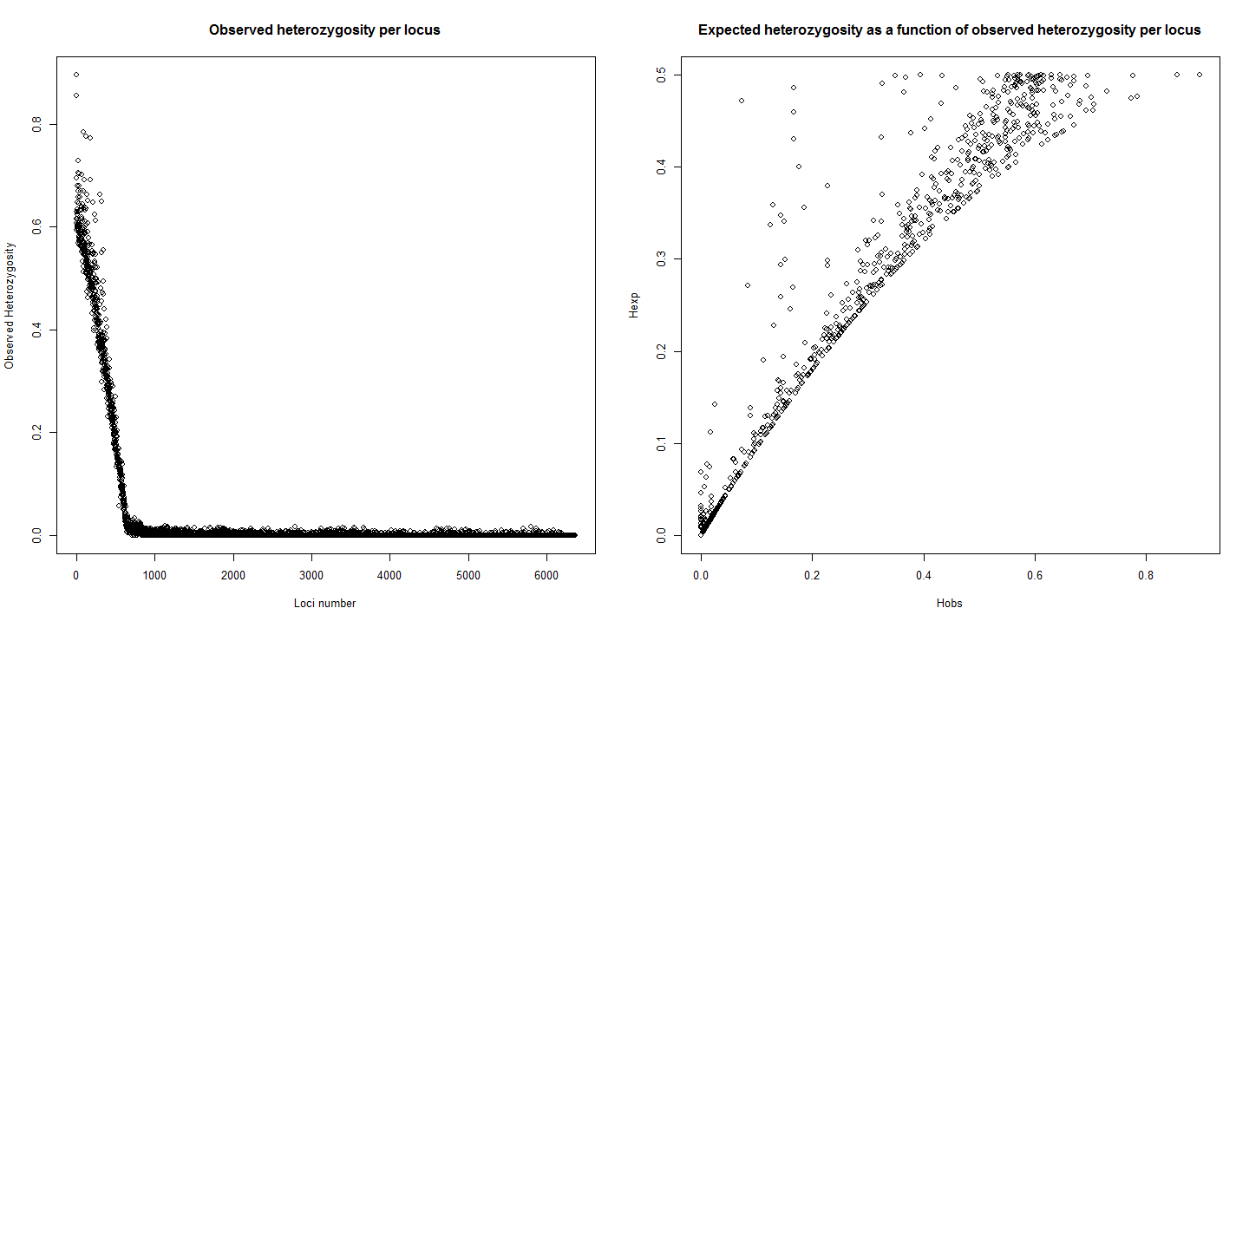

#poppr functions  
library(poppr)   
mlg(gi)

## #############################  
## # Number of Individuals: 243   
## # Number of MLG: 243   
## #############################

## [1] 243

poppr(gi)

## | Bullen Range   
## | Kambah Pool   
## | Lanyon   
## | Murramore   
## | Nerreman   
## | Tharwa Sandwash   
## | Total

## Pop N MLG eMLG SE H G lambda E.5 Hexp Ia rbarD File  
## 1 Bullen Range 42 42 18 NaN 3.74 42 0.976 1 0.0335 4.71 0.00672 gi  
## 2 Kambah Pool 54 54 18 1.49e-06 3.99 54 0.981 1 0.0305 7.66 0.01225 gi  
## 3 Lanyon 21 21 18 NaN 3.04 21 0.952 1 0.0319 5.94 0.00997 gi  
## 4 Murramore 18 18 18 0.00e+00 2.89 18 0.944 1 0.0357 7.57 0.01196 gi  
## 5 Nerreman 55 55 18 NaN 4.01 55 0.982 1 0.0347 6.95 0.00855 gi  
## 6 Tharwa Sandwash 53 53 18 1.76e-06 3.97 53 0.981 1 0.0343 9.78 0.01107 gi  
## 7 Total 243 243 18 NaN 5.49 243 0.996 1 0.0337 6.97 0.00689 gi

pa<-data.frame(private_alleles(gi))  
pa<-data.frame(t(pa))  
summary(pa)

## Bullen.Range Kambah.Pool Lanyon Murramore Nerreman Tharwa.Sandwash   
## Min. :0.0000 Min. :0.00000 Min. :0.00000 Min. :0.0000 Min. :0.0000 Min. :0.0000   
## 1st Qu.:0.0000 1st Qu.:0.00000 1st Qu.:0.00000 1st Qu.:0.0000 1st Qu.:0.0000 1st Qu.:0.0000   
## Median :0.0000 Median :0.00000 Median :0.00000 Median :0.0000 Median :0.0000 Median :0.0000   
## Mean :0.1115 Mean :0.09248 Mean :0.02992 Mean :0.0417 Mean :0.2412 Mean :0.3536   
## 3rd Qu.:0.0000 3rd Qu.:0.00000 3rd Qu.:0.00000 3rd Qu.:0.0000 3rd Qu.:0.0000 3rd Qu.:1.0000   
## Max. :2.0000 Max. :5.00000 Max. :1.00000 Max. :2.0000 Max. :4.0000 Max. :4.0000

tab <- mlg.table(gi, plot = FALSE)  
diversity_stats(tab)

## Index  
## Pop H G lambda E.5  
## Bullen Range 3.737670 42 0.9761905 1  
## Kambah Pool 3.988984 54 0.9814815 1  
## Lanyon 3.044522 21 0.9523810 1  
## Murramore 2.890372 18 0.9444444 1  
## Nerreman 4.007333 55 0.9818182 1  
## Tharwa Sandwash 3.970292 53 0.9811321 1

adist <- diss.dist(gi, percent = TRUE)  
amsn <- poppr.msn(gi, adist)

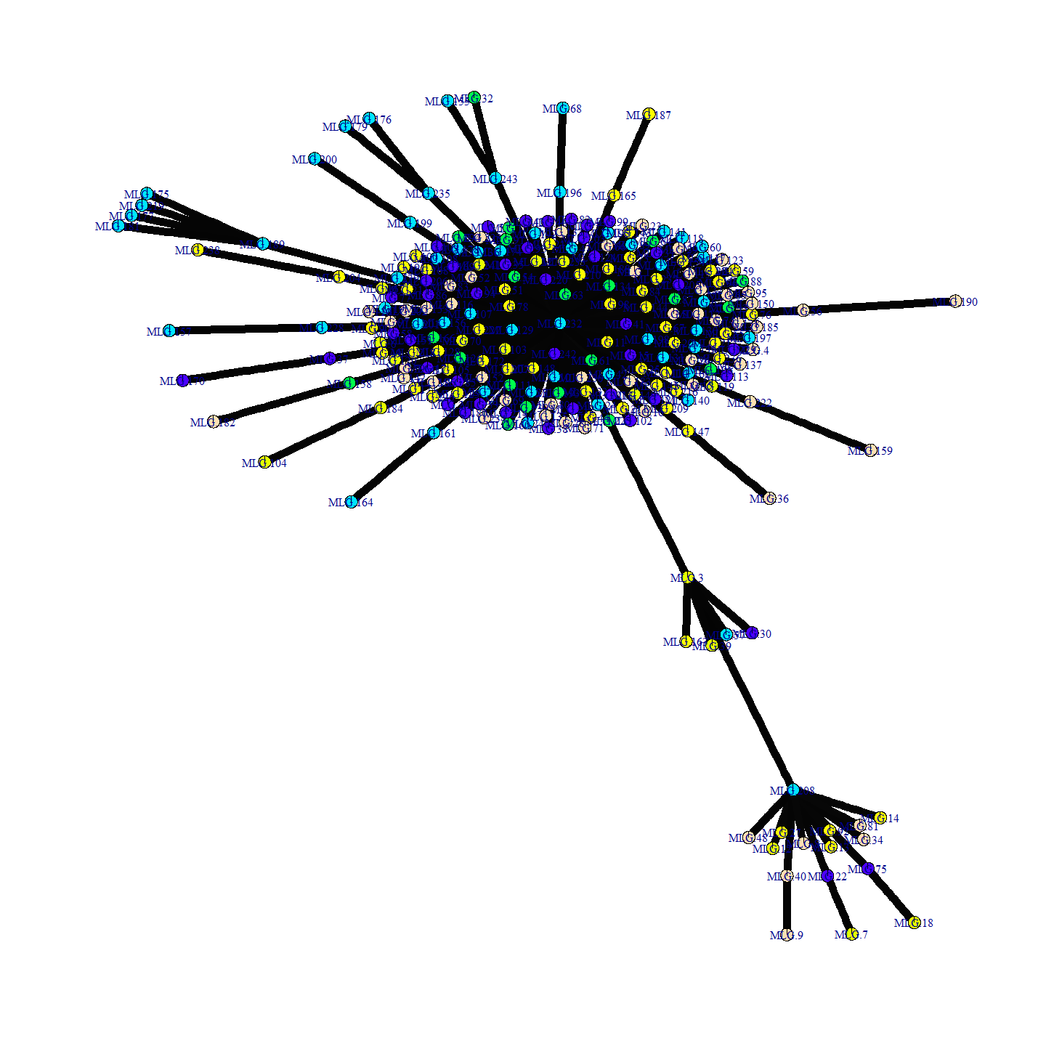

# Default  
library("igraph") # To get all the layouts.  
set.seed(500)  
plot_poppr_msn(gi, amsn, gadj = 15)

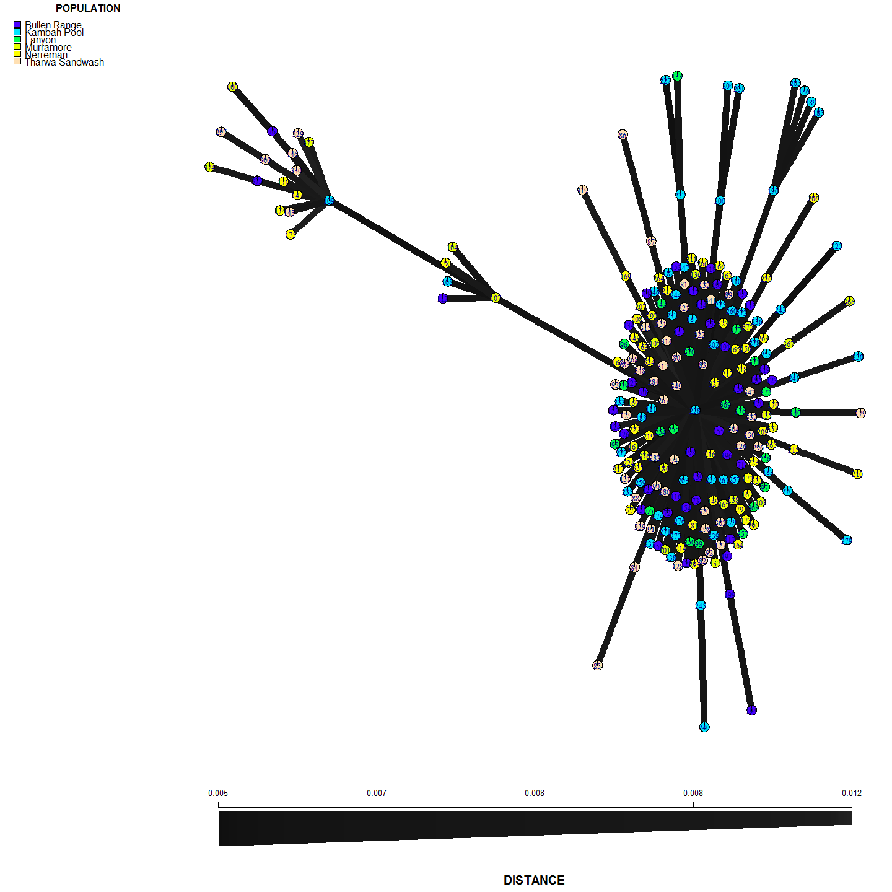

# Hardy Weinberg and Genotypic Disequilibrium

hwdf<-hw.test(gi, B=0)  
hwdf<-data.frame(hwdf)  
names(hwdf)[names(hwdf)=="Pr.chi.2..."] <- "p"  
  
p.adjust.M <- p.adjust.methods[p.adjust.methods != "fdr"]  
p.adj <- sapply(p.adjust.M, function(meth) p.adjust(hwdf$p, meth))  
corrected<-data.frame(p.adj)  
  
#Before Bonferroni correction  
nrow(subset(corrected, none<0.05))

## [1] 369

#Only   
nrow(subset(corrected, bonferroni<0.05))

## [1] 104

#after bonferroni correction  
#and with BY  
nrow(subset(corrected, BY<0.05))

## [1] 141

corrected<-apply(p.adj, 2, format.pval, digits = 3)  
corrected<-data.frame(corrected)  
corrected<-corrected[order(as.numeric(corrected$none)),]  
corrected[1:40,]

## holm hochberg hommel bonferroni BH BY none  
## 600 < 2e-16 < 2e-16 < 2e-16 < 2e-16 < 2e-16 < 2e-16 < 2e-16  
## 606 < 2e-16 < 2e-16 < 2e-16 < 2e-16 < 2e-16 < 2e-16 < 2e-16  
## 731 < 2e-16 < 2e-16 < 2e-16 < 2e-16 < 2e-16 < 2e-16 < 2e-16  
## 820 < 2e-16 < 2e-16 < 2e-16 < 2e-16 < 2e-16 < 2e-16 < 2e-16  
## 826 < 2e-16 < 2e-16 < 2e-16 < 2e-16 < 2e-16 < 2e-16 < 2e-16  
## 834 < 2e-16 < 2e-16 < 2e-16 < 2e-16 < 2e-16 < 2e-16 < 2e-16  
## 1407 < 2e-16 < 2e-16 < 2e-16 < 2e-16 < 2e-16 < 2e-16 < 2e-16  
## 2327 < 2e-16 < 2e-16 < 2e-16 < 2e-16 < 2e-16 < 2e-16 < 2e-16  
## 3234 < 2e-16 < 2e-16 < 2e-16 < 2e-16 < 2e-16 < 2e-16 < 2e-16  
## 3277 < 2e-16 < 2e-16 < 2e-16 < 2e-16 < 2e-16 < 2e-16 < 2e-16  
## 3327 < 2e-16 < 2e-16 < 2e-16 < 2e-16 < 2e-16 < 2e-16 < 2e-16  
## 3343 < 2e-16 < 2e-16 < 2e-16 < 2e-16 < 2e-16 < 2e-16 < 2e-16  
## 3643 < 2e-16 < 2e-16 < 2e-16 < 2e-16 < 2e-16 < 2e-16 < 2e-16  
## 4017 < 2e-16 < 2e-16 < 2e-16 < 2e-16 < 2e-16 < 2e-16 < 2e-16  
## 4051 < 2e-16 < 2e-16 < 2e-16 < 2e-16 < 2e-16 < 2e-16 < 2e-16  
## 4660 < 2e-16 < 2e-16 < 2e-16 < 2e-16 < 2e-16 < 2e-16 < 2e-16  
## 4661 < 2e-16 < 2e-16 < 2e-16 < 2e-16 < 2e-16 < 2e-16 < 2e-16  
## 4663 < 2e-16 < 2e-16 < 2e-16 < 2e-16 < 2e-16 < 2e-16 < 2e-16  
## 4666 < 2e-16 < 2e-16 < 2e-16 < 2e-16 < 2e-16 < 2e-16 < 2e-16  
## 4694 < 2e-16 < 2e-16 < 2e-16 < 2e-16 < 2e-16 < 2e-16 < 2e-16  
## 4731 < 2e-16 < 2e-16 < 2e-16 < 2e-16 < 2e-16 < 2e-16 < 2e-16  
## 4936 < 2e-16 < 2e-16 < 2e-16 < 2e-16 < 2e-16 < 2e-16 < 2e-16  
## 5017 < 2e-16 < 2e-16 < 2e-16 < 2e-16 < 2e-16 < 2e-16 < 2e-16  
## 5227 < 2e-16 < 2e-16 < 2e-16 < 2e-16 < 2e-16 < 2e-16 < 2e-16  
## 5482 < 2e-16 < 2e-16 < 2e-16 < 2e-16 < 2e-16 < 2e-16 < 2e-16  
## 5538 7.03e-13 7.03e-13 7.03e-13 7.07e-13 2.08e-14 1.94e-13 < 2e-16  
## 5552 < 2e-16 < 2e-16 < 2e-16 < 2e-16 < 2e-16 < 2e-16 < 2e-16  
## 5615 < 2e-16 < 2e-16 < 2e-16 < 2e-16 < 2e-16 < 2e-16 < 2e-16  
## 5934 < 2e-16 < 2e-16 < 2e-16 < 2e-16 < 2e-16 < 2e-16 < 2e-16  
## 5943 < 2e-16 < 2e-16 < 2e-16 < 2e-16 < 2e-16 < 2e-16 < 2e-16  
## 5965 < 2e-16 < 2e-16 < 2e-16 < 2e-16 < 2e-16 < 2e-16 < 2e-16  
## 6266 < 2e-16 < 2e-16 < 2e-16 < 2e-16 < 2e-16 < 2e-16 < 2e-16  
## 6335 < 2e-16 < 2e-16 < 2e-16 < 2e-16 < 2e-16 < 2e-16 < 2e-16  
## 6347 < 2e-16 < 2e-16 < 2e-16 < 2e-16 < 2e-16 < 2e-16 < 2e-16  
## 101 0.636925 0.636925 0.629253 0.651043 0.004684 0.043726 0.000102  
## 89 0.687874 0.687874 0.679476 0.703234 0.005023 0.046894 0.000111  
## 22 0.717811 0.717811 0.708930 0.733957 0.005205 0.048596 0.000115  
## 60 0.783510 0.783510 0.773564 0.801263 0.005643 0.052679 0.000126  
## 253 0.796375 0.796375 0.786392 0.814550 0.005696 0.053178 0.000128  
## 328 0.876017 0.876017 0.864752 0.896154 0.006220 0.058069 0.000141

# Population Structure

See: runPCAandTSNEYearsandSites.Rmd

# Polymorphic Information Content

#A script to plot all M. peelii snps average PIC (PIC of reference and PIC of alternate state allele) against index number of the data frame. This shows that using the first X number of snps is using the alleles with the highest PIC.  
  
  
df<-allPeeliSnps; main<-"All Peelii snps"  
df<-df[-c(1:4),]  
  
pic<-df[2:nrow(df),14] #check pic in order  
plot(as.character(pic),main="Polymorphic Information Content (PIC)", ylab="PIC")# to show PIC is in order (ish) ideally cut off would be 1300 or so.

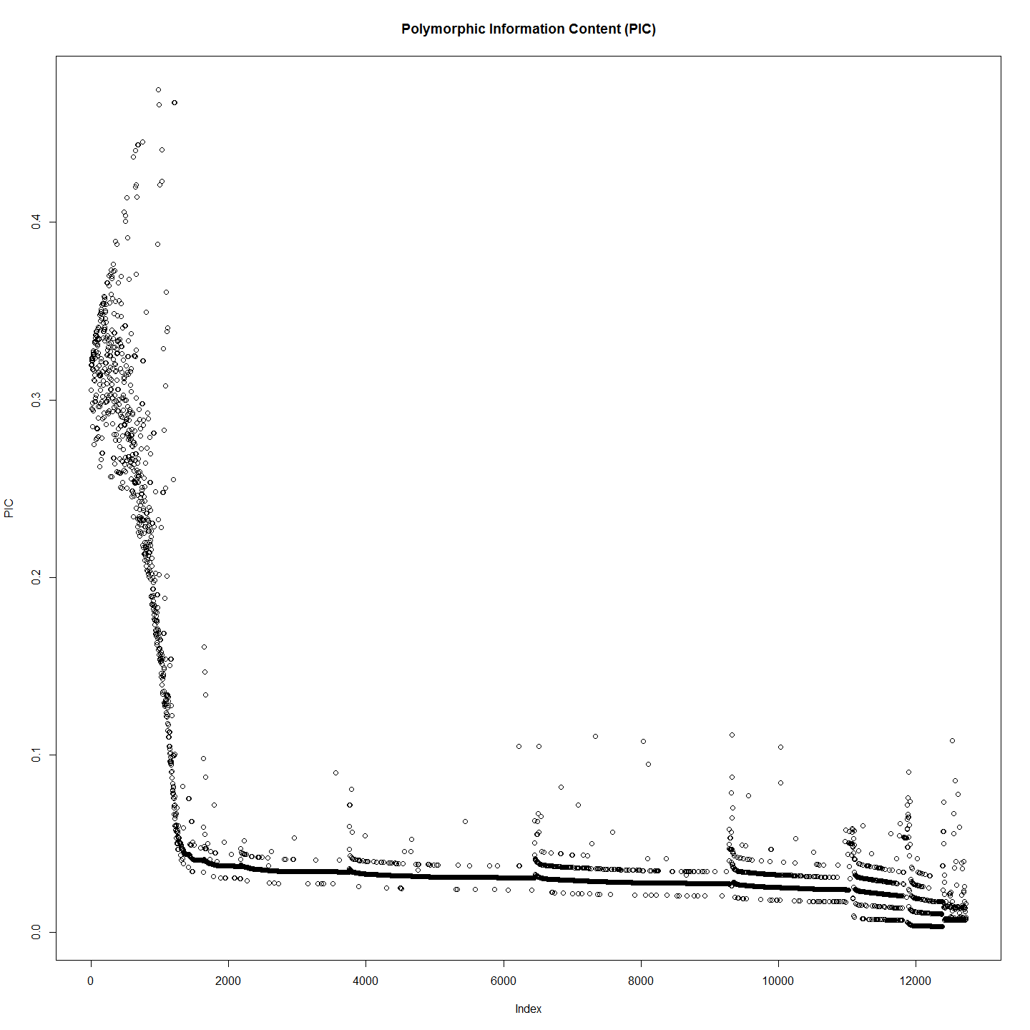

smoothScatter(pic,main="Polymorphic Information Content (PIC)", ylab="Average PIC")

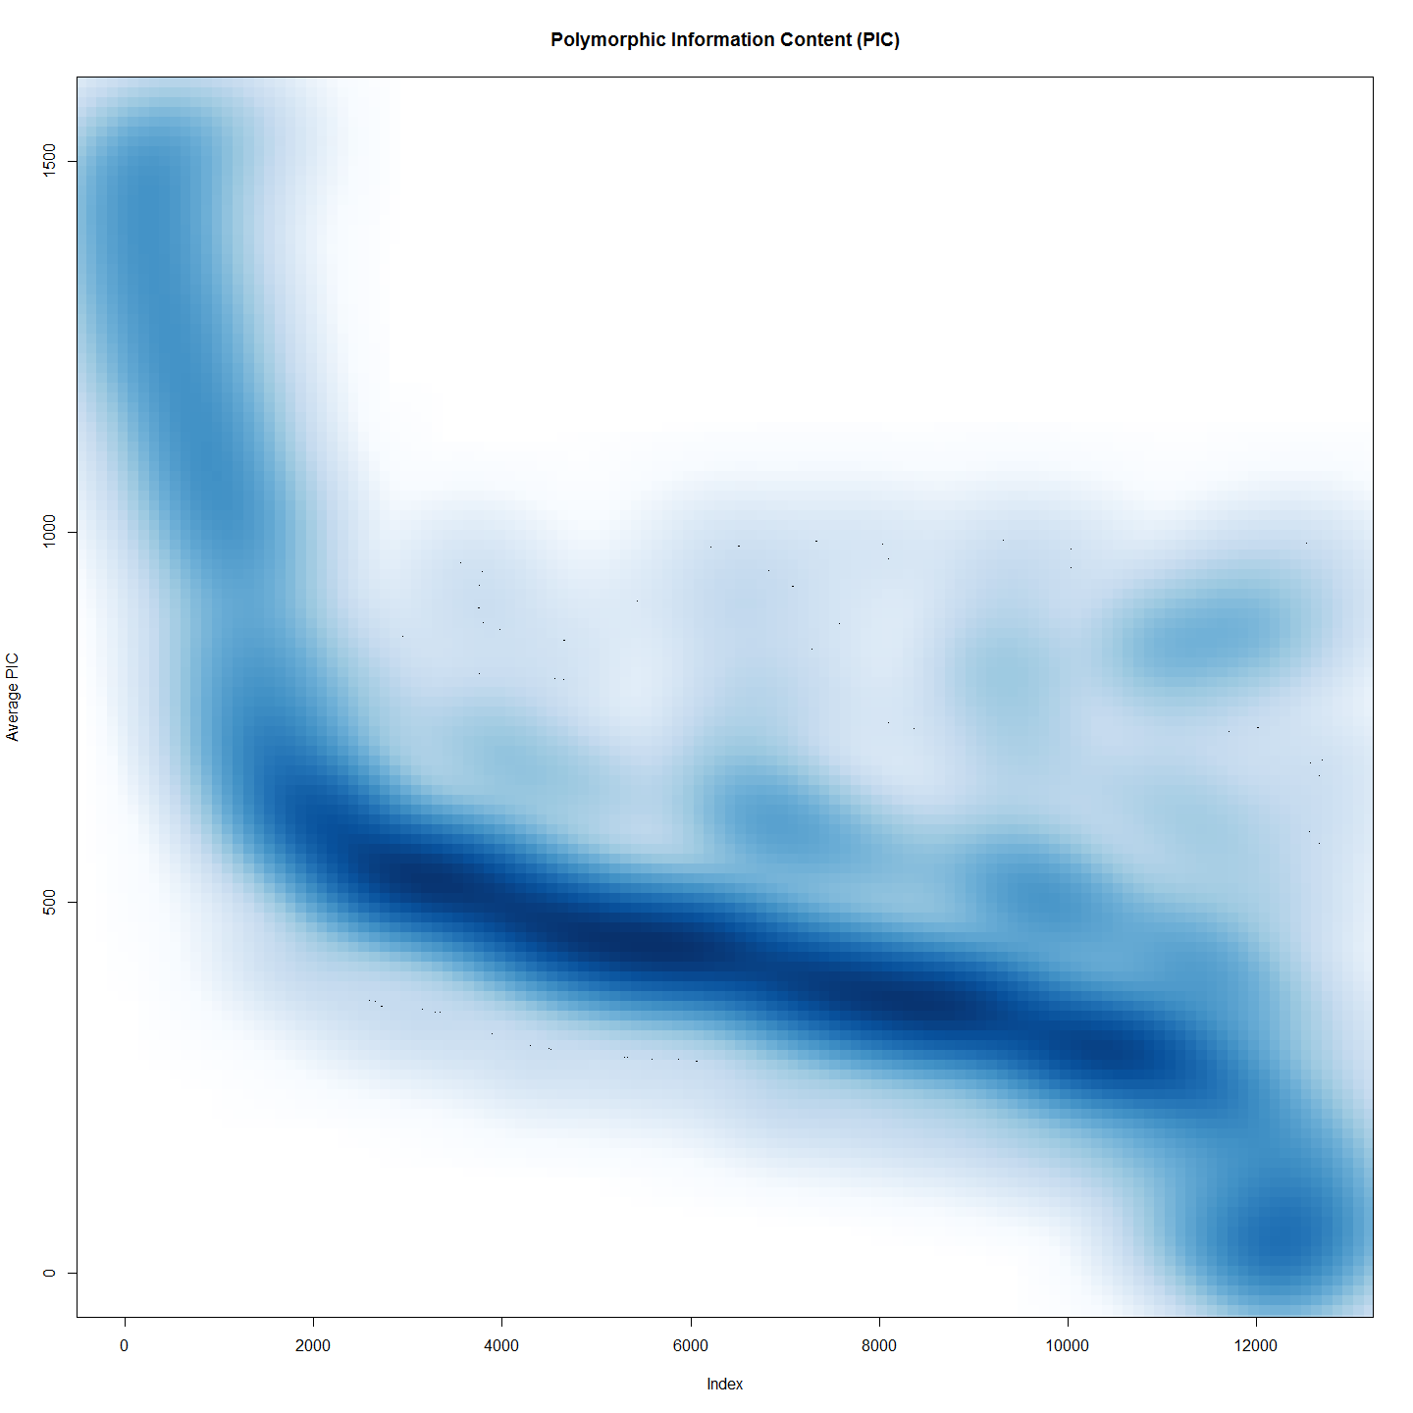

# Place in strict order of PIC and have alook  
pico<-data.frame(pic)  
rownames(pico) <- NULL  
colnames(pico)[1]<-"PIC"  
  
pico <- data.frame(pico[order(as.numeric(pico$PIC),decreasing = TRUE),])  
  
pico[,2]<-pico[,1] #Order columns to facilitate plotting.  
pico[,1]<-row.names(pico) #Replace name with index number  
colnames(pico)[1]<-"Index"  
colnames(pico)[2]<-"PIC"  
  
plot(pico, main="Ordered Polymorphic Information Content (PIC) ")

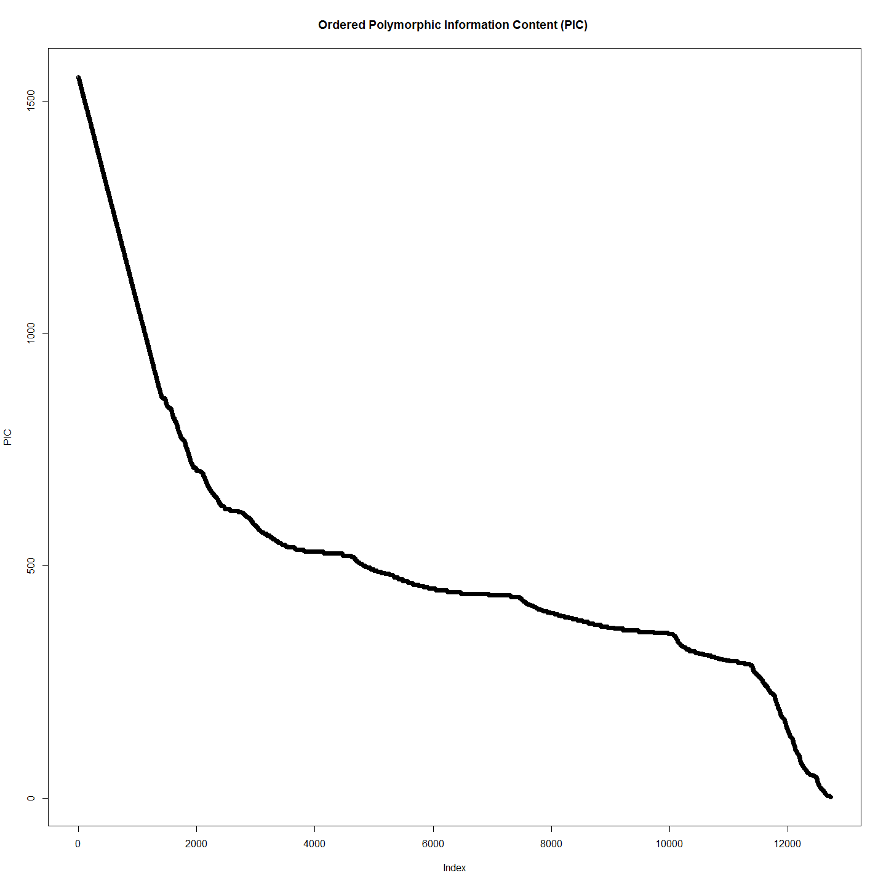

smoothScatter(pico, main="Ordered Polymorphic Information Content (PIC)")

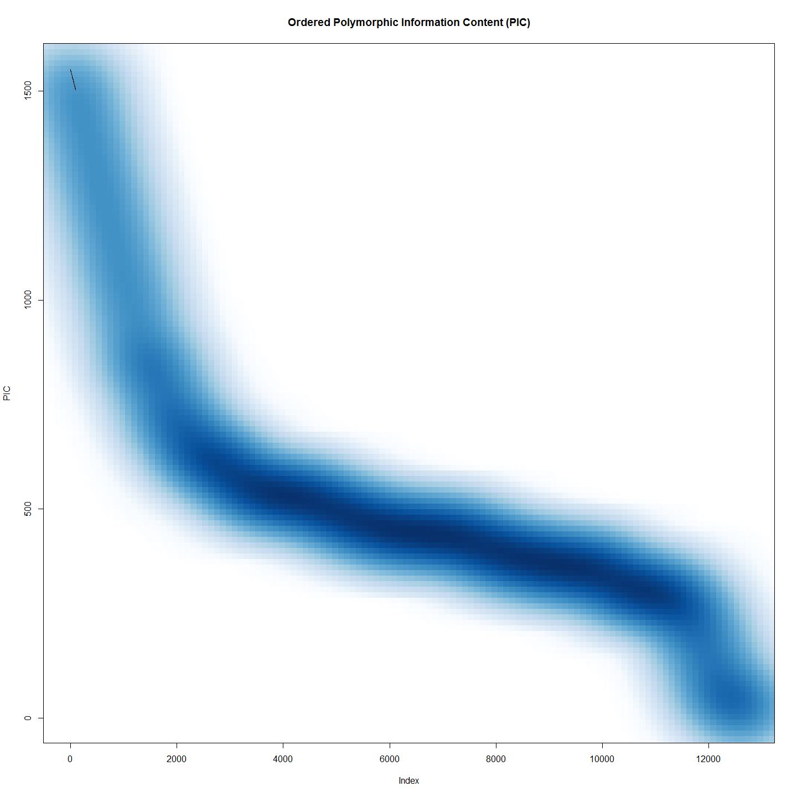

rm(pic)  
rm(pico)

## Genome Structure in Larvae by Years and Sites

### FST and Sites

library(StAMPP)  
system.time(snpfst <-stamppFst(gl,nboots=1, percent=95, nclusters=8))

## user system elapsed   
## 27.52 0.04 61.60

snpfst

## Kambah Pool Bullen Range Nerreman Tharwa Sandwash Lanyon Murramore  
## Kambah Pool NA NA NA NA NA NA  
## Bullen Range 0.01524984 NA NA NA NA NA  
## Nerreman 0.01241047 0.007348972 NA NA NA NA  
## Tharwa Sandwash 0.02727594 0.026001892 0.02273005 NA NA NA  
## Lanyon 0.02823645 0.029941074 0.02402186 0.012530020 NA NA  
## Murramore 0.02516960 0.020465393 0.01636588 0.008125193 0.004919345 NA

rm(snpfst)

Although not strong some difference in the three upper sites and the three lower sites is evident. The difference between the 3 upper and three lower sites also is greater than the difference among each of the three lower, or the three upper sites.

### Temporal Structure

glt<-gl  
glt@pop<-as.factor(gl@other$covariates)  
system.time(snpfstTemporal <-stamppFst(glt,nboots=1, percent=95, nclusters=8))

## user system elapsed   
## 13.95 0.00 17.46

snpfstTemporal

## 2013 2011 2012  
## 2013 NA NA NA  
## 2011 0.014914747 NA NA  
## 2012 0.005010593 0.01111121 NA

rm(glt); rm(npfstTemporal)

There is little difference between years.

## Genetic Distance between Sites

gi<-df2genind(data.frame(gl),ncode=1, pop=gl$pop)  
gp<-genind2genpop(gi)

##   
## Converting data from a genind to a genpop object...   
##   
## ...done.

dist.genpop(gp)

## Bullen Range Kambah Pool Lanyon Murramore Nerreman  
## Kambah Pool 0.003084083   
## Lanyon 0.004076401 0.004261646   
## Murramore 0.003632366 0.005372541 0.003149246   
## Nerreman 0.001670094 0.002379941 0.003443184 0.003267281   
## Tharwa Sandwash 0.002998878 0.003526237 0.002719802 0.002499254 0.002531829

#or Isolation by Distance (site)  
library(ade4)  
Dgen <- dist.genpop(gp, method = 2)  
Dgeo2<-select(larv, SiteName, Distance.to.Angle.Crossing..m.)  
Dgeo2<-unique(Dgeo2)  
rownames(Dgeo2)<-Dgeo2[,1]  
Dgeo2[,1]<-NULL  
Dgeo2<-dist(Dgeo2)  
ibd <- mantel.randtest(Dgen, Dgeo2)  
ibd

## Monte-Carlo test  
## Call: mantel.randtest(m1 = Dgen, m2 = Dgeo2)  
##   
## Observation: 0.3790073   
##   
## Based on 999 replicates  
## Simulated p-value: 0.086   
## Alternative hypothesis: greater   
##   
## Std.Obs Expectation Variance   
## 1.440281716 -0.005850301 0.071401155

# Heterozygosity

Hs(gi)

## Bullen Range Kambah Pool Lanyon Murramore Nerreman Tharwa Sandwash   
## 0.04375030 0.04420646 0.04083251 0.04254215 0.04704342 0.04643666

This function computes the expected heterozygosity (Hs) within populations of a genpop object. This function is available for codominant markers (@type="codom") only. Hs is commonly used for measuring within population genetic diversity (and as such, it still has sense when computed from haploid data).

#First we do PCA and tSNE using peelii larvae and site  
#Vanilla PCA  
require(adegenet)  
require(ggplot2)  
  
system.time(pca1 <- glPca(gl[,], parallel=F, nf=3))

## user system elapsed   
## 52.89 0.00 53.01

gg <- data.frame(pca1$scores,cluster=pop(gl))  
gg$labels <- rownames(gg)  
  
ggplot(gg, aes(x=PC1, y=PC2))+  
 geom_text(aes(label=labels, color=factor(cluster)),hjust=-0.2, size=4) +  
 geom_hline(yintercept=0,linetype=2) +  
 geom_vline(xintercept=0,linetype=2) +  
 scale_color_discrete(name="Site Name") +  
 ggtitle("Principal Components - Peelii larvae and sites")+  
 theme(plot.title = element_text(lineheight=.8, face="bold", size=29))+  
 theme(axis.text=element_text(size=15), axis.title=element_text(size=15,face="bold"),legend.text = element_text(size = 20),legend.title = element_text(size = 20))

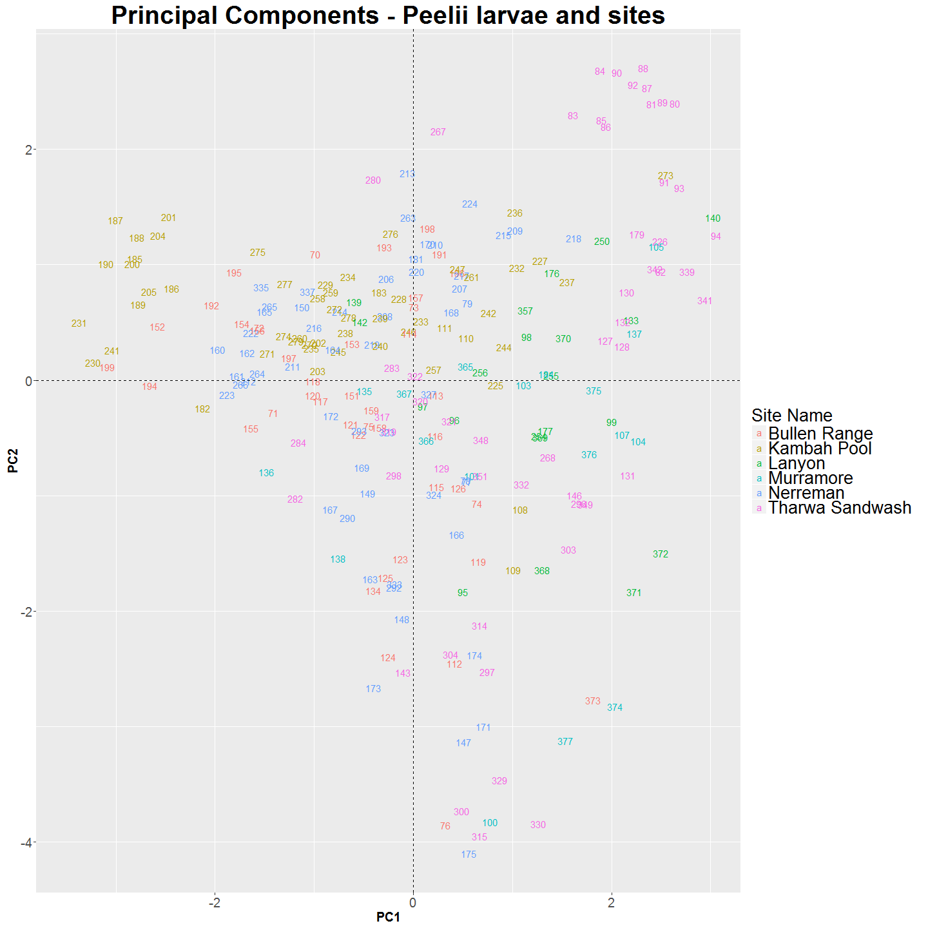

#tsne 2d  
require(tsne)  
colors<- rainbow(length(unique(gg$cluster)))  
names(colors) <- unique(gg$cluster)  
#ecb <-function(x,y){ plot(x,t='n',main="Larval M. peelii by Sites"); text(x,labels= row.names(gg),col=colors[gg$cluster])} #to make series  
#tsne_gg <- tsne(gg[,1:3], max_iter=10000,k=2, epoch_callback = ecb, perplexity=5,epoch=1000)  
tsne_gg <- tsne(gg[,1:3], max_iter=10000,k=2, perplexity=5)  
plot(tsne_gg,t='n',main="Larval M. peelii by Sites"); text(tsne_gg,labels= row.names(gg),col=colors[gg$cluster])

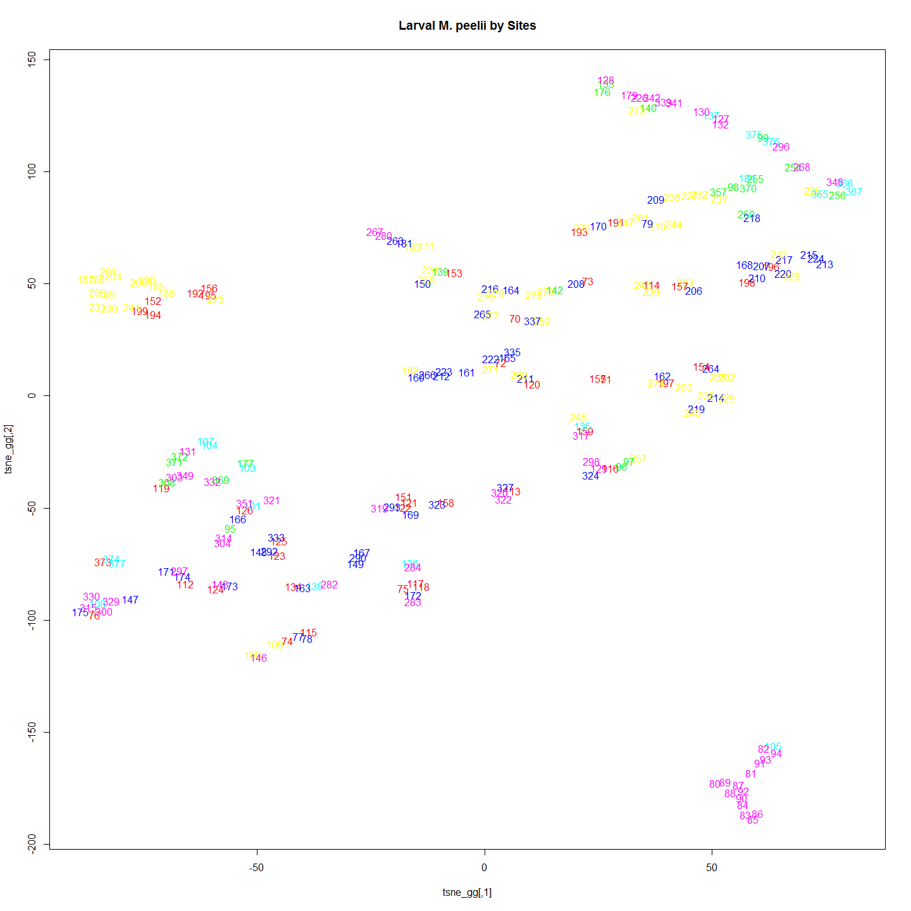

#Second we do PCA and tSNE with the same larvae coloured by year   
gg<- data.frame(pca1$scores,cluster=as.character(gl@other$covariates))  
gg$labels <- rownames(gg)  
ggplot(gg, aes(x=PC1, y=PC2))+  
 geom_text(aes(label=labels, color=factor(cluster)),hjust=-0.2, size=4) +  
 # geom_hline(yintercept=0,linetype=2) +  
 # geom_vline(xintercept=0,linetype=2) +  
 scale_color_discrete(name="Year") +  
 ggtitle("Principal Components - Peelii larvae and Years")+  
 theme(plot.title = element_text(lineheight=.8, face="bold", size=29))+  
 theme(axis.text=element_text(size=15), axis.title=element_text(size=15,face="bold"),legend.text = element_text(size = 20),legend.title = element_text(size = 20))

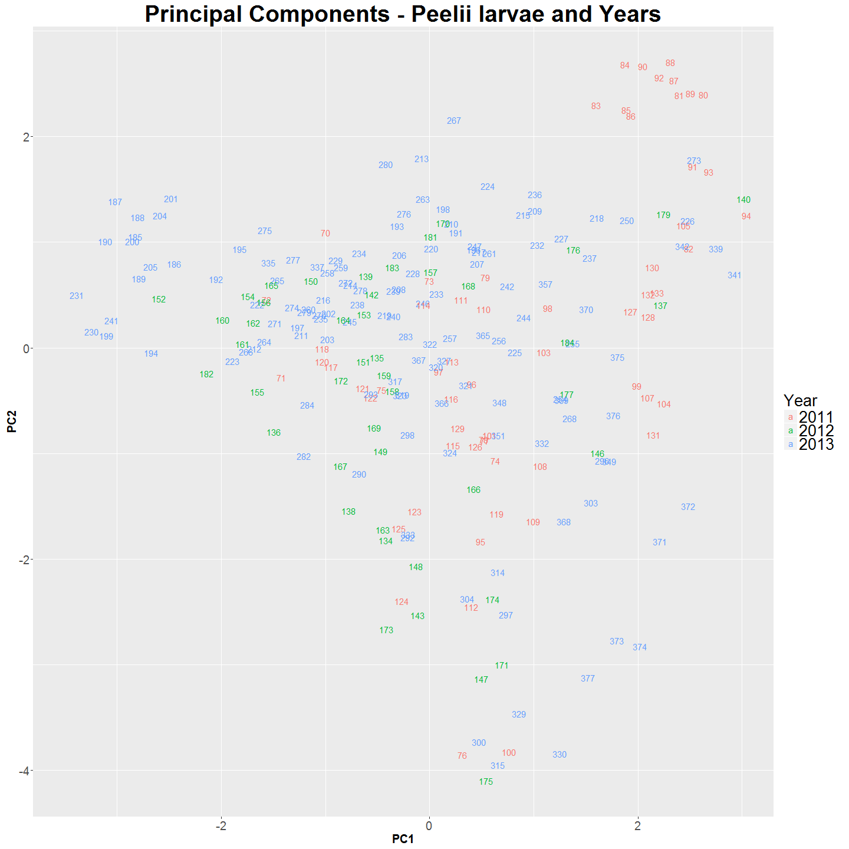

#tsne 2d  
require(tsne)  
colors<- rainbow(length(unique(gg$cluster)))  
names(colors) <- unique(gg$cluster)  
#ecb <-function(x,y){ plot(x,t='n',main="Larval M. peelii by Years"); text(x,labels= row.names(gg),col=colors[gg$cluster])} #to make series   
#tsne_gg <- tsne(gg[,1:3], max_iter=10000, epoch_callback = ecb, perplexity=5,epoch=1000)  
tsne_gg <- tsne(gg[,1:3], max_iter=10000, perplexity=5)  
plot(tsne_gg,t='n',main="Larval M. peelii by Years"); text(tsne_gg,labels= row.names(gg),col=colors[gg$cluster])

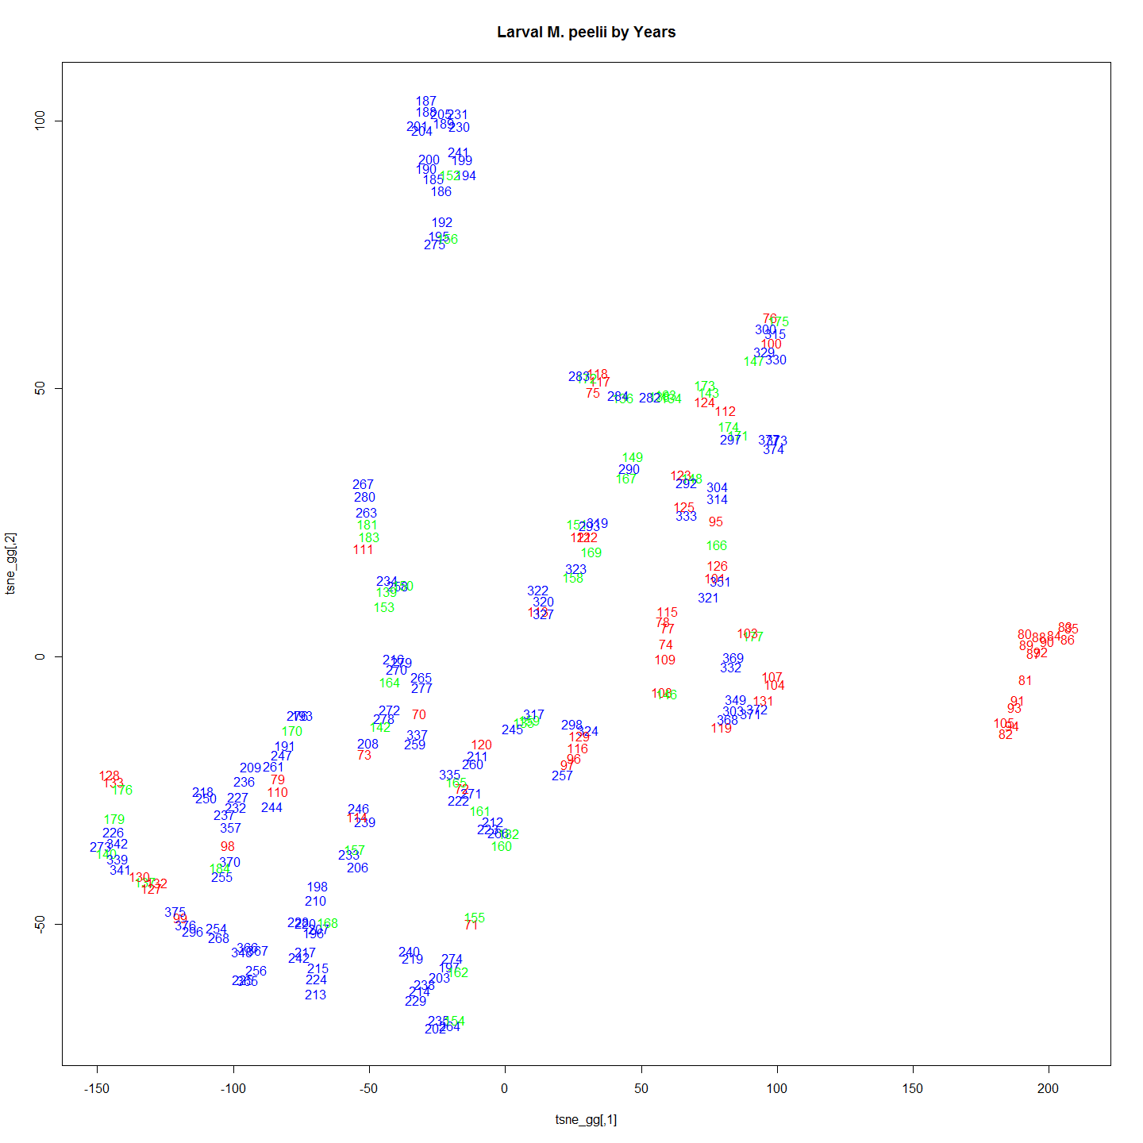

# ####################################Incase we need 3d plots  
# require(scatterplot3d)  
# tsne_gg <- tsne(gg[,1:3], max_iter=1000,k=3, perplexity=5)  
# scatterplot3d(tsne_gg[,1],tsne_gg[,2],tsne_gg[,3], pch=16, highlight.3d=TRUE, main="3D Scatterplot")  
#   
# require(rgl)  
# #plot3d(tsne_gg[,1],tsne_gg[,2],tsne_gg[,3], col="red", size=3)  
# plot3d(tsne_gg[,1],tsne_gg[,2],tsne_gg[,3], col=colors[gg$cluster], size=3)

A little structure is evident if we look at structure based on collection site. 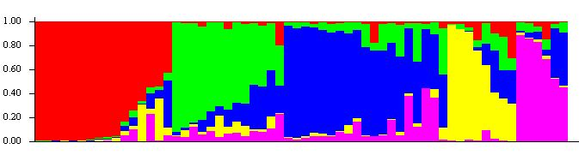 or as a triangle plot 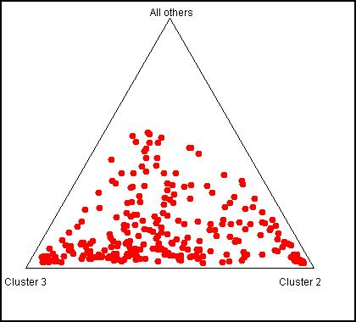

Following the evanno method we settled on 3 groups. 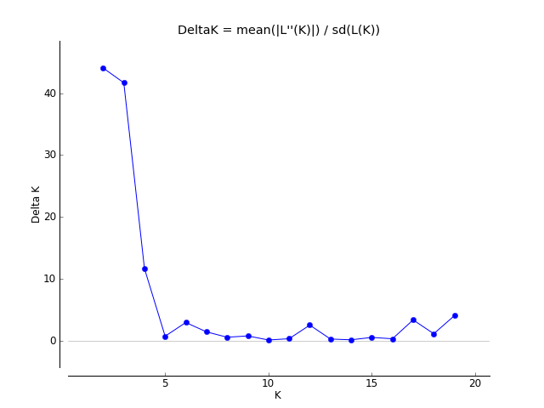

so with three groups.

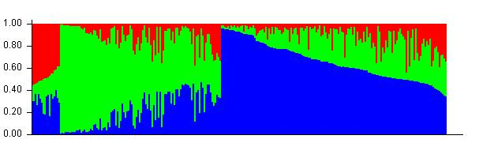 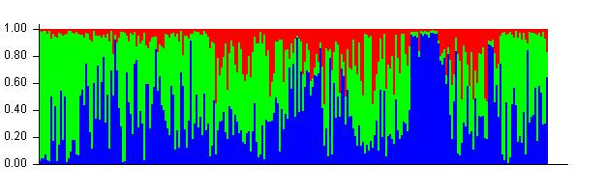

The structure is a associated with collection site. 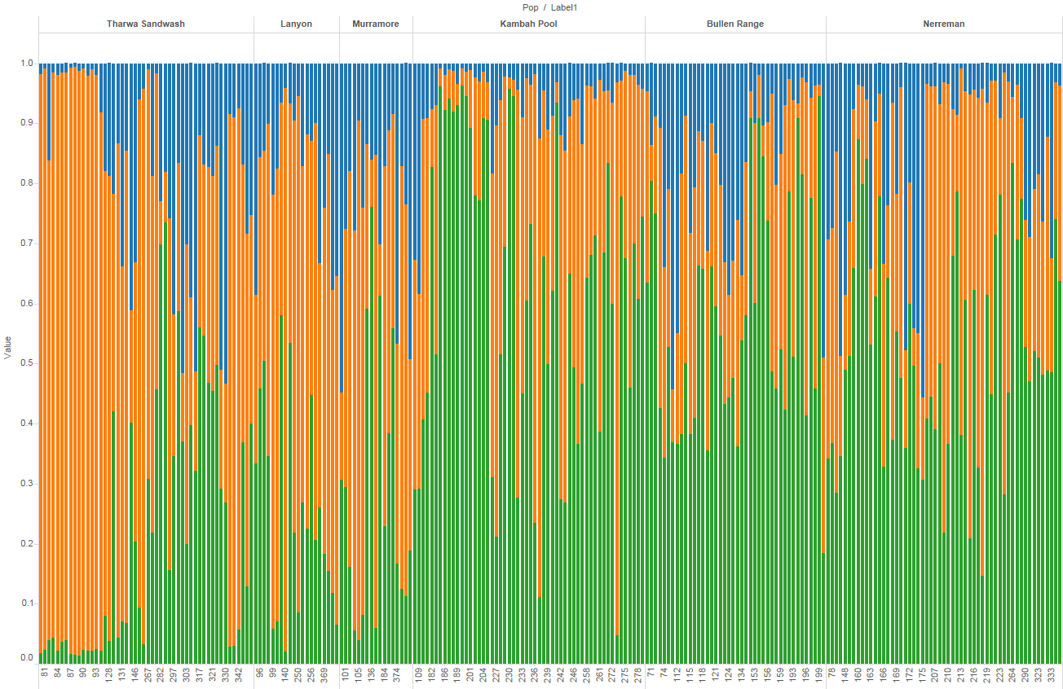

When the structure is examined based on the nest site rather than the collection site which better accounts for putative barriers and unidirectional dispersal. then:

after nests chapter is done

#Looking for DAPC, fixed differences, and Correspondence Analysis between populations.  
  
require(reshape2)  
require(dart)  
require(pegas)  
all.dart <- read.dart("otherData/larvalPeeliSnps.csv", topskip = 5)

## Added the following covmetrics:  
## CloneID SNP SnpPosition CallRate OneRatioSnp FreqHomRef FreqHomSnp FreqHets AvgCountRef AvgCountSnp RepAvg .  
## Number of rows per Clone. Should be only 2s:  
## 2  
## Recognised: 243 individuals and 6364 SNPs in otherData/larvalPeeliSnps.csv

gl.dart <- dart2genlight(all.dart, covfilename = "otherData/qslLarvalPeeliiMetaForPCA.csv") # this glObject is then suitable for sharing via GitHub or such for open data as required by PeerJ etc. Need better file but.

## Start conversion....  
## Please note conversion of bigger data sets will take some time!  
## Once finished, we recommend to save the object using save(object, file="object.rdata")  
##   
 |   
## Try to add covariate file: otherData/qslLarvalPeeliiMetaForPCA.csv .  
## Ids of covariate file does not match the number of ids in the genetic file. Maybe this is fine if a subset matches.  
## Ids of covariate file (at least a subset of) are matching!  
## Found 243 matching ids out of 251 ids provided in the covariate file.  
## Added pop factor.  
## Added latlon data.  
## Added YearOnly to the other$covariates slot.  
## Added estimatedAge to the other$covariates slot.  
## Added Day.of.Year to the other$covariates slot.  
## Added hatchedDoY to the other$covariates slot.  
## Added Delta13C to the other$covariates slot.  
## Added Delta15N to the other$covariates slot.  
## Added CNRatio to the other$covariates slot.  
## Added Distance.to.Angle.Crossing..m. to the other$covariates slot.  
## Added raceCladeName to the other$covariates slot.  
## Added cladeGoTName to the other$covariates slot.  
## Added mumPulldown to the other$covariates slot.  
## Added Fathers to the other$covariates slot.  
## Added inbredCoeff to the other$covariates slot.

# cant work gl.fixed.diff(gl.dart, t=0)  
  
#PCA  
pca1 <- glPca(gl.dart, nf = 3 ,parallel = FALSE)  
pca1

## === PCA of genlight object ===  
## Class: list of type glPca  
## Call ($call):glPca(x = gl.dart, nf = 3, parallel = FALSE)  
##   
## Eigenvalues ($eig):  
## 2.077 1.762 1.245 1.144 1.078 0.908 ...  
##   
## Principal components ($scores):  
## matrix with 243 rows (individuals) and 3 columns (axes)   
##   
## Principal axes ($loadings):  
## matrix with 6364 rows (SNPs) and 3 columns (axes)

scatter(pca1, posi="topleft")  
title("PCA of Murray Cod data\n axes 1-2")

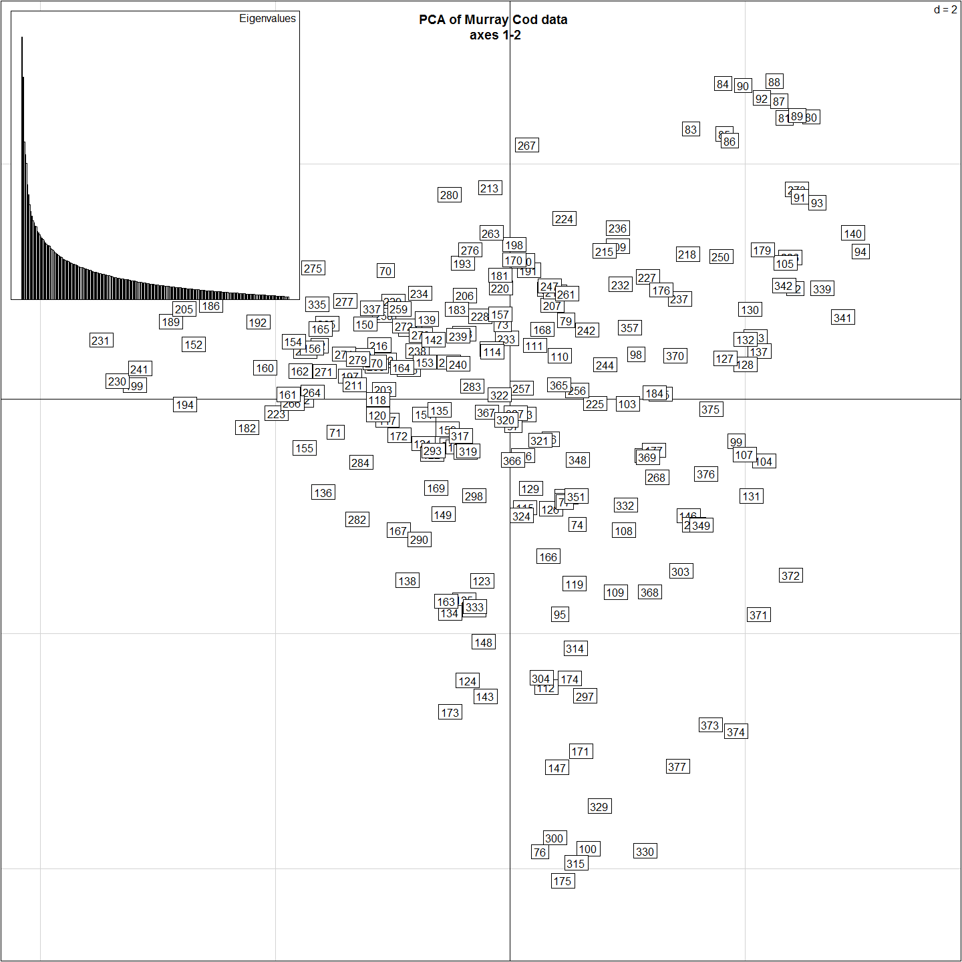

myCol <- colorplot(pca1$scores,pca1$scores, transp=TRUE, cex=4)  
abline(h=0,v=0, col="grey")  
add.scatter.eig(pca1$eig[1:40],2,1,2, posi="topright", inset=.05, ratio=.3)

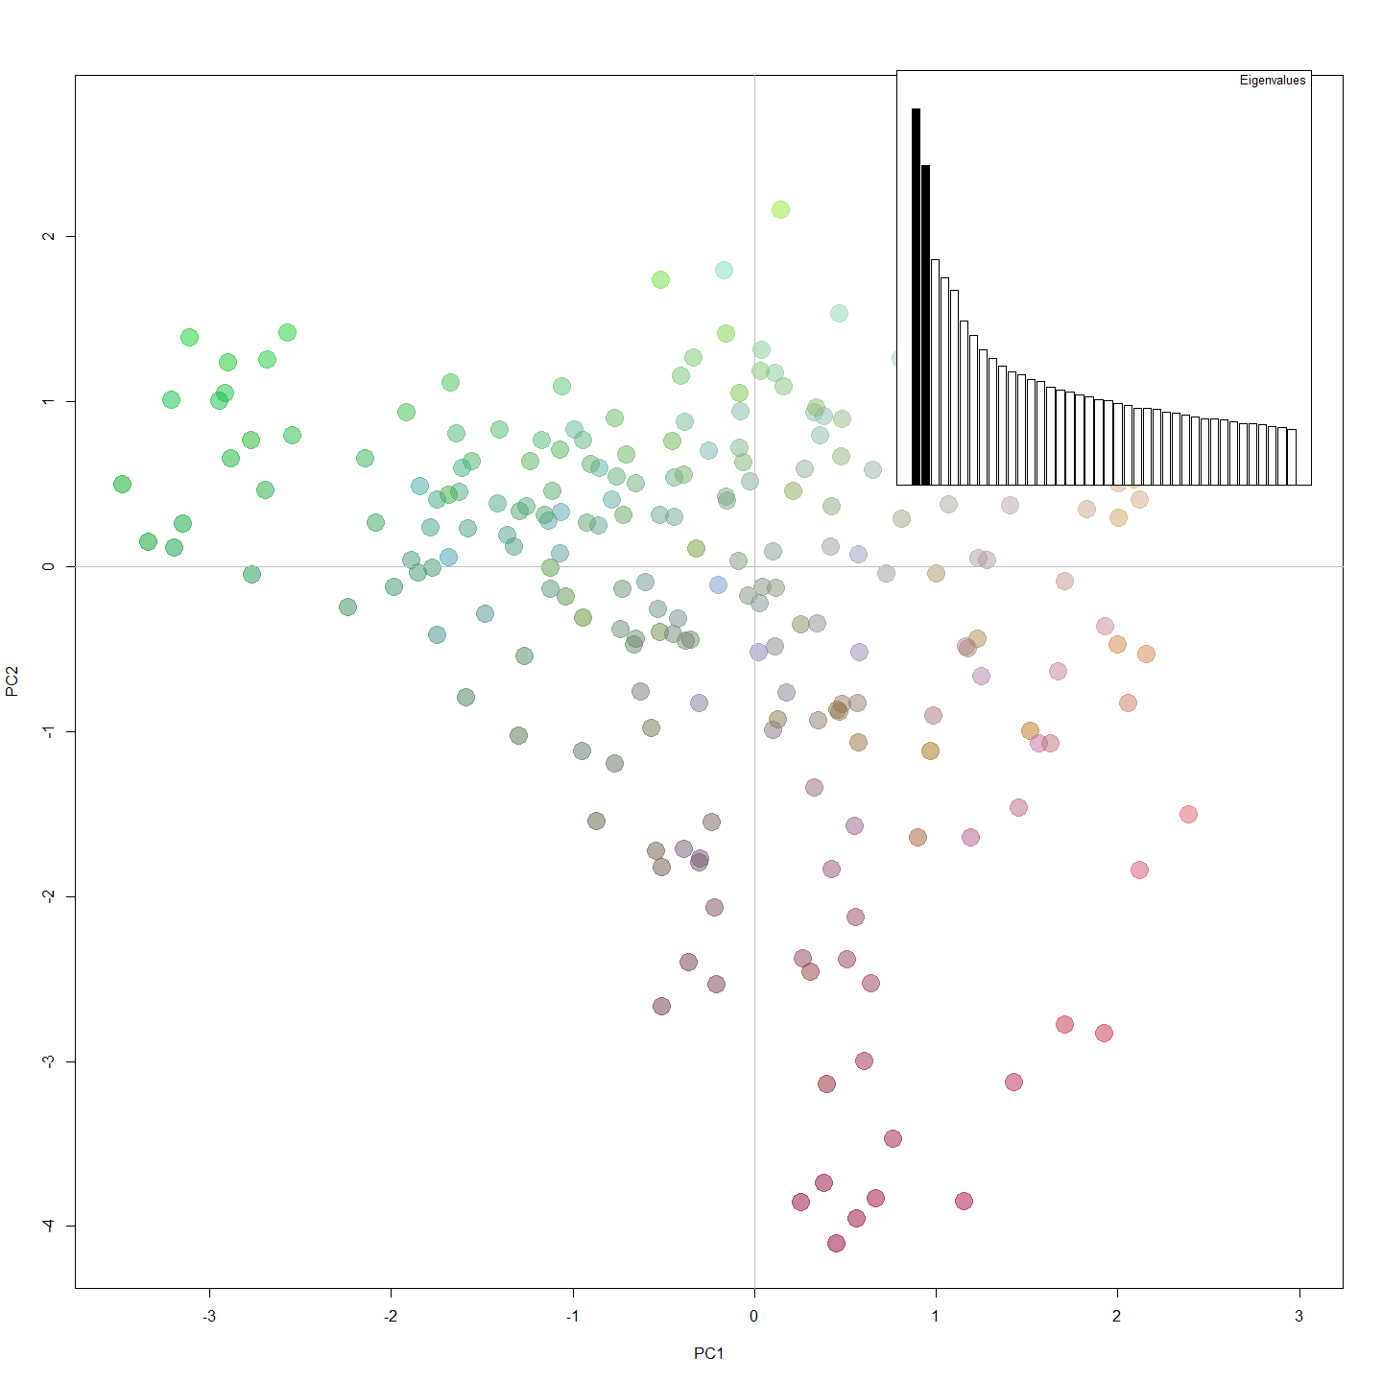

require(ape)  
tre <- nj(dist(as.matrix(gl)))  
tre

##   
## Phylogenetic tree with 243 tips and 241 internal nodes.  
##   
## Tip labels:  
## 185, 186, 187, 188, 189, 190, ...  
##   
## Unrooted; includes branch lengths.

plot(tre, typ="fan", cex=0.7)  
title("NJ tree of the Upper Murrumbidgee Murray Cod data")

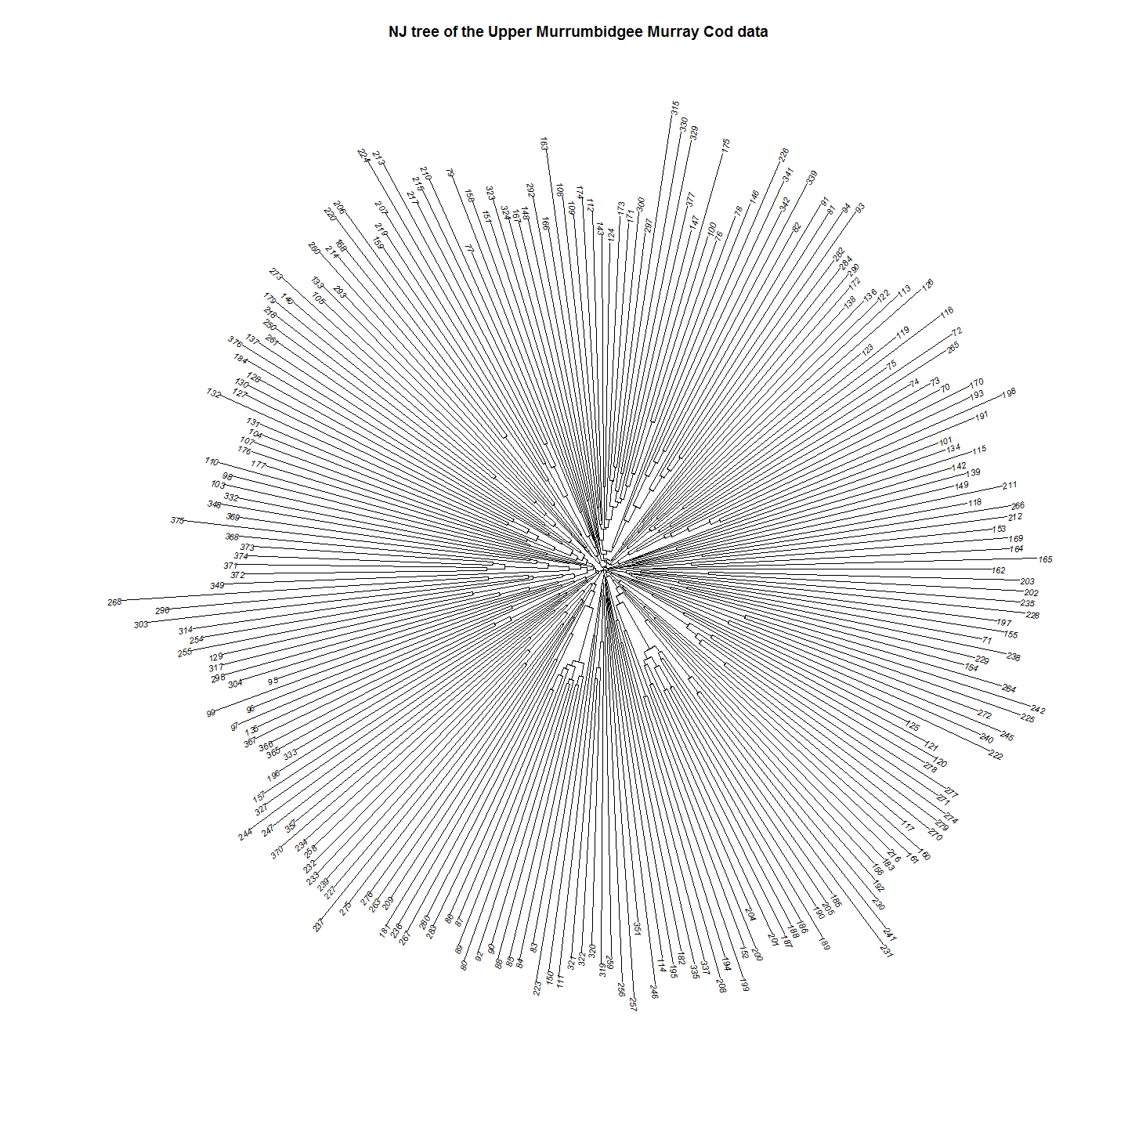

plot(tre, typ="fan", show.tip=FALSE)  
tiplabels(pch=20, col=myCol, cex=4)  
title("NJ tree of the Upper Murrumbidgee Murray Cod data")

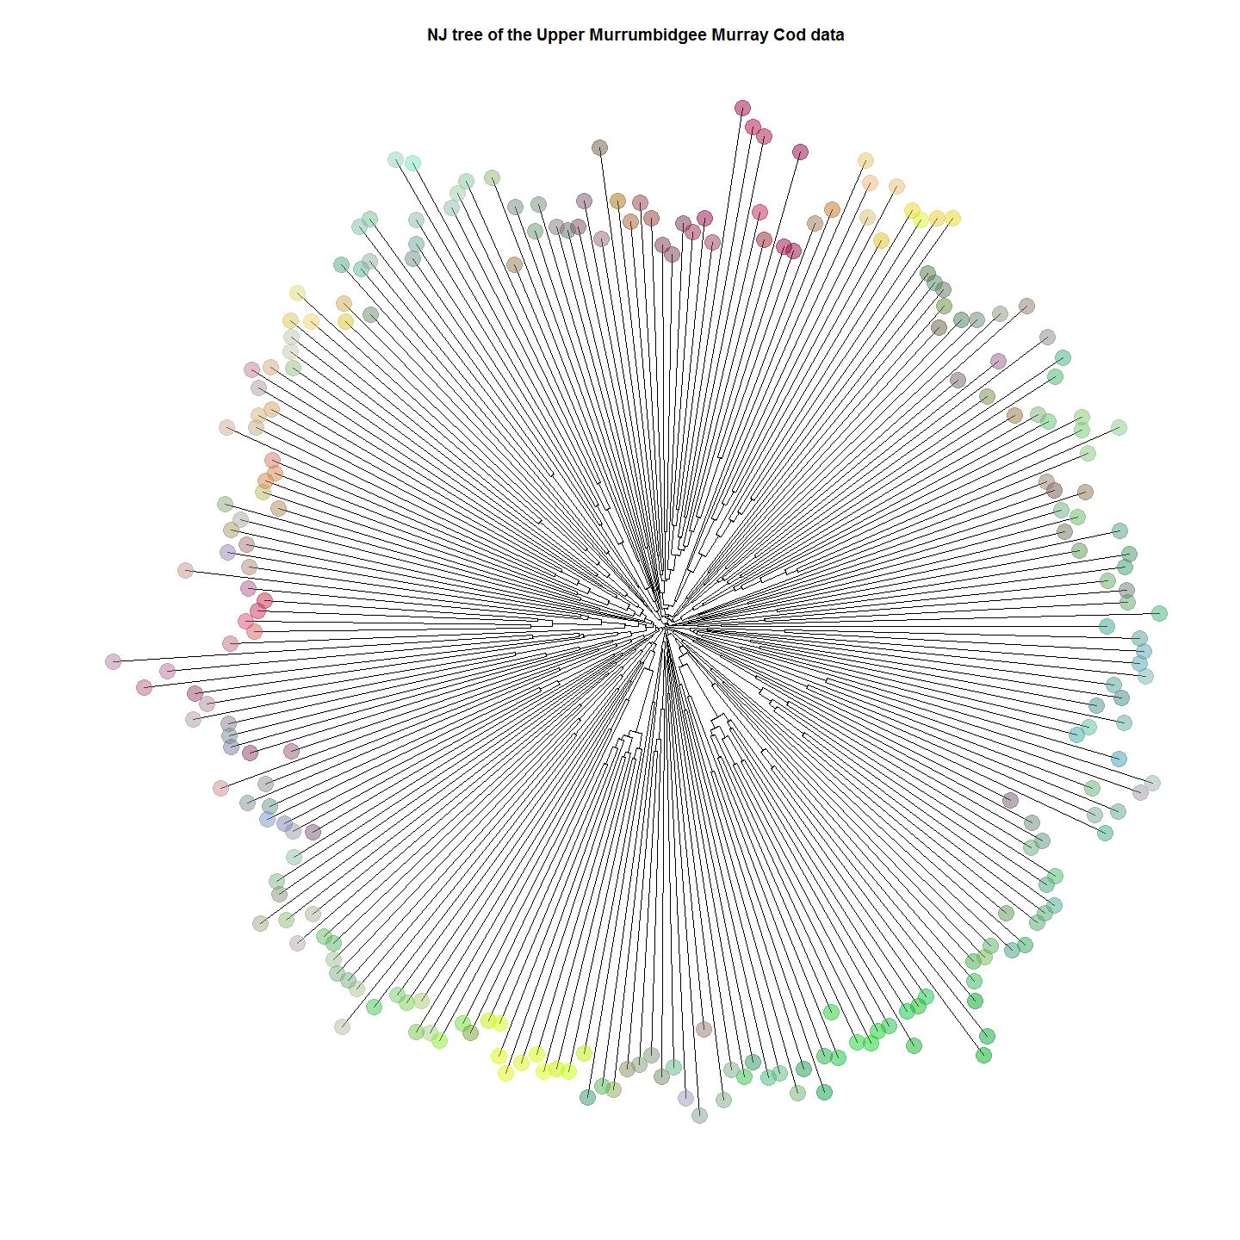

#Discriminant Component Analysis   
dapc2 <- dapc(gl.dart, n.pca=10, n.da=1, parallel=FALSE)  
scatter(dapc2,scree.da=FALSE, bg="white", posi.pca="topright", legend=TRUE, txt.leg=paste("group", 1:5), col=c("red","blue","green","orange", "pink"))

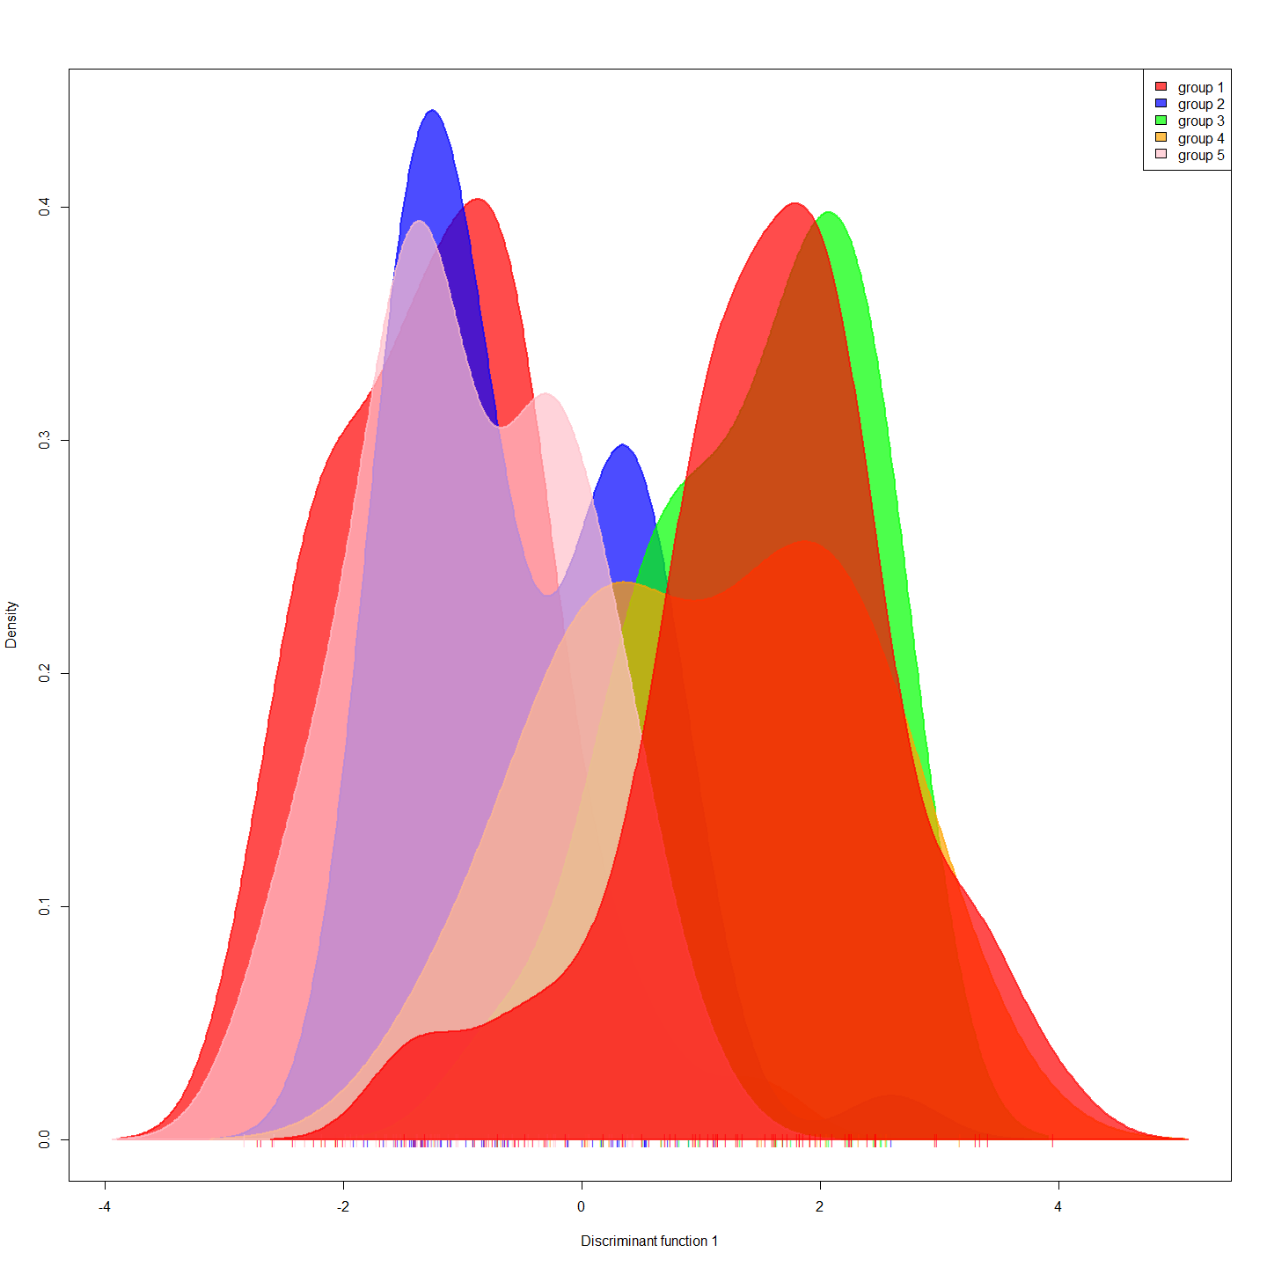

compoplot(dapc2, col=c("red","blue","green","orange", "pink"),lab="", txt.leg=paste("group", 1:5), ncol=5)

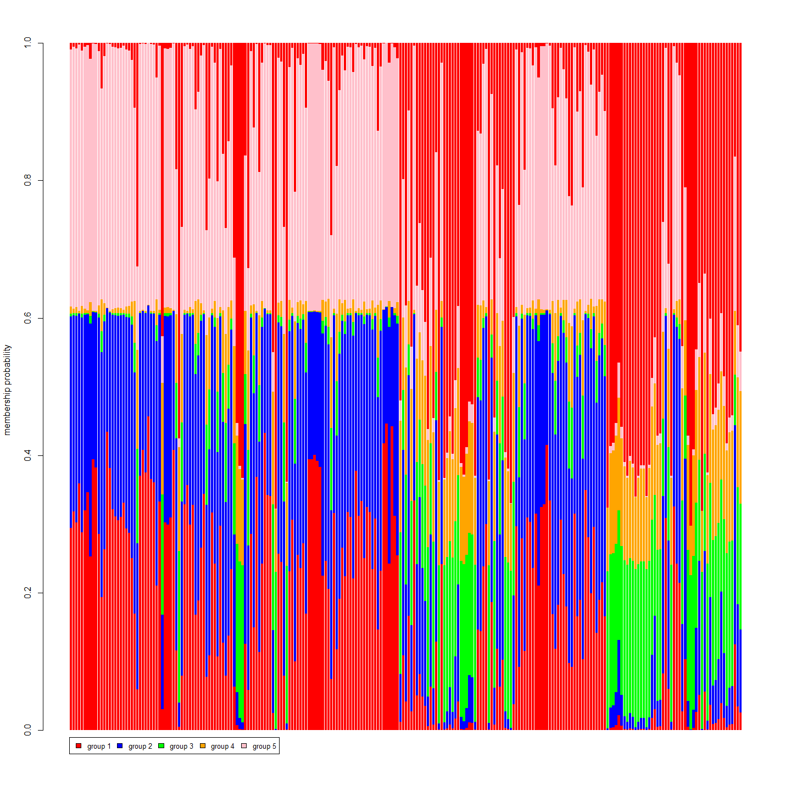

#Analysis on genInd object (individuals)  
#Hardy Weinberg  
source("genlight2genInd.R")  
gI<-genlight2genind(gl.dart)

## Start conversion....  
## Please note conversion of bigger data sets will take some time!  
## Once finished, we recommend to save the object using >save(object, file="object.rdata")  
##   
## Matrix converted.. Prepare genind object...  
## Finished! Took 72 seconds.

hwe<-hw.test(gI, B=0)  
hwedf<-data.frame(hwe)  
hist(hwedf$Pr.chi.2...)

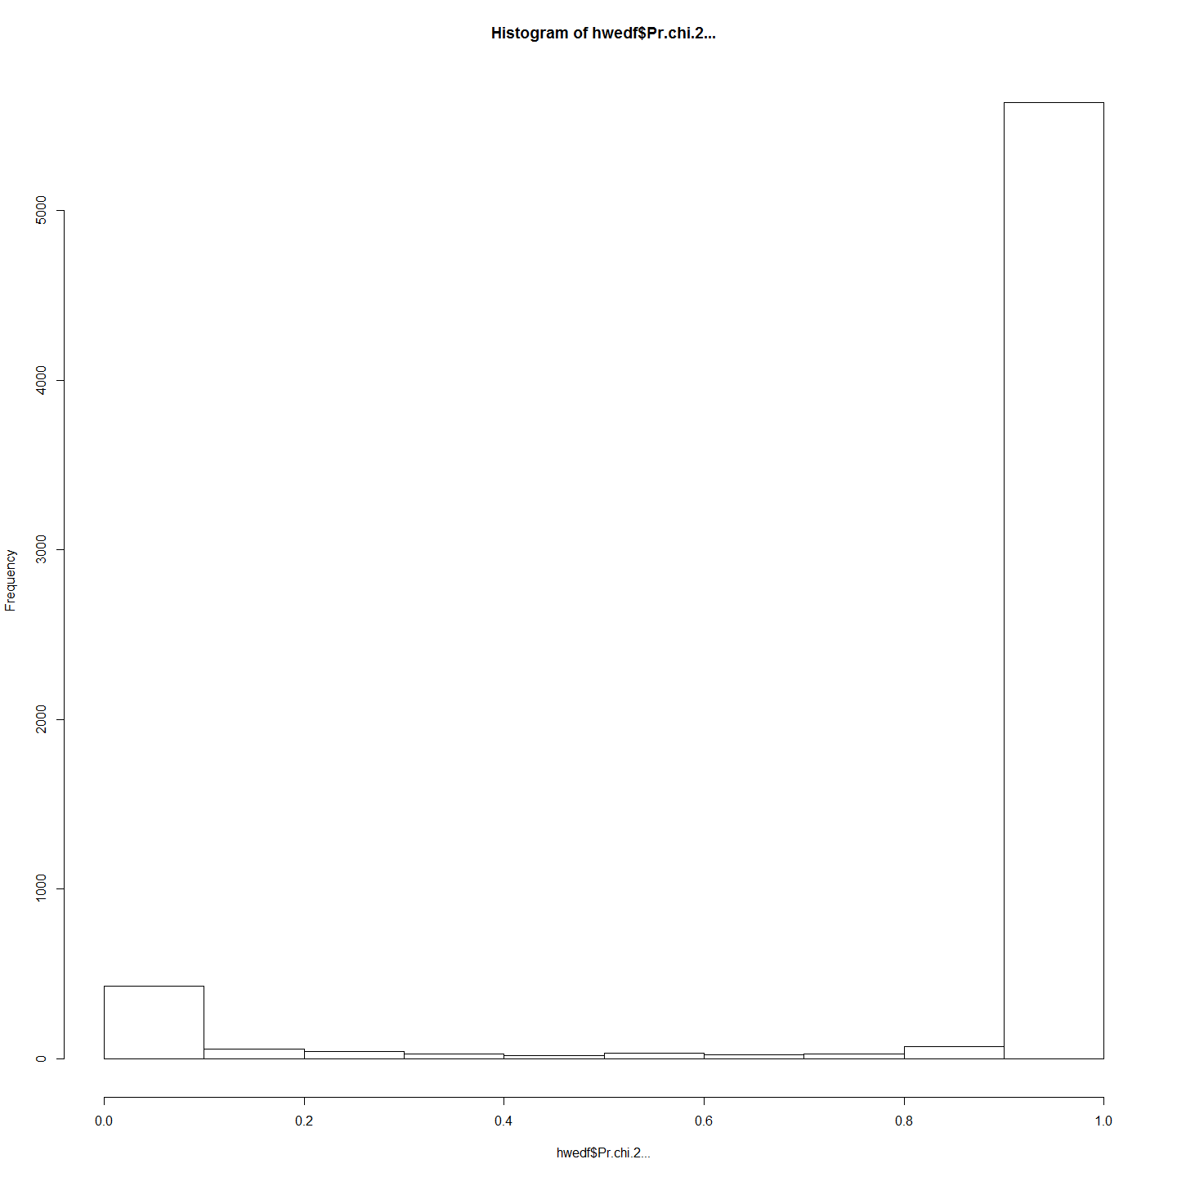

#There are   
sum(is.na(gI$tab)) #missing values in the data

## [1] 30511

forPCOA<-scaleGen(gI, NA.method="mean") #scale the data  
forPCOA[1:5,1:5]

## 6661549-60-C/T.A 6661549-60-C/T.B 6650588-15-C/T.A 6650588-15-C/T.B 6661794-21-A/G.A  
## 185 2.006758 -2.006758 1.499011 -1.499011 0.1184337  
## 186 2.006758 -2.006758 1.499011 -1.499011 1.7172889  
## 187 0.289708 -0.289708 1.499011 -1.499011 0.1184337  
## 188 0.289708 -0.289708 1.499011 -1.499011 1.7172889  
## 189 0.289708 -0.289708 1.499011 -1.499011 0.1184337

pca1 <- dudi.pca(forPCOA,cent=FALSE,scale=FALSE,scannf=FALSE,nf=3)  
barplot(pca1$eig[1:50],main="PCA eigenvalues", col=heat.colors(50))

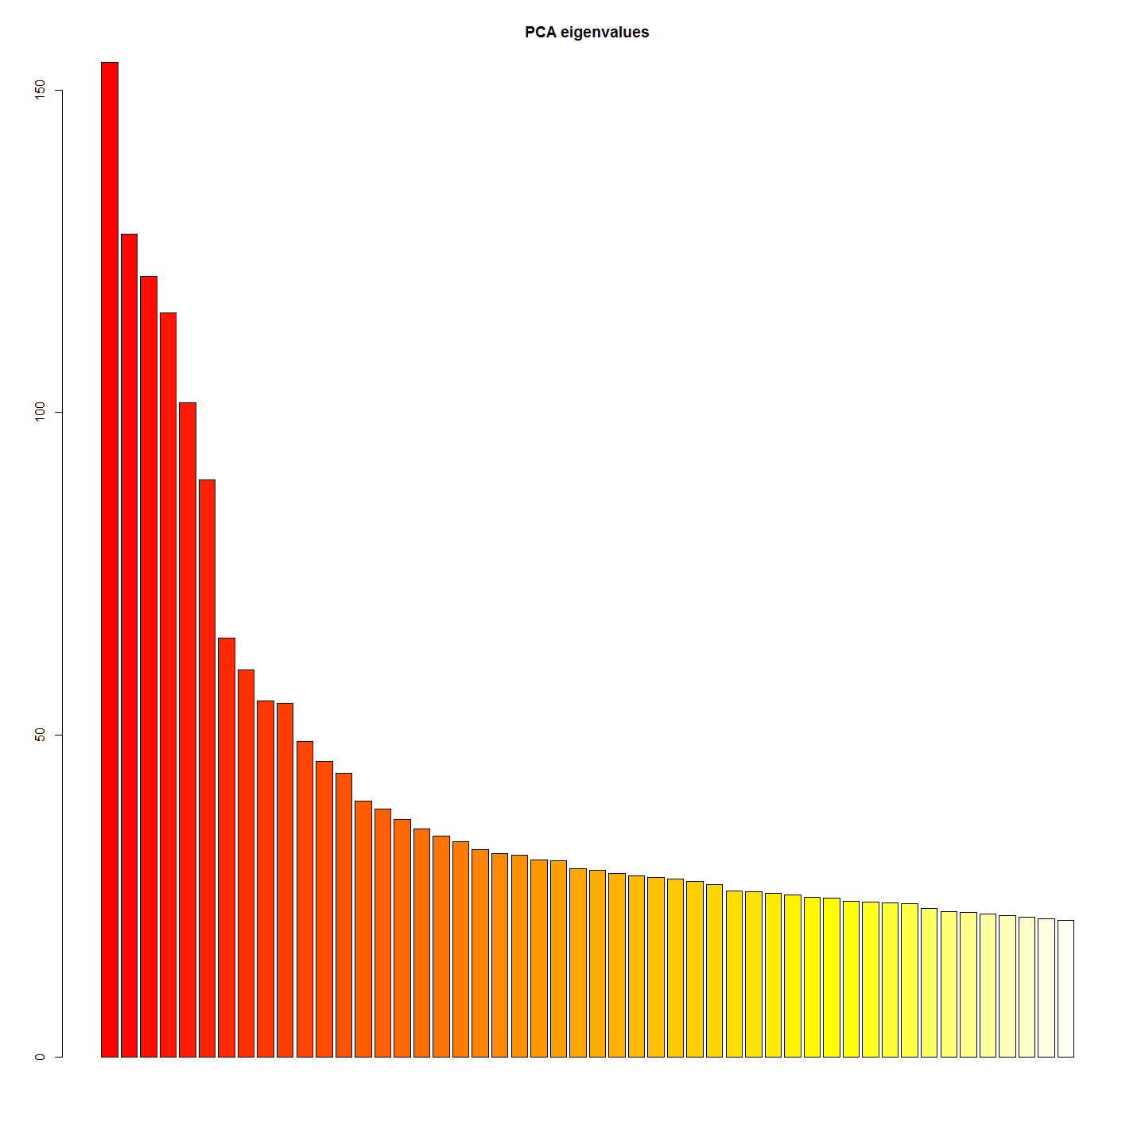

s.label(pca1$li)  
title("PCA of cod dataset\naxes 1-2")  
add.scatter.eig(pca1$eig[1:20], 3,1,2)

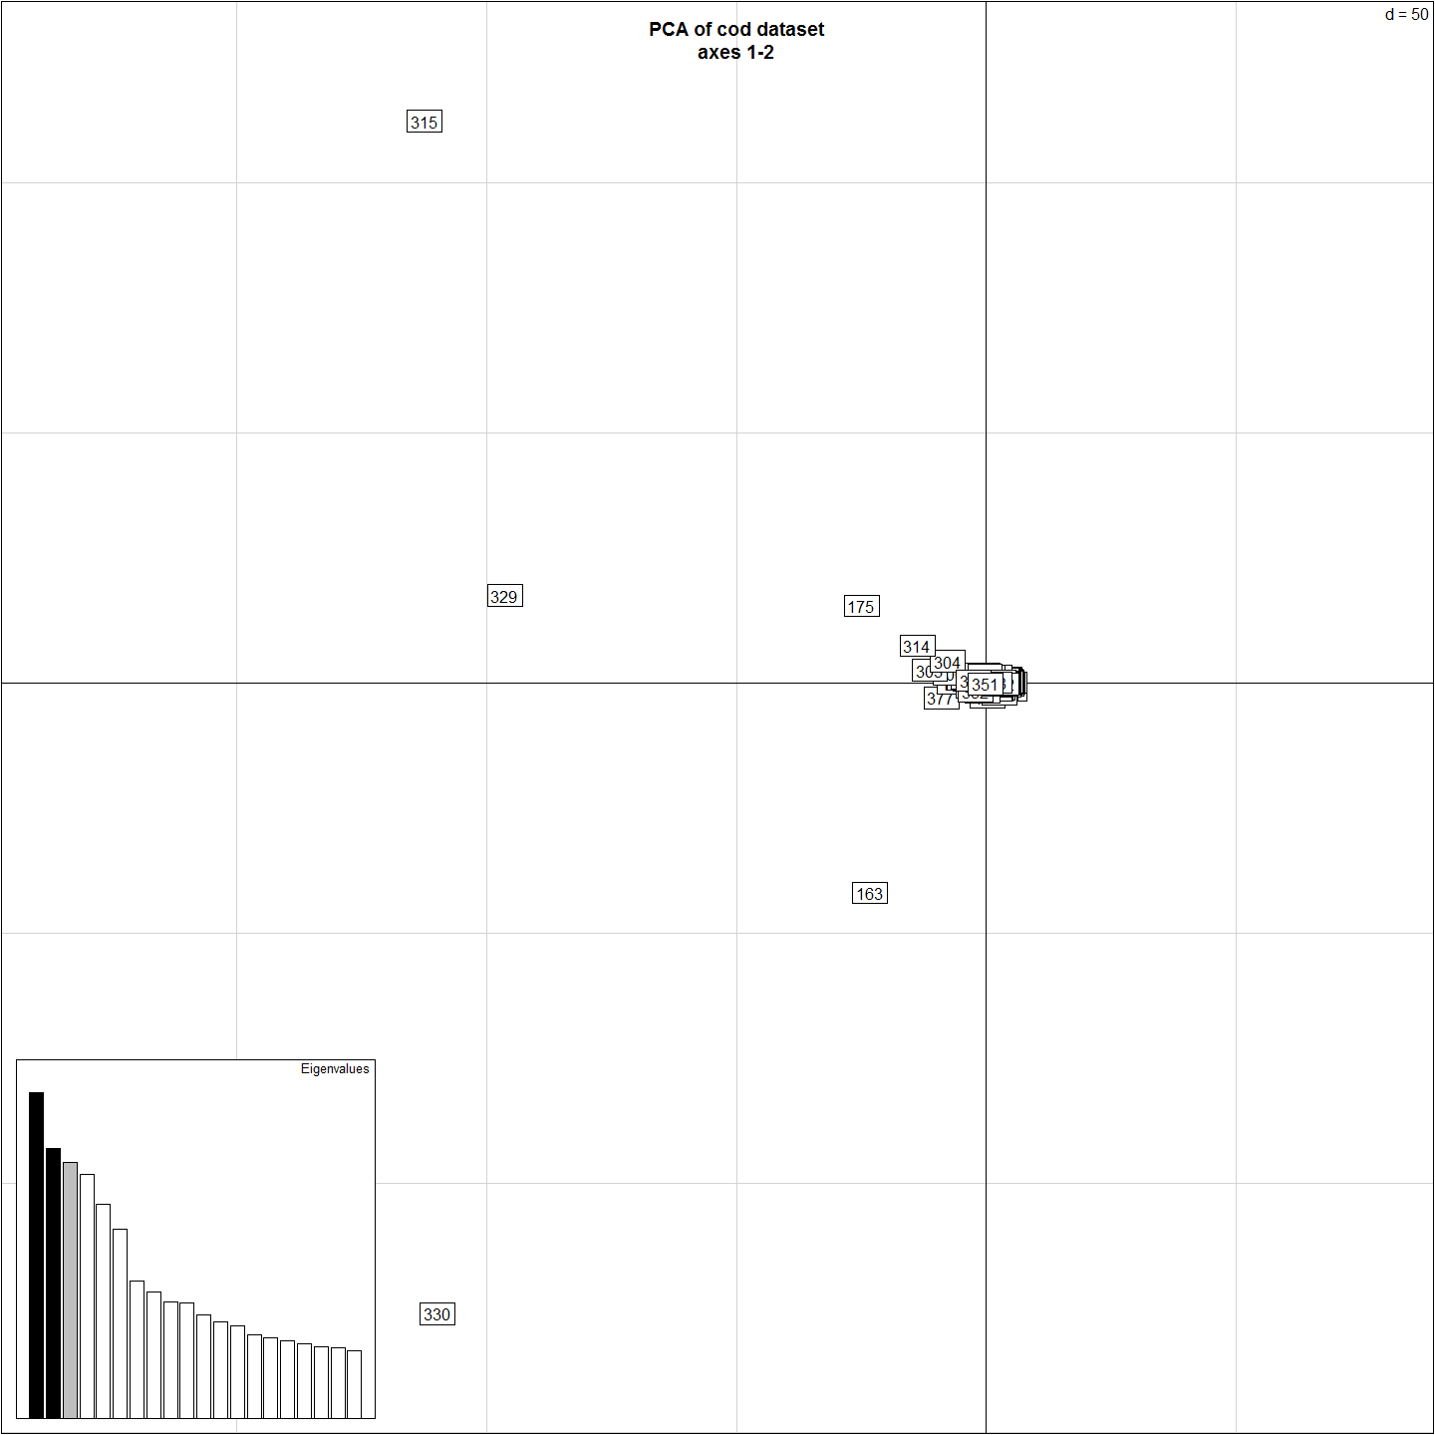

s.class(pca1$li, pop(gI))

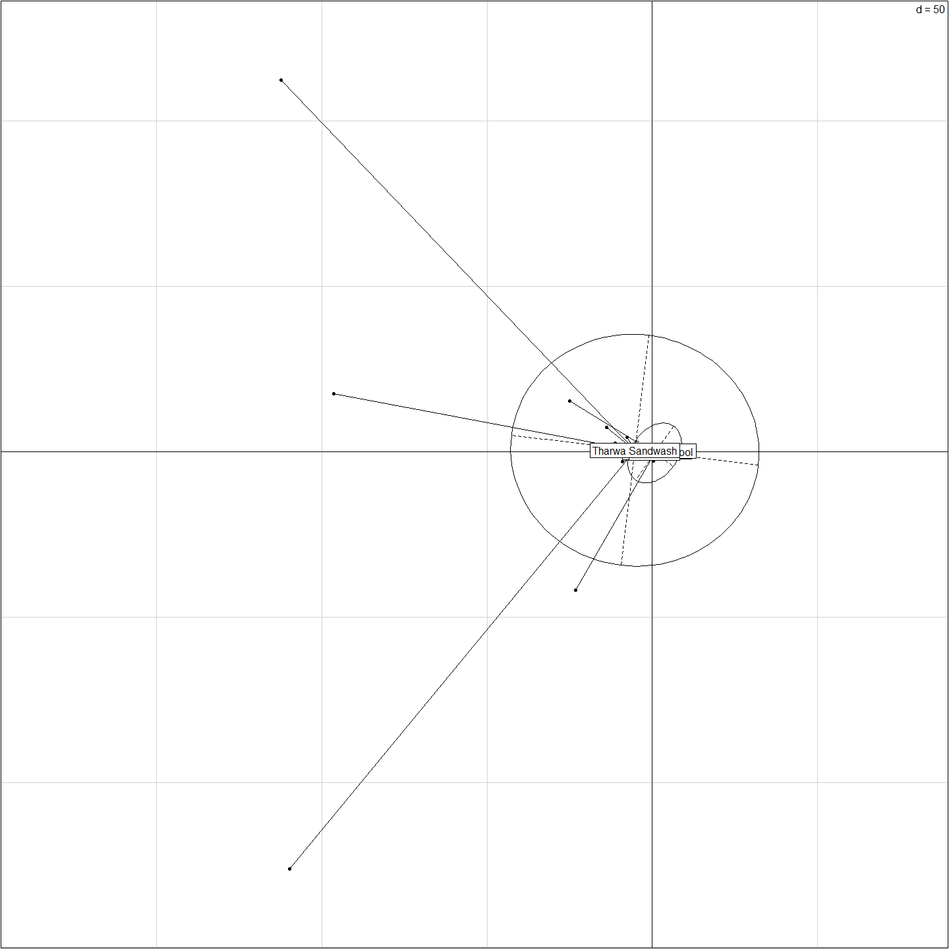

s.class(pca1$li,pop(gI),xax=1,yax=3,sub="PCA 1-3",csub=2)  
title("PCA of cod dataset\naxes 1-3")  
add.scatter.eig(pca1$eig[1:20],nf=3,xax=1,yax=3)

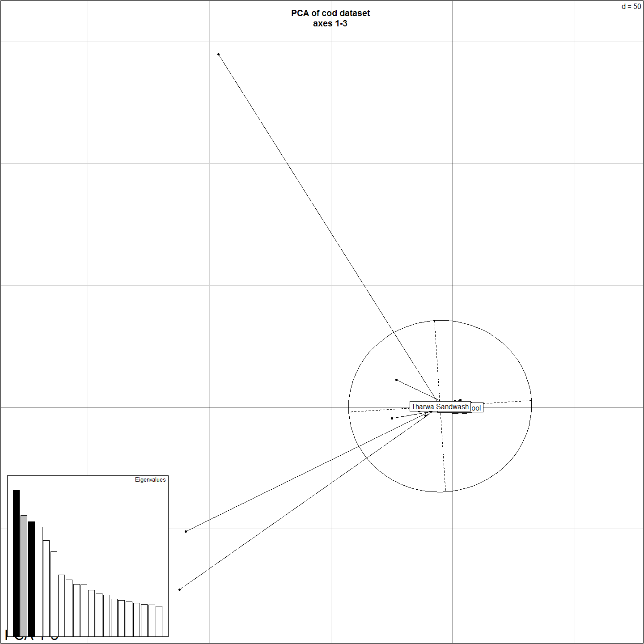

col <- funky(15)  
s.class(pca1$li, pop(gI),xax=1,yax=3, col=transp(col,.6), axesell=FALSE,  
 cstar=0, cpoint=3, grid=FALSE)

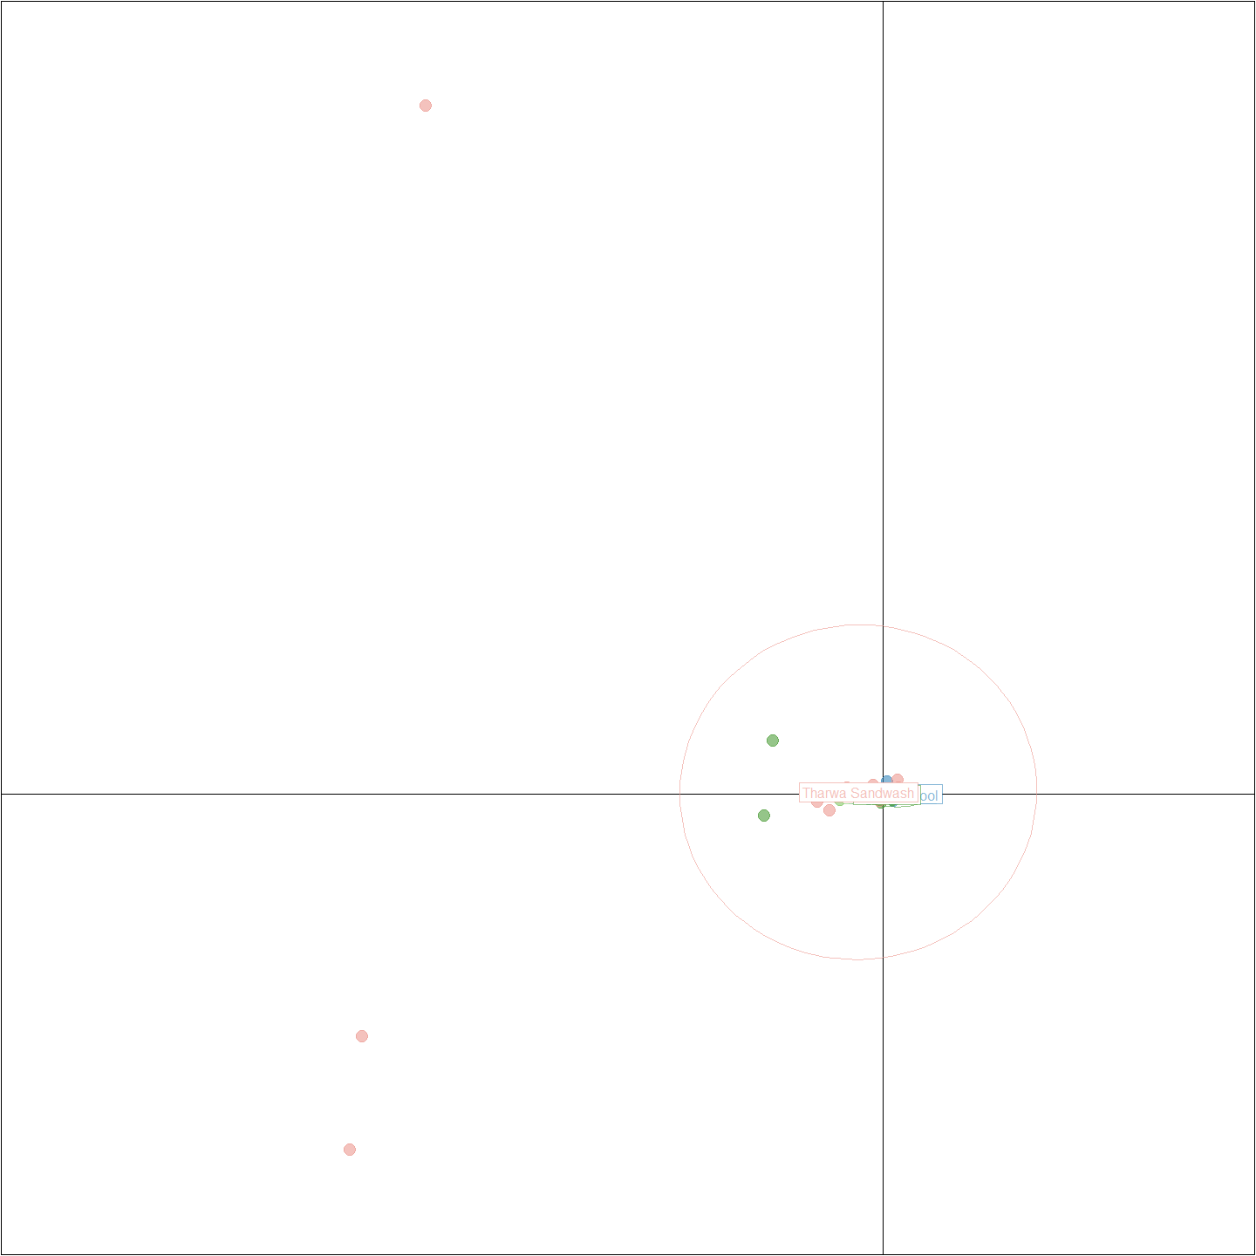

colorplot(pca1$li[c(1,3)], pca1$li, transp=TRUE, cex=3, xlab="PC 1", ylab="PC 3")  
title("PCA of cod dataset\naxes 1-3")  
abline(v=0,h=0,col="grey", lty=2)

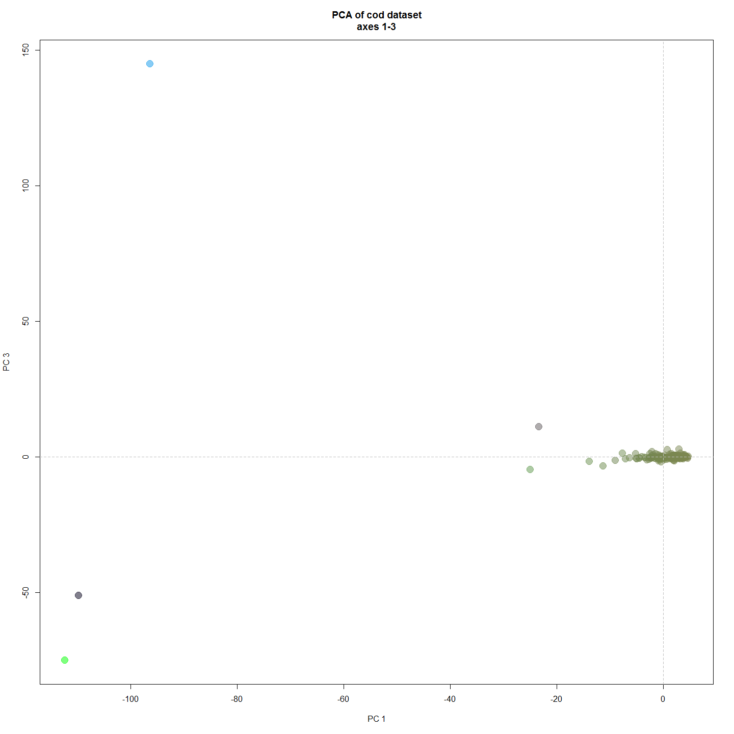

#Correspondance Analysis (genepop object)  
obj <- genind2genpop(gI)

##   
## Converting data from a genind to a genpop object...   
##   
## ...done.

ca1 <- dudi.coa(tab(obj),scannf=FALSE,nf=3)  
barplot(ca1$eig,main="Correspondence Analysis eigenvalues",  
 col=heat.colors(length(ca1$eig)))

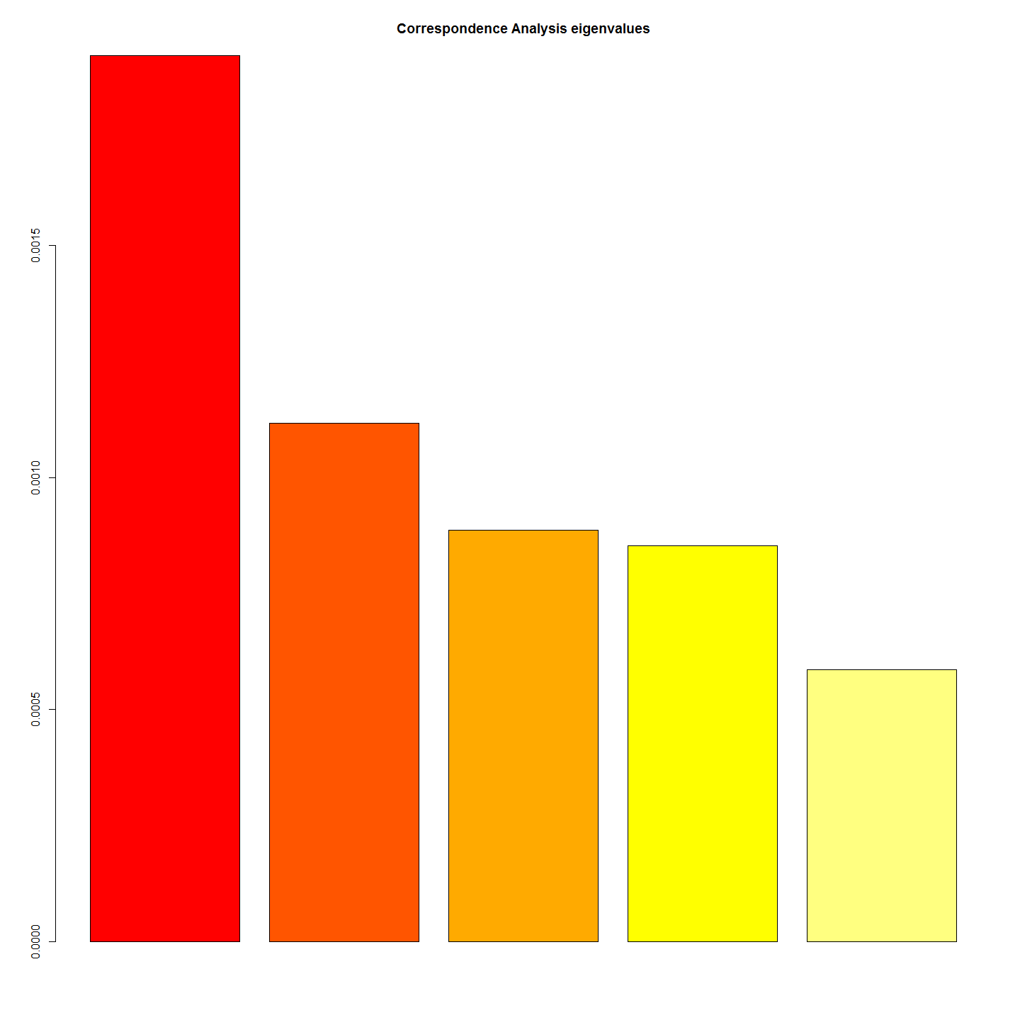

s.label(ca1$li, sub="Correspondance Analysis",csub=2)  
add.scatter.eig(ca1$eig,nf=3,xax=1,yax=2,posi="topleft")

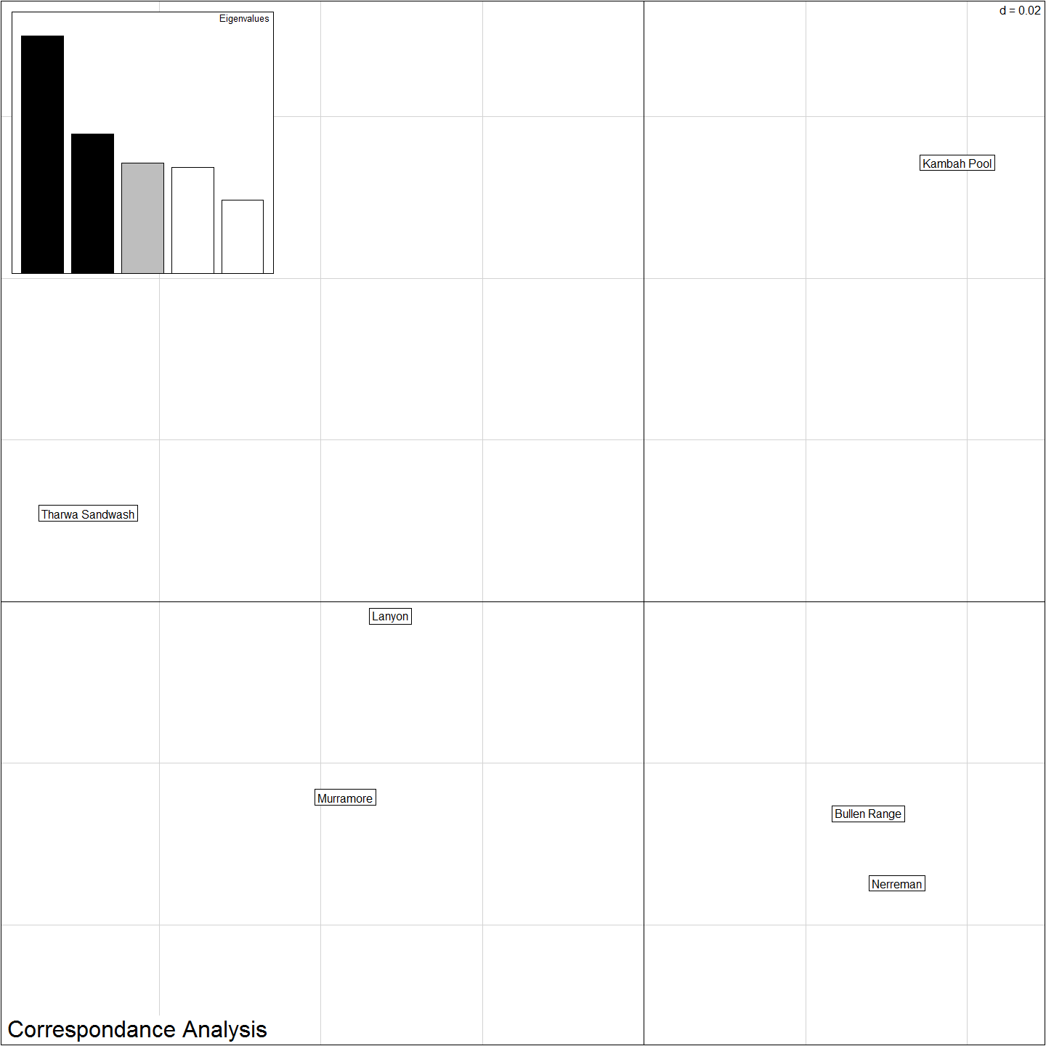

#Isolation By Distance  
# Dgen <- dist.genpop(obj,method=2)  
# Dgeo <- dist(gI$other$latlong) #need xys for sites in gI for this to work.  
# ibd <- mantel.randtest(Dgen,Dgeo)  
# ibd

all_labels()

## [1] "Project_Template_and_Knitr" "Set_Global_Options" "unnamed-chunk-1" "unnamed-chunk-2"   
## [5] "unnamed-chunk-3" "unnamed-chunk-4" "unnamed-chunk-5" "poppr functions"   
## [9] "unnamed-chunk-6" "unnamed-chunk-7" "unnamed-chunk-8" "unnamed-chunk-9"   
## [13] "unnamed-chunk-10" "unnamed-chunk-11" "PCAtSNEStructure" "unnamed-chunk-12"   
## [17] "dapcCorrespondence" "Include_Chunk_Labels_and_Session Information" "averagePIC" "dapcCorroStructure"

proc.time()-ptm

## user system elapsed   
## 3712.95 13.85 3921.54

#Session Information  
sessionInfo()

## R version 3.3.0 (2016-05-03)  
## Platform: x86_64-w64-mingw32/x64 (64-bit)  
## Running under: Windows 7 x64 (build 7601) Service Pack 1  
##   
## locale:  
## [1] LC_COLLATE=English_Australia.1252 LC_CTYPE=English_Australia.1252 LC_MONETARY=English_Australia.1252 LC_NUMERIC=C LC_TIME=English_Australia.1252   
##   
## attached base packages:  
## [1] stats graphics grDevices utils datasets methods base   
##   
## other attached packages:  
## [1] reshape2_1.4.1 StAMPP_1.4 igraph_1.0.1 poppr_2.2.1 mmod_1.3.1 hierfstat_0.04-22 pegas_0.9 ape_3.5 tsne_0.1-3   
## [10] dart_0.3 adegenet_2.0.1 ade4_1.7-4 ggplot2_2.1.0 plyr_1.8.4 dplyr_0.5.0 ProjectTemplate_0.7 knitr_1.13   
##   
## loaded via a namespace (and not attached):  
## [1] Rcpp_0.12.6 lattice_0.20-33 deldir_0.1-12 gtools_3.5.0 assertthat_0.1 digest_0.6.10 foreach_1.4.3 mime_0.5 R6_2.1.2 nnls_1.4   
## [11] evaluate_0.9 coda_0.18-1 lazyeval_0.2.0 spdep_0.6-6 gdata_2.17.0 vegan_2.4-0 phangorn_2.0.4 gmodels_2.16.2 Matrix_1.2-6 rmarkdown_1.0   
## [21] labeling_0.3 splines_3.3.0 stringr_1.0.0 munsell_0.4.3 shiny_0.13.2 httpuv_1.3.3 mgcv_1.8-13 htmltools_0.3.5 tibble_1.1 quadprog_1.5-5   
## [31] codetools_0.2-14 permute_0.9-0 MASS_7.3-45 grid_3.3.0 nlme_3.1-128 xtable_1.8-2 gtable_0.2.0 DBI_0.5 magrittr_1.5 formatR_1.4   
## [41] scales_0.4.0 KernSmooth_2.23-15 stringi_1.1.1 LearnBayes_2.15 doParallel_1.0.10 sp_1.2-3 seqinr_3.3-0 boot_1.3-18 fastmatch_1.0-4 iterators_1.0.8   
## [51] tools_3.3.0 parallel_3.3.0 yaml_2.1.13 colorspace_1.2-6 cluster_2.0.4