Relatedness Between Murray Cod Larvae 2011-2013 Results

Alan Couch

Sun Jun 26 12:15:06 PM 2016

# Relatedness and Mating Systems

# Inbreeding Analysis

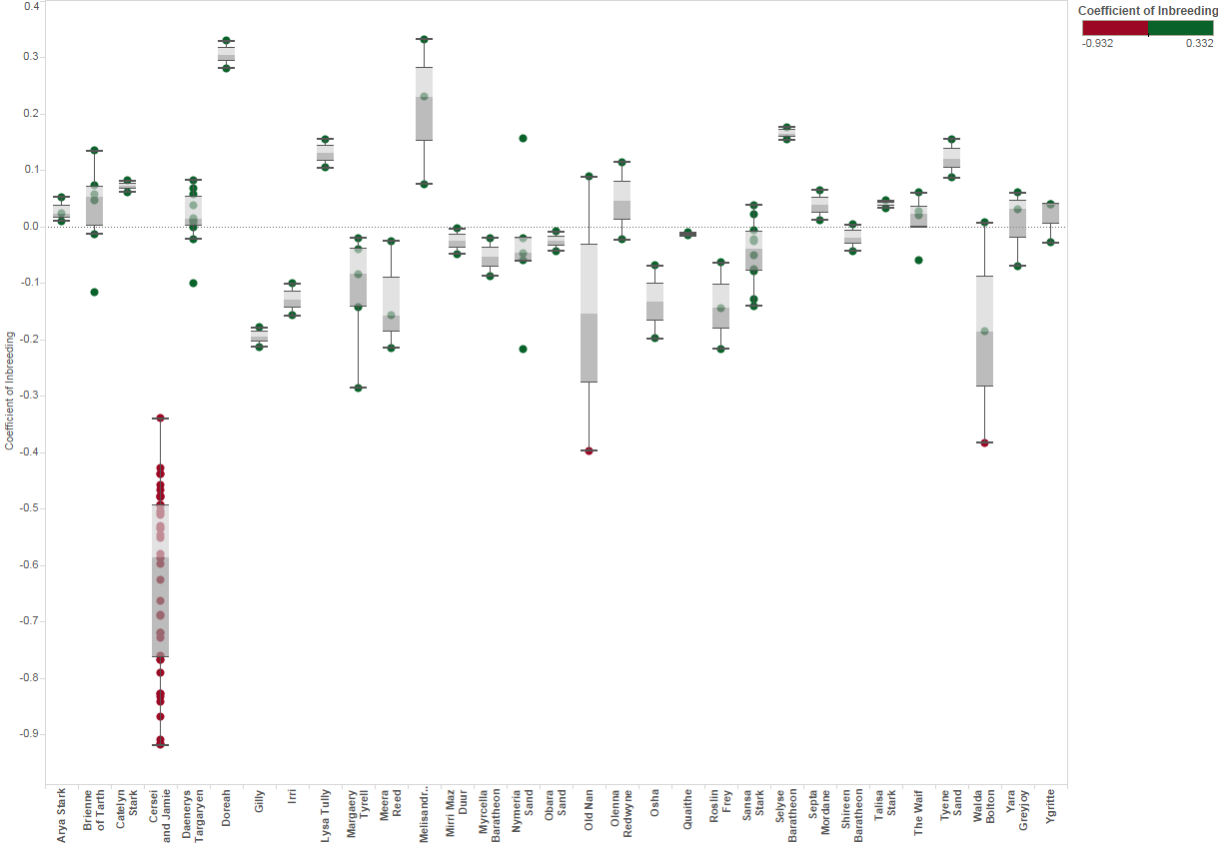

Putative Mother

Coefficient of Inbreeding

It is apparent from the above plot that there is one outlier group with strongly negative inbreeding coefficients. They are likely outbred with Trout cod such that 'related' incorrectly assigned them as siblings on the basis of alleles they have in common from Trout cod. These are likely the third and fourth generation hybrid larvae thet were not previously excluded from the data set. First and second generation hybrids and backcrosses had been excluded prioir to this analysis. These were either omitted from the remaining analysis for the purposes of measuring dispersal, assigned based on the spatio-temporal clustering alone.

# Choosing Relatedness Measures

First we need to choose which estimators we are to use. (see compareEstimators) The related package offers a choice of algorithms to use as estimators and provides a method to compare estimators using the relevant data to enhance selection.

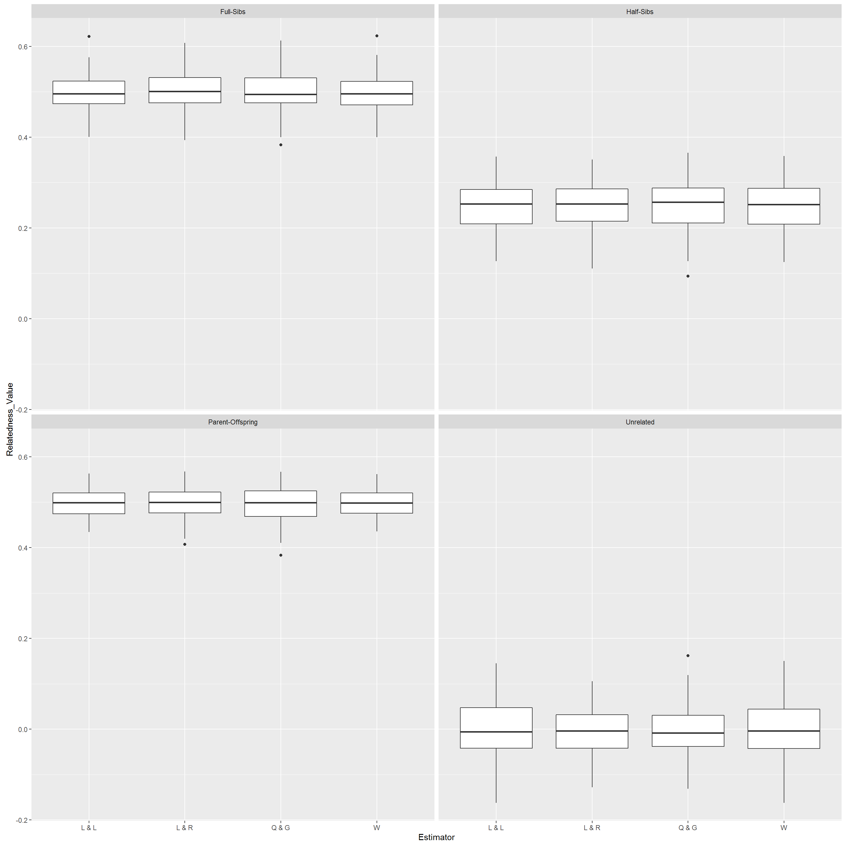

Related Estimators Performance

Given the large number of SNPS each of the estimator algorithms performs very well. In this case we use the maximum likliehood estimator 'trioml'. This was chosen as it enables allowing for inbreeding in the population although it is much slower.

The simulation provides estimates, based on the allele frequencies, of hypothetical known parent-offspring,full and half siblings, and unrelated individuals. From this the cutoff probabilities for the relatedness values need to be chosen. The cutoff points for the probability between assigning as full siblings or half siblings and the same distinction between half siblings and 'unrelated' can be selected from a density plot to minimise overlap.

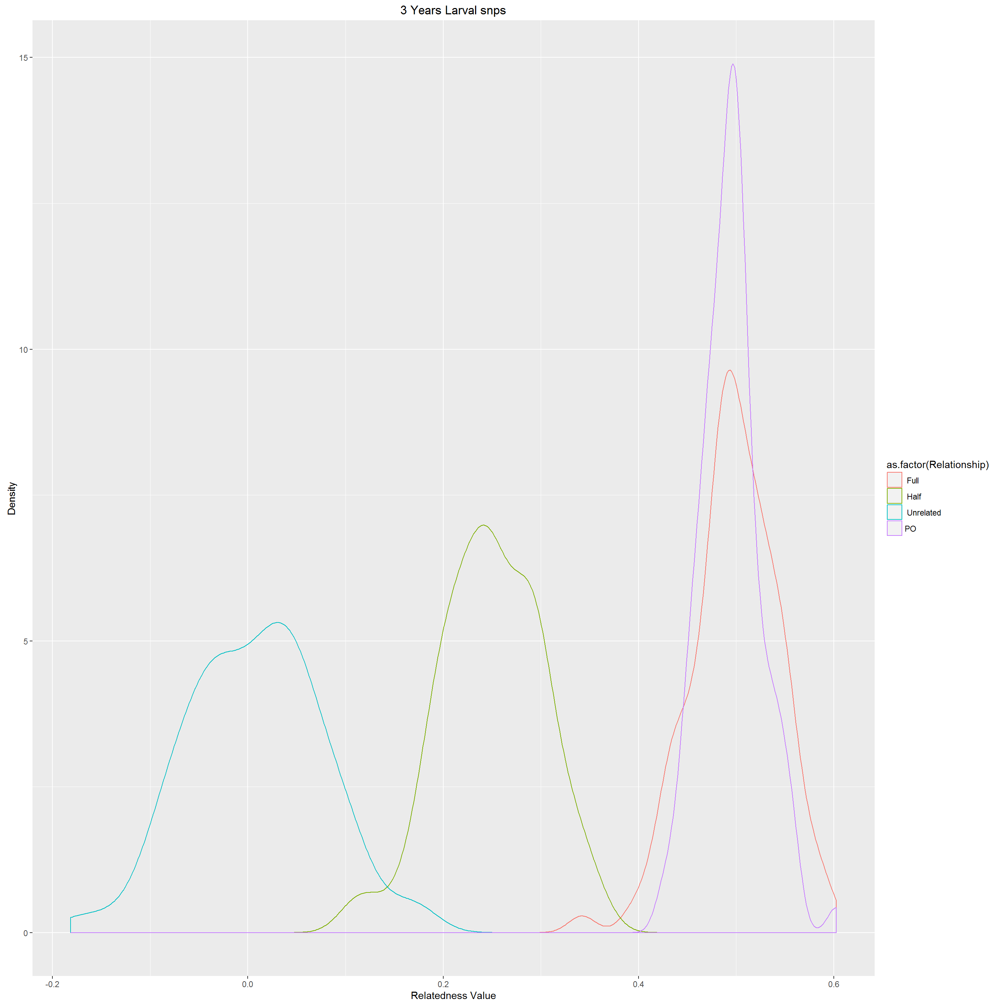

Setting Cutoff Probabilities for Relatedness

Given the large number of snps the cutoffs between classes of siblings are clear choices with little overlap. These are displayed for all years 2011-2013 only as the results for each year individually produced results that differred in probability by less than 0.02. Given the probabilistic nature of the identification of sibling class, and the amount of overlap between classes there is no benefit in changing cutoffs for each years nomination of sibling class.

estimator=5 #5-trioml,6-wang,7-lynchli,8-lynchrd,9-ritland,10-quellergt,11-dyadml  
estimatorName="trioml" # change as needed with above  
#Also choose which cutoffs to use. These are dependant on density plots  
fshsCut<-0.4  
hsurCut<-0.17

Cut off parameters for the classes were selected. Dyads with a relatedness probability above 0.4 were considered to be full siblings, and dyads with a relatedness probability between 0.17 and 0.4 were assigned as half siblings. Any dyad with a relatedness probability below 0.17 was consisent with the related package assigned as 'unrelated' although really they are merely less related and probably neither a full or half sibling.

The results of the relatedness dyads, as calculated by 'related' were plotted using iGraph to visualised relatedness between larvae within each year so as to identify full sibling pairs(FS) and half sibling pairs (HS). Unrelated (UR) is also calculated by the 'r' package 'related'. However we are interested only in FS at this stage to identify common parents and to assist with determining the distance of larval dispersal.

The same is finally ploted for all three years combined.

# 2011 Larval Relatedness Plots

main="2011 Larval snps"  
fileName=paste("./outData/",main," coancestoryOutput", sep="")  
load(file = fileName)

## Refine set and Plot relationships

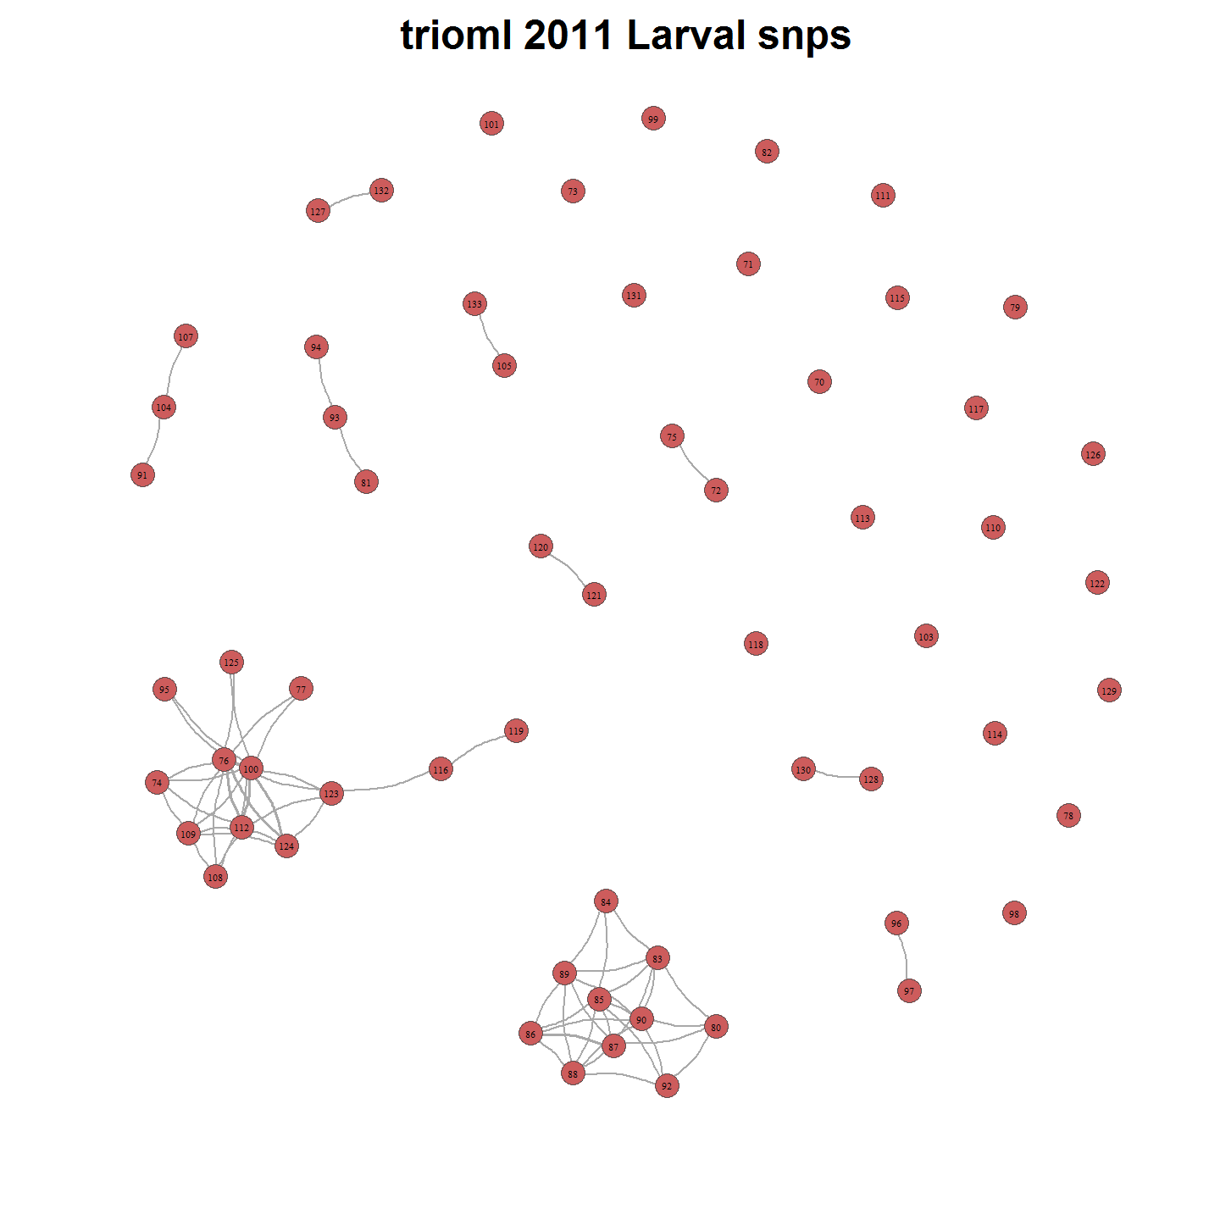

There are 62 individuals and 1891 related dyads. There are 30 families.

# 2012 Larval Relatedness Plots

main="2012 Larval snps"  
load(file = paste("./outData/",main," coancestoryOutput", sep=""))

## Refine set and Plot relationships

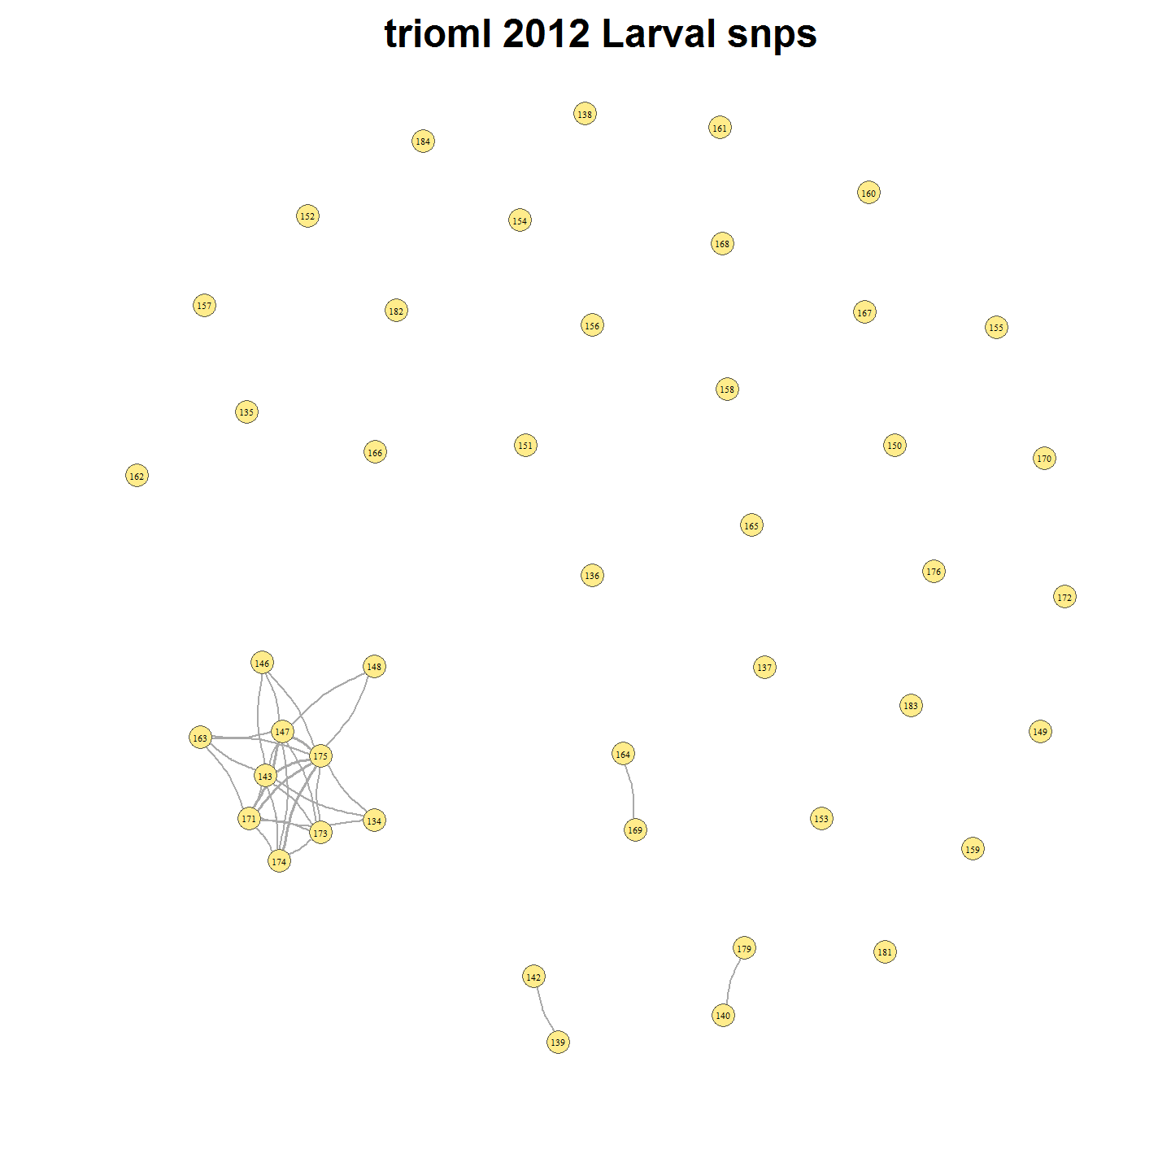

There are 45 individuals and 990 related dyads. There are 38 families. # 2013 Larval Relatedness Plots

main="2013 Larval snps"  
load(file = paste("./outData/",main," coancestoryOutput", sep=""))

## Refine set and Plot relationships

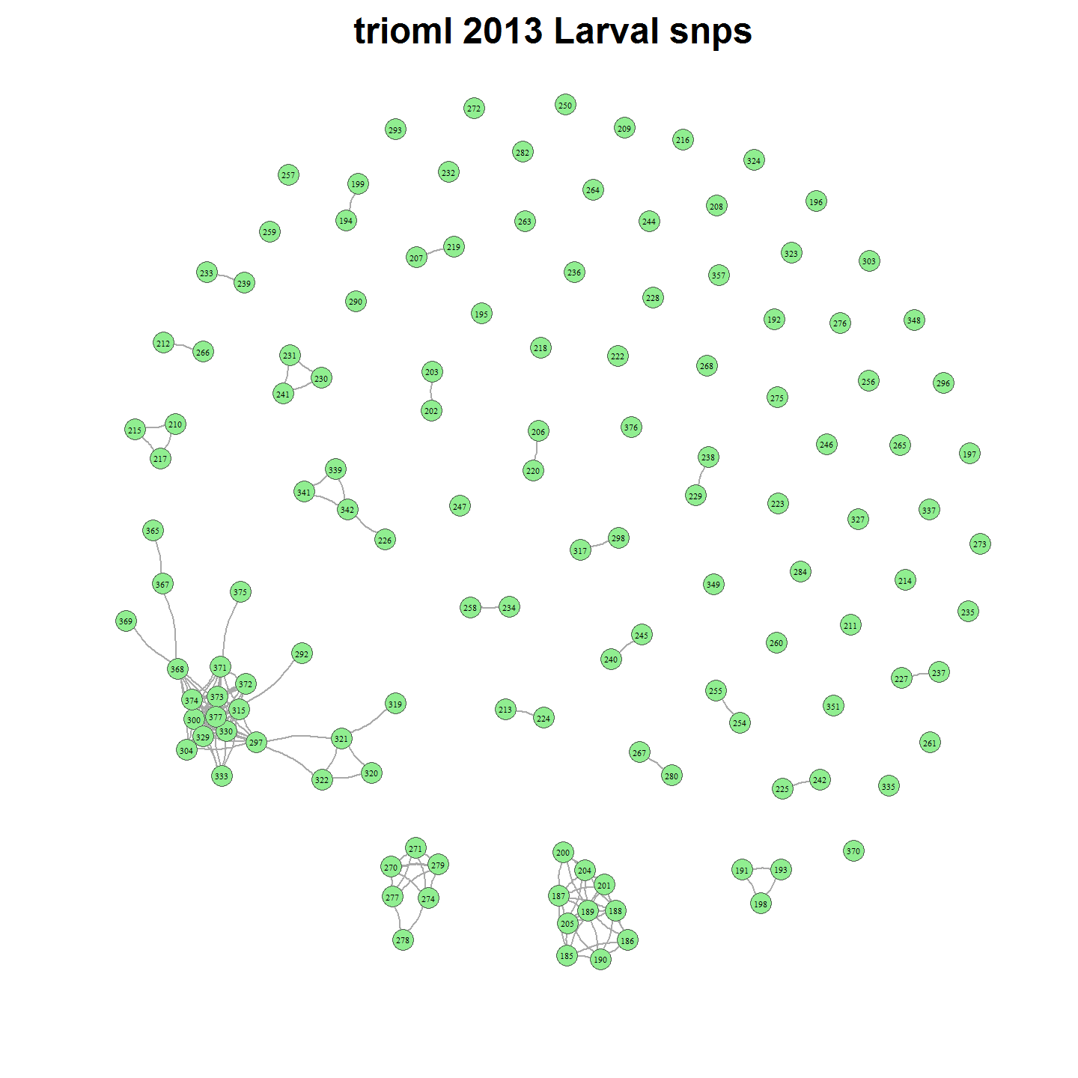

There are 131 individuals and 8515 related dyads. There are 70 families. # 2011-2013 Larval Relatedness Plots

main="2011-2013 Larval snps"  
load(file = paste("./outData/",main," coancestoryOutput", sep=""))

## Refine set and Plot relationships

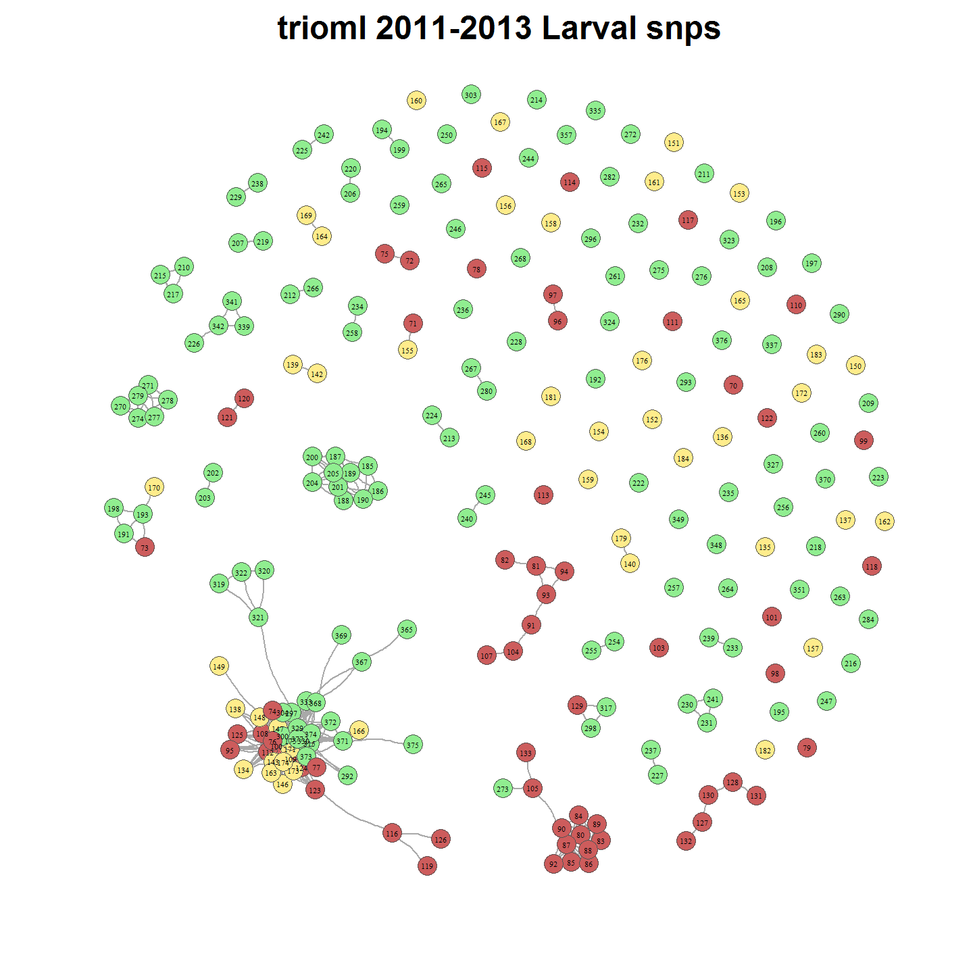

There are 238 individuals and 28203 related dyads.

# 2011-2013 Larvae Relatedness with Adults

main="2011-2013 Larval snps with Adults"  
load(file = paste("./outData/",main," coancestoryOutput", sep=""))

## Refine set and Plot relationships

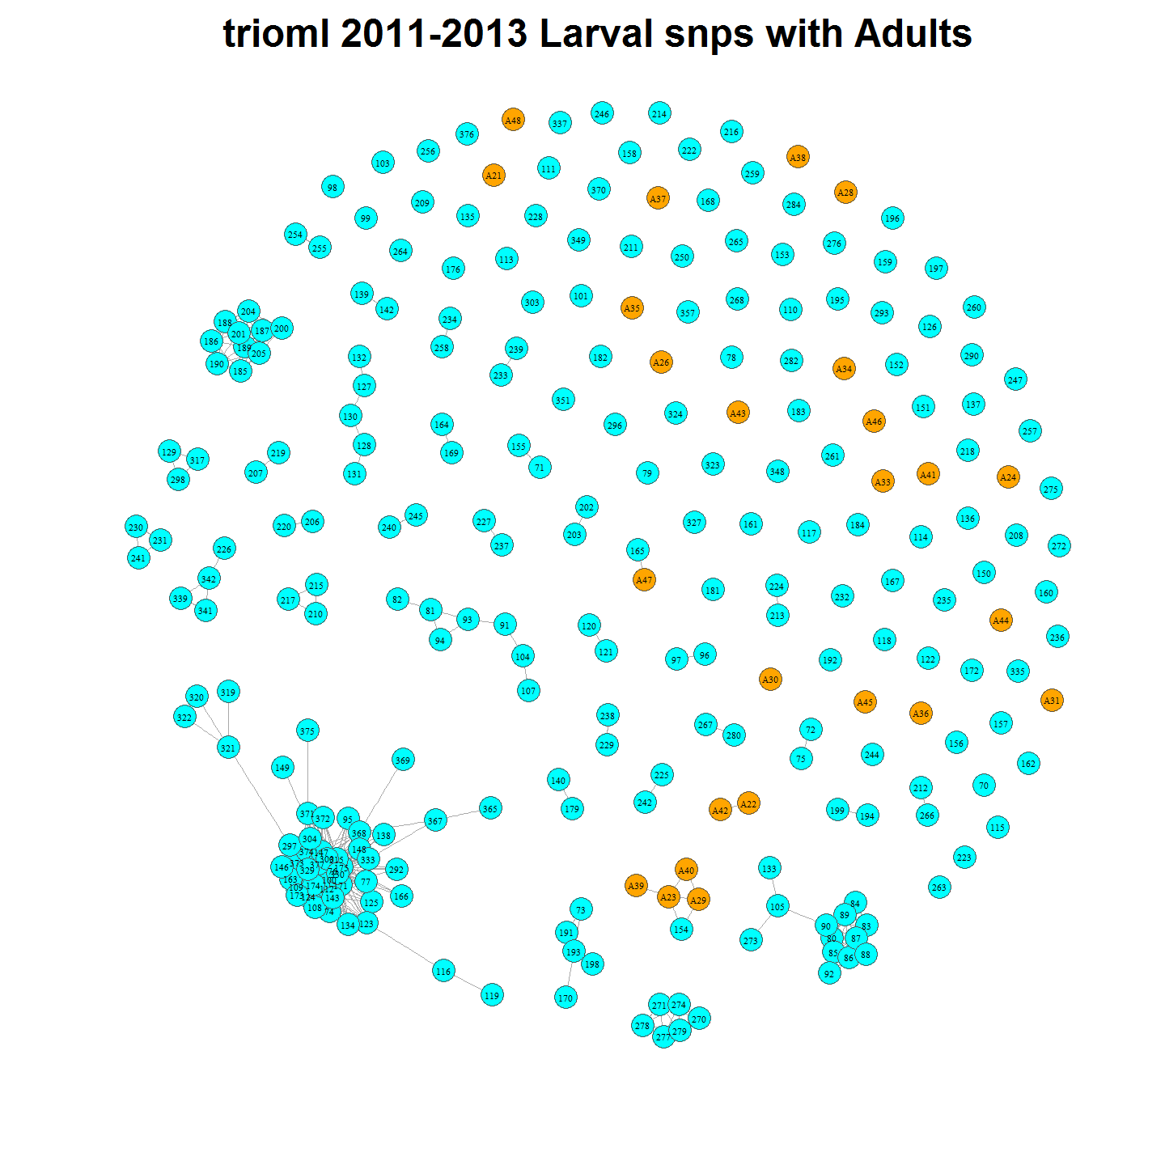

# 2011-2013 Larvae with Parents

# Nominating Parents

Given the above we can nominate putative parents for each family group. Initially we do this without allowing for the possibility of polygynous or polyandrous matings. 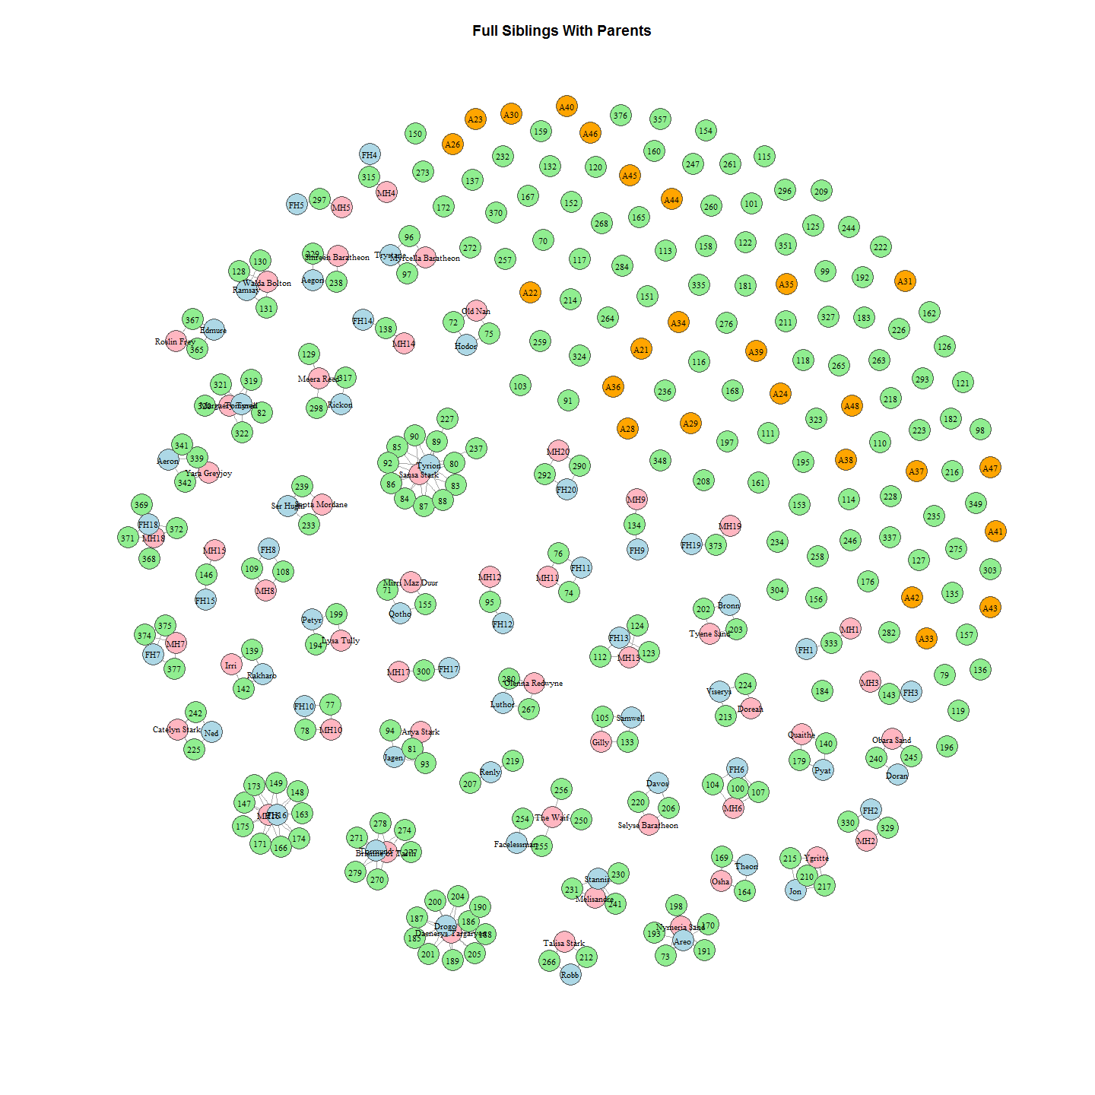

# Support for Estimates of Parental Assignments

The uncertainty around the estimates of parental assignment is not clear from the probability data alone. Related meta data provides some opportunity to test the uncertainty around assignments.

## Spatial and Temporal Correlation

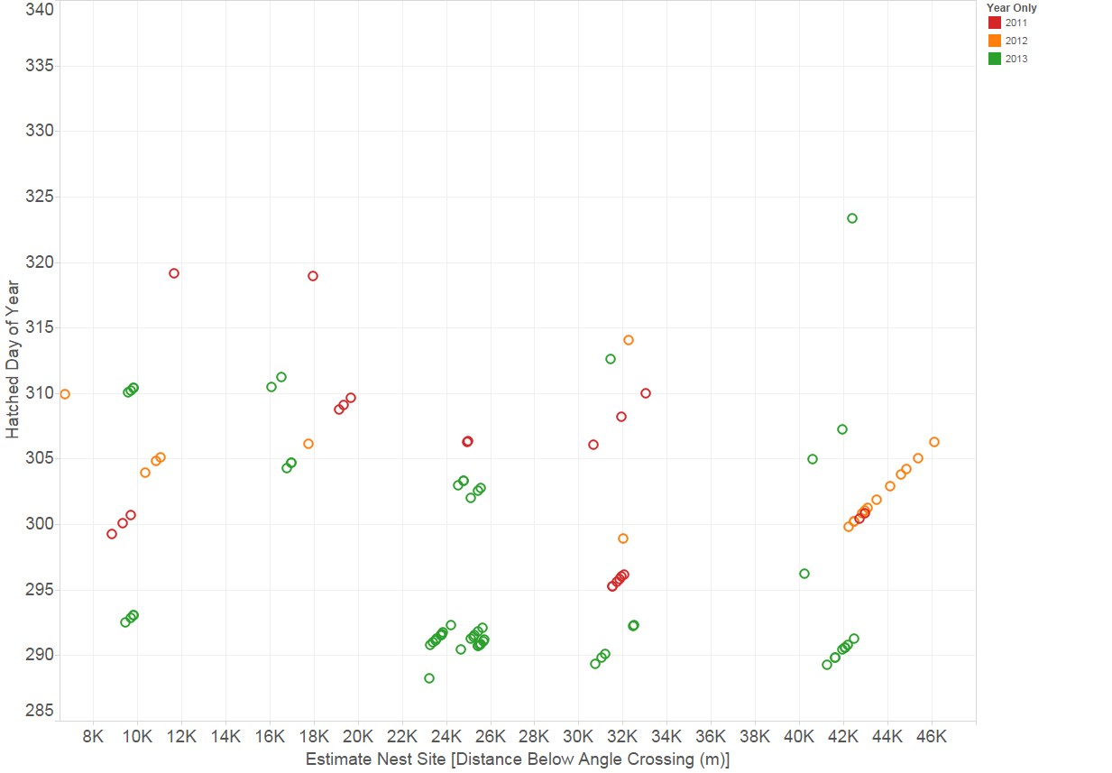

Nest Assignments Based on Spatio-Temporal Factors

Nests, and therefore common mothers, were assigned on the basis of larvae spatial and temporal positioning, within years, as seen in the above plot. We can then colour that plot by the genetic assignment of ‘related’ from which a putative mother and a putative father were assigned to full siblings. The 2011,2012 and 2013 plots above refer.

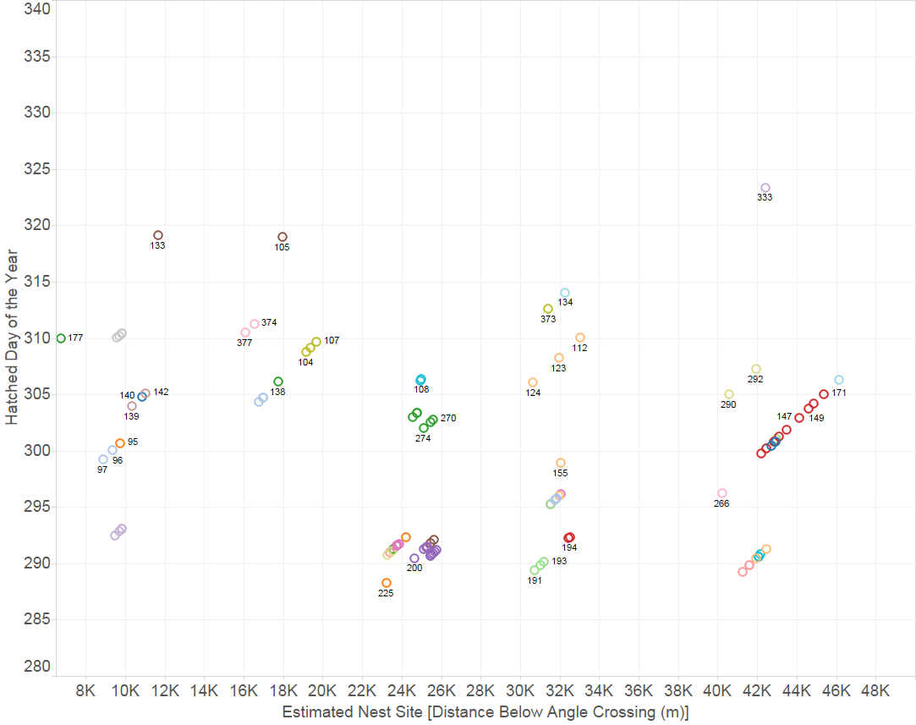

Nest Assignments Based on Spatio-Temporal Factors Coloured by GeneticParental Assignment

As can be seen there is a high correlation between the genetic assignment of parents and the spatio-temporal locations of nests assignments.

## Correlation with parental biogeochemical markers

Assignment of mothers to larvae based on isotpic ratios also seems to bear out the assignment. There is only one unclustered group that show little correlation between identity of mother and deltaN, deltaC isotopic ratios.

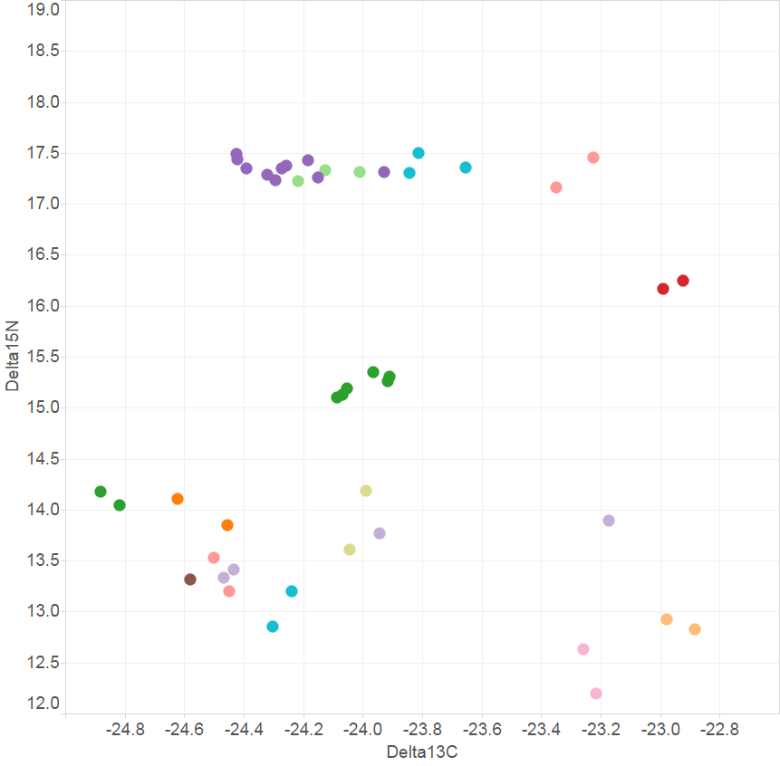 Nitrogen and Carbon Isotope ratios of larvae, coloured by putative mother. Putative mother was independently assigned by genetic analysis of relatedness and spatio-temporal clustering of larvae in years 2011, 2012 and2013.

# Probability of Multi Year Pair Bonds

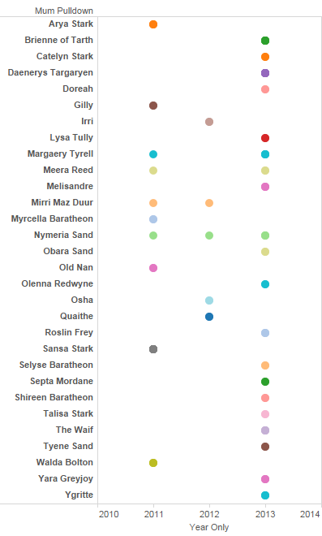

Inter Year Pair Bonds

Figure shows there are four pairs that mate more than one of the three years. The probability of this occurring for each female can be calculated as follows.

p=(1/n-1)^y-1

y = number of years same mate selected n = number of opposite sex n is approximated by number of family groups. In practice there are less mates to choose from than that because some will be involved in polyganous and polyandrous matings. So a conservative estimate of n would be number(families)/2. Also to err on conservative side we should divide n by three to account for mates being selected from only adjacent sites (two sites) rather than the whole reach (six sites). This conservatively allows for some barriers to adult movement but also that the adults are known to migrate between more than one site in some cases (female Nymeria is an example) OR REFKoehn. We should further reduce n to be conservative regarding assortative mating on size class. Again we will divide by 3. Thus n = number of families/12.

Thus the probability of Nymeria mating with the same male for three each of the three years is:

p=(1/((30+38+70)/12)-1)^(3-1)

p=0.0090703

The probability of Mirri, Meere and Margery each mating mating with the same male for two of the three years is: p = (1/((30+38+70)/12)-1)^(2-1)

p =0.0952381

Thus the probability of all three selecting the same mate is p^(n-1)

p = 0.0090703

The probability of the rest of the females mating with a male for one of the three years is neccessarily one:

p=(1/((30+38+70)/12)-1)^(1-1)

p=1

Thus it seems improbable that the inter year pair bonding is merely random assortment of adult fish.

# Session Info

## R version 3.3.0 (2016-05-03)  
## Platform: i386-w64-mingw32/i386 (32-bit)  
## Running under: Windows 7 x64 (build 7601) Service Pack 1  
##   
## locale:  
## [1] LC_COLLATE=English_Australia.1252 LC_CTYPE=English_Australia.1252 LC_MONETARY=English_Australia.1252 LC_NUMERIC=C LC_TIME=English_Australia.1252   
##   
## attached base packages:  
## [1] stats graphics grDevices utils datasets methods base   
##   
## other attached packages:  
## [1] ggplot2_2.1.0 igraph_1.0.1 dplyr_0.4.3 ProjectTemplate_0.6 knitr_1.13   
##   
## loaded via a namespace (and not attached):  
## [1] Rcpp_0.12.5 digest_0.6.9 assertthat_0.1 plyr_1.8.4 grid_3.3.0 R6_2.1.2 gtable_0.2.0 DBI_0.4-1 formatR_1.4 magrittr_1.5 scales_0.4.0   
## [12] evaluate_0.9 stringi_1.1.1 lazyeval_0.1.10 rmarkdown_0.9.6 tools_3.3.0 stringr_1.0.0 munsell_0.4.3 yaml_2.1.13 parallel_3.3.0 colorspace_1.2-6 htmltools_0.3.5