Relatedness Between Murray Cod Larvae 2011-2013 Results

Alan Couch

Sat Jun 25 6:18:45 PM 2016

## Loading required package: knitr

## Loading project configuration

## Autoloading helper functions

## Running helper script: funRel.R

## Autoloading cache

## Autoloading data

## Loading data set: DARTallIdentifiers

## Loading data set: qslAllLarvaInfo

## Loading data set: qslMetaLarvAndAdultsUnion

## Loading data set: qslMPeeliiForRelated

## Loading data set: Report.DMac15.1861

## Munging data

## Running preprocessing script: 01MungeGeneticsDatacontaminationfix.R

## Loading required package: dplyr

##   
## Attaching package: 'dplyr'

## The following objects are masked from 'package:stats':  
##   
## filter, lag

## The following objects are masked from 'package:base':  
##   
## intersect, setdiff, setequal, union

## Running preprocessing script: 02MungeLarvaSnpsByYears.R

## Running preprocessing script: 03MungeLarvaSnpsByYearCombos.R

a<-suppressPackageStartupMessages({  
library(dplyr)  
library(igraph)  
library(ggplot2)  
})  
  
ptm <- proc.time()

# Relatedness and Mating Systems

# Inbreeding

Also see Tableau graph.

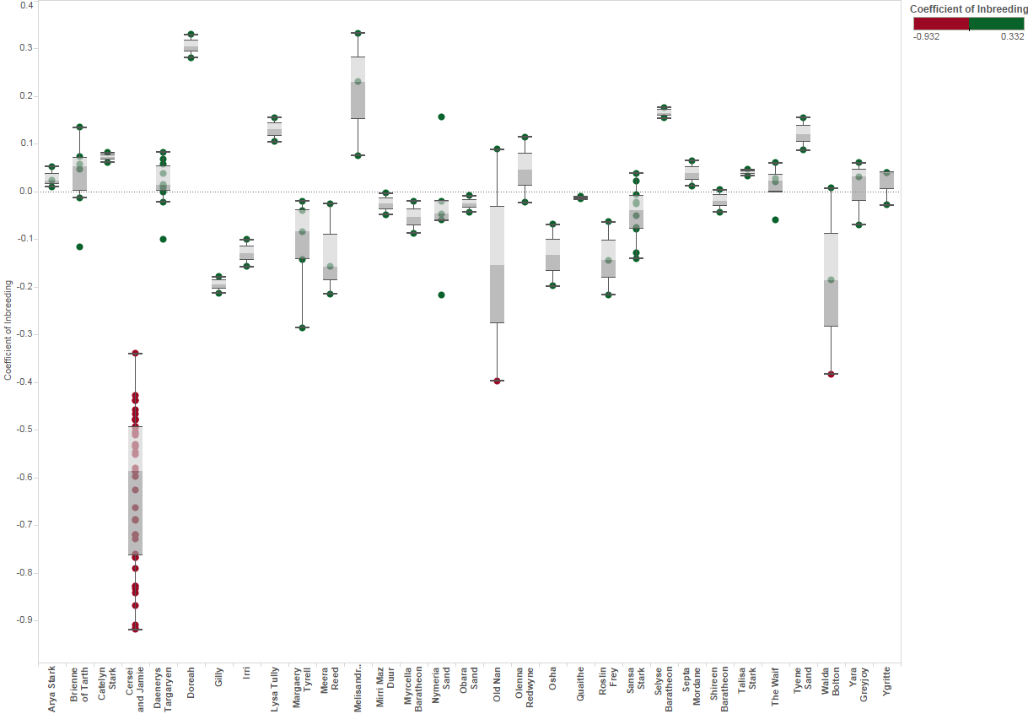

Coefficient of Inbreeding

It is apparent from the above plot that there is one outlier group with strongly negative inbreeding coefficients. These were omitted from the remaining analysis as they are likely outbred with Trout cod such that related incorrectly assigned them as siblings on the basis of alleles they have in common from Trout cod. These are likely the third and fourth generation hybrid larvae thet were not previously excluded from the data set. First and second generation hybrids and backcrosses had been excluded prioir to this analysis.

Pairing, whether sexually faithful or not, is very uncommon in fish and has not previously been confirmed in fish from seagrass habitats. Here, the first underwater study of seahorse reproduction reveals that males and females of an Australian species (Hippocampus whitei) form pairs that mate repeatedly and exclusively. Vincent ACJ., Sadler LM. 1995. Faithful pair bonds in wild seahorses, Hippocampus whitei. Animal Behaviour 50:1557–1569. DOI: 10.1016/0003-3472(95)80011-5.

This uses iGraph to plot relatedness between larvae within each year so as to identify full sibling pairs(FS) and perhaps half sibling pairs (HS). Unrelated (US) is also calculated by the 'r' package 'related'. However we are interested only in FS at this stage to identify common parents and to assist with determining the distance of larval dispersal.

The same is finally ploted for all three years combined.

First choose which estimatore we are to use. (see compareEstimators) The related package offers a choice of algorithms to use as estimators and provides a method to compare estimators using the relevant data to enhance selection.

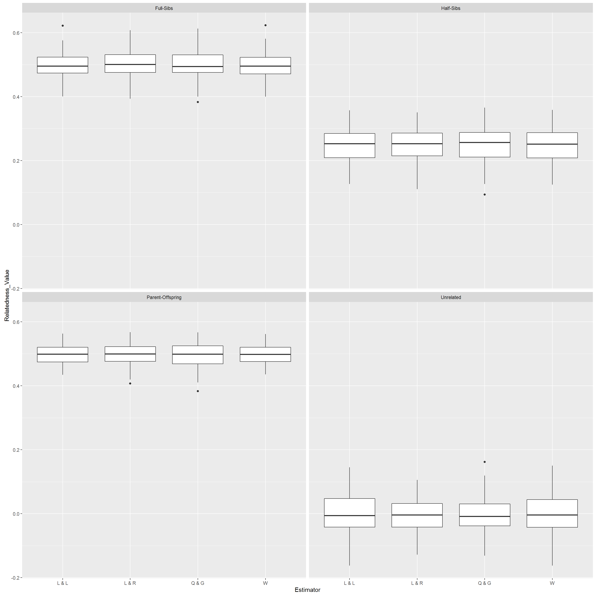

Related Estimators Performance

Given the large number of SNPS the estimator... The simulation provides After this the cutoff probabilities for the relatedness values need to be chosen. The cutoff points for the probability between assigning as full siblings or half siblings and the same distinction between half siblings and 'unrelated' can be selected from a density plot to minimise overlap.

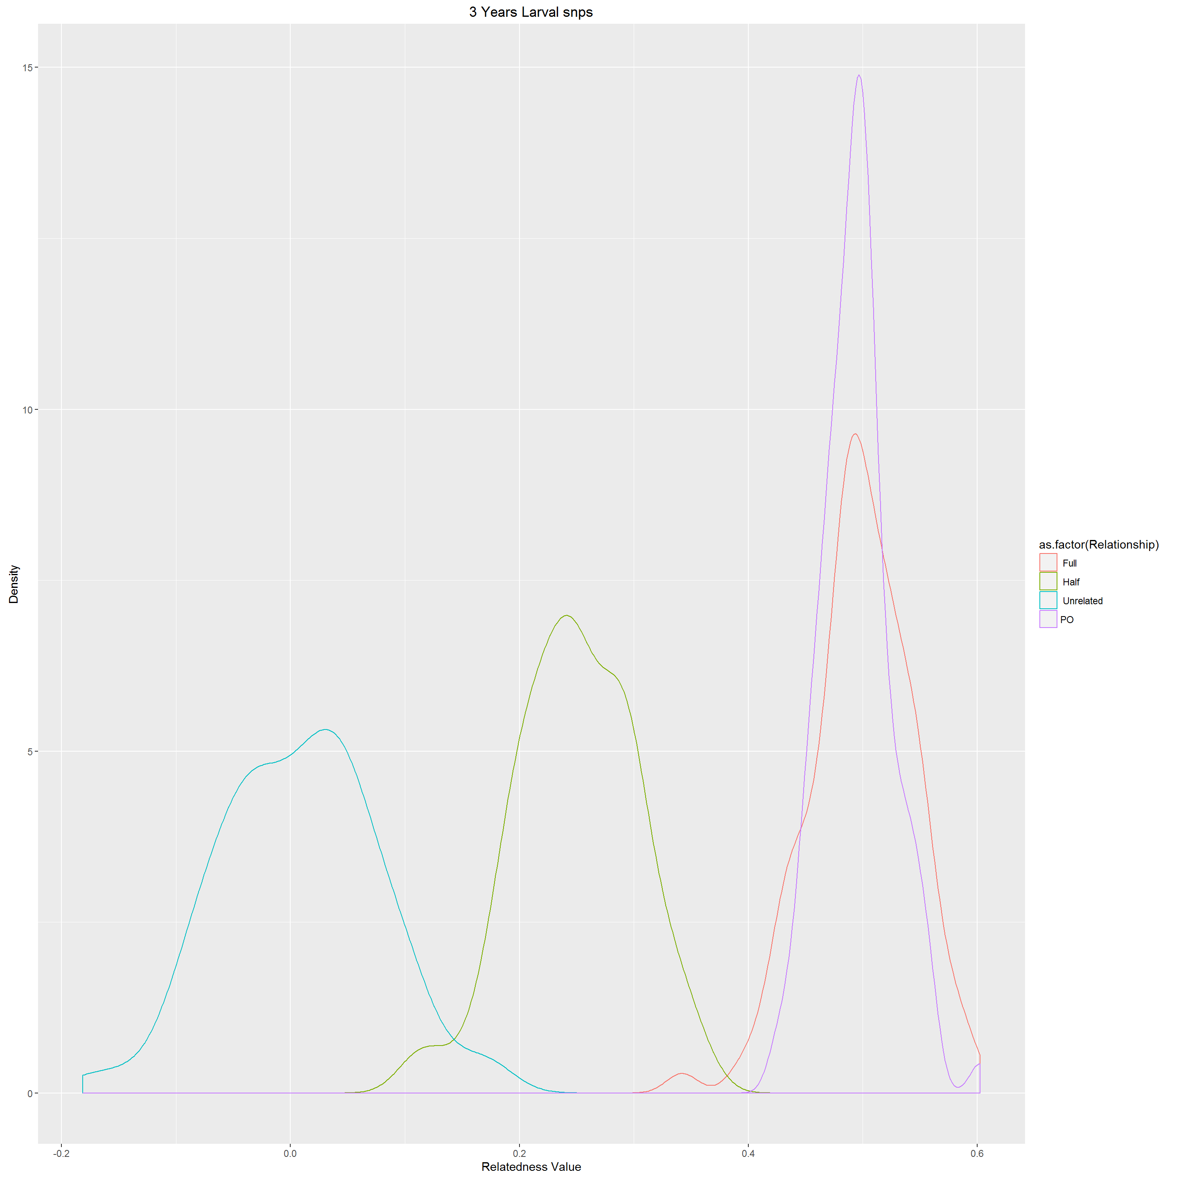

Setting Cutoff Probabilities for Relatedness

Given the large number of snps the cutoffs between classes of siblings are clear choices with little overlap. These are displayed for all years only as the results for each year individually produced results that differred in probability by less than 0.2. Given the probabilistic nature of the identification of sibling class, and the amount of overlap between classes there is no benefit in changing cutoffs for each years nomination of sibling class.

estimator=5 #5-trioml,6-wang,7-lynchli,8-lynchrd,9-ritland,10-quellergt,11-dyadml  
estimatorName="trioml" # change as needed with above  
#Also choose which cutoffs to use. These are dependant on density plots  
fshsCut<-0.4  
hsurCut<-0.17

Cuttoff for the classes were selected. Dyads with a relatedness probability above 0.4 were considered to be full siblings, and dyads with a relatedness probability between 0.17 and 0.4 were assigned as half siblings. Any dyad with a relatedness probability below 0.17 was consisent with the related package assigned as 'unrelated' although really they are merely less related and probably neither a full or half sibling.

# 2011 Larval Relatedness Plots

main="2011 Larval snps"  
fileName=paste("./outData/",main," coancestoryOutput", sep="")  
load(file = fileName)

require(igraph)  
relData <- output$relatedness[, c(2, 3, estimator)]  
hist(relData[, 3], main = "Histogram of estimator")

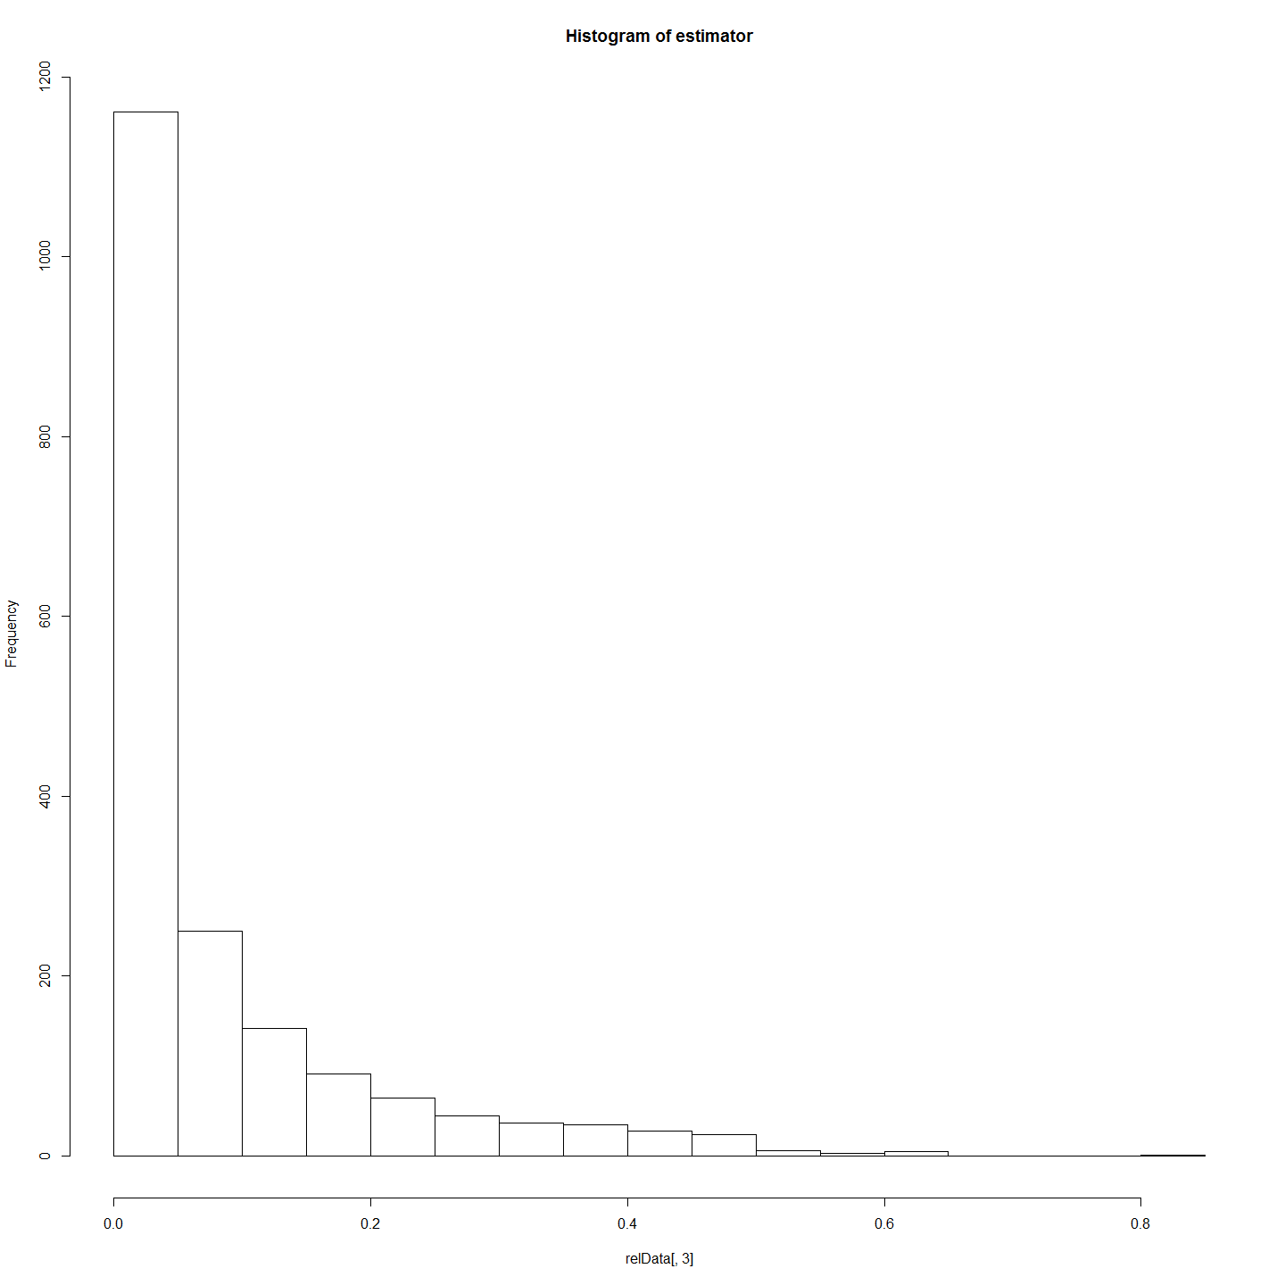

lrelData <- relData  
colnames(lrelData)[1] <- "from"  
colnames(lrelData)[2] <- "to"  
colnames(lrelData)[3] <- "weight"  
lrelData$type <- "probRel"  
relDataNoRows <- nrow(relData)  
nrelData <- data.frame(matrix(ncol = 4, nrow = relDataNoRows))  
colnames(nrelData) <- c("id", "name", "type", "label")  
nrelData[, 1] <- relData[, 2]  
nrelData[, 2] <- relData[, 2]  
newrow = c(relData[1, 1], relData[1, 1], NA, NA)  
nrelData = rbind(nrelData, newrow)  
nrow(nrelData)

## [1] 1892

length(unique(nrelData$id))

## [1] 62

nrow(lrelData)

## [1] 1891

nrow(unique(lrelData[, c("from", "to")]))

## [1] 1891

nrelData <- data.frame(unique(nrelData[, 1:4]))  
tst <- ifelse(grepl("^A", nrelData$id), nrelData$type <- "adult", nrelData$type <- "larvae")  
nrelData$type <- tst  
rm(tst)  
larvNrel <- merge(nrelData, larv, by.x = "id", by.y = "LarvalRecords_LarvaID")  
larvNrel <- larvNrel[, c(1:4, 66)]  
head(nrelData)

## id name type label  
## 1 71 71 larvae <NA>  
## 2 72 72 larvae <NA>  
## 3 73 73 larvae <NA>  
## 4 76 76 larvae <NA>  
## 5 75 75 larvae <NA>  
## 6 74 74 larvae <NA>

head(larvNrel)

## id name type label YearOnly  
## 1 100 100 larvae <NA> 2011  
## 2 101 101 larvae <NA> 2011  
## 3 103 103 larvae <NA> 2011  
## 4 104 104 larvae <NA> 2011  
## 5 105 105 larvae <NA> 2011  
## 6 107 107 larvae <NA> 2011

net <- graph_from_data_frame(d = lrelData, vertices = larvNrel, directed = FALSE)  
fileName = paste("./outData/", main, " net", sep = "", collapse = " ")  
save(net, file = fileName)

## Refine set and Plot relationships

fileName=paste("./outData/",main," net",sep="")  
load(file = fileName)  
  
#Limit to full siblings - this also makes it more sparse.  
net.FS <- delete_edges(net, E(net)[weight<fshsCut])  
l <- layout_with_fr(net.FS)  
  
V(net.FS)$color=V(net.FS)$YearOnly #assign the "YearOnly" attribute as the vertex color  
V(net.FS)$color=gsub("2011","indianred",V(net.FS)$color) #2011 will be red  
V(net.FS)$color=gsub("2012","lightgoldenrod1",V(net.FS)$color) #2012 will be blue  
V(net.FS)$color=gsub("2013","lightgreen",V(net.FS)$color) #2013 will be blue  
  
E(net.FS)$weight<-E(net.FS)$weight*5  
  
plot(net.FS, edge.arrow.size=0, edge.curved=0.2, vertex.size=5, vertex.color=V(net.FS)$color,vertex.frame.color="#555555",vertex.label=V(net)$name, vertex.label.color="black",vertex.label.cex=.7,edge.width=E(net.FS)$weight,layout=l)  
#removed main=main;added edge.width=E(net.FS)$weight  
title(paste(estimatorName,main),cex.main=3)  
legend(x=-1.5, y=-1.1, c("2011","2012", "2013"), pch=21,col="#777777", cex=.8, bty="n", ncol=1)

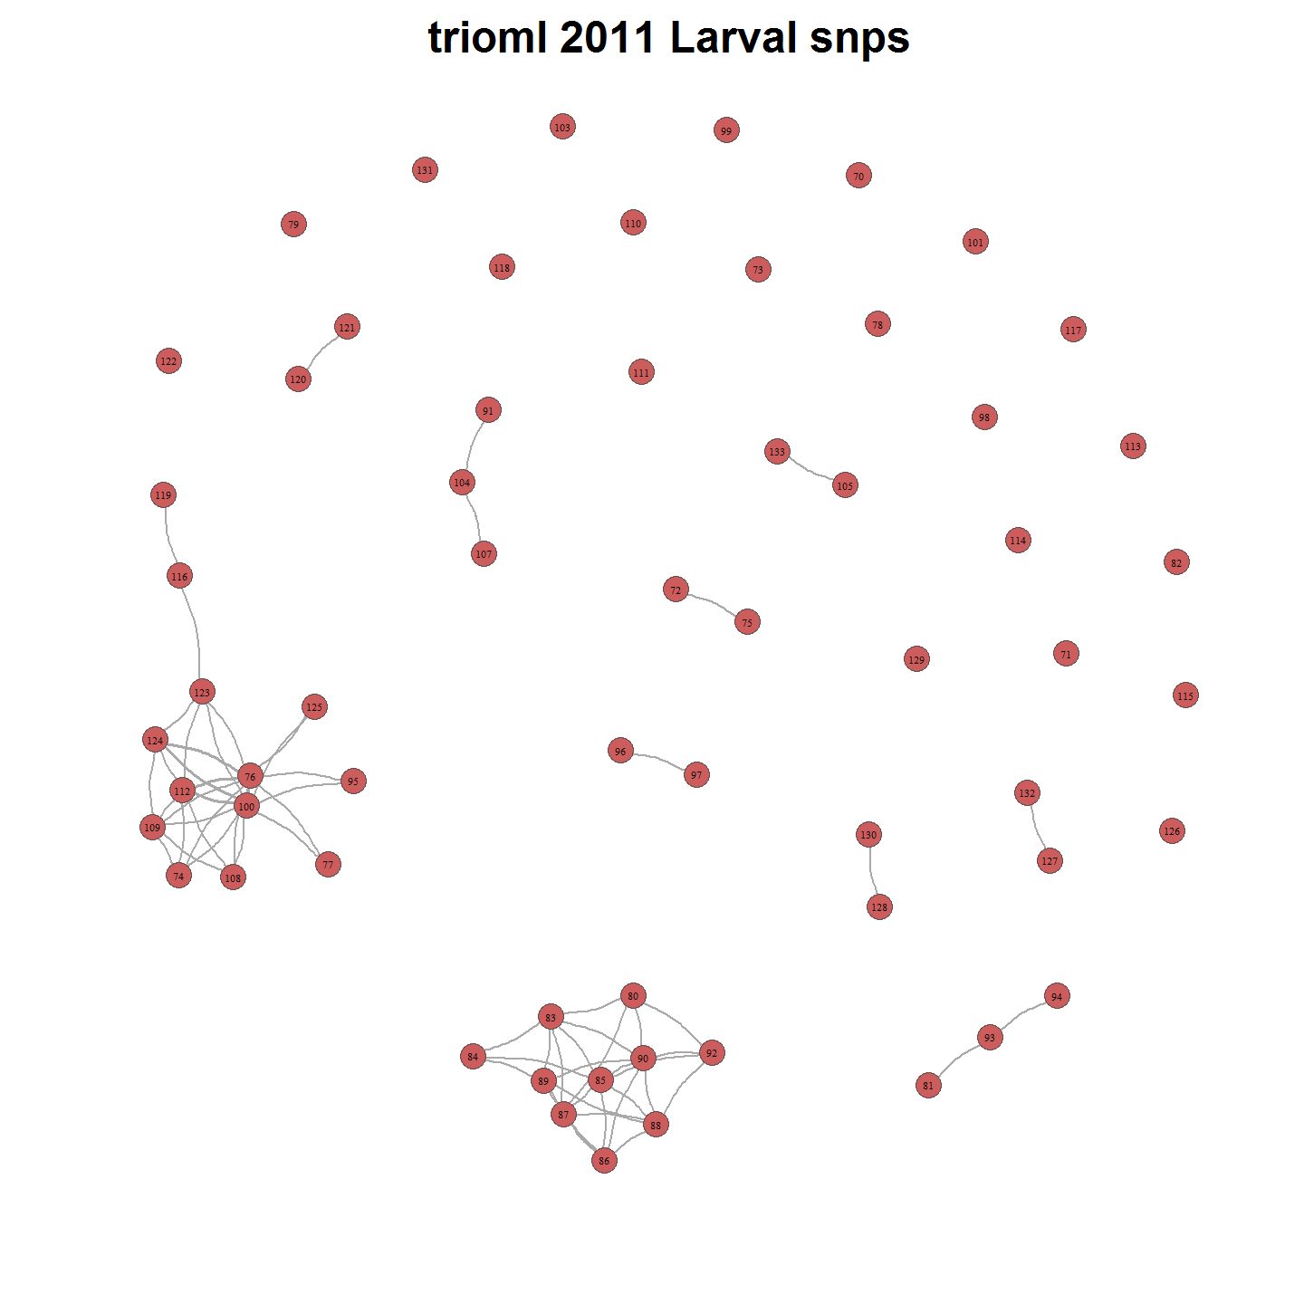

# 2012 Larval Relatedness Plots

main="2012 Larval snps"  
load(file = paste("./outData/",main," coancestoryOutput", sep=""))

require(igraph)  
relData <- output$relatedness[, c(2, 3, estimator)]  
hist(relData[, 3], main = "Histogram of estimator")

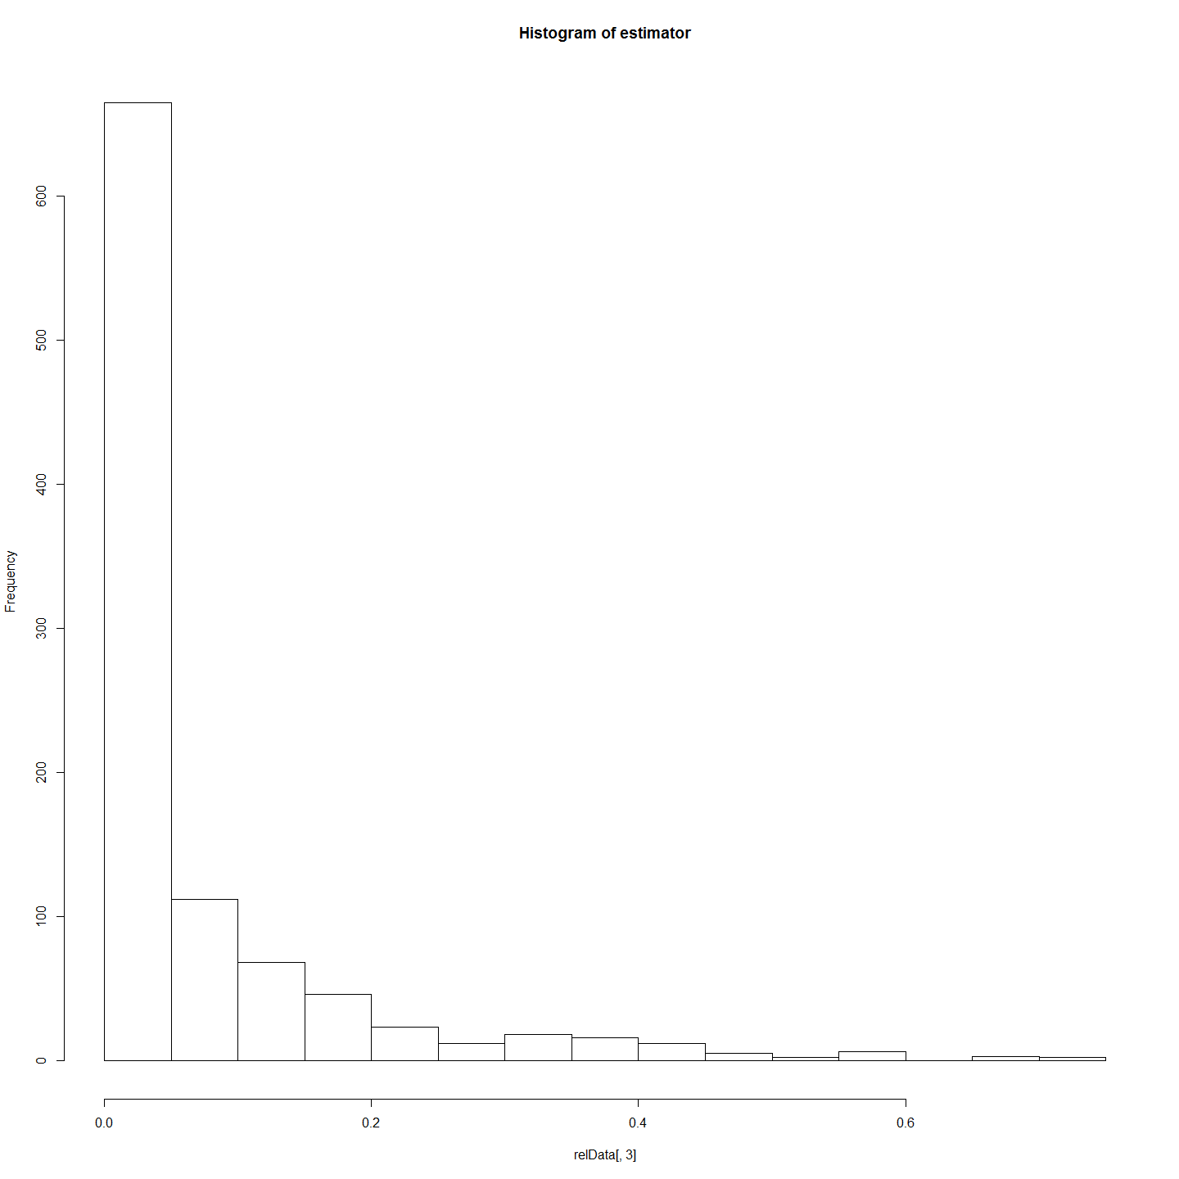

lrelData <- relData  
colnames(lrelData)[1] <- "from"  
colnames(lrelData)[2] <- "to"  
colnames(lrelData)[3] <- "weight"  
lrelData$type <- "probRel"  
relDataNoRows <- nrow(relData)  
nrelData <- data.frame(matrix(ncol = 4, nrow = relDataNoRows))  
colnames(nrelData) <- c("id", "name", "type", "label")  
nrelData[, 1] <- relData[, 2]  
nrelData[, 2] <- relData[, 2]  
newrow = c(relData[1, 1], relData[1, 1], NA, NA)  
nrelData = rbind(nrelData, newrow)  
nrow(nrelData)

## [1] 991

length(unique(nrelData$id))

## [1] 45

nrow(lrelData)

## [1] 990

nrow(unique(lrelData[, c("from", "to")]))

## [1] 990

nrelData <- data.frame(unique(nrelData[, 1:4]))  
tst <- ifelse(grepl("^A", nrelData$id), nrelData$type <- "adult", nrelData$type <- "larvae")  
nrelData$type <- tst  
rm(tst)  
larvNrel <- merge(nrelData, larv, by.x = "id", by.y = "LarvalRecords_LarvaID")  
larvNrel <- larvNrel[, c(1:4, 66)]  
head(nrelData)

## id name type label  
## 1 151 151 larvae <NA>  
## 2 157 157 larvae <NA>  
## 3 156 156 larvae <NA>  
## 4 155 155 larvae <NA>  
## 5 154 154 larvae <NA>  
## 6 153 153 larvae <NA>

head(larvNrel)

## id name type label YearOnly  
## 1 134 134 larvae <NA> 2012  
## 2 135 135 larvae <NA> 2012  
## 3 136 136 larvae <NA> 2012  
## 4 137 137 larvae <NA> 2012  
## 5 138 138 larvae <NA> 2012  
## 6 139 139 larvae <NA> 2012

net <- graph_from_data_frame(d = lrelData, vertices = larvNrel, directed = FALSE)  
fileName = paste("./outData/", main, " net", sep = "", collapse = " ")  
save(net, file = fileName)

## Refine set and Plot relationships

fileName=paste0("outData/",main," net",sep=" ")  
load(fileName)   
  
#Limit to full siblings - this also makes it more sparse.  
net.FS <- delete_edges(net, E(net)[weight<fshsCut])  
l <- layout_with_fr(net.FS)  
  
V(net.FS)$color=V(net.FS)$YearOnly #assign the "YearOnly" attribute as the vertex color  
V(net.FS)$color=gsub("2011","indianred",V(net.FS)$color) #2011 will be red  
V(net.FS)$color=gsub("2012","lightgoldenrod1",V(net.FS)$color) #2012 will be blue  
V(net.FS)$color=gsub("2013","lightgreen",V(net.FS)$color) #2013 will be blue  
  
E(net.FS)$weight<-E(net.FS)$weight*5  
  
plot(net.FS, edge.arrow.size=0, edge.curved=0.2, vertex.size=5, vertex.color=V(net.FS)$color,vertex.frame.color="#555555",vertex.label=V(net)$name, vertex.label.color="black",vertex.label.cex=.7,edge.width=E(net.FS)$weight,layout=l)  
#removed main=main;added edge.width=E(net.FS)$weight  
title(paste(estimatorName,main),cex.main=3)  
legend(x=-1.5, y=-1.1, c("2011","2012", "2013"), pch=21,col="#777777", cex=.8, bty="n", ncol=1)

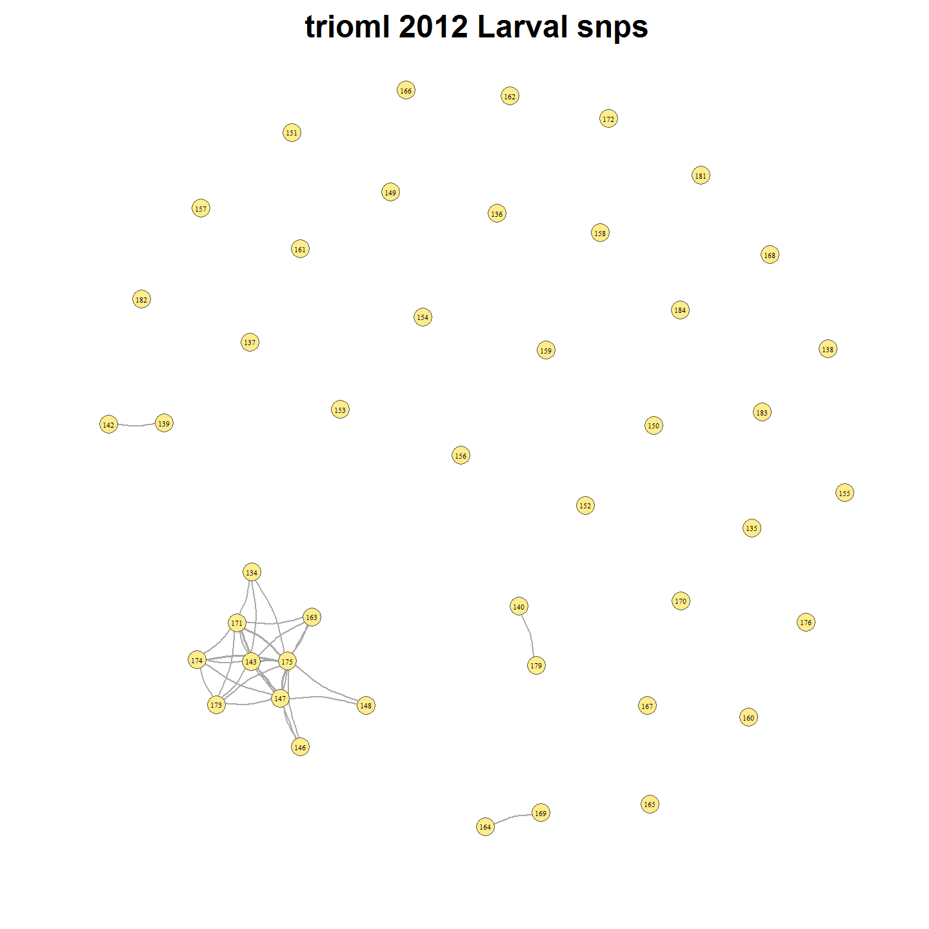

# 2013 Larval Relatedness Plots

main="2013 Larval snps"  
load(file = paste("./outData/",main," coancestoryOutput", sep=""))

require(igraph)  
relData <- output$relatedness[, c(2, 3, estimator)]  
hist(relData[, 3], main = "Histogram of estimator")

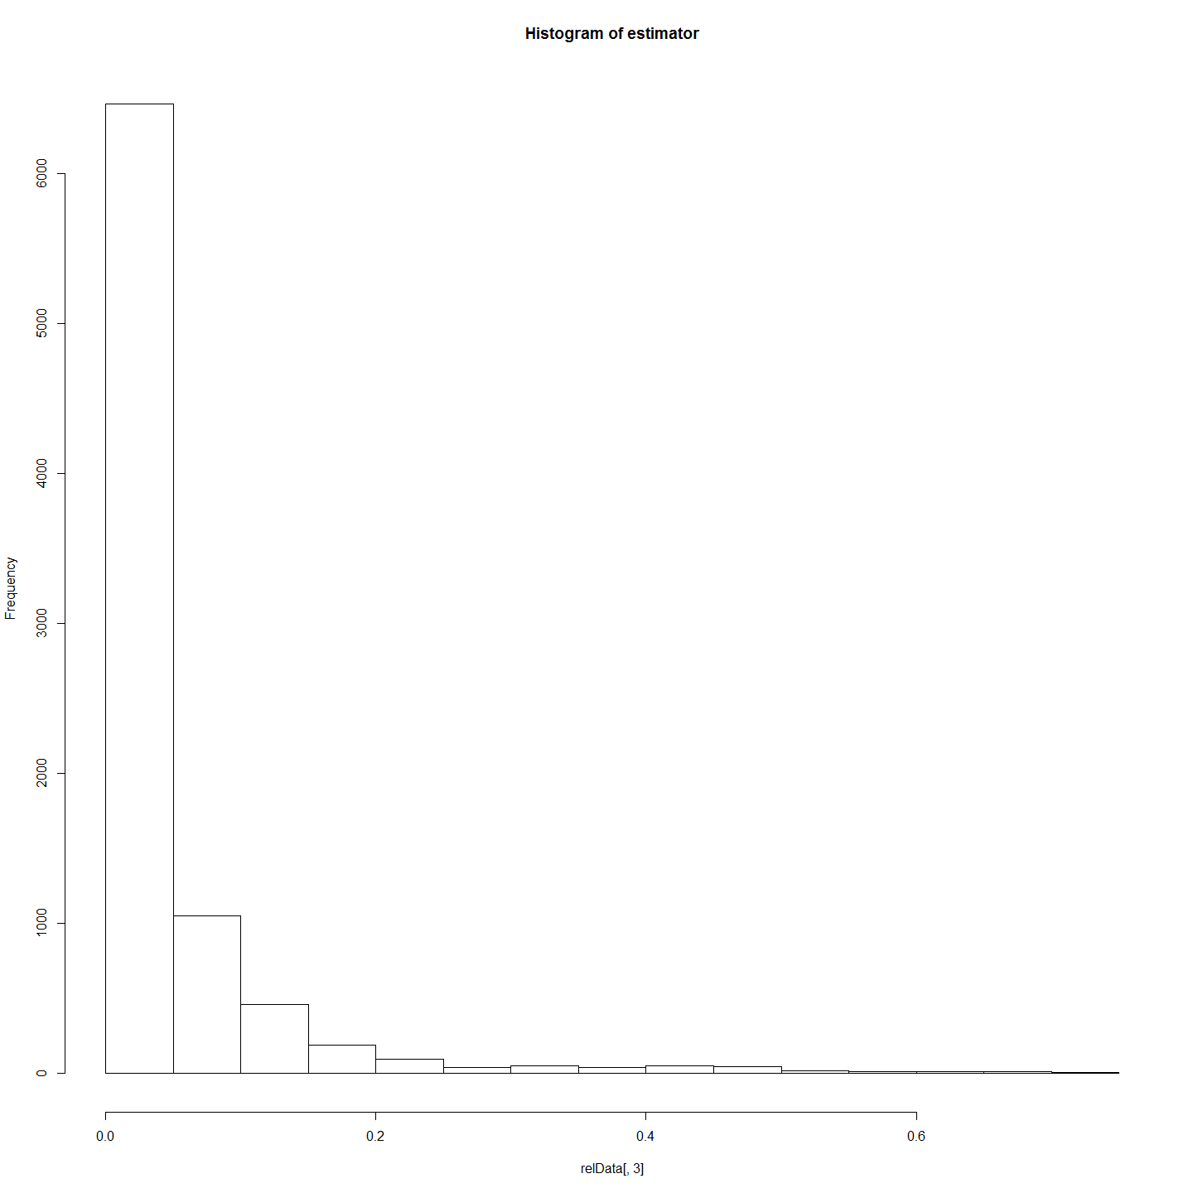

lrelData <- relData  
colnames(lrelData)[1] <- "from"  
colnames(lrelData)[2] <- "to"  
colnames(lrelData)[3] <- "weight"  
lrelData$type <- "probRel"  
relDataNoRows <- nrow(relData)  
nrelData <- data.frame(matrix(ncol = 4, nrow = relDataNoRows))  
colnames(nrelData) <- c("id", "name", "type", "label")  
nrelData[, 1] <- relData[, 2]  
nrelData[, 2] <- relData[, 2]  
newrow = c(relData[1, 1], relData[1, 1], NA, NA)  
nrelData = rbind(nrelData, newrow)  
nrow(nrelData)

## [1] 8516

length(unique(nrelData$id))

## [1] 131

nrow(lrelData)

## [1] 8515

nrow(unique(lrelData[, c("from", "to")]))

## [1] 8515

nrelData <- data.frame(unique(nrelData[, 1:4]))  
tst <- ifelse(grepl("^A", nrelData$id), nrelData$type <- "adult", nrelData$type <- "larvae")  
nrelData$type <- tst  
rm(tst)  
larvNrel <- merge(nrelData, larv, by.x = "id", by.y = "LarvalRecords_LarvaID")  
larvNrel <- larvNrel[, c(1:4, 66)]  
head(nrelData)

## id name type label  
## 1 186 186 larvae <NA>  
## 2 187 187 larvae <NA>  
## 3 188 188 larvae <NA>  
## 4 189 189 larvae <NA>  
## 5 190 190 larvae <NA>  
## 6 191 191 larvae <NA>

head(larvNrel)

## id name type label YearOnly  
## 1 185 185 larvae <NA> 2013  
## 2 186 186 larvae <NA> 2013  
## 3 187 187 larvae <NA> 2013  
## 4 188 188 larvae <NA> 2013  
## 5 189 189 larvae <NA> 2013  
## 6 190 190 larvae <NA> 2013

net <- graph_from_data_frame(d = lrelData, vertices = larvNrel, directed = FALSE)  
fileName = paste("./outData/", main, " net", sep = "", collapse = " ")  
save(net, file = fileName)

## Refine set and Plot relationships

fileName=paste("./outData/",main," net",sep="")  
load(file = fileName)  
#Limit to full siblings - this also makes it more sparse.  
net.FS <- delete_edges(net, E(net)[weight<fshsCut])  
l <- layout_with_fr(net.FS)  
  
V(net.FS)$color=V(net.FS)$YearOnly #assign the "YearOnly" attribute as the vertex color  
V(net.FS)$color=gsub("2011","indianred",V(net.FS)$color) #2011 will be red  
V(net.FS)$color=gsub("2012","lightgoldenrod1",V(net.FS)$color) #2012 will be blue  
V(net.FS)$color=gsub("2013","lightgreen",V(net.FS)$color) #2013 will be blue  
  
E(net.FS)$weight<-E(net.FS)$weight*5  
  
plot(net.FS, edge.arrow.size=0, edge.curved=0.2, vertex.size=5, vertex.color=V(net.FS)$color,vertex.frame.color="#555555",vertex.label=V(net)$name, vertex.label.color="black",vertex.label.cex=.7,edge.width=E(net.FS)$weight,layout=l)  
#removed main=main;added edge.width=E(net.FS)$weight  
title(paste(estimatorName,main),cex.main=3)  
legend(x=-1.5, y=-1.1, c("2011","2012", "2013"), pch=21,col="#777777", cex=.8, bty="n", ncol=1)

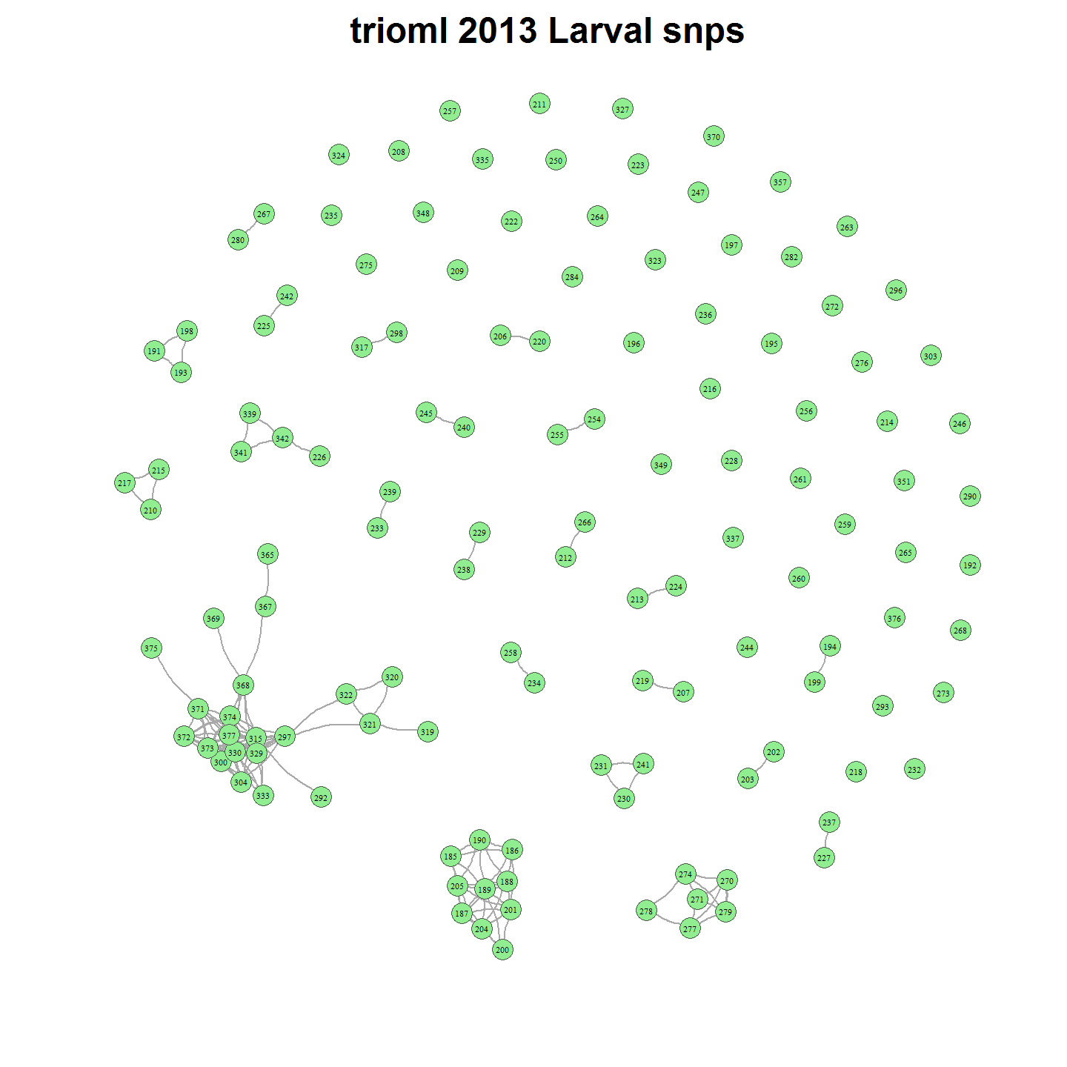

# 2011-2013 Larval Relatedness Plots

main="2011-2013 Larval snps"  
load(file = paste("./outData/",main," coancestoryOutput", sep=""))

require(igraph)  
relData <- output$relatedness[, c(2, 3, estimator)]  
hist(relData[, 3], main = "Histogram of estimator")

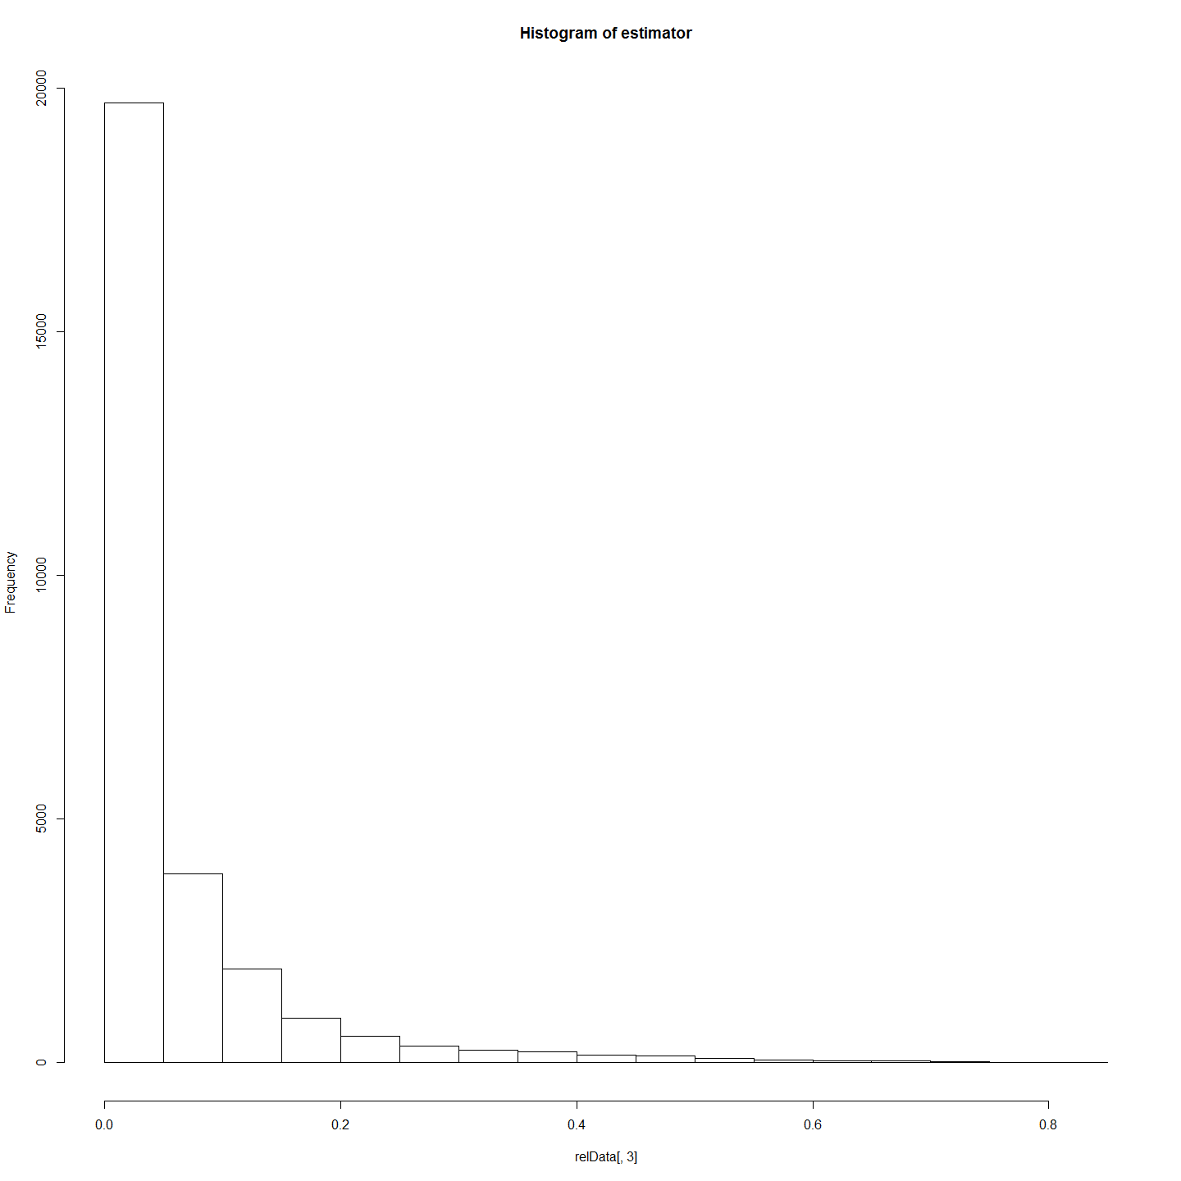

lrelData <- relData  
colnames(lrelData)[1] <- "from"  
colnames(lrelData)[2] <- "to"  
colnames(lrelData)[3] <- "weight"  
lrelData$type <- "probRel"  
relDataNoRows <- nrow(relData)  
nrelData <- data.frame(matrix(ncol = 4, nrow = relDataNoRows))  
colnames(nrelData) <- c("id", "name", "type", "label")  
nrelData[, 1] <- relData[, 2]  
nrelData[, 2] <- relData[, 2]  
newrow = c(relData[1, 1], relData[1, 1], NA, NA)  
nrelData = rbind(nrelData, newrow)  
nrow(nrelData)

## [1] 28204

length(unique(nrelData$id))

## [1] 238

nrow(lrelData)

## [1] 28203

nrow(unique(lrelData[, c("from", "to")]))

## [1] 28203

nrelData <- data.frame(unique(nrelData[, 1:4]))  
tst <- ifelse(grepl("^A", nrelData$id), nrelData$type <- "adult", nrelData$type <- "larvae")  
nrelData$type <- tst  
rm(tst)  
larvNrel <- merge(nrelData, larv, by.x = "id", by.y = "LarvalRecords_LarvaID")  
larvNrel <- larvNrel[, c(1:4, 66)]  
head(nrelData)

## id name type label  
## 1 186 186 larvae <NA>  
## 2 187 187 larvae <NA>  
## 3 188 188 larvae <NA>  
## 4 189 189 larvae <NA>  
## 5 190 190 larvae <NA>  
## 6 191 191 larvae <NA>

head(larvNrel)

## id name type label YearOnly  
## 1 100 100 larvae <NA> 2011  
## 2 101 101 larvae <NA> 2011  
## 3 103 103 larvae <NA> 2011  
## 4 104 104 larvae <NA> 2011  
## 5 105 105 larvae <NA> 2011  
## 6 107 107 larvae <NA> 2011

net <- graph_from_data_frame(d = lrelData, vertices = larvNrel, directed = FALSE)  
fileName = paste("./outData/", main, " net", sep = "", collapse = " ")  
save(net, file = fileName)

## Refine set and Plot relationships

fileName=paste("./outData/",main," net",sep="")  
load(file = fileName)  
#Limit to full siblings - this also makes it more sparse.  
net.FS <- delete_edges(net, E(net)[weight<fshsCut])  
l <- layout_with_fr(net.FS)  
  
V(net.FS)$color=V(net.FS)$YearOnly #assign the "YearOnly" attribute as the vertex color  
V(net.FS)$color=gsub("2011","indianred",V(net.FS)$color) #2011 will be red  
V(net.FS)$color=gsub("2012","lightgoldenrod1",V(net.FS)$color) #2012 will be blue  
V(net.FS)$color=gsub("2013","lightgreen",V(net.FS)$color) #2013 will be blue  
  
E(net.FS)$weight<-E(net.FS)$weight*5  
  
plot(net.FS, edge.arrow.size=0, edge.curved=0.2, vertex.size=5, vertex.color=V(net.FS)$color,vertex.frame.color="#555555",vertex.label=V(net)$name, vertex.label.color="black",vertex.label.cex=.7,edge.width=E(net.FS)$weight,layout=l)  
#removed main=main;added edge.width=E(net.FS)$weight  
title(paste(estimatorName,main),cex.main=3)  
legend(x=-1.5, y=-1.1, c("2011","2012", "2013"), pch=21,col="#777777", cex=.8, bty="n", ncol=1)

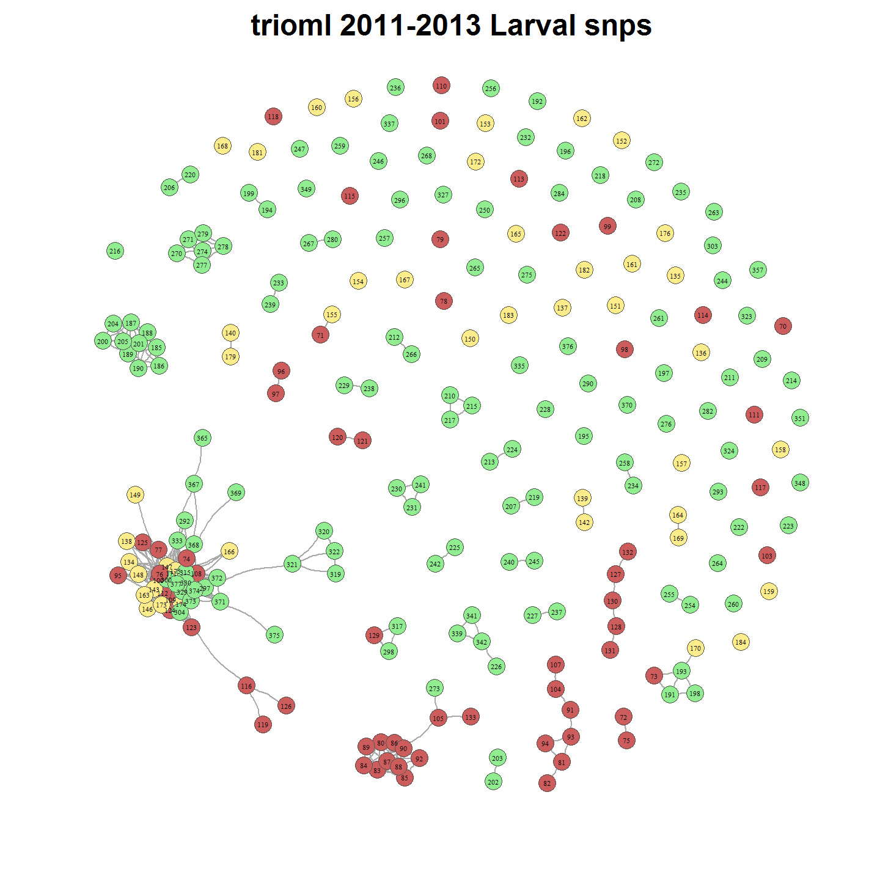

# 2011-2013 Larvae Relatedness with Adults

main="2011-2013 Larval snps with Adults"  
load(file = paste("./outData/",main," coancestoryOutput", sep=""))

require(igraph)  
relData <- output$relatedness[, c(2, 3, estimator)]  
hist(relData[, 3])

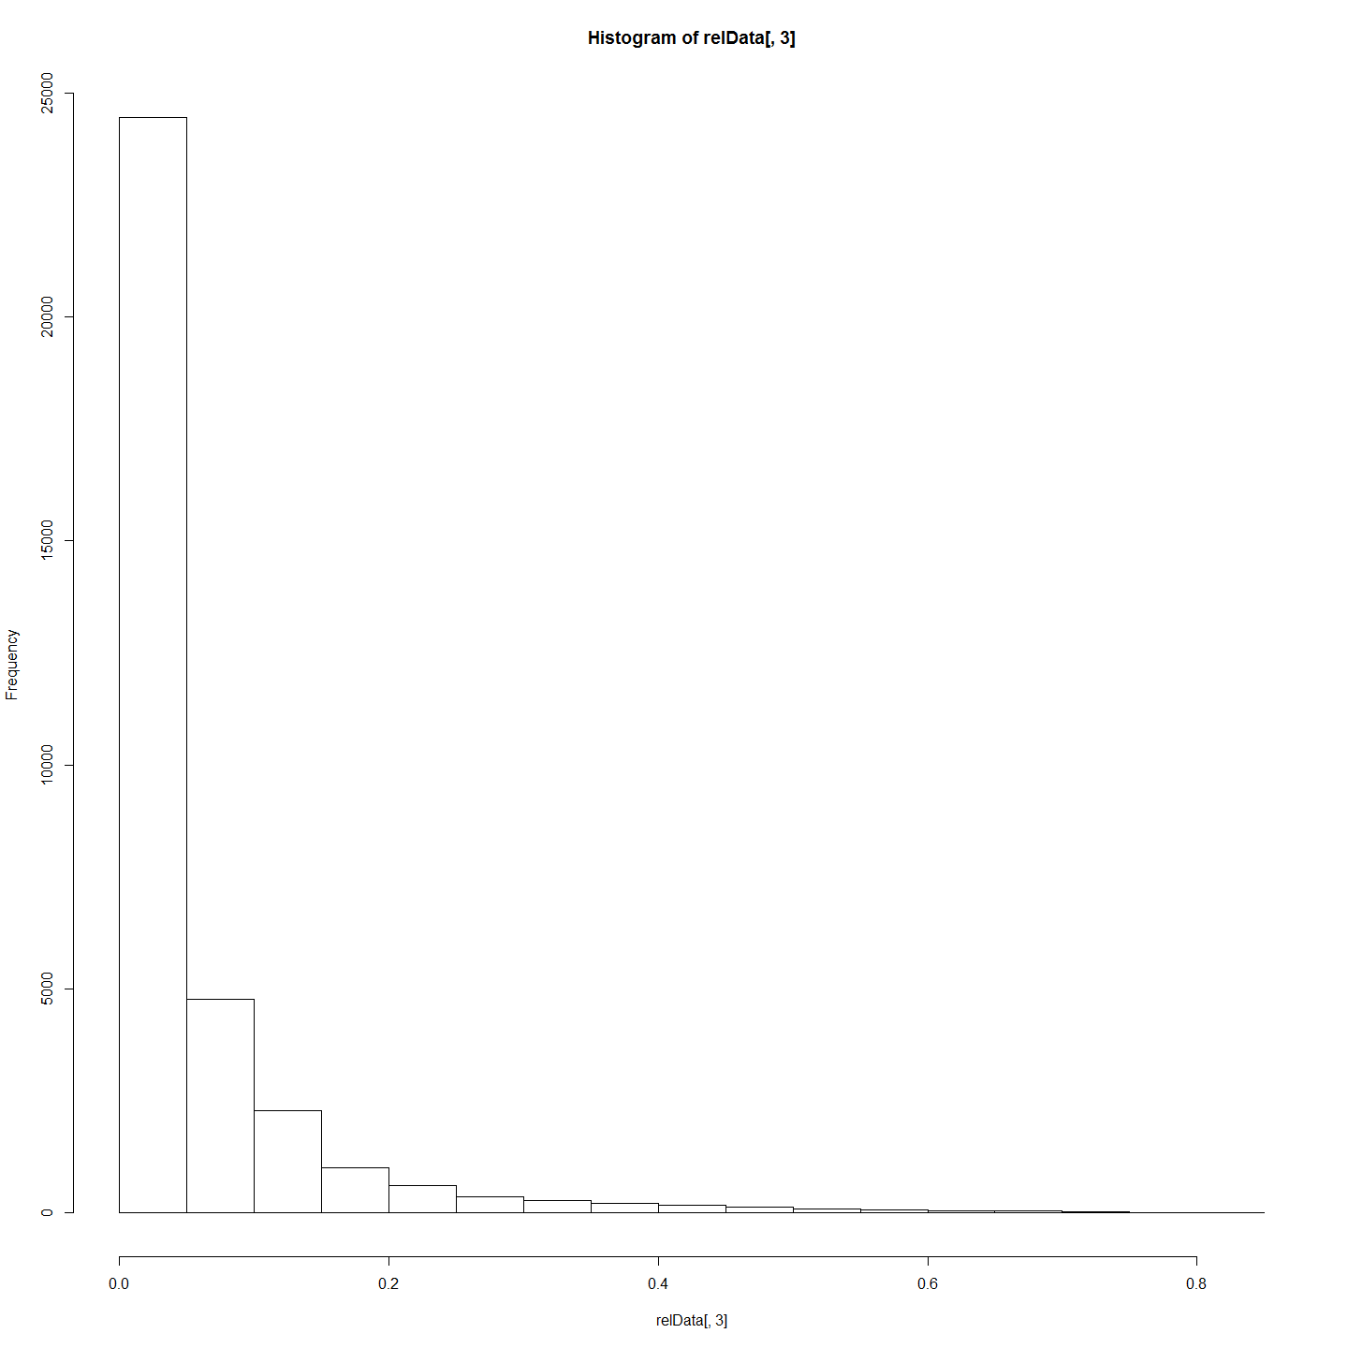

lrelData <- relData  
colnames(lrelData)[1] <- "from"  
colnames(lrelData)[2] <- "to"  
colnames(lrelData)[3] <- "weight"  
lrelData$type <- "probRel"  
relDataNoRows <- nrow(relData)  
nrelData <- data.frame(matrix(ncol = 4, nrow = relDataNoRows))  
colnames(nrelData) <- c("id", "name", "type", "label")  
nrelData[, 1] <- relData[, 2]  
nrelData[, 2] <- relData[, 2]  
newrow = c(relData[1, 1], relData[1, 1], NA, NA)  
nrelData = rbind(nrelData, newrow)  
nrow(nrelData)

## [1] 34454

length(unique(nrelData$id))

## [1] 263

nrow(lrelData)

## [1] 34453

nrow(unique(lrelData[, c("from", "to")]))

## [1] 34453

nrelData <- data.frame(unique(nrelData[, 1:4]))  
tst <- ifelse(grepl("^A", nrelData$id), nrelData$type <- "adult", nrelData$type <- "larvae")  
nrelData$type <- tst  
rm(tst)  
larvNrel <- merge(nrelData, qslMetaLarvAndAdultsUnion, by = "id")  
head(nrelData)

## id name type label  
## 1 186 186 larvae <NA>  
## 2 187 187 larvae <NA>  
## 3 188 188 larvae <NA>  
## 4 189 189 larvae <NA>  
## 5 190 190 larvae <NA>  
## 6 191 191 larvae <NA>

head(larvNrel)

## id name type label pop YearOnly hatchDoY lat lon Site.Name catchDoY estimatedAge mother father  
## 1 100 100 larvae <NA> M. peelii 2011 309.1240 -35.43 149.07 Murramore 326 9.39 MH6 FH6  
## 2 101 101 larvae <NA> M. peelii 2011 309.8434 -35.43 149.07 Murramore 326 8.67   
## 3 103 103 larvae <NA> M. peelii 2011 297.4343 -35.43 149.07 Murramore 326 21.08   
## 4 104 104 larvae <NA> M. peelii 2011 308.7643 -35.43 149.07 Murramore 326 9.75 MH6 FH6  
## 5 105 105 larvae <NA> M. peelii 2011 318.9451 -35.43 149.07 Murramore 340 11.73 Gilly Samwell  
## 6 107 107 larvae <NA> M. peelii 2011 309.6635 -35.43 149.07 Murramore 326 8.85 MH6 FH6

net <- graph_from_data_frame(d = lrelData, vertices = nrelData, directed = FALSE)  
fileName = paste("./outData/", main, " net", sep = "", collapse = " ")  
save(net, file = fileName)

## Refine set and Plot relationships

fileName=paste("./outData/","2011-2013 Larval snps with Adults"," net",sep="")  
load(file = fileName)  
#Limit to full siblings - this also makes it more sparse.  
net.FS <- delete_edges(net, E(net)[weight<fshsCut])  
l <- layout_with_fr(net.FS)  
  
plot(net.FS, edge.arrow.size=0, edge.curved=0, vertex.size=5,vertex.color=c("orange", "cyan")[(V(net.FS)$type=="larvae")+1], vertex.frame.color="#555555",vertex.label=V(net)$name, vertex.label.color="black",vertex.label.cex=.7,layout=l)  
title(paste(estimatorName,main),cex.main=3)

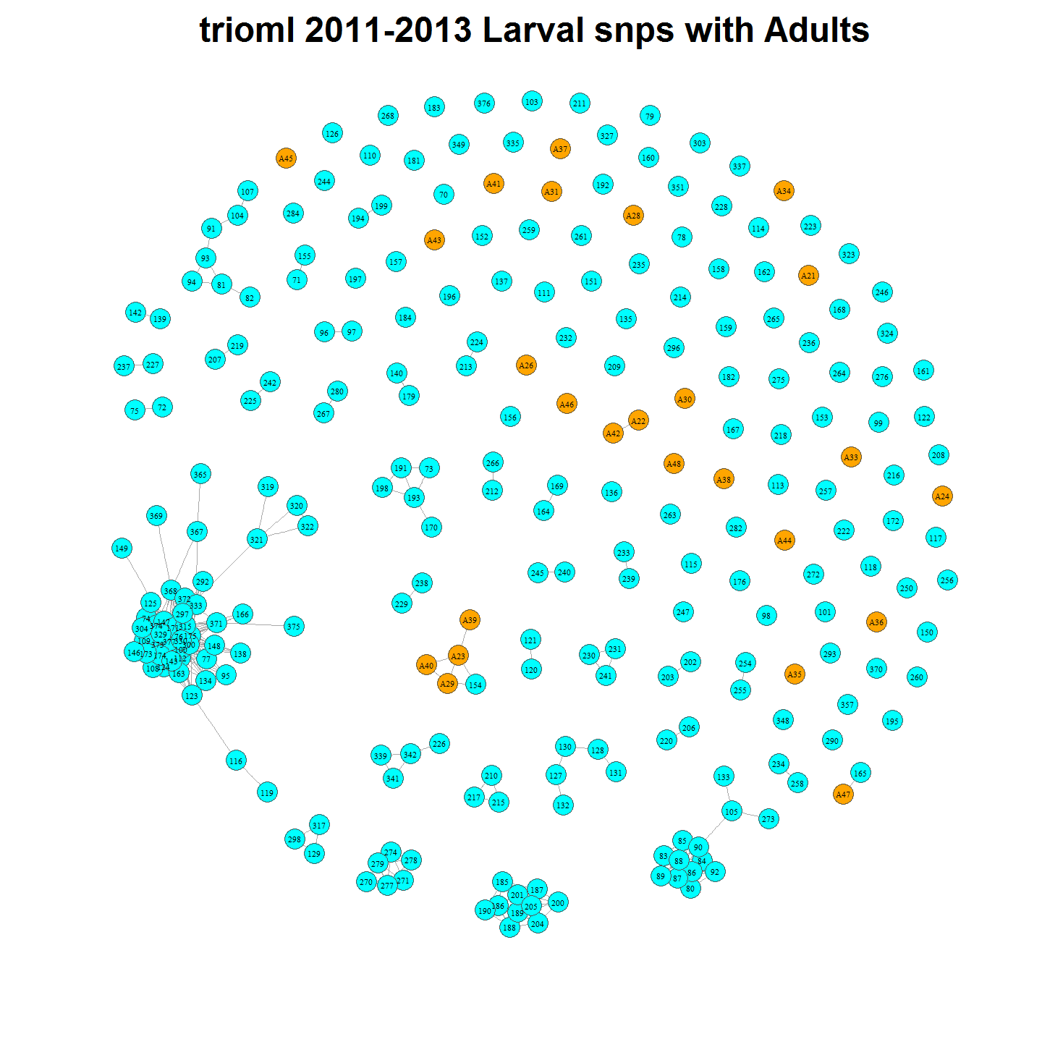

# 2011-2013 Larvae with Parents

# Nominating Parents - ? or method?

#Prepare data  
prelDataA<-cbind(larvNrel[,c(1,13)],rep("1",nrow(larvNrel)),rep("mother",nrow(larvNrel)))  
  
colnames(prelDataA)[1]<-"from"  
colnames(prelDataA)[2]<-"to"  
colnames(prelDataA)[3]<-"weight"  
colnames(prelDataA)[4]<-"type"  
  
prelDataB<-cbind(larvNrel[,c(1,14)],rep("1",nrow(larvNrel)),rep("father",nrow(larvNrel)))  
colnames(prelDataB)[1]<-"from"  
colnames(prelDataB)[2]<-"to"  
colnames(prelDataB)[3]<-"weight"  
colnames(prelDataB)[4]<-"type"  
prelData<-rbind(prelDataA,prelDataB)  
prelData[prelData==""] <- NA  
rm(prelDataB);rm(prelDataA)  
tmp<-prelData[complete.cases(prelData),]  
  
#Create Vertices Data Frame  
prelVert <- data.frame(matrix(ncol = 4, nrow = nrow(tmp)))  
colnames(prelVert) <- c("id", "name", "type", "label")  
  
prelVert$id<-tmp$to  
prelVert$name<-tmp$to  
prelVert$type<-tmp$type  
prelVert<-rbind(prelVert, nrelData)  
prelVert<-unique(prelVert)  
  
  
prelData<-prelData[complete.cases(prelData),]  
  
prelData <- subset(prelData, !from == 177) #these line needed to remove a few potential contaminants  
prelData <- subset(prelData, !from == 314) #although I doubt there was actually contam as the otherhs are the same.  
prelData <- subset(prelData, !from == 366)  
  
  
require(igraph)  
net.parents<-graph_from_data_frame(d=prelData, vertices=prelVert, directed=FALSE)  
  
l <- layout_with_fr(net.parents)  
  
#Colour vertices :parents and larvae  
V(net.parents)$color=V(net.parents)$type #assign the "type" attribute as the vertex color then assign a colour based on that type.  
V(net.parents)$color=gsub("mother","lightpink",V(net.parents)$color)  
V(net.parents)$color=gsub("father","lightblue",V(net.parents)$color)  
V(net.parents)$color=gsub("larvae","lightgreen",V(net.parents)$color)  
V(net.parents)$color=gsub("adult","orange",V(net.parents)$color)  
  
plot(net.parents, edge.arrow.size=0, edge.curved=0, vertex.size=5, vertex.color=V(net.parents)$color,vertex.frame.color="#555555",vertex.label=V(net.parents)$name, vertex.label.color="black",vertex.label.cex=.7,layout=l, main = "Full Siblings With Parents")

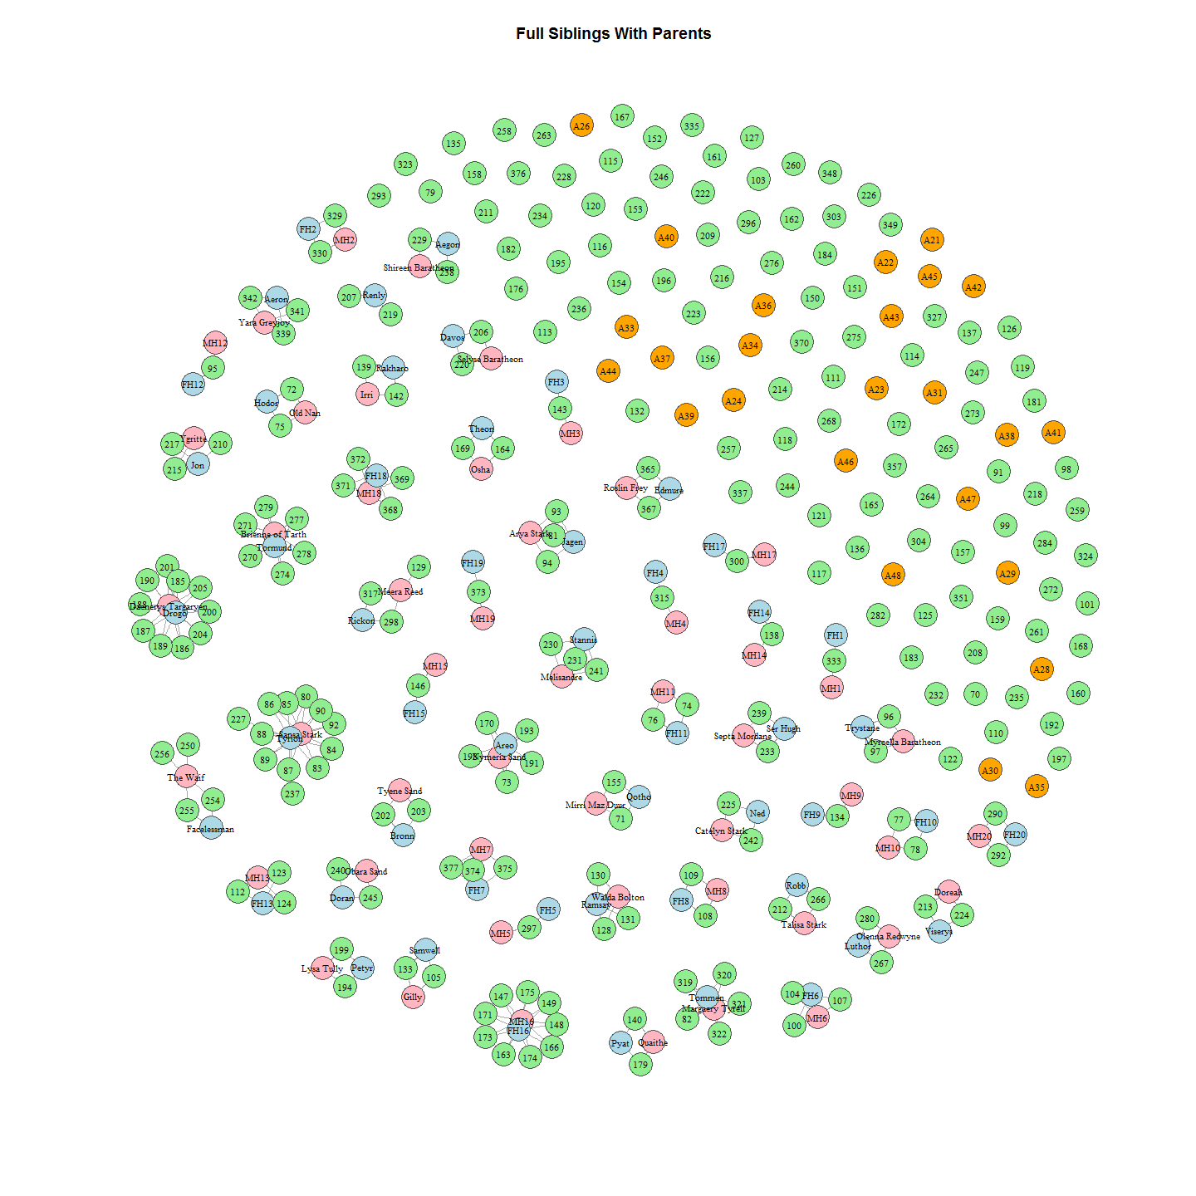

# 2011-2013 With Parents and half-sibling links

Half siblings can help us identify parents in common.

##Now to add in sib weights so we can include half sibs and exclude full sib edges.  
prelData$weight<-as.numeric(as.character(prelData$weight))  
allData<-rbind(prelData, lrelData)  
allData<-allData[complete.cases(allData),]  
net.all<-graph_from_data_frame(d=allData, vertices=prelVert, directed=FALSE)  
  
#set parmeters for edges to delete (so they dont show and clutter the graph)  
net.all <- delete_edges(net.all, E(net.all)[weight>0.379])  
net.all <- delete_edges(net.all, E(net.all)[weight<0.2])  
  
#to colour half sibling edges according to weight   
E(net.all)[ weight > .34 ]$color <- "darkgreen"  
E(net.all)[ weight < .3 ]$color <- "green"  
E(net.all)[ weight < .24 ]$color <- "yellow"  
  
#to colour parents and larvae  
V(net.all)$color=V(net.all)$type #assign the "type" attribute as the vertex color  
V(net.all)$color=gsub("mother","lightpink",V(net.all)$color) #mums will be pink  
V(net.all)$color=gsub("father","lightblue",V(net.all)$color) #dads will be blue  
V(net.all)$color=gsub("larvae","lightgreen",V(net.all)$color) #larvae will be green  
V(net.all)$color=gsub("adult","orange",V(net.all)$color) #adult will be orange  
  
plot(net.all, edge.arrow.size=0, edge.curved=0, vertex.size=5, vertex.color=V(net.all)$color,vertex.frame.color="#555555",vertex.label=V(net.all)$name, vertex.label.color="black",vertex.label.cex=.7,layout=l, main = "Half Siblings With Parents")

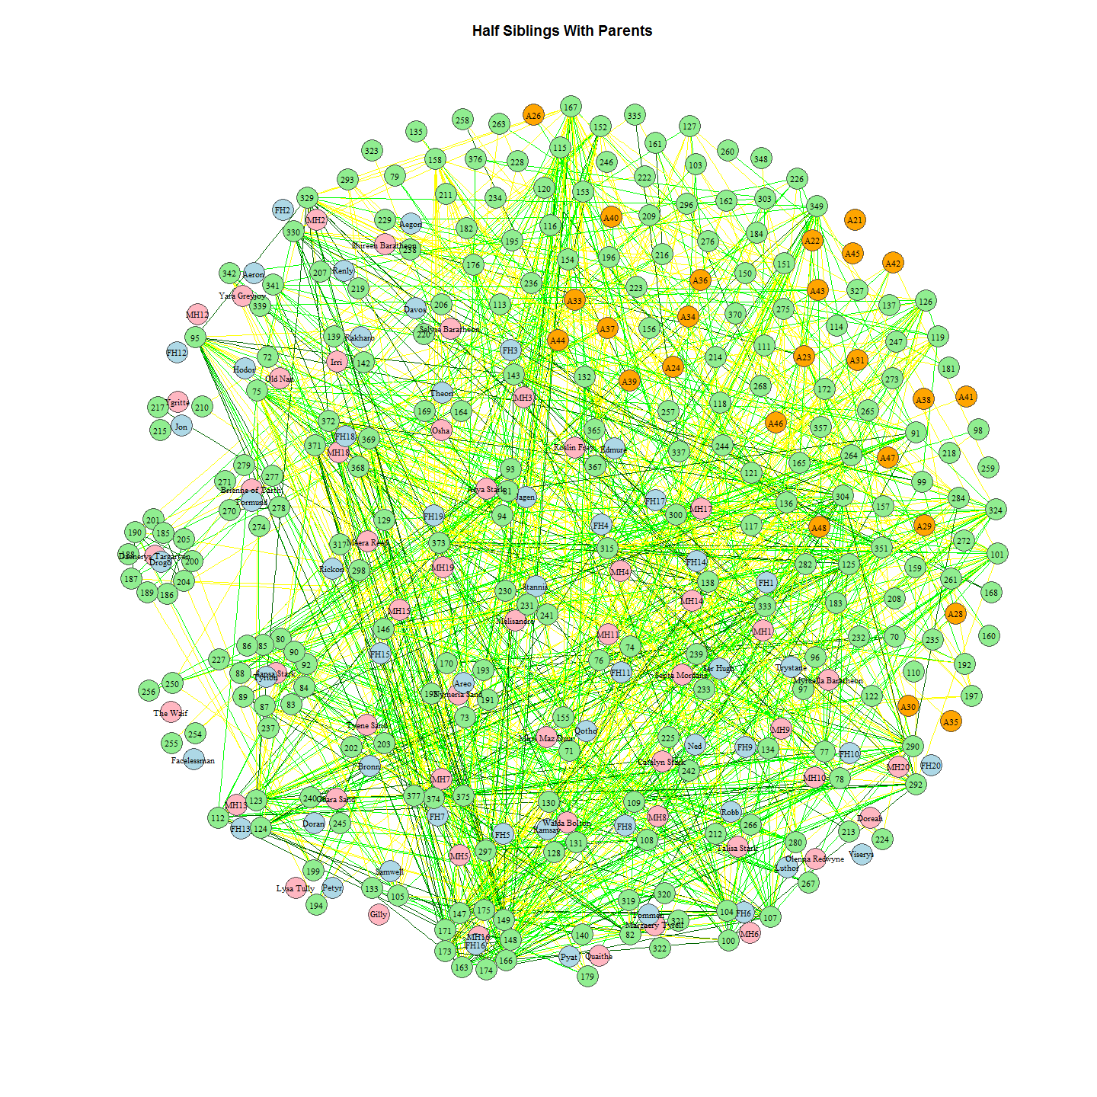

## Half sibs coloured by Year

#Now another look coloured by Years  
net.all<-graph_from_data_frame(d=allData, vertices=prelVert, directed=FALSE)  
  
#set parmeters for edges to delete (so they dont show and clutter the graph)  
net.all <- delete_edges(net.all, E(net.all)[weight>0.379])  
net.all <- delete_edges(net.all, E(net.all)[weight<0.2])  
  
#to colour half sibling edges according to weight   
E(net.all)[ weight > .34 ]$color <- "darkgreen"  
E(net.all)[ weight < .3 ]$color <- "green"  
E(net.all)[ weight < .24 ]$color <- "yellow"  
  
#to colour vertices by yearsparents and larvae  
V(net.all)$color=gsub("mother","lightpink",V(net.all)$color) #mums will be pink  
V(net.all)$color=gsub("father","lightblue",V(net.all)$color) #dads will be blue  
V(net.all)[name<134]$color<-"red"#2011 will be red  
V(net.all)[name>133]$color<-"yellow"#2012 will be yellow  
V(net.all)[name>184]$color<-"lightgreen" #2013 will be green  
  
  
plot(net.all, edge.arrow.size=0, edge.curved=0, vertex.size=5, vertex.color=V(net.all)$color,vertex.frame.color="#555555",vertex.label=V(net.all)$name, vertex.label.color="black",vertex.label.cex=.7,layout=l, main = "Half Siblings With Some Parents Coloured by Year")

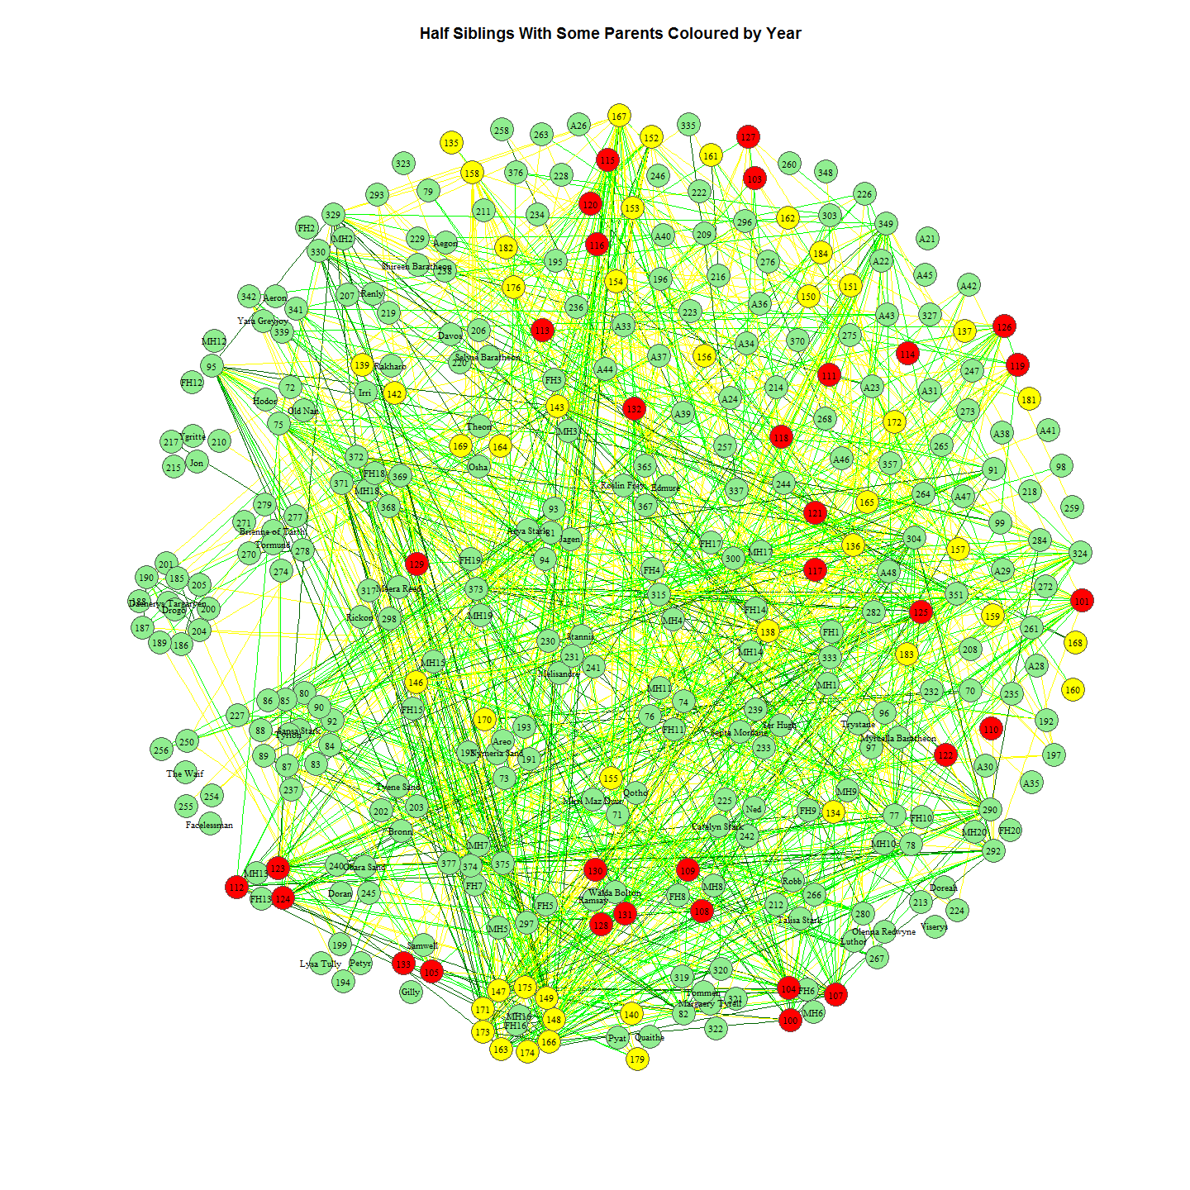

# Support for Estimates of Parental Assignments

The uncertainty around the estimates of parental assignment is not clear from the probability data alone. Related meta data provides the opportunity to test assignments

## Spatial and Temporal Correlation

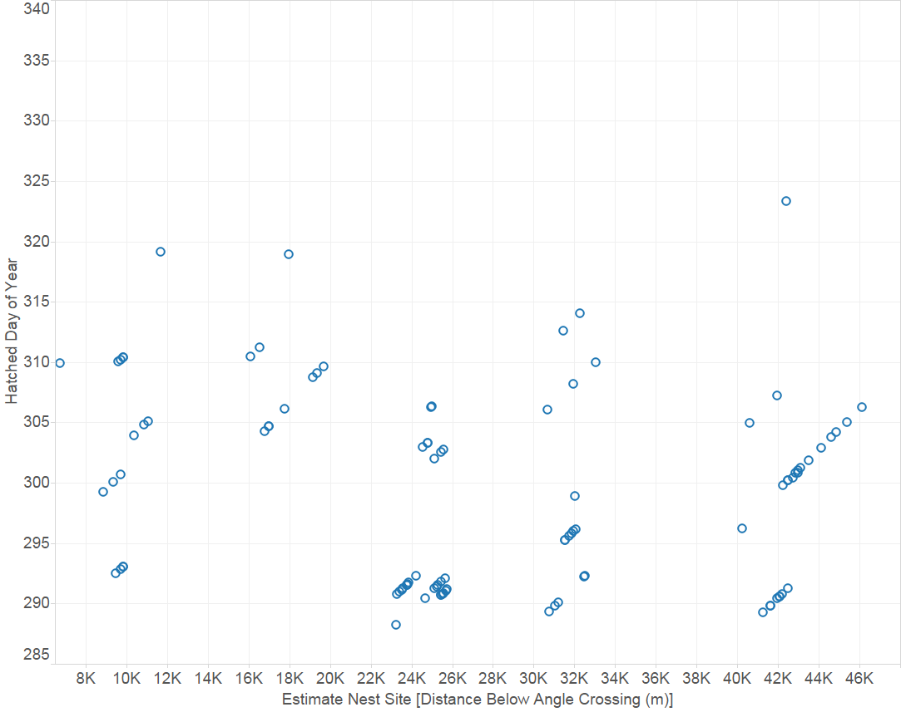

Nest Assignments Based on Spatio-Temporal Factors

Nests were assigned on the basis of larvae spatial and temporal positioning, as seen in the above plot.

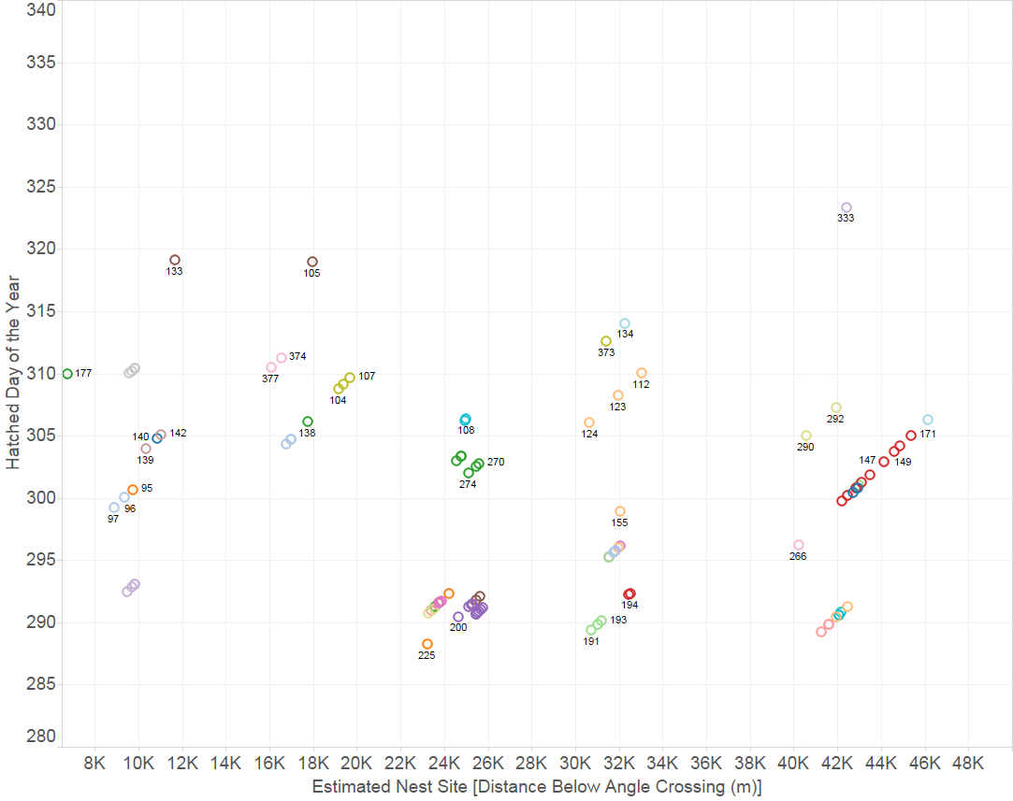

Nest Assignments Based on Spatio-Temporal Factors Coloured by GeneticParental Assignment

## Correlation with parental biogeochemical markers

Assignment of mothers to larvae based on isotpic ratios also seems to bear out the assignment. 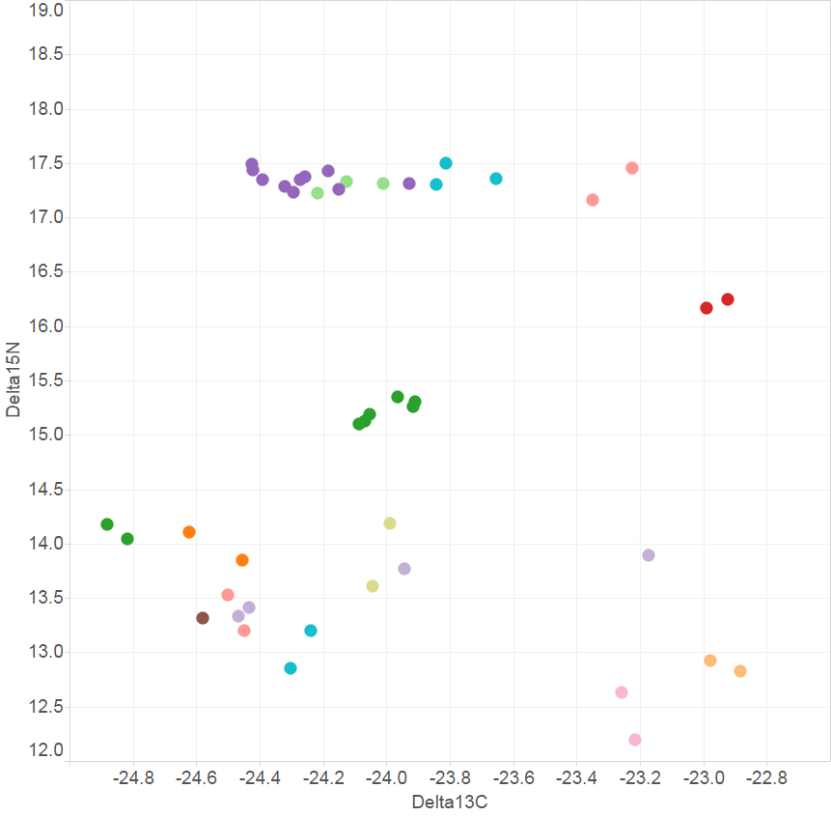 mumCNratios

# Session Info

all_labels()

## [1] "Project_Template_and_Knitr" "Set_Global_Options" "unnamed-chunk-1" "unnamed-chunk-2"   
## [5] "unnamed-chunk-3" "Nominate Estimator to Use" "unnamed-chunk-4" "Larvae2011Net"   
## [9] "unnamed-chunk-5" "unnamed-chunk-6" "Larvae2012Net" "unnamed-chunk-7"   
## [13] "unnamed-chunk-8" "Larvae2013Net" "unnamed-chunk-9" "unnamed-chunk-10"   
## [17] "Larvae2011-2013Net" "unnamed-chunk-11" "unnamed-chunk-12" "unnamed-chunk-13"   
## [21] "LarvaeAdults2011-2013Net" "unnamed-chunk-14" "unnamed-chunk-15" "unnamed-chunk-16"   
## [25] "HalfSibsColouredByYear" "Include_Chunk_Labels_and_Session Information" "createNet" "createNetA"

proc.time()-ptm

## user system elapsed   
## 10.10 1.26 11.62

#Session Information  
sessionInfo()

## R version 3.3.0 (2016-05-03)  
## Platform: i386-w64-mingw32/i386 (32-bit)  
## Running under: Windows 7 x64 (build 7601) Service Pack 1  
##   
## locale:  
## [1] LC_COLLATE=English_Australia.1252 LC_CTYPE=English_Australia.1252 LC_MONETARY=English_Australia.1252 LC_NUMERIC=C LC_TIME=English_Australia.1252   
##   
## attached base packages:  
## [1] stats graphics grDevices utils datasets methods base   
##   
## other attached packages:  
## [1] ggplot2_2.1.0 igraph_1.0.1 dplyr_0.4.3 ProjectTemplate_0.6 knitr_1.13   
##   
## loaded via a namespace (and not attached):  
## [1] Rcpp_0.12.5 digest_0.6.9 assertthat_0.1 plyr_1.8.4 grid_3.3.0 R6_2.1.2 gtable_0.2.0 DBI_0.4-1 formatR_1.4 magrittr_1.5 scales_0.4.0   
## [12] evaluate_0.9 stringi_1.1.1 lazyeval_0.1.10 rmarkdown_0.9.6 tools_3.3.0 stringr_1.0.0 munsell_0.4.3 yaml_2.1.13 parallel_3.3.0 colorspace_1.2-6 htmltools_0.3.5