Chapter 5 Genomics and Larval Dispersal Analysis

Alan Couch

Thu Aug 06 8:25:47 PM 2015

## Loading required package: knitr  
## Loading project configuration  
## Autoloading helper functions  
## Running helper script: helpers.R  
## Running helper script: otoPartChem.R  
## Autoloading data  
## Loading data set: allOtoChemData  
## Loading data set: CladeNamesToMerge  
## Loading data set: cnData  
## Loading data set: CopyOfDMac14.1567snps  
## Loading data set: DMac14.1567DistMatrix  
## Loading data set: DMac14.1567snps  
## Loading data set: qslAgeData  
## Loading data set: qslGeneticsForNestChapter  
## Loading data set: qslLarvaeAgePlus  
## Loading data set: siteGroupings  
## Munging data  
## Running preprocessing script: 01MungeGeneticsData.R  
## Running preprocessing script: 02MungeChemAverages.R

This document includes methods, results and possibly some discussion dot points for the genomics and larval dispersal chapter.

source("http://addictedtor.free.fr/packages/A2R/lastVersion/R/code.R")# load code of A2R function  
library(ggplot2)  
library(ggdendro)  
library(ape)  
library(dendextend)  
library(Hmisc)  
library(ade4)

## Method

The larvae used in the dispersal analysis were collected in 2013 from 6 sites.

Age was determined:

Species seperation

Clades and r apps.

DaRT as described...

## Results

### Polymorphisms Examined

Dart sequencing on Next Generation Sequencing (NGS) platforms was used to reduce genome complexity allowing an intelligent selection of genome fraction corresponding predominantly to active genes. This selection is achieved through the use of a combination of Restriction Enzymes which separate low copy sequences (most informative for marker discovery and typing) from the repetitive fraction of the genome. The advantage of DArTseq is the very high marker densities (tens of thousands of markers) which allows high resolution mapping and detailed genetic dissection of traits.

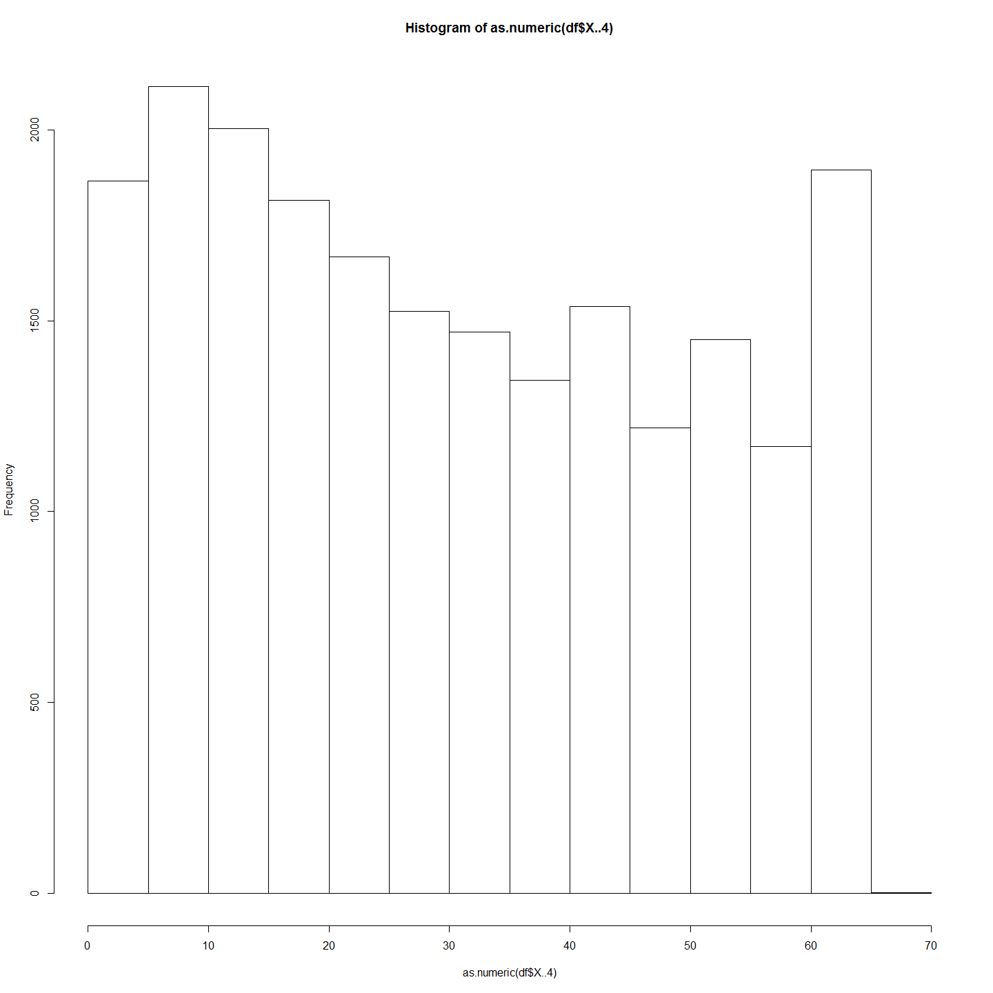 Number of unique Maccullochella snps analysed in the DaRT sequences was 9871. This provide high resolution of the genotypes of the larvae. The base pairs that had mutated we as follows: Became  
Was | A | C | G | T | Totals| ----|-----|-----|-----|-----|-------| A | |424 |1629 |422 |2475 | C |491 | |447 |1893 |2831 | G |1790 |432 | |541 |2763 | T |457 |1570 |442 | |2469 | ----|-----|-----|-----|-----|-------| Tot |2738 |2426 |2518 |2856 | 10538 | of 21076

The polymorphisms examined included SNPs and small indels in restriction enzyme recognition sites, and larger insertions/deletions in restriction fragments. The polymorphism selected for genotyping were all snps.

The length of the fragments of DNA in this sequencing was 69 base pairs. The position of the polymorphism along the 69 base pair DNA fragment can be seen in the following histogram



### All *Maccullochella* Larvae

A dendrogram of all the larvae allows examination of the relationships between all the larvae. In the first instance this is neccessary to ensure there are no species other than Murray cod in the subsequent analysis.

MacDm <- dist(allsnps) #Create a distance matrix for all Maccullochella larvae  
  
heatmap(as.matrix(MacDm)) #Make a heat map

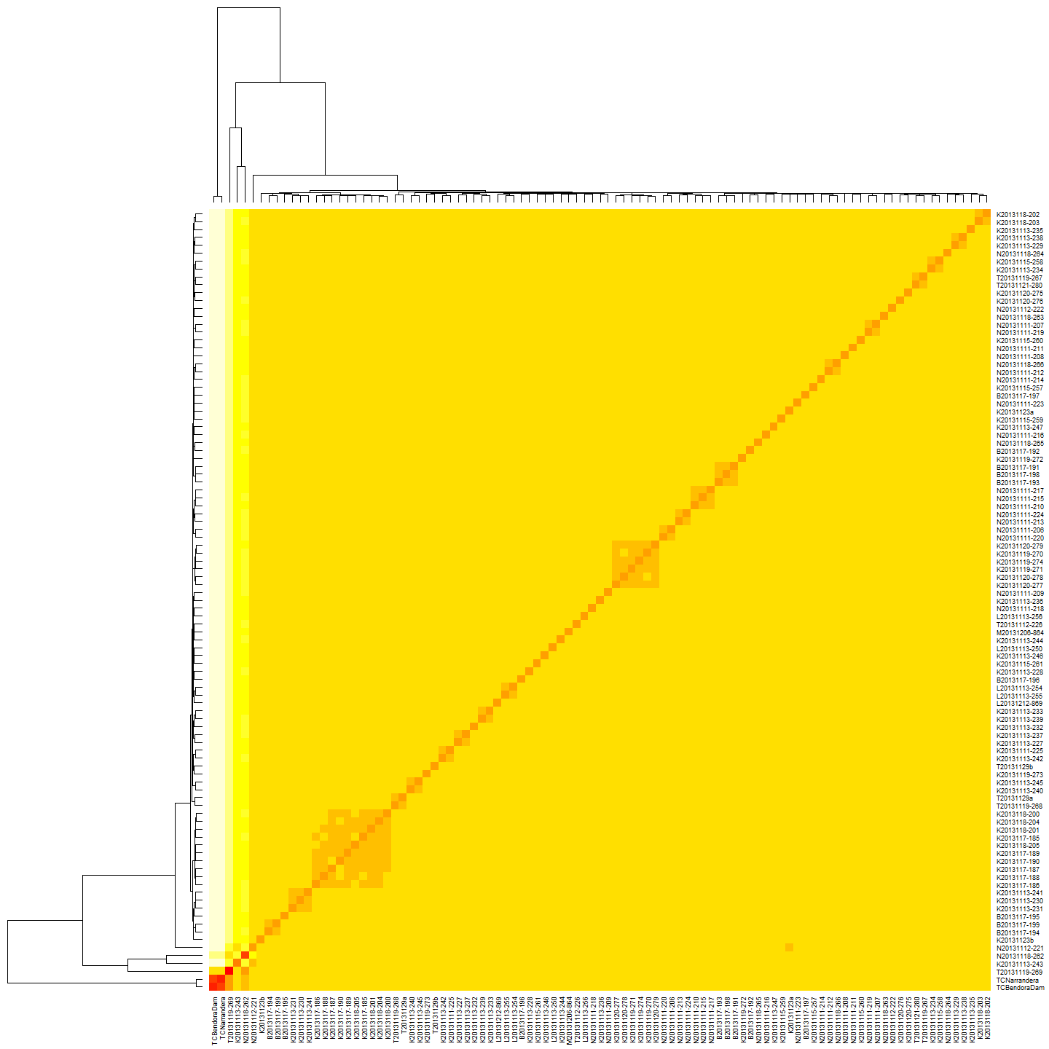

MacHC <- hclust(MacDm) #make a heirarchical cluster  
  
plot(color_labels(MacHC, k = 5), main="All Maccullochella Larvae") #Plot the cluster dendrogram

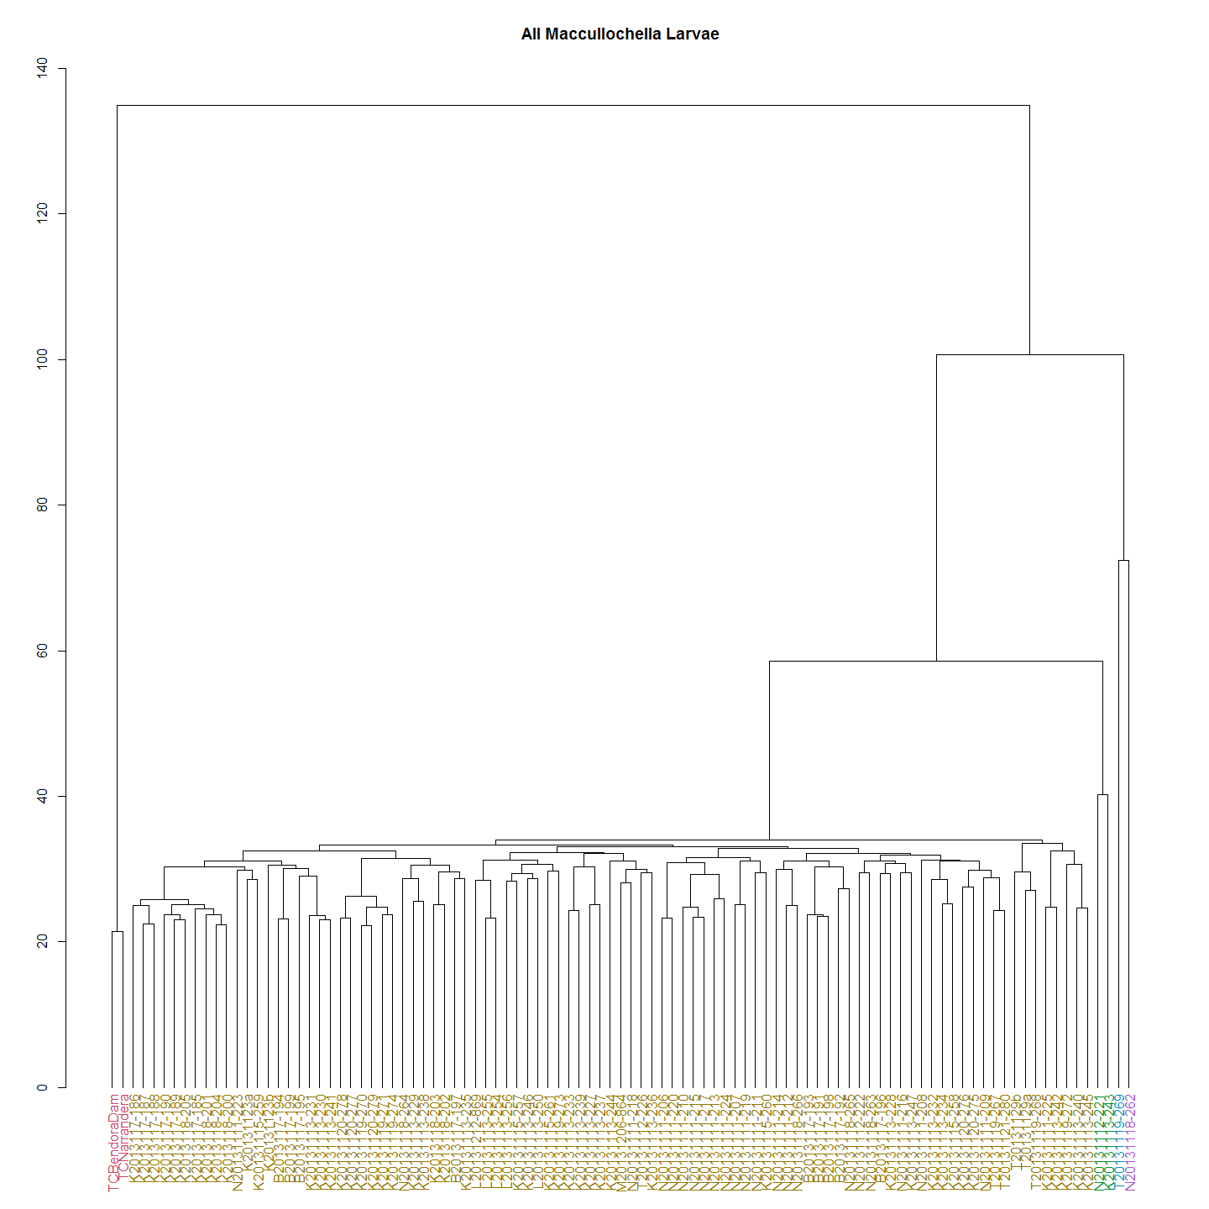 As it turns out there are multiple *Maccullochella* species. All the larvae collected fall into one of four distinct clades. The above dendrograms shows all larvae (mostly Murray cod) and two known Trout cod controls, and what appears to be F1 and F2 hybrids between the two species. There were 4 hybrid and no pure trout cod larvae detected in the 92 larvae caught and sequenced from the river.

So we now use the set with the non-Murray cod removed to identify Murray cod clades and conduct the remainder of the analysis on the Upper Murrumbidgee Murray cod larvae only. The Trout cod and the hybrids are easily identified and eliminated from the data to ensure we are looking only at the Murray cod larvae.

### Murray Cod Larvae

First we look at a heat map and dendrogram of Murray cod larvae having excluded Trout cod and hybrids data from the data frame.

MCdm <- dist(MCsnps)#Create a Murray Cod Only distance matrix  
  
heatmap(as.matrix(MCdm), main="Murray Cod Heat Map")#Heat map

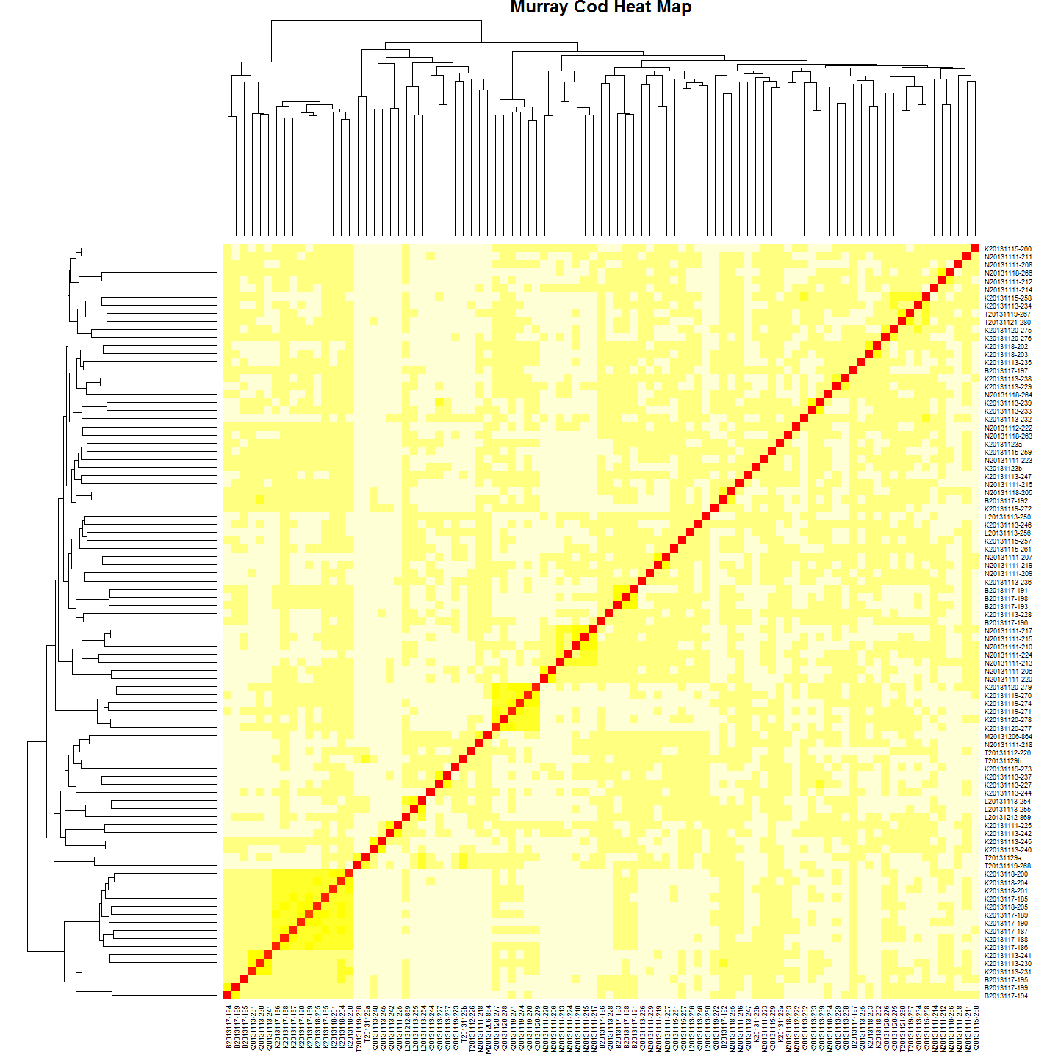

MChc <- hclust(MCdm) #Clutser  
#Plot it  
plot(MChc,main="Maccullochella peelii Larvae")

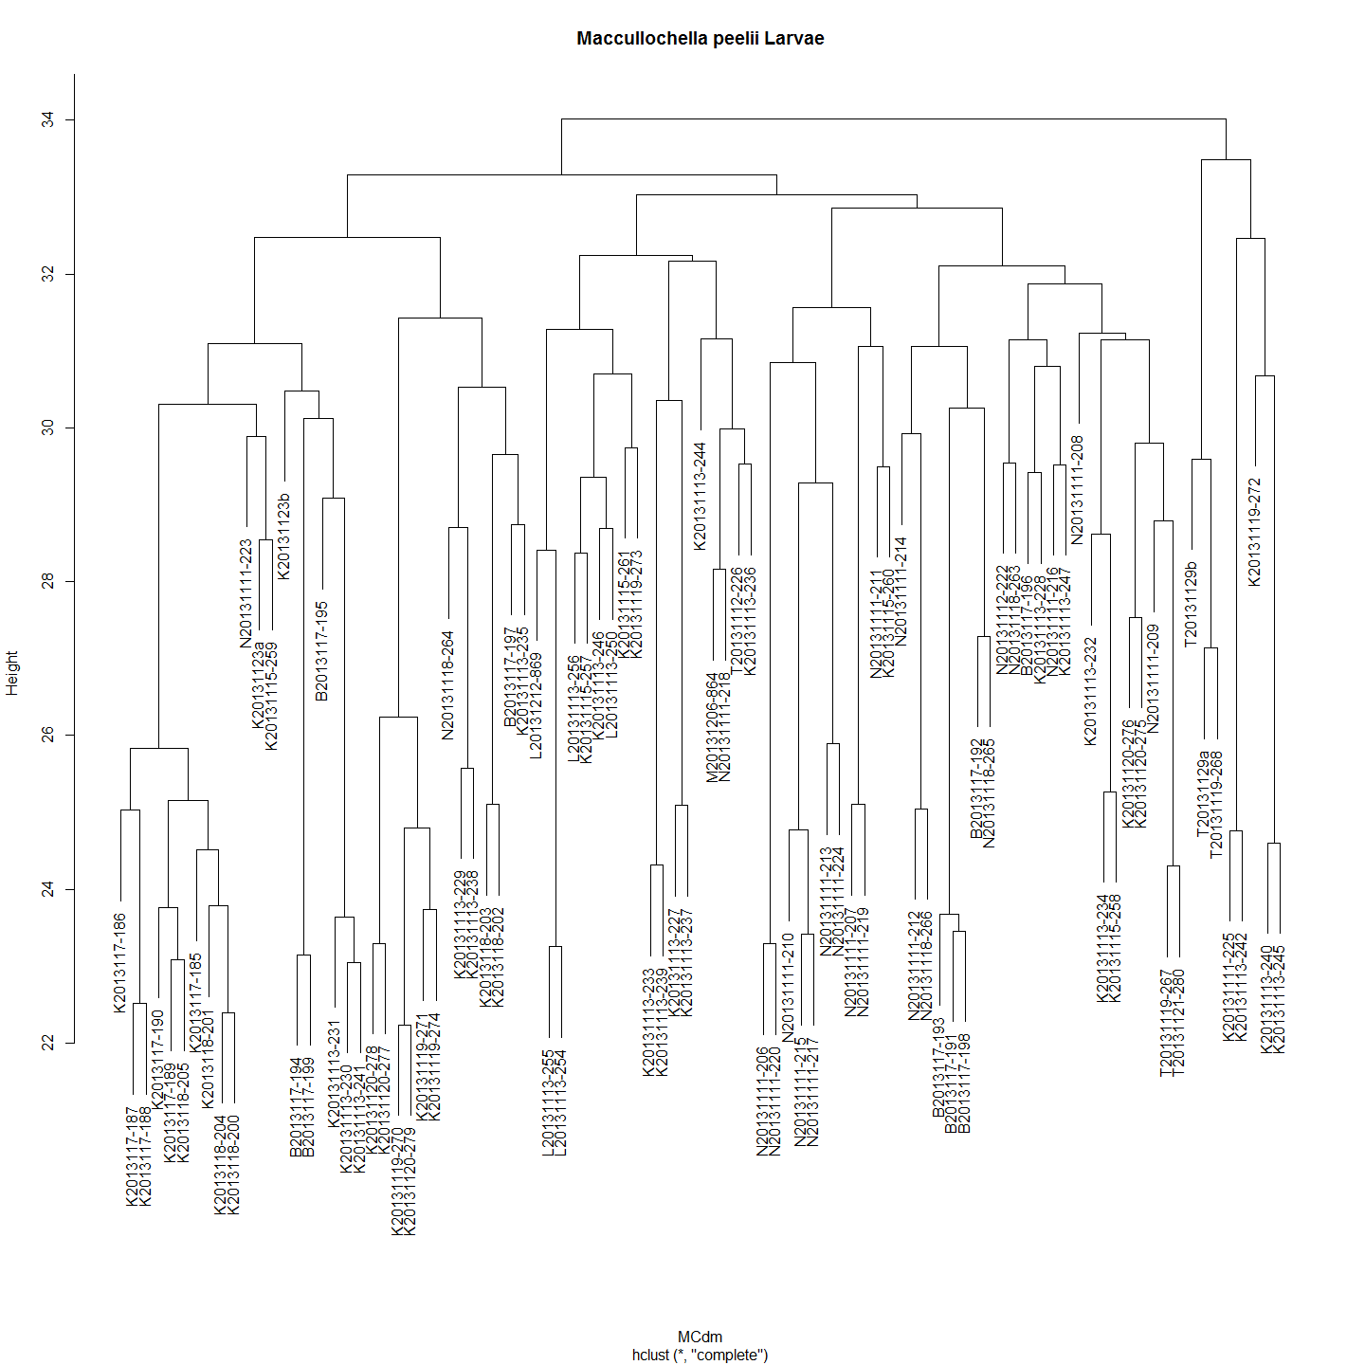

In most cases very closely related larvae have been collected at the same spot over the same period of a few of days. Pairs or clusters of larvae with a height of less than 26.5 are likely siblings. But in some cases very closely related pairs of larvae have turned up at different sites. Sometimes over time frames that seem unlikely or suggest the larvae have travelled upstream. However, must remember that it is siblings - not the same fish - that is caught so this might just represent the 'smear' of larvae along the river after dispersing from the nest.

The distance matrix suggests a very low genetic diversity in the population of Murray cod sampled with most of the distances around 0.03. Given this, can we be sure that the most closely related larvae are siblings?

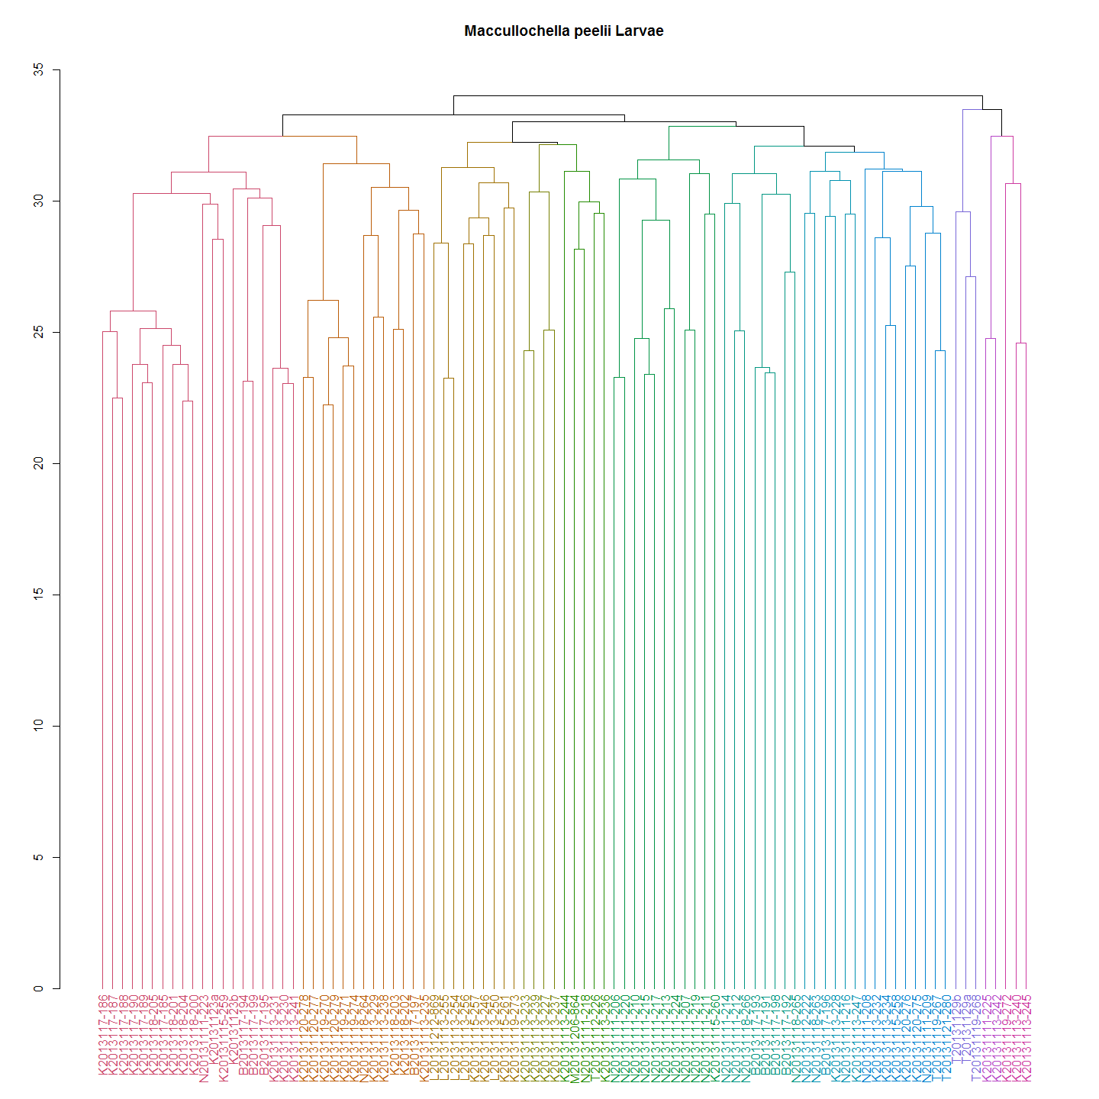

While the Murray cod larvae are all very closely related, they can now be resolved into 12 clades.These clades represent 12 'extended family groups' and the 3 clades represent the three higher level (race) clades in the river.

cladeNo<-cutree(dend1,k=12) #This is like using:dendextend:::cutree.dendrogram(dend1,h=70) h or k can be specified  
cladeNo<-as.data.frame(cladeNo)  
#For example:  
cladeNo[c(20:30),] #The clades are numbered by default. So I need to name them something sensible for subsequent analysis.

## [1] 7 3 6 8 9 9 3 3 8 8 3

Extract three higher level clades

dend2 <- color_labels(MChc, k = 3)#Use h or k  
raceCladeNumber<-cutree(dend2,k=3) #This is like using:dendextend:::cutree.dendrogram(dend1,h=70) h or k can be specified  
raceCladeNumber<-as.data.frame(raceCladeNumber)  
raceCladeNumber[,] #The clades are numbered by default. So I need to name them something sensible for subsequent analysis.

## [1] 1 1 1 1 1 2 2 1 1 1 1 1 1 1 1 1 1 1 1 1 1 1 1 1 1 1 1 1 1 1 1 1 1 1 1 1 1 1 1 1 1 1 1 1 1 2 1 1 1 1 1 1 3 1 1 3 1 1 1 1 1 1 1 3 1 1 1 1 3 1 1 1 1 1 1 1 1 1 1 1 1 1 1 1 1 1 1 1 1 1 1 1 3

larvalClades<-merge(cladeNo,raceCladeNumber, by="row.names")  
row.names(larvalClades)<-larvalClades$Row.names  
larvalClades$Row.names<-NULL  
  
#Add Clade Names  
#So the list of larval clades (two levels) is:  
larvalClades

## cladeNo raceCladeNumber  
## B2013117-191 6 1  
## B2013117-192 6 1  
## B2013117-193 6 1  
## B2013117-194 3 1  
## B2013117-195 3 1  
## B2013117-196 1 1  
## B2013117-197 8 1  
## B2013117-198 6 1  
## B2013117-199 3 1  
## K20131111-225 11 3  
## K20131113-227 10 1  
## K20131113-228 1 1  
## K20131113-229 8 1  
## K20131113-230 3 1  
## K20131113-231 3 1  
## K20131113-232 7 1  
## K20131113-233 10 1  
## K20131113-234 7 1  
## K20131113-235 8 1  
## K20131113-236 4 1  
## K20131113-237 10 1  
## K20131113-238 8 1  
## K20131113-239 10 1  
## K20131113-240 12 3  
## K20131113-241 3 1  
## K20131113-242 11 3  
## K20131113-244 4 1  
## K20131113-245 12 3  
## K20131113-246 2 1  
## K20131113-247 1 1  
## K20131115-257 2 1  
## K20131115-258 7 1  
## K20131115-259 3 1  
## K20131115-260 9 1  
## K20131115-261 2 1  
## K20131119-270 8 1  
## K20131119-271 8 1  
## K20131119-272 12 3  
## K20131119-273 2 1  
## K20131119-274 8 1  
## K20131120-275 7 1  
## K20131120-276 7 1  
## K20131120-277 8 1  
## K20131120-278 8 1  
## K20131120-279 8 1  
## K20131123a 3 1  
## K20131123b 3 1  
## K2013117-185 3 1  
## K2013117-186 3 1  
## K2013117-187 3 1  
## K2013117-188 3 1  
## K2013117-189 3 1  
## K2013117-190 3 1  
## K2013118-200 3 1  
## K2013118-201 3 1  
## K2013118-202 8 1  
## K2013118-203 8 1  
## K2013118-204 3 1  
## K2013118-205 3 1  
## L20131113-250 2 1  
## L20131113-254 2 1  
## L20131113-255 2 1  
## L20131113-256 2 1  
## L20131212-869 2 1  
## M20131206-864 4 1  
## N20131111-206 9 1  
## N20131111-207 9 1  
## N20131111-208 7 1  
## N20131111-209 7 1  
## N20131111-210 9 1  
## N20131111-211 9 1  
## N20131111-212 6 1  
## N20131111-213 9 1  
## N20131111-214 6 1  
## N20131111-215 9 1  
## N20131111-216 1 1  
## N20131111-217 9 1  
## N20131111-218 4 1  
## N20131111-219 9 1  
## N20131111-220 9 1  
## N20131111-223 3 1  
## N20131111-224 9 1  
## N20131112-222 1 1  
## N20131118-263 1 1  
## N20131118-264 8 1  
## N20131118-265 6 1  
## N20131118-266 6 1  
## T20131112-226 4 1  
## T20131119-267 7 1  
## T20131119-268 5 2  
## T20131121-280 7 1  
## T20131129a 5 2  
## T20131129b 5 2

### Trout Cod Larvae

Although Trout cod and hybrid *Maccullochella* data are excluded from further analysis, the heatmap and dendrogram are provided here for completeness. In any case it is not an insignificant finding that the two species do in fact hybridise in this natural riverine environment even though hybrids have been seen in hatcheries and impoundments previoulsy. Furthermore this is the first time fertile F1 have been recorded as evidenced by the finding of an F2 hybrid. That said there is some question as to the providence of the Trout cod in this case as they were believe extirpated and restocked too recently (2006?) for 2 generations to have occured. FACT check this.

#A heatmap and dendrogram for Trout Cod shows three distinct clades.  
TCdm <- dist(TCsnps)  
#Heat map  
dataMatrix <- as.matrix(TCdm)  
heatmap(dataMatrix, main="Trout Cod Heat Map")

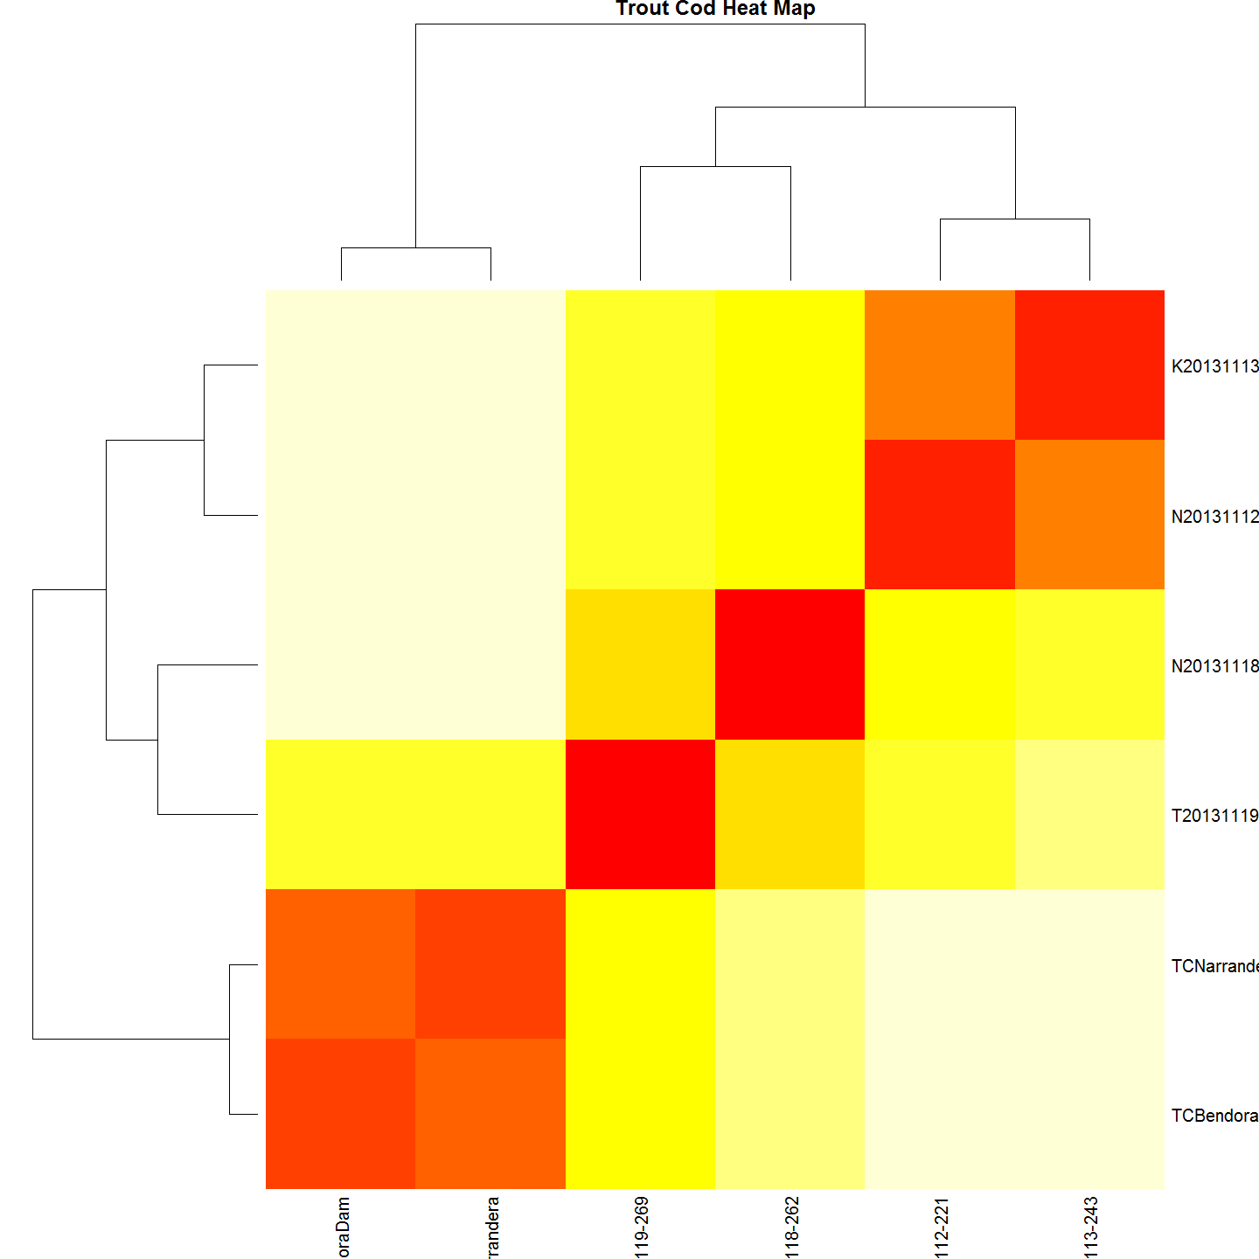

#cluster  
TChc <- hclust(TCdm)  
#Plot it  
#plot(TChc, main="Maccullochella macquariensis larvae")  
A2Rplot(TChc, k =3, boxes = FALSE, col.up = "gray50",main = "Maccullochella macquariensis larvae")

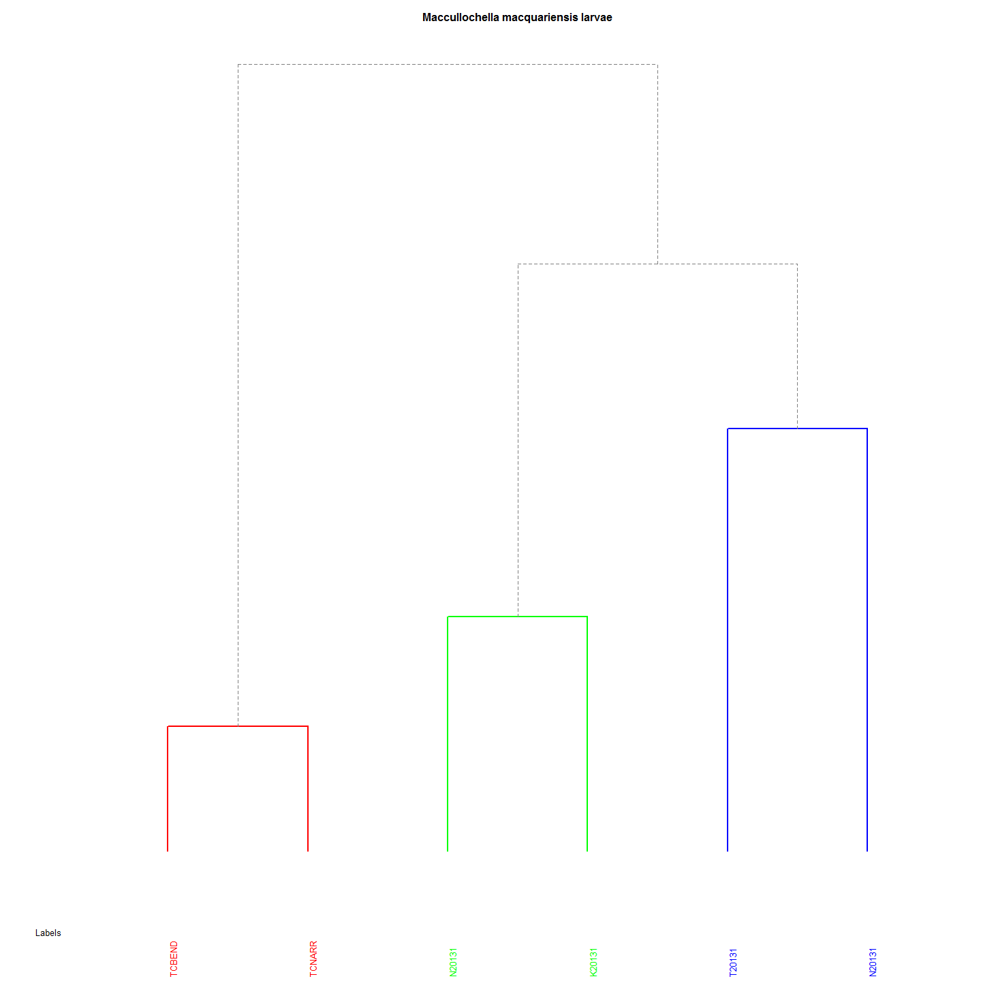 Both the heatmap and dendrogram for Trout Cod shows three distinct clades.

## Upper Murrumbidgee Larval Murray Cod Genetic and Geographic Distances

This test correlates the physical distances of the nests of the larvae with genetic distance of larvae from the Murrumbidgee collected in 2013 from 6 sites.

By iterating the mantel test using distance matrices generated for nest distances based on a range of larval dispersal velocities and the time available to those larvae for dispersal, we can identify the most highly correlated - the peak - which then allows an estimate of the average distance a nest site is from the collection site. The iterations of the Mantel test used a larval dispersal velocity range from 1 m to 5000 metres per day. The highest correlation represents the the average distance that larvae disperse. The assumption is that drift is downstream, not upstream. The curve produced from the estimations is as follows.

### Iterate through Mantel test using a range of possible larval dispersal velocities.

library(Hmisc)  
library(ade4)  
  
#This file is to calculate the data as before but mainly to iterate the mantel test from 1 to 5000 metres at 100m increments (to save time).  
  
# The calculations that can happen outside the iteration are:  
  
#Age from Otolith Length: 0.0591584*larv$MeanOtolithLength + 0.0331233  
#Hatch DoY : [Day of Year Caught]-[Age From Otolith Length]  
#Incubation: 20.67-0.667*[WaterTemp(DegC) Mean]  
#Spawnin:[Hatch]-[Incubation]  
#larv$nestdist<-larv$Distance.to.Angle.Crossing..m.-(300*(larv$Day.of.Year-(larv$hatchDoY+7)))  
  
#Create a MCsnps set with row names as a column.  
MCchecklist<-row.names(MCsnps)  
MCchecklist<-as.data.frame(MCchecklist)# 93 records  
  
#remove a few more anomolies  
MCchecklist1 <- as.data.frame(MCchecklist[-c(1:7), ])  
# Keep every record in larv that is also in MCchecklist (i.e., the intersection).  
  
larv_intersection <- larv[larv$Label %in% MCchecklist$MCchecklist,]  
#Thanks: https://heuristically.wordpress.com/2009/10/08/delete-rows-from-r-data-frame/  
  
larv<-larv_intersection  
larv_intersection<-NULL  
  
itmant <- matrix(nrow=5000, ncol=3) #Is 5000 DF to store result but NA omited later. They result from the increment 100 in the for loop below.  
  
#Iteration begins here:  
for (nd in seq(1,5000, by=100)){#To be 0:5000 eventually for(i in seq(1, 10, by = 2))   
   
 larv$nestdist<-larv$Distance.to.Angle.Crossing..m.-(nd*(larv$Day.of.Year-(larv$hatchDoY+7)))   
   
 ###########  
 # Create GenDist from code in the Murray Cod SNPS table  
 MCdm<-MCsnps[-c(1:7),] #remove non-numeric variables  
 MCdm <- dist(MCdm) # Create a Murray Cod distance matrix  
 MCdm<-as.matrix(MCdm)  
 MCdm<-as.data.frame(MCdm)  
 #This is to be used for plotting  
 ###########  
 #Create Geographic Distance Matrix using Nest Distance  
 geodist<-data.frame(larv$Label,larv$nestdist)  
 row.names(geodist)<-geodist[,1]  
 geodist$larv.Label<-NULL  
 geodist<-na.omit(geodist)  
 #geodist<-geodist[complete.cases(geodist),]  
   
 GeoDistMat<-dist(geodist)  
 GeoDistMathm <- as.matrix(GeoDistMat)  
   
   
 #make sure both matrices are in correct order - rows and cols  
 #First sort MCdm  
   
 MCdm<-as.data.frame(MCdm)  
 MCdm$sort<-row.names(MCdm)  
 MCdm <- MCdm[order(MCdm$sort),]#sort row order  
 MCdm$sort<-NULL  
 MCdm<-MCdm[,order(names(MCdm))]#sort column order  
 MCdm<-as.matrix(MCdm)  
   
 #Second sort GeoDist  
 GeoDistMathm<-as.data.frame(GeoDistMathm)  
 GeoDistMathm$sort<-row.names(GeoDistMathm)  
 GeoDistMathm <- GeoDistMathm[order(GeoDistMathm$sort),]#sort row order  
 GeoDistMathm$sort<-NULL  
 GeoDistMathm<-GeoDistMathm[,order(names(GeoDistMathm))]#sort column order  
 GeoDistMathm<-as.matrix(GeoDistMathm)  
   
 mant<-mantel.rtest(as.dist(GeoDistMathm), as.dist(MCdm), nrepet = 9999)  
 #print(nd)  
 #print(mant$obs)  
 #print(mant$pvalue)  
   
 itmant[nd,] <- c(nd, mant$obs, mant$pvalue)  
}  
  
itmant<-na.omit(itmant)  
itmantdf<-as.data.frame(itmant)  
plot(itmantdf$V1,itmantdf$V2)

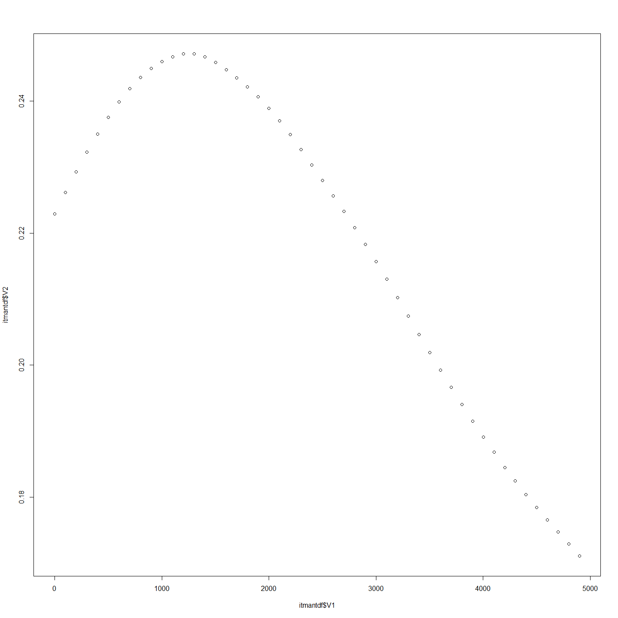

###########  
require(plotrix)  
op <- par(cex.main = 1.5, mar = c(5, 6, 4, 5) + 0.1, mgp = c(3.5, 1, 0), cex.lab = 1.5 , font.lab = 2, cex.axis = 1.3, bty = "n", las=1)  
plot(itmantdf$V1, itmantdf$V2, col="black", pch=21, bg = "grey", cex = 2,  
 xlim=c(0,5000), ylim=c(0,.25), ylab="", xlab="", axes=F)  
axis(1)  
axis(2)   
reg1 <- lm(itmantdf$V2~itmantdf$V1)  
ablineclip(reg1, lwd=2,x1 = .9, x2 = 1.2)   
par(las=0)  
mtext("Daily Drift Distance (m)", side=1, line=2.5, cex=1.5)  
mtext("Correlation", side=2, line=3.7, cex=1.5)

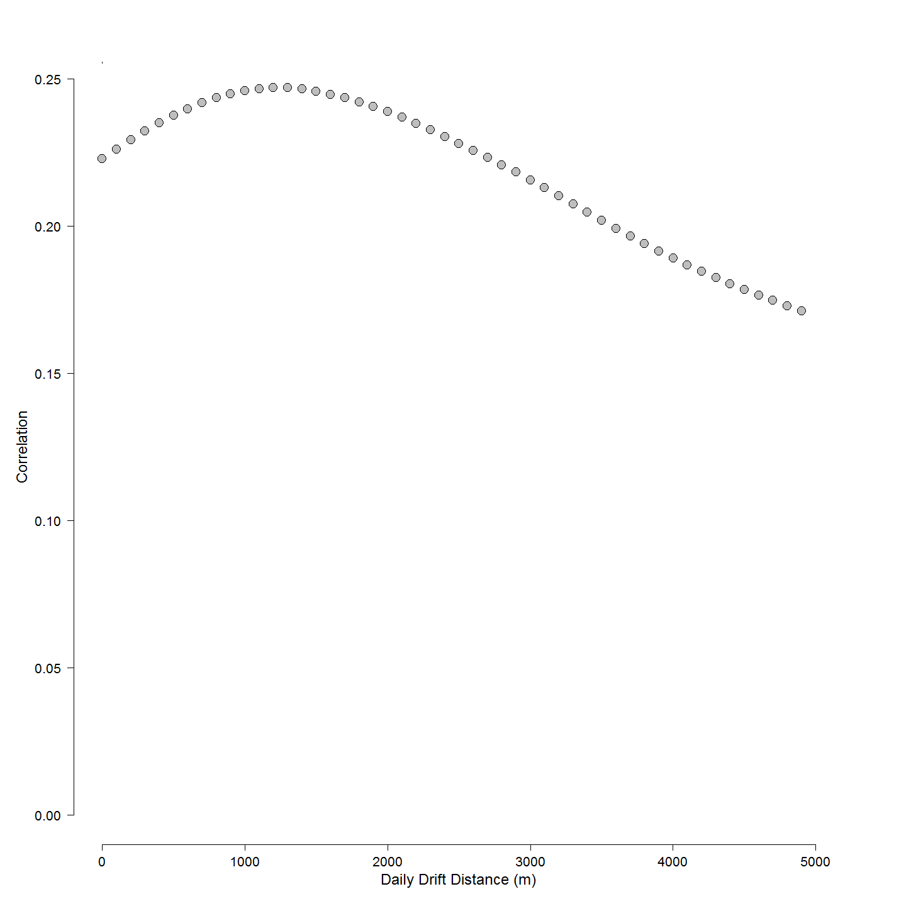

###########  
  
dispersalVelocity<- subset(itmantdf, V2==max(V2) , select = V1)  
dispersalVelocity<-as.numeric(dispersalVelocity)

The distance above the collection site as the larvae disperse at 1201 metres per day between leaving the nest and being collected at sampling site also allows an estimate of the Murray cod pelagic larval drift duration to be made.

This average pelagic larval dispersal (PLD) value is an average for larvae along the entire river reach. It tells us nothing about the variance of that dispersal (or can it)??? It is most likely a distribution of larvae drifting (dispersing) varying distances below the nest. The obvious thing to do would be to take the approach on a site by site basis over a number of years, because the river speeds vary at each site and between years but at present there are too few samples from most sites and other years to use such an approach with confidence.

# To create a distance using the previously calculated best estimate of drift velocity (m/d available since leaving brood care)  
larv$nestdist<-larv$Distance.to.Angle.Crossing..m.-(dispersalVelocity*(larv$Day.of.Year-(larv$hatchDoY+7)))  
#write.csv(format(larv), file="./Tableau/larvForTableau.csv", row.names=FALSE)  
#remove larvae that do not have genetic analysis done.  
#Creat a MCsnps set with row names as a column.  
MCchecklist<-row.names(MCsnps)  
MCchecklist<-as.data.frame(MCchecklist)# 93 records  
  
#remove a few more anomolies  
MCchecklist1 <- as.data.frame(MCchecklist[-c(1:7), ])  
# Keep every record in larv that is also in MCchecklist (i.e., the intersection).  
  
larv_intersection <- larv[larv$Label %in% MCchecklist$MCchecklist,]  
#Thanks: https://heuristically.wordpress.com/2009/10/08/delete-rows-from-r-data-frame/  
  
larv<-larv_intersection  
larv_intersection<-NULL  
  
###########  
# Recreate Genetic Distance  
# Create a Murray Cod distance matrix  
MCdm<-MCsnps[-c(1:7),]  
MCdm <- dist(MCdm)  
MCdm<-as.matrix(MCdm)  
MCdm<-as.data.frame(MCdm)  
#This is to be used for plotting  
MCdmForSibs<-MCdm #need this matrix for sibling analysis .r  
###########  
  
geodist<-data.frame(larv$Label,larv$nestdist)  
row.names(geodist)<-geodist[,1]  
geodist$larv.Label<-NULL  
geodist<-na.omit(geodist)  
geodist1000<-geodist #save this estimate for haplogroups distance plot (after the Iterated Mantel has changed it)  
  
GeoDistMat<-dist(geodist)  
GeoDistMathm <- as.matrix(GeoDistMat)  
heatmap(GeoDistMathm)

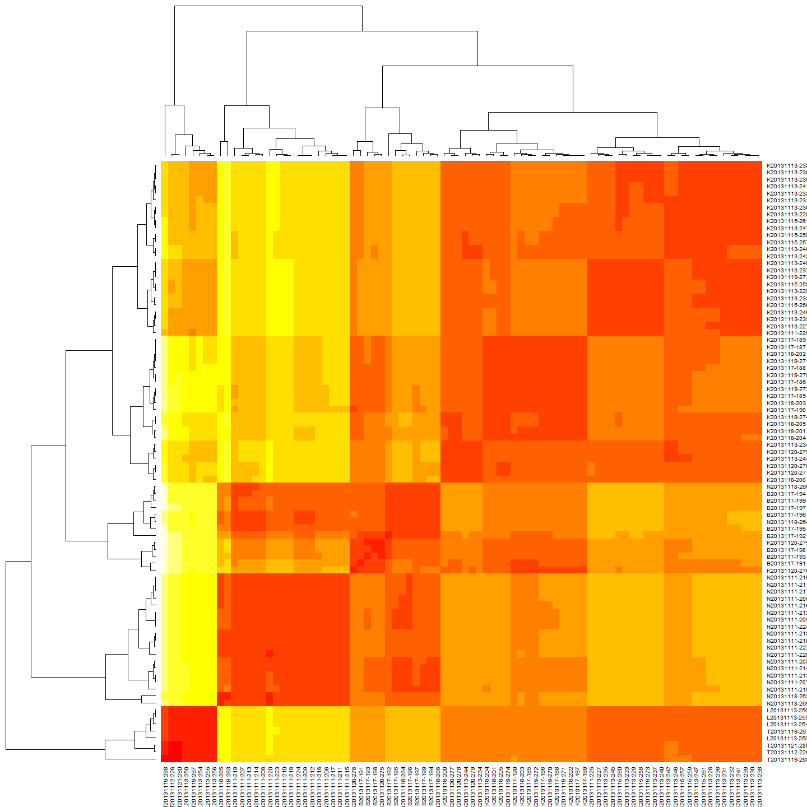

geoclust<-hclust(GeoDistMat)  
plot(geoclust)

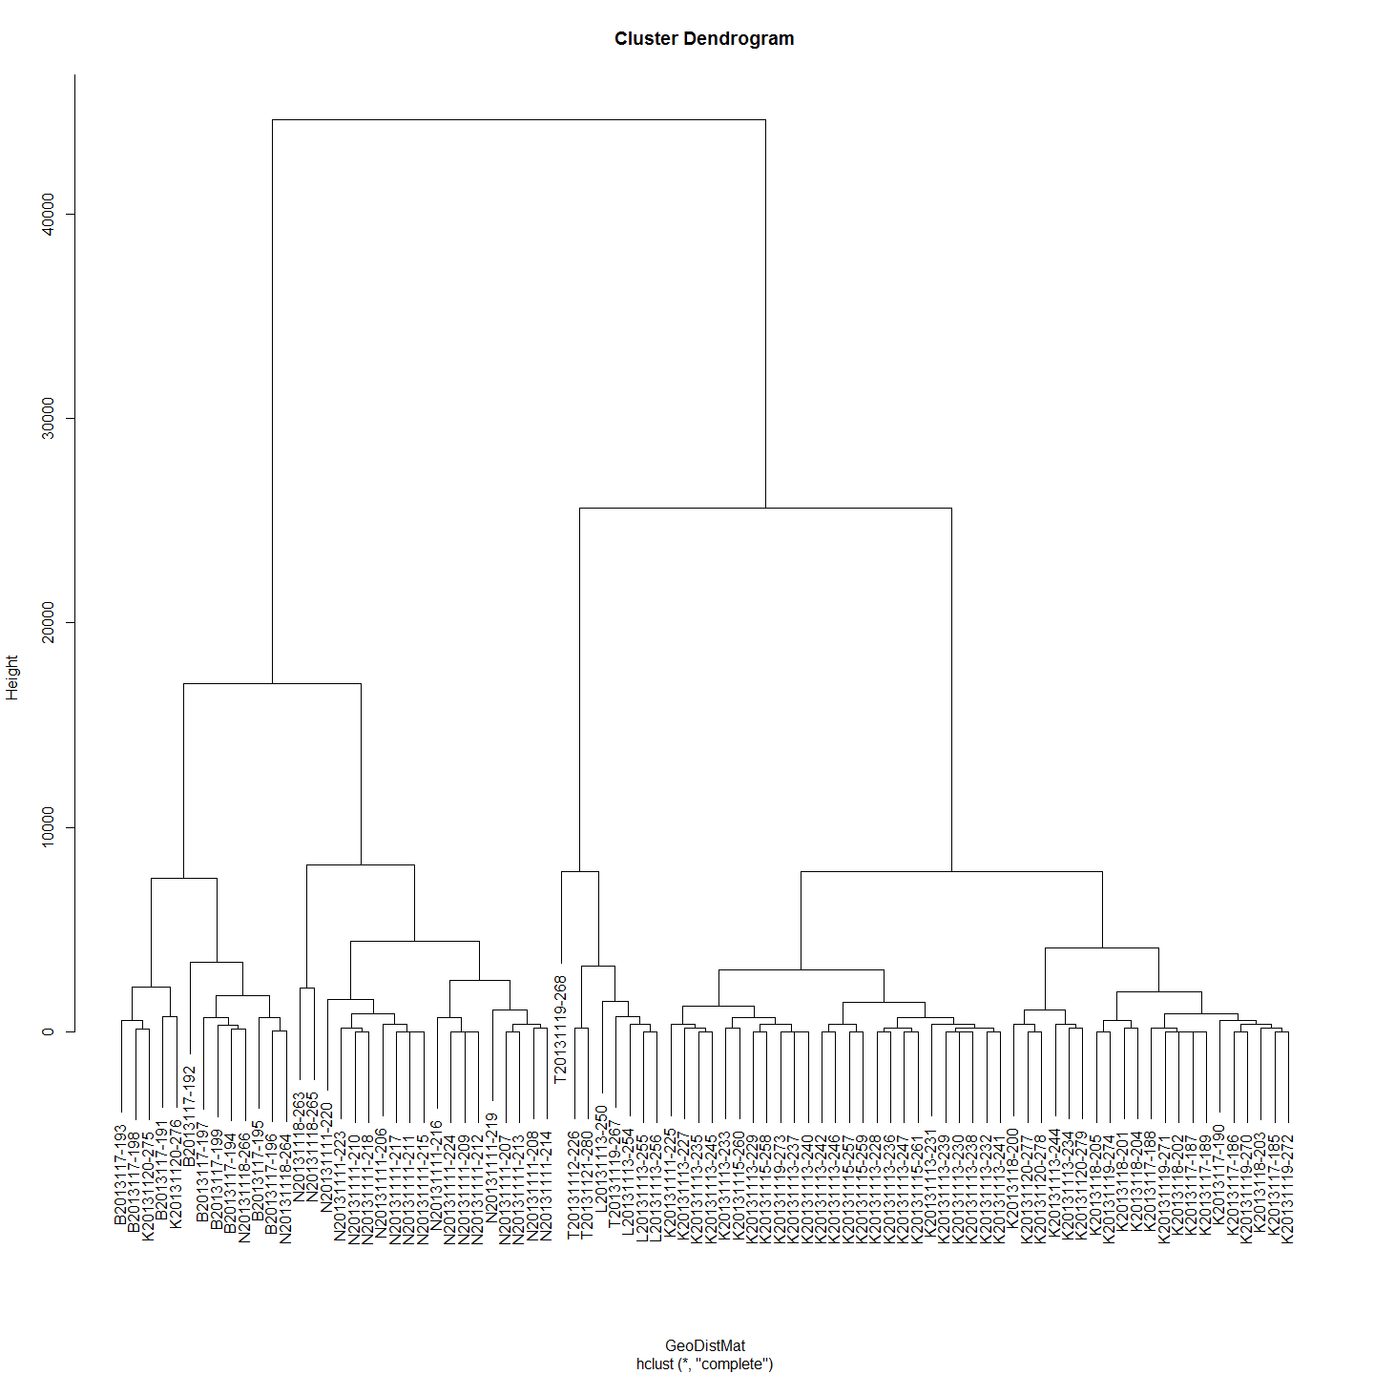

#make sure both matrices are in correct order - rows and cols  
#First sort MCdm  
  
MCdm<-as.data.frame(MCdm)  
MCdm$sort<-row.names(MCdm)  
MCdm <- MCdm[order(MCdm$sort),]#sort row order  
MCdm$sort<-NULL  
MCdm<-MCdm[,order(names(MCdm))]#sort column order  
MCdm<-as.matrix(MCdm)  
  
#Second sort GeoDist  
GeoDistMathm<-as.data.frame(GeoDistMathm)  
GeoDistMathm$sort<-row.names(GeoDistMathm)  
GeoDistMathm <- GeoDistMathm[order(GeoDistMathm$sort),]#sort row order  
GeoDistMathm$sort<-NULL  
GeoDistMathm<-GeoDistMathm[,order(names(GeoDistMathm))]#sort column order  
GeoDistMathm<-as.matrix(GeoDistMathm)  
  
heatmap(GeoDistMathm)

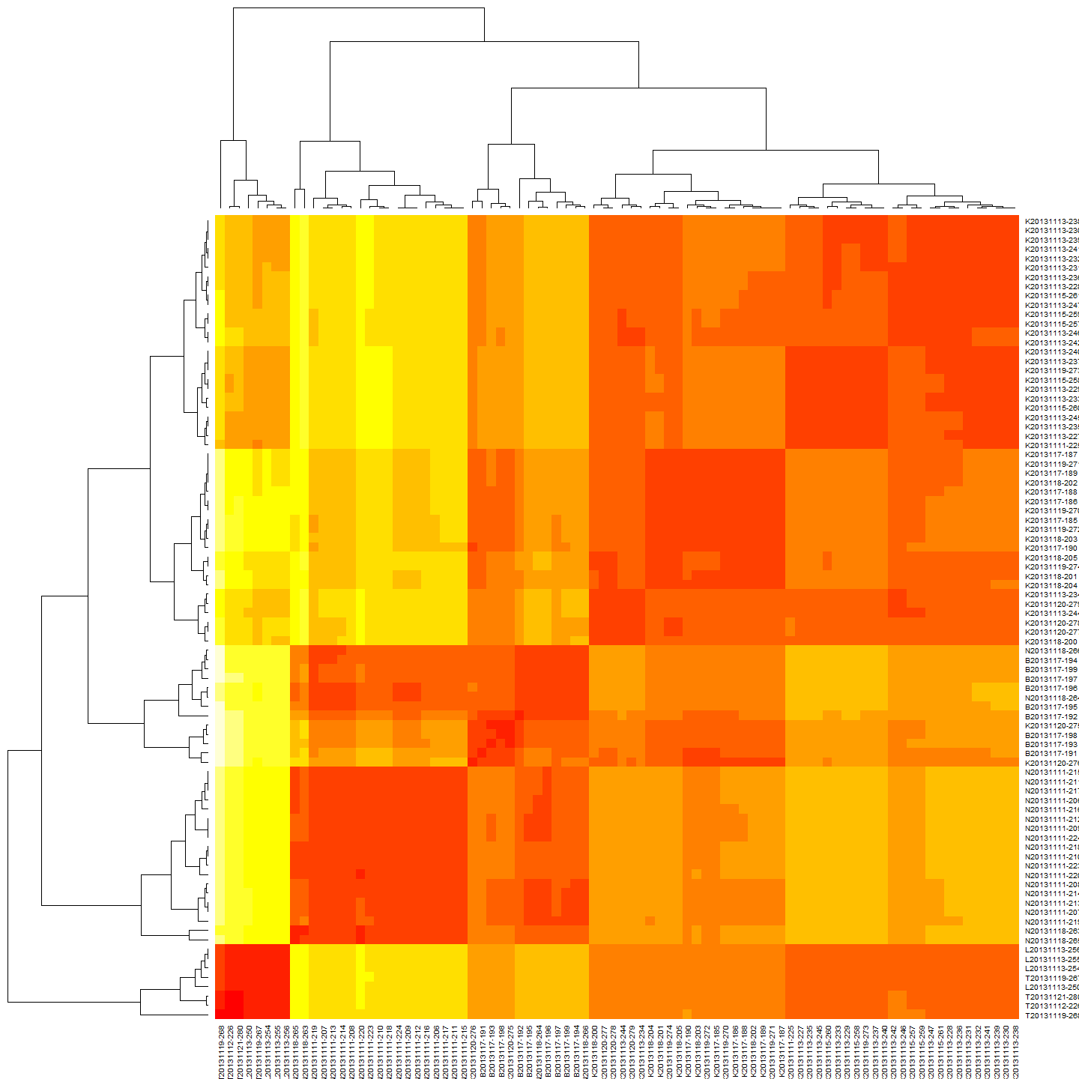

geoclust<-hclust(GeoDistMat)  
plot(geoclust)



hist(larv$nestdist)

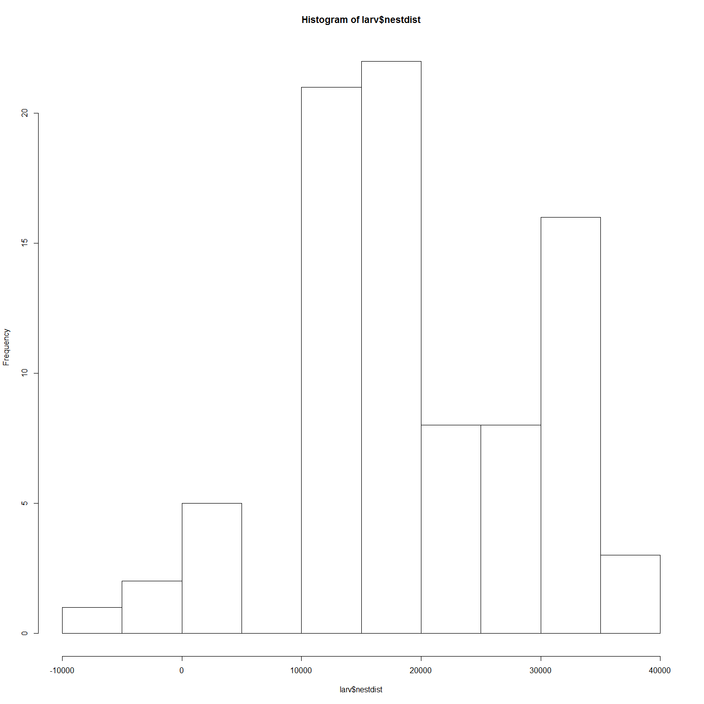

larv1<-larv#save this estimate for haplogroups distance plot (after the Iterated Mantel has changed it)

Now that these various matrices, class 'dist' objects are created we can proceed for plot.

### Plot and Correlate genetic and geographic distance matrices

First a regression model is calculated and then the plot:

#Linear Regression Model  
reg=lm(MCdm[lower.tri(MCdm)]~GeoDistMathm[lower.tri(GeoDistMathm)])  
summary(reg)

##   
## Call:  
## lm(formula = MCdm[lower.tri(MCdm)] ~ GeoDistMathm[lower.tri(GeoDistMathm)])  
##   
## Residuals:  
## Min 1Q Median 3Q Max   
## -8.320 -0.475 0.183 0.756 3.257   
##   
## Coefficients:  
## Estimate Std. Error t value Pr(>|t|)   
## (Intercept) 3.04e+01 3.63e-02 838.1 <2e-16 ***  
## GeoDistMathm[lower.tri(GeoDistMathm)] 3.95e-05 2.56e-06 15.4 <2e-16 ***  
## ---  
## Signif. codes: 0 '***' 0.001 '**' 0.01 '*' 0.05 '.' 0.1 ' ' 1  
##   
## Residual standard error: 1.34 on 3653 degrees of freedom  
## Multiple R-squared: 0.0611, Adjusted R-squared: 0.0608   
## F-statistic: 238 on 1 and 3653 DF, p-value: <2e-16

plot(GeoDistMathm[lower.tri(GeoDistMathm)],MCdm[lower.tri(MCdm)])  
abline(reg)

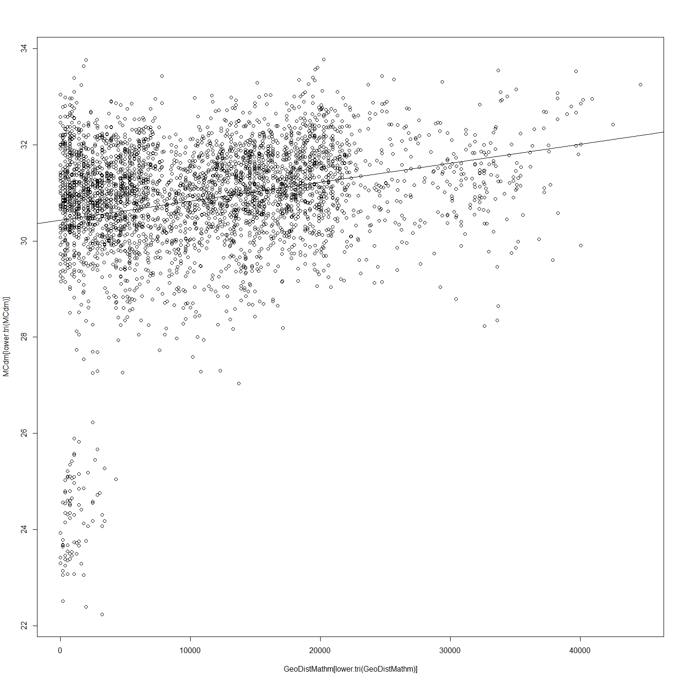

# Correlations with significance levels  
rcorr(GeoDistMathm[lower.tri(GeoDistMathm)],MCdm[lower.tri(MCdm)])#(x, type="pearson") # type can be pearson or spearman

## x y  
## x 1.00 0.25  
## y 0.25 1.00  
##   
## n= 3655   
##   
##   
## P  
## x y   
## x 0  
## y 0

#ANOVA  
anova(reg)

## Analysis of Variance Table  
##   
## Response: MCdm[lower.tri(MCdm)]  
## Df Sum Sq Mean Sq F value Pr(>F)   
## GeoDistMathm[lower.tri(GeoDistMathm)] 1 425 425 238 <2e-16 ***  
## Residuals 3653 6541 2   
## ---  
## Signif. codes: 0 '***' 0.001 '**' 0.01 '*' 0.05 '.' 0.1 ' ' 1

#Plot residuals  
par(mfrow=c(2,2))  
plot(reg)

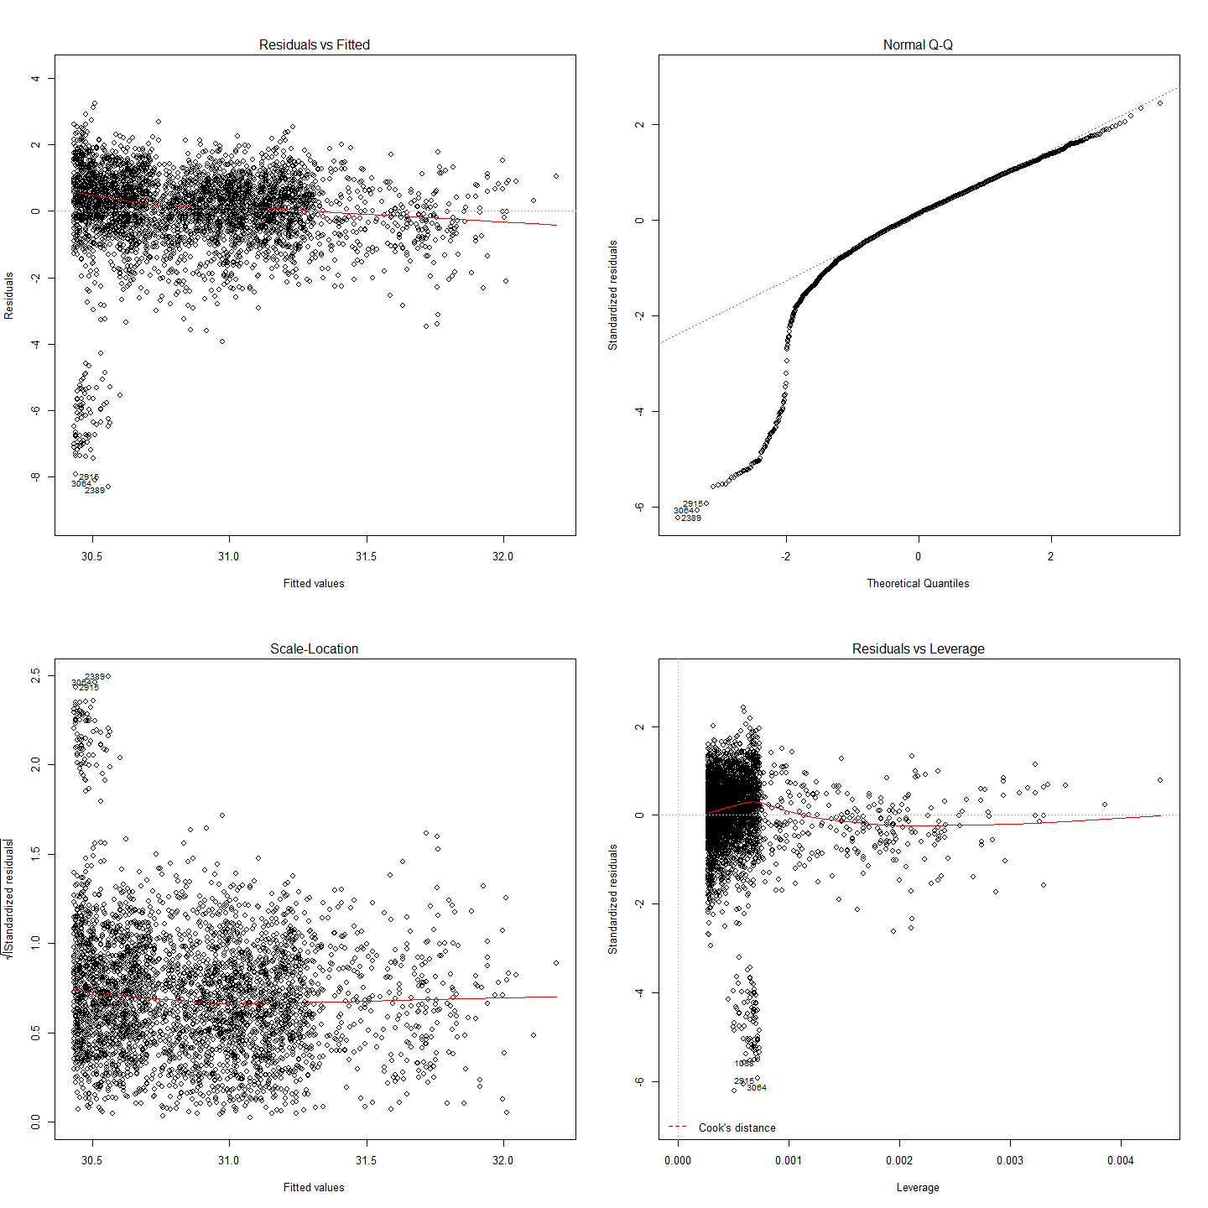

So there is some small but significant correlation between genetic distance and geographic distance in the Murray cod sampled. Isolation by distance does occur, even over this very small spatial scale.

### Mantel Test

mant<-mantel.rtest(as.dist(GeoDistMathm), as.dist(MCdm), nrepet = 9999)  
mant

## Monte-Carlo test  
## Observation: 0.2471   
## Call: mantel.rtest(m1 = as.dist(GeoDistMathm), m2 = as.dist(MCdm),   
## nrepet = 9999)  
## Based on 9999 replicates  
## Simulated p-value: 1e-04

#Check all is in order  
as.matrix(GeoDistMathm)[1:5, 1:5]

## B2013117-191 B2013117-192 B2013117-193 B2013117-194 B2013117-195  
## B2013117-191 0 3375 1417 5512.6 6041.0  
## B2013117-192 3375 0 1958 2137.8 2666.2  
## B2013117-193 1417 1958 0 4095.4 4623.9  
## B2013117-194 5513 2138 4095 0.0 528.4  
## B2013117-195 6041 2666 4624 528.4 0.0

as.matrix(MCdm)[1:5, 1:5]

## B2013117-191 B2013117-192 B2013117-193 B2013117-194 B2013117-195  
## B2013117-191 0.00 30.08 23.66 30.13 30.33  
## B2013117-192 30.08 0.00 30.05 28.74 30.06  
## B2013117-193 23.66 30.05 0.00 30.12 29.26  
## B2013117-194 30.13 28.74 30.12 0.00 29.87  
## B2013117-195 30.33 30.06 29.26 29.87 0.00

Based on these results, we can reject the null hypothesis that these two matrices, spatial distance and genetic distance, are unrelated with alpha = 10-4. The observed correlation, 0.2471, suggests that the matrix entries are positively associated. This means that smaller differences in genotype are generally seen among pairs of larvae that are from nests geographically close to each other, rather than nests which are estimated to be further away from each other. Note that since this test is based on random permutations, the code will always arrive at the same observed correlation but rarely at exactly the same p-value.

The most likely positon of nests as estimated based on the best estimate of larval drift can now be mapped onto the river topology.

## Siblings and What they can tell us about Larval Dispersal

The identification of various sibling pairs and groups in the data (they can be seen in the bottom left of the genetic distance v. distance scatterplot) can potentially be useful in exploring some angles of larval dispersal. For example:

* do siblings dispere in schools or alone?
* How long does the hatch period in the wild last? It is known in hatcheries to last x days but not in the wild. Siblings also facilitate accurate allocation of larvae to nest because, by definition, they come from the same nest. If siblings appear between years then this would suggest repeat adult pairings over years. To date we do not know if this happens.

## This file is to examine the siblings collected that are known to be siblings from DaRT sequencing. The idea is to learn:  
# 1. What duration is hatching in wild nests?   
# 2. Create a list of larvae with siblings (withSibs) and maybe (withoutSibs?) for checking  
# 3. Create a logical matrix of siblinf relationships to re-use (sibsLogical)  
  
#These data can then be used to inform Nest assignments in cases where clade and location are the same.  
  
#Line to extract subset of DF which include at least one sibling in the dataframe  
sibsSubset<-subset(MCdmForSibs, apply(MCdmForSibs, 1, function(MCdmForSibs){any(MCdmForSibs > 0 & MCdmForSibs < 26.5)}))  
#The siblings have a dissimilarity index of less than 26.5. This can be seen in the dendrogram and in the scatterplot for IBD.  
  
sibsLogical<-sibsSubset<26.5 #a logical DF to record T and F for sibling pairs  
sibsSubset<-sibsLogical*sibsSubset #This turns to 0 all the genetic similarity above 26.5 (no-sibs)  
  
sibsSubset<-sibsSubset[!sapply(sibsSubset, function(x) all(x == 0))] #now remove those with no sibs  
sibsLogical<-sibsSubset>0  
  
#Make a list (data frame) with names   
withSib<-row.names(sibsSubset) #make a list of those with sibs  
withSibDF<-as.data.frame(withSib)  
row.names(withSibDF)<-withSibDF[,1] # Make sensible row names (larva labels)  
withSibDF<-as.data.frame(withSibDF) #make back to a df  
  
##Now to see how many days between hatch of sibs.  
  
withSib2<-subset(larv, select=c(Label,hatchDoY)) #get labels and hatch DoY  
withSib2<-withSib2[withSib2$Label %in% withSib,] #reduce df to the siblings only  
  
row.names(withSib2)<-withSib2[,1] #make label row names for making distance matrix  
withSib2$Label<-NULL #tidy up redundant  
  
#Then to make a distance matrix.  
withSibDM<-dist(withSib2)  
withSibDM2<-as.matrix(withSibDM)  
  
###sort rows and columns of both before we can do matrix algebra  
withSibDM2<-as.data.frame(withSibDM2)  
withSibDM2$sort<-row.names(withSibDM2)  
withSibDM2 <- withSibDM2[order(withSibDM2$sort),]#sort row order  
withSibDM2$sort<-NULL  
withSibDM2<-withSibDM2[,order(names(withSibDM2))]#sort column order  
withSibDM2<-as.matrix(withSibDM2)  
  
sibsLogical<-as.data.frame(sibsLogical)  
sibsLogical$sort<-row.names(sibsLogical)  
sibsLogical <- sibsLogical[order(sibsLogical$sort),]#sort row order  
sibsLogical$sort<-NULL  
sibsLogical<-sibsLogical[,order(names(sibsLogical))]#sort column order  
sibsLogical<-as.matrix(sibsLogical)  
####  
  
sibsHatchDiff<-sibsLogical*withSibDM2  
sibsHatchDiff[sibsHatchDiff == 0] <- NA  
sibsHatchDiffMeans<-as.data.frame(colMeans(sibsHatchDiff, na.rm=TRUE))  
  
#Get rid of NAs  
sibsHatchDiffMeans<-na.omit(sibsHatchDiffMeans)  
  
#Output something  
write.csv(format(sibsHatchDiffMeans), file="sibsHatchDiffMeans.csv")  
  
#Describe and Plot Summary Statistics regading the difference in hatch day-of-year between siblings  
describe(sibsHatchDiffMeans)

## sibsHatchDiffMeans   
##   
## 1 Variables 53 Observations  
## --------------------------------------------------------------------------------------------------------------------------------------------------------------------------------------------------------  
## colMeans(sibsHatchDiff, na.rm = TRUE)   
## n missing unique Mean .05 .10 .25 .50 .75 .90 .95   
## 53 0 31 0.8492 0.1890 0.2900 0.4033 0.5900 0.8900 1.3300 3.4500   
##   
## lowest : 0.145 0.150 0.215 0.220 0.290, highest: 1.058 1.330 1.388 3.450 4.520   
## --------------------------------------------------------------------------------------------------------------------------------------------------------------------------------------------------------

sibsHatchDiffMeans

## colMeans(sibsHatchDiff, na.rm = TRUE)  
## B2013117-191 0.9600  
## B2013117-193 0.8100  
## B2013117-194 0.1500  
## B2013117-198 0.5900  
## B2013117-199 0.1500  
## K20131111-225 4.5200  
## K20131113-227 0.4400  
## K20131113-229 0.8900  
## K20131113-230 0.2150  
## K20131113-231 0.2200  
## K20131113-233 0.4500  
## K20131113-234 0.8100  
## K20131113-237 0.4400  
## K20131113-238 0.8900  
## K20131113-239 0.4500  
## K20131113-240 0.5900  
## K20131113-241 0.1450  
## K20131113-242 4.5200  
## K20131113-245 0.5900  
## K20131115-258 0.8100  
## K20131119-270 1.0580  
## K20131119-271 0.8180  
## K20131119-274 0.5580  
## K20131120-277 0.6375  
## K20131120-278 0.6375  
## K20131120-279 0.9340  
## K2013117-185 0.4900  
## K2013117-186 0.3789  
## K2013117-187 0.4912  
## K2013117-188 0.3789  
## K2013117-189 0.4912  
## K2013117-190 0.6233  
## K2013118-200 1.3878  
## K2013118-201 0.4033  
## K2013118-202 0.4500  
## K2013118-203 0.4500  
## K2013118-204 0.4700  
## K2013118-205 0.3878  
## L20131113-254 0.2900  
## L20131113-255 0.2900  
## N20131111-206 1.3300  
## N20131111-207 0.5900  
## N20131111-210 0.3000  
## N20131111-212 3.4500  
## N20131111-213 0.8900  
## N20131111-215 0.3000  
## N20131111-217 0.3000  
## N20131111-219 0.5900  
## N20131111-220 1.3300  
## N20131111-224 0.8900  
## N20131118-266 3.4500  
## T20131119-267 0.6600  
## T20131121-280 0.6600

names(sibsHatchDiffMeans)[names(sibsHatchDiffMeans)=="colMeans(sibsHatchDiff, na.rm = TRUE)"] <- "colM"  
hist(sibsHatchDiffMeans$colM,breaks = 25, col = "lightblue", border = "pink")

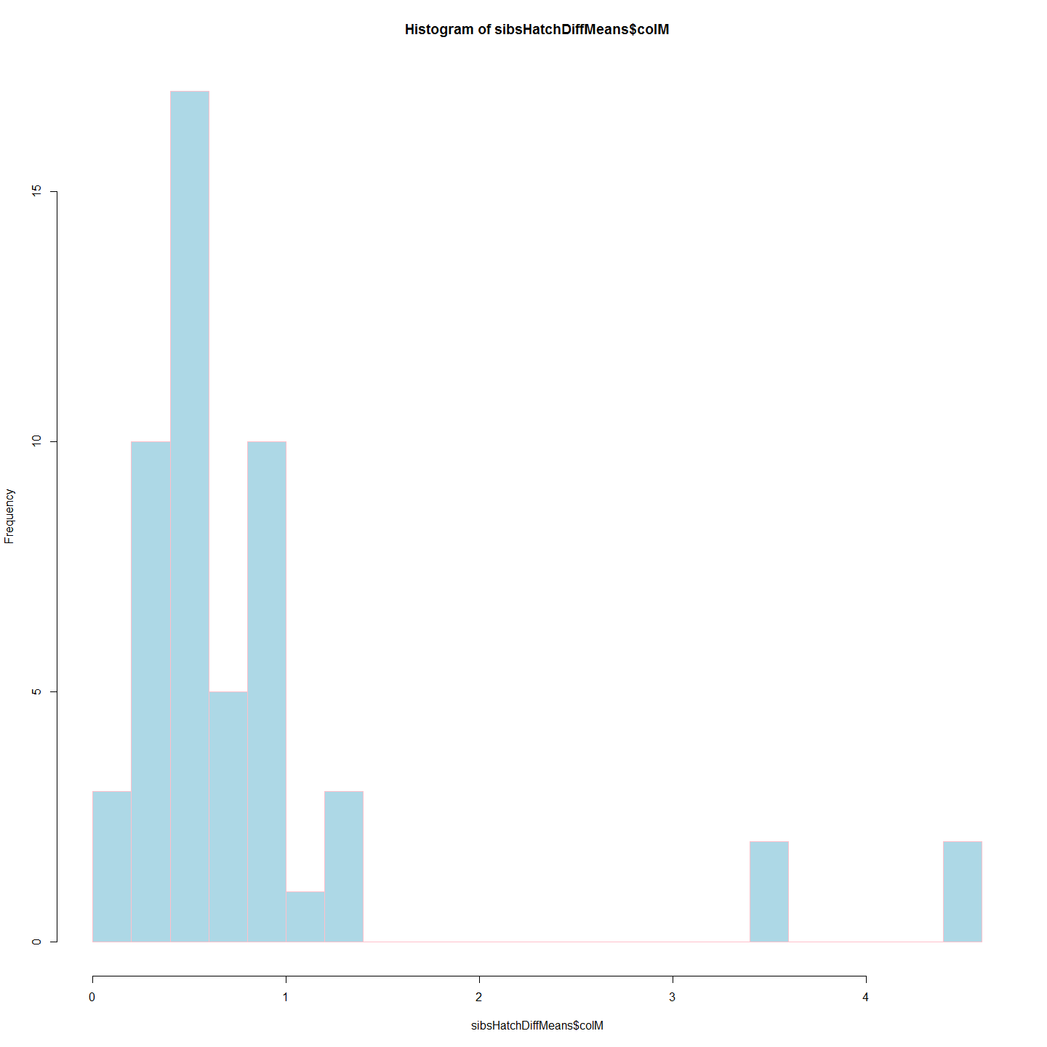

#So the three objective have been achieved.   
# 1. What duration is hatching in wild nests? Description above showns mean etc.  
# 2. Create a list of larvae with siblings (withSibsDF) done  
# 3. Create a logical matrix of siblinf relationships to re-use (sibsLogical) done  
  
#Clean Up  
rm(sibsSubset)  
rm(sibsHatchDiff)  
rm(sibsHatchDiffMeans)  
rm(sibsLogical)  
rm(withSib)  
rm(withSib2)  
rm(withSibDF)  
rm(withSibDM)  
rm(withSibDM2)  
rm(MCdmForSibs)  
  
#END

### AMOVA

* Bernd's data munging etc

## Discussion (points only)

* It will be interesting to mito-sequence the trout cod and determine the species of the male and female parent. It is likely that that the female is the Trout cod in the mating pair given the scarcity of trout cod compared with Murray cod and the mate pressure that must exist.
* Evidence for local recruitment. Re recruitment to local area.
* IBD quite marked compared to some marine species. See salmon over thousands of kilometres (same r squared) [ref: powerpoint slide]

## Code Chunks in this Document

## [1] "Project_Template_and_Knitr" "Set_Global_Options" "LoadLibraries" "unnamed-chunk-1"   
## [5] "unnamed-chunk-2" "unnamed-chunk-3" "unnamed-chunk-4" "All_Maccullochella_Larvae"   
## [9] "Murray_Cod_Larvae_Only" "A2R_Dendrogram" "ExtractClades" "extractRaceClades"   
## [13] "Trout_Cod_Dendrograms" "unnamed-chunk-5" "first" "Distance_Matrices_and_Ordering"   
## [17] "Plots_and_Correlation" "Mantel_Test" "unnamed-chunk-6" "siblingAnalysisGo"   
## [21] "Include_Chunk_Labels_and_Session Information" "IM" "siblingAnalysis"

## R version 3.1.1 (2014-07-10)  
## Platform: x86_64-w64-mingw32/x64 (64-bit)  
##   
## locale:  
## [1] LC_COLLATE=English_Australia.1252 LC_CTYPE=English_Australia.1252 LC_MONETARY=English_Australia.1252 LC_NUMERIC=C LC_TIME=English_Australia.1252   
##   
## attached base packages:  
## [1] splines grid stats graphics grDevices utils datasets methods base   
##   
## other attached packages:  
## [1] ade4_1.6-2 Hmisc_3.14-4 Formula_1.1-2 survival_2.37-7 lattice_0.20-29 dendextend_0.18.3 ape_3.1-4 ggdendro_0.1-15   
## [9] ggplot2_1.0.0 ProjectTemplate_0.5-1 knitr_1.6   
##   
## loaded via a namespace (and not attached):  
## [1] cluster_1.15.2 colorspace_1.2-4 digest_0.6.4 evaluate_0.5.5 formatR_1.0 gtable_0.1.2 htmltools_0.2.6 latticeExtra_0.6-26 magrittr_1.0.1   
## [10] MASS_7.3-34 munsell_0.4.2 nlme_3.1-117 plyr_1.8.1 proto_0.3-10 RColorBrewer_1.0-5 Rcpp_0.11.2 reshape2_1.4 rmarkdown_0.2.54   
## [19] scales_0.2.4 stringr_0.6.2 tools_3.1.1 whisker_0.3-2 yaml_2.1.13