Murray Cod Larval Clusters in the Murrumbidgee River 2013

Alan Couch

Thursday, August 14, 2014

In this analysis it is important to remember a few points when interpreting the analysis. Firstly, the larvae come from a nest some unknown distance **above** the site Name, not neccessarily at that site although that is where they were collected. Secondly, it is assumed that the female travelled an unknown distance upstream to deposit her eggs in the nest. It is not unknown however for females to travel downstream to spawn (citation needed).

It is also important to remember this analysis is a hypothesis generation exercise regarding how many nests are likely represented by the larvae sampled. It is not a post-hoc assignation therefore. The number of nests hypothesesised based on biogeochemistry will need to be validated by genetic analysis.

The movement of the females upstream and the larval dispersal downstream conspire to confound interpretation of the spatial distribution based on biogeochemistry alone.

It should also be remembered that this analysis will ultimately have both elements and C and N isotopes which may improve (or weaken) assignment to clusters.

# Including DC13, D15N and Mean Otolith Length aka Mummies.

In this case I have standardised the variables iaw Milligan et al 1988, (value/range) which gives more accurate assignation to clusters under a variety of conditions.

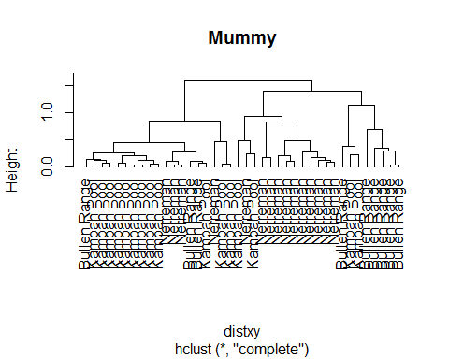 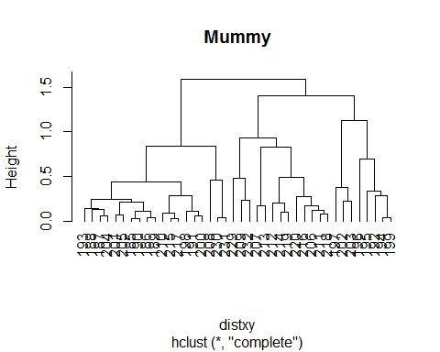 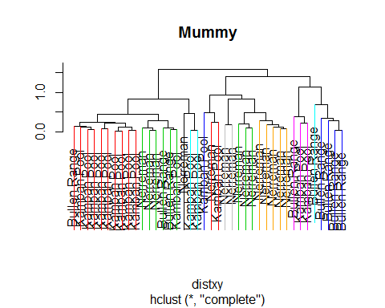 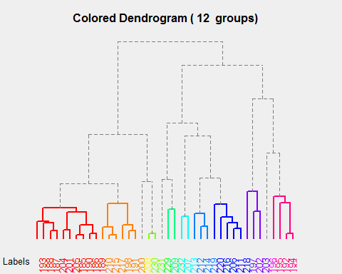 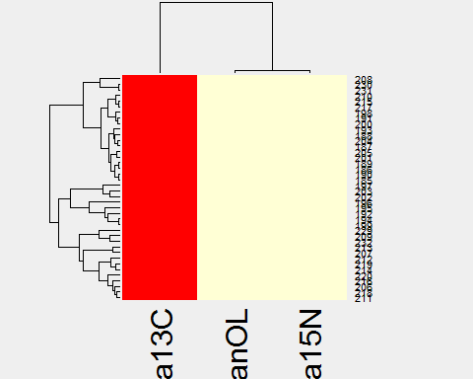 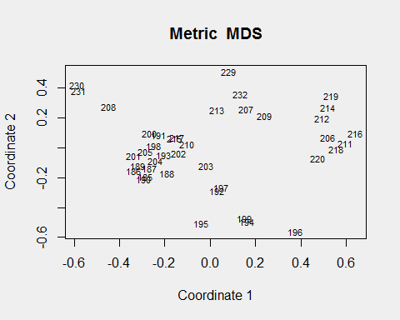

In this case there are 40 rows ( 185, 186, 187, 188, 189, 190, 191, 192, 193, 194, 195, 196, 197, 198, 199, 200, 201, 202, 203, 204, 205, 206, 207, 208, 209, 210, 211, 212, 213, 214, 215, 216, 217, 218, 219, 220, 229, 230, 231, 232 ) and 3 columns (smeanOL, sDelta13C, sDelta15N) in the dataframe.

# This Time the Analysis Includes a estimate of Nest Location based on dispersal days and capture location

This analysis includes an 'arbitrary' nest location calculation based on age of the larva as determined from otolith length, the time it is likely to have had available for dispersal (age - 7), and distance above the capture site calculated at 300 metres movement per day. The formula in r is as follows:

## Cluster Analysis Based on Standardised Variables (Milligan and Cooper 1988)

In this case I have standardised the variables iaw Milligan et al 1988, (value/range) which gives more accurate assignation to clusters under a variety of conditions.

An example of this code is:

$$df$sDelta13C<-df$Delta13C/(max(df$Delta13C) - min(df$Delta13C))$$

**Needs verification from body of paper (abstract used).**

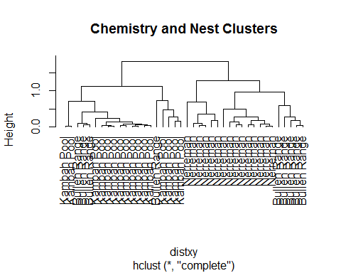 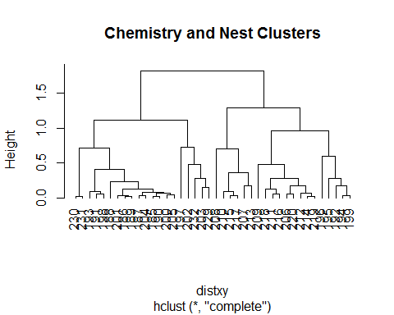 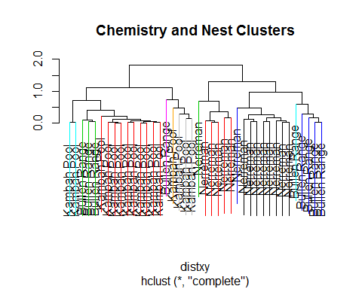 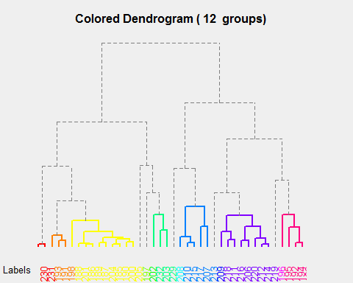 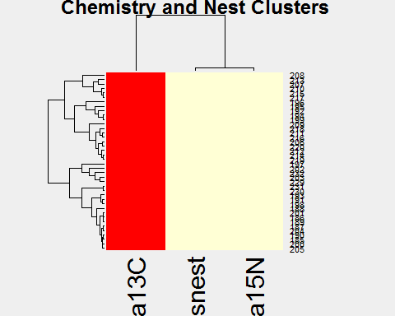 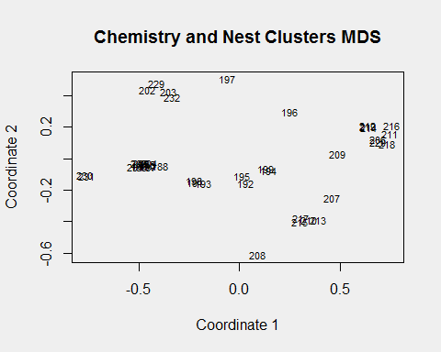

In this case there are 40 rows (185, 186, 187, 188, 189, 190, 191, 192, 193, 194, 195, 196, 197, 198, 199, 200, 201, 202, 203, 204, 205, 206, 207, 208, 209, 210, 211, 212, 213, 214, 215, 216, 217, 218, 219, 220, 229, 230, 231, 232) and 3 columns (snest, sDelta13C, sDelta15N) in the dataframe.