SIGNGUY AI

EC15 — WRAP LAB
  - Full wrap-project workflow, packet layouts, vector design, production, installation, completion, warranty, and aftercare authority
PLANNING AUTHORITY — NO IMPLEMENTATION AUTHORIZATION

1. Exact packet-layout rule
The supplied example packets are visual authorities, not vague inspiration. Preserve their clean white-card layout, strong section headers, two-column summary blocks, detailed coverage and damage tables, vehicle diagram areas, checklist hierarchy, financial summary, proof/timeline blocks, and completion/warranty sections. Branding remains tenant-configurable, but information hierarchy and professional packet density must stay substantially the same.

2. Required Wrap Lab workflow
- Lead/intake
- Vehicle and customer record
- Coverage and measurement plan
- Estimate/Quote
- Contract and deposit
- Pre-install checklist and inspection
- Damage/photos/acknowledgements/signatures
- Design and proof
- Panel planning and production checks
- Production and install scheduling
- Installation
- Pickup/completion packet
- Warranty and aftercare
- History and reporting

3. Vector design rule
- True vector layout engine
- Layers, locks, grouping, precision scale
- Original logos preserved
- AI may suggest placement but may not redraw sponsor logos
- Vehicle templates
- Panels, bleed, seams, overlap
- Resolution/color/font/preflight checks
- Production exports

4. Visual references
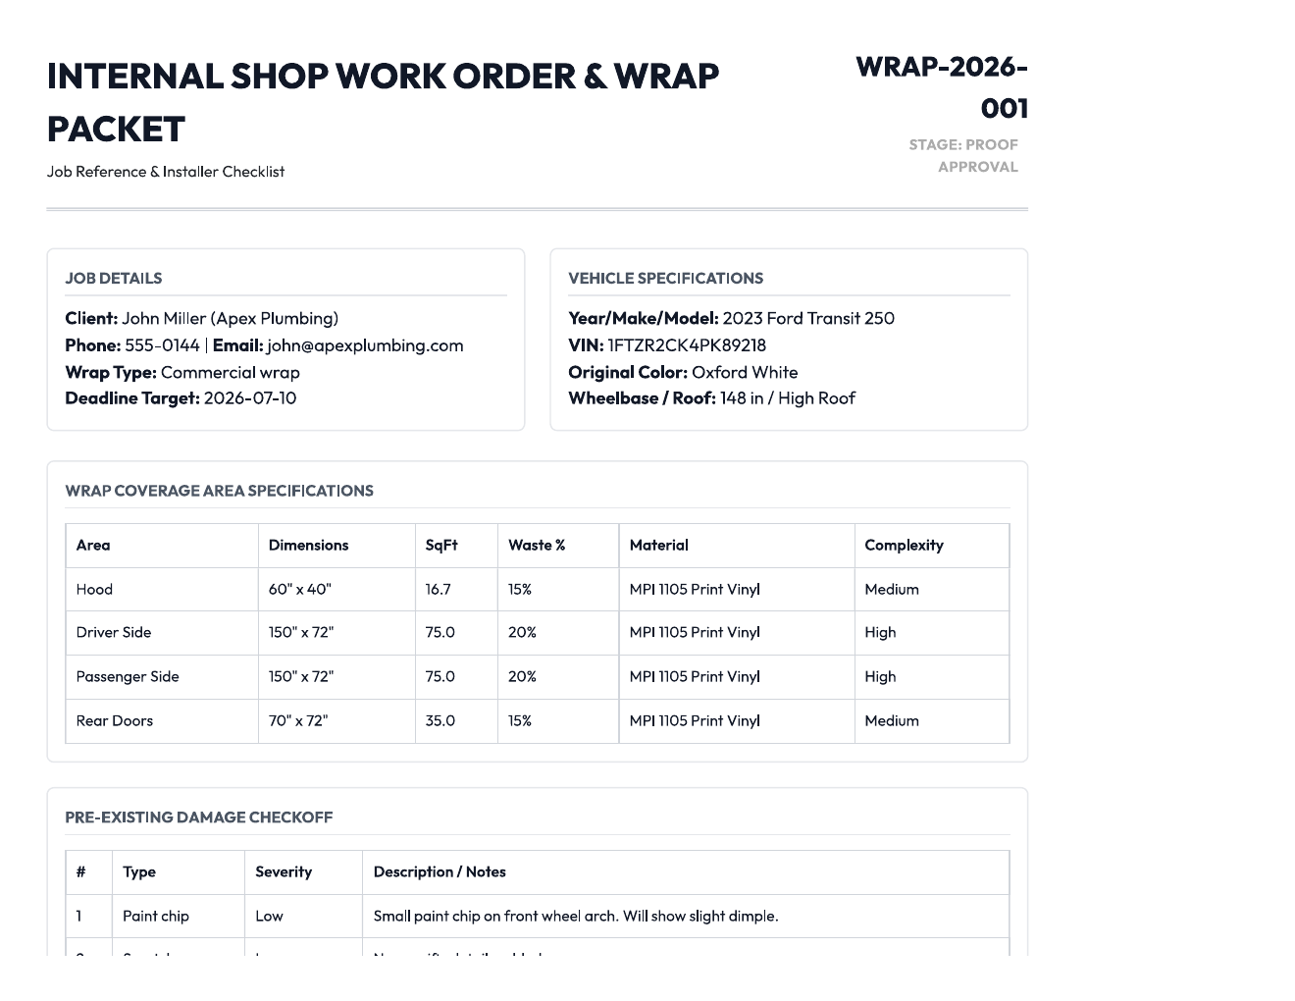
Binding layout reference: wrap-01.png
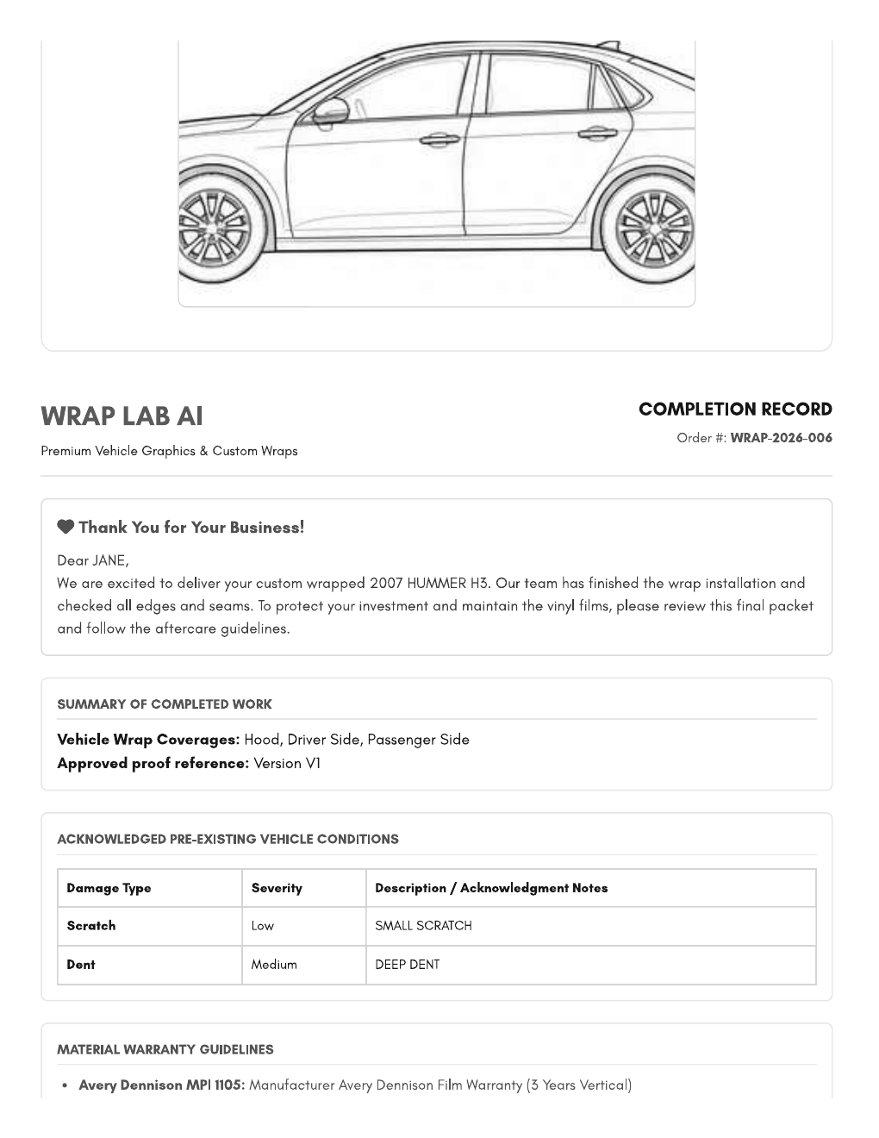
Binding layout reference: wrap-02.png
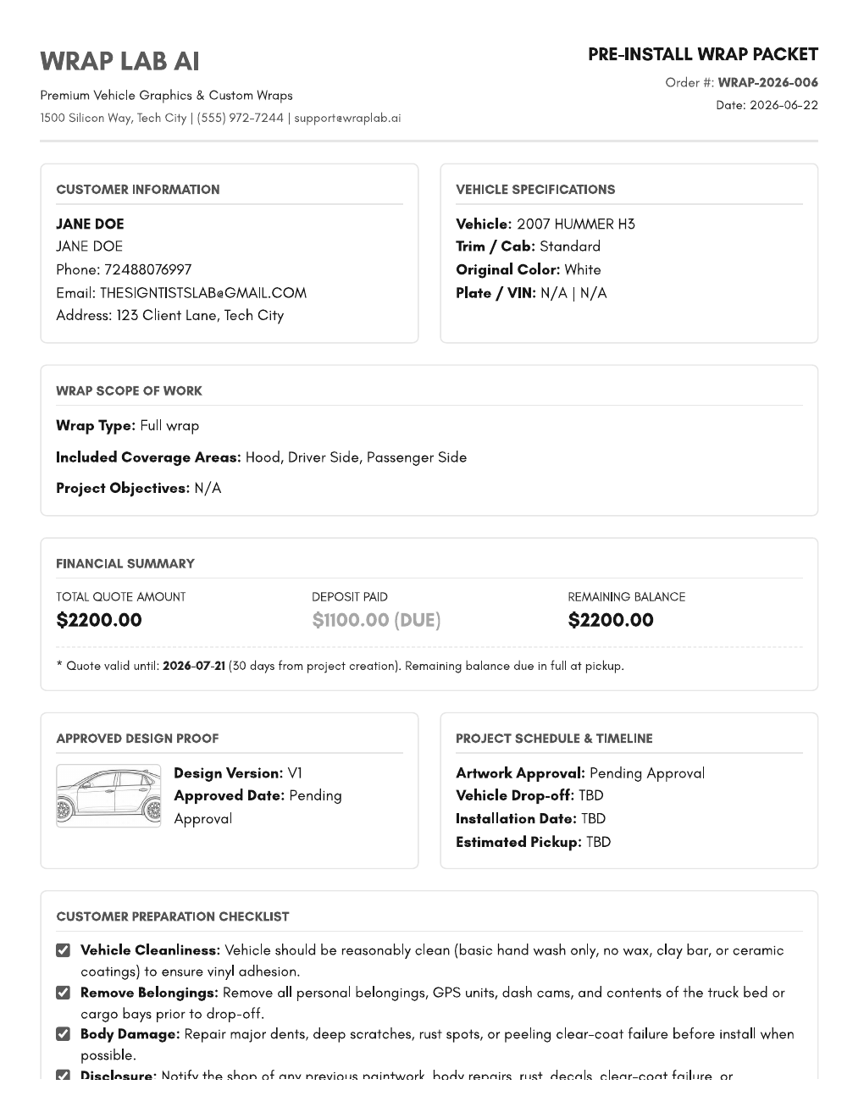
Binding layout reference: wrap-03.png

5. Consolidated source

Appendix — Wrap Lab Source Specification
VEHICLE WRAP & GRAPHICS
pre-installation checklist
DATE

NAME

ADDRESS CITY ZIP

ORDERED BY

PHONE # EMAIL
YEAR MAKE: MODEL:
We thank you for your interest in THE SIGN GUY PA vehicle graphics and wraps. THE SIGN GUY PA prides
itself in only producing the best quality service and elements involved from conception to final product. We ask
that you take a look at the checklist below to prepare yourself for an initial consultation before production
begins on your vehicle. We recommend having any damages repaired prior to installation, as this can hinder
proper installation and greatly reduce the life of your graphics.
Dents, scratches, and other damages that were found on the vehicle
are pointed out. THE SIGN GUY PA can not be held liable to any pre-
existing damages.
I have been explained and understand that the installation will reflect
the condition of the paint of the vehicle.
INSTALLATION
I understand that any dents or scratches to the paint of the vehicle may
be visible and appear as bubbles or wrinkles on the material.
I understand that seams and patches on the material may be necessary.
BEFORE
I understand the following areas cannot be wrapped:
• porous areas • door jams • rubber molding • caulking-silicone
• windshield • plastic trim • driver/passenger windows • chrome
I understand this is a vehicle wrap and the color of the vehicle may show
in these areas unless specified and agreed upon at the time of sale
• door jams • behind bumpers • bottom pinch welds
• vents/hole-slats • in between bed & cap for pick-ups
While THE SIGN GUY PA makes every effort to ensure consistent
colors, I understand that there may be some slight color variations
from panel to panel and vehicle to vehicle.
I understand that vehicle wraps are meant to be viewed from 6-10
feet away.
I understand THE SIGN GUY PA will not be liable for any paint
damage occurring during installation.

ACCEPTED BY DATE
VEHICLE WRAP & GRAPHICS
pre-installation inspection

SEDAN PICKUP

INITIALS INITIALS

VAN TRAILER

PASSENGER

DRIVER

BACK FRONT

INITIALS INITIALS
Vehicle Wrap AI Tool - Full Specifications
Saved for Future Development
---
1. CORE ARCHITECTURE RULES (NON-NEGOTIABLE)
This tool is NOT a generative image toy.
It must be a vector-based layout engine with AI-assisted placement logic and
production-aware export.
Hard Requirements:
Canvas must support:
True vector rendering
Layer system
Locked asset layers
Grouping
Precise scaling
All sponsor logos:
Must remain original uploaded assets
Never be recreated or redrawn by AI
Never rasterized unless originally raster
AI is allowed to:
Suggest layout
Create background graphics
Adjust hierarchy
Recommend sizing
Generate shape layers
AI is NOT allowed to:
Rebuild logos
Guess brand fonts
Convert logos to text-to-image
Replace vector artwork
---
2. FILE INPUT REQUIREMENTS
Supported Upload Types:
SVG
AI
EPS
PDF (vector)
High-res PNG
High-res JPG
Behavior Rules:
If vector:
→ Preserve vector format internally.
If raster:
→ Keep original resolution.
→ Do not attempt auto-vectorization unless user requests it.
All uploaded logos become:
→ Locked Smart Objects
→ Editable scale/position only
---
3. VEHICLE TEMPLATE SYSTEM
System must include:
Preloaded accurate vehicle templates
True scale measurements
Defined printable zones
Door gap overlays
Wheel well cutouts
Window masked areas
When user selects vehicle:
Load scaled vector template
Define total printable area
Store actual dimensions in inches
No fake perspective mockups. Use flat production profiles.
---
4. AI LAYOUT ENGINE
User Inputs:
Industry
Brand colors
Wrap coverage level (Spot graphics / Partial / Full)
Design style preference
Uploaded logos
Optional slogan
Optional website
AI Must Generate:
3–5 Layout Concepts
Different hierarchy styles
Different background directions
Different logo emphasis
Maintain:
Minimum readable text size
Proper contrast ratios
Clean visual flow
Apply design to:
Driver side
Passenger side
Rear
Hood (if selected)
AI must respect:
Safe zones
Panel edges
Handle cutouts
---
5. SPONSOR & MULTI-LOGO HANDLING
When multiple logos uploaded:
System must:
Allow sponsor tier assignment:
Primary
Secondary
Supporting
AI must:
Scale primary largest
Maintain equal spacing
Avoid overlapping wheel wells
Keep logos visually balanced
NO logo distortion. NO stretching. NO color modification.
---
6. PRINT PANELING ENGINE
User Inputs:
Printer max width (ex: 54", 60")
Desired overlap (default 0.5–1")
Bleed setting (default 0.5")
System Must:
Calculate total wrap width
Divide evenly into panels
Add:
Overlap margins
Bleed extension
Label panels:
Panel 1A
Panel 1B
etc.
Each panel must:
Be exportable individually
Maintain correct scale
Include alignment marks
This is geometry, not generative AI.
---
7. RESOLUTION & COLOR CONTROL
Background graphics must be generated at:
True production scale OR
Scalable vector format
If raster:
Minimum 150 DPI at full scale
300 DPI at half scale minimum
Color Mode:
CMYK export option
ICC profile selection
No upscaling low-res mockups for print.
---
8. TEXT HANDLING
System Text Fields:
Must use selectable fonts
Convert to outlines before export
Uploaded Logos:
Never convert to system font
Never substitute fonts
Never regenerate text
---
9. EXPORT OPTIONS
Export Formats Required:
PDF/X-1a
High-res TIFF
Layered PDF
Individual paneled PDFs
Export must include:
Bleed
Crop marks
Panel labels
Scale reference
Optional:
Production summary sheet
Total sq ft
Estimated vinyl usage
Estimated laminate usage
---
10. PRODUCTION INTELLIGENCE FEATURES
Add optional AI tools:
Material Usage Calculator
Auto-calc square footage
Add waste factor %
Install Complexity Estimator
Detect heavy curves
Suggest labor hours
Visibility Analyzer
Simulate viewing distance
Contrast Warning System
Flag low readability areas
---
11. UI STRUCTURE
Step-by-step workflow:
Select Vehicle
Upload Logos
Choose Coverage Level
Select Style
Generate Concepts
Adjust Layout
Confirm Print Settings
Export Production Files
Do NOT overwhelm with too many controls at once.
---
12. MVP VS ADVANCED
If building in phases:
MVP:
Logo placement AI
Background generator
Basic panel splitting
PDF export
Advanced:
3D preview
Traffic simulation
Install heat map
Fleet auto-variation
---
13. TECHNICAL IMPLEMENTATION NOTES
Recommended Tech Stack:
Canvas Library: Fabric.js (handles vector/raster, layers, locking, JSON save/load)
PDF Generation: pdf-lib or jsPDF for client-side, reportlab/WeasyPrint for
server-side
Vector Parsing: svg-parser, pdf.js for handling uploads
Export: Server-side CMYK conversion with ImageMagick or similar
Key Principle:
Separate generative design logic from production export logic.
AI assists in layout and background creation only
Vector integrity preserved at all times
Export engine operates independently from AI image generation
---
Vehicle Templates Needed:
Box Truck
Sprinter Van
Pickup Truck (F-150 style)
Enclosed Trailer
Semi Truck
Sprint Car (dirt track)
Late Model (dirt track)
NASCAR style stock car
---
Saved: February 2026
Status: Future Development - Build after current features are perfected
Vehicle Wrap Workflow Panel Breakdown
If I was making a vehicle wrap workflow for my app and I want it to be like the form that is filled in as the
ORDER progresses I want an area that puts in the coverage of the car so what areas did the car be broken
down into for me to get Dimensions like Hood driver door passenger door Etc
To build a highly functional vehicle wrap workflow, breaking the vehicle down into standard, industry-
recognized body panels is exactly the right approach. Wrap installers think in terms of panels because
material is cut from rolls to fit these specific sections.
Grouping these panels by the "view" of the car makes the form intuitive for the user to fill out as they walk
around the vehicle.
Here is the comprehensive breakdown of the areas you should include in your form to capture dimensions
and track progress:
1. Front Section
• Hood: The main hood area.
• Front Bumper: Often a complex piece requiring specific measurements.
• Front Fenders: Broken down into Driver Front Fender and Passenger Front Fender.
• Grille/Valance: Optional, but important for custom or textured trim wraps.
2. Driver Side Panels
• Driver Front Door
• Driver Rear Door (Include a toggle for 2-door vs. 4-door vehicles).
• Driver Rear Quarter Panel: The large panel stretching from the rear door to the taillights.
• Driver Rocker Panel: The bottom skirt beneath the doors.
• Driver Pillars: The vertical supports around the windows (A-Pillar by the windshield, B-Pillar between
doors, C/D-Pillars at the back).
3. Passenger Side Panels
• Passenger Front Door
• Passenger Rear Door
• Passenger Rear Quarter Panel
• Passenger Rocker Panel
• Passenger Pillars
4. Rear Section
• Trunk / Tailgate / Hatch: Depending on whether it’s a sedan, truck, or SUV.
• Rear Bumper
• Spoiler / Wing: Often wrapped separately or in a accent color.
5. Top Section
• Roof: A massive surface area that often requires its own section of vinyl.
• Sunroof / Panoramic Roof: Good to have as a checkbox to indicate if vinyl coverage is needed or if it's
skipped/cut out.
6. Accents & Small Parts (The "Details")
Installers love tracking these because they are time-consuming and easy to miss:
• Side Mirrors: Left and Right.
• Door Handles: Total count or specific positions.
1
• Emblems / Badging: To note if they need to be removed and reinstalled.
• Window Trim: For "Chrome Delete" ORDERs.
UX Tip for Your App Form
Instead of making the user type in dimensions for every single panel on every ORDER, structure your form
dynamically:
1. Coverage Selector: Let them check a box next to each panel (e.g., [x] Hood, [x] Driver Front Door).
2. Conditional Inputs: Only reveal the Width × Height input fields and progress status for the panels they
checked.
3. Progress States: For each active panel, give it a status dropdown like: Not Started ➔ Prepped/Cleaned
➔ Wrapped ➔ Quality Checked.
궰
궱
궲
궳
궷
궵
궶 Vehicle Wrap ORDER Dashboard: Workflow Blueprint
궴
Header: ORDER Identity & Quick Actions
• ORDER ID / Client Name: e.g., #1024 - Apex Plumbing Fleet (Van #1)
• Vehicle Info: 2024 Ford Transit Cargo Van (High Roof, Long Wheelbase)
• Workflow Status Bar: Intake ➔ Inspection ➔ Design ➔ Production ➔ Ready for Pickup
Phase 1: Intake & Legal Hub
This section ensures you get paid and protected before a blade ever touches the vinyl.
• Design Questionnaire Link:
꼐 View Completed Design Questionnaire].
• UI: A prominent button/status chip: [꼏
• Quick Summary: Displays key notes from the client (e.g., "Gloss Black accents, client prefers minimal
seams").
• Contract Management Module:
김 Send Wrap Contract/Terms of Service]
긿
긾
긽
• Button: [긼
• Status Indicator:
• 꾂 Sent - Awaiting Signature
• 밄 Signed & Stored (Clicking allows view/download of the secure PDF timestamp).
Phase 2: The Digital Inspection Bay (Pre-Existing Damage)
Installers must document every rock chip, scratch, or failing clear coat so they aren't blamed for it later.
• Vehicle Blueprint Markup Area:
• An interactive, generic SVG wireframe based on the vehicle type (Sedan, SUV, Truck, Van).
• The installer taps on the diagram to drop "Damage Pins."
• Damage Log Grid:
• Every pin dropped on the diagram generates a row below it:
• Panel: (e.g., Driver Front Door)
• Type: (Drop-down: Scratch, Dent, Paint Chip, Rust, Failing Clear Coat)
• Notes: Short text field.
• Photo Attachment: Click to open mobile camera.
뱌 AI Feature — Vision Damage Tagging: Instead of manually filling out the grid, the installer takes a photo
뱋
뱊
뱉
뱈
뱇
뱆
뱅
of a scratch. The AI detects the defect, automatically categorizes it as a "Deep Scratch," maps it to the
correct panel, and drops the pin on the diagram for them.
2
Phase 3: Materials, Dimensions & Estimation Hub
This is the math engine of the ORDER page.
• Vehicle Dimensions Card:
• Total Estimated Surface Area: ~280 sq ft
• Waste Multiplier: 1.2x (Standard industry buffer for curves and handling)
• Total Material Ordered: 336 sq ft
• Panel-by-Panel Specs Table:
Panel Name Width (in) Height (in) SQFT Status
Hood 65 50 22.5 밄 Wrapped
Driver Front Door 42 36 10.5 밃 In Progress
Roof 120 60 50.0  Not Started

• Materials Used Log:
• Primary Roll: 3M 2080 - Gloss Flip Psychedelic (Lot #A123)
• Accent Roll: Avery Dennison SW900 - Satin Black (Lot #B456)
• Knifeless Tape Used: 1.5 Rolls
• Financial Summary Block:
• Material Cost: $840.00 | Labor Est: $2,200.00 | Total ORDER Value: $3,040.00
뱅
뱆
뱊
뱇
뱉
뱈
뱌 AI Feature — VIN/Plates Spec Autofill: The installer snaps a photo of the vehicle’s VIN or License Plate. The
뱋
AI queries a vehicle database, identifies the exact trim level, pulls the factory manufacturer dimensions, and
automatically populates the standard panel sizes in the table above.
Phase 4: Production & Quality Assurance
Tracks the physical labor as it happens.
• Installer Assignment: Dropdown to assign specific panels to specific team members.
• Post-Heating Checklist: (Crucial for wraps to prevent peeling)
• [ ] Hood edges post-heated to 180°F
• [ ] Door recesses post-heated to 180°F
• [ ] Wheel wells sealed
Phase 5: Handoff & Offboarding
• Aftercare Automation Trigger:
• A toggle switch or automatic trigger when the ORDER status changes to "Completed."

 Auto-Send Aftercare Instructions] — Fires off a pre-templated email/SMS to the client
• [
detailing how to wash the wrap, ceramic coating tips, and things to avoid (like pressure washers closer
than 12 inches).
궲
궰
궱
궳
궴
궷
궵
궶 Comprehensive Vehicle Wrap ORDER Dashboard
Header: ORDER Identity & Quick Actions
• ORDER ID / Client Name: #1024 - Apex Plumbing Fleet (Van #1)
• Vehicle Info: 2024 Ford Transit Cargo Van (High Roof, Long Wheelbase)
• Workflow Status Bar: Intake ➔ Design & Mockup ➔ Pre-Inspection ➔ Production ➔ Ready
for Pickup
3
Phase 1: Intake, Legal & Design Assets
This section acts as the central repository for the foundational digital files and agreements before
production begins.
• Contract Management:
김 Send Wrap Contract/Terms of Service]
긿
긾
긽
• Button: [긼
• Status Indicator: 밄 Signed & Stored (Secure PDF with timestamp)
• Artwork & Design Hub:
꼐 View Completed Questionnaire]
• Design Questionnaire Link: [꼏
• Asset Upload Component: Drag-and-drop zone supporting high-res formats (.AI, .EPS, .PDF, .TIFF).
• File Category Toggles: Mark files as Client Assets (Logos), Print-Ready Print Files, or Cut-Ready Vector
Profiles.
Phase 2: AI Visualization & Creative Approval
An interactive sandbox where the digital design meets the physical vehicle dimensions.
• The AI Wrap Mockup Engine:
• Input: Takes the uploaded 2D artwork patterns/logos and maps them over the vehicle profile
• Output: A high-fidelity, 3D perspective rendering of the wrapped vehicle.
• 긴 Send AI Mockup to Client for Approval]
긳
긲
Action Button: [긱
• Approval Status: 밃 Awaiting Client Approval | 밄 Approved by Client (Timestamped)
뱉
뱅
뱆
뱇
뱈
뱌 AI Feature — Smart Layout Assistant: If a logo or critical text alignment cuts directly across a complex
뱋
뱊
door handle or deep body recess line, the AI flags the clash on the mockup and suggests a minor layout
offset to prevent graphic distortion during physical installation.
Phase 3: The Digital Inspection Bay (Before & After Gallery)
Protects your shop from liability and automatically gathers marketing collateral.
• Vehicle Blueprint Markup Area:
• An interactive SVG wireframe where installers tap to drop "Damage Pins" (scratches, chips, rust).
• Media Gallery Matrix:
Before Images (Intake Quality) After Images (Finished Quality)
꺛
꺘
꺓
꺚
꺔
꺕
꺙 Upload Front Angle]
[꺑 꺙 Upload Front Angle]
꺕
꺛
꺔
꺚
꺓
꺘
[꺑
꺚
꺓
꺘
꺕
꺛
꺔
꺙 Upload Driver Side]
[꺑 꺙 Upload Driver Side]
꺕
꺛
꺔
꺚
꺓
꺘
[꺑
꺚
꺘
꺓
꺔
꺛
꺕
꺙 Upload Passenger Side]
[꺑 꺙 Upload Passenger Side]
꺕
꺛
꺔
꺚
꺓
꺘
[꺑
꺘
꺓
꺚
꺛
꺕
꺙 Upload Rear Angle]
꺔
[꺑 꺙 Upload Rear Angle]
꺕
꺛
꺔
꺚
꺓
꺘
[꺑
뱉
뱅
뱆
뱇
뱈
뱊
뱋
뱌 AI Feature — Vision Damage Tagging: Instantly parses "Before" photos, automatically tags pre-existing
scratches or clear coat failure, logs them to the specific panel, and drops a corresponding marker pin onto
the interactive vehicle diagram.
Phase 4: Materials & Panel Dimensions
The physical manifest and calculation engine for the raw inventory.
• Material Allocation Log:
• Primary Wrap Material: 3M 2080 - Gloss Flip Psychedelic (Lot #A123)
• Accent/Trim Material: Avery Dennison SW900 - Satin Black (Lot #B456)
• Panel Estimation & Spec Card:
• Total Estimated Surface Area: ~280 sq ft
• Waste Multiplier: 1.2x (Standard industry buffer for curves and handling)
4
• Total Material Ordered: 336 sq ft
뱌 AI Feature — VIN/Plates Spec Autofill: Instantly looks up factory manufacturer panel blueprints based on
뱅
뱆
뱇
뱈
뱉
뱊
뱋
the scanned VIN, automatically populating exact width/height specifications for every body panel in the
production table.
Phase 5: Labor & Time Tracking Engine
The operational clock tracking human resources, productivity metrics, and actual vs. estimated labor costs.
• Active ORDER Clock:
Clock In to ORDER] / [膆
• [ Clock Out / Pause]
• Assigned Installers: Lead Installer: Sarah M. | Assistant: John D.
• Panel-by-Panel Labor Matrix:
Panel Name Width × Height Est. Time Actual Time Installer Panel Status
Hood 65" × 50" 1.5 hrs 1.2 hrs Sarah M. 밄 Wrapped
Driver Front 42" × 36" 1.0 hrs 1.4 hrs John D. 밃 In Progress
Door
Roof 120" × 60" 3.0 hrs 0.0 hrs Unassigned  Not Started

• Live Labor Cost Summary:
• Estimated Labor: 12.5 hrs | Actual Labor Expended: 2.6 hrs
• Labor Spend to Date: $195.00 (Calculated dynamically using installer hourly rates mapped in user
settings)
Phase 6: Handoff & Automated Offboarding
• Post-Heating Compliance Check:
• [ ] Hood edges post-heated to 180°F
• [ ] Recessed channels checked and post-heated
• Aftercare Automation Trigger:
 Auto-Send Aftercare Package] — Moving the ORDER status to "Completed" automatically fires a

• [
localized SMS/Email packet to the customer. This details immediate wrap care (avoiding car washes for
2 weeks, pressure washing clearances, UV protection tips) alongside a side-by-side PDF export of the
Before/After Media Gallery.
5

