# Introduction

In this project, the team has decided to answer the question: ‘What trends in business activity can help encourage self-employment through NEIS?’. With this in mind, a plan was made to make use of a set of data and in order to establish decisions based on for or against support for self-employment in that section.

# Deliverable summary

The data parts used within the current context were mainly categorized as follows:

* Number of employees.
* Type of industry.
* Available off street parking spaces.
* Location.

This was a brief and initial data set with the aim to extend more to it in order to allow for more accurate decision support; however this is enough data to give a context or base of implementation.

The reasoning behind number of employees stems from the fact that as a business grows through the course of time, if more employees join, then it is a potential indication that the business as thrived and is progressing.

The type of industry is considered because in certain situations, having a parking space nearby helps but in others it does not.

The available parking spaces (off street) is considered as people value having a parking space near their employment location. Having this is important as high talent employees would want to be happy in their work space and not have to worry about these matters.

Location was also considered because some businesses thrive in certain locations while others don’t.

The end result was a data gathering exercise highlighting where employees have been high. With the current data set, there is not enough to suggest that this is proof of business success but may indicate a potential. The context of the data has to be taken into account in the delivered graph; a sample of which is below:

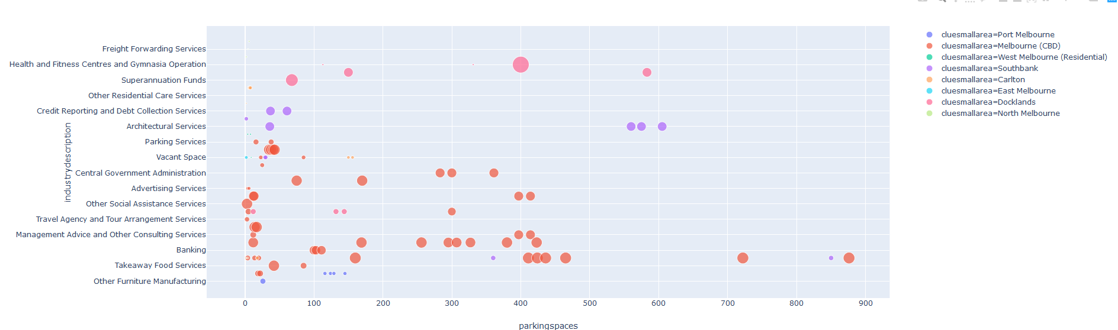

* The x-axis suggests the number of parking areas available (increasing towards the right).
* The y-axis presents different industries.
* The colour represents location.
* The greater the dot, the more employees involved.

This image is available in the project for a more detailed review and is the result of the sample data set used.

# Some analysis and conclusive result examples using the dataset

* In some scenarios, off street parking spaces do not correspond with employee count.
* There are not many employees working in sewerage and drainage or automotive electrical services and a business in this area does not require off street parking spaces near it.
* In Health and Fitness business, it was established that the more parking spaces there is, the more employees work in such business, suggesting opportunities for growth.

# Limitations

* The highlighted data set ‘New Business Assistance with NEIS data’ was a bit limited (see below).
* In the initial stages, still requires human element to decision making (see future expansions).
* Performance has not been taken into account for this project given the time limitations.
* The diagram can be unreadable if there is a lot of data being processed.

# Future expansions

* The model can be extended to support the highlighted ‘New Business Assistance with NEIS data’.
* More data can be used to come up with more accurate results.
* Deep learning and data mining tools can enhance the information gathering of this product.
* AI Techniques and data mining can also be used to automate a decision.
* More caching of data can be introduced to speed this up further.
* Improved diagramming techniques to have more clarity.

# Reference and Credits

* Python Tutorials and references used
* City of Melbourne Open Data https://data.melbourne.vic.gov.au/clue
* City of Melbourne Open Data Pedestrian Counting System:
  + https://data.melbourne.vic.gov.au/Transport-Movement/Pedestrian-Counting-System-Sensor-Locations/h57g-5234/data
  + https://data.melbourne.vic.gov.au/Transport-Movement/Pedestrian-Counting-System-2009-to-Present-counts-/b2ak-trbp
* Public Transport Victoria Traffic Data