Create a service account

* IP and services
* Go to credential then select service account

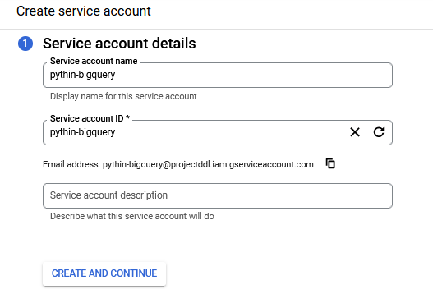

Click CREATE AND CONTINUE.

Go to Grant this service account access to project

* Select BigQuery and then BigQuery Admin
* CONTINUE

Grant users access

* Nothing has to change.
* DONE

Go to IAM admin and service account

* Select KEY