Delete a project from BigQuery

Go to IAM admin

Select Manage resource

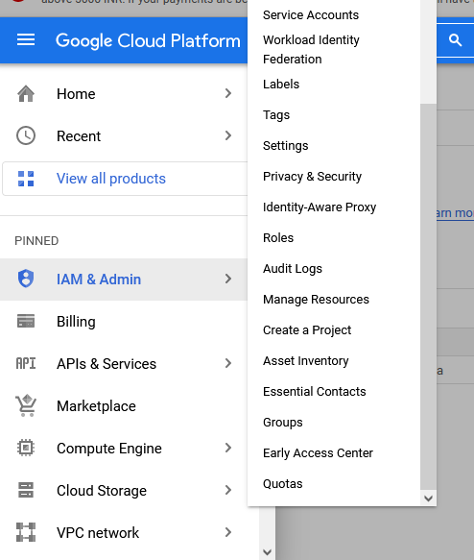

CLICK ON Manage resources

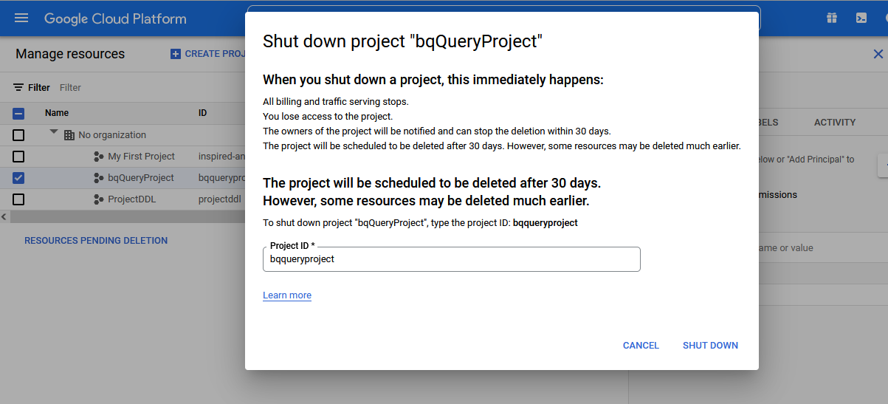

Give the projectID

Click on shutdown

It takes 30 days to delete the project.

END