<https://cloud.google.com/bigquery/docs/external-tables>

<https://cloud.google.com/bigquery/external-table-definition>

What is an external table?

Any data or file system which is not a part of or reside in BigQuery is called external data. This document explains how to query data stored outside of BigQuery.

Data sources associated with External table

Following data sources are associated with external table.

* *Bigtable*
* *Cloud storage*
* *Drive*

Querying Cloud Bigtable data

The following paragraph describes how to use BigQuery to query data stored in Cloud Bigtable.

*Cloud BigTable* is Google’s high performance NoSQL database service which can store millions of rows, columns and petabytes of data. ( NoSQL : are non-tabular databases and stores data in a different way than relational databases. Types are document, key-value and graph)

Create a table definition file for an external data source

A table definition file contains table’s data and related properties. To create a table we can use schema auto-detection to define the schema for an external data source.

* Schema auto-detection

To enable schema auto-detection when loading data, we can use one of these approaches as

1. From the cloud console, in the **schema** section

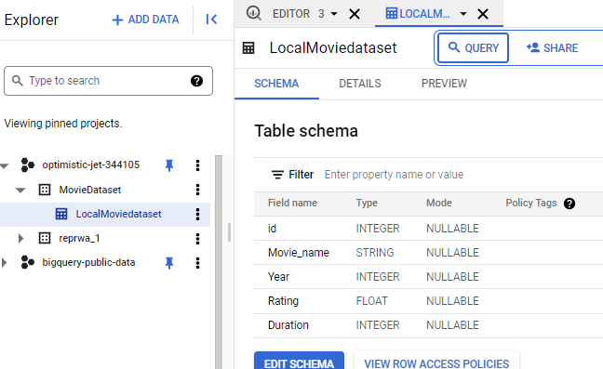

1. bg command line tool using *bg load* command line.

Create an external table for a Cloud Bigtable data source

To create an external table for Cloud Bigtable data source, it is necessary to have a Cloud Bigtable URI. The following steps describes to retrieve Cloud Bigtable URI.

* Open the cloud Bigtable console
* Create your project
* Create a dataset
  + Check your project ID
  + set dataset ID
  + data location

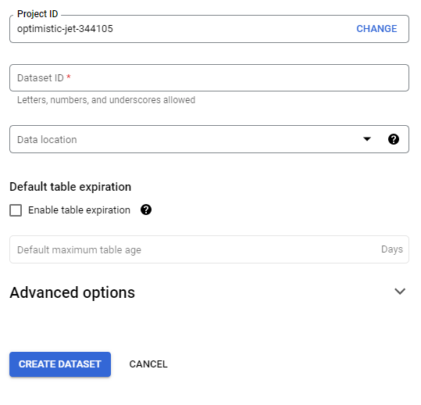

* Create an instance

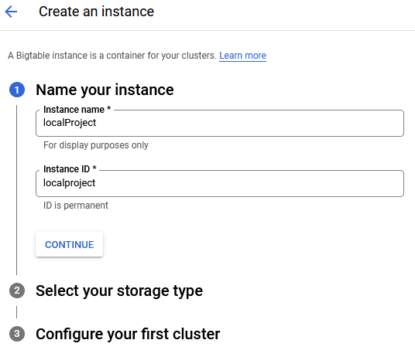

Permanent versus temporary external tables

An external table can be a permanent or a temporary table. A permanent table is created in a dataset and is linked to external data source, we can use *access control* option to query the table at any time and share with others. For temporary table, we do not need to create table in BigQuery datasets and as the table is not permanently stored in a dataset, it cannot be shared with others.

Querying Cloud Bigtable data using permanent external tables

There are two ways to specify a table name while creating a permanent external table in BigQuery.

* bg command-line tool
* using the Cloud Console

Querying Cloud Bigtable data using temporary external tables

To query an external data source without creating a permanent table, run a command

* A table definition file with a query
* An inline schema definition with a query
* A JSON schema definition with a query