**Querying an ingestion-time partitioned table**

When we create a table partitioned by **ingestion time**, BigQuery automatically assigns rows to partitions based on the time when BigQuery ingests the data.

* Hourly
* Daily
* Monthly
* Yearly

The table has following columns:

**Timezone**: DATE

**Events**: integer

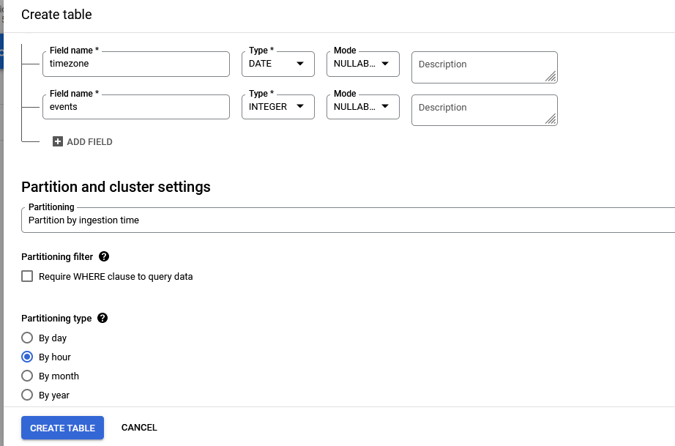

We’ll use **timestamp** to identify the correct partition in the new table. Let’s insert some data into this table.

INSERT INTO

sah16feb22.demo.ingestionHistory (timezone,

id)

VALUES

('2017-09-02 09:01:01.00 UTC',101),

('2017-09-04 09:01:01.00 UTC',102),

('2018-09-04 09:04:01.00 UTC',103),

('2019-09-02 05:01:02.00 UTC',104);

SELECT

*

FROM

sah16feb22.demo.ingestionHistory

WHERE

DATE(_PARTITIONTIME)='2022-04-09';

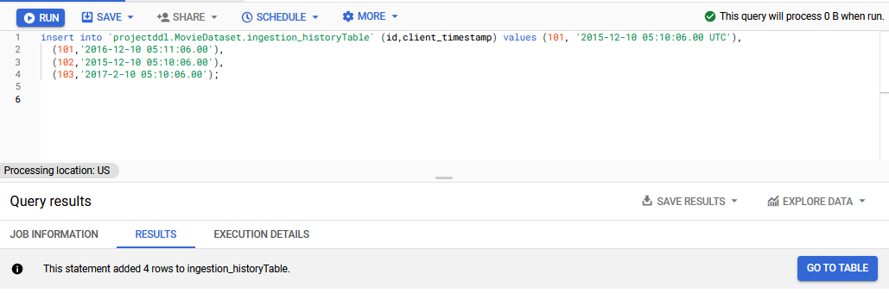

*****************

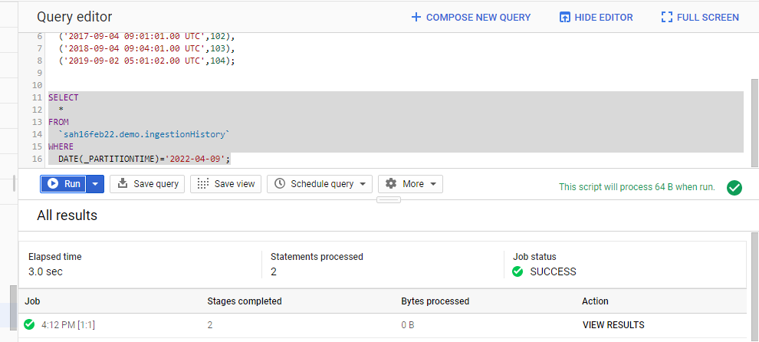

The query shows

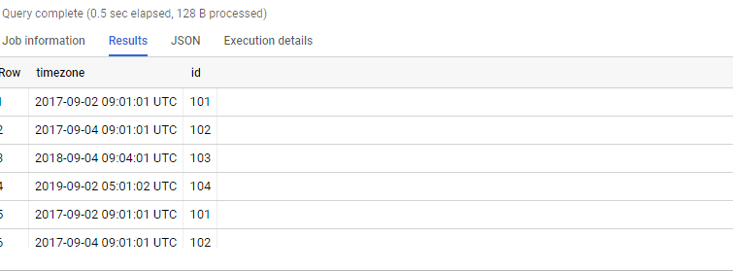

If I will use the query by using date =’2017-03-05’ I get an error message as

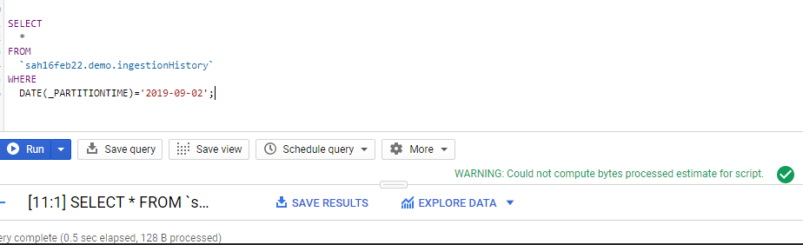

**Continue…..**