Running Interactive and Batch queries

By default BigQuery runs interactive query jobs that means query is executed as soon as possible.

1. To run an interactive query that writes output to a temporary table.

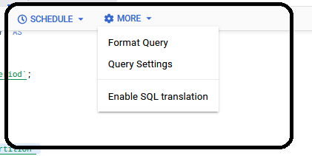

* Write down a valid query statement then …
* Got to More option THEN click on Query settings

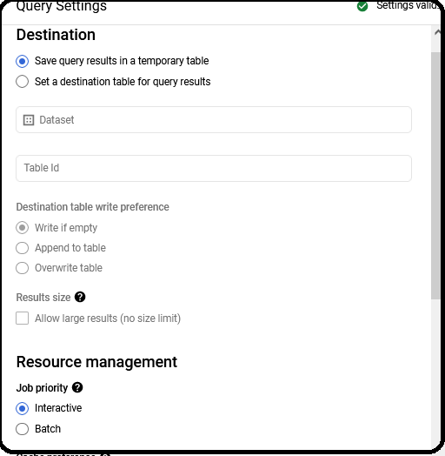

* (Optional) To change the data processing location, click **More**, then **Query settings**. Under **Processing location**, click **Auto-select** and choose your data's [location](https://cloud.google.com/bigquery/docs/locations). Finally, click **Save** to update the query settings.
* Click **Run**.

This creates a query job that writes the output to a temporary table.

**Limitations**

When you run 50 large queries simultaneously, they will compete with each other for resources and slow down. So to avoid this situation it is better to use **batch query**.

1. **Running Batch queries**

In batch query, BigQuery starts to query as soon as idle resources are available in resource pool. If BigQuery hasn't started the query within 24 hours, BigQuery changes the job priority to interactive. Batch queries use the same resources as interactive (on-demand) queries.

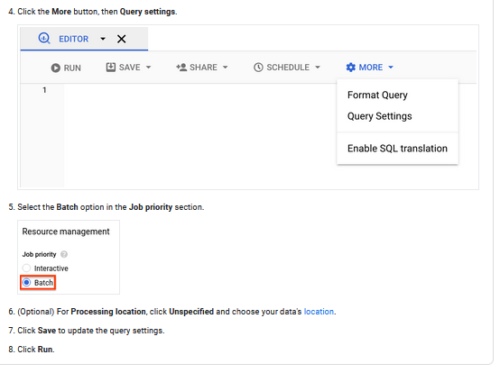

**END**