**MySQL database on Gcp : access database through cloud console**

MySQL is the world's most popular open source database because of its comprehensive support for every application development need. We have several options for deploying MySQL as part of Google Cloud project. We can use Cloud SQL, Google Cloud Marketplace, or manually install MySQL on Compute Engine.

There are several options to connect Cloud SQL for MySQL such as

* Connect to cloud SQL for MySQL from Cloud shell
* Connect to cloud SQL for MySQL with private IP
* Connect to cloud SQL for MySQL using the cloud SQL auth proxy
* Connect to cloud SQL for MySQL from google kubernetes engine

This document explains “**Connect to Cloud SQL for MySQL from Cloud Shell**”.

Steps:

Go to Navigation menu.

Select SQL

Steps to create an instance:

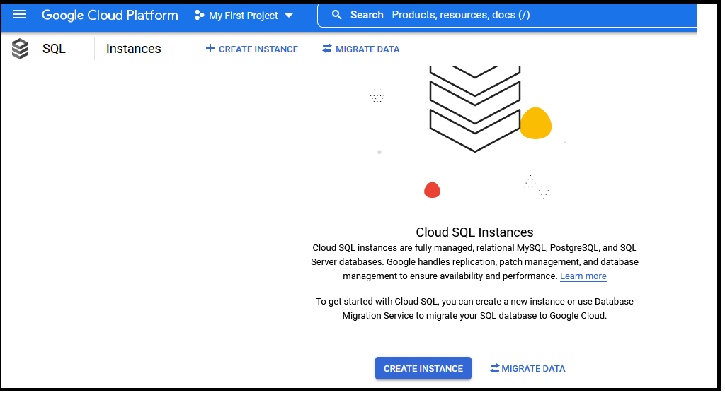

Here we have options as

* Mysql
* Postgresql
* sql server.

From these choose MySQL database.

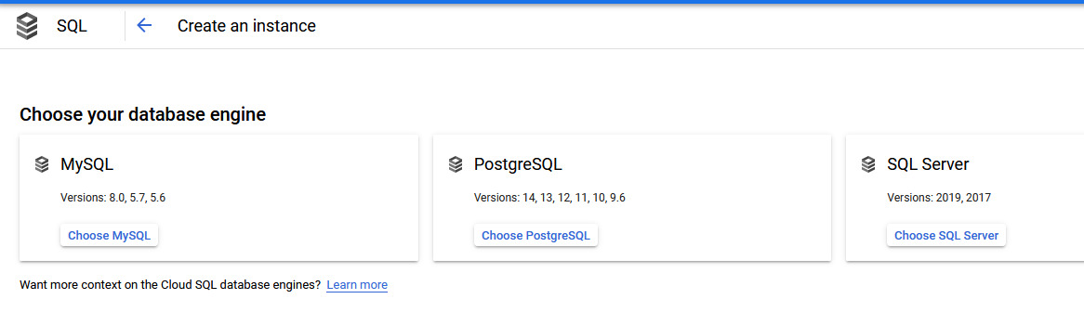

Take the option ENABLE API.

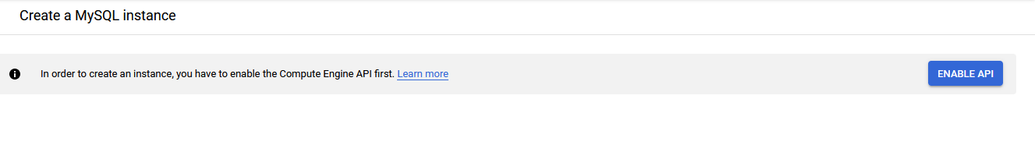

Then …..

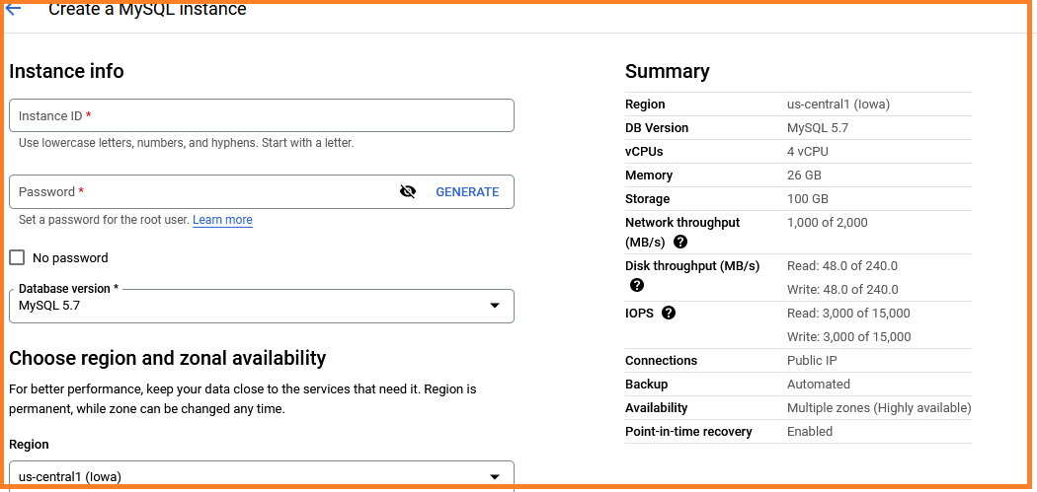

Give an instance id to your choice.

gcp-demo-tutininks

Generate a password ,

so click on GENERATE

Location choose

Us-central

Database version

MySQL 8.0

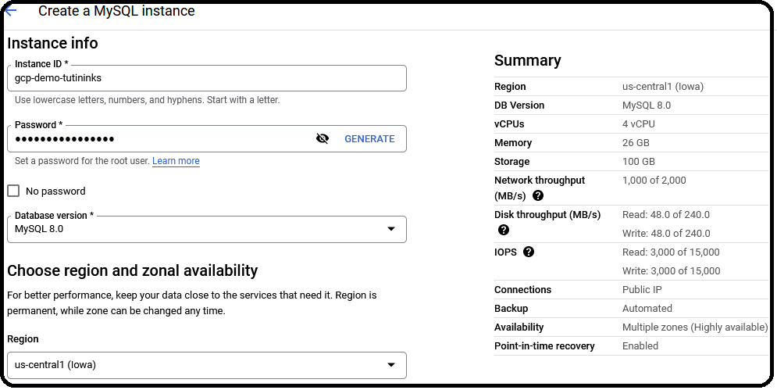

Customize the configuration option as

* Go to Machine type and storage

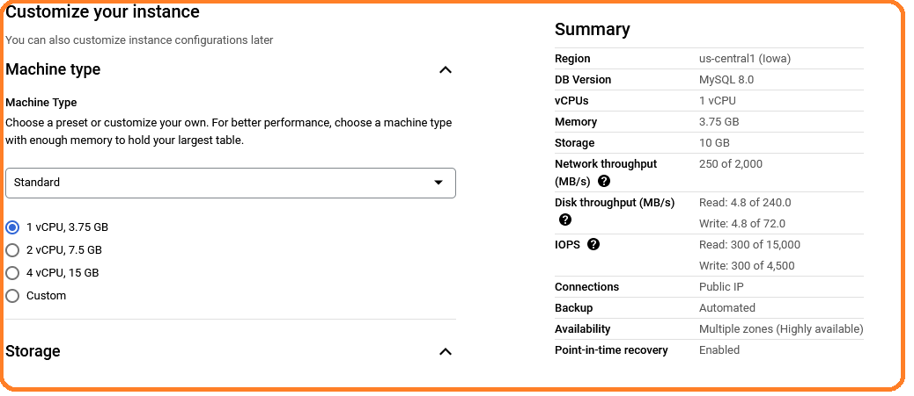

* Storage type
  + HDD
* Storage capacity
  + 10 GB

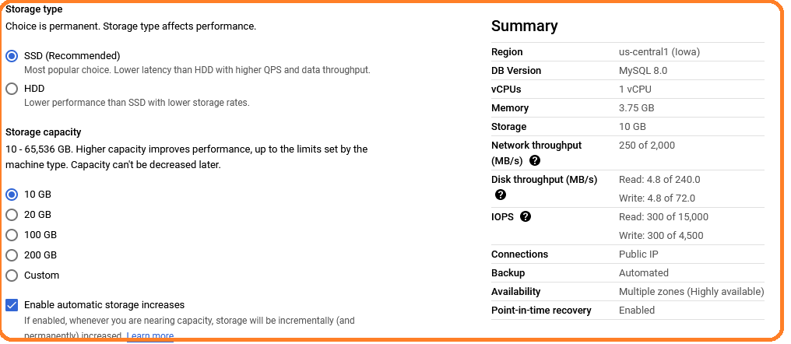

Auto backups and high availability

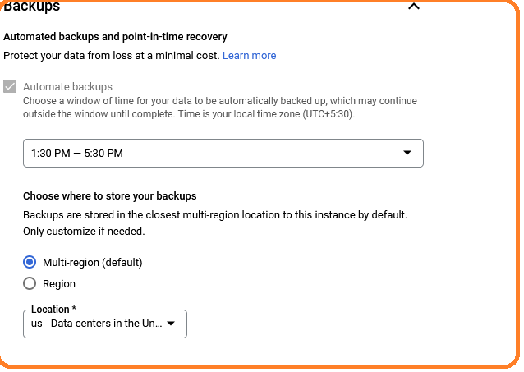

Availability

* You can choose the Mumbai(asia) zone with Multiple zones.

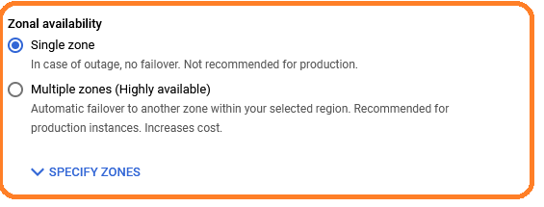

Connectivity

To access mySql data base through local pc, So click on add network.

In browser type “ whats is my IP”?. Copy the IP address and paste in new references.

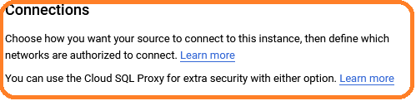

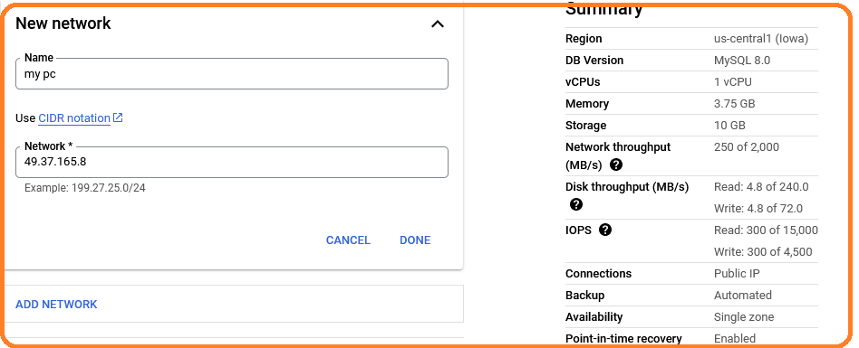

1. **Connect SQL using gcloud**

* Click on OPEN CLOUD SHELL
* It will open a cloud console and asks the password to connect(root).
* If you are getting an error such as…

**Error**

* Not connect to local address then copy the public IP address from overview option and paste the IP address values
* Go to Overview and copy the IP address value (34.100……)

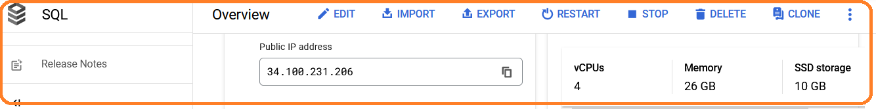

* Go to Connections then CLICK on ADD NETWORK and paste the IP address in

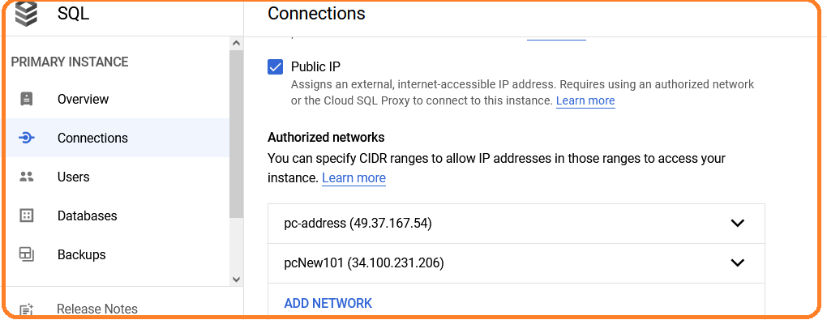

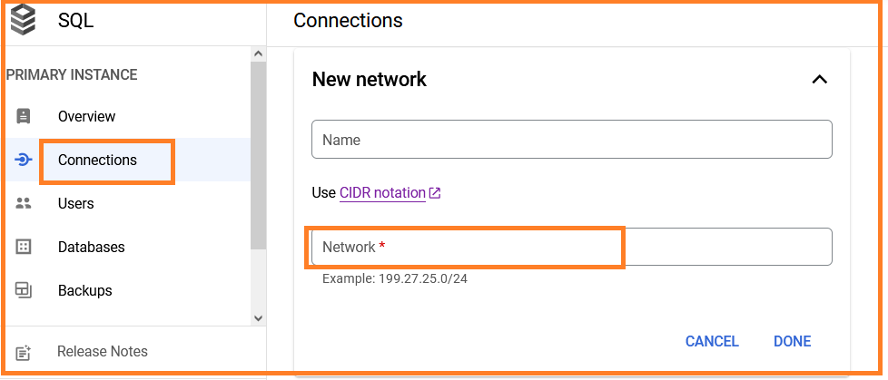

CLICK on DONE.

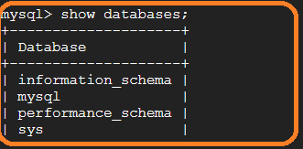

**Exit** to exit from database**.**

## **Clean up**

Steps

* In the Cloud Console, go to the **Manage resources** page.

[Go to Manage resources](https://console.cloud.google.com/iam-admin/projects?_ga=2.128958092.1032803318.1650042252-1250535692.1647423533&_gac=1.183569236.1649668424.CjwKCAjwo8-SBhAlEiwAopc9WzVuDPKYb3v0jzdHha30GzvICxwBqJUESGOcd2qBzJUzx6vl86gHHxoCJ3UQAvD_BwE)

* In the project list, select the project that you want to delete, and then click **Delete**.
* In the dialog, type the project ID, and then click **Shut down** to delete the project.

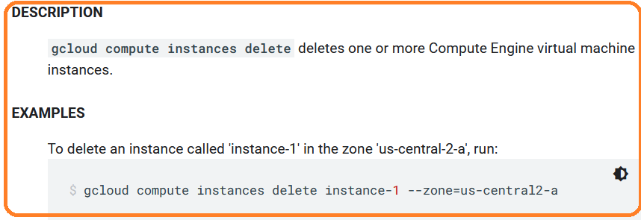

END