How to import data into cloud dataprep

* File upload
* GCP
* BigQuery

Go to home page of cloud dataprep.

1. Import data from local directory

* Go to Library and take the option import data.

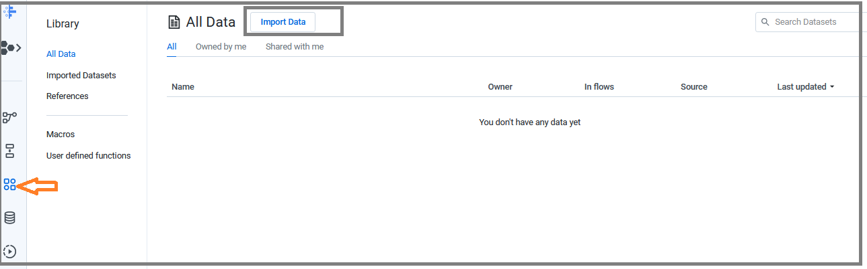

* Select the option upload

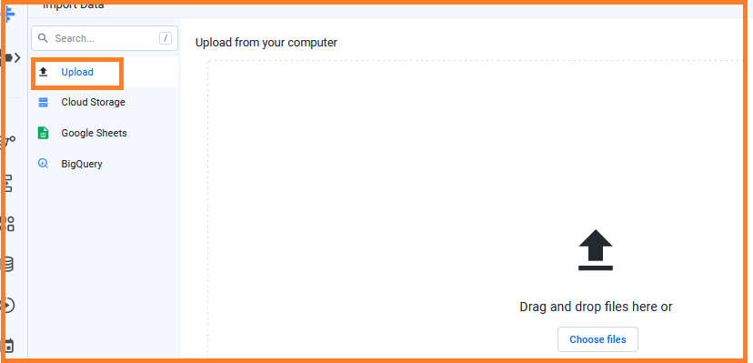

* Here you can select a file or drop a file from your local drive.
* Click on choose file

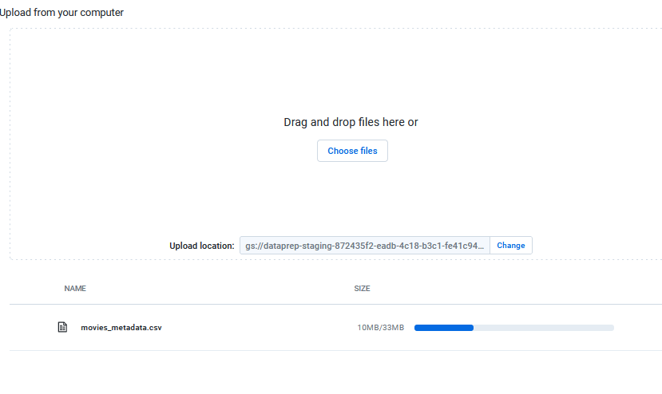

* You can add a description here

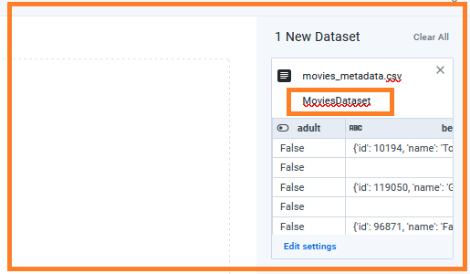

* Edit settings
  + Have the option to change the file format
  + Detect structure
  + Remove special characters from column name
* Click the option continue.

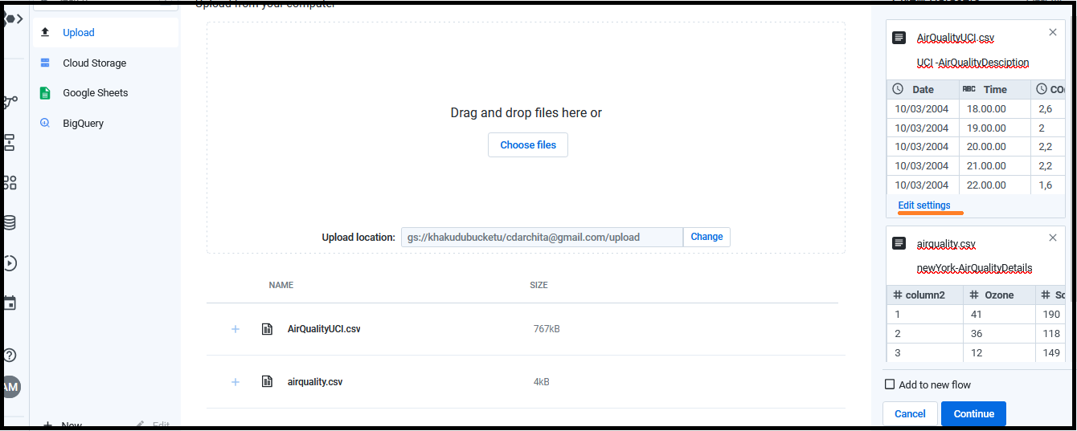

* The file get stored in GCS location. Let’s check this…
* Go to storage bucket of GCP
* Click on your login id.

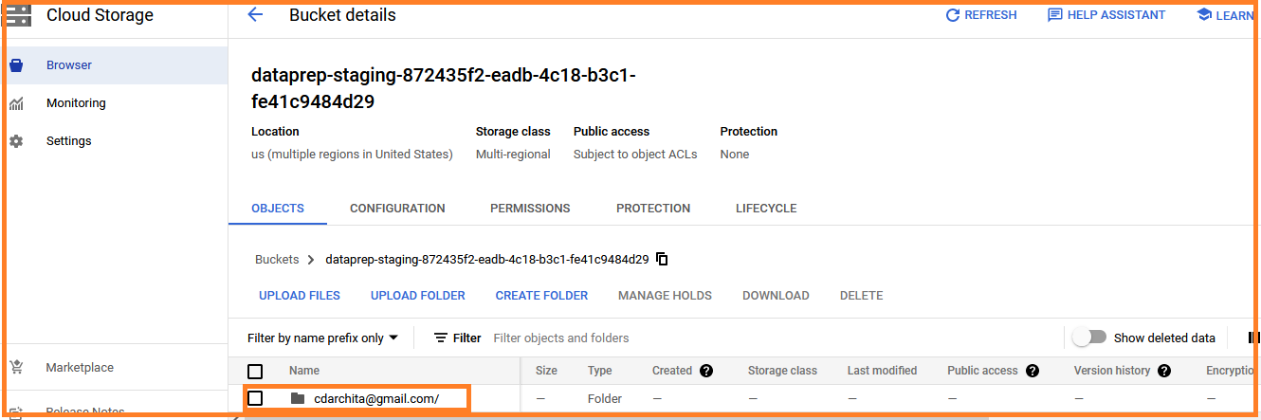

* The page will redirect to…

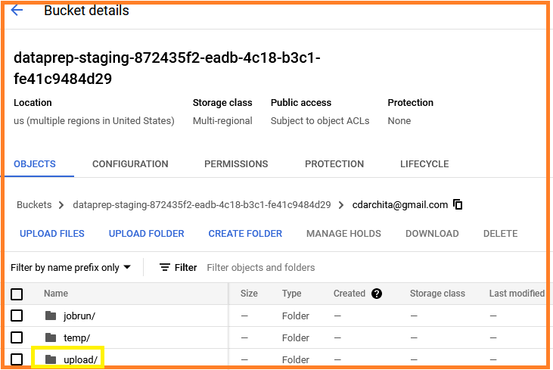

Under this folder we have

* Job run
* Temp
* Upload

The file saved under upload folder. We can download the csv file

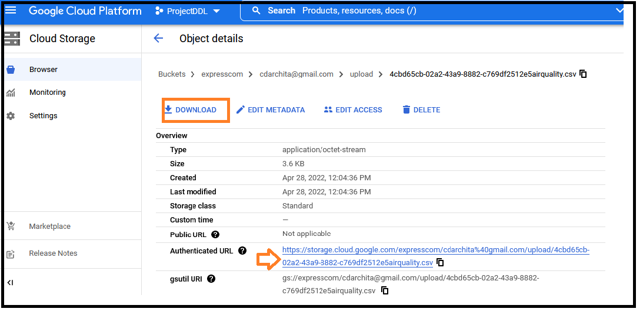

We can download airquality.csv file from bucket.

1. Import data from cloud storage.

* Go to cloud storage and then to original bucket id.

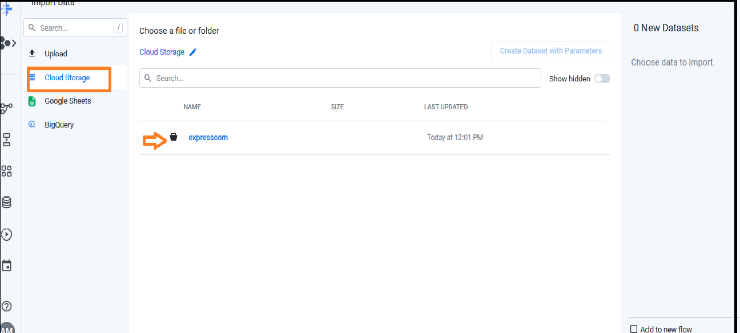

* Go to the upload folder and select your dataset.

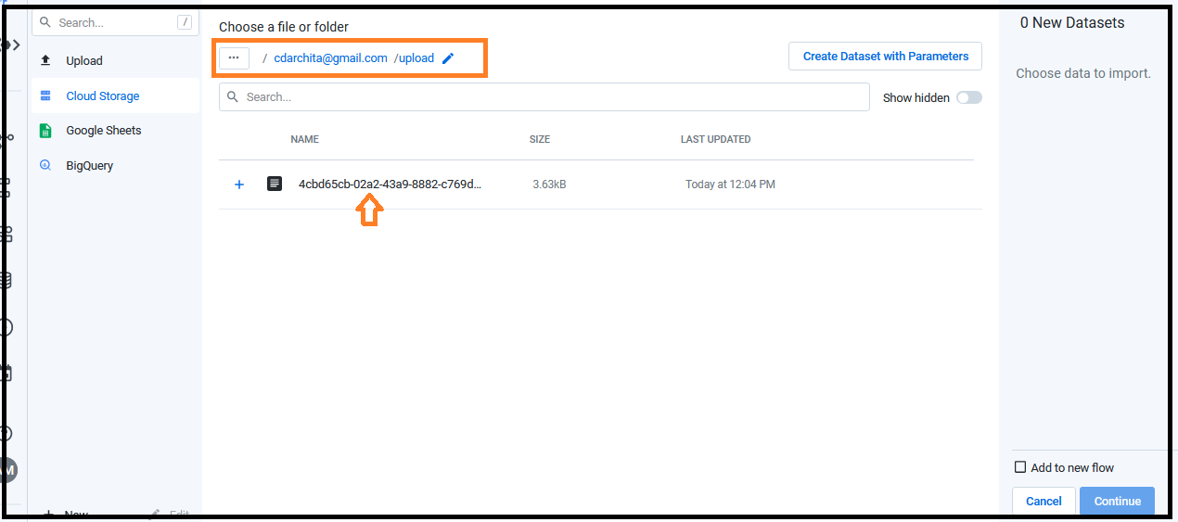

* Select the dataset and u can Add description on right side of your panel.

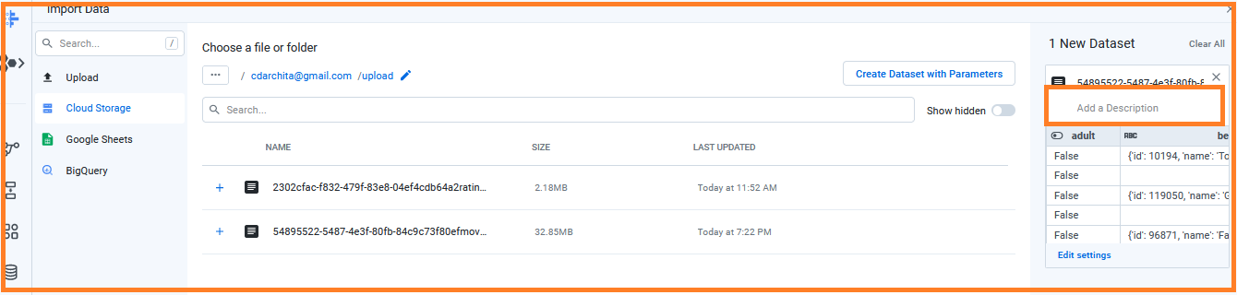

* Click on Continue.

Details about all datasets before we ingest to flow.

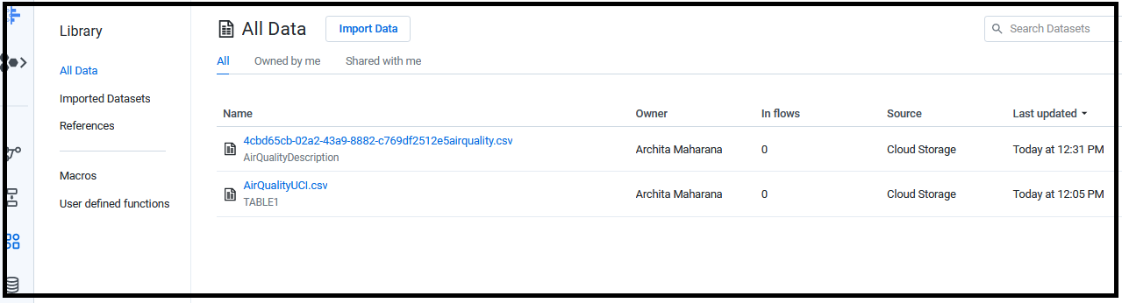

1. Import data from BigQuery

* Go to BigQuery
* Select your dataset and the table which you want to upload.
* Go to dataprep and select import data.
* Select the option BigQuery(check your dataset name..)
* Select the table which you want to import from the dataset.
  + I have selected the table “transaction”.

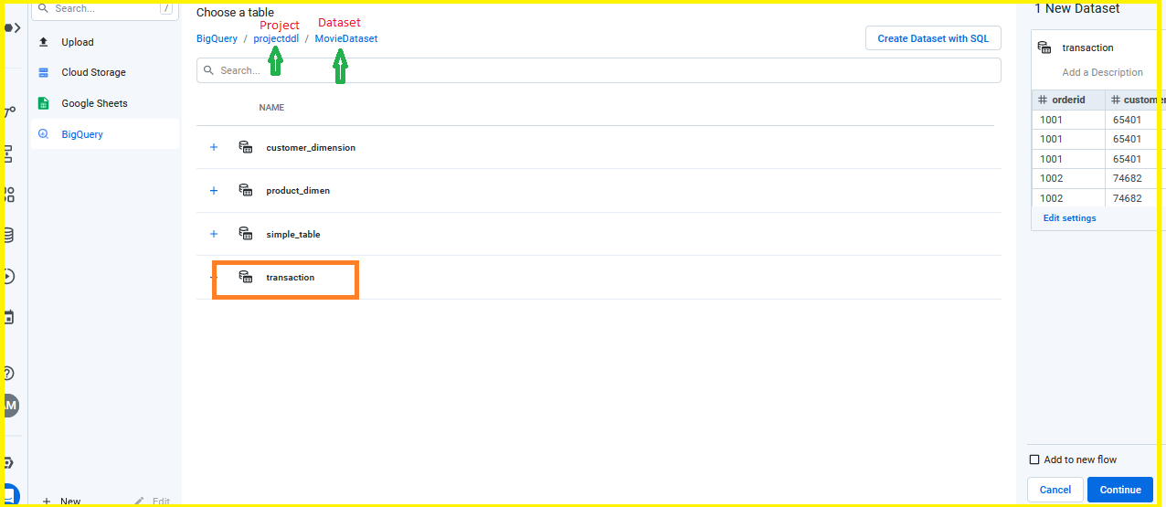

* Click continue

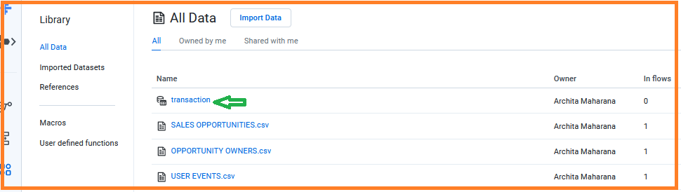

* Transaction data has a symbol of BigQuery and the files uploaded from BiQuery.
* If you will click on the transaction table the view shows as



* Click Use in new flow. It takes few seconds to upload data to transaction.

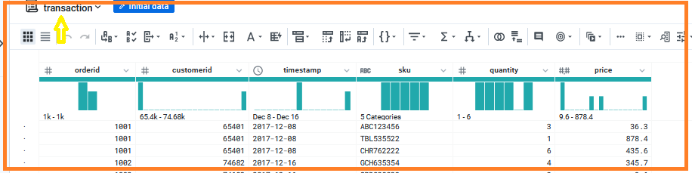

End