Array_bigQuery

We can create an array using name, int, string, dateTime data types. But while creating an array it consists of a single data type.

**Dataset** : Farmers Markets in the United States

<https://www.kaggle.com/datasets/madeleineferguson/farmers-markets-in-the-united-states?resource=download>

**How to create an array**

Go to column ‘Website_new’

Select the pattern from row which you want to store in an array

From RHS of suggestion box, select the option ‘Extract list of values’

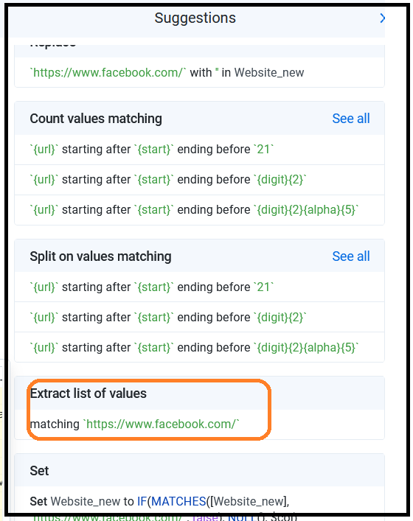

Click add.

How to change these cell values into particular unique rows.

Steps:

Go to object and arrays option



Select the Expand arrays to rows option from the drop-down menu.

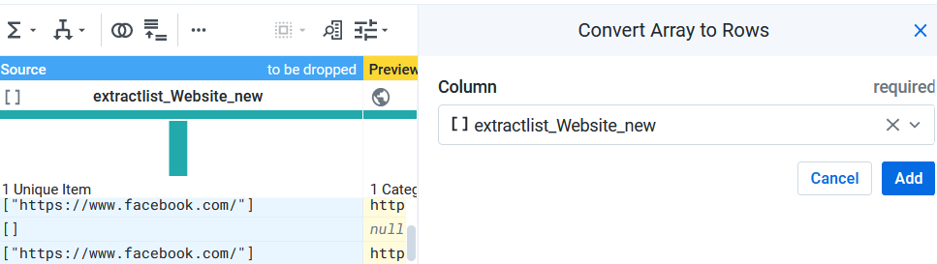

You will find the extractlist_website_new column with updated values.

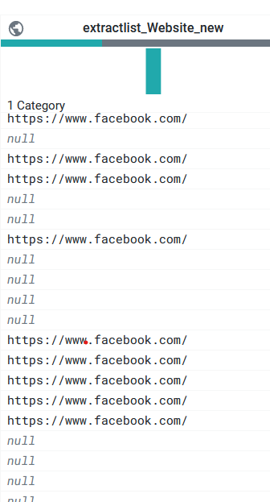

END