Join

* Go to Recipe and click on New step
* Search join
* Select datasets which you want to take for join. It has following options
  + Inner
  + Left
  + Outer
  + Cross
  + right
* I have selected orders.csv and customer.csv files.

**OR**

Go to flow click on add dataset

Select the dataset from flow and click on + symbol.

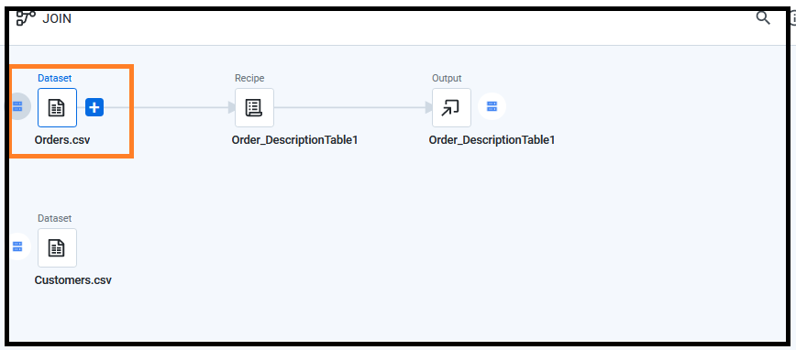

Options

* Add new recipe
* Add join
* Add union

Select the option Add join

Add the dataset which you want to join.

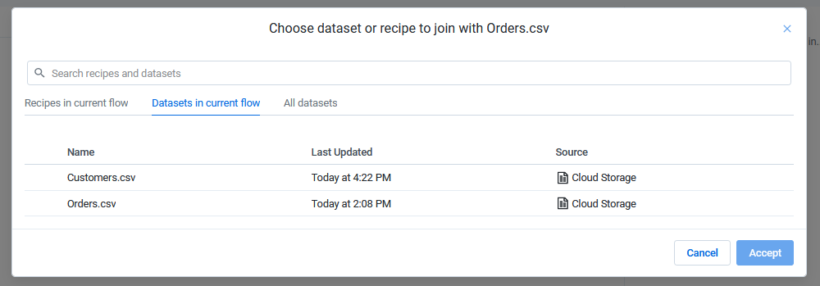

* Select the datasets
* Click Accept