Lookup

Combines multiple datasets with the help of ‘lookup’.

**Dataset**

**<https://www.kaggle.com/code/benbrooker1/u-s-farmer-s-markets-trend-analysis/data>**

wiki_country_info.csv

**Steps**

Go to flow

Select your dataset.

Select a column and go to the drop down list of the selected column.

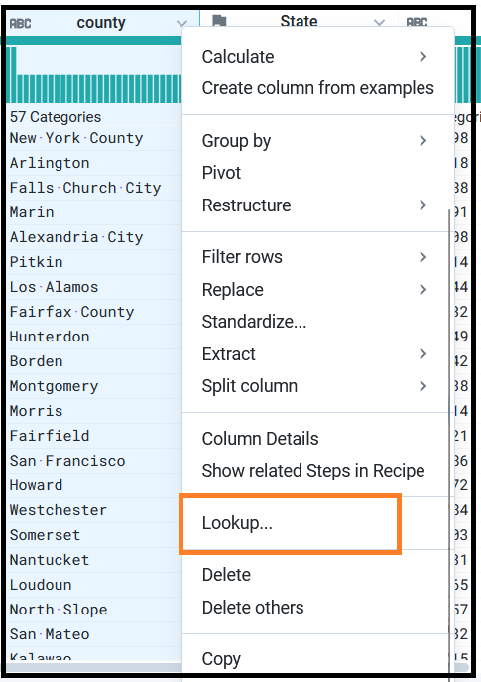

Select the dataset; which lookup dataset you want to select.

Take the dataset farmers market_usda.csv from above given link.

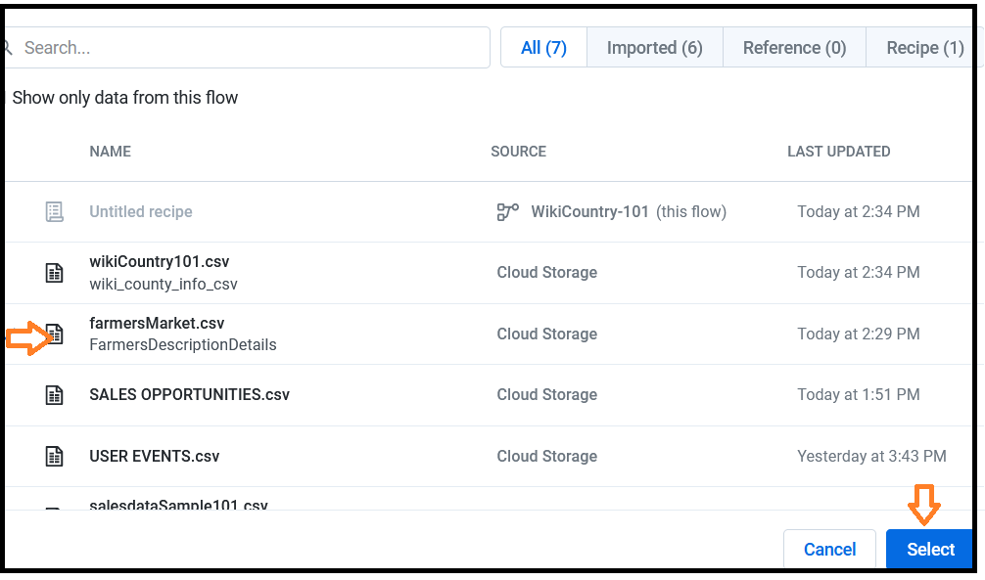

Check the result from two datasets.

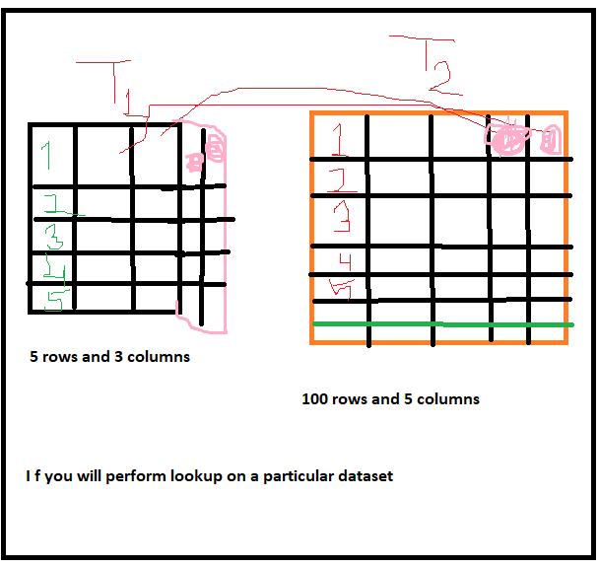

**Note**

Here we want to find matching records (T1 table) from T2. So, the columns which are not present in T1 table is going to copied in to T1 from T2.

Here we are combining the datasets depending on matching records.

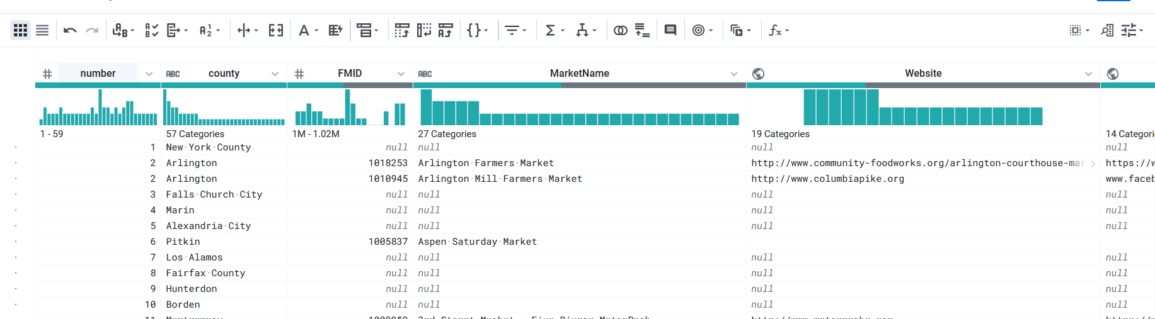

End