Scheduling

**Data wrangling**

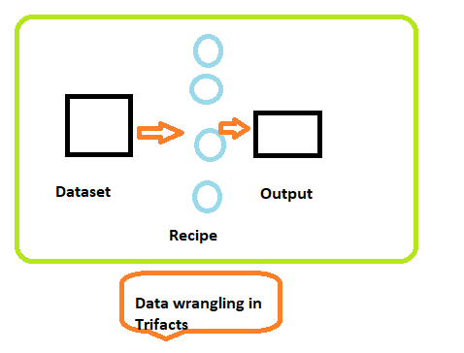

In data wrangling system, we do work on local data(csv file) and apply data transformation techniques on it. But in organizations when we do work on huge set of datasets, data points to a different location where data keeps on updating in every second.

**Steps**

Go to schedule option

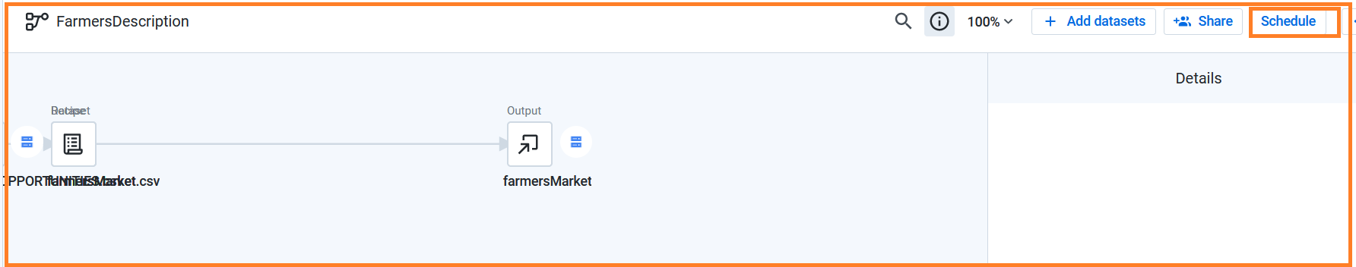

Select the option from frequency

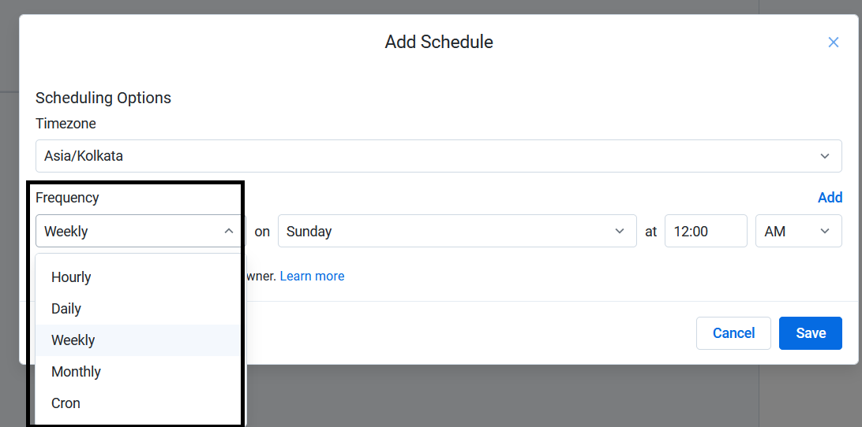

But the result shows as No schedule destination set.

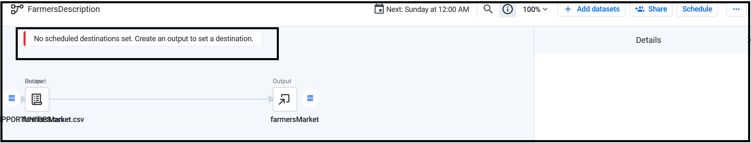

Steps:

Run your job.

Click on output.

Click on the option scheduled settings and then click on Publishing action.

Click on Add action

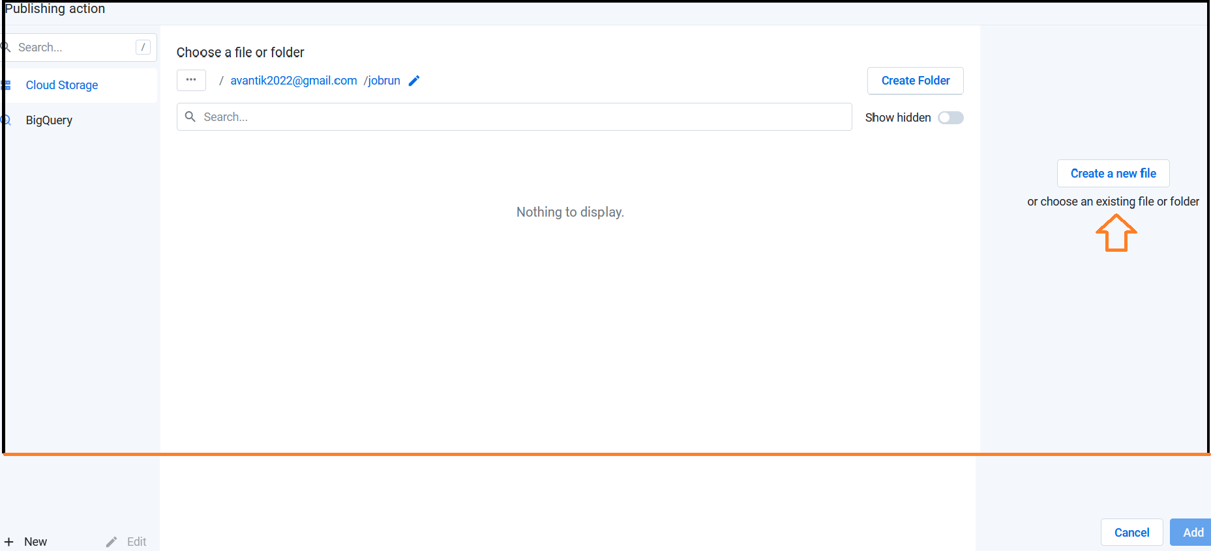

Click on Create a new file.

We can set the output directory also.

Click on Add

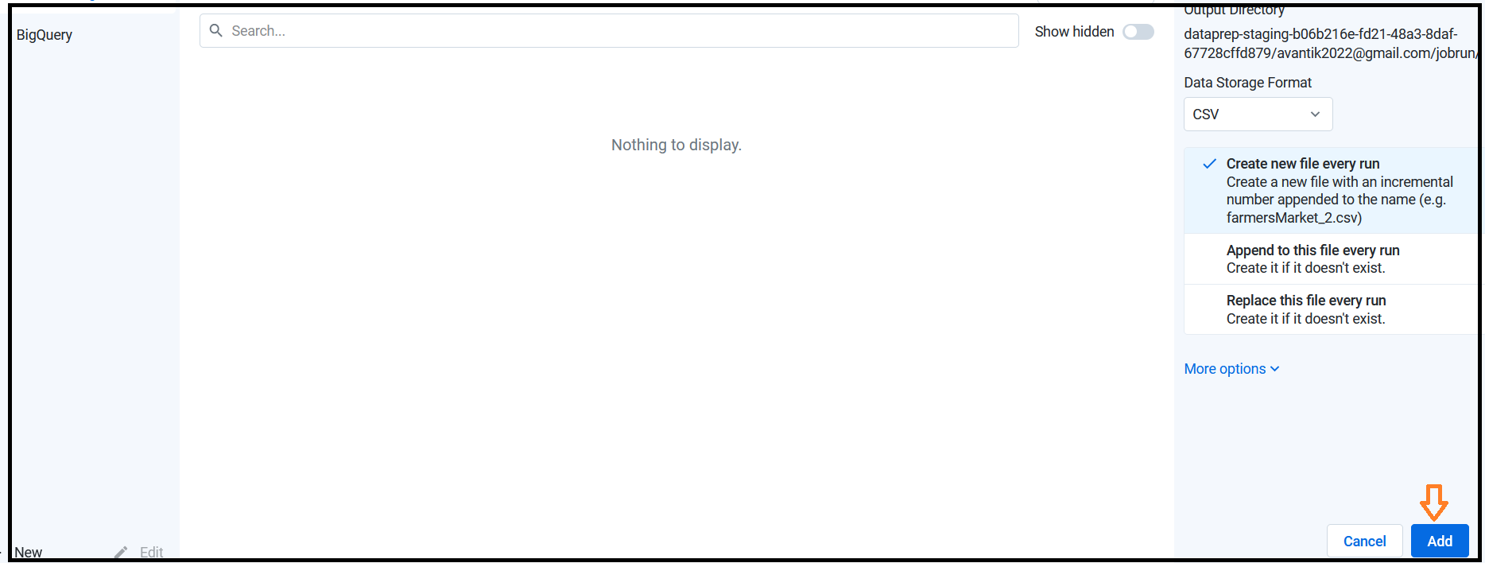

Click on save settings.

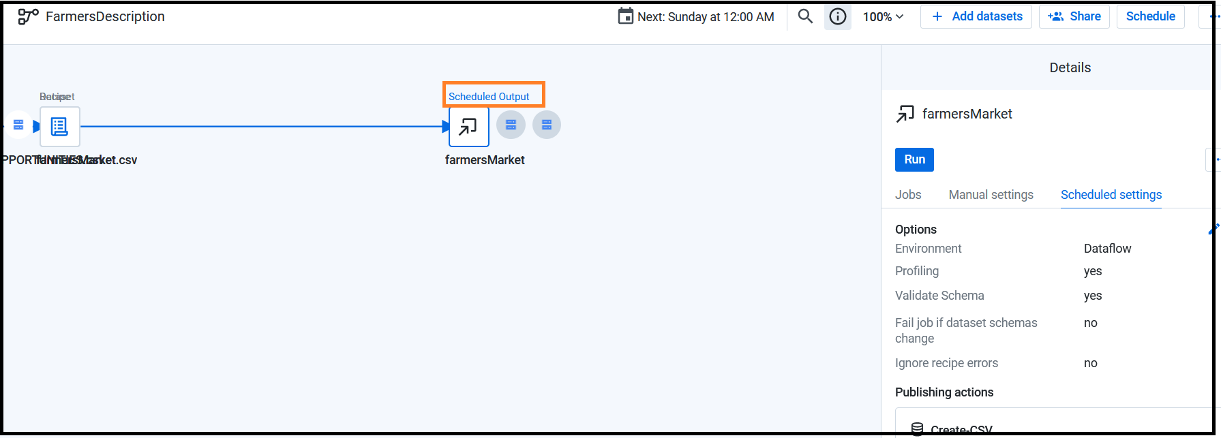

end