Union

Here we are working on two datasets.

**Dataset**

[**https://www.kaggle.com/code/benbrooker1/u-s-farmer-s-markets-trend-analysis/data?select=wiki_county_info.csv**](https://www.kaggle.com/code/benbrooker1/u-s-farmer-s-markets-trend-analysis/data?select=wiki_county_info.csv)

farmers market from usda.

**Steps**



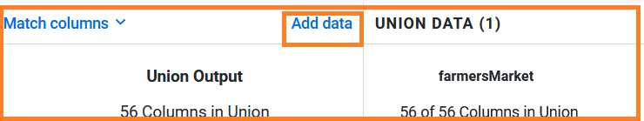

Click on Add data.

Add a new dataset to it.

**Note**

If dataset is not matching we can drop a column.

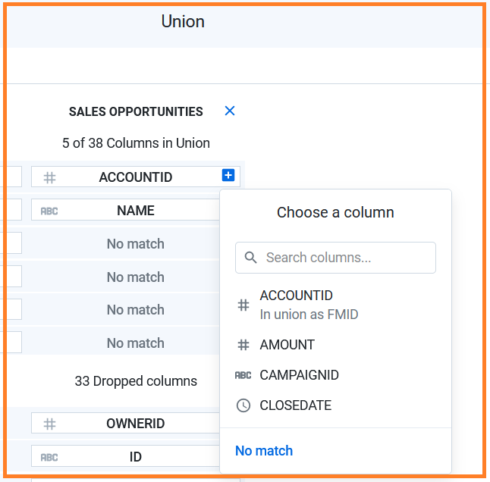

Click on Add to Recipe.

End