Use of Recipe

**Benefits of using recipe**

Reuse of recipe

* Replace the dataset (data can be new and updated)

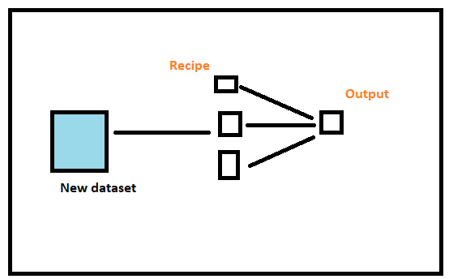

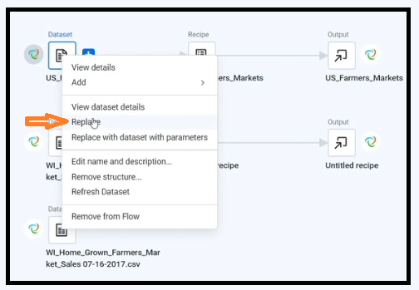

* Copy the recipe without dataset.

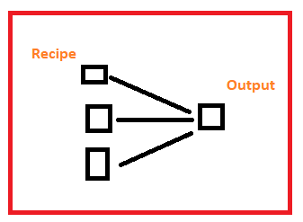

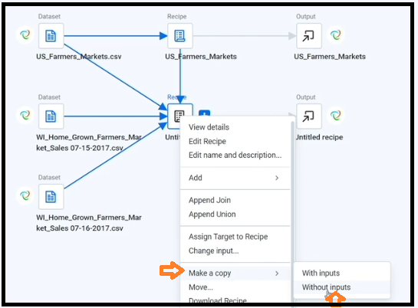

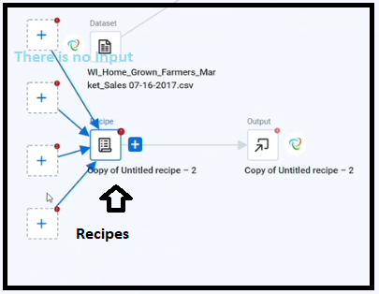

* Make a template of recipe.
  + Once a template has created, we can use this in different flow.

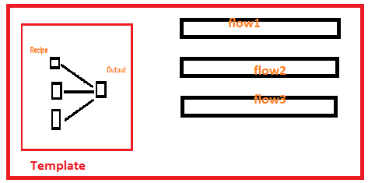

Click on recipe and select the option Move and make new name as “xyz” and then click Move to new Flow.

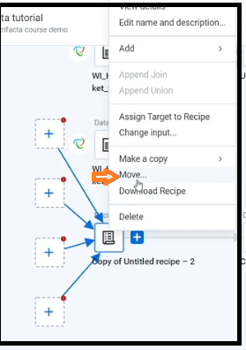

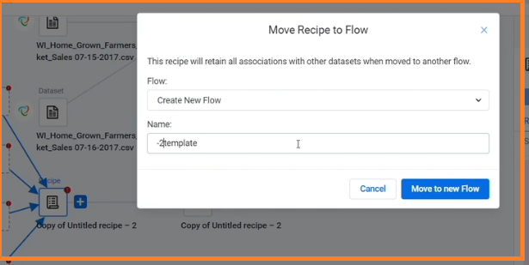

Let template1 is the name of new flow.

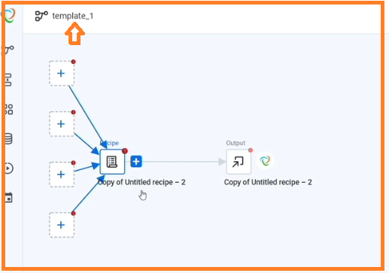

end