Add, count, group by

**Dataset** : Farmers Markets in the United States

<https://www.kaggle.com/datasets/madeleineferguson/farmers-markets-in-the-united-states?resource=download>

**Note**. To add a number to zip code.

merge(['12',zip])

**Q. group by using city and state.**

Steps:

Search count

Go to suggestion box

You will get New formula option and having following options as

* Formula
* Sort rows by
* Group rows by
  + Give column names as country and state

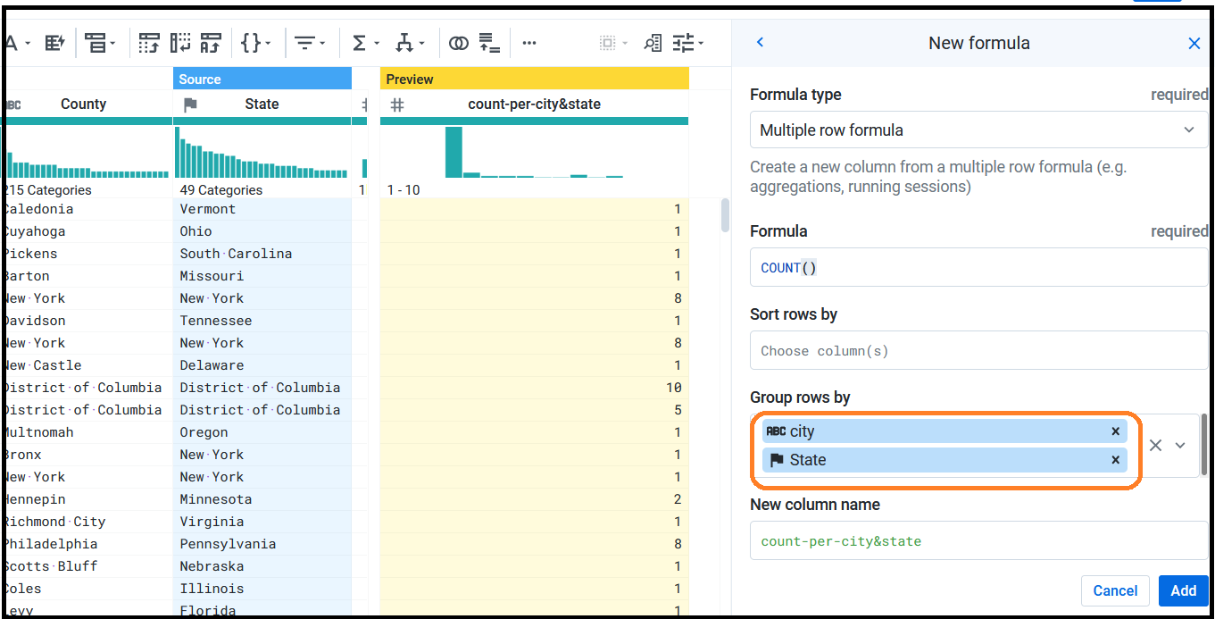

end