Task Comprehension or Risk Preference? Decomposing Two Channels of Cognitive Ability in a Large Indonesian Survey Elicitation
Dandy Aulya, Lury Sofyan, Dimas Prasetyo, and Fadel Aribowo
Yayasan Nudgeplus Arsitek Perilaku, Indonesia
Corresponding author: Dandy Aulya, [email address]. ORCID: [0000-0000-0000-0000].

Abstract
Survey elicitations of risk preference routinely produce a group of respondents who reject a stochastically dominant gamble. Whether these responses index extreme risk aversion or a failure to engage with the task determines what the resulting index measures. We address this using the fifth wave of the Indonesian Family Life Survey (IFLS5), which pairs an adaptive multiple price list with a broad cognitive battery and a 15-item Big Five inventory (N = 25,040 adults aged 18–65). The Set 1 dominance screen yields a three-level comprehension gradient: respondents who chose correctly at once, those who reversed a dominated choice when challenged, and those who confirmed it. Cognitive ability declines monotonically across these levels (Raven’s matrices 5.84, 5.27, 4.95; number series 522.5, 508.8, 501.3). Modeling comprehension and preference as separate channels shows that cognitive ability and schooling operate almost entirely on comprehension (schooling 67 times larger in the comprehension channel; Raven’s 4.6 times), whereas gender operates almost entirely on preference, with opposite signs across the two channels. The comprehension channel is also where the explainable variance sits (McFadden R² = .031 versus .007 for preference). Within the ordinal risk index, proportional odds fails precisely for the cognitive measures and for gender, because cognitive effects are absent at the lowest cut point and concentrated at the highest; a multinomial model shows that ability predicts interior rather than extreme responses. A simulation of random responding through the actual branching logic reproduces this pattern: a coin-flip respondent has a 25% chance of being classified gamble averse and a 19% chance of being classified most risk seeking, and the observed distribution moves toward that prediction as cognitive ability falls (odds of an extreme response 0.71 per SD of ability, p < .001). Out-of-sample, the personality-versus-cognition comparison that motivates much of this literature is null. Cross-elicitation stability rises with ability, from a rank correlation of .07 in the lowest cognitive quintile to .26 in the highest, so responses from the bottom of the ability distribution carry little reproducible signal. One further test qualifies this: conditional on giving an extreme answer, respondents reproduce it about equally often at every ability level. We therefore conclude that decision noise depresses the reliability of survey risk indices and inflates extreme responding among low-ability respondents, that screening for dominated choices addresses only one of the two extremes affected, and that gender remains the one robust preference-side predictor. We do not estimate the size of the noise component, which would require a formal error model.
Keywords: risk preference, decision noise, task comprehension, cognitive ability, multiple price list, IFLS, Indonesia

Introduction
Risk preferences are central to economic theory and influence decisions about savings, insurance, occupational choice, and entrepreneurship (Dohmen et al., 2011; Falk et al., 2018). Large household surveys have made population-scale measurement of these preferences routine, and the resulting indices are now used as explanatory variables across development economics, health, and behavioral science. The credibility of that literature depends on what the indices actually capture.
A recurring feature of survey elicitation is that a substantial minority of respondents makes choices that no risk preference can rationalize. These designs commonly open with a dominance screen, a gamble whose worst outcome equals the certain amount. A large share of respondents nonetheless take the certain option. In the fifth wave of the Indonesian Family Life Survey, 29% of respondents did so and confirmed the choice when challenged. The standard response, following Thamarapani and Rockmore (2022), is to classify these respondents as gamble averse and exclude them. The alternative, sometimes adopted to avoid selection concerns, is to retain them as an extra category at the risk-averse end of the scale.
Both choices presuppose an answer to a measurement question that is rarely tested: does a dominated choice reflect an extreme preference or a failure to engage with the task? The distinction matters beyond bookkeeping. Andersson et al. (2016) showed that when respondents make errors, the apparent relationship between cognitive ability and risk aversion depends on where the safe option sits in the design, because random responding pushes low-ability respondents toward whichever end of the scale the design happens to place them. On that account, an observed cognition–risk association may be a property of the instrument rather than of preferences. Gillen et al. (2019) make a parallel argument for measurement error more generally.
This study treats the ambiguity as the object of analysis rather than a nuisance. IFLS5 is unusually well suited to it. The dominance screen is administered with a confirmation prompt, which produces not a binary classification but a three-level gradient: respondents who chose the dominant gamble immediately, respondents who initially chose the dominated certain option but reversed when asked whether they were sure, and respondents who confirmed the dominated choice. That middle category is informative in a way a binary flag is not, because a comprehension account predicts an ordered dose–response in ability across the three levels while an extreme-preference account does not. The survey also fields a broad cognitive battery alongside a 15-item Big Five inventory, so comprehension and preference can be modeled with the same predictors. The battery covers Raven’s Progressive Matrices, an adaptive number series harmonized with the U.S. Health and Retirement Study, Serial 7 subtraction, and word recall.
We ask three questions. First, do respondents who fail the dominance screen differ from those who pass in the graded way a comprehension account requires? Second, when comprehension and preference are modeled as separate channels, which predictors load on which channel? Third, is the ordinal risk index recovered from the branching logic well behaved as a measure of preference, or does decision noise contaminate its extreme categories?
The answers reframe a question this literature has mostly posed as a horse race. Personality and cognitive ability are usually compared as rival predictors of elicited risk preference (Becker et al., 2012; Rustichini et al., 2016), with cognitive measures typically winning (Burks et al., 2009; Dohmen et al., 2010). We show that in this sample the horse race is null once evaluated out of sample, and that the cognitive measures earn their apparent advantage on the comprehension side of the elicitation rather than the preference side. Gender, by contrast, survives every specification as a preference-side effect, replicating one of the most robust findings in the field (Charness & Gneezy, 2012; Croson & Gneezy, 2009; Nelson, 2015) in a Muslim-majority developing economy.
We make three contributions. The first is a direct, graded test of the comprehension interpretation of dominated choices using a screening structure that has been available in IFLS for a decade but not exploited. The second is a decomposition of a widely used ordinal risk index into a comprehension channel and a preference channel, which shows that the predictors sort cleanly between them. The third comes from simulating random responding through the actual branching logic, which shows that noise accumulates at both extremes of the index, so excluding gamble-averse respondents cleans only one tail.

Method

Data and Sample
Data come from the fifth wave of the Indonesian Family Life Survey (IFLS5), conducted in 2014–2015 across 13 of Indonesia’s 34 provinces (Strauss et al., 2016). IFLS5 interviewed roughly 50,000 individuals in more than 15,000 households and recontacted over 90% of respondents from earlier waves. Because panel members are tracked when they move, respondents resided in 24 provinces at interview.
We restrict attention to adults aged 18–65 who reached the Set 1 risk module with a non-missing screening outcome, and who have complete data on all modeling variables. This yields N = 25,040, of whom 17,886 were scored on the four-group preference index and 7,154 confirmed a dominated choice. The 25,040 respondents live in 13,263 households across 24 provinces; among the 17,886 scored on preference, 11,207 households are represented, with up to eight co-resident adults per household.
Two sample-construction details matter for reproducibility. First, 13 respondents passed the dominance screen but could not be scored because a downstream branching item was missing; they are excluded throughout, which reconciles the descriptive and estimation samples. Second, all specifications are estimated on one fixed complete-case sample, so that model comparisons are not confounded by differing N.

Risk Preference Elicitation
Financial risk preferences were elicited with an adaptive multiple price list in Module SI. Respondents chose between a certain monthly amount and a 50/50 gamble. In Set 1 the certain amount is Rp 800,000 per month (about US$60, above average monthly earnings) and the high outcome is fixed at Rp 1,600,000; the low outcome varies across branching items. The first item (si01) is a dominance screen in which the gamble’s low outcome equals the certain amount, so the gamble weakly dominates. Respondents choosing the certain option are asked to confirm (si02). Those who confirm are classified as having confirmed a dominated choice; those who reverse are retained and flagged as corrected.
Respondents who pass the screen face si03 (low outcome Rp 400,000). Those who take the certain option there are offered a safer gamble (si04, low outcome Rp 600,000); those who take the gamble are offered a riskier one (si05, low outcome Rp 200,000). The four resulting response patterns form an ordinal index from most risk averse to most risk seeking.
Because the amounts are fixed and known, each pattern implies a bounded interval on the coefficient of relative risk aversion. Under constant relative risk aversion the indifference point for si03 falls exactly at r = 1, since the gamble’s outcomes (2× and 0.5× the certain amount) have geometric mean equal to the certain amount. Table 1 reports the implied intervals, which are monotone in the index and which we use directly in an interval regression as a robustness check.
Set 2 raises the stakes to Rp 4,000,000 per month but is not structurally parallel: its branching items vary both outcomes and the final item (si15) offers a gamble with an outright loss of Rp 2,000,000. Group 4 in Set 2 therefore indexes loss tolerance rather than risk tolerance alone. Set 1 is our primary outcome; Set 2 results are reported in full in the supplement rather than set aside.

Comprehension Gradient
The screen and its confirmation prompt yield three ordered levels: chose the dominant gamble immediately (n = 14,975), initially chose the dominated option and reversed on challenge (n = 2,924), and confirmed the dominated choice (n = 7,154). We treat this as the comprehension measure. It is constructed entirely from the dominance screen and is therefore logically independent of the preference index, which is constructed from the later branching items.

Predictors
Six cognitive measures are used: immediate and delayed word recall from a 10-word list harmonized with the Health and Retirement Study (Crimmins et al., 2011), Serial 7 subtraction, self-rated memory, an adaptive number series W-score harmonized with the HRS, and Raven’s Progressive Matrices (12 items). A composite cognitive score is formed as the mean of z-scored objective measures for the quintile analyses. Personality is measured with the 15-item Big Five Inventory short form used in the German Socio-Economic Panel (Gerlitz & Schupp, 2005; John et al., 2008), three items per trait, with four items reverse coded. Demographic covariates are age (mean-centred, with a quadratic term), sex, years of schooling, rural residence, and current employment.
Internal consistency of the BFI-15 scales is low in absolute terms, but this is a length property rather than evidence that the items carry no signal. Mean inter-item correlations range from .116 (Neuroticism) to .210 (Openness); the corresponding raw alphas of .289 to .440 are close to what three items with those inter-item correlations must produce, and the same items at ten-item length would imply alphas of .567 to .727. We therefore report item-level and composite specifications side by side and interpret composite results as attenuated rather than absent.

Analytic Strategy
The preference index is modeled with ordered logistic regression (McCullagh, 1980). Because the proportional odds assumption is central to whether a single coefficient per predictor is meaningful, we test it with the Brant (1990) test and, more directly, by estimating separate binary logits at each cumulative cut point. Where proportional odds fails we report a multinomial logit and compare it to the ordered model by likelihood ratio.
The two channels are estimated as a hurdle: a binary logit for confirming a dominated choice on the full sample, and an ordered logit for the four-group index among respondents who passed the screen. Coefficients are placed on a common scale as the change in log-odds per standard deviation of the predictor, which makes the two channels directly comparable. All standard errors are clustered at the household level.
Model comparison uses 10-fold cross-validation with folds assigned by household, so co-resident adults never straddle the train–test boundary. We report multinomial log-loss with its across-fold standard error, because the differences at issue are small relative to sampling variability and information criteria on a sample this size do not reveal that.
To assess whether random responding could produce the observed distribution, we push a respondent who chooses the gamble with probability q at every node through the actual Set 1 tree and derive the implied distribution analytically. Analyses were conducted in R 4.5.2 using MASS (Venables & Ripley, 2002), sandwich, brant, nnet, survival, and marginaleffects (Arel-Bundock et al., 2024). Analysis code is available at the repository listed under Data Availability. The study was not preregistered; it is a secondary analysis of an existing public survey.

Results
Table 1
Implied Coefficient of Relative Risk Aversion by Set 1 Response Pattern
Group | Response pattern | Implied CRRA | n (%)
1 (most risk averse) | Certain at si03, certain at si04 | r > 2.92 | 6,650 (37.2)
2 | Certain at si03, gamble at si04 | 1.00 < r < 2.92 | 2,952 (16.5)
3 | Gamble at si03, certain at si05 | 0.31 < r < 1.00 | 3,269 (18.3)
4 (most risk seeking) | Gamble at si03, gamble at si05 | r < 0.31 | 5,015 (28.0)
Note. Certain amount Rp 800,000; high outcome Rp 1,600,000. Bounds solve 0.5u(H) + 0.5u(L) = u(C) under constant relative risk aversion. Percentages are of the 17,886 respondents who passed the dominance screen and were scored.

The Comprehension Gradient Is Ordered in Ability
Table 2 reports the three screening levels. Every cognitive measure declines monotonically from respondents who chose correctly at once, through those who corrected a dominated choice, to those who confirmed it. Raven’s matrices fall from 5.84 to 5.27 to 4.95, the number series W-score from 522.5 to 508.8 to 501.3, Serial 7 from 3.07 to 2.79 to 2.65, and schooling from 10.0 to 8.9 to 8.4 years. The gap between the extreme levels is 0.32 SD on Raven’s and 0.33 SD on the number series.
The intermediate position of the corrected group is the informative feature. An extreme-preference account of dominated choices has no reason to predict it: respondents who reversed when challenged did not, in the end, reject the dominant gamble. A comprehension account predicts exactly this ordering, because the probability of an initial error and the probability of failing to recognize the error when prompted should both fall with ability.
Table 2
Cognitive Ability and Schooling Across the Set 1 Comprehension Gradient
Screening outcome | n | Raven’s | Number series | Serial 7 | Word recall | Schooling
Chose dominant gamble at once | 14,975 | 5.84 | 522.5 | 3.07 | 5.40 | 9.97
Corrected on confirmation | 2,924 | 5.27 | 508.8 | 2.79 | 5.19 | 8.90
Confirmed dominated choice | 7,154 | 4.95 | 501.3 | 2.65 | 5.00 | 8.41
Note. Means. N = 25,040 adults aged 18–65 with complete data. Word recall is the immediate 10-word trial. In an ordered logit on the three levels with household-clustered standard errors, the odds of a worse comprehension outcome per SD of predictor are 0.87 for Raven’s matrices, 0.90 for the number series, 0.92 for Serial 7, and 0.82 for years of schooling (all p < .001).
Figure 1
Cognitive Ability Across the Comprehension Gradient
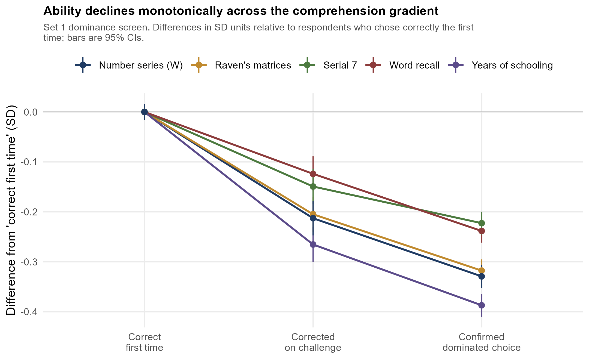
Note. Differences are expressed in SD units of each measure, relative to respondents who chose the dominant gamble immediately. Bars are 95% confidence intervals.

The Two Channels Separate Cleanly
Table 3 places the comprehension and preference channels side by side, with every coefficient expressed as the change in log-odds per SD of the predictor. The separation is sharp. Years of schooling carries a coefficient of −.183 in the comprehension channel and −.003 in the preference channel, where it is indistinguishable from zero (p = .88). We report ratios in Table 3 for readability, but they should not be read as estimates: where the preference-channel coefficient is statistically indistinguishable from zero, the ratio is unstable and its magnitude carries no information beyond the sign pattern. Raven’s matrices is 4.6 times larger, Serial 7 3.8 times, and the number series 2.3 times. Gender runs the other way: it is 2.3 times larger in the preference channel, and its sign reverses between channels. Women are more likely to confirm a dominated choice (+.083, p < .001) and, conditional on passing the screen, substantially more risk averse (−.190, p < .001).
The channels also differ in how much they explain. The comprehension model reaches McFadden R² = .031, against .007 for the preference model on the same predictors. Most of the systematic variance that cognitive measures capture in this elicitation is variance in getting the task right, not variance in preference.
Table 3
Two-Channel Decomposition: Log-Odds per SD of Predictor
Predictor | Comprehension | p | Preference | p | Ratio
Cognitive
Raven’s matrices | −0.142 | < .001 | −0.031 | .101 | 4.6
Number series (W) | −0.099 | < .001 | −0.043 | .015 | 2.3
Serial 7 | −0.089 | < .001 | −0.023 | .109 | 3.8
Word recall (immediate) | −0.054 | .014 | −0.040 | .057 | 1.3
Word recall (delayed) | 0.009 | .674 | 0.011 | .597 | 0.8
Self-rated memory | 0.034 | .016 | 0.035 | .011 | 1.0
Demographic
Years of schooling | −0.183 | < .001 | −0.003 | .876 | 66.6
Female | 0.083 | < .001 | −0.190 | < .001 | 0.4
Rural | 0.069 | < .001 | −0.007 | .644 | 10.3
Age | −0.051 | .009 | 0.026 | .162 | 2.0
Age squared | 0.083 | < .001 | −0.025 | .124 | 3.4
Employed | −0.004 | .785 | 0.028 | .070 | 0.2
Note. Comprehension channel: binary logit for confirming a dominated choice, N = 25,040; positive means more likely to confirm. Preference channel: ordered logit on groups 1–4 among respondents who passed the screen, N = 17,886; negative means more risk averse. Household-clustered standard errors throughout. Ratio is the absolute comprehension coefficient divided by the absolute preference coefficient. McFadden R² = .031 (comprehension) and .007 (preference).
Figure 2
Predictors Sort Between the Comprehension and Preference Channels
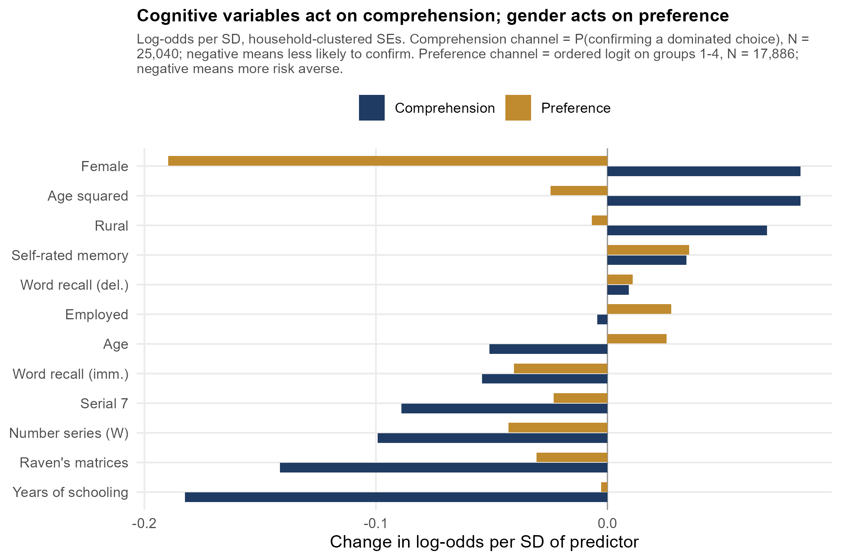

Within the Preference Index, Proportional Odds Fails Where It Matters
The ordered logit summarizes each predictor with a single coefficient, which is only interpretable if that predictor shifts every cumulative cut point equally. It does not. The Brant test rejects proportional odds decisively, χ²(24) = 223.23, p < .001. The rejection is not diffuse: it is concentrated in gender, χ²(2) = 49.46, p < .001, the number series, χ²(2) = 24.27, p < .001, and Raven’s matrices, χ²(2) = 22.69, p < .001. Serial 7, self-rated memory, schooling, employment, age, and rural residence all satisfy the assumption. The predictors on which the paper’s substantive claims rest are exactly the ones for which a single coefficient is not well defined.
Cut-point-specific logits (Table 4, Figure 3) show why. Raven’s matrices has no association with the lowest cut, +.005 (p = .53), a weak negative association with the middle cut, −.012 (p = .11), and a strong negative association with the highest, −.033 (p < .001). The number series behaves identically: .000 (p = .97), −.001 (p < .001), −.001 (p < .001). Cognitive ability does not order respondents along a risk-aversion continuum; it specifically predicts not being in the most risk-seeking category. Gender, by contrast, operates at every cut and strengthens monotonically, −.301, −.334, −.535, which is why its rejection of proportional odds does not undermine its substantive interpretation.
A multinomial logit taking the most risk-averse group as reference confirms the pattern and, crucially, shows that it is non-monotone. Relative to Group 1, higher Raven’s scores raise the probability of Group 2 (+.026, p = .014) and Group 3 (+.023, p = .026) but lower the probability of Group 4 (−.021, p = .018). The number series behaves the same way (+.0015, p < .001; +.0001, p = .79; −.0009, p = .001). Ability pushes respondents toward the interior of the scale and away from both ends. The multinomial model fits far better than the ordered one, LR = 221.69, df = 24, p < .001.
Table 4
Cut-Point-Specific Logit Coefficients for the Four-Group Preference Index
Predictor | Y > 1 | Y > 2 | Y > 3 | Brant p
Raven’s matrices | 0.005 (.53) | −0.012 (.11) | −0.033 (< .001) | < .001
Number series (W) | 0.000 (.97) | −0.001 (< .001) | −0.001 (< .001) | < .001
Serial 7 | −0.015 (.09) | −0.010 (.25) | −0.013 (.18) | .68
Word recall (immediate) | −0.021 (.14) | −0.034 (.01) | −0.018 (.24) | .21
Self-rated memory | 0.025 (.07) | 0.032 (.02) | 0.038 (.01) | .69
Female | −0.301 (< .001) | −0.334 (< .001) | −0.535 (< .001) | < .001
Years of schooling | −0.002 (.71) | 0.001 (.88) | 0.000 (.94) | .77
Note. Each column is a separate binary logit for Pr(Y > k), with household-clustered standard errors; p-values in parentheses. The final column is the per-predictor Brant test against proportional odds. Omnibus Brant χ²(24) = 223.23, p < .001. N = 17,886.
Figure 3
Cognitive Effects Are Confined to the Highest Cut Point
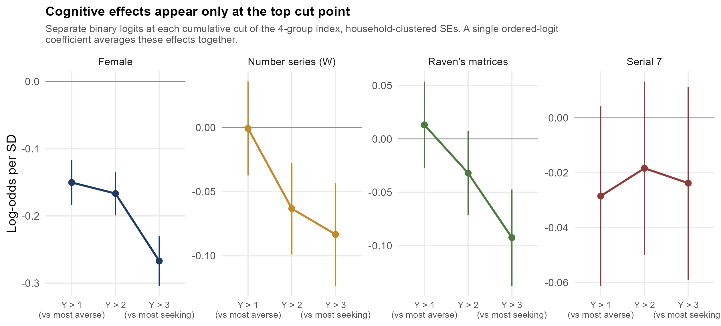

Random Responding Reproduces the Observed Shape
If low-ability respondents are partly answering at random, the branching logic implies where they should land. A respondent who chooses the gamble with probability q = .5 at every node has a .25 probability of being classified as having confirmed a dominated choice, because that requires two independent certain choices, and a .1875 probability of landing in each of the four scored groups. Pure noise therefore produces mass at both extremes, not one.
The observed distribution has the same qualitative signature. Against the coin-flip prediction of 25.0 / 18.8 / 18.8 / 18.8 / 18.8 percent, the data give 28.6 / 26.6 / 11.8 / 13.1 / 20.0: mass at both ends and a thin interior. We note that the agreement of any single marginal proportion with the noise prediction is not itself evidence, since a group of genuine risk seekers could produce the same share. What the comparison establishes is only that the observed shape is the shape noise would produce, which motivates the individual-level tests that follow.
The test that carries weight is whether the resemblance strengthens as ability falls. Table 5 splits the sample by cognitive quintile and reports a χ²-style distance to the coin-flip prediction: .178, .122, .093, .097, .079 from lowest to highest quintile. The trend is downward but not strictly monotone, since the third and fourth quintiles are effectively tied, and with only five points the rank correlation is not itself informative (Spearman ρ = −.90, p = .083). We therefore rest the claim on the two quantities estimated at the individual level. The interior share rises monotonically from 19.0% to 32.5% across quintiles while the extreme share falls from 60.3% to 38.7%. In a logit for landing in an extreme category, the odds ratio per SD of composite cognitive ability is 0.71 (z = −13.96, p < .001), with schooling contributing independently (−.031 per year, p < .001). Gender does not behave like a noise variable here: conditional on ability, women are less likely to give an extreme response (−.190, p < .001).
Two implications follow. First, the standard exclusion of gamble-averse respondents is justified but incomplete: it removes noise from the risk-averse tail while leaving a comparable accumulation in the risk-seeking tail. Second, the sign of an estimated cognition–risk association in this design is largely determined by which tail is retained, which is the design dependence Andersson et al. (2016) identified.
Table 5
Response Distribution and Distance to the Coin-Flip Prediction, by Cognitive Quintile
Quintile | G0 | G1 | G2 | G3 | G4 | Interior (G2+G3) | Distance to coin flip
1 (lowest) | 39.2 | 20.7 | 8.4 | 10.6 | 21.1 | 19.0 | 0.178
2 | 32.4 | 26.0 | 9.5 | 11.9 | 20.2 | 21.4 | 0.122
3 | 28.8 | 27.5 | 11.4 | 13.0 | 19.3 | 24.4 | 0.093
4 | 24.0 | 29.9 | 12.9 | 14.0 | 19.2 | 26.9 | 0.097
5 (highest) | 18.4 | 28.8 | 16.7 | 15.8 | 20.3 | 32.5 | 0.079
Coin flip (q = .5) | 25.0 | 18.8 | 18.8 | 18.8 | 18.8 | 37.5 | —
Note. Percentages within quintile; n = 5,008 per quintile. G0 = confirmed a dominated choice. Quintiles formed on the mean of z-scored objective cognitive measures. Distance is Σ(p_obs − p_exp)²/p_exp against the coin-flip prediction. Spearman ρ between quintile and distance = −.90.
Figure 4
Convergence on the Coin-Flip Distribution as Cognitive Ability Falls
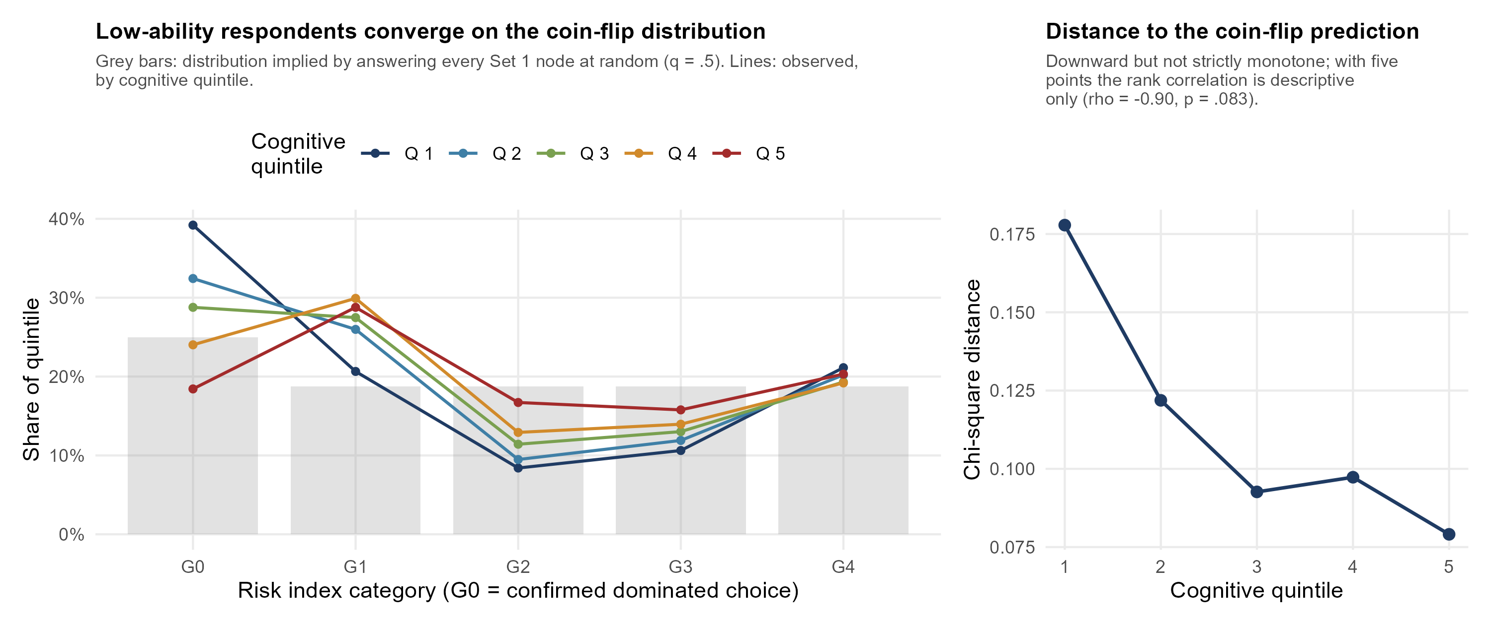

Cross-Set Stability Supports the Noise Account in Part
The tests reported so far establish that low-ability respondents answer more extremely, but a preference account predicts that too. The accounts separate on stability. If an extreme answer is noise it should not reproduce in an independent elicitation; if it is a genuine extreme preference it should. Set 2 differs from Set 1 in stakes and includes a loss prospect, so some disagreement is expected at every ability level. That constant is not the test. The test is whether agreement varies with ability.
It does, and substantially (Table 7). The rank correlation between the Set 1 and Set 2 indices rises monotonically across cognitive quintiles, from .072 in the lowest to .255 in the highest, with exact agreement rising from 27.5% to 35.3% and the mean absolute discrepancy falling from 1.31 to 1.09 categories. A correlation of .072 is close to the zero that purely random responding implies. At the individual level, a standard deviation of composite ability reduces the absolute cross-set discrepancy by .108 categories (t = 7.96, p < .001) and raises the odds of exact agreement by a factor of 1.14 (z = 5.09, p < .001). Responses from the bottom of the ability distribution carry little reproducible signal, which a preference account cannot easily explain.
One further test does not support us, and we report it because it bears on the strongest version of our claim. Among the 12,137 respondents whose Set 1 answer was extreme, we asked whether ability predicts giving an extreme answer again in Set 2, over and above the quintile-specific base rate. It does not in the direction the noise account requires. The excess probability of repeating an extreme response is roughly flat across quintiles and largest in the highest one (15.4, 15.5, 13.1, 14.5, and 19.0 percentage points above base rate), and conditional on a Set 1 extreme, higher ability slightly lowers the odds of an extreme Set 2 response (OR = 0.88 per SD, z = 3.27, p = .001).
Taken together these results support a narrower conclusion than the one we set out to test. Low-ability responses to this elicitation are substantially less reproducible, which is what noise implies. But conditional on giving an extreme answer, that answer carries a similar amount of reproducible signal at every ability level. We therefore claim that decision noise depresses the reliability of the index and inflates extreme responding among low-ability respondents, and we do not claim that the extreme categories consist mainly of noise. Separating those two statements requires a formal mixture model with an estimated error parameter, which the present design supports but which we leave to future work.

Out of Sample, Personality and Cognition Are Indistinguishable on Preference
The comparison that organizes much of this literature does not survive cross-validation. Table 6 reports 10-fold log-loss with folds held at the household level. For the preference index the five specifications span .00087 in log-loss, while the across-fold standard error of each estimate is between .0017 and .0039. The differences are an order of magnitude smaller than the sampling variability, so the specifications are statistically indistinguishable out of sample. Information criteria on a sample of 17,886 register these same gaps as apparently decisive, which is why we do not rely on them.
For comprehension the picture differs. Cognitive measures improve log-loss by .0044 over demographics alone, against a standard error of about .0030, and raise the area under the ROC curve from .611 to .624. The cognitive advantage in this elicitation is real but located in the comprehension channel.
Table 6
Ten-Fold Cross-Validated Model Comparison
Specification | Preference log-loss | SE | Comprehension log-loss | SE | AUC
Demographics only | 1.32586 | .0024 | 0.58420 | .0030 | .611
+ trait composites | 1.32621 | .0039 | 0.58322 | .0032 | .615
+ personality items | 1.32555 | .0024 | 0.58315 | .0019 | .614
+ cognitive | 1.32534 | .0017 | 0.58023 | .0027 | .624
Full | 1.32550 | .0038 | 0.57951 | .0043 | .628
Note. Folds assigned by household. Preference outcome: four-group index, N = 17,886. Comprehension outcome: confirmed a dominated choice, N = 25,040. SE is the standard error across folds. Lower log-loss is better. For the preference outcome the spread across specifications (.00087) is smaller than the across-fold SE of any single estimate.
Table 7
Cross-Set Agreement Between the Set 1 and Set 2 Elicitations, by Cognitive Quintile
Quintile | n | Spearman rho | Exact agreement (%) | Mean absolute gap | Excess repeat of extreme (pp)
1 (lowest) | 4,989 | .072 | 27.50 | 1.31 | 15.4
2 | 4,995 | .112 | 31.01 | 1.23 | 15.5
3 | 5,003 | .134 | 32.16 | 1.18 | 13.1
4 | 5,005 | .186 | 34.41 | 1.13 | 14.5
5 (highest) | 5,007 | .255 | 35.25 | 1.09 | 19.0
Note. N = 24,999 respondents scored on both elicitations. Both indices run from 0 to 4, where 0 denotes the screening failure specific to that set. Purely random responding implies a cross-set rank correlation of zero. The final column is P(extreme in Set 2 | extreme in Set 1) minus P(extreme in Set 2 | not extreme in Set 1), computed within quintile.

Robustness
Household clustering changes little. The median ratio of clustered to conventional standard errors is 1.011 and the maximum is 1.035; a single personality item moves across the .05 threshold (p = .049 to p = .052). Within-household correlation in elicited risk preference is evidently low, so the conventional standard errors were not materially overstated.
Interval regression on the implied CRRA bounds, which uses the amounts in the design rather than the group index, gives the same substantive picture in interpretable units. Women’s implied CRRA is higher by 0.674 (p < .001), a large displacement relative to the group boundaries at 0.31, 1.00, and 2.92. The number series remains associated with higher risk aversion among comprehenders (0.0011 per point, p = .016) and self-rated memory with lower (−0.055, p = .011), while schooling is null (p = .85).
Set 2 is reported in full rather than dropped. Its distribution is far more concentrated, with 70.7% in the most risk-averse group and 12.1% unscored, and it is not structurally parallel to Set 1 because its final item involves an outright loss. Agreement across sets is modest (Spearman ρ = .329; 44.3% exact agreement, N = 15,877), which is itself consistent with substantial noise in both. In the Set 2 ordered logit, gender retains its sign and magnitude (−0.425) while schooling reverses to a positive association (+0.022), the same instability that motivates our decomposition.
Finally, we note that the claim, sometimes made about IFLS, that the elicitation involves no possibility of loss holds for Set 1 only. Set 2’s si15 offers a gamble with a Rp 2,000,000 loss, so reconciliations of gain-domain findings should be restricted to Set 1.

Discussion
Survey risk indices are widely treated as measures of preference. In this large Indonesian sample they are better described as mixtures of preference and task engagement, and the mixture is systematically related to cognitive ability.
Four separate results point the same way. Cognitive ability declines in ordered steps across a comprehension gradient built entirely from the dominance screen, with the respondents who corrected themselves falling between those who never erred and those who confirmed the error. When comprehension and preference are estimated as separate channels, cognitive measures and schooling load on comprehension and gender loads on preference, with schooling 67 times larger on the comprehension side and gender changing sign between channels. Within the preference index, proportional odds fails specifically for the cognitive measures, whose effects are absent at the lowest cut point and concentrated at the highest, and a multinomial model shows that ability predicts interior rather than extreme responses. Random responding pushed through the actual branching logic predicts mass at both extremes, and the observed distribution converges on that prediction as ability falls.
Relative to Andersson et al. (2016), which established the underlying point experimentally, our contribution is an extension rather than a new mechanism: we supply a graded comprehension marker their design did not contain, at population scale, in a lower-income setting. Readers who accept their argument should read our results as a field confirmation of it. What follows from our data is a resolution of an apparent tension in the literature on cognition and risk taking. Frederick (2005) and Dohmen et al. (2010) report that more cognitively able respondents behave in a more risk-neutral, less anomalous way, whereas our comprehender-only estimates associate higher ability with greater measured risk aversion. Both can hold. Our elicitation places the certain option at a meaningful fraction of monthly income and confines Set 1 to gains, so choosing the certain amount is not itself an anomaly. What the more able respondents avoid is not risk but the extremes of the scale, which is precisely what a noise account predicts and what Andersson et al. (2016) argued makes the sign of the cognition–risk relationship a property of the design.
The practical implication for secondary users of these indices is specific. Excluding respondents who confirm a dominated choice, as is now standard, removes noise from one tail only. Extreme responding is elevated at the risk-seeking end as well, and no screening item detects it because there is no dominance violation at that end. We stop short of calling that category mainly noise, because our cross-set test found that extreme answers reproduce about equally well at every ability level. Analysts using such indices as regressors should expect attenuation, and where the design permits it, should consider either trimming both tails or modeling the extremes as a separate response mode. Designs that include a dominance screen at both ends of the switching range would identify this directly.
For gender the news is more reassuring. Women’s greater risk aversion is the largest effect in every specification, survives the channel decomposition with its sign intact, strengthens across cut points, appears in interpretable CRRA units, and behaves oppositely to the noise variables in the extreme-response model. It replicates in a Muslim-majority developing economy with gender roles and labour-force participation quite unlike the Western samples in which the finding was established (Charness & Gneezy, 2012; Croson & Gneezy, 2009), and the methodological concerns raised by Nelson (2015) about aggregate comparisons do not apply to a within-sample conditional estimate of this kind.
On personality our result is a null, and we report it as one. The Big Five contributes nothing distinguishable out of sample to the prediction of elicited preference, whether entered as composites or as items. Because the BFI-15’s three-item scales have mean inter-item correlations of .12 to .21, this null is consistent with either a small true association attenuated by measurement or with no association; our design cannot separate those. The in-sample information-criterion ordering that would have supported a stronger claim does not survive cross-validation, and we think that is the more informative result to put on record given how often such orderings are reported in this literature.

Limitations
The comprehension interpretation rests on a graded ability gradient and on a noise simulation, not on a direct comprehension check; IFLS includes no debriefing or comprehension question, so an unobserved preference-based account of dominated choices cannot be excluded outright. Our noise simulation assumes independent responding at each node, which is a deliberately simple benchmark rather than an estimated mixture; we do not claim to quantify what share of any group is noise. Our own cross-set test limits the claim further: the excess reproduction of extreme answers does not fall with ability, which a strong version of the noise account would predict, and we report that result rather than set it aside. The second stage conditions on passing the dominance screen, which is the outcome modeled in the first stage, so its estimates are conditional on a selected subsample. If unobserved characteristics drive both channels, the preference-channel coefficients are biased by that selection, and we do not correct for it. The design is cross-sectional, so no causal ordering among ability, schooling, and response behavior is identified. Choices are hypothetical rather than incentivised. Complete-case analysis reduces the eligible sample, and although the modeling sample is fixed across specifications, selection on missingness cannot be ruled out. The IFLS frame covers 13 of 34 provinces and under-represents eastern Indonesia. Finally, the low reliability of the BFI-15 limits what can be concluded about latent traits as opposed to these measures of them.

Conclusion
The confirmation prompt attached to the dominance screen can be used as a measurement instrument rather than only as a basis for exclusion. Used that way, it shows that cognitive ability in this large Indonesian survey operates mainly on whether respondents engage correctly with a risk elicitation rather than on the preference the elicitation is meant to record. Responses from low-ability respondents are also markedly less reproducible across the survey’s two elicitations, and extreme responding is elevated among them at the risk-seeking end as well as at the end screening detects. Gender is the one predictor that behaves throughout as a preference-side effect. Researchers using survey risk indices should treat their extreme categories as partly a record of task engagement, and designers of such instruments can recover a good deal by screening at both ends of the switching range rather than one.

Statements

Acknowledgements
The authors thank the RAND Corporation and the survey teams responsible for the Indonesian Family Life Survey for collecting and maintaining the data used in this study.

Use of Generative AI
During the preparation of this manuscript the authors used a generative AI assistant (Claude, Anthropic) in both the analysis and the writing process. Its contribution included implementing and running the statistical analyses reported here, namely the proportional-odds diagnostics, the multinomial and two-stage specifications, the cross-validated model comparison, the response-noise simulation, the cross-set stability tests, and the interval regression on implied CRRA bounds; generating the figures; and drafting manuscript text. The authors set the research questions, reviewed and verified all analyses and output, made all interpretive and reporting decisions, and take full responsibility for the content of the manuscript. Analysis code reproducing every reported result is available at the repository listed under Data Availability.

Ethics
[TO BE COMPLETED. This is a secondary analysis of de-identified public survey data. Cite the RAND institutional review board approvals under which IFLS5 was collected, and state that no new data collection was undertaken.]

Author Contributions
D.A.: Conceptualization, Data curation, Formal analysis, Visualization, Writing – original draft. L.S.: Conceptualization, Methodology, Supervision, Writing – review & editing. D.P.: Methodology, Validation, Writing – review & editing. F.A.: Software, Data curation, Visualization, Writing – review & editing. All authors approved the final version.

Competing Interests
The authors declare none.

Data Availability
IFLS5 is publicly available from the RAND Corporation (https://www.rand.org/well-being/social-and-behavioral-policy/data/FLS/IFLS/ifls5.html). Analysis code reproducing all reported results is available at https://github.com/dndyzz/ifls5_risk_preference.

Financial Support
This research received no specific grant from any funding agency, commercial or not-for-profit sector.

References
Andersson, O., Holm, H. J., Tyran, J.-R., & Wengström, E. (2016). Risk aversion relates to cognitive ability: Preferences or noise? Journal of the European Economic Association, 14(5), 1129–1154.
Andersson, O., Holm, H. J., Tyran, J.-R., & Wengström, E. (2020). Robust inference in risk elicitation tasks. Journal of Risk and Uncertainty, 61(3), 195–209.
Arel-Bundock, V., Greifer, N., & Heiss, A. (2024). How to interpret statistical models using marginaleffects for R and Python. Journal of Statistical Software, 111(9), 1–32.
Beauchamp, J. P., Cesarini, D., & Johannesson, M. (2017). The psychometric and empirical properties of measures of risk preferences. Journal of Risk and Uncertainty, 54(3), 203–237.
Becker, A., Deckers, T., Dohmen, T., Falk, A., & Kosse, F. (2012). The relationship between economic preferences and psychological personality measures. Annual Review of Economics, 4(1), 453–478.
Brant, R. (1990). Assessing proportionality in the proportional odds model for ordinal logistic regression. Biometrics, 46(4), 1171–1178.
Burks, S. V., Carpenter, J. P., Goette, L., & Rustichini, A. (2009). Cognitive skills affect economic preferences, strategic behavior, and job attachment. Proceedings of the National Academy of Sciences, 106(19), 7745–7750.
Charness, G., & Gneezy, U. (2012). Strong evidence for gender differences in risk taking. Journal of Economic Behavior & Organization, 83(1), 50–58.
Charness, G., Gneezy, U., & Imas, A. (2013). Experimental methods: Eliciting risk preferences. Journal of Economic Behavior & Organization, 87, 43–51.
Crimmins, E. M., Kim, J. K., Langa, K. M., & Weir, D. R. (2011). Assessment of cognition using surveys and neuropsychological assessment. Journals of Gerontology: Series B, 66B(suppl 1), i162–i171.
Croson, R., & Gneezy, U. (2009). Gender differences in preferences. Journal of Economic Literature, 47(2), 448–474.
Dohmen, T., Falk, A., Huffman, D., & Sunde, U. (2010). Are risk aversion and impatience related to cognitive ability? American Economic Review, 100(3), 1238–1260.
Dohmen, T., Falk, A., Huffman, D., Sunde, U., Schupp, J., & Wagner, G. G. (2011). Individual risk attitudes: Measurement, determinants, and behavioral consequences. Journal of the European Economic Association, 9(3), 522–550.
Dohmen, T., Falk, A., Golsteyn, B. H. H., Huffman, D., & Sunde, U. (2017). Risk attitudes across the life course. Economic Journal, 127(605), F95–F116.
Falk, A., Becker, A., Dohmen, T., Enke, B., Huffman, D., & Sunde, U. (2018). Global evidence on economic preferences. Quarterly Journal of Economics, 133(4), 1645–1692.
Frederick, S. (2005). Cognitive reflection and decision making. Journal of Economic Perspectives, 19(4), 25–42.
Frey, R., Pedroni, A., Mata, R., Rieskamp, J., & Hertwig, R. (2017). Risk preference shares the psychometric structure of major psychological traits. Science Advances, 3(10), e1701381.
Gerlitz, J.-Y., & Schupp, J. (2005). Zur Erhebung der Big-Five-basierten Persönlichkeitsmerkmale im SOEP (Research Notes No. 4). DIW Berlin.
Gillen, B., Snowberg, E., & Yariv, L. (2019). Experimenting with measurement error: Techniques with applications to the Caltech cohort study. Journal of Political Economy, 127(4), 1826–1863.
Henrich, J., Heine, S. J., & Norenzayan, A. (2010). The weirdest people in the world? Behavioral and Brain Sciences, 33(2–3), 61–83.
Holt, C. A., & Laury, S. K. (2002). Risk aversion and incentive effects. American Economic Review, 92(5), 1644–1655.
John, O. P., Naumann, L. P., & Soto, C. J. (2008). Paradigm shift to the integrative Big Five trait taxonomy. In O. P. John, R. W. Robins, & L. A. Pervin (Eds.), Handbook of personality: Theory and research (3rd ed., pp. 114–158). Guilford Press.
Mata, R., Frey, R., Richter, D., Schupp, J., & Hertwig, R. (2018). Risk preference: A view from psychology. Journal of Economic Perspectives, 32(2), 155–172.
McCullagh, P. (1980). Regression models for ordinal data. Journal of the Royal Statistical Society: Series B, 42(2), 109–142.
Nelson, J. A. (2015). Are women really more risk-averse than men? A re-analysis of the literature using expanded methods. Journal of Economic Surveys, 29(3), 566–585.
Rammstedt, B., & John, O. P. (2007). Measuring personality in one minute or less: A 10-item short version of the Big Five Inventory. Journal of Research in Personality, 41(1), 203–212.
Rustichini, A., DeYoung, C. G., Anderson, J. E., & Burks, S. V. (2016). Toward the integration of personality theory and decision theory in explaining economic behavior. Journal of Behavioral and Experimental Economics, 64, 122–137.
Strauss, J., Witoelar, F., & Sikoki, B. (2016). The fifth wave of the Indonesia Family Life Survey: Overview and field report (Working Paper WR-1143/1-NIA/NICHD). RAND Corporation.
Thamarapani, D., & Rockmore, M. (2022). Risk preferences, gender, and stakes: Evidence from Indonesia. Journal of Development Economics, 158, 102901.
Venables, W. N., & Ripley, B. D. (2002). Modern applied statistics with S (4th ed.). Springer.
Vieider, F. M., Lefebvre, M., Bouchouicha, R., Chmura, T., Hakimov, R., Krawczyk, M., & Martinsson, P. (2015). Common components of risk and uncertainty attitudes across contexts and domains: Evidence from 30 countries. Journal of the European Economic Association, 13(3), 421–452.

