Does Cognitive Ability Predict Risk Preference or Task Comprehension? Disentangling Two Channels in a Large Indonesian Survey
Abstract
Individual differences in risk preferences shape consequential economic decisions, yet little is known about their psychological and cognitive determinants in low- and middle-income countries. Using data from 17,886 adults aged 18–65 in the fifth wave of the Indonesian Family Life Survey (IFLS5), this study compared how well Big Five personality traits, cognitive ability measures, and demographic characteristics predict financial risk preferences elicited through an adaptive multiple price list. In ordered logistic regression, cognitive variables (fluid intelligence, numeracy, and verbal memory) collectively outperformed personality measures in model fit comparisons (ΔAIC = 11.0 vs. 23.2–33.2 from the best-fitting specification). A measurement finding also emerged: individual personality items predicted risk preferences better than aggregated trait composites, consistent with the low internal consistency of the 15-item Big Five Inventory short form (α = .28–.44). Gender was the single strongest predictor (β = −0.25, p < .001), with women showing substantially greater risk aversion. The full model explained 1.7% of the variance, in line with established limits on predicting stated risk preferences from observable characteristics. A robustness check that reintroduced gamble-averse respondents (N = 25,040) showed that the cognitive coefficients reversed sign, shifting from predicting risk aversion to predicting risk seeking. This pattern indicates that the excluded group’s behavior reflects a failure to comprehend the task rather than extreme risk preference. Cognitive factors thus account for more of the individual variation in financial risk attitudes than dispositional ones, and separating task comprehension from preference is important in survey-based elicitation.
Keywords: risk preferences, Big Five personality, cognitive ability, IFLS, Indonesia, individual differences, gamble aversion

Background
Risk preferences are central to economic theory and influence decisions about savings, insurance, occupational choice, and entrepreneurship (Dohmen et al., 2011; Falk et al., 2018). The behavioral consequences of variation in risk attitudes are well established: more risk-tolerant individuals are likelier to invest in equities, migrate for employment, and select into self-employment (Bonin et al., 2007; Jaeger et al., 2010). Knowing what drives this variation, and who is risk averse or risk seeking, therefore matters for both economic theory and the design of policy and behavioral interventions.
Many studies have documented demographic correlates of risk preferences. Gender differences are among the most robust: women consistently show greater risk aversion across cultures, elicitation methods, and decision domains (Charness & Gneezy, 2012; Croson & Gneezy, 2009; Eckel & Grossman, 2008). Age effects are less clear-cut, with evidence pointing to an inverted-U pattern in which risk tolerance rises into middle adulthood before declining (Dohmen et al., 2017; Josef et al., 2016). Income, education, and wealth have also been linked to risk attitudes, though the direction of causality remains debated (Tanaka et al., 2010). Even so, observable socioeconomic variables typically explain only a modest fraction of the total variance in stated risk preferences, often between 1% and 5% in large population samples (Beauchamp et al., 2017; Dohmen et al., 2011).
Two classes of psychological variables have drawn growing attention as predictors: personality traits and cognitive abilities. The Five-Factor Model, which comprises Openness, Conscientiousness, Extraversion, Agreeableness, and Neuroticism, offers a taxonomy of stable individual differences in behavioral tendencies (McCrae & Costa, 2008). Several theoretical channels link personality to risk attitudes. Neuroticism, marked by heightened sensitivity to negative outcomes, should predict risk aversion through amplified loss anticipation (Borghans et al., 2009). Openness, a receptivity to novel experience, may make uncertainty easier to tolerate (Lauriola & Levin, 2001). Extraversion, tied to approach motivation and positive affect, has been linked to risk seeking in both laboratory and survey settings (Nicholson et al., 2005).
The evidence connecting personality to risk preferences, however, is mixed and often weak. Becker et al. (2012) found that the Big Five together explained less than 2% of the variance in experimentally elicited risk aversion in a German sample. Rustichini et al. (2016) reported that personality and cognitive ability jointly predicted economic preferences, but the personality contribution was modest once cognitive measures were included. A review by Borghans et al. (2008) concluded that personality–risk associations are real but small. This leaves open whether personality traits, especially when measured with abbreviated instruments, carry enough signal for meaningful prediction.
For cognitive ability the evidence is more consistent. Dohmen et al. (2010) found that higher cognitive ability went together with greater patience and more risk-neutral behavior in a large German panel, which they attributed to more accurate probability weighting among cognitively skilled respondents. Frederick (2005) reported that people who scored higher on the Cognitive Reflection Test made less risk-averse choices in gain domains, consistent with the idea that reflective processing reduces reliance on heuristic, loss-focused evaluation. Burks et al. (2009) extended this to a field setting and showed that cognitive skills predicted both risk and time preferences among truckers. The proposed mechanism is straightforward: cognitive ability supports more precise evaluation of expected values and reduces the noise and bias that produce departures from risk neutrality (Benjamin et al., 2013).
Two gaps limit how far this literature generalizes. First, most studies have been conducted in Western, educated, industrialized, rich, and democratic (WEIRD) societies (Henrich et al., 2010). Whether personality–cognition–risk relationships hold in low- and middle-income countries, where educational variation is greater and the cultural meaning of personality constructs may differ, remains an open question. The few studies in developing contexts have looked mainly at demographic correlates or experimental elicitation rather than the relative predictive power of psychological and cognitive measures (Tanaka et al., 2010; Vieider et al., 2015). Second, most studies that include personality measures use full-length inventories. The psychometric consequences of abbreviated instruments, which are common in large household surveys with limited interview time, have received little attention. Short personality scales tend to be less reliable, and the resulting attenuation of trait–outcome associations may bias conclusions about how useful personality is as a predictor.
Indonesia is well suited to addressing these gaps. It is the world’s fourth most populous country, with wide regional variation in economic development, ethnic composition, and cultural norms, which gives the setting considerable ecological validity. The Indonesian Family Life Survey (IFLS) is a longitudinal household survey covering about 83% of the Indonesian population across 13 provinces, and it brings risk preference elicitation, personality measurement, and a broad cognitive assessment together in one large-scale dataset (Strauss et al., 2016). The fifth wave (IFLS5, 2014–2015) added a 15-item Big Five Inventory (BFI-15), an adaptive number series test harmonized with the U.S. Health and Retirement Study, Raven’s Progressive Matrices, and a word recall protocol, alongside the existing adaptive multiple price list for risk and time preferences.
The present study uses this data structure to address three questions. First, how do personality traits and cognitive abilities compare in predicting financial risk preferences in a large, diverse Indonesian sample? Second, does the level of personality measurement, individual items versus aggregated trait composites, affect predictive performance, and what does this imply about ultra-short personality inventories in surveys? Third, which demographic and psychological variables are the strongest correlates of risk attitudes in this population, and do these patterns match or differ from findings in high-income settings?
Method
Participants and Data Source
Data came from the fifth wave of the Indonesian Family Life Survey (IFLS5), a longitudinal household survey conducted in 2014–2015 across 13 of Indonesia’s 34 provinces (Strauss et al., 2016). IFLS5 surveyed roughly 50,000 individuals from more than 15,000 households and recontacted over 90% of respondents from previous waves. The analytic sample was restricted to adults aged 18–65 with complete data across all modules, yielding N = 17,886 (51.2% female; M age = 36.1 years, SD = 11.7). Respondents came from 24 provinces, with the largest concentrations in Central Java (13.4%), West Java (12.7%), and East Java (11.7%). About 37.8% lived in rural areas and 65.3% were employed.
Measures
Risk Preferences. Financial risk preferences were elicited using an adaptive multiple price list (MPL) in Module SI of the IFLS5 household questionnaire. Respondents chose between a certain monetary payoff and a risky lottery offering a 50/50 chance of a higher or lower outcome. Two stake levels were administered: Set 1 (certain amount of Rp 800,000 per month, approximately US$60, exceeding average monthly earnings) and Set 2 (Rp 4,000,000 per month, approximately US$300). Branching logic adaptively narrowed each respondent’s switching point across five questions per set. The presentation order of Set 1 and Set 2 was randomized via computer-assisted personal interview (CAPI). Following Thamarapani and Rockmore (2022), respondents who chose the certain amount in the initial dominance gamble (where the risky option weakly dominated) and confirmed this choice on a consistency check were classified as “gamble averse” and excluded from the primary analysis (28.9% in Set 1). This yielded a four-group ordinal risk aversion index for eligible respondents (1 = most risk averse to 4 = most risk seeking). Set 1 was designated as the primary outcome because Set 2 exhibited excessive concentration in the most risk-averse category (~75%). As a robustness check, gamble-averse respondents were reintroduced as a fifth category (Group 0) in a separate five-group specification (N = 25,040).
Personality. The Big Five personality dimensions were assessed using a 15-item short form of the Big Five Inventory (BFI-15; John et al., 2008), with three items per trait rated on a 5-point Likert scale (1 = strongly disagree to 5 = strongly agree). Four items required reverse coding: PSN_04r (Agreeableness), PSN_05r and PSN_09r (Neuroticism), and PSN_14r (Conscientiousness). The instrument was drawn from the same version used in the German Socio-Economic Panel (Gerlitz & Schupp, 2005). Internal consistency was poor across all five scales: Cronbach’s α ranged from .28 (Agreeableness) to .44 (Openness), with standardized α between .27 (Neuroticism) and .45 (Openness). These values are consistent with published findings for ultra-short personality instruments in non-Western survey contexts (Rammstedt & John, 2007). Both trait composite scores (mean of three items per dimension) and individual item responses were retained for analysis, given the low reliability of composites.
Cognitive Ability. Six cognitive measures were derived from IFLS5 modules. Immediate and delayed word recall tasks assessed episodic memory using a standard 10-word list protocol harmonized with the Health and Retirement Study (Crimmins et al., 2011). The Serial 7 subtraction task (five sequential subtractions of 7 from 100) measured working memory and numeracy. Self-rated memory was assessed on a 5-point scale. An adaptive number series test, developed under the direction of John McArdle and harmonized with the HRS (Strauss et al., 2016), yielded a W-score reflecting quantitative reasoning ability. Raven’s Progressive Matrices (12 items) assessed nonverbal fluid intelligence.
Demographic Variables. Age (mean-centered, with a quadratic term to capture nonlinear effects), sex (0 = male, 1 = female), years of education, rural/urban residence, and employment status (0 = not working, 1 = currently employed) were included as covariates. Age was restricted to 18–65 at the time of interview to focus on the working-age adult population and exclude respondents for whom the hypothetical financial scenarios may carry qualitatively different meaning (e.g., minors and retirees).
Analytic Strategy
Five nested model specifications were estimated using ordered logistic regression (proportional odds model; McCullagh, 1980) to assess the incremental predictive value of each variable set: (1) demographics only, (2) trait composites plus demographics, (3) individual personality items plus demographics, (4) cognitive variables plus demographics, and (5) the full model combining individual personality items, cognitive measures, and demographics. Model comparisons were based on the Akaike Information Criterion (AIC; Burnham & Anderson, 2002). Ordinary least squares regression was fitted in parallel to the full specification to obtain standardized coefficients (β) for effect size interpretation. Average marginal effects (AMEs) were computed from the ordered logit to quantify the probability shift associated with each predictor across outcome categories. As a robustness check, all five specifications were re-estimated using the five-group index that included gamble-averse respondents as Group 0. All analyses were conducted in R 4.3 using the MASS package (Venables & Ripley, 2002) for ordered logistic regression and the margins package for AME computation.
Results
Descriptive Statistics and Distribution of Risk Preferences
Table 1 presents descriptive statistics for all continuous predictor variables. The analytic sample comprised 17,886 adults aged 18–65 (51.2% female, 37.8% rural, 65.3% employed), distributed across 24 provinces. Mean age was 36.1 years (SD = 11.7), and mean education was 9.8 years (SD = 4.0). Big Five trait composites showed limited variability (all SDs < 0.67). Internal consistency was poor across all five scales: Cronbach’s α ranged from .28 (Agreeableness) to .44 (Openness), with standardized α between .27 (Neuroticism) and .45 (Openness).
Table 1
Descriptive Statistics for Continuous Variables
Variable | N | M | SD | Min | Max
Age (years) | 17,886 | 36.10 | 11.69 | 18 | 65
Education (years) | 17,886 | 9.80 | 3.98 | 0 | 21
Openness | 17,886 | 3.76 | 0.64 | 1.00 | 5.00
Conscientiousness | 17,886 | 3.85 | 0.54 | 1.33 | 5.00
Extraversion | 17,886 | 3.47 | 0.66 | 1.00 | 5.00
Agreeableness | 17,886 | 3.92 | 0.50 | 1.00 | 5.00
Neuroticism | 17,886 | 2.66 | 0.66 | 1.00 | 5.00
Word recall (immediate) | 17,886 | 5.37 | 1.69 | 1 | 10
Word recall (delayed) | 17,886 | 4.36 | 1.81 | 1 | 10
Serial 7 score | 17,886 | 3.02 | 1.85 | 0 | 5
Self-rated memory | 17,886 | 3.02 | 1.12 | 1 | 5
Number series (W-score) | 17,886 | 520.34 | 63.82 | 299 | 635
Raven’s matrices | 17,886 | 5.75 | 2.79 | 0 | 12
Note. Complete cases, adults aged 18–65. Cronbach’s α: Openness = .44, Extraversion = .39, Neuroticism = .31, Conscientiousness = .30, Agreeableness = .28.
The risk aversion distribution was bimodal (Figure 1): 37.2% of respondents fell in Group 1 (most risk averse), 28.0% in Group 4 (most risk seeking), and two smaller intermediate groups (16.5% and 18.3%). This polarization is consistent with previous IFLS analyses (Thamarapani & Rockmore, 2022).
Figure 1
Distribution of Risk Aversion Index (Set 1, N = 17,886)
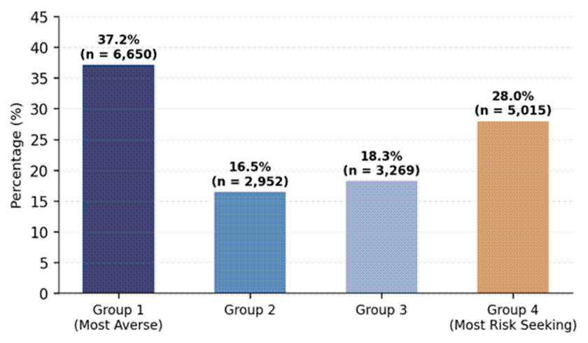
Adults aged 18–65. Gamble-averse respondents excluded following Thamarapani and Rockmore (2022).
Kruskal–Wallis tests (Table 2) confirmed significant between-group differences on most variables. Cognitive measures dominated the top ranks: Raven’s matrices (χ² = 98.7, p < .001) and number series W-score (χ² = 93.2, p < .001) showed substantially greater variation than any personality trait. Among the Big Five, only neuroticism (χ² = 23.4, p < .001) showed a nontrivial difference; neither conscientiousness nor agreeableness differed across risk categories.
Table 2
Kruskal–Wallis Tests of Between-Group Differences Across Risk Categories
Variable | χ² | df | p
Raven’s matrices | 98.68 | 3 | < .001
Number series (W-score) | 93.24 | 3 | < .001
Age | 79.15 | 3 | < .001
Education (years) | 37.56 | 3 | < .001
Neuroticism | 23.45 | 3 | < .001
Serial 7 score | 21.17 | 3 | < .001
Openness | 9.62 | 3 | .022
Extraversion | 7.73 | 3 | .052
Conscientiousness | 2.77 | 3 | .429
Agreeableness | 1.64 | 3 | .650
Note. Sorted by χ² descending.
Model Comparisons

Five ordered logistic regression specifications were compared (Table 3). The full model provided the best fit (AIC = 47,399.7).
Table 3
Model Fit Comparisons for Ordered Logistic Regression Specifications
Model specification | AIC | ΔAIC | Log-lik. | k
Full (items + cognitive + demographics) | 47,399.70 | — | −26,669.85 | 30
Cognitive + demographics | 47,410.72 | 11.03 | −26,690.36 | 12
Personality items + demographics | 47,422.93 | 23.24 | −26,687.47 | 22
Trait composites + demographics | 47,432.87 | 33.17 | −26,702.44 | 12
Demographics only | 47,433.08 | 33.38 | −26,707.54 | 9
Note. ΔAIC = difference from best-fitting model. k = estimated parameters excluding three threshold parameters.
Cognitive variables contributed considerably more than personality. The cognitive-plus-demographics model (ΔAIC = 11.0) captured most of the predictive information, whereas personality items lagged (ΔAIC = 23.2). The trait-composites model (AIC = 47,432.9) was almost identical to demographics alone (AIC = 47,433.1; ΔAIC = 0.2), so aggregated Big Five scores added no measurable information. The gap between the item-level and composite-level personality models (ΔAIC = 10.0) shows that aggregation discarded predictive signal, which is what one would expect when internal consistency (α = .28–.44) falls far below the level needed for reliable composite interpretation (Nunnally & Bernstein, 1994).
Individual Predictors of Risk Preferences
Table 4 reports standardized coefficients from the full OLS regression (adjusted R² = .017, F(27, 17,858) = 12.32, p < .001).
Table 4
Standardized OLS Regression Coefficients for the Full Model
Predictor | β | B | SE | 95% CI | p
Demographics
Female | −0.249 | −0.249 | 0.021 | [−0.29, −0.21] | < .001 | ***
Employed | 0.041 | 0.041 | 0.022 | [−0.002, 0.08] | .064 | †
Age (centered) | 0.002 | 0.002 | 0.001 | [−0.000, 0.004] | .078 | †
Age² | −0.000 | −0.000 | 0.000 | [−0.000, −0.000] | .042 | *
Education (years) | −0.005 | −0.001 | 0.003 | [−0.007, 0.005] | .660
Rural | −0.010 | −0.010 | 0.020 | [−0.05, 0.03] | .627
Cognitive
W-score (number series) | −0.033 | −0.001 | 0.000 | [−0.001, −0.000] | .003 | **
Word recall (immediate) | −0.028 | −0.017 | 0.008 | [−0.03, −0.000] | .048 | *
Self-rated memory | 0.025 | 0.022 | 0.008 | [0.006, 0.04] | .008 | **
Raven’s matrices | −0.023 | −0.008 | 0.004 | [−0.02, 0.000] | .062 | †
Serial 7 score | −0.016 | −0.009 | 0.005 | [−0.02, 0.002] | .105
Personality items
PSN_09r (calm/stress, rev.) | −0.037 | −0.040 | 0.011 | [−0.06, −0.02] | < .001 | ***
PSN_04r (quarrelsome, rev.) | −0.024 | −0.022 | 0.009 | [−0.04, −0.004] | .016 | *
PSN_01 (talkative) | 0.019 | 0.017 | 0.009 | [−0.001, 0.03] | .060 | †
PSN_07 (active imagination) | −0.019 | −0.016 | 0.009 | [−0.03, 0.001] | .064 | †
PSN_08 (thorough) | 0.018 | 0.018 | 0.010 | [−0.001, 0.04] | .062 | †
Note. Positive β = more risk seeking. “rev.” = reverse-coded. Only |β| ≥ .015 shown; 9 personality items omitted (|β| < .015, p > .14). *** p < .001, ** p < .01, * p < .05, † p < .10.
Gender was the dominant predictor (β = −0.25, p < .001). The average marginal effect indicated that being female increased the probability of Group 1 by 8.5 percentage points, with a 7.4-point reduction for Group 4. Employment showed a marginal positive association (β = 0.04, p = .064), and age followed a weakly significant inverted-U (quadratic p = .042).
Among the cognitive measures, the number series W-score (β = −0.03, p = .003) and immediate word recall (β = −0.03, p = .048) were significantly and negatively associated with the risk index, so higher cognitive ability went with greater risk aversion. Self-rated memory ran the other way and was positively associated with risk seeking (β = 0.03, p = .008). At the item level, PSN_09r (β = −0.04, p < .001) and PSN_04r (β = −0.02, p = .016) reached significance, and no personality item exceeded any cognitive variable. Figure 2 plots these coefficients by domain.
Figure 2
Standardized Regression Coefficients for Predictors of Risk Preferences (OLS Full Model)
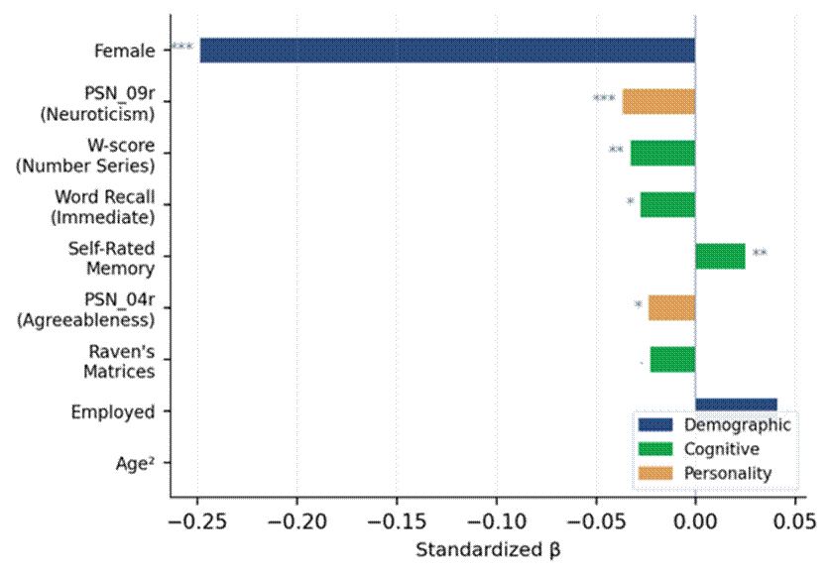
Positive values = more risk seeking. *** p < .001, ** p < .01, * p < .05, † p < .10.
Profiles Across Risk Groups
Table 5 reports mean values across the four risk categories. Group 4 (most risk seeking) had the oldest mean age (M = 37.2), the highest employment rate (70.7%), the lowest proportion of women (41.5%), and the lowest cognitive scores (Raven’s M = 5.47, W-score M = 514.9). Personality trait means barely varied across groups (< 0.06 SD).
Table 5
Descriptive Profiles by Risk Aversion Group
 | Group 1 (n = 6,650) | Group 2 (n = 2,952) | Group 3 (n = 3,269) | Group 4 (n = 5,015)
Age, M (SD) | 36.0 (11.8) | 34.9 (11.6) | 35.8 (11.4) | 37.2 (11.8)
Female (%) | 56.1 | 53.1 | 54.3 | 41.5
Education, M (SD) | 9.8 (3.9) | 10.1 (3.8) | 9.9 (4.0) | 9.5 (4.2)
Employed (%) | 62.8 | 63.1 | 63.9 | 70.7
Raven’s matrices, M (SD) | 5.74 (2.74) | 6.11 (2.87) | 5.86 (2.79) | 5.47 (2.79)
W-score, M (SD) | 520.2 (61.9) | 528.4 (61.8) | 521.7 (63.5) | 514.9 (67.2)
Serial 7, M (SD) | 3.05 (1.83) | 3.10 (1.86) | 3.04 (1.86) | 2.93 (1.86)
Neuroticism, M | 2.67 | 2.68 | 2.69 | 2.63
Note. Group 1 = most risk averse; Group 4 = most risk seeking. Adults aged 18–65.
Robustness Check: Inclusion of Gamble-Averse Respondents

The primary analysis excluded gamble-averse respondents, those who chose the dominated option in the screening gamble and confirmed that choice, following Thamarapani and Rockmore (2022). To test how much this choice mattered, all models were re-estimated with a five-group index that kept gamble-averse respondents as a fifth category (Group 0). This raised the sample from 17,886 to 25,040 (Figure 3).
Figure 3
Risk Index Distribution: Primary (4-Group) vs. Robustness (5-Group) Specifications
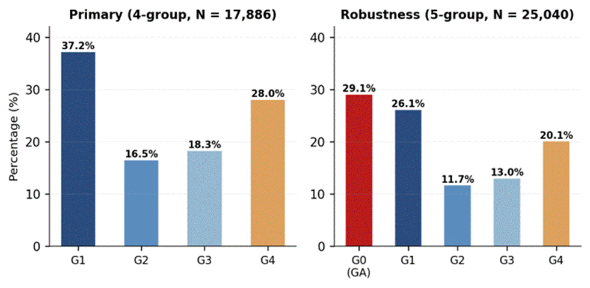
GA = gamble-averse. Group 0 comprises 29.1% of the expanded sample.
The AIC ordering held in the five-group specification (Table 6): the full model remained best (AIC = 76,946.9), followed by cognitive + demographics (ΔAIC = 45.0), personality items + demographics (ΔAIC = 59.3), trait composites + demographics (ΔAIC = 69.5), and demographics only (ΔAIC = 110.7). Unlike the primary analysis, where trait composites were indistinguishable from demographics alone, the five-group specification showed a clear gap between them (ΔAIC = 41.3). Personality composites can therefore separate gamble-averse from non-gamble-averse respondents even when they cannot tell apart risk preference levels.
Table 6
Model Fit Comparisons: 5-Group Robustness Specification
Model specification | AIC | ΔAIC | Log-lik. | k
Full (items + cognitive + demographics) | 76,946.85 | — | −38,442.43 | 30
Cognitive + demographics | 76,991.81 | 44.95 | −38,479.90 | 12
Personality items + demographics | 77,006.13 | 59.27 | −38,478.06 | 22
Trait composites + demographics | 77,016.32 | 69.47 | −38,493.16 | 12
Demographics only | 77,057.60 | 110.75 | −38,518.80 | 9
Note. 5-group index: Group 0 = gamble-averse, Groups 1–4 = as in primary. N = 25,040.
Although the model ordering held, the individual predictor effects diverged sharply from the primary analysis (Table 7; Figure 4). Three shifts stood out.
Table 7
Comparison of Standardized Coefficients: Primary (4-Group) vs. Robustness (5-Group)
Predictor | β (4-grp) | p | β (5-grp) | p | Direction change?
Female | −0.249 | < .001 | −0.085 | < .001 | Same (attenuated)
Education | −0.005 | .660 | 0.051 | < .001 | Reversed
Raven’s matrices | −0.023 | .062 | 0.031 | < .001 | Reversed
W-score | −0.033 | .003 | 0.017 | .027 | Reversed
Serial 7 score | −0.016 | .105 | 0.019 | .004 | Reversed
Word recall (imm.) | −0.028 | .048 | 0.003 | .729 | Lost significance
Self-rated memory | 0.025 | .008 | −0.002 | .790 | Lost significance
PSN_09r (neuroticism) | −0.037 | < .001 | −0.012 | .067 | Same (attenuated)
PSN_04r (agreeableness) | −0.024 | .016 | −0.004 | .586 | Lost significance
PSN_08 (conscient.) | 0.018 | .062 | 0.029 | < .001 | Strengthened
Rural | −0.010 | .627 | −0.024 | < .001 | Gained significance
Age² | −0.000 | .042 | −0.038 | < .001 | Same (strengthened)
Note. Positive β = more risk seeking. Bold entries indicate direction reversal.

Figure 4
Comparison of Standardized Coefficients Across Primary and Robustness Specifications
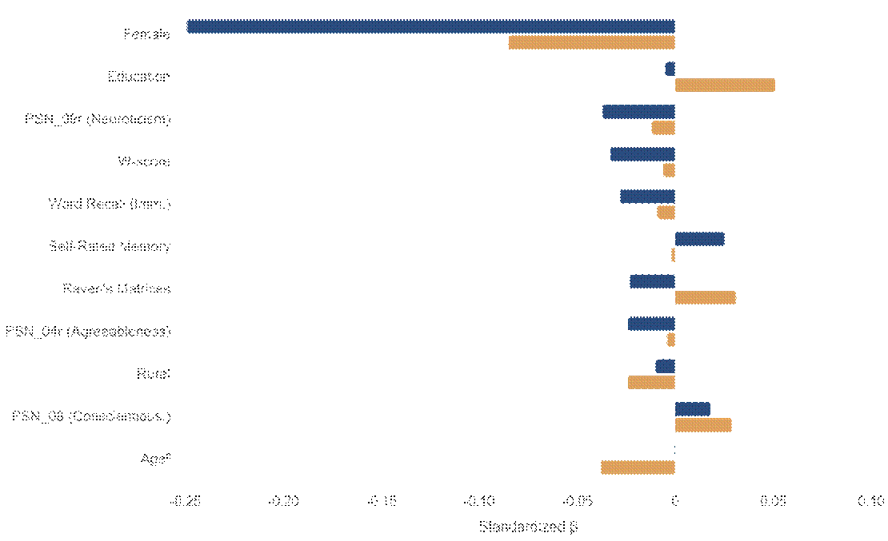
Navy = primary (4-group); gold = robustness (5-group). Each bar pair shows the same predictor under both specifications.
First, the cognitive–risk relationship reversed direction. In the primary analysis, higher scores on Raven’s matrices, number series, and word recall went with greater risk aversion (negative β). In the five-group specification, all three flipped to positive coefficients, so higher cognitive ability predicted less extreme responding, that is, staying out of Group 0 (gamble aversion). This fits the reading that gamble-averse responding reflects a failure to comprehend the task: respondents who chose the dominated option and confirmed it are disproportionately those with lower cognitive capacity. Once they anchor the bottom of the ordinal scale, cognitive ability appears to predict risk seeking only because it predicts staying out of the dominated-choice category.
Second, education became a strong positive predictor (β = 0.05, p < .001) in the five-group model, having been nonsignificant in the primary analysis. The same logic applies: education predicts the ability to correctly identify the dominant option, not risk preference per se. The education effect in the five-group model thus captures comprehension variance rather than preference variance.
Third, the gender effect attenuated from β = −0.25 to β = −0.09. Women are overrepresented in the gamble-averse category, so part of the gender–risk aversion association in the four-group model reflects a genuine preference difference, while part of the expanded effect in the primary analysis reflects the removal of a group that was disproportionately female. The five-group estimate may understate the true gender effect on risk preference by conflating preference with comprehension.
These divergences support rather than undermine the primary analysis. The gamble-averse category seems to measure something different from risk preference, namely a failure to engage correctly with the dominance screening, and including it conflates cognitive task performance with risk attitudes. The exclusion used by Thamarapani and Rockmore (2022) is therefore justified: it yields a cleaner measure of risk preference that is not contaminated by comprehension artifacts.

Discussion
This study compared how much personality and cognitive ability contribute to financial risk preferences in a large Indonesian sample. Three main findings emerged, each with implications for theory, measurement, and applied behavioral science. A robustness check that reintroduced gamble-averse respondents further clarified the cognitive–risk relationship.
The clearest result was that cognitive variables outperformed personality traits. Entered alongside demographics, cognitive measures narrowed the gap to the full model to ΔAIC = 11.0, against 23.2 for personality items and 33.2 for trait composites. This ordering matches Dohmen et al. (2010), who found cognitive ability to be a stronger correlate of both risk and time preferences than personality in the German SOEP, and Rustichini et al. (2016), who found that personality’s contribution shrank once cognitive controls were added. The pattern held in a population with lower average education, more varied occupations, and different cultural connotations for personality constructs (Church, 2010). This suggests it reflects how information-processing capacity shapes the evaluation of probabilistic outcomes rather than a culturally specific association.
The direction of the cognitive–risk relationship, and how much it depends on the way the risk index is defined, deserves comment. In the primary four-group analysis (gamble-averse respondents excluded), higher scores on Raven’s matrices, number series, and word recall went with greater risk aversion. This seems at odds with Frederick’s (2005) finding that cognitively reflective individuals are less risk averse. Two features of the setting help reconcile the results. The IFLS elicitation frames every choice as a gain with no possibility of loss, and the certain amounts are meaningful sums relative to respondents’ incomes. Under those conditions, choosing the certain option can reflect a sound expected-value calculation rather than irrational loss aversion.
The robustness check made this clearer. When gamble-averse respondents were reintroduced as Group 0, the cognitive coefficients reversed direction entirely: Raven’s matrices shifted from β = −0.023 to β = +0.031, the number series W-score from −0.033 to +0.017, and education from nonsignificant to β = +0.051 (p < .001). The reason is straightforward. Gamble-averse respondents chose the dominated option in the screening gamble and confirmed it, a pattern more consistent with a failure to comprehend the task than with extreme risk aversion. They also tend to have lower cognitive ability and less education. When they anchor the bottom of the ordinal scale, cognitive measures appear to predict risk seeking only because they predict staying out of the dominated-choice category. In the four-group specification, where this comprehension-related variance is gone, the remaining cognitive effect reflects a different process: deliberate evaluation of lottery payoffs among respondents who understood the task. The robustness check thus shows that cognitive ability works through two channels, task comprehension and preference formation, and that conflating them gives a misleading picture of the cognition–risk relationship.
A related finding concerns the split between objective and subjective cognitive measures. In the primary analysis, self-rated memory was positively associated with risk seeking (β = 0.03, p = .008), the opposite of every objective cognitive variable. This fits an overconfidence account: people who overestimate their cognitive capacity may also overestimate their ability to handle risky outcomes, so their risk seeking comes from a miscalibrated self-assessment rather than genuine risk tolerance. The effect vanished in the five-group specification (β = −0.002, p = .79), which suggests the overconfidence signal is specific to risk preference and does not carry over to the cognitively distinct task of dominance recognition. The gap between calibrated competence and subjective confidence is worth further study, especially in populations where financial literacy varies widely (Lusardi & Mitchell, 2014).
The measurement finding, that individual personality items outperformed trait composites, has direct practical implications. The BFI-15 yielded Cronbach’s α between .28 and .44, far below the .70 usually treated as acceptable (Nunnally & Bernstein, 1994). At this level of reliability, aggregation adds noise rather than removing it and blurs the distinct signals that individual items carry. PSN_09r (emotional stability under stress) was the strongest personality predictor precisely because it captures a specific behavioral regularity that gets diluted when combined with two weaker indicators. The robustness check showed that trait composites did gain predictive value once gamble-averse respondents were included (the ΔAIC between composites and demographics-only moved from 0.2 to 41.3), so composites capture something about comprehension capacity that overlaps with the cognitive measures without being identical to them. The broader point holds: for predicting risk preference itself, item-level modeling beats composite scoring when the instrument is ultra-short (Mõttus et al., 2017).
The gender effect deserves attention both for its size and for what the robustness check shows about its makeup. Women’s greater risk aversion (β = −0.25 in the primary analysis) dwarfed every other predictor and stayed the strongest effect across all specifications. This replicates one of the most consistent findings in the risk preference literature (Charness & Gneezy, 2012; Croson & Gneezy, 2009), here in a Muslim-majority developing country where gender roles and economic participation differ markedly from Western samples. The five-group analysis cut the effect to β = −0.09 and showed that women are overrepresented in the gamble-averse category. The four-group gender gap therefore combines two processes: a genuine preference difference and a difference in comprehension. Whether the comprehension component comes from financial literacy, survey experience, or task engagement cannot be settled with these data, but the result is a caution against reading the full gender gap as a preference effect. For policy design the practical point still holds: targeting financial interventions by gender is likely to help regardless of which mechanism dominates (Nelson, 2015).
The full model’s explanatory power (adjusted R² = .017) was low in absolute terms but in line with the broader literature on stated risk preferences. Dohmen et al. (2011) reported 3–5% with a general risk willingness measure and richer demographics, and Beauchamp et al. (2017) found similarly modest associations in a genetically informed sample. Several things contribute to this ceiling: measurement error in hypothetical scenarios (Holt & Laury, 2002), state-dependent influences such as mood and recent experience that stable trait measures cannot capture (Lerner et al., 2015; Malmendier & Nagel, 2011), and domain specificity, since the IFLS measure taps financial risk attitudes in particular, which correlate only moderately with risk taking in health, social, or recreational contexts (Weber et al., 2002). The small gain in R² when gamble-averse respondents were included (.023 vs. .017) again points to the extra explained variance coming from differences in comprehension rather than differences in preference.
Limitations
Several limitations should be noted. The cross-sectional design rules out causal inference about the direction of the personality–cognition–risk relationships. The risk preference measure follows an established elicitation protocol but uses hypothetical rather than incentivized choices, which may introduce hypothetical bias, although evidence from similar large-scale surveys suggests the bias is modest for the kind of lottery questions used here (Strauss et al., 2016). The low reliability of the BFI-15 is useful for the measurement question but limits what can be said about the “true” relationship between latent personality traits and risk preferences; longer instruments or structural equation models that account for measurement error may produce stronger associations. Complete-case analysis cut the sample from roughly 26,000 eligible respondents to 17,886, which could introduce selection bias if the missingness was related to risk attitudes. The IFLS sample is large and diverse but covers 13 of 34 provinces and may not fully capture the cultural and economic variation of eastern Indonesia. Finally, reading gamble-averse responding as a failure to comprehend the task is supported by the cognitive reversals but cannot be confirmed without direct comprehension checks or post-task debriefing, which the IFLS design does not include.
Conclusion
In a large Indonesian household survey, cognitive ability measures consistently outperformed Big Five personality traits in predicting financial risk preferences. This held whether personality was measured as trait composites or individual items, though item-level modeling recovered some of the signal that aggregation loses in a low-reliability short form. Gender remained the single most powerful predictor, repeating a near-universal pattern in a culturally distinct setting. A robustness check that added gamble-averse respondents showed that cognitive ability works through two channels, task comprehension and preference formation, which the standard exclusion approach cleanly separates. Efforts to understand and predict risk attitudes in diverse populations should therefore give priority to cognitive and demographic variables over personality, especially when personality is measured with abbreviated instruments. For applied behavioral science in developing contexts, interventions aimed at financial risk behavior are likely to gain more from assessing cognitive capacity and demographic segmentation than from personality profiling.

References
Beauchamp, J. P., Cesarini, D., & Johannesson, M. (2017). The psychometric and empirical properties of measures of risk preferences. Journal of Risk and Uncertainty, 54(3), 203–237. https://doi.org/10.1007/s11166-017-9261-3
Becker, A., Deckers, T., Dohmen, T., Falk, A., & Kosse, F. (2012). The relationship between economic preferences and psychological personality measures. Annual Review of Economics, 4(1), 453–478. https://doi.org/10.1146/annurev-economics-080511-110922
Benjamin, D. J., Brown, S. A., & Shapiro, J. M. (2013). Who is “behavioral”? Cognitive ability and anomalous preferences. Journal of the European Economic Association, 11(6), 1231–1255. https://doi.org/10.1111/jeea.12055
Binswanger, H. P. (1980). Attitudes toward risk: Experimental measurement in rural India. American Journal of Agricultural Economics, 62(3), 395–407. https://doi.org/10.2307/1240194
Bonin, H., Dohmen, T., Falk, A., Huffman, D., & Sunde, U. (2007). Cross-sectional earnings risk and occupational sorting: The role of risk attitudes. Labour Economics, 14(6), 926–937. https://doi.org/10.1016/j.labeco.2007.06.007
Borghans, L., Duckworth, A. L., Heckman, J. J., & ter Weel, B. (2008). The economics and psychology of personality traits. Journal of Human Resources, 43(4), 972–1059. https://doi.org/10.3368/jhr.43.4.972
Borghans, L., Golsteyn, B. H. H., Heckman, J. J., & Meijers, H. (2009). Gender differences in risk aversion and ambiguity aversion. Journal of the European Economic Association, 7(2–3), 649–658. https://doi.org/10.1162/JEEA.2009.7.2-3.649
Burks, S. V., Carpenter, J. P., Goette, L., & Rustichini, A. (2009). Cognitive skills affect economic preferences, strategic behavior, and job attachment. Proceedings of the National Academy of Sciences, 106(19), 7745–7750. https://doi.org/10.1073/pnas.0812360106
Burnham, K. P., & Anderson, D. R. (2002). Model selection and multimodel inference: A practical information-theoretic approach (2nd ed.). Springer.
Charness, G., & Gneezy, U. (2012). Strong evidence for gender differences in risk taking. Journal of Economic Behavior & Organization, 83(1), 50–58. https://doi.org/10.1016/j.jebo.2011.06.007
Church, A. T. (2010). Current perspectives in the study of personality across cultures. Perspectives on Psychological Science, 5(4), 441–449. https://doi.org/10.1177/1745691610375559
Crimmins, E. M., Kim, J. K., Langa, K. M., & Weir, D. R. (2011). Assessment of cognition using surveys and neuropsychological assessment: The Health and Retirement Study and the Aging, Demographics, and Memory Study. Journals of Gerontology: Series B, 66B(suppl_1), i162–i171. https://doi.org/10.1093/geronb/gbr048
Croson, R., & Gneezy, U. (2009). Gender differences in preferences. Journal of Economic Literature, 47(2), 448–474. https://doi.org/10.1257/jel.47.2.448
Dohmen, T., Falk, A., Huffman, D., & Sunde, U. (2010). Are risk aversion and impatience related to cognitive ability? American Economic Review, 100(3), 1238–1260. https://doi.org/10.1257/aer.100.3.1238
Dohmen, T., Falk, A., Huffman, D., Sunde, U., Schupp, J., & Wagner, G. G. (2011). Individual risk attitudes: Measurement, determinants, and behavioral consequences. Journal of the European Economic Association, 9(3), 522–550. https://doi.org/10.1111/j.1542-4774.2011.01015.x
Dohmen, T., Falk, A., Golsteyn, B. H. H., Huffman, D., & Sunde, U. (2017). Risk attitudes across the life course. Economic Journal, 127(605), F95–F116. https://doi.org/10.1111/ecoj.12322
Eckel, C. C., & Grossman, P. J. (2002). Sex differences and statistical stereotyping in attitudes toward financial risk. Evolution and Human Behavior, 23(4), 281–295. https://doi.org/10.1016/S1090-5138(02)00097-1
Eckel, C. C., & Grossman, P. J. (2008). Forecasting risk attitudes: An experimental study using actual and forecast gamble choices. Journal of Economic Behavior & Organization, 68(1), 1–17. https://doi.org/10.1016/j.jebo.2008.04.006
Falk, A., Becker, A., Dohmen, T., Enke, B., Huffman, D., & Sunde, U. (2018). Global evidence on economic preferences. Quarterly Journal of Economics, 133(4), 1645–1692. https://doi.org/10.1093/qje/qjy013
Frederick, S. (2005). Cognitive reflection and decision making. Journal of Economic Perspectives, 19(4), 25–42. https://doi.org/10.1257/089533005775196732
Gerlitz, J.-Y., & Schupp, J. (2005). Zur Erhebung der Big-Five-basierten Persönlichkeitsmerkmale im SOEP [The measurement of the Big Five-based personality traits in the SOEP] (Research Notes No. 4). DIW Berlin.
Henrich, J., Heine, S. J., & Norenzayan, A. (2010). The weirdest people in the world? Behavioral and Brain Sciences, 33(2–3), 61–83. https://doi.org/10.1017/S0140525X0999152X
Holt, C. A., & Laury, S. K. (2002). Risk aversion and incentive effects. American Economic Review, 92(5), 1644–1655. https://doi.org/10.1257/000282802762024700
Jaeger, D. A., Dohmen, T., Falk, A., Huffman, D., Sunde, U., & Bonin, H. (2010). Direct evidence on risk attitudes and migration. Review of Economics and Statistics, 92(3), 684–689. https://doi.org/10.1162/REST_a_00020
John, O. P., Naumann, L. P., & Soto, C. J. (2008). Paradigm shift to the integrative Big Five trait taxonomy. In O. P. John, R. W. Robins, & L. A. Pervin (Eds.), Handbook of personality: Theory and research (3rd ed., pp. 114–158). Guilford Press.
Josef, A. K., Richter, D., Samanez-Larkin, G. R., Wagner, G. G., Hertwig, R., & Mata, R. (2016). Stability and change in risk preferences: The role of above/below median shifts. Journal of Personality and Social Psychology, 111(3), 430–450. https://doi.org/10.1037/pspp0000090
Lauriola, M., & Levin, I. P. (2001). Personality traits and risky decision-making in a controlled experimental task. Personality and Individual Differences, 31(2), 215–226. https://doi.org/10.1016/S0191-8869(00)00130-6
Lerner, J. S., Li, Y., Valdesolo, P., & Kassam, K. S. (2015). Emotion and decision making. Annual Review of Psychology, 66, 799–823. https://doi.org/10.1146/annurev-psych-010213-115043
Lusardi, A., & Mitchell, O. S. (2014). The economic importance of financial literacy: Theory and evidence. Journal of Economic Literature, 52(1), 5–44. https://doi.org/10.1257/jel.52.1.5
Malmendier, U., & Nagel, S. (2011). Depression babies: Do macroeconomic experiences affect risk taking? Quarterly Journal of Economics, 126(1), 373–416. https://doi.org/10.1093/qje/qjq004
McCrae, R. R., & Costa, P. T., Jr. (2008). The five-factor theory of personality. In O. P. John, R. W. Robins, & L. A. Pervin (Eds.), Handbook of personality (3rd ed., pp. 159–181). Guilford Press.
McCullagh, P. (1980). Regression models for ordinal data. Journal of the Royal Statistical Society: Series B, 42(2), 109–142. https://doi.org/10.1111/j.2517-6161.1980.tb01109.x
Mõttus, R., Kandler, C., Bleidorn, W., Riemann, R., & McCrae, R. R. (2017). Personality traits below facets: The consensual validity, longitudinal stability, heritability, and utility of personality nuances. Journal of Personality and Social Psychology, 112(3), 474–490. https://doi.org/10.1037/pspp0000100
Nelson, J. A. (2015). Are women really more risk-averse than men? A re-analysis of the literature using expanded methods. Journal of Economic Surveys, 29(3), 566–585. https://doi.org/10.1111/joes.12069
Nicholson, N., Soane, E., Fenton-O’Creevy, M., & Willman, P. (2005). Personality and domain-specific risk taking. Journal of Risk Research, 8(2), 157–176. https://doi.org/10.1080/1366987032000123856
Nunnally, J. C., & Bernstein, I. H. (1994). Psychometric theory (3rd ed.). McGraw-Hill.
Rammstedt, B., & John, O. P. (2007). Measuring personality in one minute or less: A 10-item short version of the Big Five Inventory. Journal of Research in Personality, 41(1), 203–212. https://doi.org/10.1016/j.jrp.2006.02.001
Rustichini, A., DeYoung, C. G., Anderson, J. E., & Burks, S. V. (2016). Toward the integration of personality theory and decision theory in explaining economic behavior. Journal of Behavioral and Experimental Economics, 64, 122–137. https://doi.org/10.1016/j.socec.2016.04.019
Strauss, J., Witoelar, F., & Sikoki, B. (2016). The Fifth Wave of the Indonesia Family Life Survey: Overview and field report (Working Paper WR-1143/1-NIA/NICHD). RAND Corporation.
Tanaka, T., Camerer, C. F., & Nguyen, Q. (2010). Risk and time preferences: Linking experimental and household survey data from Vietnam. American Economic Review, 100(1), 557–571. https://doi.org/10.1257/aer.100.1.557
Thamarapani, D., & Rockmore, M. (2022). Risk preferences, gender, and stakes: Evidence from Indonesia. Journal of Development Economics, 158, 102901. https://doi.org/10.1016/j.jdeveco.2022.102901
Venables, W. N., & Ripley, B. D. (2002). Modern applied statistics with S (4th ed.). Springer.
Vieider, F. M., Lefebvre, M., Bouchouicha, R., Chmura, T., Hakimov, R., Krawczyk, M., & Martinsson, P. (2015). Common components of risk and uncertainty attitudes across contexts and domains: Evidence from 30 countries. Journal of the European Economic Association, 13(3), 421–452. https://doi.org/10.1111/jeea.12102
Weber, E. U., Blais, A.-R., & Betz, N. E. (2002). A domain-specific risk-attitude scale: Measuring risk perceptions and risk behaviors. Journal of Behavioral Decision Making, 15(4), 263–290. https://doi.org/10.1002/bdm.414

