**Author: Dinesh Neeli**

The following are the steps to test mulesoft code challenge solutions

**Prerequisite:** Please test from postman tool

1. **URL**: <http://localhost:8081/jsonsample?route=Flow1>

**Method**: Post

**Body**: {

"employee": {

"id": "A007",

"first_name": "Jan",

"last_name": "Doe"

}

}

**Output**: "Jan Doe employee profile is created in HRMS System."

**Screenshots**

**Input**:

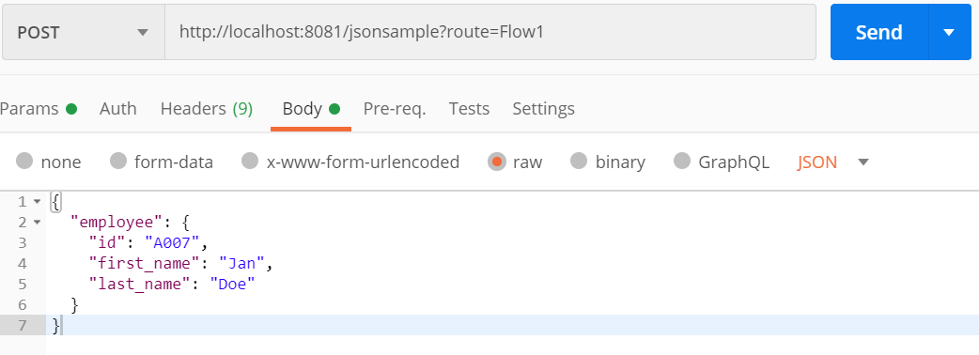

**Output**:

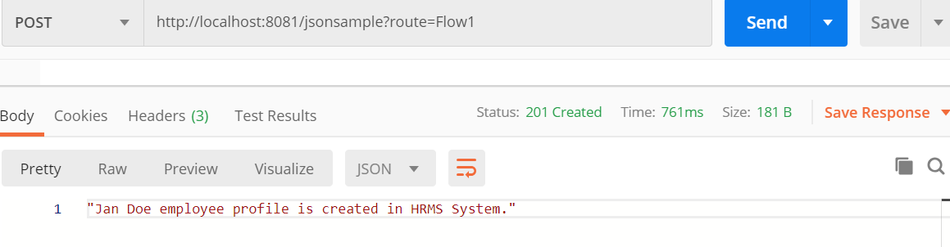

1. **URL**: http://localhost:8081/jsonsample?route=Flow2

**Method**: Post

**Body**: {

"employee": {

"id": "A007",

"first_name": "Jan",

"last_name": "Doe"

}

}

**Output**: {

"employee": {

"id": "A007",

"first_name": "Jan",

"last_name": "Doe"

}

}

**Input**:

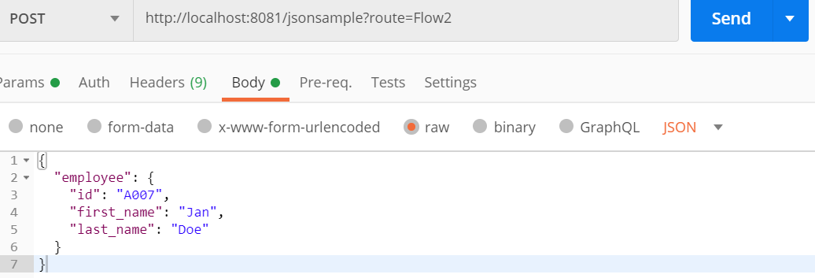

**Output**:

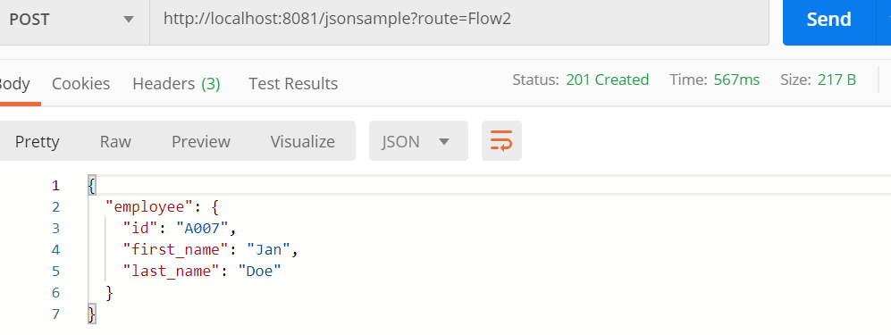

1. **URL**: http://localhost:8081/camelcase?str=test camel case

**Method**: Get

**Output**: Test Camel Case

**Screenshots(Input and Output)**

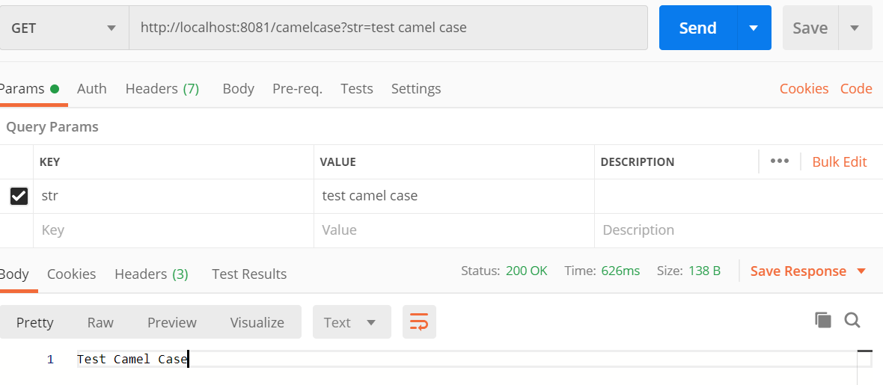

1. 4.1) **URL**: http://localhost:8081/arraymerge

**Method**: Get

**Output**: Please verify in Postman as the output is large to paste here

4.2) **URL**: http://localhost:8081/arraymerge2

**Method**: Get

**Output**: Please verify in Postman as the output is large to paste here

1. **URL**: http://localhost:8081/shownumbers/10

**Method**: Get

