VELLORE INSTITUTE OF TECHNOLOGY, VELLORE
School of Computer Science and Engineering (SCOPE)

MINI PROJECT REPORT

VaxTrack – Newborn Vaccination Schedule Tracker

Course Code: BCSE302P – Database Systems Laboratory

Submitted by

S. No. | Name | Registration Number
1 | Nekita Saras Dhanabal | 24BCE2991

Under the guidance of
Dr. G. M. Karthik
Associate Professor, School of Computer Science and Engineering (SCOPE)
Vellore Institute of Technology, Vellore

Date of Submission: 12 / 10 / 2026

CERTIFICATE

This is to certify that the Mini Project Report titled “VaxTrack – Newborn Vaccination Schedule Tracker” submitted by Nekita Saras Dhanabal (24BCE2991) in partial fulfilment of the requirements of the course BCSE302P – Database Systems Laboratory, is a record of original work carried out under my supervision during the Fall Semester 2026–27.

Signature of the Faculty
Dr. G. M. Karthik
Associate Professor, SCOPE
VIT, Vellore

Place: Vellore
Date: 12 / 10 / 2026

ABSTRACT
Newborns in India must receive vaccines in a fixed sequence at set ages, from birth to the boosters at 16–23 months, while clinics must also keep track of vaccine batches and their expiry dates. Paper cards and spreadsheets make it easy to miss a dose, to give a vaccine from an empty or expired batch, or to lose track of who changed a record. VaxTrack is a newborn vaccination schedule tracker built on Oracle Database 21c Express Edition, in which PL/SQL owns every business rule. The vaccination schedule of the National Immunization Schedule is stored as data and expanded into 24 dose records per baby (26 in districts where Japanese encephalitis is endemic). Four packages, five standalone functions, one standalone procedure, five triggers, explicit, parameterized, FOR-loop and REF cursors, and a DBMS_SCHEDULER job handle scheduling, dose administration with first-expiry-first-out stock deduction, overdue detection, alerts and auditing. A Node.js and Express API passes requests to the packages, and a React web application serves three kinds of users: administrators, nurses and parents. The behaviour was verified with 31 automated PL/SQL test cases, 152 API checks and browser tests. The project covers infants and the 16–23 month boosters.
Keywords: DBMS, Oracle PL/SQL, Packages, Triggers, Cursors, Normalization, Immunization Schedule

TABLE OF CONTENTS
CERTIFICATE 2
ABSTRACT 3
TABLE OF CONTENTS 4
1. INTRODUCTION 6
1.1 Problem Statement 6
1.2 Objectives 6
1.3 Importance of DBMS 7
1.4 Scope of the Project 7
2. SYSTEM REQUIREMENTS 9
2.1 Hardware Requirements 9
2.2 Software Requirements 9
3. DATABASE DESIGN 10
3.1 Entity–Relationship (ER) Diagram 10
3.2 Relational Schema 11
3.3 Schema Definition (DDL) 17
3.4 Normalization 17
4. IMPLEMENTATION 20
4.1 Functions 20
4.2 Procedures 22
4.3 Packages 23
4.4 Triggers 26
4.5 Cursors 28
4.6 Scheduled Job 30
4.7 Transactions and Error Handling 30
5. FRONT-END 32
5.1 User Interface 32
5.2 Integration with the DBMS 39
6. VERIFICATION & TESTING 42
6.1 Test Cases 42
6.2 Output Screenshots 44
6.3 Validation of Functionality 47
7. RESULTS & DISCUSSION 49
7.1 Achievements 49
7.2 Challenges Faced 50
7.3 Possible Improvements 51
8. CONCLUSION 52
8.1 Summary of Learning Outcomes 52
8.2 Future Scope 52
9. REFERENCES 53
10. APPENDICES 55
Appendix A – Additional Code 55
Appendix B – Additional Screenshots 56

1. INTRODUCTION

1.1 Problem Statement
A newborn has to receive a long series of vaccines at fixed ages. In India the National Immunization Schedule (NIS) of the Ministry of Health and Family Welfare lists them: BCG, oral polio and hepatitis B at birth, a first round of five vaccines at 6 weeks, further rounds at 10 and 14 weeks, the measles-rubella, pneumococcal booster, polio and vitamin A doses at 9–11 months, and boosters at 16–23 months [6]. Each dose has an age at which it becomes due and an age after which it counts as late, so a single child has 24 doses to track, and 26 in districts where Japanese encephalitis is endemic.
The people involved are the clinic nurses who give the vaccines, the parents or guardians who must bring the child on time, and an administrator who supervises several clinics. In many clinics the record is a paper card or a spreadsheet. With that approach nobody is told which dose is due next or which one has been missed, a nurse can record a dose from a batch that is empty or past its expiry date, a stock count can drift away from the number of doses actually given, and there is no trustworthy answer to the question of who changed a record, and when. VaxTrack addresses these four problems with a database that enforces the rules itself.

1.2 Objectives
1. Design a normalized relational schema (up to 3NF/BCNF) for guardians, newborns, the vaccine schedule, clinic stock, dose records, alerts and an audit trail, with constraints that reject invalid data.
2. Implement all business rules in Oracle PL/SQL, using standalone functions and a procedure, packages, triggers and the four kinds of cursor, so that scheduling, stock deduction, overdue detection and alerts are decided in the database and not in application code.
3. Provide a web application for three roles (administrator, nurse, parent) that reaches the database only through the PL/SQL packages.
4. Verify the system with an automated test script and with end-to-end runs, and keep the evidence.

1.3 Importance of DBMS
A database management system is the natural home for this application [1], [2], for the following reasons, each of which we use directly.
- Integrity. Primary, foreign, unique and check constraints keep the data valid: a dose marked DONE must have an administered date, stock can never go below zero, and a nurse account must belong to a clinic. Triggers cover the rules a constraint cannot express, such as a date of birth that is not in the future.
- Reduced redundancy. The schema is normalized, so guardian details, clinic details and vaccine details are stored once and referred to by key. The vaccination schedule itself is data in a table, so changing a due age needs an UPDATE, not a code change.
- Concurrency control. Two nurses may give the last dose of a batch at the same moment. The administration procedure locks the dose row with SELECT … FOR UPDATE and guards the stock update, so only one of them succeeds.
- Atomicity and recovery. Recording a dose changes the dose row and the stock row. Both changes happen inside one transaction with a savepoint, so a failure leaves neither of them changed.
- Security. Passwords are stored as hashes, access depends on the role, and the application reaches the data only through named packages.
- Auditability. A trigger writes every insert, update and delete on the dose records, together with the user who caused it, to a log that is not removed when the audited row is deleted.
- Efficiency. Indexes support the frequent queries, for example the first-expiry-first-out choice of a batch.

1.4 Scope of the Project
Included. Infants (0–1 year) and the 16–23 month boosters of the NIS: 24 core doses per baby, plus the two Japanese encephalitis doses for babies registered in an endemic district. Registration of babies and guardians, automatic schedule generation, administration of doses with stock deduction, rescheduling, overdue and due-soon detection, low-stock and expiry alerts, clinic stock management, reports, a printable vaccination card, an audit log, and administrator tools to correct or delete a newborn record. Three user roles with their own views.
Out of scope. Td for pregnant women, the DPT booster at 5–6 years, Td at 10 and 16 years, and vitamin A doses 3 to 9, because they are beyond newborn tracking. SMS or WhatsApp reminders, a native mobile application and a progressive web app are also left out; the application is a responsive web application only. These items are listed again as future scope in Section 8.2.
Assumptions we made. We count one month as 30 days throughout. The NIS gives age bands and not exact limits, so the "late after" age (max_age_days) is a limit we defined: 14 days for the birth doses, four weeks of grace for the doses due at 6, 10 and 14 weeks, and the end of the stated band for the month-based doses. A dose is allowed from its due age. The route of administration and the disease covered by each vaccine are standard programme facts that are not printed in the NIS document we used.

2. SYSTEM REQUIREMENTS
Values below were read from the machine on which the project was built and tested.

2.1 Hardware Requirements
Component | Specification
Processor | Intel Core Ultra 7 155U, 12 cores, 14 logical processors
RAM | 16 GB installed class (15.4 GB usable)
Storage | 512 GB class NVMe SSD (KIOXIA, 477 GB formatted)
Other | None. The application runs in a desktop or phone web browser; no mobile device or special hardware is needed

We did not test on a smaller machine, so these figures describe what we used and not a minimum.

2.2 Software Requirements
Category | Tool / Version
Operating System | Windows 11 Home Single Language, version 10.0.26200
DBMS | Oracle Database 21c Express Edition, release 21.3.0.0.0, pluggable database XEPDB1, application schema vaxapp
Query / IDE Tool | SQL*Plus 21.3.0.0.0 for running the scripts; Visual Studio Code for editing
Front-End Language | JavaScript (React 18.3.1, Vite 8.3.2, Tailwind CSS 4.3.3, React Router 7.18.4, TanStack Query 5.104.1, Recharts 3.10.1, lucide-react 1.52.0)
Back-End | Node.js 24.13.1 (the project needs 20 or later), npm 11.14.1, Express 5.2.1
Connectivity | node-oracledb 7.0.1 in thin mode (no Oracle Client installation needed)
Security libraries | bcrypt 6.0.0, jsonwebtoken 9.0.3, helmet 8.3.0, cors 2.8.6, zod 4.6.5
Browser | Microsoft Edge 155 (Chromium)
Other Tools | Git 2.53.0, Mermaid for the ER and architecture diagrams, Lighthouse and Playwright (driving Edge) for the accessibility and browser checks

The Oracle features we used are described in [3]–[5]; the driver, server, front-end and style libraries in [7]–[11].

3. DATABASE DESIGN

3.1 Entity–Relationship (ER) Diagram
The schema has ten tables. The entities and their key attributes are as follows.
- CLINICS (clinic_id): a vaccination centre, with a unique name, a city and a phone number.
- GUARDIANS (guardian_id): the parent or guardian of a baby, with a unique phone number.
- NEWBORNS (baby_id): a baby, with date of birth, gender and birth weight. Each baby has exactly one guardian and is registered at exactly one clinic.
- VACCINE_MASTER (vaccine_id): one row per dose of the national schedule, with the minimum, due and late-after age in days. It is the schedule stored as data.
- VACCINE_INVENTORY (inventory_id): one row per batch of one vaccine at one clinic, with expiry date, quantity and a low-stock threshold.
- DOSE_RECORDS (record_id): one row per baby per dose, with the scheduled date, the status (PENDING, DONE or OVERDUE), and, once given, the date, the batch used and the user who gave it.
- APP_USERS (user_id): a login. A nurse belongs to a clinic, a parent belongs to a guardian, an administrator belongs to neither.
- ALERTS (alert_id): overdue, due-soon, late-dose, low-stock and expiry messages.
- AUDIT_LOG (audit_id) and TEST_LOG (test_id): the audit trail and the record of the automated tests. They have no foreign keys, deliberately: audit rows must survive the deletion of the rows they describe.

Relationship | Cardinality | Participation
Guardian – Newborn | 1 : N | Every newborn must have a guardian; a guardian may exist without a newborn
Clinic – Newborn | 1 : N | Every newborn is registered at one clinic
Newborn – Dose record | 1 : N | A baby has 24 or 26 dose records; each dose record belongs to one baby
Vaccine master – Dose record | 1 : N | Each dose record refers to one scheduled dose
Clinic – Vaccine inventory | 1 : N | A clinic holds many batches
Vaccine master – Vaccine inventory | 1 : N | A batch is of one vaccine
Vaccine inventory – Dose record | 1 : N (optional) | A dose record refers to the batch used only after the dose is given
Clinic – App user (nurse) | 1 : N (optional) | Required for the NURSE role, empty for others
Guardian – App user (parent) | 1 : 1 (optional) | Required for the PARENT role; a guardian has at most one login (enforced by account_pkg, not by a key)
App user – Dose record | 1 : N (optional) | The user who gave the dose
Dose record – Alert | 1 : N (optional) | An alert may point to the dose that caused it

The diagram is Figure 3.1.
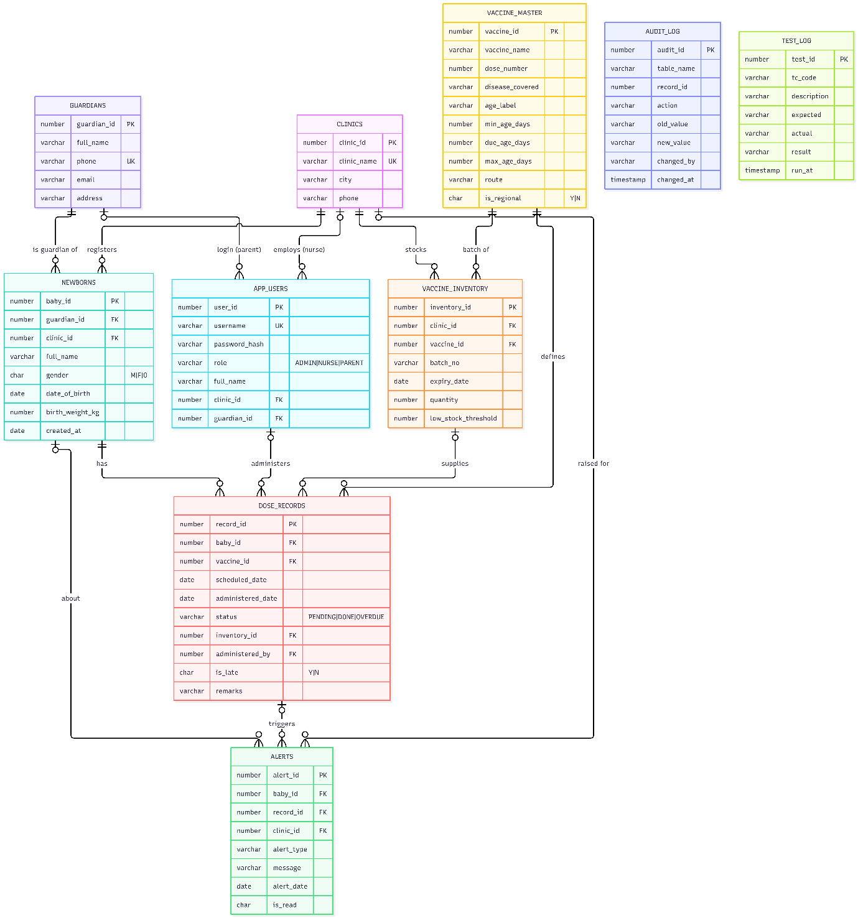

Figure 3.1: Entity-relationship diagram of the VaxTrack schema

3.2 Relational Schema
Each relation is shown below with its constraints. Primary keys are identity columns, so no identifier is typed by hand anywhere in the project.
Table 3.1: CLINICS
Attribute | Data Type | Constraint | Description
clinic_id | NUMBER | PRIMARY KEY (identity) | Clinic identifier
clinic_name | VARCHAR2(100) | NOT NULL, UNIQUE | Name of the clinic
city | VARCHAR2(60) | NOT NULL | City
phone | VARCHAR2(20) |  | Contact number

Table 3.2: GUARDIANS
Attribute | Data Type | Constraint | Description
guardian_id | NUMBER | PRIMARY KEY (identity) | Guardian identifier
full_name | VARCHAR2(100) | NOT NULL | Name
phone | VARCHAR2(15) | NOT NULL, UNIQUE, CHECK 7–15 digits, spaces, + or - | Phone number; a guardian found by phone is reused
email | VARCHAR2(120) |  | Optional e-mail address
address | VARCHAR2(250) |  | Address (required by the registration procedure for a new guardian)

Table 3.3: APP_USERS
Attribute | Data Type | Constraint | Description
user_id | NUMBER | PRIMARY KEY (identity) | Login identifier
username | VARCHAR2(50) | NOT NULL, UNIQUE | Login name
password_hash | VARCHAR2(100) | NOT NULL | bcrypt hash, never the password
role | VARCHAR2(10) | NOT NULL, CHECK IN ('ADMIN','NURSE','PARENT') | Role
full_name | VARCHAR2(100) | NOT NULL | Display name
clinic_id | NUMBER | FOREIGN KEY → CLINICS(clinic_id) | Clinic of a nurse
guardian_id | NUMBER | FOREIGN KEY → GUARDIANS(guardian_id) | Guardian of a parent
(table check) |  | CHECK: ADMIN, or NURSE with a clinic, or PARENT with a guardian | A login always has the scope its role needs

Table 3.4: NEWBORNS
Attribute | Data Type | Constraint | Description
baby_id | NUMBER | PRIMARY KEY (identity) | Baby identifier
guardian_id | NUMBER | NOT NULL, FOREIGN KEY → GUARDIANS(guardian_id) | Guardian
clinic_id | NUMBER | NOT NULL, FOREIGN KEY → CLINICS(clinic_id) | Registering clinic
full_name | VARCHAR2(100) | NOT NULL | Name
gender | CHAR(1) | NOT NULL, CHECK IN ('M','F','O') | Gender
date_of_birth | DATE | NOT NULL | Date of birth; not in the future (trigger)
birth_weight_kg | NUMBER(4,2) | CHECK between 0.5 and 9.99 | Birth weight
created_at | DATE | DEFAULT SYSDATE, NOT NULL | Registration date

Table 3.5: VACCINE_MASTER
Attribute | Data Type | Constraint | Description
vaccine_id | NUMBER | PRIMARY KEY (identity) | Dose identifier
vaccine_name | VARCHAR2(60) | NOT NULL, UNIQUE with dose_number | Vaccine name as in the NIS
disease_covered | VARCHAR2(150) | NOT NULL | Diseases prevented
dose_number | NUMBER(2) | NOT NULL, CHECK >= 0 | Dose number (0 for the birth polio dose)
age_label | VARCHAR2(30) | NOT NULL | Age band, e.g. "6 weeks"
min_age_days | NUMBER(5) | NOT NULL | Earliest age at which the dose may be given
due_age_days | NUMBER(5) | NOT NULL | Age at which the dose is due
max_age_days | NUMBER(5) | NOT NULL | Age after which the dose counts as late
route | VARCHAR2(30) | NOT NULL | Route of administration
is_regional | CHAR(1) | DEFAULT 'N', NOT NULL, CHECK IN ('Y','N') | 'Y' for Japanese encephalitis (endemic districts only)
(table check) |  | CHECK min_age_days <= due_age_days <= max_age_days | The three ages are in order

Table 3.6: VACCINE_INVENTORY
Attribute | Data Type | Constraint | Description
inventory_id | NUMBER | PRIMARY KEY (identity) | Batch row identifier
clinic_id | NUMBER | NOT NULL, FOREIGN KEY → CLINICS(clinic_id) | Clinic holding the batch
vaccine_id | NUMBER | NOT NULL, FOREIGN KEY → VACCINE_MASTER(vaccine_id) | Vaccine
batch_no | VARCHAR2(40) | NOT NULL, UNIQUE with clinic_id and vaccine_id | Batch number
expiry_date | DATE | NOT NULL | Expiry date
quantity | NUMBER(6) | DEFAULT 0, NOT NULL, CHECK >= 0 | Doses left
low_stock_threshold | NUMBER(6) | DEFAULT 10, NOT NULL, CHECK >= 0 | Alert level

Table 3.7: DOSE_RECORDS
Attribute | Data Type | Constraint | Description
record_id | NUMBER | PRIMARY KEY (identity) | Dose record identifier
baby_id | NUMBER | NOT NULL, FOREIGN KEY → NEWBORNS(baby_id), UNIQUE with vaccine_id | Baby
vaccine_id | NUMBER | NOT NULL, FOREIGN KEY → VACCINE_MASTER(vaccine_id) | Scheduled dose
scheduled_date | DATE | NOT NULL | Due date (date of birth + due_age_days, or a rescheduled date)
administered_date | DATE |  | Date the dose was given
status | VARCHAR2(10) | DEFAULT 'PENDING', NOT NULL, CHECK IN ('PENDING','DONE','OVERDUE') | State of the dose
inventory_id | NUMBER | FOREIGN KEY → VACCINE_INVENTORY(inventory_id) | Batch used
administered_by | NUMBER | FOREIGN KEY → APP_USERS(user_id) | User who gave the dose
is_late | CHAR(1) | DEFAULT 'N', NOT NULL, CHECK IN ('Y','N') | Given after max_age_days
remarks | VARCHAR2(500) |  | Free text, e.g. a reschedule reason
(table check) |  | CHECK: DONE if and only if administered_date is not null | A dose is DONE exactly when it has a date

Table 3.8: ALERTS
Attribute | Data Type | Constraint | Description
alert_id | NUMBER | PRIMARY KEY (identity) | Alert identifier
baby_id | NUMBER | FOREIGN KEY → NEWBORNS(baby_id) | Baby concerned
record_id | NUMBER | FOREIGN KEY → DOSE_RECORDS(record_id) | Dose concerned
clinic_id | NUMBER | FOREIGN KEY → CLINICS(clinic_id) | Clinic to be told
alert_type | VARCHAR2(10) | NOT NULL, CHECK IN ('DUE_SOON','OVERDUE','LATE_DOSE','LOW_STOCK','EXPIRY') | Kind of alert
message | VARCHAR2(400) | NOT NULL | Text shown to the user
alert_date | DATE | DEFAULT SYSDATE, NOT NULL | When it was raised
is_read | CHAR(1) | DEFAULT 'N', NOT NULL, CHECK IN ('Y','N') | Read flag

Table 3.9: AUDIT_LOG
Attribute | Data Type | Constraint | Description
audit_id | NUMBER | PRIMARY KEY (identity) | Audit row identifier
table_name | VARCHAR2(30) | NOT NULL | Table that changed
record_id | NUMBER |  | Key of the changed row
action | VARCHAR2(10) | NOT NULL, CHECK IN ('INSERT','UPDATE','DELETE') | Kind of change
old_value, new_value | VARCHAR2(4000) |  | Text of the row before and after
changed_by | VARCHAR2(100) |  | User, taken from the session's client information
changed_at | TIMESTAMP | DEFAULT SYSTIMESTAMP, NOT NULL | Time of the change

Table 3.10: TEST_LOG
Attribute | Data Type | Constraint | Description
test_id | NUMBER | PRIMARY KEY (identity) | Row identifier
tc_code | VARCHAR2(20) | NOT NULL | Test case code, e.g. TC-P4
description | VARCHAR2(300) | NOT NULL | What is tested
expected, actual | VARCHAR2(1000) |  | Expected and observed output
result | VARCHAR2(4) | NOT NULL, CHECK IN ('PASS','FAIL') | Outcome
run_at | TIMESTAMP | DEFAULT SYSTIMESTAMP, NOT NULL | Time of the run

The tables of the schema are listed in Figure 3.2 and their constraints in Figure 3.3.
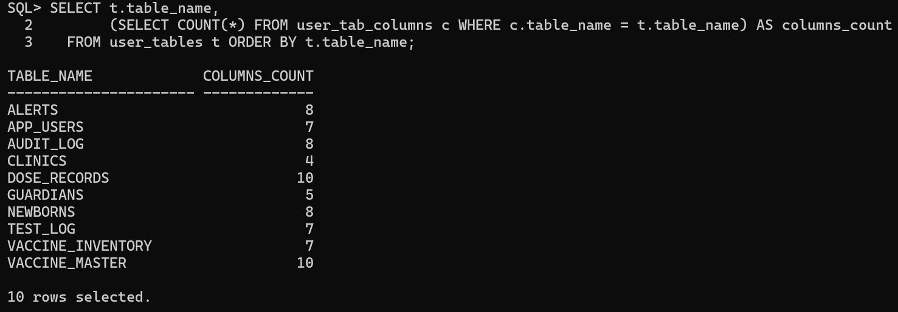
Figure 3.2: Tables of the schema with column counts
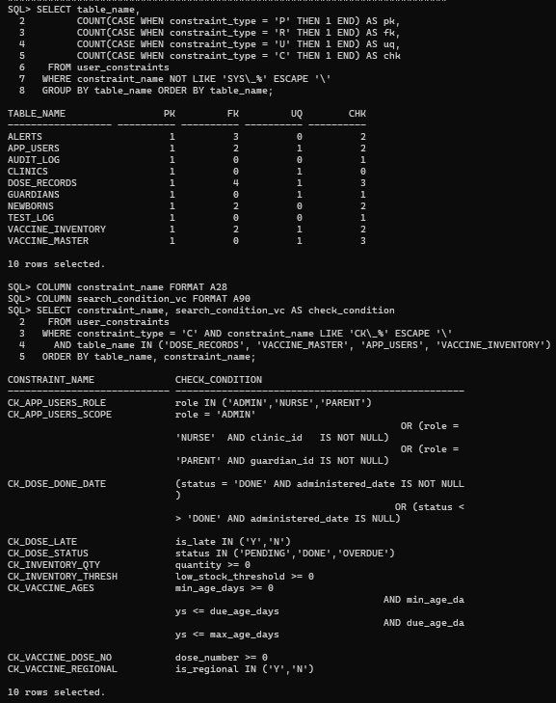
Figure 3.3: Primary, foreign, unique and check constraints per table
The schedule that vaccine_master holds is given in Figure 3.4. It follows the NIS: 3 rows at birth, 5 at 6 weeks, 3 at 10 weeks, 5 at 14 weeks, 4 at 9–11 months and 4 at 16–23 months, which makes 24, plus the two Japanese encephalitis rows marked is_regional = 'Y'.
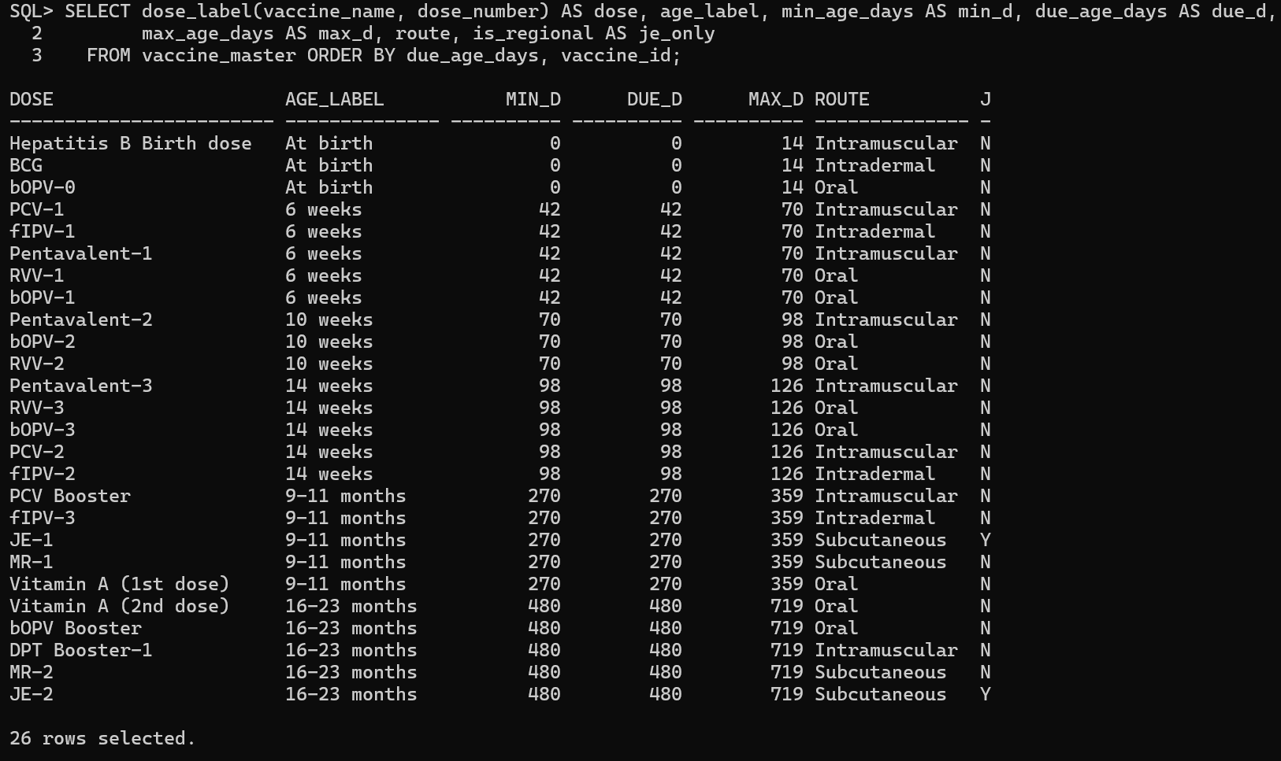
Figure 3.4: The immunization schedule stored as data in vaccine_master
Two design points are worth stating. First, "date of birth is not in the future" cannot be a CHECK constraint because SYSDATE is not allowed in one, so a trigger enforces it. Second, the 14 indexes beyond the keys and unique constraints support the frequent access paths; the most important is ix_inventory_fefo on (clinic_id, vaccine_id, expiry_date), which serves the first-expiry-first-out choice of a batch, and ix_dose_status_sched on (status, scheduled_date), which serves the overdue and due-soon queries.

3.3 Schema Definition (DDL)
The complete script is db/01_schema.sql (Appendix A). Two of the tables are shown here to illustrate the constraints.
CREATE TABLE vaccine_master (
vaccine_id NUMBER GENERATED BY DEFAULT AS IDENTITY,
vaccine_name VARCHAR2(60) NOT NULL,
disease_covered VARCHAR2(150) NOT NULL,
dose_number NUMBER(2) NOT NULL,
age_label VARCHAR2(30) NOT NULL,
min_age_days NUMBER(5) NOT NULL,
due_age_days NUMBER(5) NOT NULL,
max_age_days NUMBER(5) NOT NULL,
route VARCHAR2(30) NOT NULL,
is_regional CHAR(1) DEFAULT 'N' NOT NULL,
CONSTRAINT pk_vaccine_master PRIMARY KEY (vaccine_id),
CONSTRAINT uq_vaccine_dose UNIQUE (vaccine_name, dose_number),
CONSTRAINT ck_vaccine_dose_no CHECK (dose_number >= 0),
CONSTRAINT ck_vaccine_ages CHECK (min_age_days >= 0
AND min_age_days <= due_age_days
AND due_age_days <= max_age_days),
CONSTRAINT ck_vaccine_regional CHECK (is_regional IN ('Y','N'))
);

CREATE TABLE dose_records (
record_id NUMBER GENERATED BY DEFAULT AS IDENTITY,
baby_id NUMBER NOT NULL,
vaccine_id NUMBER NOT NULL,
scheduled_date DATE NOT NULL,
administered_date DATE,
status VARCHAR2(10) DEFAULT 'PENDING' NOT NULL,
inventory_id NUMBER,
administered_by NUMBER,
is_late CHAR(1) DEFAULT 'N' NOT NULL,
remarks VARCHAR2(500),
CONSTRAINT pk_dose_records PRIMARY KEY (record_id),
CONSTRAINT uq_dose_baby_vaccine UNIQUE (baby_id, vaccine_id),
CONSTRAINT ck_dose_status CHECK (status IN ('PENDING','DONE','OVERDUE')),
CONSTRAINT ck_dose_late CHECK (is_late IN ('Y','N')),
CONSTRAINT ck_dose_done_date CHECK ((status = 'DONE' AND administered_date IS NOT NULL)
OR (status <> 'DONE' AND administered_date IS NULL)),
CONSTRAINT fk_dose_baby FOREIGN KEY (baby_id) REFERENCES newborns (baby_id),
CONSTRAINT fk_dose_vaccine FOREIGN KEY (vaccine_id) REFERENCES vaccine_master (vaccine_id),
CONSTRAINT fk_dose_inventory FOREIGN KEY (inventory_id) REFERENCES vaccine_inventory (inventory_id),
CONSTRAINT fk_dose_user FOREIGN KEY (administered_by) REFERENCES app_users (user_id)
);

3.4 Normalization
Unnormalized form. We started from the paper vaccination card. One sheet carries the baby (name, gender, date of birth, birth weight), the guardian (name, phone, e-mail, address), the clinic (name, city, phone) and then a repeating group of vaccine rows, each with vaccine name, disease, dose number, route, due date, given date, status, batch number, expiry date and the person who gave it:
CARD(baby_name, gender, dob, birth_weight,
guardian_name, guardian_phone, guardian_email, address,
clinic_name, clinic_city, clinic_phone,
{ vaccine_name, disease, dose_no, route, due_date, given_date,
status, batch_no, expiry_date, given_by }*)

First normal form. The repeating group is removed: there is one row per baby per dose, with the key (baby, vaccine), and every column holds one value. The anomaly removed is the variable-length list inside one record.
Second normal form. The key is now composite, (baby_id, vaccine_id), and some columns depend on only part of it. baby_id → baby_name, gender, dob, weight, guardian_*, clinic_* moves to newborns. vaccine_id → vaccine_name, disease, dose_no, route, age windows moves to vaccine_master. What remains in dose_records (scheduled date, administered date, status, late flag, remarks, administering user) depends on the whole key. The update anomaly removed: a change to a vaccine's route or age window is made once and not on every baby's card.
Third normal form. Transitive dependencies are removed. baby_id → guardian_id → guardian name, phone, e-mail, address moves to guardians. baby_id → clinic_id → clinic name, city, phone moves to clinics. dose → inventory_id → batch number, expiry date, quantity moves to vaccine_inventory, one row per clinic, vaccine and batch. Login data forms app_users, with a role-dependent reference to a clinic or a guardian. The anomaly removed: a guardian's new phone number or a clinic's new address is stored once.
BCNF. We checked every non-trivial functional dependency. In each table the determinants are candidate keys, as listed below, so the schema is in BCNF.
Normal Form | Relations | Justification
1NF | card split into one row per baby and dose | Atomic values; no repeating groups
2NF | newborns, vaccine_master, dose_records | No partial dependency on the composite key (baby_id, vaccine_id)
3NF | guardians, clinics, vaccine_inventory, app_users | No transitive dependency: guardian, clinic and batch details depend on their own keys
BCNF | all ten tables | Every determinant is a candidate key: clinic_id/clinic_name; guardian_id/phone; user_id/username; baby_id; vaccine_id/(vaccine_name, dose_number); inventory_id/(clinic_id, vaccine_id, batch_no); record_id/(baby_id, vaccine_id); surrogate keys for alerts, audit_log and test_log

is_regional and age_label are stored in vaccine_master. Both depend only on vaccine_id, so they do not break third normal form. age_label is a descriptive label for the age band; the day counts remain the source of truth.

4. IMPLEMENTATION
All business rules live in the database: the scripts in db/ are run in numeric order on an empty schema (99_drop_all.sql resets it, and every script can be run again) and the whole chain is run by run_all.sql (Figure 4.1). After compilation no object is invalid (Figure 4.2). The project contains five standalone functions, one standalone procedure, four packages, five triggers, one scheduler job and all four kinds of cursor. Errors are raised with RAISE_APPLICATION_ERROR in the range −20001 to −20099; the table of codes is at the top of db/04_pkg_newborn.sql. The language features are those of the Oracle PL/SQL Language Reference [3].
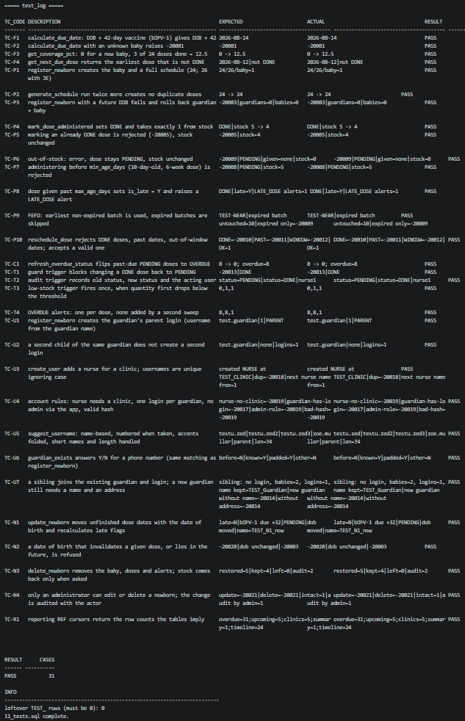
Figure 4.1: Scripts 99 to 11 running in order on an empty schema
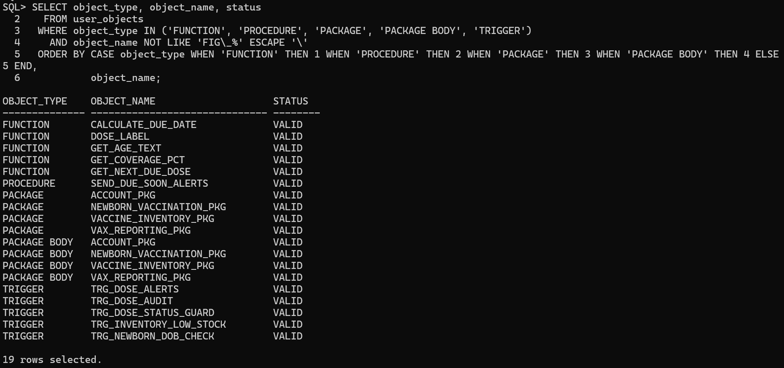
Figure 4.2: PL/SQL functions, procedures, packages and triggers, all VALID

4.1 Functions
Five standalone functions (db/03_functions.sql) compute the values the rest of the system relies on.
Function | Returns | Purpose
calculate_due_date(p_baby_id, p_vaccine_id) | DATE | date of birth plus the vaccine's due_age_days; raises −20001 or −20002 if the baby or vaccine does not exist
get_age_text(p_baby_id) | VARCHAR2 | readable age such as "3 months 12 days"
get_coverage_pct(p_baby_id) | NUMBER | doses given divided by doses scheduled, times 100
get_next_due_dose(p_baby_id) | NUMBER | record_id of the earliest dose that is not DONE, or NULL
dose_label(p_vaccine_name, p_dose_number) | VARCHAR2 | display name such as "bOPV-1" or "Vitamin A (1st dose)"; deterministic, so it can be used inside SQL

calculate_due_date is called by generate_schedule for every dose of a new baby, and the other functions are called from the API queries that build the baby list, the profile and the dashboard.
CREATE OR REPLACE FUNCTION calculate_due_date (
p_baby_id IN NUMBER,
p_vaccine_id IN NUMBER
) RETURN DATE
IS
v_dob newborns.date_of_birth%TYPE;
v_days vaccine_master.due_age_days%TYPE;
BEGIN
BEGIN
SELECT date_of_birth INTO v_dob FROM newborns WHERE baby_id = p_baby_id;
EXCEPTION
WHEN NO_DATA_FOUND THEN
RAISE_APPLICATION_ERROR(-20001, 'Baby not found: ' || NVL(TO_CHAR(p_baby_id), 'NULL'));
END;
BEGIN
SELECT due_age_days INTO v_days FROM vaccine_master WHERE vaccine_id = p_vaccine_id;
EXCEPTION
WHEN NO_DATA_FOUND THEN
RAISE_APPLICATION_ERROR(-20002, 'Vaccine not found: ' || NVL(TO_CHAR(p_vaccine_id), 'NULL'));
END;
RETURN TRUNC(v_dob) + v_days;
END calculate_due_date;

Output of the four functions, including the error case, is in Figure 4.3.
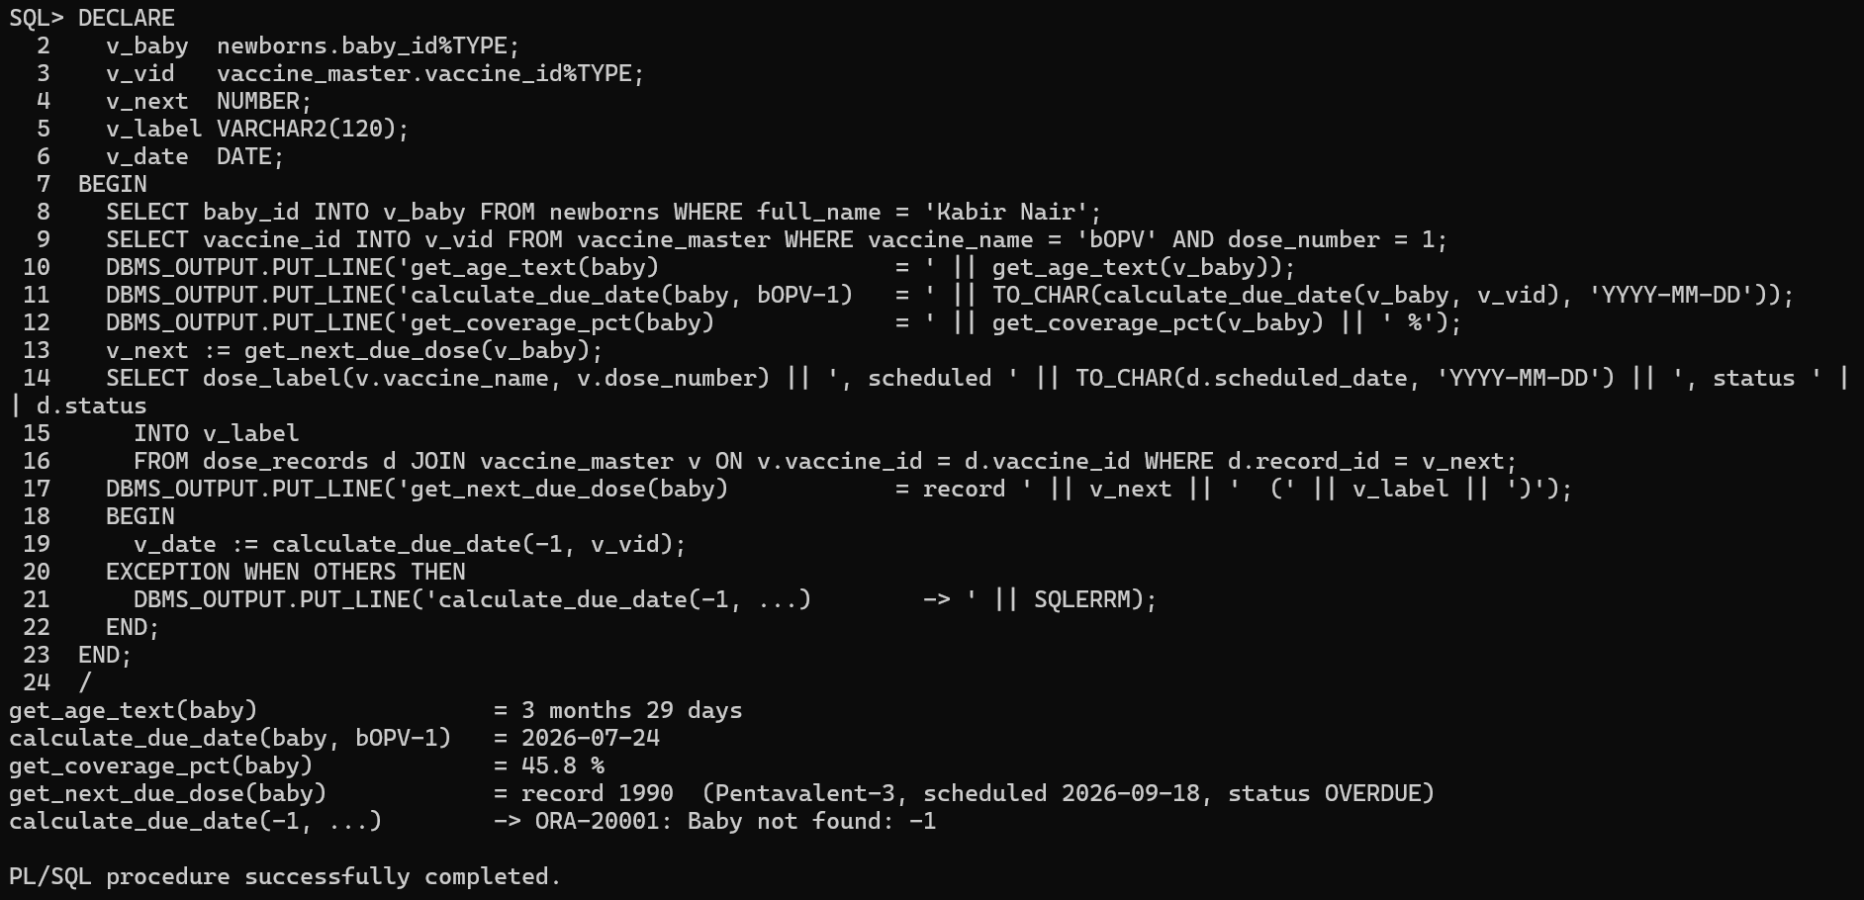
Figure 4.3: Output of the four standalone functions, including the error case

4.2 Procedures
`send_due_soon_alerts(p_days_ahead)` (db/07_procedures.sql) is the standalone procedure. It loops over the pending doses due from today up to p_days_ahead days ahead and inserts one DUE_SOON alert for each, skipping a dose that already has one, so the daily job never duplicates an alert. It sets a savepoint, commits on success and rolls back to the savepoint on failure; a negative number of days raises −20014.
CREATE OR REPLACE PROCEDURE send_due_soon_alerts (
p_days_ahead IN NUMBER DEFAULT 7
)
IS
CURSOR c_due (p_window NUMBER) IS
SELECT d.record_id, d.baby_id, d.scheduled_date, n.clinic_id, n.full_name AS baby_name,
dose_label(v.vaccine_name, v.dose_number) AS dose_name
FROM dose_records d
JOIN newborns n ON n.baby_id = d.baby_id
JOIN vaccine_master v ON v.vaccine_id = d.vaccine_id
WHERE d.status = 'PENDING'
AND d.scheduled_date BETWEEN TRUNC(SYSDATE) AND TRUNC(SYSDATE) + p_window
ORDER BY d.scheduled_date, d.record_id;
v_created PLS_INTEGER := 0;
BEGIN
SAVEPOINT sp_due_soon;
IF p_days_ahead IS NULL OR p_days_ahead < 0 THEN
RAISE_APPLICATION_ERROR(-20014, 'Days ahead must be zero or more');
END IF;

FOR r IN c_due(p_days_ahead) LOOP
INSERT INTO alerts (baby_id, record_id, clinic_id, alert_type, message)
SELECT r.baby_id, r.record_id, r.clinic_id, 'DUE_SOON',
r.dose_name || ' for ' || r.baby_name || ' is due on ' || TO_CHAR(r.scheduled_date, 'YYYY-MM-DD')
FROM dual
WHERE NOT EXISTS (SELECT 1 FROM alerts a
WHERE a.record_id = r.record_id AND a.alert_type = 'DUE_SOON');
v_created := v_created + SQL%ROWCOUNT;
END LOOP;
COMMIT;
-- (exception handler: ROLLBACK TO sp_due_soon, re-raise -20xxx, wrap the rest as -20099)
END send_due_soon_alerts;

The alerts raised by this procedure and by the triggers and sweeps are shown in Figure 4.4.
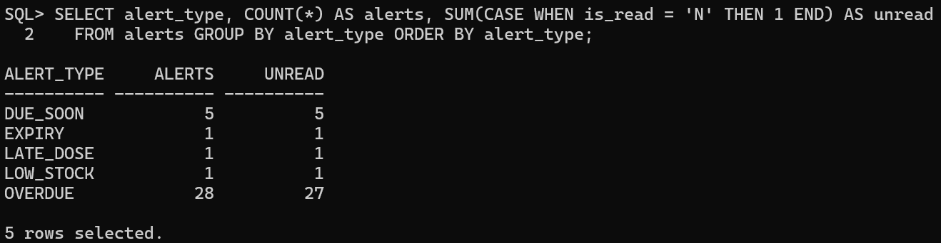
Figure 4.4: Alerts raised by triggers and sweeps

4.3 Packages
The application logic is grouped into four packages. The API calls only these packages.
Package (file) | Main members
newborn_vaccination_pkg (04) | register_newborn, generate_schedule, guardian_exists, is_dose_allowed, mark_dose_administered, reschedule_dose, refresh_overdue_status, update_newborn, delete_newborn, set_actor
vaccine_inventory_pkg (05) | restock, pick_batch, expiry_sweep
vax_reporting_pkg (06) | dashboard_summary, overdue_list, upcoming_list, clinic_coverage, baby_timeline (all return a SYS_REFCURSOR)
account_pkg (03b) | next_nurse_username, suggest_username, add_user, create_user

Registering a baby. register_newborn reuses a guardian found by phone number or inserts a new one (a new guardian needs a name and an address), inserts the baby, calls generate_schedule, and creates the guardian's parent login the first time, all in one transaction. If any step fails, including a date of birth in the future that the trigger rejects, the savepoint rolls everything back, so no half-registered family remains (Figure 4.5). The parent's username is built from the guardian's name by account_pkg.suggest_username (for example priya.sharma, with a number added if the name is taken). A second child of the same guardian creates no second login.
Figure 4.5: register_newborn creates 24 doses; a future date of birth rolls everything back
Recording a dose. mark_dose_administered is the core transaction of the system. It sets a savepoint first, so a failure at any step also releases the row lock, then proceeds as follows. It locks the dose row (FOR UPDATE) and reads the baby and the vaccine. It rejects a dose that is already DONE, a date before the date of birth or in the future, and a baby younger than the dose's min_age_days. It asks vaccine_inventory_pkg.pick_batch for the batch that expires first among those that are not expired and have stock (first-expiry-first-out), and raises −20009 if there is none. It reduces that batch by one, guarded by quantity > 0 so that a concurrent session taking the last dose makes this one fail cleanly. It marks the dose DONE with the batch and the nurse, sets is_late = 'Y' and inserts a LATE_DOSE alert when the baby is past max_age_days, and commits. Any error rolls back to the savepoint, so the dose and the stock can never disagree (Figure 4.6).
-- 1. lock the dose row and read everything the checks need
SELECT d.status, d.baby_id, d.vaccine_id, n.date_of_birth, n.full_name, n.clinic_id,
v.min_age_days, v.max_age_days, dose_label(v.vaccine_name, v.dose_number)
INTO v_status, v_baby_id, v_vaccine_id, v_dob, v_baby_name, v_baby_clinic,
v_min_age, v_max_age, v_label
FROM dose_records d
JOIN newborns n ON n.baby_id = d.baby_id
JOIN vaccine_master v ON v.vaccine_id = d.vaccine_id
WHERE d.record_id = p_record_id
FOR UPDATE OF d.status;
-- (checks: already DONE, before birth, in the future, younger than min_age_days)

-- 2. FEFO batch (raises -20009 when empty or expired)
v_inventory := vaccine_inventory_pkg.pick_batch(p_clinic_id, v_vaccine_id);

-- 3. deduct stock; the quantity > 0 guard catches a concurrent session taking the last dose
UPDATE vaccine_inventory
SET quantity = quantity - 1
WHERE inventory_id = v_inventory
AND quantity > 0;
IF SQL%ROWCOUNT = 0 THEN
RAISE_APPLICATION_ERROR(c_err_no_stock, 'The last dose of the selected batch was just used; please retry');
END IF;

UPDATE dose_records
SET status = 'DONE', administered_date = v_date, inventory_id = v_inventory,
administered_by = p_user_id, is_late = v_late
WHERE record_id = p_record_id;
-- (LATE_DOSE alert when v_age_days > v_max_age), then COMMIT;
EXCEPTION
WHEN OTHERS THEN
v_code := SQLCODE; v_msg := SQLERRM;
ROLLBACK TO sp_administer; -- 4. undo stock and dose together
IF v_code BETWEEN -20999 AND -20000 THEN RAISE; END IF;
RAISE_APPLICATION_ERROR(c_err_unexpected, 'Could not record the dose: ' || v_msg);

Figure 4.6: mark_dose_administered: FEFO batch, stock minus one, late flag, and the error paths
First-expiry-first-out. pick_batch returns the inventory row that expires first among the clinic's non-expired batches of that vaccine that still have stock; an expired batch is skipped even if it holds stock.
SELECT inventory_id
INTO v_inv
FROM (SELECT inventory_id
FROM vaccine_inventory
WHERE clinic_id = p_clinic_id
AND vaccine_id = p_vaccine_id
AND quantity > 0
AND expiry_date >= TRUNC(SYSDATE)
ORDER BY expiry_date, inventory_id)
WHERE ROWNUM = 1;

Other members. reschedule_dose moves a dose that is not DONE to a date that is today or later and inside its age window, and records the reason. update_newborn and delete_newborn are available to administrators only (error −20021 otherwise): a corrected date of birth moves the due dates of the unfinished doses and rebuilds the stale alerts, and it is refused (−20020) if a dose that was already given would fall before its minimum age; deleting a baby can return the given doses to stock. restock inserts a batch or adds to an existing one. set_actor stores the acting user in the session's client information so that the audit trigger knows who acted.
Usage example
EXEC newborn_vaccination_pkg.mark_dose_administered(:record_id, NULL, :clinic_id, :user_id);

4.4 Triggers
Five triggers (db/08_triggers.sql) enforce the rules that must hold whichever program changes the data. None of them reads the table that fired it, which is how the mutating-table error (ORA-04091) is avoided; they read only other tables.
Trigger | Event, level | Rule
trg_newborn_dob_check | BEFORE INSERT OR UPDATE OF date_of_birth ON newborns, row | the date of birth must not be in the future (−20003)
trg_dose_status_guard | BEFORE UPDATE ON dose_records, row | a DONE dose can never go back to PENDING or OVERDUE (−20013); the administered date may not be before the date of birth or in the future (−20006, −20007); a PENDING dose whose date has passed becomes OVERDUE
trg_dose_alerts | AFTER UPDATE OF status ON dose_records, row, with a WHEN clause | inserts one OVERDUE alert when a dose becomes overdue, once per dose
trg_dose_audit | AFTER INSERT OR UPDATE OR DELETE ON dose_records, row | writes old and new values and the acting user to audit_log
trg_inventory_low_stock | AFTER UPDATE OF quantity ON vaccine_inventory, row, with a WHEN clause | inserts a LOW_STOCK alert when a batch crosses below its threshold, once while it stays low

CREATE OR REPLACE TRIGGER trg_dose_status_guard
BEFORE UPDATE ON dose_records
FOR EACH ROW
DECLARE
v_dob newborns.date_of_birth%TYPE;
BEGIN
IF :OLD.status = 'DONE' AND :NEW.status <> 'DONE' THEN
RAISE_APPLICATION_ERROR(-20013, 'A dose that is DONE cannot be changed back to ' || :NEW.status);
END IF;

IF :NEW.administered_date IS NOT NULL
AND (:OLD.administered_date IS NULL OR :NEW.administered_date <> :OLD.administered_date) THEN
SELECT date_of_birth INTO v_dob FROM newborns WHERE baby_id = :NEW.baby_id;
IF TRUNC(:NEW.administered_date) < TRUNC(v_dob) THEN
RAISE_APPLICATION_ERROR(-20006, 'Administered date is before the date of birth');
ELSIF TRUNC(:NEW.administered_date) > TRUNC(SYSDATE) THEN
RAISE_APPLICATION_ERROR(-20007, 'Administered date cannot be in the future');
END IF;
END IF;

IF :NEW.status = 'PENDING' AND :NEW.scheduled_date < TRUNC(SYSDATE) THEN
:NEW.status := 'OVERDUE';
END IF;
END trg_dose_status_guard;

CREATE OR REPLACE TRIGGER trg_inventory_low_stock
AFTER UPDATE OF quantity ON vaccine_inventory
FOR EACH ROW
WHEN (NEW.quantity < NEW.low_stock_threshold AND OLD.quantity >= OLD.low_stock_threshold)
DECLARE
v_label VARCHAR2(100);
BEGIN
SELECT dose_label(vaccine_name, dose_number) INTO v_label
FROM vaccine_master WHERE vaccine_id = :NEW.vaccine_id;

INSERT INTO alerts (clinic_id, alert_type, message)
VALUES (:NEW.clinic_id, 'LOW_STOCK',
'Low stock: batch ' || :NEW.batch_no || ' of ' || v_label || ' has ' || :NEW.quantity
|| ' dose(s) left (threshold ' || :NEW.low_stock_threshold || ')');
END trg_inventory_low_stock;

The guard trigger blocking a change from DONE to PENDING, and the audit row it leaves with the old status, the new status and the acting user, are shown in Figure 4.7; the audit rows are listed in Figure 4.8.
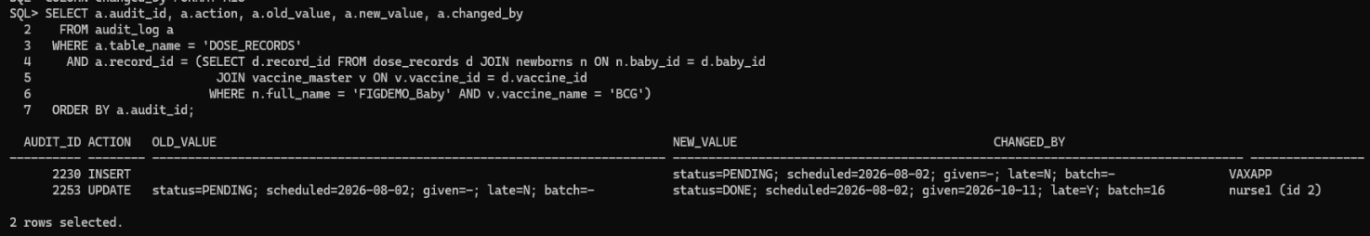
Figure 4.7: Status-guard trigger blocking DONE to PENDING, and the audit row with the actor
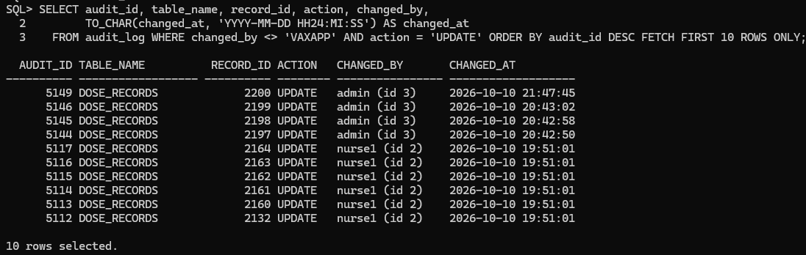
Figure 4.8: audit_log rows written by the trigger

4.5 Cursors
The project uses every kind of PL/SQL cursor.
Kind | Where | Why a cursor is needed
Explicit cursor with a parameter | generate_schedule: CURSOR c_vaccines (p_regional VARCHAR2), opened, fetched in a loop and closed | the schedule is built dose by dose from vaccine_master; Japanese encephalitis rows are included only when requested; the cursor is closed in the exception handler as well
Parameterized cursor in a FOR loop | expiry_sweep: CURSOR c_expiring (p_window NUMBER); send_due_soon_alerts: c_due (p_window) | each batch or dose needs its own alert, and the window (days) is passed in
Cursor FOR loop over an inline query | refresh_overdue_status | each past-due pending dose is touched individually so that the row triggers fire
REF cursor (SYS_REFCURSOR) | the five procedures of vax_reporting_pkg | the API receives the result set from the package and sends it as JSON
Implicit cursor | SQL%ROWCOUNT after the stock update and the alert inserts | detects that no row was changed

-- refresh_overdue_status: cursor FOR loop
FOR r IN (SELECT record_id
FROM dose_records
WHERE status = 'PENDING'
AND scheduled_date < TRUNC(SYSDATE)) LOOP
UPDATE dose_records SET status = 'PENDING'
WHERE record_id = r.record_id AND status = 'PENDING';
v_flipped := v_flipped + SQL%ROWCOUNT;
END LOOP;

A row-level trigger fires only when its row is touched, and nothing touches a dose merely because a date has passed. The loop therefore updates each past-due pending dose to its own value: the update itself changes nothing, but trg_dose_status_guard turns the status into OVERDUE and trg_dose_alerts raises the alert. The AND status = 'PENDING' condition makes the loop skip a dose that a nurse marked DONE after the cursor read it (Figure 4.9).
-- expiry_sweep: parameterized cursor
CURSOR c_expiring (p_window NUMBER) IS
SELECT i.clinic_id, i.batch_no, i.expiry_date,
dose_label(v.vaccine_name, v.dose_number) AS vaccine_label
FROM vaccine_inventory i
JOIN vaccine_master v ON v.vaccine_id = i.vaccine_id
WHERE i.quantity > 0
AND i.expiry_date <= TRUNC(SYSDATE) + p_window
ORDER BY i.expiry_date, i.inventory_id;

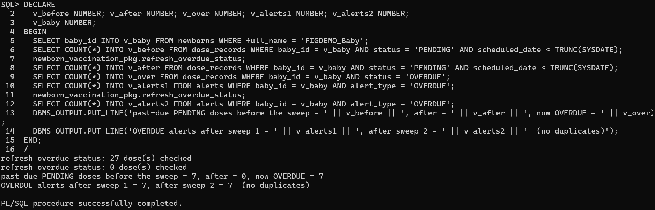
Figure 4.9: Overdue sweep flipping past-due doses; one alert per dose
The REF cursors of the reporting package return the dashboard summary and the clinic coverage (Figure 4.10) and a baby's timeline with its colour bucket and batch (Figure 4.11). clinic_coverage aggregates per clinic and then ranks the clinics with the analytic function RANK() OVER (ORDER BY coverage_pct DESC).
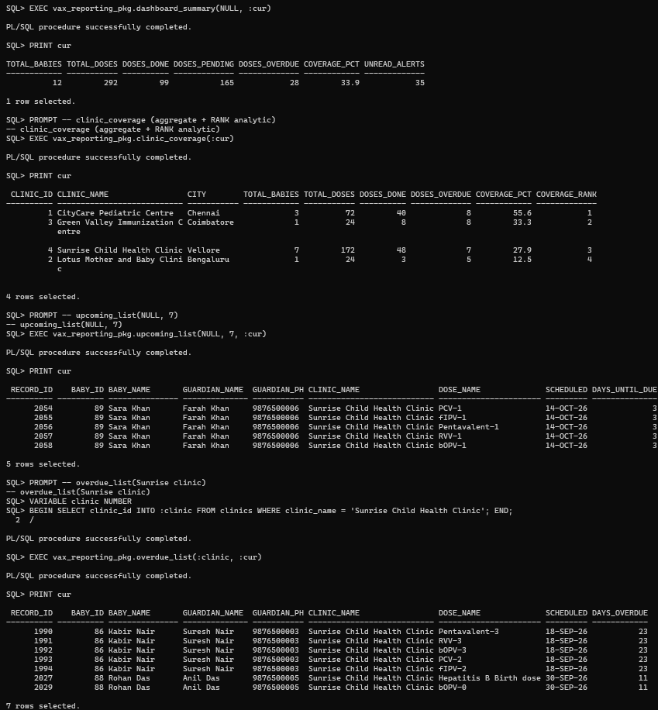
Figure 4.10: REF CURSOR output: dashboard summary and clinic coverage
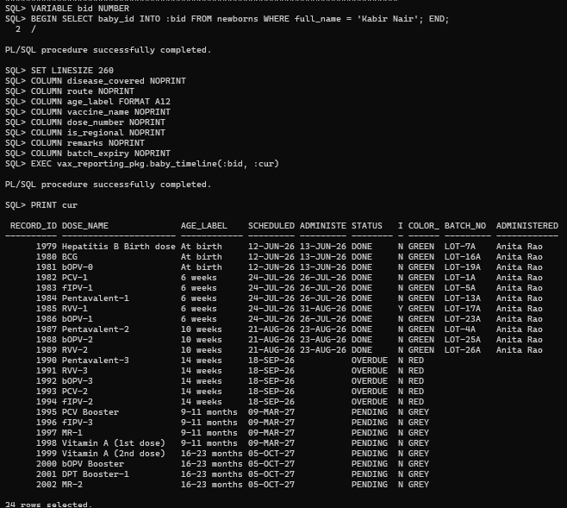
Figure 4.11: REF CURSOR output: a baby's timeline with colour bucket and batch

4.6 Scheduled Job
db/09_scheduler.sql creates the DBMS_SCHEDULER job JOB_DAILY_VAX_SWEEP, which runs every day at 01:00 (Oracle Scheduler [5]). It calls refresh_overdue_status, send_due_soon_alerts(7) and expiry_sweep(30). The API also runs refresh_overdue_status when the dashboard loads, so overdue doses are current even between two runs of the job (Figure 4.12).
DBMS_SCHEDULER.CREATE_JOB(
job_name => 'JOB_DAILY_VAX_SWEEP',
job_type => 'PLSQL_BLOCK',
job_action => 'BEGIN
newborn_vaccination_pkg.refresh_overdue_status;
send_due_soon_alerts(7);
vaccine_inventory_pkg.expiry_sweep(30);
END;',
start_date => SYSTIMESTAMP,
repeat_interval => 'FREQ=DAILY;BYHOUR=1;BYMINUTE=0;BYSECOND=0',
enabled => TRUE);

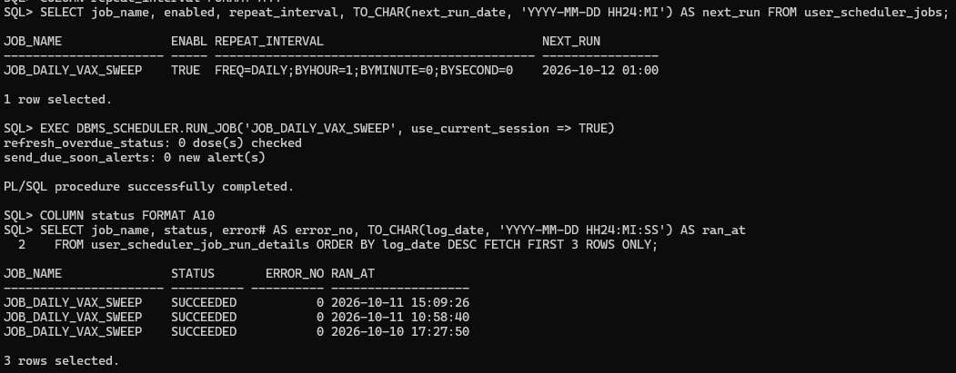
Figure 4.12: DBMS_SCHEDULER job definition and a successful run

4.7 Transactions and Error Handling
Every unit of work that changes data (register_newborn, mark_dose_administered, reschedule_dose, refresh_overdue_status, the two administrator procedures, the sweeps) has the same shape: set a savepoint, do the work, commit, and on any exception roll back to the savepoint, then re-raise a coded error (−20001 to −20021) or wrap an unexpected Oracle error as −20099 with the original message appended. generate_schedule does not commit, because it is a building block of register_newborn. The API turns each −20xxx code into a clean HTTP status and message for the user interface.

5. FRONT-END
The front end is a responsive web application written with React and Vite. It serves three roles: the administrator sees every clinic and the audit log and manages logins, a nurse works on the babies and the stock of one clinic, and a parent sees only their own children and their vaccination cards. Status colours are the same on every screen: green for a dose given, amber for a dose due soon, red for an overdue dose, grey for a dose in the future. Light and dark themes are both available.

5.1 User Interface
Sign-in. The sign-in page (Figure 5.1) lists the demo accounts with their passwords and a button that shows or hides what is typed in the password box.
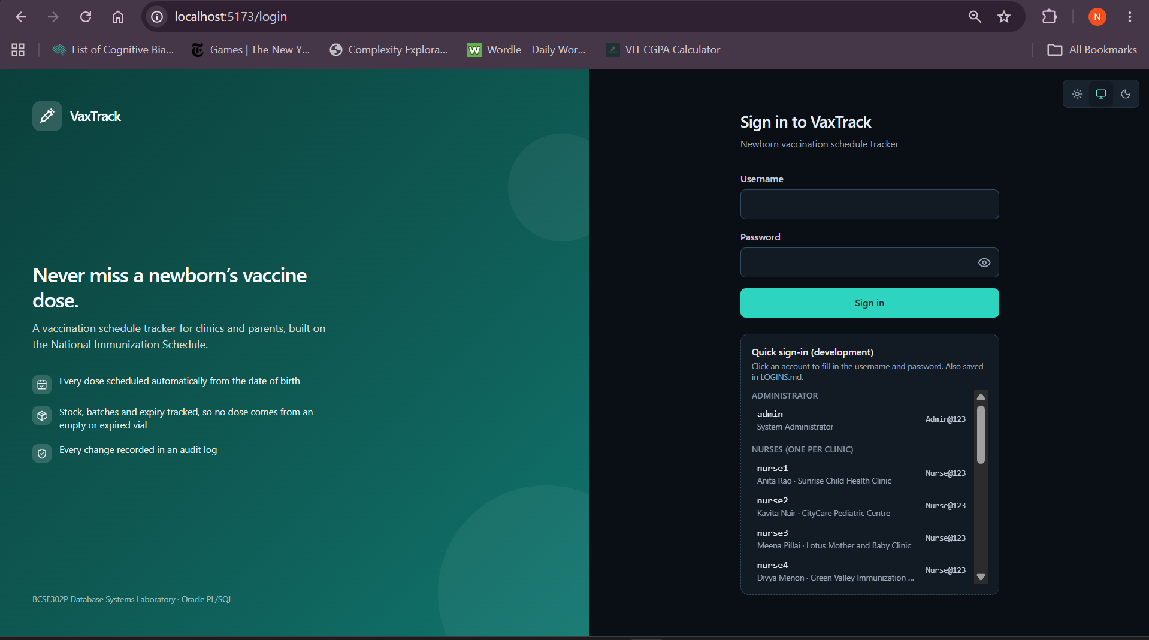
Figure 5.1: Sign-in page
Dashboard. The dashboard (Figure 5.2) shows the number of babies and of doses given, pending and overdue, a coverage chart, the overdue doses, the doses due within seven days, and the number of unread alerts. Figure 5.3 shows the same page in the light theme.
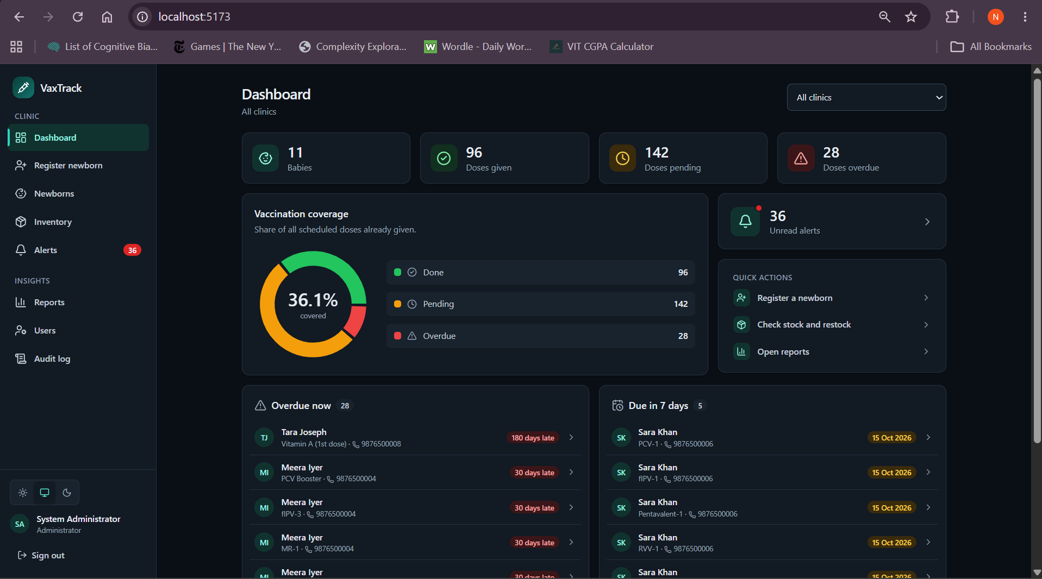
Figure 5.2: Dashboard with coverage chart, overdue list and unread alerts
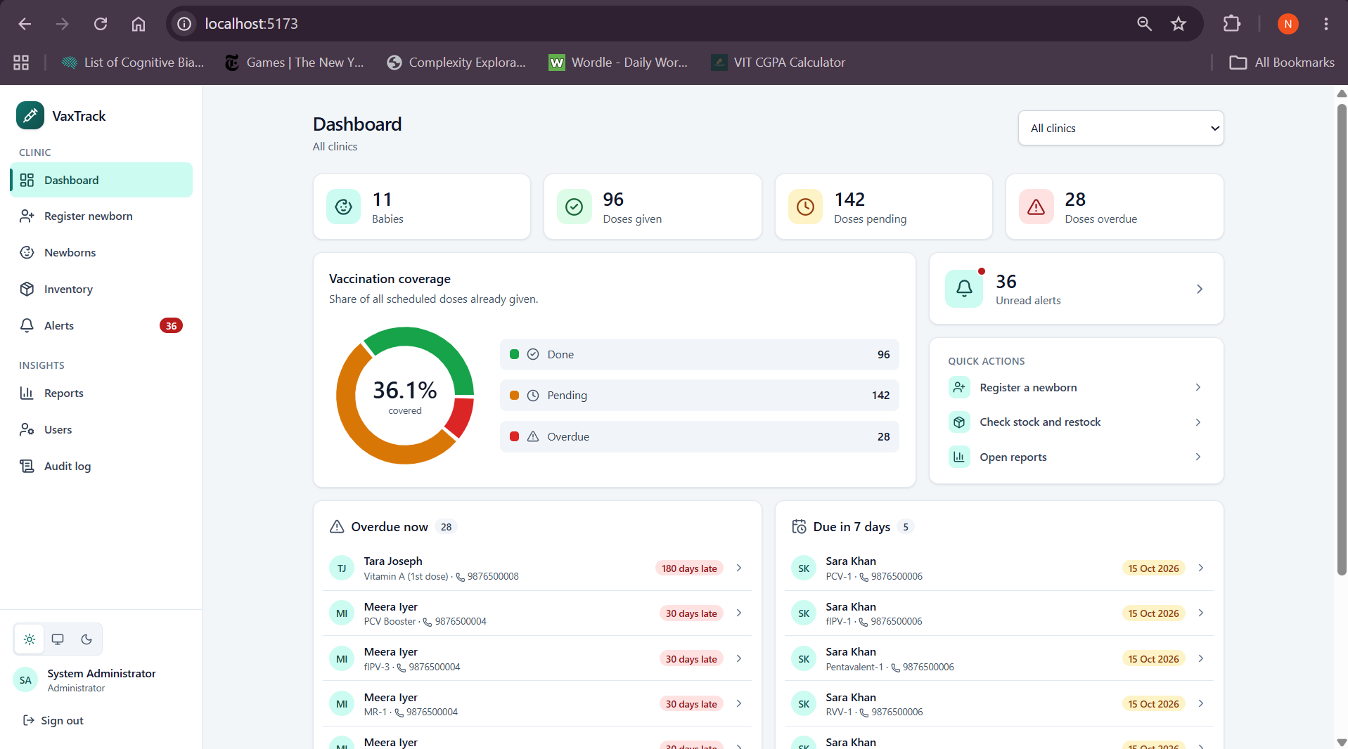
Figure 5.3: The same dashboard in light mode
Registering a newborn. The form (Figure 5.4) validates the input before it is sent and has an "Endemic district (JE)" box that adds the two Japanese encephalitis doses. The phone field tells the nurse whether the number already belongs to a registered guardian, answering only yes or no and showing no detail about the guardian (Figure 5.5). A new guardian needs a name and an address; for a known number the stored details are kept. When the baby is saved, the generated schedule appears at once (Figure 5.7), and a card shows the parent login that was created, with a button to copy it.
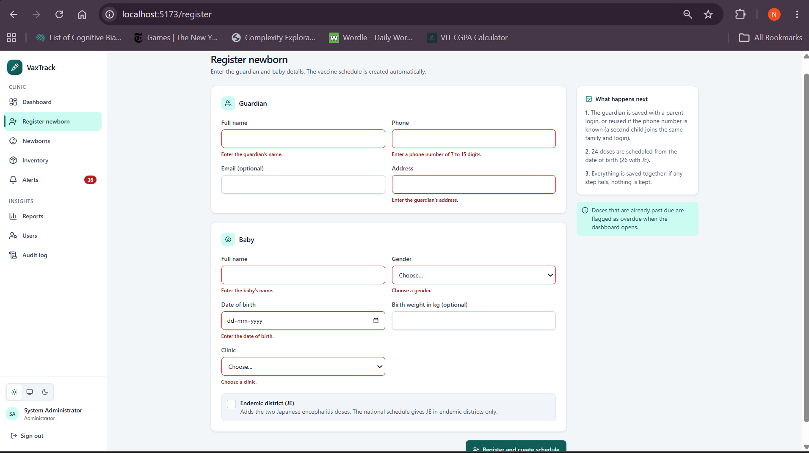
Figure 5.4: Register newborn form showing validation messages
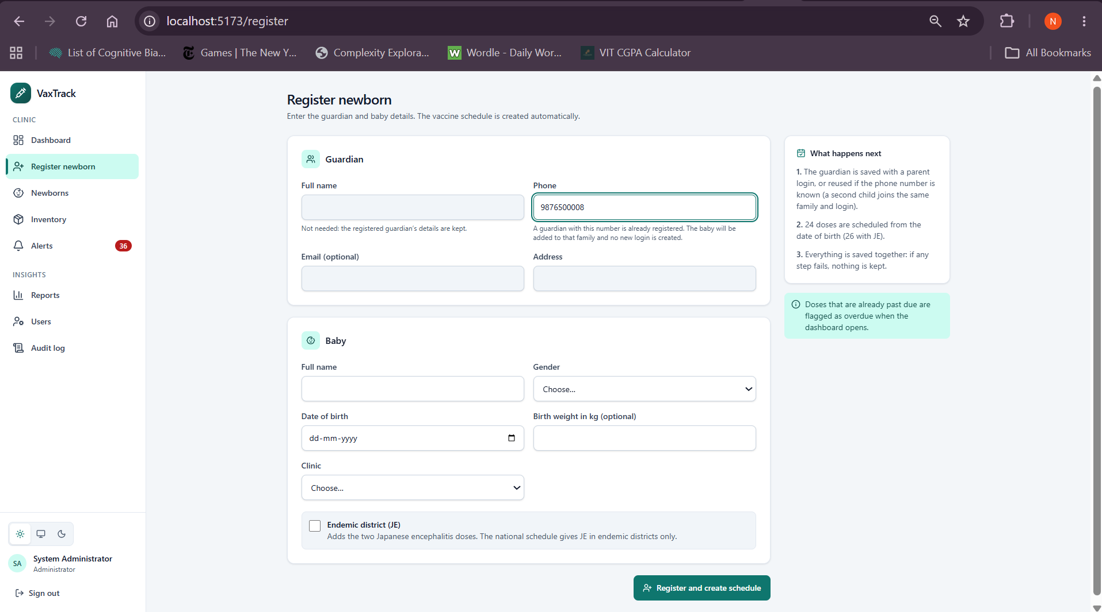
Figure 5.5: Register form: the phone number belongs to a registered guardian (yes/no only, guardian fields disabled)
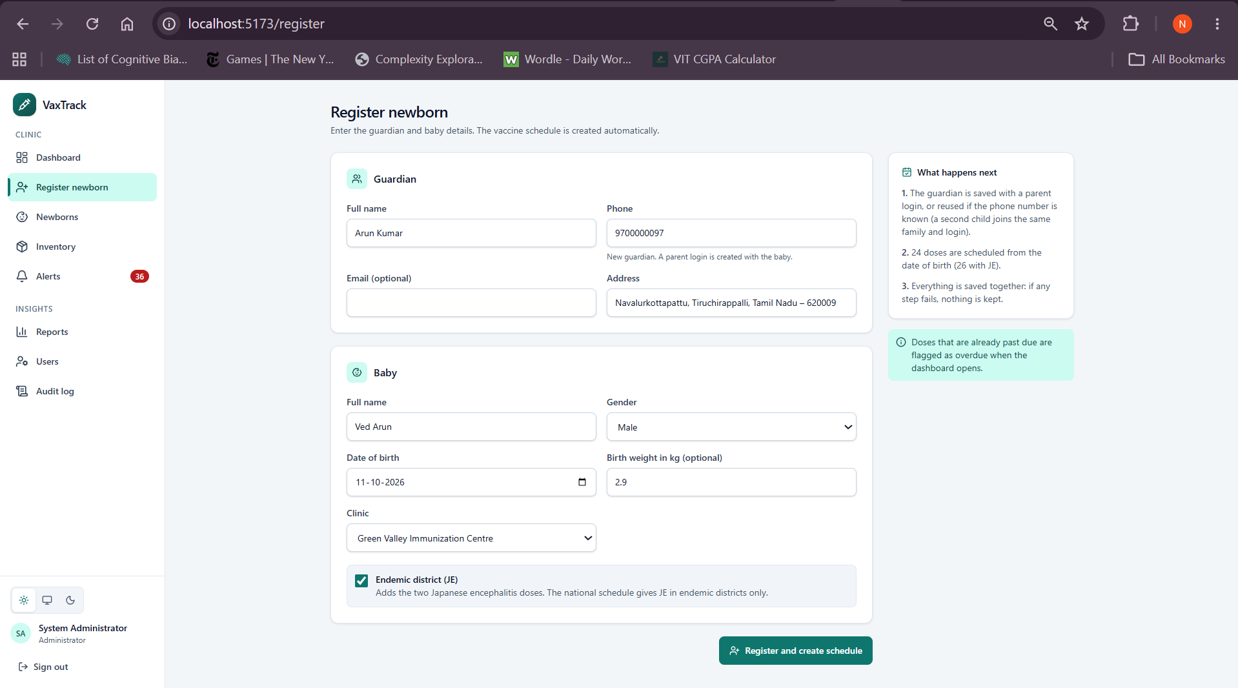
Figure 5.6: Registering a newborn
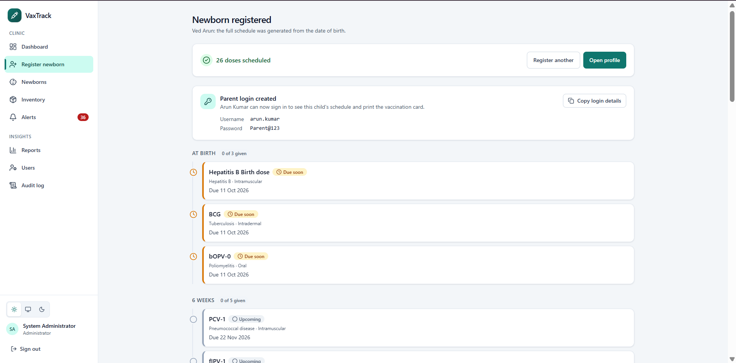
Figure 5.7: Generated 24-dose schedule shown right after registration
Baby profile. The profile (Figure 5.8) shows the age, the coverage, a bar of doses given, pending and overdue, and a vertical timeline grouped by age band, with a status filter. Each dose has actions for a nurse or an administrator. Mark administered opens a dialog (Figure 5.9) that shows which batch the database will use; if the clinic has no usable stock the dialog says so and the confirm button is disabled (Figure 5.10). Reschedule (Figure 5.11) asks for a new date and a reason.
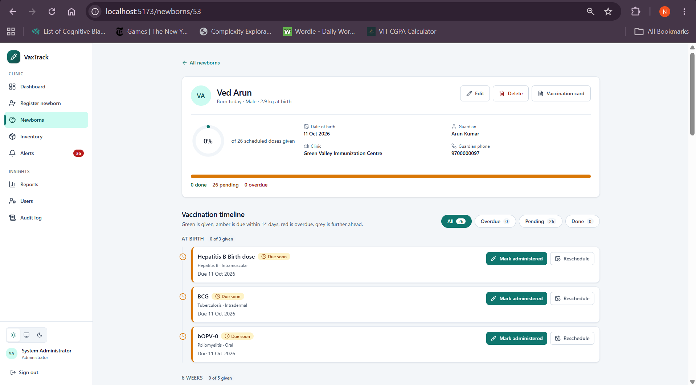
Figure 5.8: Baby profile: coverage, status bar and colour-coded timeline
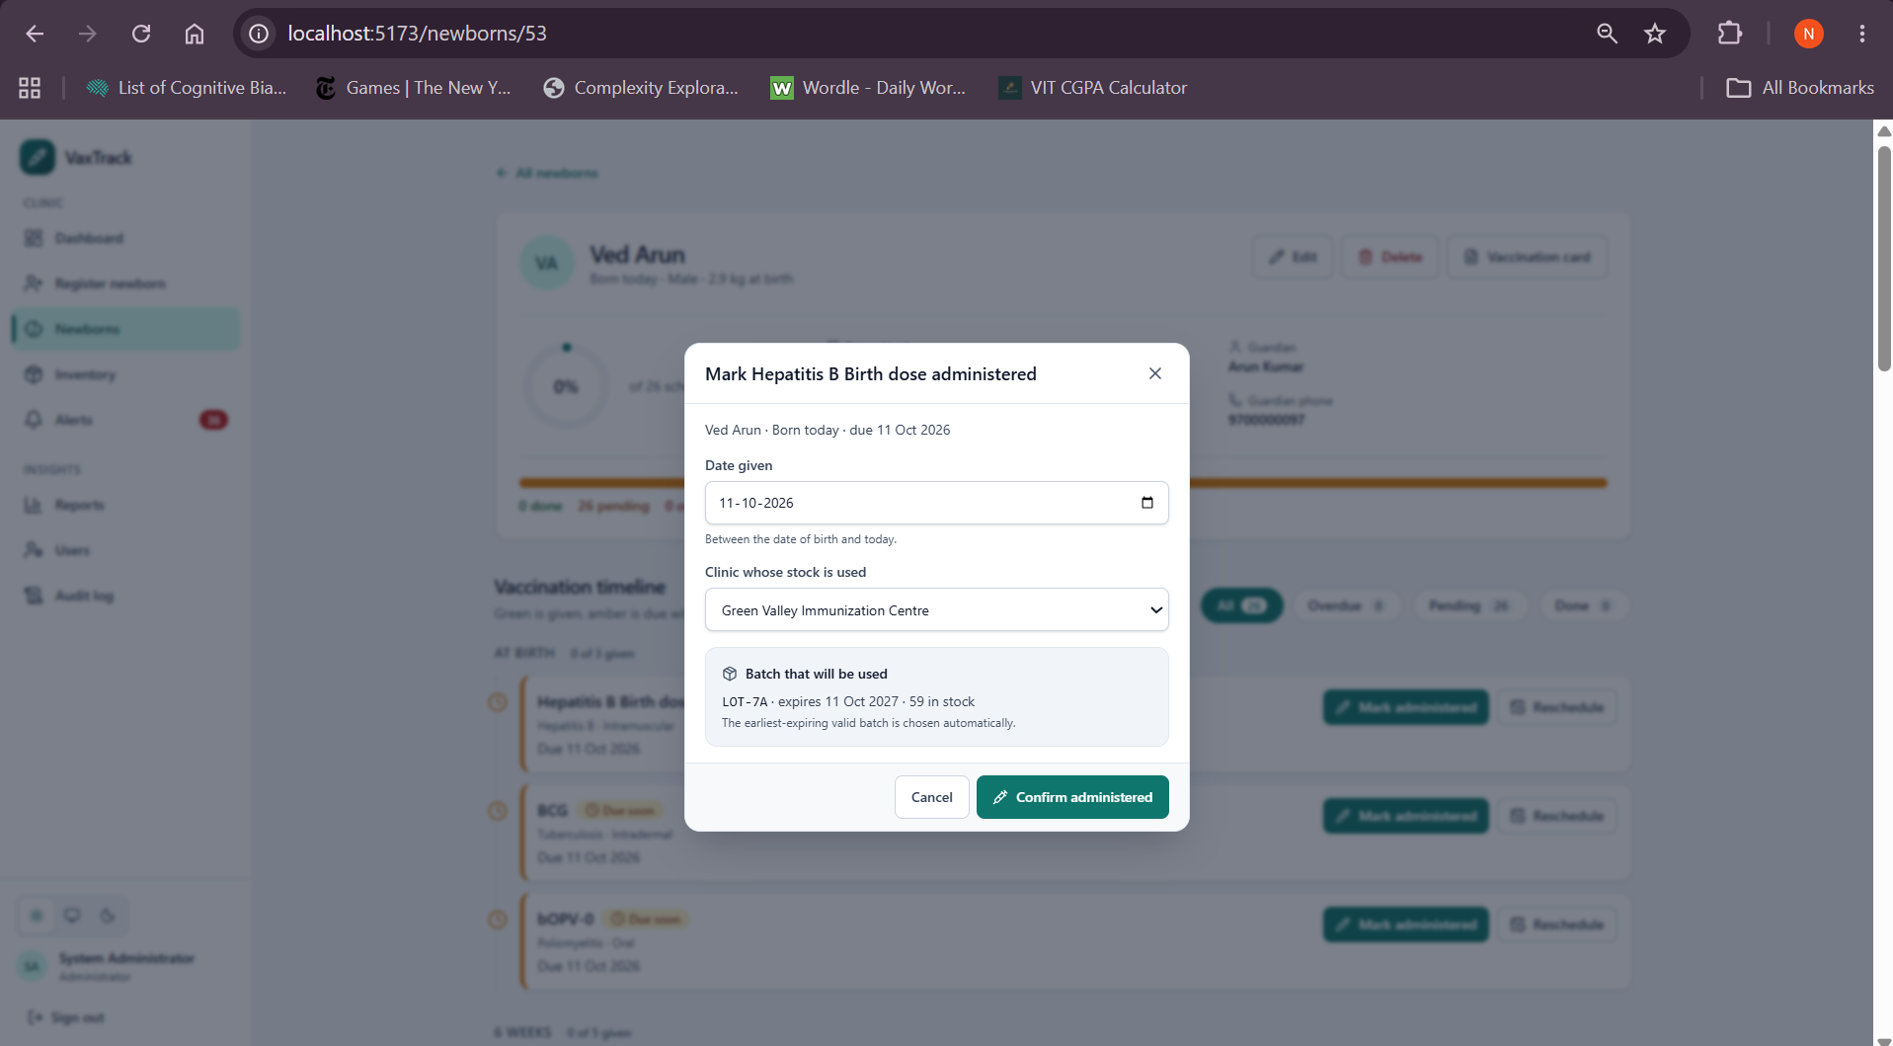
Figure 5.9: Mark administered dialog with the automatically chosen batch
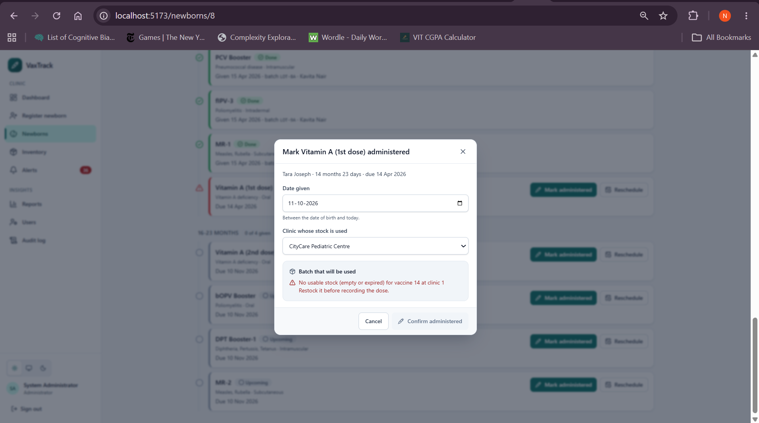
Figure 5.10: Mark administered dialog when the clinic has no stock (Confirm disabled)
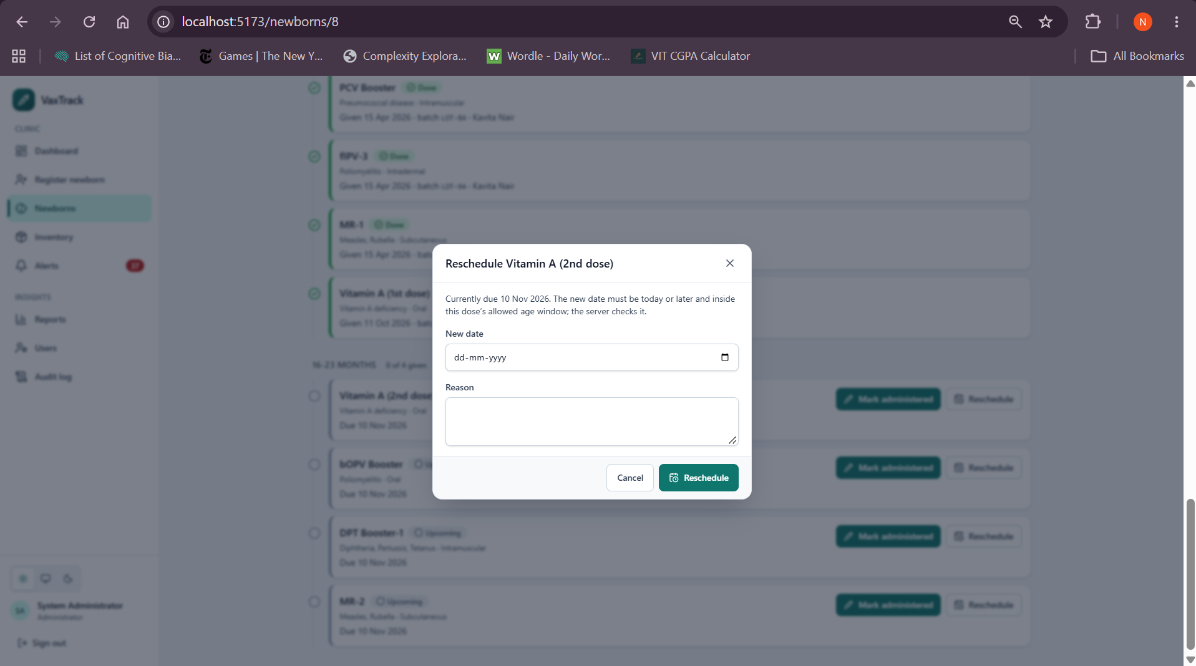
Figure 5.11: Reschedule dialog
Inventory and alerts. The inventory page (Figure 5.12) lists the batches with expiry and low-stock badges, and Restock (Figure 5.13) adds a batch. The alerts page (Figure 5.14) filters by type and marks alerts as read.
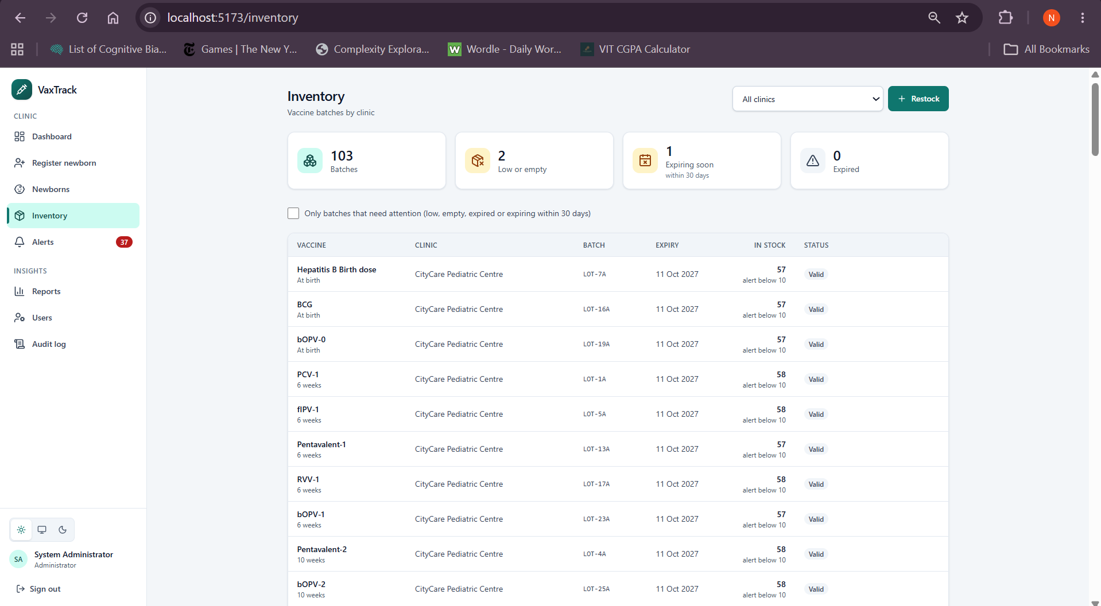
Figure 5.12: Inventory with a low-stock batch and expiry badges
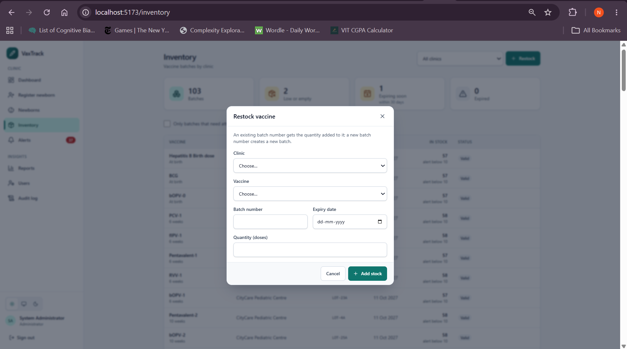
Figure 5.13: Restock dialog
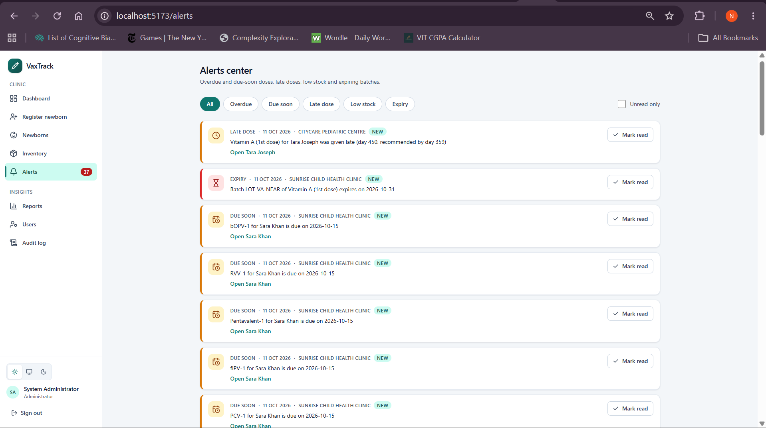
Figure 5.14: Alerts center filtered to low-stock alerts
Reports, vaccination card and parent view. Reports (Figure 5.15) compares the clinics' coverage and lists the overdue doses, with a CSV export. The vaccination card (Figure 5.16) is a printable page that a parent can open. A parent sees only their own children (Figure 5.17).
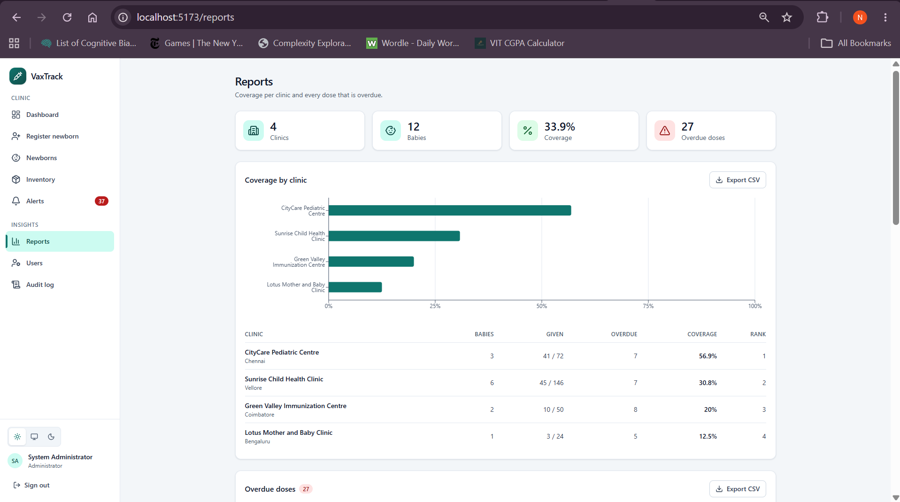
Figure 5.15: Reports: coverage by clinic chart, table and overdue list
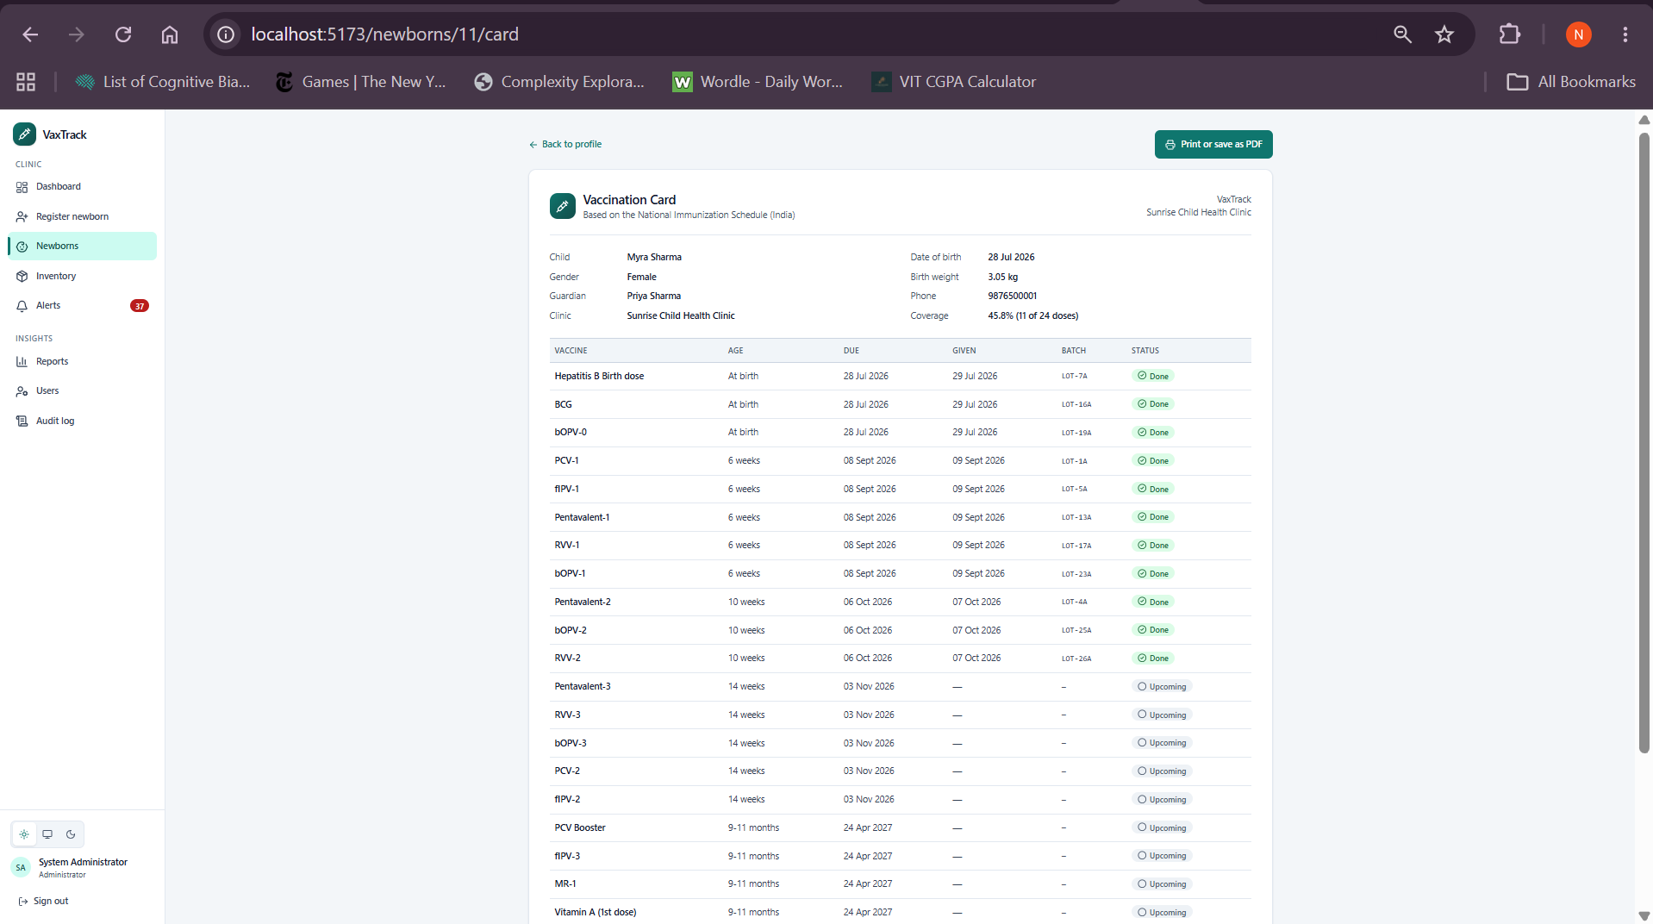
Figure 5.16: Printable vaccination card (parent view)
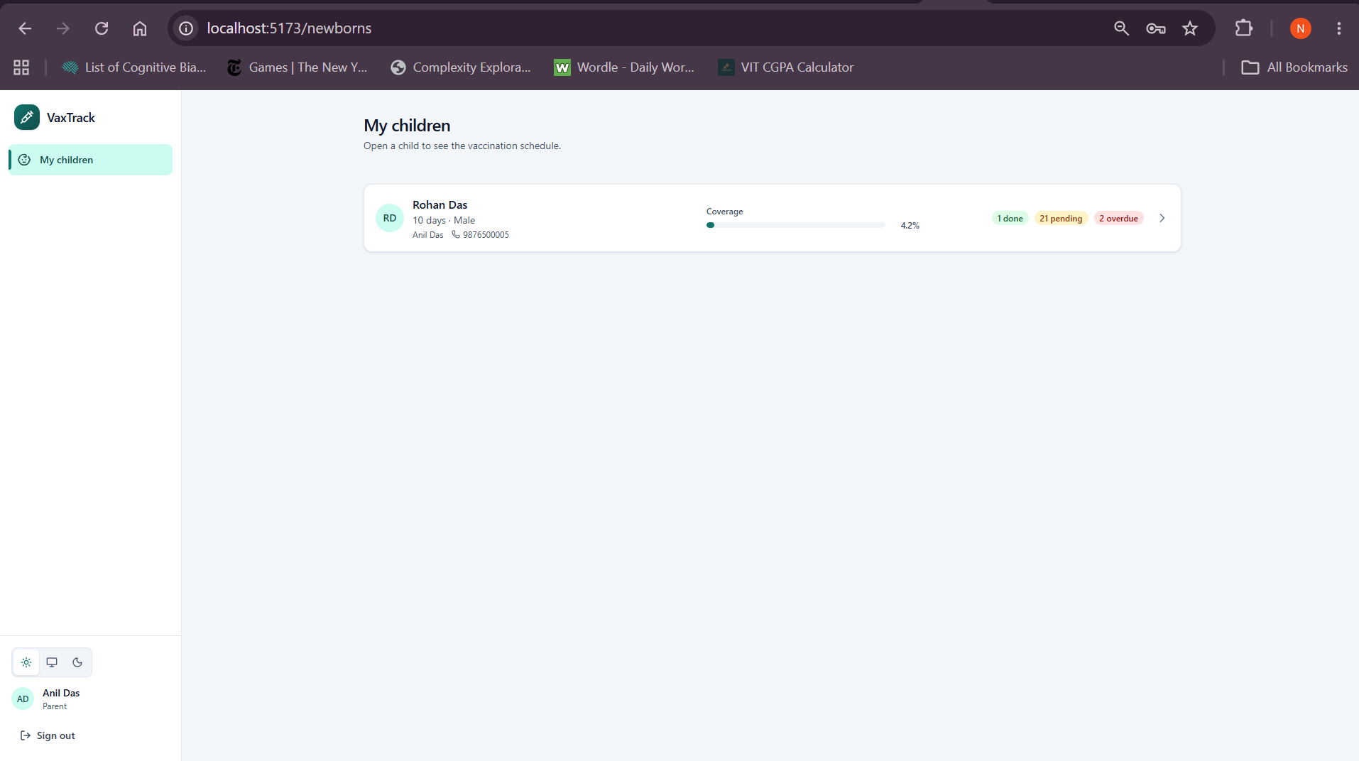
Figure 5.17: Parent sees only their own child
Administrator pages. The audit log (Figure 5.18) shows who changed which dose and when. The Users page (Figure 5.19) lists every login and adds nurses or parent logins. An administrator can also correct a newborn's date of birth (Figure 5.20), which moves the unfinished doses, or delete a newborn record after typing the baby's name (Figure 5.21).
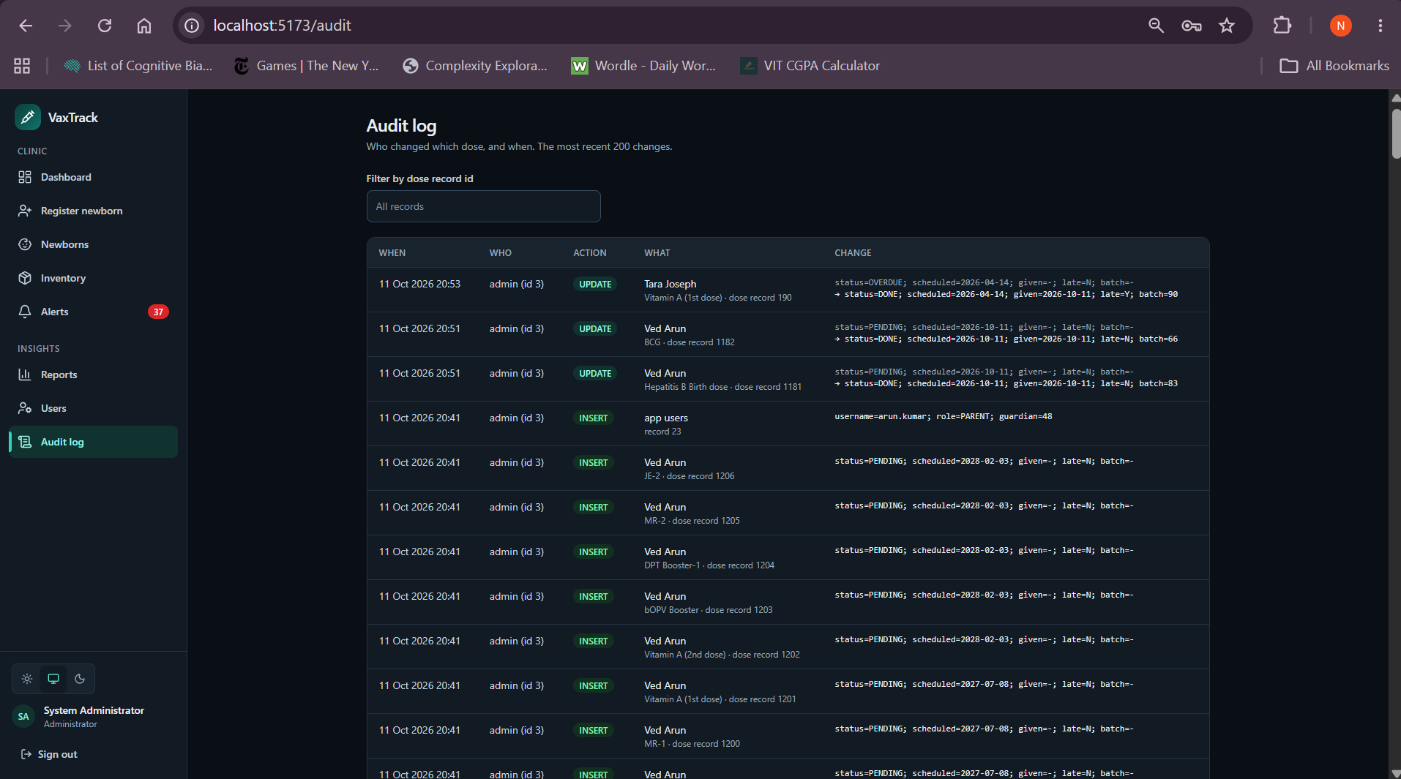
Figure 5.18: Admin audit log showing who changed the dose and when
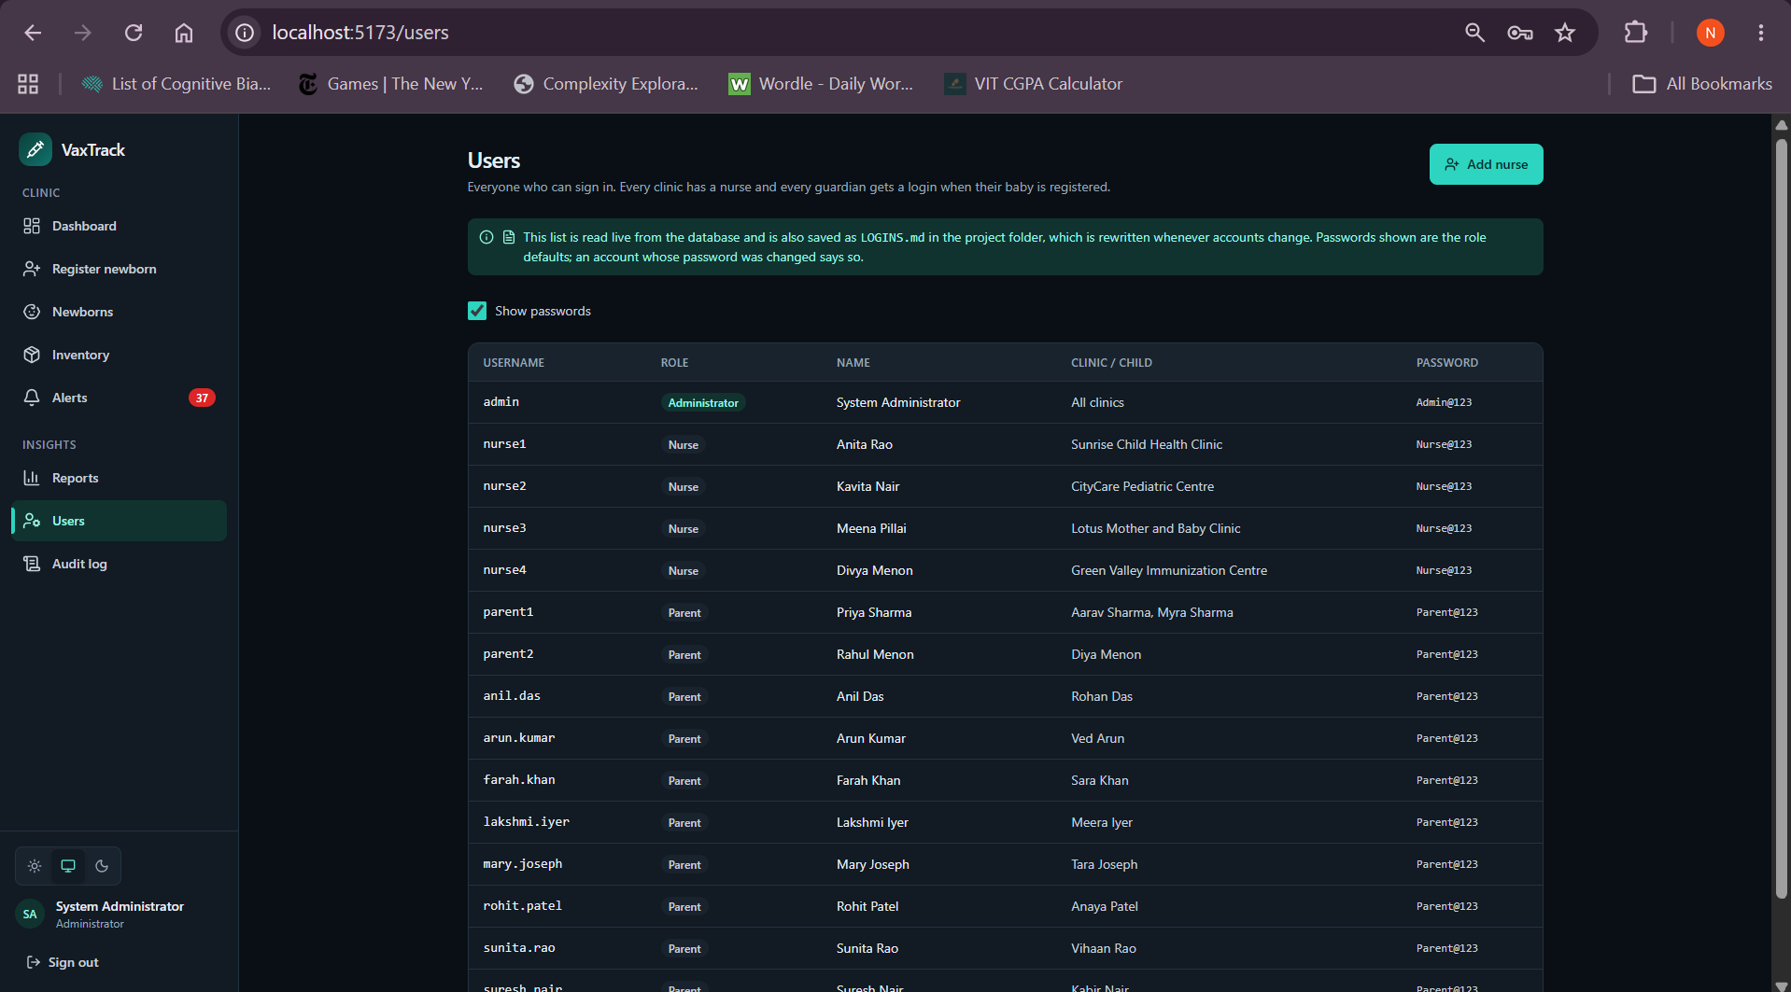
Figure 5.19: Admin Users page: every login, with the add-nurse and add-parent-login actions
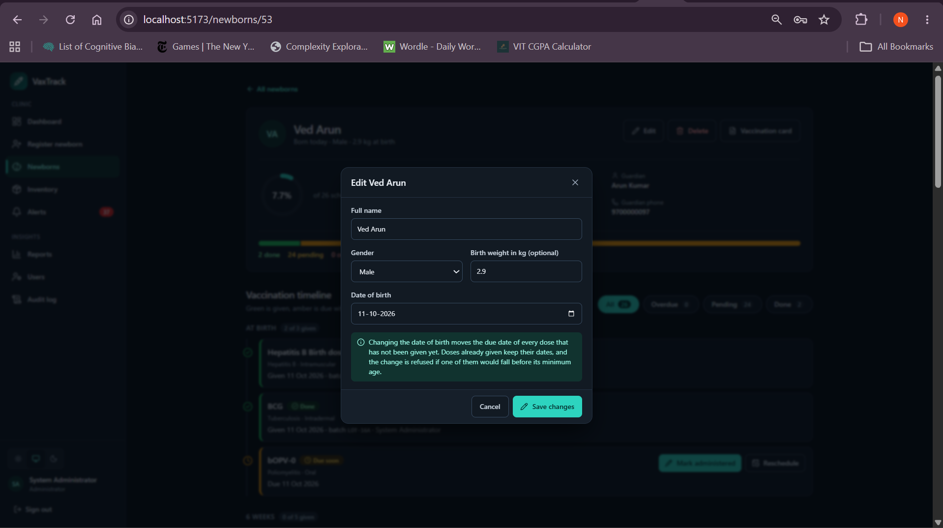
Figure 5.20: Administrator edit dialog: correcting a date of birth
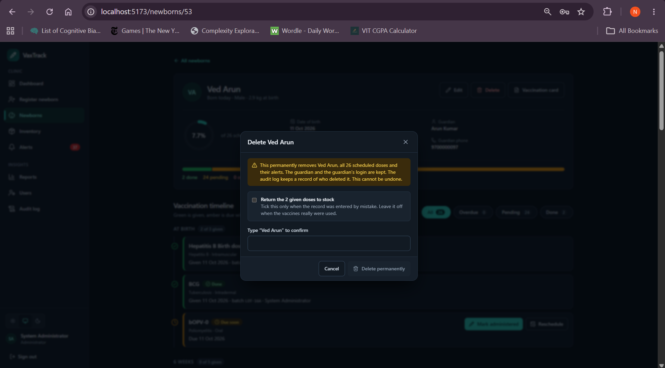
Figure 5.21: Administrator delete confirmation (type the name, optional stock return)

5.2 Integration with the DBMS
The application has three tiers (Figure 5.25). The React application [9] sends JSON over HTTP with a JSON Web Token [12]. The Express API validates the input, checks the role and the clinic, sets the acting user, calls one PL/SQL package procedure with bind variables, and turns the result into JSON. The Oracle database applies every rule. The API contains no business logic: the schedule, the stock deduction, the late-dose flag and the alerts are all decided by the packages and triggers of Section 4.
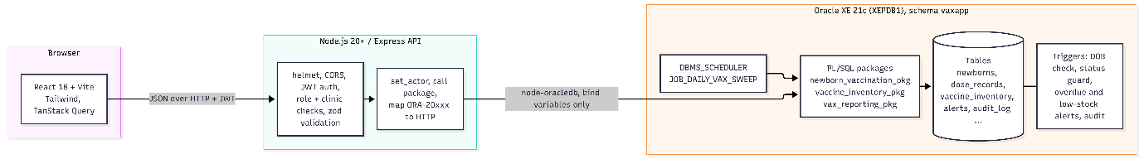
Figure 5.25: Architecture: React, Express, PL/SQL packages, Oracle
Connection. The API uses a node-oracledb connection pool in thin mode [7]. For each request it takes a connection, calls newborn_vaccination_pkg.set_actor so that the audit trigger records the right user, runs the work, commits or rolls back, and releases the connection.
export async function withConn(userId, fn) {
const conn = await pool.getConnection();
try {
await conn.execute('BEGIN newborn_vaccination_pkg.set_actor(:id); END;', { id: num(userId) });
const result = await fn(conn);
await conn.commit();
return result;
} catch (err) {
try { await conn.rollback(); } catch { /* connection may already be gone */ }
throw err;
} finally {
await conn.close();
}
}

Calling a package. Registering a newborn is one call to the package; every value is a bind variable, and no SQL string is built from user input.
await call(conn,
`BEGIN
newborn_vaccination_pkg.register_newborn(
p_guardian_name => :gname, p_guardian_phone => :gphone,
p_guardian_email => :gemail, p_guardian_address => :gaddress,
p_baby_name => :bname, p_gender => :gender,
p_dob => TO_DATE(:dob, 'YYYY-MM-DD'), p_birth_weight_kg => :weight,
p_clinic_id => :clinic, p_include_regional => :regional,
p_baby_id => :baby_id, p_parent_hash => :phash, p_parent_username => :puser);
END;`, { /* bind values */ });

Errors. A coded Oracle error such as ORA-20009: No usable stock … is mapped to an HTTP status (409 for no stock, 422 for a date that is not allowed, 403 for an action that only an administrator may take, and so on) and the readable message is shown to the user.
Security. Passwords are stored as bcrypt hashes [13]. Sign-in returns a signed token, and every route checks the role; a nurse can reach only the babies and the stock of their own clinic, and a parent only their own children. Input is validated with zod before it reaches the database, and the API sets the standard security headers with helmet. The known limitations are listed in Section 7.3.
Which package each screen calls.
Page (route) | Roles | API endpoints | PL/SQL objects reached
Login (/login) | all | POST /auth/login, GET /me | none (bcrypt + JWT in the API; reads app_users)
Dashboard (/) | A, N | GET /dashboard/summary, /overdue, /upcoming?days=7, GET /clinics | newborn_vaccination_pkg.refresh_overdue_status, vax_reporting_pkg.dashboard_summary, overdue_list, upcoming_list
Register newborn (/register) | A, N | POST /newborns, GET /newborns/guardian-lookup?phone= (yes/no only, 30 a minute), GET /clinics | newborn_vaccination_pkg.guardian_exists, register_newborn (calls generate_schedule, calculate_due_date, account_pkg.suggest_username and add_user for the guardian's parent login, all in one transaction; the guardian name is optional for a known phone), vax_reporting_pkg.baby_timeline, trigger trg_newborn_dob_check
Newborns (/newborns) | A, N, P | GET /newborns?search= | functions get_age_text, get_coverage_pct
Baby profile (/newborns/:id) | A, N, P | GET /newborns/:id | vax_reporting_pkg.baby_timeline, get_age_text, get_coverage_pct
Edit / Delete newborn (dialogs, admin only) | A | PATCH /newborns/:id, DELETE /newborns/:id?restoreStock=1 | newborn_vaccination_pkg.update_newborn (recalculates unfinished due dates, late flags and stale alerts; refuses a birthday that invalidates a given dose), delete_newborn (optional stock return; guardian and login kept); both audited, both admin-checked in the database; triggers trg_dose_status_guard, trg_dose_alerts, trg_dose_audit
Mark administered (dialog) | A, N | GET /doses/:id/batch-preview, POST /doses/:id/administer | newborn_vaccination_pkg.is_dose_allowed, vaccine_inventory_pkg.pick_batch, newborn_vaccination_pkg.mark_dose_administered; triggers trg_dose_status_guard, trg_dose_audit, trg_inventory_low_stock
Reschedule (dialog) | A, N | POST /doses/:id/reschedule | newborn_vaccination_pkg.reschedule_dose
Inventory (/inventory) | A, N | GET /inventory, GET /vaccines, POST /inventory/restock | dose_label, vaccine_inventory_pkg.restock
Alerts (/alerts) | A, N | GET /alerts, PATCH /alerts/:id/read | alerts are written by trg_dose_alerts, trg_inventory_low_stock, send_due_soon_alerts, expiry_sweep, mark_dose_administered
Reports (/reports) | A, N | GET /reports/clinic-coverage, GET /dashboard/overdue | vax_reporting_pkg.clinic_coverage (RANK analytic), overdue_list
Vaccination card (/newborns/:id/card) | A, N, P | GET /newborns/:id | vax_reporting_pkg.baby_timeline
Users (/users) | A | GET /users, GET /users/options, POST /users | account_pkg.create_user (nurse needs a clinic, one login per guardian, unique username, audit row); list is a SELECT
Sign-in login directory (/login) | public, development only | GET /auth/demo-logins (needs DEMO_LOGINS=true) | reads app_users; the API also rewrites LOGINS.md
Audit log (/audit) | A | GET /audit?recordId= | table audit_log, filled by trg_dose_audit and restock

The daily job JOB_DAILY_VAX_SWEEP runs the same sweeps without any page being open.

6. VERIFICATION & TESTING

6.1 Test Cases
The script db/11_tests.sql runs 31 test cases as anonymous blocks. Each block builds its own data (a test clinic and babies whose names start with TEST_), calls the object under test, compares the actual result with the expected one and writes a PASS or FAIL row to the table test_log; at the end the script deletes its own data, so it can be run repeatedly. The table below is taken from a run on a database built from scratch with scripts 99 to 10. Dates in the "Actual" column depend on the day of the run, and the counts in TC-R1 depend on the demo data.
ID | Description | Input | Expected | Actual | Result
TC-F1 | calculate_due_date for a 42-day vaccine | baby DOB = today − 100, bOPV-1 (due day 42) | 2026-08-09 (DOB + 42) | 2026-08-09 | PASS
TC-F2 | calculate_due_date with an unknown baby | baby_id −999 | error −20001 | −20001 | PASS
TC-F3 | get_coverage_pct before and after doses | new baby; then 3 birth doses marked | 0 → 12.5 | 0 → 12.5 | PASS
TC-F4 | get_next_due_dose | baby with BCG done | earliest non-DONE date, not DONE | 2026-08-07, not DONE | PASS
TC-P1 | register_newborn creates schedule | one baby; one baby with JE flag | 24 / 26 doses, 1 baby | 24/26/baby=1 | PASS
TC-P2 | generate_schedule idempotent | called twice more on a baby | 24 → 24 | 24 → 24 | PASS
TC-P3 | future DOB rolls everything back | DOB = today + 5, new guardian phone | −20003, 0 guardians, 0 babies | −20003, guardians=0, babies=0 | PASS
TC-P4 | administer sets DONE, stock −1 | BCG, batch qty 5 | DONE, 5 → 4 | DONE, 5 → 4 | PASS
TC-P5 | already DONE rejected | administer same dose twice | −20005, stock stays 4 | −20005, stock=4 | PASS
TC-P6 | out-of-stock rolls back | fIPV-1 batch with qty 0 | −20009, PENDING, no date, stock 0 | −20009, PENDING, given=none, stock=0 | PASS
TC-P7 | too early | 10-day-old baby, bOPV-1 (min day 42) | −20008, PENDING, stock 5 | −20008, PENDING, stock=5 | PASS
TC-P8 | late dose | 100-day-old baby, bOPV-1 (max day 70) | DONE, late=Y, 1 LATE_DOSE alert | DONE, late=Y, 1 alert | PASS
TC-P9 | FEFO, expired skipped | batches +200 d, +50 d, expired −5 d | TEST-NEAR used, expired untouched (10), expired-only → −20009 | as expected | PASS
TC-P10 | reschedule rules | DONE dose; yesterday; before min age; DOB + 50 | −20010, −20011, −20012, accepted | DONE=−20010, PAST=−20011, WINDOW=−20012, OK=1 | PASS
TC-C1 | overdue sweep | 60-day-old baby (8 past-due doses) | 8 → 0 PENDING past due, 8 OVERDUE | 8 → 0; overdue=8 | PASS
TC-T1 | guard trigger | DONE dose updated to PENDING | −20013, status stays DONE | −20013, DONE | PASS
TC-T2 | audit trigger | administer BCG as nurse1 | old status=PENDING, new status=DONE, actor nurse1 | status=PENDING | status=DONE | nurse1 | PASS
TC-T3 | low-stock trigger fires once | batch qty 11, threshold 10, three doses | alerts after each dose: 0, 1, 1 | 0,1,1 | PASS
TC-T4 | overdue alert once | sweep run twice on a 60-day-old baby | 8, 8, max 1 per dose | 8,8,1 | PASS
TC-R1 | REF cursor row counts | demo seed + one test baby | overdue=18; upcoming=5; clinics=5; summary=1; timeline=24 | identical | PASS
TC-U1 | register_newborn creates the guardian's parent login | new guardian TEST_Guardian, password hash of the default | username made from the guardian name, one PARENT login | test.guardian | 1 | PARENT | PASS
TC-U2 | a second child of the same guardian creates no second login | same phone, second baby | no new username, still one login | test.guardian | none | logins=1 | PASS
TC-U3 | create_user adds a nurse; usernames unique ignoring case | nurse for TEST_CLINIC, then the same name in capitals | created, duplicate -20018, next nurse name free | created NURSE at TEST_CLINIC | dup=-20018 | next nurse name free=1 | PASS
TC-U4 | account rules | nurse without clinic; second login for a guardian; ADMIN role; bad hash | -20019, -20017, -20019, -20019 | as expected | PASS
TC-U5 | suggest_username: name-based, numbered when taken, accents folded, short names and length handled | "Testu Zed" three times (the first two get accounts), "Zoë Müller" with accents, "Li", a 120-character name | testu.zed | testu.zed2 | testu.zed3 | zoe.muller | parent | len=34 | identical | PASS
TC-U6 | guardian_exists answers Y/N (same matching as register_newborn) | unknown phone, then the same phone after registering (also with spaces around it), then another phone | before=N, known=Y, padded=Y, other=N | identical | PASS
TC-U7 | a sibling joins the existing guardian and login; a new guardian still needs a name and an address | sibling registered with guardian name NULL and a known phone; a new phone with name NULL; a new phone with a name but no address | no new login, babies=2, logins=1, stored name kept; −20014 for both new-guardian cases | sibling: no login, babies=2, logins=1, name kept=TEST_Guardian | new guardian without name=-20014 | without address=-20014 | PASS
TC-N1 | update_newborn moves unfinished dose dates with the date of birth, recalculates late flags | 60-day-old baby, BCG given, then date of birth set to 10 days ago (admin) | late=N, bOPV-1 due +32 days, PENDING, new name | as expected | PASS
TC-N2 | a date of birth that invalidates a given dose, or lies in the future, is refused | bOPV-1 given at day 60, DOB moved to day 30; DOB in the future | -20020, date unchanged; -20003 | -20020 | dob unchanged | -20003 | PASS
TC-N3 | delete_newborn removes baby, doses and alerts; stock returns only when asked | two babies, BCG given to each; delete one with restore, one without | stock 5 then 4, nothing left, 2 audit rows | restored=5 | kept=4 | left=0 | audit=2 | PASS
TC-N4 | only an administrator can edit or delete a newborn; the change is audited with the actor | nurse1 tries both; admin renames | -20021 twice, baby intact, 1 audit row by admin | update=-20021 | delete=-20021 | intact=1 | audit by admin=1 | PASS

6.2 Output Screenshots
The full test_log after a run is shown in Figure 6.1, and close-ups of four key cases follow: the dose is recorded and the stock goes down by exactly one (Figure 6.2), an out-of-stock dose is rolled back (Figure 6.3), a late dose is flagged and raises an alert (Figure 6.4), and the low-stock trigger fires once (Figure 6.5).
Figure 6.1: test_log: all 31 test cases PASS
Figure 6.2: TC-P4 close-up: DONE and stock decremented by exactly one
Figure 6.3: TC-P6 close-up: out-of-stock rolls back
Figure 6.4: TC-P8 close-up: late dose flag and alert
Figure 6.5: TC-T3 close-up: low-stock trigger fires once
The API was tested separately. api/scripts/smoke.mjs calls every endpoint on success and failure paths (152 checks, Figure 6.11) and api/scripts/authz-matrix.mjs calls every route as an anonymous user, a parent, a nurse and an administrator, with forged and expired tokens as well (Figure 6.12). Examples of single responses are a login (Figure 6.6), a registration that returns 24 timeline rows (Figure 6.7), a recorded dose (Figure 6.8), an out-of-stock refusal with HTTP 409 and a clear message (Figure 6.9), and a parent who is refused a staff route with HTTP 403 (Figure 6.10).
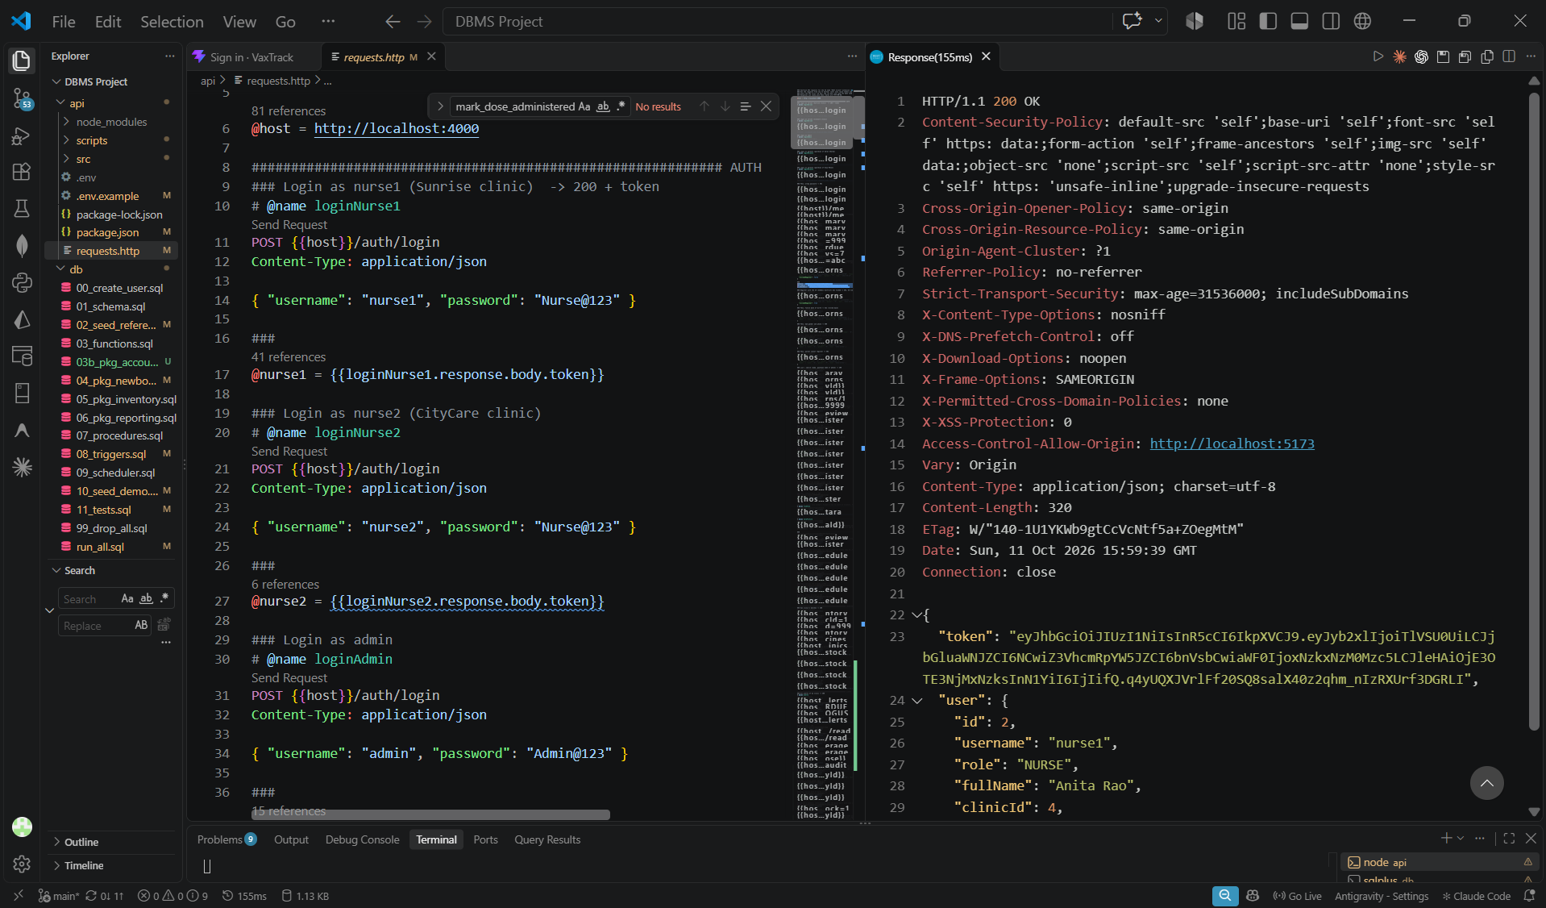
Figure 6.6: API: login returns a token and the user
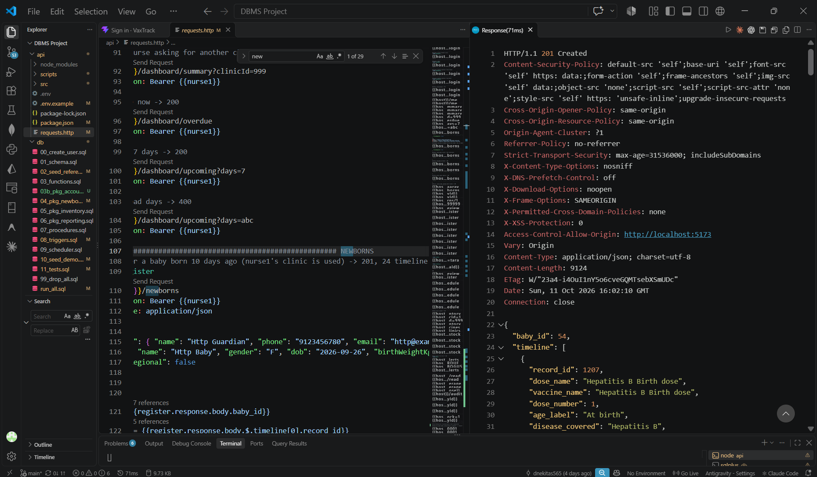
Figure 6.7: API: register a newborn returns 24 timeline rows
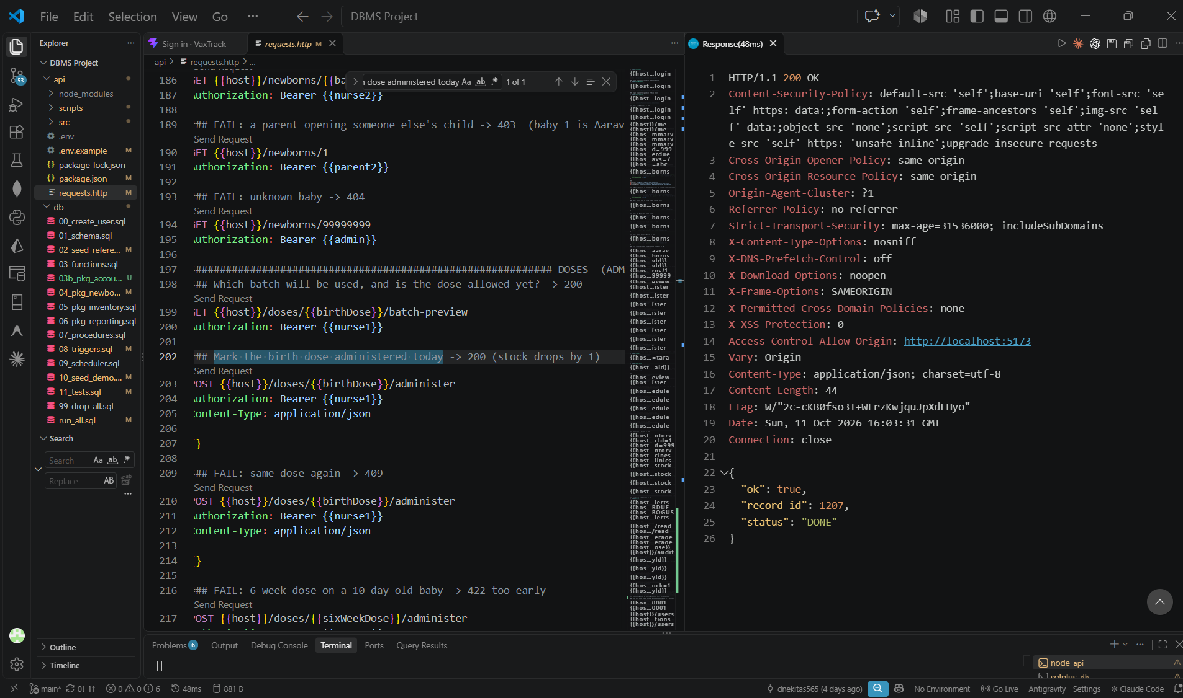
Figure 6.8: API: administer a dose
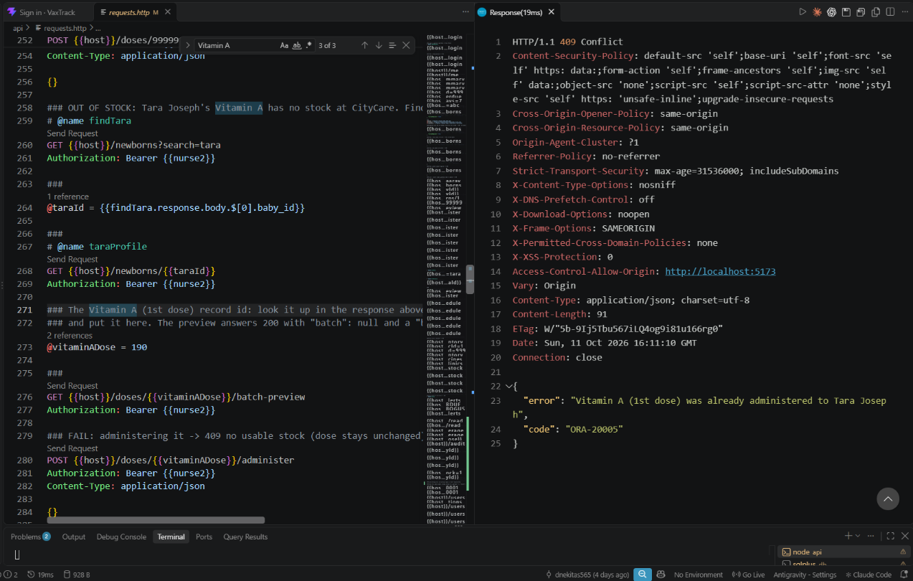
Figure 6.9: API: out of stock returns 409 with a clear message
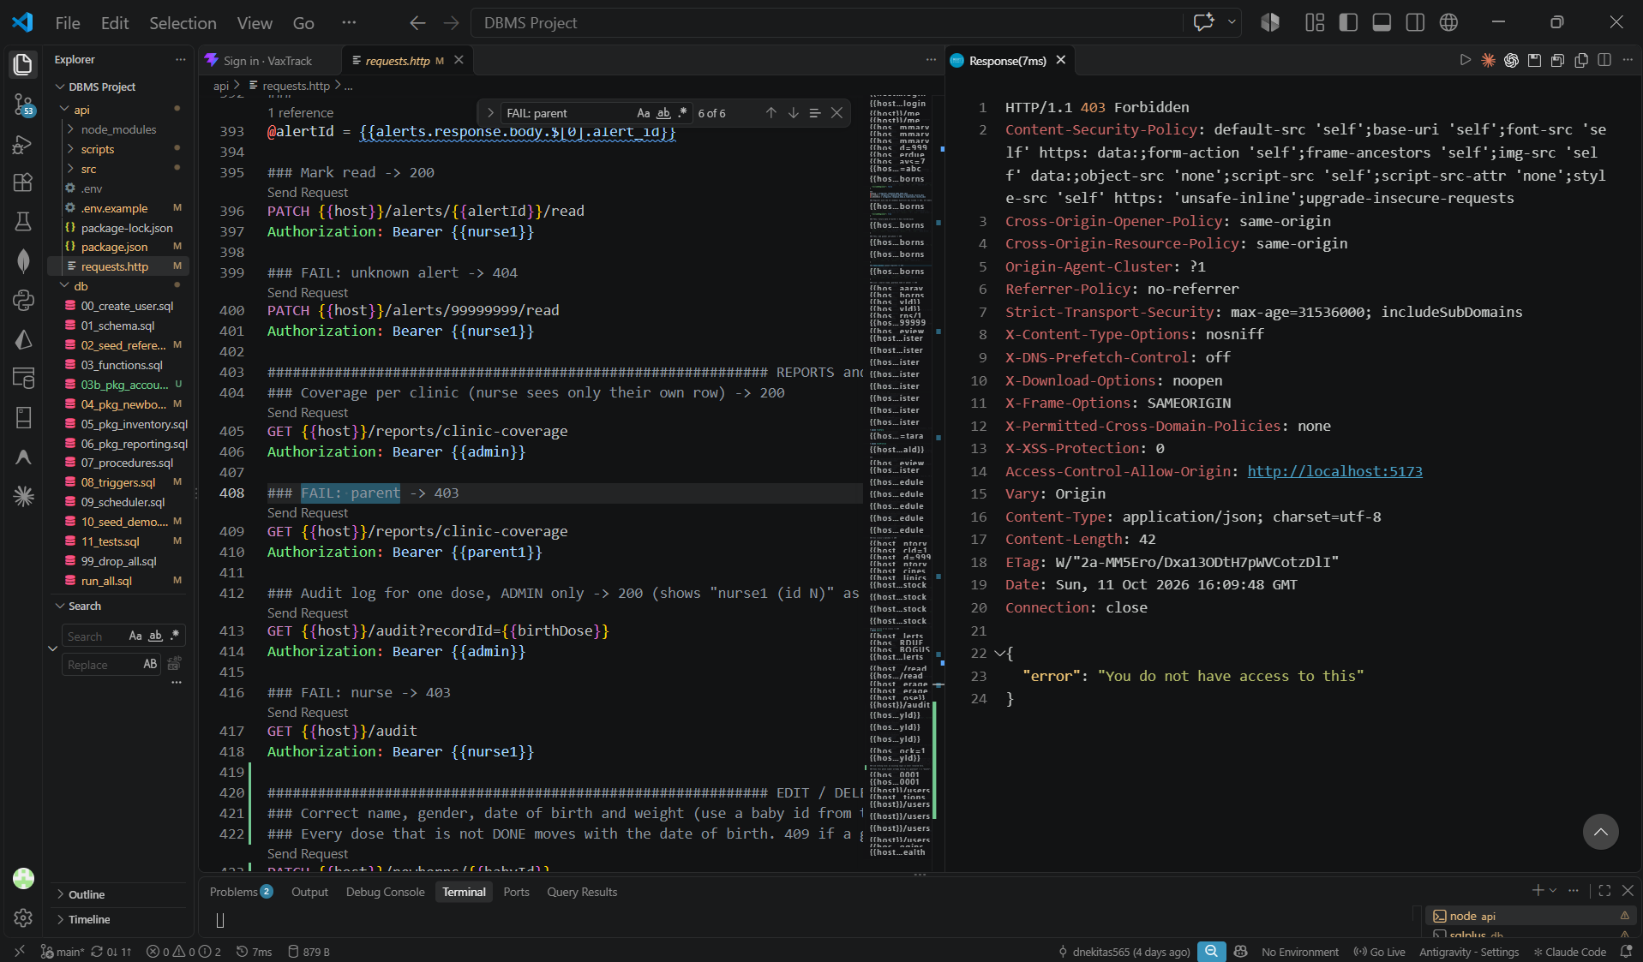
Figure 6.10: API: a parent calling a staff route gets 403
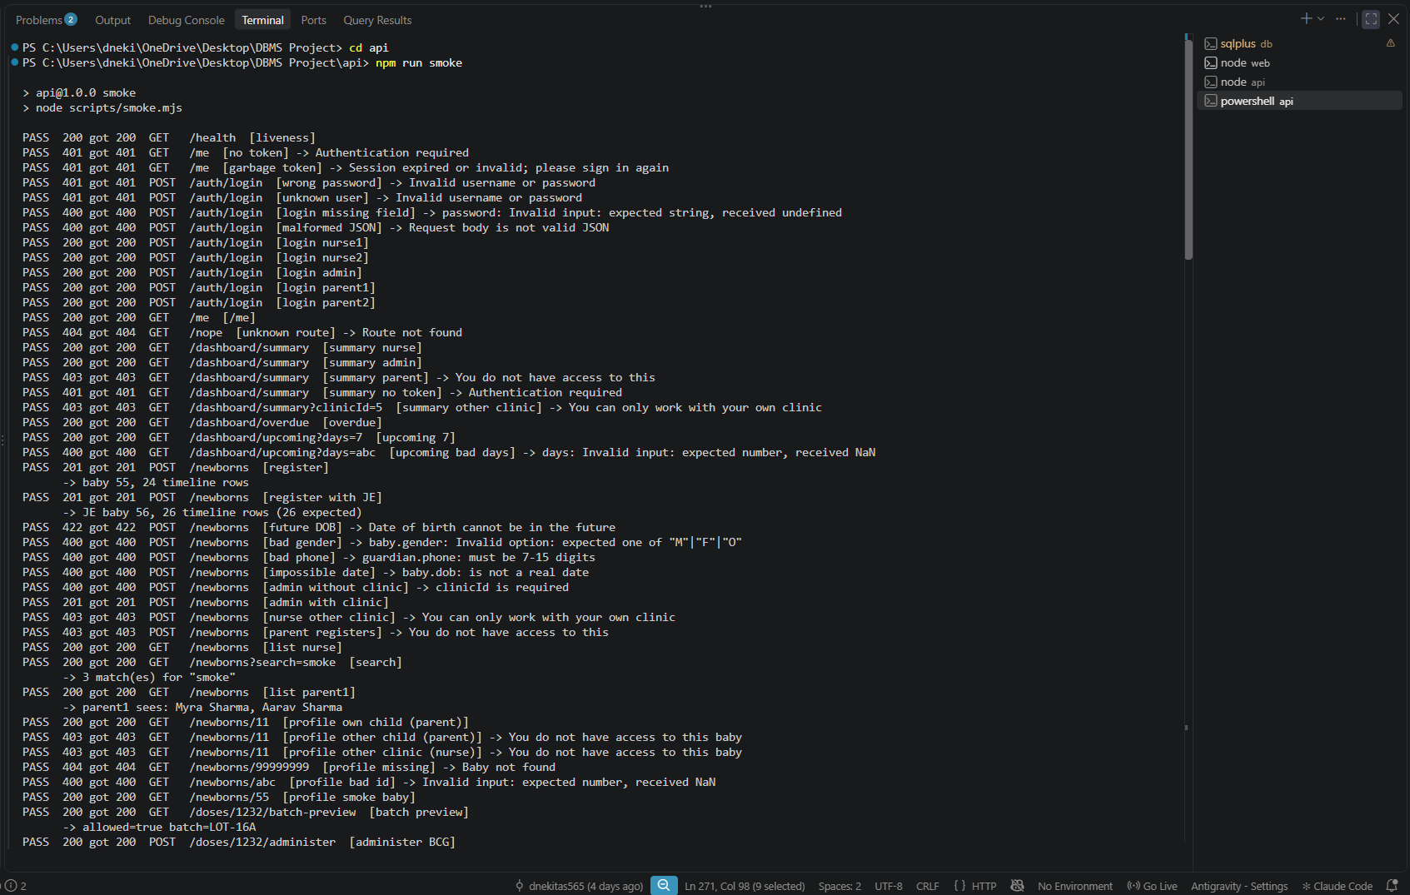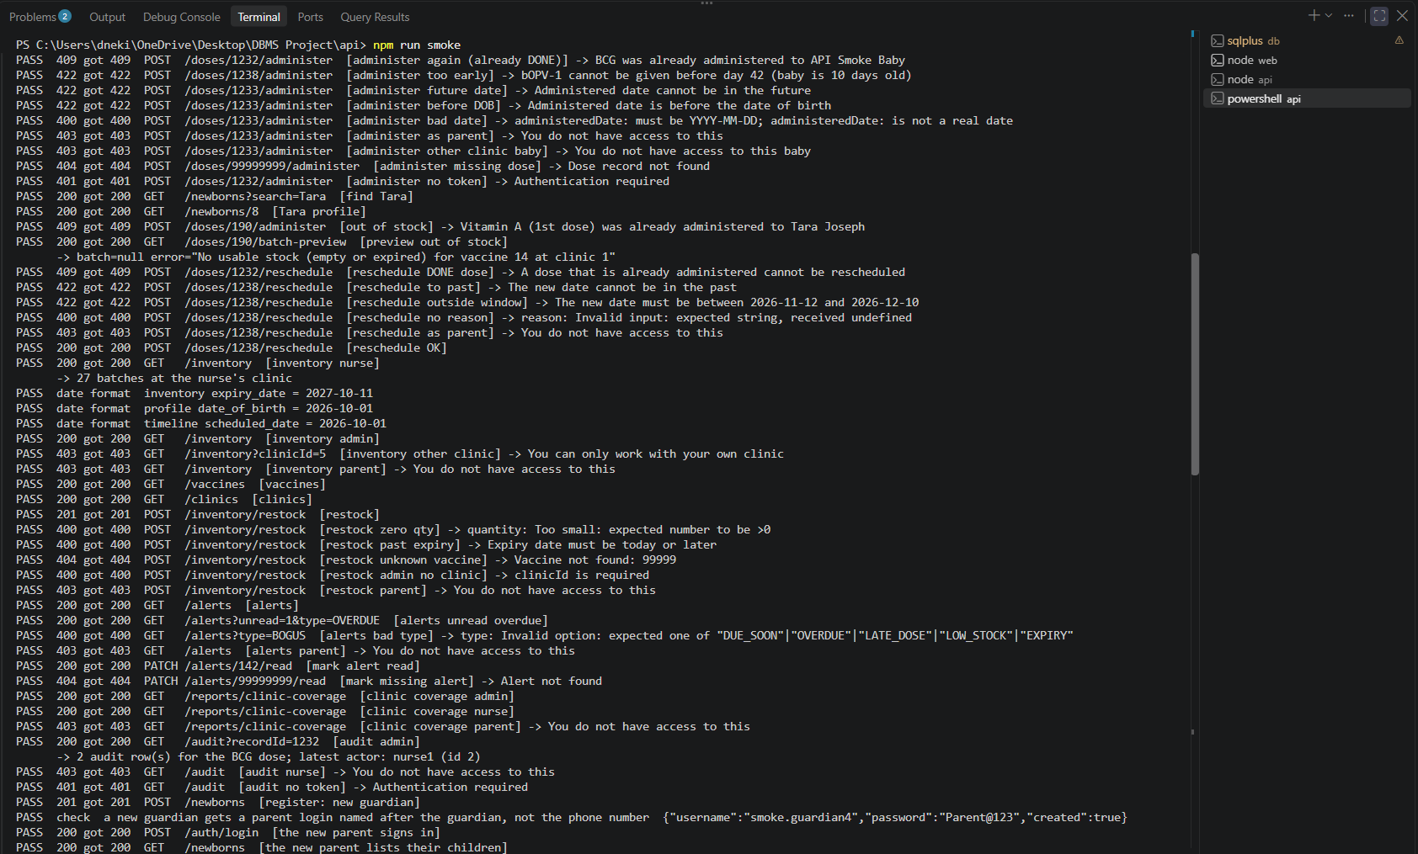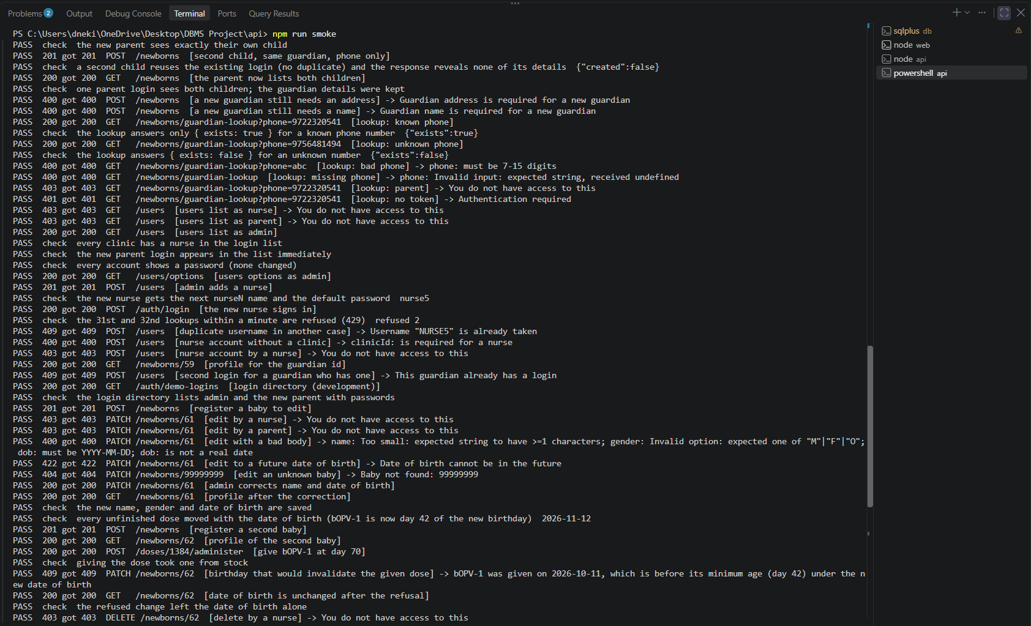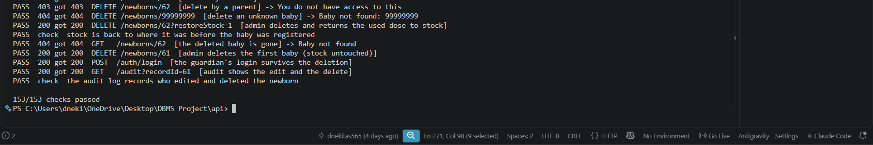
Figure 6.11: npm run smoke: 152 of 152 checks
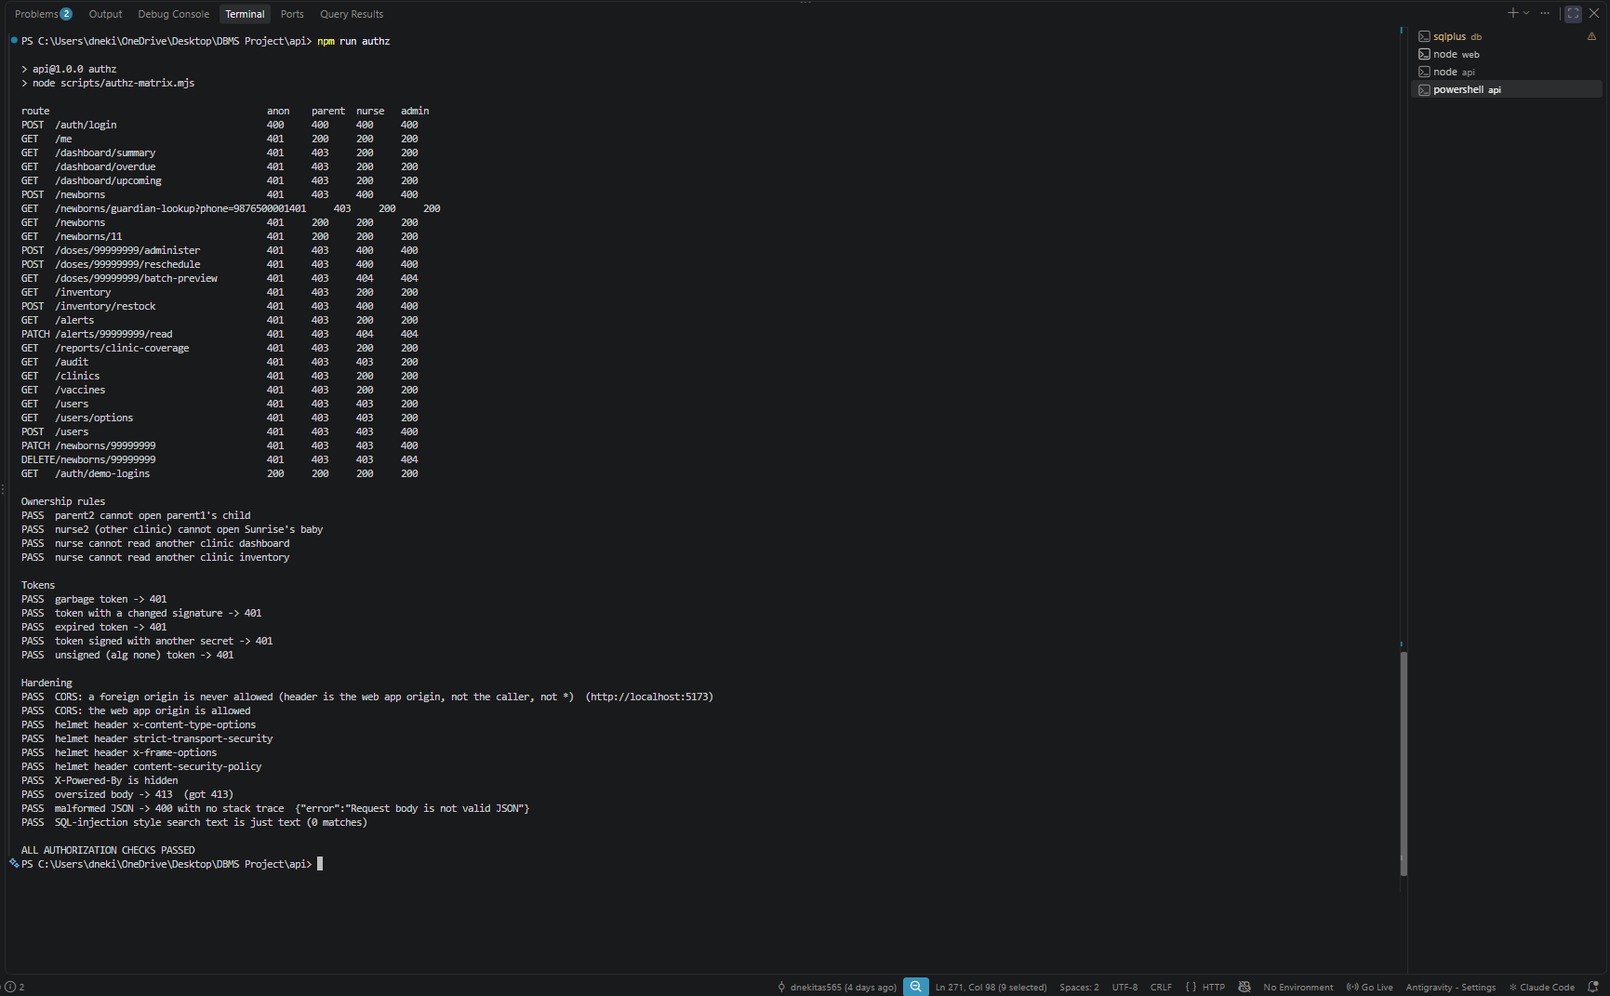
Figure 6.12: npm run authz: role by route matrix and token checks

6.3 Validation of Functionality
Constraints and triggers. The negative cases show that the database defends itself. A date of birth in the future is rejected and the registration rolls back completely (TC-P3). A DONE dose cannot be changed back to PENDING (TC-T1). Stock cannot go below zero, and a failed administration leaves both the dose and the stock unchanged (TC-P6). The audit trigger records the old and new status and the acting user (TC-T2), the low-stock alert is raised once and not on every dose (TC-T3), and the overdue alert is raised once per dose even when the sweep runs twice (TC-T4).
Procedures and packages. The registration creates 24 doses, or 26 with the Japanese encephalitis box ticked, and running generate_schedule again adds none (TC-P1, TC-P2). Recording a dose rejects a dose that is already given, a baby that is too young, and an empty or expired batch, flags a late dose, and picks the batch that expires first while skipping an expired one (TC-P4 to TC-P9). Rescheduling rejects a given dose, a past date and a date outside the age window (TC-P10). The overdue sweep flips exactly the past-due doses (TC-C1). The reporting cursors return the number of rows that plain SQL counts at the same moment (TC-R1).
Accounts and administrator tools. A new guardian gets exactly one parent login named after the guardian, a second child adds no second login, and a sibling can be registered with the phone number alone (TC-U1, TC-U2, TC-U7). Usernames are unique ignoring case and are numbered when a name is taken (TC-U3, TC-U5). The account rules reject a nurse without a clinic, a second login for a guardian, an administrator account created through the application, and a bad password hash (TC-U4). The date-of-birth correction moves the unfinished doses, is refused when it would invalidate a given dose, and only an administrator can edit or delete a newborn (TC-N1 to TC-N4).
Front end. A scripted browser run of 25 steps (sign-in, restock, registration, administering a dose, the low-stock alert, rescheduling, the failure case, the parent's view and the audit log) passes in the light and in the dark theme. Further browser checks cover the account and administrator features, theme switching, and the absence of horizontal scrolling at 360, 390, 768 and 1280 px.
Bugs the tests found. The first run failed TC-R1 with ORA-00937: not a single-group group function, because dashboard_summary combined aggregates and scalar subqueries in one SELECT. We rewrote the query with inline views joined together and ran the whole chain again from an empty schema. When the account tests were added, repeated runs left some test guardians behind, because the cleanup matched them by phone pattern; it now matches them by name, and the final check counts any leftover rows.

7. RESULTS & DISCUSSION

7.1 Achievements
Measured against the objectives of Section 1.2:
1. Schema. A ten-table schema in BCNF with primary, foreign, unique and check constraints, identity keys and 14 supporting indexes. The immunization schedule is data: changing a due age is an UPDATE of vaccine_master.
2. Business rules in the database. All five kinds of object are implemented and compile without errors: five functions, one procedure, four packages, five triggers and a scheduler job, together with explicit, parameterized, FOR-loop and REF cursors. Dose and stock can never disagree because recording a dose is one transaction with a savepoint, and the stock update is guarded against two nurses taking the last dose.
3. Web application. Three roles use a responsive web application with light and dark themes that reaches the database only through the packages. A baby's full schedule appears at registration, overdue and due-soon doses are flagged, and a parent can print the vaccination card.
4. Verification. 31 of 31 automated PL/SQL test cases pass and leave no test data behind; 152 of 152 API checks pass; the authorization matrix shows that every route refuses the roles that may not use it; and the scripted browser journey passes in both themes.
5. Accessibility. Lighthouse accessibility scores were 100 on every page and device profile that we audited in the production build, in both themes (Figure 7.1, Figure 7.2), measured with Lighthouse [15] against the accessibility guidelines [14]. The target was 90. Lighthouse covers only part of the accessibility guidelines, so this does not replace a manual keyboard and screen-reader test.
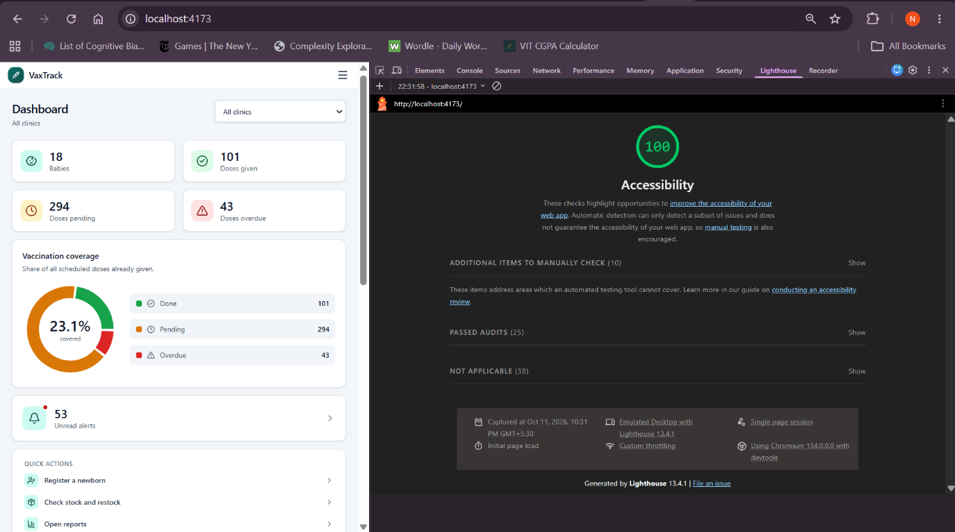
Figure 7.1: Lighthouse accessibility score for the dashboard (production build)
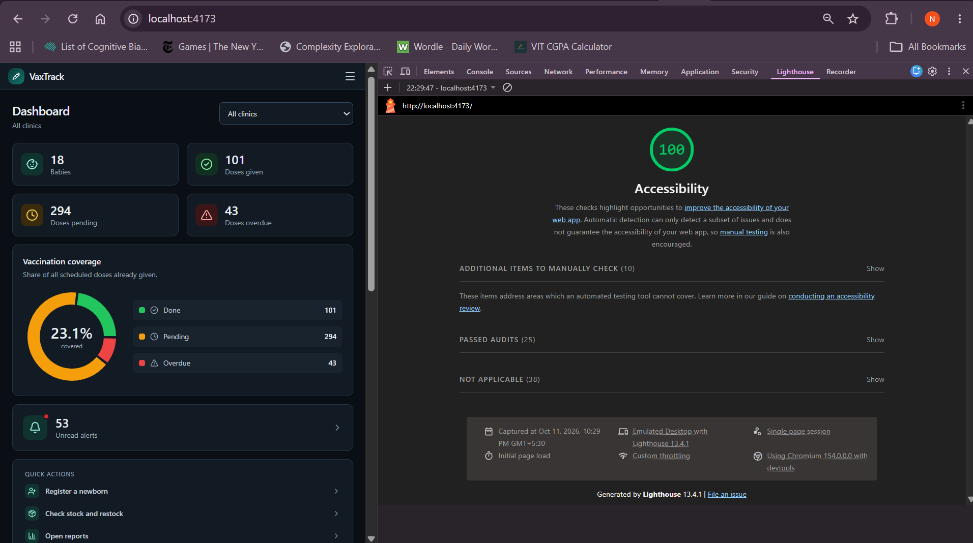
Figure 7.2: Lighthouse accessibility score in dark mode

7.2 Challenges Faced
- Mutating-table errors. A row-level trigger that reads the table it fires on raises ORA-04091. We avoided it by design: no trigger reads its own table (the status guard reads newborns, the alert trigger reads newborns and vaccine_master). Because a row trigger fires only when its row is touched and nothing touches a dose merely because time has passed, the overdue sweep updates each past-due pending dose to its own value so that the triggers fire.
- Keeping stock and doses consistent. Recording a dose changes two tables. We put both changes in one procedure with a savepoint, locked the dose row, and added the guard quantity > 0 to the stock update, so a failure at any step, or a second nurse taking the last dose, leaves nothing half done.
- A sweep that could abort. While reviewing, we saw that refresh_overdue_status touched each past-due row with an unguarded update. If a nurse marked a dose DONE just after the sweep read it, the guard trigger would have rejected the update and aborted the whole sweep. The update now has AND status = 'PENDING', so such a row is skipped. Forty-eight concurrent dashboard requests, each of which runs the sweep, all succeeded.
- A correct date of birth. After an administrator corrects a date of birth, an overdue dose gets a new date but keeps its status, so the alert trigger did not fire. We changed its WHEN clause to fire also when an overdue dose's date changes, which still gives one alert per dose.
- PL/SQL restrictions. A function declared inside a block cannot be called from a SQL statement (PLS-00231); we assigned its value to a variable first. The first version of the dashboard summary query failed with ORA-00937 and was rewritten (Section 6.3).
- Application issues. Oracle DATE values reached the browser as JavaScript date strings and every page showed "Invalid Date"; a fetch-type handler now returns YYYY-MM-DD. User names were case sensitive, so "Nurse1" was refused on phones that capitalize the first letter; sign-in is now case-insensitive. An asynchronous session callback stalled the connection pool and was removed. On a 390 px phone the page was 425 px wide because grid columns would not shrink; the grids now have a one-column base. The overflow check that had missed this compared the page with window.innerWidth, which a phone browser widens; it now compares with the real device width.

7.3 Possible Improvements
- Performance. The tables are small, but paging of the long lists and a materialized view for the clinic coverage report would be needed for many clinics.
- Security. The token is kept in the browser's local storage, so a cross-site-scripting flaw would expose it; a production system should use an HttpOnly cookie. The login limiter is in memory and is lost when the API restarts. The demo accounts share one default password per role; a real deployment would force a change at first sign-in and provide a change-password page. A web server in front of the application should add a content security policy and HSTS. The application schema owner is used by the API; a production system would use a smaller set of privileges.
- Data. Phone numbers are compared exactly as typed, so "98765 43210" and "9876543210" would be two guardians; a normalisation step would remove this.
- Features. SMS or WhatsApp reminders to parents, a multi-language interface, digital vaccination certificates, and the vaccines that are outside our scope.

8. CONCLUSION

8.1 Summary of Learning Outcomes
Through this project we applied the main ideas of a database course to one working application. We moved from an unnormalized vaccination card to a BCNF schema and saw how each step removes an anomaly. We used constraints for the rules that fit them and triggers for those that do not, such as a date of birth that cannot be in the future. We wrote functions, a procedure and packages in PL/SQL, and used explicit, parameterized, FOR-loop and REF cursors where row-by-row processing or a result set for the application was needed. We learned to design a transaction as a unit: savepoints, row locks and guarded updates keep a dose and its stock consistent, and an error is raised with a code that the application can translate. We learned that a row-level trigger must not read its own table, and why a trigger needs a row to be touched before it fires. We also learned to test a database systematically: a script that builds its own data, compares expected with actual output, and removes what it created found real defects that manual clicking had not.

8.2 Future Scope
- The vaccines beyond newborn tracking: Td for pregnant women, the DPT booster at 5–6 years, Td at 10 and 16 years, and vitamin A doses 3 to 9.
- Reminders to parents by SMS or WhatsApp, a multi-language interface, and digital vaccination certificates.
- A progressive web app or native mobile application, and deployment to a cloud database and web server with proper session cookies, a content security policy and a forced password change at first sign-in.
- Analytics across clinics: coverage by district, drop-out between doses, and forecasting of the stock each clinic needs.
- More than one login per family, so that both parents can have their own.

9. REFERENCES
[1] A. Silberschatz, H. F. Korth, and S. Sudarshan, Database System Concepts, 7th ed. New York, NY, USA: McGraw-Hill, 2019.
[2] R. Elmasri and S. B. Navathe, Fundamentals of Database Systems, 7th ed. Boston, MA, USA: Pearson, 2016.
[3] Oracle Corporation, "Database PL/SQL Language Reference, 21c," Oracle Help Center. [Online].
[4] Oracle Corporation, "Oracle Database 21c Express Edition Documentation," Oracle Help Center. [Online].
[5] Oracle Corporation, "Oracle Database 21c: Administrator's Guide, Scheduling Jobs with Oracle Scheduler (DBMS_SCHEDULER)," Oracle Help Center. [Online].
[6] Ministry of Health and Family Welfare, Government of India, "National Immunization Schedule (NIS)," document supplied for the project (file National Immunization Schedule (NIS).pdf).
[7] Oracle Corporation, "node-oracledb: The Node.js Driver for Oracle Database, documentation, version 7." [Online].
[8] OpenJS Foundation, "Express 5.x API reference." [Online].
[9] Meta Platforms, "React documentation, version 18." [Online].
[10] Vite contributors, "Vite documentation." [Online].
[11] Tailwind Labs, "Tailwind CSS documentation, version 4." [Online].
[12] M. Jones, J. Bradley, and N. Sakimura, "JSON Web Token (JWT)," RFC 7519, IETF, May 2015. [Online].
[13] N. Provos and D. Mazières, "A future-adaptable password scheme," in Proc. USENIX Annual Technical Conf., FREENIX Track, Monterey, CA, USA, 1999, pp. 81–91.
[14] World Wide Web Consortium, "Web Content Accessibility Guidelines (WCAG) 2.1," W3C Recommendation. [Online].
[15] Google, "Lighthouse accessibility scoring," Chrome for Developers. [Online].

10. APPENDICES

Appendix A – Additional Code
The complete source is in the project folder and is to be pasted into this appendix in the order below (monospaced, 9–10 pt). Run in this order on an empty schema, each script can be run again.
Order | File | Contents
1 | db/00_create_user.sql | creates the application user vaxapp and its privileges
2 | db/01_schema.sql | all tables, constraints, identity keys and indexes
3 | db/02_seed_reference.sql | clinics, the vaccine schedule, the administrator and nurse logins
4 | db/03_functions.sql | the five standalone functions
5 | db/03b_pkg_accounts.sql | account_pkg
6 | db/04_pkg_newborn.sql | newborn_vaccination_pkg with the table of error codes
7 | db/05_pkg_inventory.sql | vaccine_inventory_pkg
8 | db/06_pkg_reporting.sql | vax_reporting_pkg
9 | db/07_procedures.sql | send_due_soon_alerts
10 | db/08_triggers.sql | the five triggers
11 | db/09_scheduler.sql | the daily scheduler job
12 | db/10_seed_demo.sql | demonstration babies, doses and stock
13 | db/11_tests.sql | the 31 automated test cases
– | db/run_all.sql, report/run_all.log | the whole chain and a log of one clean run
– | api/src/ | the API: db.js, app.js, errors.js, validate.js and the routes
– | web/src/ | the React application

The API and web sources are long; if the page limit is a problem, include db.js, errors.js, routes/newborns.js and pages/RegisterNewborn.jsx and refer to the repository for the rest.

Appendix B – Additional Screenshots
Screenshots that are not placed in the main body, each with a figure caption in the same numbering style, go here (for example further API responses, or additional pages in the dark theme).

