Bài 1:

#include<bits/stdc++.h>

using namespace std;

struct HocSinh{

char maSV[10];

char hoTen[30];

int namSinh;

float diemTB;

};

void input(HocSinh &elem){

cout<<"Ma SV:"; fflush(stdin); cin.getline(elem.maSV, 10);

cout<<"Ho ten:"; fflush(stdin); cin.getline(elem.hoTen, 30);

cout<<"Nam sinh:"; cin>>elem.namSinh;

cout<<"Diem TK:"; cin>>elem.diemTB;

}

void output(HocSinh elem){

cout<<"Ma SV:"<<elem.maSV<<endl;

cout<<"Ho ten:"<<elem.hoTen<<endl;

cout<<"Nam sinh:"<<elem.namSinh<<endl;

cout<<"Diem TK:"<<elem.diemTB<<endl;

}

struct Node{

HocSinh infor;

Node *next;

};

typedef Node *TRO;

TRO L;

void creat(TRO &L){

L = NULL;

}

int empty(TRO L){

return L == NULL;

}

void display(TRO l){

TRO Q;

if(!empty(L)){

Q = L;

while(Q != NULL){

output(Q->infor);

Q = Q->next;

}

}

}

int Length(TRO L){

TRO Q = L;

int dem = 0;

if(empty(L)) return dem;

else {

while(Q != NULL){

Q = Q->next;

dem++;

}

return dem;

}

}

void search(TRO L){

TRO Q = L;

char tieptuc;

do{

char maSV[10];

cout<<"Nhap ma SV can tim:"; fflush(stdin); cin.getline(maSV, 10);

while(Q != NULL && strcmp(Q->infor.maSV,maSV) != 0)

Q = Q->next;

cout<<"Thong tin:"<<endl;

output(Q->infor);

cout<<"Co muon tim nua hay khong(C/K)?"<<endl;

cin>>tieptuc;

} while(toupper(tieptuc) == 'C');

}

void input_List(TRO &L){

TRO P, Q;

HocSinh elem;

char tieptuc;

creat(L);

do{

input(elem);

P = new Node;

P->infor = elem; P->next = NULL;

if(L == NULL){

L = P;

}

else{

Q->next = P;

}

Q = P;

cout<<"Co nhap nua khong(C/K)?";

cin>>tieptuc;

}while(toupper(tieptuc) == 'C');

}

int main(){

cout<<"Tao moi danh sach:"<<endl;

input_List(L);

cout<<"Danh sach vua nhap:"<<endl;

display(L);

cout<<"\nChieu dai cua danh sach:"<<Length(L)<<endl;

search(L);

return 0;

}

Bài 2:

#include<bits/stdc++.h>

using namespace std;

struct SinhVien{

char maSV[10];

char hoTen[30];

int namSinh;

float diemTK;

};

struct Node{

SinhVien infor;

Node *next;

};

typedef Node *TRO;

TRO L;

void input(SinhVien &elem){

cout<<"Ma SV:"; fflush(stdin); cin.getline(elem.maSV, 10);

cout<<"Ho ten:"; fflush(stdin); cin.getline(elem.hoTen, 30);

cout<<"Nam sinh:"; cin>>elem.namSinh;

cout<<"Diem TK:"; cin>>elem.diemTK;

}

void output(SinhVien elem){

cout<<"Ma SV:"<<elem.maSV<<endl;

cout<<"Ho ten:"<<elem.hoTen<<endl;

cout<<"Nam sinh:"<<elem.namSinh<<endl;

cout<<"Diem TK:"<<elem.diemTK<<endl;

}

void create(TRO &L){

L = NULL;

}

int empty(TRO L){

return L == NULL;

}

void input_List(TRO &L){

TRO P, Q;

SinhVien elem;

create(L);

int n;

cout<<"Nhap n phan tu:"; cin>>n;

int dem = 0;

while(dem < n){

input(elem);

P = new Node;

P->infor = elem;

P->next = NULL;

if(L == NULL){

L = P;

}

else{

Q->next = P;

}

Q = P;

dem++;

}

}

void Display(TRO L){

TRO Q;

if(!empty(L)){

Q = L;

while(Q!= NULL){

output(Q->infor);

Q = Q->next;

}

}

}

void Display1(TRO L){

TRO Q = L;

while(Q != NULL){

if(Q->infor.diemTK >= 6.5)

output(Q->infor);

Q = Q->next;

}

}

void insert(TRO L, int k){

TRO Q = L;

int dem = 1;

cout<<"Nhap thong tin SV can chen:";

SinhVien elem;

input(elem);

while(Q != NULL && k > dem){

Q = Q->next;

dem++;

}

TRO P;

P = new Node;

P->infor = elem;

P->next = Q->next;

Q->next = P;

}

int main(){

cout<<"Nhap moi n phan tu cho danh sach:"<<endl;

input_List(L);

cout<<"Danh sach vua nhap:"<<endl;

Display(L);

cout<<"Danh sach SV co diem TK tu 6.5 tro len:"<<endl;

Display1(L);

cout<<"Chen mot SV vao danh sach:"<<endl;

int k;

cout<<"Nhap vi tri can chen:"<<endl;

cin>>k;

insert(L, k);

cout<<"Danh sach sau khi chen:"<<endl;

Display(L);

}

Bài 3:

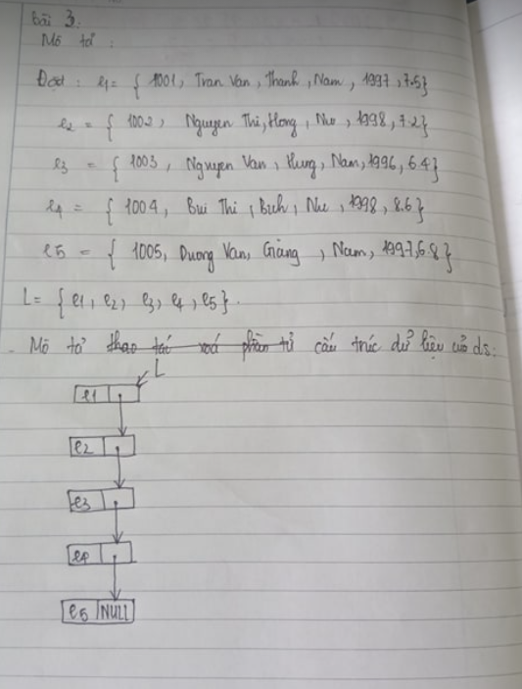

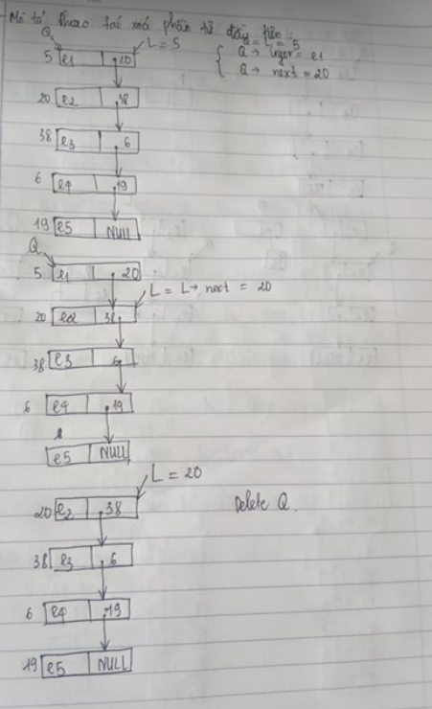

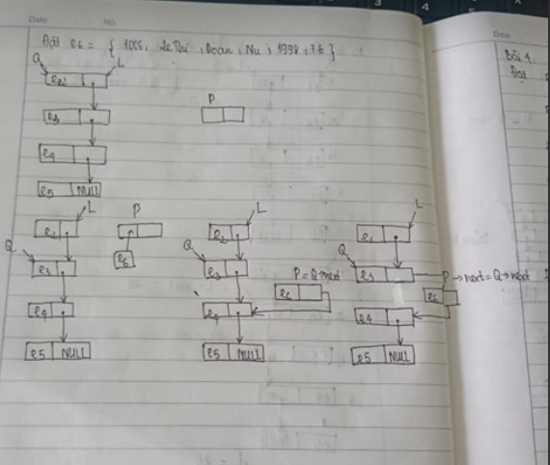

#include<bits/stdc++.h>

using namespace std;

struct SinhVien{

char maSV[10];

char hoDem[30];

char ten[20];

char gt[5];

int namSinh;

float diemTK;

};

void output(SinhVien elem){

cout<<"Ma SV:"<<elem.maSV<<endl;

cout<<"Ho dem:"<<elem.hoDem<<endl;

cout<<"Ten:"<<elem.ten<<endl;

cout<<"Gioi tinh:"<<elem.gt<<endl;

cout<<"Nam Sinh:"<<elem.namSinh<<endl;

cout<<"Diem TK:"<<elem.diemTK<<endl;

}

struct Node{

SinhVien infor;

Node *next;

};

typedef Node *TRO;

TRO L;

void create(TRO &L){

L == NULL;

}

int empty(TRO L){

return L == NULL;

}

void input_List(TRO &L){

SinhVien arr[5] = {{"1001", "Tran Van", "Thanh", "Nam", 1997, 7.5}, {"1002","Nguyen Thi", "Hong", "Nu", 1998, 7.2},{"1003","Nguyen Van", "Hung", "Nam", 1996, 6.4}, {"1004", "Bui Thi", "Bich", "Nu", 1998, 8.6},{"1005","Duong Van", "Giang", "Nam", 1997,6.8}};

TRO P, Q;

create(L);

for(int i = 0; i < 5; i++){

P = new Node;

P->infor = arr[i];

P->next = NULL;

if(L == NULL){

L = P;

}

else{

Q->next = P;

}

Q = P;

}

}

void Display(TRO L){

TRO Q;

if(!empty(L)){

Q = L;

while(Q != NULL){

output(Q->infor);

Q = Q->next;

}

}

}

void firstDelete(TRO &L){

TRO Q;

Q = L;

L = L->next;

delete Q;

}

void insert(TRO &L){

TRO Q = L;

int dem = 1;

cout<<"Nhap thong tin SV can chen:";

SinhVien elem = {"1006","Le Thi","Doan","Nu",1998,7.6};

while(Q != NULL && dem < 2){

Q = Q->next;

dem++;

}

TRO P;

P = new Node;

P->infor = elem;

P->next = Q->next;

Q->next = P;

}

void sort(TRO L){

TRO P, Q;

if(!empty(L)){

for(Q = L; Q != NULL; Q = Q->next){

for(P = Q->next; P != NULL; P = P->next){

if(strcmp(Q->infor.ten, P->infor.ten) > 0){

SinhVien a;

a = Q->infor;

Q->infor = P->infor;

P->infor = a;

}

}

}

}

}

int main(){

cout<<"Danh sach:"<<endl;

input_List(L);

Display(L);

cout<<"Danh sach sau khi xoa phan tu dau tien:"<<endl;

firstDelete(L);

Display(L);

cout<<"Danh sach sau khi chen them vao vi tri thu 3:"<<endl;

insert(L);

Display(L);

cout<<"Danh sach sau khi sap xep theo ten:"<<endl;

sort(L);

Display(L);

return 0;

}

Bài 4:

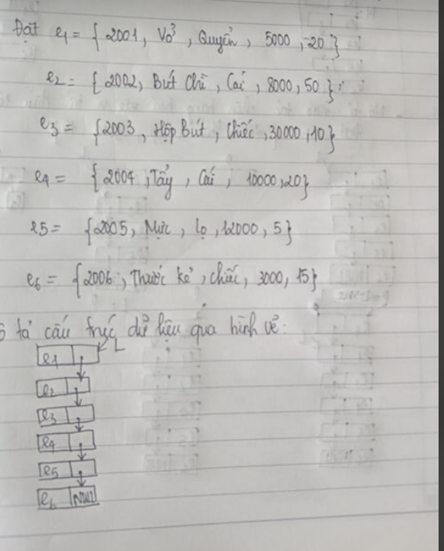

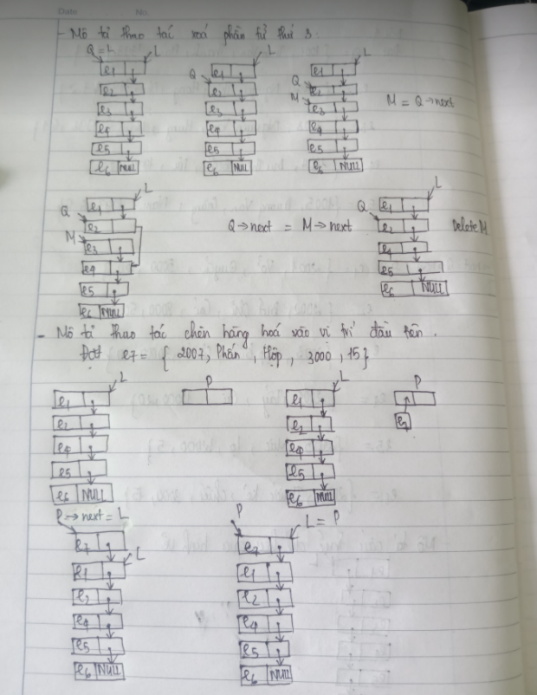

#include<bits/stdc++.h>

using namespace std;

struct HangHoa{

char maH[10];

char tenH[30];

char DVT[10];

float DG;

int SL;

};

struct Node{

HangHoa infor;

Node *next;

};

typedef Node *TRO;

TRO L;

void output(HangHoa elem){

cout<<setw(10)<<elem.maH<<setw(30)<<elem.tenH<<setw(10)<<elem.DVT<<setw(10)<<elem.DG<<setw(10)<<elem.SL<<setw(20)<<elem.DG*elem.SL<<endl;

}

void create(TRO &L){

L == NULL;

}

int empty(TRO L){

return L== NULL;

}

void input_List(TRO &L){

HangHoa arr[6] = {{"2001","Vo","Quyen",5000,20},{"2002","But chi","Cai",8000,50},{"2003","Hop but","Chiec",30000,10},{"2004","Tay","Cai",10000,20},{"2005","Muc","Lo",12000,5},{"2006","Thuoc ke","Chiec",3000,15}};

TRO P, Q;

create(L);

for(int i = 0; i < 5; i++){

P = new Node;

P->infor = arr[i];

P->next = NULL;

if(L == NULL){

L = P;

}

else{

Q->next = P;

}

Q = P;

}

}

void Display(TRO L){

TRO Q;

if(!empty(L)){

Q = L;

while(Q != NULL){

output(Q->infor);

Q = Q->next;

}

}

}

void remove(TRO &L){

TRO Q, M;

int dem = 1;

if(!empty(L)){

M = L;

while(Q != NULL && dem < 2){

M = M->next;

dem++;

}

Q = M->next;

M->next = Q->next;

delete Q;

}

}

void insert(TRO &L){

HangHoa elem = {"2007","Phan","Hop",3000,15};

TRO P;

P = new Node;

P->infor = elem;

P->next = L;

L = P;

}

void sort(TRO L){

TRO P, Q;

if(!empty(L)){

for(P = L; P != NULL; P = P->next){

for(Q = P->next; Q != NULL; Q = Q->next){

if(Q->infor.DG*Q->infor.SL < P->infor.DG*P->infor.SL){

HangHoa a;

a = Q->infor;

Q->infor = P->infor;

P->infor = a;

}

}

}

}

}

int main(){

cout<<"Danh sach:"<<endl;

input_List(L);

cout<<setw(10)<<"Ma H"<<setw(30)<<"Ten Hang"<<setw(10)<<"DVT"<<setw(10)<<"Don Gia"<<setw(10)<<"So luong"<<setw(20)<<"Thanh Tien"<<endl;

Display(L);

cout<<"Danh sach sau khi xoa phan tu thu ba:"<<endl;

remove(L);

cout<<setw(10)<<"Ma H"<<setw(30)<<"Ten Hang"<<setw(10)<<"DVT"<<setw(10)<<"Don Gia"<<setw(10)<<"So luong"<<setw(20)<<"Thanh Tien"<<endl;

Display(L);

cout<<"Chen vao vi tri dau tien trong DS:"<<endl;

insert(L);

cout<<setw(10)<<"Ma H"<<setw(30)<<"Ten Hang"<<setw(10)<<"DVT"<<setw(10)<<"Don Gia"<<setw(10)<<"So luong"<<setw(20)<<"Thanh Tien"<<endl;

Display(L);

cout<<"Danh sach sau Khi sap xep theo Thanh Tien:"<<endl;

sort(L);

cout<<setw(10)<<"Ma H"<<setw(30)<<"Ten Hang"<<setw(10)<<"DVT"<<setw(10)<<"Don Gia"<<setw(10)<<"So luong"<<setw(20)<<"Thanh Tien"<<endl;

Display(L);

return 0;

}

Bai5:

#include<bits/stdc++.h>

using namespace std;

struct SinhVien{

char maSV[10];

char hoTen[30];

int namSinh;

float diemTK;

};

struct Node{

SinhVien infor;

Node *next;

};

typedef Node *TRO;

TRO L;

void output(SinhVien elem){

cout<<setw(10)<<elem.maSV<<setw(30)<<elem.hoTen<<setw(10)<<elem.namSinh<<setw(10)<<elem.diemTK<<endl;

}

void create(TRO &L){

L = NULL;

}

int empty(TRO L){

return L == NULL;

}

void input_List(TRO &L){

TRO P, Q;

SinhVien elem;

create(L);

cout<<"Ma SV:"; fflush(stdin); cin.getline(elem.maSV, 10);

while(strcmp(elem.maSV,"") != 0){

cout<<"Ho ten:"; fflush(stdin); cin.getline(elem.hoTen, 30);

cout<<"Nam Sinh:"; cin>>elem.namSinh;

cout<<"Diem TK:"; cin>>elem.diemTK;

P = new Node;

P->infor = elem;

P->next = NULL;

if(L == NULL) L = P;

else Q->next = P;

Q = P;

cout<<"Ma SV:"; fflush(stdin); cin.getline(elem.maSV, 10);

}

}

void Display(TRO L){

TRO Q;

if(!empty(L)){

Q = L;

while(Q != NULL){

output(Q->infor);

Q = Q->next;

}

}

}

void Display1(TRO L){

TRO Q;

if(!empty(L)){

Q = L;

while(Q != NULL){

if(Q->infor.namSinh == 1998)

output(Q->infor);

Q = Q->next;

}

}

}

void deleteFirst(TRO &L){

TRO Q;

Q = L;

L = L->next;

delete Q;

}

void remove(TRO &L){

TRO Q, M;

int dem = 1;

if(!empty(L)){

M = L;

while(M != NULL && dem<4){

M = M->next;

dem++;

}

Q = M->next;

M->next = Q->next;

delete Q;

}

}

void remove1(TRO &L){

TRO Q, M;

char maSV[10];

cout<<"Nhap ma SV can xoa:"; fflush(stdin); cin.getline(maSV, 10);

if(!empty(L)){

M = L;

while(M != NULL){

if(strcmp(M->infor.maSV,maSV) == 0){

M = M->next;

break;

}

M = M->next;

}

Q = M->next;

M->next = Q->next;

delete Q;

}

}

int main(){

cout<<"Nhap danh sach: "<<endl;

input_List(L);

cout<<"Danh sach nhung nguoi sinh nam 1998:"<<endl;

cout<<setw(10)<<"Ma SV"<<setw(30)<<"Ho ten"<<setw(10)<<"Nam sinh"<<setw(10)<<"Diem TK"<<endl;

Display1(L);

cout<<"Danh sach sau khi xoa phan tu dau tien:"<<endl;

deleteFirst(L);

cout<<setw(10)<<"Ma SV"<<setw(30)<<"Ho ten"<<setw(10)<<"Nam sinh"<<setw(10)<<"Diem TK"<<endl;

Display(L);

cout<<"Danh sach sau khi xoa phan tu thu 5:"<<endl;

remove(L);

cout<<setw(10)<<"Ma SV"<<setw(30)<<"Ho ten"<<setw(10)<<"Nam sinh"<<setw(10)<<"Diem TK"<<endl;

Display(L);

remove1(L);

cout<<"Danh sach sau khi xoa MaSV:"<<endl;

cout<<setw(10)<<"Ma SV"<<setw(30)<<"Ho ten"<<setw(10)<<"Nam sinh"<<setw(10)<<"Diem TK"<<endl;

Display(L);

return 0;

}

Bài 6:

#include<bits/stdc++.h>

using namespace std;

struct SinhVien{

char maSV[10];

char hoTen[30];

int namSinh;

float diemTK;

};

struct Node{

SinhVien infor;

Node *next;

};

typedef Node *TRO;

TRO L;

void input(SinhVien &elem){

cout<<"Ma SV:"; fflush(stdin); cin.getline(elem.maSV, 10);

cout<<"Ho ten:"; fflush(stdin); cin.getline(elem.hoTen, 30);

cout<<"Nam Sinh:"; cin>>elem.namSinh;

cout<<"Diem TK:"; cin>>elem.diemTK;

}

void output(SinhVien elem){

cout<<setw(10)<<elem.maSV<<setw(30)<<elem.hoTen<<setw(10)<<elem.namSinh<<setw(10)<<elem.diemTK<<endl;

}

void create(TRO &L){

L = NULL;

}

int empty(TRO L){

return L == NULL;

}

void input_List(TRO &L){

TRO P, Q;

SinhVien elem;

create(L);

for(int i = 0; i < 6; i++){

input(elem);

P = new Node;

P->infor = elem;

P->next = NULL;

if(L == NULL) L = P;

else Q->next = P;

Q = P;

}

}

void Display(TRO L){

TRO Q;

if(!empty(L)){

Q = L;

while(Q != NULL){

output(Q->infor);

Q = Q->next;

}

}

}

void addFirst(TRO &L){

TRO Q;

SinhVien elem;

input(elem);

Q = new Node;

Q->infor = elem;

Q->next = L;

L = Q;

}

void addLast(TRO &L){

TRO P, Q;

SinhVien elem;

input(elem);

P = new Node;

P->infor = elem;

P->next = NULL;

if(empty(L)) L = P;

else{

Q = L;

while(Q->next != NULL)

Q = Q->next;

Q->next = P;

}

}

void add(TRO &L){

TRO P, Q;

SinhVien elem;

input(elem);

P = new Node;

P->infor = elem;

P->next = NULL;

int dem = 1;

if(!empty(L)){

Q = L;

while(Q != NULL && dem < 4){

dem++;

Q = Q->next;

}

P->next = Q->next;

Q->next = P;

}

}

void sort(TRO L){

TRO Q, P;

for(P = L; P!= NULL; P = P->next){

for(Q = P->next; Q != NULL; Q = Q->next){

if(P->infor.diemTK > Q->infor.diemTK){

SinhVien a;

a = P->infor;

P->infor = Q->infor;

Q->infor = a;

}

}

}

}

int main(){

cout<<"Nhap danh sach:"<<endl;

input_List(L);

cout<<"danh sach vua nhap:"<<endl;

cout<<setw(10)<<"Ma SV"<<setw(30)<<"Ho ten"<<setw(10)<<"Nam sinh"<<setw(10)<<"Diem TK"<<endl;

Display(L);

cout<<"Them 1 phan tu vao dau danh sach:"<<endl;

addFirst(L);

cout<<setw(10)<<"Ma SV"<<setw(30)<<"Ho ten"<<setw(10)<<"Nam sinh"<<setw(10)<<"Diem TK"<<endl;

Display(L);

cout<<"Them 1 phan tu vao cuoi dnah sach:"<<endl;

addLast(L);

cout<<setw(10)<<"Ma SV"<<setw(30)<<"Ho ten"<<setw(10)<<"Nam sinh"<<setw(10)<<"Diem TK"<<endl;

Display(L);

cout<<"Them 1 phan tu vao vi tri thu 5"<<endl;

add(L);

cout<<setw(10)<<"Ma SV"<<setw(30)<<"Ho ten"<<setw(10)<<"Nam sinh"<<setw(10)<<"Diem TK"<<endl;

Display(L);

cout<<"Sap xep DS :"<<endl;

sort(L);

cout<<setw(10)<<"Ma SV"<<setw(30)<<"Ho ten"<<setw(10)<<"Nam sinh"<<setw(10)<<"Diem TK"<<endl;

Display(L);

return 0;

}