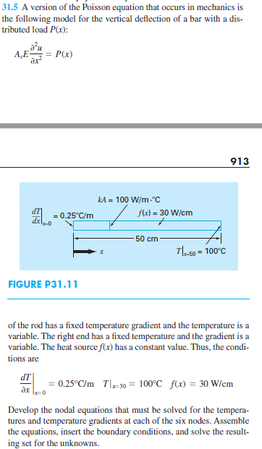

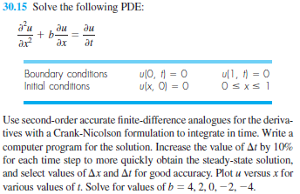

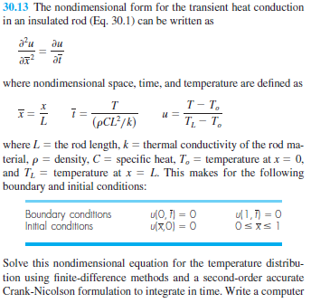

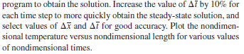

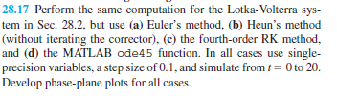

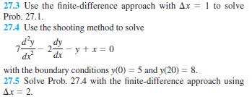

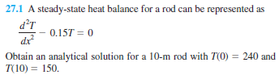

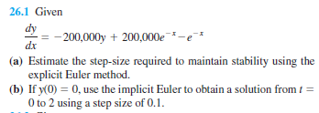

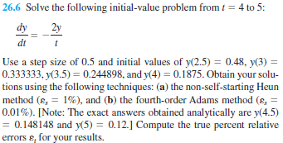

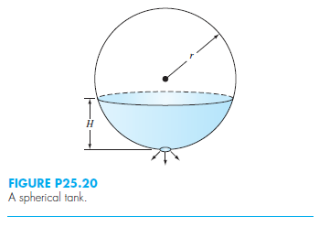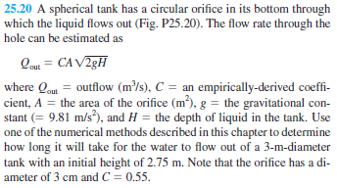

HW 4 Problem 25.20. Solve using your RK4 code with a “while” loop in MATLAB where the simulation stops when the tank is empty. Use a step size of 50 seconds.  
  
Note that: V=π(rH2-H3/3) and Q=dV/dt=dV/dH\*dH/dt and Q = -CA(2gH)0.5 (add the negative).  
  
  
You should get a time to drain of about 7490 seconds.  
  
You will submit:  
MATLAB codes of the RK4 Method with the “while” loop  
MATLAB plot (full sized) of your simulation (1 full sized graphs)   
Due: Tuesday, June 27 at the beginning of class.  
The sheets should be placed in this order and stapled, please!

