Họ và Tên: Đặng Ngọc Khuê

MSSV: 1150070024

Lớp: 11_TMĐT

**LAB 3**

Tạo project 🡪 chọn empty views activity

Tạo contact.java trong file java/com.example.sqlite

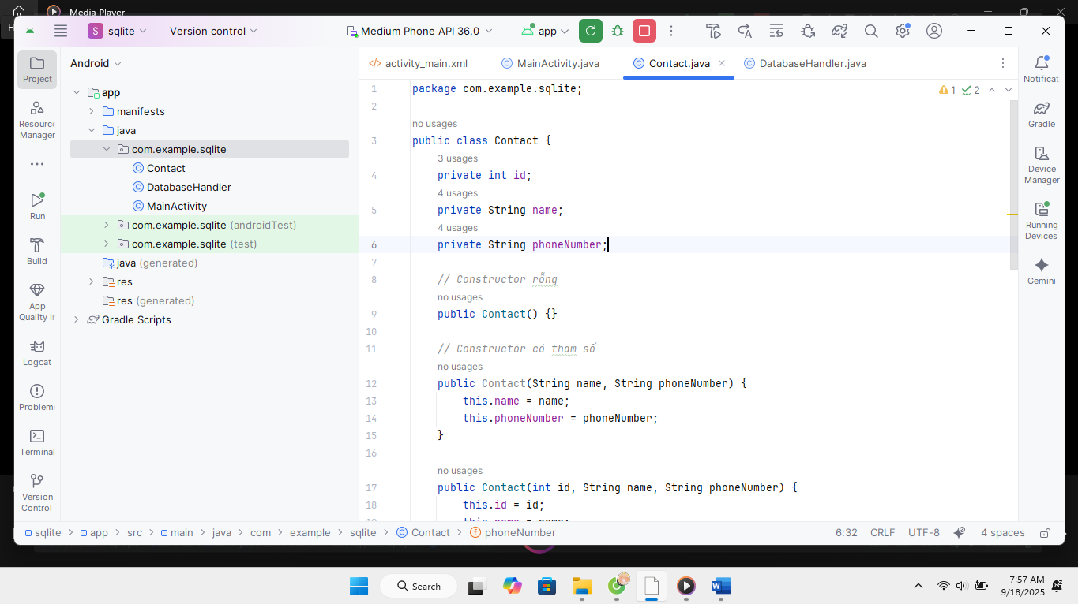

Nhập code

|  |
| --- |
| package com.example.sqllite;  public class Contact {  private int id;  private String name;  private String phoneNumber;  public Contact() {}  public Contact(String name, String phoneNumber) {  this.name = name;  this.phoneNumber = phoneNumber;  }  public Contact(int id, String name, String phoneNumber) {  this.id = id;  this.name = name;  this.phoneNumber = phoneNumber;  }  public int getID() {  return id;  }  public void setID(int id) {  this.id = id;  }  public String getName() {  return name;  }  public void setName(String name) {  this.name = name;  }  public String getPhoneNumber() {  return phoneNumber;  }  public void setPhoneNumber(String phoneNumber) {  this.phoneNumber = phoneNumber;  }  } |

Tương tự tạo thêm DatabaseHandler trong file java/com.example.sqlite

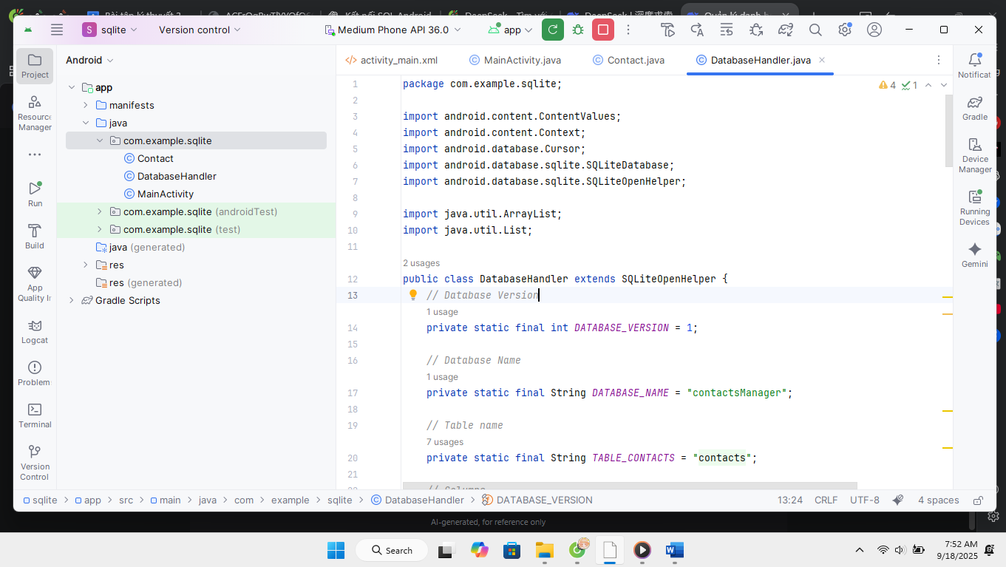

Nhập code

|  |
| --- |
| package com.example.sqllite;  import android.content.ContentValues;  import android.content.Context;  import android.database.Cursor;  import android.database.sqlite.SQLiteDatabase;  import android.database.sqlite.SQLiteOpenHelper;  import java.util.ArrayList;  import java.util.List;  public class DatabaseHandler extends SQLiteOpenHelper {  private static final int DATABASE_VERSION = 1;  private static final String DATABASE_NAME = "contactsManager";  private static final String TABLE_CONTACTS = "contacts";  private static final String KEY_ID = "id";  private static final String KEY_NAME = "name";  private static final String KEY_PH_NO = "phone_number";  public DatabaseHandler(Context context) {  super(context, DATABASE_NAME, null, DATABASE_VERSION);  }  @Override  public void onCreate(SQLiteDatabase db) {  String CREATE_CONTACTS_TABLE = "CREATE TABLE " + TABLE_CONTACTS + "("  + KEY_ID + " INTEGER PRIMARY KEY," + KEY_NAME + " TEXT,"  + KEY_PH_NO + " TEXT" + ")";  db.execSQL(CREATE_CONTACTS_TABLE);  }  @Override  public void onUpgrade(SQLiteDatabase db, int oldVersion, int newVersion) {  db.execSQL("DROP TABLE IF EXISTS " + TABLE_CONTACTS);  onCreate(db);  }  public void addContact(Contact contact) {  SQLiteDatabase db = this.getWritableDatabase();  ContentValues values = new ContentValues();  values.put(KEY_NAME, contact.getName());  values.put(KEY_PH_NO, contact.getPhoneNumber());  db.insert(TABLE_CONTACTS, null, values);  db.close();  }  public Contact getContact(int id) {  SQLiteDatabase db = this.getReadableDatabase();  Cursor cursor = db.query(TABLE_CONTACTS, new String[] { KEY_ID,  KEY_NAME, KEY_PH_NO }, KEY_ID + "=?",  new String[] { String.valueOf(id) }, null, null, null, null);  if (cursor != null)  cursor.moveToFirst();  Contact contact = new Contact(Integer.parseInt(cursor.getString(0)),  cursor.getString(1), cursor.getString(2));  cursor.close();  return contact;  }  public List<Contact> getAllContacts() {  List<Contact> contactList = new ArrayList<>();  String selectQuery = "SELECT * FROM " + TABLE_CONTACTS;  SQLiteDatabase db = this.getWritableDatabase();  Cursor cursor = db.rawQuery(selectQuery, null);  if (cursor.moveToFirst()) {  do {  Contact contact = new Contact();  contact.setID(Integer.parseInt(cursor.getString(0)));  contact.setName(cursor.getString(1));  contact.setPhoneNumber(cursor.getString(2));  contactList.add(contact);  } while (cursor.moveToNext());  }  cursor.close();  return contactList;  }  public int updateContact(Contact contact) {  SQLiteDatabase db = this.getWritableDatabase();  ContentValues values = new ContentValues();  values.put(KEY_NAME, contact.getName());  values.put(KEY_PH_NO, contact.getPhoneNumber());  return db.update(TABLE_CONTACTS, values, KEY_ID + " = ?",  new String[] { String.valueOf(contact.getID()) });  }  public void deleteContact(Contact contact) {  SQLiteDatabase db = this.getWritableDatabase();  db.delete(TABLE_CONTACTS, KEY_ID + " = ?",  new String[] { String.valueOf(contact.getID()) });  db.close();  }  } |

Tại file mainactivity.java 🡪 nhập code

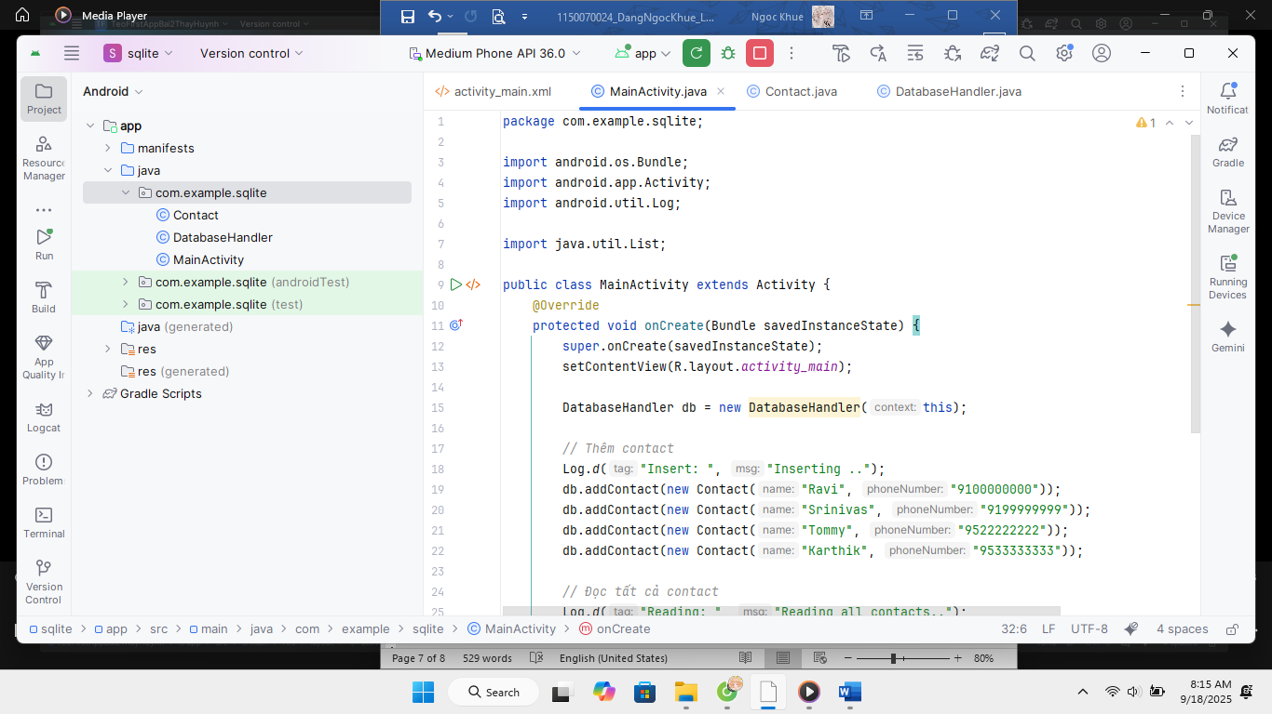

Nhập code

|  |
| --- |
| package com.example.sqllite;  import android.os.Bundle;  import android.app.Activity;  import android.util.Log;  import android.widget.ListView;  import android.widget.ArrayAdapter;  import android.content.Context;  import android.view.LayoutInflater;  import android.view.View;  import android.view.ViewGroup;  import android.widget.TextView;  import java.util.List;  public class MainActivity extends Activity {  @Override  protected void onCreate(Bundle savedInstanceState) {  super.onCreate(savedInstanceState);  setContentView(R.layout.activity_main);  DatabaseHandler db = new DatabaseHandler(this);  // Insert contacts  Log.d("Insert: ", "Inserting ..");  db.addContact(new Contact("Đặng Ngọc Khuê", "1150070024"));  db.addContact(new Contact("Văn Thanh", "9199999999"));  db.addContact(new Contact("Tuấn Tú", "9522222222"));  db.addContact(new Contact("Ngọc Khánh", "9533333333"));  // Read all contacts  Log.d("Reading: ", "Reading all contacts..");  List<Contact> contacts = db.getAllContacts();  // Set up ListView  ListView contactsListView = findViewById(R.id.contacts_list);  ContactAdapter adapter = new ContactAdapter(this, contacts);  contactsListView.setAdapter(adapter);  // Log contacts for debugging  for (Contact cn : contacts) {  String log = "Id: " + cn.getID() + " ,Name: " + cn.getName() + ", Phone: " + cn.getPhoneNumber();  Log.d("Name: ", log);  }  }  // Custom ArrayAdapter for contacts  private class ContactAdapter extends ArrayAdapter<Contact> {  private List<Contact> contactList;  public ContactAdapter(Context context, List<Contact> contacts) {  super(context, 0, contacts);  this.contactList = contacts;  }  @Override  public View getView(int position, View convertView, ViewGroup parent) {  if (convertView == null) {  convertView = LayoutInflater.from(getContext()).inflate(R.layout.list_item_contact, parent, false);  }  Contact contact = contactList.get(position);  TextView idTextView = convertView.findViewById(R.id.contact_id);  TextView nameTextView = convertView.findViewById(R.id.contact_name);  TextView phoneTextView = convertView.findViewById(R.id.contact_phone);  idTextView.setText("ID: " + contact.getID());  nameTextView.setText("Name: " + contact.getName());  phoneTextView.setText("Phone: " + contact.getPhoneNumber());  return convertView;  }  }  } |

Trong mainactivity.xml nhập

*<?*xml version="1.0" encoding="utf-8"*?>*<androidx.constraintlayout.widget.ConstraintLayout xmlns:android="http://schemas.android.com/apk/res/android"  
 xmlns:app="http://schemas.android.com/apk/res-auto"  
 xmlns:tools="http://schemas.android.com/tools"  
 android:id="@+id/main"  
 android:layout_width="match_parent"  
 android:layout_height="match_parent"  
 android:padding="16dp"  
 tools:context=".MainActivity">  
  
 <TextView  
 android:id="@+id/title_text"  
 android:layout_width="0dp"  
 android:layout_height="wrap_content"  
 android:text="Contacts List"  
 android:textSize="20sp"  
 android:textStyle="bold"  
 android:paddingBottom="8dp"  
 app:layout_constraintTop_toTopOf="parent"  
 app:layout_constraintStart_toStartOf="parent"  
 app:layout_constraintEnd_toEndOf="parent" />  
  
 <ListView  
 android:id="@+id/contacts_list"  
 android:layout_width="0dp"  
 android:layout_height="0dp"  
 android:divider="@android:color/darker_gray"  
 android:dividerHeight="1dp"  
 app:layout_constraintTop_toBottomOf="@id/title_text"  
 app:layout_constraintBottom_toBottomOf="parent"  
 app:layout_constraintStart_toStartOf="parent"  
 app:layout_constraintEnd_toEndOf="parent" />  
  
</androidx.constraintlayout.widget.ConstraintLayout>

Tạo thêm list_item_contact

*<?*xml version="1.0" encoding="utf-8"*?>*<LinearLayout xmlns:android="http://schemas.android.com/apk/res/android"  
 android:layout_width="match_parent"  
 android:layout_height="wrap_content"  
 android:orientation="vertical"  
 android:padding="8dp">  
  
 <TextView  
 android:id="@+id/contact_id"  
 android:layout_width="match_parent"  
 android:layout_height="wrap_content"  
 android:textSize="14sp"  
 android:textStyle="bold" />  
  
 <TextView  
 android:id="@+id/contact_name"  
 android:layout_width="match_parent"  
 android:layout_height="wrap_content"  
 android:textSize="16sp" />  
  
 <TextView  
 android:id="@+id/contact_phone"  
 android:layout_width="match_parent"  
 android:layout_height="wrap_content"  
 android:textSize="14sp" />  
  
</LinearLayout>

Ra Kết quả

