Họ và Tên: Đặng Ngọc Khuê
Lớp: 11_ĐH_TMĐT
MSSV: 1150070024
Số máy: 03

Lab 13-14. Ứng dụng đăng nhập và đăng ký

Luyện tập: Xây dựng giao diện đǎng nhập/đǎng ký
Tạo project mới chọn empty views activity đặt tên cho project
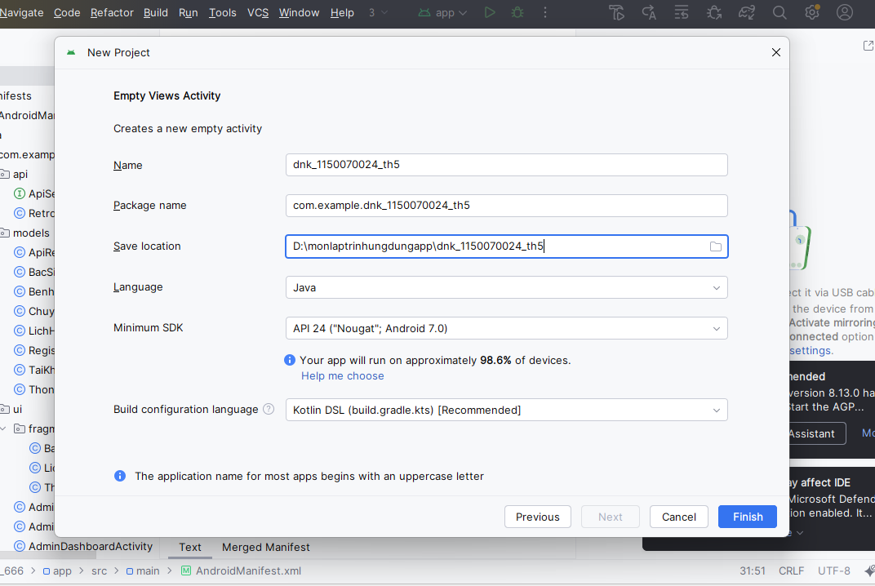
Sau khi tạo được project mở file color trong res/values thêm các màu vào file
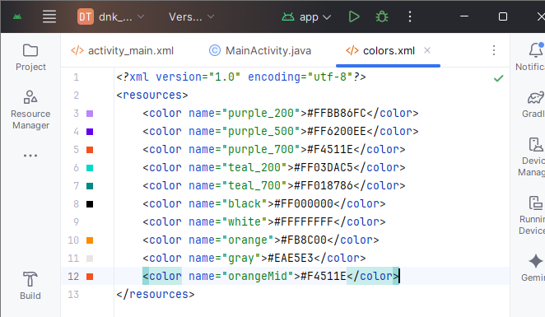
Tiếp tục tại folder values mở file string thêm vào các chuỗi text
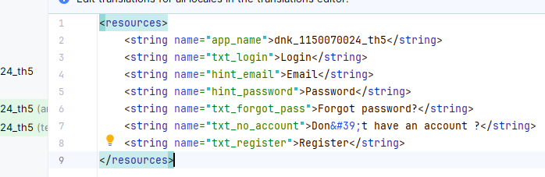
Sau đó trong drawable tạo thêm file đặt tên là bg_rect.xml nền màu cam cho background dưới cùng
<?xml version="1.0" encoding="utf-8"?>
<shape xmlns:android="http://schemas.android.com/apk/res/android">
<solid android:color="@color/orangeMid" />
</shape>

Cũng tại file drawable tạo file đặt là bg_radius.xml khung nhập bo góc trắng
<?xml version="1.0" encoding="utf-8"?>
<shape xmlns:android="http://schemas.android.com/apk/res/android">
<corners android:radius="20dp"/>
<solid android:color="@color/white"/>
</shape>

Tạo tiếp bg_login.xml trong values nút Login màu cam có bóng
<layer-list xmlns:android="http://schemas.android.com/apk/res/android">
<item android:drawable="@drawable/bg_rect" />
<item android:bottom="3dp">
<shape>
<corners android:radius="20dp"/>
<gradient
android:angle="180"
android:startColor="@color/orangeMid"
android:endColor="@color/orange"/>
</shape>
</item>
</layer-list>

Tạo thêm file ms đặt là bg_top.xml
<?xml version="1.0" encoding="utf-8"?>
<shape xmlns:android="http://schemas.android.com/apk/res/android">
<corners android:bottomLeftRadius="100dp" />
<gradient
android:angle="145"
android:startColor="@color/orangeMid"
android:endColor="@color/orange" />
</shape>
Lần lượt thêm các icon vào drawable
Chuột phải drawable new chọn art tìm email ok
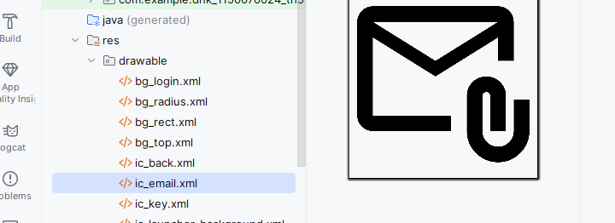
Tương tự tại ô clip art chọn tìm kiếm back chọn icon sau đó lưu về file
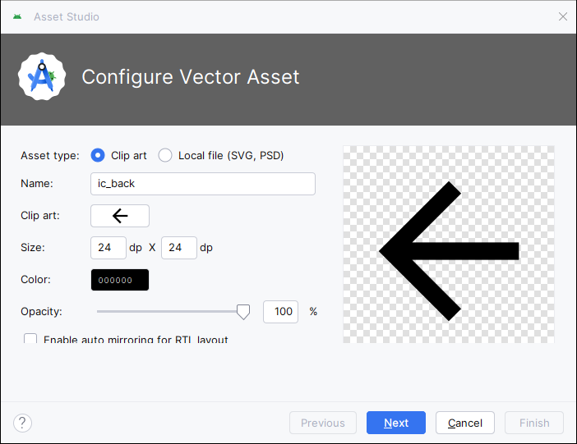
Tương tự lưu key về file drawable
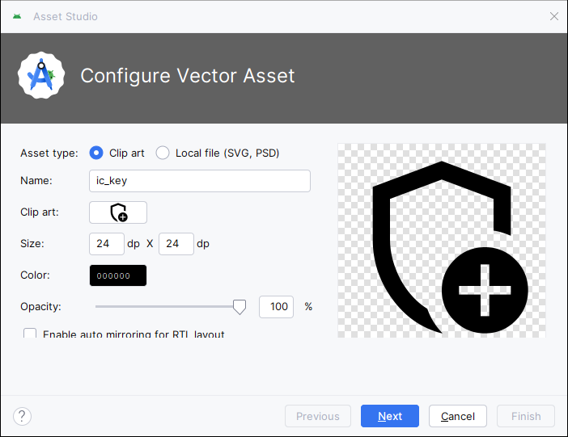

Trong folder layout tạo thêm 1 file layout cho login đặt là m000_frg_login.xml
<?xml version="1.0" encoding="utf-8"?>
<LinearLayout xmlns:android="http://schemas.android.com/apk/res/android"
android:layout_width="match_parent"
android:layout_height="match_parent"
android:background="@color/gray"
android:orientation="vertical">

<FrameLayout
android:layout_width="match_parent"
android:layout_height="wrap_content">

<View
android:layout_width="match_parent"
android:layout_height="300dp"
android:background="@drawable/bg_top" />

<TextView
android:layout_width="wrap_content"
android:layout_height="wrap_content"
android:layout_gravity="end"
android:layout_marginTop="220dp"
android:layout_marginEnd="30dp"
android:layout_marginRight="30dp"
android:text="@string/txt_login"
android:textColor="@color/white"
android:textSize="20sp" />
</FrameLayout>

<EditText
android:id="@+id/edt_email"
android:layout_width="match_parent"
android:layout_height="50dp"
android:layout_marginHorizontal="30dp"
android:layout_marginTop="50dp"
android:layout_marginBottom="3dp"
android:autofillHints="Email"
android:inputType="textEmailAddress"
android:background="@drawable/bg_radius"
android:drawableLeft="@drawable/ic_email"
android:drawablePadding="10dp"
android:hint="@string/hint_email"
android:padding="10dp"
android:textSize="18sp" />

<EditText
android:id="@+id/edt_pass"
android:layout_width="match_parent"
android:layout_height="50dp"
android:layout_marginHorizontal="30dp"
android:layout_marginTop="20dp"
android:layout_marginBottom="3dp"
android:autofillHints="Password"
android:inputType="textPassword"
android:background="@drawable/bg_radius"
android:drawableLeft="@drawable/ic_key"
android:drawablePadding="10dp"
android:hint="@string/hint_password"
android:padding="10dp"
android:textSize="18sp" />

<TextView
android:layout_width="wrap_content"
android:layout_height="wrap_content"
android:layout_gravity="end"
android:layout_marginTop="10dp"
android:layout_marginRight="30dp"
android:text="@string/txt_forgot_pass"
android:textColor="@color/black"
android:textSize="18sp" />

<TextView
android:id="@+id/tv_login"
android:layout_width="match_parent"
android:layout_height="50dp"
android:layout_gravity="end"
android:layout_marginHorizontal="30dp"
android:layout_marginTop="40dp"
android:background="@drawable/bg_login"
android:gravity="center"
android:padding="10dp"
android:text="@string/txt_login"
android:textColor="@color/white"
android:textSize="18sp" />

<TableRow
android:layout_width="match_parent"
android:layout_height="wrap_content"
android:layout_marginTop="30dp"
android:gravity="center">

<TextView
android:layout_width="wrap_content"
android:layout_height="wrap_content"
android:text="@string/txt_no_account"
android:textColor="@color/black"
android:textSize="14sp" />

<TextView
android:id="@+id/tv_register"
android:layout_width="wrap_content"
android:layout_height="wrap_content"
android:layout_marginLeft="5dp"
android:text="@string/txt_register"
android:textColor="@color/orange"
android:textSize="14sp"
android:textStyle="bold" />
</TableRow>

</LinearLayout>

Tiếp tục tạo file layout cho đăng kí đặt là m001_frg_register.xml
<?xml version="1.0" encoding="utf-8"?>
<LinearLayout xmlns:android="http://schemas.android.com/apk/res/android"
xmlns:app="http://schemas.android.com/apk/res-auto"
xmlns:tools="http://schemas.android.com/tools"
android:layout_width="match_parent"
android:layout_height="match_parent"
android:background="@color/gray"
android:orientation="vertical">

<FrameLayout
android:layout_width="match_parent"
android:layout_height="wrap_content">

<View
android:layout_width="match_parent"
android:layout_height="300dp"
android:background="@drawable/bg_top" />

<ImageView
android:id="@+id/iv_back"
android:layout_width="56dp"
android:layout_height="56dp"
android:padding="10dp"
android:src="@drawable/ic_back"
app:tint="@color/white"
tools:ignore="ContentDescription" />

<TextView
android:layout_width="wrap_content"
android:layout_height="wrap_content"
android:layout_gravity="end"
android:layout_marginTop="220dp"
android:layout_marginRight="30dp"
android:text="@string/txt_register"
android:textColor="@color/white"
android:textSize="20sp" />
</FrameLayout>

<EditText
android:id="@+id/edt_email"
android:layout_width="match_parent"
android:layout_height="50dp"
android:layout_marginHorizontal="30dp"
android:layout_marginTop="50dp"
android:layout_marginBottom="3dp"
android:autofillHints="Email"
android:background="@drawable/bg_radius"
android:drawableLeft="@drawable/ic_email"
android:drawablePadding="10dp"
android:hint="@string/hint_email"
android:inputType="textEmailAddress"
android:padding="10dp"
android:textSize="18sp" />

<EditText
android:id="@+id/edt_pass"
android:layout_width="match_parent"
android:layout_height="50dp"
android:layout_marginHorizontal="30dp"
android:layout_marginTop="10dp"
android:layout_marginBottom="3dp"
android:autofillHints="Password"
android:background="@drawable/bg_radius"
android:drawableLeft="@drawable/ic_key"
android:drawablePadding="10dp"
android:hint="@string/hint_password"
android:inputType="textPassword"
android:padding="10dp"
android:textSize="18sp" />

<EditText
android:id="@+id/edt_re_pass"
android:layout_width="match_parent"
android:layout_height="50dp"
android:layout_marginHorizontal="30dp"
android:layout_marginTop="10dp"
android:layout_marginBottom="3dp"
android:autofillHints="Password"
android:background="@drawable/bg_radius"
android:drawableLeft="@drawable/ic_key"
android:drawablePadding="10dp"
android:hint="@string/hint_password"
android:inputType="textPassword"
android:padding="10dp"
android:textSize="18sp" />

<TextView
android:id="@+id/tv_register"
android:layout_width="match_parent"
android:layout_height="50dp"
android:layout_gravity="end"
android:layout_marginHorizontal="30dp"
android:layout_marginTop="20dp"
android:background="@drawable/bg_login"
android:gravity="center"
android:padding="10dp"
android:text="@string/txt_register"
android:textColor="@color/white"
android:textSize="18sp" />

</LinearLayout>

Mở file activity_main.xml sửa các câu lệnh
<?xml version="1.0" encoding="utf-8"?>
<LinearLayout xmlns:android="http://schemas.android.com/apk/res/android"
android:id="@+id/ln_main"
android:layout_width="match_parent"
android:layout_height="match_parent"
android:orientation="vertical">
</LinearLayout>

Tiếp tục mở file MainActivity.java sửa các câu lệnh
package com.example.dnk_1150070024_th5;

import android.os.Bundle;
import androidx.appcompat.app.AppCompatActivity;

public class MainActivity extends AppCompatActivity {
public static final String SAVE_PREF = "save_pref";

@Override
protected void onCreate(Bundle savedInstanceState) {
super.onCreate(savedInstanceState);
setContentView(R.layout.activity_main);
gotoLoginScreen();
}

public void gotoRegisterScreen() {
getSupportFragmentManager().beginTransaction()
.replace(R.id.ln_main, new M001RegisterFragment())
.commit();
}

public void gotoLoginScreen() {
getSupportFragmentManager().beginTransaction()
.replace(R.id.ln_main, new M000LoginFragment())
.commit();
}
}

Tạo file mới đặt tên là M000LoginFragment.java dùng để đọc email/password, xử lý đăng nhập.
package com.example.dnk_1150070024_th5;

import android.content.Context;
import android.content.SharedPreferences;
import android.os.Bundle;
import android.view.LayoutInflater;
import android.view.View;
import android.view.ViewGroup;
import android.view.animation.AnimationUtils;
import android.widget.EditText;
import android.widget.Toast;

import androidx.fragment.app.Fragment;

public class M000LoginFragment extends Fragment implements View.OnClickListener {

private EditText edtEmail, edtPass;
private Context mContext;

@Override
public View onCreateView(LayoutInflater inflater, ViewGroup container,
Bundle savedInstanceState) {
View rootView = inflater.inflate(R.layout.m000_frg_login, container, false);
initView(rootView);
return rootView;
}

@Override
public void onAttach(Context context) {
super.onAttach(context);
mContext = context;
}

private void initView(View v) {
edtEmail = v.findViewById(R.id.edt_email);
edtPass = v.findViewById(R.id.edt_pass);

v.findViewById(R.id.tv_login).setOnClickListener(this);
v.findViewById(R.id.tv_register).setOnClickListener(this);
}

@Override
public void onClick(View v) {
v.startAnimation(AnimationUtils.loadAnimation(
mContext, androidx.appcompat.R.anim.abc_fade_in));

int id = v.getId();
if (id == R.id.tv_login) {
login(edtEmail.getText().toString(), edtPass.getText().toString());
} else if (id == R.id.tv_register) {
gotoRegisterScreen();
}
}

private void gotoRegisterScreen() {
((MainActivity) mContext).gotoRegisterScreen();
}

private void login(String mail, String pass) {
if (mail.isEmpty() || pass.isEmpty()) {
Toast.makeText(mContext, "Empty value", Toast.LENGTH_SHORT).show();
return;
}

SharedPreferences pref = mContext.getSharedPreferences(
MainActivity.SAVE_PREF, Context.MODE_PRIVATE);

String savedPass = pref.getString(mail, null);
if (savedPass == null) {
Toast.makeText(mContext, "Email is not existed!", Toast.LENGTH_SHORT).show();
return;
}

if (!pass.equals(savedPass)) {
Toast.makeText(mContext, "Password is not correct!", Toast.LENGTH_SHORT).show();
return;
}

Toast.makeText(mContext, "Login account successfully!", Toast.LENGTH_SHORT).show();
}
}

Tiếp tục tạo file mới đặt tên là M001RegisterFragment.java dùng để tạo màn hình đăng ký, lấy dữ liệu từ ô nhập, kiểm tra hợp lệ, lưu tài khoản rồi chuyển người dùng về màn hình đăng nhập
package com.example.dnk_1150070024_th5;

import android.content.Context;
import android.content.SharedPreferences;
import android.os.Bundle;
import android.view.LayoutInflater;
import android.view.View;
import android.view.ViewGroup;
import android.view.animation.AnimationUtils;
import android.widget.EditText;
import android.widget.Toast;

import androidx.fragment.app.Fragment;

public class M001RegisterFragment extends Fragment implements View.OnClickListener {

private EditText edtEmail, edtPass, edtRepass;
private Context mContext;

@Override
public View onCreateView(LayoutInflater inflater, ViewGroup container,
Bundle savedInstanceState) {
View rootView =
inflater.inflate(R.layout.m001_frg_register, container, false);
initView(rootView);
return rootView;
}

@Override
public void onAttach(Context context) {
super.onAttach(context);
mContext = context;
}

private void initView(View v) {
edtEmail = v.findViewById(R.id.edt_email);
edtPass = v.findViewById(R.id.edt_pass);
edtRepass = v.findViewById(R.id.edt_re_pass);

v.findViewById(R.id.tv_register).setOnClickListener(this);
v.findViewById(R.id.iv_back).setOnClickListener(this);
}

@Override
public void onClick(View v) {
v.startAnimation(AnimationUtils.loadAnimation(
mContext, androidx.appcompat.R.anim.abc_fade_in));

int id = v.getId();
if (id == R.id.iv_back) {
gotoLoginScreen();
} else if (id == R.id.tv_register) {
register(edtEmail.getText().toString(),
edtPass.getText().toString(),
edtRepass.getText().toString());
}
}

private void gotoLoginScreen() {
((MainActivity) mContext).gotoLoginScreen();
}

private void register(String mail, String pass, String repass) {
if (mail.isEmpty() || pass.isEmpty() || repass.isEmpty()) {
Toast.makeText(mContext, "Empty value", Toast.LENGTH_SHORT).show();
return;
}

if (!pass.equals(repass)) {
Toast.makeText(mContext, "Password is not match", Toast.LENGTH_SHORT).show();
return;
}

SharedPreferences pref = mContext.getSharedPreferences(
MainActivity.SAVE_PREF, Context.MODE_PRIVATE);

String savedPass = pref.getString(mail, null);
if (savedPass != null) {
Toast.makeText(mContext, "Email is existed!", Toast.LENGTH_SHORT).show();
return;
}

pref.edit().putString(mail, pass).apply();
Toast.makeText(mContext, "Register account successfully!", Toast.LENGTH_SHORT).show();
gotoLoginScreen();
}
}

Kết quả đạt được
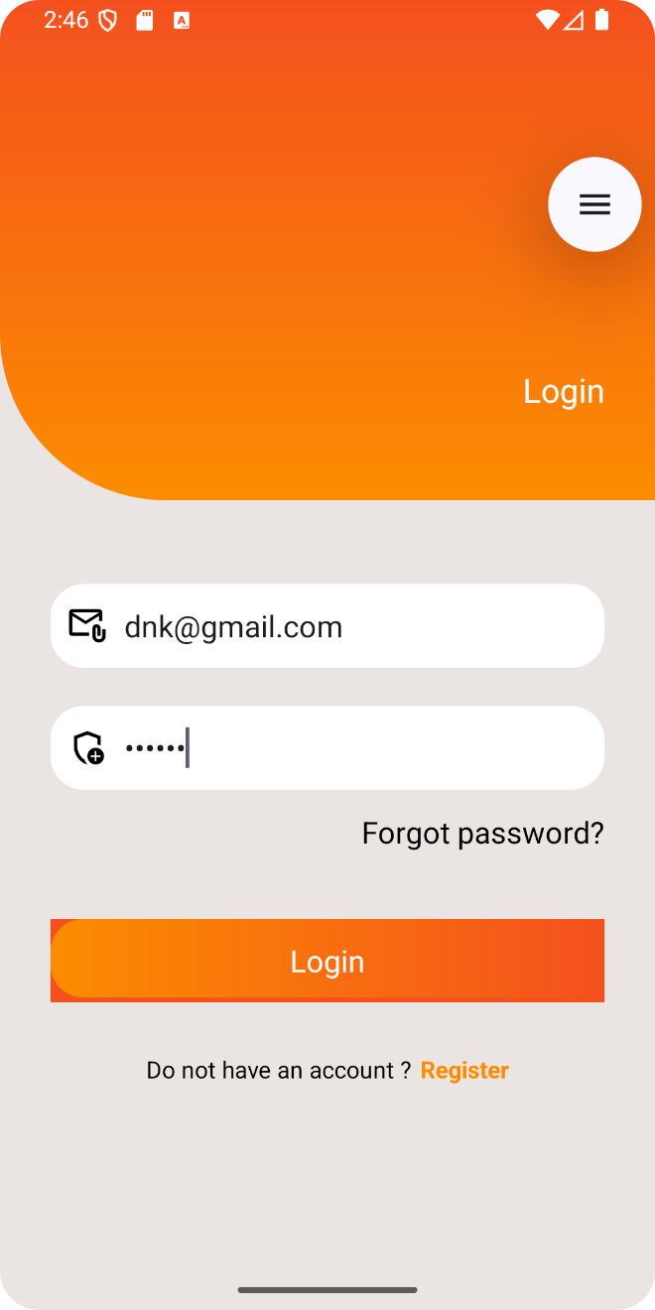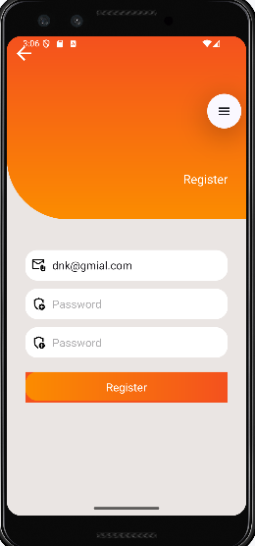

Luyện tập: Thực hiện xử lý logic đǎng ký/đǎng nhập bằng SharePreference
Tiếp tục tại project mới tạo mở file MainActivity
package com.example.dnk_1150070024_th5;

import android.os.Bundle;
import androidx.appcompat.app.AppCompatActivity;

public class MainActivity extends AppCompatActivity {
public static final String SAVE_PREF = "save_pref";

@Override
protected void onCreate(Bundle savedInstanceState) {
super.onCreate(savedInstanceState);
setContentView(R.layout.activity_main);
gotoLoginScreen();
}

public void gotoRegisterScreen() {
getSupportFragmentManager().beginTransaction()
.replace(R.id.ln_main, new M001RegisterFragment())
.commit();
}

public void gotoLoginScreen() {
getSupportFragmentManager().beginTransaction()
.replace(R.id.ln_main, new M000LoginFragment())
.commit();
}
}

Sau đó mở file java M000LoginFragment sửa
Thêm dòng import androidx.annotation.NonNull; sửa khai báo onCreateView và onAttach sửa trong onClick
package com.example.dnk_1150070024_th5;

import android.content.Context;
import android.content.SharedPreferences;
import android.os.Bundle;
import android.view.LayoutInflater;
import android.view.View;
import android.view.ViewGroup;
import android.view.animation.AnimationUtils;
import android.widget.EditText;
import android.widget.Toast;

import androidx.annotation.NonNull;
import androidx.fragment.app.Fragment;

public class M000LoginFragment extends Fragment implements View.OnClickListener {

private EditText edtEmail, edtPass;
private Context mContext;

@Override
public View onCreateView(@NonNull LayoutInflater inflater, ViewGroup container,
Bundle savedInstanceState) {
View rootView = inflater.inflate(R.layout.m000_frg_login, container, false);
initView(rootView);
return rootView;
}

@Override
public void onAttach(@NonNull Context context) {
super.onAttach(context);
mContext = context;
}

private void initView(View v) {
edtEmail = v.findViewById(R.id.edt_email);
edtPass = v.findViewById(R.id.edt_pass);

v.findViewById(R.id.tv_login).setOnClickListener(this);
v.findViewById(R.id.tv_register).setOnClickListener(this);
}

@Override
public void onClick(View v) {
v.startAnimation(AnimationUtils.loadAnimation(
mContext, android.R.anim.fade_in));

int id = v.getId();
if (id == R.id.tv_login) {
login(edtEmail.getText().toString().trim(),
edtPass.getText().toString().trim());
} else if (id == R.id.tv_register) {
gotoRegisterScreen();
}
}

private void gotoRegisterScreen() {
((MainActivity) mContext).gotoRegisterScreen();
}

private void login(String mail, String pass) {
if (mail.isEmpty() || pass.isEmpty()) {
Toast.makeText(mContext, "Empty value", Toast.LENGTH_SHORT).show();
return;
}

SharedPreferences pref = mContext.getSharedPreferences(
MainActivity.SAVE_PREF, Context.MODE_PRIVATE);

String savedPass = pref.getString(mail, null);
if (savedPass == null) {
Toast.makeText(mContext, "Email is not existed!", Toast.LENGTH_SHORT).show();
return;
}

if (!pass.equals(savedPass)) {
Toast.makeText(mContext, "Password is not correct!", Toast.LENGTH_SHORT).show();
return;
}

Toast.makeText(mContext, "Login account successfully!", Toast.LENGTH_SHORT).show();
}
}

Tiếp tục mở file java M001RegisterFragment sửa thêm import androidx.annotation.NonNull; sửa onCreateView và onAttach sửa onClick
package com.example.dnk_1150070024_th5;

import android.content.Context;
import android.content.SharedPreferences;
import android.os.Bundle;
import android.view.LayoutInflater;
import android.view.View;
import android.view.ViewGroup;
import android.view.animation.AnimationUtils;
import android.widget.EditText;
import android.widget.Toast;

import androidx.annotation.NonNull;
import androidx.fragment.app.Fragment;

public class M001RegisterFragment extends Fragment implements View.OnClickListener {

private EditText edtEmail, edtPass, edtRepass;
private Context mContext;

@Override
public View onCreateView(@NonNull LayoutInflater inflater, ViewGroup container,
Bundle savedInstanceState) {
View rootView = inflater.inflate(R.layout.m001_frg_register, container, false);
initView(rootView);
return rootView;
}

@Override
public void onAttach(@NonNull Context context) {
super.onAttach(context);
mContext = context;
}

private void initView(View v) {
edtEmail = v.findViewById(R.id.edt_email);
edtPass = v.findViewById(R.id.edt_pass);
edtRepass = v.findViewById(R.id.edt_re_pass);

v.findViewById(R.id.tv_register).setOnClickListener(this);
v.findViewById(R.id.iv_back).setOnClickListener(this);
}

@Override
public void onClick(View v) {
v.startAnimation(AnimationUtils.loadAnimation(
mContext, android.R.anim.fade_in));

int id = v.getId();
if (id == R.id.iv_back) {
gotoLoginScreen();
} else if (id == R.id.tv_register) {
register(
edtEmail.getText().toString().trim(),
edtPass.getText().toString().trim(),
edtRepass.getText().toString().trim()
);
}
}

private void gotoLoginScreen() {
((MainActivity) mContext).gotoLoginScreen();
}

private void register(String mail, String pass, String repass) {
if (mail.isEmpty() || pass.isEmpty() || repass.isEmpty()) {
Toast.makeText(mContext, "Empty value", Toast.LENGTH_SHORT).show();
return;
}

if (!pass.equals(repass)) {
Toast.makeText(mContext, "Password is not match", Toast.LENGTH_SHORT).show();
return;
}

SharedPreferences pref = mContext.getSharedPreferences(
MainActivity.SAVE_PREF, Context.MODE_PRIVATE);

String savedPass = pref.getString(mail, null);
if (savedPass != null) {
Toast.makeText(mContext, "Email is existed!", Toast.LENGTH_SHORT).show();
return;
}

pref.edit().putString(mail, pass).apply();
Toast.makeText(mContext, "Register account successfully!", Toast.LENGTH_SHORT).show();
gotoLoginScreen();
}
}

Kết quả đạt được
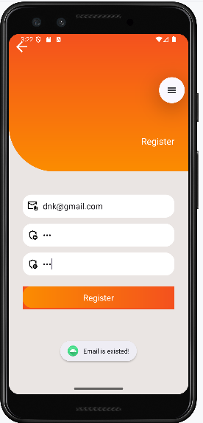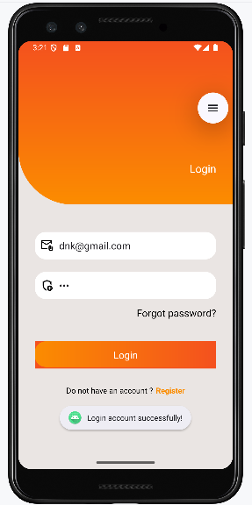

Kết nối với cơ sở dữ lieu
Mở Visual Code mở terminal lên nhập câu lệnh dotnet new webapi -n DnkAuthApi để tạo folder tên là DnkAuthApi sau đó nhập câu lệnh cd DnkAuthApi để truy cập folder mới tạo
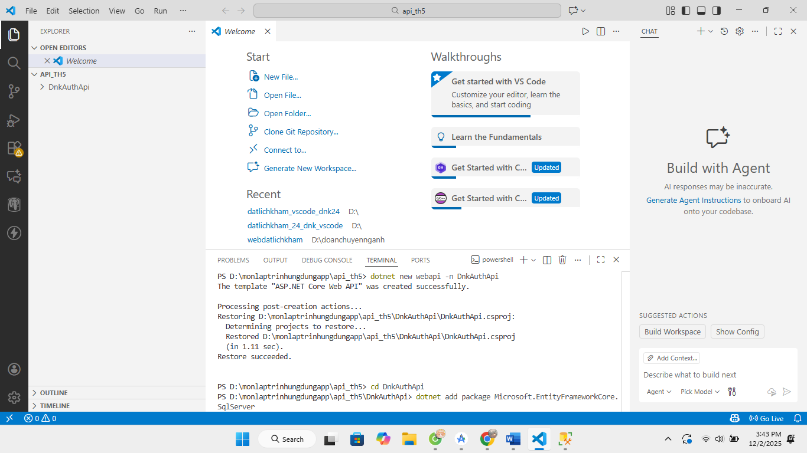
Sau đó tiếp tục ở terminal chạy lần lượt câu lệnh dotnet add package Microsoft.EntityFrameworkCore.SqlServer giúp .NET kết nối và làm việc với SQL Server câu lệnh dotnet add package Microsoft.EntityFrameworkCore.Tools giúp chạy lệnh EF Core như migrations và database update
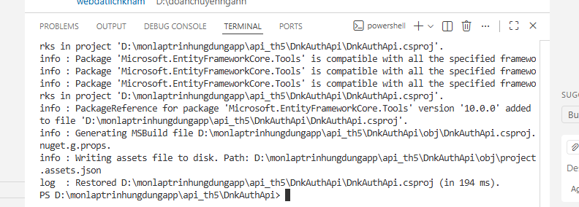
Mở appsettings.json thêm câu lệnh đẻ keets nối sql
"ConnectionStrings": {
"DefaultConnection": "Server=DESKTOP-GIPONOD;Database=DnkAuthDb;User Id=sa;Password=Khue@123;TrustServerCertificate=True;"
},
Tạo folder mới đặt tên là models sau đó tạo file User.cs
namespace DnkAuthApi.Models
{
public class User
{
public int Id { get; set; }
public string Email { get; set; } = null!;
public string Password { get; set; } = null!;
}
}

Tiếp tục tạo folder data tạo file AppDbContext.cs
using DnkAuthApi.Models;
using Microsoft.EntityFrameworkCore;

namespace DnkAuthApi.Data
{
public class AppDbContext : DbContext
{
public AppDbContext(DbContextOptions<AppDbContext> options) : base(options)
{
}

public DbSet<User> Users => Set<User>();
}
}
Sau đó tạo folder controller tạo file đặt là AuthController.cs
using DnkAuthApi.Data;
using DnkAuthApi.DTOs;
using DnkAuthApi.Models;
using Microsoft.AspNetCore.Mvc;
using Microsoft.EntityFrameworkCore;

namespace DnkAuthApi.Controllers
{
[ApiController]
[Route("api/[controller]")]
public class AuthController : ControllerBase
{
private readonly AppDbContext _context;

public AuthController(AppDbContext context)
{
_context = context;
}

[HttpPost("register")]
public async Task<ActionResult<ApiResponse>> Register(RegisterRequest request)
{
if (string.IsNullOrWhiteSpace(request.Email) ||
string.IsNullOrWhiteSpace(request.Password) ||
string.IsNullOrWhiteSpace(request.RePassword))
{
return new ApiResponse { Success = false, Message = "Empty value" };
}

if (request.Password != request.RePassword)
{
return new ApiResponse { Success = false, Message = "Password is not match" };
}

var exists = await _context.Users.AnyAsync(u => u.Email == request.Email);
if (exists)
{
return new ApiResponse { Success = false, Message = "Email is existed" };
}

var user = new User
{
Email = request.Email,
Password = request.Password
};

_context.Users.Add(user);
await _context.SaveChangesAsync();

return new ApiResponse { Success = true, Message = "Register account successfully" };
}

[HttpPost("login")]
public async Task<ActionResult<ApiResponse>> Login(LoginRequest request)
{
if (string.IsNullOrWhiteSpace(request.Email) ||
string.IsNullOrWhiteSpace(request.Password))
{
return new ApiResponse { Success = false, Message = "Empty value" };
}

var user = await _context.Users
.FirstOrDefaultAsync(u => u.Email == request.Email && u.Password == request.Password);

if (user == null)
{
return new ApiResponse { Success = false, Message = "Email or password is not correct" };
}

return new ApiResponse { Success = true, Message = "Login account successfully" };
}
}
}
Mở file Program.cs sửa
using DnkAuthApi.Data;
using Microsoft.EntityFrameworkCore;

var builder = WebApplication.CreateBuilder(args);

builder.Services.AddControllers();

builder.Services.AddDbContext<AppDbContext>(options =>
options.UseSqlServer(builder.Configuration.GetConnectionString("DefaultConnection")));

builder.Services.AddEndpointsApiExplorer();
builder.Services.AddSwaggerGen();

var app = builder.Build();

if (app.Environment.IsDevelopment())
{
app.UseSwagger();
app.UseSwaggerUI();
}

app.UseHttpsRedirection();

app.UseAuthorization();

app.MapControllers();

app.Run();
Sau đó tạo folder DTOs tạo file AuthDtos.cs
namespace DnkAuthApi.DTOs
{
public class RegisterRequest
{
public string Email { get; set; } = null!;
public string Password { get; set; } = null!;
public string RePassword { get; set; } = null!;
}

public class LoginRequest
{
public string Email { get; set; } = null!;
public string Password { get; set; } = null!;
}

public class ApiResponse
{
public bool Success { get; set; }
public string Message { get; set; } = "";
}
}
Sau đó tại terminal nhập câu lệnh dotnet run
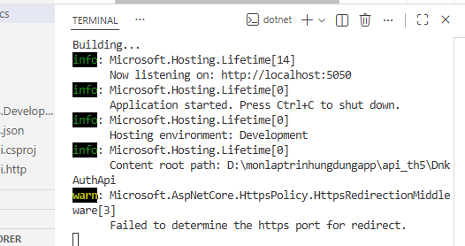
Truy cập link localhost thêm /swagger
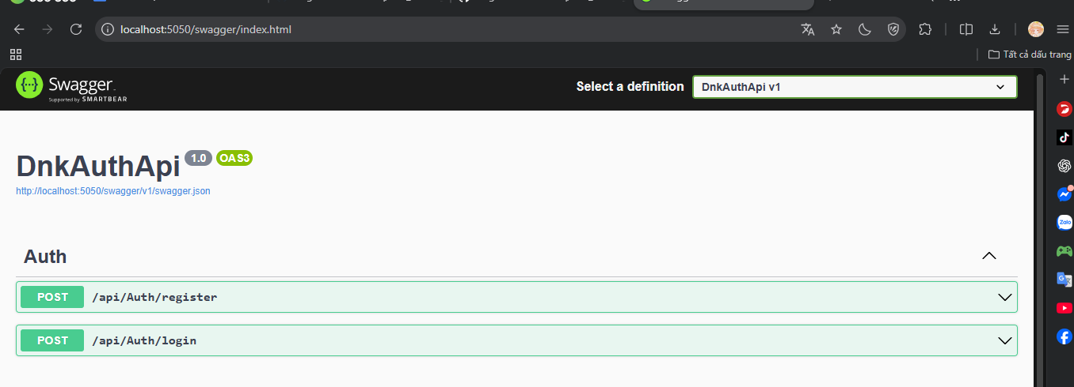
Mở AndroidManifest.xml thêm dòng <uses-permission android:name="android.permission.INTERNET" /> phía trên <application>
Mở app/build.gradle trong dependencies { ... } thêm
implementation 'com.squareup.retrofit2:retrofit:2.9.0'
implementation 'com.squareup.retrofit2:converter-gson:2.9.0'
sau đó chọn Syn now
