NONG LAM UNIVERSITY HO CHI MINH CITY

FACULTY OF INFORMATION TECHNOLOGY   
🙡🙡🟅🙣🙣



MOBILE PROGRAMMING PROJECT

ELAZY - ENGLISH QUIZ APP

Instructor: Tran Huy Cuong

Performing Students:

Le Chi Bao 15130010

Dinh Ngoc Thien 15130174

# Description

With lazy style, you just have to take a short quiz with 5 questions each time. You can do it without logging in (with Google or Facebook) however your score will not be recorded and you have to watch advertise before taking the quiz. If you login the system, except taking the quiz without watching advertise once time everyday, you can also do some extra functions: changing avatar, posting new question, feedback and your score will be recorded. The system also support resume the last question that you stop at before closing the app. Moreover members are also ranked by starts which is counted by the first quiz in a day, if you logged in the system, you can choose challenge mode that multiply your star number ten time with correct answers, but your star number will be reduce twenty time with wrong answers.

# Functions:

* Taking the test
* Loging in with Google
* Login with Facebook
* Resuming last question
* Changing avatar
* Posting new question
* Feedback
* Ranking member by stars
* Record by day or month
* Remind new quiz
* Watch advertise before redo in same day

# System architecture:

|  |
| --- |
| Android app |
| ***User Interface*** |

|  |
| --- |
| Login |
| ***Authentication & Authorization*** |

|  |  |  |  |
| --- | --- | --- | --- |
| User  Management | Take the test | Statistic | Post questions |
| ***Core business logic/application functionality System utilities*** | | | |

|  |
| --- |
| Android, Firebase, SQLite |
| ***System support (OS, database etc.)*** |

# Software architecture:

Firebase

Load, save()

DAO

SQLite

Call load, save()

Authentify()

Update UI/ user actions()

Model change/ update model()

Google DB

Facebook DB

Model change()

Controller

Model

UI

# Assignment

|  |  |  |
| --- | --- | --- |
| **Name** | **Task** | **Completed** |
| Le Chi Bao | + Connect Firebase  + Login with Google, Facebook  + Design user interface  + Remind new quiz  + Change avatar  + Feedback | 90% |
| Dinh Ngoc Thien | + Taking quiz screen  + Resume last question  + Post new question screen  + Record  + Ranking  + Advertise | 90% |

# Using guide:

- Before login screens:

You can do the quiz but your score will not be recorded.

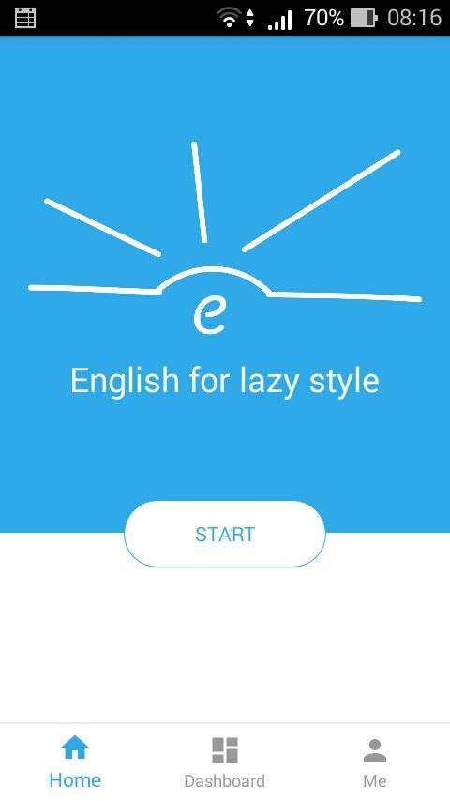 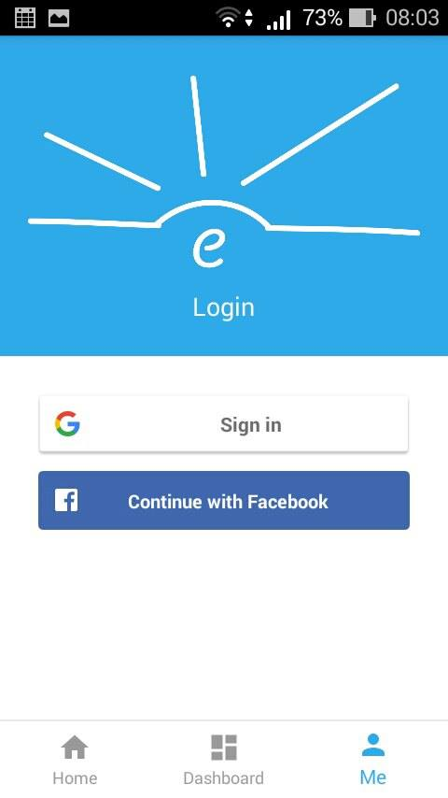

- After logged in screens:

Your score is showed on home screen, moreover you can use extra feature:

+ Challenge: with off state, your star number increase 1 for each correct answer, and keep in old value for each wrong answer. With on state, your star number increase 10 for each correct answer, but reduce 20 for each wrong answer.

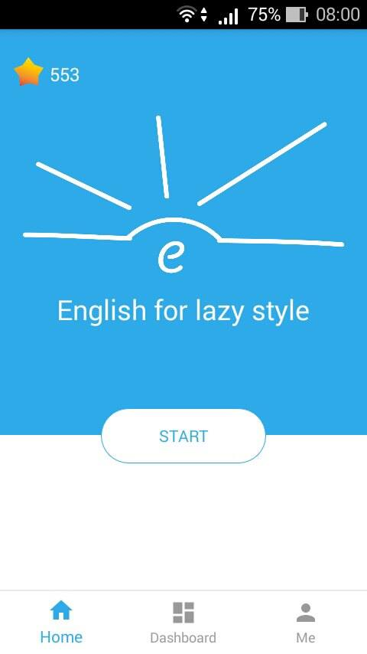 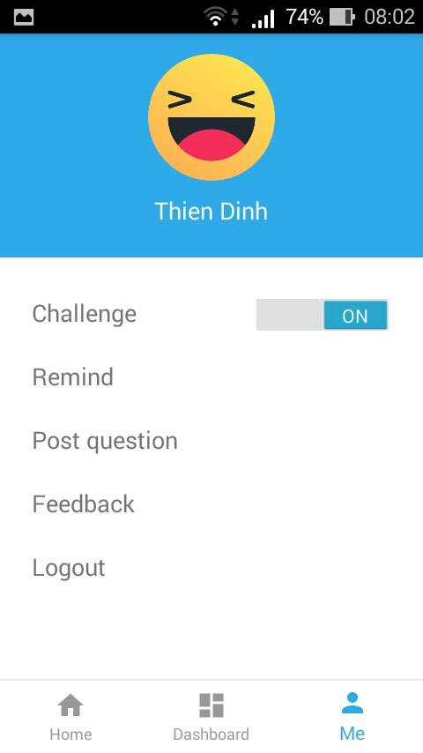

+ Remind: You can schedule the time to remind the quiz everyday with support of Calendar (a default app in Android).

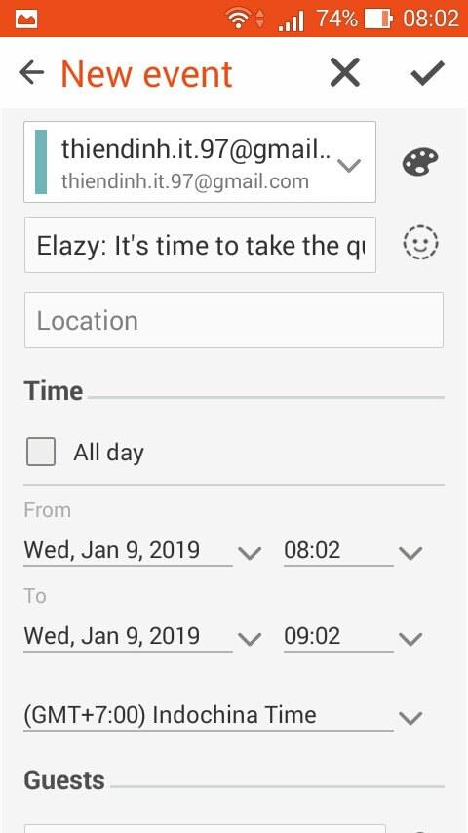 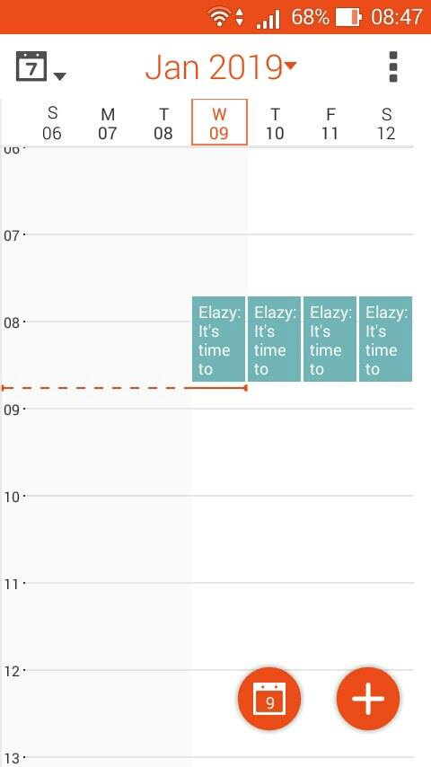

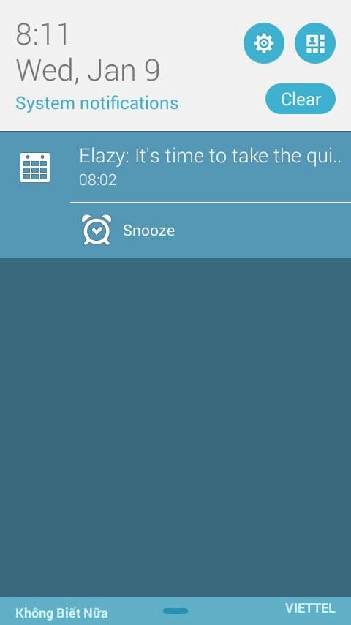

+ Post question: You can post your question for everyone to enjoy.

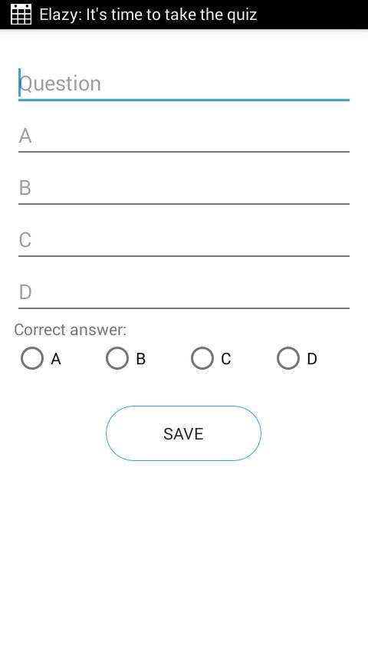

+ Feedback: you can feedback your idea.

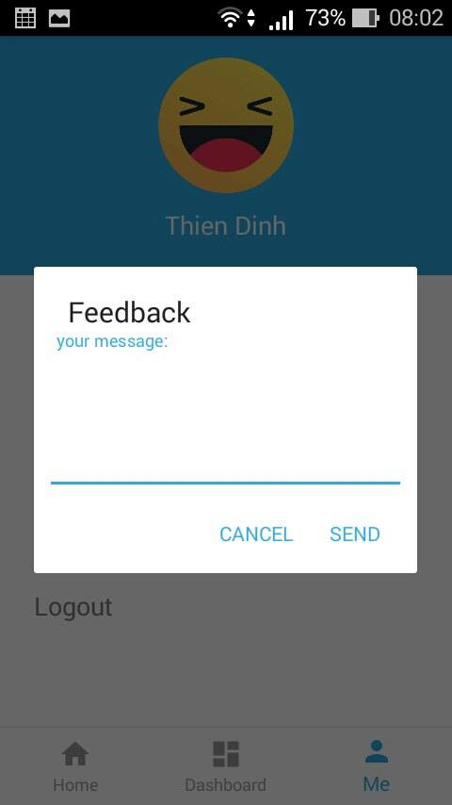

- Answer screen:

You have 20 seconds to finish each question, you cannot submit after countdown timer to zero. If you submit before that time, the system show green colour if you answer correctly, if not that answer is coloured by red. If you submit without answer, system notify “Please select answer”. If you turn off the app while doing the quiz, and then redo the quiz, it shows the last question that you stopped at.

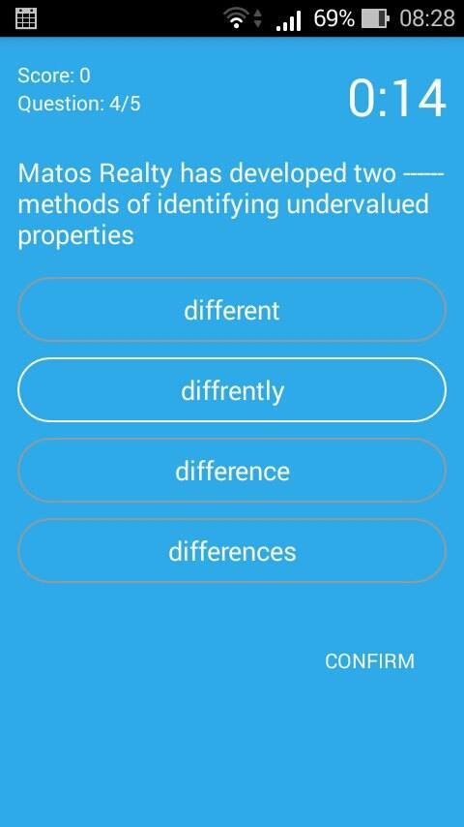 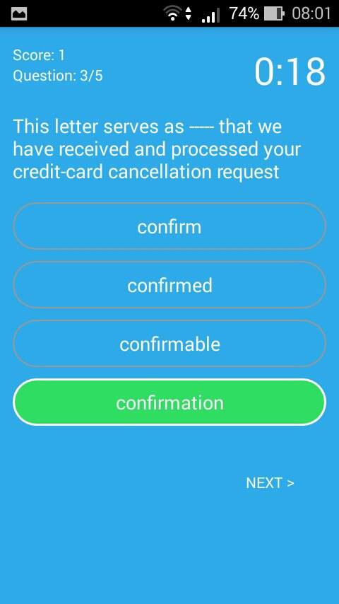

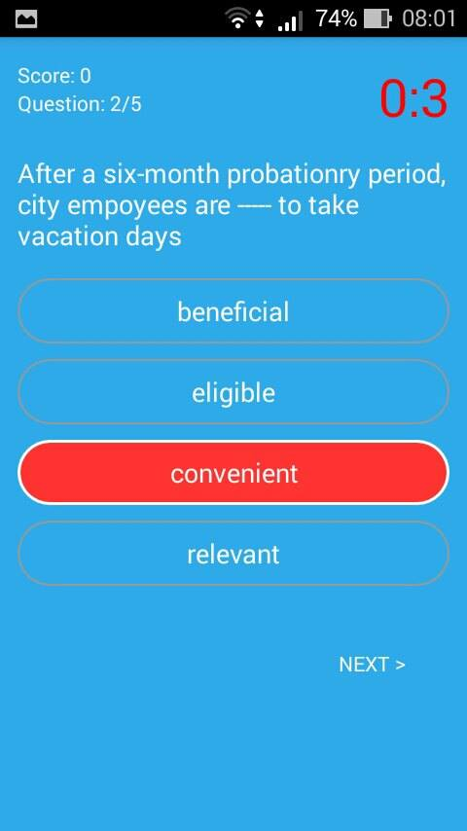 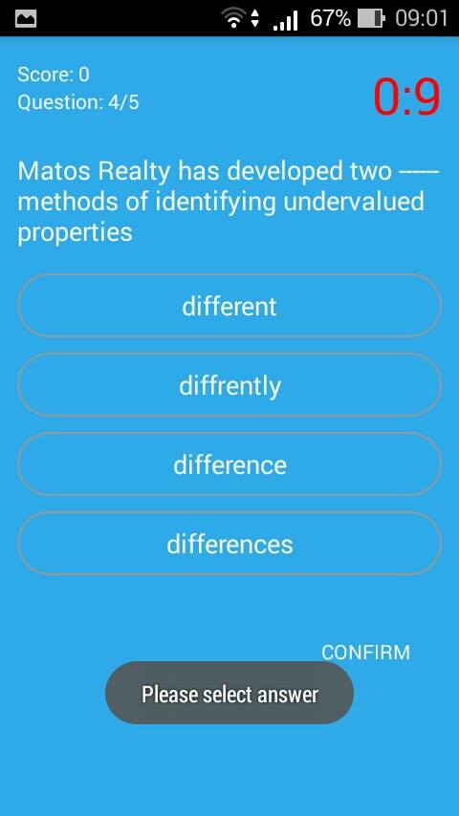

- Statistic:

+ If you logged in the system, your record will be show by score. You can also see your rank on ranking board without logging in.

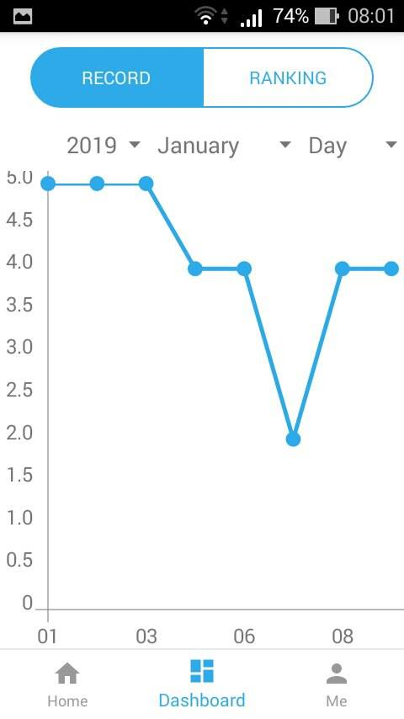 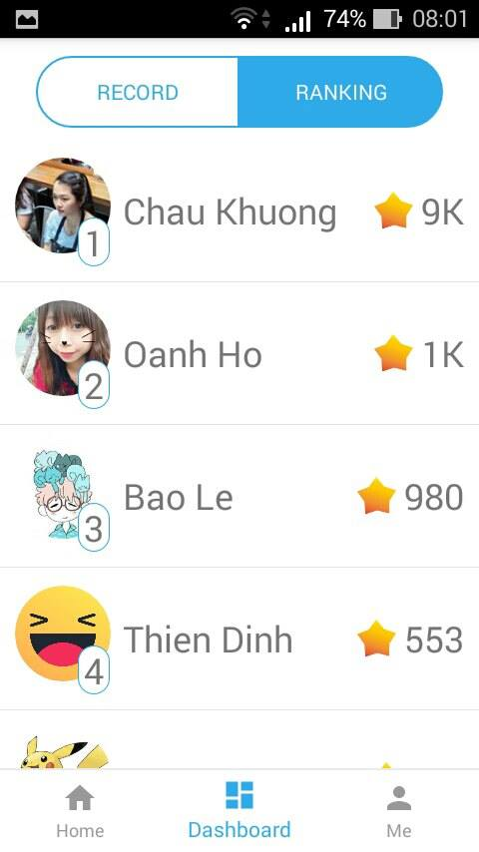

- Advertise:

If you don’t login, you have to watch add before doing the quiz, but if you login, you can do the quiz without watching advertise once time everyday, and then you have to watch advertise before redo the quiz in the same day.

