RSA

DIAGRAMS

and STATE MACHINE

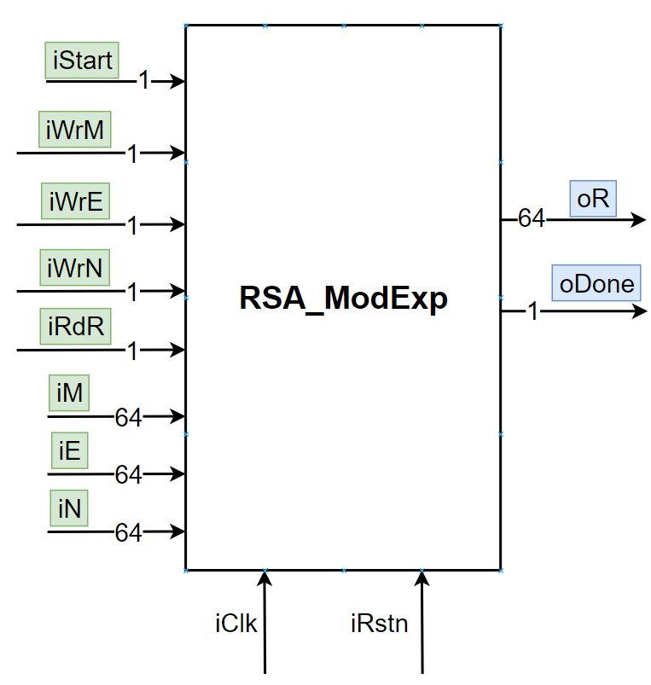

|  |  |  |  |
| --- | --- | --- | --- |
| PIN | DIR | WIDTH | Description |
| Control signals | | | |
| iClk | Input | 1 | Clock |
| iRstn | Input | 1 | Reset low |
| iStart | Input | 1 | Start computing |
| iWrM | Input | 1 | Write M |
| iWrE | Input | 1 | Write E |
| iWrN | Input | 1 | Write N |
| iRdR | Input | 1 | Read Result |
| Input Data | | | |
| iM | Input | 64 | M |
| iE | Input | 64 | E |
| iN | Input | 64 | N |
| Output Data | | | |
| oR | Output | 64 | Result |
| oDone | Output | 1 | Finish computing |

|  |  |
| --- | --- |
| Submodule | File Name |
| RSA_addsub | RSA_addsub.v |
| RSA_getNumBit | RSA_getNumBit.v |
| RSA_comp | RSA_comp.v |

|  |  |
| --- | --- |
| Name | File Name |
| RSA_ModExp | RSA_ModExp.v |

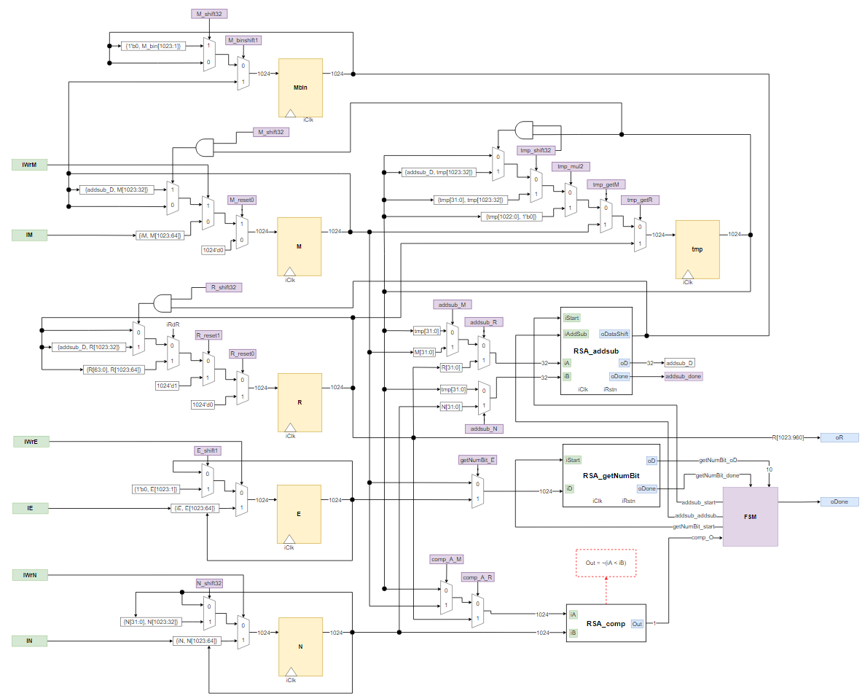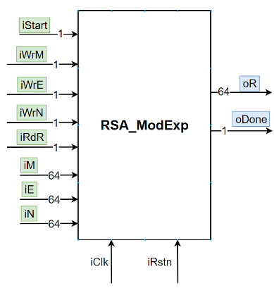

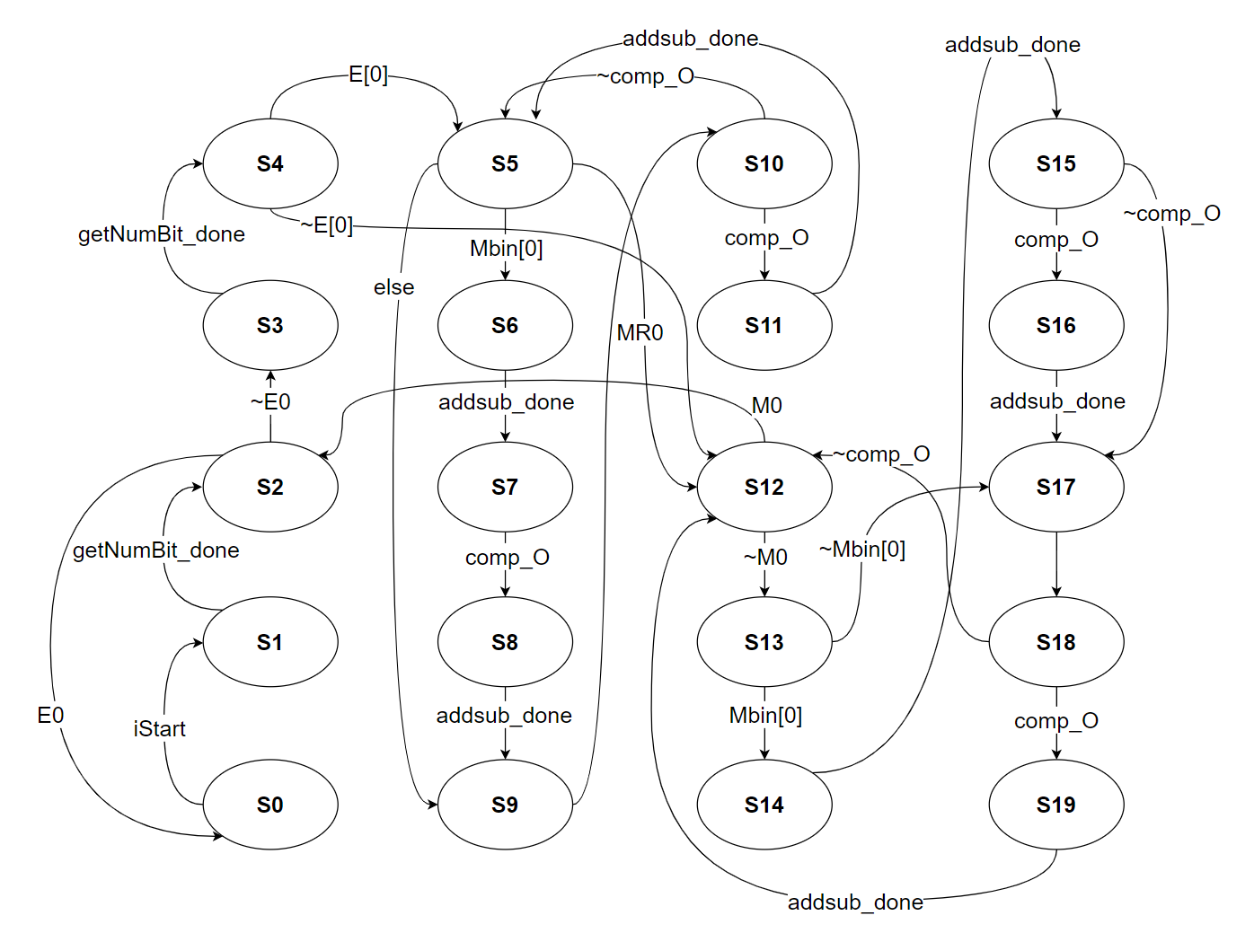

Finite State Machine

FSM Signals

**RESET**

oDone = 1’b0

State = 5’d0

M_reset0 = 1’b0

M_shift32 = 1’b0

Mbin_update = 1’b0

Mbin_shift1 = 1’b0

E_shift1 = 1’b0

N_shift32 = 1’b0

R_reset0 = 1’b0

R_reset1 = 1’b0

R_shift32 = 1’b0

tmp_getR = 1’b0

tmp_getM = 1’b0

tmp_mul2 = 1’b0

tmp_shift32 = 1’b0

tmp_shift32_update = 1’b0

addsub_start = 1’b0

addsub_addsub = 1’b0

getNumBit_start = 1’b0

comp_A_R = 1’b0

comp_A_M = 1’b0

getNumBit_E = 1’b0

addsub_R = 1’b0

addsub_M = 1’b0

addsub_N = 1’b0

lenE = 11’d0

lenM = 11’d0

**STATE0**

if (iStart) begin

State = 5’d1

getNumBit_start = 1’b1

getNumBit_E = 1’b1

else

State = State

**STATE1**

getNumBit_start = 1’b0

if(getNumBit_done)

lenE = getNumBit_oD

R_reset1 = 1

State = 5’d2

else

State = State

**STATE2**

R_reset1 = 1’b0

if (lenE = 11’b0)

oDone = 1’b1

State = 5’d0

else

getNumBit_start = 1’b1

getNumBit_E = 1’b0

State = 5’d3

**STATE3**

getNumBit_start = 1’b0

if (getNumBit_done)

lenM = getNumBit_oD

lenMR = getNumBit_oD

Mbin_update = 1’b1

State = 5’d4

else

State = State

**STATE4**

E_shift1 = 1’b1

if (E[0])

Mbin_update = 1’b0

tmp_getR = 1’b1

R_reset0 = 1’b1

State = 5’d5

else

Mbin_update = 1’b1

tmp_getR = 1’b1

M_reset0 = 1’b1

State = 5’d12

**STATE5**

E_shift1 = 1’b0

tmp_getR = 1’b0

R_reset0 = 1’b0

if (lenMR = 11’d0)

Mbin_update = 1’b1

tmp_getM = 1’b1

M_reset0 = 1’b1

State = 5’d12

else

Mbin_shift1 = 1’b1

if(Mbin[0])

addsub_start = 1’b1

addsub_addusb = 1’b1

addsub_R = 1’b1

addsub_N = 1’b0

R_shift32 = 1’b1

tmp_shift32 = 1’b1

State = 5’d6

else

tmp_mul2 = 1’b1

State = 5’d9

**STATE6**

Mbin_shift1 = 1’b0

addsub_start = 1’b0

if (addsub_done)

R_shift32 = 1’b0

tmp_shift32 = 1’b0

comp_A_R = 1’b1

State = 5’d7

else

State = State

**STATE7**

if (comp_O)

addsub_start = 1’b1

addsub_addsub = 1’b1

addsub_R = 1’b1

addsub_N = 1’b1

R_shift32 = 1’b1

N_shift32 = 1’b1

State = 5’d8

else

tmp_mul2 = 1’b1

State = 5’d9

**STATE8**

addsub_start = 1’b0

if (addsub_done)

R_shift32 = 1’b0

N_shift32 = 1’b0

tmp_mul2 = 1’b1

State = 5’d9

else

State = State

**STATE9**

Mbin_shift1 = 1’b0

tmp_mul2 = 1’b0

comp_A_R = 1’b0

comp_A_M = 1’b0

State = 5’d10

**STATE10**

if (comp_O)

addsub_start = 1’b1

addsub_addsub = 1’b1

addsub_R = 1’b0

addsub_M = 1’b0

addsub_N = 1’B1

tmp_shift32_update = 1’b1

N_shift32 = 1’b1

State = 5’d11

else

lenMR = lenMR – 1’b1

State = 5’d5

**STATE11**

addsub_start = 1’b0

if (addsub_done)

tmp_shift32_update = 1’b0

N_shift32 = 1’b0

lenMR = len MR – 1’b1

State = 5’d5

else

State = State

**STATE12**

E_shift1 = 1’b0

Mbin_update = 1’b0

tmp_getM = 1’b0

M_reset0 = 1’b0

if (lenM = 11’d0)

lenE = lenE – 1’b1

State = 5’d2

else

State = 5’d13

**STATE13**

Mbin_shift1 = 1’b1

if (Mbin[0])

addsub_start = 1’b1

addsub_addsub = 1’b0

addsub_R = 1’b0

addsub_M = 1’b1

addsub_N = 1’b0

M_shift32 = 1’b1

tmp_shift32 = 1’b1

State = 5’d14

else

tmp_mul2 = 1’b1

State = 5’d17

**STATE14**

Mbin_shift1 = 1’b0

addsub_start = 1’b0

if (addsub_done)

M_shift32 = 1’b0

tmp_shift32 = 1’b0

comp_A_R = 1’b0

comp_A_M = 1’b1

State = 5’d15

else

State = State

**STATE15**

if(comp_O)

addsub_start = 1’b1

addsub_addsub = 1’b1

addsub_R = 1’b0

addsub_M = 1’b1

addsub_N = 1’b1

M_shift32 = 1’b1

N_shift32 = 1’b1

State = 5’d16

else

tmp_mul2 = 1’b1

State = 5’d17

**STATE16**

addsub_start = 1’b0

if (addsub_done)

M_shift32 = 1’b0

N_shift32 = 1’b0

tmp_mul2 = 1’b1

State = 5’d17

else

State = State

**STATE17**

Mbin_shift1 = 1’b0

tmp_mul2 = 1’b0

comp_A_R = 1’b0

comp_A_M = 1’b0

State = 5’d18

**STATE18**

if (comp_O)

addsub_start = 1’b1

addsub_addsub = 1’b1

addsub_R = 1’b1

addsub_M = 1’b0

addsub_N = 1’b1

tmp_shift32_update = 1’b1

N_shift32 = 1’b1

State = 5’d19

else

lenM = lenM – 1’b1

State = 5’d12

**STATE19**

addsub_start = 1’b0

if (addsub_done)

tmp_shift32_update = 1’b0

N_shift32 = 1’b0

lenM = lenM – 1’b1

State = 5’d12

else

State = State

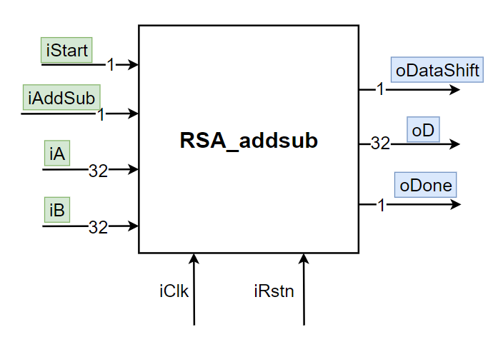

|  |  |
| --- | --- |
| Name | File Name |
| RSA_addsub | RSA_addsub.v |

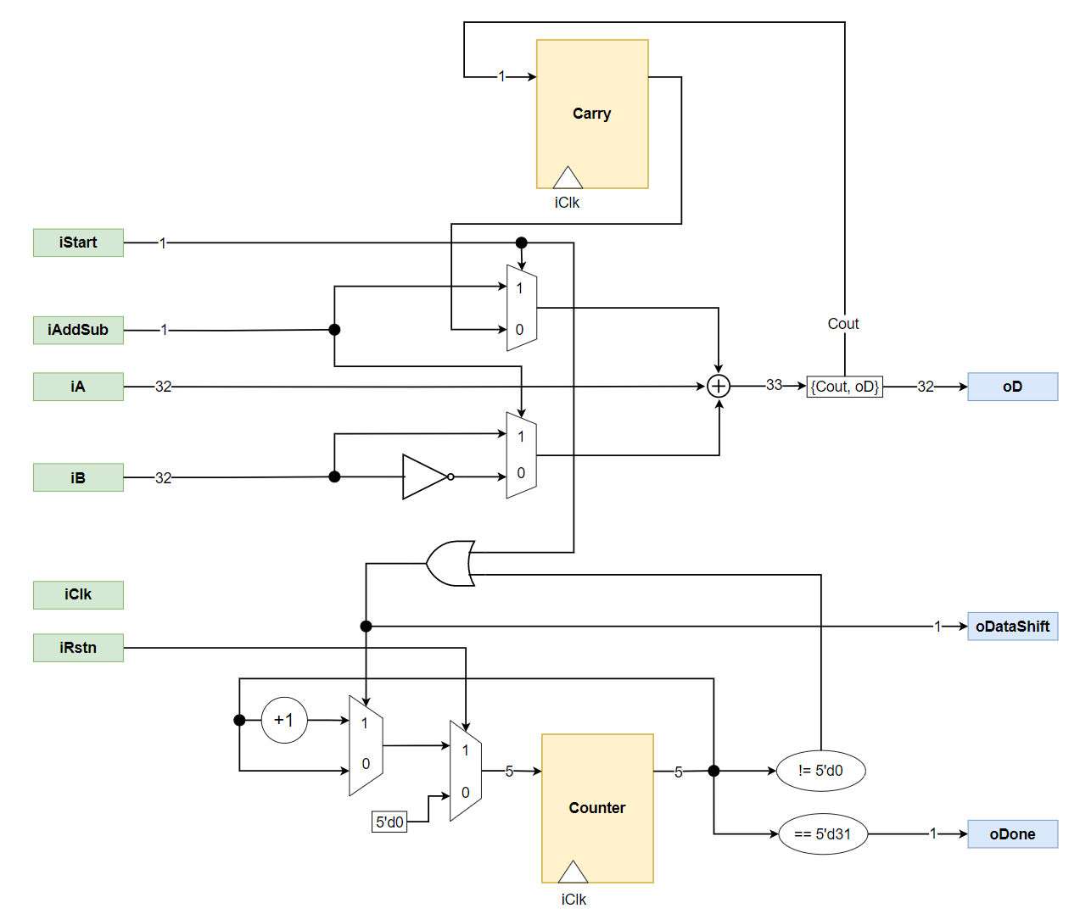

|  |  |
| --- | --- |
| Name | File Name |
| RSA_getNumBit | RSA_getNumBit.v |

