**Build Results**

1. **FPGA Results:**

Device: Stratix IV EP4SGX530NF45C3

Fmax: 160.98MHz

|  |  |  |
| --- | --- | --- |
|  | Combinational ALUTs | Registers |
| aes-gcm | 11566 | 3504 |
| * gctr_block | 3789 | 2987 |
| * + aes_core | 3489 | 2469 |
| * + aes_decipher_block | 991 | 137 |
| * + aes_encipher_block | 609 | 137 |
| * + aes_key_mem | 1526 | 2191 |
| * + aes_sbox | 160 |  |
| * ghash_block | 7391 |  |
| * + gfmul | 7263 |  |

1. **ASIC Results**

|  |  |
| --- | --- |
|  | ROHM |
| Sequential Instance | 3504 |
| Combinational Instance | 39904 |
| Cells | 43408 |
| Cell Area | 1211087.002 um2 |
| Net Area | 636855.917 um2 |
| Total Power | 869.499 mW |
| Fmax | 94 MHz |

1. Synthesis Results:

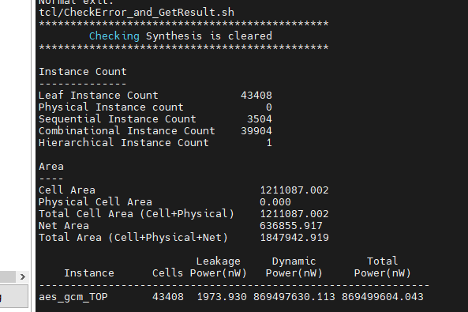



PnR Results:

