**Build Results**

1. **Synthesis Results**

|  |  |
| --- | --- |
|  | ROHM |
| Sequential Instance | 3,641 |
| Combinational Instance | 9,974 |
| Cells | 13,615 |
| Cell Area | 462,809.088 um2 |
| Net Area | 220,948.683 um2 |
| Total Power | 113.01 mW |
| Fmax | 93 MHz |

1. 50MHz:

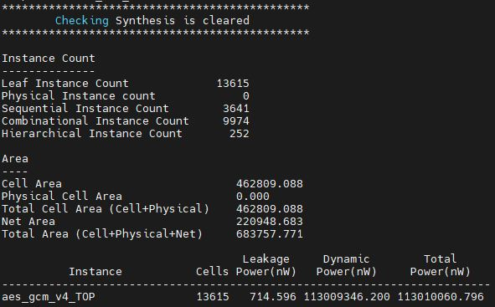

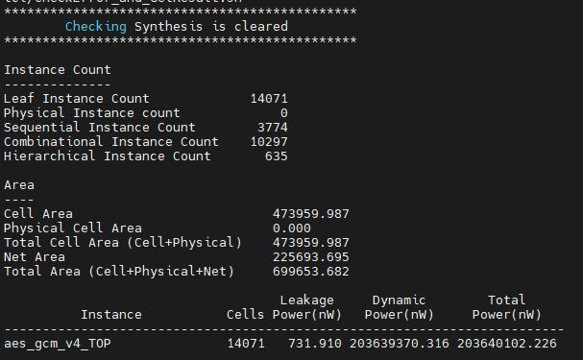2. 100MHz:

|  |  |
| --- | --- |
|  | ROHM |
| Sequential Instance | 3,774 |
| Combinational Instance | 10,297 |
| Cells | 14,071 |
| Cell Area | 473959.987 um2 |
| Net Area | 225,693.695 um2 |
| Total Power | 203.64 mW |
| Fmax | 105 MHz |

