CMSC203 Assignment 0

Class: CMSC203 CRN XXXX
Program: Assignment 0
Instructor: Iraida Cabrera Carnero and David Kuijt
Summary of Description: (Give a brief description for each Program) A program that requires you to use functions to calculate the volume of a box and the volume of a Sphere.
Due Date: No Due Date
Integrity Pledge: I pledge that I have completed the programming assignment independently.
I have not copied the code from a student or any source.

Complete the following five parts of Assignment 0. Name your file as FirstInitialLastName_Assignment0.docx

Part1: Setup GitHub: Provide the screen shots of your GitHub account with Assignment 0 file is uploaded on GitHub:
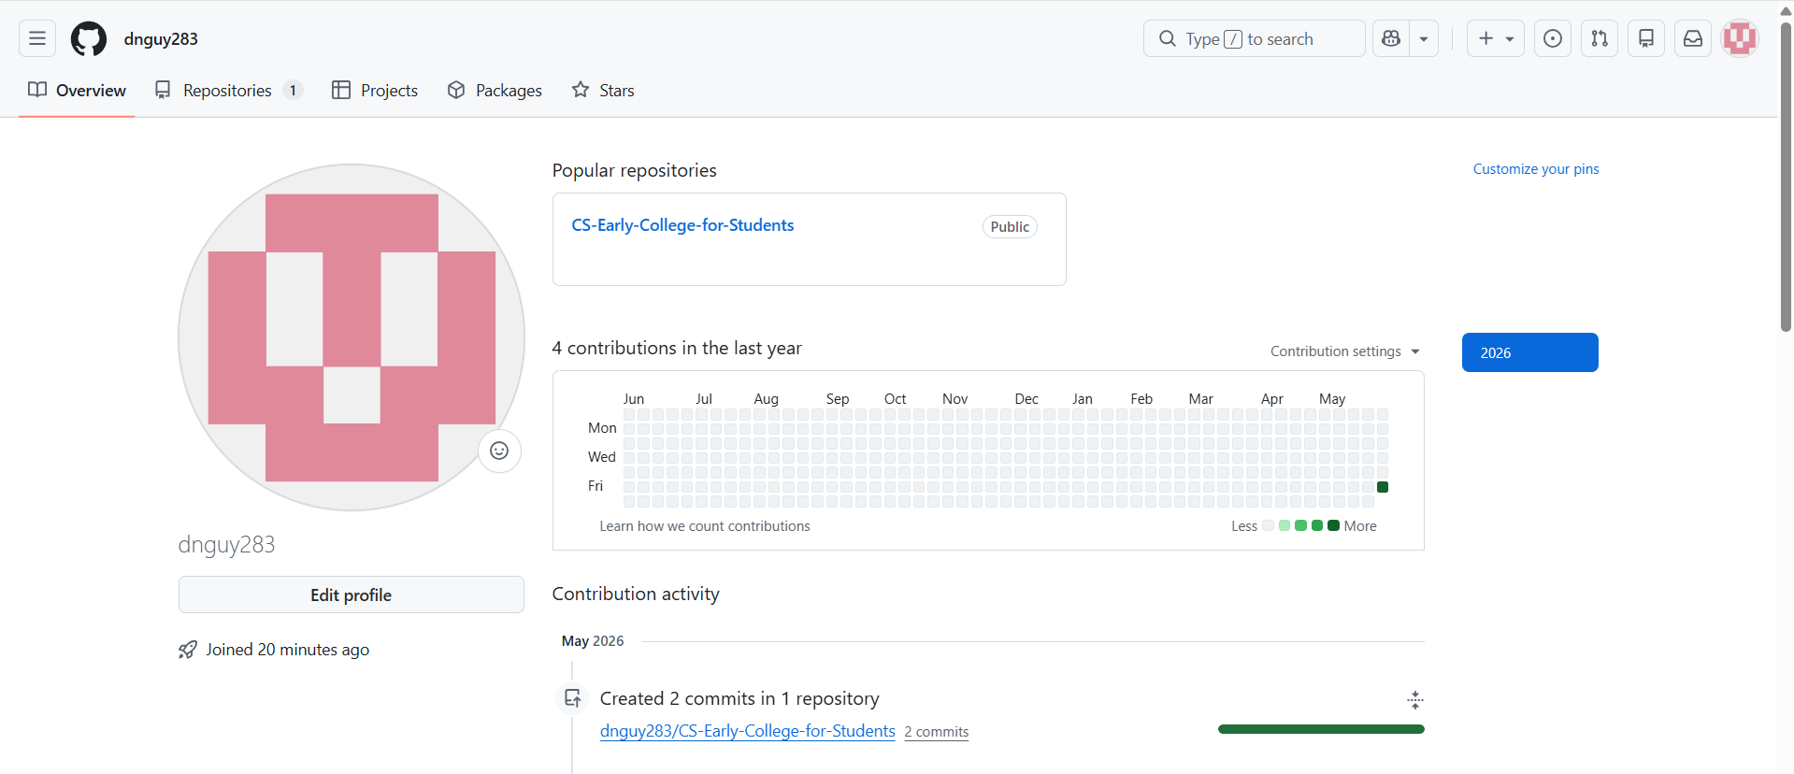
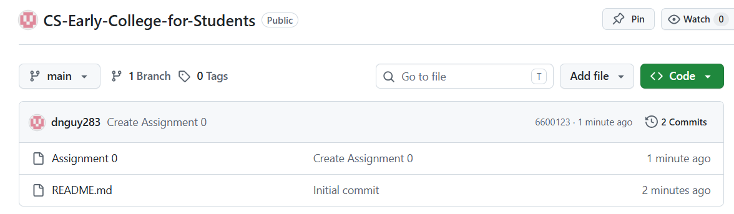

Part 2 -Install JDK, Test java Application from Command Line
Provide the screen shots from Step 1 and 2 here:
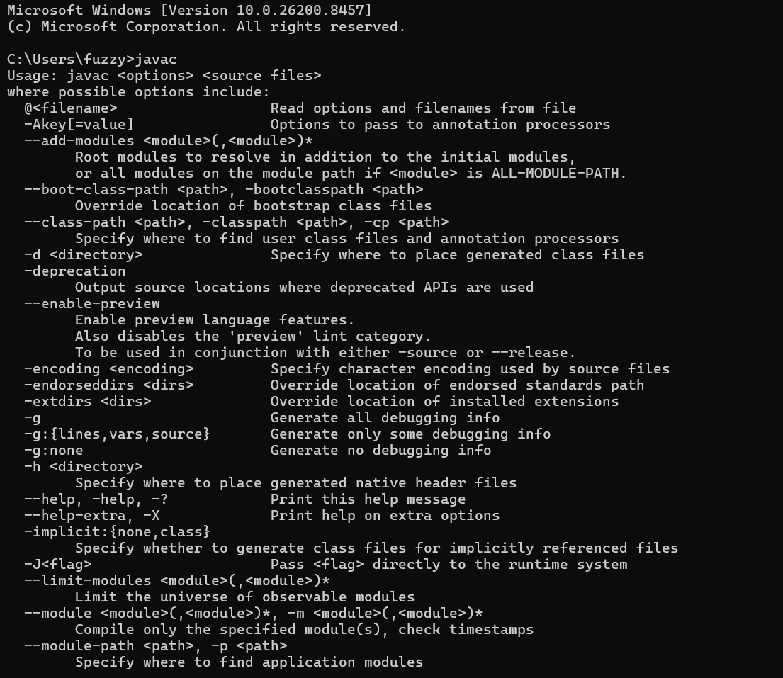
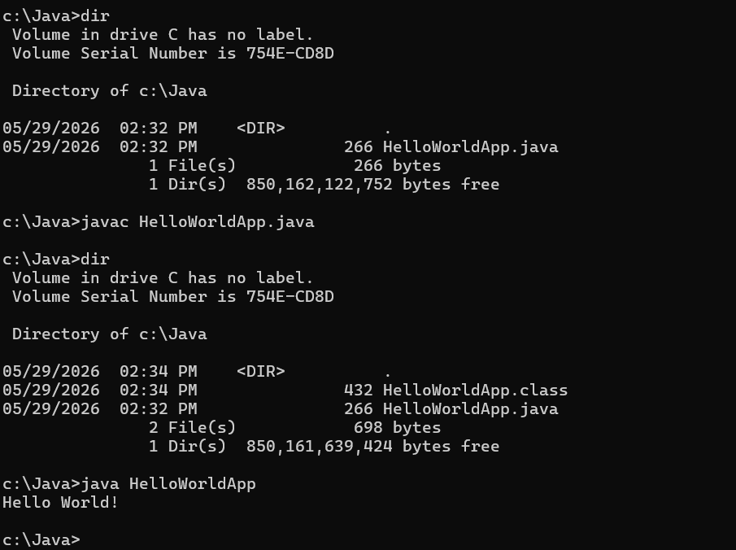

Part 3 - Install Eclipse, Test Eclipse Java Application
Provide the screen shots from Step 1 and 2 here:
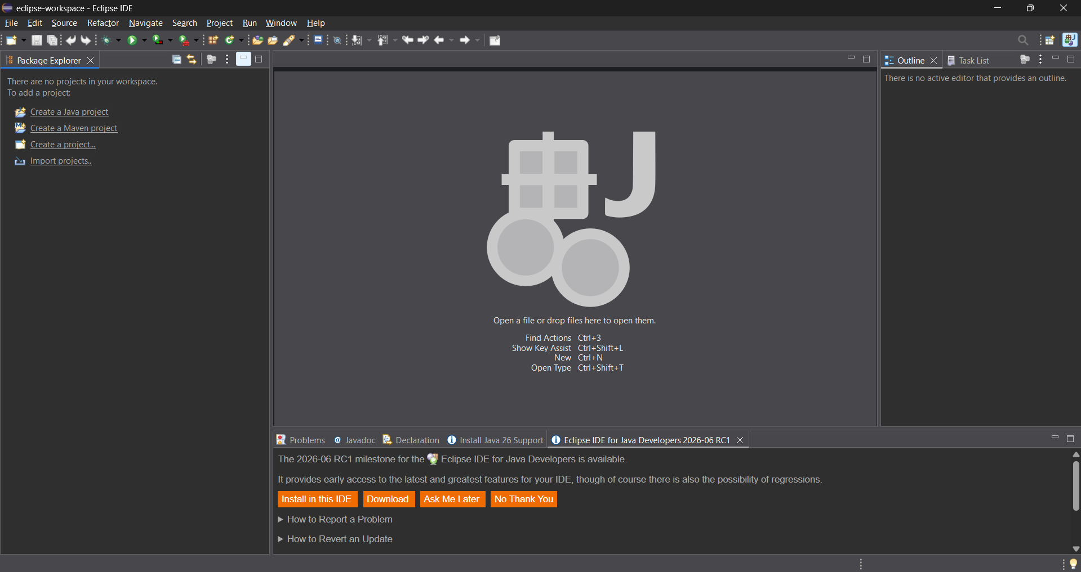
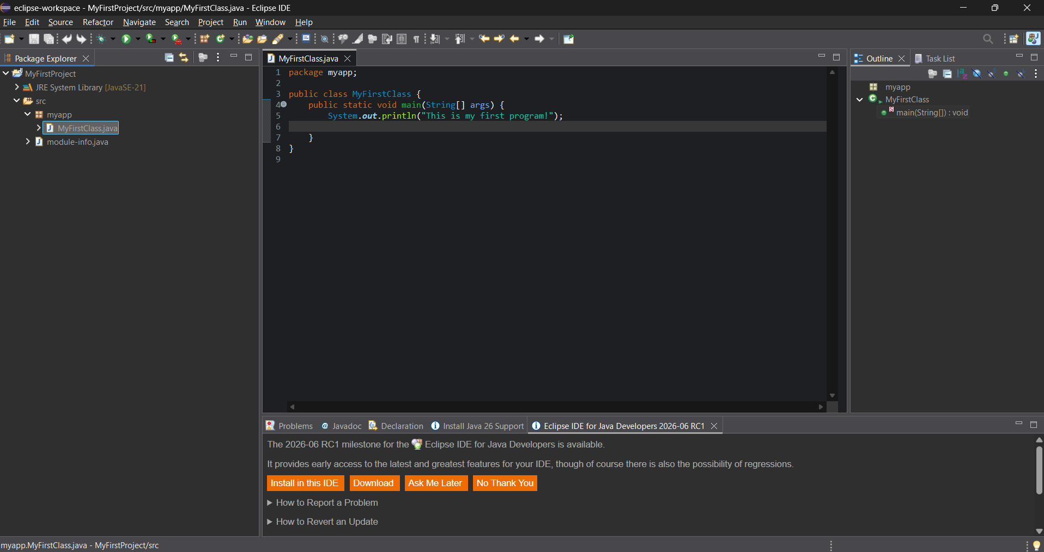
Part 4 - Install, Setup, Test Junit Program.
Provide the screen shots showing:
  - Eclipse with working JUnit Test example
  - Project screenshot
  - Running example screenshot

Part 5 - Install, Setup, and Test JavaFX Application.
Provide the screen shots showing:
- JavaFX Project screenshot
- Running example screenshot
- Java Source Code File

Lessons Learned <Provide answers to the questions listed below>:

Write about your Learning Experience, highlighting your lessons learned and learning experience from working on this assignment.

What have you learned?
I have learned how to set up a GitHub account and create repositories, set up a JDK, install Eclipse, JUnit, and JavaFX.

What did you struggle with?
I struggled in parts four and five, in which I had to install JUnit and JavaFX.

What parts of this assignment were you successful with, and what parts (if any) were you not successful with?
I was successful on all parts of this assignment.

Provide any additional resources/links/videos you used to while working on this assignment.

Check List: <Provide answers to the column Y/N or N/A >:

# |  | Y/N | Comments
 | Assignment files:
 | - FirstInitialLastName_Assignment0.docx/pdf | Yes
 | - Source java files | Yes
 | Program compiles | Yes
 | Program runs with desired outputs related to a Test Plan | Yes
 | Documentation file: Screenshots of
 | - Part1: Setup GitHub | Yes
 | - Part 2 -Install JDK, Test java Application from Command Line | Yes
 | - Part 3 - Install Eclipse, Test Eclipse Java Application | Yes
 | - Part 4 - Install, Setup, Test Junit Program | N/A | NO INSTRUCTIONS GIVEN
 | - Part 5 - Install, Setup, and Test JavaFX Application. | N/A | NO INSTRUCTIONS GIVEN
 | - Lessons Learned | Yes
 | - Checklist is completed and included in the Documentation | Yes

