**Line cooks** can even intercept the order and relay [inquiries](http://www.google.de/) back to the waiter who can then ask the patron. This way, confusion and sent-back orders can be kept to a minimum while delighting the guests with your attention to detail. All devices sport an easy-to-use touch interface and report back to a central management console which gives your management unique and aggregated insights into the day-to-day operations.

[Internal Link(Valid)](coremedia://Sites/Chef%20Corp./United%20States/English/Editorial/Homepage/Kitchen%20Dreams/Having%20fun%20in%20your%20kitchen)

[InternalLink (Invalid)](coremedia://Not%20Found)

**Productivity** and experience enhancements are made possible by **Chef Corp. Integrated Technology** for a Seamless Guest Experience. This interconnected system of handheld ordering and payment devices as well as kitchen order display and inquire devices enables your kitchen staff to go to work while the order is still being placed.

|  |  |  |
| --- | --- | --- |
| This | Is | A |
| Very | Exiting | table |

This is an unordered list

* Green
* Yellow
* Blue

This is an ordered list

1. One
2. Two
3. Three

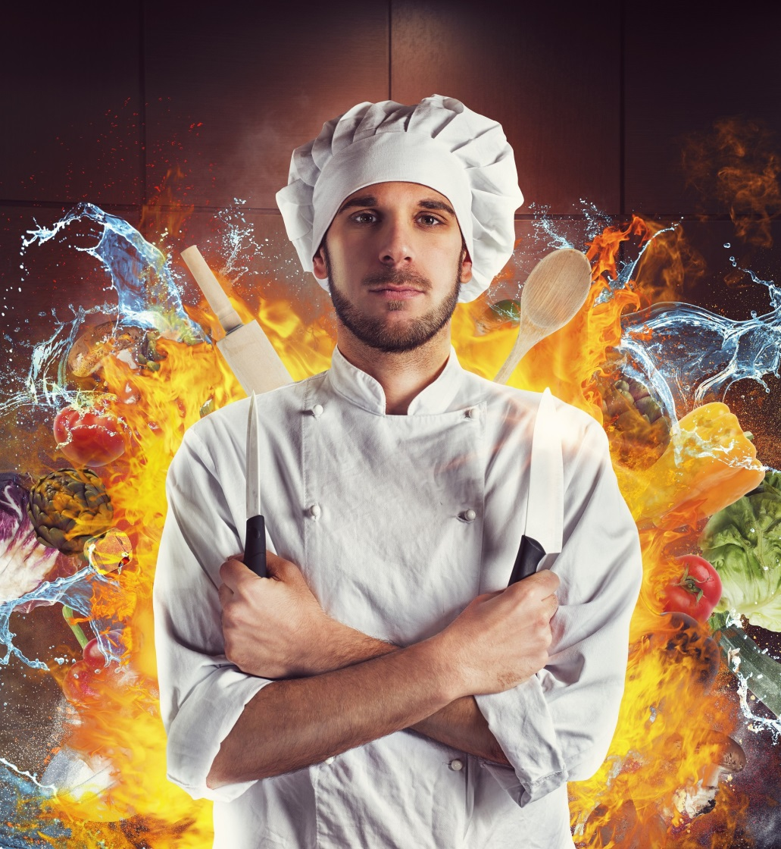

In high class restaurants, waiters are proud to memorize your order and even your special wishes by heart. If your staff is on that level, don't read any further. Most waiters, though, rely on pen and paper which are still staples of the restaurant world today. There is nothing wrong with that, since this is often still the most effective means of getting the order to the kitchen and keep everything organized until the bill has to be produced.

This is underlined text.

**This is bold text.**

*This is italic text.*

~~This is strikethrough text.~~

This is centered text.

This is right aligned text.

This is justified text.



However, new technology allows for so much more. A kitchen that has the order of the first guest in the pan while the second is still ordering is not a delusional daydream anymore. Neither is a perfect bill that the waiter can print out immediately when being asked without any delay. Even better, immediate and convenient payment at the table is entirely within your reach.

