Business Requirements Document (BRD)

MCP Code Intelligence — KSA-102: Adaptive Token Cache + Model Manager for multilingual find_tools

Document Information
Field | Value
Jira Ticket | KSA-102
Title | Adaptive Token Cache + Model Manager for multilingual find_tools
Author | BA Agent
Version | 1.0
Date | 2026-05-21
Status | Draft

Author Tracking
Role | Name - Position | Responsibility
Author | BA Agent – Business Analyst | Create document
Peer Reviewer | SA Agent – Solution Architect | Review technical feasibility

Revision History
Version | Date | Author | Changes
1.0 | 2026-05-21 | BA Agent | Initiate document — auto-generated from Jira ticket KSA-102 and design decisions

Sign-Off
Name | Signature and date
 | ☐ I agree and confirm all criteria on this BRD as expected requirements
 | ☐ I agree and confirm all criteria on this BRD as expected requirements

1. Introduction

1.1 Scope
This change request implements a self-learning multilingual tool discovery system for the MCP Code Intelligence platform. The system enhances find_tools with:
- Adaptive Token Cache — learns from embedding search results to accelerate future queries
- Model Manager — allows users to download, switch, and manage embedding models (including multilingual models for Vietnamese search)
The implementation spans all 3 MCP modules: Python, Node.js Bridge, and Kotlin Server.

1.2 Out of Scope
- Training custom embedding models
- Cloud-hosted embedding inference (all inference is local ONNX)
- Changes to the MCP protocol itself
- UI/frontend for model management (uses MCP Elicitation pattern only)
- Automatic multilingual model download (user must opt-in)

1.3 Preliminary Requirement
- KSA-101: find_tools FAILED server retry mechanism must be implemented (provides the retry infrastructure this feature builds upon)
- ONNX Runtime already bundled as optional dependency (pip install mcp-code-intel[embedding])
- Existing all-MiniLM-L6-v2 model (90MB, English-only) already available at .code-intel/models/

2. Business Requirements

2.1 High Level Process Map
The system implements a tiered search strategy with self-learning capability:
- Tier 1 — Tokenized Search (0ms): Current exact/fuzzy token matching in registry
- Tier 2 — Learned Cache Lookup (0ms): Check if query has been previously resolved via embedding
- Tier 3 — Embedding Search (10-50ms): Semantic similarity search using ONNX model
- Tier 4 — Learn & Cache: If embedding finds a match (score > 0.75), cache the mapping
- Tier 5 — Delegate/KB Fallback: Existing nested delegation and KB search
Over time, the cache grows and Tier 3 calls decrease — the system “learns” common queries.

2.2 List of User Stories / Use Cases
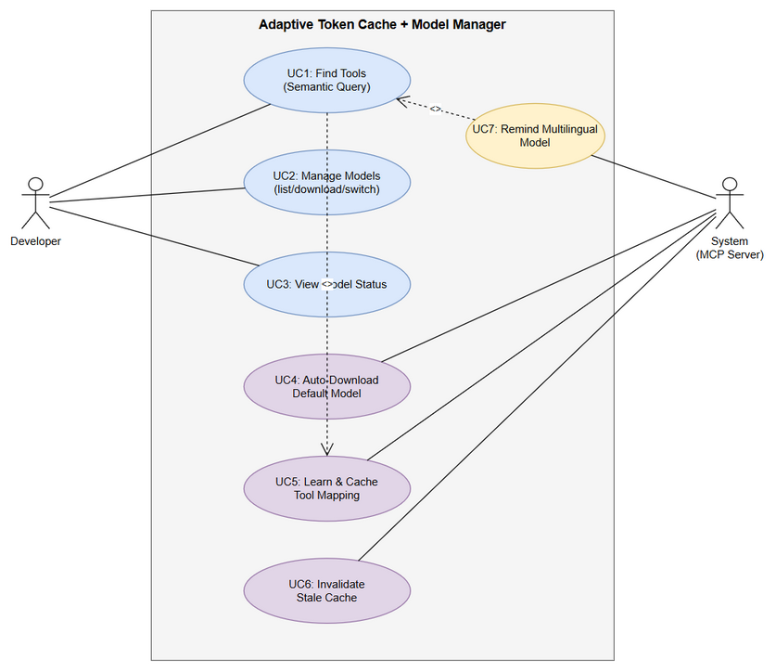
Use Case Diagram
# | Story / Use Case | Priority | Source Ticket
1 | As a developer, I want find_tools to understand semantic queries so that I can find tools even when my query doesn’t match exact token names | MUST HAVE | KSA-102
2 | As a developer, I want find_tools to learn from successful embedding searches so that repeated queries are instant | MUST HAVE | KSA-102
3 | As a developer, I want to manage embedding models (list, download, switch) so that I can enable multilingual search | MUST HAVE | KSA-102
4 | As a developer, I want the system to auto-download the smallest model on first use so that embedding works out-of-the-box | SHOULD HAVE | KSA-102
5 | As a developer, I want the system to remind me about multilingual models when Vietnamese queries fail so that I know how to enable full language support | SHOULD HAVE | KSA-102
6 | As a developer, I want the token cache to persist across sessions so that learned mappings survive restarts | MUST HAVE | KSA-102
7 | As a developer, I want cache invalidation when tools change so that stale mappings don’t return wrong results | MUST HAVE | KSA-102

2.3 Details of User Stories

Business Flow
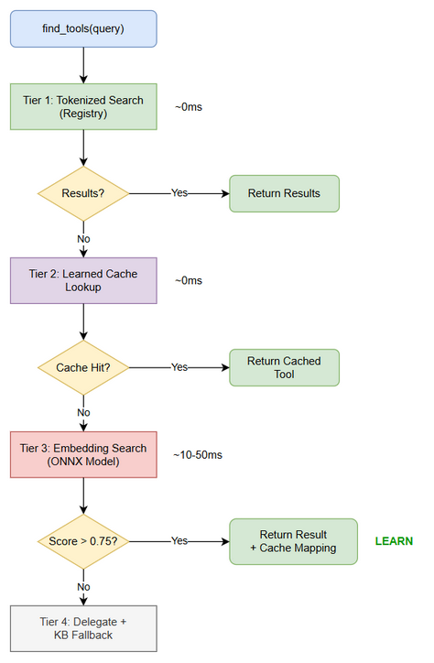
Business Flow
Step 1: User calls find_tools(query) with a natural language query (e.g., “search jira issues”)
Step 2: System performs tokenized search in registry (current behavior, ~0ms)
Step 3: If tokenized search returns results → return immediately (no change from current)
Step 4: If tokenized search misses → check learned token cache for this query
Step 5: If cache hit → return cached tool mapping instantly (~0ms)
Step 6: If cache miss → perform embedding search using ONNX model (~10-50ms)
Step 7: If embedding search finds match (cosine similarity > 0.75) → return result AND cache the query→tool mapping
Step 8: If embedding also misses → fall through to existing delegate/KB fallback
Step 9: Next time same/similar query arrives → cache hit at Step 5, skipping expensive embedding
Note: The cache uses fuzzy matching — similar queries (e.g., “jira search” and “search jira”) can share cached results via token normalization.

STORY 1: Semantic Tool Discovery via Embedding
As a developer, I want find_tools to understand semantic queries so that I can find tools even when my query doesn’t match exact token names
Requirement Details:
- When tokenized search returns no results, system MUST attempt embedding-based semantic search
- Embedding search computes cosine similarity between query embedding and all registered tool embeddings
- Results with similarity score > 0.75 are considered matches
- Embedding search MUST use the locally-installed ONNX model (no network calls during search)
- If no model is installed, embedding search is skipped gracefully (no error, just falls through to next tier)
Acceptance Criteria:
- Given a query “search jira issues” and tool named “jira_search” exists, when tokenized search misses, then embedding search finds “jira_search” with score > 0.75
- Given no ONNX model installed, when embedding search is attempted, then it gracefully skips without error and falls through to delegate/KB
- Given embedding search takes > 100ms, then it times out and falls through (hard timeout)
- Embedding search MUST NOT block the main event loop

STORY 2: Self-Learning Token Cache
As a developer, I want find_tools to learn from successful embedding searches so that repeated queries are instant
Requirement Details:
- When embedding search successfully finds a tool (score > 0.75), the system MUST cache the mapping: query_tokens → tool_name
- Cache key is the normalized token set of the query (not raw string) — enables fuzzy matching
- Cache stores: { tokens: Set<string>, tool_name: string, score: float, timestamp: ISO8601 }
- On subsequent calls, if query tokens match a cached entry, return cached tool directly (0ms)
- Fuzzy cache match: if ≥80% of query tokens match a cached entry’s tokens, consider it a hit
Data Fields:
Field | Type | Required | Description | Example
tokens | Set<string> | Yes | Normalized token set from query | {"search", "jira", "issues"}
tool_name | string | Yes | Resolved tool name | "jira_search"
score | float | Yes | Original embedding similarity score | 0.87
timestamp | string | Yes | ISO8601 when cached | "2026-05-21T10:00:00Z"
hit_count | int | Yes | Times this cache entry was used | 15
Acceptance Criteria:
- Given query “search jira” resolved via embedding to “jira_search”, when same query is called again, then result comes from cache (0ms, no embedding call)
- Given query “jira search” (reordered tokens), when called after “search jira” was cached, then cache hit occurs (fuzzy match)
- Given cache has 1000 entries, when lookup is performed, then it completes in < 1ms
- Cache entries with hit_count = 0 after 30 days are eligible for eviction

STORY 3: Model Manager Tool
As a developer, I want to manage embedding models (list, download, switch) so that I can enable multilingual search
Requirement Details:
- New MCP tool: mem_model_manager with actions: list, download, status, switch
- Uses MCP Elicitation pattern for interactive model selection (user picks from dropdown)
- Models stored globally at ~/.code-intel/models/ (shared across all workspaces)
- Registry file: ~/.code-intel/models/registry.json tracks downloaded models
- Available models:
  - all-MiniLM-L6-v2 (English-only, ~90MB, 30K vocab) — default
  - paraphrase-multilingual-MiniLM-L12-v2 (50+ languages including Vietnamese, ~470MB, 250K vocab)
Data Fields:
Field | Type | Required | Description | Example
action | string | Yes | One of: list, download, status, switch | "download"
model_name | string | No | Model identifier (required for download/switch) | "paraphrase-multilingual-MiniLM-L12-v2"
Acceptance Criteria:
- Given action=“list”, then return all available models with download status and size
- Given action=“download” with model_name, then download model from HuggingFace to ~/.code-intel/models/{model_name}/
- Given action=“status”, then return current active model name, path, and capabilities
- Given action=“switch” with model_name (already downloaded), then switch active model and rebuild tool embeddings
- If model not downloaded and action=“switch”, then return error with download instructions
- Elicitation UI shows dropdown with model options when user calls without specifying model_name

STORY 4: Auto-Download Smallest Model
As a developer, I want the system to auto-download the smallest model on first use so that embedding works out-of-the-box
Requirement Details:
- On first find_tools call that reaches embedding tier, if no model exists, auto-download all-MiniLM-L6-v2
- Download happens in background (non-blocking) — current call falls through to delegate/KB
- Next call after download completes will use embedding
- Download progress logged to stderr (visible in MCP server logs)
- If download fails (network error), log warning and continue without embedding (graceful degradation)
Acceptance Criteria:
- Given fresh install with no models, when first find_tools misses tokenized search, then model download starts in background
- Given download in progress, when find_tools is called, then it does NOT block — falls through to delegate/KB
- Given download completed, when next find_tools misses tokenized search, then embedding search is used
- Given no network available, when auto-download fails, then system continues working without embedding (no crash)

STORY 5: Multilingual Model Reminder
As a developer, I want the system to remind me about multilingual models when Vietnamese queries fail so that I know how to enable full language support
Requirement Details:
- When a query contains non-ASCII characters (Vietnamese, Chinese, etc.) AND embedding search returns no results AND current model is English-only
- System adds a hint in the response: “💡 Tip: Download multilingual model for better {language} support. Use: mem_model_manager(action=‘download’, model_name=‘paraphrase-multilingual-MiniLM-L12-v2’)”
- Hint appears at most once per session (don’t spam)
- Does NOT force download — user decides
Acceptance Criteria:
- Given English-only model active and query “tìm kiếm jira” returns no embedding results, then response includes multilingual model hint
- Given hint already shown in this session, when another Vietnamese query fails, then no duplicate hint
- Given multilingual model already active, when Vietnamese query is used, then no hint shown (model already supports it)

STORY 6: Cache Persistence
As a developer, I want the token cache to persist across sessions so that learned mappings survive restarts
Requirement Details:
- Cache persisted to {workspace}/.code-intel/token-cache.json
- Loaded on server startup (lazy — only when first cache lookup needed)
- Saved after each new cache entry (debounced — max 1 write per 5 seconds)
- File format: JSON array of cache entries
- Max cache size: 10,000 entries (LRU eviction when exceeded)
Acceptance Criteria:
- Given cache has entries, when server restarts, then cache is loaded and entries are available
- Given new entry cached, then file is updated within 5 seconds
- Given cache exceeds 10,000 entries, then least-recently-used entries are evicted
- Given corrupted cache file, then system starts with empty cache (no crash) and logs warning

STORY 7: Cache Invalidation
As a developer, I want cache invalidation when tools change so that stale mappings don’t return wrong results
Requirement Details:
- Cache entries include a tool_version field (hash of tool registry state when cached)
- On server startup, compute current tool registry hash
- If registry hash differs from cached entries’ tool_version → invalidate those entries
- When new tools are registered (nested discovery) → mark affected cache entries as stale
- Stale entries are not deleted immediately — they’re skipped during lookup and cleaned up on next persist
Acceptance Criteria:
- Given tool “jira_search” was cached, when server restarts with different tool set, then cache entry for “jira_search” is invalidated
- Given nested discovery adds new tools, when cache lookup finds a stale entry, then it’s skipped (falls through to embedding)
- Given 50% of cache entries are stale after tool change, then only stale entries are invalidated (valid entries preserved)

3. Dependencies
Dependency | Type | Related Ticket | Description
KSA-101 | System | KSA-101 | find_tools FAILED server retry — provides retry infrastructure
KSA-62/63 | System | KSA-62, KSA-63 | find_tools core requirements and architecture
ONNX Runtime | External | N/A | Already bundled as optional dep for embedding inference
HuggingFace Hub | External | N/A | Model download source (sentence-transformers models)
all-MiniLM-L6-v2 | External | N/A | Default English embedding model (90MB)
paraphrase-multilingual-MiniLM-L12-v2 | External | N/A | Optional multilingual model (470MB)

4. Stakeholders
Role | Name / Team | Responsibility | Source
Reporter | Duc Nguyen Minh | Product Owner, requirements definition | Jira reporter
Developer | Development Team | Implementation across 3 MCP modules | Jira assignee
Architect | SA Agent | Technical design and feasibility review | Review

5. Risks and Assumptions

5.1 Risks
Risk | Impact | Likelihood | Mitigation
Model download fails on restricted networks | Medium | Medium | Graceful degradation — system works without embedding, just slower
Cache grows unbounded in active workspaces | Low | Low | LRU eviction at 10K entries, debounced writes
Embedding model produces false positives (score > 0.75 but wrong tool) | High | Low | Conservative threshold (0.75), cache entries can be invalidated
ONNX Runtime not installed (optional dep) | Medium | Medium | Graceful skip — embedding tier disabled, no crash
Multilingual model too large for some users (470MB) | Low | Medium | Never auto-download large model, only remind user
Cross-platform path issues (~/.code-intel/) | Medium | Low | Use pathlib for all path operations, test on Windows/Mac/Linux

5.2 Assumptions
- ONNX Runtime is already available as optional dependency in the Python module
- The existing model_downloader.py and onnx_provider.py provide working embedding infrastructure
- Users have internet access for initial model download (but system works offline after)
- The 0.75 confidence threshold is appropriate (may need tuning based on real usage)
- Token cache JSON format is sufficient for 10K entries (no need for SQLite)
- All 3 MCP modules (Python, Node.js, Kotlin) will implement the same algorithm

6. Non-Functional Requirements
Category | Requirement | Details
Performance | Tokenized search + cache lookup | < 1ms combined
Performance | Embedding search (when needed) | < 100ms (hard timeout)
Performance | Cache persistence write | Debounced, max 1 write per 5 seconds
Storage | Cache file size | < 5MB for 10K entries
Storage | Model storage (global) | 90MB (English) or 470MB (multilingual)
Reliability | Graceful degradation | System MUST work without embedding model installed
Reliability | Corrupted cache handling | Start fresh, no crash
Scalability | Cache capacity | 10,000 entries per workspace
Compatibility | Cross-platform | Windows, macOS, Linux
Compatibility | Multi-module | Same algorithm in Python, Node.js, Kotlin

7. Related Tickets
Ticket Key | Summary | Status | Type | Relationship
KSA-102 | Adaptive Token Cache + Model Manager for multilingual find_tools | In Progress | Task | Main ticket
KSA-101 | find_tools FAILED server retry | — | Task | Dependency (retry infrastructure)
KSA-62 | find_tools requirements | — | Task | Related (core requirements)
KSA-63 | find_tools requirements | — | Task | Related (core requirements)

8. Appendix

Glossary
Term | Definition
Token Cache | JSON file storing learned query→tool mappings from embedding search results
Embedding | Dense vector representation of text, enabling semantic similarity comparison
ONNX | Open Neural Network Exchange — portable model format for local inference
Cosine Similarity | Measure of similarity between two vectors (0 = unrelated, 1 = identical)
Elicitation | MCP pattern for interactive user input (forms, dropdowns) during tool execution
LRU | Least Recently Used — eviction strategy for cache capacity management
Tokenized Search | Current search method splitting tool names into tokens for exact/fuzzy matching

Reference Documents
Document | Link / Location
Current find_tools implementation | mcp-code-intelligence-python/src/mcp_code_intel/orchestration/meta/find_tools.py
Current tokenizer | mcp-code-intelligence-python/src/mcp_code_intel/orchestration/registry/tokenizer.py
Model downloader | mcp-code-intelligence-python/src/mcp_code_intel/memory/embedding/model_downloader.py
ONNX provider | mcp-code-intelligence-python/src/mcp_code_intel/memory/embedding/onnx_provider.py
Orchestration architecture | .kiro/steering/orchestration.md

Diagram Index
# | Diagram | Image | Source (editable)
1 | Business Flow | business-flow.png | business-flow.drawio
2 | Use Case Diagram | use-case.png | use-case.drawio

