Functional Specification Document (FSD)

MCP Code Intelligence — KSA-102: Adaptive Token Cache + Model Manager

Document Information
Field | Value
Jira Ticket | KSA-102
Title | Adaptive Token Cache + Model Manager for multilingual find_tools
Author | BA Agent + TA Agent
Version | 1.0
Date | 2026-05-21
Status | Draft
Related BRD | BRD-v1-KSA-102.docx

Revision History
Version | Date | Author | Changes
1.0 | 2026-05-21 | BA Agent | Initiate document from BRD
1.0 | 2026-05-21 | TA Agent | Enriched with API contracts, pseudocode, technical review

1. Introduction

1.1 Purpose
This FSD specifies the functional behavior of the Adaptive Token Cache and Model Manager features for the MCP Code Intelligence find_tools system. It defines use cases, data flows, API contracts, and processing logic that developers will implement.

1.2 Scope
- Adaptive Token Cache: self-learning cache layer between tokenized search and embedding search
- Model Manager: MCP tool for managing embedding models (list, download, status, switch)
- Implementation across Python MCP module (primary), with algorithm parity for Node.js and Kotlin

1.3 Definitions & Acronyms
Term | Definition
Token Cache | Per-workspace JSON file storing learned query→tool mappings
Embedding | 384-dimensional dense vector from ONNX model inference
Cosine Similarity | Dot product of normalized vectors measuring semantic closeness (0-1)
LRU | Least Recently Used — eviction strategy
Elicitation | MCP protocol pattern for interactive user input
Registry | In-memory index of all registered MCP tools

1.4 References
Document | Location
BRD | documents/KSA-102/BRD.md
Current find_tools | mcp-code-intelligence-python/src/mcp_code_intel/orchestration/meta/find_tools.py
Current tokenizer | mcp-code-intelligence-python/src/mcp_code_intel/orchestration/registry/tokenizer.py
ONNX provider | mcp-code-intelligence-python/src/mcp_code_intel/memory/embedding/onnx_provider.py

2. System Overview

2.1 System Context Diagram
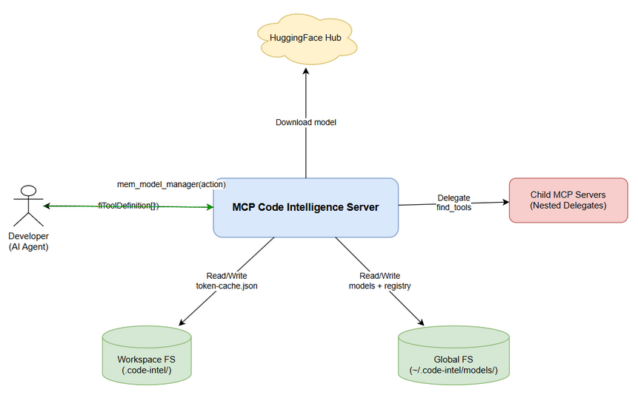
System Context
The system operates within the MCP Code Intelligence Python server. External actors: - Developer (AI Agent): Calls find_tools(query) to discover tools - HuggingFace Hub: Source for downloading embedding models - Workspace filesystem: Stores token cache (.code-intel/token-cache.json) - Global filesystem: Stores models (~/.code-intel/models/)

2.2 System Architecture
The feature adds two new components to the existing orchestration layer:
- AdaptiveTokenCache — sits between tokenized search and embedding search in find_tools
- ModelManager — new MCP tool for model lifecycle management
- EmbeddingSearcher — adapter connecting find_tools to the existing ONNX embedding provider

3. Functional Requirements

3.1 Feature: Adaptive Token Cache
Source: BRD Stories 1, 2, 6, 7

3.1.1 Description
A self-learning cache that stores successful embedding search results as token→tool mappings. When a query misses tokenized search, the cache is checked before invoking the expensive embedding model. Over time, the cache grows and embedding calls decrease.

3.1.2 Use Case: UC-1 — Find Tools with Cache
Use Case ID: UC-1 Actor: Developer (AI Agent) Preconditions: MCP server is running, tools are registered in registry Postconditions: Tool definitions returned OR empty array if no match
Main Flow:
Step | Actor | System | Description
1 | Calls find_tools(query) |  | Developer sends natural language query
2 |  | Tokenize query | Split query into normalized token set
3 |  | Search registry | Match tokens against registered tool tokens
4 |  | Return results | If registry has matches, return top 10
Alternative Flow AF-1: Cache Hit
Step | Condition | Description
3a | Registry returns no results | Proceed to cache lookup
3b | Normalize query tokens | Create token set for cache key
3c | Search cache (≥80% token overlap) | Find matching cache entry
3d | Cache hit found | Return cached tool, increment hit_count
Alternative Flow AF-2: Embedding Search + Learn
Step | Condition | Description
3e | Cache also misses | Proceed to embedding search
3f | Check model available | Verify ONNX model exists
3g | Compute query embedding | Run ONNX inference (~10-50ms)
3h | Compare with tool embeddings | Cosine similarity against all tools
3i | Best match score > 0.75 | Return tool AND cache the mapping
Exception Flow EF-1: No Model Available
Step | Condition | Description
3f-err | Model not installed | Skip embedding, trigger auto-download in background
3f-err2 | Fall through to delegate/KB | Continue with existing fallback chain
Exception Flow EF-2: Embedding Timeout
Step | Condition | Description
3g-err | Inference takes > 100ms | Abort embedding search, fall through to delegate/KB

3.1.3 Business Rules
Rule ID | Rule | Source
BR-1 | Cache confidence threshold: only cache if embedding score > 0.75 | BRD Story 2
BR-2 | Fuzzy cache match: ≥80% token overlap counts as hit | BRD Story 2
BR-3 | Max cache size: 10,000 entries per workspace | BRD Story 6
BR-4 | LRU eviction when cache exceeds max size | BRD Story 6
BR-5 | Cache invalidation on tool registry change (hash mismatch) | BRD Story 7
BR-6 | Debounced persistence: max 1 file write per 5 seconds | BRD Story 6
BR-7 | Embedding search hard timeout: 100ms | BRD Story 1
BR-8 | Cache entries with hit_count=0 after 30 days eligible for eviction | BRD Story 2

3.1.4 Data Specifications
Input Data (find_tools):
Field | Type | Required | Validation | Description
query | string | Yes | Non-empty, max 500 chars | Natural language tool search query
Output Data (find_tools — unchanged):
Field | Type | Description
tools | Array<ToolDefinition> | Top 10 matching tool definitions
tools[].name | string | Tool name
tools[].description | string | Tool description
tools[].input_schema | object | JSON Schema for tool parameters
Cache Entry Schema:
Field | Type | Required | Description
tokens | Array<string> | Yes | Sorted normalized token set
tool_name | string | Yes | Resolved tool name
score | float | Yes | Original embedding similarity (0.75-1.0)
timestamp | string | Yes | ISO8601 creation time
hit_count | int | Yes | Usage counter (starts at 0)
tool_version | string | Yes | Registry hash when entry was created

3.1.5 API Contract (Functional View)
Tool: find_tools (existing — enhanced behavior) Purpose: Discover MCP tools by natural language query
Input Parameters:
Parameter | Type | Required | Business Rule | Description
query | string | Yes | Max 500 chars | Search query
Output Data: (unchanged from current)
Field | Type | Description
(array) | ToolDefinition[] | Up to 10 matching tools
Business Error Scenarios:
Scenario | Behavior | Trigger Condition
Empty query | Return error JSON | query is null/empty
No results anywhere | Return empty array | All tiers miss
Model not available | Skip embedding tier silently | ONNX model not installed
Cache corrupted | Reset cache, continue | JSON parse error on load

3.2 Feature: Model Manager
Source: BRD Stories 3, 4, 5

3.2.1 Description
A new MCP tool mem_model_manager that allows users to manage embedding models. Supports listing available models, downloading new ones, checking status, and switching the active model.

3.2.2 Use Case: UC-2 — List Available Models
Use Case ID: UC-2 Actor: Developer Preconditions: MCP server running Postconditions: Model list returned with download status
Main Flow:
Step | Actor | System | Description
1 | Calls mem_model_manager(action=“list”) |  | Request model list
2 |  | Read registry.json | Load ~/.code-intel/models/registry.json
3 |  | Merge with known models | Combine registry with hardcoded model catalog
4 |  | Return model list | Each model: name, size, languages, downloaded status

3.2.3 Use Case: UC-3 — Download Model
Use Case ID: UC-3 Actor: Developer Preconditions: Network available, model not yet downloaded Postconditions: Model files saved to ~/.code-intel/models/{model_name}/
Main Flow:
Step | Actor | System | Description
1 | Calls mem_model_manager(action=“download”, model_name=“…”) |  | Request download
2 |  | Validate model_name | Check against known model catalog
3 |  | Download model.onnx | From HuggingFace (streaming)
4 |  | Download vocab.txt | From HuggingFace
5 |  | Update registry.json | Mark model as downloaded
6 |  | Return success | Include model path and size
Alternative Flow AF-1: Model Already Downloaded
Step | Condition | Description
2a | Model files already exist | Return success immediately with “already downloaded” message
Exception Flow EF-1: Download Failure
Step | Condition | Description
3-err | Network error or timeout | Return error with retry instructions, clean up partial files

3.2.4 Use Case: UC-4 — Switch Active Model
Use Case ID: UC-4 Actor: Developer Preconditions: Target model is downloaded Postconditions: Active model changed, tool embeddings rebuilt
Main Flow:
Step | Actor | System | Description
1 | Calls mem_model_manager(action=“switch”, model_name=“…”) |  | Request switch
2 |  | Verify model downloaded | Check files exist
3 |  | Update registry.json | Set active_model field
4 |  | Reload ONNX provider | Point to new model files
5 |  | Invalidate token cache | Clear all cached embeddings (model changed)
6 |  | Return success | Include new model info
Exception Flow EF-1: Model Not Downloaded
Step | Condition | Description
2-err | Model files not found | Return error: “Model not downloaded. Use action=‘download’ first.”

3.2.5 Business Rules
Rule ID | Rule | Source
BR-9 | Models stored globally: ~/.code-intel/models/ | BRD Story 3
BR-10 | Auto-download smallest model on first embedding need | BRD Story 4
BR-11 | Never auto-download multilingual model (user opt-in only) | BRD Story 5
BR-12 | Remind user about multilingual model max once per session | BRD Story 5
BR-13 | Switching model invalidates entire token cache | BRD Story 7

3.2.6 API Contract
Tool: mem_model_manager (new) Purpose: Manage embedding models for semantic tool search
Input Parameters:
Parameter | Type | Required | Business Rule | Description
action | string | Yes | One of: list, download, status, switch | Action to perform
model_name | string | No | Required for download/switch | Model identifier
Output Data (action=list):
Field | Type | Description
models | Array | Available models
models[].name | string | Model identifier
models[].display_name | string | Human-readable name
models[].size_mb | int | Download size in MB
models[].languages | Array<string> | Supported languages
models[].downloaded | boolean | Whether already on disk
models[].active | boolean | Whether currently in use
models[].vocab_size | int | Vocabulary size
Output Data (action=status):
Field | Type | Description
active_model | string | Current model name
model_path | string | Path to model files
dimensions | int | Embedding vector dimensions
languages | Array<string> | Supported languages
cache_entries | int | Current token cache size
Output Data (action=download):
Field | Type | Description
success | boolean | Download completed
model_name | string | Downloaded model
path | string | Where files were saved
size_mb | int | Total size downloaded
Business Error Scenarios:
Scenario | User Message | Trigger Condition
Invalid action | “Invalid action. Use: list, download, status, switch” | action not in allowed set
Model not found | “Unknown model: {name}. Use action=‘list’ to see available models” | model_name not in catalog
Download failed | “Download failed: {error}. Check network and retry.” | Network error
Switch without download | “Model not downloaded. Use action=‘download’ first.” | Files don’t exist

4. Data Model

4.1 Logical Entities

Entity: TokenCacheEntry
Attribute | Type | Required | Business Rule | Description
tokens | Array<string> | Yes | BR-2 | Sorted normalized token set (cache key)
tool_name | string | Yes |  | Resolved tool name
score | float | Yes | BR-1 (>0.75) | Embedding similarity score
timestamp | ISO8601 | Yes |  | When entry was created
hit_count | int | Yes | BR-8 | Times this entry was used
tool_version | string | Yes | BR-5 | Registry hash at creation time
last_hit | ISO8601 | No | BR-4 (LRU) | Last time entry was accessed

Entity: ModelRegistry
Attribute | Type | Required | Business Rule | Description
active_model | string | Yes | BR-13 | Currently active model name
models | Map<string, ModelInfo> | Yes |  | Downloaded models
last_updated | ISO8601 | Yes |  | Last registry modification

Entity: ModelInfo
Attribute | Type | Required | Description
name | string | Yes | Model identifier
path | string | Yes | Absolute path to model directory
downloaded_at | ISO8601 | Yes | When model was downloaded
size_bytes | int | Yes | Total size on disk
vocab_size | int | Yes | Vocabulary size
Relationships:
From Entity | To Entity | Cardinality | Description
TokenCacheEntry | Tool (Registry) | N:1 | Many cache entries can point to same tool
ModelRegistry | ModelInfo | 1:N | Registry tracks multiple downloaded models

5. Integration Specifications

5.1 External System: HuggingFace Hub
Attribute | Value
Purpose | Download ONNX embedding models
Direction | Outbound (download only)
Data Format | Binary (model.onnx) + Text (vocab.txt)
Frequency | On-demand (user-triggered or first-use auto-download)
Data Exchange:
Our Data | External Data | Direction | Business Rule
model_name | /resolve/main/onnx/model.onnx | Receive | BR-10: auto-download smallest
model_name | /resolve/main/vocab.txt | Receive | Download vocab alongside model

5.2 Internal System: ONNX Runtime
Attribute | Value
Purpose | Local embedding inference
Direction | Bidirectional (send text, receive vector)
Data Format | numpy arrays (input_ids, attention_mask, token_type_ids → embeddings)
Frequency | Real-time (on cache miss)

6. Processing Logic

6.1 Adaptive Search Process
Trigger: find_tools(query) called with no registry results Input: query string, token cache, ONNX model Output: ToolDefinition[] or empty
Processing Steps:
Step | Description | Error Handling
1 | Tokenize query → token_set | Return empty on invalid input
2 | Search cache: find entry with ≥80% token overlap | Continue to step 3 on miss
3 | If cache hit: increment hit_count, return tool
4 | Check ONNX model available | Skip to step 8 if unavailable
5 | Compute query embedding (timeout 100ms) | Skip to step 8 on timeout
6 | Compare with all tool embeddings (cosine similarity)
7 | If best score > 0.75: return tool + cache entry
8 | Fall through to delegate/KB fallback
Pseudocode:
def adaptive_search(query: str, cache: TokenCache, embedder: OnnxProvider, registry: Registry) -> list[ToolDef]:
# Step 1: Tokenize
tokens = tokenize(query)
# Step 2-3: Cache lookup (fuzzy)
cached = cache.find_fuzzy(tokens, threshold=0.80)
if cached:
cached.hit_count += 1
cached.last_hit = now()
cache.schedule_persist()
tool = registry.find(cached.tool_name)
return [tool] if tool else []
# Step 4: Check model
if not embedder.is_available():
trigger_auto_download() # background, non-blocking
return []
# Step 5-6: Embedding search
try:
query_vec = embedder.embed(query, timeout_ms=100)
best_tool, best_score = find_best_match(query_vec, registry.get_tool_embeddings())
except TimeoutError:
return []
# Step 7: Cache if confident
if best_score > 0.75:
cache.add(tokens, best_tool.name, best_score, registry.version_hash())
cache.schedule_persist()
return [best_tool]
return []

6.2 Cache Persistence Process
Trigger: New cache entry added (debounced 5s) Input: In-memory cache state Output: Updated token-cache.json file
Processing Steps:
Step | Description | Error Handling
1 | Check if persist timer already scheduled | Skip if timer pending
2 | Wait 5 seconds (debounce)
3 | Serialize cache to JSON | Log error, skip write on serialization failure
4 | Write to .code-intel/token-cache.json atomically | Write to .tmp then rename
5 | Reset persist timer

6.3 Cache Invalidation Process
Trigger: Server startup OR new tools registered Input: Current registry hash, cached entries Output: Stale entries marked/removed
Processing Steps:
Step | Description | Error Handling
1 | Compute current registry version hash | Use empty hash on error
2 | Compare each cache entry’s tool_version with current
3 | Mark mismatched entries as stale (skip during lookup)
4 | On next persist: remove stale entries from file

7. Security Requirements

7.1 Authentication & Authorization
Role | Permissions | Features
Any MCP client | Full access | find_tools, mem_model_manager
No authentication required — these are local tools running on user’s machine.

7.2 Data Sensitivity
Data Type | Classification | Business Requirement
Token cache | Internal | Contains query patterns — workspace-local only
Model files | Public | Open-source models from HuggingFace
Registry.json | Internal | Local config — no secrets

8. Non-Functional Requirements
Category | Business Requirement | Acceptance Criteria
Performance | Cache lookup instant | < 1ms for 10K entries
Performance | Embedding search fast | < 100ms hard timeout
Performance | find_tools total latency | < 150ms worst case (cache miss + embedding)
Storage | Cache file manageable | < 5MB for 10K entries
Reliability | Works without model | Graceful degradation, no crash
Reliability | Survives corrupted cache | Reset and continue
Startup | No blocking downloads | Auto-download is background-only

9. Error Handling (User-Facing)

9.1 Error Scenarios
Scenario | Severity | User Message | Expected Behavior
No model installed | Info | (silent — falls through to delegate) | System works, just slower
Cache corrupted | Warning | Log: “Token cache corrupted, starting fresh” | Reset cache, continue
Download network error | Warning | “Download failed: {error}. Retry later.” | System continues without model
ONNX Runtime missing | Info | (silent — embedding tier disabled) | Tokenized + delegate still work
Model switch while queries in-flight | Warning | (none — atomic swap) | In-flight queries use old model, next query uses new

9.2 Notification Requirements
Event | Who is Notified | Channel | Timing
Multilingual model suggestion | Developer | find_tools response hint | Once per session, on non-ASCII query miss
Model download complete | Developer | stderr log | Immediate
Cache invalidation | Developer | stderr log | On startup if tools changed

10. Testing Considerations

10.1 Test Scenarios
ID | Scenario | Input | Expected Output | Priority
TC-1 | Tokenized search hit (no cache needed) | query matching registry tokens | Tool returned, cache not consulted | High
TC-2 | Cache hit (fuzzy match) | query with 80%+ token overlap with cached entry | Cached tool returned, hit_count++ | High
TC-3 | Embedding hit + cache learn | query with no token/cache match, embedding score > 0.75 | Tool returned, new cache entry created | High
TC-4 | All tiers miss | query with no match anywhere | Empty array, falls to delegate/KB | High
TC-5 | Cache persistence | Add entry, wait 5s | token-cache.json updated | Medium
TC-6 | Cache invalidation on tool change | Change registry, restart | Stale entries skipped | High
TC-7 | Model manager list | action=“list” | All models with status | Medium
TC-8 | Model manager download | action=“download”, model_name valid | Model files saved | Medium
TC-9 | Model manager switch | action=“switch”, model downloaded | Active model changed, cache cleared | High
TC-10 | Auto-download on first use | No model, embedding tier reached | Background download starts | Medium
TC-11 | Multilingual reminder | Non-ASCII query, English model, no results | Hint in response (once) | Low
TC-12 | Cache LRU eviction | Cache at 10K, add new entry | Oldest unused entry removed | Medium
TC-13 | Corrupted cache file | Invalid JSON in token-cache.json | Cache reset, no crash | High
TC-14 | Embedding timeout | Slow model inference > 100ms | Timeout, fall through | High

11. Appendix

Sequence Diagram: find_tools with Adaptive Cache
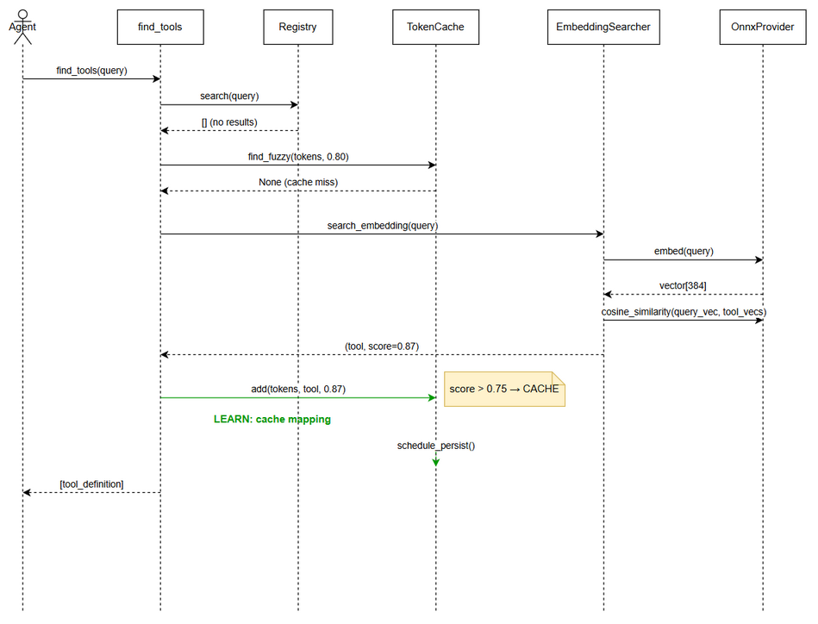
Sequence Diagram

State Diagram: Cache Entry Lifecycle
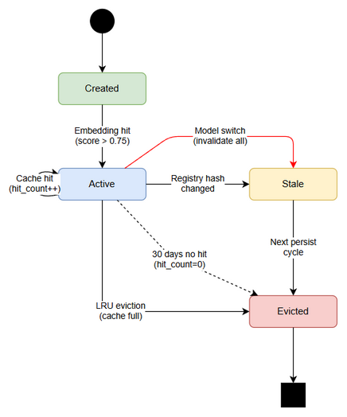
State Diagram

Diagram Index
# | Diagram | Image | Source (editable)
1 | System Context | system-context.png | system-context.drawio
2 | Sequence: find_tools with Cache | sequence-find-tools.png | sequence-find-tools.drawio
3 | State: Cache Entry Lifecycle | state-cache-entry.png | state-cache-entry.drawio

Change Log from BRD
- Added detailed pseudocode for adaptive search algorithm
- Specified fuzzy cache match threshold at 80% token overlap
- Added atomic file write requirement for cache persistence
- Clarified model switch invalidates entire cache (not just affected entries)

