Technical Design Document (TDD)

MCP Code Intelligence — KSA-102: Adaptive Token Cache + Model Manager

Document Information
Field | Value
Jira Ticket | KSA-102
Title | Adaptive Token Cache + Model Manager for multilingual find_tools
Author | SA Agent
Version | 1.0
Date | 2026-05-21
Status | Draft
Related BRD | BRD-v1-KSA-102.docx
Related FSD | FSD-v1-KSA-102.docx

Revision History
Version | Date | Author | Changes
1.0 | 2026-05-21 | SA Agent | Initiate document from BRD + FSD

1. Introduction

1.1 Purpose
This TDD specifies the technical implementation of the Adaptive Token Cache and Model Manager for the MCP Code Intelligence Python server. It covers architecture, module design, data structures, and integration patterns.

1.2 Scope
- New module: orchestration/cache/ — Adaptive Token Cache
- New module: orchestration/models/ — Model Manager
- Modified: orchestration/meta/find_tools.py — integrate cache + embedding tiers
- Modified: memory/embedding/model_downloader.py — support multiple models

1.3 Technology Stack
Layer | Technology | Version
Language | Python | 3.11+
Runtime | ONNX Runtime | 1.16+
Embedding Model | all-MiniLM-L6-v2 | latest
Storage | JSON files | N/A
Build Tool | pip / pyproject.toml | N/A
CI/CD | GitHub Actions | N/A

1.4 Design Principles
- Zero external deps for cache module (stdlib only)
- Graceful degradation — system works without ONNX/model
- Single Responsibility — each file < 200 lines, each function < 20 lines
- Lazy initialization — model loaded only when needed
- Non-blocking — downloads and persistence never block find_tools

1.5 Constraints
- Max 200 lines per file (workspace code standard)
- Max 20 lines per function
- ONNX Runtime is optional dependency
- No network calls during search (only during model download)
- Must work on Windows, macOS, Linux

1.6 References
Document | Location
BRD | BRD-v1-KSA-102.docx
FSD | FSD-v1-KSA-102.docx

2. System Architecture

2.1 Architecture Overview
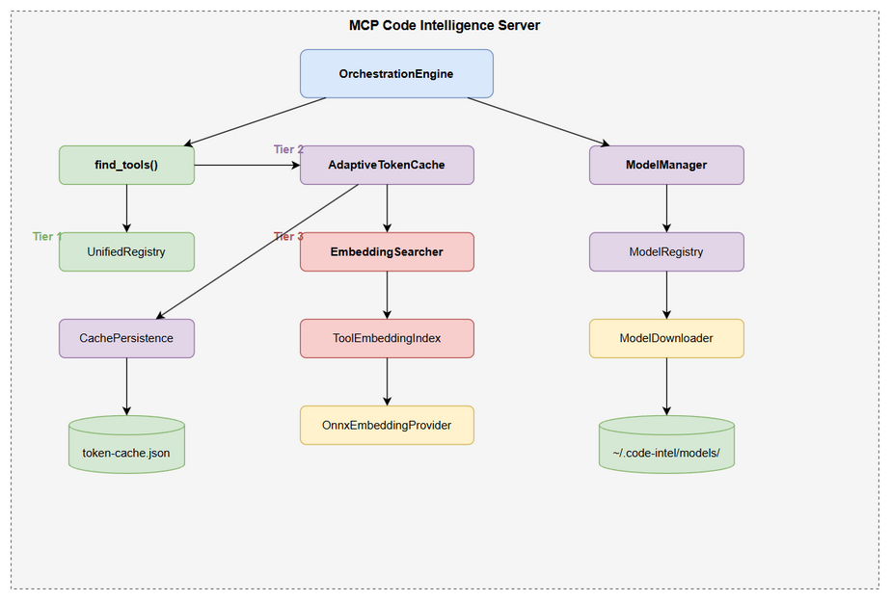
Architecture Diagram
The feature adds two new subsystems to the existing orchestration layer:
- AdaptiveTokenCache — in-memory cache with JSON persistence, sits between registry search and embedding search
- ModelManager — MCP tool + model lifecycle management, wraps existing model_downloader
- EmbeddingSearcher — adapter connecting find_tools to OnnxEmbeddingProvider with timeout

2.2 Component Diagram
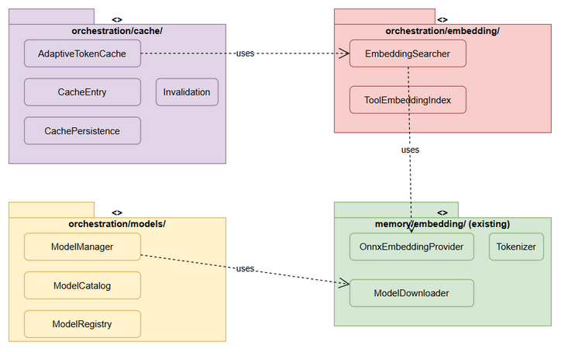
Component Diagram
Component | Responsibility | Technology
AdaptiveTokenCache | Store/lookup learned query→tool mappings | Python dict + JSON
CachePersistence | Debounced file I/O for cache | threading.Timer
ModelManager | MCP tool for model CRUD | MCP tool pattern
ModelRegistry | Track downloaded models | JSON file
EmbeddingSearcher | Compute embeddings + cosine similarity | numpy + ONNX
ToolEmbeddingIndex | Pre-computed embeddings for all tools | numpy array

2.3 Communication Patterns
From | To | Protocol | Pattern | Description
find_tools | AdaptiveTokenCache | In-process | Sync | Cache lookup/add
find_tools | EmbeddingSearcher | In-process | Sync (timeout) | Embedding search with 100ms timeout
ModelManager | ModelDownloader | In-process | Async (background) | Download model files
CachePersistence | Filesystem | File I/O | Async (debounced) | Write cache to disk
EmbeddingSearcher | OnnxProvider | In-process | Sync | ONNX inference

3. API Design

3.1 API Overview
# | Tool | Method | Description | Source
1 | find_tools | execute | Enhanced with cache + embedding tiers | UC-1
2 | mem_model_manager | execute | Model lifecycle management | UC-2,3,4

3.2 Tool: mem_model_manager
Implements: UC-2, UC-3, UC-4
Attribute | Value
Tool Name | mem_model_manager
Registration | Registered in MCP server tool list
Auth | None (local tool)
Input Schema:
{
"type": "object",
"properties": {
"action": {
"type": "string",
"enum": ["list", "download", "status", "switch"],
"description": "Action to perform"
},
"model_name": {
"type": "string",
"description": "Model identifier (required for download/switch)"
}
},
"required": ["action"]
}
Response — action=list:
{
"models": [
{
"name": "all-MiniLM-L6-v2",
"display_name": "English (Small, Fast)",
"size_mb": 90,
"languages": ["en"],
"vocab_size": 30522,
"dimensions": 384,
"downloaded": true,
"active": true
},
{
"name": "paraphrase-multilingual-MiniLM-L12-v2",
"display_name": "Multilingual (50+ languages)",
"size_mb": 470,
"languages": ["en", "vi", "zh", "ja", "ko", "fr", "de", "es", "..."],
"vocab_size": 250002,
"dimensions": 384,
"downloaded": false,
"active": false
}
]
}
Response — action=status:
{
"active_model": "all-MiniLM-L6-v2",
"model_path": "/home/user/.code-intel/models/all-MiniLM-L6-v2",
"dimensions": 384,
"languages": ["en"],
"cache_entries": 42,
"cache_hit_rate": 0.73
}
Error Responses:
Condition | Error Code | Message
Invalid action | INVALID_ACTION | “Invalid action. Use: list, download, status, switch”
Unknown model | MODEL_NOT_FOUND | “Unknown model: {name}. Use action=‘list’”
Download failed | DOWNLOAD_FAILED | “Download failed: {error}”
Switch without download | MODEL_NOT_DOWNLOADED | “Model not downloaded. Use action=‘download’ first”

4. Data Design

4.1 File: token-cache.json
Location: {workspace}/.code-intel/token-cache.json
{
"version": 1,
"registry_hash": "a1b2c3d4",
"entries": [
{
"tokens": ["issues", "jira", "search"],
"tool_name": "jira_search",
"score": 0.87,
"timestamp": "2026-05-21T10:00:00Z",
"hit_count": 15,
"last_hit": "2026-05-21T14:30:00Z",
"tool_version": "a1b2c3d4"
}
]
}
Size estimate: ~500 bytes per entry × 10,000 max = ~5MB max

4.2 File: registry.json (Model Registry)
Location: ~/.code-intel/models/registry.json
{
"active_model": "all-MiniLM-L6-v2",
"models": {
"all-MiniLM-L6-v2": {
"path": "~/.code-intel/models/all-MiniLM-L6-v2",
"downloaded_at": "2026-05-21T10:00:00Z",
"size_bytes": 94000000,
"vocab_size": 30522
}
},
"last_updated": "2026-05-21T10:00:00Z"
}

5. Class / Module Design

5.1 Package Structure
mcp_code_intel/
├── orchestration/
│ ├── cache/
│ │ ├── __init__.py
│ │ ├── adaptive_cache.py # AdaptiveTokenCache class
│ │ ├── cache_entry.py # CacheEntry dataclass
│ │ ├── persistence.py # DebouncedPersistence (file I/O)
│ │ └── invalidation.py # Cache invalidation logic
│ ├── models/
│ │ ├── __init__.py
│ │ ├── model_manager.py # ModelManager MCP tool
│ │ ├── model_catalog.py # Known models catalog
│ │ └── model_registry.py # Registry file management
│ ├── embedding/
│ │ ├── __init__.py
│ │ ├── embedding_searcher.py # EmbeddingSearcher (find_tools adapter)
│ │ └── tool_index.py # ToolEmbeddingIndex (pre-computed vectors)
│ └── meta/
│ └── find_tools.py # MODIFIED: integrate cache + embedding
├── memory/
│ └── embedding/
│ ├── model_downloader.py # MODIFIED: support multiple models
│ └── onnx_provider.py # UNCHANGED

5.2 Key Interfaces
# orchestration/cache/adaptive_cache.py
class AdaptiveTokenCache:
"""Self-learning token cache with fuzzy matching."""
def find_fuzzy(self, tokens: set[str], threshold: float = 0.80) -> CacheEntry | None:
"""Find cache entry with ≥threshold token overlap."""
def add(self, tokens: set[str], tool_name: str, score: float, registry_hash: str) -> None:
"""Add new cache entry from embedding result."""
def invalidate_stale(self, current_hash: str) -> int:
"""Mark entries with mismatched registry_hash as stale. Returns count."""
def load(self) -> None:
"""Load cache from disk (lazy, called on first access)."""
@property
def size(self) -> int:
"""Current number of active entries."""
# orchestration/embedding/embedding_searcher.py
class EmbeddingSearcher:
"""Adapter: find_tools → ONNX embedding search with timeout."""
def search(self, query: str, timeout_ms: int = 100) -> tuple[str, float] | None:
"""Search tools by embedding similarity. Returns (tool_name, score) or None."""
def rebuild_index(self) -> None:
"""Rebuild tool embedding index (after model switch or new tools)."""
@property
def is_available(self) -> bool:
"""True if ONNX model is loaded and ready."""
# orchestration/models/model_manager.py
class ModelManager:
"""MCP tool: mem_model_manager — model lifecycle management."""
def execute(self, args: dict) -> str:
"""Handle action: list/download/status/switch."""
def get_active_model(self) -> str:
"""Return current active model name."""
def auto_download_if_needed(self) -> None:
"""Background download of default model on first need."""

5.3 Design Patterns
Pattern | Where Used | Rationale
Strategy | EmbeddingSearcher (swappable model) | Support model switching without restart
Observer | CachePersistence (debounced write) | Decouple cache updates from file I/O
Lazy Init | AdaptiveTokenCache.load() | Don’t read file until first cache access
Adapter | EmbeddingSearcher wraps OnnxProvider | Isolate find_tools from embedding internals
Singleton | ToolEmbeddingIndex (per server) | One index shared across all find_tools calls

5.4 Error Handling
Exception | Behavior | When Thrown
JSONDecodeError (cache load) | Log warning, start with empty cache | Corrupted token-cache.json
TimeoutError (embedding) | Return None, fall through | ONNX inference > 100ms
ImportError (onnxruntime) | Disable embedding tier | ONNX not installed
OSError (file write) | Log error, skip persist | Disk full or permissions
NetworkError (download) | Return error message | Model download fails

6. Integration Design

6.1 Integration: find_tools Enhancement
The existing find_tools.py execute() function is modified to insert cache + embedding tiers:
# MODIFIED find_tools.py execute() — new flow
def execute(engine, args):
query = args.get("query")
# Tier 1: Registry search (EXISTING — unchanged)
registry_results = engine.get_registry().search(query)
if registry_results:
return json.dumps([t.definition for t in registry_results[:10]])
# Tier 1.5: Retry failed servers (EXISTING — unchanged)
recovered = _retry_failed_servers(engine)
if recovered:
registry_results = engine.get_registry().search(query)
if registry_results:
return json.dumps([t.definition for t in registry_results[:10]])
# Tier 2: Adaptive Token Cache (NEW)
cache = engine.get_token_cache()
tokens = tokenize(query)
cached = cache.find_fuzzy(tokens)
if cached:
tool = engine.get_registry().find(cached.tool_name)
if tool:
cached.hit_count += 1
cache.schedule_persist()
return json.dumps([tool.definition])
# Tier 3: Embedding Search (NEW)
searcher = engine.get_embedding_searcher()
if searcher and searcher.is_available:
result = searcher.search(query, timeout_ms=100)
if result:
tool_name, score = result
tool = engine.get_registry().find(tool_name)
if tool and score > 0.75:
cache.add(tokens, tool_name, score, engine.get_registry().version_hash())
cache.schedule_persist()
# Check multilingual hint
hint = _check_multilingual_hint(engine, query)
definitions = [tool.definition]
if hint:
definitions[0] = {**definitions[0], "_hint": hint}
return json.dumps(definitions)
elif not searcher or not searcher.is_available:
# Trigger auto-download in background
engine.get_model_manager().auto_download_if_needed()
# Tier 4: Delegate to nested (EXISTING — unchanged)
delegates = engine.get_find_tools_delegates()
nested_results = _delegate_to_nested(engine, query) if delegates else []
# Tier 5: KB fallback (EXISTING — unchanged)
# ... existing code ...

6.2 Integration: OrchestrationEngine Extensions
New methods added to OrchestrationEngine:
class OrchestrationEngine:
# ... existing code ...
def get_token_cache(self) -> AdaptiveTokenCache:
"""Lazy-init adaptive token cache."""
if self._token_cache is None:
cache_path = self._workspace / ".code-intel" / "token-cache.json"
self._token_cache = AdaptiveTokenCache(cache_path)
return self._token_cache
def get_embedding_searcher(self) -> EmbeddingSearcher | None:
"""Get embedding searcher (None if ONNX unavailable)."""
if self._embedding_searcher is None:
try:
self._embedding_searcher = EmbeddingSearcher(
model_manager=self.get_model_manager(),
registry=self.get_registry()
)
except ImportError:
return None
return self._embedding_searcher
def get_model_manager(self) -> ModelManager:
"""Get model manager instance."""
if self._model_manager is None:
self._model_manager = ModelManager()
return self._model_manager

7. Security Design

7.1 Authentication
No authentication — all tools are local, running on user’s machine.

7.2 Data Protection
Data Type | At Rest | In Transit | In Logs
Token cache | Plain JSON (local file) | N/A (local) | Query tokens logged
Model files | Plain binary (local) | HTTPS (download) | Download URL logged
Registry | Plain JSON (local) | N/A | No sensitive data

7.3 Input Validation
Field | Validation | Sanitization
query (find_tools) | Non-empty, max 500 chars | Strip whitespace
action (model_manager) | Must be in enum set | Lowercase
model_name | Must match catalog entry | Exact match only

8. Performance & Scalability

8.1 Caching Strategy
Cache | What | TTL | Eviction | Technology
Token Cache | query→tool mappings | No TTL (LRU) | LRU at 10K entries | Python dict
Tool Embedding Index | tool→vector mappings | Until registry change | Full rebuild | numpy array
Model (ONNX session) | Loaded model | Until switch | Replace on switch | onnxruntime

8.2 Performance Targets
Operation | Target | Measurement
Cache lookup (hit) | < 1ms | time.perf_counter
Cache lookup (miss) | < 1ms | time.perf_counter
Embedding search | < 100ms | Hard timeout
Cache persist (debounced) | < 50ms | Background, non-blocking
Model load (first use) | < 2s | One-time cost
find_tools total (cache hit) | < 2ms | End-to-end
find_tools total (embedding hit) | < 150ms | End-to-end

8.3 Scalability
- Cache: O(n) scan for fuzzy match on 10K entries ≈ < 1ms (Python set operations)
- Tool index: O(n) cosine similarity on ~100 tools ≈ < 10ms (numpy vectorized)
- File I/O: Debounced to max 1 write/5s regardless of cache update frequency

9. Monitoring & Observability

9.1 Logging
Log Event | Level | Fields | Destination
Cache hit | DEBUG | query, tool_name, hit_count | stderr
Cache miss → embedding | DEBUG | query | stderr
Embedding hit + learn | INFO | query, tool_name, score | stderr
Cache invalidation | INFO | stale_count, total_count | stderr
Model download start | INFO | model_name, size_mb | stderr
Model download complete | INFO | model_name, duration | stderr
Model switch | INFO | from_model, to_model | stderr
Cache persist | DEBUG | entry_count, file_size | stderr
Embedding timeout | WARN | query, elapsed_ms | stderr
Cache corrupted | WARN | file_path, error | stderr

9.2 Metrics (in-memory counters)
Metric | Type | Description
cache_hits | Counter | Total cache hits
cache_misses | Counter | Total cache misses
embedding_searches | Counter | Total embedding searches
embedding_timeouts | Counter | Embedding searches that timed out
cache_size | Gauge | Current cache entry count
cache_hit_rate | Gauge | hits / (hits + misses)

10. Deployment Considerations

10.1 Configuration
No environment-specific config needed. All paths are derived: - Cache: {workspace}/.code-intel/token-cache.json - Models: ~/.code-intel/models/ - Registry: ~/.code-intel/models/registry.json

10.2 Feature Flags
Flag | Default | Description
EMBEDDING_ENABLED | true | Enable/disable embedding search tier
CACHE_ENABLED | true | Enable/disable adaptive cache
AUTO_DOWNLOAD | true | Auto-download model on first need
CACHE_MAX_SIZE | 10000 | Maximum cache entries
EMBEDDING_TIMEOUT_MS | 100 | Embedding search timeout
CACHE_PERSIST_DEBOUNCE_S | 5 | Seconds between cache file writes

10.3 Rollback Strategy
- Set EMBEDDING_ENABLED=false and CACHE_ENABLED=false → reverts to original find_tools behavior
- Delete .code-intel/token-cache.json → fresh cache start
- No database migrations — all data is in JSON files that can be deleted safely

11. Implementation Checklist

Files to Create
# | File | Lines (est.) | Description
1 | orchestration/cache/__init__.py | 5 | Package init
2 | orchestration/cache/adaptive_cache.py | 120 | Main cache class
3 | orchestration/cache/cache_entry.py | 40 | CacheEntry dataclass
4 | orchestration/cache/persistence.py | 80 | Debounced file I/O
5 | orchestration/cache/invalidation.py | 60 | Invalidation logic
6 | orchestration/models/__init__.py | 5 | Package init
7 | orchestration/models/model_manager.py | 150 | MCP tool implementation
8 | orchestration/models/model_catalog.py | 50 | Known models list
9 | orchestration/models/model_registry.py | 100 | Registry file management
10 | orchestration/embedding/__init__.py | 5 | Package init
11 | orchestration/embedding/embedding_searcher.py | 120 | Embedding search adapter
12 | orchestration/embedding/tool_index.py | 100 | Pre-computed tool vectors

Files to Modify
# | File | Changes
1 | orchestration/meta/find_tools.py | Add Tier 2 (cache) + Tier 3 (embedding)
2 | orchestration/engine.py | Add get_token_cache(), get_embedding_searcher(), get_model_manager()
3 | memory/embedding/model_downloader.py | Support configurable model path + multiple models

Estimated Total: ~835 lines new code, ~50 lines modified

Appendix

Diagram Index
# | Diagram | Image | Source (editable)
1 | Architecture Overview | architecture.png | architecture.drawio
2 | Component Diagram | component.png | component.drawio
3 | Class Diagram | class-diagram.png | class-diagram.drawio

Open Questions
# | Question | Status | Answer
1 | Should cache be shared across MCP server restarts within same session? | Resolved | Yes — persisted to file
2 | Should tool embeddings be pre-computed at startup or lazy? | Resolved | Lazy — computed on first embedding search
3 | What if two queries resolve to same tool with different scores? | Resolved | Keep highest score entry, merge tokens

