Business Requirements Document (BRD)

MCP Code Intelligence — KSA-104: VS Code Command: Download Embedding Model

Document Information
Field | Value
Jira Ticket | KSA-104
Title | VS Code Command: Download Embedding Model (QuickPick UI + HTTP API)
Author | BA Agent
Version | 1.0
Date | 2026-05-21
Status | Final (Retroactive)

Author Tracking
Role | Name - Position | Responsibility
Author | BA Agent – Business Analyst | Create document
Peer Reviewer | SA Agent – Solution Architect | Review technical feasibility

Revision History
Version | Date | Author | Changes
1.0 | 2026-05-21 | BA Agent | Initiate document — auto-generated retroactively from Jira ticket KSA-104 and implemented code

Sign-Off
Name | Signature and date
 | ☐ I agree and confirm all criteria on this BRD as expected requirements
 | ☐ I agree and confirm all criteria on this BRD as expected requirements

1. Introduction

1.1 Scope
This change request adds a VS Code extension command (Kiro SDLC: Download Embedding Model) that provides a graphical interface for developers to browse, download, and switch between embedding models used by the MCP Code Intelligence system.
The feature includes: 1. VS Code QuickPick UI — command registered in Command Palette for model selection 2. HTTP API routes (/api/models/*) — backend endpoints for model lifecycle management 3. Cross-module implementation — consistent API across Python, Node.js, and Kotlin MCP servers
This extends the Model Manager capability introduced in KSA-102 by exposing it through a user-friendly VS Code interface rather than requiring direct MCP tool invocation.

1.2 Out of Scope
- Custom model upload (only pre-defined models in catalog)
- Model training or fine-tuning
- Automatic model selection based on workspace language
- Download cancellation mid-progress
- Model deletion from disk
- Download progress percentage (indeterminate progress only)

1.3 Preliminary Requirement
- KSA-102 (Adaptive Token Cache + Model Manager) must be implemented — provides the ModelManager, ModelRegistry, and ModelCatalog infrastructure this feature builds upon
- MCP server must be running with HTTP viewer enabled (port configurable, default 3200)
- VS Code extension kiro-sdlc-agents must be installed and active

2. Business Requirements

2.1 High Level Process Map
The feature enables a simple user-driven workflow for model management:
- Developer opens VS Code Command Palette (Ctrl+Shift+P)
- Selects “Kiro SDLC: Download Embedding Model”
- Extension resolves MCP server port from .kiro/settings/mcp.json
- Extension fetches model list and status from HTTP API
- QuickPick displays models with status indicators (active/downloaded/not downloaded)
- Developer selects a model → download or switch action triggered
- Background download from HuggingFace (if needed)
- Model activated for semantic search
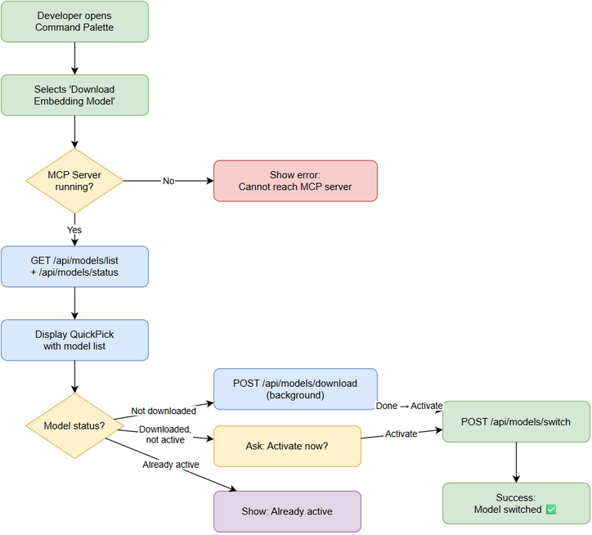 Edit in draw.io
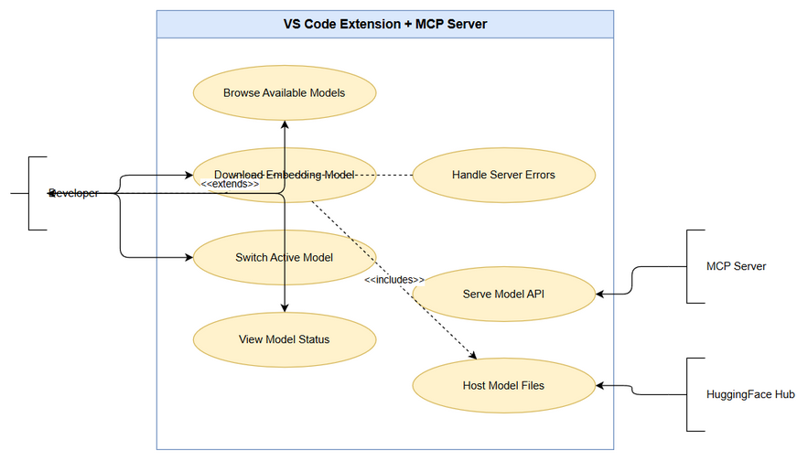 Edit in draw.io

2.2 List of User Stories / Use Cases
# | Story / Use Case | Priority | Source Ticket
1 | As a developer, I want to browse available embedding models from VS Code so that I can see what options exist without leaving my IDE | MUST HAVE | KSA-104
2 | As a developer, I want to download an embedding model via QuickPick so that I don’t need to use CLI or manual file management | MUST HAVE | KSA-104
3 | As a developer, I want to switch the active embedding model so that I can enable multilingual semantic search | MUST HAVE | KSA-104
4 | As a developer, I want clear status indicators for each model so that I know which is active, downloaded, or available | MUST HAVE | KSA-104
5 | As a developer, I want clear error messages when MCP server is unreachable so that I know how to fix the issue | SHOULD HAVE | KSA-104
6 | As a developer, I want the API to work consistently across Python, Node.js, and Kotlin MCP servers so that my experience is the same regardless of which server variant I use | MUST HAVE | KSA-104

2.3 Details of User Stories

Business Flow
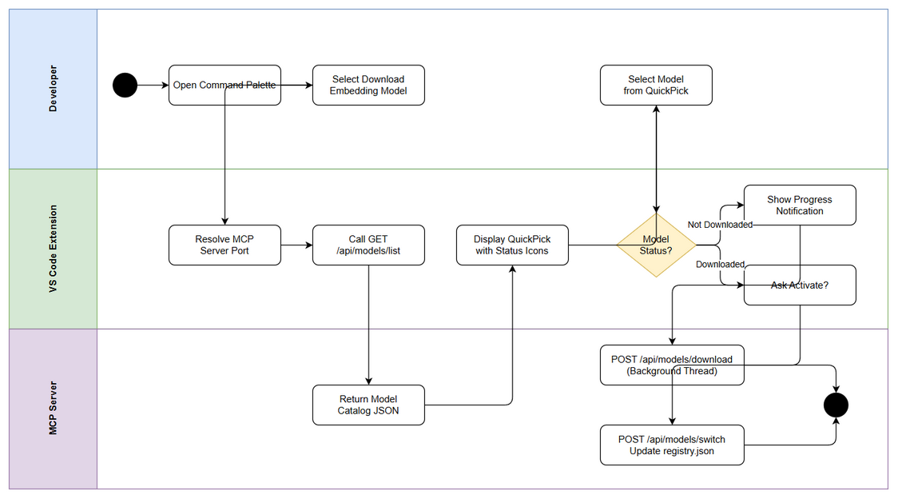 Edit in draw.io
Step 1: Developer invokes command “Kiro SDLC: Download Embedding Model” from Command Palette
Step 2: Extension reads MCP server viewer port from .kiro/settings/mcp.json (env: CODE_INTEL_VIEWER_PORT, default: 3200)
Step 3: Extension calls GET /api/models/list to fetch model catalog with download/active status
Step 4: Extension calls GET /api/models/status to get current active model info
Step 5: QuickPick UI displays models with status icons: - $(check) = Active model - $(cloud-download) = Downloaded but not active - $(cloud) = Not yet downloaded
Step 6: Developer selects a model from the list
Step 7: Based on model status: - Not downloaded → Call POST /api/models/download, show progress notification - Downloaded, not active → Ask “Activate now?” → Call POST /api/models/switch - Already active → Show info message “Model is already active”
Step 8: On success, show confirmation message with new active model name
Note: Downloads happen in a background thread on the server side. The extension receives an immediate response and shows an indeterminate progress notification.

STORY 1: Browse Available Models
As a developer, I want to browse available embedding models from VS Code so that I can see what options exist without leaving my IDE
Requirement Details:
- Command Kiro SDLC: Download Embedding Model registered in VS Code Command Palette
- On invocation, extension resolves MCP server HTTP port from workspace config
- Extension calls GET /api/models/list to retrieve model catalog
- QuickPick displays each model with: status icon, display name, size, supported languages
- Models sorted by: active first, then downloaded, then not downloaded
Data Fields:
Field | Type | Required | Description | Example
name | string | Yes | Model identifier | all-MiniLM-L6-v2
display_name | string | Yes | Human-readable name | English (Small, Fast)
size_mb | number | Yes | Model size in megabytes | 90
languages | string[] | Yes | Supported languages | ["en"]
downloaded | boolean | Yes | Whether model files exist on disk | true
active | boolean | Yes | Whether model is currently in use | true
Acceptance Criteria:
- Given MCP server is running, when user invokes command, then QuickPick shows all available models with correct status
- Given model is active, then it shows $(check) icon and appears first in list
- Given model is downloaded but not active, then it shows $(cloud-download) icon
- Given model is not downloaded, then it shows $(cloud) icon with size info
UI Specifications:
No. | Name | Type | Required | Description | Note
1 | QuickPick | VS Code QuickPick | Yes | Model selection dropdown | Triggered by command
2 | Model Item Label | QuickPick Item | Yes | {status_icon} {display_name} | Icon varies by status
3 | Model Item Description | QuickPick Detail | Yes | {size_mb}MB — {languages} | Shows size and language support
Error Handling:
- MCP server not running → Show error: “❌ Cannot reach MCP server. Ensure it is running.”
- No workspace folder open → Show error: “❌ No workspace folder open.”
- API returns unexpected format → Show error: “❌ Unexpected response from MCP server.”

STORY 2: Download Embedding Model
As a developer, I want to download an embedding model via QuickPick so that I don’t need to use CLI or manual file management
Requirement Details:
- When user selects a model marked “Not downloaded”, extension calls POST /api/models/download
- Server spawns background thread to download model files from HuggingFace
- Extension shows progress notification (indeterminate, non-cancellable)
- On completion, extension shows success message with option to activate
- Model files saved to ~/.code-intel/models/{model-name}/ (global, shared across workspaces)
- Duplicate download requests are ignored (server tracks downloading state)
Data Fields:
Field | Type | Required | Description | Example
model_name | string | Yes | Model to download (request body) | paraphrase-multilingual-MiniLM-L12-v2
success | boolean | Yes | Whether request was accepted (response) | true
status | string | Yes | Current download state (response) | downloading
Acceptance Criteria:
- Given model not downloaded, when user selects it, then download starts in background and progress notification appears
- Given download completes successfully, then notification shows “✅ Model downloaded. Activate now?”
- Given download fails (network error), then notification shows “❌ Download failed: {message}”
- Given model is already being downloaded, then duplicate request is ignored (no error)
- Given invalid model name, then server returns 400 with MODEL_NOT_FOUND error
Validation Rules:
- model_name must exist in the model catalog (server-side validation)
- Only one download per model can be in progress at a time
- Model files must include model.onnx and tokenizer file (vocab.txt or sentencepiece.bpe.model)
Error Handling:
- Network error during download → “❌ Download failed: Network error”
- Disk space insufficient → “❌ Download failed: Insufficient disk space”
- Invalid model name → Server returns HTTP 400: { "error": "MODEL_NOT_FOUND" }

STORY 3: Switch Active Model
As a developer, I want to switch the active embedding model so that I can enable multilingual semantic search
Requirement Details:
- When user selects a downloaded (but not active) model, extension asks “Activate now?”
- If user confirms, extension calls POST /api/models/switch
- Server updates registry.json to set new active model
- Extension shows success message: “✅ Active model switched to: {name}”
- Only one model can be active at a time
- Switching model affects all subsequent embedding operations (search, indexing)
Data Fields:
Field | Type | Required | Description | Example
model_name | string | Yes | Model to activate (request body) | paraphrase-multilingual-MiniLM-L12-v2
success | boolean | Yes | Whether switch succeeded (response) | true
active_model | string | Yes | New active model name (response) | paraphrase-multilingual-MiniLM-L12-v2
Acceptance Criteria:
- Given model is downloaded but not active, when user selects and confirms activation, then model becomes active
- Given model is not downloaded, when switch is attempted, then server returns error “Download first”
- Given model is already active, when user selects it, then show info “Model is already active” (no API call)
- Given user clicks “Cancel” on activation prompt, then no action is taken
Error Handling:
- Model not downloaded → Server returns HTTP 400: { "error": "MODEL_NOT_DOWNLOADED", "message": "Download first" }
- User cancels → No action, QuickPick closes

STORY 4: Model Status Indicators
As a developer, I want clear status indicators for each model so that I know which is active, downloaded, or available
Requirement Details:
- Each model in QuickPick shows a status icon prefix
- Status determined by combining /api/models/list (downloaded flag) and /api/models/status (active model)
- Icons use VS Code Codicon syntax for native rendering
UI Specifications:
No. | Name | Type | Required | Description | Note
1 | Active Icon | Codicon | Yes | $(check) — green checkmark | Model currently in use
2 | Downloaded Icon | Codicon | Yes | $(cloud-download) — cloud with arrow | Downloaded, ready to activate
3 | Not Downloaded Icon | Codicon | Yes | $(cloud) — plain cloud | Available for download
Acceptance Criteria:
- Given all-MiniLM-L6-v2 is active, then it shows $(check) icon
- Given paraphrase-multilingual-MiniLM-L12-v2 is downloaded but not active, then it shows $(cloud-download) icon
- Given a model is not downloaded, then it shows $(cloud) icon
- Status icons update correctly after download or switch operations

STORY 5: Error Handling for Unreachable Server
As a developer, I want clear error messages when MCP server is unreachable so that I know how to fix the issue
Requirement Details:
- Before making API calls, extension attempts to connect to MCP server HTTP port
- If connection fails (ECONNREFUSED, timeout), show clear error message
- Error message includes actionable guidance (ensure server is running)
- No stack traces or technical jargon in user-facing messages
Acceptance Criteria:
- Given MCP server is not running, when command is invoked, then show “❌ Cannot reach MCP server. Ensure it is running.”
- Given server responds with 503 (not initialized), then show appropriate error
- Given network timeout (> 5s), then show timeout error
Error Handling:
- ECONNREFUSED → “❌ Cannot reach MCP server. Ensure it is running.”
- Timeout → “❌ MCP server not responding. Check server logs.”
- HTTP 503 → “❌ MCP server is starting up. Try again in a moment.”

STORY 6: Cross-Module API Consistency
As a developer, I want the API to work consistently across Python, Node.js, and Kotlin MCP servers so that my experience is the same regardless of which server variant I use
Requirement Details:
- All 4 HTTP endpoints (/api/models/list, /api/models/status, /api/models/download, /api/models/switch) implemented identically across all 3 MCP modules
- Same JSON request/response format across all modules
- Same error codes and messages across all modules
- Same model catalog (hardcoded in each module)
- CORS headers enabled for localhost access
Acceptance Criteria:
- Given Python MCP server, when calling any /api/models/* endpoint, then response format matches specification
- Given Node.js MCP server, when calling same endpoints, then response is identical to Python
- Given Kotlin MCP server, when calling same endpoints, then response is identical to Python and Node.js
- Given any module, when invalid model_name is sent, then error response uses same error code MODEL_NOT_FOUND
- All modules support CORS headers for extension HTTP calls
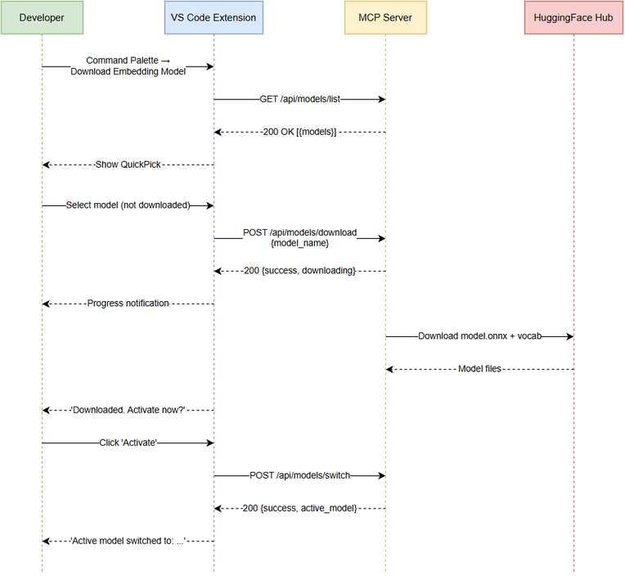 Edit in draw.io

3. Dependencies
Dependency | Type | Related Ticket | Description
KSA-102 | System | KSA-102 | Adaptive Token Cache + Model Manager — provides ModelManager, ModelRegistry, ModelCatalog infrastructure
MCP Server HTTP Viewer | System | N/A | HTTP server must be running on configurable port (default 3200)
VS Code Extension | System | N/A | kiro-sdlc-agents extension must be installed and active
HuggingFace Hub | External | N/A | Model file hosting — required for download (sentence-transformers models)
.kiro/settings/mcp.json | Configuration | N/A | Contains CODE_INTEL_VIEWER_PORT env variable for server port resolution

4. Stakeholders
Role | Name / Team | Responsibility | Source
Product Owner | Duc Nguyen Minh | Requirements definition, feature prioritization | Jira reporter
Developer | Development Team | Implementation across extension + 3 MCP modules | Jira assignee
End Users | Developers using Kiro SDLC | Primary users of the download command | Target audience
Architect | SA Agent | Technical design review | Review

5. Risks and Assumptions

5.1 Risks
Risk | Impact | Likelihood | Mitigation
MCP server not running when command invoked | Medium | High | Clear error message with guidance; check server status before API calls
Large model download (470MB) on slow network | Low | Medium | Background download, non-blocking; user can continue working
HuggingFace unavailable (network restriction) | Medium | Low | Graceful error message; model files can be manually placed
Port conflict on default 3200 | Low | Low | Port configurable via CODE_INTEL_VIEWER_PORT env variable
Inconsistent behavior across MCP modules | High | Low | Shared test suite; implementation parity matrix in FSD
Partial download (interrupted) leaves corrupted files | Medium | Low | Future: checksum verification (noted as open issue)

5.2 Assumptions
- MCP server is running with HTTP viewer enabled before command is invoked
- Developer has internet access for initial model download
- ~/.code-intel/models/ directory is writable by the current user
- VS Code extension can make HTTP calls to localhost (no firewall blocking)
- Model catalog is static (hardcoded) — no dynamic model discovery from remote registry
- The default model all-MiniLM-L6-v2 is auto-downloaded on first MCP server use (per KSA-102)

6. Non-Functional Requirements
Category | Requirement | Details
Performance | Model list response time | < 50ms (in-memory catalog, no disk I/O)
Performance | Download non-blocking | Background thread/async — does not block server or extension
Reliability | Concurrent download prevention | Same model cannot be downloaded twice simultaneously
Compatibility | Cross-platform | Windows, macOS, Linux
Compatibility | Cross-module | Identical API behavior across Python, Node.js, Kotlin
Storage | Model location | ~/.code-intel/models/{model-name}/ (global, shared across workspaces)
UX | Progress feedback | Indeterminate progress notification during download
UX | Error messages | User-friendly, actionable, no stack traces

7. Related Tickets
Ticket Key | Summary | Status | Type | Relationship
KSA-104 | VS Code Command: Download Embedding Model (QuickPick UI + HTTP API) | Done | Task | Main ticket
KSA-102 | Adaptive Token Cache + Model Manager for multilingual find_tools | Done | Task | Parent feature (provides ModelManager infrastructure)

8. Appendix

Glossary
Term | Definition
QuickPick | VS Code native dropdown UI component for item selection from a list
Embedding Model | ONNX neural network that converts text into 384-dimensional vectors for semantic similarity
ModelManager | Backend component handling model lifecycle (list, download, status, switch)
ModelRegistry | JSON file (registry.json) tracking downloaded models and active selection
HuggingFace | Model hosting platform — source for ONNX model file downloads
ONNX | Open Neural Network Exchange — portable model format for local inference
Codicon | VS Code’s built-in icon font used in QuickPick items and status bar
MCP | Model Context Protocol — communication protocol between AI agents and tool servers

Reference Documents
Document | Link / Location
FSD | documents/KSA-104/FSD.md
TDD | documents/KSA-104/TDD.md
KSA-102 BRD | documents/KSA-102/BRD.md
Extension source | kiro-sdlc-agents/src/model-downloader.ts
Python API routes | mcp-code-intelligence-python/src/mcp_code_intel/http/model_routes.py
Node.js API routes | mcp-client-bridge/src/http/model-routes.ts
Kotlin API routes | mcp-code-intelligence-kotlin/src/main/kotlin/com/codeintel/http/ModelApiRoutes.kt

HTTP API Quick Reference
Method | Path | Request Body | Success Response
GET | /api/models/list | — | { "models": [{name, display_name, size_mb, languages, downloaded, active}] }
GET | /api/models/status | — | { "active_model", "model_path", "dimensions" }
POST | /api/models/download | { "model_name": "..." } | { "success": true, "status": "downloading" }
POST | /api/models/switch | { "model_name": "..." } | { "success": true, "active_model": "..." }

Diagram Index
# | Diagram | Image | Source (editable)
1 | Use Case Diagram | use-case.png | use-case.drawio
2 | Business Flow | business-flow.png | business-flow.drawio
3 | Process Map | process-map.png | process-map.drawio
4 | Sequence — Download Flow | sequence-download.png | sequence-download.drawio

