Functional Specification Document (FSD)

MCP Code Intelligence — KSA-104: Download Embedding Model

Document Information
Field | Value
Jira Ticket | KSA-104
Title | Download Embedding Model — VS Code Command + HTTP API
Author | BA Agent + TA Agent
Version | 1.0
Date | 2026-05-21
Status | Final (Retroactive)
Related BRD | BRD-v1-KSA-104.docx
Related Ticket | KSA-102 (Adaptive Token Cache + Model Manager)

Revision History
Version | Date | Author | Changes
1.0 | 2026-05-21 | BA Agent | Created retroactively from implemented code

1. Introduction

1.1 Purpose
This FSD specifies the functional behavior of the “Download Embedding Model” feature. It provides a VS Code extension command with QuickPick UI that allows users to browse, download, and switch between embedding models used by the MCP Code Intelligence system for semantic search.

1.2 Scope
- VS Code extension command: Kiro SDLC: Download Embedding Model
- QuickPick UI for model selection with status indicators
- HTTP API routes (/api/models/*) implemented across 3 MCP modules (Python, Node.js, Kotlin)
- Background model download from HuggingFace with progress notification
- Model switching (activate a different downloaded model)

1.3 Definitions & Acronyms
Term | Definition
Embedding Model | ONNX neural network that converts text to 384-dimensional vectors
QuickPick | VS Code native dropdown UI for item selection
ModelManager | Backend component handling model lifecycle (list/download/status/switch)
ModelRegistry | JSON file tracking downloaded models and active selection
HuggingFace | Model hosting platform (source for ONNX model downloads)
ONNX | Open Neural Network Exchange — portable model format

1.4 References
Document | Location
BRD | documents/KSA-104/BRD.md
KSA-102 FSD | documents/KSA-102/FSD.md
ModelManager (Kotlin) | mcp-code-intelligence-kotlin/src/main/kotlin/com/codeintel/orchestration/models/
Model Downloader (Extension) | kiro-sdlc-agents/src/model-downloader.ts

2. System Overview

2.1 System Context Diagram
System Context
System Context
Actors: - Developer: Triggers command from VS Code Command Palette - MCP Server (Viewer HTTP): Serves model API on localhost - HuggingFace Hub: External model file hosting
Data Flow: 1. Developer invokes command → Extension reads MCP server port from .kiro/settings/mcp.json 2. Extension calls GET /api/models/list → Server returns model catalog with download status 3. Developer selects model → Extension calls POST /api/models/download or POST /api/models/switch 4. Server downloads model files from HuggingFace (background thread) 5. Server updates registry.json with download state

2.2 Feature Boundaries
In Scope | Out of Scope
List available models with metadata | Custom model upload
Download models from HuggingFace | Model training/fine-tuning
Switch active model | Automatic model selection
Progress notification in VS Code | Download cancellation
Model status query | Model deletion

3. Use Cases

3.1 UC-01: List Available Models
Field | Value
ID | UC-01
Actor | Developer
Precondition | MCP server is running, viewer HTTP port is accessible
Trigger | Developer opens Command Palette → selects “Kiro SDLC: Download Embedding Model”
Main Flow:
Step | Actor | System
1 | Invokes command | —
2 | — | Reads viewer port from .kiro/settings/mcp.json (default: 3200)
3 | — | Calls GET /api/models/list
4 | — | Server queries ModelManager → returns model catalog
5 | — | Displays QuickPick with models showing: status icon, display name, size, languages
Alternative Flow:
ID | Condition | Action
AF-01a | MCP server not running | Show error: “Cannot reach MCP server. Ensure it is running.”
AF-01b | No workspace folder open | Show error: “No workspace folder open.”
Postcondition: QuickPick displayed with model list

3.2 UC-02: Download Model
Field | Value
ID | UC-02
Actor | Developer
Precondition | QuickPick displayed, model not yet downloaded
Trigger | Developer selects a model marked “Not downloaded”
Main Flow:
Step | Actor | System
1 | Selects model | —
2 | — | Shows progress notification: “Downloading model: {name}…”
3 | — | Calls POST /api/models/download with { model_name: "..." }
4 | — | Server spawns background thread, downloads files from HuggingFace
5 | — | Server returns { success: true, status: "downloading" }
6 | — | Shows success message: “Model downloaded. Activate now?”
7 | Developer clicks “Activate” | Calls POST /api/models/switch
8 | — | Shows confirmation: “Active model switched to: {name}”
Alternative Flow:
ID | Condition | Action
AF-02a | Download fails (network error) | Show error: “Download failed: {message}”
AF-02b | Model name unknown | Server returns 400: { error: "MODEL_NOT_FOUND" }
AF-02c | User clicks “Later” at step 6 | No switch, model remains downloaded but inactive
Postcondition: Model files saved to ~/.code-intel/models/{model-name}/, registry updated

3.3 UC-03: Switch Active Model
Field | Value
ID | UC-03
Actor | Developer
Precondition | QuickPick displayed, model already downloaded but not active
Trigger | Developer selects a downloaded model
Main Flow:
Step | Actor | System
1 | Selects downloaded model | —
2 | — | Shows confirmation: “Model is already downloaded. Activate it?”
3 | Developer clicks “Activate” | —
4 | — | Calls POST /api/models/switch with { model_name: "..." }
5 | — | Server updates registry.json active_model field
6 | — | Shows success: “Active model switched to: {name}”
Alternative Flow:
ID | Condition | Action
AF-03a | Model not downloaded | Server returns 400: { error: "MODEL_NOT_DOWNLOADED", message: "Download first" }
AF-03b | User clicks “Cancel” | No action taken
AF-03c | Model already active | Show info: “Model is already active.” — no API call
Postcondition: registry.json updated with new active model

3.4 UC-04: Query Model Status
Field | Value
ID | UC-04
Actor | System (internal)
Precondition | MCP server running
Trigger | Any component needs current model info
Main Flow:
Step | Actor | System
1 | Calls GET /api/models/status | —
2 | — | Returns { active_model, model_path, dimensions }
Postcondition: Caller has current model state

4. Business Rules
ID | Rule | Enforcement
BR-01 | Only models in the catalog can be downloaded | ModelManager validates against MODELS map
BR-02 | A model must be downloaded before it can be activated | Switch checks registry.isDownloaded()
BR-03 | Only one model can be active at a time | registry.json has single active_model field
BR-04 | Default model is all-MiniLM-L6-v2 if none configured | Hardcoded in DEFAULT_MODEL constant
BR-05 | Downloads are non-blocking (background thread) | thread(isDaemon=true) in Kotlin, async in Node.js
BR-06 | Duplicate download requests are ignored | downloading set prevents concurrent downloads of same model
BR-07 | Server port is resolved from .kiro/settings/mcp.json env CODE_INTEL_VIEWER_PORT | Extension reads config, falls back to 3200

5. Data Specifications

5.1 Model Catalog (Static)
Model Name | Display Name | Size | Languages | Dimensions | Vocab
all-MiniLM-L6-v2 | English (Small, Fast) | 90 MB | en | 384 | 30,522
paraphrase-multilingual-MiniLM-L12-v2 | Multilingual (50+ languages) | 470 MB | en, vi, zh, ja, ko, fr, de, es, ar, ru | 384 | 250,002

5.2 Registry State (~/.code-intel/models/registry.json)
{
"active_model": "all-MiniLM-L6-v2",
"last_updated": "2026-05-21T10:00:00Z",
"models": {
"all-MiniLM-L6-v2": {
"path": "~/.code-intel/models/all-MiniLM-L6-v2",
"downloaded_at": "2026-05-21T09:30:00Z",
"size_bytes": 94371840
}
}
}

5.3 Model Files (Per Model Directory)
Model | Files
all-MiniLM-L6-v2 | model.onnx, vocab.txt
paraphrase-multilingual-MiniLM-L12-v2 | model.onnx, sentencepiece.bpe.model

6. API Specifications

6.1 GET /api/models/list
Request: No parameters
Response (200):
{
"models": [
{
"name": "all-MiniLM-L6-v2",
"display_name": "English (Small, Fast)",
"size_mb": 90,
"languages": ["en"],
"downloaded": true,
"active": true
},
{
"name": "paraphrase-multilingual-MiniLM-L12-v2",
"display_name": "Multilingual (50+ languages)",
"size_mb": 470,
"languages": ["en", "vi", "zh", "ja", "ko", "fr", "de", "es", "ar", "ru"],
"downloaded": false,
"active": false
}
]
}
Error (503): { "error": "Model manager not initialized" }

6.2 GET /api/models/status
Request: No parameters
Response (200):
{
"active_model": "all-MiniLM-L6-v2",
"model_path": "/home/user/.code-intel/models/all-MiniLM-L6-v2",
"dimensions": 384
}

6.3 POST /api/models/download
Request:
{ "model_name": "paraphrase-multilingual-MiniLM-L12-v2" }
Response (200):
{ "success": true, "model": "paraphrase-multilingual-MiniLM-L12-v2", "status": "downloading" }
Error (400):
{ "error": "MODEL_NOT_FOUND", "message": "Unknown: invalid-model" }

6.4 POST /api/models/switch
Request:
{ "model_name": "paraphrase-multilingual-MiniLM-L12-v2" }
Response (200):
{ "success": true, "active_model": "paraphrase-multilingual-MiniLM-L12-v2" }
Error (400):
{ "error": "MODEL_NOT_DOWNLOADED", "message": "Download first" }

7. UI Specifications

7.1 Command Registration
Field | Value
Command ID | kiro-sdlc.downloadModel
Title | Kiro SDLC: Download Embedding Model
Category | Kiro SDLC
When | Workspace is open

7.2 QuickPick Items
Each model displays: - Status icon: $(check) Active | $(cloud-download) Downloaded | $(cloud) Not downloaded - Label: {status icon} {display_name} - Description: {size_mb}MB — {languages}

7.3 Progress Notification
- Location: VS Code Notification area (ProgressLocation.Notification)
- Title: “Downloading model: {model_name}…”
- Cancellable: No

7.4 Post-Download Dialog
- Message: ✅ Model "{name}" downloaded. Activate now?
- Buttons: “Activate” | “Later”

7.5 Success/Error Messages
Scenario | Message
Switch success | ✅ Active model switched to: {name}
Already active | Model "{name}" is already active.
Server unreachable | ❌ Cannot reach MCP server. Ensure it is running.
Download failed | ❌ Download failed: {error message}
Switch failed | ❌ Switch failed: {error message}

8. Error Handling
Error Code | HTTP Status | Trigger | User Impact
MODEL_NOT_FOUND | 400 | Invalid model_name in request | Extension shows error message
MODEL_NOT_DOWNLOADED | 400 | Switch attempted on non-downloaded model | Extension shows error message
INVALID_ACTION | 400 | Unknown action in execute() | Internal error, should not reach UI
Service Unavailable | 503 | ModelManager not initialized | Extension shows “Cannot reach MCP server”
Network Error | — | HuggingFace unreachable during download | Extension shows “Download failed”

9. Non-Functional Requirements
ID | Requirement | Target
NFR-01 | Model list response time | < 50ms (in-memory catalog)
NFR-02 | Download does not block server | Background thread/async
NFR-03 | Concurrent download prevention | Same model cannot be downloaded twice simultaneously
NFR-04 | Cross-platform support | Windows, macOS, Linux
NFR-05 | No external dependencies for API routes | stdlib HTTP only (Python), Ktor (Kotlin), http (Node.js)
NFR-06 | Model storage location | ~/.code-intel/models/{model-name}/ (global, shared across workspaces)

10. Implementation Parity Matrix
Feature | Python | Node.js | Kotlin
/api/models/list | ✅ model_routes.py | ✅ model-routes.ts | ✅ ModelApiRoutes.kt
/api/models/status | ✅ | ✅ | ✅
/api/models/download | ✅ | ✅ | ✅
/api/models/switch | ✅ | ✅ | ✅
Background download | ✅ (thread) | ✅ (async) | ✅ (daemon thread)
ModelManager | ✅ | ✅ | ✅
ModelRegistry | ✅ | ✅ | ✅
ModelCatalog | ✅ | ✅ | ✅
CORS headers | ✅ | ✅ | ✅ (Ktor built-in)

11. Sequence Diagrams

11.1 Download Model Sequence
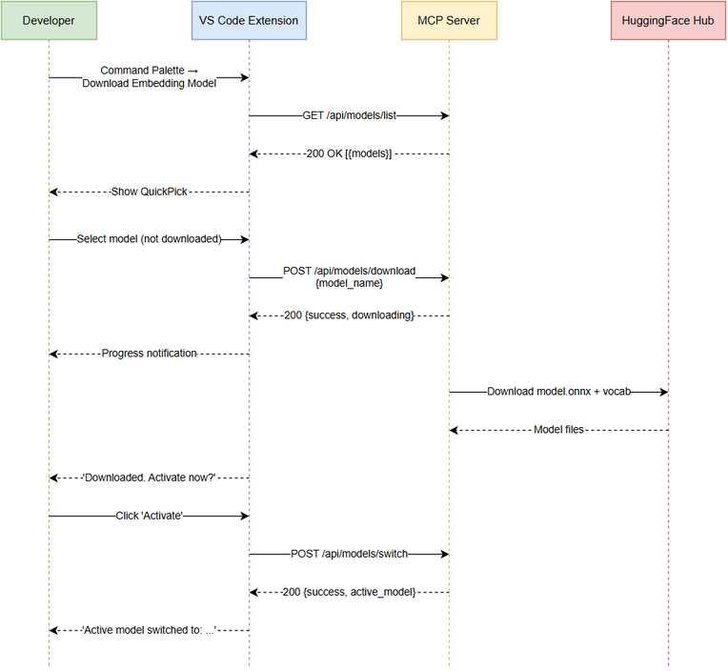
Sequence — Download Model
Developer → Extension: Invoke "Download Embedding Model" command
Extension → Extension: resolveViewerPort() from mcp.json
Extension → Server: GET /api/models/list
Server → ModelManager: execute({action: "list"})
ModelManager → ModelRegistry: isDownloaded() for each model
ModelManager → Server: JSON response with model catalog
Server → Extension: 200 OK [{models}]
Extension → Developer: Show QuickPick
Developer → Extension: Select model (not downloaded)
Extension → Server: POST /api/models/download {model_name}
Server → ModelManager: execute({action: "download", model_name})
ModelManager → Background Thread: downloadFiles(model)
ModelManager → Server: {success: true, status: "downloading"}
Server → Extension: 200 OK
Background Thread → HuggingFace: GET model.onnx
Background Thread → HuggingFace: GET vocab.txt
Background Thread → ModelRegistry: markDownloaded(model, size)
Extension → Developer: "Downloaded. Activate now?"
Developer → Extension: Click "Activate"
Extension → Server: POST /api/models/switch {model_name}
Server → ModelManager: execute({action: "switch", model_name})
ModelManager → ModelRegistry: setActive(model)
Server → Extension: {success: true, active_model: "..."}
Extension → Developer: "Active model switched to: ..."

12. State Diagram

12.1 Model Lifecycle States
State — Model Lifecycle
State — Model Lifecycle
States:
- NOT_IN_CATALOG: Model unknown to system
- AVAILABLE: In catalog, not downloaded
- DOWNLOADING: Download in progress (background)
- DOWNLOADED: Files present on disk, not active
- ACTIVE: Currently used for embedding generation
Transitions:
- AVAILABLE → DOWNLOADING: POST /api/models/download
- DOWNLOADING → DOWNLOADED: Background download completes
- DOWNLOADING → AVAILABLE: Download fails (files cleaned up)
- DOWNLOADED → ACTIVE: POST /api/models/switch
- ACTIVE → DOWNLOADED: Another model switched to active

13. Open Issues
ID | Issue | Impact | Resolution
OI-01 | No download progress percentage reported to extension | UX — user sees indeterminate progress | Future: SSE or polling /api/models/status
OI-02 | No model deletion capability | Disk space management | Future: Add DELETE endpoint
OI-03 | Download is fire-and-forget (no retry on partial failure) | Corrupted model files possible | Future: Checksum verification

Appendix A: Diagram Index
# | Diagram | Image | Source (editable)
1 | System Context | system-context.png | system-context.drawio
2 | Sequence — Download Model | sequence-download.png | sequence-download.drawio
3 | State — Model Lifecycle | state-model-lifecycle.png | state-model-lifecycle.drawio

