Business Requirements Document (BRD)

MCP Code Intelligence — KSA-105: Bug Fix — Extension Model Download Fails When MCP Server Not Running

Document Information
Field | Value
Jira Ticket | KSA-105
Title | Bug: Extension model download fails when MCP server not running
Author | BA Agent
Version | 1.0
Date | 2026-05-21
Status | Final (Retroactive)
Type | Bug Fix

Revision History
Version | Date | Author | Changes
1.0 | 2026-05-21 | BA Agent | Initial document — retroactive from implemented fix (v1.6.1)

1. Introduction

1.1 Scope
This bug fix addresses a critical dependency issue where the VS Code extension command “Download Embedding Model” (KSA-104) fails when the MCP server is not running. The fix involves two changes:
- Extension rewrite: Remove MCP server HTTP API dependency — extension downloads models directly from HuggingFace using VS Code’s built-in HTTP client
- Cache invalidation: All 3 MCP server modules’ ModelRegistry classes cache registry.json in-memory at startup — newly downloaded models are invisible until server restart. Fix: re-read file on every getModel() call.

1.2 Out of Scope
- New model additions to catalog
- Download progress percentage
- Model deletion capability
- UI changes to QuickPick (same UX, different backend)

1.3 Preliminary Requirement
- KSA-104 (Download Embedding Model feature) — the original feature this bug was found in
- KSA-102 (Model Manager infrastructure) — provides ModelRegistry that needs cache fix

2. Business Requirements

2.1 Problem Statement
Scenario: Developer installs the extension fresh. No MCP server is running yet. Developer wants to download an embedding model to enable semantic search.
Current behavior (broken): Extension calls POST /api/models/download on MCP server HTTP API → server not running → ECONNREFUSED → error message “Cannot reach MCP server” → user stuck in chicken-and-egg loop (needs model to start server, needs server to download model).
Expected behavior (fixed): Extension downloads model directly from HuggingFace without needing MCP server. After download, MCP server (when started) immediately sees the new model without restart.

2.2 Business Flow
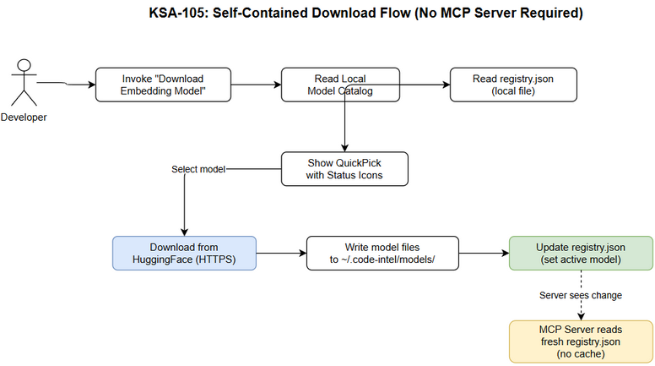 Edit in draw.io

2.3 Use Case Diagram
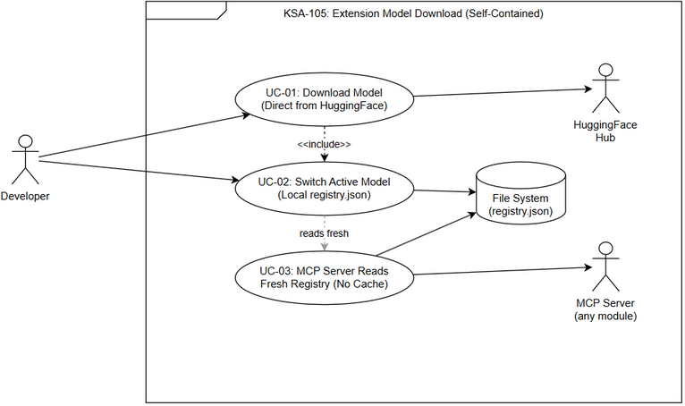 Edit in draw.io

2.4 List of User Stories
# | Story | Priority | Source
1 | As a developer, I want to download embedding models even when MCP server is not running, so that I can set up the system from scratch | MUST HAVE | KSA-105
2 | As a developer, I want the MCP server to immediately recognize newly downloaded models without restart, so that I don’t need to restart the server after downloading a model | MUST HAVE | KSA-105

2.5 Details of User Stories

STORY 1: Download Models Without MCP Server
As a developer, I want to download embedding models even when MCP server is not running, so that I can set up the system from scratch
Root Cause: Extension delegates download to MCP server HTTP API. Server may not be running.
Fix: Extension performs download directly: 1. Read model catalog (hardcoded in extension) 2. Download files from HuggingFace using https.get() 3. Save to ~/.code-intel/models/{model-name}/ 4. Update ~/.code-intel/models/registry.json directly
Acceptance Criteria:
# | Criterion
AC-1 | Given MCP server is NOT running, when user invokes “Download Embedding Model”, then QuickPick shows model list (from local catalog, no server call)
AC-2 | Given user selects a model to download, then extension downloads directly from HuggingFace without calling MCP server
AC-3 | Given download completes, then registry.json is updated with model entry and active_model set
AC-4 | Given download fails (network error), then clear error message shown to user
AC-5 | Given model already downloaded, then user can switch active model without MCP server

STORY 2: MCP Server Cache Invalidation
As a developer, I want the MCP server to immediately recognize newly downloaded models without restart
Root Cause: ModelRegistry in all 3 MCP modules reads registry.json once at startup and caches in memory. When extension downloads a model and updates registry.json, the running MCP server doesn’t see the change.
Fix: ModelRegistry.getModel() (or equivalent property access) re-reads registry.json from disk on every call instead of using cached data.
Acceptance Criteria:
# | Criterion
AC-6 | Given MCP server is running, when extension downloads a new model and updates registry.json, then server’s next getModel() call returns the new model
AC-7 | Given MCP server is running, when extension switches active model in registry.json, then server’s next activeModel read returns the new active model
AC-8 | Given registry.json is modified externally, then all 3 MCP modules (Python, Node.js, Kotlin) reflect the change on next read

3. Dependencies
Dependency | Type | Related Ticket | Description
KSA-104 | Parent Feature | KSA-104 | Original “Download Embedding Model” feature
KSA-102 | Infrastructure | KSA-102 | ModelRegistry, ModelManager, ModelCatalog
HuggingFace Hub | External | N/A | Model file hosting (now accessed directly by extension)

4. Risks and Assumptions

4.1 Risks
Risk | Impact | Likelihood | Mitigation
Extension HTTP client less robust than server-side | Medium | Low | Use Node.js https module (proven, stable)
Race condition: extension writes registry.json while server reads | Low | Low | JSON write is atomic (write temp → rename)
Performance: re-reading registry.json on every call | Low | Low | File is tiny (<1KB), OS caches in page cache

4.2 Assumptions
- Extension has direct internet access to HuggingFace (no proxy issues)
- ~/.code-intel/models/ directory is writable by both extension and server processes
- Registry.json format remains backward-compatible

5. Non-Functional Requirements
Category | Requirement
Reliability | Extension download works regardless of MCP server state
Performance | Registry re-read adds < 1ms overhead per call (file < 1KB)
Compatibility | Fix applied consistently across Python, Node.js, Kotlin modules
Backward Compat | Existing registry.json files remain valid after fix

6. Related Tickets
Ticket | Summary | Relationship
KSA-104 | VS Code Command: Download Embedding Model | Parent feature
KSA-102 | Adaptive Token Cache + Model Manager | Infrastructure dependency

Appendix

Diagram Index
# | Diagram | Image | Source (editable)
1 | Business Flow | business-flow.png | business-flow.drawio
2 | Use Case Diagram | use-case.png | use-case.drawio

