Functional Specification Document (FSD)

MCP Code Intelligence — KSA-105: Bug Fix — Extension Model Download Without MCP Server

Document Information
Field | Value
Jira Ticket | KSA-105
Title | Bug Fix: Extension Model Download Fails When MCP Server Not Running
Author | BA Agent + TA Agent
Version | 1.0
Date | 2026-05-21
Status | Final (Retroactive)
Related BRD | BRD-v1-KSA-105.docx
Related Tickets | KSA-104 (parent feature), KSA-102 (infrastructure)

Revision History
Version | Date | Author | Changes
1.0 | 2026-05-21 | BA + TA Agent | Created retroactively from implemented fix

1. Introduction

1.1 Purpose
This FSD specifies the functional changes required to fix the bug where the VS Code extension’s “Download Embedding Model” command fails when the MCP server is not running. Two fixes are specified:
- Extension self-contained download — remove HTTP API dependency, download directly from HuggingFace
- ModelRegistry cache invalidation — re-read registry.json on every access instead of caching at startup

1.2 Scope
Component | Change Type
kiro-sdlc-agents/src/model-downloader.ts | Rewrite (self-contained download)
mcp-code-intelligence-python/.../model_registry.py | Modify (cache invalidation)
mcp-code-intelligence-nodejs/.../model-registry.ts | Modify (cache invalidation)
mcp-code-intelligence-kotlin/.../ModelRegistry.kt | Modify (cache invalidation)

1.3 Definitions
Term | Definition
Self-contained download | Extension downloads model files directly without relying on any external server
Cache invalidation | Reading fresh data from disk instead of using in-memory cached copy
Registry | JSON file (~/.code-intel/models/registry.json) tracking model state

2. System Context

2.1 Before Fix (Broken)
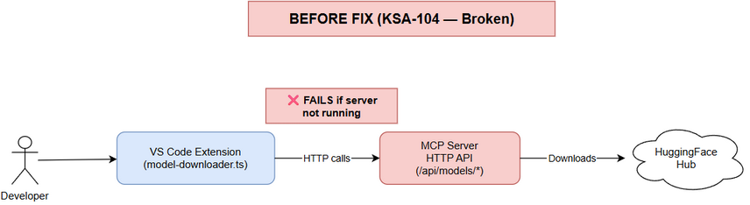 Edit in draw.io
Developer → Extension → MCP Server HTTP API → HuggingFace
↑
FAILS if not running

2.2 After Fix (Working)
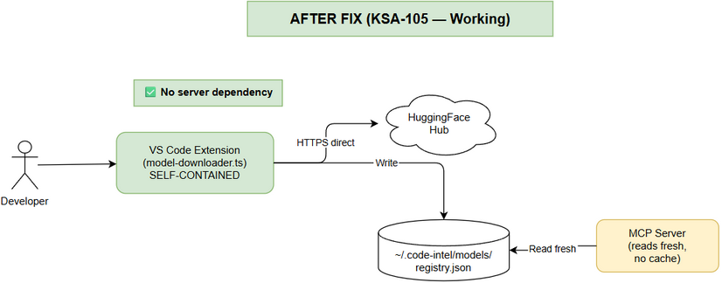 Edit in draw.io
Developer → Extension → HuggingFace (direct)
↓
registry.json (direct write)
↓
MCP Server reads fresh (no cache)

3. Use Cases

3.1 UC-01: Download Model (Self-Contained)
Field | Value
ID | UC-01
Actor | Developer
Precondition | VS Code extension active, internet available
Trigger | Developer invokes “Kiro SDLC: Download Embedding Model”
Main Flow:
Step | Actor | System
1 | Invokes command | —
2 | — | Reads model catalog from hardcoded MODELS constant
3 | — | Reads ~/.code-intel/models/registry.json to determine download/active status
4 | — | Displays QuickPick with models + status icons
5 | Selects model (not downloaded) | —
6 | — | Shows progress notification: “Downloading {name}…”
7 | — | Downloads model.onnx from HuggingFace via HTTPS
8 | — | Downloads vocab file (vocab.txt or sentencepiece.bpe.model)
9 | — | Writes model files to ~/.code-intel/models/{model-name}/
10 | — | Updates registry.json: adds model entry, sets as active
11 | — | Shows success: “✅ Model downloaded and activated: {name}”
Alternative Flows:
ID | Condition | Action
AF-01a | Network error during download | Show error: “❌ Download failed: {message}”. Clean up partial files.
AF-01b | Model already downloaded | Show option to switch active model (no re-download)
AF-01c | Model already active | Show info: “Model is already active”
AF-01d | Disk write fails | Show error: “❌ Cannot write model files. Check disk space.”
Postcondition: Model files on disk, registry.json updated, model active

3.2 UC-02: Switch Active Model (Self-Contained)
Field | Value
ID | UC-02
Actor | Developer
Precondition | Model already downloaded
Trigger | Developer selects a downloaded (non-active) model in QuickPick
Main Flow:
Step | Actor | System
1 | Selects downloaded model | —
2 | — | Asks “Activate this model?”
3 | Confirms | —
4 | — | Updates registry.json: sets active_model to selected model
5 | — | Shows success: “✅ Active model switched to: {name}”
Postcondition: registry.json updated, MCP server (if running) sees change on next read

3.3 UC-03: MCP Server Reads Fresh Registry
Field | Value
ID | UC-03
Actor | MCP Server (internal)
Precondition | Server running, registry.json modified externally
Trigger | Any code path accesses activeModel or calls getModel()
Main Flow:
Step | System
1 | Code accesses ModelRegistry.activeModel property
2 | Property getter reads registry.json from disk (no cache)
3 | Parses JSON, returns current active_model value
Key Change: Previously, registry was read once at construction time and cached. Now, every property access triggers a fresh disk read.

4. Business Rules
ID | Rule | Change from KSA-104
BR-01 | Extension MUST NOT depend on MCP server for model download | NEW — previously required server
BR-02 | Extension reads model catalog from local constant (not server API) | NEW — previously called /api/models/list
BR-03 | Extension writes registry.json directly after download | NEW — previously server wrote it
BR-04 | ModelRegistry MUST re-read registry.json on every activeModel access | CHANGED — previously cached at startup
BR-05 | ModelRegistry MUST re-read on every isDownloaded() check | CHANGED — previously cached
BR-06 | All 3 MCP modules must implement identical cache invalidation | NEW

5. Data Specifications

5.1 Model Catalog (Hardcoded in Extension)
const MODELS: Record<string, ModelInfo> = {
"all-MiniLM-L6-v2": {
displayName: "English (Small, Fast)",
sizeMb: 90,
languages: ["en"],
files: {
model: "onnx/model.onnx",
vocab: "vocab.txt"
},
baseUrl: "https://huggingface.co/sentence-transformers/all-MiniLM-L6-v2/resolve/main"
},
"paraphrase-multilingual-MiniLM-L12-v2": {
displayName: "Multilingual (50+ languages)",
sizeMb: 470,
languages: ["en", "vi", "zh", "ja", "ko", "fr", "de", "es", "ar", "ru"],
files: {
model: "onnx/model.onnx",
vocab: "sentencepiece.bpe.model"
},
baseUrl: "https://huggingface.co/sentence-transformers/paraphrase-multilingual-MiniLM-L12-v2/resolve/main"
}
};

5.2 Registry.json (Written by Extension)
Same format as KSA-104 — no schema change:
{
"active_model": "all-MiniLM-L6-v2",
"last_updated": "2026-05-21T12:00:00Z",
"models": {
"all-MiniLM-L6-v2": {
"path": "~/.code-intel/models/all-MiniLM-L6-v2",
"downloaded_at": "2026-05-21T12:00:00Z",
"size_bytes": 94371840
}
}
}

6. Sequence Diagram

6.1 Download Flow (After Fix)
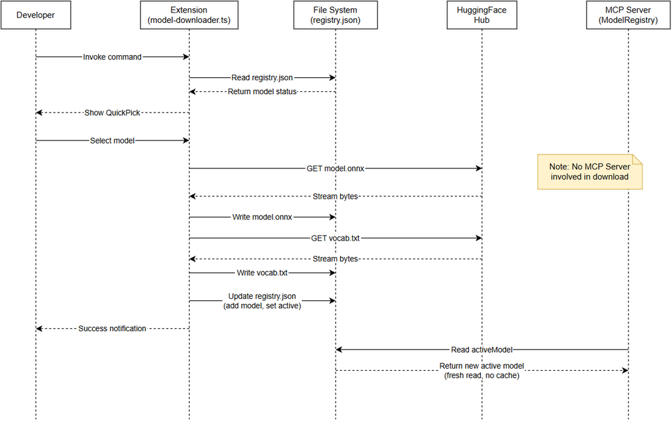 Edit in draw.io
Developer → Extension: Invoke "Download Embedding Model"
Extension → Extension: Read MODELS catalog (local constant)
Extension → Disk: Read ~/.code-intel/models/registry.json
Extension → Developer: Show QuickPick (models + status)
Developer → Extension: Select model (not downloaded)
Extension → Developer: Show progress notification
Extension → HuggingFace: GET model.onnx (HTTPS direct)
HuggingFace → Extension: Stream file bytes
Extension → Disk: Write ~/.code-intel/models/{name}/model.onnx
Extension → HuggingFace: GET vocab.txt (HTTPS direct)
HuggingFace → Extension: Stream file bytes
Extension → Disk: Write ~/.code-intel/models/{name}/vocab.txt
Extension → Disk: Update registry.json (add model, set active)
Extension → Developer: "✅ Model downloaded and activated"

6.2 Cache Invalidation Flow
Extension → Disk: Write registry.json (new model downloaded)
...later...
MCP Server → ModelRegistry: access activeModel property
ModelRegistry → Disk: Read registry.json (FRESH read, no cache)
ModelRegistry → MCP Server: Return new active_model value

7. State Diagram

7.1 Extension Download States
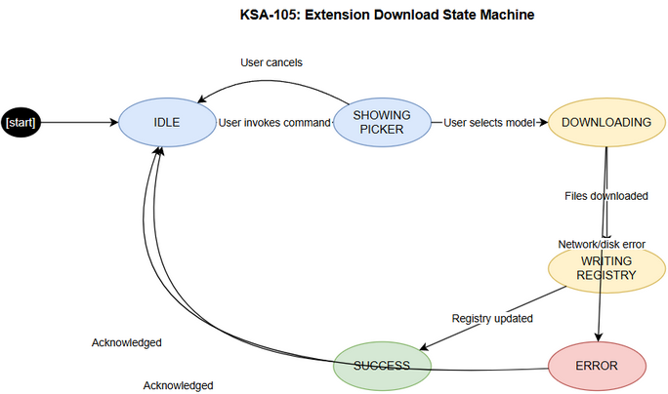 Edit in draw.io
States:
- IDLE: Waiting for user command
- SHOWING_PICKER: QuickPick displayed
- DOWNLOADING: File download in progress
- WRITING_REGISTRY: Updating registry.json
- SUCCESS: Download complete
- ERROR: Download failed
Transitions:
- IDLE → SHOWING_PICKER: User invokes command
- SHOWING_PICKER → DOWNLOADING: User selects model
- SHOWING_PICKER → IDLE: User cancels
- DOWNLOADING → WRITING_REGISTRY: Files downloaded successfully
- DOWNLOADING → ERROR: Network/disk error
- WRITING_REGISTRY → SUCCESS: Registry updated
- ERROR → IDLE: Error shown, user acknowledges
- SUCCESS → IDLE: Success shown

8. Error Handling
Error | Source | User Message | Recovery
Network timeout | HuggingFace unreachable | “❌ Download failed: Connection timed out” | Retry manually
HTTP 404 | Model URL invalid | “❌ Download failed: Model file not found” | Report bug
Disk full | Write fails | “❌ Cannot write model files. Check disk space.” | Free space, retry
Permission denied | Directory not writable | “❌ Cannot write to ~/.code-intel/models/” | Fix permissions
JSON parse error | Corrupted registry.json | Silently reset to defaults | Auto-recovery
Partial download | Interrupted | Clean up partial files, show error | Retry downloads full file

9. Non-Functional Requirements
ID | Requirement | Target
NFR-01 | Download works without MCP server | 100% — zero server dependency
NFR-02 | Registry re-read latency | < 1ms (file < 1KB, OS page cache)
NFR-03 | No breaking changes to registry.json format | Backward compatible
NFR-04 | All 3 MCP modules updated consistently | Identical behavior
NFR-05 | Extension download timeout | 60s per file (configurable)

10. Integration Requirements

10.1 Extension → File System
- Write model files to ~/.code-intel/models/{model-name}/
- Write/update registry.json atomically (write temp → rename)
- Create directories if not exist (mkdirSync with recursive: true)

10.2 MCP Server → File System
- Read registry.json on every activeModel / isDownloaded() access
- Handle file-not-found gracefully (return defaults)
- Handle JSON parse errors gracefully (return defaults)

Appendix: Diagram Index
# | Diagram | Image | Source (editable)
1 | System Context — Before | system-context-before.png | system-context-before.drawio
2 | System Context — After | system-context-after.png | system-context-after.drawio
3 | Sequence — Download | sequence-download.png | sequence-download.drawio
4 | State — Download | state-download.png | state-download.drawio

