Technical Design Document (TDD)

MCP Code Intelligence — KSA-105: Bug Fix — Self-Contained Download + Cache Invalidation

Document Information
Field | Value
Jira Ticket | KSA-105
Title | Technical Design: Extension Self-Contained Download + ModelRegistry Cache Invalidation
Author | SA Agent
Version | 1.0
Date | 2026-05-21
Status | Final (Retroactive)
Related BRD | BRD-v1-KSA-105.docx
Related FSD | FSD-v1-KSA-105.docx
Related Tickets | KSA-104 (parent), KSA-102 (infrastructure)

Revision History
Version | Date | Author | Changes
1.0 | 2026-05-21 | SA Agent | Created retroactively from implemented fix

1. Introduction

1.1 Purpose
This TDD specifies the technical implementation of the KSA-105 bug fix across 4 files: 1. Extension model-downloader.ts — complete rewrite for self-contained download 2. Kotlin ModelRegistry.kt — cache invalidation 3. Python model_registry.py — cache invalidation 4. Node.js model-registry.ts — cache invalidation

1.2 Technology Stack
Layer | Technology
Extension | TypeScript, Node.js https module, VS Code API
Kotlin | Kotlin stdlib, java.io.File, kotlinx.serialization
Python | Python stdlib (json, os, pathlib)
Node.js | Node.js stdlib (fs, path)

1.3 Design Principles
- Zero server dependency: Extension must work completely standalone
- Minimal change: Cache invalidation is a surgical fix — only change read pattern
- No schema changes: registry.json format unchanged
- Consistent behavior: All 3 MCP modules behave identically after fix

2. Architecture

2.1 Architecture Overview
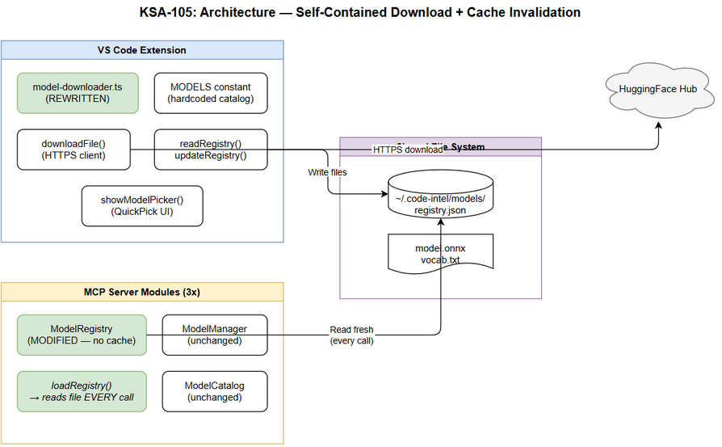 Edit in draw.io
┌─────────────────────────────────────────────────────────────┐
│ VS Code Extension (REWRITTEN) │
│ ┌─────────────────────────────────────────────────────────┐ │
│ │ model-downloader.ts (self-contained) │ │
│ │ ├── handleDownloadModel() ← Entry point │ │
│ │ ├── showModelPicker() ← QuickPick from local │ │
│ │ ├── downloadModelFiles() ← Direct HTTPS download │ │
│ │ ├── updateRegistry() ← Direct file write │ │
│ │ ├── readRegistry() ← Direct file read │ │
│ │ └── MODELS (constant) ← Hardcoded catalog │ │
│ └─────────────────────────────────────────────────────────┘ │
└───────────────────────────────┬─────────────────────────────┘
│ HTTPS (direct to HuggingFace)
▼
┌──────────────────────┐
│ HuggingFace Hub │
└──────────────────────┘
┌─────────────────────────────────────────────────────────────┐
│ MCP Server (Kotlin / Python / Node.js) │
│ ┌─────────────────────────────────────────────────────────┐ │
│ │ ModelRegistry (MODIFIED — no cache) │ │
│ │ ├── get activeModel → READ registry.json EVERY TIME │ │
│ │ ├── isDownloaded() → READ registry.json EVERY TIME │ │
│ │ └── NO in-memory cache of registry data │ │
│ └─────────────────────────────────────────────────────────┘ │
└─────────────────────────────────────────────────────────────┘
↕ (shared file)
~/.code-intel/models/registry.json

2.2 Component Diagram
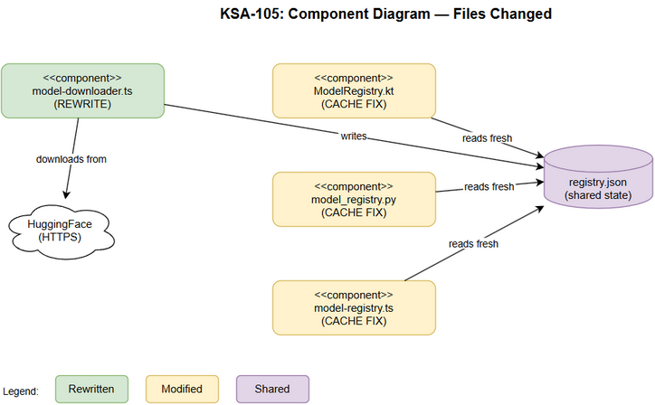 Edit in draw.io

3. Module Design

3.1 Extension: model-downloader.ts (Rewrite)
Location: kiro-sdlc-agents/src/model-downloader.ts
Key change: Previously called MCP server HTTP API. Now performs all operations locally.
Functions:
Function | Purpose | Lines
handleDownloadModel() | Entry point: read registry → show picker → download/switch | ~15
showModelPicker(models, registry) | Build QuickPick items with status from local registry | ~20
downloadModelFiles(modelName, modelInfo) | Download model.onnx + vocab from HuggingFace | ~20
downloadFile(url, destPath) | HTTPS GET with stream-to-file, returns Promise | ~18
readRegistry() | Read and parse ~/.code-intel/models/registry.json | ~10
updateRegistry(modelName, modelPath, sizeBytes) | Write updated registry.json (add model, set active) | ~15
getModelsDir() | Return ~/.code-intel/models/ path | ~3
MODELS | Hardcoded model catalog constant | ~20
Pseudocode — handleDownloadModel():
async function handleDownloadModel() {
const modelsDir = getModelsDir();
ensureDirExists(modelsDir);
const registry = readRegistry();
const items = buildQuickPickItems(MODELS, registry);
const selected = await vscode.window.showQuickPick(items);
if (!selected) return;
const modelName = selected.modelKey;
const modelInfo = MODELS[modelName];
if (registry.active_model === modelName) {
vscode.window.showInformationMessage("Model is already active.");
return;
}
if (isDownloaded(registry, modelName)) {
// Already downloaded — just switch
updateRegistry(modelName, ...);
vscode.window.showInformationMessage(`Active model switched to: ${modelInfo.displayName}`);
return;
}
// Download with progress
await vscode.window.withProgress({...}, async () => {
await downloadModelFiles(modelName, modelInfo);
updateRegistry(modelName, modelPath, sizeBytes);
});
vscode.window.showInformationMessage(`Model downloaded and activated: ${modelInfo.displayName}`);
}
Pseudocode — downloadFile():
function downloadFile(url: string, destPath: string): Promise<number> {
return new Promise((resolve, reject) => {
const file = fs.createWriteStream(destPath);
https.get(url, (response) => {
if (response.statusCode === 302 || response.statusCode === 301) {
// Follow redirect (HuggingFace uses redirects)
return downloadFile(response.headers.location!, destPath).then(resolve, reject);
}
if (response.statusCode !== 200) {
reject(new Error(`HTTP ${response.statusCode}`));
return;
}
let bytes = 0;
response.on('data', (chunk) => { bytes += chunk.length; });
response.pipe(file);
file.on('finish', () => { file.close(); resolve(bytes); });
}).on('error', reject);
});
}

3.2 Kotlin: ModelRegistry.kt (Cache Invalidation)
Location: mcp-code-intelligence-kotlin/src/main/kotlin/com/codeintel/orchestration/models/ModelRegistry.kt
Before (cached):
class ModelRegistry(private val modelsDir: String) {
private val registryFile = File(modelsDir, "registry.json")
private var data: JsonObject = loadRegistry() // Cached at construction
val activeModel: String
get() = data["active_model"]?.jsonPrimitive?.content ?: DEFAULT_MODEL
fun isDownloaded(name: String): Boolean =
data["models"]?.jsonObject?.containsKey(name) ?: false
private fun loadRegistry(): JsonObject { /* read file once */ }
}
After (no cache):
class ModelRegistry(private val modelsDir: String) {
private val registryFile = File(modelsDir, "registry.json")
val activeModel: String
get() {
val data = loadRegistry() // Fresh read every time
return data["active_model"]?.jsonPrimitive?.content ?: DEFAULT_MODEL
}
fun isDownloaded(name: String): Boolean {
val data = loadRegistry() // Fresh read every time
return data["models"]?.jsonObject?.containsKey(name) ?: false
}
private fun loadRegistry(): JsonObject {
if (!registryFile.exists()) return buildJsonObject {}
return try {
Json.parseToJsonElement(registryFile.readText()).jsonObject
} catch (e: Exception) {
buildJsonObject {} // Corrupted → return empty
}
}
}
Key change: Remove private var data field. Every property access calls loadRegistry() which reads from disk.

3.3 Python: model_registry.py (Cache Invalidation)
Location: mcp-code-intelligence-python/src/mcp_code_intel/orchestration/models/model_registry.py
Before:
class ModelRegistry:
def __init__(self, models_dir):
self._registry_file = Path(models_dir) / "registry.json"
self._data = self._load() # Cached
@property
def active_model(self):
return self._data.get("active_model", DEFAULT_MODEL)
After:
class ModelRegistry:
def __init__(self, models_dir):
self._registry_file = Path(models_dir) / "registry.json"
@property
def active_model(self):
data = self._load() # Fresh read
return data.get("active_model", DEFAULT_MODEL)
def is_downloaded(self, name):
data = self._load() # Fresh read
return name in data.get("models", {})
def _load(self):
if not self._registry_file.exists():
return {}
try:
return json.loads(self._registry_file.read_text())
except (json.JSONDecodeError, OSError):
return {}

3.4 Node.js: model-registry.ts (Cache Invalidation)
Location: mcp-code-intelligence-nodejs/src/orchestration/models/model-registry.ts
Before:
export class ModelRegistry {
private data: RegistryData;
constructor(modelsDir: string) {
this.registryFile = path.join(modelsDir, "registry.json");
this.data = this.load(); // Cached
}
get activeModel(): string { return this.data.active_model ?? DEFAULT_MODEL; }
}
After:
export class ModelRegistry {
constructor(private modelsDir: string) {
this.registryFile = path.join(modelsDir, "registry.json");
}
get activeModel(): string {
const data = this.load(); // Fresh read
return data.active_model ?? DEFAULT_MODEL;
}
isDownloaded(name: string): boolean {
const data = this.load(); // Fresh read
return name in (data.models ?? {});
}
private load(): RegistryData {
if (!fs.existsSync(this.registryFile)) return {};
try {
return JSON.parse(fs.readFileSync(this.registryFile, "utf-8"));
} catch {
return {};
}
}
}

4. Data Design

4.1 Registry.json (No Schema Change)
Format remains identical to KSA-104:
{
"active_model": "all-MiniLM-L6-v2",
"last_updated": "2026-05-21T12:00:00Z",
"models": {
"all-MiniLM-L6-v2": {
"path": "/home/user/.code-intel/models/all-MiniLM-L6-v2",
"downloaded_at": "2026-05-21T12:00:00Z",
"size_bytes": 94371840
}
}
}

4.2 File System Operations
Operation | Actor | Path
Create directory | Extension | ~/.code-intel/models/{model-name}/
Write model file | Extension | ~/.code-intel/models/{model-name}/model.onnx
Write vocab file | Extension | ~/.code-intel/models/{model-name}/vocab.txt
Write registry | Extension | ~/.code-intel/models/registry.json
Read registry | Extension + MCP Server | ~/.code-intel/models/registry.json

5. Integration Design

5.1 Extension ↔ HuggingFace (New)
Extension → HTTPS GET → HuggingFace CDN
← 302 Redirect → Follow to actual file URL
← 200 + Stream → Write to disk
Redirect handling: HuggingFace returns 302 redirects to CDN. Extension must follow redirects (max 5 hops).

5.2 Extension ↔ File System (New)
Extension → fs.mkdirSync(modelsDir, {recursive: true})
Extension → fs.createWriteStream(modelPath) ← pipe from HTTPS response
Extension → fs.writeFileSync(registryPath, JSON.stringify(data))

5.3 MCP Server ↔ File System (Modified)
Before: ModelRegistry constructor → readFileSync → cache in this.data
After: ModelRegistry.activeModel → readFileSync → return (no cache)

6. Error Handling

6.1 Extension Errors
Error | Detection | Recovery
Network timeout | https.get timeout event | Show error, clean up partial files
HTTP non-200 | Response status code check | Show error with status code
Redirect loop | Count redirects > 5 | Show error “Too many redirects”
Disk write failure | fs.createWriteStream error event | Show error, clean up partial files
Registry parse error | JSON.parse throws | Reset to empty registry {}
Directory creation fails | mkdirSync throws | Show error about permissions

6.2 MCP Server Errors (Registry Read)
Error | Detection | Recovery
File not found | !file.exists() | Return empty object (defaults)
JSON parse error | catch block | Return empty object (defaults)
Permission denied | catch block | Return empty object (defaults)

7. Security Considerations
Concern | Mitigation
HTTPS certificate validation | Node.js https validates by default
Model file integrity | No checksum yet (same as KSA-104 — tracked as OI-03)
Registry file permissions | Created with user’s default umask
Path traversal in model names | Model names validated against hardcoded MODELS constant
Concurrent registry writes | Atomic write (write temp → rename) prevents corruption

8. Testing Strategy

8.1 Unit Tests
Component | Test
readRegistry() | File not found → empty; valid JSON → parsed; invalid JSON → empty
updateRegistry() | Adds model entry, sets active_model, preserves existing entries
downloadFile() | Mock HTTPS — success, redirect, error cases
ModelRegistry.activeModel (Kotlin) | Reads fresh from disk each time
ModelRegistry.isDownloaded (Python) | Reads fresh from disk each time
ModelRegistry.activeModel (Node.js) | Reads fresh from disk each time

8.2 Integration Tests
Test | Approach
Extension download flow | Mock HuggingFace server, verify files written
Cache invalidation (Kotlin) | Write registry.json externally → verify ModelRegistry sees change
Cache invalidation (Python) | Same as Kotlin
Cache invalidation (Node.js) | Same as Kotlin

9. Implementation Checklist

9.1 Files Modified
# | File | Module | Change Type | Description
1 | kiro-sdlc-agents/src/model-downloader.ts | Extension | Rewrite | Remove HTTP API calls, add direct HuggingFace download + local registry management
2 | mcp-code-intelligence-kotlin/.../ModelRegistry.kt | Kotlin | Modify | Remove private var data cache, read from disk on every access
3 | mcp-code-intelligence-python/.../model_registry.py | Python | Modify | Remove self._data cache, read from disk on every access
4 | mcp-code-intelligence-nodejs/.../model-registry.ts | Node.js | Modify | Remove this.data cache, read from disk on every access

9.2 Files NOT Modified
File | Reason
ModelApiRoutes.kt | HTTP API still works (for other clients), just not required by extension
model_routes.py | Same — API routes unchanged
model-routes.ts | Same — API routes unchanged
ModelManager (all modules) | Business logic unchanged
ModelCatalog (all modules) | Static data unchanged

10. Deployment Notes
- No migration needed — registry.json format unchanged
- Backward compatible — MCP server HTTP API still works for other clients
- Extension update only — users get fix via VS Code extension update
- Server update recommended — cache invalidation fix improves reliability but server still functions without it (just won’t see external registry changes until restart)
- Released as v1.6.1 — patch release

Appendix: Diagram Index
# | Diagram | Image | Source (editable)
1 | Architecture | architecture.png | architecture.drawio
2 | Component | component.png | component.drawio

