Functional Specification Document (FSD)

KB Web Viewer — KSA-108: Add Mark Reviewed Button and Review Workflow on Dashboard

Document Information
Field | Value
Jira Ticket | KSA-108
Title | KB Web Viewer: Add Mark Reviewed button and review workflow on Dashboard
Author | BA Agent + TA Agent
Version | 1.0
Date | 2026-05-22
Status | Draft
Related BRD | BRD-v1-KSA-108.docx

Revision History
Version | Date | Author | Changes
1.0 | 2026-05-22 | BA Agent | Initiate document
1.0 | 2026-05-22 | TA Agent | Technical enrichment — API contracts, pseudocode, integration specs

1. Introduction

1.1 Purpose
This FSD specifies the functional behavior of the “Mark Reviewed” feature for the KB Web Viewer. It covers the Dashboard Due Reviews table button, the Entry Detail view button, toast notifications, and row removal animation.

1.2 Scope
Frontend-only changes to dashboard.html, dashboard.js, and browser.js. No backend changes required — the API endpoint POST /api/kb/entries/{id}/review already exists and is operational.

1.3 Definitions & Acronyms
Term | Definition
KB | Knowledge Base
Due Reviews | Entries overdue for periodic review (staleness > threshold)
Staleness Score | 0-1 float indicating how stale an entry is
Toast | Temporary notification popup that auto-dismisses
MCP | Model Context Protocol

1.4 References
Document | Location
BRD | BRD-v1-KSA-108.docx
Dashboard HTML | shared/viewer/dashboard.html
Dashboard JS | shared/viewer/dashboard.js
Browser JS | shared/viewer/browser.js
UX Routes (Kotlin) | mcp-code-intelligence-kotlin/src/main/kotlin/com/codeintel/http/UxRoutes.kt

2. System Overview

2.1 System Context Diagram
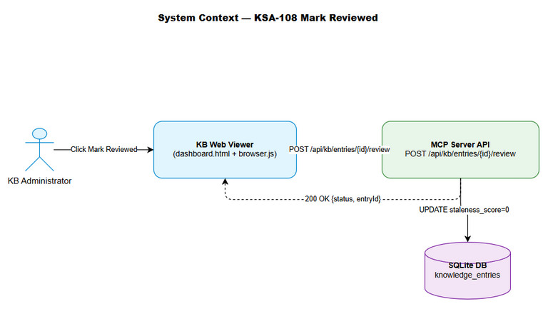
System Context
The KB Web Viewer is a single-page application served as static HTML/JS from the MCP server. It communicates with the backend via REST API calls to /api/kb/* endpoints. The “Mark Reviewed” feature adds a new user interaction that calls the existing POST /api/kb/entries/{id}/review endpoint.
Actors: - KB Administrator (human user via browser) - Backend API (MCP server — Kotlin/Python/Node.js)
Data Flow: 1. Browser loads dashboard → fetches /api/kb/reminders → renders Due Reviews table 2. User clicks “Mark Reviewed” → frontend calls POST /api/kb/entries/{id}/review 3. Backend updates DB → returns 200 OK 4. Frontend removes row + shows toast

2.2 System Architecture
┌─────────────────────────────────────────────┐
│ Browser (KB Web Viewer) │
│ ┌──────────────┐ ┌──────────────────────┐ │
│ │ dashboard.js │ │ browser.js │ │
│ │ (Due Reviews)│ │ (Entry Detail) │ │
│ └──────┬───────┘ └──────────┬───────────┘ │
│ │ │ │
│ └──────────┬───────────┘ │
│ │ fetch() │
└────────────────────┼─────────────────────────┘
│ HTTP
┌────────────────────┼─────────────────────────┐
│ MCP Server │ │
│ ┌─────────────────▼───────────────────────┐ │
│ │ UxRoutes: POST /api/kb/entries/{id}/review │
│ └─────────────────┬───────────────────────┘ │
│ │ SQL │
│ ┌─────────────────▼───────────────────────┐ │
│ │ SQLite: knowledge_entries table │ │
│ │ UPDATE staleness_score=0, updated_at=now │ │
│ └─────────────────────────────────────────┘ │
└──────────────────────────────────────────────┘

3. Functional Requirements

3.1 Feature: Mark Reviewed from Dashboard
Source: BRD Story 1

3.1.1 Description
Add a “Mark Reviewed” button to each row in the Due Reviews table on the Dashboard page. When clicked, the button calls the backend API to mark the entry as reviewed, then removes the row from the table with a fade-out animation and shows a success toast.

3.1.2 Use Case
Use Case ID: UC-01 Actor: KB Administrator Preconditions: Dashboard page is loaded; Due Reviews table has at least one entry Postconditions: Entry is marked as reviewed; row removed from table; staleness score = 0
Main Flow:
Step | Actor | System | Description
1 | Views Dashboard | Loads Due Reviews via GET /api/kb/reminders | Table displays overdue entries
2 | Clicks “Mark Reviewed” on a row |  | User initiates review action
3 |  | Disables button, shows spinner | Prevent double-click
4 |  | Calls POST /api/kb/entries/{id}/review | API request sent
5 |  | Receives 200 OK | Backend confirms success
6 |  | Shows success toast | “Entry #{id} marked as reviewed”
7 |  | Fades out row (300ms) | Visual feedback
8 |  | Removes row from DOM | Table updated
9 |  | Decrements “Stale” metric card | Dashboard metrics updated
Alternative Flows:
ID | Condition | Steps
AF-01 | Table becomes empty after removal | Show “No due reviews” message in table body
AF-02 | User clicks button on last row | Same as main flow + AF-01
Exception Flows:
ID | Condition | Steps
EF-01 | Network error (fetch fails) | Re-enable button; show error toast “Network error — please try again”
EF-02 | API returns 404 | Re-enable button; show error toast “Entry not found”
EF-03 | API returns 503 | Re-enable button; show error toast “Service unavailable — please try again later”
EF-04 | API returns other error | Re-enable button; show error toast “Error: {status}”

3.1.3 Business Rules
Rule ID | Rule | Source
BR-01 | Button must be disabled during API call (prevent double-click) | BRD Story 1
BR-02 | Row removal animation must be 300ms fade-out | BRD Story 4
BR-03 | Success toast auto-dismisses after 3 seconds | BRD Story 3
BR-04 | Error toast auto-dismisses after 5 seconds | BRD Story 3
BR-05 | Stale metric card decrements by 1 on success | BRD Story 4
BR-06 | API is idempotent — marking already-reviewed entry is a no-op | BRD Assumptions

3.1.4 Data Specifications
Input Data:
Field | Type | Required | Validation | Description
entry_id | Integer | Y | Positive integer, extracted from row data | ID of the KB entry to mark as reviewed
Output Data (API Response):
Field | Type | Description
status | String | “ok” on success
entryId | Long | ID of the reviewed entry

3.1.5 UI Specifications
Screen: Dashboard — Due Reviews Table
No. | Element | Type | Required | Behavior | Validation
1 | Action column header | th | Y | Static text “Action” | N/A
2 | Mark Reviewed button | button | Y | Calls API on click; disabled during loading | entry_id must be valid
3 | Loading spinner | span (CSS animation) | Y | Replaces button text during API call | N/A
4 | Success toast | div.toast.toast-success | Y | Shows for 3s then fades out | N/A
5 | Error toast | div.toast.toast-error | Y | Shows for 5s then fades out | N/A
Button Styling: - Normal state: background: #22c55e; color: white; border-radius: 4px; padding: 4px 8px; font-size: 0.65rem; cursor: pointer; border: none; - Hover: background: #16a34a; - Disabled/Loading: opacity: 0.6; cursor: not-allowed; - Focus: outline: 2px solid #22c55e; outline-offset: 2px;

3.1.6 API Contract (Functional View)
Endpoint: POST /api/kb/entries/{id}/review Purpose: Mark a KB entry as reviewed, resetting its staleness score
Input Parameters:
Parameter | Type | Required | Business Rule | Description
id | Integer (path) | Y | BR-06 (idempotent) | Entry ID to mark as reviewed
Output Data:
Field | Type | Description
status | String | “ok”
entryId | Long | Confirmed entry ID
Business Error Scenarios:
Scenario | User Message | Trigger Condition
Entry not found | “Entry not found” | ID doesn’t exist in DB
Engine not initialized | “Service unavailable — please try again later” | Server starting up or DB not connected
Invalid ID | “Invalid id” | Non-numeric or negative ID in URL

3.2 Feature: Mark Reviewed from Entry Detail View
Source: BRD Story 2

3.2.1 Description
Add a “Mark Reviewed” button to the Entry Detail panel in the Browser tab. After successful marking, the button transforms into a “Reviewed ✓” badge.

3.2.2 Use Case
Use Case ID: UC-02 Actor: KB Administrator Preconditions: Entry Detail panel is open (user clicked an entry in Browser tab) Postconditions: Entry marked as reviewed; button replaced with badge
Main Flow:
Step | Actor | System | Description
1 | Opens entry detail | Renders detail panel with “Mark Reviewed” button | Button in header next to ✕
2 | Clicks “Mark Reviewed” |  | User initiates review
3 |  | Disables button, shows spinner | Prevent double-click
4 |  | Calls POST /api/kb/entries/{id}/review | API request
5 |  | Receives 200 OK | Success
6 |  | Shows success toast | Same toast as UC-01
7 |  | Replaces button with “Reviewed ✓” badge | Visual confirmation
Alternative Flows:
ID | Condition | Steps
AF-01 | Entry already reviewed (button already badge) | No button shown — only badge
Exception Flows:
ID | Condition | Steps
EF-01 | API error | Same as UC-01 exception flows; button remains clickable

3.2.3 Business Rules
Rule ID | Rule | Source
BR-07 | Detail panel stays open after marking | BRD Story 2
BR-08 | Button transforms to non-interactive badge on success | BRD Story 2
BR-09 | Badge text: “Reviewed ✓” with green styling | BRD Story 2

3.2.4 UI Specifications
Screen: Browser Tab — Entry Detail Panel
No. | Element | Type | Required | Behavior | Validation
1 | Mark Reviewed button | button | Y | In header row, left of ✕ close button | N/A
2 | Reviewed badge | span | Y | Replaces button after success | Non-interactive
Button Styling (Entry Detail): - Normal: background: transparent; border: 1px solid #22c55e; color: #22c55e; border-radius: 4px; padding: 3px 6px; font-size: 0.65rem; cursor: pointer; - Hover: background: #22c55e; color: white;
Badge Styling: - background: #166534; color: #bbf7d0; border-radius: 4px; padding: 3px 6px; font-size: 0.65rem;

3.3 Feature: Toast Notification System
Source: BRD Story 3

3.3.1 Description
A lightweight toast notification system for displaying success/error messages. Toasts appear at the top-right of the viewport and auto-dismiss.

3.3.2 Business Rules
Rule ID | Rule | Source
BR-10 | Success toast: green accent, 3s auto-dismiss | BRD Story 3
BR-11 | Error toast: red accent, 5s auto-dismiss | BRD Story 3
BR-12 | Toasts stack vertically (newest on top) | BRD Story 3
BR-13 | Toasts don’t block page interaction | BRD Story 3
BR-14 | Toast has close (✕) button for manual dismiss | UX best practice

3.3.3 UI Specifications
Toast Container: - Position: fixed; top: 1rem; right: 1rem; z-index: 9999; - Layout: display: flex; flex-direction: column; gap: 0.5rem;
Toast Item: - Size: min-width: 250px; max-width: 350px; padding: 0.75rem 1rem; - Style: border-radius: 0.5rem; font-size: 0.75rem; box-shadow: 0 4px 12px rgba(0,0,0,0.3); - Success: background: #166534; color: #bbf7d0; border-left: 4px solid #22c55e; - Error: background: #7f1d1d; color: #fecaca; border-left: 4px solid #ef4444; - Animation: fade-in 200ms on appear, fade-out 200ms on dismiss

3.3.4 Pseudocode
function showToast(message, type = 'success') {
// 1. Get or create toast container
let container = document.getElementById('toast-container');
if (!container) {
container = createElement('div', { id: 'toast-container', style: TOAST_CONTAINER_STYLE });
document.body.appendChild(container);
}
// 2. Create toast element
const toast = createElement('div', {
className: `toast toast-${type}`,
innerHTML: `<span>${escapeHtml(message)}</span><span class="toast-close" onclick="this.parentElement.remove()">✕</span>`
});
// 3. Insert at top (newest first)
container.prepend(toast);
// 4. Animate in
toast.style.opacity = '0';
requestAnimationFrame(() => { toast.style.opacity = '1'; });
// 5. Auto-dismiss
const timeout = type === 'success' ? 3000 : 5000;
setTimeout(() => {
toast.style.opacity = '0';
setTimeout(() => toast.remove(), 200);
}, timeout);
}

4. Data Model

4.1 Affected Entity

Entity: knowledge_entries
Attribute | Type | Required | Business Rule | Description
id | INTEGER | Y | Primary key | Entry identifier
staleness_score | REAL | Y | BR-06: reset to 0 on review | 0.0-1.0 staleness indicator
last_reviewed_at | TEXT | N | Set to current timestamp on review | ISO 8601 datetime
updated_at | TEXT | Y | Set to current timestamp on any update | ISO 8601 datetime
No schema changes required. The existing table already has all necessary columns.

5. Integration Specifications

5.1 External System: MCP Server Backend API
Attribute | Value
Purpose | Persist review action to database
Direction | Outbound (browser → server)
Data Format | JSON
Frequency | On-demand (user click)
Data Exchange:
Our Data | External Data | Direction | Business Rule
entry_id (from row) | id (path param) | Send | Must be valid positive integer
— | { status, entryId } | Receive | Confirm success
API Details:
Method | URL | Content-Type | Auth
POST | /api/kb/entries/{id}/review | N/A (no body) | None (same-origin)
Response Codes:
Code | Meaning | Frontend Action
200 | Success | Remove row, show success toast
400 | Invalid ID | Show error toast
404 | Entry not found | Show error toast
500 | Server error | Show error toast
503 | Engine not initialized | Show error toast

6. Processing Logic

6.1 Mark Reviewed — Dashboard Flow
Trigger: User clicks “Mark Reviewed” button on a Due Reviews table row Input: Entry ID (from table row data attribute) Output: Row removed from table; toast shown; metric updated
Processing Steps:
Step | Description | Error Handling
1 | Extract entry ID from button’s data-id attribute | If missing, log error and return
2 | Disable button, show loading spinner | N/A
3 | Call POST /api/kb/entries/{id}/review | On network error → EF-01
4 | Check response status | On non-200 → EF-02/03/04
5 | Show success toast | N/A
6 | Fade out row (300ms CSS transition) | N/A
7 | Remove row from DOM after transition | N/A
8 | Check if table is empty → show empty state | N/A
9 | Decrement stale count in metrics card | N/A

6.2 Mark Reviewed — Entry Detail Flow
Trigger: User clicks “Mark Reviewed” button in Entry Detail panel Input: Entry ID (from detail panel data) Output: Button replaced with badge; toast shown
Processing Steps:
Step | Description | Error Handling
1 | Extract entry ID from panel data | If missing, log error and return
2 | Disable button, show loading spinner | N/A
3 | Call POST /api/kb/entries/{id}/review | On network error → re-enable button, show error toast
4 | Check response status | On non-200 → re-enable button, show error toast
5 | Show success toast | N/A
6 | Replace button with “Reviewed ✓” badge | N/A

6.3 Pseudocode — markReviewed Function
async function markReviewed(entryId, buttonEl, context = 'dashboard') {
// BR-01: Prevent double-click
buttonEl.disabled = true;
const originalText = buttonEl.textContent;
buttonEl.textContent = '⏳';
try {
const basePath = window.__MCP_BASE || '';
const response = await fetch(basePath + '/api/kb/entries/' + entryId + '/review', {
method: 'POST'
});
if (!response.ok) {
const errorMsg = response.status === 404 ? 'Entry not found'
: response.status === 503 ? 'Service unavailable — please try again later'
: 'Error: ' + response.status;
showToast(errorMsg, 'error');
buttonEl.disabled = false;
buttonEl.textContent = originalText;
return;
}
// Success
showToast('Entry #' + entryId + ' marked as reviewed', 'success');
if (context === 'dashboard') {
// BR-02: Fade out row
const row = buttonEl.closest('tr');
row.style.transition = 'opacity 300ms';
row.style.opacity = '0';
setTimeout(() => {
row.remove();
// Check empty state
const tbody = document.getElementById('reminders');
if (!tbody.children.length) {
tbody.innerHTML = '<tr><td colspan="5" style="padding:.4rem;font-size:.75rem;opacity:.6">No due reviews</td></tr>';
}
// BR-05: Decrement stale metric
decrementStaleCount();
}, 300);
} else {
// BR-08: Replace button with badge
const badge = document.createElement('span');
badge.textContent = 'Reviewed ✓';
badge.style.cssText = 'background:#166534;color:#bbf7d0;border-radius:4px;padding:3px 6px;font-size:.65rem;';
buttonEl.replaceWith(badge);
}
} catch (err) {
showToast('Network error — please try again', 'error');
buttonEl.disabled = false;
buttonEl.textContent = originalText;
}
}

7. Security Requirements

7.1 Authentication & Authorization
Role | Permissions | Screens/Features
KB Administrator | Read + Write | Dashboard, Browser, Mark Reviewed
No additional auth required — the API endpoint is same-origin and the server handles authorization internally.

7.2 Data Sensitivity Classification
Data Type | Classification | Business Requirement
Entry ID | Internal | Not sensitive — integer identifier
Review timestamp | Internal | Audit trail for review compliance

7.3 Input Validation
Input | Validation | Reason
entry_id | Must be positive integer from DOM data attribute | Prevent injection; API validates server-side

8. Non-Functional Requirements
Category | Business Requirement | Acceptance Criteria
Performance | Button click to visual feedback | < 100ms (loading state appears)
Performance | API round-trip | < 500ms (server response)
Performance | Row removal animation | Exactly 300ms (smooth, no jank)
Accessibility | Keyboard navigation | Button focusable via Tab, activatable via Enter/Space
Accessibility | Screen reader | aria-label=“Mark entry {id} as reviewed”
Accessibility | Color contrast | All text meets WCAG AA (4.5:1 ratio)
Compatibility | Browser support | Chrome 90+, Firefox 90+, Edge 90+
Reliability | Error recovery | User can retry without page refresh

9. Error Handling (User-Facing)

9.1 Error Scenarios
Scenario | Severity | User Message | Expected Behavior
Network failure | Warning | “Network error — please try again” | Button re-enabled, user can retry
Entry not found (404) | Warning | “Entry not found” | Button re-enabled; entry may have been deleted
Service unavailable (503) | Warning | “Service unavailable — please try again later” | Button re-enabled; server starting up
Unknown server error | Warning | “Error: {status code}” | Button re-enabled
Invalid entry ID (client) | Info | (silent — logged to console) | No API call made

9.2 Notification Requirements
Event | Who is Notified | Channel | Timing
Review success | Current user | Toast (in-app) | Immediate
Review failure | Current user | Toast (in-app) | Immediate

10. Testing Considerations

10.1 Test Scenarios
ID | Scenario | Input | Expected Output | Priority
TC-01 | Mark reviewed from dashboard — success | Click button on row with valid entry | Row fades out, toast shown, stale count decrements | High
TC-02 | Mark reviewed from dashboard — network error | Click button with network disconnected | Error toast, button re-enabled | High
TC-03 | Mark reviewed from dashboard — 404 | Click button for deleted entry | Error toast “Entry not found”, button re-enabled | High
TC-04 | Mark reviewed from dashboard — last row | Click button on only remaining row | Row removed, empty state shown | High
TC-05 | Mark reviewed from entry detail — success | Click button in detail panel | Badge replaces button, toast shown | High
TC-06 | Mark reviewed from entry detail — error | Click button with API error | Error toast, button remains clickable | Medium
TC-07 | Double-click prevention | Rapid double-click on button | Only one API call made | High
TC-08 | Keyboard activation | Focus button with Tab, press Enter | Same behavior as click | Medium
TC-09 | Toast auto-dismiss | Wait after success | Toast disappears after 3s | Medium
TC-10 | Toast manual dismiss | Click ✕ on toast | Toast immediately removed | Low
TC-11 | Multiple toasts stack | Mark 2 entries rapidly | Both toasts visible, stacked | Low

11. Appendix

State Diagram — Mark Reviewed Button
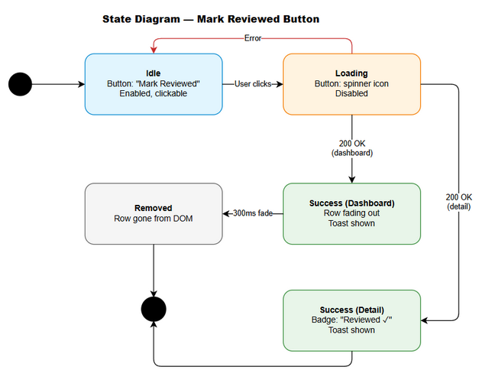
State Diagram
States: - Idle — Button shows “Mark Reviewed”, clickable - Loading — Button shows spinner, disabled - Success — (Dashboard) Row fading out / (Detail) Badge shown - Error — Button returns to Idle state

Sequence Diagram — Mark Reviewed Flow
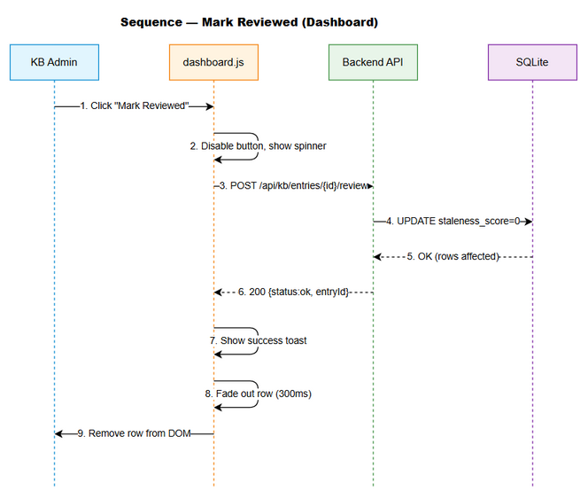
Sequence Diagram

Diagram Index
# | Diagram | Image | Source (editable)
1 | System Context | system-context.png | system-context.drawio
2 | Sequence — Mark Reviewed | sequence-mark-reviewed.png | sequence-mark-reviewed.drawio
3 | State — Mark Reviewed Button | state-mark-reviewed.png | state-mark-reviewed.drawio

Change Log from BRD
- No deviations from BRD. All acceptance criteria preserved.
- Added technical details: pseudocode, API response codes, state transitions.
- Clarified that basePath helper must be used for API calls (per ui-relative-paths steering rule).

