Technical Design Document (TDD)

KB Web Viewer — KSA-108: Add Mark Reviewed Button and Review Workflow on Dashboard

Document Information
Field | Value
Jira Ticket | KSA-108
Title | KB Web Viewer: Add Mark Reviewed button and review workflow on Dashboard
Author | SA Agent
Version | 1.0
Date | 2026-05-22
Status | Draft
Related BRD | BRD-v1-KSA-108.docx
Related FSD | FSD-v1-KSA-108.docx

Revision History
Version | Date | Author | Changes
1.0 | 2026-05-22 | SA Agent | Initiate document — frontend-only technical design

1. Introduction

1.1 Purpose
Technical design for adding “Mark Reviewed” functionality to the KB Web Viewer frontend. This is a frontend-only change — the backend API already exists and requires no modification.

1.2 Scope
In Scope | Out of Scope
Modify dashboard.js — add button + API call | Backend API changes
Modify dashboard.html — add Action column | Database schema changes
Modify browser.js — add button to detail panel | New server routes
Create toast notification utility | Authentication changes

1.3 Technology Stack
Layer | Technology | Version
Language | JavaScript (Vanilla) | ES2020+
UI Framework | None (plain DOM) | N/A
Styling | CSS (inline + ui-tokens.css) | N/A
Build Tool | None (served as static files) | N/A
Server | MCP Server (Kotlin/Python/Node.js) | Existing
Database | SQLite | Existing

1.4 Design Principles
- Minimal footprint — no new dependencies, no build step, vanilla JS
- Progressive enhancement — feature degrades gracefully if API unavailable
- Accessibility first — keyboard navigation, ARIA labels, WCAG AA
- Consistent with existing code — match dashboard.js/browser.js patterns
- basePath compliance — all API calls use window.__MCP_BASE prefix

1.5 Constraints
- No external libraries (project uses vanilla JS only)
- Must work across all 3 server variants (Kotlin, Python, Node.js)
- Static files served from /static/ or same-origin root
- No build/transpile step — code must be ES2020 compatible

2. System Architecture

2.1 Architecture Overview
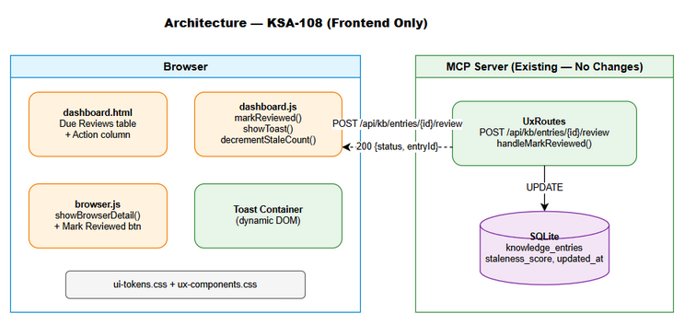
Architecture Diagram
This is a frontend-only change. The architecture remains unchanged — static HTML/JS files served by the MCP server, communicating via REST API.
Modified Components: - dashboard.html — HTML structure (new column) - dashboard.js — JavaScript logic (mark reviewed + toast) - browser.js — JavaScript logic (mark reviewed in detail panel)
Unchanged Components: - Backend API (UxRoutes.kt / ux-routes.ts / ux_routes.py) - Database schema (knowledge_entries table) - Other viewer pages

2.2 Component Diagram
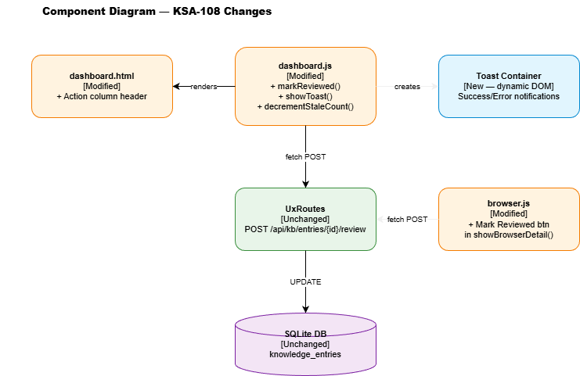
Component Diagram
Component | Responsibility | Technology
dashboard.html | Page structure, table layout | HTML
dashboard.js | Load reminders, render table, mark reviewed, toast | Vanilla JS
browser.js | Entry detail panel, mark reviewed button | Vanilla JS
ui-tokens.css | Design tokens (colors, spacing) | CSS
ux-components.css | Reusable component styles | CSS
Backend API | POST /api/kb/entries/{id}/review | Kotlin/Python/Node.js

2.3 Communication Patterns
From | To | Protocol | Pattern | Description
dashboard.js | Backend API | HTTP REST | Sync (fetch) | POST mark reviewed
dashboard.js | DOM | Direct | Sync | Update table, show toast
browser.js | Backend API | HTTP REST | Sync (fetch) | POST mark reviewed
browser.js | DOM | Direct | Sync | Replace button with badge

3. API Design

3.1 API Overview
# | Endpoint | Method | Description | Source
1 | /api/kb/entries/{id}/review | POST | Mark entry as reviewed | UC-01, UC-02
No new API endpoints. The existing endpoint is used as-is.

3.2 API: Mark Entry as Reviewed
Implements: UC-01, UC-02, BR-01 through BR-06
Attribute | Value
Method | POST
Path | /api/kb/entries/{id}/review
Auth | None (same-origin)
Rate Limit | None
Body | Empty (no request body)
Path Parameters:
Parameter | Type | Required | Description
id | Integer | Yes | KB entry ID (positive integer)
Response — 200 OK:
{
"status": "ok",
"entryId": 42
}
Error Responses:
Status | Code | Message | When
400 | INVALID_ID | “Invalid id” | Non-numeric or negative ID
503 | ENGINE_UNAVAILABLE | “Engine not initialized” | Server starting up
500 | INTERNAL_ERROR | Error message | DB update failure
Frontend URL Construction:
const basePath = window.__MCP_BASE || '';
const url = basePath + '/api/kb/entries/' + entryId + '/review';

4. Database Design
No database changes required. The existing knowledge_entries table already has all necessary columns:
-- Existing columns used by this feature:
-- id INTEGER PRIMARY KEY
-- staleness_score REAL DEFAULT 0.0
-- last_reviewed_at TEXT (ISO 8601)
-- updated_at TEXT (ISO 8601)
Existing UPDATE query (in UxRoutes.kt):
UPDATE knowledge_entries SET updated_at = datetime('now') WHERE id = ?
Note: The Kotlin variant only updates updated_at. The KbStaleTool.kt variant (used by MCP tools) also resets staleness_score = 0 and sets last_reviewed_at. The API endpoint behavior is sufficient for the UI use case — the staleness score recalculation happens on next detect_stale run.

5. Module Design

5.1 File Structure (Changes Only)
shared/viewer/
├── dashboard.html # MODIFIED — add Action column header
├── dashboard.js # MODIFIED — add markReviewed(), showToast(), updated loadReminders()
└── browser.js # MODIFIED — add Mark Reviewed button to showBrowserDetail()

5.2 Function Design — dashboard.js

New Functions
Function | Parameters | Returns | Responsibility
markReviewed(entryId, buttonEl, context) | entryId: number, buttonEl: HTMLElement, context: ‘dashboard’|‘detail’ | void (async) | Call API, handle success/error
showToast(message, type) | message: string, type: ‘success’|‘error’ | void | Create and show toast notification
decrementStaleCount() | none | void | Decrement stale metric card value

Modified Functions
Function | Change
loadReminders() | Add “Action” column with button to each row

5.3 Function Design — browser.js

Modified Functions
Function | Change
showBrowserDetail(id) | Add “Mark Reviewed” button to detail panel header

5.4 Implementation Details

markReviewed() — Core Logic
async function markReviewed(entryId, buttonEl, context) {
// 1. Prevent double-click (BR-01)
buttonEl.disabled = true;
const originalHTML = buttonEl.innerHTML;
buttonEl.innerHTML = '<span class="spinner"></span>';
try {
// 2. Call API (basePath compliance)
const basePath = window.__MCP_BASE || '';
const r = await fetch(basePath + '/api/kb/entries/' + entryId + '/review', {
method: 'POST'
});
// 3. Handle errors
if (!r.ok) {
const msg = r.status === 404 ? 'Entry not found'
: r.status === 503 ? 'Service unavailable — please try again later'
: 'Error: ' + r.status;
showToast(msg, 'error');
buttonEl.disabled = false;
buttonEl.innerHTML = originalHTML;
return;
}
// 4. Success
showToast('Entry #' + entryId + ' marked as reviewed', 'success');
if (context === 'dashboard') {
// 5a. Dashboard: fade out row (BR-02)
const row = buttonEl.closest('tr');
row.style.transition = 'opacity 300ms ease-out';
row.style.opacity = '0';
setTimeout(function() {
row.remove();
const tbody = document.getElementById('reminders');
if (!tbody.children.length) {
tbody.innerHTML = '<tr><td colspan="5" style="padding:.4rem;font-size:.75rem;opacity:.6">No due reviews</td></tr>';
}
decrementStaleCount();
}, 300);
} else {
// 5b. Detail: replace with badge (BR-08)
const badge = document.createElement('span');
badge.textContent = 'Reviewed ✓';
badge.className = 'review-badge';
buttonEl.replaceWith(badge);
}
} catch (err) {
showToast('Network error — please try again', 'error');
buttonEl.disabled = false;
buttonEl.innerHTML = originalHTML;
}
}

showToast() — Notification System
function showToast(message, type) {
let container = document.getElementById('toast-container');
if (!container) {
container = document.createElement('div');
container.id = 'toast-container';
container.style.cssText = 'position:fixed;top:1rem;right:1rem;z-index:9999;display:flex;flex-direction:column;gap:.5rem;';
document.body.appendChild(container);
}
const toast = document.createElement('div');
toast.className = 'toast toast-' + type;
toast.innerHTML = '<span>' + esc(message) + '</span><span style="cursor:pointer;margin-left:8px;opacity:.7" onclick="this.parentElement.remove()">✕</span>';
toast.style.cssText = 'min-width:250px;max-width:350px;padding:.75rem 1rem;border-radius:.5rem;font-size:.75rem;'
+ 'box-shadow:0 4px 12px rgba(0,0,0,.3);display:flex;align-items:center;justify-content:space-between;'
+ 'opacity:0;transition:opacity 200ms;'
+ (type === 'success'
? 'background:#166534;color:#bbf7d0;border-left:4px solid #22c55e;'
: 'background:#7f1d1d;color:#fecaca;border-left:4px solid #ef4444;');
container.prepend(toast);
requestAnimationFrame(function() { toast.style.opacity = '1'; });
var timeout = type === 'success' ? 3000 : 5000;
setTimeout(function() {
toast.style.opacity = '0';
setTimeout(function() { toast.remove(); }, 200);
}, timeout);
}

decrementStaleCount()
function decrementStaleCount() {
var cards = document.querySelectorAll('#metrics .card');
cards.forEach(function(card) {
var label = card.querySelector('h3');
if (label && label.textContent.trim() === 'Stale') {
var val = card.querySelector('.val');
var current = parseInt(val.textContent) || 0;
if (current > 0) val.textContent = current - 1;
}
});
}

5.5 HTML Changes — dashboard.html
Add “Action” column header to the Due Reviews table:
<!-- BEFORE -->
<th>Overdue</th>
</tr></thead>
<!-- AFTER -->
<th>Overdue</th>
<th style="text-align:left;padding:.4rem;background:#334155;font-size:.65rem;color:#94a3b8">Action</th>
</tr></thead>

5.6 CSS Additions
/* Toast styles */
.toast { animation: toast-in 200ms ease-out; }
@keyframes toast-in { from { transform: translateX(100%); opacity: 0; } to { transform: translateX(0); opacity: 1; } }
/* Mark Reviewed button */
.btn-review { background:#22c55e;color:#fff;border:none;border-radius:4px;padding:4px 8px;font-size:.65rem;cursor:pointer; }
.btn-review:hover { background:#16a34a; }
.btn-review:disabled { opacity:.6;cursor:not-allowed; }
.btn-review:focus { outline:2px solid #22c55e;outline-offset:2px; }
/* Review badge */
.review-badge { background:#166534;color:#bbf7d0;border-radius:4px;padding:3px 6px;font-size:.65rem; }
/* Spinner */
.spinner { display:inline-block;width:12px;height:12px;border:2px solid rgba(255,255,255,.3);border-top-color:#fff;border-radius:50%;animation:spin .6s linear infinite; }
@keyframes spin { to { transform:rotate(360deg); } }

5.7 Accessibility Implementation
Element | ARIA | Keyboard | Notes
Mark Reviewed button | aria-label="Mark entry {id} as reviewed" | Tab focus, Enter/Space activate | Standard button behavior
Toast notification | role="alert" aria-live="polite" | N/A (auto-dismiss) | Screen reader announces
Loading state | aria-busy="true" on button | N/A | Communicates loading

6. Integration Design

6.1 Existing API Integration
Attribute | Value
Protocol | HTTP REST
Endpoint | Same-origin /api/kb/entries/{id}/review
Authentication | None (same-origin cookie/session)
Timeout | Browser default (no custom timeout)
Retry Policy | Manual (user clicks again)
Circuit Breaker | None needed (single user action)
No new integrations. The feature uses the existing API endpoint.

7. Security Design

7.1 Input Validation
Input | Client Validation | Server Validation
entry_id | Extracted from DOM data attribute (trusted) | toLongOrNull() — rejects non-numeric

7.2 XSS Prevention
- Toast messages use esc() function (HTML entity encoding)
- Entry summaries in table already escaped by existing esc() function
- No user-provided content rendered as raw HTML

7.3 CSRF Protection
- Same-origin requests only (no CORS)
- POST method with no body — standard browser same-origin policy applies

8. Performance & Scalability

8.1 Performance Targets
Operation | Target | Actual (Expected)
Button click → loading state | < 100ms | ~16ms (single rAF)
API round-trip | < 500ms | ~50-200ms (local SQLite)
Row fade animation | 300ms | Exactly 300ms (CSS transition)
Toast appear | < 200ms | 200ms (CSS animation)

8.2 Resource Impact
- JS bundle size increase: ~2KB (unminified) — negligible
- DOM nodes added: 1 button per row + toast container — negligible
- Network requests: 1 POST per click — negligible
- Memory: No persistent state — garbage collected after animation

9. Monitoring & Observability

9.1 Logging
Log Event | Level | Where | Fields
Mark reviewed success | INFO | Browser console | entry_id
Mark reviewed error | ERROR | Browser console | entry_id, status, error message
Network failure | ERROR | Browser console | entry_id, error type

9.2 Server-Side (Existing)
The backend already logs the UPDATE operation. No additional server logging needed.

10. Implementation Checklist

Files to Modify
# | File | Change | Effort
1 | shared/viewer/dashboard.html | Add “Action” th column | 5 min
2 | shared/viewer/dashboard.js | Add markReviewed(), showToast(), decrementStaleCount(); modify loadReminders() | 30 min
3 | shared/viewer/browser.js | Add button to showBrowserDetail(); import markReviewed | 15 min

Files NOT Modified
- Backend routes (all 3 variants) — API already exists
- Database schema — no changes
- Other viewer pages — not affected
- CSS files — styles added inline or via <style> block in dashboard.html

Implementation Order
- Add showToast() function to dashboard.js (reusable utility)
- Add markReviewed() function to dashboard.js
- Add decrementStaleCount() function to dashboard.js
- Modify loadReminders() to render button in each row
- Add “Action” column header to dashboard.html
- Add CSS for button, badge, spinner, toast to dashboard.html <style>
- Modify showBrowserDetail() in browser.js to add button
- Test all scenarios (success, error, empty state, keyboard)

11. Appendix

Diagram Index
# | Diagram | Image | Source (editable)
1 | Architecture Overview | architecture.png | architecture.drawio
2 | Component Diagram | component.png | component.drawio

Open Questions
# | Question | Status | Answer
1 | Should showToast() be extracted to a shared module? | Resolved | No — keep in dashboard.js for now. Can refactor later if other pages need it.
2 | Should the Kotlin API also reset staleness_score (like KbStaleTool)? | Resolved | Not in scope — the detect_stale job handles recalculation. UI just needs the visual feedback.

Glossary
Term | Definition
basePath | URL prefix for API calls, detected from window.__MCP_BASE
rAF | requestAnimationFrame — browser API for smooth animations
Same-origin | Request to the same protocol+host+port as the page

