Business Requirements Document (BRD)

mcp-code-intelligence-nodejs — KSA-110: KB System Upgrade v0.6.0

Document Information
Field | Value
Jira Ticket | KSA-110
Title | KB System Upgrade v0.6.0
Author | BA Agent
Version | 1.0
Date | 2025-01-27
Status | Draft

Author Tracking
Role | Name - Position | Responsibility
Author | BA Agent – Business Analyst | Create document
Peer Reviewer | Duc Nguyen Minh – Product Owner | Review document

Revision History
Version | Date | Author | Changes
1.0 | 2025-01-27 | BA Agent | Initiate document — auto-generated from Jira ticket KSA-110 and linked tasks KSA-111, KSA-112, KSA-113, KSA-114
1.1 | 2025-05-22 | BA Agent | Add F4: KB Anti-Pattern Protection — agent isolation, blind retrieval prevention, ingest quality gate, search token budget (from KB-discussion analysis)

Sign-Off
Name | Signature and date
Duc Nguyen Minh | ☐ I agree and confirm all criteria on this BRD as expected requirements
 | ☐ I agree and confirm all criteria on this BRD as expected requirements

1. Introduction

1.1 Scope
Nâng cấp hệ thống Knowledge Base (KB) của mcp-code-intelligence-nodejs từ v0.5.1 lên v0.6.0 với 3 features chính:
- Core/Archival Memory (F1) — Pinned entries tự động inject vào agent context mỗi turn, giới hạn ~2000 tokens
- Structured Conversation History (F2) — Lưu trữ conversations dạng structured JSON (role, content, turn, session) thay vì flat text
- Structured Map (F3) — Mỗi entry được enrich với metadata: topic, entities_mentioned, decisions_made, action_items, context_refs, sentiment
- KB Anti-Pattern Protection (F4) — Ngăn chặn các anti-patterns đốt token: agent-level KB isolation (tag-based filtering), blind retrieval prevention (conditional search), ingest quality gate (auto-validate trước khi lưu), search token budget (cap output tokens)
Scope bao gồm schema migrations (SQLite + FTS5), 3 MCP tools mới (mem_pin, mem_conversation, mem_map), token counting utility, conversation summarizer, structured map extractor (rule-based NLP), backfill script, cross-feature integration, và F4 anti-pattern protection mechanisms.

1.2 Out of Scope
- LLM-assisted extraction (chỉ dùng rule-based NLP cho v0.6.0)
- UI/Frontend changes (hệ thống là MCP server, không có UI)
- Breaking changes đến 14 existing MCP tools
- Multi-tenant support
- Cloud deployment (chỉ local SQLite)

1.3 Preliminary Requirement
- mcp-code-intelligence-nodejs v0.5.1 đã hoạt động ổn định
- SQLite database với schema hiện tại (knowledge_entries, knowledge_vectors, knowledge_graph_edges, sessions/audit)
- better-sqlite3 package đã cài đặt
- ONNX embedding model (all-MiniLM-L6-v2, 384d) hoạt động
- Node.js runtime environment

2. Business Requirements

2.1 High Level Process Map
Hệ thống KB hiện tại cung cấp 14 MCP tools cho AI agents để lưu trữ và truy xuất knowledge. Upgrade v0.6.0 bổ sung 3 capabilities mới:
- Persistent Context — Agents có thể pin critical entries để tự động nhận context mỗi lần tương tác (không cần search lại)
- Conversation Memory — Conversations được lưu structured, cho phép query theo session/time range và auto-summarize
- Smart Metadata — Entries tự động được extract entities, decisions, action items → search chính xác hơn
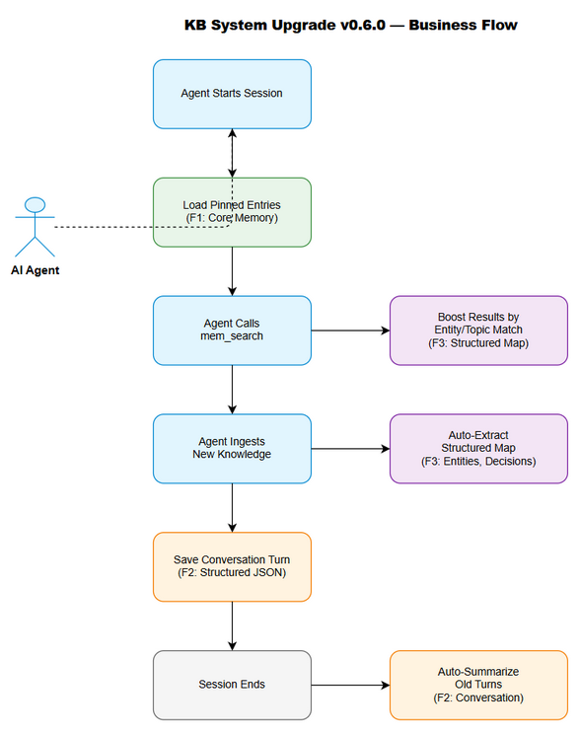
Business Flow

2.2 List of User Stories / Use Cases
# | Story / Use Case | Priority | Source Ticket
1 | As an AI agent, I want to pin critical knowledge entries so that they are automatically available in my context every turn without searching | MUST HAVE | KSA-111
2 | As an AI agent, I want to manage pinned entries (pin/unpin/reorder) so that I can control what persistent context I receive | MUST HAVE | KSA-111
3 | As an AI agent, I want a token budget enforced on pinned entries so that my context window is not overwhelmed | MUST HAVE | KSA-111
4 | As an AI agent, I want to store conversation turns as structured data so that I can query past conversations by session or time range | SHOULD HAVE | KSA-113
5 | As an AI agent, I want conversations auto-summarized on session end so that old turns are compressed without losing key information | SHOULD HAVE | KSA-113
6 | As an AI agent, I want each knowledge entry to have extracted metadata (entities, decisions, action items) so that search results are more relevant | MUST HAVE | KSA-112
7 | As an AI agent, I want to search entries by entity name or topic so that I can find related knowledge quickly | MUST HAVE | KSA-112
8 | As an AI agent, I want existing entries backfilled with structured maps so that the enhanced search works on historical data | SHOULD HAVE | KSA-112
9 | As a system, I want all 3 features integrated without conflicts so that the KB operates as a cohesive system | MUST HAVE | KSA-114
10 | As a system, I want performance targets met (<50ms pin retrieval, <100ms conversation query) so that agent responsiveness is maintained | MUST HAVE | KSA-114
11 | As an AI agent, I want tag-based KB isolation so that each agent role only retrieves knowledge relevant to its domain | MUST HAVE | KSA-110 (F4)
12 | As a system, I want blind retrieval prevention so that KB search is only triggered when the task genuinely requires historical context | MUST HAVE | KSA-110 (F4)
13 | As a system, I want an ingest quality gate that validates content before storing to prevent KB pollution with incorrect or low-quality data | SHOULD HAVE | KSA-110 (F4)
14 | As an AI agent, I want a max_tokens parameter on mem_search so that search results never exceed a configurable token budget | MUST HAVE | KSA-110 (F4)
15 | As a system, I want WORKING tier auto-expiry so that stale short-term entries are promoted or archived after 24h, preventing noise accumulation | SHOULD HAVE | KSA-110 (F4)
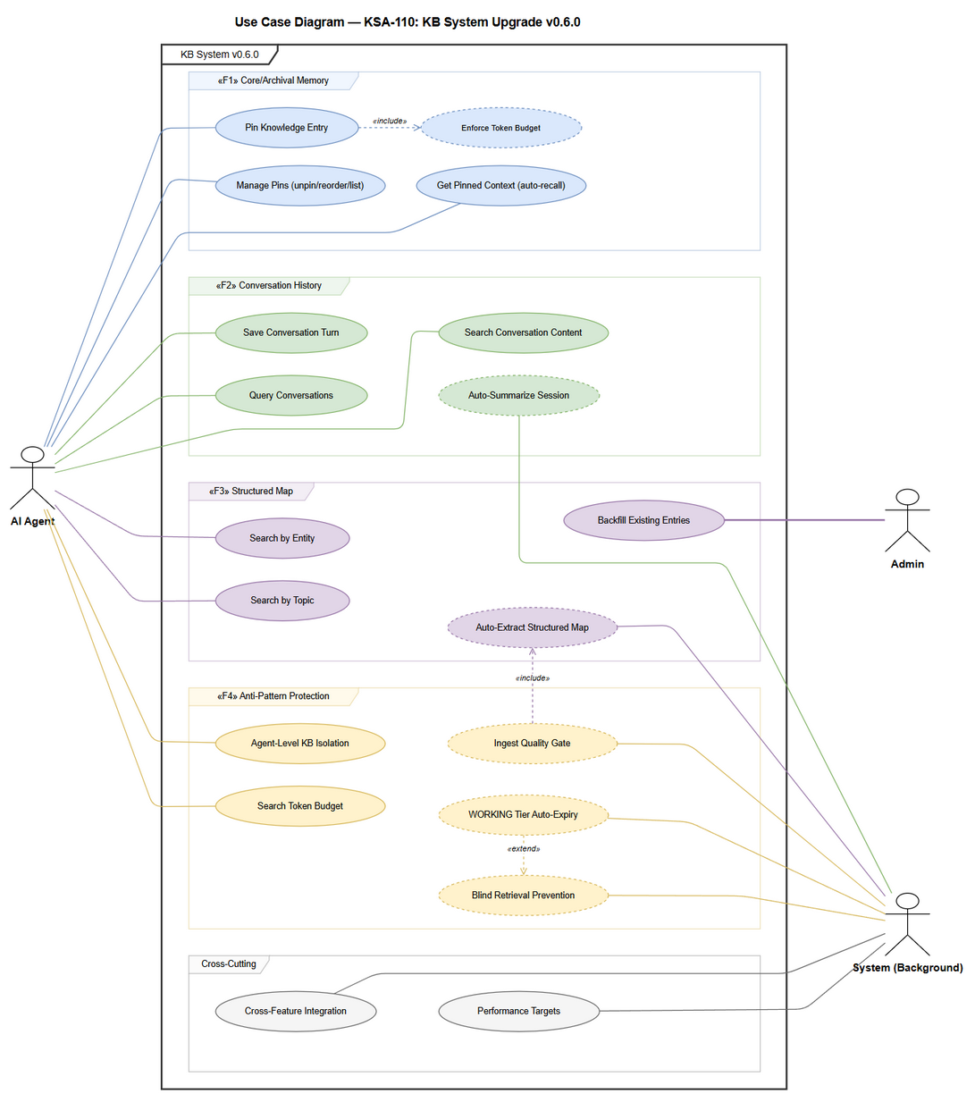
Use Case Diagram

2.3 Details of User Stories

Business Flow
Step 1: Agent starts a session → system loads pinned entries (F1) into context automatically
Step 2: Agent performs mem_search → system prepends pinned entries to results + boosts results matching entities/topics from query (F3)
Step 3: Agent ingests new knowledge → system auto-extracts structured_map (topic, entities, decisions, action_items) (F3)
Step 4: Agent saves conversation turn → system stores structured JSON with role/content/tool_calls (F2)
Step 5: Session ends → system auto-summarizes old conversation turns into a summary entry (F2)
Step 6: Agent queries past conversations → system returns structured turns filtered by session/time range (F2)
Note: All 3 features operate independently at schema level but share common infrastructure (schema-v2.ts, models.ts, tool-definitions). F1 auto-recall can leverage F3 entity matching for smarter context injection.

STORY 1: Pin Critical Knowledge Entries
As an AI agent, I want to pin critical knowledge entries so that they are automatically available in my context every turn without searching
Requirement Details:
- Agent can mark any existing knowledge entry as “pinned” via mem_pin tool
- Pinned entries are automatically prepended to every mem_search result
- Maximum 10 pinned entries allowed (safety cap)
- Total pinned content must not exceed 2000 tokens (budget enforcement)
- Pin order is configurable (reorder operation)
Data Fields:
Field | Type | Required | Description | Example
pinned | BOOLEAN | Yes | Whether entry is pinned | 1
pin_order | INTEGER | Yes | Display/injection order | 0, 1, 2…
Acceptance Criteria:
- pinned column added to knowledge_entries table via migration
- Pin/unpin/list/reorder operations work via mem_pin tool
- Pinned entries auto-prepend to mem_search results
- Token budget enforced — attempting to pin entry that exceeds budget returns error with current usage
- Max 10 pinned entries safety cap enforced
- Unit tests pass (≥80% coverage on new code)
- Performance: <50ms for pin retrieval
Validation Rules:
- Cannot pin more than 10 entries
- Cannot exceed 2000 token budget
- Cannot pin non-existent entry
- Pin order must be non-negative integer
Error Handling:
- Pin entry exceeds budget: Return error “Token budget exceeded. Current: {current}/{max}. Entry requires {needed} tokens.”
- Pin non-existent entry: Return error “Entry {id} not found”
- Exceed max pinned: Return error “Maximum pinned entries (10) reached. Unpin an entry first.”

STORY 2: Manage Pinned Entries
As an AI agent, I want to manage pinned entries (pin/unpin/reorder) so that I can control what persistent context I receive
Requirement Details:
- mem_pin tool supports actions: pin, unpin, list, reorder, get_context
- pin action: marks entry as pinned, assigns next available order
- unpin action: removes pin, reorders remaining entries
- list action: returns all pinned entries with order and token count
- reorder action: changes pin_order of specified entry
- get_context action: returns formatted pinned content ready for injection
Acceptance Criteria:
- All 5 actions callable via MCP protocol
- Unpin automatically reorders remaining entries (no gaps)
- List shows token count per entry and total budget usage
- Get_context returns entries in pin_order, formatted for agent consumption

STORY 3: Token Budget Enforcement
As an AI agent, I want a token budget enforced on pinned entries so that my context window is not overwhelmed
Requirement Details:
- Token counting uses chars/4 approximation (simple, no external dependency)
- Budget check on every pin operation
- Budget configurable via CoreMemoryConfig (default: 2000 tokens)
- Warning threshold at 90% (1800 tokens default)
Data Fields:
Field | Type | Required | Description | Example
maxTokens | INTEGER | Yes | Hard token limit | 2000
warningThreshold | INTEGER | Yes | Warning level | 1800
countMethod | STRING | Yes | Token counting method | ‘chars_div_4’
maxPinnedEntries | INTEGER | Yes | Safety cap | 10
Acceptance Criteria:
- Token count calculated correctly (content.length / 4)
- Pin rejected when budget would be exceeded
- Warning returned when threshold crossed
- Config values respected

STORY 4: Structured Conversation Storage
As an AI agent, I want to store conversation turns as structured data so that I can query past conversations by session or time range
Requirement Details:
- New conversation_turns table stores each turn with: session_id, turn_number, role, content, tool_calls (JSON), metadata (JSON), timestamp
- Roles: ‘user’, ‘assistant’, ‘system’, ‘tool’
- mem_conversation tool supports: save_turn, list_sessions, get_session, search_turns
- Query by session_id returns all turns in order
- Query by time range returns turns across sessions
Data Fields:
Field | Type | Required | Description | Example
session_id | TEXT | Yes | Session identifier | “sess_abc123”
turn_number | INTEGER | Yes | Sequential turn number | 1, 2, 3…
role | TEXT | Yes | Speaker role | “user”, “assistant”
content | TEXT | Yes | Turn content | “Search for auth patterns”
tool_calls | TEXT (JSON) | No | Tool calls made | [{“name”: “mem_search”, …}]
metadata | TEXT (JSON) | No | Extra metadata | {“tokens”: 150, “model”: “claude”}
Acceptance Criteria:
- conversation_turns table created via migration
- Turns persist with all fields correctly
- Query by session returns turns in turn_number order
- Query by time range works across sessions
- mem_conversation tool callable with all 4 actions
- Performance: <100ms for conversation query

STORY 5: Conversation Auto-Summarization
As an AI agent, I want conversations auto-summarized on session end so that old turns are compressed without losing key information
Requirement Details:
- When session ends, turns older than configurable threshold are summarized
- Summary stored as a new knowledge entry (type: CONVERSATION)
- Original turns retained but marked as summarized
- Summary includes: key decisions, action items, topics discussed
Acceptance Criteria:
- Summarization triggers on session end
- Summary entry created with correct type and tags
- Original turns not deleted (data preservation)
- Summary captures key information from conversation

STORY 6: Auto-Extract Structured Map on Ingest
As an AI agent, I want each knowledge entry to have extracted metadata (entities, decisions, action items) so that search results are more relevant
Requirement Details:
- On every mem_ingest, system auto-extracts structured_map from content
- Extraction is rule-based (no LLM dependency):
  - topic: First heading or first sentence
  - entities_mentioned: Regex for ticket IDs ([A-Z]+-\d+), file paths, @mentions, PascalCase class names
  - decisions_made: Lines starting with “Decision:”, “Decided:”, “We will”, “Chosen approach”
  - action_items: Lines with “TODO”, “Action:”, “Next step:”, checkbox patterns
  - context_refs: URLs, file paths, ticket IDs
  - sentiment: Keyword scoring (positive/negative word lists)
- Extracted entities stored in separate entity_index table for fast lookup
Data Fields:
Field | Type | Required | Description | Example
structured_map | TEXT (JSON) | Yes | Extracted metadata | {“topic”: “Auth design”, …}
entity_name | TEXT | Yes | Entity in entity_index | “KSA-110”, “AuthService”
entity_type | TEXT | Yes | Entity classification | “ticket”, “system”, “file”
Acceptance Criteria:
- structured_map column added to knowledge_entries
- entity_index table created with proper indexes
- Auto-extraction runs on every ingest without errors
- Extraction correctly identifies entities, decisions, action items
- Entity types correctly classified (person/system/concept/file/ticket)

STORY 7: Search by Entity/Topic
As an AI agent, I want to search entries by entity name or topic so that I can find related knowledge quickly
Requirement Details:
- mem_map tool supports: get_map, update_map, search_entity, search_topic
- search_entity: find all entries mentioning a specific entity
- search_topic: find entries with matching topic
- HybridSearch enhanced to boost results matching entities/topics from query
Acceptance Criteria:
- mem_map tool callable with all 4 actions
- Entity search returns relevant entries
- Topic search returns relevant entries
- HybridSearch boost improves result relevance

STORY 8: Backfill Existing Entries
As an AI agent, I want existing entries backfilled with structured maps so that the enhanced search works on historical data
Requirement Details:
- Backfill script processes all existing entries
- Extracts structured_map for each entry
- Populates entity_index table
- Non-destructive (never modifies original content)
- Idempotent (safe to run multiple times)
Acceptance Criteria:
- Script processes all existing entries without data loss
- structured_map populated for all entries
- entity_index populated correctly
- Script is idempotent
- Performance acceptable for large KBs (1000+ entries)

STORY 11: Agent-Level KB Isolation (Tag-Based Filtering)
As an AI agent, I want tag-based KB isolation so that each agent role only retrieves knowledge relevant to its domain
Requirement Details:
- Mỗi agent role (BA, SA, DEV, QA, DevOps) có một predefined tag set
- mem_search hỗ trợ agent_scope parameter — tự động filter results theo tags của agent role
- Agent scope mapping configurable (không hardcode):
  - QA agent → tags: testing, qa, test-plan, test-case
  - DEV agent → tags: code, api, architecture, implementation
  - BA agent → tags: requirement, business, stakeholder
- Khi agent_scope được set, results chỉ trả về entries có ít nhất 1 matching tag
- Entries không có tags vẫn visible cho tất cả agents (backward compatible)
Acceptance Criteria:
- mem_search accepts optional agent_scope parameter
- Results correctly filtered by agent’s tag set
- Untagged entries remain accessible to all agents
- Agent scope mapping configurable via settings
- No performance degradation (filter applied at query level, not post-filter)

STORY 12: Blind Retrieval Prevention
As a system, I want blind retrieval prevention so that KB search is only triggered when the task genuinely requires historical context
Requirement Details:
- Steering rule agent-self-learning updated: thay “luôn search KB trước mọi task” bằng conditional logic
- Conditions khi PHẢI search KB:
  - Task liên quan đến architecture decisions đã có
  - Task cần reference đến previous implementations
  - Task involves entities/tickets đã được discuss trước đó
- Conditions khi KHÔNG cần search KB:
  - Task đơn giản, self-contained (sửa typo, format code)
  - Task có đầy đủ context trong prompt hiện tại
  - Task là greenfield (chưa có history)
- mem_search trả về metadata retrieval_reason để audit tại sao search được trigger
Acceptance Criteria:
- Steering rule updated với conditional search logic
- Agents không search KB cho simple/self-contained tasks
- Token savings measurable (giảm ≥30% unnecessary KB calls)
- Audit trail: mỗi search ghi lại reason

STORY 13: Ingest Quality Gate
As a system, I want an ingest quality gate that validates content before storing to prevent KB pollution
Requirement Details:
- Trước khi mem_ingest lưu entry, chạy quality validation:
  - Minimum content length: ≥50 characters (reject noise)
  - Duplicate detection: cosine similarity >0.95 với existing entry → reject hoặc merge
  - Contradiction detection: nếu entry contradicts existing entry cùng topic → flag for review
  - Staleness check: nếu entry references outdated info (old ticket status) → warning
- Quality score tự động assigned (0-100) dựa trên:
  - Content length (longer = higher, cap at 500 chars)
  - Has structured data (tags, type specified) = +20
  - Has source reference = +10
  - Duplicate penalty = -50
- Entries với quality score <30 bị reject tự động
- Entries score 30-50 được lưu với warning flag
Acceptance Criteria:
- Quality validation runs on every mem_ingest call
- Low-quality entries rejected with clear error message
- Duplicate entries detected and handled (reject or merge suggestion)
- Quality score visible via mem_scoring tool
- No false positives on legitimate short entries (e.g., decisions)

STORY 14: Search Token Budget (max_tokens)
As an AI agent, I want a max_tokens parameter on mem_search so that search results never exceed a configurable token budget
Requirement Details:
- mem_search accepts optional max_tokens parameter (default: 2000)
- Results are truncated/limited to fit within token budget:
  - First: limit number of results
  - Then: truncate individual result content if still over budget
- Token counting uses same chars/4 method as F1
- Response includes tokens_used and tokens_budget metadata
- If single result exceeds budget, return summary instead of full content
Data Fields:
Field | Type | Required | Description | Example
max_tokens | INTEGER | No | Token budget for search results | 2000
tokens_used | INTEGER | Yes (response) | Actual tokens in response | 1850
tokens_budget | INTEGER | Yes (response) | Budget that was applied | 2000
Acceptance Criteria:
- mem_search respects max_tokens parameter
- Results never exceed specified token budget
- Truncation is intelligent (prioritize higher-ranked results)
- Response metadata includes token usage info
- Default 2000 tokens when parameter not specified
- Performance: no significant overhead from token counting

STORY 15: WORKING Tier Auto-Expiry
As a system, I want WORKING tier auto-expiry so that stale short-term entries are promoted or archived after 24h
Requirement Details:
- WORKING tier entries older than 24h are auto-processed:
  - If quality score ≥60 → promote to EPISODIC tier
  - If quality score <60 → archive (soft delete, recoverable)
- Auto-expiry runs as background check on every mem_search call (lazy evaluation)
- Configurable expiry duration (default: 24h)
- Entries with pinned=true exempt from auto-expiry
- Audit log records all auto-expiry actions
Acceptance Criteria:
- WORKING entries auto-expire after configured duration
- High-quality entries promoted (not lost)
- Low-quality entries archived (not permanently deleted)
- Pinned entries exempt
- Audit trail for all auto-expiry actions
- No performance impact on normal operations

STORY 9: Cross-Feature Integration
As a system, I want all 3 features integrated without conflicts so that the KB operates as a cohesive system
Requirement Details:
- F1 auto-recall enhanced with F3 entity matching (smarter context injection)
- All 3 features share schema-v2.ts migrations without conflicts
- No regressions in existing 14 MCP tools
- Version bumped to 0.6.0
- README updated with new tool documentation
Acceptance Criteria:
- All 3 features work together without conflicts
- F1 + F3 integration: pinned entries can be filtered by entity relevance
- No regressions in existing tools (full regression test)
- Version 0.6.0 in package.json
- README documents mem_pin, mem_conversation, mem_map

STORY 10: Performance Targets
As a system, I want performance targets met so that agent responsiveness is maintained
Requirement Details:
- Pin retrieval: <50ms (CoreMemoryManager.getContext())
- Conversation query: <100ms (ConversationRepository.getSession())
- Entity search: <100ms (entity_index lookup)
- Structured map extraction: <200ms per entry (rule-based, no network calls)
Acceptance Criteria:
- Pin retrieval consistently <50ms under normal load
- Conversation query <100ms for sessions with up to 100 turns
- Performance benchmarks documented
- No degradation of existing search performance

3. Dependencies
Dependency | Type | Related Ticket | Description
SQLite + better-sqlite3 | System | N/A | Database engine for all storage
ONNX Runtime | System | N/A | Embedding model for vector search
Existing schema (knowledge_entries, knowledge_vectors) | System | N/A | Base tables that migrations extend
FTS5 extension | System | N/A | Full-text search for entity_index
Node.js ≥18 | Infrastructure | N/A | Runtime environment

4. Stakeholders
Role | Name / Team | Responsibility | Source
Product Owner | Duc Nguyen Minh | Approve requirements, accept delivery | Jira reporter
Developer | Development Team | Implement features | Jira assignee
QA | QA Team | Test all features | Jira workflow

5. Risks and Assumptions

5.1 Risks
Risk | Impact | Likelihood | Mitigation
Schema migration breaks existing DB | High | Low | Additive-only migrations (ALTER ADD, CREATE TABLE). Never DROP.
Token counting inaccuracy | Low | Medium | Use chars/4 approximation. Good enough for 2000 token budget.
Structured map extraction quality | Medium | Medium | Start rule-based. Add LLM-assisted extraction as optional enhancement later.
Conversation table grows large | Medium | High | Auto-summarize sessions older than 7 days. Configurable retention.
Tool count explosion (14 → 17) | Low | Low | Keep consolidated pattern. Each new tool is multi-action.
Merge conflicts on shared files | Medium | Medium | Do schema-v2.ts first (all features), then implement sequentially.

5.2 Assumptions
- Existing database schema is stable and won’t change during development
- chars/4 token approximation is acceptable accuracy for budget enforcement
- Rule-based extraction provides sufficient quality for v0.6.0 (LLM enhancement deferred)
- Sessions older than 7 days can be safely summarized
- Maximum 10 pinned entries is sufficient for all use cases
- Performance targets achievable with SQLite (no need for external DB)

6. Non-Functional Requirements
Category | Requirement | Details
Performance | Pin retrieval <50ms | CoreMemoryManager.getContext() must return within 50ms
Performance | Conversation query <100ms | ConversationRepository queries must complete within 100ms
Performance | Map extraction <200ms | StructuredMapExtractor must process single entry within 200ms
Reliability | Zero data loss on migration | Additive-only schema changes, never DROP or ALTER existing columns
Reliability | Idempotent operations | Backfill script and migrations safe to run multiple times
Scalability | Support 1000+ entries | Performance targets must hold with large knowledge bases
Compatibility | No breaking changes | All 14 existing MCP tools must continue working unchanged
Testability | ≥80% code coverage | All new code must have unit tests with ≥80% coverage

7. Related Tickets
Ticket Key | Summary | Status | Type | Relationship
KSA-110 | KB System Upgrade v0.6.0 | In Progress | Epic | Main ticket
KSA-111 | [F1] Core/Archival Memory - Pinned Entries + Auto-Recall | To Do | Task | Child of KSA-110
KSA-112 | [F3] Structured Map - Entity Extraction + Metadata Enrichment | To Do | Task | Child of KSA-110
KSA-113 | [F2] Structured Conversation History | To Do | Task | Child of KSA-110
KSA-114 | [Integration] Cross-Feature Integration + Polish v0.6.0 | To Do | Task | Child of KSA-110

8. Appendix

Glossary
Term | Definition
MCP | Model Context Protocol — protocol for AI agent tool communication
KB | Knowledge Base — the memory system for AI agents
Pinned Entry | A knowledge entry marked for automatic context injection
Structured Map | JSON metadata extracted from entry content (entities, decisions, etc.)
FTS5 | SQLite Full-Text Search extension version 5
Token Budget | Maximum token count allowed for pinned entries (~2000 tokens)
Auto-Recall | Automatic injection of pinned entries into search results
Backfill | Process of extracting structured maps for existing entries

Reference Documents
Document | Link / Location
KB Upgrade Implementation Plan | documents/KB-UPGRADE-PLAN.md
Current Source Code | mcp-code-intelligence-nodejs/src/memory/
Existing Schema | src/memory/schema.ts, src/memory/schema-v2.ts

Diagram Index
# | Diagram | Image | Source (editable)
1 | Business Flow | business-flow.png | business-flow.drawio
2 | Use Case Diagram | use-case.png | use-case.drawio

