Functional Specification Document (FSD)

mcp-code-intelligence-nodejs — KSA-110: KB System Upgrade v0.6.0

Document Information
Field | Value
Jira Ticket | KSA-110
Title | KB System Upgrade v0.6.0
Author | BA Agent + TA Agent
Version | 1.0
Date | 2025-05-22
Status | Draft
Related BRD | BRD-v1.1-KSA-110.docx

Revision History
Version | Date | Author | Changes
1.0 | 2025-05-22 | BA Agent | Initiate document from BRD v1.1 (15 stories, 4 features)
1.0 | 2025-05-22 | TA Agent | Enriched with API contracts, pseudocode, technical review

1. Introduction

1.1 Purpose
This FSD specifies the functional behavior of the KB System Upgrade v0.6.0 for mcp-code-intelligence-nodejs. It covers 4 features: - F1 Core/Archival Memory (Pinned Entries + Auto-Recall) - F2 Structured Conversation History - F3 Structured Map (Entity Extraction + Metadata Enrichment) - F4 KB Anti-Pattern Protection

1.2 Scope
Upgrade from v0.5.1 to v0.6.0 adding 3 new MCP tools (mem_pin, mem_conversation, mem_map), schema migrations, token counting, conversation summarizer, structured map extractor, backfill script, and F4 anti-pattern protection mechanisms (agent isolation, blind retrieval prevention, ingest quality gate, search token budget, WORKING auto-expiry).

1.3 Definitions & Acronyms
Term | Definition
MCP | Model Context Protocol — protocol for AI agent tool communication
KB | Knowledge Base — the memory system for AI agents
Pinned Entry | A knowledge entry marked for automatic context injection
Structured Map | JSON metadata extracted from entry content (entities, decisions, etc.)
FTS5 | SQLite Full-Text Search extension version 5
Token Budget | Maximum token count allowed for pinned entries (~2000 tokens)
Auto-Recall | Automatic injection of pinned entries into search results
WORKING Tier | Short-term memory tier for ephemeral/in-progress knowledge
EPISODIC Tier | Medium-term memory tier for session-specific knowledge
RLS | Row-Level Security — tag-based access filtering per agent role

1.4 References
Document | Location
BRD v1.1 | documents/KSA-110/BRD.md
KB Discussion | documents/KSA-110/KB-discussion.md
Current Schema | mcp-code-intelligence-nodejs/src/memory/schema.ts
Schema v2 | mcp-code-intelligence-nodejs/src/memory/schema-v2.ts
Schema v3 | mcp-code-intelligence-nodejs/src/memory/schema-v3.ts
Core Memory | mcp-code-intelligence-nodejs/src/memory/core-memory.ts
Conversation Repo | mcp-code-intelligence-nodejs/src/memory/conversation-repo.ts
Structured Map | mcp-code-intelligence-nodejs/src/memory/structured-map-extractor.ts

2. System Overview

2.1 System Context Diagram
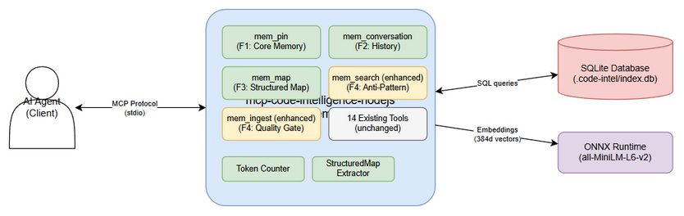
System Context
The KB system operates within the mcp-code-intelligence-nodejs MCP server. External actors: - AI Agent (Client): Calls MCP tools (mem_pin, mem_conversation, mem_map, mem_search, mem_ingest) via stdio - SQLite Database: Persistent storage for knowledge entries, vectors, conversations, entity index - ONNX Runtime: Embedding model (all-MiniLM-L6-v2, 384d) for vector search - Workspace Filesystem: .code-intel/index.db database file

2.2 System Architecture
The upgrade adds 4 functional layers to the existing KB:
- Core Memory Layer (F1) — CoreMemoryManager manages pinned entries, token budget, auto-recall injection
- Conversation Layer (F2) — ConversationRepository stores structured turns, session management, auto-summarization
- Structured Map Layer (F3) — StructuredMapExtractor + EntityRepository for metadata enrichment and entity-based search
- Anti-Pattern Protection Layer (F4) — Agent isolation (tag filter), blind retrieval prevention, ingest quality gate, search token budget, WORKING auto-expiry
All layers share the same SQLite database and are accessed via MCP tool dispatchers.

3. Functional Requirements

3.1 Feature F1: Core/Archival Memory (Pinned Entries + Auto-Recall)
Source: BRD Stories 1, 2, 3

3.1.1 Description
Agents can pin critical knowledge entries for automatic context injection every turn. Pinned entries are prepended to mem_search results without requiring explicit search. A token budget (default 2000) prevents context window overflow.

3.1.2 Use Case: UC-01 — Pin a Knowledge Entry
Use Case ID: UC-01 Actor: AI Agent Preconditions: Knowledge entry exists in KB with valid ID Postconditions: Entry marked as pinned, pin_order assigned, token budget updated
Main Flow:
Step | Actor | System | Description
1 | Agent calls mem_pin(action: "pin", entry_id: 42) |  | Agent requests to pin entry
2 |  | Validate entry exists | System checks knowledge_entries table
3 |  | Calculate token cost: content.length / 4 | System computes tokens needed
4 |  | Check budget: current_usage + cost ≤ 2000 | System enforces token budget
5 |  | Check cap: pinned_count < 10 | System enforces max pinned entries
6 |  | Set pinned=1, assign pin_order=next_available | System updates entry
7 |  | Return success with budget info | System confirms pin
Alternative Flows:
ID | Condition | Steps
AF-01a | Entry already pinned | Return current pin status, no change
AF-01b | Agent specifies custom pin_order | Reorder existing entries to accommodate
Exception Flows:
ID | Condition | Steps
EF-01a | Entry ID not found | Return error: “Entry {id} not found”
EF-01b | Token budget exceeded | Return error: “Token budget exceeded. Current: {current}/2000. Entry requires {needed} tokens.”
EF-01c | Max pinned (10) reached | Return error: “Maximum pinned entries (10) reached. Unpin an entry first.”

3.1.3 Use Case: UC-02 — Manage Pinned Entries
Use Case ID: UC-02 Actor: AI Agent Preconditions: At least one pinned entry exists Postconditions: Pin state updated per action
Main Flow (Unpin):
Step | Actor | System | Description
1 | Agent calls mem_pin(action: "unpin", entry_id: 42) |  | Agent requests unpin
2 |  | Set pinned=0, clear pin_order | System removes pin
3 |  | Reorder remaining: close gaps in pin_order | System maintains contiguous ordering
4 |  | Return updated pin list | System confirms
Main Flow (List):
Step | Actor | System | Description
1 | Agent calls mem_pin(action: "list") |  | Agent requests pin list
2 |  | Query all entries WHERE pinned=1 ORDER BY pin_order | System fetches
3 |  | Calculate token count per entry + total | System computes budget
4 |  | Return list with: id, summary, pin_order, tokens, total_budget_used | System responds
Main Flow (Reorder):
Step | Actor | System | Description
1 | Agent calls mem_pin(action: "reorder", entry_id: 42, order: 0) |  | Agent requests reorder
2 |  | Validate new order is valid (0 ≤ order < pinned_count) | System validates
3 |  | Shift other entries’ pin_order to accommodate | System reorders
4 |  | Return updated pin list | System confirms
Main Flow (Get Context):
Step | Actor | System | Description
1 | Agent calls mem_pin(action: "get_context") |  | Agent requests formatted context
2 |  | Fetch all pinned entries in pin_order | System queries
3 |  | Format as injection-ready text block | System formats
4 |  | Return formatted context + token count | System responds

3.1.4 Use Case: UC-03 — Auto-Recall on Search
Use Case ID: UC-03 Actor: AI Agent (implicit — triggered by mem_search) Preconditions: Agent has pinned entries; agent calls mem_search Postconditions: Search results include pinned entries prepended
Main Flow:
Step | Actor | System | Description
1 | Agent calls mem_search(query: "auth patterns") |  | Normal search
2 |  | Fetch pinned entries (CoreMemoryManager.getContext()) | System loads pins
3 |  | Execute normal hybrid search | System searches
4 |  | Prepend pinned entries to results (marked as [PINNED]) | System merges
5 |  | Return combined results | System responds
Alternative Flows:
ID | Condition | Steps
AF-03a | No pinned entries | Return normal search results only
AF-03b | Pinned entries + F3 entity match | Boost pinned entries matching query entities

3.1.5 Business Rules
Rule ID | Rule | Source
BR-F1-01 | Maximum 10 pinned entries allowed | BRD Story 1
BR-F1-02 | Total pinned content ≤ 2000 tokens (chars/4) | BRD Story 3
BR-F1-03 | Pin order must be contiguous (no gaps after unpin) | BRD Story 2
BR-F1-04 | Warning at 90% budget (1800 tokens) | BRD Story 3
BR-F1-05 | Pinned entries exempt from WORKING tier auto-expiry | BRD Story 15
BR-F1-06 | Cannot pin non-existent entry | BRD Story 1

3.1.6 Data Specifications
Input Data (mem_pin tool):
Field | Type | Required | Validation | Description
action | string | Yes | enum: pin, unpin, list, reorder, get_context, budget | Operation to perform
entry_id | integer | Conditional | Must exist in knowledge_entries | Required for pin/unpin/reorder
order | integer | Conditional | 0 ≤ order < pinned_count | Required for reorder
Output Data (pin action):
Field | Type | Description
success | boolean | Whether operation succeeded
entry_id | integer | Pinned entry ID
pin_order | integer | Assigned order
tokens | integer | Token cost of this entry
budget_used | integer | Total tokens used across all pins
budget_max | integer | Maximum token budget (2000)
Output Data (list action):
Field | Type | Description
entries | array | List of pinned entries
entries[].id | integer | Entry ID
entries[].summary | string | First 100 chars of content
entries[].pin_order | integer | Display order
entries[].tokens | integer | Token cost
total_tokens | integer | Sum of all pinned entry tokens
budget_max | integer | Maximum budget (2000)
budget_remaining | integer | Remaining budget

3.1.7 API Contract (Functional View)
Tool: mem_pin Purpose: Manage pinned/archival memory entries for automatic context injection
Input Parameters:
Parameter | Type | Required | Business Rule | Description
action | string | Yes | Must be valid action | pin, unpin, list, reorder, get_context, budget
entry_id | integer | For pin/unpin/reorder | BR-F1-06: must exist | Target entry ID
order | integer | For reorder | 0 ≤ order < count | New position
Output Data (get_context):
Field | Type | Description
context | string | Formatted pinned content ready for injection
tokens_used | integer | Total tokens in context
entries_count | integer | Number of pinned entries
Business Error Scenarios:
Scenario | User Message | Trigger Condition
Entry not found | “Entry {id} not found” | entry_id doesn’t exist in DB
Budget exceeded | “Token budget exceeded. Current: {n}/2000. Entry requires {m} tokens.” | Pin would exceed 2000 tokens
Max entries reached | “Maximum pinned entries (10) reached. Unpin an entry first.” | Already 10 pinned entries
Invalid action | “Invalid action. Must be: pin, unpin, list, reorder, get_context, budget” | Unknown action string

3.2 Feature F2: Structured Conversation History
Source: BRD Stories 4, 5

3.2.1 Description
Conversations are stored as structured JSON turns (role, content, tool_calls, metadata) in a dedicated conversation_turns table. Supports query by session, time range, and content search. Auto-summarization compresses old sessions into knowledge entries.

3.2.2 Use Case: UC-04 — Save Conversation Turn
Use Case ID: UC-04 Actor: AI Agent Preconditions: Valid session_id provided Postconditions: Turn persisted in conversation_turns table
Main Flow:
Step | Actor | System | Description
1 | Agent calls mem_conversation(action: "save_turn", session_id: "sess_abc", role: "user", content: "Search for auth patterns") |  | Agent saves turn
2 |  | Validate role ∈ {user, assistant, system, tool} | System validates
3 |  | Assign turn_number = max(turn_number) + 1 for session | System auto-increments
4 |  | Insert into conversation_turns with timestamp | System persists
5 |  | Return turn_id and turn_number | System confirms
Alternative Flows:
ID | Condition | Steps
AF-04a | tool_calls provided (JSON array) | Store in tool_calls column as JSON text
AF-04b | First turn in new session | Create session implicitly, turn_number = 1
Exception Flows:
ID | Condition | Steps
EF-04a | Invalid role | Return error: “Invalid role. Must be: user, assistant, system, tool”
EF-04b | Empty content | Return error: “Content cannot be empty”

3.2.3 Use Case: UC-05 — Query Conversations
Use Case ID: UC-05 Actor: AI Agent Preconditions: Conversations exist in DB Postconditions: Matching turns returned
Main Flow (get_session):
Step | Actor | System | Description
1 | Agent calls mem_conversation(action: "get_session", session_id: "sess_abc") |  | Agent queries session
2 |  | Query conversation_turns WHERE session_id = ? ORDER BY turn_number | System fetches
3 |  | Return array of turns with all fields | System responds
Main Flow (list_sessions):
Step | Actor | System | Description
1 | Agent calls mem_conversation(action: "list_sessions") |  | Agent lists sessions
2 |  | Query DISTINCT session_id with first/last timestamp, turn count | System aggregates
3 |  | Return session list ordered by most recent | System responds
Main Flow (search):
Step | Actor | System | Description
1 | Agent calls mem_conversation(action: "search", query: "database migration") |  | Agent searches
2 |  | FTS5 search on conversation_turns content | System searches
3 |  | Return matching turns with session context | System responds

3.2.4 Use Case: UC-06 — Auto-Summarize Session
Use Case ID: UC-06 Actor: System (triggered on session end or threshold) Preconditions: Session has turns older than configurable threshold (default: 7 days) Postconditions: Summary entry created, original turns marked as summarized
Main Flow:
Step | Actor | System | Description
1 |  | Detect session end or age threshold reached | System triggers
2 |  | Collect all turns for session | System fetches
3 |  | Extract: key decisions, action items, topics discussed | System summarizes
4 |  | Create knowledge entry (type: CONVERSATION, tags: “conversation, summary”) | System stores
5 |  | Mark original turns: summarized = 1 | System flags
6 |  | Return summary entry ID | System confirms
Business Rules:
Rule ID | Rule | Source
BR-F2-01 | Turns stored with role, content, tool_calls, metadata, timestamp | BRD Story 4
BR-F2-02 | Valid roles: user, assistant, system, tool | BRD Story 4
BR-F2-03 | Summarization preserves original turns (never deletes) | BRD Story 5
BR-F2-04 | Summary captures: decisions, action items, topics | BRD Story 5
BR-F2-05 | Query by session returns turns in turn_number order | BRD Story 4

3.2.5 Data Specifications
Input Data (mem_conversation tool):
Field | Type | Required | Validation | Description
action | string | Yes | enum: save_turn, get_session, list_sessions, search, summarize | Operation
session_id | string | For save_turn/get_session | Non-empty string | Session identifier
role | string | For save_turn | enum: user, assistant, system, tool | Speaker role
content | string | For save_turn | Non-empty, max 50000 chars | Turn content
tool_calls | string | No | Valid JSON array | Tool calls made (JSON)
query | string | For search | Non-empty | Search query
limit | integer | No | 1-100, default 20 | Max results
Output Data (get_session):
Field | Type | Description
session_id | string | Session identifier
turns | array | Ordered list of turns
turns[].turn_number | integer | Sequential number
turns[].role | string | Speaker role
turns[].content | string | Turn content
turns[].tool_calls | array/null | Tool calls if any
turns[].timestamp | string | ISO 8601 timestamp
total_turns | integer | Total turns in session

3.2.6 API Contract (Functional View)
Tool: mem_conversation Purpose: Store and query structured conversation history
Input Parameters:
Parameter | Type | Required | Business Rule | Description
action | string | Yes | Valid action | save_turn, get_session, list_sessions, search, summarize
session_id | string | Conditional | BR-F2-01 | Required for save_turn, get_session
role | string | Conditional | BR-F2-02 | Required for save_turn
content | string | Conditional | Non-empty | Required for save_turn, search
tool_calls | string | No | Valid JSON | Optional for save_turn
limit | integer | No | 1-100 | Max results for list/search
Business Error Scenarios:
Scenario | User Message | Trigger Condition
Invalid role | “Invalid role. Must be: user, assistant, system, tool” | role not in allowed set
Empty content | “Content cannot be empty” | content is empty/null for save_turn
Session not found | “Session ‘{id}’ not found” | get_session with non-existent session
Invalid JSON tool_calls | “tool_calls must be a valid JSON array” | Malformed JSON

3.3 Feature F3: Structured Map (Entity Extraction + Metadata Enrichment)
Source: BRD Stories 6, 7, 8

3.3.1 Description
Every knowledge entry is automatically enriched with a structured_map containing extracted metadata: topic, entities_mentioned, decisions_made, action_items, context_refs, sentiment. Extraction is rule-based (no LLM). An entity_index table enables fast entity-based search.

3.3.2 Use Case: UC-07 — Auto-Extract Structured Map on Ingest
Use Case ID: UC-07 Actor: System (triggered by mem_ingest) Preconditions: New content being ingested via mem_ingest Postconditions: structured_map populated, entity_index updated
Main Flow:
Step | Actor | System | Description
1 | Agent calls mem_ingest(content: "...") |  | Normal ingest
2 |  | Extract topic: first heading or first sentence | System extracts
3 |  | Extract entities: regex for [A-Z]+-\d+ (tickets), file paths, @mentions, PascalCase names | System extracts
4 |  | Extract decisions: lines with “Decision:”, “Decided:”, “We will”, “Chosen approach” | System extracts
5 |  | Extract action_items: lines with “TODO”, “Action:”, “Next step:”, checkbox [ ] | System extracts
6 |  | Extract context_refs: URLs, file paths, ticket IDs | System extracts
7 |  | Calculate sentiment: keyword scoring (positive/negative word lists) | System scores
8 |  | Store structured_map as JSON in knowledge_entries | System persists
9 |  | Insert entities into entity_index with type classification | System indexes
10 |  | Return entry with structured_map | System responds
Entity Classification Rules:
Pattern | Entity Type | Examples
[A-Z]+-\d+ | ticket | KSA-110, MTO-25
@\w+ | person | @ducnguyen, @team
PascalCase (2+ capitals) | system | AuthService, CoreMemory
Path with / or \ | file | src/memory/schema.ts
URL (http/https) | url | https://github.com/…
Other capitalized words | concept | SQLite, ONNX, MCP

3.3.3 Use Case: UC-08 — Search by Entity/Topic
Use Case ID: UC-08 Actor: AI Agent Preconditions: Entries exist with structured_map populated Postconditions: Matching entries returned
Main Flow (search_entity):
Step | Actor | System | Description
1 | Agent calls mem_map(action: "search_entity", entity: "KSA-110") |  | Agent searches by entity
2 |  | Query entity_index WHERE entity_name = ? | System looks up
3 |  | Join with knowledge_entries to get full entries | System fetches
4 |  | Return entries mentioning this entity | System responds
Main Flow (search_topic):
Step | Actor | System | Description
1 | Agent calls mem_map(action: "search_topic", topic: "authentication") |  | Agent searches by topic
2 |  | FTS5 search on structured_map.topic field | System searches
3 |  | Return matching entries ranked by relevance | System responds
Main Flow (get):
Step | Actor | System | Description
1 | Agent calls mem_map(action: "get", entry_id: 42) |  | Agent gets map
2 |  | Fetch structured_map for entry | System queries
3 |  | Return full structured_map JSON | System responds
Main Flow (update):
Step | Actor | System | Description
1 | Agent calls mem_map(action: "update", entry_id: 42, map: {...}) |  | Agent updates map
2 |  | Merge provided map fields with existing structured_map | System merges
3 |  | Re-index entities if entities_mentioned changed | System re-indexes
4 |  | Return updated structured_map | System responds

3.3.4 Use Case: UC-09 — Backfill Existing Entries
Use Case ID: UC-09 Actor: System Administrator (via script) Preconditions: Existing entries without structured_map Postconditions: All entries have structured_map, entity_index populated
Main Flow:
Step | Actor | System | Description
1 | Admin runs backfill script |  | Manual trigger
2 |  | Query all entries WHERE structured_map IS NULL | System finds unprocessed
3 |  | For each entry: run StructuredMapExtractor | System extracts
4 |  | Update entry with structured_map | System persists
5 |  | Insert entities into entity_index | System indexes
6 |  | Report progress: {processed}/{total} | System reports
Business Rules:
Rule ID | Rule | Source
BR-F3-01 | Extraction is rule-based only (no LLM calls) | BRD Story 6
BR-F3-02 | Backfill is non-destructive (never modifies original content) | BRD Story 8
BR-F3-03 | Backfill is idempotent (safe to run multiple times) | BRD Story 8
BR-F3-04 | Entity types: ticket, person, system, file, url, concept | BRD Story 6
BR-F3-05 | Extraction must complete <200ms per entry | BRD Story 10

3.3.5 Data Specifications
Structured Map Schema:
Field | Type | Description | Extraction Method
topic | string | Main topic of entry | First heading or first sentence
entities_mentioned | array[string] | Named entities found | Regex patterns (see UC-07)
decisions_made | array[string] | Decisions recorded | Line prefix matching
action_items | array[string] | TODOs and next steps | Line prefix + checkbox matching
context_refs | array[string] | URLs, paths, ticket IDs | URL/path/ticket regex
sentiment | string | Overall sentiment | Keyword scoring: positive/negative/neutral
Entity Index Table:
Field | Type | Required | Description
id | INTEGER | Yes (PK) | Auto-increment
entry_id | INTEGER | Yes (FK) | Reference to knowledge_entries
entity_name | TEXT | Yes | The entity string
entity_type | TEXT | Yes | Classification (ticket/person/system/file/url/concept)
created_at | TEXT | Yes | ISO 8601 timestamp

3.3.6 API Contract (Functional View)
Tool: mem_map Purpose: View and manage structured metadata for knowledge entries
Input Parameters:
Parameter | Type | Required | Business Rule | Description
action | string | Yes | Valid action | get, update, search_entity, search_topic, reextract
entry_id | integer | For get/update/reextract | Must exist | Target entry
entity | string | For search_entity | Non-empty | Entity name to search
topic | string | For search_topic | Non-empty | Topic to search
map | object | For update | Valid JSON object | Partial map to merge
limit | integer | No | 1-50, default 10 | Max results
Business Error Scenarios:
Scenario | User Message | Trigger Condition
Entry not found | “Entry {id} not found” | entry_id doesn’t exist
No structured_map | “Entry {id} has no structured map. Run reextract.” | Entry predates F3, not backfilled
Invalid map format | “Map must be a JSON object with valid fields” | Non-object or unknown fields

3.4 Feature F4: KB Anti-Pattern Protection
Source: BRD Stories 11, 12, 13, 14, 15

3.4.1 Description
Prevents common KB anti-patterns that waste tokens: blind retrieval (searching KB when not needed), KB pollution (storing low-quality data), cross-domain noise (agents seeing irrelevant entries), unbounded search results, and stale WORKING tier accumulation.

3.4.2 Use Case: UC-10 — Agent-Level KB Isolation (Tag-Based Filtering)
Use Case ID: UC-10 Actor: AI Agent with specific role Preconditions: Agent scope mapping configured; entries have tags Postconditions: Search results filtered to agent’s domain
Main Flow:
Step | Actor | System | Description
1 | Agent calls mem_search(query: "...", agent_scope: "QA") |  | Agent searches with scope
2 |  | Look up agent scope mapping: QA → [“testing”, “qa”, “test-plan”, “test-case”] | System resolves tags
3 |  | Add tag filter to search query: entries must have ≥1 matching tag | System filters
4 |  | Execute hybrid search with tag filter applied at query level | System searches
5 |  | Return filtered results (only domain-relevant entries) | System responds
Alternative Flows:
ID | Condition | Steps
AF-10a | agent_scope not provided | No filtering, return all results (backward compatible)
AF-10b | Entry has no tags | Entry visible to all agents regardless of scope
AF-10c | Unknown agent_scope value | Return warning + unfiltered results
Agent Scope Mapping (Configurable):
Agent Role | Tag Set
QA | testing, qa, test-plan, test-case, bug
DEV | code, api, architecture, implementation, design
BA | requirement, business, stakeholder, process
SA | architecture, design, infrastructure, security
DevOps | deployment, infrastructure, ci-cd, monitoring
Business Rules:
Rule ID | Rule | Source
BR-F4-01 | Agent scope mapping is configurable (not hardcoded) | BRD Story 11
BR-F4-02 | Untagged entries visible to all agents | BRD Story 11
BR-F4-03 | Filter applied at query level (not post-filter) for performance | BRD Story 11
BR-F4-04 | No performance degradation from filtering | BRD Story 11

3.4.3 Use Case: UC-11 — Blind Retrieval Prevention
Use Case ID: UC-11 Actor: System (steering rule enforcement) Preconditions: Agent about to perform a task Postconditions: KB search only triggered when genuinely needed
Main Flow:
Step | Actor | System | Description
1 | Agent receives task |  | Task arrives
2 |  | Evaluate task against conditional search rules | System checks
3 |  | If task requires historical context → allow KB search | System permits
4 |  | If task is self-contained → skip KB search | System prevents
5 |  | Log retrieval_reason in audit trail | System audits
Conditional Search Rules:
Condition | Search Required? | Reason
Task references existing architecture decisions | YES | Need historical context
Task references previous implementations | YES | Need code patterns
Task involves entities/tickets discussed before | YES | Need prior discussions
Task is simple/self-contained (typo fix, format) | NO | Full context in prompt
Task has complete context in current prompt | NO | No additional info needed
Task is greenfield (no history exists) | NO | Nothing to retrieve
Implementation:
Component | Change | Description
Steering rule agent-self-learning | Update | Replace “always search KB” with conditional logic
mem_search response | Add field | Include retrieval_reason metadata
Audit log | Add field | Record why search was/wasn’t triggered
Business Rules:
Rule ID | Rule | Source
BR-F4-05 | KB search only when task genuinely requires historical context | BRD Story 12
BR-F4-06 | Each search must log retrieval_reason for audit | BRD Story 12
BR-F4-07 | Target: ≥30% reduction in unnecessary KB calls | BRD Story 12

3.4.4 Use Case: UC-12 — Ingest Quality Gate
Use Case ID: UC-12 Actor: System (triggered by mem_ingest) Preconditions: Content submitted for ingestion Postconditions: Content accepted, rejected, or flagged based on quality
Main Flow:
Step | Actor | System | Description
1 | Agent calls mem_ingest(content: "...") |  | Normal ingest
2 |  | Check minimum length: content.length ≥ 50 chars | System validates
3 |  | Check duplicates: cosine similarity with existing entries | System deduplicates
4 |  | If similarity > 0.95 → reject as duplicate | System rejects
5 |  | Calculate quality score (0-100) | System scores
6 |  | If score < 30 → reject automatically | System rejects
7 |  | If score 30-50 → accept with warning flag | System warns
8 |  | If score > 50 → accept normally | System accepts
9 |  | Proceed with normal ingest pipeline | System stores
Quality Score Calculation:
Factor | Points | Condition
Content length | 0-30 | Linear scale: 50 chars = 0, 500+ chars = 30
Has tags specified | +20 | type or tags parameter provided
Has source reference | +10 | source parameter provided
Has structured data | +10 | Content has headings, lists, or code blocks
Duplicate penalty | -50 | Cosine similarity > 0.90 with existing entry
Contradiction flag | -20 | Contradicts existing entry on same topic
Alternative Flows:
ID | Condition | Steps
AF-12a | Duplicate detected (>0.95 similarity) | Return error with existing entry ID, suggest merge
AF-12b | Near-duplicate (0.90-0.95) | Accept with warning, suggest review
AF-12c | Contradiction detected | Accept with flag, notify for review
Exception Flows:
ID | Condition | Steps
EF-12a | Content < 50 chars | Return error: “Content too short (minimum 50 characters). Provide more detail.”
EF-12b | Quality score < 30 | Return error: “Content quality too low (score: {n}/100). Add tags, source, or more detail.”
Business Rules:
Rule ID | Rule | Source
BR-F4-08 | Minimum content length: 50 characters | BRD Story 13
BR-F4-09 | Duplicate threshold: cosine similarity > 0.95 | BRD Story 13
BR-F4-10 | Auto-reject threshold: quality score < 30 | BRD Story 13
BR-F4-11 | Warning threshold: quality score 30-50 | BRD Story 13
BR-F4-12 | No false positives on legitimate short entries (decisions) | BRD Story 13

3.4.5 Use Case: UC-13 — Search Token Budget (max_tokens)
Use Case ID: UC-13 Actor: AI Agent Preconditions: Agent calls mem_search Postconditions: Results capped to token budget
Main Flow:
Step | Actor | System | Description
1 | Agent calls mem_search(query: "...", max_tokens: 1500) |  | Agent searches with budget
2 |  | Execute normal hybrid search, get ranked results | System searches
3 |  | Calculate tokens for each result: content.length / 4 | System counts
4 |  | Accumulate results until budget reached | System limits
5 |  | If single result exceeds remaining budget → truncate content | System truncates
6 |  | Add metadata: tokens_used, tokens_budget | System annotates
7 |  | Return budget-constrained results | System responds
Truncation Strategy:
Priority | Action | When
1 | Limit number of results | Total tokens > budget
2 | Truncate individual result content | Single result > remaining budget
3 | Return summary instead of full content | Single result > entire budget
Output Metadata:
Field | Type | Description
tokens_used | integer | Actual tokens in response
tokens_budget | integer | Budget that was applied
results_truncated | boolean | Whether any results were truncated
total_matches | integer | Total matches before budget limiting
Business Rules:
Rule ID | Rule | Source
BR-F4-13 | Default max_tokens: 2000 when not specified | BRD Story 14
BR-F4-14 | Higher-ranked results prioritized (never truncate rank 1 for rank 5) | BRD Story 14
BR-F4-15 | Token counting: chars / 4 (same method as F1) | BRD Story 14
BR-F4-16 | No significant performance overhead from token counting | BRD Story 14

3.4.6 Use Case: UC-14 — WORKING Tier Auto-Expiry
Use Case ID: UC-14 Actor: System (lazy evaluation on mem_search) Preconditions: WORKING tier entries older than 24h exist Postconditions: Stale entries promoted or archived
Main Flow:
Step | Actor | System | Description
1 | Any agent calls mem_search(...) |  | Search triggers check
2 |  | Query WORKING tier entries WHERE created_at < NOW - 24h | System finds stale
3 |  | For each stale entry: check quality score | System evaluates
4 |  | If quality_score ≥ 60 → promote to EPISODIC tier | System promotes
5 |  | If quality_score < 60 → archive (soft delete) | System archives
6 |  | Skip entries with pinned = 1 | System exempts pins
7 |  | Log all actions to audit trail | System audits
8 |  | Continue with normal search | System proceeds
Alternative Flows:
ID | Condition | Steps
AF-14a | No stale WORKING entries | Skip expiry, proceed with search
AF-14b | Entry is pinned | Skip (exempt from auto-expiry)
AF-14c | Expiry duration configured differently | Use configured duration instead of 24h
Business Rules:
Rule ID | Rule | Source
BR-F4-17 | Default expiry: 24 hours | BRD Story 15
BR-F4-18 | Promotion threshold: quality_score ≥ 60 | BRD Story 15
BR-F4-19 | Archive = soft delete (recoverable) | BRD Story 15
BR-F4-20 | Pinned entries exempt from auto-expiry | BRD Story 15
BR-F4-21 | Lazy evaluation (runs on mem_search, not background job) | BRD Story 15
BR-F4-22 | Audit trail for all auto-expiry actions | BRD Story 15

3.4.7 API Contract Enhancements (Functional View)
Enhanced Tool: mem_search (existing tool, new parameters)
New Input Parameters:
Parameter | Type | Required | Business Rule | Description
agent_scope | string | No | BR-F4-01 | Agent role for tag-based filtering
max_tokens | integer | No | BR-F4-13, default 2000 | Token budget for results
New Output Fields:
Field | Type | Description
tokens_used | integer | Tokens consumed by results
tokens_budget | integer | Budget applied
retrieval_reason | string | Why this search was triggered (audit)
results_truncated | boolean | Whether budget limiting was applied
expiry_actions | array | Auto-expiry actions taken during this search
Enhanced Tool: mem_ingest (existing tool, new behavior)
New Output Fields:
Field | Type | Description
quality_score | integer | Calculated quality score (0-100)
quality_warning | string/null | Warning message if score 30-50
duplicate_detected | boolean | Whether near-duplicate was found
structured_map | object | Auto-extracted metadata (from F3)

3.5 Feature Integration: Cross-Feature Interactions
Source: BRD Story 9

3.5.1 F1 + F3 Integration: Smart Auto-Recall
When mem_search is called: 1. Load pinned entries (F1) 2. Extract entities from search query (F3 extractor) 3. If pinned entries mention entities matching query → boost their relevance 4. Prepend pinned entries to results

3.5.2 F1 + F4 Integration: Pin Exemption from Expiry
- Pinned entries (F1) are exempt from WORKING tier auto-expiry (F4)
- Pin budget check uses same token counting as search budget (F4)

3.5.3 F3 + F4 Integration: Quality-Aware Extraction
- Ingest quality gate (F4) runs BEFORE structured map extraction (F3)
- If content rejected by quality gate → no extraction performed (saves compute)
- Quality score factors into WORKING tier expiry decision (F4)

3.5.4 F2 + F3 Integration: Conversation Entity Indexing
- When conversation is summarized (F2), the summary entry gets structured_map extraction (F3)
- Entities mentioned in conversations become searchable via entity_index

4. Data Model

4.1 Entity Relationship Diagram
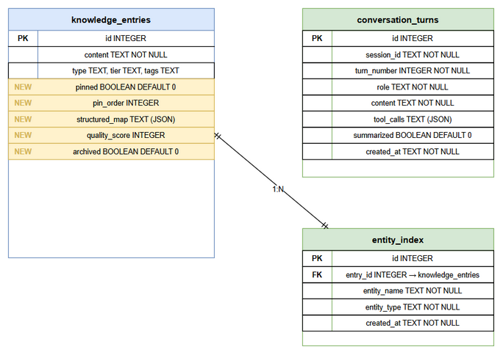
ER Diagram

4.2 Logical Entities

Entity: knowledge_entries (Extended)
Attribute | Type | Required | Business Rule | Description
id | INTEGER | Yes (PK) | Auto-increment | Entry identifier
content | TEXT | Yes | BR-F4-08: ≥50 chars | Knowledge content
type | TEXT | No |  | Entry type (DECISION, ERROR_PATTERN, etc.)
tier | TEXT | No |  | WORKING, EPISODIC, SEMANTIC, PROCEDURAL
tags | TEXT | No |  | Comma-separated tags
pinned | BOOLEAN | Yes | BR-F1-01: max 10 | NEW: Whether entry is pinned
pin_order | INTEGER | No | BR-F1-03: contiguous | NEW: Display/injection order
structured_map | TEXT (JSON) | No | BR-F3-01: rule-based | NEW: Extracted metadata JSON
quality_score | INTEGER | No | BR-F4-10: 0-100 | NEW: Content quality score
archived | BOOLEAN | No | BR-F4-19: soft delete | NEW: Archived flag
source | TEXT | No |  | Source reference
created_at | TEXT | Yes |  | ISO 8601 timestamp
updated_at | TEXT | Yes |  | ISO 8601 timestamp

Entity: conversation_turns (New)
Attribute | Type | Required | Business Rule | Description
id | INTEGER | Yes (PK) | Auto-increment | Turn identifier
session_id | TEXT | Yes | BR-F2-01 | Session identifier
turn_number | INTEGER | Yes | Auto-assigned | Sequential within session
role | TEXT | Yes | BR-F2-02: enum | user, assistant, system, tool
content | TEXT | Yes | Non-empty | Turn content
tool_calls | TEXT (JSON) | No | Valid JSON array | Tool calls made
metadata | TEXT (JSON) | No | Valid JSON object | Extra metadata
summarized | BOOLEAN | No | BR-F2-03 | Whether included in summary
created_at | TEXT | Yes |  | ISO 8601 timestamp

Entity: entity_index (New)
Attribute | Type | Required | Business Rule | Description
id | INTEGER | Yes (PK) | Auto-increment | Index entry ID
entry_id | INTEGER | Yes (FK) | References knowledge_entries | Parent entry
entity_name | TEXT | Yes | BR-F3-04 | Entity string
entity_type | TEXT | Yes | BR-F3-04: enum | ticket/person/system/file/url/concept
created_at | TEXT | Yes |  | ISO 8601 timestamp

Entity: agent_scope_config (New)
Attribute | Type | Required | Business Rule | Description
id | INTEGER | Yes (PK) | Auto-increment | Config entry ID
agent_role | TEXT | Yes | BR-F4-01: unique | Agent role name (QA, DEV, BA, SA, DevOps)
tag_set | TEXT (JSON) | Yes | BR-F4-01 | Array of allowed tags
updated_at | TEXT | Yes |  | Last modified
Relationships:
From Entity | To Entity | Cardinality | Description
knowledge_entries | entity_index | 1:N | One entry can have many entities
knowledge_entries | conversation_turns | 1:1 | Summary entry links to session
agent_scope_config | knowledge_entries | 1:N | Scope filters entries by tags

5. Integration Specifications

5.1 Internal Integration: Existing MCP Tools
Attribute | Value
Purpose | Ensure 14 existing tools continue working unchanged
Direction | Bidirectional
Data Format | JSON (MCP protocol)
Frequency | Real-time (every tool call)
Compatibility Matrix:
Existing Tool | F1 Impact | F2 Impact | F3 Impact | F4 Impact
mem_search | Pinned prepend | None | Entity boost | agent_scope + max_tokens + expiry
mem_ingest | None | None | Auto-extract map | Quality gate
mem_crud | Pin state in response | None | Map in response | Archived flag
mem_consolidate | Preserve pin state | None | Re-extract on merge | Quality re-score
mem_scoring | None | None | None | Quality score source
mem_lifecycle | Pin exempt | None | None | Expiry integration
mem_tags | None | None | None | Scope mapping source
mem_graph | None | None | Entity → graph link | None
mem_discover | Pin boost | None | Entity matching | None
mem_citations | None | None | None | None
mem_templates | None | None | None | None
mem_attachments | None | None | None | None
mem_admin | Pin stats | Session stats | Entity stats | Quality stats
mem_kb_export | Include pin state | None | Include map | Include quality

5.2 Internal Integration: Schema Migrations
Attribute | Value
Purpose | Extend SQLite schema without breaking existing data
Direction | One-way (additive only)
Data Format | SQL DDL
Frequency | Once (on first startup after upgrade)
Migration Steps:
Order | Migration | Tables Affected | Reversible
1 | Add pinned, pin_order columns | knowledge_entries | Yes (columns nullable)
2 | Add structured_map column | knowledge_entries | Yes (column nullable)
3 | Add quality_score, archived columns | knowledge_entries | Yes (columns nullable)
4 | Create conversation_turns table | New table | Yes (DROP TABLE)
5 | Create entity_index table | New table | Yes (DROP TABLE)
6 | Create agent_scope_config table | New table | Yes (DROP TABLE)
7 | Create FTS5 index on entity_index | New index | Yes (DROP)
8 | Create index on conversation_turns(session_id, turn_number) | New index | Yes (DROP)

6. Processing Logic

6.1 Token Counting
Trigger: Every pin operation, every search with max_tokens Input: Text content (string) Output: Token count (integer)
Processing Steps:
Step | Description | Error Handling
1 | Receive content string | If null/undefined → return 0
2 | Calculate: Math.ceil(content.length / 4) | Integer overflow impossible (JS safe integer)
3 | Return token count | N/A
Pseudocode:
function countTokens(content: string): number {
if (!content) return 0;
return Math.ceil(content.length / 4);
}

6.2 Structured Map Extraction
Trigger: Every mem_ingest call (after quality gate passes) Input: Entry content (string) Output: StructuredMap object
Processing Steps:
Step | Description | Error Handling
1 | Extract topic: first markdown heading (# ...) or first sentence | If no heading → use first 100 chars
2 | Extract entities: apply regex patterns sequentially | If no matches → empty array
3 | Classify entities by pattern match | Unknown patterns → type “concept”
4 | Extract decisions: scan for decision keywords | If none → empty array
5 | Extract action_items: scan for TODO/action keywords | If none → empty array
6 | Extract context_refs: URLs + file paths + ticket IDs | If none → empty array
7 | Calculate sentiment: count positive vs negative keywords | Default → “neutral”
8 | Return StructuredMap JSON | On any error → return partial map
Pseudocode:
function extractStructuredMap(content: string): StructuredMap {
const topic = extractTopic(content); // first heading or first sentence
const entities = extractEntities(content); // regex-based
const decisions = content.split('\n')
.filter(line => /^(Decision:|Decided:|We will|Chosen approach)/i.test(line.trim()));
const actionItems = content.split('\n')
.filter(line => /^(TODO|Action:|Next step:|\- \[ \])/i.test(line.trim()));
const contextRefs = [
...content.matchAll(/https?:\/\/[^\s)]+/g),
...content.matchAll(/[A-Z]+-\d+/g),
...content.matchAll(/[\w\/\\]+\.\w{1,5}/g) // file paths
].map(m => m[0]);
const sentiment = scoreSentiment(content);
return { topic, entities_mentioned: entities.map(e => e.name),
decisions_made: decisions, action_items: actionItems,
context_refs: [...new Set(contextRefs)], sentiment };
}

6.3 Quality Score Calculation
Trigger: Every mem_ingest call (before storage) Input: Content + metadata (tags, source, type) Output: Quality score (0-100)
Processing Steps:
Step | Description | Error Handling
1 | Base score from content length: min(30, (length - 50) / 15) | Clamp to 0-30
2 | Add +20 if tags or type specified | Boolean check
3 | Add +10 if source reference provided | Boolean check
4 | Add +10 if content has structure (headings, lists, code) | Regex check
5 | Check duplicates: cosine similarity with top-5 similar entries | If >0.95 → -50 penalty
6 | Check near-duplicate: if 0.90-0.95 → -20 penalty | Warning flag
7 | Clamp final score to 0-100 | Math.max(0, Math.min(100, score))
8 | Return score + decision (accept/warn/reject) | N/A
Pseudocode:
function calculateQualityScore(content: string, meta: IngestMeta): QualityResult {
let score = 0;
// Length score (0-30)
score += Math.min(30, Math.max(0, (content.length - 50) / 15));
// Metadata bonuses
if (meta.tags || meta.type) score += 20;
if (meta.source) score += 10;
if (/^#{1,3}\s|^\-\s|```/.test(content)) score += 10;
// Duplicate check
const maxSimilarity = await findMaxSimilarity(content);
if (maxSimilarity > 0.95) score -= 50;
else if (maxSimilarity > 0.90) score -= 20;
score = Math.max(0, Math.min(100, Math.round(score)));
const decision = score < 30 ? 'reject' : score < 50 ? 'warn' : 'accept';
return { score, decision, duplicate: maxSimilarity > 0.90 };
}

6.4 WORKING Tier Auto-Expiry
Trigger: Every mem_search call (lazy evaluation) Input: Current timestamp Output: List of expiry actions taken
Processing Steps:
Step | Description | Error Handling
1 | Query: SELECT * FROM knowledge_entries WHERE tier=‘WORKING’ AND pinned=0 AND created_at < NOW-24h | If none → skip
2 | For each stale entry: get quality_score | If null → treat as 0
3 | If quality_score ≥ 60 → UPDATE tier=‘EPISODIC’ | Log promotion
4 | If quality_score < 60 → UPDATE archived=1 | Log archive
5 | Insert audit records for each action | On error → log but don’t fail search
6 | Return actions list | Empty if nothing expired
Pseudocode:
async function processWorkingExpiry(db: Database): Promise<ExpiryAction[]> {
const threshold = Date.now() - (24 * 60 * 60 * 1000); // 24h
const stale = db.prepare(`
SELECT id, quality_score FROM knowledge_entries
WHERE tier = 'WORKING' AND pinned = 0 AND archived = 0
AND created_at < ?
`).all(new Date(threshold).toISOString());
const actions: ExpiryAction[] = [];
for (const entry of stale) {
if ((entry.quality_score ?? 0) >= 60) {
db.prepare('UPDATE knowledge_entries SET tier = ? WHERE id = ?')
.run('EPISODIC', entry.id);
actions.push({ entry_id: entry.id, action: 'promoted', to: 'EPISODIC' });
} else {
db.prepare('UPDATE knowledge_entries SET archived = 1 WHERE id = ?')
.run(entry.id);
actions.push({ entry_id: entry.id, action: 'archived' });
}
}
return actions;
}

6.5 Conversation Summarization
Trigger: Session end or manual mem_conversation(action: "summarize") Input: All turns in a session Output: Summary knowledge entry
Processing Steps:
Step | Description | Error Handling
1 | Fetch all turns for session ordered by turn_number | If empty → return error
2 | Extract key decisions (lines with decision keywords) | If none → note “no decisions”
3 | Extract action items (TODO, next step patterns) | If none → note “no actions”
4 | Extract topics discussed (from assistant responses) | Use first sentences
5 | Compose summary text with sections | Always produce output
6 | Create knowledge entry (type: CONVERSATION, tags: “conversation,summary,{session_id}”) | On error → retry once
7 | Mark original turns: summarized = 1 | Batch update
8 | Return summary entry ID | N/A

7. Security Requirements

7.1 Authentication & Authorization
Role | Permissions | Features
AI Agent (any) | Read/Write KB entries | All MCP tools
AI Agent (scoped) | Read filtered by agent_scope | mem_search with tag filter
System | Auto-expiry, auto-extract | Background processes

7.2 Data Sensitivity Classification
Data Type | Classification | Business Requirement
Knowledge entries | Internal | May contain project-specific decisions
Conversation turns | Internal | May contain user interactions
Entity index | Internal | Derived from content
Agent scope config | Internal | Configuration data

7.3 Audit Trail
Event | Logged Fields | Retention | Business Reason
Pin/Unpin | entry_id, action, timestamp, budget_state | Indefinite | Track context management
Quality rejection | content_hash, score, reason, timestamp | 30 days | Monitor false positives
Auto-expiry | entry_id, action (promote/archive), quality_score | Indefinite | Track data lifecycle
Search with scope | agent_scope, query, results_count, tokens_used | 7 days | Monitor isolation effectiveness

8. Non-Functional Requirements
Category | Business Requirement | Acceptance Criteria
Performance | Pin retrieval fast enough for every-turn injection | < 50ms for CoreMemoryManager.getContext()
Performance | Conversation queries responsive | < 100ms for ConversationRepository.getSession()
Performance | Entity search fast | < 100ms for entity_index lookup
Performance | Map extraction lightweight | < 200ms per entry (rule-based, no network)
Performance | Token counting negligible | < 1ms per call
Performance | Quality gate minimal overhead | < 50ms additional latency on ingest
Reliability | Zero data loss on migration | Additive-only schema changes
Reliability | Idempotent operations | Backfill + migrations safe to re-run
Scalability | Support 1000+ entries | Performance targets hold at scale
Compatibility | No breaking changes | All 14 existing MCP tools unchanged
Testability | High coverage | ≥ 80% code coverage on new code

9. Error Handling (User-Facing)

9.1 Error Scenarios
Scenario | Severity | User Message | Expected Behavior
Pin budget exceeded | Warning | “Token budget exceeded. Current: {n}/2000. Entry requires {m} tokens.” | Agent unpins something first
Max pins reached | Warning | “Maximum pinned entries (10) reached. Unpin an entry first.” | Agent manages pins
Quality rejection | Info | “Content quality too low (score: {n}/100). Add tags, source, or more detail.” | Agent improves content
Duplicate detected | Warning | “Near-duplicate found (similarity: {n}%). Existing entry: #{id}. Consider merging.” | Agent decides merge/skip
Content too short | Info | “Content too short (minimum 50 characters). Provide more detail.” | Agent adds detail
Entry not found | Error | “Entry {id} not found” | Agent checks ID
Invalid role | Error | “Invalid role. Must be: user, assistant, system, tool” | Agent fixes role
Session not found | Warning | “Session ‘{id}’ not found” | Agent checks session_id
Migration failure | Critical | “Schema migration failed: {detail}. Database unchanged.” | Admin investigates

9.2 Notification Requirements
Event | Who is Notified | Channel | Timing
Quality rejection | Calling agent | MCP response | Immediate
Auto-expiry actions | Audit log | Database | On next search
Migration success | System log | Console | On startup
Duplicate warning | Calling agent | MCP response | Immediate

10. Testing Considerations

10.1 Test Scenarios
ID | Scenario | Input | Expected Output | Priority
TC-01 | Pin entry successfully | mem_pin(action:“pin”, entry_id:1) | success=true, budget updated | High
TC-02 | Pin exceeds budget | Pin entry with 2100 tokens | Error: budget exceeded | High
TC-03 | Pin exceeds max count | Pin 11th entry | Error: max reached | High
TC-04 | Unpin reorders correctly | Unpin middle entry | Remaining entries reordered contiguously | High
TC-05 | Auto-recall prepends pins | mem_search with 3 pinned entries | Results start with [PINNED] entries | High
TC-06 | Save conversation turn | save_turn with all fields | Turn persisted, turn_number assigned | High
TC-07 | Query session returns ordered | get_session after 5 turns | 5 turns in order | High
TC-08 | Summarize session | summarize session with 10 turns | Summary entry created, turns marked | Medium
TC-09 | Extract entities from content | Content with ticket IDs, class names | Correct entities extracted and classified | High
TC-10 | Search by entity | search_entity(“KSA-110”) | All entries mentioning KSA-110 | High
TC-11 | Backfill idempotent | Run backfill twice | Same result, no duplicates | Medium
TC-12 | Agent scope filtering | mem_search with agent_scope:“QA” | Only QA-tagged entries returned | High
TC-13 | Untagged entries visible | Search with scope, untagged entry exists | Untagged entry included | High
TC-14 | Quality gate rejects short | Ingest 30-char content | Error: too short | High
TC-15 | Quality gate rejects duplicate | Ingest identical content | Error: duplicate detected | High
TC-16 | Search token budget | mem_search(max_tokens:500) | Results ≤ 500 tokens | High
TC-17 | WORKING auto-expiry promotes | WORKING entry, score=70, age=25h | Promoted to EPISODIC | High
TC-18 | WORKING auto-expiry archives | WORKING entry, score=20, age=25h | Archived | High
TC-19 | Pinned exempt from expiry | Pinned WORKING entry, age=48h | Not expired | High
TC-20 | Cross-feature: pin + search + scope | Pinned entry with QA tag, search with scope=DEV | Pinned entry still shown (pins bypass scope) | Medium

11. Appendix

11.1 State Diagram: Knowledge Entry Lifecycle
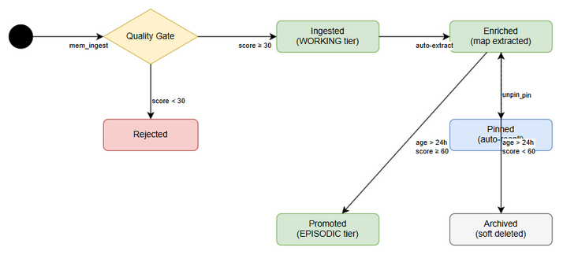
State Diagram
States: - Ingested → Quality gate passed, entry stored - Enriched → Structured map extracted, entities indexed - Pinned → Marked for auto-recall - Expired → WORKING tier auto-expiry triggered - Promoted → Moved from WORKING to EPISODIC - Archived → Soft-deleted (recoverable)

11.2 Sequence Diagram: mem_search with All Features
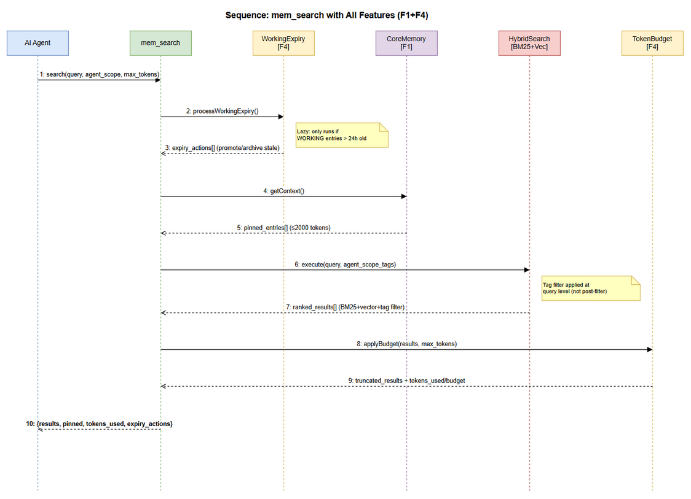
Sequence Diagram
Sequence: 1. Agent → mem_search(query, agent_scope, max_tokens) 2. System → processWorkingExpiry() [lazy] 3. System → CoreMemoryManager.getContext() [load pins] 4. System → HybridSearch.execute(query) [BM25 + vector] 5. System → applyAgentScope(results, scope) [tag filter] 6. System → applyTokenBudget(results, max_tokens) [truncate] 7. System → prependPinnedEntries(pins, results) [merge] 8. System → Agent: results + metadata

11.3 Sequence Diagram: mem_ingest with Quality Gate
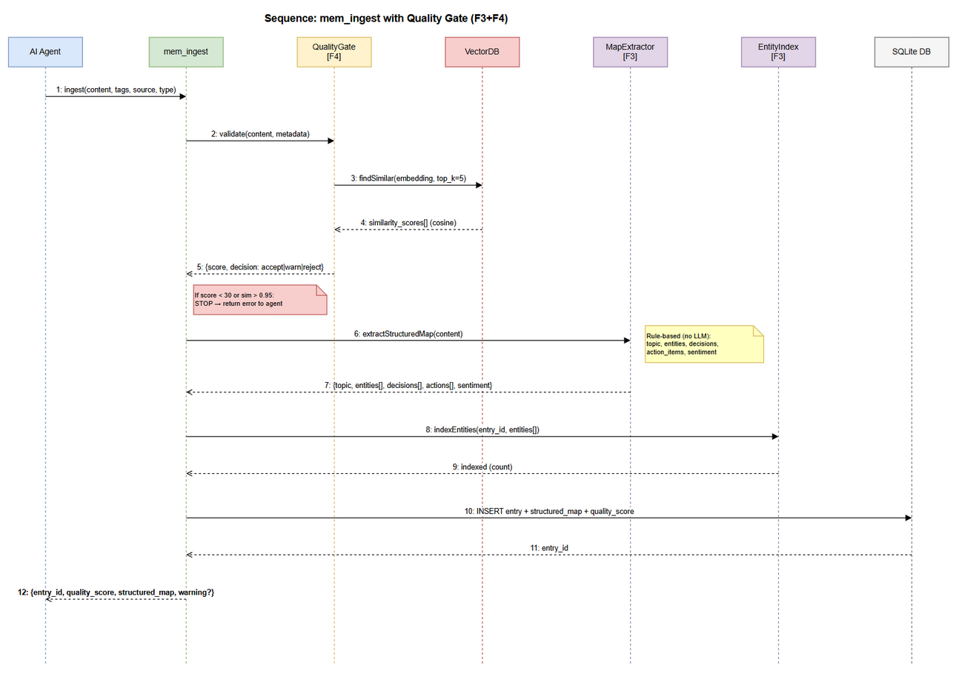
Sequence Diagram
Sequence: 1. Agent → mem_ingest(content, tags, source) 2. System → validateMinLength(content) [≥50 chars] 3. System → calculateQualityScore(content, meta) 4. System → checkDuplicates(content) [cosine similarity] 5. If rejected → return error 6. System → extractStructuredMap(content) [F3] 7. System → indexEntities(map.entities) [F3] 8. System → store entry with quality_score + structured_map 9. System → Agent: entry + quality_score + structured_map

11.4 Diagram Index
# | Diagram | Image | Source (editable)
1 | System Context | system-context.png | system-context.drawio
2 | ER Diagram | er-diagram.png | er-diagram.drawio
3 | State: Entry Lifecycle | state-entry-lifecycle.png | state-entry-lifecycle.drawio
4 | Sequence: Search Full | sequence-search-full.png | sequence-search-full.drawio
5 | Sequence: Ingest Quality | sequence-ingest-quality.png | sequence-ingest-quality.drawio

11.5 Change Log from BRD
BRD Item | FSD Clarification
Story 11: “agent_scope parameter” | Clarified as optional parameter on existing mem_search tool (not new tool)
Story 12: “blind retrieval prevention” | Implemented as steering rule update + audit metadata (not code enforcement)
Story 13: “contradiction detection” | Simplified to cosine similarity check only (full contradiction detection deferred)
Story 14: “summary instead of full content” | Truncation strategy: limit results first, then truncate content, summary as last resort
Story 15: “lazy evaluation” | Runs on every mem_search call, not as background job
F1+F4 interaction | Pinned entries bypass agent_scope filter (always visible to pinning agent)

11.6 Open Issues
# | Issue | Impact | Proposed Resolution
1 | Should pinned entries bypass agent_scope? | If yes, agent sees pins regardless of role | Proposed: Yes — pins are intentional, agent chose to pin
2 | Quality gate false positives on short decisions | Legitimate “Decision: use PostgreSQL” = 30 chars | Proposed: Exempt entries with type=DECISION from min-length
3 | Auto-expiry during high-load search | Expiry adds latency to search | Proposed: Rate-limit expiry to max 10 entries per search call
4 | Conversation summarization quality | Rule-based summary may miss nuance | Proposed: Accept for v0.6.0, add LLM-assisted in v0.7.0

