Technical Design Document (TDD)

mcp-code-intelligence-nodejs — KSA-110: KB System Upgrade v0.6.0

Document Information
Field | Value
Jira Ticket | KSA-110
Title | KB System Upgrade v0.6.0
Author | SA Agent
Version | 1.0
Date | 2025-05-22
Status | Draft
Related BRD | BRD-v1.1-KSA-110.docx
Related FSD | FSD-v1.0-KSA-110.docx

Author Tracking
Role | Name - Position | Responsibility
Author | SA Agent – Solution Architect | Create document
Peer Reviewer | Duc Nguyen Minh – Product Owner | Review document

Revision History
Version | Date | Author | Changes
1.0 | 2025-05-22 | SA Agent | Initial TDD from FSD v1.0 — 4 features, 14 use cases

Sign-Off
Name | Signature and date
Duc Nguyen Minh | ☐ I agree and confirm the technical design in this TDD
 | ☐ I agree and confirm the technical design in this TDD

1. Introduction

1.1 Purpose
This TDD specifies the technical implementation of KB System Upgrade v0.6.0 for mcp-code-intelligence-nodejs. It covers architecture, class design, database DDL, API implementation, and deployment for 4 features: Core Memory (F1), Conversation History (F2), Structured Map (F3), and Anti-Pattern Protection (F4).

1.2 Scope
- New classes: QualityGate, AgentScopeFilter, WorkingTierExpiry, ConversationSummarizer
- Extended classes: HybridSearch (agent_scope + max_tokens), IngestPipeline (quality gate + structured map)
- Schema migrations: 5 new columns on knowledge_entries, 3 new tables
- 3 new MCP tools: mem_pin, mem_conversation, mem_map
- Enhanced existing tools: mem_search (agent_scope, max_tokens), mem_ingest (quality gate)

1.3 Technology Stack
Layer | Technology | Version
Language | TypeScript | 5.x
Runtime | Node.js | ≥18
Database | SQLite (better-sqlite3) | 3.x
Embedding | ONNX Runtime (all-MiniLM-L6-v2) | 384d
Protocol | MCP (Model Context Protocol) | stdio
Build Tool | npm / tsc | latest
Test | Vitest | latest

1.4 Design Principles
- Additive-only migrations — never DROP or ALTER existing columns
- Single Responsibility — each class handles one concern
- Backward compatibility — all 14 existing MCP tools unchanged
- No external dependencies — rule-based extraction, no LLM calls
- Lazy evaluation — auto-expiry runs on search, not background jobs
- Fail-safe — quality gate failures don’t crash ingest pipeline

1.5 Constraints
- SQLite single-writer (no concurrent writes from multiple processes)
- No network calls during extraction (rule-based only)
- Token counting uses chars/4 approximation (no tiktoken dependency)
- Maximum 10 pinned entries, 2000 token budget
- ONNX model already loaded — no additional ML models

1.6 References
Document | Location
BRD v1.1 | BRD-v1.1-KSA-110.docx
FSD v1.0 | FSD-v1.0-KSA-110.docx
Current Schema | src/memory/schema.ts, schema-v2.ts, schema-v3.ts
Core Memory | src/memory/core-memory.ts
Conversation Repo | src/memory/conversation-repo.ts
Structured Map | src/memory/structured-map-extractor.ts

2. System Architecture

2.1 Architecture Overview
The KB system is a single-process Node.js MCP server communicating via stdio. The upgrade adds 4 functional layers to the existing memory engine without changing the deployment model.
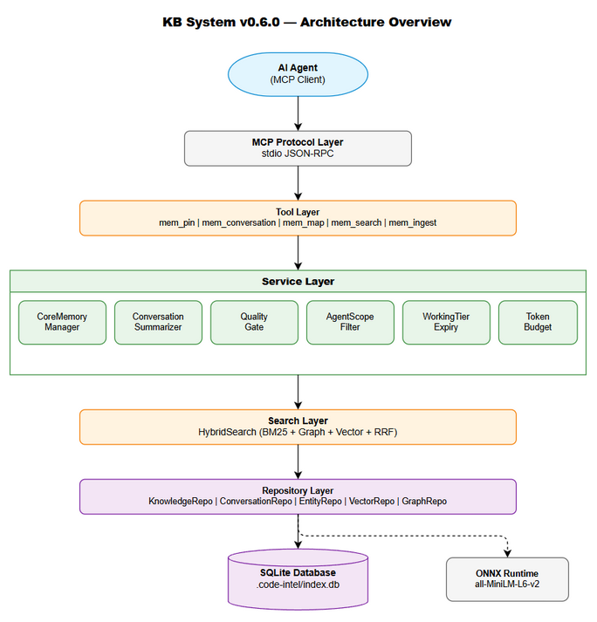
Architecture Diagram
Layers (bottom-up): 1. Storage Layer — SQLite database with better-sqlite3 (synchronous API) 2. Repository Layer — Data access classes (KnowledgeRepo, ConversationRepo, EntityRepo, etc.) 3. Service Layer — Business logic (CoreMemoryManager, QualityGate, AgentScopeFilter, WorkingTierExpiry) 4. Search Layer — HybridSearch with RRF fusion, pinned prepend, scope filter, token budget 5. Tool Layer — MCP tool dispatchers (consolidated pattern: one tool = multiple actions) 6. Protocol Layer — MCP stdio transport (unchanged)

2.2 Component Diagram
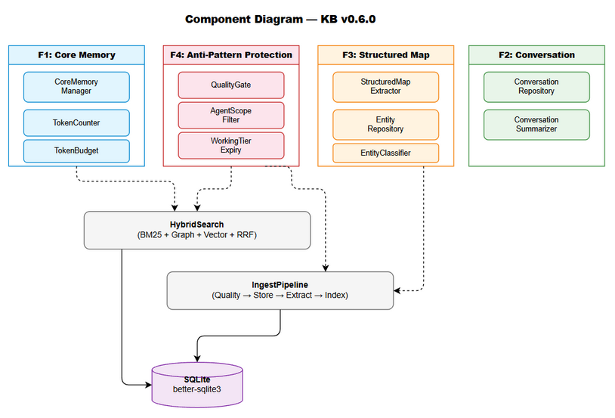
Component Diagram
Component | Responsibility | Technology
CoreMemoryManager | Pin/unpin/reorder, token budget, context injection | TypeScript class
ConversationRepository | CRUD for conversation_turns, session queries | TypeScript class
ConversationSummarizer | Auto-summarize old sessions into KB entries | TypeScript class
StructuredMapExtractor | Rule-based entity/decision/action extraction | Pure functions
EntityRepository | CRUD for entity_index, entity search | TypeScript class
QualityGate | Validate content before ingest (length, duplicates, score) | TypeScript class
AgentScopeFilter | Tag-based filtering per agent role | TypeScript class
WorkingTierExpiry | Lazy auto-expiry of stale WORKING entries | TypeScript class
HybridSearch | BM25 + graph + vector fusion, pinned prepend, scope, budget | TypeScript class
IngestPipeline | Orchestrates: quality gate → store → extract map → index entities | TypeScript class
ToolDispatcher | Routes MCP tool calls to appropriate service methods | TypeScript class

2.3 Communication Patterns
From | To | Protocol | Pattern | Description
AI Agent | MCP Server | stdio (JSON-RPC) | Sync request/response | Tool calls
ToolDispatcher | Services | In-process function call | Sync | Direct method invocation
Services | SQLite | better-sqlite3 | Sync | Prepared statements
HybridSearch | CoreMemoryManager | In-process | Sync | getContext() for auto-recall
IngestPipeline | QualityGate | In-process | Sync | Validate before store
IngestPipeline | StructuredMapExtractor | In-process | Sync | Extract after store
HybridSearch | WorkingTierExpiry | In-process | Sync (lazy) | Process stale entries on search

3. API Design (MCP Tools)

3.1 API Overview
# | Tool | Actions | Description | Source
1 | mem_pin | pin, unpin, list, reorder, get_context, budget | Core memory management | UC-01, UC-02, UC-03
2 | mem_conversation | save_turn, get_session, list_sessions, search, summarize | Conversation history | UC-04, UC-05, UC-06
3 | mem_map | get, update, search_entity, search_topic, reextract | Structured map management | UC-07, UC-08, UC-09
4 | mem_search (enhanced) | — | +agent_scope, +max_tokens params | UC-10, UC-13, UC-14
5 | mem_ingest (enhanced) | — | +quality gate, +auto-extract map | UC-07, UC-12

3.2 Tool: mem_pin
Implements: UC-01, UC-02, UC-03 | BR: BR-F1-01 through BR-F1-06
Input Schema:
{
"type": "object",
"required": ["action"],
"properties": {
"action": { "type": "string", "enum": ["pin", "unpin", "list", "reorder", "get_context", "budget"] },
"entry_id": { "type": "integer", "description": "Required for pin/unpin/reorder" },
"order": { "type": "integer", "description": "Required for reorder (0-based)" }
}
}
Dispatch Logic:
// tool-dispatcher handles routing
switch (action) {
case 'pin': return coreMemory.pin(entry_id);
case 'unpin': return coreMemory.unpin(entry_id);
case 'list': return coreMemory.listPinned();
case 'reorder': return coreMemory.reorder(entry_id, order);
case 'get_context': return coreMemory.getContext();
case 'budget': return coreMemory.getBudgetStatus();
}
Error Responses:
Condition | Error Message | HTTP-equiv
entry_id not found | “Entry {id} not found” | 404
Budget exceeded | “Token budget exceeded. Current: {n}/2000. Entry requires {m} tokens.” | 422
Max pins reached | “Maximum pinned entries (10) reached. Unpin an entry first.” | 422
Already pinned | “Entry {id} is already pinned” | 409

3.3 Tool: mem_conversation
Implements: UC-04, UC-05, UC-06 | BR: BR-F2-01 through BR-F2-05
Input Schema:
{
"type": "object",
"required": ["action"],
"properties": {
"action": { "type": "string", "enum": ["save_turn", "get_session", "list_sessions", "search", "summarize"] },
"session_id": { "type": "string", "description": "Required for save_turn/get_session/summarize" },
"role": { "type": "string", "enum": ["user", "assistant", "system", "tool"] },
"content": { "type": "string", "maxLength": 50000 },
"tool_calls": { "type": "string", "description": "JSON array of tool calls" },
"query": { "type": "string", "description": "Required for search" },
"limit": { "type": "integer", "default": 20, "minimum": 1, "maximum": 100 }
}
}
Dispatch Logic:
switch (action) {
case 'save_turn': return conversationRepo.saveTurn(session_id, role, content, tool_calls);
case 'get_session': return conversationRepo.getSession(session_id, limit);
case 'list_sessions': return conversationRepo.listSessions(limit);
case 'search': return conversationRepo.searchTurns(query, limit);
case 'summarize': return conversationSummarizer.summarize(session_id);
}
Error Responses:
Condition | Error Message
Invalid role | “Invalid role. Must be: user, assistant, system, tool”
Empty content | “Content cannot be empty”
Session not found | “Session ‘{id}’ not found”
Invalid tool_calls JSON | “tool_calls must be a valid JSON array”

3.4 Tool: mem_map
Implements: UC-07, UC-08, UC-09 | BR: BR-F3-01 through BR-F3-05
Input Schema:
{
"type": "object",
"required": ["action"],
"properties": {
"action": { "type": "string", "enum": ["get", "update", "search_entity", "search_topic", "reextract"] },
"entry_id": { "type": "integer", "description": "Required for get/update/reextract" },
"entity": { "type": "string", "description": "Required for search_entity" },
"topic": { "type": "string", "description": "Required for search_topic" },
"map": { "type": "object", "description": "Partial map to merge (for update)" },
"limit": { "type": "integer", "default": 10, "minimum": 1, "maximum": 50 }
}
}
Dispatch Logic:
switch (action) {
case 'get': return mapService.getMap(entry_id);
case 'update': return mapService.updateMap(entry_id, map);
case 'search_entity': return entityRepo.findByEntity(entity, limit);
case 'search_topic': return mapService.searchByTopic(topic, limit);
case 'reextract': return mapService.reextract(entry_id);
}

3.5 Enhanced Tool: mem_search
New Parameters (additive):
Parameter | Type | Default | Description
agent_scope | string | null | Agent role for tag-based filtering (QA, DEV, BA, SA, DevOps)
max_tokens | integer | 2000 | Token budget for results
Enhanced Response Fields:
Field | Type | Description
tokens_used | integer | Actual tokens consumed
tokens_budget | integer | Budget applied
results_truncated | boolean | Whether budget limiting was applied
expiry_actions | array | Auto-expiry actions taken during this search
Implementation Flow:
async function enhancedSearch(params: EnhancedSearchParams): SearchResponse {
// 1. Lazy auto-expiry (F4)
const expiryActions = workingTierExpiry.processStale();
// 2. Load pinned context (F1)
const pinnedContext = coreMemory.getContext();
// 3. Execute hybrid search (existing)
let results = hybridSearch.search(params);
// 4. Apply agent scope filter (F4)
if (params.agent_scope) {
results = agentScopeFilter.filter(results, params.agent_scope);
}
// 5. Apply token budget (F4)
const { limited, tokensUsed } = tokenBudget.apply(results, params.max_tokens ?? 2000);
// 6. Prepend pinned entries (F1)
return { pinnedContext, results: limited, tokens_used: tokensUsed, expiry_actions: expiryActions };
}

3.6 Enhanced Tool: mem_ingest
New Behavior (quality gate + auto-extract):
async function enhancedIngest(params: IngestParams): IngestResponse {
// 1. Quality Gate (F4) — validate before storing
const quality = qualityGate.validate(params.content, params);
if (quality.decision === 'reject') {
return { error: quality.message, quality_score: quality.score };
}
// 2. Store entry (existing pipeline)
const entry = await knowledgeRepo.create(params);
// 3. Extract structured map (F3)
const structuredMap = extractStructuredMap(entry.content);
await knowledgeRepo.updateStructuredMap(entry.id, structuredMap);
// 4. Index entities (F3)
const entities = classifyEntities(structuredMap.entities_mentioned);
entityRepo.indexEntities(entry.id, entities);
// 5. Return enriched response
return { ...entry, quality_score: quality.score, structured_map: structuredMap };
}

4. Database Design

4.1 Schema Overview
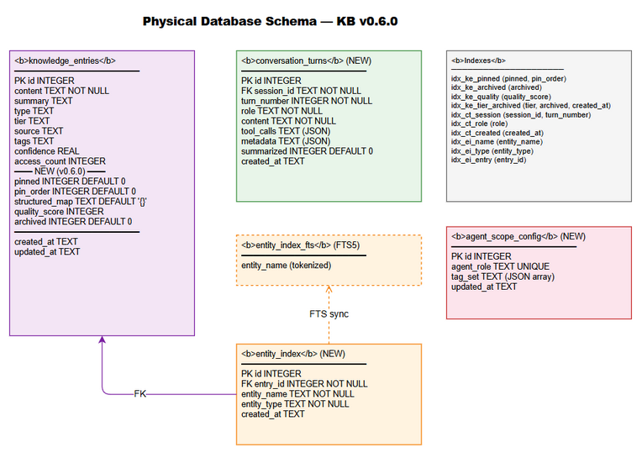
Database Schema
The upgrade extends the existing knowledge_entries table with 5 new columns and creates 3 new tables. All changes are additive-only (no DROP, no ALTER existing columns).

4.2 DDL Scripts

Migration 1: Core Memory Columns (F1)
-- V3.1: Add pinned entries support
ALTER TABLE knowledge_entries ADD COLUMN pinned INTEGER NOT NULL DEFAULT 0;
ALTER TABLE knowledge_entries ADD COLUMN pin_order INTEGER NOT NULL DEFAULT 0;
CREATE INDEX IF NOT EXISTS idx_ke_pinned ON knowledge_entries(pinned, pin_order);

Migration 2: Structured Map Column (F3)
-- V3.2: Add structured map metadata
ALTER TABLE knowledge_entries ADD COLUMN structured_map TEXT NOT NULL DEFAULT '{}';

Migration 3: Quality & Archive Columns (F4)
-- V3.3: Add quality score and archive flag
ALTER TABLE knowledge_entries ADD COLUMN quality_score INTEGER DEFAULT NULL;
ALTER TABLE knowledge_entries ADD COLUMN archived INTEGER NOT NULL DEFAULT 0;
CREATE INDEX IF NOT EXISTS idx_ke_archived ON knowledge_entries(archived);
CREATE INDEX IF NOT EXISTS idx_ke_quality ON knowledge_entries(quality_score);
CREATE INDEX IF NOT EXISTS idx_ke_tier_archived ON knowledge_entries(tier, archived, created_at);

Migration 4: Conversation Turns Table (F2)
-- V3.4: Structured conversation history
CREATE TABLE IF NOT EXISTS conversation_turns (
id INTEGER PRIMARY KEY AUTOINCREMENT,
session_id TEXT NOT NULL,
turn_number INTEGER NOT NULL,
role TEXT NOT NULL CHECK(role IN ('user', 'assistant', 'system', 'tool')),
content TEXT NOT NULL,
tool_calls TEXT,
metadata TEXT,
summarized INTEGER NOT NULL DEFAULT 0,
created_at TEXT NOT NULL DEFAULT (datetime('now'))
);
CREATE INDEX IF NOT EXISTS idx_ct_session ON conversation_turns(session_id, turn_number);
CREATE INDEX IF NOT EXISTS idx_ct_role ON conversation_turns(role);
CREATE INDEX IF NOT EXISTS idx_ct_created ON conversation_turns(created_at);
CREATE INDEX IF NOT EXISTS idx_ct_summarized ON conversation_turns(summarized);

Migration 5: Entity Index Table (F3)
-- V3.5: Entity extraction index
CREATE TABLE IF NOT EXISTS entity_index (
id INTEGER PRIMARY KEY AUTOINCREMENT,
entry_id INTEGER NOT NULL,
entity_name TEXT NOT NULL,
entity_type TEXT NOT NULL CHECK(entity_type IN ('ticket', 'person', 'system', 'file', 'url', 'concept')),
created_at TEXT NOT NULL DEFAULT (datetime('now')),
FOREIGN KEY (entry_id) REFERENCES knowledge_entries(id) ON DELETE CASCADE
);
CREATE INDEX IF NOT EXISTS idx_ei_name ON entity_index(entity_name);
CREATE INDEX IF NOT EXISTS idx_ei_type ON entity_index(entity_type);
CREATE INDEX IF NOT EXISTS idx_ei_entry ON entity_index(entry_id);

Migration 6: Agent Scope Config Table (F4)
-- V3.6: Agent-level KB isolation configuration
CREATE TABLE IF NOT EXISTS agent_scope_config (
id INTEGER PRIMARY KEY AUTOINCREMENT,
agent_role TEXT NOT NULL UNIQUE,
tag_set TEXT NOT NULL DEFAULT '[]',
updated_at TEXT NOT NULL DEFAULT (datetime('now'))
);
-- Seed default scope mappings
INSERT OR IGNORE INTO agent_scope_config (agent_role, tag_set) VALUES
('QA', '["testing","qa","test-plan","test-case","bug"]'),
('DEV', '["code","api","architecture","implementation","design"]'),
('BA', '["requirement","business","stakeholder","process"]'),
('SA', '["architecture","design","infrastructure","security"]'),
('DevOps', '["deployment","infrastructure","ci-cd","monitoring"]');

Migration 7: FTS5 on Entity Index (F3)
-- V3.7: Full-text search on entity names
CREATE VIRTUAL TABLE IF NOT EXISTS entity_index_fts USING fts5(
entity_name,
content='entity_index',
content_rowid='id'
);
-- Triggers to keep FTS in sync
CREATE TRIGGER IF NOT EXISTS entity_index_ai AFTER INSERT ON entity_index BEGIN
INSERT INTO entity_index_fts(rowid, entity_name) VALUES (new.id, new.entity_name);
END;
CREATE TRIGGER IF NOT EXISTS entity_index_ad AFTER DELETE ON entity_index BEGIN
INSERT INTO entity_index_fts(entity_index_fts, rowid, entity_name) VALUES ('delete', old.id, old.entity_name);
END;

Migration 8: Conversation Turns Index (F2)
-- V3.8: Composite index for session + time queries
CREATE INDEX IF NOT EXISTS idx_ct_session_time ON conversation_turns(session_id, created_at);

4.3 Migration Plan
Order | Script | Tables Affected | Estimated Time | Rollback
1 | V3.1 Core Memory | knowledge_entries (ALTER) | <1s | DROP COLUMN (SQLite 3.35+)
2 | V3.2 Structured Map | knowledge_entries (ALTER) | <1s | DROP COLUMN
3 | V3.3 Quality/Archive | knowledge_entries (ALTER) | <1s | DROP COLUMN
4 | V3.4 Conversation | conversation_turns (CREATE) | <1s | DROP TABLE
5 | V3.5 Entity Index | entity_index (CREATE) | <1s | DROP TABLE
6 | V3.6 Agent Scope | agent_scope_config (CREATE) | <1s | DROP TABLE
7 | V3.7 Entity FTS | entity_index_fts (CREATE) | <1s | DROP TABLE
8 | V3.8 Conv Index | conversation_turns (INDEX) | <1s | DROP INDEX
Execution strategy: All migrations run sequentially on first startup. Each migration is idempotent (IF NOT EXISTS / OR IGNORE). Migration state tracked in schema_version table.

4.4 Query Patterns
Operation | Query Pattern | Expected Performance
Get pinned entries | SELECT ... WHERE pinned=1 ORDER BY pin_order | <5ms (indexed)
Get session turns | SELECT ... WHERE session_id=? ORDER BY turn_number | <10ms (indexed)
Search by entity | SELECT ... FROM entity_index WHERE entity_name LIKE ? | <50ms
WORKING tier expiry | SELECT ... WHERE tier='WORKING' AND archived=0 AND created_at < ? | <20ms (indexed)
Quality duplicate check | Vector similarity search (existing) | <100ms
Agent scope filter | JOIN tags WHERE tag IN (?) | <10ms (post-filter)

5. Class / Module Design

5.1 Package Structure
src/memory/
├── core-memory.ts # [EXISTING] CoreMemoryManager — pin/unpin/budget
├── conversation-repo.ts # [EXISTING] ConversationRepository — CRUD turns
├── conversation-summarizer.ts # [EXISTING] ConversationSummarizer — auto-summarize
├── structured-map-extractor.ts # [EXISTING] extractStructuredMap() — rule-based
├── structured-map.ts # [EXISTING] StructuredMap interface + empty factory
├── entity-repo.ts # [EXISTING] EntityRepository — entity_index CRUD
├── entity-classifier.ts # [EXISTING] classifyEntity() — pattern → type
├── token-counter.ts # [EXISTING] countTokens(), truncateToFit()
├── role-filter.ts # [EXISTING] typesForRole() — role → type filter
├── hybrid-search.ts # [MODIFY] HybridSearch — add scope + budget
├── ingest-pipeline.ts # [MODIFY] IngestPipeline — add quality gate + map
├── v2/
│ ├── quality-gate.ts # [NEW] QualityGate — validate before ingest
│ ├── agent-scope-filter.ts # [NEW] AgentScopeFilter — tag-based filtering
│ ├── working-tier-expiry.ts # [NEW] WorkingTierExpiry — lazy auto-expiry
│ ├── token-budget.ts # [NEW] TokenBudget — cap search results
│ └── backfill-script.ts # [NEW] Backfill existing entries with maps
├── tool-defs-tier1.ts # [MODIFY] Add mem_pin, mem_conversation, mem_map
├── tool-dispatcher.ts # [MODIFY] Route new tools
├── schema-v3.ts # [EXISTING] Migration DDL constants
├── migrations-v3.ts # [MODIFY] Execute V3 migrations
└── models.ts # [MODIFY] Add new interfaces

5.2 Key Interfaces
// === NEW: v2/quality-gate.ts ===
export interface QualityResult {
score: number; // 0-100
decision: 'accept' | 'warn' | 'reject';
message: string | null;
duplicate_detected: boolean;
duplicate_entry_id: number | null;
}
export interface IngestMeta {
tags?: string;
type?: string;
source?: string;
}
export class QualityGate {
constructor(private readonly db: Database.Database, private readonly vectorRepo: VectorRepository);
validate(content: string, meta: IngestMeta): QualityResult;
private calculateScore(content: string, meta: IngestMeta): number;
private checkDuplicate(content: string): { similarity: number; entryId: number | null };
}
// === NEW: v2/agent-scope-filter.ts ===
export interface AgentScope {
role: string;
tags: string[];
}
export class AgentScopeFilter {
constructor(private readonly db: Database.Database);
getScope(agentRole: string): AgentScope | null;
filter(results: SearchResult[], agentRole: string): SearchResult[];
updateScope(agentRole: string, tags: string[]): void;
}
// === NEW: v2/working-tier-expiry.ts ===
export interface ExpiryAction {
entry_id: number;
action: 'promoted' | 'archived';
quality_score: number;
to_tier?: string;
}
export class WorkingTierExpiry {
constructor(private readonly db: Database.Database, private readonly expiryHours: number = 24);
processStale(): ExpiryAction[];
private getStaleEntries(): Array<{ id: number; quality_score: number | null }>;
}
// === NEW: v2/token-budget.ts ===
export interface BudgetResult {
results: SearchResult[];
tokensUsed: number;
truncated: boolean;
totalMatches: number;
}
export class TokenBudget {
apply(results: SearchResult[], maxTokens: number): BudgetResult;
private truncateResult(result: SearchResult, remainingTokens: number): SearchResult;
}
// === MODIFIED: hybrid-search.ts ===
export interface EnhancedSearchParams extends SearchParams {
agent_scope?: string; // NEW: agent role for tag filtering
max_tokens?: number; // NEW: token budget (default 2000)
}
export interface EnhancedSearchResponse {
pinnedContext: string;
results: SearchResult[];
tokens_used: number;
tokens_budget: number;
results_truncated: boolean;
expiry_actions: ExpiryAction[];
}
// === MODIFIED: models.ts — new interfaces ===
export interface ConversationTurn {
id: number;
session_id: string;
turn_number: number;
role: 'user' | 'assistant' | 'system' | 'tool';
content: string;
tool_calls: string | null;
metadata: string | null;
summarized: boolean;
created_at: string;
}
export interface StructuredMap {
topic: string;
entities_mentioned: string[];
decisions_made: string[];
action_items: string[];
context_refs: string[];
sentiment: 'positive' | 'negative' | 'neutral' | 'mixed';
}
export interface EntityRecord {
id: number;
entry_id: number;
entity_name: string;
entity_type: 'ticket' | 'person' | 'system' | 'file' | 'url' | 'concept';
}

5.3 Design Patterns
Pattern | Where Used | Rationale
Repository | ConversationRepo, EntityRepo, KnowledgeRepo | Encapsulate SQL, testable
Pipeline | IngestPipeline (quality → store → extract → index) | Sequential processing with early exit
Strategy | AgentScopeFilter (configurable tag sets) | Different filtering per role
Observer/Lazy | WorkingTierExpiry (triggered on search) | No background threads needed
Facade | ToolDispatcher (routes actions to services) | Single entry point per tool
Builder | QualityGate.calculateScore (additive scoring) | Composable quality factors

5.4 Error Handling
Exception/Error | Trigger | Response | Recovery
EntryNotFound | pin/unpin/reorder non-existent ID | Return error message string | Agent retries with valid ID
BudgetExceeded | Pin would exceed 2000 tokens | Return error with current/needed | Agent unpins something first
MaxPinsReached | Already 10 pinned entries | Return error message | Agent unpins first
QualityRejected | Content score < 30 | Return error + score + suggestions | Agent improves content
DuplicateDetected | Cosine similarity > 0.95 | Return error + existing entry ID | Agent merges or skips
InvalidRole | save_turn with bad role | Return error listing valid roles | Agent fixes role
EmptyContent | save_turn with empty content | Return error message | Agent provides content
MigrationFailed | DDL execution error | Log + throw (server won’t start) | Admin investigates

6. Integration Design

6.1 Internal Integration: Existing MCP Tools
All 14 existing tools continue working unchanged. The integration points are:
Existing Tool | Integration Point | Change Type
mem_search | Prepend pinned + scope filter + token budget + expiry | Behavioral (additive)
mem_ingest | Quality gate + auto-extract structured map | Behavioral (additive)
mem_crud | Include pinned/structured_map/quality_score in responses | Response enrichment
mem_consolidate | Preserve pin state on merge, re-extract map | Logic extension
mem_lifecycle | Pin exemption from expiry | Filter addition
mem_scoring | Quality score as source | Data source

6.2 Integration Sequence: mem_search with All Features
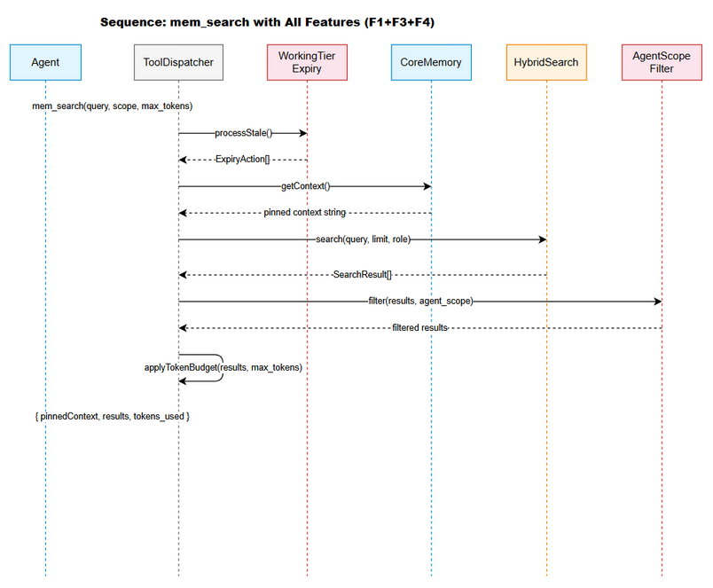
Sequence Diagram
Agent → ToolDispatcher: mem_search(query, agent_scope, max_tokens)
ToolDispatcher → WorkingTierExpiry: processStale()
WorkingTierExpiry → DB: SELECT stale WORKING entries
WorkingTierExpiry → DB: UPDATE tier/archived
WorkingTierExpiry → ToolDispatcher: ExpiryAction[]
ToolDispatcher → CoreMemoryManager: getContext()
CoreMemoryManager → DB: SELECT pinned entries
CoreMemoryManager → ToolDispatcher: formatted context string
ToolDispatcher → HybridSearch: search(query, limit, role)
HybridSearch → DB: FTS5 search + graph boost
HybridSearch → ToolDispatcher: SearchResult[]
ToolDispatcher → AgentScopeFilter: filter(results, agent_scope)
AgentScopeFilter → DB: SELECT tag_set FROM agent_scope_config
AgentScopeFilter → ToolDispatcher: filtered results
ToolDispatcher → TokenBudget: apply(results, max_tokens)
TokenBudget → ToolDispatcher: BudgetResult
ToolDispatcher → Agent: { pinnedContext, results, tokens_used, expiry_actions }

6.3 Integration Sequence: mem_ingest with Quality Gate
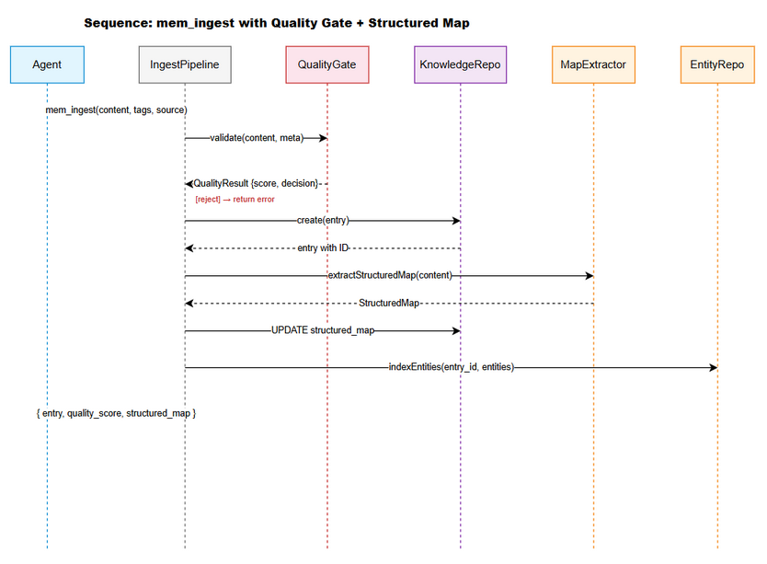
Sequence Diagram
Agent → ToolDispatcher: mem_ingest(content, tags, source, type)
ToolDispatcher → QualityGate: validate(content, meta)
QualityGate → QualityGate: calculateScore(content, meta)
QualityGate → VectorRepo: findSimilar(content, top_k=5)
VectorRepo → QualityGate: similarity scores
QualityGate → ToolDispatcher: QualityResult {score, decision}
[if reject] → ToolDispatcher → Agent: error response
ToolDispatcher → KnowledgeRepo: create(entry)
KnowledgeRepo → DB: INSERT INTO knowledge_entries
KnowledgeRepo → ToolDispatcher: entry with ID
ToolDispatcher → StructuredMapExtractor: extractStructuredMap(content)
StructuredMapExtractor → ToolDispatcher: StructuredMap
ToolDispatcher → DB: UPDATE structured_map WHERE id=?
ToolDispatcher → EntityClassifier: classifyEntities(entities_mentioned)
EntityClassifier → ToolDispatcher: classified entities
ToolDispatcher → EntityRepo: indexEntities(entry_id, entities)
EntityRepo → DB: INSERT INTO entity_index
ToolDispatcher → Agent: { entry, quality_score, structured_map }

7. Security Design

7.1 Authentication & Authorization
The MCP server runs locally via stdio — no network authentication required. Authorization is handled via agent_scope (tag-based filtering):
Agent Role | Visible Tags | Invisible Tags
QA | testing, qa, test-plan, test-case, bug | code, deployment, business
DEV | code, api, architecture, implementation, design | testing, deployment
BA | requirement, business, stakeholder, process | code, testing, deployment
SA | architecture, design, infrastructure, security | testing, business
DevOps | deployment, infrastructure, ci-cd, monitoring | testing, business, code
(no scope) | ALL tags visible | None
Note: Untagged entries are visible to ALL agents regardless of scope (backward compatible).

7.2 Data Protection
Data Type | At Rest | In Transit | In Logs
Knowledge content | Plain (SQLite file) | N/A (local stdio) | Truncated (first 100 chars)
Conversation turns | Plain (SQLite) | N/A | Session ID only
Entity index | Plain (SQLite) | N/A | Entity name only
Quality scores | Plain (SQLite) | N/A | Score value only

7.3 Input Validation
Field | Validation | Sanitization
content (ingest) | ≥50 chars, ≤100KB | Trim whitespace
role (conversation) | enum: user/assistant/system/tool | Lowercase
action (all tools) | enum per tool | Exact match
entry_id | Integer > 0, exists in DB | parseInt
session_id | Non-empty string, ≤255 chars | Trim
tool_calls | Valid JSON array or null | JSON.parse validation
agent_scope | Known role or null | Uppercase lookup
max_tokens | Integer 100-10000 | Clamp to range

8. Performance & Scalability

8.1 Performance Targets
Operation | Target | Measurement Method
Pin retrieval (getContext) | <50ms | Benchmark: 10 pinned entries, 2000 tokens
Conversation query (getSession) | <100ms | Benchmark: session with 100 turns
Entity search | <100ms | Benchmark: 1000+ entries in entity_index
Structured map extraction | <200ms | Benchmark: 5000-char content
Quality gate validation | <50ms | Benchmark: including duplicate check
Token counting | <1ms | Benchmark: 10KB content
Agent scope filter | <10ms | Benchmark: 50 results, 5 tags
WORKING tier expiry | <100ms | Benchmark: 100 stale entries

8.2 Caching Strategy
Cache | What | TTL | Eviction | Technology
Agent scope config | tag_set per role | Session lifetime | On config update | In-memory Map
Pinned entries | Formatted context string | Until pin/unpin | On mutation | Instance variable
Entity patterns | Compiled RegExp | Permanent | Never | Module-level const

8.3 Connection Pooling
Resource | Strategy | Notes
SQLite | Single connection (better-sqlite3) | Synchronous API, no pool needed
ONNX Runtime | Single instance | Loaded once at startup

8.4 Optimization Notes
- Prepared statements — all SQL queries use db.prepare() (compiled once, reused)
- Batch inserts — entity indexing uses transaction for multiple INSERT
- Lazy expiry — no background timer, runs only when search is called
- Early exit — quality gate rejects before expensive operations (embedding, storage)
- Index coverage — all WHERE clauses have supporting indexes

9. Monitoring & Observability

9.1 Logging
Log Event | Level | Fields | Destination
Pin/Unpin operation | INFO | entry_id, action, budget_state | Console + audit_trail
Quality rejection | WARN | content_hash, score, reason | Console + audit_trail
Auto-expiry action | INFO | entry_id, action, quality_score | audit_trail
Migration executed | INFO | migration_name, duration_ms | Console
Migration failed | ERROR | migration_name, error_message | Console
Duplicate detected | WARN | entry_id, similarity, existing_id | Console + audit_trail
Agent scope applied | DEBUG | agent_role, results_before, results_after | audit_trail
Token budget applied | DEBUG | tokens_used, tokens_budget, truncated | audit_trail

9.2 Metrics (via mem_admin tool)
Metric | Type | Description
pinned_entries_count | Gauge | Current number of pinned entries
pinned_tokens_used | Gauge | Current token budget usage
quality_rejections_total | Counter | Total ingest rejections
quality_score_avg | Gauge | Average quality score of recent ingests
expiry_promotions_total | Counter | Total WORKING→EPISODIC promotions
expiry_archives_total | Counter | Total WORKING archives
conversation_turns_total | Counter | Total conversation turns stored
entity_index_size | Gauge | Total entities indexed
search_tokens_avg | Gauge | Average tokens per search response

9.3 Audit Trail
All significant operations are recorded in the existing audit_trail table:
INSERT INTO audit_trail (operation, entry_id, session_id, details, created_at)
VALUES (?, ?, ?, ?, datetime('now'));
Operations logged: PIN, UNPIN, QUALITY_REJECT, QUALITY_WARN, EXPIRY_PROMOTE, EXPIRY_ARCHIVE, SCOPE_FILTER, DUPLICATE_DETECT.

10. Testing Strategy

10.1 Unit Tests
Module | Test File | Key Scenarios
CoreMemoryManager | core-memory.test.ts | Pin/unpin/budget/reorder/getContext
QualityGate | quality-gate.test.ts | Score calculation, reject/warn/accept, duplicates
AgentScopeFilter | agent-scope-filter.test.ts | Filter by role, untagged visible, unknown role
WorkingTierExpiry | working-tier-expiry.test.ts | Promote/archive/pin-exempt
TokenBudget | token-budget.test.ts | Limit results, truncate, single-result-over-budget
ConversationRepo | conversation-repo.test.ts | Save/get/list/search turns
ConversationSummarizer | conversation-summarizer.test.ts | Summarize session, mark turns
StructuredMapExtractor | structured-map-extractor.test.ts | Extract entities/decisions/actions
EntityRepo | entity-repo.test.ts | Index/find/search entities

10.2 Integration Tests
Test | Description | Dependencies
Full search pipeline | Search with pins + scope + budget + expiry | SQLite in-memory
Full ingest pipeline | Ingest with quality gate + map extraction + entity index | SQLite in-memory
Migration idempotency | Run all migrations twice, verify no errors | SQLite temp file
Backfill script | Process 100 entries, verify maps + entities | SQLite temp file
Cross-feature: pin + expiry | Pinned WORKING entry not expired | SQLite in-memory

10.3 Coverage Target
- ≥80% line coverage on all new code
- 100% coverage on critical paths: quality gate decisions, token budget, pin operations
- Regression tests for all 14 existing tools (verify no behavioral changes)

11. Deployment Considerations

11.1 Environment Configuration
Property | Default | Description
CORE_MEMORY_MAX_TOKENS | 2000 | Pin budget limit
CORE_MEMORY_WARNING_THRESHOLD | 1800 | Warning at 90%
CORE_MEMORY_MAX_PINNED | 10 | Max pinned entries
QUALITY_GATE_MIN_LENGTH | 50 | Minimum content chars
QUALITY_GATE_REJECT_THRESHOLD | 30 | Auto-reject below this score
QUALITY_GATE_WARN_THRESHOLD | 50 | Warning below this score
QUALITY_GATE_DUPLICATE_THRESHOLD | 0.95 | Cosine similarity for duplicate
WORKING_EXPIRY_HOURS | 24 | Hours before WORKING entries expire
WORKING_EXPIRY_PROMOTE_THRESHOLD | 60 | Quality score for promotion
SEARCH_DEFAULT_MAX_TOKENS | 2000 | Default token budget for search
CONVERSATION_MAX_CONTENT_LENGTH | 50000 | Max chars per turn

11.2 Feature Flags
Flag | Default | Description
ENABLE_QUALITY_GATE | true | Enable/disable ingest quality validation
ENABLE_AUTO_EXPIRY | true | Enable/disable WORKING tier auto-expiry
ENABLE_AGENT_SCOPE | true | Enable/disable tag-based filtering
ENABLE_AUTO_EXTRACT_MAP | true | Enable/disable structured map extraction on ingest
ENABLE_SEARCH_TOKEN_BUDGET | true | Enable/disable token budget on search

11.3 Rollback Strategy
- Schema rollback — All migrations are additive. To rollback:
  - New columns: ALTER TABLE ... DROP COLUMN (SQLite 3.35+)
  - New tables: DROP TABLE IF EXISTS
  - New indexes: DROP INDEX IF EXISTS
- Code rollback — Revert to previous git commit. New columns/tables are ignored by old code (nullable/default values).
- Data preservation — No data is lost on rollback. New columns simply become unused.

11.4 Upgrade Path
- Pull new code (v0.6.0)
- Start server — migrations auto-run on first startup
- Verify: mem_admin(action: "status") shows new tables
- Optional: Run backfill script for existing entries: node scripts/backfill-structured-maps.js
- Verify: mem_map(action: "search_entity", entity: "KSA-110") returns results

12. Implementation Checklist

Files to Create
# | File | Description | Priority
1 | src/memory/v2/quality-gate.ts | Ingest quality validation | High
2 | src/memory/v2/agent-scope-filter.ts | Tag-based KB isolation | High
3 | src/memory/v2/working-tier-expiry.ts | Lazy auto-expiry | Medium
4 | src/memory/v2/token-budget.ts | Search result token limiting | High
5 | src/memory/v2/backfill-script.ts | Backfill structured maps | Low
6 | src/memory/tests/quality-gate.test.ts | Unit tests | High
7 | src/memory/tests/agent-scope-filter.test.ts | Unit tests | High
8 | src/memory/tests/working-tier-expiry.test.ts | Unit tests | Medium
9 | src/memory/tests/token-budget.test.ts | Unit tests | High
10 | src/memory/tests/integration-v3.test.ts | Integration tests | High

Files to Modify
# | File | Changes | Priority
1 | src/memory/hybrid-search.ts | Add scope filter + token budget + expiry trigger | High
2 | src/memory/ingest-pipeline.ts | Add quality gate + auto-extract map | High
3 | src/memory/tool-defs-tier1.ts | Add mem_pin, mem_conversation, mem_map definitions | High
4 | src/memory/tool-dispatcher.ts | Route new tool actions | High
5 | src/memory/migrations-v3.ts | Add V3.3-V3.8 migrations | High
6 | src/memory/models.ts | Add new interfaces | Medium
7 | src/memory/schema-v3.ts | Add new DDL constants | Medium
8 | package.json | Bump version to 0.6.0 | Low

Implementation Order
Phase | Files | Dependencies | Estimated Effort
1. Schema | schema-v3.ts, migrations-v3.ts | None | 2h
2. Core Memory | core-memory.ts (already exists), tool-defs | Schema | 1h (wire up)
3. Conversation | conversation-repo.ts (exists), summarizer | Schema | 2h (summarizer)
4. Structured Map | extractor (exists), entity-repo (exists) | Schema | 1h (wire up)
5. Quality Gate | v2/quality-gate.ts | Vector repo | 3h
6. Agent Scope | v2/agent-scope-filter.ts | Schema (agent_scope_config) | 2h
7. Token Budget | v2/token-budget.ts | Token counter | 1h
8. Working Expiry | v2/working-tier-expiry.ts | Schema (quality_score, archived) | 2h
9. Integration | hybrid-search.ts, ingest-pipeline.ts | All above | 4h
10. Tests | All test files | All above | 6h
11. Backfill | v2/backfill-script.ts | Extractor + entity repo | 2h
Total estimated: ~26 hours

13. Appendix

Glossary
Term | Definition
MCP | Model Context Protocol — JSON-RPC over stdio for AI agent tools
Pinned Entry | Knowledge entry marked for automatic context injection
Structured Map | JSON metadata extracted from content (entities, decisions, etc.)
Quality Gate | Validation step before ingest (length, duplicates, score)
Agent Scope | Tag-based filtering per agent role
Token Budget | Maximum tokens allowed in search results
Auto-Expiry | Lazy promotion/archive of stale WORKING tier entries
RRF | Reciprocal Rank Fusion — score combination method
FTS5 | SQLite Full-Text Search extension v5

Open Questions
# | Question | Status | Answer
1 | Should quality gate check run on mem_ingest_file too? | Resolved | Yes — same pipeline
2 | Should pinned entries bypass agent_scope filter? | Resolved | Yes — pins always visible
3 | Should conversation summarization be automatic or manual? | Resolved | Both — auto on threshold + manual via action
4 | Should backfill run automatically on upgrade? | Resolved | No — manual script, can be slow on large DBs

Diagram Index
# | Diagram | Image | Source (editable)
1 | Architecture Overview | architecture.png | architecture.drawio
2 | Component Diagram | component.png | component.drawio
3 | Database Schema | db-schema.png | db-schema.drawio
4 | Search Enhanced Sequence | sequence-search-enhanced.png | sequence-search-enhanced.drawio
5 | Ingest Enhanced Sequence | sequence-ingest-enhanced.png | sequence-ingest-enhanced.drawio
6 | Class Diagram | class-diagram.png | class-diagram.drawio

